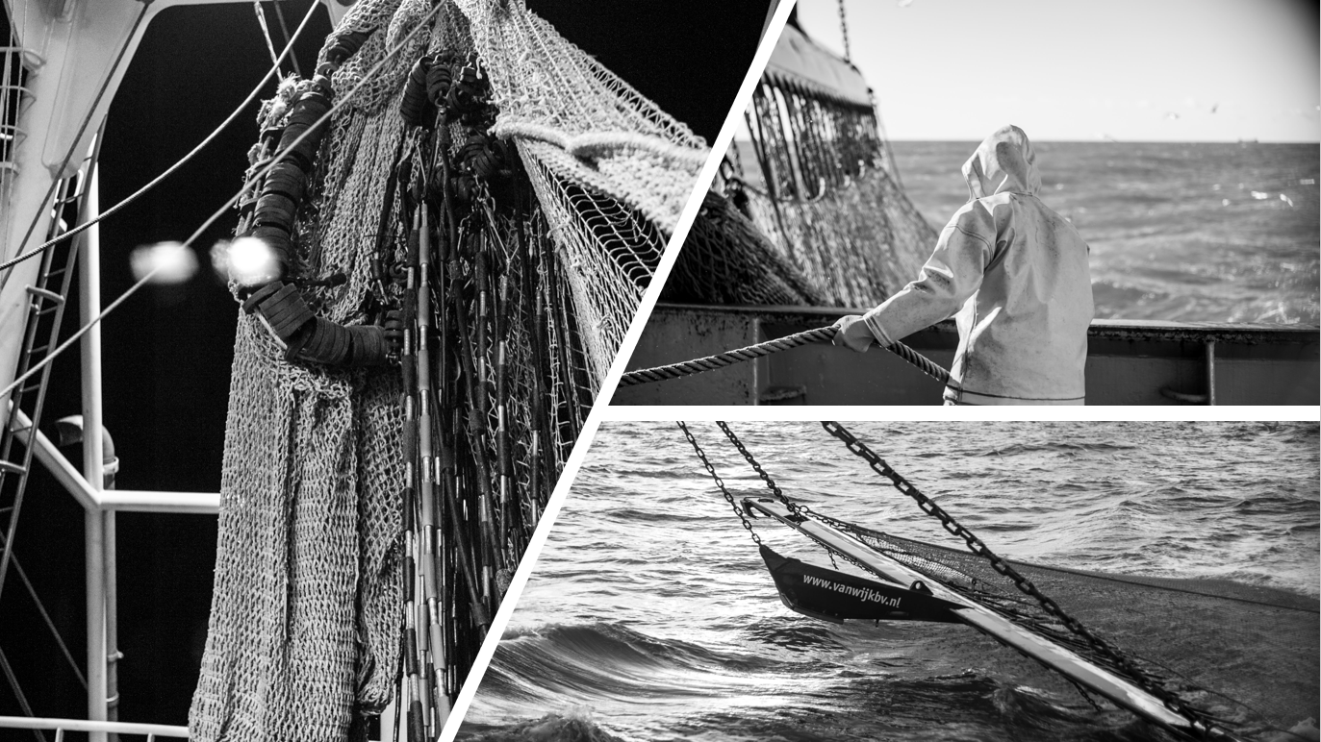

Towards a scientifically informed decision:

Effects of electrical pulse stimulation on bioirrigation and movement activity patterns of *Arenicola marina* in the context of pulse trawling

Joey Portier

06-06-2019

Yerseke, The Netherlands

Towards a scientifically informed decision:

Effects of electrical pulse stimulation on bioirrigation and movement activity patterns of *Arenicola marina* in the context of pulse trawling

Cover:

*Socks at Sea* by Menno van Mourik (RAW photography)

Reprinted with permission

Author:

Joey Portier

(00070959)

HZ University of Applied Sciences

Delta Academy

Watermanagement / Aquatic Ecotechnology

Academic year 2018-2019

Semester 8

Research report

Bachelor Thesis

Place of publication:

Royal Netherlands Institute for Sea Research (NIOZ)

Department of Estuarine & Delta systems (EDS)

Yerseke, the Netherlands

06-06-2019

Final version

First examiner:

Anneke van den Brink PhD

Delta Academy

HZ University of Applied Sciences (HZ)

Supervisors:

Justin C. Tiano MSc

Department of Estuarine & Delta Systems (EDS)

Royal Netherlands Institute for Sea Research (NIOZ)

Pim G. Boute MSc

Experimental Zoology Group (EZO)

Wageningen University & Research (WUR)

# Acknowledgements

I have many debts of gratitude towards the people who enabled me to conduct bachelor thesis at the EDS department of the Royal Netherlands Institute of Sea Research in Yerseke.

Firstly, thank you Anneke for the nice chats we have been having, not only in terms of feedback on one the many products delivered, but also on my future career prospects and your ability to put things into perspective.

Secondly, special thanks to Anton for all the help in getting to the final research setup, tirelessly explaining measurement techniques, and taking me on the nice boat trips with the Zeevonk. Also, thanks to Greg and Chiu for taking your time to help this poor student out with R, and the lovely people from the EDS department with whom I could share my frequent coffee breaks.

Above all, Justin & Pim, I am very grateful for you granting me this opportunity to conduct my bachelor thesis in such a friendly and collaborative environment. Pim, your involvement and counseling during the start of my internship and throughout has been tremendous. Providing the necessary support from Wageningen with our weekly skype meetings, proof reading, and crossing provinces to assist with additional measurements.

Justin, I am immensely grateful for your support as a supervisor and the pleasant collaboration we have had. Your patience, knowledge, and guidance were extremely valuable to me. Allowing me to work independently and explore the field of academic research, while still being able to fall back on your advice when necessary.

You have been great teachers over the last months in terms of my personal and professional development, I could not have wished for better supervisors. I certainly hope we will cross paths again in the future.

Abstract

The experimental fishing method of pulse trawling was initially developed to decrease fuel consumption rates of flatfish fisheries in the North Sea targeting common sole (*Solea solea*)*.* By replacing tickler chains with electrodes, the targeted fish is immobilised until it enters the net by using electrical pulse stimuli. The adaptation to this new technique reduced fuel consumption rates by 40-50%, while decreasing seabed damage and bycatch (Poos *et al.*, 2013; van Marlen *et al.*, 2014). However, the commercial use of this method was met with significant resistance by environmental organisations, as possible adverse effects on marine life had been documented. Earlier studies reported spinal injuries in Atlantic cod (*Gadus morhua*) as a result of exposure to electrical pulse stimuli (de Haan *et al.*, 2016; Soetaert *et al.,* 2016). This type of exposure may affect burrowing invertebrates, which may otherwise avoid the mechanical trawl disturbance. However, this area of research remains unexplored, though it is important to investigate as electrical fields can penetrate the seabed. As part of the Impact Assessment of Pulse trawl Fisheries (IAPF), this study aimed to assess the possible effects electrical pulse stimuli may have on bioirrigation and movement activity patterns of lugworm (*Arenicola marina*). In a laboratory setting, seven *A. marina* specimenswere subjected to a worst-case pulse exposure scenario using the electrical pulse parameters used in common sole (*S. solea*) pulse fisheries, to study their behavioural reaction, recovery, and the potential changes in oxygen dynamics related to this. These changes were compared to six control specimens of *A. marina*. All specimens were analysed using porewater pressure recordings and a selected group with additional oxygen consumption rate measurements to detect changes in behaviour and respiration respectively. Planar optode imaging was used to visualise the changes oxygen dynamics induced by macrofaunal activity inside the sediment in experimental setup. A significant increase in both burrowing (2.24%) and defecation (0.33%) was observed in the exposure group, as opposed to pumping activity, which showed a reduction of 2.59%. Pumping of water by the lugworm into its burrow caused oxygenation at depths of 19 cm (39 – 52%). However, after exposure to an electrical pulse stimulus, oxygen saturation values inside the gallery decreased rapidly (13 – 26%). Oxygen consumption rates were higher in the control group, which may predominantly be influenced by microbial activity. Though, the difference was not significant between the two sample groups. Our research suggests that exposure to an electrical pulse stimulus can cause alterations to the ecosystem functioning of *A. marina* in terms of bioadvection*,* while possibly increasing the vulnerability of the species towards predators such as flatfish.

Table of Contents

1. Introduction 1

1.1 Benthic ecosystems 5

1.2 *Arenicola marina* 5

1.3 *Arenicola marina* as a model species 6

2. Material & methods 8

2.1 Experimental setup 8

2.2 Electrical pulse stimulus parameters 13

2.3 Porewater pressure recording 15

2.4 Planar optode imaging 15

2.5 Data analyses 16

2.6 Statistics 16

3. Results 17

3.1 Behavioural characteristics 17

3.2 Recovery time 21

3.3 Oxygen consumption rates 21

3.4 Oxygen dynamics 22

4. Discussion & conclusion 24

4.1 Implications 25

References 26

APPENDIX i 30

APPENDIX ii 35

APPENDIX iii 39

# List of figures

[**Table 1.** Percentage of total time per movement activity pattern 19](https://d.docs.live.net/d2e17a3c969e6ba2/Documents/Joey%20Portier%20-%20Research%20report%20NIOZ%20(final%20version).docx#_Toc10217412)

**Figure 1.** Commercial 4 metre ticker chain trawl (a) and a 4 metre DELMECO pulse trawl (b)………………….2

[**Figure 2.** HFK-engineering PulseWing with the wing and trawler runner in the center 3](https://d.docs.live.net/d2e17a3c969e6ba2/Documents/Joey%20Portier%20-%20Research%20report%20NIOZ%20(final%20version).docx#_Toc10217413)

[**Figure 3.** The DELMECO pulse beam with beam and trawl shoes 3](https://d.docs.live.net/d2e17a3c969e6ba2/Documents/Joey%20Portier%20-%20Research%20report%20NIOZ%20(final%20version).docx#_Toc10217414)

[**Figure 4.** Schematic side view of the traditional shrimp beam trawl technique compared to the basic principle of the HOVERCRAN (hovering pulse trawl) 4](https://d.docs.live.net/d2e17a3c969e6ba2/Documents/Joey%20Portier%20-%20Research%20report%20NIOZ%20(final%20version).docx#_Toc10217416)

[**Figure 5.** Schematic front view of the traditional shrimp trawl 4](https://d.docs.live.net/d2e17a3c969e6ba2/Documents/Joey%20Portier%20-%20Research%20report%20NIOZ%20(final%20version).docx#_Toc10217415)

[**Figure 6.**  Sketch of the lugworm in its burrow 6](https://d.docs.live.net/d2e17a3c969e6ba2/Documents/Joey%20Portier%20-%20Research%20report%20NIOZ%20(final%20version).docx#_Toc10217419)

[**Figure 7.** Lugworm next to sediment casting. 6](https://d.docs.live.net/d2e17a3c969e6ba2/Documents/Joey%20Portier%20-%20Research%20report%20NIOZ%20(final%20version).docx#_Toc10217418)

[**Figure 8.** Schematic drawing of the experimental setup. 9](https://d.docs.live.net/d2e17a3c969e6ba2/Documents/Joey%20Portier%20-%20Research%20report%20NIOZ%20(final%20version).docx#_Toc10217421)

[**Figure 9.** Schematic drawing of the planar optode setup. 10](https://d.docs.live.net/d2e17a3c969e6ba2/Documents/Joey%20Portier%20-%20Research%20report%20NIOZ%20(final%20version).docx#_Toc10217422)

[**Figure 10.** Overview of the complete research setup with close-ups of the aquarium and the incubation core 11](https://d.docs.live.net/d2e17a3c969e6ba2/Documents/Joey%20Portier%20-%20Research%20report%20NIOZ%20(final%20version).docx#_Toc10217423)

[**Figure 11.** Schematic overview of the measurement protocol for one week per aquarium 12](https://d.docs.live.net/d2e17a3c969e6ba2/Documents/Joey%20Portier%20-%20Research%20report%20NIOZ%20(final%20version).docx#_Toc10217424)

[**Figure 12.** Front-view EPLG Laboratory pulse generator showing the power switch, USB connection, and both negative and positive outputs to fit electrical wiring 13](https://d.docs.live.net/d2e17a3c969e6ba2/Documents/Joey%20Portier%20-%20Research%20report%20NIOZ%20(final%20version).docx#_Toc10217425)

[**Figure 13.** Screenshot of the laboratory pulse generator software 14](https://d.docs.live.net/d2e17a3c969e6ba2/Documents/Joey%20Portier%20-%20Research%20report%20NIOZ%20(final%20version).docx#_Toc10217426)

[**Figure 14.** Illustration of an experimental setup using the planar optode imaging technique 15](https://d.docs.live.net/d2e17a3c969e6ba2/Documents/Joey%20Portier%20-%20Research%20report%20NIOZ%20(final%20version).docx#_Toc10217427)

[**Figure 15.** Planar optode images of oxygen dynamics in % air saturation 16](https://d.docs.live.net/d2e17a3c969e6ba2/Documents/Joey%20Portier%20-%20Research%20report%20NIOZ%20(final%20version).docx#_Toc10217428)

[**Figure 16.** Exemplary pressure sensor plot showing a response to the electrical pulse stimulus. 18](https://d.docs.live.net/d2e17a3c969e6ba2/Documents/Joey%20Portier%20-%20Research%20report%20NIOZ%20(final%20version).docx#_Toc10217430)

[**Figure 17.** Pumping behaviour quantified from control (n = 6) and pulsed animals (n = 7) in percentage of total time per day 19](https://d.docs.live.net/d2e17a3c969e6ba2/Documents/Joey%20Portier%20-%20Research%20report%20NIOZ%20(final%20version).docx#_Toc10217431)

[**Figure 19.**Defecation behaviour quantified from control (n = 6) and pulsed animals (n = 7) in percentage of total time per day 20](https://d.docs.live.net/d2e17a3c969e6ba2/Documents/Joey%20Portier%20-%20Research%20report%20NIOZ%20(final%20version).docx#_Toc10217432)

[**Figure 18.**Burrowing behaviour quantified from control (n = 6) and pulsed animals (n = 7) in percentage of total time per day 20](https://d.docs.live.net/d2e17a3c969e6ba2/Documents/Joey%20Portier%20-%20Research%20report%20NIOZ%20(final%20version).docx#_Toc10217433)

[**Figure 20.** Oxygen consumption rates from the control (n = 5) and pulsed animals (n = 7) in mmol/m2/day. 21](https://d.docs.live.net/d2e17a3c969e6ba2/Documents/Joey%20Portier%20-%20Research%20report%20NIOZ%20(final%20version).docx#_Toc10217434)

[**Figure 21.** Exemplary planar optode image of oxygen distribution before and after exposure to an electrical pulse stimulus 23](https://d.docs.live.net/d2e17a3c969e6ba2/Documents/Joey%20Portier%20-%20Research%20report%20NIOZ%20(final%20version).docx#_Toc10217435)

# 1. Introduction

Trawling is the most widely used demersal fishing method and is often carried out on the shallow seas of the continental shelf at depths less than 200m (Kaiser *et al.*, 2002). This technique dates back to the thirteenth century in the North Sea and its popularity increased considerably with industrialisation of the fleet in the 1930’s (Lindeboom & de Groot, 1998). Adaptations to fishing vessels, such as the introduction of the beam trawl in the 1960’s, quickly proved to be the most efficient equipment in the fisheries targeting common sole (*Solea solea*) and European plaice (*Pleuronectes platessa*) (de Haan *et al.*, 2016). Additionally, the increase in towing speed of bottom trawlers resulted in a significant increase in catch efficiency (Rijnsdorp *et al.*, 2008). Therefore, bottom trawl fisheries are characterised by high energy inputs and thus, large amounts of fuel consumption (Poos *et al.*, 2013).

The importance of adopting new fishing methods or altering existing ones is to (positively) influence the fisheries impact on the sustainability of a fish stock and the surrounding environment (Haasnoot *et al.*, 2016). The developments of the pulse trawling technique were initially seen by the Fisheries Innovation Platform (FIP) to reduce fuel consumption and discards in flatfish fisheries (Haasnoot *et al.*, 2016). This was a reaction to the rising of fuel costs, which could jeopardize the economic viability of (bottom trawl) fisheries (Poos *et al.*, 2013).

The conventional beam trawling method uses heavy tickler chains to stir up the sediment to drive out the targeted species (Figure 1a). In the Netherlands, this method is used to target flatfish: common sole (*S. solea*) and European plaice (*P. platessa*) (Teal *et al.*, 2014). In flatfish fisheries, pulse trawling works in a way that it invokes a cramp response in the targeted species as the electrodes are dragged over the seabed, immobilising the fish until it enters the net (de Haan *et al.*, 2016).

During towing, the fuel consumption rate is determined by the drag of the equipment towed over the seabed and the drag of the fishing vessel (Poos *et al.*, 2013). This means that the use of lighter gear with less drag can be one of the main solutions to this issue. Additionally, lighter gears such as an electric pulse beam trawl and sum wing beam trawl are generally towed at a lower speed (ca. 5.5 knots instead of 7) (Poos *et al.*, 2013). This reduces the drag of the fishing vessel and thus, decreases fuel consumption rates. Hence, the method of electrical pulse trawling in which the tickler chains are replaced by (lighter) electrodes and are dragged parallel to the fishing vessel (Figure 1b), instead of perpendicular as with tickler chains, together with the significant decrease in towing speed, seemed to be a promising alternative to conventional beam trawling (Soetaert *et al.*, 2014, 2015, 2016).

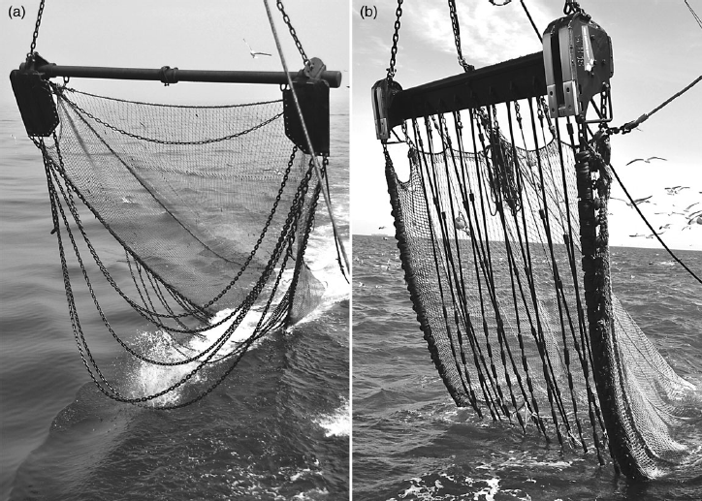

#### **Figure 1.** Commercial 4 metre ticker chain trawl (a) and a 4 metre DELMECO pulse trawl (b). From Depestele *et al.*, (2016).

The majority of the pulse fishing vessels targets flatfish, particularly *S. solea*, by using a bipolar cramp pulse of ca. 40 Hz to increase catch efficiency (Soetaert, 2015). The smaller portion of pulse vessels target brown shrimp (*Crangon crangon*), using a unipolar startle pulse of 5 Hz (i.e. 5 short electrical pulses) to significantly increase their catch rates (Soetaert, 2015). In flatfish fisheries, pulse trawls are produced by either HFK engineering (79%), characterised by the hydrodynamic ‘PulseWing’ (Figure 2), or Delmeco BV (15%) (Figure 3) (Soetaert, 2015). In shrimp fisheries this is done by Marelec (6%) (Figures 4 and 5) (Verschueren & Polet, 2009).

#### **Figure 2.** HFK-engineering PulseWing with the wing and trawler runner in the center. From: Soetaert (2015).

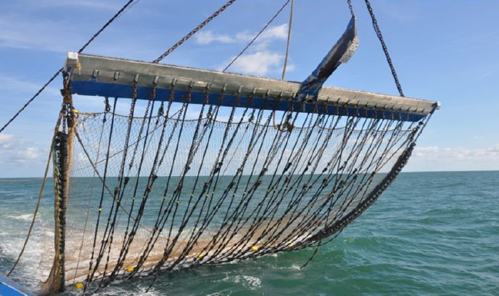

#### **Figure 3.** The DELMECO pulse beam with beam and trawl shoes. From: Soetaert (2015).

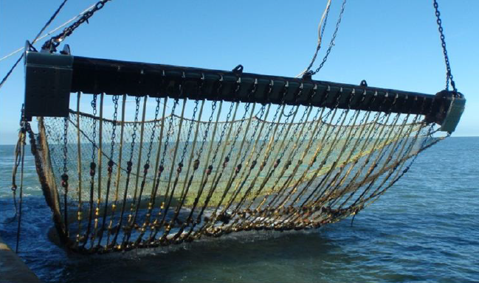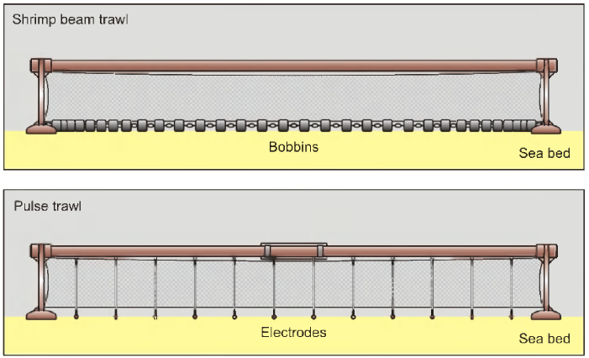

#### **Figure 5.** Schematic front view of the traditional shrimp trawl (above) using bobbins intensively touching the seabed and the HOVERCRAN (hovering pulse trawl), with only 12 lightweight electrodes touching the seabed. From: Verschueren & Polet (2009).

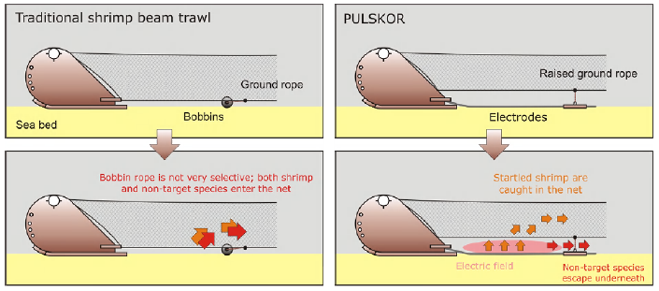

#### **Figure 4.** Schematic side view of the traditional shrimp beam trawl technique compared to the basic principle of the HOVERCRAN (hovering pulse trawl). In the HOVERCRAN, the traditional bobbin rope is replaced with electrodes, generating a specific electric field. From: Verschueren & Polet (2009).

The available evidence for pulse trawling shows that there is a substantial decrease in bycatch of fish and benthic invertebrates (80%) in both flatfish and shrimp fisheries when compared to conventional beam trawling (van Marlen *et al.*, 2014). This significant reduction in discards and seafloor disturbances also looked to be an extra commercial asset for fishermen in terms of the increasing market demand for fish caught in a sustainable manner (Soetaert, 2015). However, there are still many unknowns about how this method will affect the functioning of marine ecosystems and their recovery to exposure (Soetaert *et al.*, 2014). Therefore, fishing with pulse trawls is placed under heavy regulation and is only allowed for 5% of the beam trawl fleet per member state in certain areas of the North-Sea (ICES zones IVb south: Central North Sea and IVc: Southern North Sea) (EU council regulation C1 41/2007, annex III: transitional technical and control measures).

## 1.1 Benthic ecosystems

Oceans cover 70% of the earth's surface and provide an equal coverage in the sustaining of soft-sediment ecosystems (Olsgard *et al.*, 2008; Volkenborn *et al.*, 2010). Therefore, constituting to the most extensive ecosystem on our planet in areal coverage (Snelgrove, 1999; Volkenborn *et al.*, 2010). These ecosystems are highly heterogeneous by its interactions between hydrodynamic and nutrient regimes as well as physical and biological features (Thrush & Dayton, 2002), hosting an extremely high variety of organisms and community assemblages (Künitzer *et al.*, 1992) that reside in or on marine sediments (Snelgrove, 1999). Which on their turn, play a key role in the benthic-pelagic coupling to sustain marine food webs (Olsgard *et al.*, 2008).

Marine systems can generally be divided into two compartments: the water column and the sediment matrix (Glud, 2008), of which the sediment matrix hosts most biological activity. These biological activities are driven by soft-sediment marine organisms which play a crucial part in ecosystem processes (Thrush & Dayton, 2002). Through behavioural activities such as burrowing, feeding, locomotion and pumping, benthic infauna influences the biogeochemical distribution in the sediment-water interface (Olsgard *et al.*, 2008). Consequently, the behavioural activities play important roles in the cycling, redistributing and degradation organic material (Norling *et al.*, 2007). The degradation of organic material using oxygen yields the highest output of energy (Koho & Piña-Ochoa, 2012). Making it the most favourable electron acceptor in the world and is essential for respiratory functions of benthic organisms (Volkenborn *et al.*, 2010, 2012).

## 1.2 *Arenicola marina*

*A. marina* is the most widely found polychaete worm that inhabits intertidal sand flats in its 20-40 cm deep L- or J-shaped burrows along the North west European coasts, Arctic and Mediterranean regions (Huettel, 1990; Riisgård & Banta, 1998) and is according to Reise (1985) (as cited in Huettel, 1990), characterised by its strong bioturbation. This bioturbation, or the reworking of soils and sediments, comes from the fact that *A. marina* is a non-selective sub-surface deposit feeder that feeds on micro-organisms and particulate matter retained in the surface sediments (Rijken, 1979). During feeding, the lugworm resides in the bottom part of its burrow called ‘the gallery’ (Figure 6). In the gallery, the lugworm ingests sediment through the head shaft (or feeding pocket) by creating a hydrostatic overpressure using peristaltic movements, leaving a depression on the surface sands (Baumfalk, 1997). This depression develops a funnel shape, acting as a detritus trap (Rijken, 1979; Huettel, 1990). This is a convenient mechanism because the lugworm needs to consume large amounts of these sediments due to its low nutritional values (Riisgård & Banta, 1998).

The lugworm can migrate on intertidal habitats and is often characterised by a pattern of faecal cylinders occurring at regular intervals caused by defecation (Wells, 1966). When defecating, the worm moves back up into the tail shaft until reaching the sediment surface, where it ejects its sediment castings (Riisgård & Banta, 1998). This process may continue regularly without interruptions, creating the characteristic sand piles (Figure 7) that are generally found on the beach (Wells, 1966).

#### **Figure 7.** Lugworm next to sediment casting.

#### **Figure 7.** Lugworm next to sediment casting.

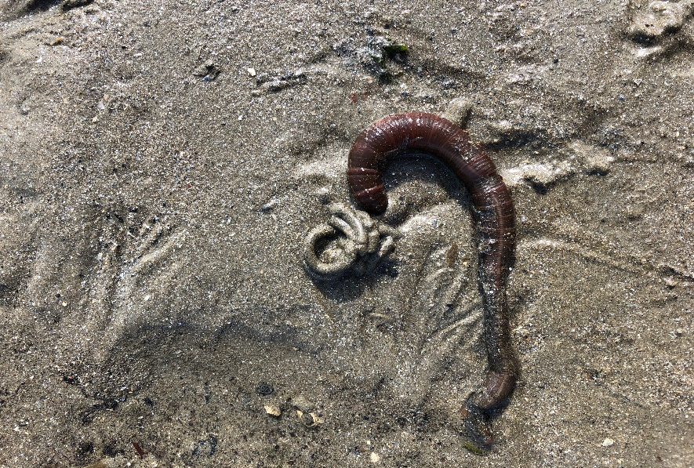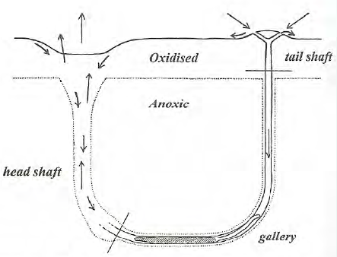

#### **Figure 6.** Sketch of the lugworm in its burrow with the longer arrows indicating the flow of water within the burrow while the shorter ones signify the movement of sand when pumped towards the lugworm. From: Riisgård & Banta (1998).

#### **Figure 6.** Sketch of the lugworm in its burrow with the longer arrows indicating the flow of water within the burrow while the shorter ones signify the movement of sand when pumped towards the lugworm. From: Riisgård & Banta (1998).

## 1.3 *Arenicola marina* as a model species

Multiple studies have assessed the types of forces and processes influencing porewater dynamics, interfacial solute exchanges and nutrient fluxes in permeable sediments (e.g. Huettel & Gust, 1992; Precht *et al.*, 2004). Hydrodynamic forces, such as waves affect the biogeochemical processes as well as porewater dynamics through its orbital motion and advective fluid exchanges between the sediment and overlying water (Huettel *et al.*, 1996, 2014; Precht *et al.*, 2004). Directionally transporting dissolved and suspended matter through the interstitial spaces (Huettel *et al.*, 1998). In addition, marine dwelling animals (infauna) influence the pressure transients in the porewater through activities such as peristaltic movements, water-jetting and inflation of body parts (Wethey *et al.*, 2008; Huettel *et al.*, 2014). These movements can be detected by pressure sensors that sense fluctuations along the hydrostatic baseline (Wethey & Woodin, 2005; Wethey *et al.*, 2008; Volkenborn *et al.*, 2010, 2012).

*A. marina* is a well-documented polychaete worm in regard to studies on advective water transport, bioirrigation, and oxygen dynamics in the sediment (e.g. Timmermann *et al.*, 2006; Wethey *et al.*, 2008; Volkenborn *et al.*, 2010). Due to its widespread distribution across the North Sea and its behavioural characteristics such as injecting water into sediments, the lugworm makes a good model animal for studying oxygen dynamics and ecosystem functioning in the sediment (Timmermann *et al.*, 2006; Wethey *et al.* 2008). The changes in oxygen dynamics can be projected as a two-dimensional image by using the planar optode technique (as described in Glud *et al.*, 1996).

One of the areas of research that is rather uncharted, is the direct impact of the pulse trawl equipment on the benthic ecosystem (Teal *et al.*, 2014). Electrical pulses can penetrate the seabed and may affect infauna (i.e. burrowing invertebrates) which may otherwise avoid the mechanical stimulation caused by conventional trawler gears. As of this moment, the European Parliament, European commission and EU member states have agreed upon banning the pulse fishing technique starting from mid-2021. However, the Impact Assessment on Pulsetrawl Fishery (IAPF) project is currently on-going and due at the end of 2019. As an addition to the current knowledge on the effects of electrical pulse stimulation on benthic animals (e.g. Smaal & Brummelhuis, 2005; Soetaert, 2016; van Marlen, 2009), it is relevant to isolate and assess the effect of electricity on the functioning of burrowing infauna as any of the changes in their behaviour may hold wider implications to the benthic ecosystem.

This study aims to assess the impact of electrical pulse stimulation on the functioning of benthic infauna in the context of pulse trawling through pressure sensors recordings, planar optode imaging and measurements of oxygen consumption rates (OCR) before and after exposures to electrical pulse stimuli. The coupling of porewater pressure sensors data with the planar optode imaging has proven to be suitable for bioirrigation and porewater bioadvection studies (e.g. Volkenborn *et al.*, 2010, 2012) and establishes an important link between visualising changes in biogeochemistry induced by macrofaunal activity. In this way, we can both qualitatively and quantitatively assess the possible effects an electrical pulse stimulus may have on the bioirrigation and movement activity patterns of *A. marina.* Therefore, the main question poses: **“How will electrical pulse stimulation affect benthic organismal functioning of the lugworm (*Arenicola marina,* Linnaeus, 1758*)*?”**

In order to substantiate the final answer to the main question, the following sub-questions together with the correlating hypotheses were formulated:

1. *What behavioural changes (e.g. burrowing, squirming and escaping) are observable in* A. marina *after electrostimulation?*

It is expected that the exposure to an electrical pulse stimulus induces a behavioural response both during the stimulation as well as after the pulse. Therefore, the hypothesis for this sub-question is formulated as: ‘*The exposure to an electrical stimulus temporarily increases behavioural activity of the lugworm’.*

1. *What are the long-term effects on the bio irrigating capacities and movement activity patterns of* A. marina *after repetitive electrical pulse stimuli?*

Assuming that the electrical pulses induce an effect on the lugworm, these effects will presumably deprive the specimen of energy. Thus, a decrease in bioirrigation and movement activities are expected to be found after repetitive exposure to electrical pulse stimuli.

1. *Are changes to bioirrigation activity caused by electrical pulse stimuli related to changes in oxygen dynamics inside the sediment?*

This sub-question will assess one of the possible sub-lethal consequences electrical pulse stimulation may have on the functioning of benthic infauna. Since the lugworm is a strong bioturbator and is closely linked to the oxygen dynamics in the sediment, the changes in activity due to exposure is expected to decrease oxygen concentrations in the porewater.

1. *What pattern can be observed regarding the recovery time of* A. marina *after electrical pulse stimulation?*

Based on a similar study by Vega Garre (2018), it is expected that due to habituation, exposures to repetitive electrical pulse stimuli will result in shorter recovery times after each successive pulse.

# 2. Material & methods

## 2.1 Experimental setup

Lugworm (*Arenicola marina*) specimens (n=13) as well as sediment were obtained from the intertidal area in the Eastern Scheldt, east of the Royal Netherlands Institute for Sea Research (NIOZ) during low tide (51° 29' 18.6252'' N, 4° 3' 28.1952'' E). Lugworms were housed in an aquarium (43 x 26 x 28 cm) with untreated sediments and an air stone before selected for experimental trials. Based on an earlier study involving *A. marina* by Volkenborn *et al.* (2010), individual lugworms were kept in narrow, cuvette shaped aquaria (Figure 8 and 9). These aquaria consisted of two rectangular acrylic panels (32 x 30 x 0.9 cm) glued against two acrylic side panels (30 x 10 x 0.9 cm). The inside volume of the aquaria was further divided by adding a partition (30 x 21 x 0.5), located 2 cm away from the front acrylic panel (Figure 8 and 9). Ultimately, resulting in an area of 30 x 21 x 2 cm. This is the area where sediment was added and will be further referred to as the ‘sediment zone’ throughout this paper. Using two stainless steel plate electrodes (35 x 2 x 0.1 cm) as side walls, the sediment zone was further divided into a smaller liveable area for *A. marina* as well as by decreasing the width of this zone using plexiglass spacers (20 x 21 x 0.4 and 20 x 21 x 0.2 cm). The decreasing of the sediment zone width was conducted in order to press the lugworm up against the front acrylic panel and reveal the worm and its burrow lumen. Therefore, the amount of the plexiglass spacers used to decrease the width of the sediment zone was dependent on the size of each lugworm. In addition, one of the selected aquaria was fitted with the planar optode and setup with the camera for the measurement of fine-scale oxygen dynamics inside the sediment (Figure 9).

Each aquarium was connected to a cylindrical incubation core (3 L) that holds a pump (EHEIM, universal 300) with a maximum flow capacity of 300 L/h, an air stone, magnetic stirrer, in- & outlet for the water and an optode (FireStingO2, Pyroscience) for oxygen measurements (Figure 9). The sediment cores were closed off with lids, and all of the tubing and wiring was fitted through rubber stoppers to establish a closed flow-through system (Figure 10). The latter enables the measurement of oxygen consumption rates for each individual setup.

These aquaria were stored in a climate room where a stable dark environment with a constant temperature of ca. 14 °C was maintained (Figure 10). The liveable space for the lugworm was filled with sediment to a depth of 20 cm to establish similar environmental conditions. Additionally, for use in the experimental setup, the sediment was sieved through a 1 mm sieve in order to remove macrofauna and rocks.

The electrical copper core wires (2.5 mm2) were cut to the same length (7 m), for all of the fitted electrodes. Making sure that the loss of voltages due to friction was homogeneous for each of the wire sets. Various toxicity studies have investigated the sensitivity of polychaete annelids to different metals (e.g. Reish & Carr, 1978; Bat & Rafaelli, 1998) and found that copper is particularly harmful to *A. marina*. Therefore, the electrical copper wire ends were fitted with heat-shrink tubing in order to protect the copper wiring from corrosion and prevent the leaching of oxidised copper into the system.

In order to prevent air bubbles in the sediment, a ‘slush’ was first created by mixing sediment with water before filling up the aquaria. After each week of measurements, water and sediment was renewed. Newly filled aquaria with the addition of individual specimen were left to acclimatize for at least 48h over the weekend before the start of any measurements.

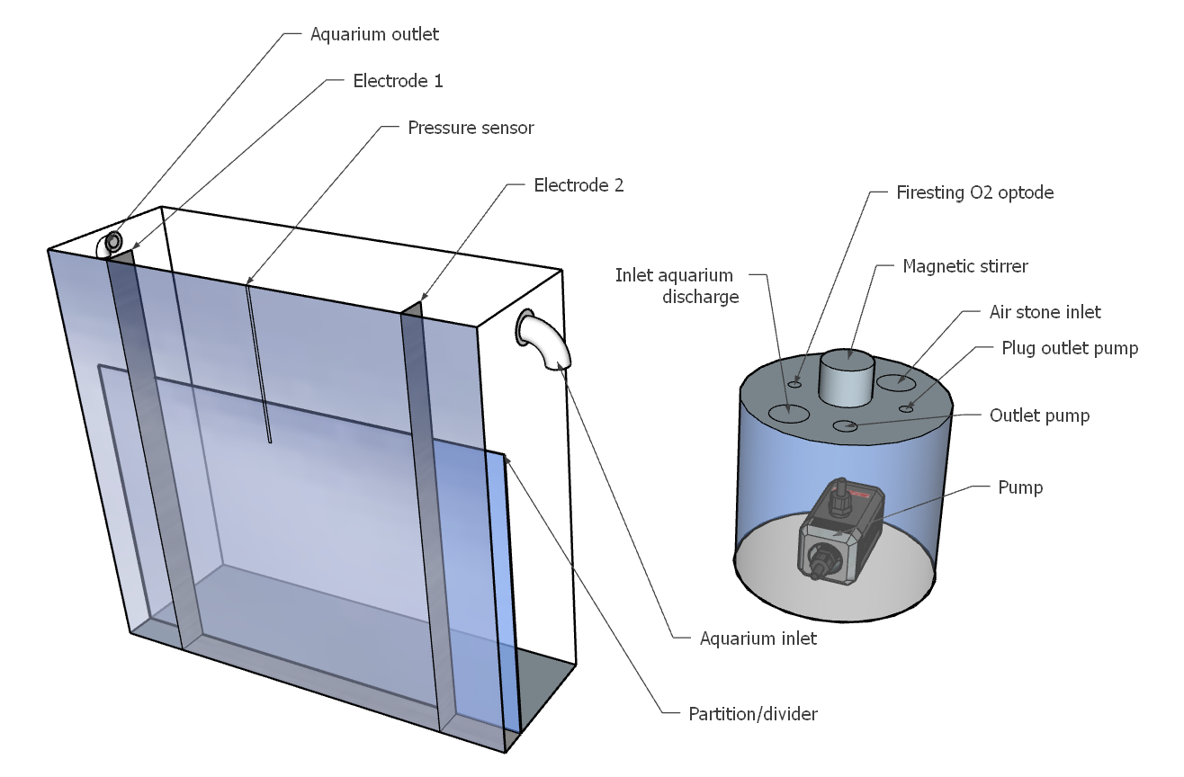

#### **Figure 8.** Schematic drawing of the experimental setup. Aquarium (left) and supporting incubation core (right). Specific parts of the setup are indicated with arrows.

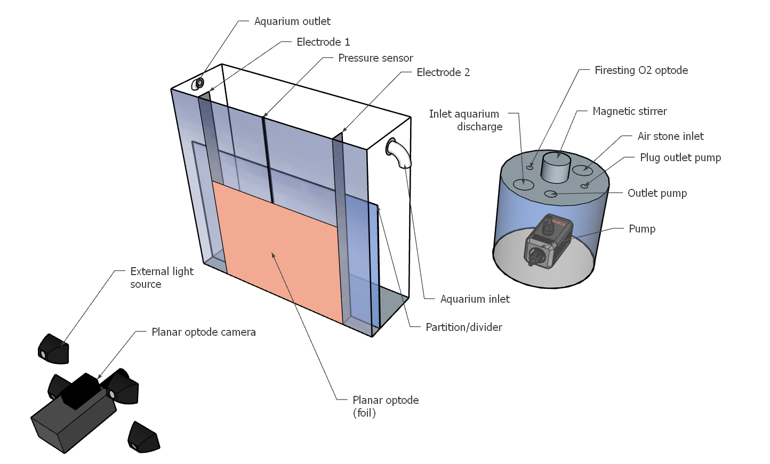

#### **Figure 9.** Schematic drawing of the planar optode setup. Planar optode camera and external light sources (left), aquarium (middle), and supporting incubation core (right). Specific parts of the setup are indicated with arrows.

Figure 11 shows a schematic overview of the measurements taken during the time span of one week. The flow-diagram indicates the days on which measurements of porewater pressure, water quality, planar optode imaging, oxygen consumption rates (OCR) as well as the three consecutive days of the exposure to an electrical pulse stimulus (*see* details in appendix I). Measurements of OCR were taken prior to the exposures to electrical pulse stimuli as well as after the exposures (*see* details in appendix II). OCR rates after consecutive exposures were compared to the control group.

#### **Figure 10.** Overview of the complete research setup with close-ups of the aquarium and the incubation core. (A) Shown is the research setup for three aquaria and their supporting incubation cores connected to the pressure sensors on the red tray, pressure sensor software (laptop) and FirestingO2 software (desktop). On the left, the planar optode setup is shown with the camera and the external light sources. (B) Front view of an aquarium with the stainless-steel plate electrodes, pressure sensor, and pile of sediment castings from the lugworm. (C) Top-view of the incubation core holding inlet to the core (= outlet aquarium), outlet from the core (= inlet aquarium), magnetic stirrer (middle), air stone (air), Firesting optode (O2), electrical plug wiring for the pump (pump), and two rubber stoppers (blue).

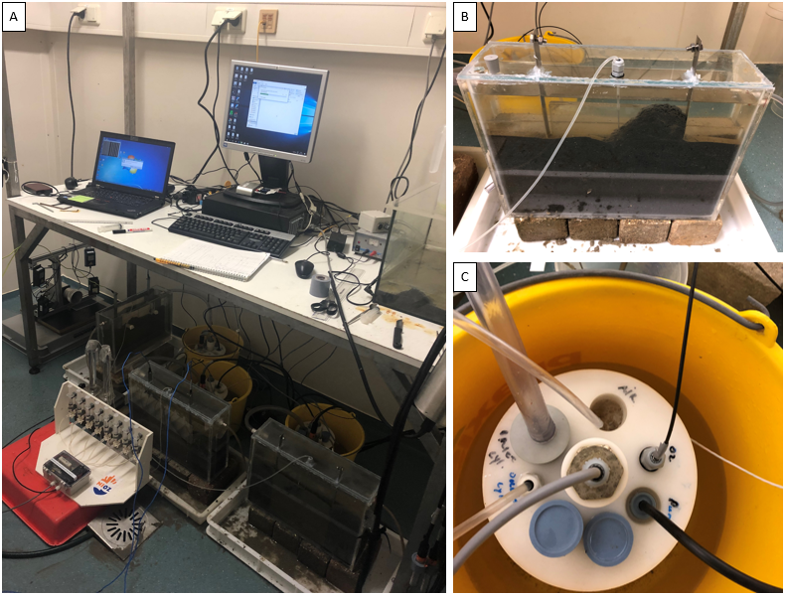

#### **Figure 11.** Schematic overview of the measurement protocol for one week per aquarium. The arrows indicate recordings and samples that either occur frequently or are taken continuously throughout the week. Additionally, measurements of oxygen consumption rates (OCR) as well as exposures to an electrical pulse stimulus are categorised to the corresponding days.

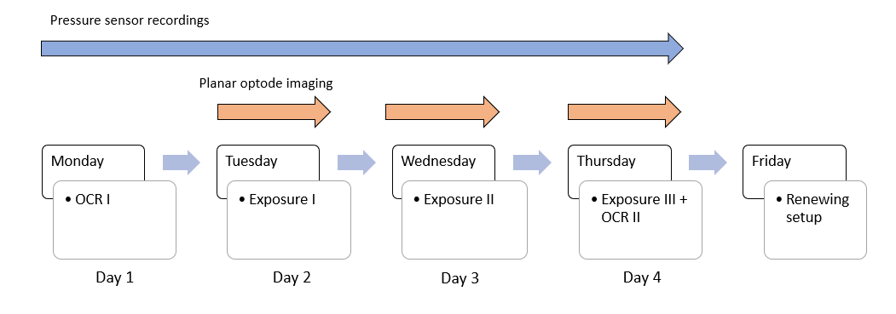

## 2.2 Electrical pulse stimulus parameters

ICES (2018) have investigated the probability of trawler vessels subjecting parts of the seafloor to repetitive exposure on ICES fishing grounds using VMS fishing positions and tracker recordings. For this study, the main fishing grounds where most fishing effort occurs were analysed at the scale of 24 x 24 m. The results of this study found that the likelihood of a trawling event occurring twice, within one week, ranges from 0.007 - 0.17% for conventional beam trawlers and 0.006 – 0.008% for pulse trawlers. For this experiment, every animal received one electrical pulse exposure per day, for three consecutive days. Therefore, we do acknowledge this results in a more frequent exposure than would be likely *in* situ. For the purpose of this study, it was necessary to use electrical pulse stimulus parameters that were representable to the field strengths generated by pulse trawlers in a fishing scenario. *In* situ, the electrical fields generated by pulse trawlers degrade over distance. However, in a worst-case pulse trawling scenario, directly next to the towed electrodes, the generated electrical fields are at its highest (de Haan *et al.*, 2016). Therefore, to simulate a worst-case pulse trawling scenario, the same electrical pulse parameters used in pulse trawl fisheries targeting common sole (*Solea solea*) with HFK-Engineering gear were simulated using a laboratory pulse generator (EPLG, LPG-V2, bvba, Belgium) with a maximum output of 230 V, maximum frequency of 50 Hz, and a 1 KW peak (Figure 12). A pulsed, bipolar current pulse type, with square waveforms, was used at a frequency of 30 Hz (based on the machine settings, this is specified as 60 Hz in the pulse software) with a pulse width of 330 µs, an electrical field strength of 200 V m-1, and an exposure time of 3 seconds (pers. comm. P.G. Boute and H.K. Woolthuis) (Figure 13).

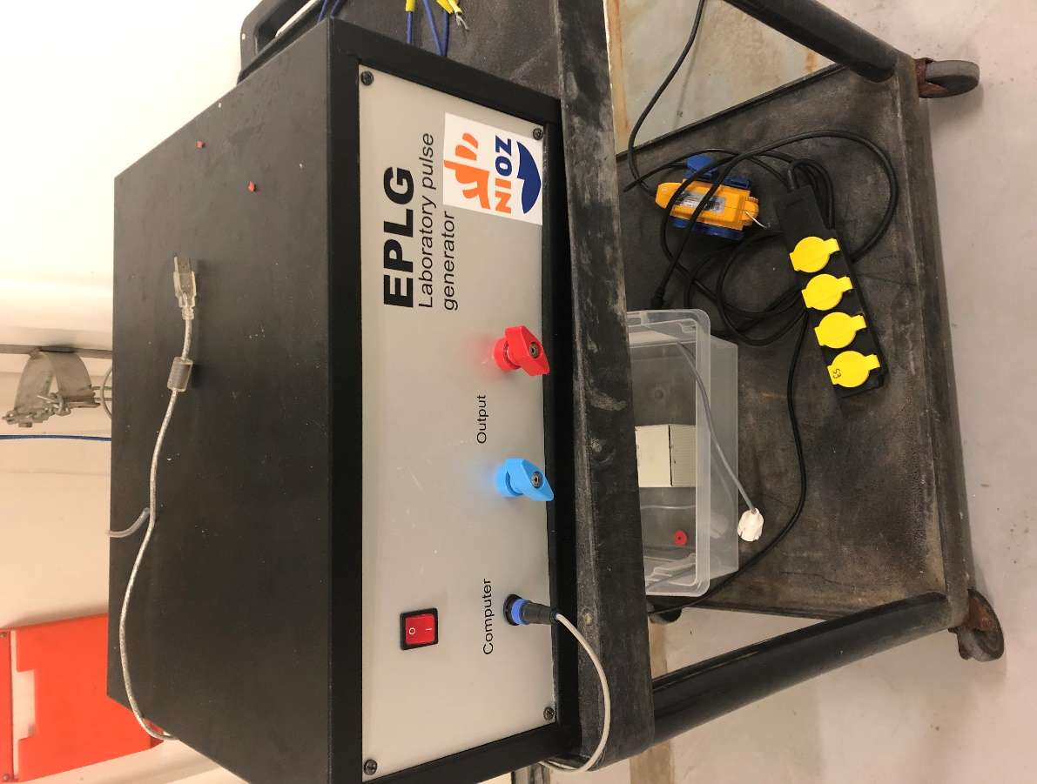

#### **Figure 12.** Front-view EPLG Laboratory pulse generator showing the power switch, USB connection, and both negative and positive outputs to fit electrical wiring.

#### **Figure 13.** Screenshot of the laboratory pulse generator software. Generating a bipolar pulse current of 200 V m-1, 30 Hz (specified as 60 Hz) and 330 µs.

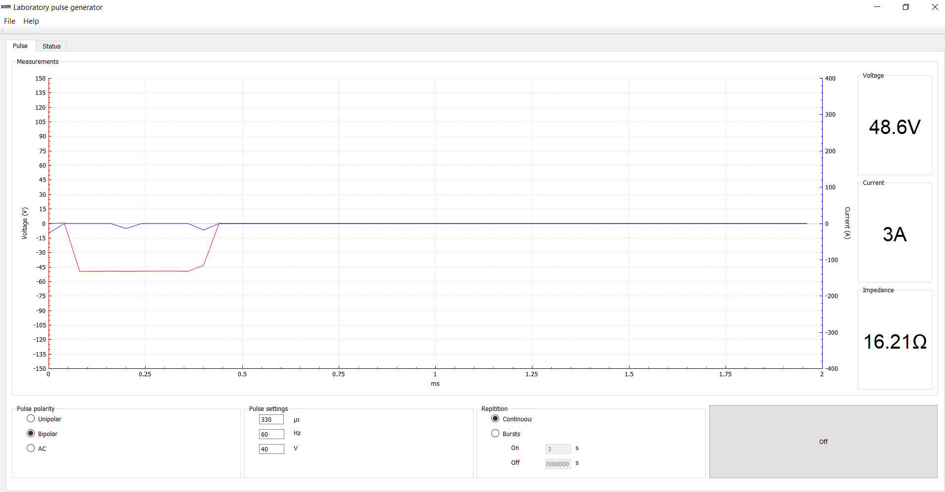

## 2.3 Porewater pressure recording

Activities by burrowing infauna that move sediments generate pressure signals in the porewater as well as vibrational signals associated with grain movement, which can be detected by porewater pressure sensors (Wethey & Woodin, 2005). These pressure sensors (All Sensors, DLVR-L10D-E1NS-C-N3F), detect fluctuations along the hydrostatic baseline through tiny electrodes on a membrane and can generally be divided into two groups; each holding two sensors; more sensitive, measuring up to 50 mm H2O pressure (sensors 1 and 2), and less sensitive (sensors 3 and 4), measuring up to 300 mm H2O pressure. These are connected to a stainless-steel capillary with silicone tubing. Each type of behavioural activity is characterised by its own recognisable pattern (Wethey *et al.*, 2008; Woodin & Wethey, 2009; Vega Garre, 2018). Pressure sensors were placed in the middle of the sediment zone at a depth of 10 cm, and located 10 cm away from both electrodes (Figure 10b).

## 2.4 Planar optode imaging

Effects of bioirrigation and movement activity patterns on the O2 dynamics in the sediment were characterised by using the planar optode technique (Figure 10a), which was introduced to the field of biogeochemistry by Glud *et al.*, (1996) for the measurement of two-dimensional (2D) fine scale oxygen dynamics in benthic communities. The use of the planar optode is a promising technique for the 2D imaging of oxygen dynamics in a laboratory setting using flow-through systems (Polerecky *et al.*, 2005). The distribution of oxygen is visualised by casting an O2-quenchable fluorophore into thin sheets (= planar optodes) (Figure 14)and covering them with polyester support foil (Glud *et al.*, 1996). Resting on the principle that the presence of O2 decreases the intensity of the luminescent light in a predictable way, which can be captured by the camera (Figure 15). One of the aquaria was equipped with this semi-transparent O2 sensitive foil (30 x 20 cm) on the inside of the front acrylic panel, up against the sediment. The O2 images were recorded with flashes in 15-s intervals over a period of at least 4h in the dark.

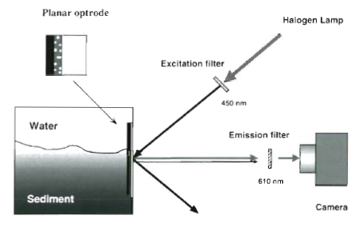

#### **Figure 14.** Illustration of an experimental setup using the planar optode imaging technique as well as an enlargement of the 3-layered planar optode (support foil, sensing layer, silicone foil) shown in the upper left corner. From Glud *et al.*, (1996).

#### **Figure 15.** Planar optode images of oxygen dynamics in % air saturation of high permeable, permeable and low permeable sediments with different hydraulic conductivities (K), and the overlying water. From Volkenborn *et al.*, (2010).

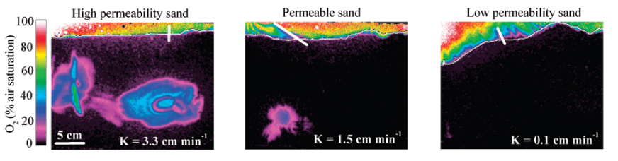

## 2.5 Data analyses

Lugworm behaviour (pumping, burrowing, and defecation) was derived from the pressure sensor data. From this data, we were able to identify changes in movement activity patterns prior to- and after exposure to an electrical stimulus. After identifying specific behavioural bouts, times per movement activity pattern were quantified in percentages from the total time per day. Additionally, the recovery time of a specimen was defined as the time it took for the individual to show the same type of movement activity pattern as prior to exposure. The planar optode technique provided the images of the changes in the oxygen saturation of the sediment, which are directly linked to changes in bio-irrigating and bioturbating behaviour of the lugworm. Images were compared to see changes in the saturation levels of oxygen after exposure to an electrical pulse stimulus. Furthermore, interchanging graphics formats (GIFs) were created in R (R Core Team, 2014) to provide us with a high-quality visualisation of the fine scale oxygen dynamics over a period of 4 hours.

## 2.6 Statistics

Shapiro-Wilk tests were conducted to determine if the data were normally distributed and/or displayed homogeneity of variances. If assumptions for parametric testing were violated, testing of the data were continued using nonparametric tests. Otherwise, two-sample t-test would account for parametric testing of the data. Differences in behaviour (pumping, burrowing, and defecation), day and group were tested for by applying Mann-Whitney U tests (also called, Wilcoxon rank-sum test, or Wilcoxon-Mann-Whitney test). The Mann-Whitney U test was used to investigate significant differences in behavioural activities among the pulsed and control group (non-parametric equivalent of independent samples t-test). If significant differences were detected by the Mann-Whitney U tests (*p* < 0.05), Bartlett tests were computed to test the homogeneity of variances between the two independent groups.

Additionally, if the outcomes of the Bartlett test for equal variances were unviolated, analyses continued with Kruskal Wallis one-way analysis of variance to compare the means of the samples. Ultimately, nonparametric post hoc Dunn tests were conducted to confirm where the differences occurred between the two sample groups (*see* details inappendix III). All statistical analyses were performed using R (R Core Team, 2014).

# 3. Results

## 3.1 Behavioural characteristics

Three common behaviours by lugworm (*Arenicola marina*)had distinctive waveforms and were observed in the pressure sensor recordings. The common behaviours were characterised as, pumping, burrowing, and defecation, with burrowing and defecation generating the largest fluctuations in water amplitude. During burrowing, specimens of *A. marina* were observed to ingest sediment by protruding their proboscis (or mouth parts) and expanding their bodies’ soft tissue, while using larger peristaltic movements to further transport the ingested sediments. Due to this ingestion of sediments, specimen of *A. marina* physically stirred up the sediment and created a funnel shape near the head shaft of its burrow. Defecation behaviour corroborated to the lugworm backing its anterior end up its tail shaft to the sediment-water interface. After which, the lugworm would stick out its posterior end into the overlying water and eject its sediment castings rapidly. Furthermore, cramping responses have been observed in some of the exposed individuals, during which any type of movement activity ceased for the whole duration of the electrical pulse stimulus. Also, in the pressure sensor recordings, this cramping response was often times immediately followed by pressure oscillations similar to burrowing activity (Figure 16). Periods of inactivity in terms of bioturbation did not appear to follow a pattern, but have been observed among both sample groups. During this period of ‘bioturbating inactivity’, pressure sensor recordings did register fluctuations characteristic to pumping. Furthermore, all animals survived experimental trials.

In terms of pumping activity, a wider array of variation was observed. Through the lugworm’s contraction waves over its dorsal ends, or piston like movements, pumping activity was typical recognised as smaller, positive fluctuations (50 µbar) along the hydrostatic baseline (Figure 16). However, recurrence of the behaviour often varied from lower, to higher frequencies (*see* Volkenborn *et al.*, 2010). Burrowing events consisted of two components, medium sized positive and negative oscillations (250 µbar). In actively irrigating individuals, burrowing events generally occurred in sequences with intervals varying from 12 – 60 min and was typically associated with more frequent defecation events. Defecation amounted for the least observed behaviour type and its events were more easily distinguishable from the rest of the behaviour activities (Figure 16). As defecation bouts were characterised by large, but short spikes of negative pressures, typically with amplitudes of -800 µbar, generally short of duration < 12s, and followed by a brief period of high frequency pressure pulses. These high frequency pressure pulses are defined as periods of under pressurisation, in which the lugworm backs its posterior end back into its burrow after creating a sediment casting on top of the sediment surface.

Table 1 shows the average values of the common behaviours in percentages of the total time over the course of three consecutive days (day 2, 3 and 4) for the six control (n = 18) and seven pulsed (n = 21) specimens. Pumping behaviour was found to be significantly higher in the control group when compared to the pulsed samples (Mann-Whitney U, *p* < 0.0001). While the pulsed group showed a significant increase in other activity typed such as burrowing and defecation (Mann-Whitney U, *p* < 0.0001).

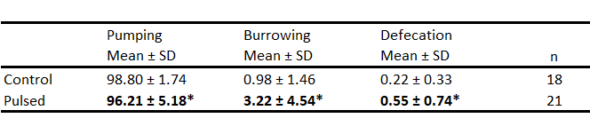

#### **Table 1.** Percentages of behaviour time per movement activity.

Bold = significantly different from control samples. *p < 0.0001

Bold = significantly different from control samples. *p < 0.0001

#### **Figure 16.** Exemplary pressure sensor plot showing a response to the electrical pulse stimulus. Indicated is an enlargement set at 0.1h prior to- and 1h after exposure to the electrical pulse stimulus. The vertical blue dashed line at 60h, indicates the exact time of exposure to a 3 second electrical pulse stimulus. Examples of movement activity types are indicated with arrows.

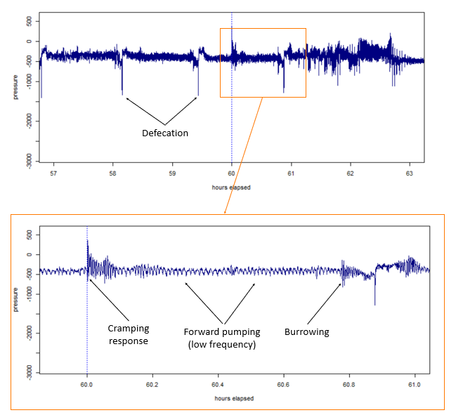

Data from all types of movement activity patterns (pumping, burrowing, and defecation) were skewed and found to not be normally distributed (Shapiro-Wilk, *p* < 0.05). The differences between the mean percentages of pumping behaviour are set between the control and the exposed groups (Figure 17). Since pumping behaviour accounted as the most common and observed movement activity pattern, upper quartile ranges trended similarly for both of the sample groups. Therefore, following a high-end distribution in the 95 to 100 percentile range. Differences in pumping behaviour by the control group were found to be very significant (Mann-Whitney U, *p* < 0.0001). As average pumping activity of the control samples had an average percentage of 98.80 ± 1.74, while exposed samples decreased to 96.21 ± 5.18. Additionally, the difference in burrowing behaviour was also found to be very significant in the pulsed samples (Mann Whitney U, *p* < 0.0001), increasing from 0.98 ± 1.46 to 3.22 ± 4.54 (Figure 18). The same trend was observed for defecation behaviour, in which the mean values accounted for 0.22 ± 0.33 in the control and 0.55 ± 0.74 in the exposed group (Figure 19). Bartlett’s test for homogeneity of variances were computed for all behaviour types and yielded unequal variances (*p* < 0.05). Further analyses continued with Kruskal-Wallis multiple comparison tests (appendix III), which confirmed there were no significant differences found between the consecutive days for both treatment types (Dunn, *p* > 0.05).

#### **Figure 17.** Pumping behaviour quantified from control (n = 6) and pulsed animals (n = 7) in percentage of total time per day. Means between the sample groups were significantly different, Mann-Whitney U (*p* < 0.05).

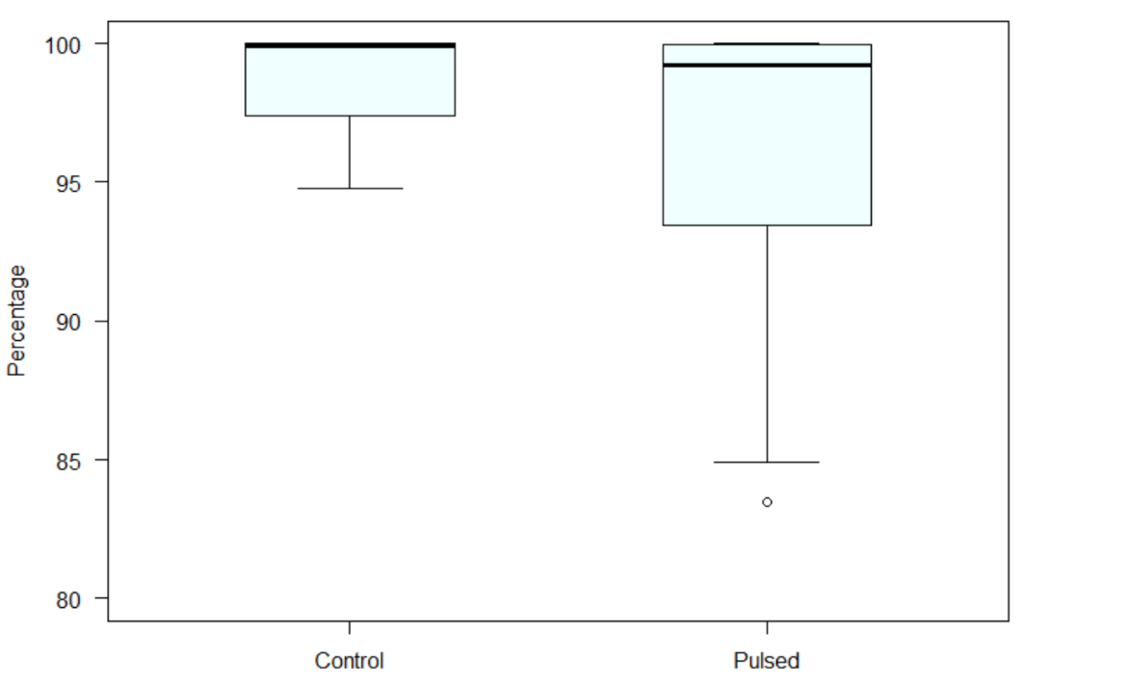

#### **Figure 19.**Defecation behaviour quantified from control (n = 6) and pulsed animals (n = 7) in percentage of total time per day. Means between the sample groups were significantly different, Mann-Whitney U (*p* < 0.05).

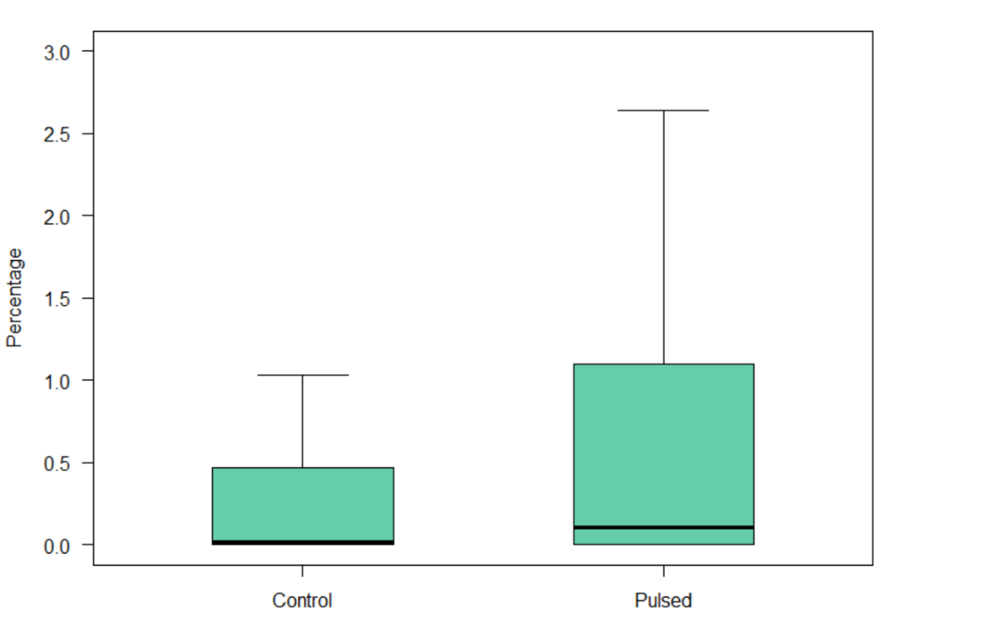

#### **Figure 18.**Burrowing behaviour quantified from control (n = 6) and pulsed animals (n = 7) in percentage of total time per day. Means between the sample groups were significantly different, Mann-Whitney U (*p* < 0.05).

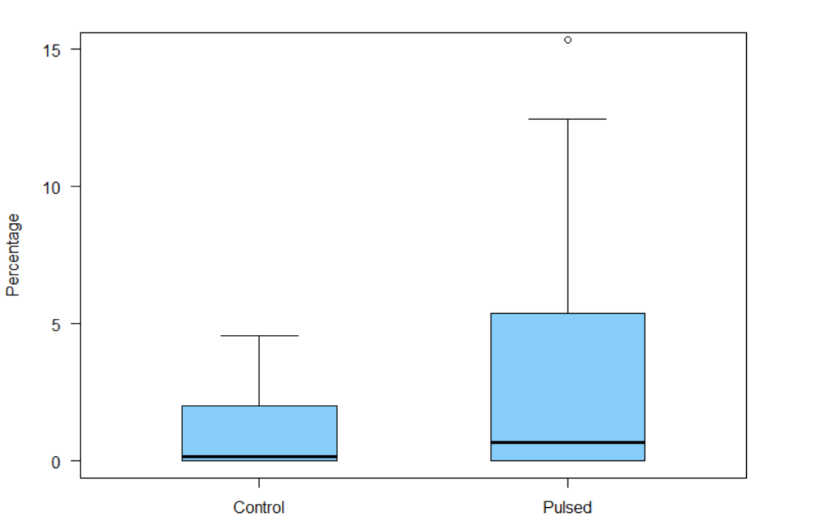

## 3.2 Recovery time

Recovery times of the exposure group (n = 7) were quantified in minutes, and averaged over each day of exposure. The means of the sample group were found to be 0.71 min. (day 2), 0.75 min. (day 3), and 32.14 min. (day 4) respectively. It is important to note that a recovery time of 28 min. was observed on day 4 (*see* details appendix III). This is considered an outlier as its closest relative was found to be 5 min. (day 2). Excluding the outlier from the calculation, the mean recovery time for the exposed group on day 4 would be 0.83 min. Still displaying an increasing trend for the expenditure of recovery times after repetitive exposures.

## 3.3 Oxygen consumption rates

Oxygen consumption rates were found to be higher in the control group (116.7 ± 18.78), compared with the exposed specimens of *A. marina* (91.91 ± 18.20) (Figure 20). A Shapiro-Wilk test for normality suggested the data to be normally distributed (*p* > 0.05). Therefore, continuing further statistical analysis with a t-test. Even though oxygen consumption rates were found to differ between the control and exposed group, this difference in mean percentages was not significant (t-test, *p* > 0.05).

#### **Figure 20.** Oxygen consumption rates from the control (n = 5) and pulsed animals (n = 7) in mmol/m2/day. Means between the two sample groups were not significantly different (t-test, *p* > 0.05).

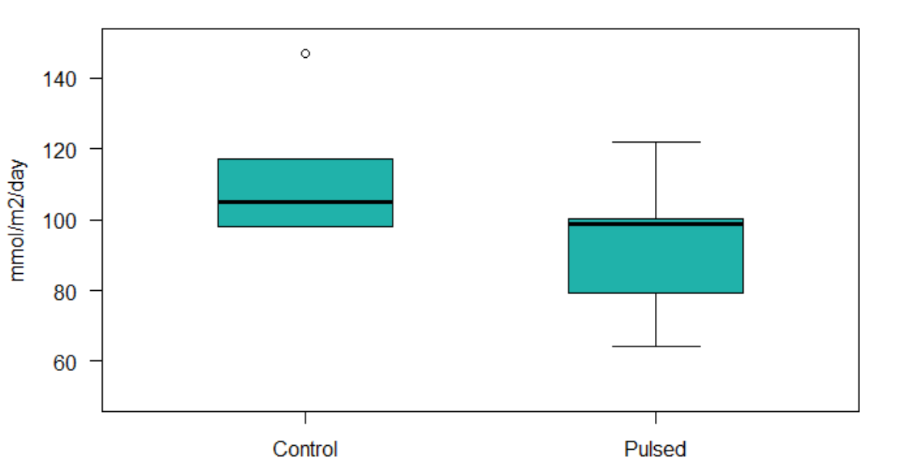

## 3.4 Oxygen dynamics

A selection of the images was taken to analyse the amount of oxygen saturation inside the sediment prior- to and after exposure to an electrical pulse stimulus (Figure 21). The burrow lumen of the lugworm is clearly visible on both images, with the tail shaft stretching all the way up to the sediment water interface (Figure 21). On the right side of both images, the distinct subsidence of sediment can be seen at the head-shaft of its burrow lumen. Furthermore, at the sediment-water interface, oxygen saturation is seen to display a stratified pattern. Indicating the boundary between the sediment matrix and the water column. A clear display of oxygenation inside the gallery of the burrow lumen can be observed prior to exposure. Since, the planar optode image depicts oxygen saturation values of 39 – 52% (Figure 21, before exposure). However, after exposure to an electrical pulse stimulus, oxygen saturation values decreased to 13 – 26% (Figure 21, after exposure).

Other images were stacked and formatted into graphics interchanging formats (GIFs). With these GIFs, we were able to visualise the sedimentary oxygen dynamics on a time-scale of 4 hours in which suboxic plumes have been detected. Suboxic plumes typically depict a small puff of anoxic seawater that shoots out of the sediment matrix into the water column. Disintegrating as the plume further travels into the overlying water.

#### **Figure 21.** Exemplary planar optode image of oxygen distribution before and after exposure to an electrical pulse stimulus. Shown are (1.) stratification at the sediment-water interface, (2.) oxidized tail shaft, and (3.) oxidized burrow gallery. Small artefacts (top-left, middle left, and bottom-left) that display an oversaturation of oxygen are notably visible on both images. These are explained by stickers that remained on the optode foils (top-left and bottom-left), as well as the external light’s reflection from the front acrylic panel (mid-left). The O2 saturation is expressed on a linear colour scale in % air saturation and is shown on the right. The image represents an area of 19 x 20 cm. Flow direction was from right to left.

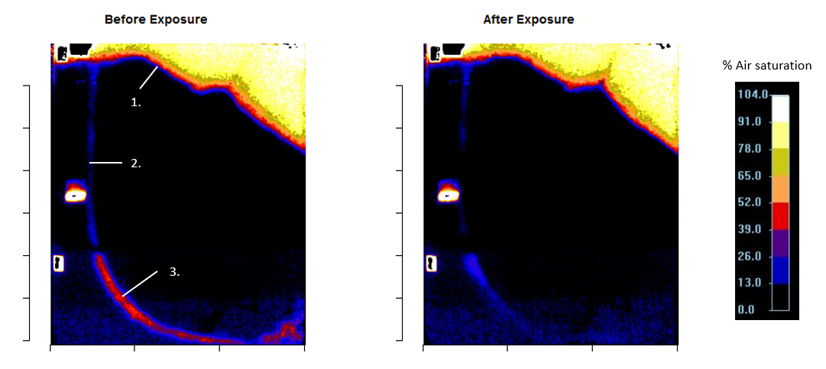

# 4. Discussion & conclusion

Our data suggests that exposure to electrical pulse stimuli, affects the ecosystem functioning of lugworm (*Arenicola marina*)by altering its movement activity patterns and thus, its ability to induce bioadvective forces inside the sediment. During this study, rates of activity differed per individual specimen of *A. marina*. However, after quantifying behaviour bouts in percentages of the total time and running statistical analyses, our results portrayed a significant increase in burrowing and defecation behaviour for the exposed animals. In the case of burrowing behaviour, this may very well suggest that contact with the electrical pulse stimulus induced an escaping response in the sample group. Contradicting our earlier hypothesis that exposure would cause the lugworms to be less active. Nonetheless, in terms of porewater pressure recordings, our own analyses and visualisations of the specific behavioural bouts and movement activity patterns through pressure sensor recordings corroborate with earlier behavioural studies conducted on *A. marina* (Woodin & Wethey, 2005; Wethey *et al.*, 2008; Woodin & Wethey, 2009; Volkenborn *et al.*, 2010).

Cramping responses were observed in some of the individual specimens from the exposed group and were used to determine the recovery times of the test animals. Recovery times of the lugworm were defined as the length of the period it took for the specimen to show the same type of behaviour as prior to exposure to the electrical pulse stimulus. The recovery times typically varied around 0 to 5 min. However, no clear explanation could be given in terms of the 28 min. outlier in the dataset. Nonetheless, even by excluding the outlier, recovery times still increased with each consecutive day of exposure. However, it is unlikely that consecutive trawling exposure would occur *in situ* (ICES, 2018). Withal, any further implications of the data may be subjective, as the definition of recovery times by lugworms is not clearly described in literature.

In an earlier study by Volkenborn *et al.* (2010), simultaneous oxygen and pressure measurements revealed that pressure oscillations associated with macrofaunal activity induced characteristic oxygen oxygenation within the sediment and the overlying water. The same relationship was found in our own results, as increasing oxygen saturation values have been observed inside the gallery. These oxygenation events can be explained by pumping activities of the lugworm, drawing oxygenated seawater inside its burrow lumen. The latter could also clarify as to why oxygen consumption rates were found to be higher in the control samples. As pumping activity inside the burrow lumen may have played a vital role in the growth and circulation of microbes.

The goal of this study was to use real time pressure recordings and high temporal two-dimensional scale oxygen imaging to investigate the possible effects of electrical pulse stimuli on macrofaunal activity patterns and benthic ecosystem functioning in regards to oxygen dynamics and bioadvection by using *A. marina* as a model species. Bioadvection by benthic infauna is in a sense similar to the intensive surface percolation induced by physical or hydrodynamic forces. However, there are important differences to be distinguished between the two. Physical forces are typically restricted to the upper 5 cm, while porewater fluxes induced by biological activity are much greater, driving oxygenation in the upper few centimetres as well as 10 – 20 cm below the surface (Wethey *et al.*, 2008). As porewater bioadvection is directly linked to macrofaunal activity, another critical difference is that the majority of its influence is therefore dependent on local characteristics, such as the presence of the animal, community densities, and its state of activity.

Even though our data gave an insight into the effects of electrical pulse stimuli on the alterations of movement activity patterns, the number of replicates for the planar optode measurements was limited. Therefore, further research is necessary to truly assess the changes in oxygen dynamics induced by electrical pulse stimuli.

## 4.1 Implications

While *A. marina* was firstly used to act as a model species for other benthic infauna that inhabit pulse fishing grounds, VMS data concurrently suggested that smaller pulse fishing vessels fish closer to shore, and may thus affect *A. marina* in a more direct manner with the towed electrodes (pers. comm. Justin Tiano). This can further be substantiated by looking at various studies that have identified the diets of commercial flatfish (e.g. *Pleuronectes platessa* and *Solea solea*) in the North Sea (Braber & De Groot, 1973; Rijnsdorp & Vingerhoed, 2001). These studies have shown that the diets of commercial flatfish primarily consist of bivalves and polychaete worms, with the ratio between food types varying on a seasonal scale.

With commercial flatfish feeding on polychaete worms, the significant increases in burrowing and defecation behaviour by exposure to electrical pulse stimuli may have an influence on food chain dynamics. Wethey and Woodin (2005) suggest that vibrational signals associated with behaviour, can be sensed by both predator and prey. This has been proven in an infrasound sensitivity study by Karlsen (1992), who found that European plaice (*P. platessa*) detect vibrational signals in the water column using a combination of sensory organs such as the lateral neuromasts and otoliths connected to the inner ear of the fish. The same may be said for common sole (*S. solea*), as this species of flatfish holds a similar physiology towards European plaice regarding sensory organs (lateral line neuromasts and otoliths) (Hagerman, 1952). However, to our knowledge, infrasound sensitivity studies on common sole have yet to be conducted.

Even though it is not certain that vibrational signals that are produced inside the sediment matrix propagate into the overlying water, behavioural activities by the lugworm such as defecation, may suggest otherwise. During defecation, the worm advances its anterior end up through the tail shaft into the overlying water (Riisgård & Banta, 1998), ejecting its sediment castings into the water column. Thereby, directly giving off vibrational signals for fish to detect. Therefore, our data suggest that the significant increase in burrowing and defecation behaviour by *A. marina*, induced by the electrical pulse stimulus, may ultimately increase the species risk of predation.

# References

Bat, L., & Raffaelli, D. (1998). Sediment toxicity testing: a bioassay approach using the amphipod Corophium volutator and the polychaete *Arenicola marina*. *Journal of Experimental Marine Biology and Ecology*, *226*(2), 217–239. <https://doi.org/https://doi.org/10.1016/S0022-0981(97)00249-9>

Baumfalk, Y. A. (1979). On the pumping activity of Arenicola marina. *Netherlands Journal of Sea Research*, *13*(3), 422–427. <https://doi.org/https://doi.org/10.1016/0077-7579(79)90015-2>

Braber, L., & de Groot, S. J. (1973). The food of five flatfish species (Pleuronectiformes) in the southern North Sea. *Netherlands Journal of Sea Research*, *6*(1–2), 163–172. Retrieved from <https://doi.org/10.1016/0077-7579(73)90011-2>

de Haan, D., Fosseidengen, J. E., Fjelldal, P. G., Burggraaf, D., & Rijnsdorp, A. D. (2016). Pulse trawl fishing: characteristics of the electrical stimulation and the effect on behaviour and injuries of Atlantic cod (Gadus morhua). *ICES Journal of Marine Science*, *73*(6), 1557–1569. Retrieved from <http://dx.doi.org/10.1093/icesjms/fsw018>

Depestele, J., Ivanović, A., Degrendele, K., Esmaeili, M., Polet, H., Roche, M., Summerbell, K., Teal, L. R., Vanelslander, B., & O’Neill, F. G. (2016). Measuring and assessing the physical impact of beam trawling. *ICES Journal of Marine Science*, *73*(suppl_1), i15–i26. Retrieved from <http://dx.doi.org/10.1093/icesjms/fsv056>

EU, 2007. Council Regulation (EC) No 41/2007 of 21 December 2006 fixing for 2007 the fishing opportunities and associated conditions for certain fish stocks and groups of fish stocks, applicable in Community waters and, for Community vessels, in waters where catch limitations are required*.* 243 pp.

Glud, R. N. (2008). Oxygen dynamics of marine sediments. *Marine Biology Research*, *4*(4), 243–289. <https://doi.org/10.1080/17451000801888726>

Glud, R., Ramsing, N., Gundersen, J. K., & Klimant, I. (1996). Planar optrodes: A new tool for fine scale measurements of two-dimensional O-2 distribution in benthic communities. *Marine Ecology Progress Series*, *140*(1–3), 217–226. <https://doi.org/10.3354/meps140217>

Haasnoot, T., Kraan, M., & Bush, S. R. (2016). Fishing gear transitions: lessons from the Dutch flatfish pulse trawl. *ICES Journal of Marine Science*, *73*(4), 1235–1243. Retrieved from <http://dx.doi.org/10.1093/icesjms/fsw002>

Hagerman, F. B. (1952). The biology of dover sole *Microstomus pacificus* (Lonkington). Calif. Dept. Fish Game Fish. Bull. 85: 1-48

Heip, C., & Craeymeersch, J. A. (1995). Benthic community structures in the North Sea. *Helgoländer Meeresuntersuchungen*, *49*(1), 313–328. <https://doi.org/10.1007/BF02368359>

Huettel, M. (1990). Influence of the lugworm Arenicola marina on porewater nutrient profiles of sand flat sediments. *Marine Ecology-Progress Series*, *62*(3), 241–248. <https://doi.org/10.3354/meps062241>

Huettel, M., Berg, P., & Kostka, J. E. (2014). Benthic Exchange and Biogeochemical Cycling in Permeable Sediments. *Annual Review of Marine Science*, *6*(1), 23–51. <https://doi.org/10.1146/annurev-marine-051413-012706>

Huettel, M., & Gust, G. (1992). Impact of bioroughness on interfacial solute exchange in permeable sediments. *Marine Ecology Progress Series*, *89*(2–3), 253–267. <https://doi.org/10.3354/meps089253>

Huettel, M., Ziebis, W., & Forster, S. (1996). Flow-induced uptake of particulate matter in permeable sediments. *Limnology and Oceanography*, *41*(2), 309–322. <https://doi.org/10.4319/lo.1996.41.2.0309>

Huettel, M., Ziebis, W., Forster, S., & Luther, G. W. (1998). Advective Transport Affecting Metal and Nutrient Distributions and Interfacial Fluxes in Permeable Sediments. *Geochimica et Cosmochimica Acta*, *62*(4), 613–631. <https://doi.org/https://doi.org/10.1016/S0016-7037(97)00371-2>

ICES. 2018. Report of the Working Group on Electric Trawling (WGELECTRA). *ICES REPORT WGELECTRA 2018 17-19 April 2018.* IJmuiden, the Netherlands*.* 155 pp*.*

Kaiser, M. J., Collie, J. S., Hall, S. J., Jennings, S., & Poiner, I. R. (2002). Modification of marine habitats by trawling activities: prognosis and solutions. *Fish and Fisheries*, *3*(2), 114–136. <https://doi.org/10.1046/j.1467-2979.2002.00079.x>

Kaiser, M. J., Hill, A. S., Ramsay, K., Spencer, B. E., Brand, A. R., Veale, L. O., Prudden, K., Rees, E. I. S., Munday, B. W., Ball, B., & Hawkins, S. J. (1996). Benthic disturbance by fishing gear in the Irish Sea: a comparison of beam trawling and scallop dredging. *Aquatic Conservation: Marine and Freshwater Ecosystems*, *6*(4), 269–285.

Karlsen, H. E. (1992). Infrasound Sensitivity in the Plaice (Pleuronectes Platessa). *Journal of Experimental Biology*, *171*(1), 173–187. Retrieved from <http://jeb.biologists.org/content/171/1/173.abstract>

Koho, K. A., & Piña-Ochoa, E. (2012). Benthic Foraminifera: Inhabitants of Low-Oxygen Environments BT - Anoxia: Evidence for Eukaryote Survival and Paleontological Strategies. In A. V Altenbach, J. M. Bernhard, & J. Seckbach (Eds.) (pp. 249–285). Dordrecht: Springer Netherlands. <https://doi.org/10.1007/978-94-007-1896-8_14>

Kunitzer, A., Basford, D., Craeymeersch, J., M. Dewarumez, J., Dorjes, J., Duineveld, G., Eleftheriou, E., Heip, C., Herman, P., Niermann, U., Rachor, E., & Rumohr, H. (1992). The benthic infauna of the North Sea: species distribution and assemblages. *ICES Journal of Marine Science*, *49*(2), 127–143. <https://doi.org/10.1093/icesjms/49.2.127>

Lindeboom, H. J., and de Groot, S. J. (1998). The effects of different typesof fisheries on the North Sea and Irish Sea benthic ecosystems. RIVO-DLO Report C003/98. 404 pp.

Norling, K., Rosenberg, R., Hulth, S., Grémare, A., & Bonsdorff, E. (2007). Importance of functional biodiversity and species-specific traits of benthic fauna for ecosystem functions in marine sediment. *Marine Ecology Progress Series*, *332*, 11–23. <https://doi.org/10.3354/meps332011>

Olsgard, F., Schaanning, M. T., Widdicombe, S., Kendall, M. A., & Austen, M. C. (2008). Effects of bottom trawling on ecosystem functioning. *Journal of Experimental Marine Biology and Ecology*, *366*(1), 123–133. <https://doi.org/https://doi.org/10.1016/j.jembe.2008.07.036>

Polerecky, L., Franke, U., Werner, U., Grunwald, B., & Beer, D. De. (2005). High spatial resolution measurement of oxygen consumption rates in permeable sediments. *Limnology and Oceanography: Methods*, *3*, 75–85. <https://doi.org/10.4319/lom.2005.3.75>

Poos, J. J., Turenhout, M. N. J., A. E. van Oostenbrugge, H., & Rijnsdorp, A. D. (2013). Adaptive response of beam trawl fishers to rising fuel cost. *ICES Journal of Marine Science*, *70*(3), 675–684. Retrieved from <http://dx.doi.org/10.1093/icesjms/fss196>

Precht, E., Franke, U., Polerecky, L., & Huettel, M. (2004). Oxygen dynamics in permeable sediments with wave-driven pore water exchange. *Limnology and Oceanography*, *49*(3), 693–705. <https://doi.org/10.4319/lo.2004.49.3.0693>

R Core Team 2014. R: *A language and environment for statistical computing.* Vienna, Austria: R Foundation for Statistical Computing

Reish, D. J., & Carr, R. S. (1978). The effect of heavy metals on the survival, reproduction, development, and life cycles for two species of polychaetous annelids. *Marine Pollution Bulletin*, *9*(1), 24–27. <https://doi.org/https://doi.org/10.1016/0025-326X(78)90280-1>

Riisgård, H. U., & Banta, G. (1998). Irrigation and deposit feeding by the lugworm *Arenicola marina*, characteristics and secondary effects on the environment. A review of current knowledge. *Vie et Milieu*, *48*, 243–257.

Rijken, M. (1979). Food and food uptake in Arenicola marina. *Netherlands Journal of Sea Research*, *13*(3–4), 406–421. <https://doi.org/10.1016/0077-7579(79)90014-0>

Rijnsdorp, A. D., & Vingerhoed, B. (2001). Feeding of plaice Pleuronectes platessa L. and sole Solea solea (L.) in relation to the effects of bottom trawling. *Journal of Sea Research*, *45*(3), 219–229. <https://doi.org/10.1016/S1385-1101(01)00047-8>

Rijnsdorp, A., Haan, D. de, Smith, S., & Strietman, W. J. (2016). *Pulse fishing and its effects on the marine ecosystem fisheries: an update of the scientific knowledge* (Wageningen Marine Research report: C117/16). 30 pages. IJmuiden: Wageningen Marine Research. Retrieved from <http://edepot.wur.nl/405708>

Rijnsdorp, A., Jaap Poos, J., J. Quirijns, F., Hillerislambers, R., W. De Wilde, J., & M. Den Heijer, W. (2008). The arms race between fishers. *Journal of Sea Research*, *60*(1), 126–138. <https://doi.org/10.1016/j.seares.2008.03.003>

Smaal, A. C., & Brummelhuis, E. (2005). *Onderzoek naar mogelijke effecten van de pulskor op bodemdieren*.

Soetaert, M, Haan, D. De, Verschueren, B., Decostere, A., Puvanendran, V., Saunders, J., Polet, H. & Chiers, K. (2016). Atlantic Cod Show a Highly Variable Sensitivity to Electric-Induced Spinal Injuries. *Marine and Coastal Fisheries: Dynamics, Management, and Ecosystem Science*, *8*(8), 412–424. Retrieved from <https://doi.org/10.1080/19425120.2016.1180332>

Soetaert, M., Chiers, K., Duchateau, L., Polet, H., Verschueren, B., & Decostere, A. (2014). Determining the safety range of electrical pulses for two benthic invertebrates: Brown shrimp (*Crangon crangon* L.) and ragworm (*Alitta virens* S.). *ICES Journal of Marine Science*, *72*(3), 973–980. <https://doi.org/10.1093/icesjms/fsu176>

Soetaert, M., Decostere, A., Polet, H., Verschueren, B., & Chiers, K. (2015). Electrotrawling: a promising alternative fishing technique warranting further exploration. *Fish and Fisheries*, *16*(1), 104–124. <https://doi.org/10.1111/faf.12047>

Soetaert, M., Verschueren, B., Chiers, K., Duchateau, L., Polet, H., & Decostere, A. (2016). Laboratory Study of the Impact of Repetitive Electrical and Mechanical Stimulation on Brown Shrimp Crangon crangon. *Marine and Coastal Fisheries*, *8* (September), 404–411. <https://doi.org/10.1080/19425120.2016.1180333>

Teal, L. R., Depestele, J., O’Neill, B., Craeymeersch, J. A. M., Denderen, P. D. van, Parker, R., Perdon, K. J., Polet, H., Rasenberg, M. M. M., Vanelslander, B., & Rijnsdorp, A. D. (2014). *Effects of beam and pulse trawling on the benthic ecosystem* (Report / IMARES Wageningen UR : C098/14). 634, 53 pages. IJmuiden: IMARES. Retrieved from <http://edepot.wur.nl/308956>

Thrush, S. F., & Dayton, P. K. (2002). Disturbance to Marine Benthic Habitats by Trawling and Dredging: Implications for Marine Biodiversity. *Annual Review of Ecology and Systematics*, *33*(1), 449–473. <https://doi.org/10.1146/annurev.ecolsys.33.010802.150515>

Timmermann, K., Banta, G. T., & Glud, R. N. (2006). Linking Arenicola marina irrigation behavior to oxygen transport and dynamics in sandy sediments. *Journal of Marine Research TA - TT -*, *64*(6), 915–938. https://doi.org/10.1357/002224006779698378 LK - <https://wur.on.worldcat.org/oclc/6896168445>

van Marlen, B., de Haan, D., van Gool, A., & Burggraaf, D. (2009). *The effect of pulse stimulation on marine biota – Research in relation to ICES advice – Progress report on the effects on benthic invertebrates*.

van Marlen, B., Wiegerinck, J. A. M., van Os-Koomen, E., & van Barneveld, E. (2014). Catch comparison of flatfish pulse trawls and a tickler chain beam trawl. *Fisheries Research*, *151*, 57–69. <https://doi.org/https://doi.org/10.1016/j.fishres.2013.11.007>

Vega Garre, B. (2018). *Impact of Electric pulse fishing on the Benthic ecosystem: is science against the EU Parliament’s decision?* HZ University of Applied Sciences. 36 pages.

Verschueren, B., & Polet, H. (2009). *Research summary on HOVERCRAN: hovering pulse trawl for a selective Crangon fishery*. *Institute for Agricultural and Fisheries Research*. 30 pages.

Volkenborn, N., Meile, C., Polerecky, L., Pilditch, C. A., Norkko, A., Norkko, J., Hewitt, J. E., Thrush, S. F., Wethey, D. S., & Woodin, S. A. (2012). Intermittent bioirrigation and oxygen dynamics in permeable sediments: An experimental and modeling study of three tellinid bivalves. *Journal of Marine Research*, *70*(6), 794–823. <https://doi.org/10.1357/002224012806770955>

Volkenborn, N., Polerecky, L., Wethey, D. S., & Woodin, S. A. (2010). Oscillatory porewater bioadvection in marine sediments induced by hydraulic activities of Arenicola marina. *Limnology and Oceanography*, *55*(3), 1231–1247. <https://doi.org/10.4319/lo.2010.55.3.1231>

Wethey, D. S., & Woodin, S. A. (2005). Infaunal hydraulics generate porewater pressure signals. *The Biological Bulletin*, *209*(2), 139–145. <https://doi.org/10.2307/3593131>

Wethey, D., Woodin, S., Volkenborn, N., & Reise, K. (2008). Porewater advection by hydraulic activities of lugworms, Arenicola marina: A field, laboratory and modeling study. *Journal of Marine Research*, *66*(2), 255–273. <https://doi.org/10.1357/002224008785837121>

# APPENDIX i

**Measurement protocol: lugworm (*Arenicola marina*)**

## Renewing aquaria

1. Switching off equipment and removing wires
   1. !!<MAKE SURE THE PULSE GENERATOR IS OFF>!!
   2. Turn off the measuring software -> Tera term and planar optode imaging.
   3. Copy the data to an external hard drive.
   4. Detach the wiring from the stainless-steel plate electrodes by undoing the screws.
   5. Remove the pressure sensors from the lids and place carefully in the graduated cylinder with the reference stainless-steel capillaries.
   6. Turn off the system (pumps, air supply, magnetic stirrer etc.)
2. Removing the lid
   1. Unscrew the electrode wiring from the plate electrodes.
   2. Carefully cut between the lid and acrylic panels using a potato knife.
   3. Cut the electrodes loose from the lid.
   4. Remove the lid in a vertical direction to slide over the electrodes.
   5. Slide the electrodes out of the setup.
   6. Scrape any excess silicone kit off the aquarium edges and the plate electrodes using your finger nails or a plastic-edged scraping tool.
3. Renewing the systems
   1. Siphon the water out of the system (both the aquarium and the sediment core).
   2. Carefully remove the sediment between the partition and the frontside acrylic panel.
   3. Make sure the animal is found inside of the removed sediment.
   4. Place the specimen inside a Ziplock bag, remove as much air as possible by partly submerging the bag and close it.
   5. Mark the Ziplock bag with a unique code and place it in a freezer for later review.
   6. Clean the inside of the acrylic panels (if necessary).
   7. Create a ‘slush’ by mixing the new sediment with seawater (to prevent air bubbles)
   8. Add the desired number of spacers to the aquarium (dependent on the size of the newly added specimen).
   9. Make sure the spacers are flush against the partition wall
      1. Do this by adding pressing the spacers against the partition wall with a plate electrode and add roughly 5 cm of sediment.
   10. Slide the plate electrodes inside the formed sediment layer.
   11. Carefully add both the slush and extra seawater between the partition and the front acrylic panel.
   12. Turn on the ‘support system’ (pumps, air supply, magnetic stirrer etc.)
   13. Set the measuring equipment according to the described protocols on the next pages.
4. Closing the lid -> DO THIS AFTER ALL MEASUREMENT EQUIPMENT IS SET-UP
   1. After setting up, calibrating, and checking all of the measurement equipment, remove the pressure sensor from the aquarium.
   2. Add the animal to the system.
   3. Make sure the animal is digging inside the sediment.
   4. Using the kit pistol, carefully add silicone kit to the edging of the acrylic panels.
   5. Carefully slide the slits of the lid over the plate electrodes.
   6. Neatly fit the lid on top of the aquaria and press down to fit into the silicone kit.
   7. Add the pressure sensors through the lids as described in ‘porewater pressure recording’.
   8. Place weights on top of the lids and let the silicone kit dry and animal acclimatise for at least 48h before starting any measurements.

## Porewater pressure recording

1. Prepare experimental tanks
   1. Make the water level in the reference cylinder is at the same height of all aquaria (to recreate ca. the same pressure counter pressure on the sensor membranes).
   2. Make sure that there are no air bubbles in the tubing and the stainless-steel capillary is not clogged.
   3. Attach the USB-wiring and fit the stainless-steel capillary through the fitted hole in the lid 10 cm deep into the sediment.
   4. Calibrate the pressure sensors as instructed in ‘protocol pressure sensors’ before addition of the animal.
   5. Check whether the pressure sensors can run.
   6. Close off the lids with the silicone kit.
   7. Run the pressure sensors
   8. Log the pressure sensor data to a .txt file and name it: <date – start time>

(example: 20190305 – 1041)

* 1. Let the pressure sensors run continuously throughout the week

## Firesting O2 optodes – Temperature and Oxygen Consumption Rates (OCR)

1. Setting up OCR measurement equipment

* 1. Check if the animal is alive and inside the sediment zone
  2. Plug the optode inside the sediment core through the lid (at the indicated location)
  3. SUBMERSE the Firesting temperature sensor completely inside one of the buckets holding the sediment core.
  4. Completely fill-up both the aquaria and the sediment cores with seawater
  5. Remove air bubbles form the system by tilting the aquarium and using the rubber stopper on the lid.
  6. Check all the tubing for air bubbles.
* If so, -> remove air bubbles
  1. Check if all rubber stoppers fit tight.
  2. Make sure the magnetic stirrer is rotating (you should be able to hear this)
     1. If not sure, try decreasing and increasing the rotational speed until you hear the stirrer.

1. Setting up OCR software
   1. Oxygen optodes are pre-calibrated
   2. Run the Pyroscience software and check if all optodes give off a signal.
   3. Make sure the use of an external temperature sensor is switched-on for all optode channels.
   4. Check if the channels set to measure in % air sat. -> Dissolved oxygen (DO).
   5. Start measurement
   6. Log the oxygen optode data to a .txt file and name it <date – time – OCR>

(example: 20190404 - 0913 – OCR)

## Planar optode imaging setup/calibration

1. Preparing camera and planar optode
   1. Set the planar optode camera and the aquarium with the sensing foil both in a FIXED position.
   2. Fill the aquarium with deoxygenated seawater prepared with sodium sulphate (Na2SO4)
2. Start the VisiSens VS software on the desktop computer
3. Start the live preview mode
   1. Set the camera to the right focus settings by gently sliding the top lever (avoid moving the camera)
   2. Find the right camera settings by adjusting the exposure time and light intensities of the external lights (in this case 60mA for all external lights and exposure time of 90000)
4. Take a snapshot of the deoxygenated sweater
5. Bubble the seawater for at least 20 min. to allow the seawater to be 100% saturated
6. Take a snapshot of the fully oxygenated seawater
7. Analyse both snapshots in the IDL Evaluation tool to retrieve the 0% and 100% calibration values

## Planar optode time series acquisition

1. Adjust the camera settings (light intensities and exposure time) to the desired values
2. Start time series acquisition
   1. Set time interval: 15-sec
   2. Set number of images taken: 960 (=4h)
3. Make sure the lights are off inside the climate room
4. Start time series acquisition

## Electrical pulse stimulus

1. Prepare pulse stimulator equipment: check the parameters before each stimulus
   1. Bring the trolley with pulse generator with pulse indicator and pulse computer, oscilloscope, and registration computer
   2. Set following parameters in tab “Pulse”
      1. Pulse type:
         * Rectangular
         * 200 V m-1
         * 330 µs
      2. Pulse polarity:
         * bipolar
      3. Measurement interval:
         * Aan: 3 seconden
         * Uit: 20000 seconden
      4. Frequency: 30 Hz.
   3. Set following parameters in tab “Elektrode”
      1. Electrode properties
         * Stainless -steel plate electrode
         * Distance: 20 cm
         * Surface area: 7 cm2
      2. Medium: (salt) water, conductivity 50 mS/cm
2. Pulse the aquaria at roughly 12:00
3. Log the exact time stamps of the electrical pulse exposures per aquarium in the Excel file ‘Pulse journal’.

Screenshot of the laboratory pulse generator software setup:

## General care

1. Daily check for each system:
   1. Water quality parameters
      1. Time of water tests -> In the morning
      2. Ammonium (Merck & Milipore, MColourtest, HC614122)
      3. Nitrite (Merck & Milipore, MColourtest, HC696520)
      4. Nitrate (Merck & Milipore, MQuant, colour strips, 110020)
      5. Dissolved oxygen (FirestingO2, Pyroscience)
      6. Temperature (FirestingO2, Pyroscience)
      7. Conductivity (YSI, IQ SensorNet Tetracon Sensors)
   2. Is water aerated?
   3. Is water flow/filtration working?
   4. Has water evaporated from the graduated cylinder holding the reference pressure sensors?
      1. if yes: refill carefully
   5. Has water been exchanged?
      1. If yes: how long did it take to refill the system? (use timer) (alternative: how much water did you replace?)
   6. Were dead animals present in the system?
      1. If yes: note down how many per tank, remove the dead animals and place them in the organic waste container in the freezer
   7. Note down any remarks not fitting above categories

# APPENDIX ii

**Additional data outputs**

### Recovery time

### Oxygen production rates (Thursday)

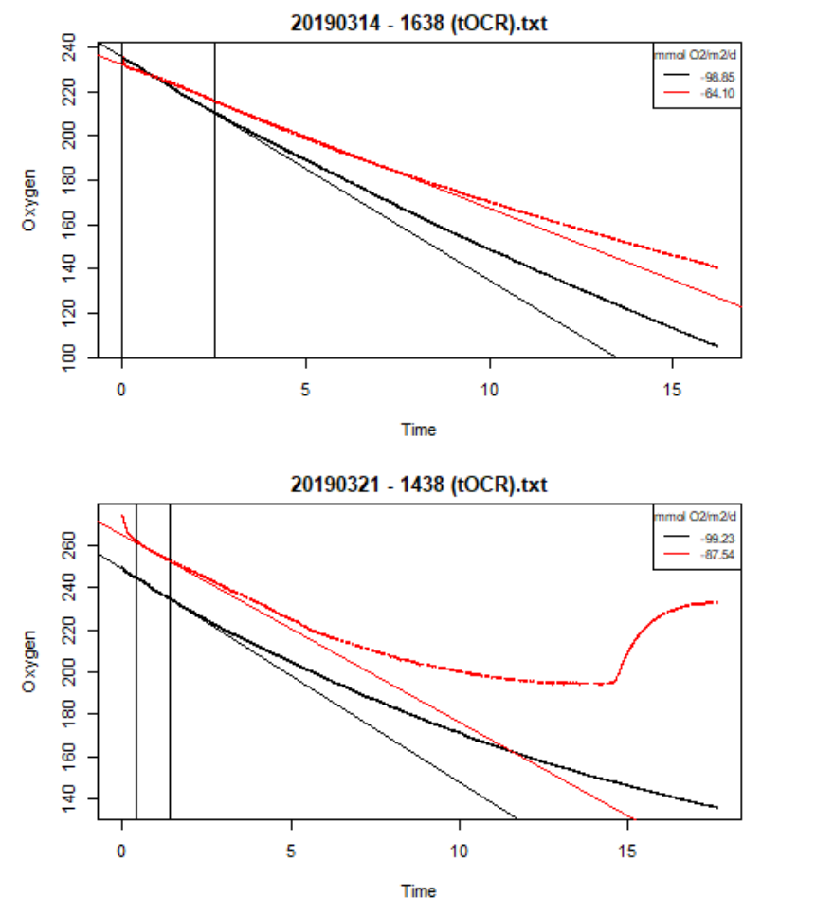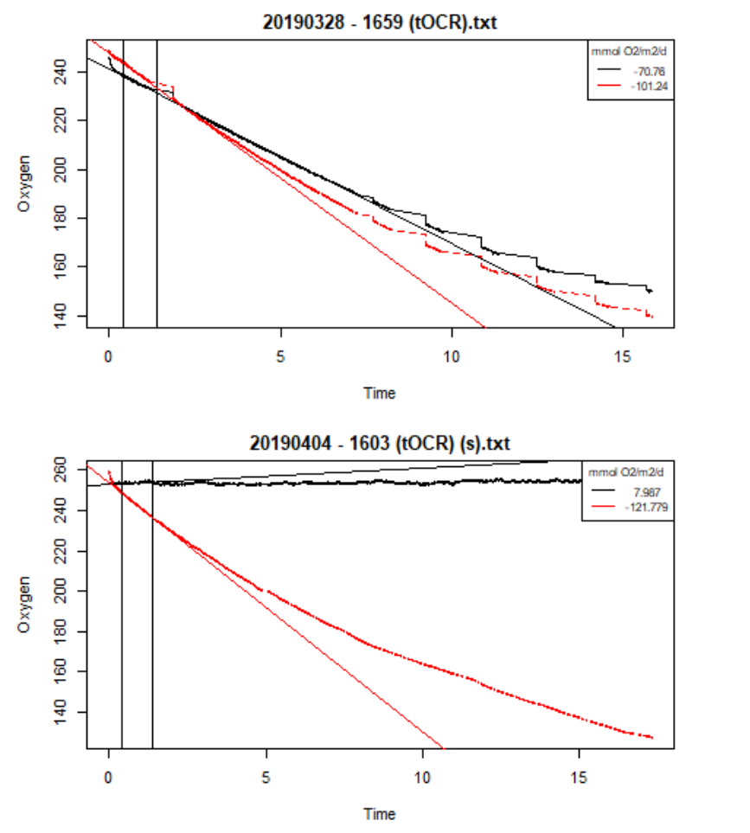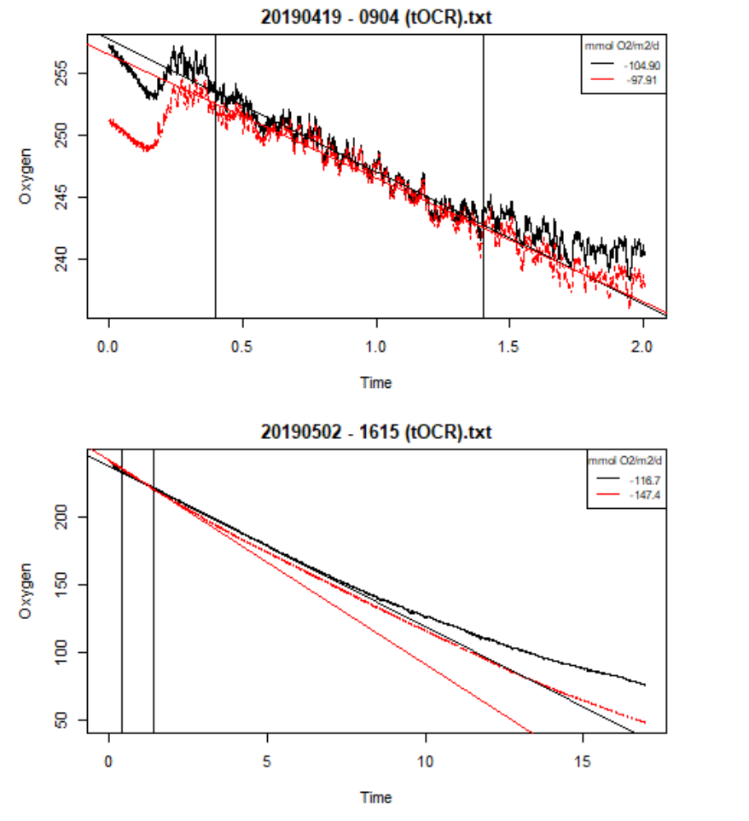

# APPENDIX iii

**Outcomes post-hoc Dunn tests per behavioural activity**

### Pumping

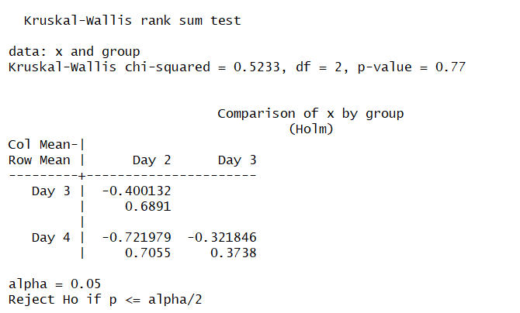

### Burrowing

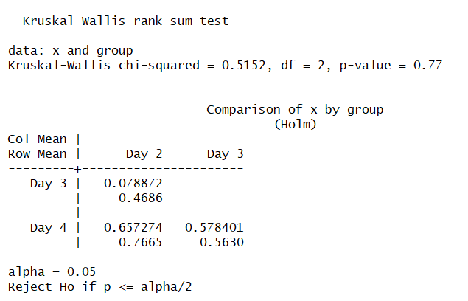

### Defecation

