CFL

2016
"Theoretically retrofitting a scrubber installation onboard of the vessel type Sole 10.000"
Thesis
Jonas Boelens

HZ University of Applied Sciences
De Ruyter Academy

CFL
Marvel Scan
Jonas Boelens
4Marof

January - August 2016
Semester 8

Abstract
This document has been prepared to advise vessel owners and charterers about the fuel sulphur reduction options and implications regarding to the introduction of 0.10% m/m sulphur distillate in the ECA's from 1 January 2015. There are also general sections to provide information on legislation and information about the several systems.
IMO MARPOL Annex VI provides the legislative framework for fuel sulphur reductions and the associated timing. The relevant parts of this legislation are in the document and the implications of the changes are analysed.
During this research the specific precautions which CFL can take to protect our environment from air pollution caused by the use of sulphur containing fuel oils will be the central matter. Because of the tightening-up of the sulphur regulations and the expansion of the ECA's, the company CFL likes to determine if the installation of a scrubber is a possible and a dignified alternative. The determination will be done during this research out of a technical and financial approach. This leads us to the research question of this paper:
"Is it possible and economical to install a scrubber onboard of the vessel type 'Sole 10.000' to comply with the SOx regulations whilst using HFO?"
The well found answer to this question follows after discussing and analyzing the technical and economic considerations. Retrofitting the complete scrubber installation into the vessels original body is not possible. Even after a conversion of the exhaust gas casing to fit the scrubbing tower, there is still not enough place available to install the auxiliary equipment of the exhaust gas cleaning system. From a technical point of view it is not feasible to install the scrubber installation onboard of a Sole 10.000.
The payback period of the scrubber is primarily sensitive to the price spread between HFO and MGO and not less sensitive to CAPEX and the absolute HFO price. 100% and 50% ECA operation give a payback period of respectively four and seven years, assuming an HFO-MGO spread of 176 USD/ton.
For the vessel type Sole 10.000 with 5% (maximum 10% (CFL)) ECA operation nowadays, the payback periods will be very long, and the most favorable for CFL from an economical point of view will be to switch to MGO when operating in an ECA. With an ECA operation of more than 90% and depending on the remaining commercial lifetime of the vessel, it is recommended to CFL to search for a similar alternative as the scrubber installation but which has an applicable footprint and a more attractive economical profile.
As the scope of this research is limited to scrubber installations, there is no detailed information provided for operation on LNG or other gaseous fuels.

Contents
1. Introduction 6
2. Theoretical Frame 8
2.1 Reference Vessel - Marvel Scan 8
2.2 MARPOL Annex VI 8
2.3 Emission Control Areas 9
2.4 Compliance Options for CFL 10
2.4.1 Using LNG 10
2.4.2 Using MGO 10
2.4.3 Using a Scrubber Installation 12
2.5 Scrubber Technologies 13
2.5.1 Comparison between Wet and Dry Scrubbers 14
2.6 Advantages and Disadvantages of the Scrubber systems 16
2.6.1 Dry Scrubbers 16
2.6.2 Open-loop (Seawater) Scrubber 16
2.6.3 Closed-loop (Freshwater) Scrubber 16
2.6.4 Caustic Soda Solution 17
2.6.5 Hybrid Scrubber 18
2.6.6 Single Stream Scrubber 18
2.6.7 Exhaust Gas Bypass 19
2.7 Stability impact 20
3. Method 21
3.1 Type Selection 21
3.2 Space Availability 21
3.3 Power Availability 22
3.4 Economical Benefit 23
4. Results 24
4.1 Type Selection 24
4.2 Space Availability 24
4.3 Power Availability 26
4.4 Economical Benefit 26
5. Discussion 28
6. Conclusions and Recommendations 29
References 30
Appendix A: Ship Particulars 31
Appendix B: Main Engine Data 32
Appendix C: Casing Adjustments - View from the top 33
Appendix D: Casing Adjustments - View from the side 34
Appendix E: Final Casing Dimensions 35
Appendix F: Engine Room Tanktop Ground Plan 36
Appendix G: Engine Room Tanktop 3D-Drawing 37
Appendix H: Engine Room Tweendeck Ground Plan 38
Appendix I: Engine Room Tweendeck 3D-Drawing 39

1. Introduction
Ship transportation is considered the most energy efficient mode of transport producing the lowest CO₂ emissions on a mass and distance basis (CIMAC, 2013). Nevertheless, SO_{x} emissions generated by the merchant fleet represent a significant contribution to the global emissions. The sulphur content of marine fuels is determined by local legislation and regulated on a worldwide basis through the International Maritime Organisation (IMO) MARPOL Annex VI. LNG and other gaseous fuels are beyond the scope of this research.
Since January the 1st of 2015, the maximum limits for sulphur content of the fuel oils inside an 'Emission Control Area' (ECA) are set to 0.1% and will be sharpened against 2020/(2025) to a maximum global limit of 0.5%. In order to comply with these limits and to achieve the best technological and economic result it is very important to make a well-founded decision for CFLs existing Sole vessels in the conceptual design phase.
A number of options are in place or under development to reduce the emissions of ships. The marine industry will be one of the key areas of environmental focus for the next decade. This is expected to place a significant challenge on the supply of sulphur fuels. Engine builders and owners may need to optimize their engines to operate on low sulphur fuels. Exhaust gas after treatment devices such as scrubbers are an alternative to the use of low sulphur fuels as they remove the sulphur products of combustion prior to discharge of the exhaust gas to the atmosphere thus allowing the continued operation on high sulphur fuels.
Because of the tightening-up of the sulphur regulations and the expansion of the ECAs, the company CFL likes to determine if the installation of a scrubber is a possible and a dignified alternative. The determination will be done during this research. This leads us to the research question:
"Is it possible and economical to install a scrubber onboard of the vessel type 'Sole 10.000' to comply with the SOx regulations whilst using HFO?"

This installation brings economic and technical implications which need to be understood. To answer the research question properly, the following sub-questions are drawn up:
- What is the most suitable scrubber-installation for the vessel type 'Sole 10.000' to comply with the SOx regulations?
- Is it possible to install a scrubber-installation onboard regarding to the available space?
- Is it possible to install a scrubber-installation onboard regarding to the available power supply?
- What is the economical benefit of the scrubber-installation?
During the research several types of information sources will be used, such as PDF-files, books, articles from newspapers and magazines, websites as well as documents from websites, papers, etc. All the consulted sources can be found in the list of references.
The fuel price scenario during this study is 333$/ton for MGO and 157$/ton for HFO (Group, 2016). Low-sulphur fuel referred to during this research comprises fuel with not more than 0.1% sulphur in the case of ECA operation as of 2015. In addition, it compromises fuel that will satisfy the global sulphur cap of 0.5% as of 2020 (or 2025). For simplicity reasons, all of these low-sulphur fuels are referred to as 'MGO'. The expectation is that the price difference between 0.1% and 0.5% sulphur fuel will be limited (Klimt-Mollenbach, Schack, Eefsen, & De Kat, 2012). The density of HFO and MGO used for calculations during this research is respectively 0.99 tons/m³ and 0.85 tons/m³. The service speed of the vessel is rated at 12 knots. Whenever "ECA" is used in this paper, it refers to an Emission Control Area established to limit SOx and particulate matter emissions in accordance with regulation 14 of MARPOL Annex VI.
The primary objective of this publication is to provide a reference for ship owners and charterers in general.

2. Theoretical Frame

2.1 Reference Vessel - Marvel Scan
This research will compare the options to comply with the MARPOL Annex VI, Regulation 14, for the existing 10.000 DWT multipurpose Sole type vessels from the company CFL. The ship particulars and main engine data of the concerning vessel type can be found in respectively Appendix A and Appendix B.

2.2 MARPOL Annex VI
Unlike the preceding Annexes I - V, which deal with single topics, MARPOL Annex VI deals with a number of air pollution streams: exhaust emissions, ozone depleting substances, volatile organic compounds and incineration.
Regulation 14 of MARPOL Annex VI controls sulphur oxides (SOx) and particulate matter (PM) emissions through limiting the maximum sulphur content of the fuel oils used. These limits apply to all fuel oils used onboard and include main and all auxiliary engines together with such items as boilers and inert gas generators.
Furthermore, lower fuel oil sulphur content limits apply, with their own sequence of reduction, in Emission Control Areas (ECA). ECAs can, and have been established in areas where a higher level of protection from emissions and pollutants is required due to factors as prevailing winds, the proximity of shipping routes to centers of pollution and the natural susceptibility of an area to acid deposition.
The fuel oil sulphur limits are subjected to staged reductions, giving the industry and bunker fuel suppliers time to plan for and adjust to the changes. The diagram below details these staged changes.
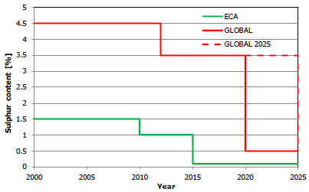
Figure 1: MARPOL Annex VI SOx Requirements (Klimt-Mollenbach, Schack, Eefsen, & De Kat, 2012).
*Depending on the outcome of a review of fuel oil availability, to be completed 2018, the 2020 date could be deferred to 2025.
Beside the MARPOL regulations there are some regional regulations:
- EU Sulphur directive 2012/33/EU (1 January 2015)
- Hong Kong fuel switch scheme (1 January 2015)
- Turkish Regulations (1 January 2012)

2.3 Emission Control Areas
“Two sets of emission and fuel quality requirements are defined by Annex VI: Global requirements and more stringent requirements applicable to ships in Emission Control Areas (ECA). An Emission Control Area can be designated for SOx and PM, or NOx, or all three types of emissions from ships, subjected to a proposal from a Party to Annex VI. These zones are shown in Figure 2.” (Hombravella, Kilicaslan, Péralès, & Rüss, 2011)
There are four existing Emission Control Areas:
- Baltic Sea ECA;
- North Sea ECA;
- North American ECA;
- United States Caribbean Sea ECA around Puerto Rico and the United States Virgin Islands.
“While there is a lot of speculation concerning possible future ECAs, at this time, Norway, Japan, Hong Kong and the Mediterranean have been indicated for potential designated ECAs in the future. There have also been discussed of further expansion of ECAs, into the entire Atlantic seaboard of Europe, coastal Korea, the Sea of Japan, the Australian coast, the shipping lanes of Singapore, Malaysia and Indonesia, as well as coastal China” (Austin, 2015).
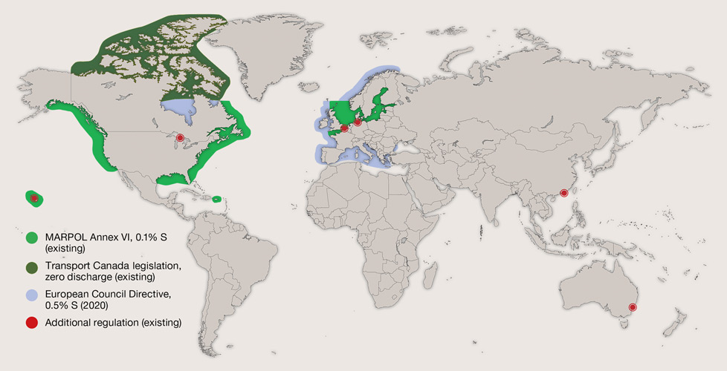
Figure 2: ECA-zones (Laval, 2015)

2.4 Compliance Options for CFL
For CFL there are three key methods to ensure compliance with the SOx and PM emission requirements under Regulation 14 of MARPOL Annex VI:

2.4.1 Using LNG
Because CFLs specialty is transporting project cargo, which requires most of the time a lot of loading space, there is no space available to offer for the LNG storage tanks. Also the high adjustment costs for the conversion of the main engine and LNG installation makes that LNG is no realistic option for CFL. Although, the sulphur emission of pure LNG is almost zero and the NOx emissions can be lowered with 85%.

2.4.2 Using MGO
Although an operator is free to use MGO when operating outside an ECA, the price differential between heavy fuel oil (HFO) and MGO normally dictates that fuel switching between the grades occur in preparation for entering an ECA and also when exiting an ECA.
The use of MGO has some advantages;
- No big space taking installations like a scrubber are needed.
- The main engine is already able to run on (LS) MGO, so no complicated changes to the ships propulsion system need to be made.
When looking at this compliance option, it seems to be the easiest option. But the usage of MGO has also some disadvantages:
- Compared to HFO, MGO has a lower viscosity. Because of this difference, the MGO will start leaking between the seal in the plunger and barrel of the fuel pumps.
- “Furthermore, this MGO will leak on the roll guide of the fuel pump. Here from it will leak onto the camshaft of the engine and will finally mix with the lubricating oil, which will lose lubricating properties. This will cause more wear to the moving parts inside the engine. To avoid this problem, all fuel related seals will need to be replaced and this can only be done when the ship is not sailing” (Brouwer, 2014).
Currently the MGO fuel capacity is only 9% of the total bunker capacity onboard of the vessel type Sole 10.000. To provide more MGO bunker space, a modification of (an) HFO tank(s) will be required. Therefore tanks will need to get cleaned and some adjustments to the current piping work will have to take place. These adjustments will need to be approved by the classification society. This job has to be done when the ship is alongside.

Already 3 of the 6 Sole types (Industrial Merchant, Marvel Scan and Momentum Scan) were modified for a long running time on MGO during a docking. This modification means that one of the HFO bunker tanks, including the bunker and transfer system, is now dedicated and converted for MGO. For each vessel a total cost of 30.000$ was made. In Table 1 the changes in bunker capacity and range due to this modification are shown.
Modification of HFO 2SB to MGO
 | Before modification |  | After modification
 | HFO | MGO | HFO | MGO
Bunker capacity (MT) | 568.20 | 67.80 | 485.60 | 150.40
Bunker capacity (T) | 562.50 | 57.63 | 480.74 | 127.84
Bunker capacity (%) | 91.00% | 9.00% | 76.00% | 24.00%
Sailing days | 37.5 | 3.83 | 32.00 | 8.50
Range (Miles) | 10800 | 1104 | 9216 | 2448
Table 1: Modification
Looking into the future is very hard, but that the ECAs will expand is a fact. So the time/percentage CFLs vessels will spend in these areas will increase for sure. Assuming the global sulphur cap enters into force in 2020, the 'base case' scenario (shift to MGO in ECA) is shown in Table 2 below.
MGO scenario:
 | 2015-2019 |  | 2020-2024
 | Non ECA | ECA | Non ECA | ECA
Consumption at sea (ME) | HFO | MGO | MGO | MGO
Consumption at port (AE's) | MGO | MGO | MGO | MGO
Table 2: MGO scenario

2.4.3 Using a Scrubber Installation
“A scrubber is a device installed in the exhaust system after the engine or boiler that treats the exhaust gas with a variety of substances including sea water, chemically treated fresh water or dry substances, so as to remove the most of the SOx from the exhaust. There are two types of scrubbers: wet and dry. The dry scrubber uses dry chemicals (Ca(OH)₂), and the wet scrubber uses water as a scrubbing medium. Wet scrubbers are more acceptable for ships because of their lower price and smaller dimensions of units. That is why the wet type of scrubber is the most widely used in shipbuilding. There are three main types of wet scrubbers” (Panasiuk I. , 2014):
- Open loop scrubbers, which uses only sea water;
- Closed-loop scrubbers, which uses fresh water that is when necessary mixed with caustic soda;
- Hybrid scrubbers, which has both benefits of the open- and the closed-loop.
“According to DNV, it is more probable that there will be a gradual increase of scrubber retrofits from 2018, rather than a sharp increase in 2020 once the global sulphur limit is enforced. Even if the global sulphur limit is not enforced until 2025, the EU has stated that it will enforce a 0.5% sulphur limit in its waters in 2020 regardless. Although this will not have a global impact as most fuel is burned in international waters, it is still expected to cause a spike in scrubber interest” (DNV, 2012).
The scenario which consists of installing a scrubber system would entail running the main engine on HFO at all times as shown in Table 3.
Scrubber scenario:
 | 2015-2019 |  | 2020-2024
 | Non ECA | ECA | Non ECA | ECA
Consumption at sea (ME) | HFO | HFO | HFO | HFO
Consumption at port (AE's) | MGO | MGO | MGO | MGO
Table 3: Scrubber scenario

Below, the most important advantages and disadvantages of each compliance option are set in Table 4.
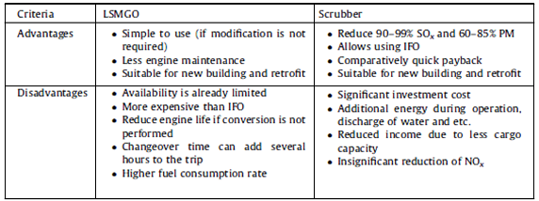
Table 4: The comparison of SOx reduction technologies (Panasiuk I. , 2015).
Because of the tightening-up of the sulphur regulations and the expansion of the ECAs, the company CFL likes to determine if the installation of a scrubber is a possible and a dignified alternative. The determination of the most suitable installation will be done during this study.
“In the study, the use of low-sulphur fuel/distillate will function as reference case as to the feasibility of the scrubber installation investigated solution. The alternative solution will be evaluated by means of various scenarios considering operational profiles and fuel prices, and the evaluation will take into account that the vessel will be sailing in both ECA and non-ECA waters” (Klimt-Mollenbach, Schack, Eefsen, & De Kat, 2012).

2.5 Scrubber Technologies
In the marine industry there exist two general categories of scrubber:
- Wet scrubbers
- Dry scrubbers
Both types have already shown that they are able to meet the requirements of MARPOL Annex VI, but wet scrubbers remain the dominant type within the marine industry. The working principle of these scrubber technologies of the different manufacturers is almost the same. In Table 5, a comparison between both scrubber technologies is given.

2.5.1 Comparison between Wet and Dry Scrubbers

 | WET SCRUBBER |  |  | DRY SCRUBBER
 | OPEN-LOOP | CLOSED-LOOP | HYBRID
Main System Components | - Scrubber  - Washwater Piping  - Washwater Pumps  - Washwater treatment equipment  - Sludge handling equipment | - Scrubber  - Washwater piping  - Washwater pumps  - Washwater processing tank  - Washwater holding tank  - Sodium hydroxide (NaOH) storage tank  - Washwater treatment equipment  - Sludge handling equipment | - Scrubber  - Washwater piping  - Washwater pumps  - Washwater processing tank  - Washwater holding tank  - Sodium hydroxide (NaOH) storage tank  - Washwater treatment equipment  - Sludge handling equipment | - Absorber  - Fresh granulate hopper  - Used granulate hopper  - Granulate transport system  - Additional granulate storage (new and used granules)
Operation In Fresh Water | No | Yes | Yes (only when operating in closed-loop mode) | Yes
Operation without discharge to Sea | No | For a limited time depending on the size of the washwater holding tank | For a limited time depending on the size of the washwater holding tank | yes
Weight (Typical Values For A 20MW SOx scrubber) | 30 -55t (excl. washwater system and treatment equipment) | 30 -55t (excl. washwater system, treatment equipment, washwater processing tank and washwater holding tank) | 30 -55t (excl. washwater system, treatment equipment, washwater processing tank and washwater holding tank) | ≈200t (incl. granules stored adjacent to the absorber but excl. additional granulate storage)
 | WET SCRUBBER |  |  | DRY SCRUBBER
 | OPEN-LOOP | CLOSED-LOOP | HYBRID
Power Consumption (% Of Rated Main Engine Power) | 1 - 2% | 0.5 - 1% | 0.5 - 2% (depending on whether it is operating in open- or closed-loop mode) | 0.15 - 0.2%
Scrubbing Chemical Consumable | No consumable | NaOH solution  (6 l/MWh.%S) | NaOH solution (only when operating in closed-loop mode)  (6 l/MWh.%S) | CA(OH)₂ granules  (10 kg/MWh.%S)
Compatibility With Waste Heat Recovery System | Yes, provided the scrubber is installed after the waste heat recovery system | Yes, provided the scrubber is installed after the waste heat recovery system | Yes, provided the scrubber is installed after the waste heat recovery system | Yes. Can be placed before or after the waste heat recovery system
Compatibility With Selective Catalytic Reduction System | No, unless a reheater is fitted after the wet scrubber to raise the exhaust gas temperature. | No, unless a reheater is fitted after the wet scrubber to raise the exhaust gas temperature. | No, unless a reheater is fitted after the wet scrubber to raise the exhaust gas temperature. | Yes
Compatibility With Exhaust Gas Recirculation System | Yes | Yes | Yes | Yes
PM Removal | Yes | Yes | Yes | Yes
Table 5: Comparison between wet and dry scrubbers (Austin, 2015).

2.6 Advantages and Disadvantages of the Scrubber systems
There are a lot of differences between the several systems. A summary of the systems advantages and disadvantages is given below and is more explained where necessary. Based on these 'drivers and barriers' the most suitable scrubber system for CFL worldwide sailing vessel type Sole 10.000 will be made.

2.6.1 Dry Scrubbers
The main advantage of this system is its negligible energy consumption. Although simple to operate, they are less common in the marine industry. In addition to the fresh granulate, the used granulate must also be stored onboard prior to onshore disposal, which means considerable extra weight and large space requirements.
Kindly note, there is these days no supplier of dry scrubber installations. The only known manufacturer 'Couple Systems' does not longer exist. This system will not be further discussed during this research.

2.6.2 Open-loop (Seawater) Scrubber
The open-loop scrubber is the most basic scrubber system. The main advantage compared to a closed-loop system is that you do not need to cool the scrubbing water and no chemicals need to be added.
The disadvantage of this open-loop system is that you are entirely depending on the seawaters alkalinity for the system performance. If the alkalinity is high enough there will not be any problem at all. When sailing in areas with brackish or fresh water, problems might start to occur because of a too low alkalinity of the washwater and IMO limits might not be reached (Brouwer, 2014).
“Combined with the required pressure for the highly placed scrubber, the power needed for scrubbing is a running cost that cannot be ignored. In certain cases, in areas where the seawater alkalinity is too low or restricted outlet criteria are in force, the system cannot be used. The addition of NaOH to the washwater or running on low sulphur will be required” (Panasiuk I. , 2014).

2.6.3 Closed-loop (Freshwater) Scrubber
The closed-loop scrubber system uses fresh water instead of seawater during the scrubbing process. Still the seawater is used to cool the washwater. Instead of the seawaters salinity, the fresh water characteristics do not change at all while sailing. This makes the system much easier to operate.
The systems main advantage, compared to the open-loop system, is that the system can always be used because the alkalinity of the washwater can be controlled very easily with the NaOH (Sodium Hydroxide/Caustic Soda) unit (Brouwer, 2014).
The fact that this system is reusing the most of the washing water, so it is only need to treat a small amount of the washwater before it can be discharged, is also a big advantage of this scrubber system.
On the other hand, is the closed-loop scrubber system more complex compared to that of the open-loop scrubber system because a water treatment system is required. Next to the scrubber himself, the necessary equipment includes caustic soda, circulation and sludge tanks, pumping and freshwater cooling systems and a waste control unit. An alternative to the waste control unit could be a holding tank to store the bleed-off water for discharge in port. The scrubber water flow is significantly reduced as the scrubbing efficiency using the closed-loop is high compared to open-loop systems. Due to reduced flow, the dimensions of inlet and outlet pipes are reduced. The running cost of the closed-loop system is higher compared to open-loop systems, mainly because of the addition of chemicals in the process. However the closed-loop system can be used in any area without any restrictions (Panasiuk I. , 2014).
Kindly note that fresh water will be consumed due to evaporation losses and the discharge of the saturated water. This all depends on the ambient conditions. At low seawater temperature, a low ambient temperature, a relative humidity of 80% and a main engine that is most of the time running at 80% MCR, the freshwater consumption can be calculated as follows (Brouwer, 2014): 0.05 x [MW] = consumption (m³/hr)

2.6.4 Caustic Soda Solution
The closed-loop scrubber system uses an Alkali-unit which doses a caustic soda solution (NaOH 50%) into the system to monitor the alkalinity of the washing water. The high ph of the sodium hydroxide helps to neutralize the acid products and maintains its base properties while sulphur oxides are being dissolved into the washwater. In Table 6 and Figure 4, the properties of the NaOH solution are stated.

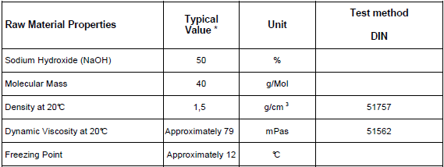
Table 6: Material Properties of the consumed NaOH (GmbH&Ko, 2011)

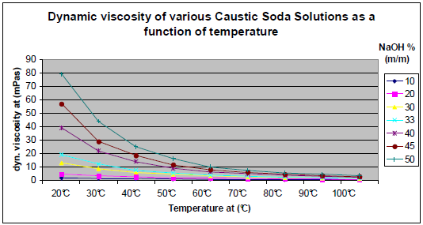
Figure 4: Dynamic viscosity of various Caustic Soda Solutions as a function of temperature (GmbH&Ko, 2011)

As this substance has a low freezing point of about 12°C and a high viscosity at 20°C, it should be heated while stored onboard to be transferable at all times. The consumption of the caustic soda solution (1,5MT/day (Laval, 2015)) is a running cost of the closed-loop system, about 400$/MT, which must also be taken into account when calculating the ROI of the system.

2.6.5 Hybrid Scrubber
The hybrid system combines the low running costs of the open-loop system and the flexibility provided by the closed-loop system. The combination of the systems results in a higher price and more space is needed for the installation of the equipment. The combination of a closed-loop system and an exhaust gas bypass can easily replace the flexibility of the hybrid.

2.6.6 Single Stream Scrubber
As the oil fired burner and both auxiliary engines are consuming MGO, the main engine with his shaft generator is the only HFO consumer onboard. Hence it follows that a single stream scrubber design will be installed in the funnel to scrub the exhaust gas stream of the main engine.

2.6.7 Exhaust Gas Bypass
An exhaust gas bypass controls the direction of the exhaust flow between the scrubber and atmosphere. Unless made with suitable materials for the high exhaust temperatures, wet scrubbers are normally not recommended to be operated dry, i.e. operated with exhaust gas passing through them without washwater flowing. A separate bypass will not be required for scrubbers which are suitable for dry operation, which saves even more space and weight.
For most scrubbers fitting a bypass is a requirement if there is a need to be able to operate the equipment connected to the scrubber when the scrubber is non-operational for any reason. This would apply to engines and boilers considered essential services of a vessel. When the scrubber is not needed, such as when the ship is outside an ECA, the exhaust bypass can be used and the scrubber shut down, saving electric power consumption.
Bypass exhaust pipes are as large as the original exhaust pipe and the required space in the engine exhaust system casing for the bypass pipe and the bypass valve can be large. The bypass pipe normally passes alongside the scrubber and requires a separate exhaust outlet at the top of the funnel in addition to the scrubber outlet.
“Where the valve is a two-damper design, an interlock would be required to prevent both dampers from being closed at the same time (see Figure 3). Exhaust bypass valves may require frequent maintenance because of the hot gas environment and soot accumulation that occurs” (ABS, 2013).

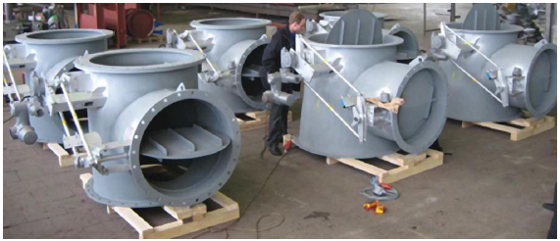
Figure 3: Wärtsilä exhaust bypass valves (ABS, 2013).

2.7 Stability impact
For existing ships a reversion of the stability may need to be considered based on the increased wind profile and additional weight of the scrubber. In general, if the change in lightship displacement exceeds 2% (200tons), and/or the change in lightship longitudinal center of gravity (LCG) exceeds 1% of length between perpendiculars (LBP), a stability test may be required on the vessel and stability calculations may need to be revised to indicate the changes. When a ship is within these limits, immediate update of the Stability Booklet may not be required. In this case the principal particular page would need to be updated and the ship would be required to use the latest lightship properties when assessing new conditions (ABS, 2013).
It is estimated that the structure to support the scrubber, including the expanded exhaust system casing, will weigh about 50 percent of the scrubber weight, so the weight impact on the vessel deadweight and stability will be about 150 percent of the scrubber operational weight (DNV, 2012).
For the vessels in question the influence on the stability aspects will not be evaluated in details during this study as the weight impact of the scrubber installation is only 0.3% (30tons) of the lightship displacement. It is assumed that the impact of the conversion will not have a significant impact on the stability compliance thus operability of the vessel.

3. Method
In this section, an explanation of how the study tries to achieve a valid and reliable answer to the research question is given. This study is based on qualitative research. The elements of the proposed methodology relevant to the scrubber's conceptual design phase will be discussed. These elements are:
- The selection of the most suitable scrubber installation by the study and analysis of similar cases. The gathered information will be analyzed, compared and applied to the present situation of the vessel type Sole 10.000.
- The space and power availability onboard of the vessel type Sole 10.000 will be investigated by executing field work and analyzing the gathered information of the theoretical frame. Also ground plans and 3D drawings of the engine room will be used to agree with a proper and well found result.
- The economical benefit for CFL regarding to the investment costs for retrofitting the selected scrubber system. The study will process the gathered information of the consulted sources, such as manufacturers and companies, into an excel file to establish a well founded answer.
The working principle of different equipment manufacturers is almost the same. It means that the scrubbers are approximately the same in size and mass, in pumping capacities, caustic soda solution, etc. That is why differences between manufacturers are not taken into account.

3.1 Type Selection
There are a lot of differences between the several systems. Each system has its own advantages, disadvantages and specifications. Based on these 'drivers and barriers' the most suitable scrubber system for CFL worldwide sailing vessel type Sole 10.000 will be composed. The selected scrubber type must meet the most important requirement of CFL, the preservation of their global sailing area. As an open-loop system is already restricted in his operational area due to local discharge regulations, this will not be further discussed during this study.

3.2 Space Availability
“Wet scrubbers together with their associated auxiliary equipment are large units. Table 7 shows the principal dimensions based on engine power rating, for scrubbers produced by Alfa Laval Aalborg Industries. Scrubbers from other manufacturers will have different dimensions, but the size is expected to be of a similar order of magnitude” (ABS, 2013). The space and stability calculations made during this study will therefore be based on these dimensions.
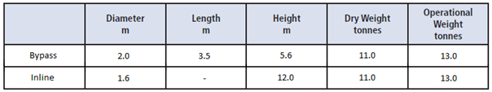
Table 7: Alfa Laval closed-loop wet scrubber principal dimensions for a 4 MW engine (Laval, 2015).
In addition to the scrubber itself, the research will consider the space requirements of the associated scrubber auxiliary equipment, such as pumps, process tanks, particulate separators, and coolers, which are similar in size to other engine room auxiliary equipment of the same type. The main auxiliary equipment and the systems required tank capacities for several engine sizes are listed below in Table 8.
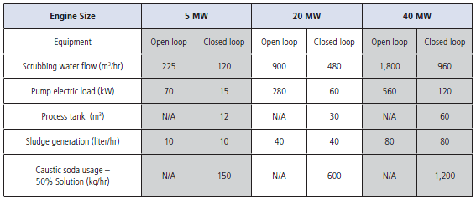
Table 8: Sample Wet Scrubber Auxiliary Equipment Sizing (ABS, 2013).
The research will in the first case check if the necessary space for the scrubbing tower is available by measuring the present space dimensions and compare these to the required space, extracted from Table 8. The Sole vessels of CFL do not have cargo aft of the deckhouse and there is space to expand the engine exhaust casing to the aft. If it seems to be possible to fit the scrubbing tower in the funnel, it will be investigated if there is enough space available for the main auxiliary equipment based on the figures above; assuming the consumed Caustic Soda and generated sludge substances will be supplied/discharged from/to the shore on a monthly base.

3.3 Power Availability
Also, the study will check if the required energy to operate the scrubber system can be delivered by the main and auxiliary engines as they are installed at this moment. This will be done by analyzing the electricity production of the generators during several sailing situations. To keep record of the generated power, a log-sheet will be made.

3.4 Economical Benefit
Based on the financial factors an estimation of the total investment cost of the selected scrubber system will be made. Based on the respective investment costs/capital expenses (CAPEX) and operating expenses (OPEX) to the retrofit option versus the added operational cost associated with the shift to MGO as required by the regulations, the return on investment (ROI) will be calculated. The ROI results will be presented as a function of the operating time inside ECAs (Klimt-Mollenbach, Schack, Eefsen, & De Kat, 2012). The figures used in the Excel file are abstracted form the consulted manufacturers and companies during this research which can be found in the list of references. These figures apply to this research but can be adjusted at all times in the excel file according to the selected scrubber manufacturer and future situations among the alternating prices of the several consumables. The most important investment costs for retrofitting a scrubber installation are as next:
- Initial cost of the scrubber (Incl. additional miscellaneous auxiliary equipment)
- Conversion materials (Steel, pipes, electrical installations and modifications)
- Additional fuel consumption to operate the scrubber system
- Docking (2weeks)
- Off-Hire cost/installation time (3-4weeks at a rate of 10.000 USD/day)
- Caustic Soda consumption
- Maintenance of the system
- Design and Classification costs

4. Results
This chapter contains the information by which a proper answer to the research question can be made. Therefore, the most important technical, operational and financial aspects off the selected scrubber type will be approached.

4.1 Type Selection
Although a dry scrubber system is simple to operate, they are less common in the marine industry. In addition to the fresh granulate, the used granulate must also be stored onboard prior to onshore disposal, which means considerable extra weight and large space requirements, which makes this type of scrubbers not suitable for installation onboard of the vessel type Sole 10.000.
CFL is an international sailing company, eager to transport project cargo from places that are for the most companies inaccessible because of their draft. Though CFL's average time spend inside an ECA nowadays is about 5%, it would be a shame CFLs operational area would get limited because of not being able to comply with the territorial MARPOL sulphur regulations and USA washwater discharge regulations. From an operational perspective, an open-loop scrubber system will be excluded as a non-suitable option. Also from a technical perspective, a closed-loop system is favorable to an open-loop system as it consumes less electrical energy. This leaves us to the choice between a closed-loop and a hybrid system. When finally looking at the financial aspect, a closed-loop system will be relatively cheaper. Kindly note the bypass option depends on the selected system manufacturer.
Therefore, a closed-loop system would be the most suitable installation to install onboard of the vessel type Sole 10.000.

4.2 Space Availability
The scrubber unit should always be installed in a vertical direction. Horizontal positioning is not possible as the efficient exhaust gas cleaning requires countercurrent interaction between the exhaust gas and scrubbing water. As the exhaust funnel casing of the vessel type Sole 10.000 has a spoiler-design, there is no other possibility than expanding the casing to the aft to fit the scrubber in a vertical position. A view from the top and from the side of the funnel is given and the possible adjustments to the casing are drawn in a red color (see Appendix C and Appendix D).
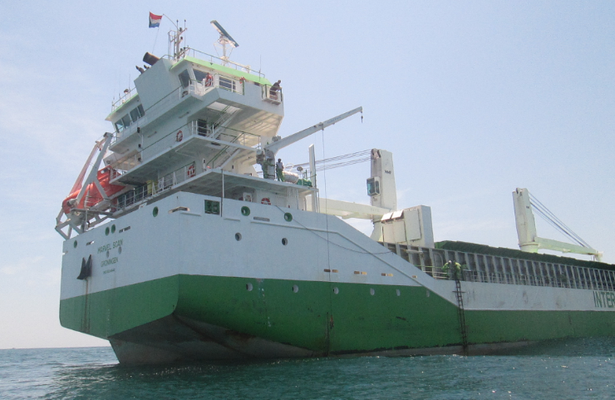
Figure 4: Spoiler designed superstructure of the Marvel Scan
Considering the dimensions of Table 8, it is suggested for CFL to select a scrubber manufacturer who provides closed-loop scrubber systems having a bypass function, as an inline scrubber will not be possible to fit in the converted exhaust gas casing (see Appendix E). Kindly note these casing dimensions are based on the original 'General Arrangements Plan' of the vessel, according to the use of the correct scale.
A proper foundation will be necessary to support the casing and the installed scrubber. The side space in the funnel area would be used to fit the required pipe work, exhaust bypass and the support of the scrubber installation. The next parameters are extracted from table 8 and from previous calculations, for a 4MW engine:
- Process tank 10 m³
- Sludge generation 8 l/hr = 6 m³/ month
- Caustic Soda Solution usage 1,5m³/day = 45 m³/month
- Additional freshwater consumption 160 m³/hr = 4 m³/day
After examining the ships drawings (see Appendix F – I) and analyze the various data above, it became clear no space is available to offer for the systems process, sludge and storage tanks. As these main components does not fit in the ships body, no further investigation will be done regarding space availability for the auxiliary equipment in and around the engine room. Considering the specific vessel type Sole 10.000, there is unfortunately not enough space to offer. Seen from a space technical perspective, the scrubber scenario is not feasible.
Finally, the closed loop system consumes each day because of evapoartion about 4m³ (= 0.05*(0.80*4MW)*24hr) on top of the vessels daily freshwater consumption, which is about 3m³/day. The currently installed evaporator produces only 2m³/day. With a freshwater storage capacity of 80m³, the vessel would be able to sail a maximum of 16 days before it runs out of freshwater. Therefore it is necessary to install an evaporator with a higher production, what is again resulting in these space restrictions.

4.3 Power Availability
To operate the scrubber system there is about 40kW (1% of the rated power of the main engine) needed from the generated power onboard. The biggest part of this energy will be consumed by the pumps for the circulation of the washwater. During a standard sea passage, the average power consumption is only 150kW of the 450kW the shaft generator is able to produce. The main switchboard is equipped with spare connections and space for the necessary electrical components is available inside the electrical lockers. Here, no limitations regarding power availability are expected to occur.
When having bad weather conditions, the necessary electrical power is delivered by one auxiliary engine, as the frequency of the shaft generator is constantly changing because of the altering load. Here again, no problem might occur due to a lack of power generation, as one generator is able to produce a maximum of 377kW. The generation of this extra 40kW will result in higher fuel consumption which is also taken into account when calculating the period of return on investment.
As the main engine with his generator is the only HFO consumer onboard of the vessel type Sole 10.000, there is no need to discuss the power availability during port operations or on anchorage. Seen from a power technical perspective, the scrubber scenario is feasible.

4.4 Economical Benefit
In the following section, the scrubber alternative to the MGO case is considered from a financial perspective. The current spread between HFO and MGO will be assumed as a constant during the calculation, as speculating about future fuel prices is unreliable.
The average time spend inside an ECA during a year is about 5% (maximum 10%). Nowadays (07-03-'16) the price difference between HFO and MGO (in Houston) is 176$/ton (Group, 2016). Calculated from the daily fuel consumption data sheets, the main engine consumes about 15 tons MGO at 80%load (eco-speed) . This would result in an 'extra' fuel cost of: 14*176*15 = 36.960 $/year to comply with the current MARPOL Regulations 14.
Based on the respective investment costs/capital expenses (CAPEX) and operating expenses (OPEX) to the retrofit option versus the added operational cost associated with the shift to MGO as required by the regulations, the return on investment (ROI) are calculated. The ROI results are presented as a function of the operating time inside ECAs as shown in Figure 5. This diagram was the result of a calculating process explained in an attached Excel file (see Excel file: 'ROI').
From this financial perspective, the scrubber alternative is potentially attractive when the vessel would operate a reasonable amount of time inside ECAs. The payback time is sensitive to the spread in fuel cost between HFO an MGO. For a cost differential of around 176 $/ton, the payback time is around 3,5 years for 100% ECA operation, 5 years for 75% ECA, 7 years for 50% and 16 years for 25% ECA operation (see Figure 5). If a payback time of at most 4 years would be considered acceptable, then the time spend inside ECA would have to be at least 90%; using this criterion in the case of 80% or less time spent inside ECA, it is more attractive to shift to MGO until the global sulphur cap enters into force in 2020/2025, and eventually it is also depending on the remaining commercial lifetime of the vessel.

Figure 5: Return on Investments for CFL

5. Discussion
The choice of retrofitting a scrubber system on the vessel type Sole 10.000 depends on technical, operational and financial considerations. From a technical and financial perspective, the base case of shifting to MGO to comply with future SOx regulations should not present any major issues, provided due consideration is given to fuel cooling, renewal of some rubber seals of the fuel delivery system and proper lubrication oil for the main engine under prolonged operation; no other vessel modifications are necessary at this moment. From 2020/2025 is might be necessary to convert more HFO storage tanks to MGO storage tanks, to be able to comply with the global MARPOL sulphur regulations.
For retrofit installations the engine exhaust system casing modifications together with space for new pumps and piping systems, including new sea chest and overboard discharges, plus space for the alkaline material storage and wastewater processing can mean significant space requirements. This space is not available in the existing engine room and retrofitting a scrubber will require a significant out of service period.
As the exhaust gas cleaning techniques are continuously developing, manufacturers might invent systems on a short term base, with similar ecological purposes but smaller in size and easier to purchase from a financial perspective.
As shown in Figure 6, speculating about future fuel prices is very difficult. This figure shows the crude oil prices during the period 2003 - 2015. This is an important factor when choosing a way to be able to comply with the future MARPOL Regulations.

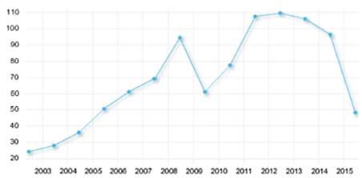
Figure 6: Crude oil prices from 2003 until 2015 (Panasiuk I. , 2015)

6. Conclusions and Recommendations
Retrofitting the complete scrubber installation into the vessels original body is not possible. Even after a conversion of the exhaust gas casing to fit the scrubbing tower, there is still not enough place available to install the auxiliary equipment of the exhaust gas cleaning system. From a technical point of view it is not feasible to install the scrubber installation onboard of a Sole 10.000.
The payback period of the scrubber is primarily sensitive to the price spread between HFO and MGO and not less sensitive to CAPEX and the absolute HFO price. 100% and 50% ECA operation give a payback period of respectively four and seven years, assuming an HFO-MGO spread of 176 USD/ton.
For the vessel type Sole 10.000 with 5% (maximum 10%) ECA operation nowadays, the payback periods will be very long, and the most favorable for CFL from an economical point of view will be to switch to MGO when operating in an ECA. With an ECA operation of more than 90% and depending on the remaining commercial lifetime of the vessel, it is recommended to CFL to search for a similar alternative as the scrubber installation but which has an applicable footprint and a more attractive economical profile.

References
ABS. (2013). Exhaust Gas Scrubber Systems Advisory. ABS.
Austin, C. (2015). Marine Scrubbers: The Guide 2015. Berkshire: Fathom.
Brouwer, B. (2014). In-depth assignment. Anthony Veder.
CFL. (sd). Fleet. Opgehaald van Canada Feeder Lines: https://www.cfl.nl/content/fleet/over-onze-vloot-1
CIMAC. (2013). Guideline for the operation of marine engines on low sulphur diesel.
Delft, C. (sd). Scrubber - An Economic and Ecological Assessment . 2015.
Diks, R. (2014). Deciding your route to SOx compliance. Alfa Laval.
DNV. (2012). Maritime Fuel Price and Uptake Projections to 2035, DNV Research & Innovation.
EGCSA. (2011). Exhaust Gas Cleaning Systems Selection Guide.
GmbH&Ko, V. (2011, January 10). Caustic Soda Solution (NaOH 50%). Opgeroepen op April 5, 2016, van www.vinnolit.com.
Group, K. M. (2016, 03 07). Bunker Prices. Maritime News , p. 1.
Hombravella, A., Kilicaslan, A., Péralès, J., & Rüss, C. (2011). Study of Exhaust Gas Cleaning Systems for vessels to fulfill IMO III in 2016.
Klimt-Mollenbach, C., Schack, C., Eefsen, T., & De Kat, J. (2012). Green ship of the future. Greenship.
Laval, A. (2015). ECA zones. Opgeroepen op maart 23, 2016, van Alfa Laval: http://www.alfalaval.com
Panasiuk, I. (2014). Selection of Exhaust Scrubber: Concept for Optimal Solution. Klaipeda University, Lithuania.
Panasiuk, I. (2015). The evaluation of investments efficiency of SOx scrubber installation. 10.
Ship&Bunker. (2016, feb). Opgeroepen op 2016, van Ship and Bunker: http://shipandbunker.com/prices/emea/nwe/nl-rtm-rotterdam#LSMGO

Appendix A: Ship Particulars
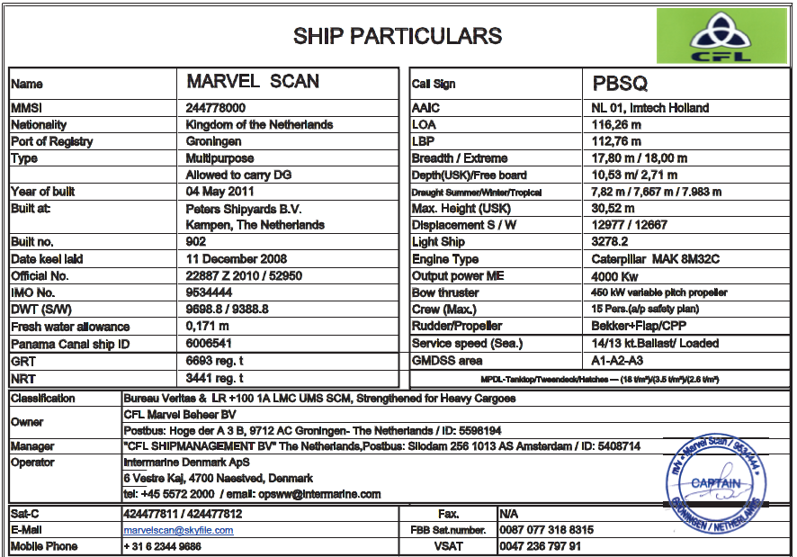

Appendix B: Main Engine Data

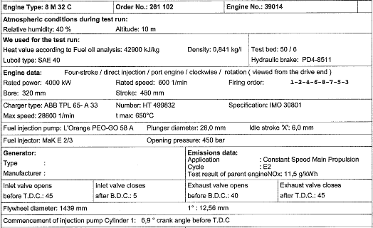

Appendix C: Casing Adjustments - View from the top

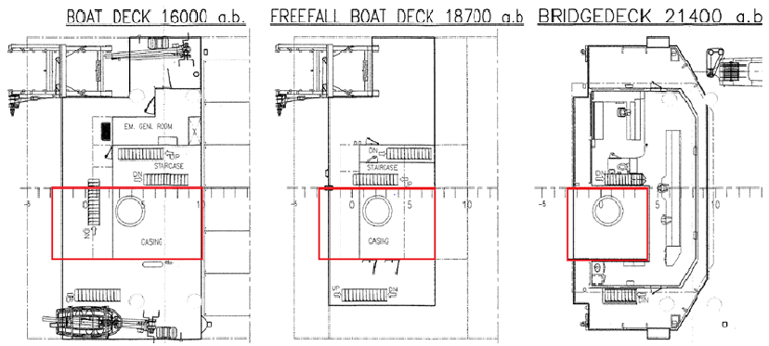

Appendix D: Casing Adjustments - View from the side

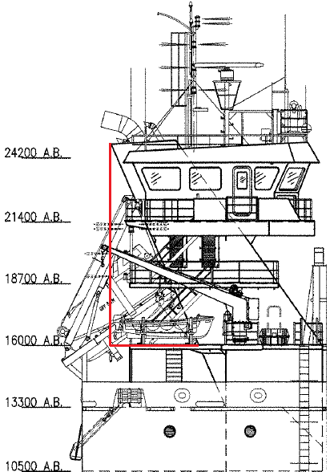

Appendix E: Final Casing Dimensions

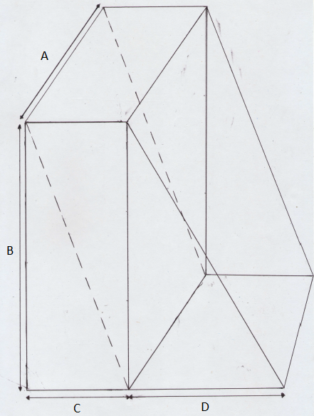
A: Width - 4.20 m
B: Height - 9.00 m
C: Depth - 3.00 m
D: Side Space - 6.00 m

Appendix F: Engine Room Tanktop Ground Plan

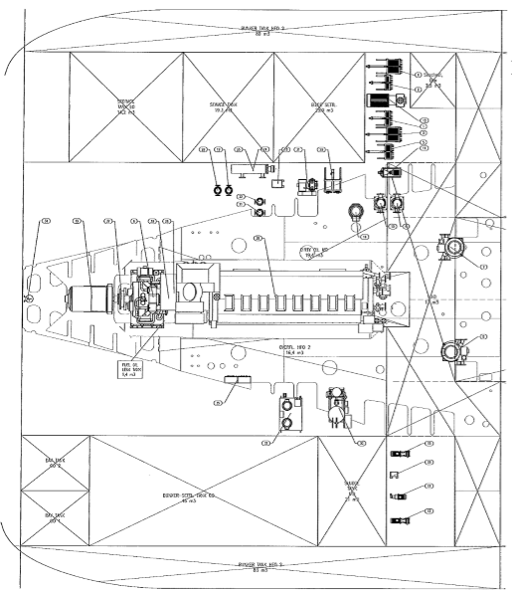

Appendix G: Engine Room Tanktop 3D-Drawing

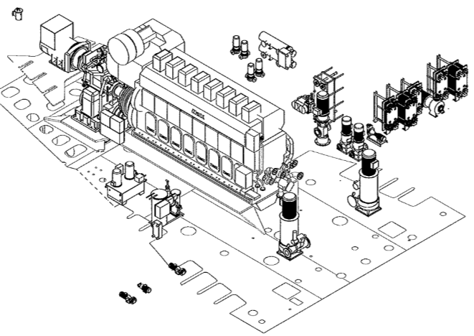

Appendix H: Engine Room Tweendeck Ground Plan

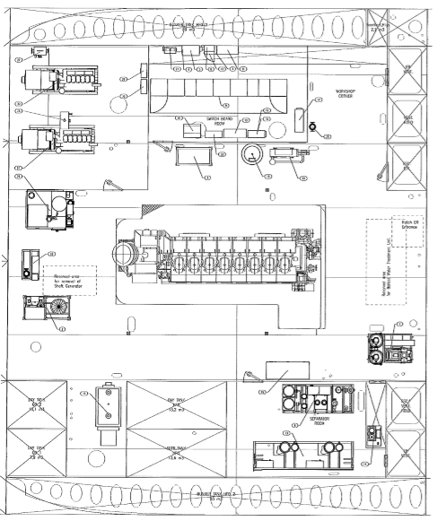

Appendix I: Engine Room Tweendeck 3D-Drawing

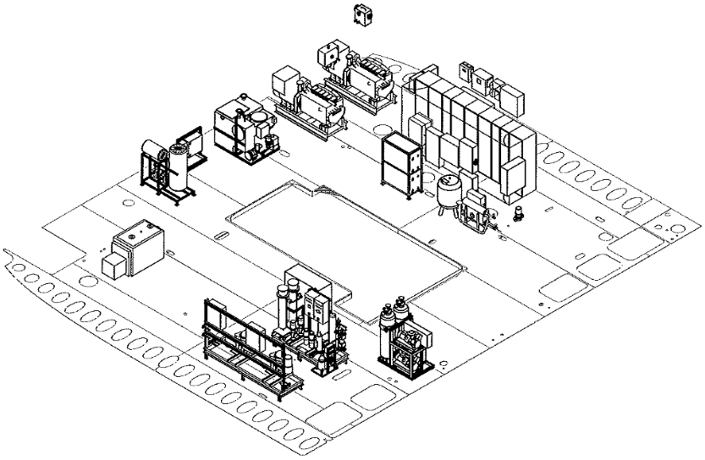

For more information about regional regulations, please refer to the book 'Marine Scrubbers: The Guide 2015'; paragraph 1.5: 'Regulatory Requirements' (Austin, 2015).
For more information about the working principle of the different scrubber systems, please refer to the book: 'Marine Scrubbers: The guide 2015', Chapter 4: Scrubber Technologies (Austin, 2015).

