Determining the electron temperature in a CO2 plasma using optical emission spectroscopy

  - A bachelor thesis on how to determine the electron temperature in a CO2 plasma by analyzing the continuum emission gathered with optical emission spectroscopy

Author: | H.J.L. Hendrickx
 | Bachelor Thesis
Commissioning party: | Dutch Institute for Fundamental Energy Research
 | HZ University of applied sciences
 | Energie- & Procestechnologie
First examiner: | J.T.H. Hoeijmakers
Second examiner: | J.A.H.R. Prins
Supervisor: | F.J.J. Peeters
 | Eindhoven
 | 07-06-2017
Version: | 2

Determining the electron temperature in a CO2 plasma using optical emission spectroscopy

  - A bachelor thesis on how to determine the electron temperature in a CO2 plasma by analyzing the continuum emission gathered with optical emission spectroscopy

Author: | H.J.L. Hendrickx
 | Bachelor Thesis
Commissioning party: | Dutch Institute for Fundamental Energy Research
 | HZ University of applied sciences
 | Energie- & Procestechnologie
First examiner: | J.T.H. Hoeijmakers
Second examiner: | J.A.H.R. Prins
Supervisor: | F.J.J. Peeters
 | Eindhoven
 | 07-06-2017
Version: | 2

Abstract

The Dutch Institute For Fundamental Energy Research (DIFFER) carries out research into the conversion and storage of sustainable energy in so-called solar fuels. The research into solar fuels aims to find efficient and convenient methods to chemically store electrical energy in fuels. An efficient and easy to use method of storing electrical energy would facilitate the increase of sustainable energy production. With sufficient electrical energy CO2 from the atmosphere, combined with water, can be converted to hydrocarbons. The first step in converting CO2 into a carbon based fuel is the dissociation of CO2 into CO and O. DIFFER explores the possibilities of this process by using a microwave plasma. This project focusses on this step of the process, studying the plasma that converts CO2 into CO and O.
The dissociation process in the plasma is strongly influenced by the conditions in the plasma. One of these conditions is the electron temperature. Finding a method to measure the electron temperature in a CO2 plasma could improve the understanding of CO2 plasma and the conversion processes within. One method of analyzing plasmas is by studying its natural light emission using spectroscopy. This report is centered around the research question:

How can visible and near UV emission spectroscopy be used to determine the electron temperature in a microwave CO2 plasma?

The goal of this research was to find a method to obtain an absolute emission spectrum of CO2 plasma from which the electron temperature can be determined by analyzing the continuum emission.
In order to reach this goal, an optical collection system was built. The spectrometer was found to have a dark-offset in the transmitted signal. This offset is both pixel- and temperature dependent. To eliminate this offset, for every pixel the relation between the offset of the pixel and the temperature was determined. Using two calibrated light sources, the optical setup was calibrated. The resulting calibration curve corrects the signal for losses in all parts of the setup, such as the quartz tube, lenses, fiber and spectrometer. Using the dark correction and the calibration curve a quantitative emission spectrum could be calculated. By measuring spectra at different locations in the plasma, the location-dependent light emission could be reconstructed with a spatial resolution of 200 μm. This method was used to analyze two CO2 plasmas under different pressures, 100 mbar and 250 mbar. Both plasmas had a power input of 1.4 kW and a flow of 6 slm.
A theoretical model for bremsstrahlung and an empirical model for CO-O recombination emission was subsequently fitted onto the continuum emission spectrum. Values for the electron temperature, gas temperature and the [CO][O] density product were obtained by this fit. The electron temperature was 2.2 eV (or 25000 K) for both plasmas. The electron temperature does not vary for different radial positions in the plasma, but the uncertainty increases with radius. The method is also shown to be effective in regions where CO-O recombination radiation is dominant over bremsstrahlung, as is the case downstream from the plasma. Here, the model can be used to determine the local gas temperature and give information about the CO and O concentrations.

Samenvatting

Het Dutch Institute For Fundamental Energy Research (DIFFER) verricht onderzoek naar de omzetting en opslag van duurzame energie in zogenaamde solar fuels. Het onderzoek naar solar fuels streeft naar efficiënte en handige methoden om elektrische energie chemisch op te slaan in brandstoffen. Een efficiënte en makkelijk te gebruiken methode voor het opslaan van elektrische energie zou de toename van duurzame energieproductie vergemakkelijken. Met voldoende elektrische energie kan CO2 uit de atmosfeer gecombineerd met water worden omgezet in koolwaterstoffen. De eerste stap in het omzetten van CO2 in een organische brandstof is de dissociatie van CO2 in CO en O. DIFFER onderzoekt de mogelijkheden voor dit proces door gebruik te maken van een microgolf plasma. Dit project richt zich op deze stap van het proces, het bestuderen van het plasma dat CO2 omzet in CO en O.
Het dissociatieproces in het plasma wordt sterk beïnvloed door de condities in het plasma. Een van deze condities is de elektronentemperatuur. Het vinden van een methode om de elektronentemperatuur in een CO2-plasma te meten zou het begrip van CO2-plasma en de omzettingsprocessen binnen kunnen verbeteren. Een methode om plasmas te analyseren is door het bestuderen van zijn natuurlijke lichtemissie met behulp van spectroscopie. Dit rapport is gericht op de onderzoeksvraag:

Hoe kan zichtbare en UV-emissie spectroscopie worden gebruikt om de elektronentemperatuur in een microgolf CO2 plasma te bepalen?

Het doel van dit onderzoek was om een ​​methode te vinden om een ​​absoluut emissiespectrum van CO2 plasma te verkrijgen, waaruit de elektronentemperatuur kan worden bepaald door de continuumemissie te analyseren.
Om dit doel te bereiken, werd een optische meetopstelling gebouwd. De spectrometer bleek een achtergrondafwijking in het doorgegeven signaal te hebben. Deze afwijking is zowel pixel- als temperatuurafhankelijk. Om deze afwijking te elimineren, werd voor elke pixel de relatie tussen de afwijking van de pixel en de temperatuur bepaald. Met behulp van twee gekalibreerde lichtbronnen is de optische opstelling gekalibreerd. De resulterende kalibratiekromme corrigeert het signaal voor verliezen in alle delen van de opstelling, zoals de kwartsbuis, lenzen, fiber en spectrometer. Met behulp van de achtergrondcorrectie en de kalibratiekromme kan een kwantitatief emissiespectrum worden berekend. Door spectra op verschillende locaties in het plasma te meten, kan de locatie-afhankelijke lichtemissie worden gereconstrueerd met een ruimtelijke resolutie van 200 μm. Deze methode is gebruikt om twee CO2-plasma's te analyseren bij verschillende druk, 100 mbar en 250 mbar. Beide plasma's hadden een vermogen van 1,4 kW en een volumestroom van 6 slm.
Een theoretisch model voor remstraling en een empirisch model voor CO-O recombinatie emissie werd vervolgens gefit op de continuumemissie spectrum. Waarden voor de elektronentemperatuur, gastemperatuur en het [CO] [O] concentratieproduct werden verkregen door deze fit. De elektronentemperatuur was 2,2 eV (of 25000 K) voor beide plasma's. De elektronentemperatuur varieert niet voor verschillende radiale posities in het plasma, maar de onzekerheid neemt toe met de straal. De methode blijkt ook effectief te zijn in gebieden waar CO-O recombinatie straling dominant is over remstraling, zoals stroomafwaarts ten opzichte van het plasma. Hier kan het model worden gebruikt om de lokale gastemperatuur te bepalen en informatie te geven over de CO en O concentraties.
List of symbols

Units:
Unit | SI | Info
m | m | Distance
K | m | Temperature
W | Js⁻¹ | Power
sr |  | Steradian Solid angle
GHz | s⁻¹ | Frequency
s | s | time
°C | K | Temperature, 0°C = 273 K
slm | m³s⁻¹ | Flow in standard liter per minute (1atm, 0°C)
eV | K | Actually eV/k_{b} , 1eV = 11604 K

Symbols:
Parameter | Use | Units
c₁ | Constant | Wm⁵sr⁻¹nm⁻¹
c₂ | Constant | mK
f | Dissociation factor | -
f_{CO} | CO concentration actor | -
f_{O} | O concentration factor | -
f₁ | Focal length of L1 | mm
f₂ | Focal length of L2 | mm
H | Hankel function
i | Square root of -1
I_{e-n} | Electron neutral radiation intensity | Wm⁻³sr⁻¹nm⁻¹
I_{CO-O} | CO-O recombination intensity | Wm⁻³sr⁻¹nm⁻¹
k | Reaction rate coefficient | Wm³ sr⁻¹nm⁻¹
n | Electron energy state | -
n | Amount of substance | mole
N_{A} | Avogadro constant | -
n₀ | Molecule/particle density | m⁻³
n_{e} | Electron density | m⁻³
n_{i} | Ion density | m⁻³
n_{n} | Neutral particle density | m⁻³
p | Pressure | Pa or mbar
Q | Cross-section | m²
R | Gas constant | kgm²s⁻²K⁻¹mol⁻¹
r | Radial position | m or mm
T_{g} | Gas temperature | K
T_{e} | Electron temperature | K or eV
V | Volume | m³
x | Coordinate of optics | M
y | Coordinate of optics | m
𝜆 | Wavelength | m or nm

Table of Contents

1 Introduction 1
2 Theory 3
2.1 Plasma 3
2.1.1 Plasma parameters 3
2.1.2 Plasma for chemical dissociation 4
2.2 Light emission from plasma 5
2.2.1 Electron excitation and line emission 5
2.2.2 Continuum emission: Bremsstrahlung 6
2.2.3 Continuum emission: CO-O recombination radiation 8
2.3 Abel inversion 10
3 Experimental method 11
3.1 Experimental setup 11
3.1.1 Microwave 12
3.1.2 Optics 12
3.1.3 Spectrometer 13
3.1.4 Spectrometer calibration 13
3.2 Positioning with stepper motor 14
3.3 Matlab 14
4 Processing data, results and discussion 15
4.1 Calibration 15
4.2 Dark correction 16
4.2.1 Pixel dependent offset 16
4.2.2 Temperature dependent offset 16
4.2.4 Effect of dark correction on a dark signal 18
4.3 Processing the spectrum data 19
4.4 Fitting model to data 21
4.4.1 Assumed electron density and gas temperature in the plasma 21
4.4.2 100 mbar plasma 22
4.4.3 250 mbar plasma 24
4.4.4 Afterglow 27
4.5 Discussion 29
4.5.1 Spectrometer temperature 29
4.5.2 Temperature profile 29
4.5.3 Gas composition 29
4.5.4 Cross-section and electron density profile 29
5 Conclusion and recommendations 30
6 References 32
Appendix A: k values by Slack and Grillo I
Appendix B: Power spectra calibration lamps II
Appendix C Matlab scripts IV
C1 Script to run experiment IV
C2 Script for abel inversion and analyzing data XIII

1 Introduction

The Dutch Institute For Fundamental Energy Research (DIFFER) carries out fundamental scientific research into new and improved energy technology for the future. Research at DIFFER focuses on two major energy themes. The first conducts research into fusion energy as a clean, safe and sustainable energy source. The second research is geared towards the conversion and storage of sustainable energy in so-called solar fuels. The research into solar fuels aims to find efficient and convenient methods to store electrical energy chemically in fuels. An efficient and easy to use method of storing energy would facilitate the increase of sustainable energy production.
Throughout its history, humanity has been on a quest to exploit as much cheap energy as it could find. The discovery of fossil fuels has boosted mankind’s energy consumption and standard of living. But the use of fossil fuels does not come without its problems. The two most prominent ones are the limited supply of fossil fuels and the environmental impact the burning of fossil fuels has. The emission of carbon dioxide is widely regarded as a severe environmental issue due to its effect on climate change. While clean energy sources are available to produce electricity, the periodic fluctuation of, primarily, photovoltaic and wind energy results in a mismatch between energy consumption and production. Storing electrical energy surpluses for later use would solve this problem. The solar fuel cycle is shown in Figure 1.
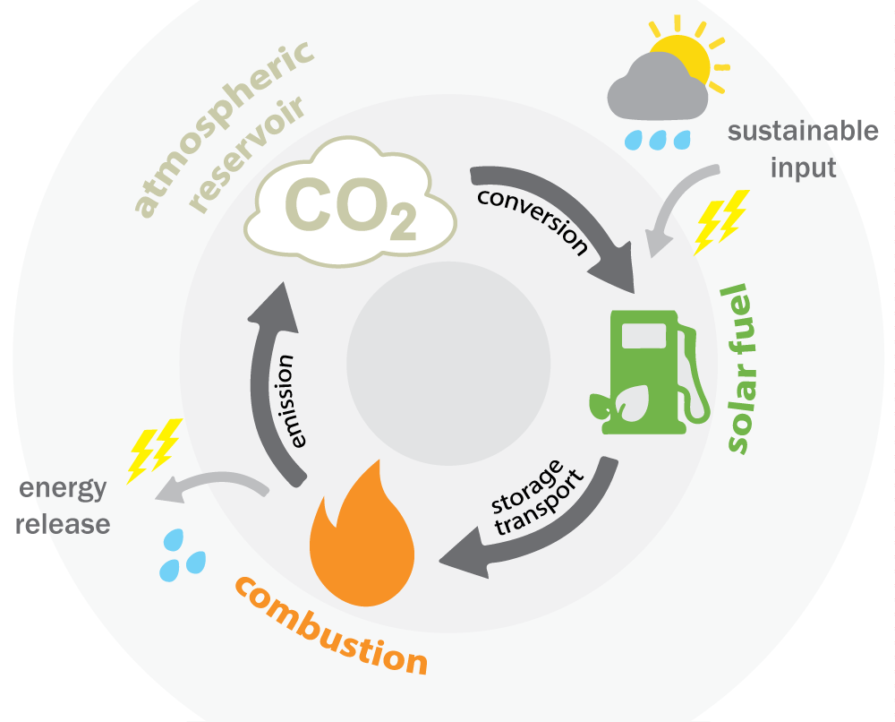
Figure 1 The CO2 neutral solar fuel cycle

One method of doing this is storing the electrical energy as chemical fuels, a concept referred to as power-to-gas. With sufficient energy, CO2 from the atmosphere, combined with water, can be converted to hydrocarbons. When using only sustainable energy sources such as wind and solar as input in such a power-to-gas process, the resulting CO2-neutral fuels are referred to as ‘solar fuels’. Using a chemical fuel as a means of storage has the side benefit that the energy stored can be used in other areas of energy consumption like transportation. The Dutch Institute for Fundamental Energy Research (DIFFER) is conducting research into utilizing a non-equilibrium plasma for the efficient production of these solar fuels.

The first step in converting CO2 into a carbon based fuel is the dissociation of CO2 into CO and O. The usage of a plasma to dissociate CO2 has the potential for efficient conversion. This project focusses on this step of the process, studying the plasma that converts CO2 into CO and O.
The dissociation process in the plasma is strongly influenced by the conditions in the plasma. One of these conditions is the electron temperature. Finding a method to measure the electron temperature in a CO2 plasma could improve the understanding of CO2 plasma and the conversion processes within. One method of analyzing plasmas is spectroscopy. This report is centered around the research question:

How can visible and near UV emission spectroscopy be used to determine the electron temperature in a microwave CO2 plasma?

The goal of this research is to find a method to obtain an absolute emission spectrum of CO2 plasma from which the electron temperature can be determined by analyzing the continuum emission.

This report guides the reader through the steps taken to reach this goal:
First the theory of plasmas is concisely explained, addressing the characteristics and parameters of plasmas. It explains how plasmas absorb energy and emit light. Then the experimental method is explained. In the succeeding chapter, the steps taken in processing the data are shown, followed by a discussion of the results of the research. Finally, the conclusions that can be made on the basis of this research are stated, including recommendations for further research and suggested improvements for the experimental method.

2 Theory

2.1 Plasma
After solid, liquid and gas, plasma is the fourth state of matter. Plasma is formed when molecules in a gas ionize. A molecule ionizes if an electron bound to the molecule receives enough energy to become a free electron. A typical plasma contains positively charged ions and negatively charged electrons. This causes a plasma to be electrically conductive. Examples of both technological and natural plasma include fluorescent lamps, welding arcs, static electricity, lightning, as well as the sun and other stars. Plasmas are characterized by a much higher conductivity than the original gas, significant emission of light and, depending on the composition of the gas, a high chemical reactivity.
To create and sustain a plasma, the energy required for ionization must be provided by an energy source. Energy sources commonly used for creating plasma are high voltage sources or electromagnetic sources. During the activation of the plasma certain steps occur. An electric field accelerates the few naturally occurring free electrons in a gas, which then collide with neutral gas atoms. If the energy of the electrons exceeds the ionization energy, the gas molecules will be ionized, releasing new free electrons. These electrons can in turn get accelerated and collide with neutral molecules in an avalanche effect. A plasma is considered to have formed once the number of new free electrons created per unit time is equal to the number of electrons lost through recombination with ions or through losses at the walls of the system per unit time.
Plasmas are classified as either thermal or non-thermal. In a thermal plasma all the different particles (ions, electrons, neutral molecules) have the same temperature and are in thermal equilibrium. In a non-thermal plasma the gas temperature is significantly lower than the electron temperature. Thermal plasma tends to occur at high gas pressures, such as in a welding arc or in the interior of the sun, while non-thermal plasma occurs at sub-atmospheric pressures, such as in a fluorescent lamp.

2.1.1 Plasma parameters
Not all molecules in a plasma have to be ionized. The number of ions as a fraction of the total number of molecules is called the degree of ionization, which varies from 0 to 1:

$degree of ionization= \frac{n_{i}}{n_{0}}= \frac{n_{i}}{n_{n}+n_{i}}$ , (1)

with $n_{i}$ the ion density [m⁻³], $n_{0}$ the molecule density [m⁻³] and $n_{n}$ the neutral particle density [m⁻³]. The number of free electrons per volume is the electron density $n_{e}$. If the contribution of second degree ionization, i.e. double ionized gas molecules, is presumed to be negligible, the electron density $n_{e}$and ion density $n_{i}$are equal:

$degree of ionization= \frac{n_{e}}{n_{0}}$ . (2)

In a typical technological plasma, the fluorescent lamp, $n_{0}$≈ 10²³ m⁻³ and $n_{e}$ ≈ 10¹⁸ m⁻³, so that the degree of ionization is only ≈ 10⁻⁵ [1]. Such low degrees of ionization imply that the molecule density $n_{0}$ and the neutral particle density$n_{n}$ are effectively equal.
The temperature of the gas is expressed as $T_{g}$ [K]. The microscopic interpretation of temperature is the distribution of energy over the particles in a gas, see Figure 2. In a non-thermal plasma the energy distribution of electrons differs from the energy distribution of the molecules, with the electron temperature $T_{e}$ [K] higher than $T_{g}$. This is a consequence of the fact that electrons have ~3500 times less mass than the least massive molecule (H₂). Since it is the electrons which are directly accelerated in the applied electric field, they easily gain a lot of energy (in the form of velocity). They lose this energy only through collisions with the heavier gas particles, which may occur at a lower rate than they gain energy in the field. This leads to higher electron temperature $T_{e}$ coexisting with a lower gas temperature $T_{g}$ within the same volume of gas. This difference in temperature is what makes non-thermal plasma of technological interest: low temperature gas particles can be bombarded by high temperature electrons, allowing certain processes to occur at higher rates than would be expected based on the temperature of the gas particles alone. $T_{e}$ is often given in units of [eV], 1 eV corresponds with 11604 K.
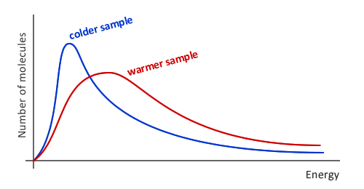
Figure 2 Energy distribution of molecules for two different temperatures

2.1.2 Plasma for chemical dissociation
In Solar Fuels research, plasma is employed primarily for its high chemical reactivity. Plasma in CO2 can be used to dissociate the molecules into CO and O. Dissociation of CO2 in the plasma can take place via two mechanisms. The first is by thermal dissociation, which relies on a reversible shift in the chemical equilibrium towards the products induced by thermal heating. This type of dissociation is simply the result of the heavy gas particles colliding and reacting with each other. The dissociation fraction is then governed by the gas temperature $T_{g}$ and becomes significant at temperatures typically above 2000 K.
The second mechanism of dissociation is initiated via electron-induced vibrational excitation. This dissociation channel relies heavily on the non-thermal nature of the plasma. Collisions of electrons with CO2 molecules result in the excitation of vibrational modes of CO2 which favor dissociation. With this type of dissociation, the CO2 molecule simply vibrates until it breaks apart. This mechanism allows for dissociation that uses less energy than thermal dissociation. In theory, CO2 dissociation could be achieved through vibrational excitation without the need to heat the gas to > 2000 K. Essential to boosting vibrational dissociation over thermal dissociation is to have an electron temperature no greater than 12000 K in the plasma [2].

2.2 Light emission from plasma
The particles in the plasma can emit light. There are several effects that can cause this. The emission spectrum is a result of all effects combined. The CO2 plasma emits both line/band radiation and continuum radiation, together shaping the spectrum of which an example is shown in Figure 3. This report analyses the continuum emission of the CO2 plasma to determine plasma conditions like the electron and gas temperatures.
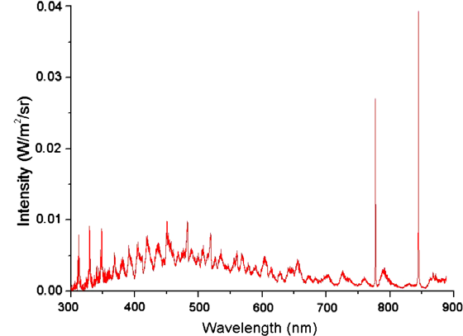
Atomic line emission
Molecular band emission
Continuum emission
Figure 3 A spectrum of a CO2 plasma, consisting of both line/band emission and continuum components [3]

2.2.1 Electron excitation and line emission
If energy is absorbed by a molecule, it is possible that the energy is absorbed by a bound electron in the outer shell of a molecule. Transfer of energy from a free electron to the molecule can excite a bound electron into a higher orbit, which is schematically depicted in Figure 4. For example, an electron in the ground state n=1 can absorb energy and be excited to exited states n=2 or n=3. If an electron absorbs enough energy to go to n=∞, the electron becomes unbound and ionization has taken place. Thus, the amount of electrons exited to n=∞ determines the degree of ionization and increases the electron density. It must be noted that electron energy levels occur in very discrete levels; it is not possible for an electron to be in state n=2.5. This discrete energy level behavior determines, to a large extent, the light-emitting properties of the plasma. When an electronically excited molecule relaxes back to a lower state, the extra energy is released as a photon with a specific wavelength. This spontaneous process causes plasma to produce specific photon emission lines, depending on the type of gas, which can be studied spectroscopically. Some of these transitions are more common than others, resulting in a wavelength dependent intensity showing up in the emission spectrum as peaks of varying height. All molecules in the plasma have characteristic wavelengths at which photons are emitted. This process is referred to as line- or band emission and the resulting spectrum is called a line- or band spectrum. An example of line emission is shown in Figure 5 for a low pressure argon plasma. In the CO2 plasma being studied in this project, several atoms and molecules occur: CO2, CO, O, O2, C and C2. Although this project focusses on other types of emission, line and band emission from these species will be evident in the spectrum.

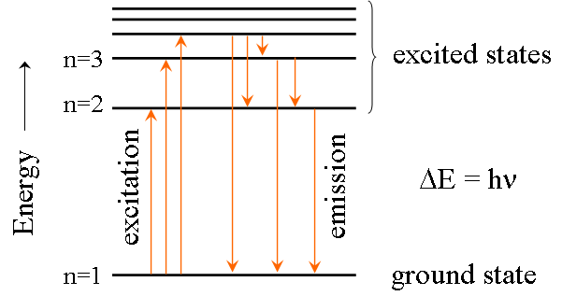
Figure 4 Electron excitation and emission

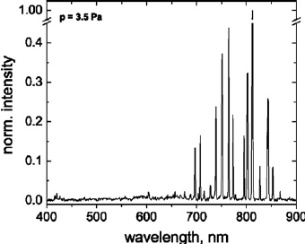
Figure 5 Example of line emission in argon plasma [4]

2.2.2 Continuum emission: Bremsstrahlung
If an electron in the plasma interacts with another particle and its momentum changes, excess energy can be released as a photon. This is schematically depicted in Figure 4, where an electron approaching a heavy particle is deflected while simultaneously emitting a photon. The emission resulting from these electron-particle interactions is referred to as bremsstrahlung (‘braking radiation’). The energy the photon has is not restricted to discrete transitions, as is the case in line- or band-emission, and thus the contribution of the bremsstrahlung to the spectrum is a continuum. Electrons can produce bremsstrahlung through interactions with ions, potentially recombining in the process, or with neutral molecules. The neutral particles have a positive nucleus which can interact with electrons. The intensity of the bremsstrahlung depends on the electron and (ion or neutral) particle densities.
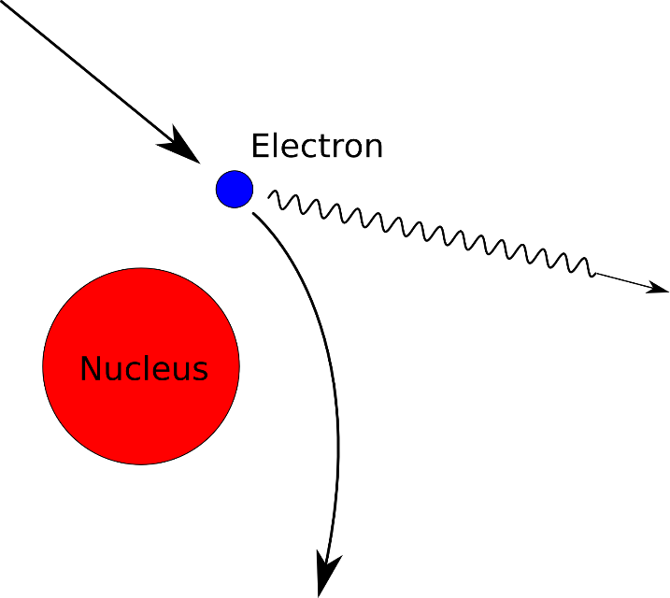
Figure 6 Bremsstrahlung: when an electron changes momentum due to interaction with a heavy particle, it can emit a photon.

In a CO2 plasma, the relatively low degrees of ionization make the contribution of electron-ion bremsstrahlung negligible, leaving only the electron-neutral radiation [5] [6]. The absolute intensity of electron-neutral radiation in [Wm⁻³sr⁻¹nm⁻¹] is expressed by Akcasu and Wald as [7]:
$$I_{e-n}\left(λ\right)= c_{1}n_{e}n_{n}Q\frac{e^{\frac{-c_{2}}{λT_{e}}}}{λ^{4}\sqrt{T_{e}}}({-i*H}_{2}^{\left(1\right)}\left[ \frac{ic_{2}}{ λT_{e}}\right])$$, (3)

where $c_{1}$=1.05·10⁻⁴⁶ Wm⁵sr⁻¹nm⁻¹ , $c_{2}$=7.2·10⁻³ mK and $H_{2}^{\left(1\right)}$ a second order Hankel function of the first kind. $Q$ is the cross-section for electron momentum transfer to gas particles in [m²], or in other words the likeliness of electron-molecule interaction. $Q$ depends weakly on $T_{e}$ and the type of molecules in the gas, but is set to be constant at 10⁻¹⁹ m² for this report.

2.2.3 Continuum emission: CO-O recombination radiation
CO and O molecules in the plasma can recombine into CO2. The CO2 produced in this recombination reaction tends to be in a higher energy state (Figure 3). The CO2 can subsequently transition to a lower energy state by emitting a photon. While CO2 transitions are discreet, due to the many possible transitions, the spectrum looks continuous. The shape of the spectrum is dependent on the temperature of the gas, while its intensity depends on the product of the concentration of CO and O. The emission $I_{CO-O}$ [Wm⁻³sr⁻¹nm⁻¹] can be described by:

$I_{CO-O}\left(λ\right)=k\left(T_{g},λ\right)\left[CO\right][O]$ (4)

With [CO] and [O] concentrations in [m⁻³] and $k\left(T_{g},λ\right)$a reaction rate coefficient in [Wm³ sr⁻¹nm⁻¹]. For the values of $k\left(T_{g},λ\right)$ empirical data by Slack an Grillo is used [8]. Clarification of $k\left(T_{g},λ\right)$ can be found in Appendix A. Since $k\left(T_{g},λ\right)$ is dependent on $T_{g}$, an assumption for the gas temperature must be made.
The gas temperature is also needed to calculate the particle density of the gas using the ideal gas law:

$pV=nRT_{g}$ , (5)

with pressure p in [pa], volume V in [m³], n the amount of substance in the gas in [mole], gas constant R=8.314 kgm²s⁻²K⁻¹mol⁻¹ and T the temperature in [K]. The particle density $n_{0}$ [m⁻³] is calculated in a variation of the ideal gas law:

$n_{0}=\frac{pN_{A}}{RT_{g}}$ , (6)

with N_{A} being Avogadro’s constant 6.022*10²³. [CO] and [O] in equation (4) are dependent on $n_{0}$ and the degree of dissociation of CO2. If for a moment the assumption is made that the plasma contains only CO2, CO and O, a factor $f$ can be introduced. $f$ is the degree to which CO2 is dissociated into CO and O so that the concentrations of CO and O are
$\left[CO\right]=\left[O\right]=fn_{0}$ (7)

Applying (7) to equation (4) results in the following expression for the emission:

$I_{CO-O}\left(λ\right)=k\left(T_{g},λ\right)f^{2}{n_{0}}^{2}$ (8)

In reality the concentration of CO is not equal to that of O due to the formation of O2. To take the disparity in concentration of CO and O into consideration the value of factor $f$ should formally be split into separate fractions$f_{CO}$ and $f_{O}$for CO and O, respectively. The end result, however, is the same as when combining equation (4) with equation (8):

$f=\sqrt{f_{CO}f_{O}}=\sqrt{\frac{\left[CO\right]\left[O\right]}{n_{0}^{2}}}$ (9)

This definition for $f$ will be used throughout this report, thereby supposing the formation of C and C2 to be negligible. Since the fraction $f_{O}$ may be lower than $f_{CO}$ due to formation of O2, $f$ only provides a lower limit to the dissociation degree of CO2.

2.3 Abel inversion
In order to determine local plasma properties using spectroscopic methods, the emission must be determined locally. When measuring the plasma, the integrated emission along a line of sight through the plasma is observed instead, see Figure 7. Considering the non-homogenous shape of the plasma, simply correcting for the width of the circle at each measurement point will not suffice.
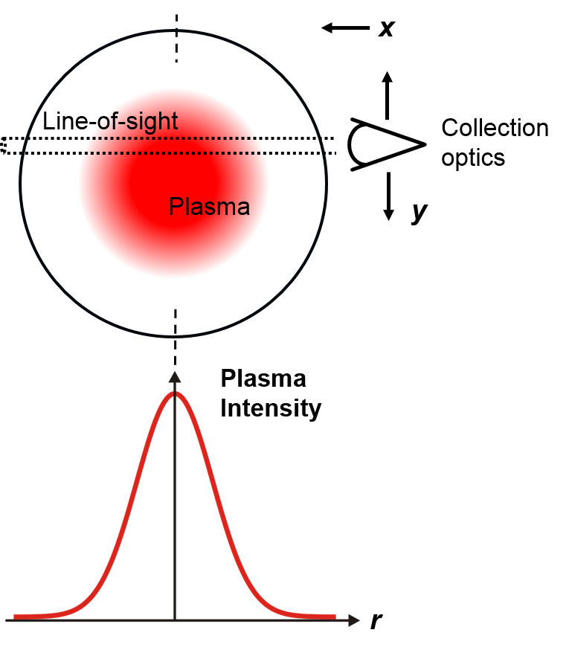
Figure 7 Schematic of the line of sight measurements through the plasma as seen from above. The integrated plasma intensity is observed along the x-coordinate at each y position (top). With Abel inversion the radial plasma intensity profile can be reconstructed (bottom).

To reconstruct the radial emission profile from the measured profile, the data is Abel Inverted. Abel inversion is an integral transform technique that can be used to obtain the radial distribution function of an axially or spherically symmetric function or dataset. The Abel inversion is conducted as described by Cho and Na. [9]

3 Experimental method

3.1 Experimental setup
A schematic view of the experimental setup is shown in Figure 8, with a more detailed drawing of the plasma setup and a photograph of the plasma are shown in Figure 9. CO2 flows in a vortex through a Ø3 cm quartz tube. The CO2 flow can be adjusted but is for this project set to 6 slm (standard liter per minute for 0°C and 1 atm). The CO2 in the tube is exposed to microwave radiation resulting in the formation of a plasma. Light emitted by the plasma along a line of sight is caught by the optical setup after which it is converted to a signal by the spectrometer. The optical setup will be discussed in more detail in the following sections.
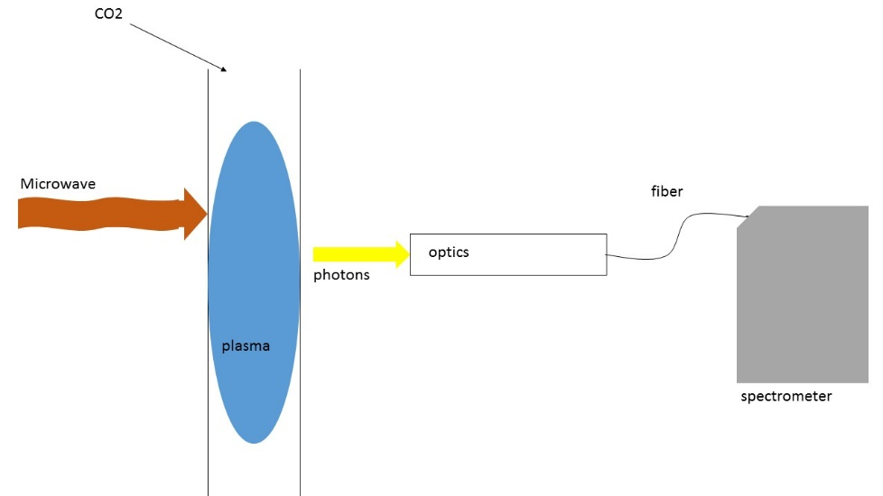
Quartz tube
Figure 8 Schematic view of the experimental setup
The purpose of CO2 flowing in a vortex as opposed to a purely axial flow, as depicted in Figure 9, is to stabilize the plasma in the middle of the tube and keep the temperatures at the sides of the flow relatively low as not to melt the quartz tube.

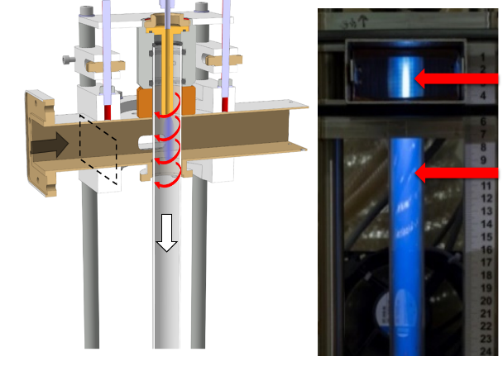
Figure 9 On the left a cross-sectional view of the plasma setup and on the right a photograph of the CO2 plasma in the quartz tube. The red arrows in the left image indicate the vortex flow. The arrows in the right image indicate axial measurement positions.

3.1.1 Microwave
To activate and maintain the plasma the CO2 gas is exposed to microwave radiation. The microwave radiation is contained within a rectangular waveguide surrounding the quartz tube, see Figure 9. The frequency of the microwave is 2.45 GHz, corresponding to a wavelength of 12.2cm. This is the same frequency as used in common microwave ovens. The power of the microwave radiation can be adjusted but is set to 1.4 kW for the purposes of this project.

3.1.2 Optics
The light emitted by the plasma is collected by the optical setup as shown in Figure 10. The optical system consists of lens L1 with f1=125 mm (600 nm), a pinhole of 200 𝜇m diameter, lens L2 with f1=35 mm and an optical fiber with an opening of 50 𝜇m in diameter. The diameter of the lenses is 22.9 mm. With these optics, light emitted in front of the lens L1 can be collected with roughly equal efficiency, see Figure 11, leading to a line of sight measurement of plasma emission.
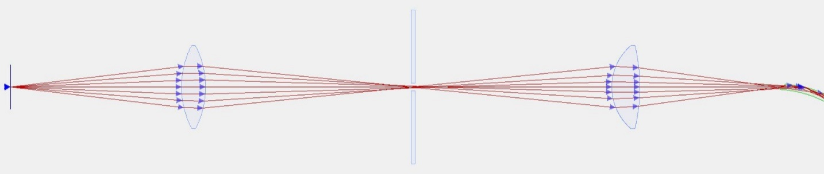
245mm
245mm
176mm
37mm
Fiber to spectrometer
L2
pinhole
L1
plasma

Figure 10 Optical system (not to scale)

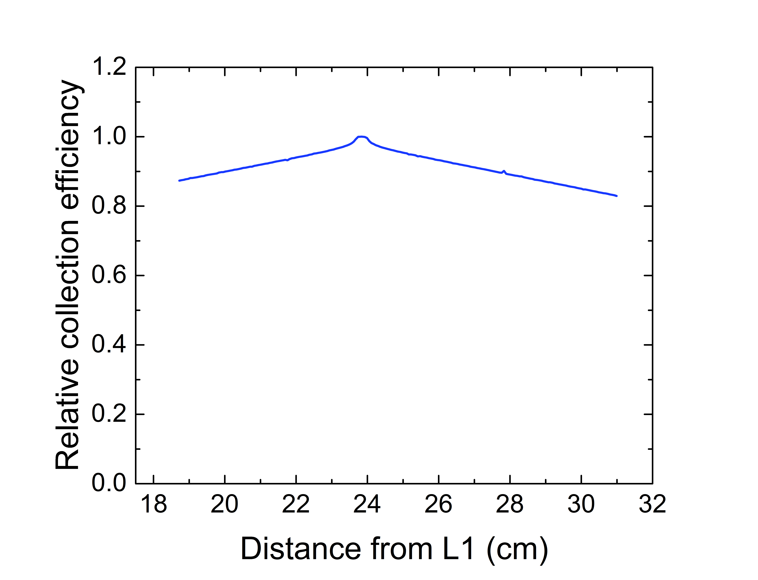
Figure 11 The purpose of CO2 flowing in a vortex as opposed to a purely axial flow, as depicted in Figure 9, is to stabilize the plasma in the middle of the tube and keep the temperatures at the sides of the flow relatively low as not to melt the quartz tube.

L1 is positioned a distance from the light source at circa twice the distance of the focal length f1. The pinhole is positioned at roughly the same distance on the other side of L1. The pinhole is used to narrow down the diameter of the line of sight. The size of the pinhole therefore determines the spatial resolution of the measurements. L2 is used to focus the light coming through the pinhole into the fiber. The reason the positioning at 245 mm deviates from 2*f1=250 mm is due to the wavelength dependent focal length of lenses (chromatic aberration), the chosen position favors wavelengths below 600 nm.

3.1.3 Spectrometer
The spectrometer used is the Ocean Optics HR4000. Specifications of the HR4000 that are relevant for this project can be found in Table 1. The spectrometer can measure emission from 200 nm to 1100 nm. There is a temperature sensor inside which can be used to monitor the temperature which is needed to correct the signal for background noise, which will be discussed later in this report. Data collected by the spectrometer is sent to a computer via a USB-cable.
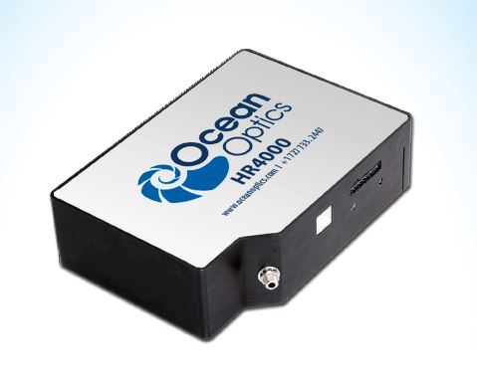
Figure 12 Ocean Optics HR4000 spectrometer

Table 1 Specifications of the HR4000 [10]
Number of pixels | 3648
Detector range | 200-1100nm
Average pixel range | 0.258nm
Integration time | 3.8ms to 10 s

3.1.4 Spectrometer calibration
To obtain the power spectrum from the light collected by the spectrometer, the relation between the signal from the spectrometer (in counts/s/pixel) and the actual power spectrum (in Wm⁻³sr⁻¹nm⁻¹) must be established. To do this, two light sources with known radiation spectra are used, one for the UV range and one for the visible range. The power spectra of these sources can be found in Appendix B.

3.2 Positioning with stepper motor
To create a profile of the plasma, the positioning of the optics needs to be adjusted repeatedly. The position of the optics can be adjusted by stepper motors. Two stepper motors are used, allowing for adjustment of the radial and axial position of the optics relative to the quartz tube. The stepper motors are controlled by a Newport Single-Axis Motion Controller/Driver: SMC100 [11].

3.3 Matlab
The spectrometer and the stepper motors can both be controlled by a computer. A Matlab script is used to control the measurements of the experimental setup. The script automatically scans the plasma at the designated positions and stores the data (spectra and spectrometer temperature). The Matlab script can be found in Appendix C.
Matlab is also used for determining the calibration curve, execute Abel inversion, calculate the background signal and comparing the processed data with the theoretical models. The Matlab scripts can be found in Appendix C.

4 Processing data, results and discussion
This chapter addresses the necessary steps in processing and analyzing the data. It explains the calibration of the equipment, the elimination of background radiation and the necessary assumptions about the conditions in the plasma. After that, the results of the analysis and the application of the model are discussed, ending with a discussion of the used method.

4.1 Calibration
Using two calibration lamps, a calibration curve was made. The result provides the relation between each count (per pixel) registered by the spectrometer and the number of photons emitted by the plasma. The calibration curve includes losses in the quartz tube, optics, fiber and the spectrometer itself.
In Figure 13 the calibration curve is shown. It shows the amount of photons that need to be captured by the system in order for a count to be registered. It can be seen that the sensitivity is relatively low in the 200-270 nm range, is optimal in the visible range and decreases again in the infrared range. Since no signal could be distinguished from the base-line noise in these low sensitivity ranges (typically +/- 15 counts), the data in these ranges do not provide reliable information and are avoided when fitting equation (3) and (8) on the experimental data.
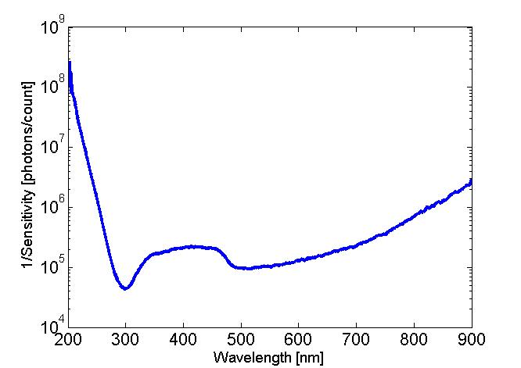
Figure 13 Calibration curve of the optical system and spectrometer combined. Sensitivity is optimal in the range of 270 – 710 nm.

4.2 Dark correction
If no light is absorbed by the spectrometer, the spectrometer still registers a base line signal: the dark spectrum. To obtain an accurate power spectrum the signal coming from the spectrometer has to be corrected for this dark spectrum.

4.2.1 Pixel dependent offset
In Figure 14 a dark spectrum collected over 10 seconds is shown. Figure 14 seems to indicate a significant noise in the signal with an uncertainty range of about 2000 counts. However in Figure 15, three different dark measurements show that the ‘noise’ is, in fact, primarily a pixel specific offset, which is almost completely reproducible.
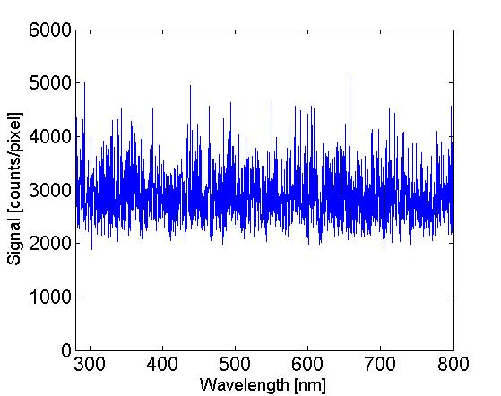 | 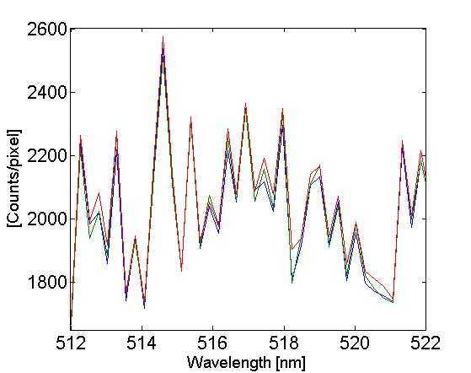
Figure 14 Dark signal: the apparent noise is, in fact, a pixel specific offset. | Figure 15 Three consecutive dark measurements zoomed in, showing the reproducibility of the pixel specific offset.

4.2.2 Temperature dependent offset
Although the offset of a pixel is predictable, it is not constant. The offset is strongly influenced by the temperature of the spectrometer, which varies significantly between measurements. The temperature dependence of some pixels can be seen in Figure 16.
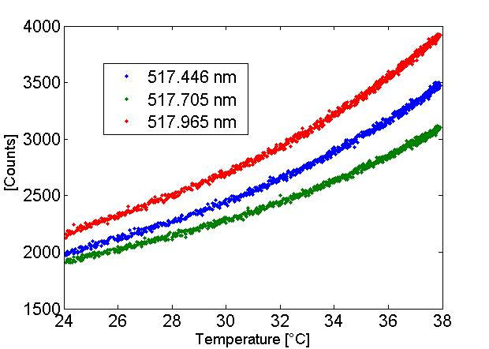
Figure 16 Temperature dependence of dark signal

In order to correct for the temperature dependent offset, a fit is made for every pixel to determine the offset, with the temperature of the spectrometer as input. The fit is a fourth degree polynomial function with $T_{g}$ in [°C]:

${Darkcounts=P}_{1}{T_{g}}^{4}+P_{2}{T_{g}}^{3}+P_{3}{T_{g}}^{2}+P_{4}T_{g}+P_{5}$ (10)

The values of P₁₋₄ are pixel dependent. The result of a fit is shown in Figure 17. It has been found that the response of a pixel “jumps” unpredictably as shown in Figure 18. This behavior sometimes causes the dark correction to be off. This is taken under consideration when correcting for dark signal, by correcting the peaks resulting from this phenomenon.
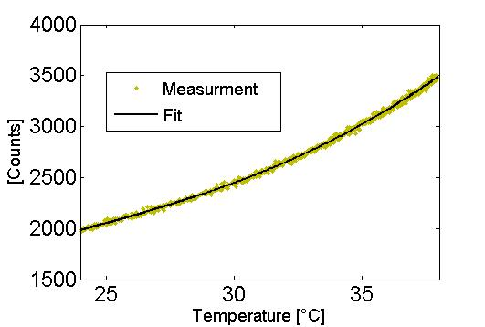
Figure 17 Temperature dependent fit using equation (10)

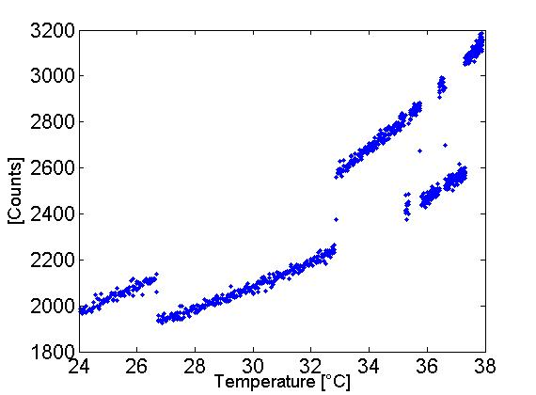
Figure 18 Dark-offset of a pixel can change randomly, negatively affecting the overall dark correction

4.2.4 Effect of dark correction on a dark signal
In Figure 19 and Figure 20 a measured dark spectrum and a digitally reconstructed dark spectrum are shown respectively. It can be seen that the shape of the dark signal, that appears as noise on first glance, is fairly accurately reconstructed by the temperature-dependent-pixel-offset-polynomials.
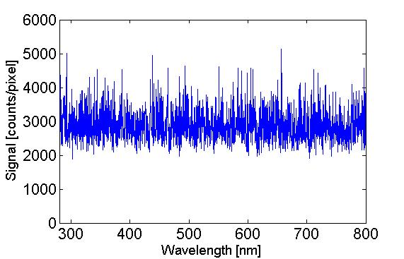 | 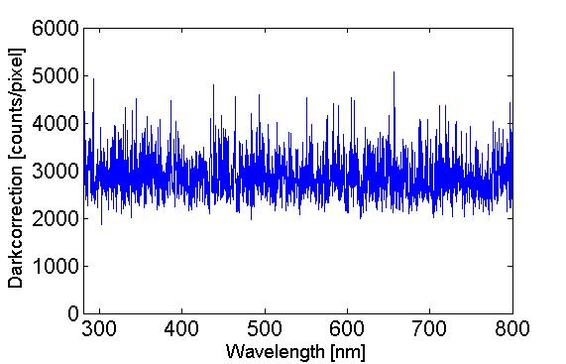
Figure 19 Dark spectrum measurement | Figure 20 Dark spectrum reconstructed digitally

The spectra in Figure 19 and Figure 20 are subtracted in order to find the actual noise and errors in the spectrum. The result in Figure 21 shows that the residual noise is reduced to a margin of about 100 counts, which is a significant improvement from the 2000 counts in Figure 19. The spectrum in Figure 21 also shows some peaks that are a result of pixels that “jumped” as shown in Figure 18.
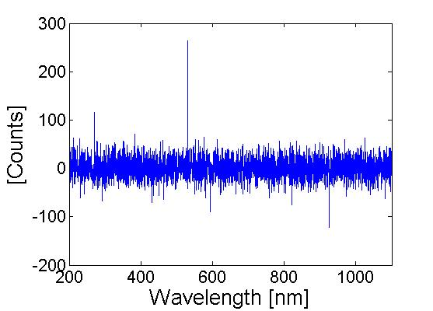
Figure 21 Dark corrected background measurement

4.3 Processing the spectrum data
In Figure 22 the unprocessed signal from a CO2 plasma is shown. The plasma has a pressure of 100 mbar a flow of 6 slm CO2 and a power input of 1.4 kW. The spectrum is taken near the center of the plasma at r=0.4 mm.
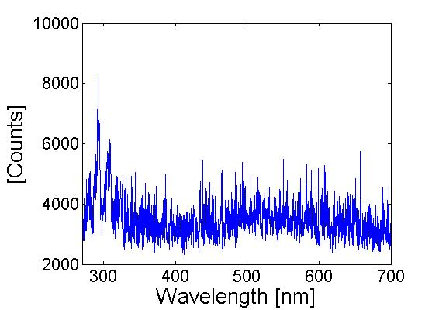
Figure 22 Unprocessed spectrometer signal for CO2 plasma at r=0.4 mm for 100 mbar, 6 slm and 1.4 kW

After the dark spectrum is subtracted from the signal the spectrum in Figure 23 remains. The spectrum in Figure 23 is in counts. The spectrum was converted into a power spectrum in units of Wm⁻³sr⁻¹nm⁻¹ using Abel inversion and application of the calibration curve, combined with the specifications of the optical system, the duration of the measurement, and the photon energy. The result of this process is shown in Figure 24.

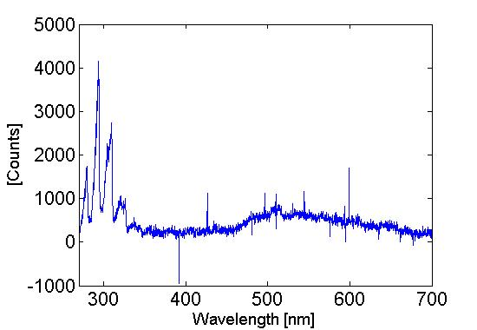 | 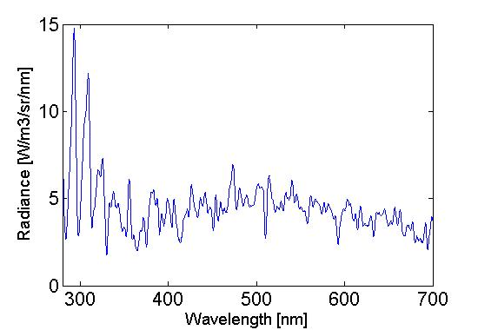
Figure 23 Spectrum for CO2 plasma after dark correction at r=0.4 mm for 100 mbar, 6 slm and 1.4 kW | Figure 24 Power spectrum for CO2 plasma at r=0.4 mm for 100 mbar, 6 slm and 1.4 kW

Without processing, the shape of the spectrum can still be recognized in the signal in Figure 22. The same process is applied to the signal in Figure 25 resulting the power spectrum in Figure 26. The process obtains a power spectrum that can be analyzed from a signal that appears to be little more than noise.

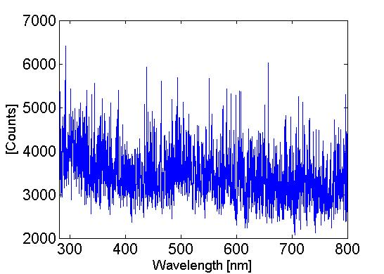 | 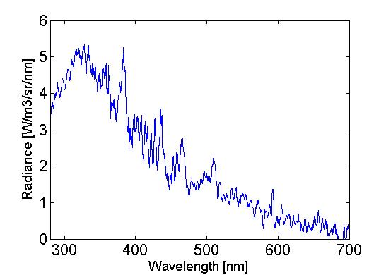
Figure 25 Unprocessed spectrometer signal for CO2 plasma at r=6 mm for 250 mbar, 6 slm and 1.4 kW | Figure 26 Power spectrum for CO2 plasma at r=6 mm for 250 mbar, 6 slm and 1.4 kW

4.4 Fitting model to data

To determine $T_{e}$ and $f$ of a CO2 plasma using (3) and (8), plasmas under two sets of conditions are analyzed. The two CO2 plasmas have the same flow of 6 slm and the same power input of 1.4 kW. Only the pressures of the plasmas differ, being 100 mbar and 250 mbar. At a pressure of 100 mbar, the plasma is visually much wider than at 250 mbar. Plasma at 100 mbar is at the edge of the so-called ‘diffuse regime’, while at 250 mbar it is in the so-called ‘contracted regime’. Since these are the only two distinct plasma regimes, these two sets of conditions allow for a complete evaluation of the capabilities of optical emission spectroscopy in CO2 plasma.

4.4.1 Assumed electron density and gas temperature in the plasma
In order to fit equations (3) and (8) on the experimental data, the profiles of the electron density and gas temperature are taken from previous experimental campaigns. Gaussian profiles can be assumed for both parameters. For the values of $n_{e}$, experimental data from Toonen is employed, determined using microwave interferometry [12]. $T_{g}$ in the plasma is derived from data from Den Harder, measured using laser scattering spectroscopy [13]. The assumed electron densities are shown in Figure 27 for 100 mbar and in Figure 28 for 250 mbar. The assumed gas temperature are depicted in Figure 29 and Figure 30.

Figure 27 The electron density profile in a CO2 plasma under conditions: 100 mbar, 1.4 kW and 6 slm | Figure 28 The electron density profile in a CO2 plasma under conditions: 250 mbar, 1.4 kW and 6 slm
Figure 29 The gas temperature profile in a CO2 plasma under conditions: 100 mbar, 1.4 kW and 6 slm |  | Figure 30 The gas temperature profile in a CO2 plasma under conditions: 250 mbar, 1.4 kW and 6 slm

Since values for $n_{e}$ and $T_{g}$ are assumed equal to previous experiments, only $f$ and $T_{e}$ remain to fit (3) and (8) to the emission spectrum. Because $n_{e}$ is highest in the center of the plasma and much lower towards the edges, the bremsstrahlung is dominant near the center of the plasma and the CO-O recombination emission is dominant further away from the center. This has the consequence that the value of $f$ near the center of the plasma can not be accurately determined. Likewise, $T_{e}$ can not accurately be deduced near the edges of the plasma, though it is expected to be very low, or even non-existent where $n_{e}$ becomes negligibly small.

4.4.2 100 mbar plasma

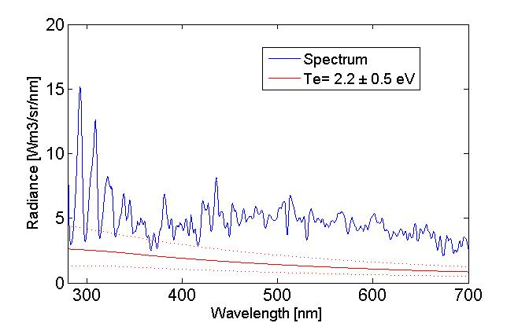
Figure 31 Emission spectrum of CO2 plasma at r=0.6 mm under conditions: 100 mbar, 1.4 kW and 6 slm. The red line is a continuum radiation fit with an uncertainty band of 0.5 eV and f=0.3

In Figure 31 the power spectrum at r=0.6 mm of the 100 mbar plasma is shown. The peaks around 300 nm are recognizable CO band emission peaks, with the smaller peaks between 350 – 700 nm tentatively attributed to CO band emission. In the 100 mbar plasma, the shape of the spectrum remains more or less the same for the width of the plasma. Contrary to that, the total intensity of the emission gradually decreases further from the center of the plasma up to r=10 mm. Further from the center of the plasma the CO band emission peaks can no longer be identified and emission is minimal to none. The width of the plasma is about 20 mm. The model describes continuum emission only, therefore the peaks in the plasma are ignored when the model is fitted on the experimental data.
The red line in Figure 31 is the fitted continuum emission using $f$=0.3 and $T_{e}$=2.2 eV. The dotted red lines indicate the emission for $T_{e}$=1.7 eV and $T_{e}$=2.7 eV providing an indication of the uncertainty in the electron temperature. The electron temperature is found to be around 2.2 eV. For different values of r, there seems to be no notable variation in the electron temperature, being about 2.2 eV for the entire width of the plasma.

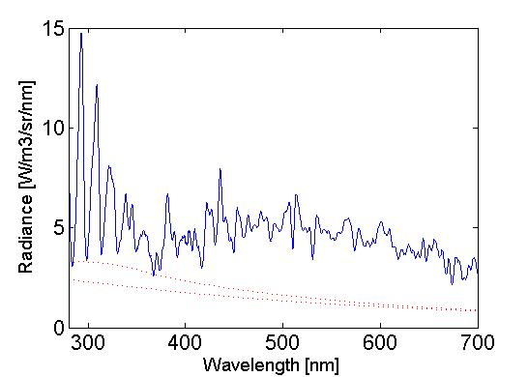
Figure 32 Emission spectrum of CO2 plasma at r=0.8 mm under conditions: 100 mbar, 1.4 kW and 6 slm. The red lines are continuum radiation fits for Te=2.2 eV for f=0 (lower line) and f=0.4 (upper line)
In the center of the plasma bremsstrahlung is dominant but CO-O recombination radiation can not be neglected. The dotted lines in Figure 32 are the continuum emission fits for $f$=0 and $f$=0.4, showing the contribution of recombination radiation. Higher values for $f$ correspond with slightly lower values for $T_{e}$. The exact value of f in the center region of the plasma can, at present, only be estimated. Using a chemical equilibrium calculation, as demonstrated by Den Harder [13], gives f ≤ 0.45 at the conditions of Figure 31 and Figure 32. This type of calculation assumes an infinite time for reactions to take place, however, while in reality the CO2 passes through the plasma within several milliseconds. The value of f = 0.3 employed in Figure 31 is considered a good estimate, since it also matches well with the amount of CO produced by the plasma, see [13].

4.4.3 250 mbar plasma
In Figure 33 the power spectrum at r=0.6 mm of the 250 mbar plasma is shown. The CO peak near 300 nm can again be identified. The notable difference from the 100 mbar plasma are the big peaks in the 350 – 560 nm range. These peaks are called Swan bands and are caused by emission from C2. It shows that the formation of C2 molecules is occurring significantly more in a 250 mbar plasma than in a 100 mbar plasma. Contrary to the 100 mbar plasma, the shape of the spectrum of the 250 mbar plasma does not remain the same if observed further from the center.
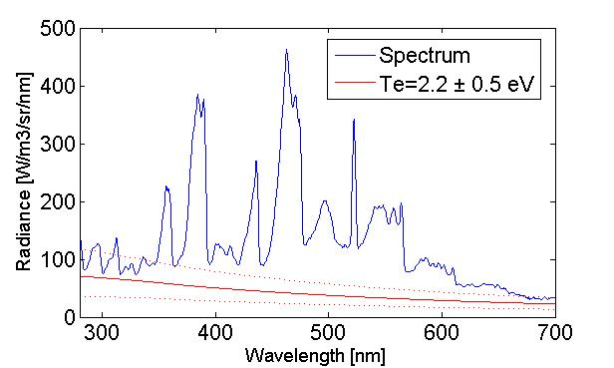
Figure 33 Emission spectrum of CO2 plasma at r=0.6 mm under conditions: 250 mbar, 1.4 kW and 6slm. The red line is a continuum radiation fit with an uncertainty band of 0.5 eV

The spectrum in Figure 33 is taken at r=0.6 mm. The red line in Figure 33 is the modelled continuum emission for $T_{e}$=2.2 eV. The dotted lines indicate the range between 1.7 eV and 2.7 eV. The electron temperature for the 250 mbar plasma is around 2.2 eV. The electron temperature is the same for a 100 mbar plasma as it is for a 250 mbar plasma.
The CO-O recombination radiation is negligible in the center of the 250mbar plasma. In Figure 34 the dotted lines show the continuum radiation fit for $f$=0 and $f$=0.4, showing the limited contribution of recombination radiation. The value of $f$ can not be determined using this method under these conditions. The chemical equilibrium calculation of Den Harder predicts f ≤ 0.50, but is assumed to be no greater than 0.4, as discussed for the case of 100 mbar plasma.
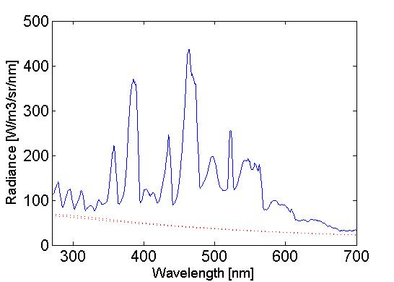
Figure 34 Emission spectrum of CO2 plasma near the center under conditions: 250 mbar, 1.4 kW and 6slm. The dotted lines are continuum radiation fits with f=0 (lower line) and f=0.4 (upper line)

Toward the edge of the plasma, the shape and intensity of the spectrum change significantly while CO-O recombination radiation is dominant. In Figure 35 the spectrum at r=6 mm of the 250 mbar CO2 plasma is shown. Some C2 peaks can still be recognized but the overall shape of the spectrum looks a lot different from Figure 33.
The green line in Figure 35 is the continuum emission fit, primarily shaped by the CO-O recombination radiation model. The shape of the fit depends on the gas temperature and $T_{g}$=2114 K is the assumed temperature as shown in Figure 30. Using this temperature results in an $f$=0.25. However, in the same spectrum a fit can be made assuming a different temperature. In Figure 36 a fit is made using $T_{g}$=2777 K and $f$=0.29, which better fits the experimental data.

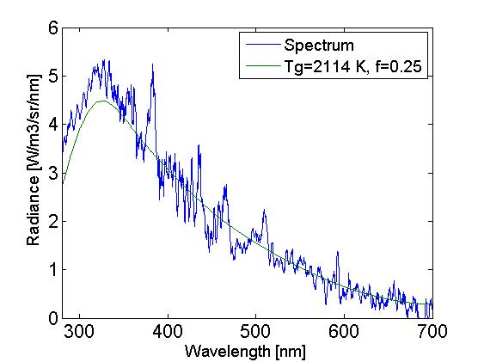
Figure 35 Emission spectrum of CO2 plasma at r=6mm under conditions: 250 mbar, 1.4 kW and 6slm. The green line (model) assumes the gas temperature shown in Figure 30.
From the comparison between Figure 35 and Figure 36, it can be concluded that the temperature in the plasma at r=6 mm is near 2777 K instead of the previously assumed 2114 K. This method can therefore be used to determine the gas temperature profile of the CO2 plasma, by another means than the (much more time-intensive) laser scattering method employed by Den Harder [13]. This also allows for a more accurate determination of the value for$f$, which could provide a better understanding of how the dissociation and recombination vary throughout the plasma.
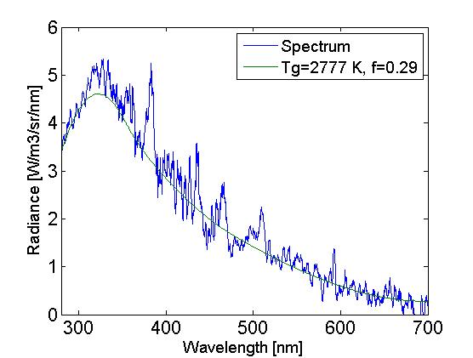
Figure 36 Emission spectrum of CO2 plasma at r=6mm under conditions: 250 mbar, 1.4 kW and 6slm. The green line (model) assumes a gas temperature based on a best match with the data.

4.4.4 Afterglow
For both the 100 mbar and the 250 mbar CO2 plasma the emission has also been measured 8.2 cm downstream from where the previous measurement was conducted. In this region, the gas is no longer ionized and has stopped being an ‘active’ plasma. But due to the presence of CO and O molecules that can recombine, light is still emitted. This afterglow is in essence similar to a flame. Since the electron density is negligible, no information about the electron temperature can be, or needs to be, gained. Information about the gas temperature and$f$can be obtained. The afterglow data is not Abel inverted, but is instead simply corrected for the path length of the line of sight through the quartz tube.

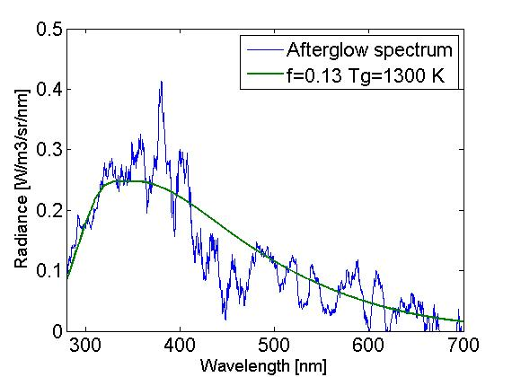 | 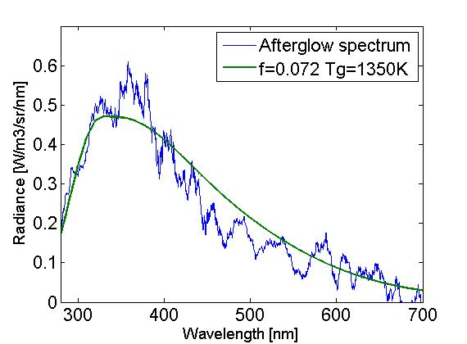
Figure 37 Afterglow emission spectrum of CO2 plasma in the middle of the tube under conditions: 100 mbar, 1.4 kW and 6 slm | Figure 38 Afterglow emission spectrum of CO2 plasma in the middle of the tube under conditions: 250 mbar, 1.4 kW and 6 slm

Figure 37 and Figure 38 show the emission of the afterglow of the 100 mbar plasma and 250 mbar plasma, respectively. The temperatures of the afterglow are comparable, while the value of $f$significantly differs. In Figure 39 and Figure 40 profile of the gas temperature and factor $f$are shown for the width of the tube.

Figure 39 Downstream gas temperature of a CO2 plasma for 100mbar and 250 mbar with conditions: 1.4kW, 6slm

Figure 40 Downstream factor f values of a CO2 plasma for 100mbar and 250 mbar with conditions: 1.4kW, 6slm

4.5 Discussion
The described method can be used to find the electron temperature in a CO2 plasma. However, here are some factors that might result in some inaccuracies:

4.5.1 Spectrometer temperature
The offset the spectrometer experiences varies with the temperature of the spectrometer. Although the dark correction used in this research is adequate, it might be an improvement to regulate the temperature of the spectrometer through active cooling and keeping it as low as possible.

4.5.2 Temperature profile
As noted in 4.4.3, the assumed gas temperature might differ from the actual gas temperature. A more accurate profile of $T_{g}$ can be constructed by fitting the model from equation (8) onto the experimental spectra. Since the gas temperature influences the particle density in the plasma, finding a more accurate temperature profile also helps to improve the applicability of the bremsstrahlung model from equation (3).

4.5.3 Gas composition
Because the concentrations of O and CO cannot be deduced separately from the continuum emission spectrum, the factor $f$ is a combination of both O and CO fractions via equation (9). Knowing the composition of the plasma locally could allow for separation of $f$ into $f_{CO}$and $f_{O}$. The method used and described in this report has been focused on continuum emission, ignoring the peaks from line and band emission in the collected data. The experimental setup, however, does allow for quantifying and analyzing peaks in the emission spectrum. It might be possible to get a more detailed picture of the local composition inside the plasma from these peaks, which show separate contributions from both CO (band emission) and O (line emission).

4.5.4 Cross-section and electron density profile
The cross-section $Q$ in equation (3) has for this research been set constant at 10⁻¹⁹ m². In reality the cross section depends on the electron temperature and the composition of the plasma [14]. The cross section for CO is at certain electron temperatures three times the cross section of CO2, so the value of $Q$ could have a significant role in fitting the model to the experimental spectra. To calculate $Q$ accurately, it is important to know the composition of the gas.
In this research, the electron density profile is assumed to have a Gaussian shape. If a more accurate value for $Q$ is found, fitting the model onto the data might result in an indication of a more accurate shape of the electron density profile. The model is sensitive to changes in electron density and gas temperature. Slightly different values for $T_{e}$ might be found.

5 Conclusion and recommendations

The goal of this research was to find a method to obtain an absolute emission spectrum of CO2 plasma, from which the electron temperature ($T_{e}$) can be determined by analyzing the continuum emission. Reaching this goal would answer the research question:

How can visible and near UV emission spectroscopy be used to determine the electron temperature in a microwave CO2 plasma?

This report has shown that it is possible to determine $T_{e}$ by using optical emission spectroscopy. To achieve this, the following steps must be taken:

- An optical collection system must be constructed allowing for line of sight measurements through the plasma with a known spatial resolution. This was achieved using a double lens system with a pinhole. Mounting the optics on a stepper motor system, line of sight data could be collected automatically at different positions in the plasma. Using the method of Abel inversion, the emission from the plasma could be reconstructed with a spatial resolution of 200 μm.
- The signal from the spectrometer needs to be corrected for dark signal, taking into account the pixel specific and temperature dependent character of the dark signal.
- The experimental setup needs to be calibrated. The calibration data is needed to correct for photon losses in the quartz tube, optics and spectrometer. The calibration curve, obtained using two different calibrated light sources, allows for the conversion of raw data into an absolute intensity spectrum.
- Fitting the model for continuum radiation from bremsstrahlung and CO-O recombination radiation onto the data allows for $T_{e}$ to be determined, provided the gas temperature and electron density are known a priori. This has been resolved in this study by relying on data obtained using other experimental methods.

The method was used to analyze CO2 plasmas of 100 mbar and 250 mbar, both with a power input of 1.4 kW and a flow of 6 slm. Under the presumed conditions, for both plasmas $T_{e}$ was found to be approximately 2.2 eV, primarily based on the spectrum from the center of the plasma. Near the edges of the plasma $T_{e}$ was harder to determine due to the dominance of CO-O recombination radiation. No variations for $T_{e}$ could be observed for the full width of the plasma, remaining constant at 2.2 eV, with higher uncertainty in the outer regions.
The method can be applied for purposes other than finding $T_{e}$. In regions where CO-O recombination radiation is dominant over bremsstrahlung, like it is downstream from the plasma, the model can be used to determine the local gas temperature, producing a gas temperature profile. The CO-O recombination model can also be used to get information about the local concentration of CO and O.

Some observed differences between the 100 mbar plasma and the 250 mbar plasma.
- The 250 mbar plasma is more narrow and more bright than the 100 mbar plasma.
- Emission from the center of the 250 mbar plasma is dominated by C2 emission, but C2 emission is not observed in the 100 mbar plasma.
- The shape of spectrum from the 100 mbar plasma has a similar shape for the width of the plasma, where the shape of the spectrum from the 250 mbar plasma changes.
- The net CO production is higher in the 100 mbar plasma.

The results in this report are only a small fraction of the information that can be obtained with this method. Further research using this method is recommended. Possible follow up studies are described below.
- Measurements could be conducted at different axial positions, so that an axial profile of $T_{e}$, as well as a radial profile, could be determined. Axial measurements could also provide insight into the formation and destruction rate of the molecules in the plasma as well as the rate at which the gas cools.
- This research has been limited to analyzing the continuum emission from the plasma but is also suited to make a basic analysis of the line and band emission from the plasma. Peaks in the spectrum could help determine the local composition of the plasma.
- The cross-section is assumed to be constant at 10⁻¹⁹ m². In reality the cross-section may vary. The dependency of the cross-section on $T_{e}$ and composition of the gas could be taken into account. Analyzing the effect the cross-section has on the spectrum could help obtain a more accurate picture of the electron density profile.
- The method of determining $T_{e}$ could be improved by using a spectrometer that is more sensitive to UV. Accurate radiance data for wavelengths below 270 nm could improve the accuracy of the fit and value of $T_{e}$.

6 References

[1] | Yunqiang Yang. (2004) Time-Resolved Measurements of Plasma Electron Number Density and Electron-Neutral Collision Frequency Using a Microwave Diagnostic Method, University of Tennessee-Knoxville
[2] | Bogaerts A, Wang W, Berthelot A, and Guerra V. (2016) Modeling plasma-based CO 2 conversion : Crucial role of the dissociation cross section Plasma Sources Sci. Technol. 25 55016
[3] | Rond, C. et al. (2008) , Chemical Physics 354, 16–26
[4] | Iordanova S. and Koleva I. (2007) Optical emission spectroscopy diagnostics of inductively-driven plasmas in argon gas at low pressures DOI: 10.1016/j.sab.2007.03.026
[5] | Iordanova, E. et al., (2008) - Absolute measurements of the continuum radiation to determine the electron density in a microwave-induced argon plasma. 3, 10.1088/0022-3727/41/1/015208
[6] | Cabannes F, Chapele J C and Venugopalan M (1976) Spectroscopic plasma diagnostics Reaction Under Plasma Conditions (New York: Wiley) 405-420
[7] | Akcasu A. Z. and Wald L. H. (1967) Bremsstrahlung of Slow Electrons in Neutral Gases and Free-Free Absorption of Microwaves Phys. Fluids 10 1327–35
[8] | Slack, Grillo, (1985) COMBUSTION AND FLAME 59:189-196
[9] | Cho, Na. (2005) - Application of Abel inversion in real-time calculations for circularly and elliptically symmetric radiation sources
[10] | Ocean Optics, Inc. (2008) HR4000 and HR4000CG-UV-NIR Series Spectrometers Installation and Operation Manual
[11] | SMC100CC-SMC100PP-User-Manual (2015) Newport Corporation, Irvine, CA
[12] | Toonen. (2017), Electron density measurements in a CO2 microwave plasma, Fontys University of Applied Sciences
[13] | Harder et al (2016) - Homogeneous CO2 conversion by microwave plasma: Wave  propagation and diagnostics DOI:10.1002/ppap.201600120
[14] | ANU database, https://fr.lxcat.net/cache/592d97adc82a4/, retrieved on May 9, 2017

Appendix A: k values by Slack and Grillo
The value of k in (8) follows from:

$$k\left(T_{g},λ\right)=A*e^{{-B}/{T_{g}}}$$

The values for A and B are in the table below. For intermediate wavelengths, the values are interpolated.
𝜆 [nm] | A [Wm³sr⁻¹nm⁻¹] | B [K] |  | 𝜆 [nm] | A [Wm³sr⁻¹nm⁻¹] | B [K]
250 | 5.83E-46 | 7621.459 |  | 480 | 7.36E-47 | 1372.793
260 | 5.63E-46 | 6443.997 |  | 490 | 6.93E-47 | 1392.706
270 | 5.27E-46 | 5341.127 |  | 500 | 6.52E-47 | 1413.406
280 | 4.47E-46 | 4313.765 |  | 510 | 6.11E-47 | 1431.544
290 | 3.93E-46 | 3574.378 |  | 520 | 5.69E-47 | 1446.637
300 | 3.56E-46 | 3053.82 |  | 530 | 5.29E-47 | 1458.554
310 | 3.32E-46 | 2703.53 |  | 540 | 4.88E-47 | 1467.193
320 | 3.16E-46 | 2507.251 |  | 550 | 4.49E-47 | 1472.505
330 | 3.05E-46 | 2427.581 |  | 560 | 4.11E-47 | 1474.522
340 | 2.85E-46 | 2340.012 |  | 570 | 3.74E-47 | 1473.403
350 | 2.51E-46 | 2171.72 |  | 580 | 3.39E-47 | 1469.499
360 | 2.15E-46 | 1976.806 |  | 590 | 3.06E-47 | 1463.446
370 | 1.88E-46 | 1815.658 |  | 600 | 2.75E-47 | 1456.282
380 | 1.67E-46 | 1693.497 |  | 610 | 2.47E-47 | 1449.625
390 | 1.51E-46 | 1601.98 |  | 620 | 2.22E-47 | 1445.884
400 | 1.37E-46 | 1530.893 |  | 630 | 2.00E-47 | 1448.523
410 | 1.25E-46 | 1472.462 |  | 640 | 1.81E-47 | 1462.35
420 | 1.15E-46 | 1425.65 |  | 650 | 1.66E-47 | 1493.751
430 | 1.05E-46 | 1390.242 |  | 660 | 1.55E-47 | 1550.753
440 | 9.71E-47 | 1366.074 |  | 670 | 1.48E-47 | 1642.714
450 | 8.99E-47 | 1352.931 |  | 680 | 1.47E-47 | 1779.395
460 | 8.37E-47 | 1350.411 |  | 690 | 1.52E-47 | 1969.327
470 | 7.83E-47 | 1357.697 |  | 700 | 1.65E-47 | 2217.65

Appendix B: Power spectra calibration lamps

The calibration data of the sources used to calibrate the experimental setup:

Table 2 Spectral radiance calibration data of the labsphere integrating sphere
Wavelength (nm) | Spectral Radiance (W cm-2 sr-1 nm-1) at 3.452 10-5 A
300 | 0.000000127
310 | 0.00000021
320 | 0.000000337
330 | 0.000000519
340 | 0.000000756
350 | 0.00000108
400 | 0.00000409
450 | 0.00000915
500 | 0.0000161
555 | 0.0000251
600 | 0.0000323
655 | 0.0000404
700 | 0.000046
800 | 0.0000538
900 | 0.0000541
1050 | 0.0000486
1150 | 0.0000401
1200 | 0.0000358
1300 | 0.000031
1540 | 0.0000138
1600 | 0.0000126
1700 | 0.0000109
2000 | 0.00000283
2100 | 0.00000271
2300 | 0.00000167
2400 | 0.00000117

Table 3 Spectral radiance calibration data of the Deuterium Cathodium lamp
(nm) | W/m2/nm |  | (nm) | W/m2/nm |  | (nm) | W/m2/nm |  | (nm) | W/m2/nm
200 | 0.0014 |  | 250 | 6.70E-04 |  | 300 | 2.80E-04 |  | 351 | 1.40E-04
201 | 0.00162 |  | 251 | 6.70E-04 |  | 301 | 2.70E-04 |  | 352 | 1.30E-04
202 | 0.00154 |  | 252 | 6.40E-04 |  | 302 | 2.70E-04 |  | 353 | 1.30E-04
203 | 0.00151 |  | 253 | 6.20E-04 |  | 303 | 2.60E-04 |  | 354 | 1.30E-04
204 | 0.00149 |  | 254 | 6.00E-04 |  | 304 | 2.60E-04 |  | 355 | 1.30E-04
205 | 0.00143 |  | 255 | 5.80E-04 |  | 305 | 2.50E-04 |  | 356 | 1.20E-04
206 | 0.00139 |  | 256 | 5.90E-04 |  | 306 | 2.50E-04 |  | 357 | 1.30E-04
207 | 0.00142 |  | 257 | 5.70E-04 |  | 307 | 2.50E-04 |  | 358 | 1.20E-04
208 | 0.00135 |  | 258 | 5.50E-04 |  | 308 | 2.60E-04 |  | 359 | 1.20E-04
209 | 0.00131 |  | 259 | 5.50E-04 |  | 309 | 2.50E-04 |  | 360 | 1.10E-04
210 | 0.00134 |  | 260 | 5.50E-04 |  | 310 | 2.30E-04 |  | 361 | 1.20E-04
211 | 0.00132 |  | 261 | 5.30E-04 |  | 311 | 2.30E-04 |  | 362 | 1.20E-04
212 | 0.00128 |  | 262 | 5.20E-04 |  | 312 | 2.30E-04 |  | 363 | 1.20E-04
213 | 0.00127 |  | 263 | 5.30E-04 |  | 313 | 2.30E-04 |  | 364 | 1.10E-04
214 | 0.00126 |  | 264 | 5.00E-04 |  | 314 | 2.40E-04 |  | 365 | 1.10E-04
215 | 0.00123 |  | 265 | 4.80E-04 |  | 315 | 2.30E-04 |  | 366 | 1.10E-04
216 | 0.00123 |  | 266 | 4.80E-04 |  | 316 | 2.40E-04 |  | 367 | 1.20E-04
217 | 0.00118 |  | 267 | 4.80E-04 |  | 317 | 2.20E-04 |  | 368 | 1.10E-04
218 | 0.00118 |  | 268 | 4.60E-04 |  | 318 | 2.20E-04 |  | 369 | 1.10E-04
219 | 0.00117 |  | 269 | 4.70E-04 |  | 319 | 2.10E-04 |  | 370 | 1.10E-04
220 | 0.00114 |  | 270 | 4.50E-04 |  | 320 | 2.10E-04 |  | 371 | 1.00E-04
221 | 0.0011 |  | 271 | 4.60E-04 |  | 321 | 2.00E-04 |  | 372 | 1.00E-04
222 | 0.00108 |  | 272 | 4.30E-04 |  | 322 | 2.00E-04 |  | 373 | 1.00E-04
223 | 0.00108 |  | 273 | 4.20E-04 |  | 323 | 2.00E-04 |  | 374 | 1.00E-04
224 | 0.00108 |  | 274 | 4.30E-04 |  | 324 | 2.00E-04 |  | 375 | 1.00E-04
225 | 0.00107 |  | 275 | 4.20E-04 |  | 325 | 1.90E-04 |  | 376 | 1.00E-04
226 | 0.00104 |  | 276 | 3.90E-04 |  | 326 | 1.90E-04 |  | 377 | 1.00E-04
227 | 9.90E-04 |  | 277 | 4.00E-04 |  | 327 | 1.90E-04 |  | 378 | 1.00E-04
228 | 0.00102 |  | 278 | 3.80E-04 |  | 328 | 1.80E-04 |  | 379 | 1.00E-04
229 | 9.70E-04 |  | 279 | 3.90E-04 |  | 329 | 1.90E-04 |  | 380 | 1.00E-04
230 | 9.70E-04 |  | 280 | 3.80E-04 |  | 330 | 1.80E-04 |  | 381 | 9.00E-05
231 | 9.50E-04 |  | 281 | 3.90E-04 |  | 331 | 1.80E-04 |  | 382 | 9.00E-05
232 | 9.00E-04 |  | 282 | 3.70E-04 |  | 332 | 1.70E-04 |  | 383 | 1.00E-04
233 | 9.10E-04 |  | 283 | 3.70E-04 |  | 333 | 1.70E-04 |  | 384 | 9.00E-05
234 | 8.80E-04 |  | 284 | 3.70E-04 |  | 334 | 1.80E-04 |  | 385 | 9.00E-05
235 | 8.50E-04 |  | 285 | 3.50E-04 |  | 335 | 1.70E-04 |  | 386 | 9.00E-05
236 | 8.40E-04 |  | 286 | 3.50E-04 |  | 336 | 1.60E-04 |  | 387 | 9.00E-05
237 | 8.20E-04 |  | 287 | 3.40E-04 |  | 337 | 1.70E-04 |  | 388 | 9.00E-05
238 | 8.40E-04 |  | 288 | 3.30E-04 |  | 338 | 1.60E-04 |  | 389 | 9.00E-05
239 | 7.80E-04 |  | 289 | 3.30E-04 |  | 339 | 1.60E-04 |  | 390 | 9.00E-05
240 | 7.90E-04 |  | 290 | 3.30E-04 |  | 340 | 1.50E-04 |  | 391 | 9.00E-05
241 | 7.70E-04 |  | 291 | 3.20E-04 |  | 341 | 1.50E-04 |  | 392 | 9.00E-05
242 | 7.70E-04 |  | 292 | 3.20E-04 |  | 342 | 1.50E-04 |  | 393 | 9.00E-05
243 | 7.30E-04 |  | 293 | 3.10E-04 |  | 343 | 1.60E-04 |  | 394 | 9.00E-05
244 | 7.40E-04 |  | 294 | 3.20E-04 |  | 344 | 1.40E-04 |  | 395 | 8.00E-05
245 | 7.10E-04 |  | 295 | 3.10E-04 |  | 345 | 1.50E-04 |  | 396 | 8.00E-05
246 | 7.10E-04 |  | 296 | 2.90E-04 |  | 346 | 1.40E-04 |  | 397 | 8.00E-05
247 | 6.80E-04 |  | 297 | 2.80E-04 |  | 347 | 1.40E-04 |  | 398 | 9.00E-05
248 | 7.00E-04 |  | 298 | 2.90E-04 |  | 348 | 1.40E-04 |  | 399 | 9.00E-05
249 | 6.70E-04 |  | 299 | 2.70E-04 |  | 349 | 1.40E-04 |  | 400 | 8.00E-05

Appendix C Matlab scripts

C1 Script to run experiment
clear all, clc, close all
go=0; %added to publish without running script
if go==1;

Setting zone in which the measurement takes place and determning the desired step size and spectrometer integration time
Radstart=0; %radial starting position
Radstep=1; %radial stepsize in mm
Radfin=25; %radial final position
Axialstart=0; %axial starting position
Axialstep=5; %axial stepsize in mm
Axialfin=0; %axial final position
Intt=10000000; %integration time in microseconds
Et=10; %desired total emission measurement time in seconds, Et=Intetragiontime*#measurements being averaged
Runs=1; %number of times the measurement is repeated (full radial and axial profile)

specify the settings for data saving purposes
The settings at which the experiment is run should be entered here This script does not control these settings, entering the settings is only for naming the folder and files in which the data is stored
Pressure='248mbar'; %pressure in mbar
Input='1400W'; %power of the microwave applied to the plasma
Medium='CO2'; %CO2, N2 ....
Flow='6.0slm afterglow'; %volume flow in slm

connect to spectrometer
the spectrometer uses a java library and a wrapper, the try, catch
%command prevents an error that would occur if the library would be added
%twice. Then the spectrometer settings are set
try
ocop = com.oceanoptics.omnidriver.api.wrapper.Wrapper();
catch
javaaddpath('C:\Users\Huub\Documents\HZ\Afstuderen\Differ\spectrometer\OOI_HOME\OmniDriver.jar'); %The path of the spectrometer driver, needs to be changed
ocop = com.oceanoptics.omnidriver.api.wrapper.Wrapper(); %if script is used on a different device
end
ocop.openAllSpectrometers();
ocop.setIntegrationTime(0,Intt);
Nspec=Et/Intt*10^6;
ocop.setScansToAverage(0,Nspec);
ocop.setCorrectForElectricalDark(0,0)
boardTemperature =ocop.getFeatureControllerBoardTemperature(0);

Reset stepmotor and move to starting position
delete(instrfind);
SMC=serial('com3','BaudRate',57600,'DataBits',8,'flowcontrol','software','Parity','None','Terminator','CR/LF','StopBits',1);
status = SMC.Status; %Check status to see if connected
if strcmp(status,'open')==0
fopen(SMC); %open communication if not yet open
end
Motor1status='resetting'
Motor29status='resetting'
fprintf(SMC,'1RS') %resetting both stepmotors
fprintf(SMC,'29RS')
pause(10)

configuration
disp('configuration mode')
fprintf(SMC,'1PW1') %enter configuration mode of motor 1
pause(1)
fprintf(SMC,'29PW1') %enter configuration mode of motor 2
pause(1)
fprintf(SMC,'1SL0') %set lower position limit for motor 1
fprintf(SMC,'1OH0.5') %set homing speed for motor 1
fprintf(SMC,'1SR25') %set upper position limit for motor 1
fprintf(SMC,'1VA0.25') %set positioning speed for motor 1
fprintf(SMC,'29SL0') %idem motor 29
fprintf(SMC,'29OH0.5') %idem motor 29
fprintf(SMC,'29SR43.7') %idem motor 29
fprintf(SMC,'29VA0.5') %idem motor 29
pause(1)
disp('leaving configuration mode')
fprintf(SMC,'1PW0') %close configuration mode
pause(5) %pause to properly leave configuration mode
fprintf(SMC,'29PW0')
pause(5)

Homing and go to startposition motor 1
%the script checks the status of the step motor and takes action
%accordingly
smc1Ready = 0;
smc1Err = '';
while smc1Ready == 0
smc1Err = query(SMC,'1TS'); %find current motor status
smc1ErrResult1 = '';
smc1ErrResult2 = '';
for i = (4):(7)
smc1ErrResult1 = strcat(smc1ErrResult1,smc1Err(i));
end
for i = (8):(9)
smc1ErrResult2 = strcat(smc1ErrResult2,smc1Err(i));
end
% error handling -- See page 65 of user manual
switch smc1ErrResult2
case {'0A','0B','0C','0D','0E','0F','10','11'}
fprintf(SMC,'1OR');
Motor1status='homing'
case {'14'}
%
case {'1E','1F'}
disp('motor 1 homing')
pause(5);
case {'28'}
disp('motor 1 in motion')
pause(3);
case {'32','33','34','35'}
smc1Ready = 1;
case {'3C','3D','3E'}
%
case {'46','47'}
%
otherwise
disp('Unknown error');
end
end
Radstartorder=strcat('1PA',num2str(Radstart));
fprintf(SMC,Radstartorder);
Motor1status='going to startposition'
smc1Ready = 0;
smc1Err = '';
while smc1Ready == 0
smc1Err = query(SMC,'1TS');
smc1ErrResult1 = '';
smc1ErrResult2 = '';
for i = (4):(7)
smc1ErrResult1 = strcat(smc1ErrResult1,smc1Err(i));
end
for i = (8):(9)
smc1ErrResult2 = strcat(smc1ErrResult2,smc1Err(i));
end
% error handling -- See page 65 of user manual
switch smc1ErrResult2
case {'0A','0B','0C','0D','0E','0F','10','11'}
fprintf(SMC,'1OR');
case {'14'}
%
case {'1E','1F'}
disp('motor 1 homing')
pause(5)
case {'28'}
pause(3);
disp('motor 1 in motion')
case {'32','33','34','35'}
smc1Ready = 1;
Motor1status='ready'
case {'3C','3D','3E'}
%
case {'46','47'}
%
otherwise
disp('Unknown error motor 1');
end
end

Homing and go to startposition motor 29
smc29Ready = 0;
smc29Err = '';
while smc29Ready == 0
smc29Err = query(SMC,'29TS');
smc29ErrResult1 = '';
smc29ErrResult2 = '';
for i = (4):(8)
smc29ErrResult1 = strcat(smc29ErrResult1,smc29Err(i));
end
for i = (9):(10)
smc29ErrResult2 = strcat(smc29ErrResult2,smc29Err(i));
end
% error handling -- See page 65 of user manual
switch smc29ErrResult2
case {'0A','0B','0C','0D','0E','0F','10','11'}
fprintf(SMC,'29OR');
Motor29status='homing'
case {'14'}
%
case {'1E','1F'}
disp('motor 29 homing')
pause(5);
case {'28'}
pause(3);
disp('motor 29 in motion')
case {'32','33','34','35'}
smc29Ready = 1;
case {'3C','3D','3E'}
%
case {'46','47'}
%
otherwise
disp('Unknown error motor29');
end
end
Axialstartorder=strcat('29PA',num2str(Axialstart));
fprintf(SMC,Axialstartorder);
Motor29status='going to startposition'
smc29Ready = 0;
smc29Err = '';
while smc29Ready == 0
smc29Err = query(SMC,'29TS');
smc29ErrResult1 = '';
smc29ErrResult2 = '';
for i = (4):(8)
smc29ErrResult1 = strcat(smc29ErrResult1,smc29Err(i));
end
for i = (9):(10)
smc29ErrResult2 = strcat(smc29ErrResult2,smc29Err(i));
end
% error handling -- See page 65 of user manual
switch smc29ErrResult2
case {'0A','0B','0C','0D','0E','0F','10','11'}
fprintf(SMC,'29OR');
case {'14'}
%
case {'1E','1F'}
disp('motor 29 homing')
pause(5);
case {'28'}
pause(3);
disp('motor 29 in motion')
case {'32','33','34','35'}
smc29Ready = 1;
Motor29status='ready'
case {'3C','3D','3E'}
%
case {'46','47'}
%
otherwise
disp('Unknown error motor 2');
end
end

loop for going to position, get data from spectrometer and write to file
P=importdata('Pixeloffset.txt','\t'); % Polynomial data for dark offset correction
measurementdata = importdata('Darkbasis2.txt','\t',1);
D=measurementdata.data;
measurementdata4 = importdata('DCalibratie 300nm focus fit 26apr.txt','\t',1); %Calibration data
Curve=measurementdata4.data;
CC=Curve(:,2);
L=Curve(:,1);
LD=D(:,1);
L3=LD(22:2733);
h=6.626070040*10^-34; %plancks constant in Js
c=299792458; %speed of light in m/s
Ep=h*c./L*10^9; %J/photon in wavelengthrange
folder=[date ' ' Medium ' ' Pressure ' ' Input ' ' Flow]; %names the folder the data will be stored in
mkdir(folder); %creates the folder
wavelengths = ocop.getWavelengths(0)';
Countsmatrix(:,1)=wavelengths; %the spectrum data will be stored in Countsmatrix,
%this creates the first column wavelengths
disp('initial spectrum collection to remove offset') %it takes a few collection to get a stable signal
for w=1:5
counts2 = ocop.getSpectrum(0)';
wavelengths2 = ocop.getWavelengths(0)';
pause(0.1)
w
plot(wavelengths2,counts2)
pause(0.1)
end
close
for Run=1:Runs
Run
for apos=Axialstart:Axialstep:Axialfin;
Countsmatrix=Countsmatrix(:,1);
aposorder = strcat('29PA',num2str(apos));
fprintf(SMC,aposorder)
ready29=0;
while ready29==0
stat29 = query(SMC,'29TS');
stat29err='';
for i = (9):(10)
stat29err = strcat(stat29err,stat29(i));
end
switch stat29err
case {'28'}
disp('move to axial position')
earlyradorder=strcat('1PA',num2str(Radstart));
fprintf(SMC,earlyradorder)
pause(0.5);
case {'32','33','34','35'}
ready29 = 1;
posi29=['in axial position ' num2str(apos)];
disp(posi29)
otherwise
disp('Unknown error motor 29');
end
end
%writes first line of the spectrum file, indicating the axial position and the integration time
Experiment=[date ' ' Medium ' ' Pressure ' ' Input ' ' Flow ' ' 'apos' num2str(apos) ' ' 'Run' num2str(Run) '.txt'];
fileID = fopen(fullfile([pwd,'\', folder],Experiment),'w');
fprintf(fileID,'Axial position %5.2f\t Integration time %d microseconds\r\n',apos,Intt);
fprintf(fileID,'nm\t');
%writes first line, naming the columns of the file that stores the total
%registered counts
Positioning=[date ' ' Medium ' ' Pressure ' ' Input ' ' Flow ' ' 'apos' num2str(apos) ' ' 'Total count, positioning' ' ' 'Run' num2str(Run) '.txt'];
file2ID =fopen(fullfile([pwd,'\', folder],Positioning),'w');
fprintf(file2ID,'%6s\t%10s\r\n','rpos','Counts');
%writes first line, naming the columns of the file that stores temperature
%data
Temp=[date ' ' Medium ' ' Pressure ' ' Input ' ' Flow ' ' 'apos' num2str(apos) ' ' 'temperature' ' ' 'Run' num2str(Run) '.txt'];
file3ID =fopen(fullfile([pwd,'\', folder],Temp),'w');
fprintf(file3ID,'%6s\t%10s\r\n','rpos','Temperature');
r=1; %counter that helps displaying a radial profile during measurements
RCd=0; %parameter that helps displaying a radial profile during measurements
RPd=0; %parameter that helps displaying a radial profile during measurements
for rpos=Radstart:Radstep:Radfin;
fprintf(fileID,'rpos %4.3f\t',rpos); %writes the position to the spectrum file
rposorder = strcat('1PA',num2str(rpos));
fprintf(SMC,rposorder) %orders step motor to go to radial position rpos
ready1=0;
while ready1==0
stat1 = query(SMC,'1TS');
stat1err='';
for i = (8):(9)
stat1err = strcat(stat1err,stat1(i));
end
switch stat1err
case {'28'}
disp('move to radial position')
pause(0.5);
case {'32','33','34','35'}
ready1 = 1;
posi=['in radial position ' num2str(rpos)];
disp(posi)
otherwise
disp('Unknown error motor 1');
end
end
pause(8) %remain idle in order to collect light
counts = ocop.getSpectrum(0)'; %get countspectrum
wavelengths = ocop.getWavelengths(0)'; %get wavelength
Ts=boardTemperature.getBoardTemperatureCelsius() %get temperature
for i=1:length(counts)
Dark(i)=(P(i,1).*Ts.^4+P(i,2).*Ts.^3+P(i,3).*Ts.^2+P(i,4).*Ts+P(i,5)); %calculate dark signal for every pixel
end
Signal2=counts-Dark; %corrects offset for live display purposes
Signal3=Signal2(22:2733);
Signal3=smooth(Signal3,11);
Ph1=Signal3.*CC; %photon spectrum
E1=Ph1.*Ep; %energy spectrum
Countstot=sum(counts);
Countsnet=sum(Signal2);
Countsmatrix(:,end+1)=counts; %saves spectrum to countsmatrix
pause(0.1)
subplot(2,2,1) %displaying the raw signal, corrected signal
plot(wavelengths,counts) %and intensity profile in one image
xlim([200 800])
subplot(2,2,2)
plot(L,E1)
xlim([300 800])
ylim([0 1.5*max(E1(500:2000))])
subplot(2,2,3)
plot(wavelengths,Signal2)
xlim([250 800])
subplot(2,2,4)
RCd(r)=Countsnet;
RPd(r)=rpos;
plot(RPd,RCd)
pause(0.1)
fprintf(file2ID,'%4.2f\t%8.2f\r\n',[rpos;Countstot]); %save to total counts
fprintf(file3ID,'%4.2f\t%5.2f\r\n',[rpos;Ts]); %save the temperature
r=r+1;
end
fprintf(fileID,'\r\n');
SizeCM=size(Countsmatrix);
for i=1:SizeCM(1);
fprintf(fileID,'%9.4f\t',Countsmatrix(i,1)); %write all spectra to file
for j=2:SizeCM(2);
fprintf(fileID,'%10.3f\t',Countsmatrix(i,j));
end
fprintf(fileID,'\r\n');
end
fclose(fileID);
fclose(file2ID);
fclose(file3ID);
end
end
fclose('all');
disp('experiment finished')
end
Published with MATLAB® R2013a

C2 Script for abel inversion and analyzing data

close all, clear all, clc

This script converts data so it can be analyzed, the script file should be in the same folder as the data files

import experimental data and processing tools
delimiterIn = '\t';
headerposidark=1;
headerlinesscan=2;
measurementdata1 = importdata('02-May-2017 CO2 99mbar 1400W 6.0slm apos25 Run1.txt',delimiterIn,headerlinesscan);
A=measurementdata1.data;
measurementdata2 = importdata('02-May-2017 CO2 99mbar 1400W 6.0slm apos25 temperature Run1.txt',delimiterIn,headerposidark);
B=measurementdata2.data;
measurementdata3 = importdata('02-May-2017 CO2 99mbar 1400W 6.0slm apos25 Total count, positioning Run1.txt',delimiterIn,headerposidark);
C=measurementdata3.data;
measurementdata4 = importdata('DCalibratie 300nm focus fit 26apr.txt',delimiterIn,1);
Curve=measurementdata4.data;
P=importdata('Pixeloffset.txt','\t');
COOmodel = fopen('Slack_model nm Wm3sr-1nm-1 K.txt','r');
formatSpec = '%f %f %f';
sizeA = [3 46];
Slack = fscanf(COOmodel,formatSpec,sizeA)';

define parameters for processing and calculation
p=100; %mbar
pa=p*100; %pa
R=8.314; %Gasconstant J/molK
Na=6.022*10^23; %avogardro
LD=A(:,1);
L=LD(22:2733);
lambda=L/10^9;
L2=LD(322:2733);
CC=Curve(:,2);
T=B(:,2)-0.8;
T=flipud(T);
T=smooth(T,15);
Rad=B(:,1);
Int=10;
Db=0.027; %diameter tube in m
X3=245*10^-3; % m from arcpoint to telescope
R1=23/2*10^-3; %m radius of lens on telescope
pinhole=0.2; %diameter of pinhole in mm
Apin=pi*(pinhole/2)^2; %area of pinhole in mm2
Apinm=Apin/10^6; %in m2
Srad=(pi*R1^2)/X3^2; %sterradian of measurement
Srm2=Srad*Apinm; %sr m2
h=6.626070040*10^-34; %plancks constant in Js
c=299792458; %speed of light in m/s
Ep=h*c./L*10^9; %J/photon in wavelengthrange
k=1.38064852*10^-23; %J/K or m2 kg /s2/K
e=1.60217662*10^-19; %coulombs or As %electron charge
E0=8.854187817*10^-12; %F?m?1 or A2s4/kg/m3 %vacuum permitivity
me=9.10938356*10^-31; % kilograms %electronmass
alpha=e^2/(2*E0*h*c); %fine structure constant
Q0=10^-19; %cross section in m2
nmp=L(2:end)-L(1:end-1);
nmp(end+1)=nmp(end); %nm/pixel

Process the experimental data
Sig=A(:,2:127);
Sig=fliplr(Sig);
for i=1:126
for j=1:length(LD)
Dark(j,i)=(P(j,1).*T(i).^4+P(j,2).*T(i).^3+P(j,3).*T(i).^2+P(j,4).*T(i)+P(j,5));
end
end
Sig2=Sig-Dark;
Sig4=Sig2;
for i=1:126
Cou(:,i)=sum(Sig2(:,i));
for W=1:10
for j=3:(length(LD)-2) %this section removes peaks caused by pixel jump
if abs(Sig2(j,i)-Sig2(j-1,i))>400
if abs(Sig2(j+1,i)-Sig2(j+2,i))<800
Sig4(j,i)=(Sig4(j+1,i)+(Sig4(j-1,i)))/2;
else
Sig4(j,i)=(Sig4(j-1,i));
end
end
end
end
end
Sig3=Sig4(22:2733,:);
for i=1:126
Sig3(:,i)=smooth(Sig3(:,i),11);
end
for i=1:126 %quick spectrum calculation without abel inversion
Sig3(:,i)=(Sig3(:,i));
Ph(:,i)=Sig3(:,i).*CC; %photonen/pixel
Phnm(:,i)=Ph(:,i)./nmp; %photonen/nm
Jnm(:,i)=Phnm(:,i).*Ep; %J/nm
Jsm(:,i)=Jnm(:,i)/Srm2; %J/nm/sr/m2
I(:,i)=Jsm(:,i)/Int; %W/nm/sr/m2
I(:,i)=I(:,i)/Db; %W/nm/sr/m3
[M(i) LA(i)]=max(I(:,i));
end
d=0; %if d=1, the processing steps will be
if d==1 %plotted in one figure
for i=48
figure
subplot(2,2,1)
plot(LD,Sig(:,i));
xlim([270 800])
subplot(2,2,2)
plot(LD,Sig2(:,i));
xlim([270 800])
subplot(2,2,4)
plot(L,I(:,i));
xlim([270 800])
subplot(2,2,3)
plot(L,Sig3(:,i));
xlim([270 800])
end
figure
end
[Cmax R0]=max(Cou); %find the maximum value of the intensity

Abel inversion
a=0; %if a=1 this section performs an able inversion
R0=48;
Prof=(C(R0:end,1)-C(R0,1))/1000;
if a==1;
close
ASig3=Sig3(:,R0:end);
Stepsize=Prof(2)-Prof(1);
for pix=1:length(L)
Ab=ASig3(pix,:);
Ab=smooth(Ab,3);
s=0;
for r=0:Stepsize:Prof(end)
s=s+1;
for i=1:length(Prof)
for j=1:length(Prof)
if i>j
theta(i,j)=0;
else
theta(i,j)=acos((i-1)/j);
end
end
end
for i=1:length(Prof)
for j=1:length(Prof)
if i>j
P(i,j)=0;
else
P(i,j)=0.5*(j*Stepsize)^2*theta(i,j)-0.5*((i-1)*Stepsize)^2*tan(theta(i,j));
end
end
end
for i=1:length(Prof)
for j=1:length(Prof)
if i>j
S(i,j)=0;
elseif j==1;
S(i,j)=P(i,j);
elseif i==length(Prof);
S(i,j)=P(i,j);
else
S(i,j)=P(i,j)-P(i+1,j)-(P(i,j-1)-P(i+1,j-1));
end
end
end
E=linsolve(S,Ab);
E=E*Stepsize*0.5;
plot(Prof,E)
Ir(pix,:)=E;
end
% plot(Prof,E)
L(pix)
% pause(0.03)
end
dlmwrite('Abelinversie100mbar1400W6slm2.txt',Ir,'\t') %saves inverted data to file
end

plot abeldata
%this section compares the model to the abel inverted data
b=1;
if b==1;
Abel = dlmread('Abelinversie100mbar1400W6slm2.txt','\t');
for i=1:length(Prof)
Cou2(i)=sum(Abel(:,i));
Abel2(:,i)=smooth(Abel(:,i),1); %counts/pixel/m
Ph2(:,i)=Abel2(:,i).*CC; %photonen/pixel/m
Phnm2(:,i)=Ph2(:,i)./nmp; %photonen/nm/m
Jnm2(:,i)=Phnm2(:,i).*Ep; %J/nm/m
Jsm2(:,i)=Jnm2(:,i)/Srm2; %J/nm/sr/m3
I2(:,i)=Jsm2(:,i)/Int; %W/nm/sr/m3
[M2(i) LA2(i)]=max(I2(300:2000,i));
Lam(i)=L(300+LA2(i));
Cou3(i)=sum(I2(:,i));
end
Profmm=Prof*1000;
nep=30.52*10^17*exp(-(Prof/(4.5/1000)).^2); %34.28
Tgep=2900*exp(-(Prof/(10/1000)).^2)+700;
Iker=nep.*Tgep;
n=0;
for i=4
for nd=0.4; %value of factor f
for TeeV=2.2; %electron temperature to be determined
n=n+1;
TeK=11604.505*TeeV;
na=pa*Na/(R*Tgep(i))
na_o=na*nd;
na_co=na_o;
nfrac=na/nep(i)
ne=nep(i)
Tg=Tgep(i)
Z=1j*h*c./(2*lambda*k*TeK);
K2=besselh(2,Z);
A2=nep(i)*na*(4*alpha/(3*pi))*((2/(pi*me*k*TeK))^(1/2))*(Q0/me);
B2=((h./lambda).^2);
C2=-h*c./(2.*lambda*k*TeK);
D=(1/2)*pi*(1j^(2+1));
E=(h*c./(lambda.^2));
Ire(:,n)=A2*B2.*exp(C2).*D.*K2.*E; %W/m3/sr/m
Irem(:,n)=Ire(:,n)/10^9;
kc = interp1(Slack(:,1),Slack(:,2),L); %Wm3/sr/nm
Ec = interp1(Slack(:,1),Slack(:,3),L); %K
Icoo(:,n)=na_o*na_co*kc.*exp(-Ec/Tgep(i));
Icon(:,n)=Icoo(:,n)+Irem(:,n);
end
end
IO=sum(I2(2200:2220,i))
ICO=sum(I2(372:419,i))
plot(L,I2(:,i))
% plot(L,I2(:,i),':',L,Icon(:,n),L,Irem(:,n))
xlim([280 700])
figure
plot(L,I(:,i+48))
xlim([280 700])
% ylim([0 10])
end
end
na =
2.0178e+23
nfrac =
6.7301e+04
ne =
2.9982e+18
Tg =
3.5896e+03
IO =
996.3783
ICO =
406.9702
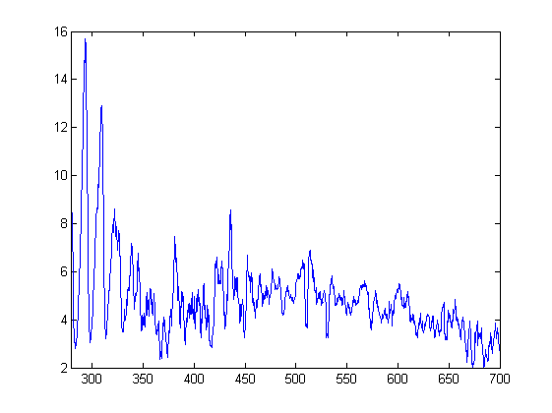
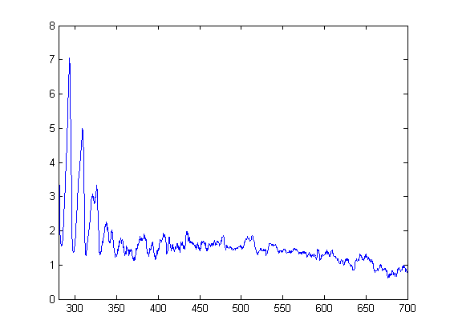
Published with MATLAB® R2013a

