Macrobenthos Vlakte van de Raan
DA Final Thesis

Author: Joshu van Baars
Course: DA Final Thesis CU11020
Institution: HZ University of Applied Sciences
Supervisor: Tim van Oijen
Date: 09-06-2018
Place of publication: Ghent
Version: 2.0

The spatial distribution of macrobenthos at the Vlakte van de Raan

Final Report

CU 11020 DA Final Thesis

Author: Joshu van Baars (student nr. 00068894)
Institution: HZ University of Applied Sciences
Address: Edisonweg 4, 4382 NW Vlissingen, Netherlands
E-mail: baar0011@hz.nl

Client: Ghent University

In company supervisor: Dhr. Carl Van Colen
Institution: Ghent University
Address: Krijgslaan 281, B-9000 Ghent, Belgium
E-mail: Carl.VanColen@UGent.be

HZ Supervisor: Tim van Oijen
Institution: HZ University of Applied Sciences
Address: Edisonweg 4, 4382 NW Vlissingen, Netherlands
E-mail: tim.van.oijen@hz.nl

Cover image: The macrobenthos of a piece of the bottom of the North Sea after sieving through a 1mm sieve. Retrieved from ‘The macrobenthos atlas of the Belgian part of the North Sea”.

Table of contents
Acknowledgement 8
Abstract 9
1. Introduction 1
1.1. Background 1
1.2. Problem statement and goal 2
1.3. Reading guide 3
2. Theoretical Framework 4
2.1. What is (macro)benthos? 4
2.2. What is the role of macrobenthos? 4
2.3. Macrobenthos in the Belgian part of the North Sea (distribution patterns of the four most abundant communities) 6
2.4. Macrobenthos of the Western Scheldt (distribution of four common species) 8
2.5. Expectations Vlakte van de Raan 11
3. Method and Materials 12
3.1. Sample method and location 12
3.2. Macrofauna Identification 13
3.3. Sediment grain size 13
3.4. TOM (Total Organic Material) 14
3.5. Salinity, chlorophyll a & bathymetry 14
3.6. Data analysis 15
3.7. Spearman’s Rank-Order Correlation 15
4. Results 16
4.1. Species number (S) and total species abundance 16
4.2. Pielou's evenness (J) and the Shannon Wiener Index (H) 17
4.3. Spatial distribution (indicator/most common species) 18
4.4. Abiotic factors 22
4.4.1. Chlorophyll a 22
4.4.2. Salinity 22
4.4.3. Bathymetry 22
4.4.4. Median Grain Size 23
4.4.5. Mud content 24
4.4.6. Total Organic Material (TOM) 24
4.5. Spearman’s Rank Order Correlation (MEDGS) 25
4.6. Spearman’s Rank Order Correlation (MUDC) 27
4.7. Spearman’s Rank Order Correlation (TOM) 28
5. Discussion 29
5.1. Synthesis 29

5.2. Identification 30
5.3. Abiotic Factors 30
5.3.1. Sediment grain size 30
5.3.2. TOM & MUDC 30
5.3.3. Salinity 30
5.3.4. Chlorophyll A 30
5.3.5. Bathymetry 30
6. Conclusions 32
7. Recommendations further research 33
References 34
Appendix 1 35
Appendix 2 37
Appendix 3 38
Appendix 4 38
Appendix 5 39
5.1. Analysis of Similarities (ANOSIM) 39
5.2. One-way Analysis (SIMPER, Similarity Percentages - species contributions) 39
5.3. Analysis of Similarities: ANOSIM (One-way Analysis) 39
5.4. Similarity Percentages - Species Contributions: SIMPER (One-way Analysis) 40
5.5. RELATE (Testing matched resemblance matrices) 45
Appendix 6 45

Acknowledgement
First of all, I would like to share my gratitude to HZ University of Applied Sciences, as I had the opportunity to fulfill my final thesis at my home county Belgium, and Ghent University for having me. This way I was able to scale up my network in Belgium.

Furthermore, I would like to recognize my in company supervisor Carl Van Colen for supervising me and making sure I could participate on a research trip at sea. Additionally, I would like to thank Elise Toussaint as well for letting me be part of the research team upon this trip. Moreover, I would like to thank Bart Beuselinck for helping me out defining the median grain size of the samples.

Finally, I would like to thank my supervisor Tim van Oijen as the report would not have the same end product without his help.

Abstract
This study aimed to get more insight into the spatial distribution pattern of the macrobenthos at the Vlakte van de Raan in relation to environmental gradients (median grain size, salinity and bathymetry). 82 samples were collected in November 2016 with a Van Veen grab using the research vessel the ‘RV Simon Stevin’. For this research, the macrobenthos of 43 samples were identified using microscopy. In addition, data were collected on the following environmental gradients: salinity, bathymetry, median grain size, mud content and TOM (Total Organic Material). The salinity was measured while collecting the samples. The sediment samples were collected as well for the calculation of TOM. Using a Mastersizer, the median grain sizes and mud content of the area were determined. Data on bathymetry was provided via VLIZ (Vlaams Instituut voor de Zee).

Most dominant species of the Vlakte van de Raan are: Nephtys sp., Magelona johnstoni, Spiophanes bombyx, Scoloplos armiger, Aphelochaeta marioni, Abra alba, Macoma balthica and Petricola pholadiformis, with Nephtys sp., Magelona johnstoni and Macoma balthica being most abundant.

The macrobenthos biodiversity was highest in the Northern part of the Vlakte van de Raan and lowest in the East as low salinity (and perhaps fluctuations in salinity) and large median grain sizes (MEDGS) is not preferable for the organisms. Overall the organisms tend to prefer to live in an area having a smaller median grain size, a higher mud content and a higher organic material.

Introduction

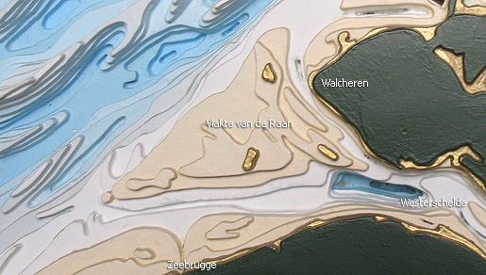
Background
This thesis aims to achieve a better insight in the spatial distribution of the macrobenthos of the Vlakte van de Raan region (figure 1). The Vlakte van de Raan is a sandbar in the mouth region of the Western Scheldt estuary (Netherlands) and has a surface of 175m². It is located between the Belgian Part of the North Sea and the Western Scheldt estuary and its variable bathymetry and sediment composition encompass diverse habitats for macrobenthos populations and communities.
Figure 1 Vlakte van de Raan. Retrieved from http://www.vliz.be/vleet/content-vleet.php?id=7987&language=0
Macrobenthos are important components of estuarine and coastal ecosystems as they serve as critical links between a variety of primary producers and organic matter sources (e.g., phytoplankton, benthic microalgae and macroalgae, detritus) and economically, ecological, and recreationally important fish and crustaceans. (Virginia Institute of Marine Science, 2018)

Benthic macrofauna have been used for decades as indicators of environmental status and trends in estuaries and coastal areas because: most infauna are sedentary and respond to local environmental impacts; they encompass a wide range of physiological tolerances, living positions, feeding modes and trophic interactions; assemblages respond relatively quickly to habitat disturbances and they are important components of aquatic food webs and they affect transport and cycling of nutrients and toxicants. (Virginia Institute of Marine Science, 2018)

Additionally, shallow soft-sediment continental shelf habitats are among the most productive marine ecosystems. In addition to nutrient supply from land run-off and from the atmosphere, the internal recycling of nutrients within these systems substantially contributes to their nutrient load. The nutrients support primary production which, together with imported organic matter, is at the basis of the pelagic and benthic food webs.

The recycling largely results from remineralization of organic matter in sediments and from the subsequent release of (part of these) nutrients to the water column (i.e. benthic-pelagic coupling). Larger sediment animals (macrobenthos) play an important role in benthic-pelagic coupling.

Suspension feeders capture suspended organic matter from the water column and incorporate part of it in the sediment, i.e. biodeposition. In addition, many macrobenthic species mediate benthic-pelagic coupling through bio-irrigation and bioturbation activities.

Problem statement and goal
The Netherlands and Belgium have agreed on joint policy and management of the estuary (laid down in a treaty in 2005). Shipping in the estuary is essential for four major ports, but the estuary also is an extremely valuable, unique and protected nature reserve. Other issues are flood safety, agriculture, salt intrusion and the opportunities for the tourism industry. Due to this multitude of functions, the Scheldt estuary is a stage for a broad range of stakeholders and (conflicting) interests. Especially in the past decades these diverging interests led to an extremely tense and complex decision-making process and accompanying implementation. (Jansen et al., 2015)

Having a spatial distribution plan of the macrobenthos will be helpful regarding these discussions and the managing of the use of marine space in the estuary of the Western Scheldt (Vlakte van de Raan). However, while the macrobenthos of the Belgian part of the North Sea and the Western Scheldt were already studied and their spatial distribution is known, there is a lack of knowledge of the macrobenthos in the mouth area of the Western Scheldt (Vlakte van de Raan). Besides, due to this absence of knowledge on the spatial distribution of the macrobenthos, empirical evidence for the important role of marine biodiversity is often lacking as well.

The goal of this bachelor thesis is to identify the infaunal invertebrate species present in the Vlakte van de Raan area and to describe their distribution patterns in relation to the environmental gradients in the area (median grain size, mud content, total organic material (TOM), salinity, chlorophyll A and bathymetry).

The main question of this research is: What is the spatial distribution pattern of the macrobenthos at the Vlakte van de Raan in relation to the environmental gradients?

The main question is divided in the following sub questions:
- What is the spatial distribution of the macrobenthos at the Vlakte van de Raan area?
- What is the spatial distribution of the sediment grain sizes at the Vlakte van de Raan area?
- What is spatial distribution of the mud content at the Vlakte van de Raan area?
- What is spatial distribution of the total organic material at the Vlakte van de Raan area?
- What is spatial distribution of the salinity at the Vlakte van de Raan area?
- What is spatial distribution of Chlorophyll A at the Vlakte van de Raan area?
- What is spatial distribution of the bathymetry at the Vlakte van de Raan area?

Reading guide
Chapter 2 provides an overview of the current knowledge about the spatial distribution of the macrobenthos of the Belgian part of the North Sea and the Western Scheldt. In chapter 3, the collection of data and the method for sample processing are described, followed by the results of the data analysis (chapter 4). A synthesis of the research including possible shortcomings of the research method are presented in the discussion (chapter 5). Finally, the main findings of this study are outlined in the conclusion.

Theoretical Framework

This chapter provides a theoretical background on the role of macrobenthos in the marine ecosystem and the spatial distribution of macrobenthos in the Belgian part of the North Sea and the Western Scheldt. I chose to enlighten the macrobenthos in these two areas as the Vlakte van de Raan is located between them. Moreover, a small part of the sandbar the Vlakte van de Raan is located in the Belgian part of the North Sea.

What is (macro)benthos?
Benthos is the assemblage of organisms inhabiting the seafloor. Benthic epifauna live upon the seafloor or upon bottom objects; the so-called infauna lives within the sediments of the seafloor. By far the best-studied benthos are the macrobenthos that are larger than 1 mm in size and are dominated by polychaete worms, bivalves, echinoderms, and crustaceans in shallow coastal seas like the Belgian part of the North Sea and estuaries such as the Westerschelde. Meiobenthos, those organisms between 0.1 and 1 mm in size, include polychaetes, pelecypods, copepods, ostracodes, cumaceans, nematodes, turbellarians, and foraminiferans. The microbenthos, smaller than 0.1 mm, include bacteria, diatoms, ciliates, amoeba, and flagellates.

The variety and abundance of the benthos vary with latitude, depth, water temperature and salinity, locally determined conditions such as the nature of the substrate, and ecological interactions such as predation and competition. The principal food sources for the benthos are plankton and organic debris. In shallow waters, larger algae are important, and, where light reaches the bottom, benthic photosynthesizing diatoms are also a significant food source.

Hard and sandy substrates are populated by suspension feeders such as sponges and bivalves while softer bottoms are dominated by deposit feeders, of which the polychaetes are the most dominant group. Fish, starfish, snails, cephalopods, and the larger crustaceans are important predators and scavengers. (Encyclopædia Britannica, 2016)

What is the role of macrobenthos?
Coastal and estuarine ecosystems are hot spots of environmental variability, biogeochemical transformations, and biological interactions, where dynamic exchanges of energy, mass, and nutrients occur between benthic and pelagic habitats via diverse pathways. Consequently, they are among the world's most productive ecosystems that provide important ecosystem services, such as food provision and water filtration.

Essential ecosystem functions, such as production and energy transfer in food webs, biogeochemical cycling, and provisioning of fish nursery areas, are supported by multiple and interacting benthic-pelagic coupling processes. (Griffiths et al., 2017)

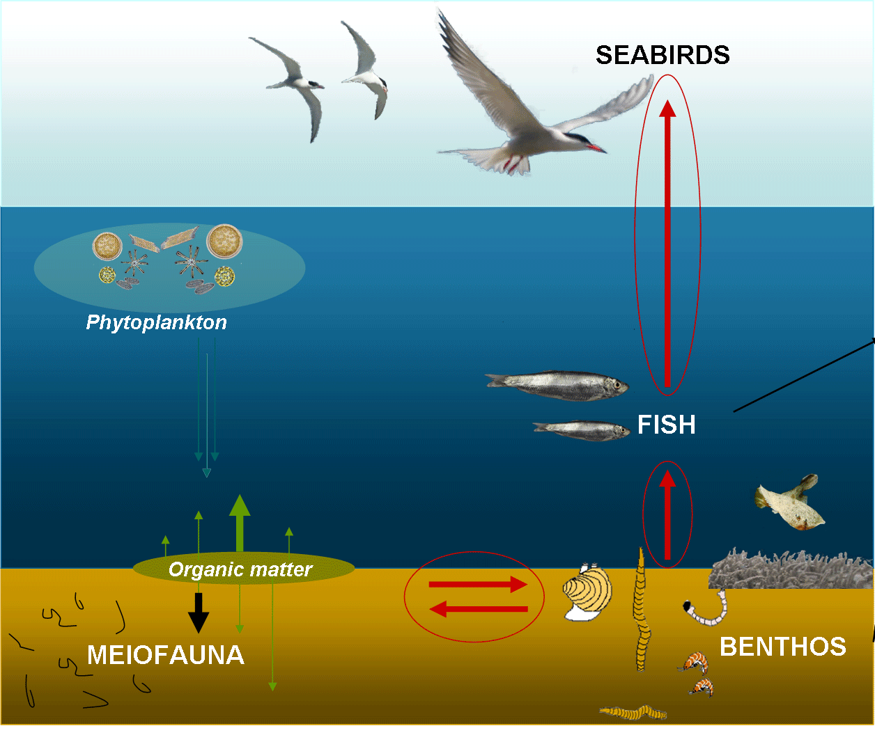
Figure 2 Benthic-pelagic coupling. Retrieved from http://www.vliz.be/projects/westbanks/

Macro- as well as microinvertebrates play an important role in this ecosystem (figure 2). They not only serve as food for fish and water birds (red arrows on the right), they are also involved in the breakdown of organic matter and nutrients (green arrows).

Macrobenthos alter their habitat by their metabolism and bioturbation activities on a local scale. Any critical change in an estuary alters the entire aquatic food web. Perturbation of any anthropogenic or natural cause may result in shifts in the diversity and numerical abundance of species and relative sizes of populations. The small scale distribution of benthic organisms in an estuary is related to factors such as depth, current speed and sediment characteristics (Geetha et al., 2010).

Macrobenthos in the Belgian part of the North Sea (distribution patterns of the four most abundant communities)
In the Belgian part of the North Sea there are about 265 different species of macrobenthos (Degraer et al., 2006). However, not all these species are found all over the area as they prefer different habitats. Due to this different habitat preference, some species are hardly found while others are very abundant. In the Belgian part of the North Sea, four macrobenthic communities are found, each having a characteristic species.

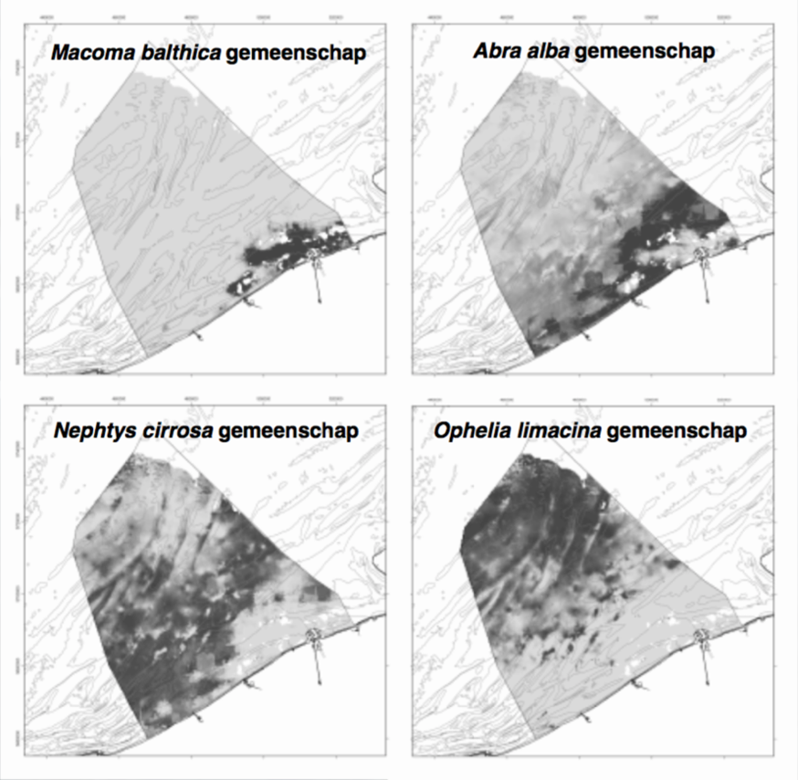
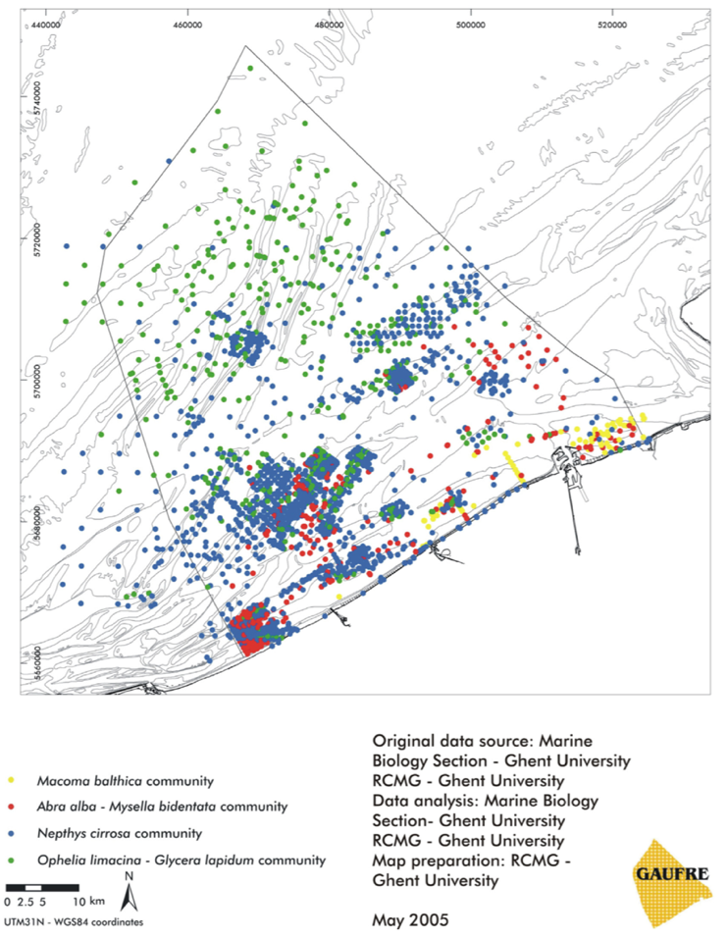
The distribution of the four communities can be seen in figure 3. The yellow dots represent the Macoma balthica (A.K.A. Limecola balthica) (bivalve) community, the red dots the Abra alba (bivalve) community, the blue dots the Nephtys cirrosa (Polychaeta) community and the green dots the Ophelia limacine (Polychaeta) community. See Appendix 1 for an image of the organisms.

Figure 3 Spatial distribution of the four soft-sediment macrobenthic communities in the Belgian part of the North Sea, based on direct (i.e. macrobenthos samples) as well as modeled. Retrieved from: https://www.belspo.be/belspo/organisation/Publ/pub_ostc/MA/Gaufre/Gaufre_en.pdf

Comparing the distribution of the four macrobenthic communities to the median grain size of the Belgian part of the North Sea (figure 4), it is remarkable that bivalves are more abundant when the sediment grain size is between 0-200µm, and the Polychaeta are more abundant when the sediment grain size between 300-500µm. However, Polychaeta are found in 0-200µm grainsizes as well as bivalves in sediments with 300-500 µm.
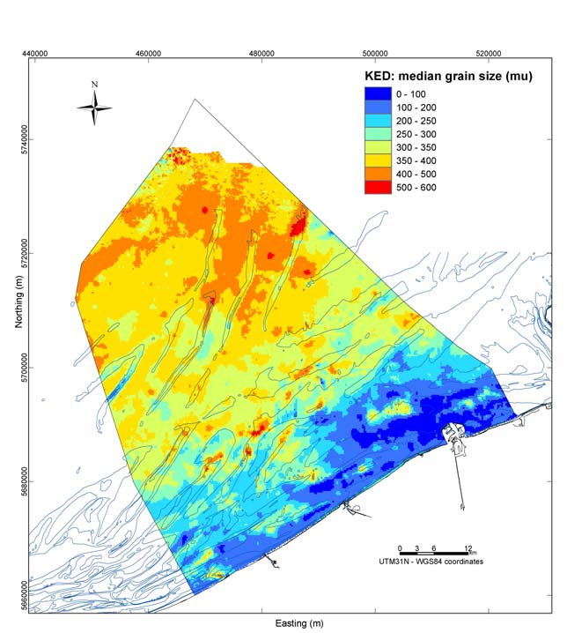
Figure 4 Median grain size. Retrieved from: http://docplayer.nl/38949854-Het-macrobenthos-van-het-belgisch-deel-van-de-noordzee.html

So as figure 5 shows, as the median grain size increases, the habitat is more suitable for the Polychaeta (Nephtys cirrosa and Ophelia limancina), while as the sediment mud content increases, the habitat is more suitable for the bivalves (Abra alba and Macoma balthica).

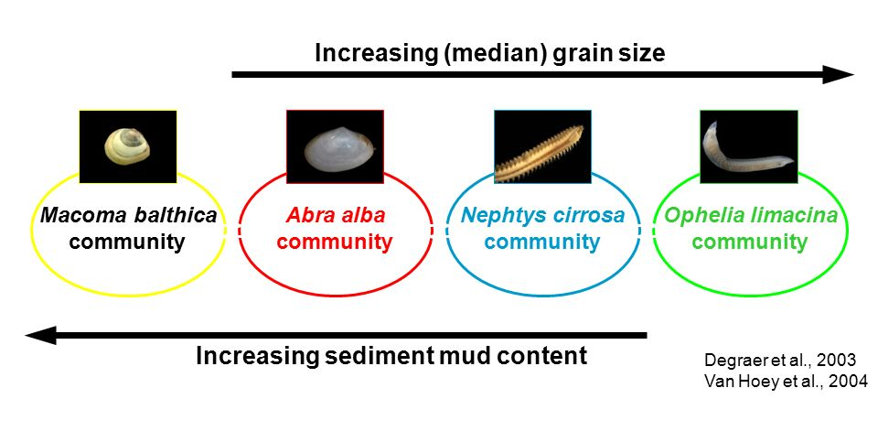
Figure 5 Increasing median grain size VS increasing sediment mud content. Retrieved from:slideplayer.com/slide/8782574/

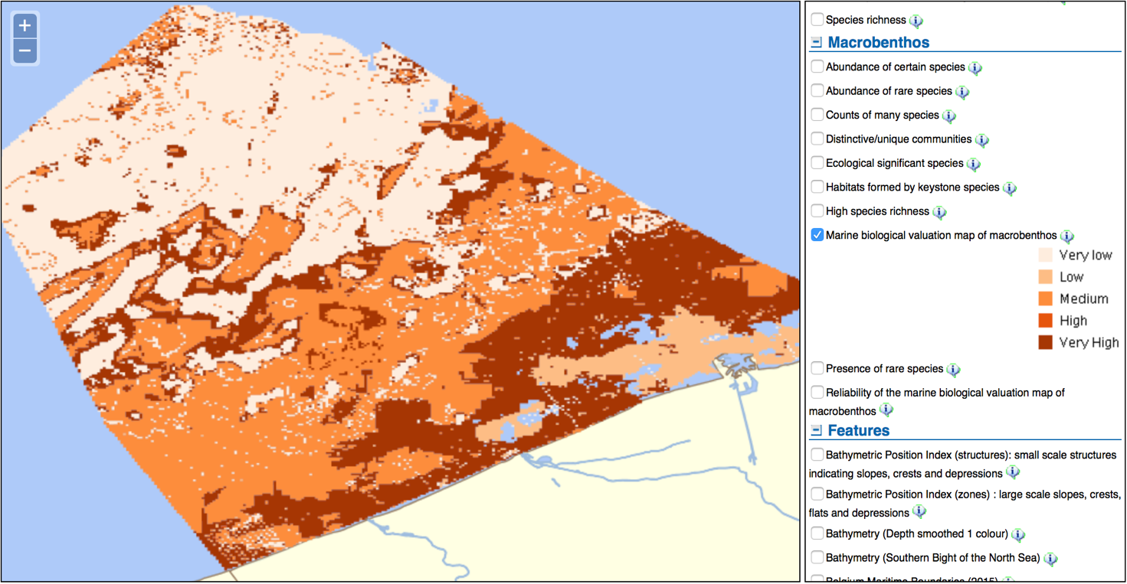
figure 6 Biological valuation map of macrobenthos for the Belgian part of the North Sea. Retrieved from: http://www.vliz.be/projects/bwzee/atlas.php
Vlaams Instituut voor de Zee (VLIZ) has already made a macrobenthos biological valuation map of the Belgian part of the North Sea (figure 6). The darker the color, the higher the biological value. Comparing the valuation map with the median grain size map, there can be seen that the sediment of 0-350µm has a higher biological value than the area with a sediment grain size of 350-600µm.

Macrobenthos of the Western Scheldt (distribution of four common species)
An extensive data set on macrobenthos is available for the Western Scheldt estuary. A total of 3112 macrobenthos samples, mainly within the framework of monitoring programs, were collected in the study area by different institutes in the period 1978 to 1997, but with >90% of the samples collected from 1990 onwards. Qualitatively, no fundamental nor systematic changes in the occurrence of the macrobenthos appeared in the study area during this study period (Ysebaert et al., 2002). The distribution pattern of the four most common species are shown in Figures 7 - 10. Images of two of the organisms (Cerastoderma edule and Corophium volutator) can be found in Appendix 2.

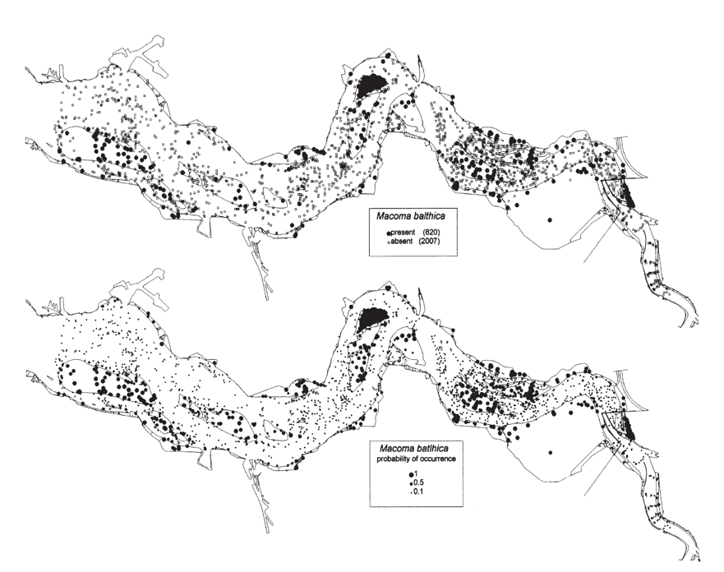
Figure 7 Spatial distribution of Macoma balthica in the Western Scheldt (Ysebaert et al., 2002)
Looking at figure 7, the spatial distribution (presence/absence) of Macoma balthica can be seen at the top graph, dominating at the Southern part of the entrance and at the end of the Western Scheldt. At the bottom graph, the distribution of the determined probabilities of species occurrence based on multiple logistic regressions model is shown. Both graphs have quite the same result. Probabilities of occurrence (p) can be seen at the bottom scale at figure 7-10.
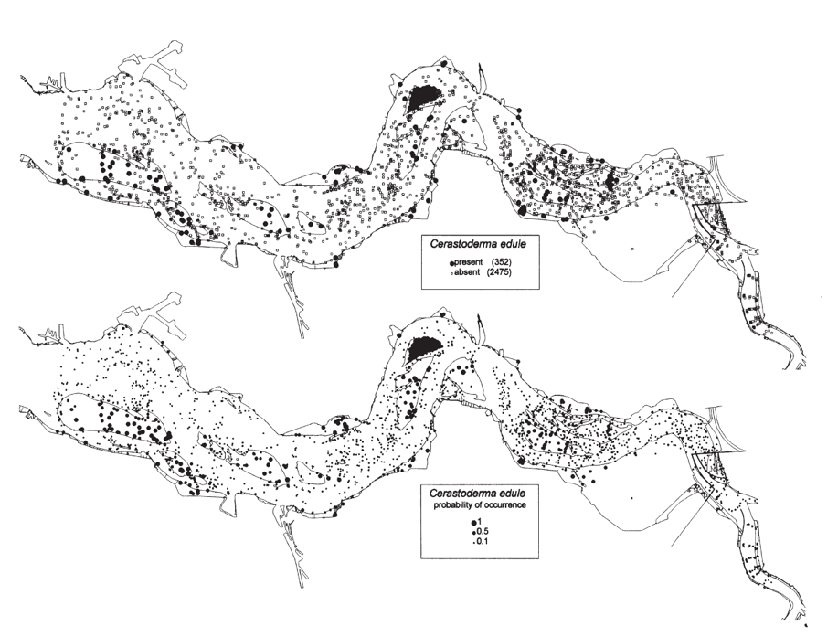
Figure 8 Spatial distribution of Cerastoderma edule in the Western Scheldt (Ysebaert et al., 2002)
Figure 8 shows the spatial distribution (presence/absence) of Cerastoderma edule at the top graph, dominating at about the same locations as Macoma balthica, however Cerastoderma edule is less present. Again, the bottom graph shows the distribution of the determined probabilities of species occurrence based on multiple logistic regressions model.

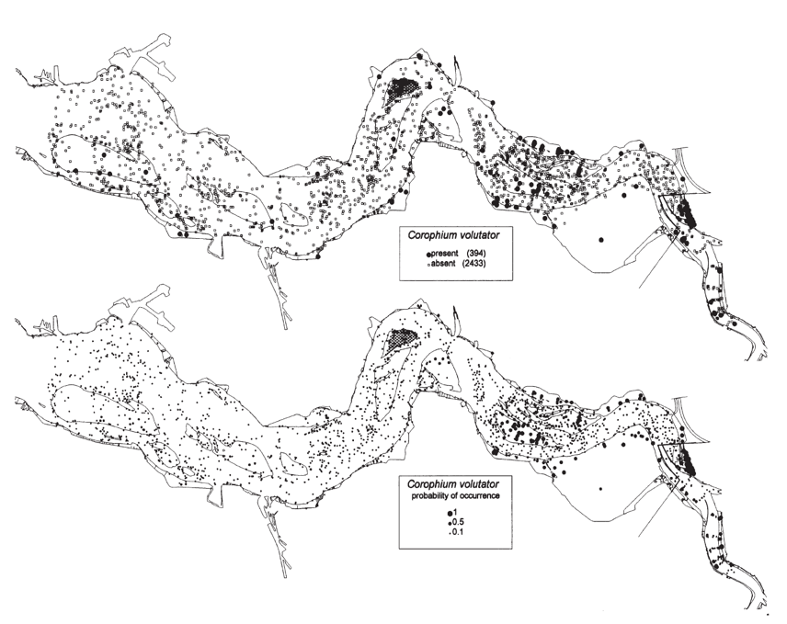
Figure 9 Spatial distribution of Corophium volutator in the Western Scheldt (Ysebaert et al., 2002)
Looking at figure 9, the spatial distribution (presence/absence) of Corophium volutator can be seen at the top graph, and the distribution of the determined probabilities of species occurrence based on multiple logistic regressions model can be seen on the bottom graph. The species tends to be more present at the end of the Western Scheldt than at the estuary.
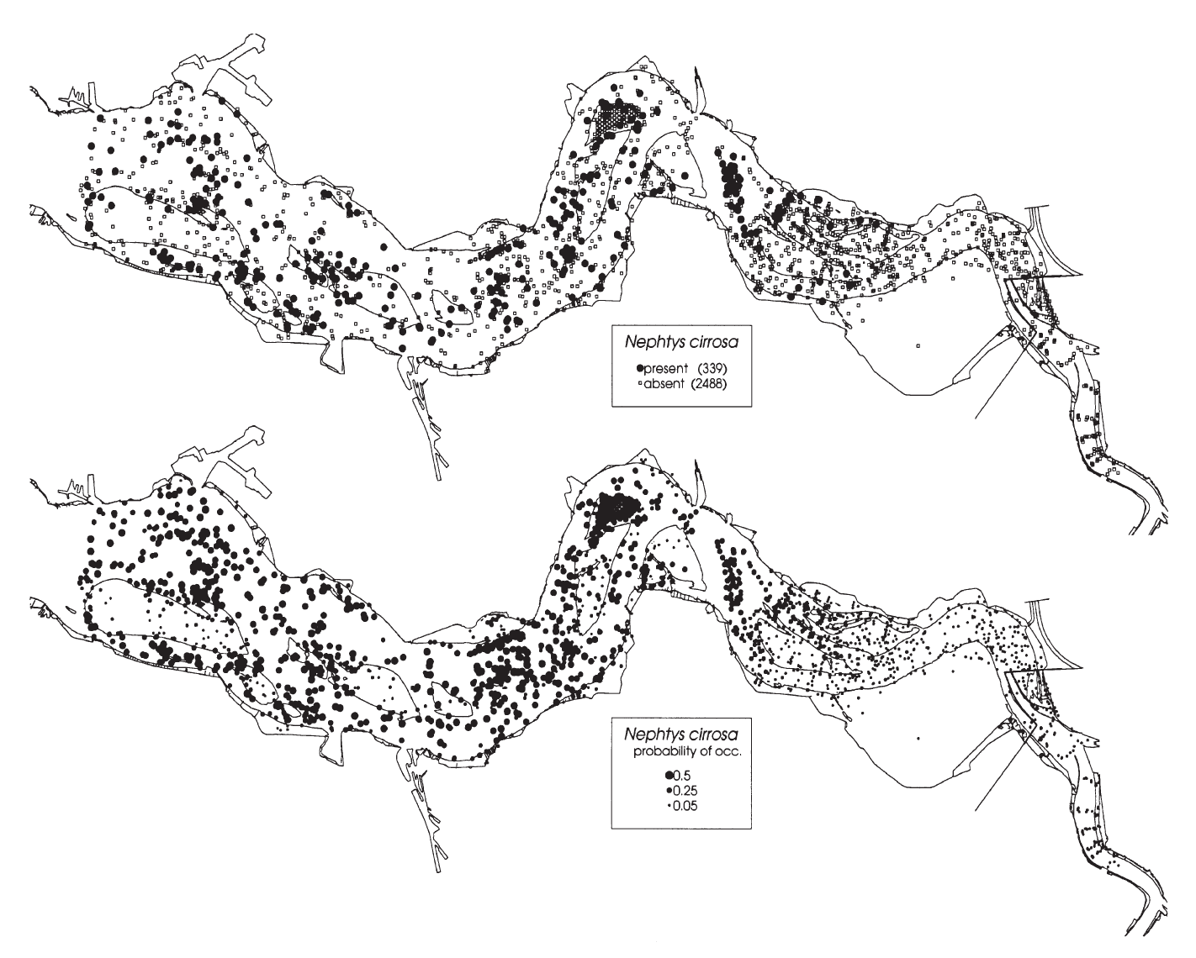
Figure 10 Spatial distribution of Nephtys cirrosa in the Western Scheldt (Ysebaert et al., 2002)
Figure 10 shows the spatial distribution (presence/absence) of Nephtys cirrosa at the top graph. The distribution of the determined probabilities of species occurrence (bottom graph) is similar to the top graph. Comparing the distribution of the figure above with figures 7-9, it is remarkable that Nephtys cirrosa has a significantly greater distribution, being present along the entire Western Scheldt.

Expectations Vlakte van de Raan
Above the spatial distribution of indicator species has been described for the Belgian part of the North Sea as well as the Western Scheldt are given. It is remarkable that the Nephtys cirrosa and the Macoma balthica species are very abundant in the Western Scheldt as well as the Belgian part of the North Sea. Looking at figure 3 (the yellow dots), there can be seen that the Macoma balthica species is abundant close to the shore (South), near the estuary. Figure 7 shows that the species is abundant in the Western Scheldt as well. Again, the species is flanking shore, near the Belgian part of the North Sea (South). Expectations are therefore that the Macoma balthica will be present at the Vlakte van de Raan.

Looking at figure 10, there can be seen that the Nephtys cirrosa species is quite abundant close to the estuary. Though, figure 3 (blue dots) shows that the species is more common near the French part of the North Sea than near the estuary. However, as the species is present all over the Western Scheldt, it is expected to be present at the Vlakte van de Raan as well.

Method and Materials

Sample method and location
For this study, samples were taken at 82 locations in the Vlakte van de Raan region in November 2016 (Figure 11). For each location, besides the macrobenthos community sampling, samples were taken for the sediment properties, salinity and water column chlorophyll a (see paragraphs 3.3-3.5). Macrobenthos sampling occurred with the use of the RV Simon Stevin research vessel. The macrobenthos was sampled with a Van Veen grab (figure 12) and separated from the sediment by sieving the sample over a sieve with a mesh size of 1 mm. The sediment passes through the sieve while the macrobenthic organisms and coarse sediment particles are retained. The macrobenthos was subsequently fixed and preserved in an 4% formaldehyde seawater solution. 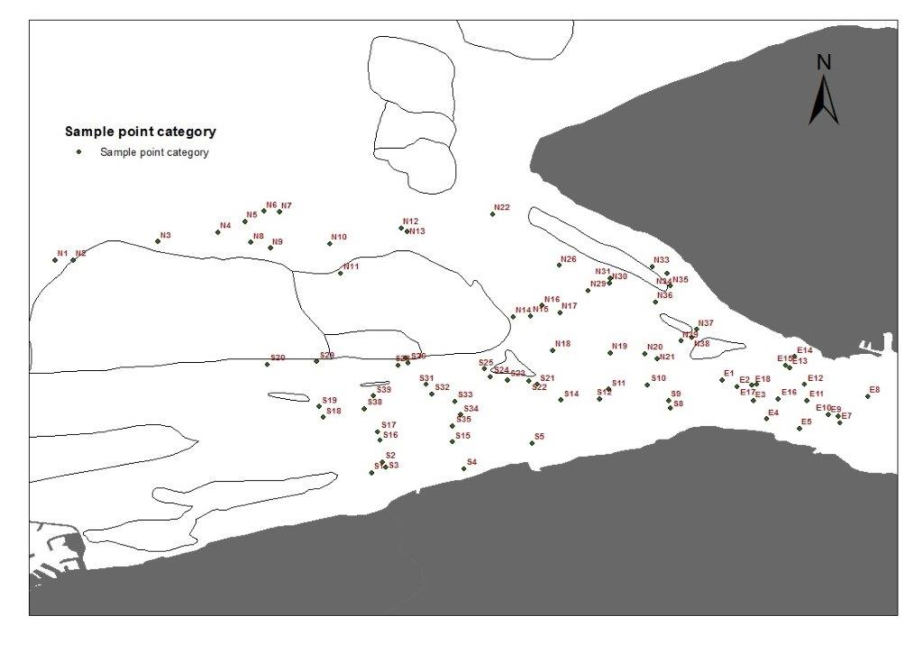
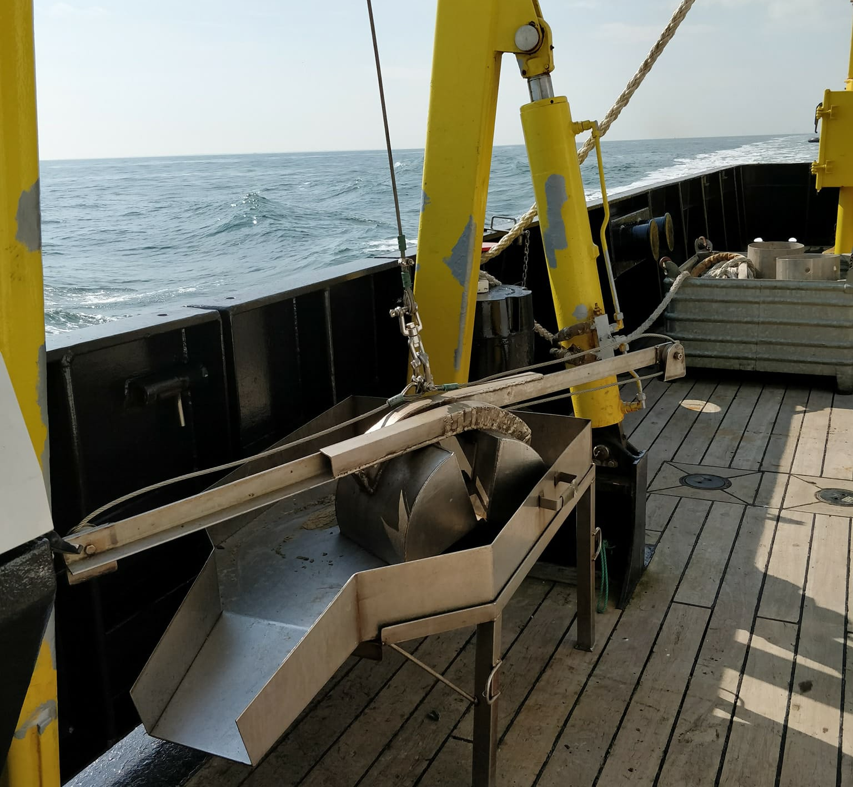
Figure 11 Sample locations in the Vlakte van de Raan

Figure 12 Van Veen grab

Macrofauna Identification
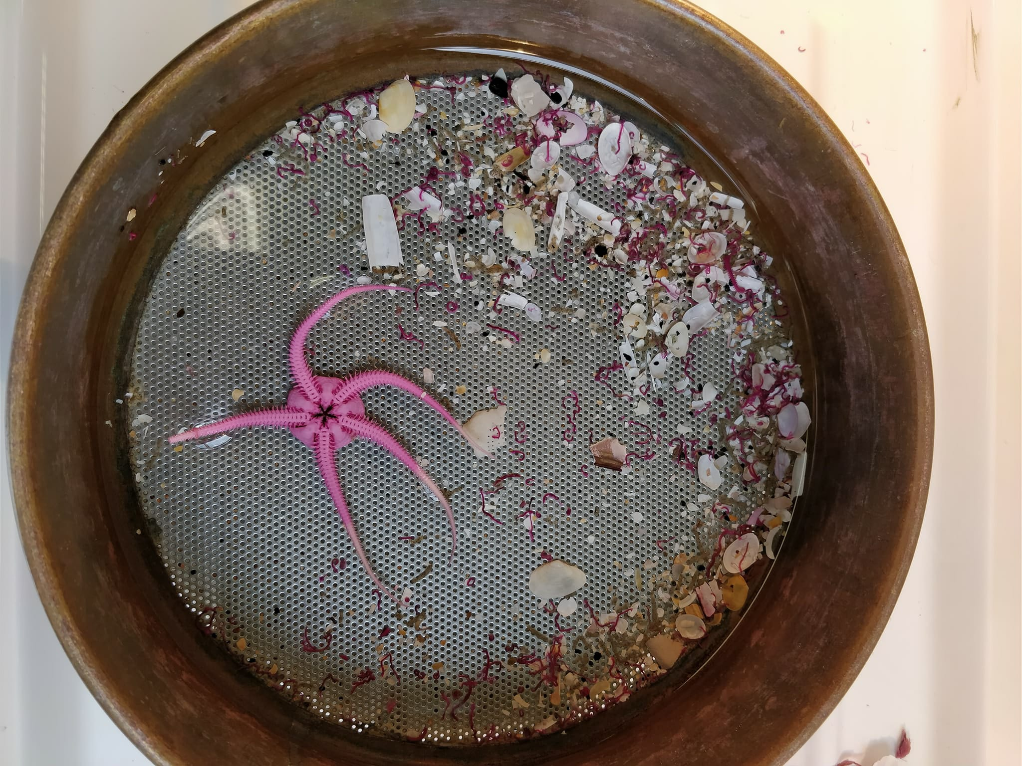
Since identifying 82 samples was not realistic in the framework of this bachelor thesis, 43 samples were selected based on a stratified randomization scheme. To this end, samples were ad random selected from each of the three subregions: East, North and South of the sandbar in the center of the study area. These three regions encompass the general gradients in bathymetry and sediment composition. This division will be kept to easily distinct different locations over the area.
Figure 13 Sample bottle emptied above 1mm sieve

For the purpose of the identification of the macrobenthos, the samples were colored with Rose Bengal so all organic material became pink. This way, it is more easy to see organic material that is present. To separate the macrobenthos in the sample bottle of sediment, the bottle was emptied above a sieve with a mesh size of 1mm (figure 13).
With the use of a tweezer, the organisms were sorted and kept in a smaller bottle prior to identification with the use of a binocular and using the identification guides: ‘Handbook of the Marine fauna of North-West Europe, ‘The macrobenthos atlas of the Belgian part of the North Sea’ and ‘Die Tierwelt Deutschlands’. The organisms were identified until species level (when possible). Whenever a species was identified, it was put into a tube and preserved using a 4% formaldehyde solution. All the same species of the same sample were counted and put together in the tube.

Sediment grain size
At every sample location, a sediment sample was collected as well. Wanting to know the median grain size of each sample, the samples were put in a dry-oven (60°C). Afterwards they were analyzed using a Mastersizer 3000.

The Mastersizer 3000 uses the technique of laser diffraction to measure the size of particles. It does this by measuring the intensity of light scattered as a laser beam passes through a dispersed particulate sample. This data is then analyzed to calculate the size of the particles that created the scattering pattern (Malvern Panalytical, 2018). This way the MEDGS (DX50) and the MUDC (above 63µm) was measured.

TOM (Total Organic Material)
The TOM percentage was gathered by knowing the difference of sediment weight before and after burning (500°C). To this end the sediment sample was mixed and porcelain cups were filled with a teaspoon of sediment of each sample. These were put in the dry-oven for two days to make sure they were completely dry. Afterwards the sample was weighed and put into a muffle furnace at 500°C (figure 14). After two hours, the cups were weighed again. The percentage of the total organic material present in the sediment was calculated as (weight before ignition - weight after ignition)/weight before ignition.

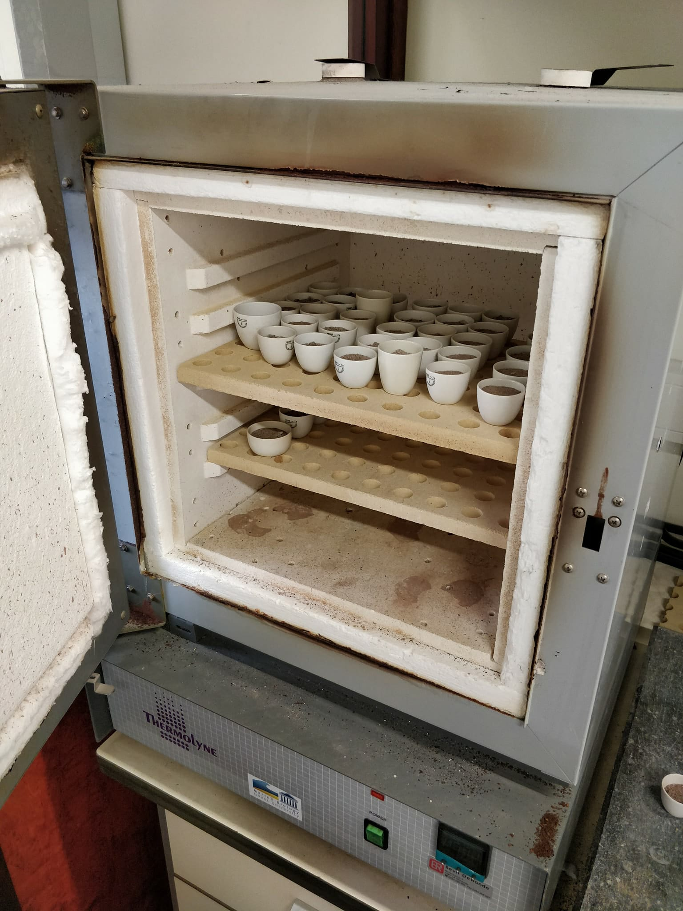
Figure 14 Porcelain cups filled with sediment in muffle furnace

Salinity, chlorophyll a & bathymetry
The Underway Data Acquisition system of the Simon Stevin research vessel automatically registers a vast set of environmental water column data among which salinity and chlorophyll a content were used in this thesis. When the samples were being collected by the RV Simon Stevin, it measured the salinity every 5 seconds. Knowing the exact time each sample was taken, the logbooks were used to know what the salinity was at each location.
The depth of each sampling location was provided via VLIZ (Nathalie De Hauwere).

Data analysis
To analyze the diversity of the species, the Shannon Wiener Index was calculated for each sample. The index accounts for both abundance and evenness of the species present (Beals et al., 2000).

The Kruskal Wallis test was used to pinpoint if there is any difference between the three groups (North, South and East). The Kruskal Wallis test is the non-parametric alternative to the One Way ANOVA. Non parametric means that the test doesn’t assume the data comes from a particular distribution. The test determines whether the medians, species number, total density and diversity of the three groups are different. This was completed using the software Primer5 (Plymouth Routines In Multivariate Ecological Research).

Spearman’s Rank-Order Correlation
The Spearman's correlation coefficient measures the strength and direction of monotonic (function that either never increases or never decreases as its independent variable increases) association between two ranked variables. (Lund Research Ltd, 2018)
With this test, the correlation of MEDGS, MUDC and TOM with the main species, species number (S), total species abundancy (N), Pielou’s evenness (J) and Shannon’s diversity index (H) is observed.

Results

Species number (S) and total species abundance
On figure 15, the species number at each sample location is shown. Remarkable is that the highest number of species is located in the North, while East has the fewest. The total species abundance (N) is also greatest in the North (figure 16). This pattern corresponds with the so called curve of Remane, which shows the relation between species richness and the salinity gradient. A schematic representation of this curve can be seen in appendix 3.

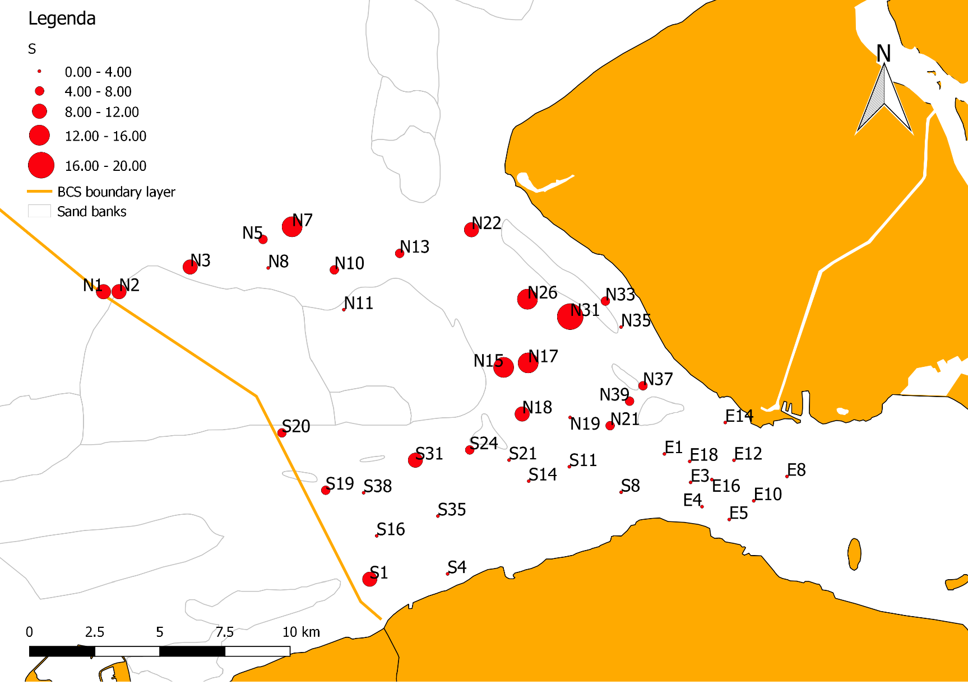
Figure 15 The species number at the different sample locations.
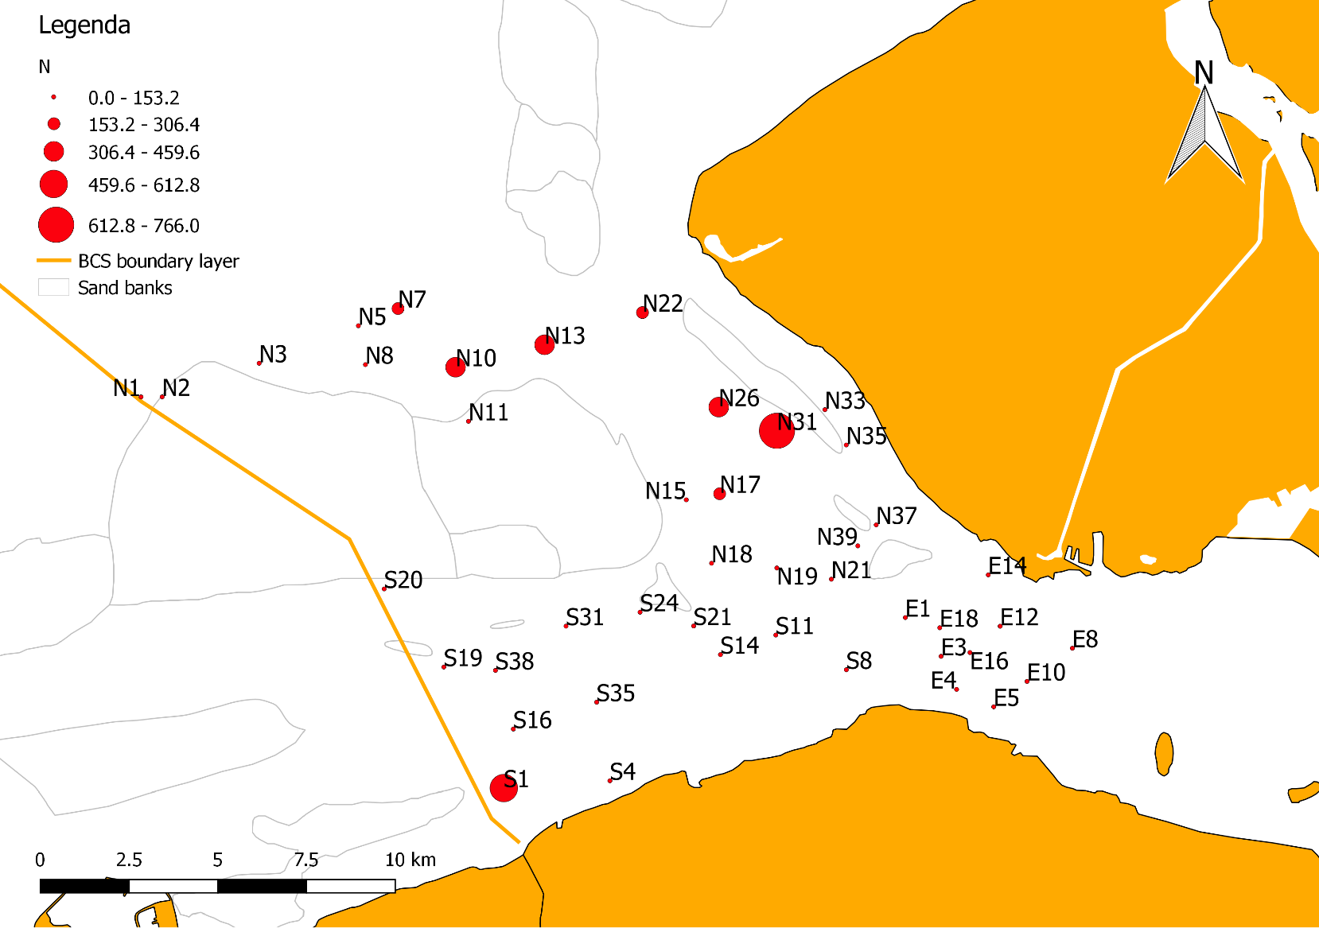
Figure 16 The total species abundance (N) at the different sample locations.

Pielou's evenness (J) and the Shannon Wiener Index (H)
Pielou’s evenness is the evenness with which the individuals are distributed among the species (Hurlbert, 1971). The higher the number, the greater the evenness. Looking at figure 17, the difference in evenness of the community is relatively even. The plotted results of the Shannon Wiener’s diversity index reveal that sample locations located in the North have a greater diversity than the ones in the East and South (figure 18). Be aware that there is only a small difference the lowest and highest evenness in the figure below.

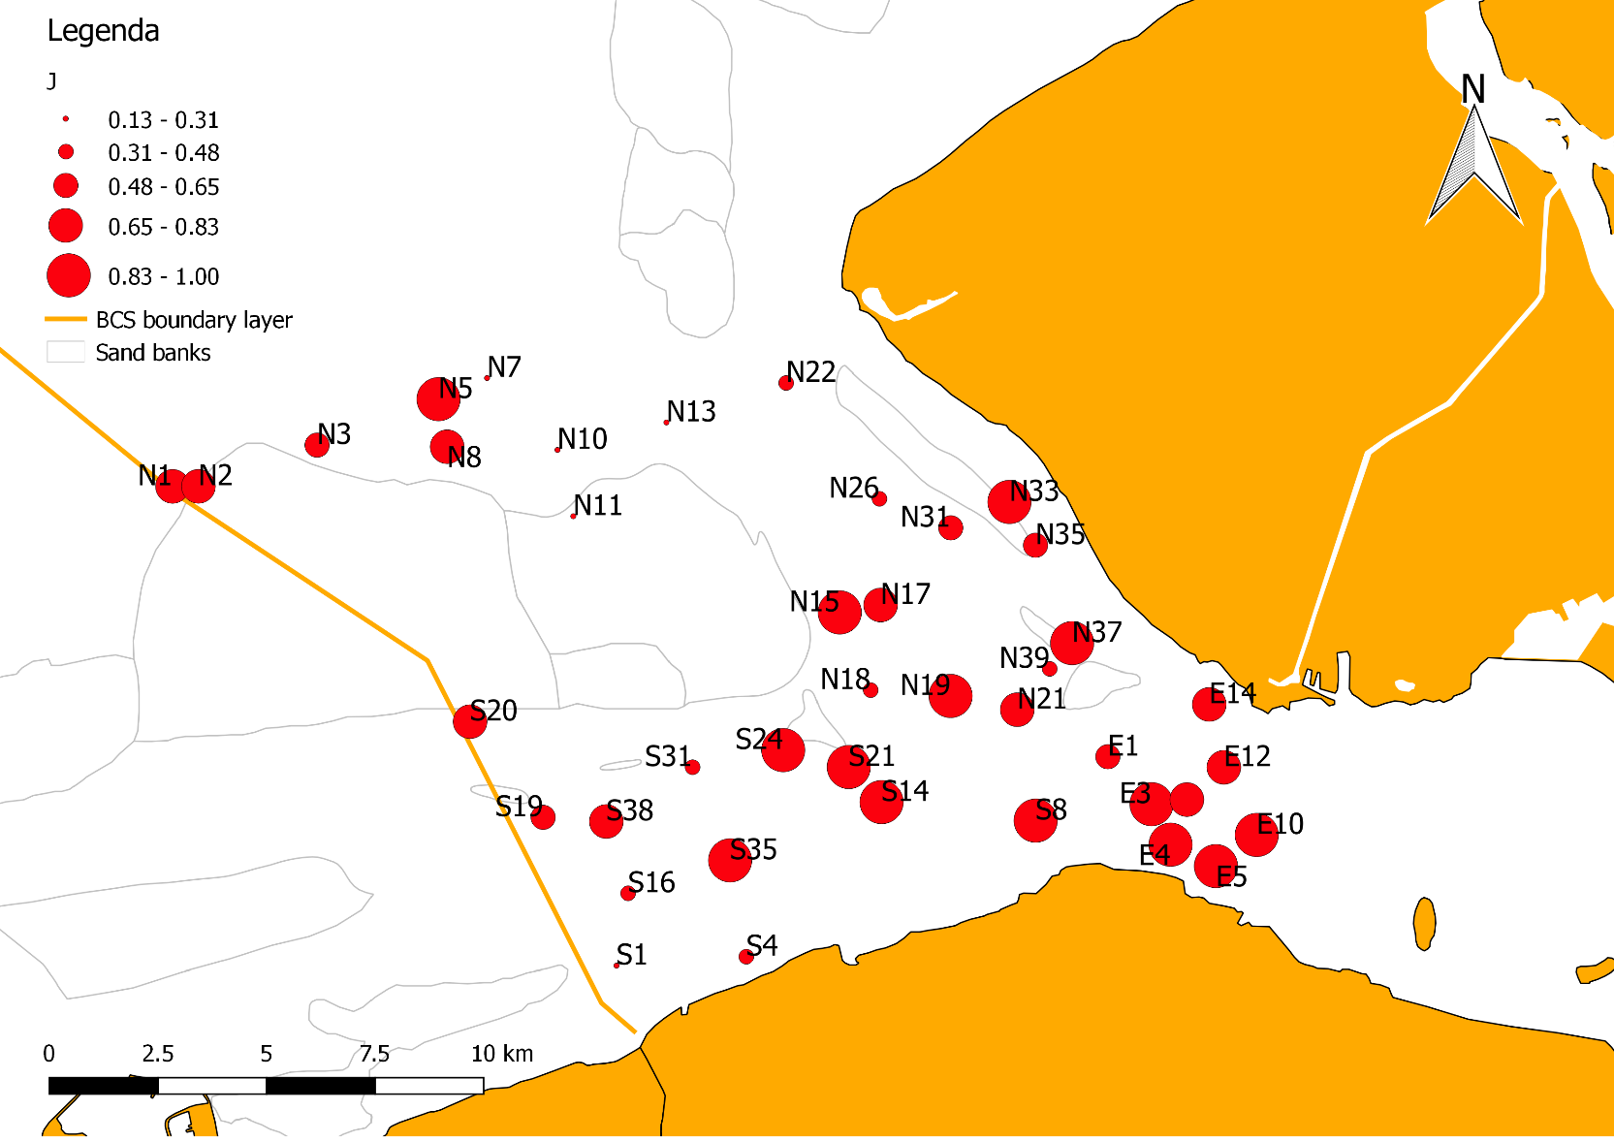
Figure 17 Pielou's evenness (J) at the different sample locations.

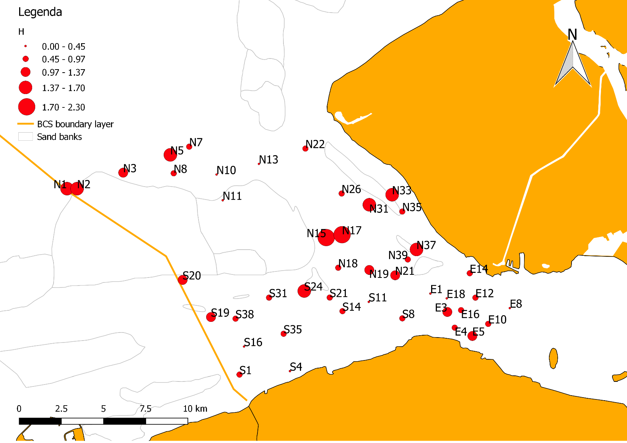
Figure 18 Shannon Wiener Index (H) at the different sample locations.

Spatial distribution (indicator/most common species)
Some species have a wide distribution, while others are only found at some locations. Nephtys sp., Spiophanes bombyx, Scoloplos armiger, Magelona johnstoni and Abra alba are distributed more in the North of the study area. Aphelochaeta marioni and Macoma balthica are however more abundant in the South.

Comparing the spatial distribution (figures 19-25) with figure 27 (salinity), it is apparent that there are fewer organisms present where the salinity is lower than 31 g/L. This is notable when looking at the sample locations in the East.

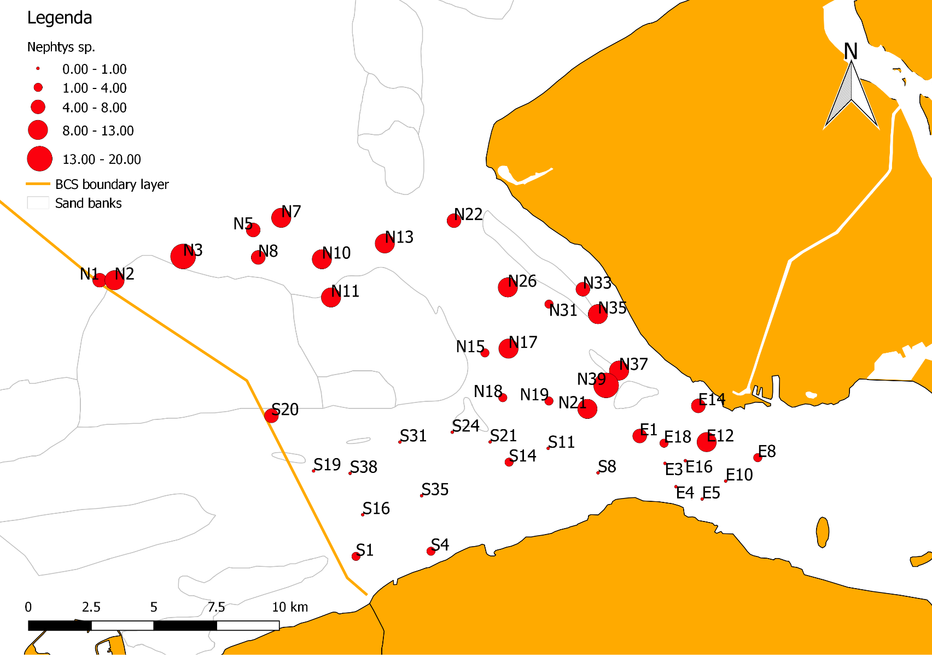
Figure 19 Spatial distribution Nephtys sp.

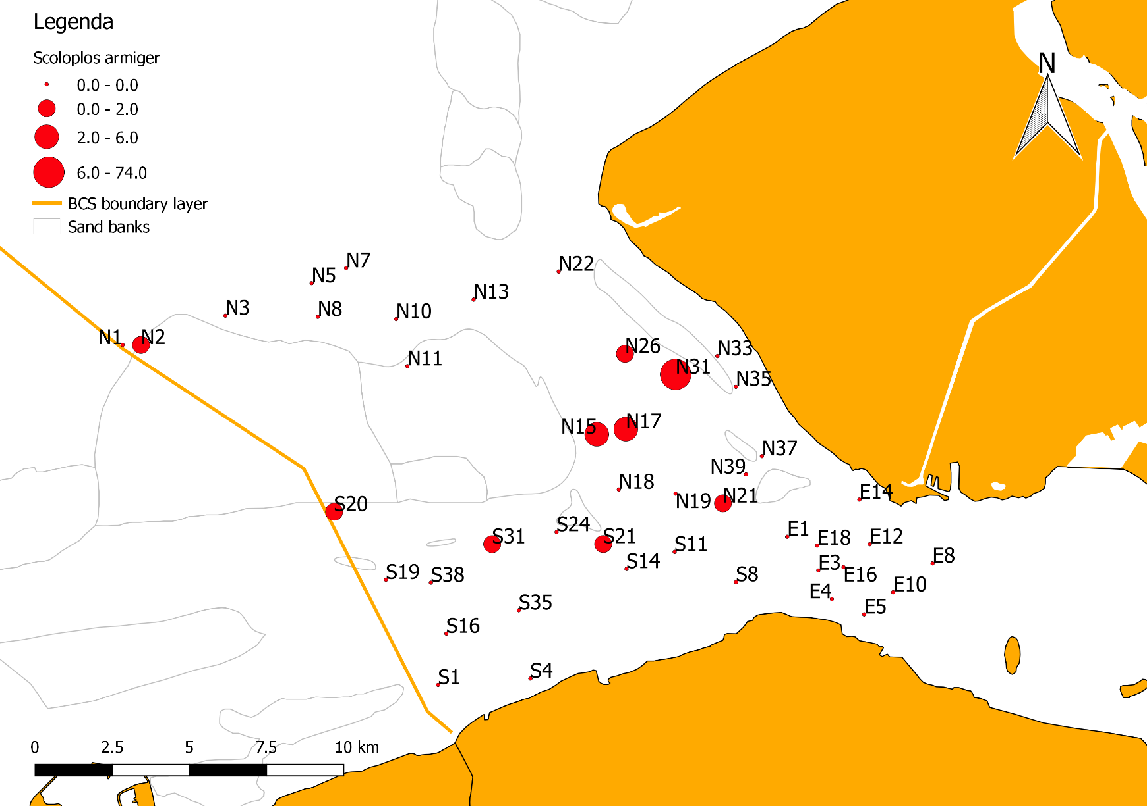
Figure 20 Spatial distribution Scoloplos armiger

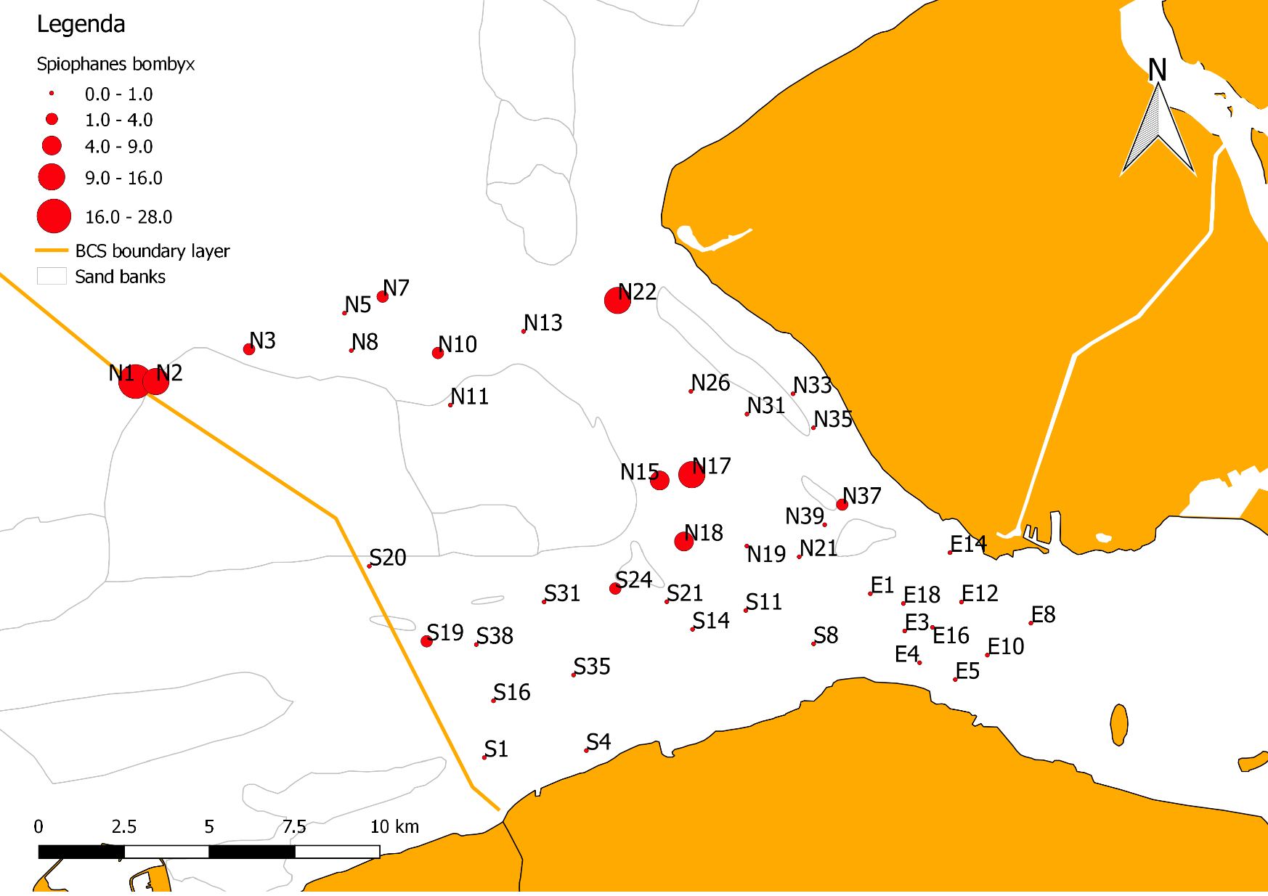
Figure 21 Spatial distribution Spiophanes bombyx

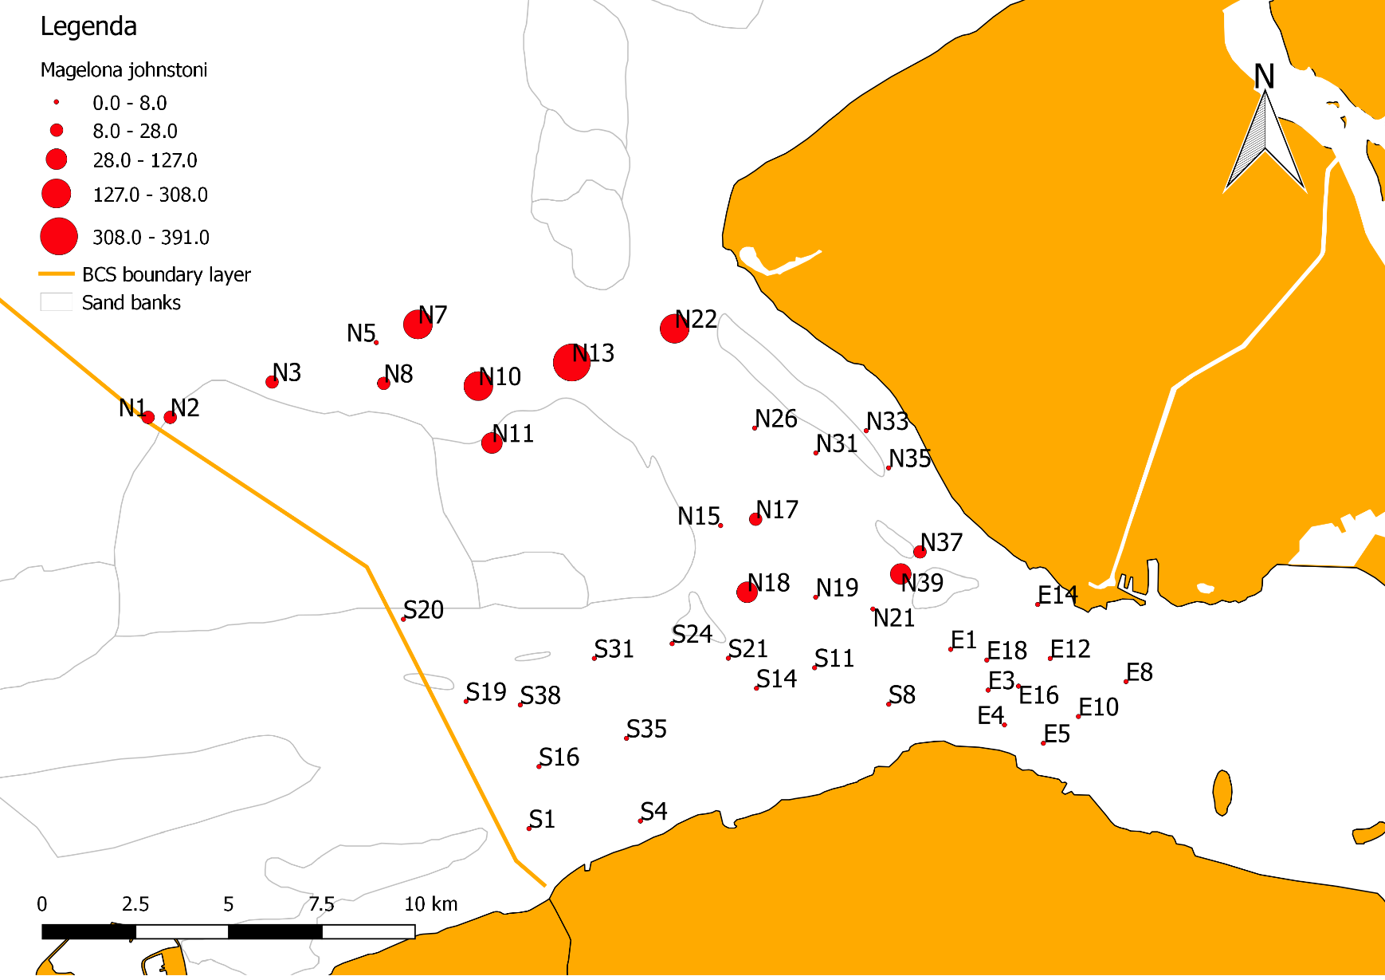
Figure 22 Spatial distribution Magelona johnstoni
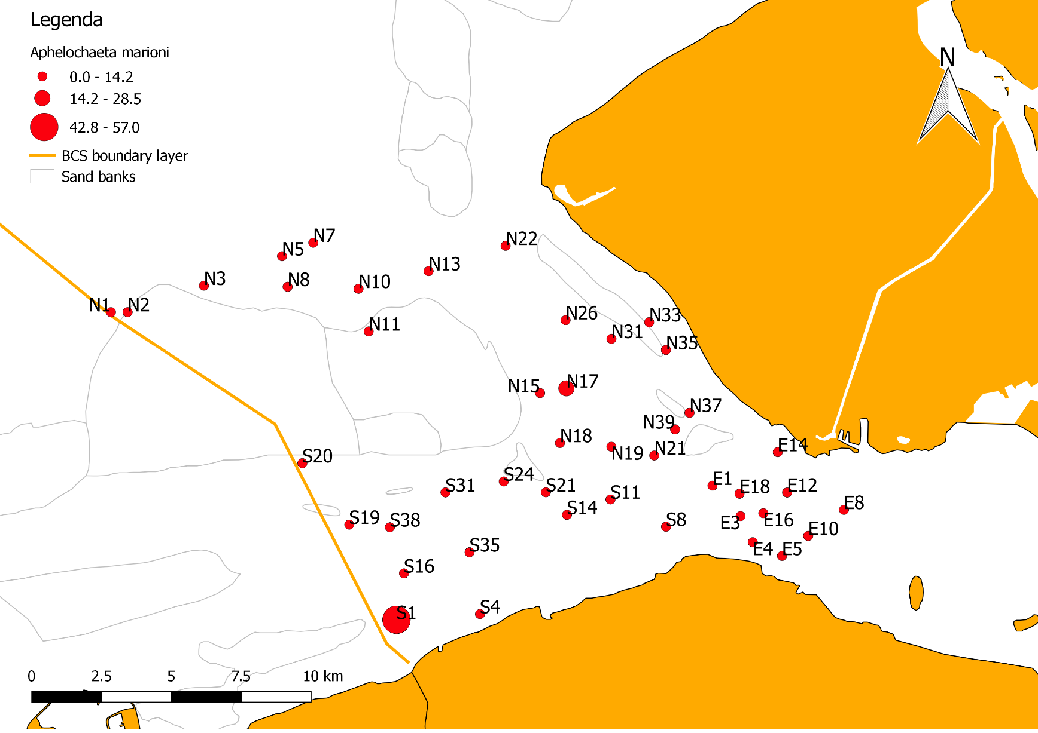
Figure 23 Spatial distribution Aphelochaeta marioni

Bivalves
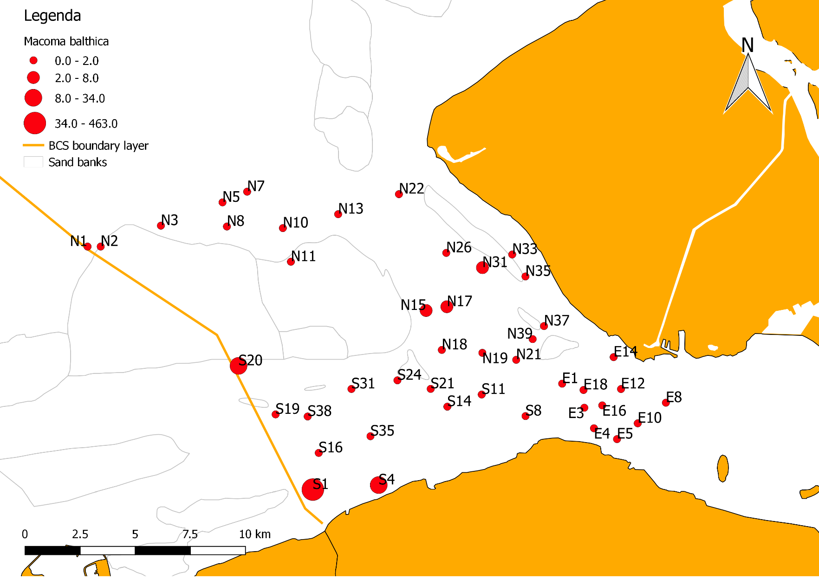
Figure 24 Spatial distribution Macoma balthica

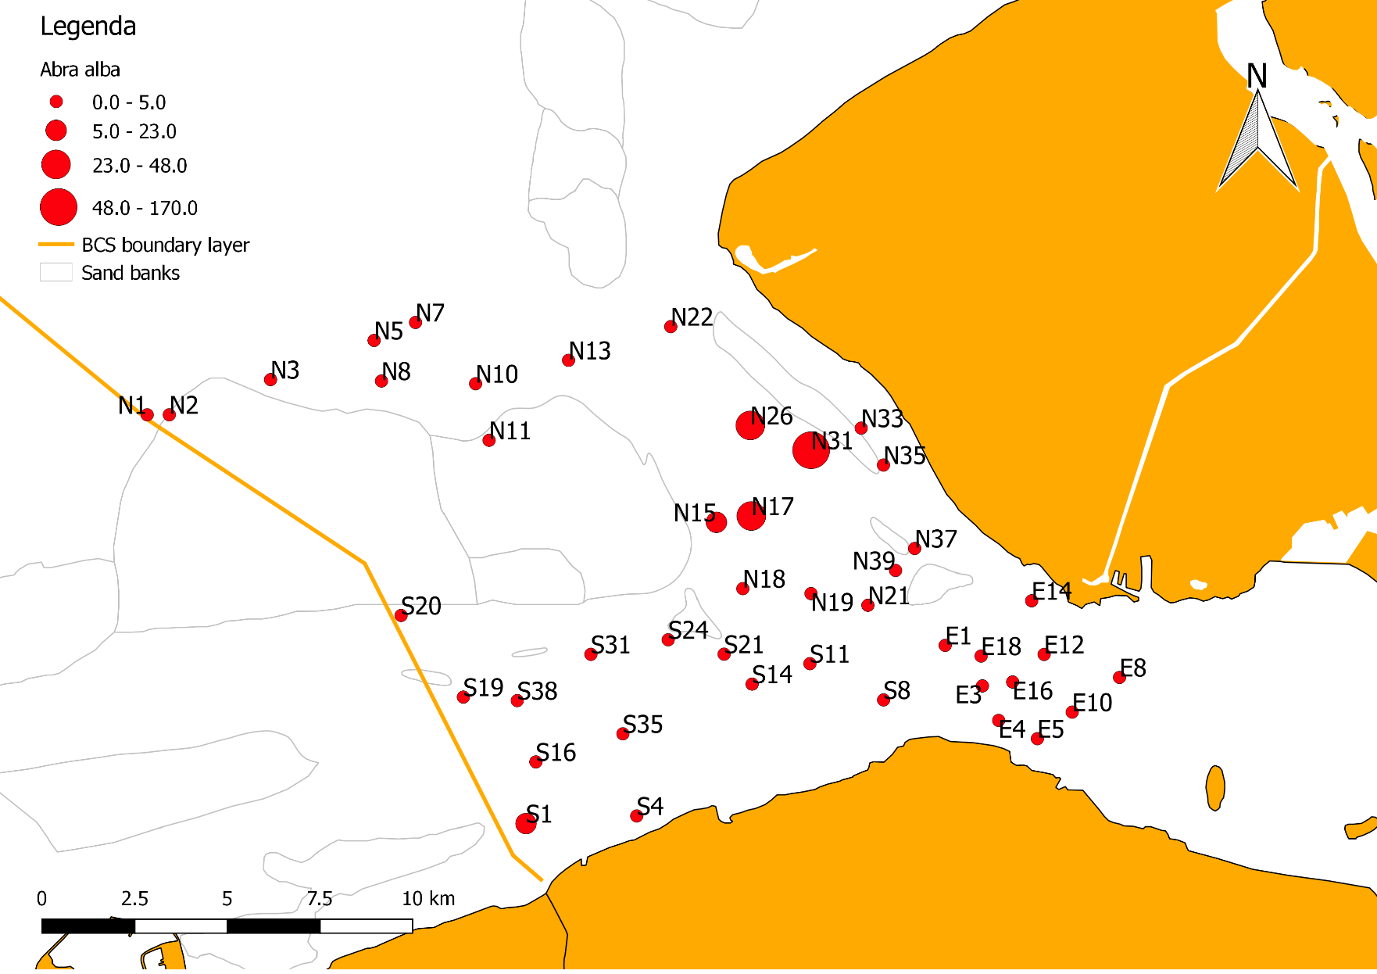
Figure 25 Spatial distribution Abra alba

Abiotic factors

Chlorophyll a
The chlorophyll a concentration did not differ much between locations (3,12 – 3,84 µg/L).
Keep in mind that each chlorophyll a factor was measured at a different time of the day. Due to this, it can be that there were differences between light penetration in the water. In Appendix 6 the exact time of each measurement is given.

Salinity
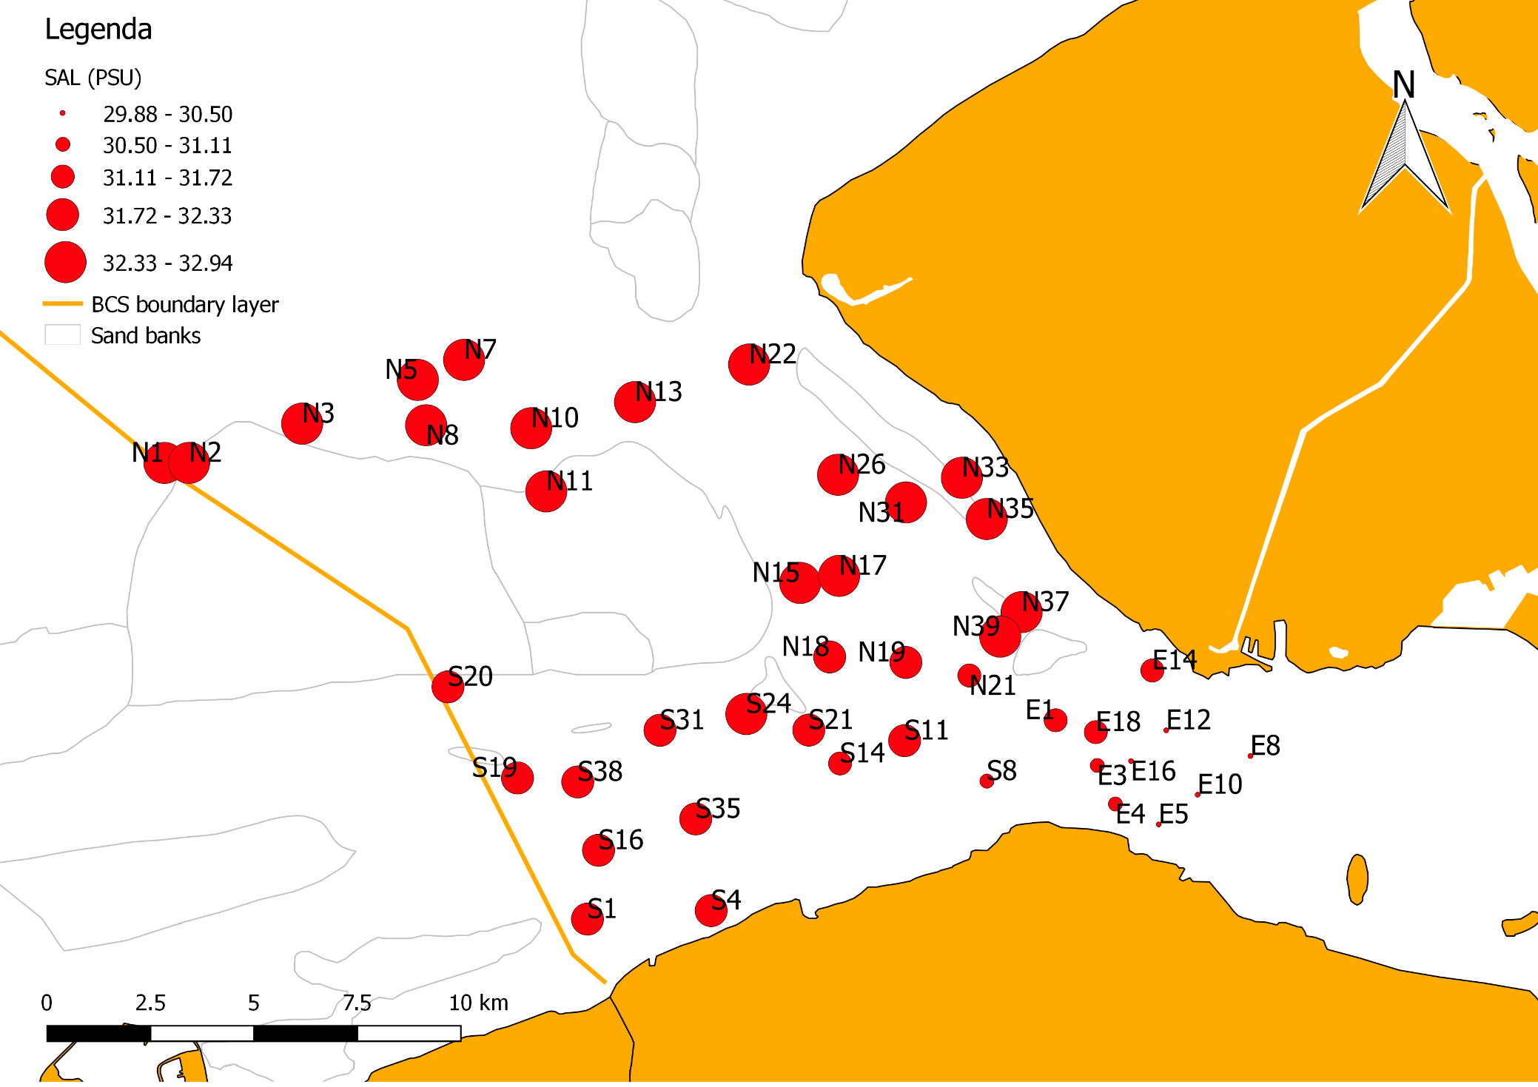
Group E (located in the estuary) has a lower salinity than the other groups. Again the measurements were completed at a different time of the day. However, what is more important for the results is whether it was high tide or low tide (currents). This would lead to different salinity gradients as water would flow in the Western Scheldt (becoming more salt) or water would flow out of the Western Scheldt (becoming more fresh). An indication that the water was flowing out of the Western Scheldt can be found in appendix 6.
Figure 26 The salinity at the different sample locations.

Bathymetry
The depths of the sample locations were ranging from 3-21 meter, with the East having the deepest locations and the North the shallower locations.

Median Grain Size
The median grain size is an important factor determining whether a species can live in that area or not.
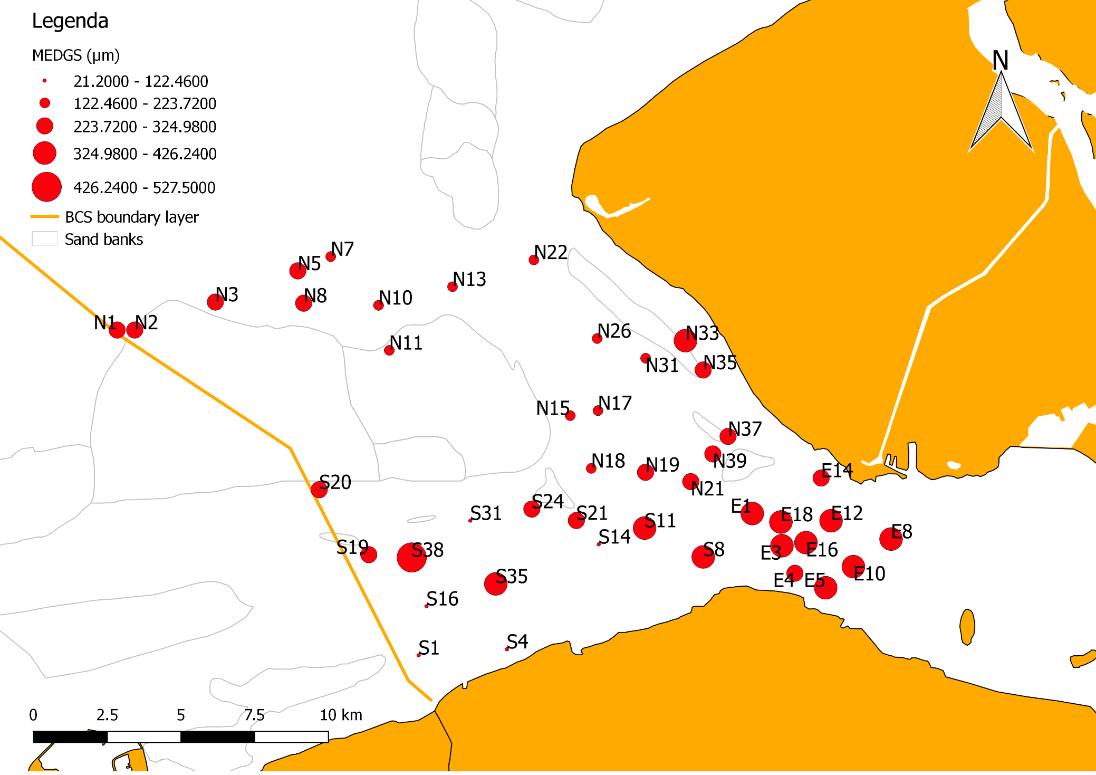
Figure 27 Median Grain Size at all sample locations
Group E has the largest median grain size (figure 27). Figure 28 shows the median grain size (y) in relation to depth (x). There can be seen that the deeper it gets, the coarser the sediment becomes.
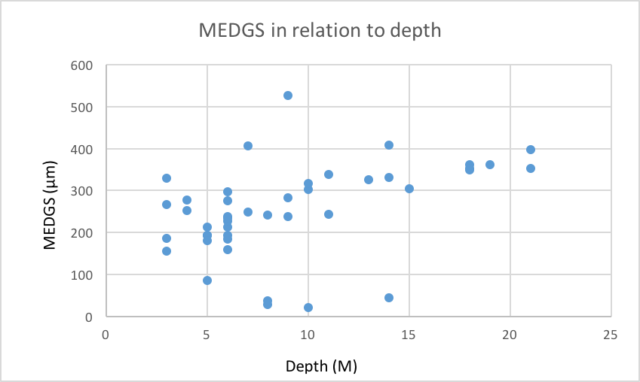
Figure 28 Median Grain Size (µm) in relation to depth (M)

Mud content
It is remarkable that the South has a higher mud content than North or East (figure 29). There is also more organic material present in the South (figure 30).
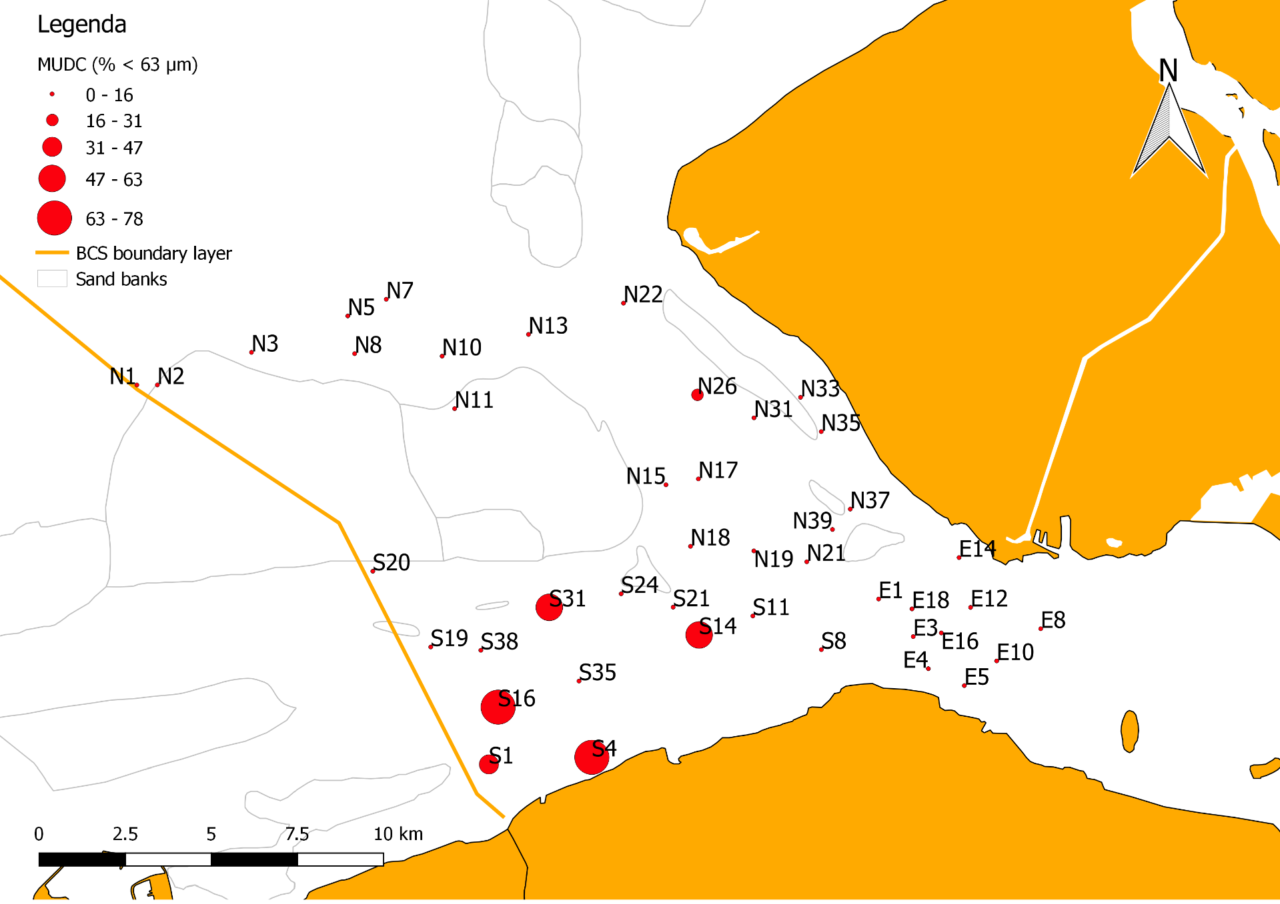
Figure 29 Mud content at all sample locations

Total Organic Material (TOM)
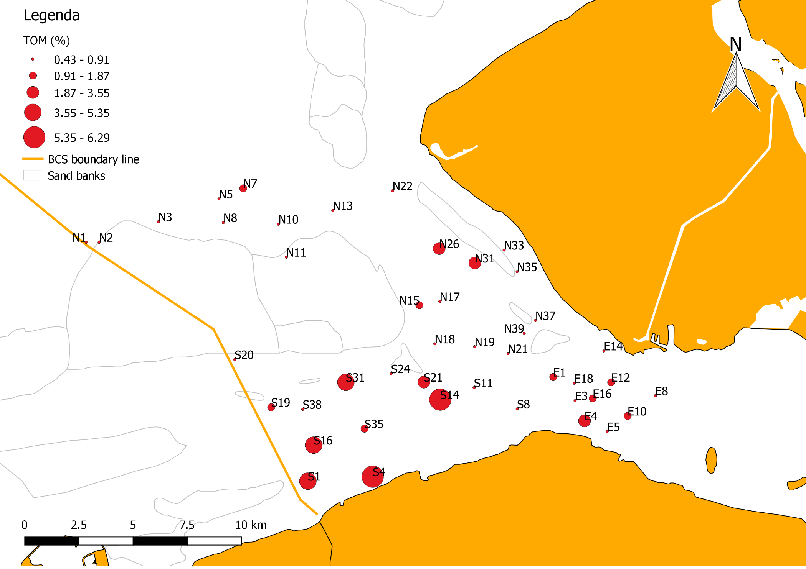
Figure 30 Total organic material content at all sample locations

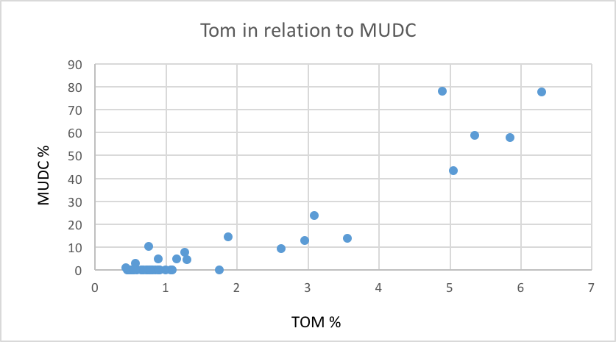
Figure 31 TOM (%) in relation to MUDC (%)
As already mentioned, the more mud present in the sediment, the more organic material there is present. TOM (x) in relation to the mud (y) content was plotted in a graph (figure 31). This graph shows clearly that the more mud there is present, the higher the TOM, thus, the more food for the benthos.

Spearman’s Rank Order Correlation (MEDGS)
The results of the Spearman Rank Order Correlations give a N-, Spearman-R and P-value (table 1). The N value gives the amount of quantities looked into (sample size). Spearman-R values are interesting as they give a value from +1 to -1, where +1 indicates a positive association, a value of zero indicates no association and a value of -1 indicates a negative association between two parameters. Spearman’s – R value is only significant when the P-value is lower than 0.05. Thus, all marked correlations are significant.

Table 1 Spearman Rank Order Correlation with MEDGS
Spearman Rank Order Correlations
Marked correlations are significant (p <,05000)
 | Valid - N | Spearman - R | t(N-2) | p-value
MEDGS (µm) & S | 44 | -0,612286 | -5,01883 | 0,000010
MEDGS (µm) & N | 44 | -0,692745 | -6,22520 | 0,000000
MEDGS (µm) & J | 41 | 0,579106 | 4,43607 | 0,000073
MEDGS (µm) & H | 44 | -0,044507 | -0,28873 | 0,774212
MEDGS (µm) & Nephtys sp. | 44 | -0,286018 | -1,93442 | 0,059816
MEDGS (µm) & Magelona johnstoni | 44 | -0,334260 | -2,29846 | 0,026581
MEDGS (µm) & Spiophanes bombyx | 44 | -0,348090 | -2,40637 | 0,020590
MEDGS (µm) & Scoloplos armiger | 44 | -0,331016 | -2,27339 | 0,028179
MEDGS (µm) & Aphelochaeta marioni | 44 | -0,314317 | -2,14576 | 0,037718
MEDGS (µm) & Abra alba | 44 | -0,591219 | -4,75076 | 0,000024
MEDGS (µm) & Macoma balthica | 44 | -0,451637 | -3,28059 | 0,002088
MEDGS (µm) & Petricola pholadiformis | 44 | -0,257587 | -1,72765 | 0,091398

As can be seen, a larger MEDGS generally relates to a lower number and abundance of species present at a location (-0,612286) with the highest species number and total abundance found at a median grain size of x µm (Figure 32 and 33). All other parameters become negative as the MEDGS gets larger, except for Pielou’s evenness (in what way the quantity of different species are even). The larger the sediment median grain size, the higher the Pielou’s evenness (figure 34). The relation of the organisms and the MEDGS can be seen comparing figure 27 with the figures 19-25.

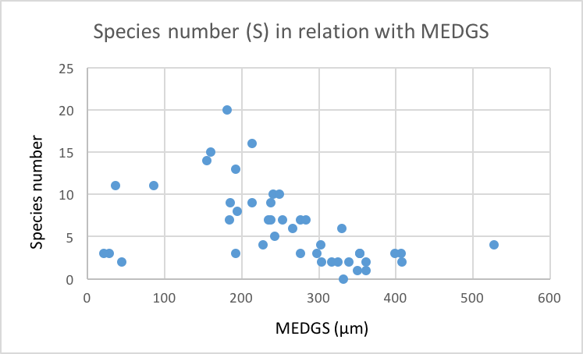
Figure 32 Species number in relation with MEDGS (µm)

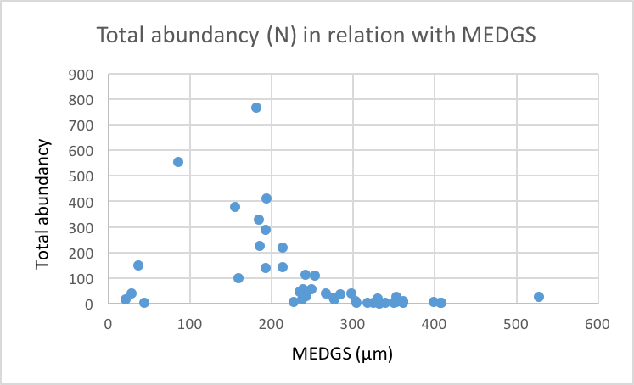
Figure 33 Total abundancy in relation with MEDGS (µm)

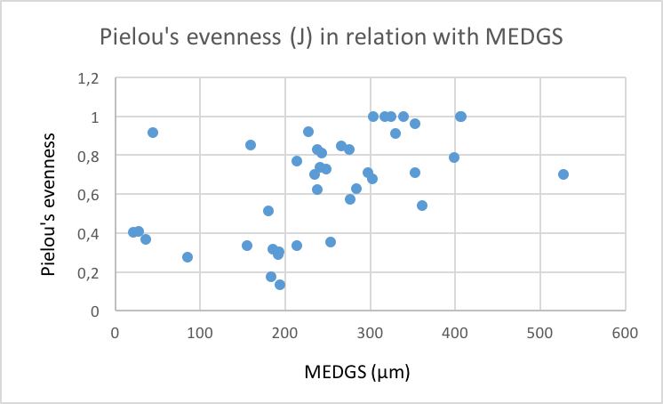
Figure 34 Pielou's evenness in relation with MEDGS (µm)

Spearman’s Rank Order Correlation (MUDC)
The table below shows that the more mud present, the more likely organisms are present. However, the P-value is not always below 0.05, and thus the data not significant. According to the results, Nephtys sp. and Magelona johnstoni are not likely to be present in a muddy environment, while Aphelochaeta marioni, Macoma balthica and Petricola pholadiformis do. These results can be seen when comparing figure 29 with the figures 19-25.

Table 2 Spearman Rank Order Correlation with MUDC
Spearman Rank Order Correlations
Marked correlations are significant (p <,05000)
 | Valid - N | Spearman - R | t(N-2) | p-value
MUDC (% < 63 µm) & S | 44 | 0,051999 | 0,33745 | 0,737462
MUDC (% < 63 µm) & N | 44 | -0,028809 | -0,18678 | 0,852732
MUDC (% < 63 µm) & J | 41 | 0,103999 | 0,65301 | 0,517579
MUDC (% < 63 µm) & H | 44 | -0,007399 | -0,04795 | 0,961982
MUDC (% < 63 µm) & Nephtys sp. | 44 | -0,509778 | -3,84019 | 0,000408
MUDC (% < 63 µm) & Magelona johnstoni | 44 | -0,464741 | -3,40152 | 0,001482
MUDC (% < 63 µm) & Spiophanes bombyx | 44 | -0,187389 | -1,23632 | 0,223210
MUDC (% < 63 µm) & Scoloplos armiger | 44 | 0,286552 | 1,93836 | 0,059320
MUDC (% < 63 µm) & Aphelochaeta marioni | 44 | 0,347305 | 2,40020 | 0,020896
MUDC (% < 63 µm) & Abra alba | 44 | 0,224704 | 1,49447 | 0,142529
MUDC (% < 63 µm) & Macoma balthica | 44 | 0,460416 | 3,36130 | 0,001662
MUDC (% < 63 µm) & Petricola pholadiformis | 44 | 0,455295 | 3,31407 | 0,001900

Spearman’s Rank Order Correlation (TOM)
Table 3 presents the correlations between TOM and other factors. Expectations would be that Spearman’s - R would be positive for each factor as TOM is the amount of organic material (food) present. However, this is not the case.

Nephtys sp. and Magelona johnstoni are less present when there is more TOM present. This could be as the amount of TOM correlates with the mud content (Figure 31). So the discussed organisms are more likely to be present in larger grain sizes with less mud. Nevertheless, Aphelochaeta marioni, Abra alba and Macoma balthica favor larger amounts of TOM. The results of the other organisms are not reliable as p>0.05000.

Table 3 Spearman Rank Order Correlation with TOM
Spearman Rank Order Correlations
Marked correlations are significant (p <,05000)
 | Valid - N | Spearman - R | t(N-2) | p-value
TOM (%) & S | 44 | 0,007352 | 0,04765 | 0,962221
TOM (%) & N | 44 | 0,071567 | 0,46500 | 0,644332
TOM (%) & J | 41 | -0,066309 | -0,41501 | 0,680407
TOM (%) & H | 44 | -0,208366 | -1,38067 | 0,174685
TOM (%) & Nephtys sp. | 44 | -0,381265 | -2,67277 | 0,010665
TOM (%) & Magelona johnstoni | 44 | -0,354132 | -2,45407 | 0,018353
TOM (%) & Spiophanes bombyx | 44 | -0,159891 | -1,04972 | 0,299851
TOM (%) & Scoloplos armiger | 44 | 0,185540 | 1,22368 | 0,227893
TOM (%) & Aphelochaeta marioni | 44 | 0,355889 | 2,46801 | 0,017743
TOM (%) & Abra alba | 44 | 0,323245 | 2,21371 | 0,032333
TOM (%) & Macoma balthica | 44 | 0,389633 | 2,74179 | 0,008940
TOM (%) & Petricola pholadiformis | 44 | 0,270172 | 1,81854 | 0,076117

Discussion
In this section the results into perspective. Thereby, possible explanations for
observed trends are put forward (5.1) along with a description of uncertainties and shortcomings regarding the data (5.2 and following).

Synthesis
The goal of this bachelor thesis was to identify the infaunal invertebrate species present in the Vlakte van de Raan area and to describe their distribution patterns in relation to the environmental gradients in the area (salinity, median grain size, mud content, total organic material, chlorophyll a and bathymetry). Therefore, the main question of this research was: What is the spatial distribution pattern of the macrobenthos at the Vlakte van de Raan in relation to the environmental gradients? After identification of the species in a selection of 43 of the 82 samples, the spatial distribution patterns of the most common species were plotted.

The locations in the North have the highest species number, total abundance and diversity in comparison with those in the East and South (figure 15-18). Possible reasons for this can be that the North has no or little fluctuations in salinity. Moreover, there is an average MEDGS (155-330µm) and a quite low mud content present. As the biological valuation map of the macrobenthos for the Belgian part of the North Sea (figure 6) shows, the highest valuated areas are close to the North of the Vlakte van de Raan having a MEDGS between 100-350µm. With the MEDGS of the samples fitting right in, this can be a reason the North has the highest species abundance and diversity.

The East has a lot of factors which can support its low score as already mentioned before. However, the South has fewer. Though it still has some, for example the South has the muddiest locations. As the comparison of figure 4 and 6 shows, muddy locations have a relative low biological valuation. A muddier seafloor is only favorable for some species (e.g. Aphelochaeta marioni, Macoma balthica and Petricola pholadiformis, see table 2).

Moreover, the South does not have only the muddiest locations; it has one location (S38) with the largest MEDGS as well (ranging from 28-527µm). Considering table 1, there can be seen that a large median grain size has a negative effect towards each species. The outcomes of table 1 may not be completely trustable as the East has the largest median grain size overall, but has the lowest salinity gradient as well. Therefore, it might be that the salinity is a more important factor than the MEDGS. Besides, figure 32 and 33 indicate that a very small MEDGS is not favorable as well for most species. This extreme difference of small and large sediment may cause there is only a small part suitable to live.

Identification
Challenges during the identification process were that the samples were over a year old and that I was inexperienced in the determination.

Abiotic Factors

Sediment grain size
Considering figure 27, it is notable the South has both the largest and the smallest median grain size. This can be due to a muddy sandbar located in the South, near the Belgian border, which figure 4 verifies. In the East, the largest overall median grain size can be found. According to (Bridge and Dominic, 19), when a fluid stream flows over a bed of loose sediment grains, it may result in transportation of a finite number of grains. Perhaps there are higher velocity rates in the estuary, which transports the smaller sediment away. However, the velocity was not measured so this relation could not be made.

TOM & MUDC
Looking at the results of the total organic material present in the sediment, it is remarkable that the most organic material is present in the South (figure 30). This was expected to be an important factor as it indicates whether there is a lot of little food present. However, comparing the TOM with the spatial distribution of the organisms, it is notable that only Macoma balthica and Aphelochaeta marioni have their highest abundancy in the South. This outcome of low diversity and species richness can be due to the high mud content present in the South (as figure 33 indicates, the organic material present increases as the mud content rises).

Salinity
The salinity stays overall quite the same and no large differences occur, except for the East as already said before. In the estuary, the salinity level probably is depending on the circumstances whether the water level is rising, and thus flowing into the Western Scheldt (making it more salt), or the water level is shrinking, and thus flowing out of the Western Scheldt (making it more fresh). As there can be seen in appendix 6, when collecting the samples in the East, the water level was shrinking. Perhaps this is the reason why the East has a lower salinity compared to the North or South.

Chlorophyll A
As figure 15 shows, there is very little difference in the amount of CHL A present at the sample locations. However, the most CHL A is present in the North and the least in the East. The CHL A of sample locations N33-N39 was measured before 7:50hr (appendix 6). Due to this, the sun was not risen yet, so no light was penetrating the water. This can be the reason that these locations in the North have a lower number than the other locations North.

Bathymetry
As the Western Scheldt has several important shipping lanes to some immense harbors, a lot of dredging occurs. As the estuary (Vlakte van de Raan) is the entrance of the Western Scheldt, a lot of dredging occurs here as well.

Figure 27 supports this as it indicates that the East is the deepest part of all other locations. When dredging, the sediment is extracted up and moved. However, not only sediment is extracted, but the organisms living in it as well. Besides, their habitat is disturbed. This possible can be the trigger there is so little life in the East.

Conclusions

- At least Nephtys sp., Magelona johnstoni, Spiophanes bombyx, Scoloplos armiger, Aphelochaeta marioni, Abra alba, Macoma balthica and Petricola pholadiformis do prefer the Vlakte van de Raan area as their habitat, with Nephtys sp., Magelona johnstoni and Macoma balthica being most abundant.

- The North is the most ecologically rich location of the Vlakte van de Raan area as it has the highest species number (S), total abundancy (N) and diversity (H).

- Nephtys sp., Magelona johnstoni, Spiophanes bombyx, Scoloplos armiger and Abra alba are most abundant in the North.

- The South is a suitable habitat for Aphelochaeta marioni, Macoma balthica and Petricola pholadiformis as the seafloor is quite muddy.

- Aphelochaeta marioni and Macoma balthica are most abundant in the South.

- In the East of the Vlakte van de Raan area, little organisms are being observed as it has a large median grain size, deep water and a low salinity.

- The organisms found at the Vlakte van de Raan area do not prefer extremely small or extremely large sediment particles.

- The deeper the water, the less organisms present.

- Low salinity (and perhaps fluctuations in salinity) is not preferable for the organisms.

Recommendations further research

This section provides some recommendations for future research to have more reliable outcomes:

- The other 39 samples should be identified and compared with new samples (dating from 2018 or later).

- Research should be done to know whether there are less organisms present in the East due to the lower salinity gradients (and possibly salinity fluctuations), or due to the larger MEDGS present.

- As the MEDGS was determined with two different devices, it should be investigated whether this gave a different outcome.

- Because the salinity was only measured for a few minutes and no expanded measurements were done, the outcome is less steadfast. Therefore, more measurements should be done to know whether the salinity gradients stay overall the same over time or not.

- The reason the East has the lowest amount of CHL A present perhaps is due to high velocity currents in combination with salinity fluctuations. However, no measurements are available to support this theory. Therefore, research should be done to know if the salinity and velocity correlates with the amount of CHL A present.

- When dredging, the sediment is extracted up and moved. However, not only sediment is extracted, but the organisms living in it as well. Besides, their habitat is disturbed. This possible can be the trigger there is so little life in the East. Therefore, further research should be done to know how much the dredging disturbs the organisms at the Vlakte van de Raan.

References
Encyclopædia Britannica. (2016, September 6). Benthos. Retrieved March 29, 2018, from Encyclopædia Britannica: https://www.britannica.com/science/benthos#ref289758
Hartmann-Schröder, G. (1996). Annelida, Borstenwürmer, Polychaeta: Die Tierwelt Deutschlands. In G. Hartmann-Schröder, Annelida, Borstenwürmer, Polychaeta: Die Tierwelt Deutschlands, Teil 58 (Vol. 58). Jena: Gustav Fischer.
J.R. Griffiths, M. Kadin, F.J.A. Nascimento, T. Tamelander, A. Törnroos, S. Bonaglia, E. Bonsdorff, V. Brüchert, A. Gårdmark, M. Järnström, J. Kotta, M. Lindegrin, M.C. Nordström, A. Norkko, J. Olsson, B. Weigel, R. Zydelis, T. Blenckner, S. Niiranen and M. Winder. (2017). The importance of benthic–pelagic coupling for marine ecosystem functioning in a changing world. John Wiley & Sons Ltd.
J.S. Bridge and D.F.Dominic. (1984). Bed Load Grain Velocities and Sediment Transport Rates. Binghamton.
Lund Research Ltd. (2018). Spearman's rank-order correlation using SPSS Statistics. Retrieved from Laerd Statistics: https://statistics.laerd.com/spss-tutorials/spearmans-rank-order-correlation-using-spss-statistics.php
Malvern Panalytical. (2018). Mastersizer 3000. Retrieved from Malvern Panalytical: https://www.malvernpanalytical.com/en/products/product-range/mastersizer-range/mastersizer-3000/?gclid=EAIaIQobChMI4KHys_ue2wIVrLftCh2iWQREEAAYASAAEgLu5vD_BwE
M. Beals, L. Gross, and S. Harrell. (2000). Diversity indices: Shannon's H and E. Retrieved from The Institute for Environmental Modeling (TIEM): http://www.tiem.utk.edu/~gross/bioed/bealsmodules/shannonDI.html
P.H. Ryland. (1996). Handbook of the Marine Fauna of North-West Europe. Swansea: Oxford University Press.
P.N. Geetha, T.A. Thasneem and S.B. Nandan. (2010). Macrobenthos and its relation to ecosystem dynamics in the cochin estuary. Cochin University of Science & Technology.
PISCES Conservation. (2018). Similarity Percentages (SIMPER). Retrieved from pisces conservation: http://www.pisces-conservation.com/caphelp/index.html?similaritypercentages(simper.html
S. Degraer, J. Wittoeck, W. Appeltans, K. Cooreman, T. Deprez, H. Hillewaert, K. Hostens, J. Mees, E.V. Berghe and M. Vincx. (2006). The macrobenthos atlas of the belgian part of the north sea. De Windroos.
S.H.Hurlbert. (1971, July 1). The Nonconcept of Species Diversity: A Critique and Alternative Parameters. California.
S.K.H. Janssen, G.J. Ellen and M. Taal (2015). From stakeholder to shareholder – organising stakeholder commitment for the schelde estuary of the future –. Deltares, Delft.
T. Ysebaert, P. Meire, P.M.J. Herman and H. Verbeek. (2002). Macrobenthic species response surfaces along estuarine gradients: prediction by logistic regression. Inter-Research Science Centre.
Virginia Institute of Marine Science. (2018). Shallow Water Communities - Macrofauna. Virginia. Retrieved April 2018, from Shallow Water Habitats: http://web.vims.edu/bio/shallowwater/benthic_community/macrofauna.html

Appendix 1

Figure 1 Macoma balthica. Retrieved from: https://naturalhistory.museumwales.ac.uk/britishbivalves/browserecord.php?-recid=86
Figure 2 Nephtys cirrosa. Retrieved from: https://nl.wikipedia.org/wiki/Nephtys_cirrosa

Figure 3 Ophelia limacina. Retrieved from: http://www.marinespecies.org/photogallery.php?album=673&pic=494

Figure 4 Abra alba. Retrieved from: https://commons.wikimedia.org/wiki/File:Abra_alba.jpg

Appendix 2

Figure 1 Cerastoderma edule. Retrieved from: http://www.idscaro.net/sci/04_med/class/fam5/species/cerast_edule1.htm
Figure 2 Corophium volutator. Retrieved from: https://alchetron.com/Corophium-volutator

Appendix 3
Figure 1 Schematic representation of Remane's curve. The number of species is plotted against salinity and shows region of reduced diversity (grey shaded area) where fresh water and sea water met. These “transitional waters” are often considered to be depauperate. Retrieved from: https://www.eolss.net/Sample-Chapters/C09/E4-27-02-06.pdf

Appendix 4
Figure 1 New group formation according to MEDGS

Appendix 5
To analyze the community structure, several statistical methods were used. First of all, an analysis of similarities (ANOSIM) was done, which defines whether the groups in the North, South and East are different to each other or not. Moreover, species contributions to these differences were defined using a one-way analysis (SIMPER).

5.1. Analysis of Similarities (ANOSIM)
Analysis of similarities (ANOSIM) provides a way to test statistically whether there is a significant difference between two or more groups of sampling units.

The test generates a value of R which is scaled to lie between 0 and 1, a value of zero representing the null hypothesis (no difference among a set of samples). In ANOSIM, comparison of pairwise R values, measuring how separate groups are, on a scale of 0 (indistinguishable) to 1 (all similarities within groups are less than any similarity between groups) gives an interpretable number for the difference between groups.

The results of the ANOSIM (One Way) gives the R and P value for each level of the factors/samples (zone N, zone S and zone E). The pairwise test will show if the samples are significantly different (P value) and how strongly they are different to each other (R value). So, with the outcomes of the test, there is known whether the three zones are different to each other and how much.

5.2. One-way Analysis (SIMPER, Similarity Percentages - species contributions)
The SIMPER analysis gives the percentage of similarity and dissimilarity of the samples, between levels of the samples and for specific levels of the samples. This is based on the Bray-Curtis measure, where each group is considered in turn. The test also presents which variables in the data explain the similarities; the percentage of contribution of the variables (Contrib%). (PISCES Conservation, 2018)

5.3. Analysis of Similarities: ANOSIM (One-way Analysis)
Pairwise Tests
R Significance Possible Actual Number >=
Groups Statistic Level % Permutations Permutations Observed
N, E 0,539 0,1 44352165 999 0
N, S 0,560 0,1 354817320 999 0
E, S 0,116 4,6 646646 999 45

Above the data of the ANOSIM test can be seen. This test, especially the R values, indicates how separate the groups (North, South and East) are. The compared groups are found at the left.

The lower the R value (between 0 and 1), the less difference there is between those groups. The R values show that there are quite some differences between the groups their species composition. However, between group E and group S, the number (0,116) is remarkably lower than the other two R values above. This probably as the groups were made according to the location (N, E and S), and not according to the median grain size or bathymetry. So perhaps it would be better if the groups were made like Figure 1 in Appendix 4. This way group E and S would have relative little similarities as well.

5.4. Similarity Percentages - Species Contributions: SIMPER (One-way Analysis)
Group N
Average similarity: 41,19

Species Av.Abund Av.Sim Sim/SD Contrib% Cum.%
Nephtys sp. 2,20 15,21 2,01 36,94 36,94
Magelona johnstoni 2,99 14,67 1,24 35,61 72,55
Spiophanes bombyx 1,17 3,36 0,76 8,15 80,69
Bathyporeia guilliiamsoniana 0,81 3,08 0,55 7,49 88,18
Abra alba 0,99 0,87 0,36 2,12 90,31

As there can be seen, group N has an average similarity of 41,19% between the group members. Nephtys sp. and Magelona johnstoni together contributed 72,55% of the total similarity followed by Spiophanes bombyx with 8,15%. As Nephthys sp. and Magelona johnstoni have such a high contribution, they are the indicator species of group N.

Group E
Average similarity: 24,64

Species Av.Abund Av.Sim Sim/SD Contrib% Cum.%
Nephtys sp. 1,03 18,36 0,79 74,53 74,53

Gastrosaccus spinifer 0,63 4,04 0,38 16,39 90,92

Group E has only a similarity of 24,64% where Nephtys sp. has a contribution of 74,53% followed by Gastrosaccus spinifer with 16,39%. Remarkable is that group E has only 2 species contribute to get about 90%. This indicates that there are less species found in group E than in group N or group S.

Group S
Average similarity: 16,01

Species Av.Abund Av.Sim Sim/SD Contrib% Cum.%
Nephtys sp. 0,82 8,16 0,75 50,95 50,95
Macoma balthica 1,26 3,72 0,42 23,21 74,16
Petricola pholadiformis 0,95 1,80 0,26 11,27 85,43

Aphelochaeta marioni 0,57 0,42 0,20 2,64 88,07
Scoloplos armiger 0,21 0,36 0,21 2,24 90,31

Group S has an even lower percentage of average similarity than group E. This as the group has more different species than the other groups (E and N). However, the SIMPER results indicate that Nephtys sp. is the variable that contributes the most to the within-group similarities at every site.

Groups N & E
Average dissimilarity = 80,74

Group N Group E
Species Av.Abund Av.Abund Av.Diss Diss/SD Contrib% Cum.%
Magelona johnstoni 2,99 0,18 19,37 1,51 23,99 23,99
Nephtys sp. 2,20 1,03 9,56 1,12 11,85 35,83
Spiophanes bombyx 1,17 0,00 6,56 1,14 8,12 43,95
Bathyporeia guilliiamsoniana 0,81 0,21 6,19 0,90 7,67 51,62
Gastrosaccus spinifer 0,07 0,63 4,24 0,69 5,25 56,87
Abra alba 0,99 0,00 3,47 0,71 4,30 61,16
Ophiura albida 0,55 0,07 2,49 0,69 3,09 64,25
Urothoe poseidonis 0,33 0,07 2,27 0,65 2,81 67,06
Ensis sp. 0,58 0,00 2,17 0,68 2,69 69,75
Owenia fusiformis 0,68 0,00 2,10 0,38 2,60 72,35
Macoma balthica 0,45 0,07 2,09 0,71 2,59 74,94
Echinocardium cordatum 0,22 0,07 1,68 0,58 2,08 77,01
Scoloplos armiger 0,48 0,00 1,64 0,58 2,02 79,04
Fabulina fabula 0,34 0,00 1,61 0,56 1,99 81,03
Spionidae sp. 0,21 0,00 1,29 0,50 1,59 82,63
Tellymia ferruginosa 0,24 0,00 1,18 0,39 1,46 84,09

Notomastus latericeus 0,35 0,00 1,11 0,43 1,38 85,47
Donax vittatus 0,18 0,00 1,09 0,40 1,36 86,82
Phyllodoce mucosa 0,26 0,07 1,04 0,54 1,29 88,12
Corophium sp. 0,18 0,00 0,84 0,22 1,05 89,16
Diastylis rathkei 0,07 0,07 0,82 0,39 1,01 90,17

The average dissimilarity between group N and group E is 80.74%. The variables are given which contributes most to the observed dissimilarity. In this case, the greatest dissimilarity is generated by Magelona johnstoni as group N has an average abundance of 2.99% and group E only 0.18% for this species. This way the species contributes for 23.99% of the total dissimilarity.

Groups N & S
Average dissimilarity = 84,87

Group N Group S
Species Av.Abund Av.Abund Av.Diss Diss/SD Contrib% Cum.%
Magelona johnstoni 2,99 0,15 16,08 1,38 18,95 18,95
Nephtys sp. 2,20 0,82 8,53 1,24 10,05 29,00
Macoma balthica 0,45 1,26 5,88 0,80 6,93 35,93
Spiophanes bombyx 1,17 0,18 5,36 1,10 6,32 42,24
Bathyporeia guilliiamsoniana 0,81 0,26 5,27 0,85 6,20 48,45
Petricola pholadiformis 0,00 0,95 4,33 0,58 5,10 53,55
Abra alba 0,99 0,36 3,66 0,84 4,31 57,86
Aphelochaeta marioni 0,21 0,57 2,50 0,58 2,94 60,81
Ensis sp. 0,58 0,15 2,15 0,75 2,53 63,34
Owenia fusiformis 0,68 0,09 2,12 0,43 2,50 65,84
Scoloplos armiger 0,48 0,21 2,09 0,74 2,46 68,30

Ophiura albida 0,55 0,00 1,94 0,61 2,29 70,59
Urothoe poseidonis 0,33 0,00 1,68 0,58 1,98 72,57
Notomastus latericeus 0,35 0,25 1,60 0,60 1,89 74,46
Corophium sp. 0,18 0,22 1,57 0,42 1,85 76,31
Fabulina fabula 0,34 0,00 1,37 0,55 1,62 77,93
Mysella bidentata 0,14 0,21 1,29 0,64 1,52 79,44
Tellymia ferruginosa 0,24 0,06 1,21 0,46 1,43 80,87
Echinocardium cordatum 0,22 0,00 1,17 0,50 1,38 82,25
Ophelia limacina 0,00 0,21 1,16 0,28 1,36 83,61
Polychaet sp 1 0,00 0,21 1,12 0,28 1,32 84,93
Spionidae sp. 0,21 0,00 1,06 0,48 1,25 86,18
Eteone sp. 0,11 0,18 0,97 0,47 1,15 87,33
Donax vittatus 0,18 0,00 0,91 0,38 1,07 88,40
Phyllodoce mucosa 0,26 0,06 0,90 0,52 1,06 89,45
Eunereis longissima 0,10 0,19 0,89 0,39 1,05 90,50

Magelona johnstoni again is the species that contributes most to the dissimilarity. This as the species has a high abundancy in the North and fewer in the East and South.

Groups E & S
Average dissimilarity = 84,88

Group E Group S
Species Av.Abund Av.Abund Av.Diss Diss/SD Contrib% Cum.%
Nephtys sp. 1,03 0,82 12,04 1,07 14,18 14,18
Macoma balthica 0,07 1,26 11,40 0,82 13,44 27,62
Petricola pholadiformis 0,00 0,95 8,51 0,59 10,02 37,64

Gastrosaccus spinifer 0,63 0,00 7,54 0,65 8,89 46,53
Bathyporeia guilliiamsoniana 0,21 0,26 4,96 0,66 5,84 52,37
Aphelochaeta marioni 0,00 0,57 3,59 0,54 4,23 56,60
Polychaet sp 1 0,07 0,21 3,48 0,40 4,10 60,70
Magelona johnstoni 0,18 0,15 3,27 0,52 3,85 64,56
Scoloplos armiger 0,00 0,21 2,58 0,44 3,04 67,59
Ophelia limacina 0,00 0,21 2,42 0,30 2,85 70,44
Nereis sp. 0,00 0,17 2,23 0,38 2,63 73,07
Capitella sp. 0,00 0,12 1,86 0,33 2,19 75,26
Mysella bidentata 0,00 0,21 1,86 0,53 2,19 77,45
Abra alba 0,00 0,36 1,77 0,48 2,09 79,54
Corophium sp. 0,00 0,22 1,75 0,44 2,07 81,61
Spiophanes bombyx 0,00 0,18 1,73 0,44 2,04 83,65
Eteone sp. 0,00 0,18 1,46 0,42 1,72 85,36
Heteromastus filiformis 0,07 0,12 1,40 0,40 1,65 87,01
Diastylis rathkei 0,07 0,06 1,29 0,33 1,52 88,54
Notomastus latericeus 0,00 0,25 1,18 0,44 1,39 89,93
Phyllodoce mucosa 0,07 0,06 1,15 0,42 1,36 91,28

The SIMPER test indicates that group E and group S are the most dissimilar where Nephtys sp. and Macoma balthica have the highest contribution to this result.

5.5. RELATE (Testing matched resemblance matrices)
Sample statistic (Rho): 0,408
Significance level of sample statistic: 0,1 %
Number of permutations: 999
Number of permuted statistics greater than or equal to Rho: 0

As the tests above present, 40.8% of the species are dependent on the measured environmental gradients. The other 59.2% is dependent on other environmental gradients (e.g. biological interaction).

Appendix 6
The sun rose at 7:50hr and went down at 16:56hr. The red marked values are those who were sampled when it was still dark. This way, probably less CHL A was measured.
Figure 1 Chlorophyll a for each sample location
Except for E7 and E8, all other samples in the East were collected when high tide was becoming low tide, so more fresh water was flowing into the estuary.

Location | Time (Chl A) | High/low tide | Location | Time (Chl A) | High/low tide
N39 (9/11) | 06:48 | HT->LT | N13 (8/11) | 13:17 | Low tide
N37 (9/11) | 07:02 | HT->LT | E7 (9/11) | 13:19 | Low tide
N35 (9/11) | 07:19 | HT->LT | E8 (9/11) | 13:33 | Low tide
N33 (9/11) | 07:30 | HT->LT | E12 (9/11) | 13:44 | LT->HT
N22 (9/11) | 08:48 | HT->LT | N15 (8/11) | 13:44 | LT->HT
N26 (9/11) | 09:08 | HT->LT | N17 (8/11) | 13:57 | LT->HT
N31 (9/11) | 09:35 | HT->LT | N18 (8/11) | 14:07 | LT->HT
 | Break |  | S8 (9/11) | 14:08 | LT->HT
E14 (9/11) | 11:25 | HT->LT | N19 (8/11) | 14:16 | LT->HT
N1 (8/11) | 11:38 | HT->LT | S5 (9/11) | 14:24 | LT->HT
N2 (8/11) | 11:44 | HT->LT | N21 (8/11) | 14:28 | LT->HT
N3 (8/11) | 11:57 | HT->LT | S4 (9/11) | 14:36 | LT->HT
E18 (9/11) | 12:01 | HT->LT | S1 (9/11) | 14:48 | LT->HT
N5 (8/11) | 12:15 | HT->LT | S11 (8/11) | 14:58 | LT->HT
E1 (9/11) | 12:15 | HT->LT | S16 (9/11) | 15:06 | LT->HT
N7 (8/11) | 12:26 | HT->LT | S14 (8/11) | 15:16 | LT->HT
E3 (9/11) | 12:27 | HT->LT | S21 (8/11) | 15:25 | LT->HT
N8 (8/11) | 12:35 | HT->LT | S35 (9/11) | 15:33 | LT->HT
E4 (9/11) | 12:36 | HT->LT | S33 (9/11) | 15:44 | LT->HT
E5 (9/11) | 12:45 | HT->LT | S31 (9/11) | 15:54 | LT->HT
N10 (8/11) | 12:50 | HT->LT | S24 (8/11) | 16:09 | LT->HT
E16 (9/11) | 12:54 | HT->LT | S38 (9/11) | 16:12 | LT->HT
N11 (8/11) | 13:00 | HT->LT | S19 (9/11) | 16:26 | LT->HT
E10 (9/11) | 13:12 | HT->LT | S20 (9/11) | 16:48 | LT->HT

