Potential of Camera Monitoring for classifying and counting fish species
The possibilities of camera monitoring as an alternative for conventional trap monitoring in Dutch waters
Research Report
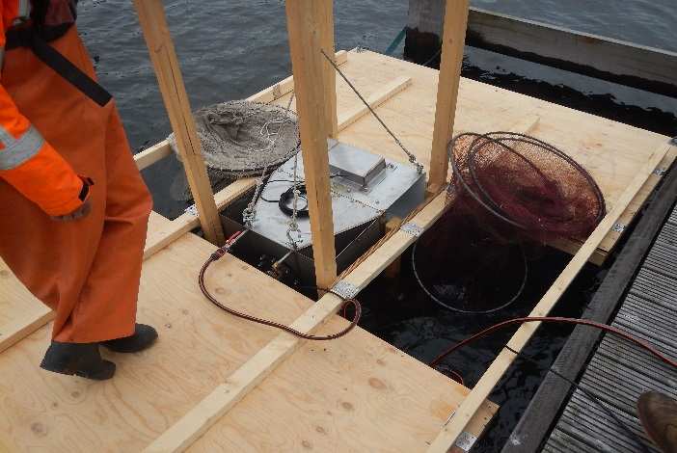

Author: Patrick David Deitelzweig Senior
Course: Final Thesis
Education: Water Management
Study year: 2017/2018, semester 2
School: HZ University of Applied Sciences
Supervisor: A.C. Oele
Company supervisor: Ben Griffioen
Version: 1

Potential of Camera Monitoring for classifying and counting fish species
The possibilities of camera monitoring as an alternative for conventional trap monitoring in Dutch waters

HZ University of Applied sciences
IJmuiden, June 8th 2018
Version: 1.0

Author: Patrick David Deitelzweig Senior
Student number: 00067825
Institution: HZ University of Applied Sciences
Address: Edisonweg 4, 4382 NW Vlissingen
E-mail: deit0003@hz.nl
HZ Supervisor: A. C. Oele
Institution: HZ University of Applied Sciences
Address: Edisonweg 4, 4382 NW Vlissingen
Email: a.c.oele@hz.nl

WMR supervisor: Ben Griffioen
Institution: Wageningen Marine Research
Address: Haringkade 1, 1976 CP IJmuiden
E-mail: ben.griffioen@wur.nl

Abstract
Wageningen Marine Research (WMR) conducts a variety of monitoring programs in Dutch waters. These monitoring programs are conducted to gain knowledge of trends, abundance and diversity of fish species in the Dutch rivers and lakes. Many monitoring programs pay special attention to diadromous fish which are only temporarily present in certain waterbodies. Mostly, these monitoring programs are conducted by fishermen which are contracted by WMR. Most of these fisherman own unique fishing rights for specific waterbodies. Since they are contracted to do research, no commercial fishing activities are allowed during monitoring and regulations defined in the permits are to be followed. Violations of these regulations and exclusion of fisherman cause a loss of monitoring locations since other fisherman do not own the fishing rights. Therefore, alternatives are needed to minimize risk of irregular trend monitoring data. However, further research is needed to test whether alternatives provide reliable trend monitoring data and whether data are sufficient to answer research questions. The goal of this project was to determine if remote camera monitoring is a suitable alternative to conventional trap monitoring. Camera boxes could remove the need for catching and handling fish and therefore prevent the risk of poaching.
A camera box was deployed at an existing monitoring location. Data was collected and analysed from 5th of April until 14th of May. The camera box was connected to a conventional monitoring trap. To determine accuracy, an additional collection net was attached at the end of the camera box to obtain data on actual catches for comparison. By determining species and abundance with obtained video recordings and comparing these to actual catches data, the accuracy and the pros and cons of camera monitoring were determined. Therefore, the main research question is:
What is the effectiveness of video monitoring compared to actual catches of conventional trap monitoring?
The results of the field experiments revealed that camera monitoring shows potential for counting individual fish. With the used set-up, a counting accuracy of 91% was reached. Camera monitoring also showed potential for classifying fish but this is highly dependent on the species. With the used setup, flatfish were difficult to classify. Certain species of round fish with similar physiological traits were also difficult to distinguish. Distinguishing silver eel from yellow eel using the video recordings did not seem possible. The overlap in similar physiological traits, and the lack of colour in the recordings, made it impossible to distinguish the two with certainty.
Camera monitoring shows potential as an alternative monitoring method but will require further research for improvements and fine tuning of this method.

Voorwoord
Voor u mijn scriptie “Potential of camera monitoring for classifying and counting fish”, voor het afrodnden van mijn bachelor Aquatische Eco Technologie aan de Hogeschool Zeeland.
Het onderzoek is uitgevoerd bij en onder opdracht van Wageningen Marine Research in IJmuiden.
Ik wil mijn begeleider Ben Griffioen hartelijk bedanken voor alle tijd, geduld en mogelijkheden die hij mij geboden heeft. Ik had het geluk twee stages onder zijn begeleiding te volgen en daar heb in immens veel van geleerd.

Patrick Deitelzweig Senior
Ijmuiden, June 10, 2018

Table of Contents
1. Introduction 1
2. Theoretical framework 4
2.1 Existing video monitoring systems and (future) possibilities 4
2.2 Key Indicator Species 5
2.2.1 Physiological Characteristics 5
2.2.2 Relevant indicator species 6
2.3 Yellow eel & Silver eel 7
2.3.1 Physiological characteristics 8
3. Method 9
3.2 Monitoring location 9
3.3 Experimental setup 10
3.4 Data collection 11
3.5 Data analyses 12
3.5.1 Species determination 12
3.5.2 Counting of individuals 12
3.5.3 Distinguishing yellow eel and silver eel 13
3.6 Practical application 13
4. Results 14
4.1 Results species determination 15
4.2.1 Accuracy of species determination 15
4.2.2 Accuracy of external experts 17
4.3 Results individual counting 19
4.3 Distinguishing of Yellow and Silver Eel 21
4.3.1 Eel recordings 21
4.3.2 Accuracy of external experts 22
4.4 Practical application 22
5. Conclusion 23
6. Discussion 24
7. Recommendations 25
Bibliography 26
Appendix 1 Water types for indicator species 27
Appendix 2 Key Indicator Species 28
Appendix 3 Description of expected species 30
Freshwater species 30
Saltwater species 30
Flatfish 31
Diadromous fish 32

Introduction
Wageningen Marine Research (WMR) executes a variety of fish monitoring programs in the Dutch rivers and lakes. These programs are often commissioned by the government of Nature and the environment (Ministerie van Landbouw, Natuur en Voedselkwaliteit, LNV) and Rijkswaterstaat (RWS, MWTL). Some of the activities within the monitoring programs uses traps for trend monitoring for diadromous fish which are usually only present in the lakes and rivers for a limited amount of time during migration periods.
To run these monitoring programs, local fishermen are contracted to collect data and maintain the traps according to provided protocols from WMR. Because these fishermen are contracted to catch fish for scientific purposes there are strict regulations and agreements. For example, fish must be quickly released into the same waterbody after measurements. These regulations are to ensure proper handling the catches, the data and to prevent poaching. If a fisherman fails to comply these regulations, he will not be able to participate in further collaborations.
In the Netherlands, many fishermen have unique fishing rights in specific, designated waters. Therefore, those fishermen that are excluded from monitoring programs which have specific rights are not easily replaced by other fisherman. Moreover, the (local) fisherman has to give permission to a potential third party to catch fish using traps. Therefore, if a fisherman is excluded from the program this means an automatic change in the trend of the catches. Also, replacement options to contract other fishermen for the exact same trap locations using the same gear are limited.
Recent years have shown that multiple fishermen have violated regulations and were therefore excluded from the monitoring programs. WMR has found alternatives to continue monitoring in these areas however, WMR expects within 3-5 years, these alternatives will lack in providing reliable trend monitoring or any monitoring for diadromous fish at all.
The advantages of camera boxes are that they can be fixed to a certain location and they register fish without catching them. Besides the benefits of not catching fish, this also prevents the possibility for poaching. Furthermore, fish do not have to be caught or handled which reduces damage and stress. However, camera monitoring also has disadvantages. The need of a power source and less accuracy in determining species are several problems that camera monitoring could bring. Furthermore, theft of equipment also becomes an issue.
LNV
LNV has interest in trend monitoring of silver eel. For this purpose, it is important to determine the maturity stage of eel and thus whether silver eel (mature) can be distinguished from yellow eel (immature). In order to determine if camera monitoring is suitable to collect this data, the reliability and accuracy of eel determination was tested.
RWS
Interest of RWS is mainly due to the Water Framework Directive. For the Water Framework Directive, data is needed on fish species composition in an specific waterbody. In order to determine if camera monitoring is suitable to collect this data, the reliability and accuracy of species determination was tested.
This project aimed to determine if video monitoring could be used as an alternative for conventional trap monitoring. The objective was to determine how reliable video monitoring is in determining fish species and how accurately individuals can be counted. This project was in collaboration with Visserij Service Nederland and KBTS.

The main research question was:
What is the effectiveness of video monitoring compared to actual catches of conventional trap monitoring?
The camera box was connected to an existing conventional monitoring trap. Effectiveness was based on how accurately species composition can be determined and how reliable video recordings are for counting individuals compared to the manual catches that were collected using the same trap (see Chapter 3.3 Experimental Setup). Previous data from the conventional trap monitoring provide insight into species composition, which helped narrowing down relevant species for the analyses of the video recordings.
To determine the effectiveness, three sub questions were structured to act as guidelines. These sub questions were specified to the desired applications of the camera box. These applications were to determine diversity and abundance of species and the ability to distinguish eel characteristics as it is an important catadromous species and one of the reasons for monitoring at the proposed location. Therefore, the ability to distinguish yellow eel from silver eel is an important factor to determine if a camera box is a suitable alternative for conventional trap monitoring.
Besides the accuracy of the data collection and analyses, the practical application of the camera box compared to conventional methods was also taken up in determining the effectiveness of the camera box.
The sub questions were as followed:
How accurately can species be differentiated using video monitoring?
Using a camera box for species determination could differ from determination during catching and handling. A camera box has the benefit of recording the individuals physiology and behaviour underwater. However, certain species determination methods use touch (e.g. roughness of skin) or species have very subtle differences to distinguish species, which is not possible with a camera box.
Additionally, when light conditions are poor underwater, the camera requires to use infra-red light and therefore removes the colour factor which can make species determination more difficult. All individuals were caught and determined using traditional methods and will act as a control.
Not all species are deemed equally important for the Water Framework Directive. Monitoring programs focus on key indicator species (Appendix 1) to determine the quality of a certain waterbodies (STOWA 2016)
This project focussed on how accurate key indicator species can be distinguished using camera recordings. Some species are easier to determine than others. Determining one accuracy for all species is therefore not representable. Because of this, species were individually assessed to determine how accurately they were able to be determined. The species were divided into three categories: round fish, flatfish and eel-like fish. Accuracy for round fish was expected to be higher than flatfish and eel-like fish as they have more distinguishing traits that can be used in video recordings. For flatfish and some eel-like species the first step was to determine if species could be differentiated and if so, at what accuracy.

How accurately can individual fish be counted using video recordings?
The goal of the camera box was to exclude the actual catching and handling of the fish. To ensure data collected with a camera box is reliable, it was essential to determine if all individuals which were caught in the trap were registered by video. This dependent on the fine tuning of the camera system. Because the camera only records once it detects movement, it is also dependent on the sensitivity of the movement detection system.
Furthermore, a camera box adds the possibility of double counting, which is not the case with conventional methods. Fish could enter or re-enter the camera box from the opposite side which could cause double counting. As long as the swimming direction of the fish is determinable, this can be processed in the results and would not be a problem.
Because all individuals passing the camera box were caught in a collection net, it was possible to determine a accuracy in percentage at which the camera box was able to count individuals. Double counting is not an issue as long as all individuals going through the camera box are registered.
One of the main reasons for trap monitoring in rivers is to obtain data on eel. Eel is one of the important diadromous target species for the Eel Management Plan, Water Framework Directive, as well as the commercial market and is abundantly found at the monitoring location. Therefore, this project added additional focus on if yellow and silver eel could be distinguished using camera recordings and if so, how accurate? This was determined with the following sub-question:
Can yellow eel be distinguished from silver eel using video recordings?
And if so, at what accuracy?
The theoretical background has an additional chapter devoted to physiological traits for distinguishing yellow and silver eel because the distinction is not between species but between life phases which are essential in eel monitoring.

Theoretical framework
This chapter will provide in-depth information on already existing technologies, key physiological characteristics and key indicator species.

Existing video monitoring systems and (future) possibilities
In order to study effects on populations in water systems, long-term trend monitoring is necessary. As previously mentioned, WMR is looking into alternatives for trend monitoring techniques for fish in lakes and rivers with a focus on diadromous fish. In recent years, digital video recording with the use of underwater cameras has become much cheaper. Together with the increase in automated video processing and pattern recognition software, processing this kind of data becomes more accessible (Boom et al. 2014).
Monitoring water systems is often more challenging than land-based monitoring. Factors such as turbidity, water depth, pressure and scale can make access to certain sampling locations difficult and costlier. Remote camera technologies can provide a non-destructive method for monitoring at these locations.
Worldwide, especially marine protected areas make use of remote camera observation. These systems are often used to observe behaviour of different species and the effects of human impacts on reefs. Camera systems are often preferred in behavioural sciences as most species ignore the camera systems over time and present more natural behaviour due to less disturbance.
Besides natural environments, research into fisheries can also benefit from the use of camera systems. Stock depletion, incidental mortality and capturing of non-target species represents one of the main threats to marine ecosystems. Effective management is complicated as underwater fishing gear cannot be seen and therefore not observed. Underwater camera systems can provide important information on behaviour and bycatch and could be used to improve management and gear (Bicknell et al. 2016).
Although camera traps have been used for decades, there use in marine systems is more recent (Williams et al. 2014). These remotely triggered cameras automatically start recording or make an image once it detects movement. The relatively low costs and low-power consumption make camera traps a popular choice to determine species, size and behaviour of animals. In combination with better data collection techniques due to infra-red light with low visibility and recordings only triggered when movement is present, make data analyses faster and more accurate.
Despite the advances in camera technologies for data collection, the automation of data analyses systems and software lags behind. Motion detection software for video files is widely available and is often used in camera systems. Software for visual recognition and classification of fish without human observers do exist for analysing video (Edgington et al. 2006). However, the availability of this software is very limited and expensive and often has to be tailored to a specific setting.
Manual data analyses of video recordings are currently the most common method and is very time consuming. It is unlikely that these automated software methods will completely exclude the need for human observers. However, developing these techniques will hopefully decrease the amount of time for analyses. These technologies are needed to further propel videography for optimal benefits and use in the future.

2.2 Key Indicator Species
As previously mentioned, the camera box was tested at an already existing monitoring location. By looking at past data it was possible to evaluate what species could be expected. Past data is published for each year per season (de Graaf et al. 2016). However, this published data was collected in autumn and the experiments for this project was conducted in spring. Quantities may slightly differ from autumn to spring, but the species composition does provide an insight on what was to be expected. This information was valuable to narrow the focus on species most likely to be present. Because the monitoring location was located near to where the North Sea connects with the North Sea Canal, freshwater as well as estuarine and saltwater species could be present. For the physiological description of Dutch species, information was used from Sportvisserij Nederland (Sportvisserij-Nederland 2018).

2.2.1 Physiological Characteristics
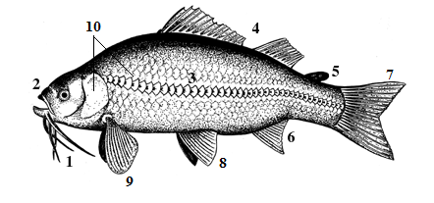
To distinguish species using video recordings, key physiological characteristics were looked at. An overview of these characteristics that will be used to determine species (Fig. 1).
Figure 1 A Schematic example fish, showing presence of barbels, position of the mouth.... etc. (Sportvisserij-Nederland 2018)
- Barbels
Barbels are sensory organs present near the mouth in some species of fish. If present, the amount of barbels and the length can be used to identify the species.
- Position of the mouth
The position of the mouth can be divided into three categories, superior, inferior and terminal. Superior mouth fish have an upturned mouth opening and a lower jaw longer than the upper jaw. Inferior mouth fish have a down facing mouth opening and a lower jaw shorter than the upper jaw. These types of fish are often bottom feeding fish. Terminal mouth fish have a forward-facing mouth opening and a lower/upper jaw of approximately the same length.
- Shape, colour and amount of scales on the lateral line
The scales on the lateral line can be easily differentiated from the other scales due to the presence of a horizontal line through these scales. The amount of scales on the lateral line can be specific to certain species as well as the colour or shape.
- Amount, shape and location of dorsal fin(s)
Fish can have one to three dorsal fins which can be grown together or separate. The front dorsal fin can consist of loose or joint spines. Furthermore, the shape of the dorsal fins can be typical to species as well as its location compared to the ventral or anal fin.
- Adipose fin
Between the dorsal fin and the tail fin some species have a small adipose fin without fin rays.
- Amount, shape and location of the anal fin(s)
The anal fin can be cut out or rounded. Some species have very long or multiple anal fins. The position of the anal fin compared to dorsal fin can also be typical for certain species.
- Tail fin
The shape of the tail fin (e.g. rounded, forked, truncated) or the lack of one can be typical for certain species.
- Ventral fins
The location of the ventral fins compared to the dorsal fin and anal fin is often used to distinguish certain species from each other. The ventral fins can also absent.
- Pectoral fins
The stance, size and shape of the pectoral fins can be specific to certain fish species. In some species the lower pectoral fins are separate and thickened into sensory organs. The pectoral fins can also be absent.
- Spots
Some species have typical spots on the dorsal fins, the body or the gill covers which can be used to distinguish certain species.

2.2.2 Relevant indicator species
As mentioned in the introduction, not all species are of equal importance in classifying water type according to the WFD. Because species diversity and abundance data collected by passive trap monitoring is mainly used for the Water Framework Directive, this experiment followed the guidelines on key indicator species in the Dutch waterbodies (O2, R7, R8 and R16 - Appendix 1) (STOWA 2016).
Together with data of previous years at the study site, an estimate was made on the distinguishable traits of the relevant indicator species (table 1).
An overview of all species of the described water types was also created (appendix 2).
Table 1 Key indicator species caught in previous monitoring years at the experiment location and a classification of distinguishing characteristics (green = distinguishable with high accuracy orange = species with similar traits or unusable traits for video determination red = nearly impossible to distinguish)
Species | Name | Distinguishing characteristics
Anguilla anguilla | Eel
Perca fluviatilis | Perch
Barbus barbus | Barbel
Platichthys flesus | Flounder
Pholis gunnellus | Butterfish
Abramis brama | Bream
Chelon labrosus | Thicklip mullet
Gasterosteus aculeatus | Three-spined stickleback
Liza ramada | Thinlip mullet
Scophthalmus rhombus | Brill
Clupea harengus | Herring
Gadus morhua | Atlantic cod
Cyprinus carpio carpio | Carp
Atherina presbyter | Sand smelt
Lampetra Fluviatilis | River lamprey
Chelidonichthys lucernus | Tub gurnard
Limanda limanda | Dab
Pleuronectes platessa | Plaice
Liparis liparis | Seasnail
Esox lucius | Pike
Sander lucioperca | Pikeperch
Osmerus eperlanus | Smelt
Sprattus sprattus | Sprat
Trisopterus luscus | Pouting
Psetta maxima | Turbot
Solea solea | Sole
Ciliata mustela | Five beard rockling
Merlangius merlangus | Whiting
Salmo salar | Salmon
Dicentrarchus labrax | Sea bass
Myoxocephalus scorpius | Shorthorn sculpin
Salmo trutta | Sea trout
Lepomis gibbosus | Pumpkinseed
Gobius niger | Black goby

The distinguishing characteristics were a prediction of how accurately species could be distinguished using video recordings. Red was considered nearly impossible to determine with 100% accurately. Green were species with unique traits that were considered to be determined at a high accuracy (90-100%). Orange were species that have similar traits or have traits that might not be usable for determining with video recordings.
This table is a prediction based on key physiological characteristics described above. For commonly found species at this location a more elaborate description is given in appendix (3). In the results (chapter 4) a comparison is made between the predictions and how accurately species could be distinguished on video (table 3).

Yellow eel & Silver eel
For the Eel Management Plan, the monitoring programs focus on eel. Eel can be found in nearly all freshwater systems in the Netherlands. Commercial fisheries target silver eel as well as yellow eel. Due to declining glass eel recruitment, the population has decreased drastically since the 1950’s. Currently, the glass eel index is only 1-5% of what it used to be in the 80’s (de Graaf et al. 2016) (Dekker 2004).
The status of eel remains critical. In 2017 the annual recruitment of yellow eel into European waters was 24% of the 1960’s – 1970’s level (ICES 2017). Because eel fisheries are still an important sector in the Netherlands, monitoring programs are necessary to maintain a good understanding of the eel population.
Once larvae reach the European coasts after traveling across the Atlantic Ocean from their spawning grounds in the Sargasso Sea, larvae metamorphose into glass eel. These glass eel swim upstream in large numbers and colonize the freshwater systems.
During this period, that last several years, glass eel undergoes a growth phase or yellow stage and are called yellow eel. Depending on the sex, this period varies. After this growth phase, yellow eel undergoes another metamorphosis called silvering. This phase prepares the eels for migration across the ocean and finally reproduction. This transition goes parred with physiological changes which can be used to distinguish the yellow from the silver stage.
the North Sea Canal is an important route for migrating silver and yellow eel and therefore an important monitoring location for eel. It is important to gain an understanding of the yearly downstream migration of silver eel.

Physiological characteristics
There are several physiological changes between yellow eel and silver eel, most apparent is the changes in colour. Yellow eel usually have shades of green or brown dorsally and yellow or white ventrally. As sexual maturation continues the eel develop a silvery white on the belly and the flanks and becomes dark dorsally.
Although this change in colour is most commonly used to determine stages, there are cases in which the reliability of this standard are questioned (Pankhurst and Lythgoe 1982). Especially large migratory eel often express intermediate features, such as a more bronze colour on the belly and flanks (Durif et al. 2009a).
Skin colour can be affected by more factors then sexual maturation. Light can cause changes in skin colour and eels from different locations have been observed to adapt their skin colour, within a particular tonal range, according to the colour of their surroundings (Tesch 2003).
Another common used characteristic is the larger eye size and the darkening and the length of the pectoral fins. Silver eel tend to have larger eyes compared to yellow eel for females as well as males. By taking the mean horizontal and vertical eye diameter an eye index was calculated and showed substantial difference between resident yellow eel and migrant silver eel (+/- 50%) (Durif et al. 2009a).
Apart from the darkening of the pectoral fin, Durif et al. (2009) also suggests that the length of the pectoral fin compared to the length of the body is also higher in-migrant silver eel and become black. Size is also often used as an additional confirmation of silver or yellow eel however this does vary and especially between males and females. Female eel is considered silver eel once they reach a length between 50 – 100 centimetres. Male silver eel is shorter and are mainly between 35 – 46 centimetres.
The lateral line in fishes is an important sensory organ used to detected currents, orientate in close environments, hunt or avoid predators and for schooling. During the silvering process eel metamorphose their body for the migration across the ocean. For this purpose, the sensory organs on the lateral line change.
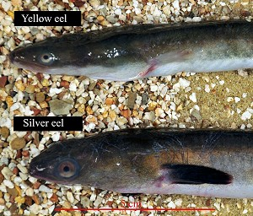
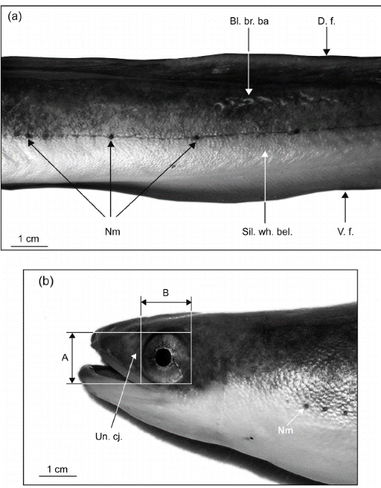
During silvering, the lateral line becomes visible on the body and the number of sensory cells increase. These physiological characteristics are commonly used to distinguish silver eel from yellow eel. However, in practice it can be difficult to determine what phase the eel is in because eel can present characteristics of both silver and yellow eel. Looking at these key characteristics is essential to determine the stage of the eel (Durif et al. 2009b).

Figure 2 The difference in eye area between yellow and silver eel

Figure 3 (a) Body section of a silver eel, showing the changes in the lateral line, the black corpuscles (neuromasts, Nm) and the colour contrast. (b) Head section of the body showing an enlarged eye.(Acou et al. 2005)

Method
This chapter describes and motivates the experiments that were executed to determine the accuracy and reliability of video monitoring. Due to the fact that the availability of software for visual recognition and classification of fish without human observers is limited and expensive, this project used manual species determination for classification and counting.
However, this project, being a pilot, study into the potential of camera monitoring, it does not exclude the possibility for future research into the use of automated recognition software.

Monitoring location
The experiment location was at an existing monitoring location in the North Sea Canal near Ijmuiden, at the freshwater side of the southern sluice (figure 4). This location was chosen due to its accessibility and already present trap setup, but most importantly due to its high diversity in fish species.
Figure 4 The monitoring location at the sluices near Ijmuiden
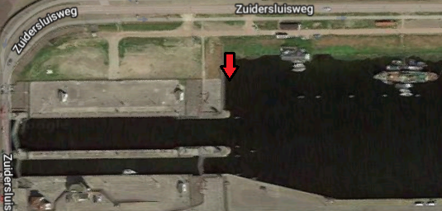
The location was situated close to the sluices that separate the North Sea from the North Sea Canal. To determine the accuracy of the trap a location was chosen with a wide range of species, to test how accurately they could be recognized and distinguished from one another.

Experimental setup
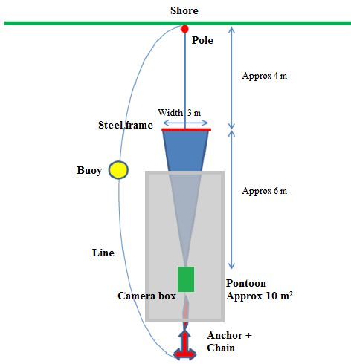
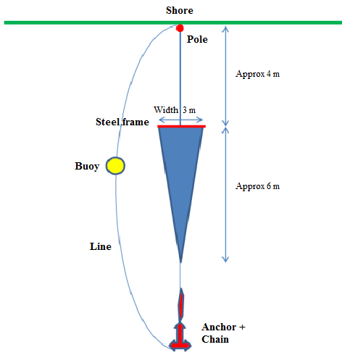
The camera box was connected to the end of a conventional monitoring trap at an existing monitoring location (figure 5).
Figure 5 Schematic overview of the original trap and the proposed trap with the camera box for this project

A net trap was attached to a pole near the shore. The opening of the trap was approximately 4 meters from shore and had a width of 3 meters. The length of the trap was approximately 6 meters and runs narrow near the end of the trap.
The trap was positioned using anchors and buoys. Standard monitoring uses this trap setup to catch fish. For the use of the camera box a few alterations were made to the trap. Above the trap, a 10 m² pontoon was positioned using anchors at every corner. The pontoon kept the camera box and the trap in position and afloat (figure 6).
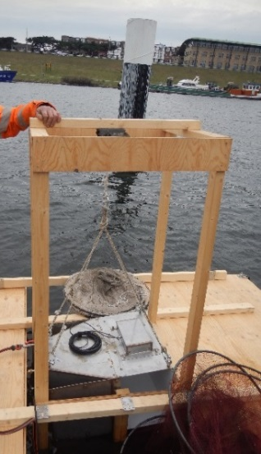
The end of the trap was attached to the camera box. The camera is a 3 MP full HD IP camera with build in infrared LED’s. For the experiments however, an external IR lamp was used to reduce the reflection into the camera lens. Fish that reached the end of the trap were guided through the camera box, which started recording once it detected movement. At the other side of the camera box a collection net was attached which collected all fish that had passed the camera box. This collection net was emptied once or twice a week.
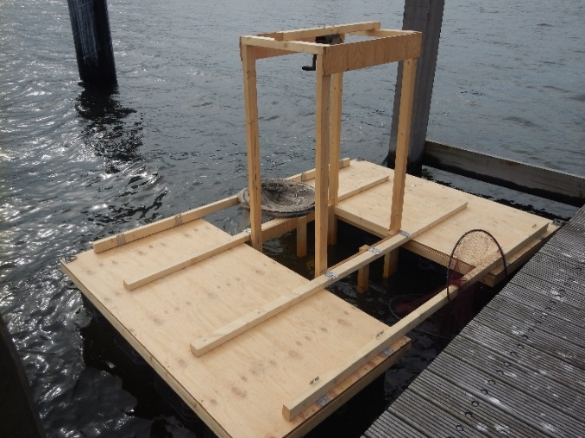

Figure 6 The pontoon with camera that was used at the monitoring location near the sluices of the North Sea Canal near Ijmuiden

Data collection
The monitoring program ran from the beginning of March until May. During this period the trap was deployed continuously over the whole period. To obtain reliable results, a minimum of one month was analysed from 5th of April until 14th of May.
The camera system was triggered by movement and started recording when fish entered the camera box. This means that during data analyses relevant time frames at which fish have passed the trap could be directly analysed.
The recordings were made using a high-resolution camera. With sufficient light, the camera was able to record in colour. However, as waters in the Netherlands are murky and the camera was shaded by the pontoon, the camera system often automatically switched to infrared recording due to the absence of light. Although this does provide a clear recording in an otherwise too dark environment, infrared recordings did limit the use of colour for determination as recordings were black and white.
The data was stored on a server above water and was collected approximately once a week. Data on actual catches were measured during the emptying of the collection net once or twice a week depending on availability. Each emptying was considered as a period. In total there were nine periods between 5th of April and 14th of May.
During the emptying of the collection net the fish were determined for species, counted, measured for length (cm), and photographed if necessary, before release (Photo 1).
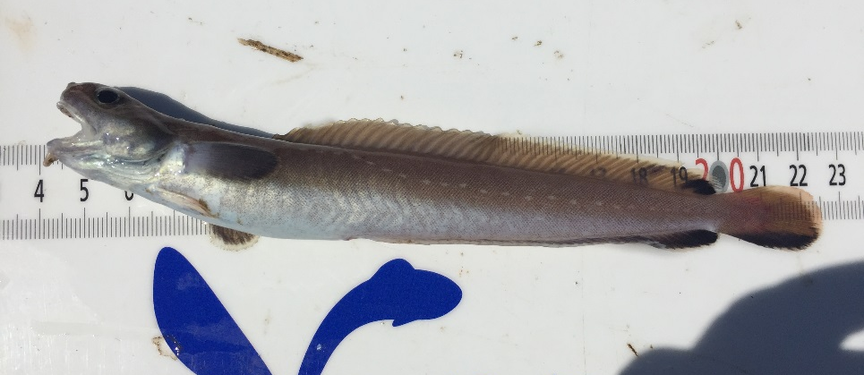
Photo 1 Example of infield measurement of a four-beard rockling

Data analyses
In order to determine reliability and accuracy, video recordings between 5th of April and 14th of May were analysed and compared to actual catches.

Species determination
Species determination was done manually, by observing key physiological characteristics of species, as described in the theoretical framework. The analyses was split into two parts:
Part 1
In part 1 the goal was to find and distinguish all fish that were caught in the collection net on the camera recordings. Once data was collected, the irrelevant recordings were removed. These were false detections of murky water, sediment, sunlight etc.
Once all irrelevant recordings were removed, the relevant recordings containing fish were left. Every recording was then analysed to determine the species. During this part 1, it was not important to determine accuracy but simply if all caught fish could be recognized and found in the recordings.
Once all data was analysed, a selection of 20 videos was made of a variety of species that, with the knowledge of actual catches, were 100% correctly determined.
Part 2
During part 2, these 20 videos were used in a determination test. In this test, experts in the field of salt and fresh water species were asked to determine the species that were shown in the videos. These experts consisted of fishermen, researchers or other specialists in the field of fish species.
The experts were not given any knowledge of the actual catches and were only given information on the location of the camera box and in what period the recordings were made. The goal was to simulate the situation where researchers or fishermen were asked for video analysis if the camera box were ever to be used as a monitoring method.
The experts were asked to determine the species on the recordings as accurately as possible. Experts also had the opportunity to describe characteristics or observations.
Using the results obtained from this test, an accuracy could be determined for classifying fish using video recordings. The results were compared with results from part 1 and also compared between experts. Accuracy of species determination was divided into three categories, round fish, flatfish and eel-like fish, all obtaining their own accuracy.

Counting of individuals
Counting of individuals was also done manually using the same video recordings. Each recording was analysed and treated independently. Fish that entered the box from the trap and swam into the collection net were given a “+”. Fish that entered the camera box from the collection net and swam back up the trap were given a “-”. Fish that swam into the box and returned to the same side were given a “0”. Fish that stayed in the box during the whole recording were also given a “0”.
Once all recordings were analysed, the amount of fish swimming back (-) were subtracted from the amount of fish swimming into the collection net (+). This total was then compared to the actual catches of that certain period.
A total overview of all periods combined was made of the number of individuals found in the collection net and the amount found in the video recordings, per species.

Distinguishing yellow eel and silver eel
All video recordings of eel were analysed. With the use of physiological indicators, yellow eel was attempted to be distinguished from silver eel.
In the determination test performed by external experts, a series of recordings containing eel were shown. It was the experts task to determine if a yellow eel or silver eel was shown in the video.
The results between experts were compared to determine of there was any consistency in distinguishing yellow eel and silver eel between experts. These test results were used to give an indication if yellow and silver eel could be distinguished.

Practical application
As the project was looking into the potential of camera monitoring as an alternative for conventional trap monitoring, not only species counting and classifying was taken into account, but also practical use. During the deployment there were different circumstances concerning weather, water conditions etc. But also, technical limitations and problems as well as benefits were all taken into account and described in the field.
This resulted in an overview of the possibilities of camera monitoring, its weaknesses, strengths compared to conventional methods and points for future improvement and possibilities.

Results
The results were collected and analysed according to the described periods. The start date of the experiments was later than expected due to technical issues during the first deployment. Over the course of the second deployment, a small logbook was made for problems and defects in the system (table 2). All fish that was caught during these periods were determined, measured and counted (table 3)
Table 2 Overview of experiment duration
Period | Date | Remarks
1 | 05/04 – 09/04 | When setting up for the second deployment, some videos presumably were lost between 5-6 of April.
2 | 09/04 – 16/04 | Sunlight triggered the movement detection and caused a lot of false recordings. This was solved by placing a canvas over the pontoon, blocking off the sunlight.
3 | 16/04 – 18/04 | -
4 | 18/04 – 21/04 | The external IR-lamp broke and constantly turned on and off causing false recordings. Furthermore, there were several blackouts in which fish could have passed undetected.
5 | 21/04 – 24/04 | IR-lamp was still broken. Furthermore, during troubleshooting the camera system was reset to default settings and not updated again. This resulted in a period with very low video quality.
6 | 24/04 – 30/04 | As a temporary solution the IR-lights of the camera were activated. These lights however reflected back into the lens and caused more blind spots on the recordings.
7 | 30/04 – 03/05 | At the beginning of this period, a new external IR-lamp was installed. Remarkably only eel was caught during this period.
8 | 03/05 – 07/05 | -
9 | 07/05 – 14/05 | Murky waters and algae growth and sedimentation in the camera box caused worse visibility than usual.

Species | Period | 1 | 2 | 3 | 4 | 5 | 6 | 7 | 8 | 9 | Total per species
Silver Eel |  | 8 | 4 | 3 | 6 | 9 | 2 | 4 | 2 | 1 | 39
Yellow Eel |  |  |  | 2 |  |  |  | 1 |  | 7 | 10
Sea Bass |  | 3 | 5 |  | 5 | 3 |  |  | 3 | 10 | 29
Bass |  | 1 | 2 | 1 |  |  |  |  | 1 | 2 | 7
Herring |  | 1 | 4 |  |  |  | 1 |  |  |  | 6
Mullet |  |  | 3 | 2 | 2 |  | 93 |  |  | 2 | 102
Whiting |  |  | 1 |  |  |  |  |  | 1 |  | 2
Cod |  |  | 1 |  |  |  |  |  |  |  | 1
Plaice |  |  | 1 | 1 |  |  |  |  |  |  | 2
Flounder |  | 22 | 10 | 4 | 2 | 6 | 2 |  | 5 | 1 | 52
Sole |  | 1 |  |  | 1 | 1 |  |  |  |  | 3
River Lamprey |  |  | 1 |  |  |  |  |  |  |  | 1
Ruffe |  | 1 |  |  |  |  |  |  |  |  | 1
Rock goby |  | 1 |  |  |  |  | 1 |  |  |  | 2
Five Beard Rockling |  | 1 |  |  |  |  |  |  |  |  | 1
Four Beard Rockling |  |  |  |  |  |  |  |  | 1 |  | 1
Common Rudd |  |  |  |  | 1 |  |  |  |  |  | 1
Silver Bream |  |  |  |  |  | 1 |  |  |  |  | 1
Round goby |  |  |  |  |  |  | 1 |  |  |  | 1
Pouting |  |  |  |  |  |  | 1 |  |  |  | 1
Total per period |  | 39 | 32 | 13 | 17 | 20 | 101 | 5 | 13 | 23
Table 3 overview of the total catches per period

4.1 Results species determination

4.2.1 Accuracy of species determination
During analyses of the video recordings it was clear that some species are easier to determine then others. This was not only dependent on physiological traits but also on aspects such as behaviour and size.
The distinguishability of the physiological traits was estimated at the beginning of the project. After analyses a secondary assessment was made for the species that were caught during the experiment. This assessment is made with new knowledge and experience using video recordings.
Table 4 Overview of the indicator species caught, and corrections based on physiological characteristics. Corrections are made if species were easier or more difficult to distinguish then originally anticipated.
Species | Name | Indicator for water type | Distinguishing characteristics |  |  | Corrections
Anguilla anguilla | Eel | O2, R7, R8, R16
Perca fluviatilis | Perch | Only for small rivers
Platichthys flesus | Flounder | O2, R7, R8
Chelon labrosus | Thick lip mullet | O2
Liza ramada | Thin lip mullet | O2
Clupea harengus | Herring | O2
Gadus morhua | Atlantic cod | O2
Lampetra Fluviatilis | River lamprey | O2, R7, R8, R16
Pleuronectes platessa | Plaice | O2
Trisopterus luscus | Pouting | O2
Solea solea | Sole | O2
Ciliata mustela | Five beard rockling | O2
Merlangius merlangus | Whiting | O2
Dicentrarchus labrax | Sea bass | O2
Additional Species
Gymnocephalus cernuus | ruffe | -
Enchelyopus cumbrius | Four beard rockling | - |  | n/a
Gobius paganellus | rock goby | - |  | n/a
Scardinius erythrophthalmus | Common rudd | -
Blicca bjoerkna | Silver bream | -
During the experiment, 19 different species of fish were caught. 14 of these species were key indicator species for O2, R7, R8, R16 water types. 5 species were not indicator species for the local water types.
Mullet
The thick lip and thin lip mullet were distinguishable from other fish species. Distinguishing between thick lip and thin lip using the camera seemed impossible. However, during conventional monitoring, there is also no distinction made between thin lip and thick lip in the current monitoring program.
Flatfish
Furthermore, out of the flat fish species that were caught, flounders and plaice remained very difficult to classify. Especially the distinction between each other was difficult to impossible to make, as flounders and plaice share many similar traits. Sole however, was easier to distinguish, mostly due to its body shape.
Additional species: rockling, goby, silver bream
Finally, among the additional species caught, the four-beard rockling and the rock goby were not taken up in the preliminary assessment. The distinguishing traits of the silver bream seemed more apparent than additionally anticipated. The traits were distinctive enough to be determined as silver bream and not normal bream, with which it often gets confused. It is however important to mention that there were no normal bream caught during the experiment period for comparison.
The corrections made to the distinguishability of the physiological traits is solely based on the observations and experiences made during analysing of the video recordings. In chapter 4.2.2 the classification results are shown done by external experts in fresh and saltwater species.

4.2.2 Accuracy of external experts
This chapter looks at the results of the determination test. The answers could either be correct, incorrect or partially correct. The results are shown in percentages and per video and species shown in the test (figure 8,9).

Figure 7 Results of the determination test part 1 in percentages

Figure 8 Results of the determination test part 2 in percentages
The correct species that was shown in the video is given on the X-axis. This graph contains the answers of all candidates (n = 15, n = 11 in part two) that participated. No distinction was made between the candidates’ backgrounds.
Most flatfish scored poorly with the exception of sole (100%). Plaice, which was shown twice in different videos, scored 0% and 7% correct. Plaice was mainly confused with flounders and dab. Flounders also scored low. Several candidates also added that their determination of the flatfish was often more a guess then a solid answer.
The only flatfish species caught that seemed to be distinguishable is the sole, scoring a perfect 100%.
The four beard and five beard rocklings both scored low on the test. ~25% of the candidates did manage to recognize the fish as a rockling but were unable to determine the exact species. This was mainly due to the fact that the amount of barbels could not be counted on the videos which is often the key physiological characteristic to distinguish rockling species. The five-beard rockling seemed to be easier to correctly classify (20%) then the four-beard rockling (7%). This could be due to the fact that five beard rocklings are found more often in Dutch coastal waters.
Interestingly, it seems the quality of the video also has effect on determination. Flounder, which was shown twice, scored differently. The first video scored 60% correct as the second video scored much lower with 36% correct. This indicates that aside from physiological characteristics of fish, the quality of the video also effects the ability to classify fish.
The results from the determination test can be divided into round fish and flatfish (figure 10)

Figure 9 Total accuracy of round fish and flatfish in percentages
Overall, flatfish scored low at 40% correct. This score is substantially increased by the score of the sole. Excluding sole, would results in a score of only 25% correct for the total flatfish.
The combined score of all round fish is 66% determined correctly.

4.3 Results individual counting
Out of the 226 fish that were caught, 206 of them were found in the recorded videos (figure 11).

Figure 10 Total number of fish caught and found on video
Individuals passing through the camera box were mostly identifiable and the swimming direction was clearly visible. During analyses, period 4 and 5 were excluded due to technical issues with the IR lamp which caused blackouts. During these blackouts it was impossible to find out which fish had passed and was therefore useless in the analyses of individual counting.
After analyses of the video recordings, the amount of fish that was seen on camera and the amounts of what was actually caught were compared (figure 12,13). Of some species, only one individual was caught during the monitoring period. Most of these species were also found on the camera recordings.
Figure 11 Counting results per species
One rock goby and one round goby could both not be found in video recordings. This was during period 6 at which the IR lamp was not working and the IR lamp from the camera was used. The Camera IR caused large blind spots at the bottom of the camera box due to light reflecting off the back panel into the camera lens. This could explain why these gobies could not be found on the recordings as gobies prefer to swim close to the bottom and therefore out of sight.
During analyses it was observed that bass had the tendency to remain in the camera box instead of continuing into the collection net. This caused for allot of detections which increases the chance of missing one recording.
Another possibility is that the individuals swam through the camera box via the blind spot at the top of the camera box. Especially smaller fish and flatfish would be able to swim across the camera box undetected or unrecognizable.

Figure 12 Counting results of most abundant caught species
Some species were caught in higher abundance then others (figure 13). There were more eel seen on the camera box then that were actually caught. Looking at the video recordings it seemed eel showed very active behaviour and were constantly looking for a way out. This active behaviour caused for allot of detections and recordings. In several recordings eel would swim close to the bottom or top of the camera box which was out of view of the camera. For several recordings this made it very difficult or even impossible to determine the swimming direction.
The amount of sea bass seen on camera was lower than the actual catches. Most sea bass that were not found were from the same period. In period 9, only two out of ten sea bass were found on camera that were actually caught.
Most of the mullets were caught in period 6. In total 93 of these had passed the camera box over 2 days in period 6. Of these 93 caught, 91 individuals were counted on the video recordings. The remaining mullets (n=7) were caught during other periods. Whit the use of camera monitoring it is possible to see day to day catches, while conventional monitoring only shows an end result. This could give camera monitoring an additional benefit as it could possibly include behaviour analyses in monitoring.
Out of all flatfish caught, flounders were most abundant. As previously described, the camera box had blind spots at the top and at the bottom of the box. Flat fish such as flounders could have passed the camera without being detected if they swam close to the bottom or top of the box.

Finally, the species were categorized by type (figure 13). Round fish had the largest difference between video counting and catches. Round fish however were also the largest group and had the highest diversity. The difference is mainly caused by sea bass and bass.
Figure 13 Counting results per fish type
All though flatfish were difficult to determine, they were easier to count. The main cause of the difference between video counting and catches is likely due to the camera having blind spots at the bottom and top. Flat fish could have passed undetected due to their body shape.

4.3 Distinguishing of Yellow and Silver Eel
This chapter shows the results of the ability to distinguish yellow and silver eel.

4.3.1 Eel recordings
During the experiment period, there were three periods in which both silver eel and yellow eel were caught (table 3). All remaining periods contained only silver eel.
Even in period 9, in which 7 out of 8 eels were yellow eel, it was not possible to isolate the silver eel with 100% certainty. Unfortunately, there was no period containing only yellow eel.
One of the problems with distinguishing yellow and silver eel, is the lack of perspective in terms of length. With the used setup it was not possible to estimate the length of the fish. This made isolating different individuals difficult.
All video recordings of eel were analysed. With the available recordings it was not possible to distinguish yellow eel from silver eel with a 100% certainty. Because of this, for the determination test by external experts, a period was chosen which contained one yellow eel and four silver eels. Using distinguishing marks or spots, all individual eel were isolated in the video recordings.
One video was shown of each individual eel and two videos of the eel that was presumed to be the yellow eel, to test consistency in the answers. Because during analyses it was not possible to distinguish the two, it was not possible to make a comparison with the results of the experts.
Therefore, the results between experts were compared to determine of there was any consistency in distinguishing yellow eel and silver eel between experts. These test results were used to give an indication if yellow and silver eel could be distinguished.

4.3.2 Accuracy of external experts
This chapter shows the results of the blind test for distinguishing yellow eel from silver eel.

Figure 14 Results of the blind test for distinguishing eel
The results of the test varied significantly (figure 14). Between the candidates (n=10) that participated there was a clear difference in answers per individual. The remarks that were given by the candidates furthermore mentioned that most of the answers could not be given with complete certainty.
The presumed yellow eel, Eel 5, obtained different results in both videos. Eel 4 is the only video that seemed to have some consistency between the candidates.

4.4 Practical application
Even though fish will not have to be caught and measured with camera monitoring, maintenance is still needed. Depending on the local conditions of the monitoring location, the camera box will still require weekly visits to clean the trap and the camera box.
Furthermore, camera monitoring will be more susceptible to technical problems which can cause loss of data. During the experiments, failure of the external IR-lamp caused blackouts at night and data of those periods were lost.
The use of camera systems also increases the possibility of theft. Even though camera technologies have become cheaper in recent years, it remains valuable and sensitive to theft.
Camera monitoring also requires access to a power source which makes it deploy ability bound to locations with a nearby power source. A possible alternative will be a remote power source such as solar panels. However, this will increase the cost of camera monitoring and further increase the chances of theft.
The quality of the video recordings in the current setup was not an issue during the analyses. The added benefit of camera monitoring is that it gives an insight into the behaviour of fish which is not possible in conventional monitoring.
Apart from the technical problems with the external IR-lamp, there were no major issues during the experiment period.

Conclusion
With the use of the obtained results, a few conclusions can be drawn.
How accurately can species be differentiated using video monitoring?
In the seven weeks of data collection, 19 different species were caught.
As was expected, flatfish were difficult to determine both during analyses, and on the determination test. The accuracy of flatfish on the determination test was 40%. Between flatfish species, sole seemed to be the exception with a perfect score on the test.
Round fish had an accuracy of 66% on the test. During analyses round fish seemed easier to determine. This was likely due to experience.
With the data collected it is not possible to determine how accurate a camera box is for all species. Of the 19 species caught, it is clear that certain species are unlikely to be accurately determined at all times. However, 10 of the 19 species were determined with an accuracy higher than 70% and 6 species higher than 90%.
How accurately can individual fish be counted using video recordings?
In the seven weeks of data collection, 226 fish passed the camera box and were caught. Out of these 226 fish, 206 individuals could be counted using the video recordings. This results in an accuracy of ~91%. This suggest that fish may pass the camera box unseen.
The quality of the video recordings made it possible to determine the swimming direction of the individuals and therefore prevent double counting of the same individual. Even if double counting does occur, it should not pose a problem for trend monitoring as long as it is done consistent for year to year comparison.
Can yellow eel be distinguished from silver eel using video recordings?
And if so, at what accuracy?
With the data that was collected, it was not possible to distinguish yellow eel from silver eel with the use of the video recordings.
The results from the determination test performed by external experts also showed inconsistent answers between experts. Out of the 6 videos shown to the candidates, only one video of an eel had 80% consistent answers (yellow eel) between candidates. It is however still not possible to determine if this individual was indeed a yellow eel.
Even though the determination test mainly consisted of silver eel (4 silver eel and 1 yellow eel), 55% of all the answers given on the test were yellow eel. Which further proves that with the collected data it is not possible to make a distinction between silver eel and yellow eel.
To answer the main research question:
What is the effectiveness of video monitoring compared to actual catches of conventional trap monitoring?
The main goal of this project was to test an alternative monitoring method which was less susceptible to poaching. If the camera box were mounted properly at the monitoring location, camera monitoring could prevent poaching as fish will not be caught.
The accuracy of determination varies per species. With experience the accuracy will likely increase but certain species are likely to remain undeterminable. Before application it would be important to determine what species are necessary for the monitoring program.
For counting individuals, the camera monitoring seems capable. However, in some cases and for some species blind spots needs to be prevented. The collected data resulted in an accuracy of 91%. With fine tuning and removing the blind spots, the camera box should be able to approach an accuracy of 100%.
For distinguishing yellow eel and silver eel, the current system is unreliable. As eel is one of the target species of the monitoring program, the current system will not be an effective alternative for monitoring eel.
As this was a pilot study, camera monitoring does show potential as an alternative monitoring method. However, further testing and improving will be required. The application of camera monitoring as an alternative to the current monitoring programs however, will be dependent on its ability to distinguish yellow eel from silver eel.

Discussion
In terms of preventing poaching, camera monitoring shows potential as an alternative for conventional trap monitoring. However, the applicability of a camera box remains a uncertain factor.
If the camera box were to be used as a monitoring device, the removing of the blind spots is essential. The camera needs to have a complete view of the box if species are to be classified correctly. Fish that swim in or partially in blind spots will be impossible to determine and count properly.
Water conditions and weather conditions also have an influence on the current system. Turbid or (fast) flowing water can trigger the detection system and create a false recording. During the day, incoming sunlight was also registered as movement. This caused a high number of false recordings (92% of all recordings made) and could indicate that the sensitivity of the detection system was set too high in these conditions. It is important to consider that the experiment location did have clear water.
Classifying of fish species seemed to vary between species. Flatfish seem especially difficult to classify using only a side view. A top view camera or a mirror inside the camera box could however solve this problem by providing a top view of the fish. The effect of these changes on the determination accuracy would have to be tested.
Due to the high diversity of round fish, determining one accuracy for all round fish might not be representable and should be seen as an indication of the possibilities. As was clear in the results, certain species such as cod and whiting scored nearly to a 100%, while other species such as rocklings were not able to be classified correctly at all.
Furthermore, adding the possibility to determine the length of an individual could be an additional tool in classifying fish correctly. Even though the length of a fish is not a reliable parameter for determining fish on itself, it can be of added value in combination with other physiological characteristics.
It is important to take into consideration that this was a pilot study and that the results of the determination test only give an indication of the possibilities to classify fish. Camera monitoring in water systems is a recent development (Williams et al. 2014) and the candidates had no to little prior experience of determining fish using video. As is seen with determination of species in field, experience could increase the accuracy at which species can be determined on video.
With the current setup, the video recordings are organised manually, which is very time consuming and could cause mistakes in separating false recordings from recordings containing fish. Missing recordings could be a possible cause for miscounting and the inability to find individuals in the recordings.
Distinguishing yellow eel from silver eel did not seem possible with the data collected during this experiment. The physiological differences between yellow eel and silver eel might be too little for distinguishing the stages with the use of the video recordings. Furthermore, some eel show traits of both yellow and silver eel, which makes it more difficult.
Literature also suggests that there are more than one stages in the silvering process of eel, and that even these stages differ per location (C. Durif 2005). Without the possibility to measure physical parameters such as eye diameter and pectoral fin length, distinguishing these stages with the current set-up seems impossible.
Being able to measure fish length based on the video recordings, could possibly increase the chances of recognizing yellow and silver eel. The camera box should therefore be extended to 120cm for eel. The addition of length measurements in video monitoring combined with more extensive research into physiological traits could still hold potential for camera monitoring.
Further experiments and data collection could give a better indication of how data can be interpreted and could bring other negative or positive aspects to light. Camera monitoring is unlikely to obtain the exact same data as conventional monitoring. For trend monitoring this is not a problem, as long as application and data collection is done consistently. The effectiveness of camera monitoring however, is of importance were camera monitoring to be used as an alternative for conventional monitoring traps in the Netherlands.

Recommendations
As mentioned in the discussion, experience is likely to increase the accuracy of the determination of different species. If camera monitoring were to be used, a training program for the analysts would be useful. Video recordings use different factors for determination and fish can look different in water then on land. A training program could teach analysts how to approach determination and how to recognize different fish species.
The used pilot setup created too much false data to analyse manually. Currently, software is in production for automatic separating of false recordings with correct ones and would decrease the labour substantially.
Furthermore, software for automated length measurement is also in production. However, with the current setup the camera box would have been too short to measure eel and other large fish. A camera box with a length of 120 centimetres would provide at least enough length to measure eel.
In the used setup the camera box was suspended from a pontoon. This caused the trap to go upwards to be connected to the camera box. During the experiments it was observed that especially species of flatfish refused to swim upwards trough the camera box and preferred to remain in the beginning of the trap which was lower in the water column. The camera box should be placed lower to better position the trap or a sort of correction has to be made for this problem.
Finally, not one video is the same. Of most species only one or two individuals were caught in these experiments. More data collection and analyses could provide better picture of the classifying potential of camera monitoring.

Bibliography
Acou, A., P. Boury, P. Laffaille, C. Alain, and E. Feunteun. 2005. Towards a standardized characterization of the potentially migrating silver European eel (Anguilla anguilla, L.). Archiv für Hydrobiologie:237-255.
Bicknell, A. W. J., B. J. Godley, E. V. Sheehan, S. C. Votier, and M. J. Witt. 2016. Camera technology for monitoring marine biodiversity and human impact. Environment and Sustainability Institute, UK.
Boom, B. J., P. X. Huang, C. Beyan, C. Spampinato, S. Palazzo, J. He, E. Beauxis-Aussalet, S.-I. Lin, H.-M. Chou, G. Nadarajan, Y.-H. Chen-Burger, J. v. Ossenbruggen, D. Giordano, L. Hardman, F.-P. Lin, and R. B. Fisher. 2014. Long-term underwater camera surveillance for monitoring and analysis of fish populations.
C. Durif, S. D., P. Elie. 2005. The silvering process of Anguilla anguilla: a new classification from the yellow resident of the silver migrating stage. Journal of Fish Biology.
de Graaf, M., O. A. van Keeken, M. van Hoppe, I. J. de Boois, R. Hoek, A. B. Griffioen, M. Lohman, B. van Os-Koomen, H. J. Westerink, and H. Wiegerinck. 2016. Toestand vis en visserij in de zoete Rijkswateren 2015. C116/16.
Dekker, W. 2004. Monitoring van de intrek van glasaal in Nederland. RIVO.
Durif, C., A. Gulbert, and P. Elie. 2009a. Morphological discrimination of the silvering stages of the European Eel.
Durif, C., V. van Ginneken, S. Dufour, T. Muller, and P. Elie. 2009b. Seasonal evolution and individual differences in silvering eels from different locations. Spawning migration of the European eel: Reproduction index, a useful tool for conservation management.
Edgington, D. R., D. E. Cline, D. Davis, I. Kerkez, and J. Mariette. 2006. Detecting, Tracking and Classifying Animals in Underwater Video. Pages 1-5 in OCEANS 2006.
ICES. 2017. European eel (Anguilla anguilla) throughout its natural range.
Pankhurst, N. W., and J. N. Lythgoe. 1982. Structure and colour of the integument of the European eel Anguilla anguilla (L.). Journal of Fish Biology 21:279-296.
Sportvisserij-Nederland. 2018. Vissoorten Sportvisserij Nederland.
STOWA. 2016. Referenties en maatlatten voor natuurlijke watertypen voor de kaderrichtlijn water 2015-2021.
Tesch, F. W. 2003. The eel 5edition. Blackwell science Ltd, UK.
Williams, K., A. De Robertis, Z. Berkowitz, C. Rooper, and R. Towler. 2014. An underwater stereo-camera trap. Methods in Oceanography 11:1-12.

Appendix 1 Water types for indicator species
Not all species are indicated as equally important to characterise a specific water type. Because of this, specific indicator species are categorized by water type.
The existing monitoring location at which the camera box was tested is classified as an O2 (estuarine) waterbody. Because surrounding areas categorize as large rivers, indicator species from R7, R8 and R16 were also taken into account in this report.
O2 water type – Estuary with mediocre tidal difference
This water type can be found in estuaries where a river mouths into the sea through a tidal area. In the Netherlands many waterbodies are strongly altered by mankind, both hydrologically and morphologically. For this reason, the O2 water type is derived from the natural estuary water type.
For fish, the O2 water type has many purposes. Some species spend their whole lifecycle in these waters. Some species use the estuaries as nurseries. Furthermore, some species use these waters as gateway from sea to freshwater systems or the other way around. These are catadromous or anadromous species and rely on these estuaries to move to their reproduction areas in either salt or fresh water.
Finally, estuaries can also be home to seasonal species or wandering species from either salt or freshwater systems.
R7 water type – Slow flowing rivers on sand or clay
This water type typically has a low discharge and a low water velocity. Slow flowing rivers can be found anywhere in the river system.
For fish, these slow flowing sandy streams are important to early life stages of several rheophile and eurytope fish species. Limnophile species are also found in these water types. Finally, these water types function as a migration route for diadromous fish species such as salmon and sea trout.
R8 water type – Freshwater tidal areas on sand or clay
These freshwater systems can be found upstream where there is still influence off the sea tide but there is no saltwater intrusion. Because in the Netherlands dams are built at the salt and brackish transition areas, this water type is strongly altered from the natural system.
This water type is also home to rheophile and eurytope species. Diadromous species such as flounders and fint can also be found in these waters. Finally, these waters also function as a migration route for multiple fish species.
R16 water type – Fast flowing rivers on sand or gravel
These water types typically have a high discharge and a high-water velocity which varies over the length and width of the river.
Because of the high-water velocity and gravel bottom, these water types are used by several anadromous species for reproduction. Furthermore, these waters are ideal for obligate fish species (STOWA 2016).

Appendix 2 Key Indicator Species
Table 2 shows all the relevant key indicator species for the O2 monitoring location in the North Sea Canal. A prediction of how well a species can be distinguished is shown using the same method described in the theoretical framework. Because some Dutch species do not have an English name or are not commonly known under the English name, the Dutch names are given. Not all of these species were found in previous monitoring at North Sea canal. Species that were found during monitoring between 2012 and 2014 are marked with grey. Species that were not previously found can however still be found in future monitoring. In appendix 2 a more in-depth description is given of species that can be expected during the experiments.
Table 5 All indicator species relevant for O2 waterbodies
Species | Dutch name | Distinguishing characteristics |  |  | Found in previous monitoring
Anguilla anguilla | Aal
Alburnus alburnus | Alver
Umbra pygmaea | Amerikaanse hondsvis
Engraulis encrasicolus | Ansjovis
Perca fluviatilis | Baars
Barbus barbus | Barbeel
Barbatula barbatula | Bermpje
Rhodeus amarus | Bittervoorn
Rutilus rutilus | Blankvoorn
Platichthys flesus | Bot
Pholis gunnellus | Botervis
Pomatoschistus microps | Brakwatergrondel
Abramis brama | Brasem
Pomatoschistus minutus | Dikkopje
Chelon labrosus | Diklipharder
Gasterosteus aculeatus | Driedoornige stekelbaars
Liza ramada | Dunlipharder
Alosa alosa | Elft
Phoxinus phoxinus | Elrits
Alosa fallax | Fint
Salmo trutta | Forel
Belone belone | Geep
Alburnoides bipunctatus | Gestippelde alver
Carassius gibelio | Giebel
Aphia minuta | Glasgrondel
Ctenopharyngoden idella | Graskarper
Scophthalmus rhombus | Griet
Coregonus lavaretus | Grote marene
Misgurnus fossilis | Grote modderkruiper
Syngnathus acus | Grote zeenaald
Clupea harengus | Haring
Agonus cataphractus | Harnasman
Coregonus oxyrinchus | Houting
Gadus morhua | Kabeljauw
Cyprinus carpio carpio | Karper
Cobitis taenia | Kleine modderkruiper
Syngnathus rostellatus | Kleine zeenaald
Blicca bjoerkna | Kolblei
Atherina presbyter | Koornaarvis
Leuciscus cephalus | Kopvoorn
Carassius carassius | Kroeskarper
Lota lota | Kwabaal
Silurus glansis | Meerval
Dasyatis pastinacra | Pijlstaartrog*
Gymnocephalus cernuus | Pos
Zoarces viviparus | Puitaal
Cottus gobio | Rivierdonderpad
Gobio gobio gobio | Riviergrondel
Lampetra Fluviatilis | Rivierprik
Chelidonichthys lucernus | Rode poon
Aspius aspius | Roofblei
Scardinius erythrophthalmus | Ruisvoorn
Limanda limanda | Schar
Pleuronectes platessa | Schol
Leuciscus leuciscus | Serpeling
Acipenser, - | Steur
Liparis liparis | Slakdolf
Chondrostoma nasus | Sneep
Esox lucius | Snoek
Sander lucioperca | Snoekbaars
Cyclopterus lumpus | Snotolf
Osmerus eperlanus | Spiering
Sprattus sprattus | Sprot
Trisopterus luscus | Steenbolk
Psetta maxima | Tarbot
Pungitius pungitius | Tiendoornige stekelbaars
Solea solea | Tong
Syngnathus typhle | Trompetterzeenaald
Leucaspius delineatus | Vetje
Ciliata mustela | Vijfdradige meun
Raniceps raninus | Vorskwab
Merlangius merlangus | Wijting
Leuciscus idus | Winde
Salmo salar | Zalm
Ammodytes tobianus | Zandspiering
Dicentrarchus labrax | Zeebaars
Myoxocephalus scorpius | Zeedonderpad
Salmo trutta | Zeeforel
Tinca tinca | Zeelt
Petromyzon marinus | Zeeprik
Spinachia spinachia | Zeestekelbaars
Lepomis gibbosus | Zonnebaars
Gobius niger | Zwarte grondel

Appendix 3 Description of expected species
This appendix contains the in-depth description of species that can abundantly be found during the experiments. The species are divided into freshwater species, saltwater species, diadromous species and flat fish.

Freshwater species
Table 3 shows the most common species caught at the monitoring location. As can be seen, the abundance of species differs greatly between species.
Table 6 Freshwater species caught at the monitoring location North Sea Canal
Freshwater species | Average individuals (2012-2014)
Perch | 170
Bream | 5
Barbel | < 5
Mullet | 69
Pikeperch | 66
Round goby (zwartbekgrondel) | 53

Perch has two separate dorsal fins and has a black dot on the front dorsal fin. Perch has several vertical, dark lines running across the body. Bream is often mistaken with other comparable species. Most commonly used to determine bream is the eye diameter. The eye diameter is smaller than the distance from the eye to the tip of the mouth. The barbel has an inferior mouth with thick outward facing lips and 4 barbels. The dorsal fin is cut in hollowly. Mullets can be recognized by their wide terminal facing mouth. On the flanks, Mullets have horizontal dark stripes. Pikeperch can be recognized by its two separate dorsal fins and its long slender body. The round goby, as most goby’s, has its eyes high, nearly at the top of its head. The round goby has a yellow grey colour. The front dorsal fin has a clear black spot and males are darker to black during mating season.

Saltwater species
In table 4 the most common caught saltwater species caught at the monitoring location can be seen.
Table 7 Diversity of saltwater species at the monitoring location
Saltwater species | average individuals (2012-2014)
Horse mackerel | 25
Cod | 8
Sand smelt (koornaarvis) | 20
Tub gurnard (rode poon) | 30
European sprat | 13
pouting (steenbolk) | 26
whiting | 14
Sea bass | 114
Herring | < 5
Shorthorn sculpin (Zeedonderpad) | < 5
Pollack | < 5
Pipefish (zeenaald) | < 5
Sea trout | < 5
salmon | < 1
The horse mackerel has two separate dorsal fins and a dark spot on the gill covers. The lateral line has a clear nod at the end part of the fish. The cod species (cod, whiting, pollack, pouting) can often be distinguished by their 3 dorsal fins and 2 anal fins. Most cod species also have a very visible lateral line running across the entire body. The species can be distinguished by looking at the shape of the body and fins, position of the mouth and the presence or absence of barbels. The sand smelt has two short separate dorsal fins and has a silver coloured line on its flanks. The tub gurnard has a pointy nose with small spikes on the sides. The ventral fins have a blue edge and blue spots on the top of the fins. The body itself is often orange-red or brown Herring species (herring, European sprat) can be recognized by the location of the dorsal and ventral fins. In both herring and sprat, the start of the ventral fin is behind the start of the dorsal fin. Sprat is smaller than herring but are often mistaken for small herring. In practice the structure of the scales is often used to distinguish the species. For camera analyses the focus will be on size and colour. The sea bass has two separate dorsal fins of approximately the same length. Except for a dark spot in the gill covers, the body has even colour. The shorthorn sculpin has a large head with spikes and has more spikes covering its body. The shorthorn sculpin has a patterned coloured body ranging from yellow brown till dark brown. The pipefish has a long snake-like body with a tubular snout and bony body rings over its body. The salmonids and trout species (salmon, sea trout) both have an adipose fin and an upper jaw that extends until beneath the eye. The salmon and sea trout are often confused with one another. To distinguish the two species the by counting the rows of scales from the end of the adipose fin to the lateral line. Salmon are often narrower just before the tailfin compared to sea trout. Colour and spots can also be used to distinguish the species

Flatfish
The flatfish (table 5) can be divided into two groups, eyes on the right side or on the left side of the body.
Left: turbot, brill.
Right: plaice, dab, flounder, lemon sole, sole.
Table 8 The diversity of flatfish that can be found near the monitoring location
Flatfish | average individuals (2012-2014)
Flounder (bot) | 305
PLaice (schol) | 10
Sole (tong) | 499
Brill (Griet) | < 5
Turbot | < 5
Lemon sole (Tongschar) | < 5
dab (Schar) | < 1

Aside from the position of the eyes, the colour and the shape of the body are often used to distinguish species. In practice, the texture of flatfish is commonly used to distinguish species. Although this is not applicable for the use of video recordings, some physiological characteristics causing these differences in texture can also be seen with the eye such as nodules, warts or rough scales.

Diadromous fish
Table 6 shows the rarer diadromous species. These are species that spend part of their life cycle in freshwater systems and part in saltwater.
Table 9 The diadromous fish caught near the monitoring location
Diadromous fish
Yellow eel | 558 (number of individuals lower in spring)
Silver eel | 2912 (number of individuals lower in spring)
River lamprey | 13
Smelt | 6
The characteristics of yellow and silver eel are described in chapter 2.3. The river lamprey has a suction mouth filled with small grating teeth. River lampreys have 7 gill holes on the side of its body and have a silver colour. Sexually mature individuals have an almost completely even black back. Smelt has a superior mouth and have an adipose fin. In practice these fish are known for their cucumber-like smell.

