Validation of the short-chronic early life stage fish toxicity test.

A study into acute and chronic ecotoxicity of the embryonic zebrafish *(Danio rerio).*

**Research report**

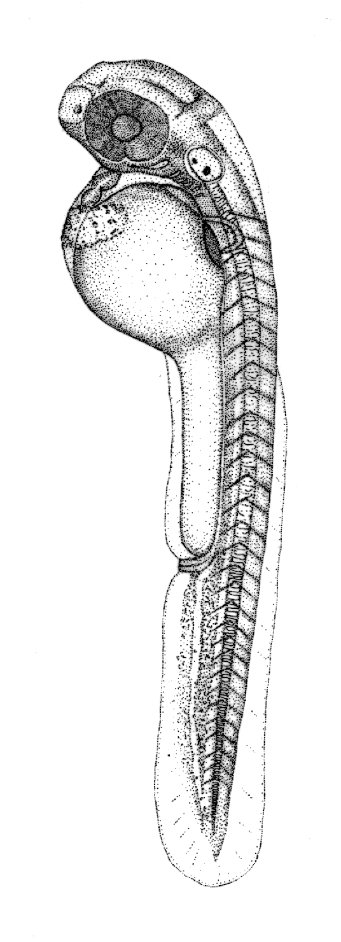

Figure 1: Illustration of a hatched zebrafish larvae (Knight, 2019)

**Author: S.Y.Z. Teng**

**Course: Final Thesis**

**Education/group: AEi4**

**Study year/semester: 2018-2019, semester 2**

**School: HZ University of Applied Sciences**

**Examiner: E. McAteer**

**Supervisor: K. Kaag**

**Place & Date of publication: Den Helder, June 6, 2019**

**Version: 3.0**

Validation of the short-chronic early life stage fish toxicity test.

A study into acute and chronic ecotoxicity of the embryonic zebrafish *(Danio rerio).*

**Place of publication:** Den Helder

**Date:** June 6, 2019

**Student number:** 70181

**Study year:** 2018-2019

**Semester:** 2

**Report type:** Thesis report

**Examiner:** E. McAteer

**Supervisor:** K. Kaag

**Version:** 3.0

# Preface

Presented before you lies the thesis report on the “Validation of the short-chronic early life-stage fish toxicity test”, in which an evaluation of an ecotoxicological protocol is made. It had been written to meet the graduation requirements of the study program Aquatic Ecotechnology at the *HZ University of Applied Sciences* in Vlissingen. The research project was initiated in February 2019 and lasting until June in the same year. At the request of *Wageningen Marine Research*, I took part in this project, serving as an intern under the guidance of the researcher Klaas Kaag. The project served to be quite a challenge as time was limited and I myself of little experience. Fortunately, this thesis showed to be a great learning experience, while fuelling a further interest for the aquatic ecotoxicology field.

I would like to thank my supervisor Klaas Kaag, as he provided much input and suggestions regarding the perfection of the protocol, while his deep understanding of the topic provided much constructive feedback and really helped to improve the end-product. I greatly appreciate his help during the weekends, giving up his free time to achieve the necessary results. I also wish to thank the lab technician, Martijn Keur, who helped me out a great many moments in the lab (including some of the weekends) and showed to provide excellent training in handling the protocol. Furthermore, I’d like to thank Ewout Blom, who came specially to Den Helder to train us in the handling of the zebrafish eggs. Lastly, I would like to thank my first examiner Emma McAteer, who never failed to provide sound advice and feedback whenever I seemed to meet a wall.

I hope this report to be an enjoyable and interesting read,

Sean Teng

Den Helder, June 6, 2019

# Abstract

In light of recent developments of the onboard ballast water treatment, WMR has developed a new protocol for the assessment of ecotoxicological effects and aims to use it as a standardised test. This study looks into the validation of this short-chronic ELS fish toxicity test, by use of the embryonic zebrafish *(Danio rerio)*. The compounds potassium dichromate, sodium dodecyl sulphate and copper(II)sulphate were used as reference substances for the validation process. During the tests the toxicity of these compounds were evaluated at lethal and sub-lethal levels applying the combination of two OECD guidelines, which stretches the 4 day acute embryo fish test into a short-chronic 7 days test. During experiments, the embryos were emerged in either one of the reference toxicants over a varied concentrations range, actualising the identification of the dose-dependent relationship followed by the determination of LC-/EC50 values. In this context, adverse effects were defined experimentally while compared through a review of literature from similarly executed studies. For PDC the LC50 was determined to be 154.08 mg/L which is similar to literature values. Sub-lethal effect showed to be minimal and alternative methods for assessing chronic toxicity may be required. SDS toxicity revealed to be instantly toxic, LC50 = 7.1 mg/L, affecting only the chorion while larvae remain unharmed. Its toxicity shows to be relatively consistent with literature. Cu2+ toxicity mainly revealed itself in a decreased/delayed hatching success which is also reported in a great deal of studies. Results were lacking to successfully identify the LC50 of copper. Although many similarities are found between the experimentally obtained results and the literature review, further continuation of the investigation is certainly necessary. This study illustrates a good foundation for the continuation of the research and demonstrates the potential of the method in identifying both short- and long-term effects, giving a good implication of the sensitivity of the zebrafish to the compounds.

# Glossary

Cr(VI) Hexavalent chromium

Dpf Days post fertilisation

EC50 Median effective concentration

ELS Early life stage

Hpf Hours post fertilisation

IBWMC International Ballast Water Management Convention

IMO International Maritime Organisation

LC50 Median lethal concentration

96h LC-/EC50 LC- and/or EC50 at t = 96 hpf

168h LC-/EC50 LC- and/or EC50 at t = 168 hpf

µ mean

OECD Organisation of Economic Co-operation and Development

PDC Potassium dichromate

±SD Standard Deviation

SDS Sodium dodecyl sulphate

SFW Standard Fresh Water

WET Whole effluent toxicity

WMR Wageningen Marine Research

Table of contents

1. Introduction 1

2. Theoretical framework 3

2.1. Early life stage (ELS) fish test 3

2.2. *Danio rerio* (zebrafish) 4

2.3. Test substances 6

3. Methodology 8

3.1. General approach 8

3.2. Detailed procedure 9

4. Results 13

4.1. Potassium dichromate 13

4.2. Sodium dodecyl sulphate 14

4.3. Copper(II)sulphate 16

4.4. Investigation of the test-water and *D. rerio*. 16

5. Discussion 18

5.1. Validity of the tests 18

5.2. An elaboration and review of potassium dichromate toxicity 19

5.3. An elaboration and review of sodium dodecyl sulphate toxicity 23

5.4. An elaboration and review of copper(II)sulphate toxicity 27

5.5. Using one of the compounds as a reference substance 30

5.6. Dilution water and development of the zebrafish 31

5.7. Evaluation on the short-chronic ELS-test and the added value of the chronic section of the test. 32

6. Conclusion 34

7. Recommendations 36

8. Literature 38

9. Appendices 42

Appendix I: Embryonic development of the zebrafish *(Danio rerio).* 42

Appendix II: Materials and substances required for the short-chronic ELS test. 43

Appendix III: Experiment set-up. 44

Appendix IV: Lethal endpoints for the short-chronic zebrafish embryo toxicity tests. 45

Appendix V: Analytical formulas 47

Appendix VI: Q-table used for the Tukey and Tukey-Kramer post hoc tests 49

Appendix VII: lengths of the larvae at day 7 50

Appendix VIII: Water quality of the tap water used for experiments 51

# Introduction

For safety purposes in steel-hulled vessels, ballast water is used for stabilisation at sea. The use of the ballast water reduces external stress on the hull, provides stability, improves momentum and manoeuvrability, while compensating for weight changes in for example cargo loads. While increasing safety and efficiency for the ships, this ballast water can have a significant environmental impact. The main cause of these impacts concerns the introduction of non-indigenous species into the port of discharge, these include bacteria, various life stages of plant and animal species and other micro-organisms. These species can be the cause of ecological, economic and health problems (IMO, 2019). In order to reduce environmental impacts, the IBWMC has agreed on various standards for ballast water effluent and has established that water treatment is a necessity. The introduction of on-board treatment installations and methods has been approved by the IMO. These treatments include the use of oxidative chemicals or UV radiation in combination with high-performance filters. However, one of the main problems of oxidative water treatment is the forming of disinfection by-products; chemical species that have the ability to cause genotoxic, carcinogenic or other long-term toxic effects. In the natural environment, these contaminants can be the cause of serious mortality levels and malformations in the biotic species present. At present, this exposure to the treatment chemicals can only be estimated and systematic studies on this topic are lacking (Werschkun, et al., 2014). The IBWMC has issued certain guidelines and guidance documents in relation to the implementation for the control and management of the ships. Included in these guidelines, is the ‘*procedure for approval of ballast water management systems that make use of active substances’*, also known as G9. This procedure investigates the acceptability of these chemical by-products (or active substances) used or coming forth from the ballast water treatment systems (MEPC, 2008). Through the use of WET-tests, new treatment systems are evaluated and correct application of the active substances is to be acquired. The range of these tests however, is very limited (Kaag, 2019).

For this risk assessment of ballast water, *Wageningen Marine Research* is looking into the development of short-chronic WET-tests. In essence, the acute toxic tests (which are low cost tests) and chronic tests (which are more delicate but also more expensive) will be combined into a short-chronic WET-test that looks at both the mortality/survival of the test-organism and the sublethal effects in relation to the contaminants. Moreover, these short-chronic tests will make use of an organism with a relative short development, reducing the costs significantly (WUR, 2019). This research looks into the validation of such a method. The procedure is developed as an early life stage fish-test (ELS-test) based on the OECD 236 guideline and the addition of a chronic part (based on the OECD 212 guideline). The embryos of the commonly used zebra fish *(Danio rerio)* are used as test-organism. During the experiments these embryos are submerged in either potassium dichromate (K2Cr2O7), copper(II)sulphate (CuSO­4) or sodium dodecyl sulphate (C12H25O4S·Na) in varied concentration ranges; these compounds will serve as reference substances for the validation procedure. Following a series of range-finding tests, the dose-effect relationship of these compounds was determined, testing on both the acute and chronic effects; looking primarily at the lethality and growth of the organism. Considering the newness of the protocol, room for perfection and further investigation was created. To allow a better understanding of the test organism, the growth and influence of hatching time was to be studied in addition to the main assessment. The study is closed off with a validation of the method, where experimentally obtained values are compared to literature. In summary, international available tests are used to draw up new procedures, specific to the circumstances for the ballast water treatment systems. These procedures are finally validated by use of reference toxicants, their acute and chronic effects, and the statistically acquired LC- and EC50 values. These are compared to literature for further validation.

In the preliminary orientation of the study the following problem definitions were anticipated:

* For the short-chronic ELS toxicity test to become a standardised method for the WMR, the method must be validated through both experimental results and literature study;
* Literature shows a great variation of LC- and EC50 values per substance tested with *D. rerio*. Determining the sensitivity of the *D. rerio* strain is therefore to be carried out with a reference chemical. OECD guidelines suggest using 3, 4-DCA to determine the dose-effect relationship. This standard reference toxicant is known to be relatively unstable and its solubility is low (Kim, et al., 2019). Using of such a compound as quality control seems to be an illogical choice and an alternative is required;
* A successful experiment completely relies on the successful fertilization, further development and later hatching success. Quality of test water is one of the greatest influences and thus an optimum quality is vital to the success of such ELS-tests;
* Large variations in results suggest a diverse sensitivity of the *D. rerio* amongst different strains. A better understanding of the individual strain applied in this study is to be acquired.

Considering the research objective of this project and the prementioned problem definition, the following research question and sub-questions have been set-up:

* *What is the validity of the combination of the acute toxic test and short-chronic test into the fully-realised short-chronic ELS test for ecotoxicological purposes?*
  + *What lethal and sub-lethal effects are observed during the experiments and did they differ amongst the varied test compounds?*
  + *What are the LC- and EC50 values of reference test-substances obtained by use of the short-chronic ELS test?*
  + *What are the LC- and EC50 values of the reference test-substances obtained through literature study?*
  + *Can one of the reference substances tested be used for quality control (replacing the unstable 3, 4-DCA)?*
  + *What type of testing water has an optimum survival, fertilisation success, hatching success and growth of embryonic D. rerio?*
  + *How does the D. rerio larvae grow over the course of the course of the experiment and has the hatching time have influence on this growth?*

By the end of the thesis phase the graduation lecturer can expect the following products:

* A research proposal, covering a theoretical framework regarding the acute and chronic tests used for the development of the short-chronic the test, the test species (*Danio rerio)* and the selected chemicals for testing. In addition, the methodology will be described which will help to ascertain the answers to the established research questions. Furthermore, a planning of the project will be provided, including the important milestones of the project.
* A research report, which consists of the aforementioned chapters (in the research proposal, along with the results gathered from executing the various tests and research, followed up by a discussion and conclusion.
* A portfolio, assessing the experiences of the student and reviewing his results and skills applied to the project. The portfolio mainly describes how the student has achieved the well-defined professional competences and gives and describes judgement on his performance by his in-company supervisor by a series of forms.

# Theoretical framework

## Early life stage (ELS) fish test

Traditionally, acute tests are conducted to establish the toxicity of chemicals (Braunbeck & Lammer, 2005). Depending on the species used, the duration of the test can range between 24-96 h (Kaag, 2019). As OECD guidelines (203) suggest, the results are presented with the LC50 value, which describes the concentration of the test chemical leading to a mortality of 50% of the test individuals. Over the years, an extensive database of acute toxicity has formed, varying greatly over many substances and test-organisms. Reviewing this data, it can already be observed that the LC50 values can differ greatly depending on the fish species. For instance, salmonid fish are more sensitive than cypriniform- or cyprinodontiform species (Nagel, 2002). The implementation of fish in the monitoring of aquatic pollution has shown to be a great indicator; both nationally and internationally. Regarding the development of toxicity tests, the OECD has created a notable number of guidelines with the application of various fish species as an indicator of both acute and chronic effects of certain wastes or compounds. Examples of these are the testing of acute toxicity (OECD 203), early life-stage toxicity (OECD 210), short term toxicity test on embryo and sac-fry stages (OECD 212), juvenile growth test (OECD 215) and most recently the FET test (OECD 236) . Given the growing global importance of the improvement of water quality, identification of the more subtle toxic effects has experienced an equal growing importance. Most importantly, fish populations still have not experienced a significant recovery in many waters, while great efforts have been made to reduce aquatic contamination (Braunbeck & Lammer, 2005). Moreover, pollutants in the natural environment are normally not at a lethal dose. In other words, acute tests primarily describe chemical spill cases. Thus, environmental chronic effects from long-term exposure to much lower concentrations have undergone significant increase in relevance. Although acute tests are still used as a base for assessment of chemicals, offering a single endpoint (death). The chronic early life stage (embryo) fish test provides several more toxicological sub-lethal endpoints and offers a more detailed description of the possible effects a chemical substance could have (Nagel, 2002). Considering this shift in the ecotoxicology world, the need for much more sophisticated methods are in dire need, with emphasis on the more specific toxic effects, such as endocrine disruption. Therefore, new standardised tests are developed which take the more sensitive endpoints into consideration (Braunbeck & Lammer, 2005).

Studies have shown that the use of early life-stages could predict at least 80% of the long-term toxicity cases. Originally, the acute fish toxicity test and the embryo toxicity test were seen as two competing alternatives, where the embryo test showed to be more sensitive. It showed much promise on replacing the acute fish test and was finally successful in 2005 when it became mandatory. This embryo toxicity assay made use of fertilised zebrafish eggs, which showed to be an excellent test-organism (Braunbeck & Lammer, 2005). Guidelines stated that the experiment should preferably start within 30 minutes after eggs have been fertilized. Once the blastodisc cleavage stage commences, the embryos are to be submerged in the test solution. Alternatively, the submerging of the embryos could be carried out after the onset of the blastodisc cleavage stage. However, this step should be implemented as soon as possible after this happens and should always be before the start of the gastrula stage (OECDa, 1998). Over the following years newer protocols were developed using different species (e.g. fathead minnow, Japanese medaka, etc.) However, considering its rapid development, high number of spawning eggs, the superior transparency in the eggs and of course the immense amount of data on the development of the species, the zebrafish is the logical and superior choice for routine embryo toxicity assays (Braunbeck & Lammer, 2005). Alternatively, as mentioned, *Wageningen Marine Research* is attempting to combine the acute and chronic toxicity tests as a standardised test of their own. This is primarily done considering the convenience of combining the two tests. In this way, the acute toxicity test will be extended with a longer time period to establish the chronic effects of the tested toxicant (Kaag, 2019). Such integrations of existing embryo toxicity tests could lead to a reduction of number of embryos necessary for toxic testing, covering both the acute and chronic test in one setting. In addition, with respect to animal welfare, the embryonic toxicity tests are not considered to be animal tests; until the fish larvae’s yolk sac is completely depleted, the zebrafish is not considered to count as an animal when tested upon (Braunbeck & Lammer, 2005).

## *Danio rerio* (zebrafish)

As mentioned before, the zebrafish *Danio rerio* (formerly known as *Brachydanio rerio*) has been selected as test-organism for the short-chronic WET test. *D. rerio* (figure 2), is a small benthopelagic cyprinid commonly found in the branches and tributaries of the Ganges River, South-East Asia and is commonly used for interpretation concerning effects from environmental pollution. The fish can thrive in both soft and hard water and grows to maturity in about 3 months under temperature conditions of 26oC. It can grow up to 5 cm under the right conditions (Nagel, 2002), but rarely exceeds a length of 45 mm. The body is cylindrical in shape and is filled with 7-9 horizontal dark-blue silvery stripes. Males are typically slimmer than the females. The latter having a larger abdomen, particularly prior to spawning (OECDa, 1998). The species can be easily obtained, are inexpensive, easy to maintain and produces a notable number of non-adherent and transparent eggs under specified conditions (Nagel, 2002). Spawning is carried out by the male butting the female, after which the female expels the eggs and are fertilised. These eggs fall to the bottom and are sometimes eaten by the parents (OECDa, 1998). During this period, males are easily recognised by their orange/red tint in in the silvery bands along the body (Braunbeck & Lammer, 2005). The female zebrafish lays approximately 50-200 eggs per day (Nagel, 2002). It is greatly influenced by light; if sufficient, the fish usually spawn in the early hours of daybreak. A standardised method for the cultivation of zebrafish embryos can be found in detail in the OECD 212 guideline (OECDa, 1998). In recent decades, embryonic development has been widely researched (Nagel, 2002). Due to the high transparency of both the eggs and post-hatch larvae, observations of the early life stages of *D. rerio* are easily followed (OECDa, 1998). Thus, the zebrafish serves as a major model in toxicological studies (Braunbeck & Lammer, 2005). Upon fertilisation, given the temperature conditions are around 26oC, the first cleavage occurs after approximately 15 minutes, followed by consecutive cleavages of 4-32 cell blastomeres. A representation of this cleavage process can be found in figure 3 below. Identification of the fertilised and unfertilised eggs could be made at this stage of the embryonic development as the formation of a blastula can be recognised (OECDb, 2013). This cleavage of cells remains observable until the 4 h point, where a bulk of cells can be observed at the top of the fertilised egg and is granular in appearance (Braunbeck & Lammer, 2005).

Figure 2: Adult zebrafish (Danio rerio), upper individual is female and lower individual is male (Braunbeck & Lammer, 2005).

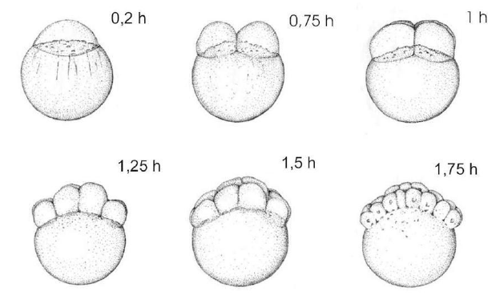

Figure 3: Selected stages of early zebrafish (Danio rerio) development at 26oC, 0.2-1.75 h post-fertilisation (OECDb, 2013).

Already at the 22 hpf point, the formation of somites, formation of yolk-sac, and the formation and detachment of tail occurs. At this point the beginning of the fish larvae are already developed; the embryo is still enveloped by a chorion. Between the 22 and 48 hpf point heartbeats are already observed. In figure 4 this larval development is illustrated. Most commonly the hatching or dechorionation occurs at 48 hpf (OECDb, 2013). Table 5 in Appendix I shows a more detailed description of the embryonic development of *D. rerio* (Braunbeck & Lammer, 2005)

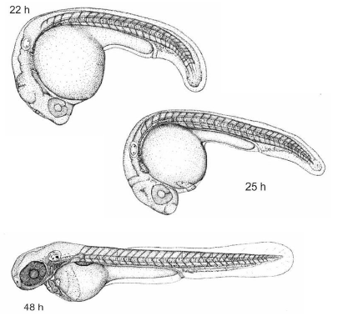

Figure 4: Selected stage of late zebrafish (Danio rerio) development (dechorionated embryo), 22-48 h post-fertilisation (OECDb, 2013).

## Test substances

As stated in the introduction a selection of test-substances was made which would serve as reference for the validation of the short-chronic early life stage fish toxicity test. This selection is based on a literature evaluation of several similar early life stage toxicity studies of the zebrafish (Braunbeck & Lammer, 2005; Plhalová et al., 2010; Rodriquez-Estrada, Sobrino-Figueroa & Martinez-Jeronimo, 2015; Yin, et al., 2014). As values like LC50 are already known through literature, they can be readily used for the validation procedure. Attention was given to the chemicals commonly used in these studies and are thus used as reference toxicants. The compounds selected for this research are potassium dichromate, copper(II)sulphate and sodium dodecyl sulphate. In addition, the bioavailability of the substance was reviewed, as embryos are not expected to be sensitive to a limited bioavailable toxicant (other toxicity tests might be more appropriate for this type of chemicals). Moreover, the physical nature and relevant physical-chemical properties were determined (and presented below in table 1) per chemical compound. Furthermore, the compounds are discussed upon the structural formulas, molecular weight, stability in reference to the test conditions, pKA-values, Kow­-values, vapour pressure and water solubility.

Table 1: Some significant properties of the test-substances.

**Substance Solubility (g/L) Vapour pressure (mm Hg) Log K­ow (-) pKa (-)**

K2Cr2O7 115 - - -

CuSO4 ­2.43 - - -

SDS 100 4.7·10-13 1.6 -

### Potassium dichromate (CAS:7778-50-9)

Potassium dichromate (K2Cr­2O7) is a stable, non-combustible, carcinogenic substance with a molecular weight of 294.18 g/mol. It is an orange crystalline inorganic compound, mainly used in wood preservation, manufacturing of pigments and in photomechanical processes. K2Cr2O7 is highly corrosive and a strong oxidizing agent. When heated toxic fumes of Cr(VI) are emitted, which are known to be significantly harmful. It is known to mainly affect the respiratory tract causing ulcerations, shortness of breath, bronchitis, pneumonia and asthma. Moreover, it can affect the gastrointestinal tract, liver, kidneys and immune system. It is highly harmful to organic tissues; thus, direct contact should be avoided. This compound is denser than water but is in fact highly soluble in water (Kim, et al., 2019); 115 g/L (ECHO, 2019). No distinctive odour is forthcoming. Its melting point is at a temperature of 398oC and decomposition occurs at a temperature of 500oC. At a 1% solution its pH is shown to be 4.04 while at a 10% solution this value will decrease to 3.57. The compound can be absorbed through inhalation, absorption through the skin and digestion (Kim, et al., 2019). Data indicates that vapour pressure is not present in K2Cr2O7; evaporation is thus negligible and no losses of the compound are expected (Young, 2003). As it is an inorganic compound, the assessment for both dissociation (pKa) and bioaccumulation (Kow) is not necessary (ECHO, 2019). Studies show the lethal dose concentrations of Cr(VI) (LC50) is established to be 145.7 mg/L (Domingues, et al., 2010). The purity of the K2Cr2O7 used for the experiments is ≥99%.

### Copper(II)Sulphate (CAS: 7758-98-7)

Copper(II)Sulphate is a sulphate based salt containing the heavy metal (and essential trace element) copper. CuSO4 is most commonly used as a potent emetic against phosphorous poisoning or as an inhibitor to prevent algae growth (Rodriquez-Estrada, Sobrino-Figueroa, & Martinez-Jeronimo, 2015). In addition, it reveals to inhibit bacterial growth (e.g. *Salmonella sp., Edwardsiella sp.,* etc.) resulting in a use of CuSO4 in aquaria against parasites and infections (Lasiené, Straukas, Vitkus, & Juodziukyniené, 2016).As a micronutrient Cu is typically used for the betterment of certain enzymes or liver related injuries. Although seldom needed, Cu is often found in multivitamins and/or mineral supplements; copper deficiency is thus a rare occurrence. In contrast, overdose of this element can have serious consequences; causing acute and/or chronic liver injury, depending on the rate of ingestion. CuSO4 is blue crystalline of appearance and has a molecular weight of 159.6 g/mol. It is a non-combustible compound with a melting point of 590oC and a boiling point of 650oC, at which it decomposes into cupric oxide, emitting the toxic fumes of sulphur oxides. It has a significantly high water solubility, which is higher at warmer temperatures. At 0oC the solubility the inorganic compound is approximately 243 g/L in water (Kim, et al., 2019). Similarly to K­2Cr2O7, no dissociation occurs at any given pH. Furthermore, vapour pressure is negligible as well as the partitioning in bioaccumulation (or soil adsorption) of ionic Cu. Losses due to evaporation and bioaccumulation are thus not expected (Hansen, et al., 2014). Cu(II) is known to be extremely toxic to aquatic life, having both acute and chronic effects. Regarding health, CuSO4 ingestion may have severe gastral effects, causing vomiting, gastroenteric pain and local corrosion. Moreover, it can cause circulatory failure and respiratory difficulties, affecting the red blood cells notably. Transport routes consist of aerosol route and ingesting route (Kim, et al., 2019). The LC50 value of Cu2+ was determined to be approximately 0.15 mg/L (Rodriquez-Estrada, Sobrino-Figueroa, & Martinez-Jeronimo, 2015).

### Sodium dodecyl sulphate (CAS: 151-21-3)

Sodium dodecyl sulphate, C12H25O4S·Na, is an anionic surfactant, which lowers tension of aqueous solutions. It is mainly used as a fat emulsifier, wetting agent and a cosmetic detergent. Moreover, it can be found in various pharmaceutical products and in toothpaste. Its main property is its ability to disperse certain compounds and is thus used extensively for this. This substance is derived from coconut and palm oil, can be pasty or crystalline in appearance and white to yellow in colour. It has a molecular weight of 288.38 g/mol, has a melting point of approximately 204oC and is extremely soluble in water (100 g/L). When heated until decomposition, toxic fumes of sulphur oxides and sodium oxides are emitted. SDS has a log Kow of 1.6 which is known to be low; no bioaccumulation is expected. A low vapour pressure of 4.7 ·10-13 mm Hg indicates no loss to evaporation is expected. As a solid it is flammable and can be seriously damaging to the eye. It possessed an acute toxicity upon inhalation and is significantly harmful to the aquatic environment affecting the organisms chronically. Routes of exposure are adsorption through skin and ingestion. LC50 values are found to be around 4.5 mg/L for the embryonic zebrafish (Kim, et al., 2019).

# Methodology

All experimental procedures of this project were conducted in accordance to the national and international regulations. As Dutch regulation the law of animal testing (Article 9) allows zebrafish embryos to be used until they reach to point of ‘free-living’ individuals (5 – 7 dpf), as stated in the guidelines on the protection of experimental animals by the Council of Europe, Directive 86/609/EEC. As experiments were eliminated upon the opening of the mouth (rendering the fish free-living), no licence were required from the Council of Europe (1986), Directive 86/609/EEC or the Leiden University ethics committee (Ali, van Mil, & Richardson, 2011).

## General approach

The toxicity protocol conducted for validation is based on the combination of the OECD 212 (*the fish, short-term toxicity on embryo and sac-fry stages assay)* and OECD 236 (*fish embryo acute toxicity (FET) test)* guidelines. After the results from the experiments were obtained, the validation of the newly developed method was carried out through statistics and literary review.

OECD 236 was used as the acute part of the test, while OECD 212 test described the chronic part of the total assay. The FET test determined the acute toxic effect by chemicals to the embryos of the *D. rerio.* In essence, newly fertilised eggs were exposed to a series of test substances at various concentrations for approximately 96 hours. The chronic test enveloped the period which starts at the newly fertilized eggs until the end of the sac-fry stage. In this period of time, as was the case with the acute test, the embryos were to be exposed to a selected substance at a selected range of concentrations (dissolved in standard freshwater). Over the duration of the assay, no food was provided, mainly due to the fact that the sac-fry still nourish from the yolk-sac in this life-stage. Over the course of 7 days, both lethal and sublethal effect of the selected chemicals were observed. Strictly speaking, this combination of methods provides useful data forming a bridge between lethal and the chronic sublethal effects in ecotoxicity. In the protocol it was opted to use a semi-static procedure, which means a daily renewal of the test substance was to be carried out. Each fertilized egg was placed in a test chamber where the test-substance was added at desired concentration. Over the course of the test the lethal and sub-lethal effects were observed and compared with control samples. By use of regression modelling the LC-/EC50 values were estimated, while the lengths of fish larvae were analysed with a one-way ANOVA test.

The following conditions applied for the test to be valid:

* Overall fertilisation rate of all eggs collected in the batch tested was to be ≥ 70% on t=96 h;
* Overall survival of the fertilized eggs in the negative control (and if relevant the solvent control vessels) had to be ≥ 90%;
* Hatching rate in the negative control (and solvent control vessels) had to be ≥ 80%;
* Substance concentration had to remain within a 20% range of the nominal concentration over the course of the experiment in each test vessel;
* Throughout the test, dissolved oxygen (DO) concentration had to remain between 60 and 100% of air saturation value (ASV);
* Throughout the test, water temperature had to remain within the specified temperature range of 25oC ± 1 and while not differing by more than 1.5oC between test chambers or between successive days;
* The pH and hardness of the dilution water had to remain around 7.8 and ≤250 CaCO3/L, respectively;
* The experimental design should allow significant variation for statistical purposes (e.g. number of test chambers, number of test concentrations, starting number of fertilised eggs and in parameters measurements).

## Detailed procedure

Material and substances required for each of the experiments can be found in Appendix II.

### Concentration ranges

Appropriate concentration ranges of potassium dichromate, copper(II)sulphate and sodium dodecyl sulphate were obtained through preliminary literature study, based on LC50 values. Upon deviation in actual practice due to sensitivity of the zebrafish strain (or other reasons) the correct concentrations were found through range-finding tests. The toxicity tests consisted of five dilution concentrations prepared without the use of solvents. The concentration range and dilution series depended highly on the test-substance, while great consideration was made to the chronic (long-term) effects of these compounds, ensuring a detailed investigation of the toxicity of these compounds. The LC50 values and the dilution series are presented below in table 2. In addition to the toxic solutions, a dilution-water control tests (as negative control and internal plate control) was carried out. Guidelines state the internal plate control is to be carried out for each plate used. If more than one embryo died of this internal control during the experiment, the plate was rejected. Once rejected, the concerned test had to be repeated. Traditionally, a positive control needs to be carried out twice a year, which is done by use of 3,4-DCA; the sensitivity of the fish strain is tested and the dose-response relationship is determined. As this study looks into the use of a more stable compound as reference, this 3,4-DCA toxicity test was omitted. As no solvent was used for either of the solutions, the solvent control did not need to be carried out.

Table 2: The LC50 values acquired from literature and the determined concentration range per test-substance found through range finding tests (Braunbeck & Lammer, 2005; Plhalová, et al., 2010; Rodriquez-Estrada et al., 2015; Yin, et al., 2014).

***Substance LC50 (mg/L) C5 (mg/L) C4 (mg/L) C3 (mg/L) C2 (mg/L) C1(mg/L)***

*K2Cr2O7*  145.7 500 370 350 300 250

*CuSO4* 0.15 1 0.5 0.25 0.1 0.05

*SDS* 4.5 12 9.6 7.8 6.2 5

### Embryo selection and well-plate preparation

The principle of the ELS stage is that fertilized ­*D. rerio* eggs are submerged in the toxicant as early as possible. OECD guidelines state that if the *D. rerio* eggs are obtained from an outsourced supplier, which applies for experiments carried out at WMR, it may not be an option to start the experiment immediately after fertilization. Note that sensitivity of the test may be seriously influenced by delayed initiation of the test. In any case, the embryonic stage at the start of the exposure period were verified as precisely as possible, as well as no irregularities were to be found at this stage.

A selection of successfully fertilised eggs was made approximately 4 hours after spawning. Figure 18 in Appendix III gives a schematic of the selection procedure. This selection procedure was done by use of binocular, where double the amount of the eggs needed for the experiment (2n) were placed in a petri dish and fully submerged in the respective test concentration or control, this ensured exposure at the earliest stage of development as possible. During the selection procedure, the following criteria were followed: the fertilised eggs were undergoing cleavage, were showing no obvious irregularities or injuries of the chorion and were showing an adequate cell division. Upon completion, the embryonic fish were translocated into the 24-well plates (placing one egg per well), covered with self-adherend foil and incubated at the appropriate temperature without further aeration. Note that the eggs (and larvae) were not to come into contact with the air. However, efforts were made to keep the amount of water in the pipette as low as possible. In total, 20 embryos were exposed per concentration of the test-substance; the test-substance was added to each well (2 mL) prior to the placement of fertilised eggs. In summary, the following number of *D. rerio* eggs were distributed over the following number of 24-well plates (and presented in Appendix III in figure 19):

* 20 eggs in one plate for each test concentration (=five 24-well plates);
* 4 eggs in dilution water as internal plate control in each of the above plates;
* 24 eggs in dilution water as negative control in one plate.

### Daily renewal and quality control

Regarding the daily renewal of test substance, the *D. rerio* embryos were kept in the test vessels while at least three quarters (75%; 1.5 mL) of the test water was changed; this is called the static-renewal method or the semi-static test. Guidelines recommend a daily water renewal for unstable substances in particular. Note that the stress to the test organisms should be avoided and should always remain submerged.

Over the course of the experiment the testing solution was to be assessed on its quality. For the semi-static test this was done by measuring the test water in the prepared replicate vessels. Guidelines state the majority are to be carried out for only the controls and the highest concentration (C5). Furthermore, DO and pH were assessed in each test plate. Temperature was measured in three randomly selected vessels. These parameters were measured daily before and after each renewal. Water hardness was measured once in each test. Since the well-plates are renewed on a daily basis, measurement of concentrations was deemed unnecessary.

### Observations

Observations on hatching and survival were carried out daily. For the compound comparison and analysis, the traditional toxicological endpoints were adopted as described in the OECD guidelines. These included egg coagulation, non-development of somites, non-detachment of the tail and the lack of heartbeat; these endpoints were mainly found during the acute test. In addition to the lethal endpoints, attention was given to completion of somite formation, development of the eyes, spontaneous movement, presence of blood circulation in the dorsal aorta, degree of pigmentation (to a certain extent). As sublethal effects both physical and behavioural abnormalities were considered. These included mainly malformation of the spinal cord (scoliosis) and/or tail, a significantly slow heartbeat, an abnormal inactive behaviour (including the lack of reaction to mechanical stimulus), enlargement of the yolk-sac and general growth retardation measured at t=7 dpf in both standard- and/or total length; the total length envelops the complete length including the transparent caudal fin, while standard length envelops the length of the fish excluding the caudal fin. Traditionally, the standard length is used when the majority of the caudal fins are damaged and cannot be measured properly. In this study the total length was used with exception of the dilution water tests; in the first test only, the standard length was successfully measured.

Within 24 hpf mortality rate of the eggs were expected to be highest (5-40%). In addition, development- and hatching rate of the eggs is known to vary greatly depending on the batch. Traditionally, eggs and yolk sac larvae have 90% survival rate once fertilisation is successful. At 25oC hatching usually occurred 3-4 dpf. Deaths differ greatly depending on the life stage (these lethal endpoints are illustrated in Appendix IV, figures 20-23).

### Data analysis

Once observations were made statistical analysis was carried out. This was done through the use of the cumulative mortality, hatching success, number of healthy larvae at the end of the test, time of hatching, length of surviving individuals at end of the test, number of larvae that were deformed or abnormal in appearance and/or behaviour. Using the cumulative mortality and hatching success the LC-/EC50 values were estimated by use of a non-linear regression analysis; the sigmoidal dose response suitability curve fit is used. For calculating these values, the Graphpad prism software was used.

These curves were fitted using the data of interest, using a 95% confidence interval, where the percentage of embryos scores positive for the aforementioned observations at 96 h and/or 168 h was plotted against the individual test concentrations. Through parametrisation of the curves, LC-/EC50 of interest and its standard errors can be estimated directly. This regression analysis was suitable for all types of observations listed above. Correction calculations of the surviving eggs and larvae was carried out with the *Abbott’s formula*. This correction can be used in the eventual determination of the LC-/EC50 values. Both formulas of the non-linear regression analysis and *Abbott* are displayed in Appendix V.

Growth retardation was estimated by using analysis of variance of a single factor (one-way ANOVA) between the results of the individual concentrations and those of the controls (negative control). In essence a multiple comparison procedure was used. Homogeneity of the variance was estimated by the use of the *Levene’s test* (which looks at the variation in the standard deviation of the groups), while all samples were drawn up independently from each other (a matter of arranging the data). To check whether the groups are individually distributed, the *Shapiro-Wilk test* was carried out. Upon failing of these tests, the data would undergo transformation. As an ANOVA analysis only indicates if there is a variance or not and not where the actual differences lie, a post-hoc test was chosen as a final calculation. In this study, either the *Tukey HSD (honestly significant difference) test* or the *Tukey-Kramer test* was used (depending on the equality of the sample sizes between groups). In essence, the standard error (SE) was determined through the formulas viewed in Appendix V which helps to find the q-value (Sokal & Rohlf, 1995). Beside that the critical q-value is determined by use of the Tukey table, using both the number of groups used for the analysis (*k­-*value) and degrees of freedom found through the ANOVA analysis (Appendix VI).

## Overview of the tests

Overall four tests have been conducted. In each test two of the compounds were conducted, with additional test-plates for further investigation. In table 3 below, an overview of the tests has been made. The full short-chronic ELS test envelopes the regular protocol described above; five concentrations were tested per compound including a control plate. In these tests the dose-dependent relationship was determined through data analysis. Looking at the acute and chronic effects independently and calculating LC-/EC50 values and growth retardation. Once all data was obtained the results of 4 dpf and 7 dpf were compared with each other. Upon observing the decreased hatching success in the copper solution, it was opted to investigate more, using different types dilution water and different concentrations to see if there were any differences to be found. These tests would be inconclusive as they were only single plate tests; they merely served as an investigation for future reference. Lastly, it can be seen that different types of dilution water were tested. This was to study which dilution water revealed to be the most suitable for use.

Table 3: a general lay-out of the planned tests; note the test code consists of the DR (standing for Danio rerio) and the number of the test.

**Test code Date of initiation Compounds tested Description**

DR-01 04-03-2019 Potassium dichromate Full short-chronic ELS test

with Daphnia water.

Copper(II)sulphate Full short chronic ELS test

with Daphnia water.

DR-02 25-03-2019 Potassium dichromate Full short chronic ELS test

with EPA water.

Sodium dodecyl sulphate Full short chronic ELS test

with EPA water.

Copper(II)sulphate Single test plate with 1 mg/L concentration in EPA water.

DR-03 12-04-2019 Potassium dichromate Full short chronic ELS test

with tap water.

Sodium dodecyl sulphate Full short chronic ELS test

with tap water.

Copper(II)sulphate Single test plate with various lesser concentrations.

DR-04 29-04-2019 Potassium dichromate Full short chronic ELS test

with EPA water.

Sodium dodecyl sulphate Full short chronic ELS test

with EPA water.

Copper(II)sulphate Single plate test with 1.25 mg/L concentration in EPA water.

### Validation procedure

The validation process is carried out through a literature study and processing the results from the experiments. LC- and EC50 values obtained from the experiments carried out at the lab of WMR, will need to correspond (or match) with the values found in literature. If the results do not match, further investigation is necessary on what could have led to these results. Furthermore, growth retardation and the type of dilution/test water is studied.

# Results

Upon non-linear regression analysis the embryonic toxicity of PDC, CuSO4 and SDS were determined and the LC50 and EC50 values were calculated; the median lethal concentrations are viewed below in table 4. Lethal effects were almost always in the form of coagulation. Initial results already indicated a need for adjustments of the concentrations ranges, narrowing down dilution series and working to a more detailed and accurate insight to the dose-effect relationship. The negative controls showed a relative successful development; overall hatching success was around 100% on the 4th day of the tests. Excluding test DR-03, which was carried out with tap water. This means DR-01, DR-02 and DR-04 meets the requirements for validity, while DR-03 does not. Hatching usually started on the 3rd day of the test, while achieving 100% at day 4.

Table 4: Lethal toxicity of the reference compounds and their concentration ranges used for the most recent test.

**Compound LC50-4d (mg/L) LC50-7d (mg/L) Concentration range**

Potassium dichromate 435.9 383.8 250 – 500 mg/L

Copper(II)sulphate - - 0.05 – 1.25 mg/L

Sodium dodecyl sulphate 7.2 7.1 5.0 – 12.0 mg/L

## Potassium dichromate

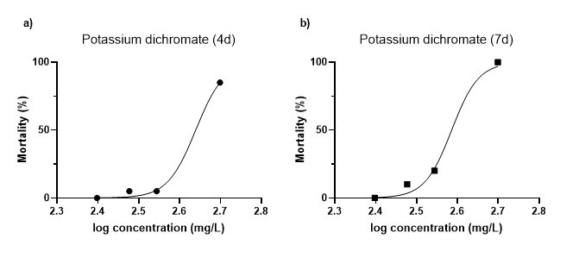The effects in PDC were mostly found as a lethal effect; hatching retardation was hardly observed, while physical formations in the development of somites, eyes, pigmentation, detachment of the tail-bud, etc. were hardly forthcoming. In contrast, there were some cases of inactivity observed on day 7, often paired with a seemingly slower heartrate, unable to remain in an upright position in the well. This could point to an increased mortality on a longer term, but no observable trend in the increasing concentrations was observed. Remarkably, cumulative mortality was particularly observed upon initiation of the hatching and effects were hardly found before this point; it seems the chorion forms a sufficient protection against lethal dosages of PDC. Looking at the LC50 of PDC, it shows to be relatively high. Figure 5 shows the dose-dependent sigmoidal curve of PDC in relation to the mortality of the embryos, where figure 5a shows the curve after 4 dpf and 5b shows the curve at 7 dpf. In the long-term PSD seems to have an increased mortality, showing a 100% mortality at 500 mg/L, decreasing its LC50 value to approximately 383.8 mg/L.

Figure 5: Non-linear regression analysis of PDC’s lethal toxicity a) analysis at 4 dpf b) analysis at 7 dpf.

As sub-lethal effects in PDC were minor and not showing any dosage-dependant trend, the EC50 could not be determined due to this.

In terms of growth retardation, PDC has shown some minor effect; differences are minimal but still present. The total lengths of the larvae were measured and are shown in figure 6 below. Note the variation of the samples, illustrated by the error bars. Taking the ±SD into consideration, the fish in the varied concentration show to have quite overlap in lengths between the groups. As can be seen length is dependent on the concentration.

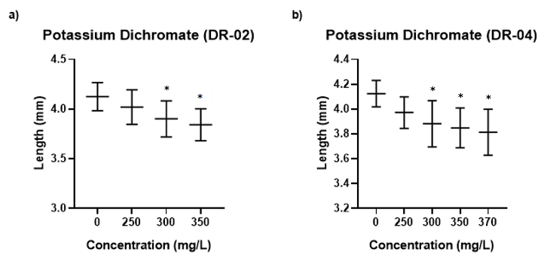

Figure 6: Mean lengths of the larvae at t=7 dpf at several concentrations of PDC. The middle line signifies the µ, while the outer error bars signify the ±SD. a) Growth retardation of experiment DR-02; b) growth retardation of experiment DR-04. (*= sample group with a significant difference between concerned concentration and the negative control; 0 mg/L).

One-way ANOVA analysis (p<0.001) indicated a significant difference amongst concentrations. A post-hoc test Tukey-Kramer test indicated this growth inhibition started from 300 mg/L in the DR-02 test (figure 6a), showing an increasing growth retardation as concentrations increased to 350 mg/L; the absolute mean lengths and growth retardation of the larvae in relation to the concentration is shown Appendix VII in table 7 and 8. Similarly to DR-02, DR-04 (figure 6b)shows a growth retardation from 300 mg/L and onwards. It seems that indeed a dose-dependent effect is found in the form of growth retardation to the larval fish. As undoubtedly noticed, the higher concentration (500 mg/L) is missing in the graph. This is due to the fact that in these concentrations, mortality is high and sample sizes is reduced notably, losing its statistical reliability when determining the growth retardation.

## Sodium dodecyl sulphate

Effects of SDS show to be similar to that of PDC as it mainly seems to have a lethal effect rather than a sublethal effect. Deaths occurred already on the first day at much lower concentration indicating SDS to be a highly potent toxicant. It seems the chorion does not serve as a protective layer as effectively as in the PDC samples. Figure 7 below shows the curve fit regression of both 4 dpf and 7 dpf. SDS shows to have minor increased effect on the long-term. The regression analysis of the lethal effect led to a LC50 of 7.2 mg/L at 4 dpf and 7.1 at 7 dpf (table 4).

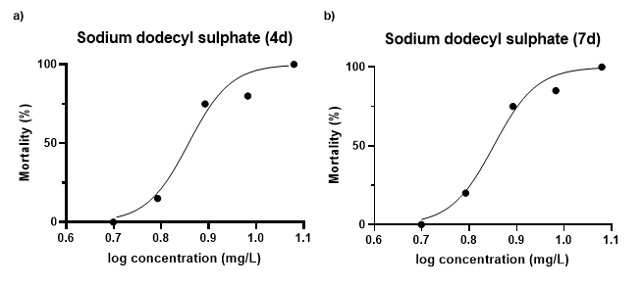

Figure 7: Non-linear regression analysis of SDS’s lethal toxicity a) analysis at 4 dpf b) analysis at 7 dpf.

Sublethal effects, mainly observed in test DR-04, showed to be in the form of hatching retardation with an obvious trend over an increasing concentration; non-linear regression analysis gave an EC50 of 7.06 mg/L which is not far from the LC50 values.

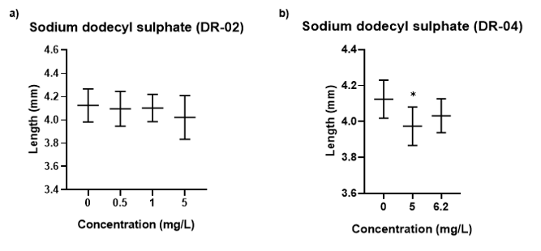For the growth retardation in larvae a one-way ANOVA of the DR-02 test of SDS (figure 8a) showed no statistically significant difference between the different concentrations (p=0.15). Thus, at these lower concentrations there seems to be no induced effect of SDS on the zebrafish larvae. Following further analysis of DR-04 (figure 8b), one-way ANOVA (p=0.01) showed there was indeed a significant difference between groups. Further analysis by use of the post-hoc Tukey-Kramer test indicated this difference was found only between the negative control and the concentration of 5 mg/L and not in a concentration of 6.2 mg/L (Appendix VII), indicating the differences are very slight.

Figure 8: Mean lengths of the larvae at t=7 dpf at several concentrations of SDS. The middle line signifies the µ, while the outer error bars signify the ±SD. a) Growth retardation of experiment DR-02; b) growth retardation of experiment DR-04. (*= sample group with a significant difference between concerned concentration and the negative control; 0 mg/L).

## Copper(II)sulphate

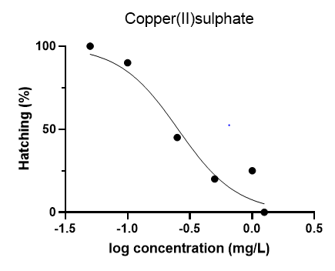Toxicity of CuSO­4 was particularly found in the form of sublethal effects; as hatching retardation. Mortality was only found in the highest concentration of 1.25 mg/L and showed to be around 50%, which suggests LC50 to be around 1.25 mg/L. However, the lack of further data at higher concentrations makes regression analysis unreliable. Through sigmoidal regression analysis, of which the curve is presented in figure 9, an EC50 of 0.25 mg/L was determined, making CuSO4 an relatively potent toxicant. As can be seen this hatching effect has a clearly defined dose-dependent relationship; with an increasing concentration, a lower hatching success is observed.

Figure 9: Hatching success of the zebrafish embryos dependent on the CuSO4 concentration.

As hatching success was rather low and measurement of the larvae was still to be perfected at the time of the copper test, the length retardation could not be determined.

## Investigation of the test-water and *D. rerio*.

In efforts to further understand the factors affecting the outcome of the results of test, the method and test organism, *D. rerio,* were investigated. This included the testing of three different dilution/test waters; two of these are commonly used as standard fresh water (SFW), prepared individually with the Daphnia tox-kit medium (DR01) or the EPA tox-kit medium (DR-02 and DR-04). In addition, regular tap water (DR-03) was tested. For this analysis the negative controls were used. While both Daphnia- and EPA water both showed acceptable survival and hatching success; both showing 100% survival and hatching success on the acute endpoint (4 days) and chronic endpoint (7 days). However, when reviewing the negative control of tap water, it is found that hatching at the first acute part of the test is null; later hatching success increases to 87.5%. This reduced hatching effect has dire consequences on the validity of the test-results. Furthermore, tap water seems to have a chronic lethal effect as mortality was found to be 4.2%. When looking at the lengths in the individual types of test-waters, one-way ANOVA (p<0.001) paired with a post-hoc Tukey-Kramer analysis showed a significant difference between both the SFWs and tap water. Where EPA- and Daphnia water showed to have mean length of 3.84 (±SD=0.018) and 3.82 (±SD=0.018) mm, respectively; the larval *D. rerio* in tap water grew to a length of 3.41 (±SD=0.019). No significant difference was found between EPA and Daphnia water. Note that for this analysis the standard length was used as the number of values for the total length in the Daphnia water was found to be too small for statistical analysis.

In addition, the influence of hatching time on the growth was investigated. The lengths were measured at the end of the test, on the 7th day. Through the comparison of the lengths of the individuals that hatched on day 3 and the individuals that hatched on day 4. A two-tailed t-test of equal variance indicated in both the negative controls of DR-02 (p=0.4) and DR-04 (p=0.35) no significant difference is found between the *D. rerio* that hatched on the 3rd day of the test and those that hatched on the 4th day.

Finally, the growth over time was investigated once 100% of hatching was achieved. This means that starting from day four, the length of the larval *D. rerio* were measured daily. One-way ANOVA (p<0.001) paired with a post-hoc Tukey HSD test indicated that the in the first couple of days a steady growth is observed ranging from a mean total length of 3.51 (±SD=0.001) mm on the first measurement to a mean total length of 4.08 (±SD=0.002) mm per the 6th day of the test. Note that the total length was used here instead of the standard length. No significant difference was found between the mean lengths of the last two days of the test, suggesting no further growth occurs in this period of time. In figure 10 to the right, the graduation of growth is illustrated, revealing that indeed the larvae seem to halt after the 6th day.

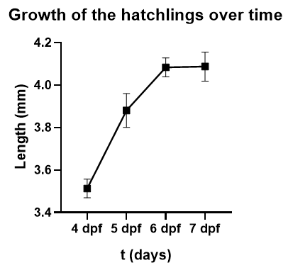

Figure 10: Growth of the hatchlings over time within EPA water.

# Discussion

## Validity of the tests

As stated in the methodology, the short-chronic ELS fish toxicity test needs to meet certain requirements. Should the test fail to meet these requirements the results are deemed invalid; for the sake of discussion however, the invalid results are still considered and used for continuation of the present study.

* Overall fertilization of the eggs collected was sufficient in all tests. The number of unfertilised eggs was kept at a minimum, fertilisation success exceeded 90%. DR-04 had an overall fertilisation of 100%;
* Survival of the negative controls were exceeding the 90% boundary for all tests;
* Apart from the DR-03 test, hatching success in the negative controls showed to be sufficient. Consequently, the DR-03 test was considered to be invalid;
* As each well in the test plates were renewed on a daily basis the assumption is made that the substance concentration remained within a 20% range of the nominal concentration over the course of the experiment;
* As quality control indicated for the initial tests, DO remained between 60- and 100% of ASV throughout the tests, while temperature remained around 25oC and did not differ by more than 1.5oC;
* pH and hardness levels of the dilution water remained sufficient for most of the tests as indicated by the quality control with exception of DR-01 which showed to exceed the boundary level of 250 mgCaCO3/L for hardness, rendering the use of Daphnia water insufficient;
* Experimental design allowed significant variation for statistical purposes.

As stated, the datasets of the measured lengths in the PDC and SDS samples were analysed beforehand on their distribution and variation as is required when conducting a one-way ANOVA test. Levene’s test revealed a homogeneity in variance while the Shapiro-Wilk test showed all datasets to be normally distributed. As a result, the ANOVA test was allowed to be used for determination of growth retardation.

## An elaboration and review of potassium dichromate toxicity

### Accuracy and reliability of the regression analysis

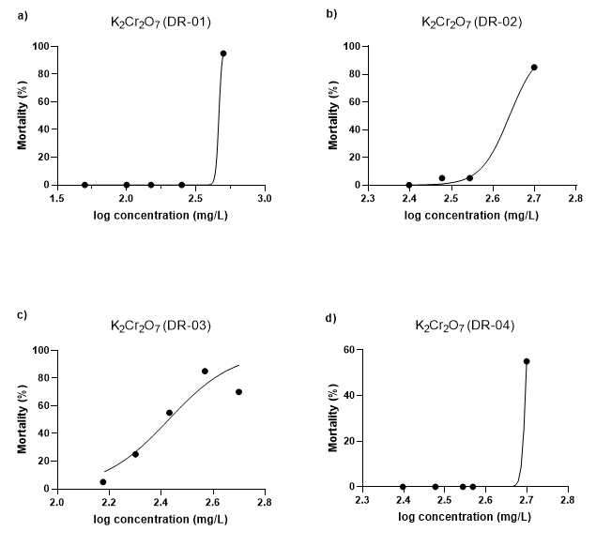For the determination of the effect of PDC various repetition of the experiment have been carried out. The regression analysis of the acute effect is viewed below in figure 11. Upon reviewing the non-linear regression analysis, it can already be seen that the curves are not of sigmoidal shape. Initially, during the first test of DR-01 (figure 11a), which had a concentration range of 50-, 100-, 150-, 250- and 500 mg/L, it was found that the concentration series was quite broad; where 250 mg/L PDC showed no mortality at all, while the entire population was found to have died at a exposure to a concentration of 500 mg/L. Making such a jump from one concentration to another resulted in a very wide 95% confidence interval (CI) and a particularly steep Hill’s slope, which in turn led to ambiguous results in a LC50 of 463.4 mg/L. DR-01 is therefore used as a range-finding test. After the concentration range was adjusted for the DR-02 (figure 11b) test, giving a range of 250-, 300-, 350-, 400- and 500 mg/L, new sigmoidal regression analysis gave a less ambiguous results. Looking at the results however, one might observe the exclusion of the data of 400 mg/L (102.6). This is due to the fact that during the execution of the test an error occurred (probably a dilution error), which deemed the results for this plate unusable; an instant 100% lethality was observed in the 400 mg/L well plate. This missing data interfered with an accurate LC50 identification and was thus omitted from the regression analysis. Reviewing the 95% CI (lower=400.7 mg/L; upper = 474.2 mg/L) and Hill’s slope (5.74) of the DR-02 test, indicates a relatively broad range while showing the curve to be still quite steep. Overall the model has a good fit (R­2 > 0.99); DR-02 shows to be the most reliable result of the series with a LC50 of 435.9 mg/L.

Figure 11: Acute toxicity of potassium dichromate (t=4 dpf); a) Regression analysis of DR-01, b) Regression analysis of DR-02, c) regression analysis of DR-03, d) Regression analysis of DR-04

DR-03 had a concentration range of 150-, 200, 270, 370 and 500 mg/L and does not, as stated earlier, meet requirements for a valid short-chronic ELS toxicity test; results are not deemed valid and are not used. DR-04 was carried out with a similar concentration to DR-02 with a series of 250-, 300-, 350-, 370- and 500 mg/L. The results of this test however, were contradictory to that of its predecessors, DR-01 and DR-02. Showing zero effect in the lower concentrations, while at 500 mg/L exposure a mortality of 55% was found. As was the case with DR-01, the 95% CI and Hill’s slope were significantly broad, while the model fit was found to be ambiguous. The outcome of a LC50 of almost 500 mg/L is deemed inaccurate.

Overall the regression curves still seem too steep for reliable results. It is clear that the range finding process is still to be continued for determining the toxicity of this compound. One missing aspect is the lethal toxicity of PDC between 370- and 500 mg/L, which might be key to finding a more accurate LC50 value.

### Comparison of potassium dichromate toxicity with other studies

#### Acute toxicity

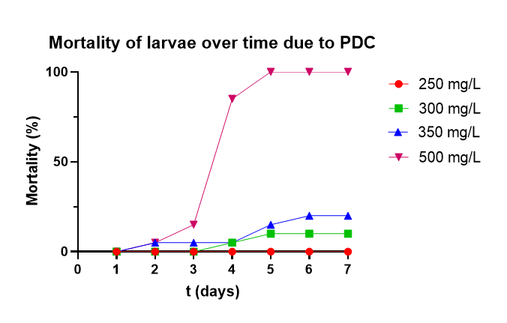Overall the present study has demonstrated that the embryotoxicity of PDC primarily comes forth as a lethal compound. The most noteworthy aspect in the observations of the lethality was ultimately that mortality was only put in affect upon the initiation of hatching; this observation was found in all experiments with the exception of DR-03 which had mortality within the first 24 h of the test (due to tap water). This protective nature of the chorion is more clearly defined upon review of the mortality of larvae over time (figure 12). Once dechorionisation ensues on the third day of the experiment, the hatchlings come into contact with the PDC. As demonstrated in the graph, the majority of the deaths occur between 3 – 5 dpf and does not seem to change significantly thereafter. In addition, figure 12 illustrates the notable contrast between the lower concentrations (250 – 350 mg/L) and the higher concentration (500 mg/L). Where, 350 mg/L showed to have a mortality of 20%, while 500 mg/L showed to have a mortality of 100% at 7dpf. It seems the missing data on the lethality of PDC at 400 mg/L would be definitive in acquiring an accurate result on the toxicity of the compound. Based on the repetitions of the experiment, it is known the LC50 is at least >400 mg/L.

Figure 12: Mortality of the larvae over time displayed per concentration of potassium dichromate.

The protective ability of the chorion is indeed a frequently found observation in the assessment of PCD’s toxicity. Domingues et al. (2010) for example has already established this relation by comparing the lethal effect of Cr(VI) to both embryonic and adult *D. rerio*; adult zebrafish seem to be more sensitive to the compound (96h LC50­=39.4 mg/L) while the embryos survive in much higher concentrations (96h LC50=145.7 mg/L). This notion is also supported in other studies such as that of Kovrižnych et al. (2013), while also found in other species like the common carp (Krejâí & Palíkavá, 2006). This lethality of PDC has primarily been linked to the ability of Cr(VI) to cause oxidative stress and harm to the immune system; the forming of reactive oxygen species (ROS) can have dire consequences on cellular level, damaging proteins, lipids and DNA, eventually leading to cell death (Yin, et al., 2014). Upon converting the experimentally found LC50 of PDC to an LC50 of Cr(VI), it is found that Cr(VI) has a LC50 of approximately 154.08 mg/L; showing a relatively small difference from the LC50 determined by Domingues et al.; approximately 10 mg/L. Seen the other way around, upon conversion of the LC50 determined by Domingues et al. the value for PDC would be 412.17 mg/L, while the present study has a LC50 of around 435.9 mg/L. Interestingly enough, as experimental analysis is deemed less reliable, both values are still close to each other.

What can be seen in the present study, is that indeed Cr(VI) is unable to accumulate in embryos when still protected by the chorion. This is supported by the fact that hatching time remains unaffected in comparison to the control. As figure 13 illustrates, a decreased hatching only occurs in the concentrations where the majority of the *D. rerio* die, while hatching in the lower concentrations show to follow regular hatching success. Once hatching is initiated the Cr(VI) particles are taken up by the cells and through the forming of ROS lead to cell death, both acutely and chronically. Comparison between short-term and long-term effects shows that the longer treatment of Cr(VI) increases mortality only slightly (displayed in figure 12). This is primarily seen in the higher concentration between the 4 and 5 dpf and is only observed in a small increase in the lower concentrations. It is clear that the compound does not have an effect on the chorion while it does have a notable effect on the fish larvae themselves. On an acute level, the results found in the presents study are in great agreement to what is found in literature, demonstrating the corresponding sensitivity of the fish to the compound. The similarity is a great indication on the reliability of the protocol used for this project.

#### Chronic toxicity

Figure 13: Hatching success of larvae over time displayed per concentration of potassium dichromate.

Notably, literature studies suggest the presence of sublethal effect in the form of physical malformations. The *Danio* hatchlings would undergo malformation in the vertebral column, head, fins, yolk-sac and heart (Nguyen & Janssen , 2001). Although these abnormalities were observed in the present study, they did not seem to follow dose-dependent trend. Often these malformations were seen in dead individuals and disregarded as decomposition of the larvae. As literature describes, PDC seems to have a neurotoxic effect, inhibiting enzymes (e.g. acetylcholinesterase) that control neurotransmitters involved in nerve- and muscle action (Domingues, et al., 2010). Inhibition of these enzymes may lead to a severe weakness in muscles and thus the larvae could have trouble with staying upright within the wells. Moreover, the inhibition of acetylcholinesterase has been linked to affecting growth, which may account for the reduced length in the PDC samples (Ansari & Ansari, 2015). Furthermore, the breakdown of lipids due to ROS in particular, can lead to higher energy consumption as it is mainly used for the stabilisation of the cell membrane (Schmidt, 2007). Oxidative stress is said to influence to probability of several pathological conditions, increasing the sensitivity of the embryos, as stated by Mugoni, Comporeale & Santoro (2014).

In retrospect, the inhibition of certain enzymes may have resulted in a severe weakness in the embryos while the breakdown of lipids led to a higher energy consumption. It could be possible that this weakness and shortage of energy proved to be lethal on a longer term, eventually being scored as a lethal effect. On a long-term level, the relevance is really put to question. Primarily due to the fact that it could be argued that these malformations indeed follow a trend but ultimately led to mortality. This is further elaborated upon when looking at the growth retardation, showing a significant trend while the differences are extremely small. It is argued that on an ecological or even toxicological point of view this difference does not show any relevance.

## An elaboration and review of sodium dodecyl sulphate toxicity

### Accuracy and reliability of the regression analysis

Upon review of the embryonic toxicity of SDS investigated over the course of several experiments, displayed in figure 14, it is shown the LC50 ranges between 4.76- and 7.1 mg/L. Initial range-finding tests of DR-02 (with a concentration range between 0.5 and 50 mg/L) showed a steep sigmoidal curve. As can be seen in figure 14a, lethal effect makes a huge jump between 5 mg/L and 20 mg/L, from 0% to 100%; leading to the conclusion the optimal concentration range is somewhere between 5- and 20 mg/L. The adjustment of the concentration range for the following test (DR-03) was determined to be 1-, 4-, 6-, 12- and 20 mg/L. As can be seen in figure 14b, the top two concentrations were found to have a 100% mortality. The regression analysis shows a good fit, with a sufficiently narrow 95% CI (lower = 5.08 mg/L; upper = 5.2 mg/L) and a Hill’s slope of approximately 5.53, a relatively steep curve but still a good fit. However, as the negative control did not meet hatching standards for the DR-03 test, these results are deemed invalid and are discarded. Eventually, this test is used as a range-finding test and the new adjustments for DR-04 were made. The new concentration range of the last test was determined to be 5-, 6.2-, 7.8-, 9.6- and 12 mg/L. Regression analysis (figure 14c) showed to have a lesser fit than its predecessor with a broader 95% confidence interval (lower = 6.43 mg/L; upper = 8.07) and a higher Hill’s slope of 9.84 (mainly caused by the relatively high Hill’s slope of the Upper 95% CI). All things considered, it shows a good fit (R2 = 0.96) and its results are deemed reliable. For a more detailed curve an even narrower range would be a viable option, concentrations ranging between 6- and 8 mg/L.

Figure 14: Acute toxicity of SDS (t=4 dpf); a) Regression analysis of DR-01, b) Regression analysis of DR-02, c) regression analysis of DR-03.

### Comparison of sodium dodecyl sulphate toxicity with other studies

#### Acute toxicity

The relatively instant lethal effect of SDS (figure 15) illustrates the very potent toxicity of this compounds in comparison with many other substances that fail to accumulate within the embryos due to the protective nature of the chorion. As can be seen little too no further effect is observed after initial deaths. It has been suggested that SDS has such high toxic effect due to its surfactant properties (Ali, van Mil, & Richardson, 2011). The mechanisms of surfactant toxicity have been widely theorised upon. In 1964 for example, Prat and Giroud have stated the overall lethal effect is caused by the reduction in surface tension, while this was later rejected as surface tension has little to do with toxic effect on fish (Muller, 1980). It has been suggested, surfactants have the ability to affect the biological membranes and subcellular organelles, while also disrupting functions of certain enzymes (Thoraugh, 1992).

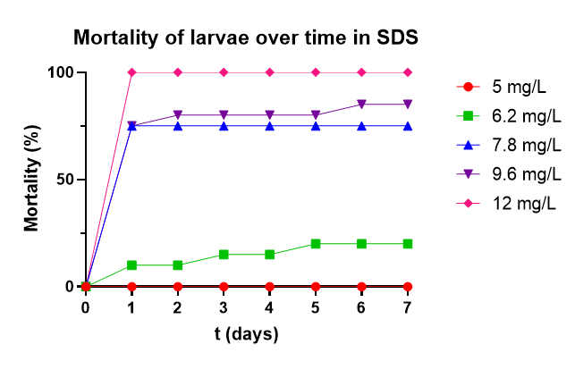

Figure 15: Mortality of larvae over time displayed per concentration of sodium dodecyl sulphate.

Comparing the toxicity of SDS of the present study with other similar conducted research, it is found that overall this compound is reported to be more toxic than presently determined in this study. Ali, van Mil & Richardson (2011) for example, determined the 96h LC50 to be 3.6 mg/L, while Vaughan & van Egmond (2010) reported it to be around 4.1 mg/L. Although the values seem to be relatively close to each other it still seems to be a significant difference in comparison with the experimentally found 7.2 mg/L.

The most striking aspect in the adverse effects of SDS in the present study is that deaths occur within the first 24 hours of the test while no further mortality is reported once they are hatched; this is clearly demonstrated in figure 15. This would suggest that SDS in fact has an effect on the eggs rather than the fish themselves, implying that it could be a mechanical effect rather than be toxic on a cellular level (as suggested in literature). It could be that the compound attaches itself to the chorion, causing a lack in the exchange of oxygen, leading to suffocation. Once hatched this problem does not seem to occur, implying that the surfactant is unable to attach or accumulated in the fish; possibly due to the movement of the fish. This is also supported due to the decreased hatching success found during the experiments, showing that SDS only seems to have effect on the chorion. As figure 16 illustrates, SDS seems to cause a dose-dependent delayed hatching effect. This is particularly seen between the lower two concentration (5- and 6.2 mg/L); hatching is nearly nothing at the higher dosages as most individuals are already dead and will thus be unable to hatch. While at 5 mg/L the hatching occurs at relatively regular pace, the embryos emerged in 6.2 mg/L SDS show to complete hatching at a significantly slower pace. Comparing the hatching- and lethality data, it can clearly be observed that while the compounds causes delayed hatching, the hatchlings remain unaffected after dechorionisation, showing no additional effect. This leads to the conclusion that in fact SDS has an effect on the chorion, while an uptake by the larvae does not occur. The eggs seem to become harder due to the surfactant making it impossible for the fish to hatch. As already derived from the literature study, the effects of SDS on the chorion will need to be investigated more. The similarities between the effect found in the present study and found in literature is significant. Indicating the method for this compound to be relatively suitable and revealing the sensitivity of the fish properly. Of course, the discovery of LC50 values found in literature differing from the experimentally found value reveals some disagreement. At this point, it is difficult to explain why this is the case; repetitions of the experiments are greatly advised.

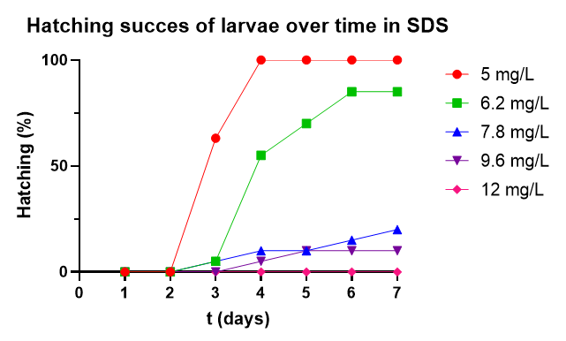

Figure 16: Hatching success of larvae over time displayed per concentration of sodium dodecyl sulphate.

#### Chronic toxicity

Apart from lethal effects, sub-lethal effects seem to be less common from SDS; surviving individuals carry on with a normal development. Similarly to the present study, literature suggests that embryos are particularly affected during the early stages of development while SDS is lacking effects on a longer term. The first 12 hours of development is reported to be more sensitive to the toxicity of surfactants. It is theorised that the embryos obtain an increased ability to metabolise these toxicants, hence the lack of chronic effects (Vaughan & van Egmond, 2010). At present the mechanisms of surfactants effects are still discussed. While its recently discovered dose-dependent toxic potency is evident, further research is into the subject is certainly required. Furthermore, the growth retardation established in this study is contradictory to the report of missing lethal effects in other examinations, stating that surviving individuals show to continue their development at a regular pace. Considering that this reduction in length was only observed during DR-04 test at a concentration of 5.0 mg/L while the individuals emerged in 6.2 mg/L of SDS revealed to be unaffected, it is speculated that this occurrence arose by mere chance. Additionally, the reported difference although statistically significant shows to be extremely small, again seemingly putting the relevance of growth as an indication of toxicity to question.

The lack of long-term or any other sub-lethal effects, especially for SDS, is an indication of the redundancy regarding the chronic part of the test; as effect only showed to be acute, stretching the protocol to 7 days for this compound seems to be elaborate.

## An elaboration and review of copper(II)sulphate toxicity

### Accuracy and reliability of the regression analysis

The non-linear regression analysis of CuSO4, illustrated in figure 9, showed the notable sub-lethal toxicity of copper. Based on literature the range concentration was determined to be between 0.05 and 1.25 mg/L. The rather low 168h EC50 of 0.25 mg/L demonstrates how seriously toxic Cu2+ can really be. The regression analysis showed a good fit (R2=0.94) while 95% CI showed to be relatively good as well (lower = 0.16 mg/L; upper = 0.40 mg/L) and the Hill’s slope presented to be a sufficient 1.83. Overall results seem to be quite accurate and reliable. As stated, before the lethal effects of CuSO4 presented in this study are still to minimal to make any concrete statements. Initial examination shows the LC50 to be estimated around 1.25 mg/L. Further assessment of copper toxicity in concentration exceeding to 1.5 – 2.0 mg/L is therefore advised.

### Comparison of copper toxicity with other studies

#### Acute toxicity

As stated, determination of the lethality of copper is still to be investigated in future studies. Literature suggests a LC50 of 0.35 mg/L as stated by Hernandez et al. (2011), while Kovrižnych et al. (2013) report it to be between 1.0 – 1.5 mg/L. In response to the results from the experiment of emergence of the embryos in 1.25 mg/L of CuSO4, it is expected the 96h LC50 of copper will be determined to be approximately 0.49 mg/L (derived from a loosely estimated 96h LC50 of 1.25 mg/L of CuSO­4; using the fraction of Cu in the compound). The variation in literature makes it difficult to determine what the actual LC50 is. Copper is known to be highly toxic to fish, so one would expect its LC50 to be more in the trend of 0.35 rather than 1.5. The fact that it is still unknown in the present study if there’s no uptake by the fish of the copper compound at all, makes it difficult to ascertain if the copper only has effect on the chorion. If the latter is the case the chorion forms a protective layer and would inhibit the lethal effect on the larvae themselves. On the other hand, once hatched in lower concentrations, no further mortality was observed, implying that copper has no lethal uptake. It could be the case that concentration is just too low for a lethal effect. The confirmation of the dose-effect relationship between the embryos and CuSO­4 will need to be investigated more.

#### Chronic toxicity

Upon the first observations of the hatching effect in the CuSO4, the initial theory was that it could be due to the hardness of the water. However, when further tests in the softer EPA water (at the C5 concentration) showed similar effects, it could be concluded that it is not the case. Indeed, the test showed similar hatching percentages as in the harder Daphnia-water. Several studies have shown that free Cu2+-ions seem to cause either a delayed hatching effect or reduced hatching success to the embryonic *D. rerio* (Thit et al., 2017; Mohammabakir, 2016; Zhang et al., 2015; Johnson, Carew & Sloman, 2007). In addition, this hatching effectshows to come forth in several other fish species; Stasiunaité (2005) and Cao et al. (2005) reported similar effects in the rainbow trout *(Oncorhynchus mykiss)* and red sea bream *(Pagrus major)*, respectively.

It is stated that the hatching mechanism is managed both mechanically and enzymatically. These mechanisms are initiated by the secretion of chorionase from the hatching glands of the fish; this hatching enzyme is known to break down the internal zone of the chorion while hatching occurs. While the internal layer of the chorion is being broken down, the outer layer is torn open by movements of the embryos themselves. It is theorised that the metal exposure causes a retardation in embryonic development and growth and thus leads to a delayed hatching. Due to this lacking development the mechanisms are initiated much later and thus a delayed hatching effect occurs (Mohammadbakir, 2016).

To go more deeply into it, Zhang et al. (2015) reported on the genes which regulate the locomotive ability of the embryos. Due to recent studies, 166 mutant genes have been identified that may cause problems in locomotive behaviour; these genes were primarily directed in somatic muscle development or in neuronal development, which are the main genes involved for mechanical behaviour. Indeed, further investigation by Zhang et al. indicated that the *D. rerio* exposed to Cu have exhibited malfunctioned movement. It is suggested that copper exposure in the earlier stages of embryogenesis affects the prementioned genes, contributing to dysfunctional locomotive behaviour; a reported decrease in certain biomarkers supports this theory.

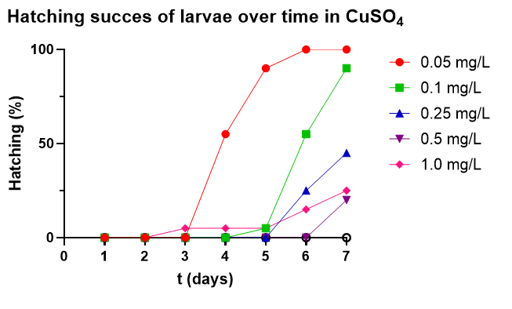In summary, one could state that the reduced hatching success and delay of hatching found during this study, is caused by affected genes during critical stages of development. Thus, resulting in a lack of disintegration of the inner layer of the egg and the lack of locomotive behaviour during the hatching phase of the zebrafish. Review of the hatching success per concentration of CuSO4 over time, presented in figure 17, reveals that in fact the copper compounds cause a dose-dependent delay in hatching. In other words, with an increasing concentration, the time of hatching is postponed significantly. In addition, figure 17 illustrates how in the higher concentrations (0.25 – 1.0 mg/L), the hatching success is decreased rather than delayed. Of course, it could be possible that if the test was expended upon, further hatching would occur. In fact, it seems that from 5 dpf hatching is initiated in these concentrations in a notably slower pace that the lower concentrations.

Figure 17: The hatching success over time displayed per concentration of copper(II)sulphate.

As literature states, the primary cause is that the Cu has a significant effect on enzymatic level in a dose-dependent manner. One very notable observation in the present study was a significant increase in faecal matter in the chorion, indicating a digestion of yolk, signifying the continuation of development of the embryonic *D. rerio*. This suggests a full inhibition of the mechanisms discussed earlier rather than a lacking development. It could be suggested that certain processes are not initiated, supporting the statements made by Zhang et al. Another theory could be that it is not a genetic effect at all. It seems improbable that the copper compound has effect on these genes while showing a clearly continued development. This continued development and the seemingly unaffected hatchlings reveals that the reduced hatching success is more mechanical than genetic. This is also shown in the fact that the copper compounds reveal to have a delayed hatching effect (figure 17), demonstrating no additional adverse effect so far. As measurement procedures still had to be perfected at this point of the study, the lengths of the larvae in the CuSO4 samples are absent. To see if indeed CuSO4 is taken up by the fish rather than the chorion, the lengths will definitely have to be measured in future studies.

Regarding the EC50 (0.25 mg/L), it is traditionally not calculated by a decreased hatching effect, this makes it difficult to compare the actual hatching effect. Braunbeck et al. (2005) for example, has reported the EC50 to be approximately 0.26 mg/L, while Lahnsteiner (2005) reported it to be 2.9 mg/L. These EC50 values are based on physical and behavioural abnormalities (e.g. scoliosis, slower heartbeat, inactivity, etc.), rather than a delayed hatching effect. As was the case with the lethality of copper compounds, there seems to be a notable variation in EC50 values amongst different studies. Regarding the difference on the long-term hatching effect between the lower and higher concentrations illustrates the importance of stretching the test to 7 days; especially if the aim is to calculate an EC50 value. Overall, validation procedure demonstrated many similarities in the present study in in literature. While a great variation in EC50 values is still found, the hatching effect is well documented; it shows the fish have a similar sensitivity and reaction to the compound, indicating the method as a suitable reference.

## Using one of the compounds as a reference substance

It is an interesting sight, that each of the compounds show to have a dissimilar effect on the zebrafish embryos. This gives quite a varied range in adverse effects and a good insight on how the embryos react differently to each compound. The great variance in adverse effect, and the compound dependency of it demonstrates the zebrafish to be a very suitable organism for testing as its sensitivity reveals to be very widespread to a various number of influences, while also shows the compounds to be extremely suitable for testing the validity of the test as they cause different endpoint each in their own way. This is very useful for testing the validity of the proposed protocol.

Regarding the suitability of one of these compounds as a reference substance instead of 3,4-DCA (as stated in OECD guidelines), PDC appears to be the most prominent candidate. This is mainly due to the fact that copper compound show to have a decreased hatching effect, complicating identification of any sub-lethal effects in the form of physical or behavioural abnormalities. What is more, SDS toxicity reveals to be relatively instant while lacking further established long-term effects on the fish themselves; this also applies for the copper solution as it has not been confirmed if the compound only has effect on the chorion. More specifically, SDS only seems to affect the chorion while the larvae themselves remain unharmed. The suitability of PDC mainly comes forward in the fact that PDC appears to have acute lethal effects (within 96h) and as claimed by separate studies, long-term sub-lethal effects (within 168h). In addition, PDC shows to have a dose-dependent growth retardation effect. PDC toxicity seemingly covers both lethal and sub-lethal effects, coming forward in the short- and long-term. Lastly, PDC shows to be a stable compound in comparison to the instable less soluble 3,4-DCA. As a reference substance however, the concentration matching with a >30% mortality has to be determined. The tests indicated this concentration to be somewhere between 350 – 500 mg/L, a rather broad definition.

## Dilution water and development of the zebrafish

When reviewing the results of the dilution water tests, it is clear that tap water is least suitable as testing water in comparison to the harder Daphnia water and the softer EPA water. It seems that while emerged in tap water, the zebrafish undergo a slower development as hatching is delayed and length is reduced.This begs the question why tap water has such a significant effect while the standard fresh water tox-kits do not. Appendix VIII shows a table on the chemical water quality of the tap water (table 9). In order to investigate what could have influence on the delay in hatching and length retardation of the tap water, the content of the two SFW media were compared with the content of the tap water. Table 10 in Appendix VIII shows the salt content of both Daphnia water and EPA water. The data of this table was used and converted to match that of table 8; this converted data is shown in table 11 (also in Appendix VIII). The theory is that if the content of a particular element is higher in either of the SFW media in comparison to tap water, it will not be considered as harmful. As can be seen in table 11, the compounds that appear to be in higher concentrations in tap water are aluminium (although extremely minor), hydrogen carbonate, ammonium and nitrate. Further literature study indicated that these compounds present in these concentrations are not harmful enough to cause any adverse effects (Anandhan et al., 2013; Gerolsteiner, 2019; Simmens et al., 2012).

It seems the minerals and other compounds found in tap water are not present in harmful concentrations at all. However, there is still a lot unknown about the consistancy of the tap water. It could be the case that certain compounds are not yet identified to be present in tap water which show to come forward, affecting the embryos (Schreuder, 2013). Indeed, OECD guidelines show the approval of the use of tap water during ELS fish tests, while additionally stating a preference for the use a a synthetic medium; this would increase the reproducability of the test.

Nevertheless, a significant effect was found, where the cause is still unidentified. It is clear however, that this influence has largely increased the vulnerability of the embryos as the PCD test showed an unexpected instant lethal effect (while normally forthcoming upon hatching). A lack in research on negative effects of tap water on the embryonic *Danio* shows that either no similar effect was found in other studies that used the same dilution water or that is has just not been investigated yet. Moreover, tap water is known to be different in consistency all over the world, making it difficult to get a difinitive assessment of this particular dilution water. One could argue of course that in this case the determination as to why the tap water tests went so bad is not important. The aim of these dilution water tests was to find an optimum standard test water, which was found in the process.

Regarding the growth of the hatchlings, the larvae seem to stop growing on 6 dpf. It is the theory that on this day the yolk-sac is nearly to fully depleted, leading to no more food being consumed; the larvae stop growing and will need to feed on outsourced material as their mouths start to open on 7 dpf. It could be theorised that the sac-fry stage already ends on sixth day rather than the seventh day. This theory cannot be confirmed as data on yolk-sac depletion and percentage of opening mouths on 6- and 7 dpf is lacking.

## Evaluation on the short-chronic ELS-test and the added value of the chronic section of the test.

The OECD guidelines are a definitely useful and frequently used bioassay for identifying chronic toxicity of fish. The guidelines 212 and 236 were originally combined to extent to a 7 day test as it was believed to predict adverse effect for the full life-cycle of the organism tested more elaborately. Although definitely valuable, these tests have proven to be distinctly labour- and resource intensive, while requiring a remarkable big amount of embryos per substance tested (144 eggs; excluding range-finding tests and breeding of the *Danio*).

As evident from the additional literature that had to be provided, the ELS test is not designed to provide explanation regarding the chemical mode of action of the test compounds; toxicity is mainly described through the chief endpoints of survival and growth, which is complemented with the supplement information on behavioural and physical malformations. For instance, when the present protocol will be used for assessment of the treated ballast water, the adverse effect will be identified (if present), while the reason of these effects will not be identified. Eventually, in the process of improving ballast water treatment, additional methods will have to be applied to identify the chemical modes of action of treated ballast water. Still, the short-chronic ELS test has proven to be a good basis and fundamental step in the assessment of toxicity; a first step in the overall process. Nonetheless, with respect to the future, it should be taken into account that accompanying methods will have to be administered for the improvement of the ballast water treatment. Regarding the physical and behavioural abnormalities, it was seen during the present study and likewise supported by Villeneuve et al. (2013) that these observations merely link to the adverse endpoint of growth and mortality. Strictly speaking, the physical and behavioural abnormalities mainly lead to the observed growth retardation and mortality. It could thus be derived that growth and survival are the primary apical endpoints of relevance.

It has been argued in earlier discussion, that the extent of the protocol to a 7 days chronic test might be too elaborate. Typically, embryonic tests are known to last until 96 hpf and the it has already been ascertained that the sublethal effects in the form of physical and behavioural abnormalities merely serve as linkages to the main apical endpoints on growth retardation and dead. It could be argued, that these sublethal effect help in describing the overall process, but seem to provide no conclusive aspect to the table. Using the presently developed protocol as a model for identification of specific later-stage forms of toxicity however, may require more precision in observing the these sublethal effect. For example, upon assessment of cardiotoxicity and/or neurotoxicity, quantification of heart rates and behavioural abnormalities would require to be addressed more extensively. However, since the present study mainly focusses on establishing a vast variety of sensitivity of the zebrafish to variable testing compounds and is not concentrated on very specific forms of toxicity, it would be could to neglect this latter statement. In extending the protocol to a chronic test, the main component is the assessment on growth retardation. In the present study, this revealed to be really minimal, while in higher concentrations deaths already occurred. The differences show to be so small that they could arguably reveal themselves to be irrelevant, ecological speaking. Alternatively, this growth retardation could have a more prominent effect in the later stages in zebrafishes’ life. For example, what is a mere inhibition in length of 0.2 mm during the larval stage, could be several cm in the adult individuals, an argument that could alter its ecological significance notably. To acquire if this minor growth retardation has extensive effects in later stages, one could suggest investigating through extending the ELS-test to a full life cycle test. On the other hand, it should not be forgotten that the ELS test is intended as a predictive model for identification of adverse effects consequently affecting later adulthood (Villeneuve, et al., 2013). Based on this assumption one would expect the observed effect to be in compliance with the later stages in life; in this case that would mean growth retardation would be notably minor. Ultimately, although the occurrence of the effect can be explained, these results are shown to be very small relative to the more clearly defined short-term effects. As stated by Villeneuve et al. effects of the compound on growth would reveal to be distinct until after the yolk-sac is completely depleted and the larvae is supposed to feed on outsourced material (forage). It would thus be recommended to elect upon a different kind of endpoint more suitable in describing a predictive effect in regard to chronic toxicity. Alternatively, the extent of the protocol to 7 days (instead of the 4 days) might actually be unnecessary as the acute test already is a good and reliable indication of the sensitivity of the fish. Making such a choice at this point of the project may be ill advised without further assessment into alternative means.

# Conclusion

At the start of the thesis project, several research questions were established and described in the introduction chapter. The main focus of this report was to evaluate if the protocol, prepared for the assessment of treated ballast water, serves as a suitable model in describing and identifying the toxicological effects in a diversified and reacts to a variable range of substances. In order to assess if this is the case, the research questions are answered accordingly.

In efforts to validate the short-chronic ELS fish toxicity test it was found that the effect on the embryonic zebrafish were of very variable nature and showed quite the compound dependent relationship. PDC showed to be affected only after initiation of hatching, due to the chorion serving as a barrier. SDS revealed to have a relatively instant effect, demonstrating a reduced survival already within the first 24 hours. Lethal effects almost always appeared in the form of coagulation of the embryos or larvae. Sub-lethal effects came forward as a decreased (or delayed) hatching success, growth retardation and several physical- and behavioural abnormalities. The latter was mainly found in PDC samples but showed no dose-dependent trend although literature suggests otherwise. The only dose-dependent occurrence of growth retardation was found in PDC; although showing to be statistically significant, on an ecological and toxicological level the differences are tremendously low. Regarding the toxicity of SDS, it was found to be mainly a lethal toxicant (as literature confirms), while sub-lethal effects are shown to be barely of existence. Furthermore, a delay in hatching was observed. The combined findings led to the suggestion that SDS only has effect on the chorion, while no further uptake by the hatchlings occurs. Copper toxicity mainly came forward in a decreased hatching success; according to studies it is linked to genetic harm, while the present study would suggest a more mechanical reason. Lethal toxicity of this compound is still lacking and should thus still be determined in further studies and validation.

Considering the steepness of the regression curves, the LC50 of Cr(VI) was still determined to be 154.08 mg/L, which showed to be fairly close to the LC50 of 145.7 mg/L found in a separate study. It is believed that if indeed the lethality of Cr(VI) would be studied more accurately, these values would show to be even closer to each other. As stated, the only inconsistency is found in the dose-dependent relationship of the sub-lethal malformations, although these are primarily regarded as a linkage to ultimately lead to the apical endpoint of decreased survival and growth. In contrast, SDS shows to share the adverse effect found both in experimentally and reported sources; primarily in the lethal effects, but also showing a delayed hatching effect. Comparison of the LC50 values showed a relative larger difference between the 7.1 mg/L of the present study and the 3.6-4.1 mg/L from similar studies. The EC50 was determined to be 7.05 mg/L which revealed to be very close to the LC50. At this point in the process, the absolute lethal toxicity of copper is still to be established, while estimations imply a LC50 of around 0.49 mg/L (1.25 mg/L for CuSO4). While the lethality of this compound is reported with quite a variable result, claiming the LC50 to be around 0.35- or ranging between 1.0 – 1.5 mg/L, reduced hatching success is reported more often, showing consistency with the present study. The EC50 of the CuSO­4 induced hatching effect to be 0.25 mg/L, while similar studies have suggested an EC50 between 0.26 – 2.9 mg/L which proves to be quit a broad range. Based on the LC50 values found it is believed the EC50 would be closer to 0.26 mg/L rather than 2.9 mg/L.

From the different test compounds, PDC reveals to be the most promising as a replacement of 3,4-DCA. While supposedly showing appropriate sensitivity to the compound, PDC is shown to be a more stable compound and would thus be more convenient as a reference compound for the quality control and ascertaining the dose-effect relationship of the zebrafish strain. While mainly expressing adverse effects in the acute form, the chronic effects although present are limited and far from showing an actual 50% effect. The relevance of this is dubious as most of the sub-lethal effect for the most part lead to death, while growth retardation has presented itself to be extremely low. Further investigation into alternative sub-lethal effect that could be used and quantified more definitively for the test can be a viable option. In efforts of adopting PDC as a reference toxicant it would be necessary to determine the appropriate concentration; OECD guidelines state that there has to be a >30% mortality in this concentration. Upon review of the results it is impossible to make a precise estimation, but is confirmed to be between 350 – 500 mg/L.

For future reference, the use of EPA water as dilution water would be advised. Although Daphnia water showed to be equally successful in terms of hatching, fertilisation and survival, this particular SFW medium failed to meet the quality standards for water hardness. From the three types of water, tap water shows to be the least suitable as hatching was significantly delayed as well as seemingly increasing sensitivity of the embryos and thus the adverse effects of the toxicants. The reason for these effects could not be determined. Further investigation of the test-organisms showed that zebrafish seem to undergo growth until 6 dpf, while hatching time does not seem to be of affect to the growth.

As has been illustrated above, the validity of the method at this point of the study is still hard to be assessed. This is mainly due to a lack in reliability of some of the results which would require more attention in the continuation of this study. Considering this lack in reliability of the absolute values, the toxicity of the variable compounds found in the present study do seem to share many consistencies with literature. Overall, PDC shows to be most consistent in the LC50 values, while SDS still shows a relative difference. CuSO4 demonstrated to be a very varied compound in its LC-/EC50 values, presenting them to be different over a number of studies; the present study seems to agree the most with the lower range of the found values. The short-chronic ELS toxicity test shows to be a very suitable test, covering both lethal and sub-lethal effects by the compounds quite successfully by a notably simple alternations to the methods published by the OECD. It should be noted that while sublethal effects are of occurrence, no definitive observations are made. It is argued that most sub-lethal effect ultimately lead to the primary apical endpoints, while growth retardation was observed to be minimal; the relevance of these adverse effects seem small. One of the most vital successes in the project was that the zebrafish reacted differently on each compound, giving a nice variation in adverse effects. It seems the zebrafish is sensitive to a wide range of toxicants and or influences, which is a very useful thing when selecting an appropriate testing organism. The compounds selected for this study have shown to be notably suitable as reference toxicants. When doing a validation procedure, it is certainly wished to have a widespread set of effects, as when the method is actually applied, it will be probable that the species will react to the substance that is tested.

In conclusion, this study reveals the sensitivity of the embryonic stages of the zebrafish and that there are critical moments during development that could influence the toxicity in particular, targeting different components of the fish. Exposure to harmful substances can cause disturbances in vital biochemical processes, on a molecular level or affect the chorion mechanically. A point of criticism would be that the chemical modes of action to the zebrafish cannot be determined through the singular use of the present protocol. Should the identification of these aspects be required, complementary assays will have to be considered. Based on the findings in this study, it can be concluded that the early life-stage of the *D. rerio* species show to be an excellent model for studying the unfavourable effects of toxicants. The data obtained in the present study should be notably useful in further research on the validation of the short-chronic ELS toxicity test, forming a good foundation for future endeavours.

# Recommendations

It is actively recommended to conduct further research on the effects of short- and long-term impacts of these reference compounds as well as other toxic substances in efforts to properly validate the concerned method.

Regular repetition of the experiments will need to be carried out, primarily confirmation of the LC50 values of both PDC and SDS, increasing their statistical power and reliability of the results. The lethality of CuSO4 will still need to be confirmed as it has not been determined yet. For these two strategies could be adopted. One could be to prepare a regular test with 5 concentration starting from 0.25 mg/L and exceeding to either 1.5 or 2.0 mg/L. This test will illustrate the lethal effect including the reduced hatching success. The second strategy would be to initiate hatching manually with a teasing needle around the same time as the control initiates hatching. If done successfully, one could observe if the adverse effects are forthcoming once the larvae are without their chorion. It would be advised to start off with the same concentration range as was used in DR-01 (0.05 – 1.0 mg/L), if effects prove to be too minimal, the concentration range is adjusted. For both experiments it would be advised to measure the lengths at the end of the experiment, to test if the compound is taken up by the larvae or not.

As discussed earlier, the added value of the sub-lethal effect both in the form of physical/behavioural abnormalities and growth retardation is doubtful. Both types of adverse effect have mainly been reported upon in PDC samples. It is argued that the former only serves as a linkage to eventual apical endpoints on survival and growth, while the latter is too low to be of any ecological and/or toxicological significance. The omittance of this chronic part of the test altogether is a viable option, solving both the labour intensity and the question of relevance; at this stage in the study, it would seem an imprudent course of action without further assessment. It would be highly recommended to first look into alternative forms of quantification of chronic toxicity. For instance, one could look more into more specific occurrences of chronic effect like cardiotoxicity and neurotoxicity. While growth revealed to be minimal, there have been some observations regarding the heartbeat which seemed to beat slower at times. Timing the number of beats per minute would be a great indication of sub-lethality on a cardiotoxicity level. The heartrate of the sample group emerged within a reference compound would be compared with the heartrate of the sample group of the negative control. Additionally, the inactivity of the larvae (being unable to remain upward within the well) is equally an appropriately signifying effect which could be linked to neurotoxicity. It is primarily the task to identify and confirm if a sub-lethal effect that shows a significant dose-dependent effect, that reaches well above 50% in occurrence. It would be strongly recommended to test on this aspect to confirm if it is a more suitable method for quantifying chronic toxicity while keeping the test as a short-chronic 7 days test as these effects mainly come forward on a longer term.

Alternatively, the measuring of the larvae upon termination of the test could still prove to be useful. While the values on growth retardation reveal to have no definitive aspect, it could be used as a tool to ascertain if the compound is actually taken up or not. The statistical significance implies the presence of uptake by the larvae. For example, in copper it is still unsure if the compound is accumulated within the larvae or if it merely attaches to the outer layer of the chorion. It would therefore be useful to measure the lengths to confirm if there is any decreased growth rate in the larvae due to toxicant. It is recommended to keep using this form of assessment as a supportive tool for confirmation purposes.

Based on the dilution water tests it was opted that EPA-water is the optimal test water to be used. It is therefore recommended to continue in using this medium in further continuation of the project.

Regarding the growth test, it was found the fish stop growing on the sixth day, showing no significant growth thereafter. This would imply the yolk-sac is completely depleted and the sac-fry stage is ended much earlier than expected. Further study would need to investigate on this by a daily measuring of the yolk-sac depletion, while also observing on the opening of the mouth by quantifying the percentage of the sample group that reveals to open their mouths at which time of the test.

Although showing no priority at this point of the study, it’s endorsed to look into complementing assays that could help in identifying the chemical modes of action of the compounds that are tested. The protocol presently used serves as a good initial and vital step while it establishes the primary adverse effects caused by the concerned toxicants. For the bigger picture of risk assessment and further management, determination of the chemical modes of action will prove to be very useful in adapting the method and implementation of e.g. ballast water treatment systems.

# Literature

Ali, S., van Mil, H., & Richardson, M. (2011). *Large-Scale Assessment of the Zebrafish Embryo as a Possible Predictive Model in Toxicity Testing.* Leiden University, Institute of Biology. Leiden: PLoS One. doi:10.1371/journal.pone.0021076

Anandhan, R., Hemalatha, S., Kavitha, V., & Bhuyan, G. (2013). *Effect of aluminium on development of Zebrafish, Brachydanio rerio (Ham.).* Annamalai University, Department of Zoology. Annamalainagar: INTERNATIONAL JOURNAL OF PHARMACY & LIFE SCIENCES. Retrieved from https://pdfs.semanticscholar.org/78c3/4ccebe26e34b430e261d1afb411df6da0baa.pdf

Ansari , S., & Ansari, B. (2015). *Effects of Heavy Metals on the Embryo and Larvae of Zebrafish, Danio rerio(Cyprinidae).* Gorakhpur University, Department of Zoology. Gorakhpur, India: Scholars Academic and Scientific Publisher.

Braunbeck, T., & Lammer, E. (2005). *Draft detailed review paper on Fish Embryo Toxicity Assays.* University of Heidelberg, Department of Zoology. Heidelberg: Aquatic Ecology and Toxicology Section. doi:203-85-422

Braunbeck, T., M., B., Hollert, H., Kosmehl, T., Lammer, E., E., L., . . . Seitz, N. (2005). *Towards an alternative for the acute fish LC50 test in chemical assessment: The fish embryotoxicity test goes multi-species — an update.* -: ALTEX.

Cao, L., Huang, W., Liu, J., Ye, Z., & Dou, S. (2005). *Toxicity of short-term copper exposure to early life stages of red sea bream,Pagrus major.* -: Environmental Toxicology and chemistry.

Domingues, I., Oliveira, R., Lourenco, J., Grisolia, C., Mendo, S., & Soares, A. (2010). *Biomarkers as a tool to assess effects of chromium (VI): comparison of responses in zebrafish early life stages and adults.* University of Aveiro, Department of Biology. Aveiro, Portugal: Elsevier Inc. doi:10.1016/j.cbpc

ECHO. (2019, Maart 1). *Potassium dichromate*. Retrieved from European Chemicals Agency: https://echa.europa.eu/nl/registration-dossier/-/registered-dossier/15102/1

Freiry, R., Stelzer, J., Maltchik, L., & Arenson, A. (2014). *Sensitivity of Danio rerio (Teleostei, Cyprinidae) During Two Stages of Development Based on Acute Toxicity Tests.* -: Springer US. doi:https://doi.org/10.1007/s00128-014-1367-6

Gerolsteiner. (2019, May 30). *Bicarbonate at a glance*. Retrieved from Gerolsteiner, Water at its best: https://www.gerolsteiner.de/en/minerals/bicarbonate/

Graphpad-Software. (2019, May 5). *Graphpad*. Retrieved from Equation: Sigmoidal dose-response (variable slope): https://www.graphpad.com/guides/prism/8/curve-fitting/Reg_Classic_DR_variable.htm

Hansen, E., Sorensen, G., Mikkelsen, S., Kjolholt, J., Christensen, F., Lassen, C., & Kjellerup, U. (2014). *Survey of copper(I)oxide, copper(II)sulphate and copper(I)chloride.* Danish Technological Institute. Copenhagen: Danish Environmental Protection Agency. Retrieved from https://www2.mst.dk/Udgiv/publications/2014/01/978-87-93026-92-6.pdf

Hernandez, P., Undurraga, C., Gallardo , V., Machenzie, N., Allende, M., & Reyes, A. (2011). *Sublethal concentrations of waterborne copper induce cellular stress and cell death in zebrafish embryos and larvae.* Santiago, Chili: Biological Research. doi:10.4067/S0716-97602011000100002

IMO. (2019, Januari 29). *Ballast Water Management*. Retrieved from International Maritime Organisation: http://www.imo.org/en/OurWork/Environment/BallastWaterManagement/Pages/Default.aspx

Johnson, A., Carew, E., & Sloman, K. (2007). *The effects of copper on the morphological and functional development of zebrafish embryos.* Amsterdam, Netherlands: Aquatic toxicology. doi:10.1016/j.aquatox.2007.07.003

Kaag, K. (2019, January 14). Early life stage fish test. (S. Teng, Interviewer)

Kim, S., Chen, J., Cheng, T., Gindulyte, A., He, J., He, S., . . . Bolton, E. (2019, January 8). *Potassium Dichromate*. doi:10.1093/nar/gky1033.

Knight, J. (2019, Maart 5). *Developmental Biology Laboratory Observations of the Zebrafish Embryo*. Retrieved from University of Oregon, Institute of Neurosciences: http://www.uoneuro.uoregon.edu/k12/contacts.html

Kovrižnych, J., Sotníková, R., Zeljenková, D., Rollerová, E., Szabová, E., & Wimmerová, S. (2013). *Acute toxicity of 31 different nanoparticles to zebrafish (Danio rerio) tested in adulthood and in early life stages – comparative study.* Institute of Experimental Pharmacology and Toxicology. Bratislava: Slovak Toxicology Society (SETOX). doi:10.2478/intox-2013-0012

Krejâí, R., & Palíkavá, M. (2006). *Potassium Dichromate as aReference Substance for Embryonic Tests of Toxicity in the Common Carp (Cyprinus carpioL.).* Mendel's Agricultural and Forestry University, Department of Zoology, Fisheries, Hydrobiology and Apiculture. Brno, Czech Republic: ACTA VET. Retrieved from https://actavet.vfu.cz/media/pdf/avb_2006075020259.pdf

Lahnsteiner, F. (2008). *The Sensitivity and Reproducibility of the Zebrafish (Danio rerio) Embryo Test for the Screening of Waster Water Quality and for Testing the Toxicity of Chemicals.* University of Salzburg, Department of Organismic Biology . Salzburg: ATLA. doi:https://journals.sagepub.com/doi/pdf/10.1177/026119290803600308

Lasiené, K., Straukas, D., Vitkus, A., & Juodziukyniené, N. (2016). *The influence of copper sulphate pentahydrate (CuSO4·5H2O) on the embryo development in the guppies (Poecilia reticulata).* Italy: Italian Journal of Animal Science. doi:10.1080/1828051X.2016.1209990

MEPC. (2008). *Procedure for approval of ballast water management systmes that make use of active substances (G9).* -: The Marine Environment Protection Committee. doi:MEPC,149 (55)

Mohammadbakir, S. (2016). *IImpacts of waterborne copper and silver on the early life stage (ELS) of zebrafish (Danio rerio): physiological, biochemical and molecular responses.* School of Biological Sciences, Faculty of Science and Engineering. Plymouth: University of Plymouth. Retrieved from https://pdfs.semanticscholar.org/4e95/a58700d53fcd33ee6f3bc256019ff02a15b0.pdf

Mugoni, V., Camporeale , A., & Santoro , M. (2014). *Analysis of oxidative stress in zebrafish embryos.* University of Torino, Department of Molecular Biotechnology and Health Science. Torino: NCBI. doi:10.3791/51328

Muller, R. (1980). *Fish toxicity and surface tension of non-ionic surfactants: investigations and anitfoam agentss.* -: J. Fish Biol.

Nagel, R. (2002). *DarT: The Embryo Test with the Zebrafish Danio rerio - a General Model in Ecotoxicology and Toxicology.* Insitut für Hydrobiologie. Dresden: TU Dresden. Retrieved from https://pdfs.semanticscholar.org/3002/c3dbed270179655685d79b512eb80e1a2458.pdf

Nguyen , L., & Janssen , C. (2001). *Comparative sensitivity of embryo-larval toxicity assays with African catfish( Clarias gariepinus) and zebrafish (Danio rerio).* Noosa, Australia: International Conference on Toxic Cyanoacteria, .

Nogueira, A., Soares, A., Domingues, P., André, M., & Candeias-Guilhermino, L. (2009). *Zebrafish early life-stages and adults as a tool for ecotoxicity assessment.* Aveiro: Universidade de Aveiro.

OECDa. (1998). OECD 212: Fish, Short-term Toxicity Test on Embryo and Sac-fry Stages. *OECD Guideline or testing of chemicals* (p. 20). -: OECD.

OECDb. (2013). OECD 236: Fish Embryo Acute Toxicity (FET) Test. *OECD Guidelines for the Testing of Chemicals* (p. 22). -: OECD.

Plhalová, L., Mácová, S., Dolezelová, P., Marsálek, P., Svobodová, Z., Pisteková, V., . . . Modrá, H. (2010). *Comparison of Terbutryn Acute Toxicity to Danio rerio and Poecilia reticulata.* University of Veterinary and Pharmaceutical Sciences Brno, Depeartment of Veterinary Public Health and Toxicology. Czech Republic: Faculty of Veterinary Hygiene and Ecology. doi:10.2754/avb201079040593

Prat, R., & Giroud, A. (1964). *The pollution of water by detergents.* Paris: OECD.

PWN. (2018, June -). *Samenstelling van het drinkwater.* Retrieved from PWN: https://www.pwn.nl/samenstelling-van-het-drinkwater

Rodriquez-Estrada, J., Sobrino-Figueroa, A., & Martinez-Jeronimo, F. (2015). *Acute toxicity and sublethal effects on macromolecules concentration, coloric conctenc, and lipid peroxidation during exogenous-feeding of Danio rerio larvae exposed to Cu2+.* Colonia Santo Tomas: Instituto Politecnico Nacional and Universidad Autonoma Metropolitana. Retrieved from http://www.scielo.org.mx/pdf/rica/v31n4/v31n4a7.pdf

Schmidt, R. (2007). *Psysiologie des Menschen.* -: Springer.

Schreuder, A. (2013, September 17). *Drinkwater veilig? Nee!* Retrieved from NRC: https://www.nrc.nl/nieuws/2013/09/17/drinkwater-veilig-nee-1258319-a546310

Simmens, A., Karimi, I., Talwar, M., & Simmons, T. (2012). *Effects of Nitrite on Development of Embryos and Early Larval Stages of the Zebrafish (Danio rerio).* Indiana University of Pennsylvania, Department of Biology. Pennsylvania: NCBI. Retrieved from https://www.ncbi.nlm.nih.gov/pmc/articles/PMC3698666/

Sokal, R., & Rohlf, F. (1995). *Biometry; the Principles and Practice of Statistics in Biological Research* (3e ed.). New York: W.H. Freeman and Company.

Stasiūnaitė, P. (2005). *Toxicity of copper to embryonic development of rainbow trout (Oncorhynchus mykiss).* Lithuania: Acta Zoologica Lituanica.

Thit, A., Skjolding , L., Selck, H., & Sturve, J. (n.d.). *ects of copper oxide nanoparticles and copper ions tozebrafish (Danio rerio) cells, embryos and fry.* -: oxicology in Vitro, 4. doi:10.1016/j.tiv.2017.08.010

Thoraugh, A. (1992). Oil spills in the tropics and subtropics. In C. D. D, *Pollution in tropical aquatic systems* (pp. -). London: CRC Press.

Vaughan, M., & van Egmond, R. (2010). *The Use of the Zebrafish (Danio rerio) Embryo for theAcute Toxicity Testing of Surfactants, as a PossibleAlternative to the Acute Fish Test.* Brixham Environmental Laboratory. Brixham, UK: AstraZeneca.

Villeneuve, D., Volz, D., Embry, M., Ankley, G., Belanger, S., Léonard, M., . . . Wehmas, L. (2013). *Investigating Alternatives to the Fish Early Life-stage Test: a Strategy for Discovering and Annotating Adverse Outcome Pathways for Early Fish Development.* United Stated of America: Wiley Periodicals Inc. doi:10.1002/etc.2403

Werschkun, B., Banerji, S., Basurko, O., David, M., Gollasch, S., Grummt, T., . . . Höfer, T. (2014). Emerging risks from ballast water treatment: The run-up to the International Ballast Water Management Convention. In J. de Boer, & S. Snyder, *Chemosphere* (pp. 256-266). -: Elsevier.

WUR. (2019, January 29). *Stage: Ontwikkeling van short-chronic Whole Effluent Toxicity tests (WET-tests)*. Retrieved from Wageningen University & Research : https://www.wur.nl/nl/Onderzoek-Resultaten/Onderzoeksinstituten/marine-research/show-marine/Stage-Ontwikkeling-van-short-chronic-Whole-Effluent-Toxicity-tests-WET-tests.htm

Yin, J., Yang, J., Zhang, F., Miao, P., Lin, Y., & Chen, M. (2014). *Individual and joint toxic effects of cadmium sulfae and a-naphthflavone on the development of zebrafish embryo.* Zeijang University. Berlin: Springerlink. doi:1862-1783

Young, J. (2003). CLIP, Chemical Laboratory Information Profile, Potassium Dichromate. In N. Pienta, *Journal of Chemical Education* (80 ed., p. 874). Washington: ACS Publications. Retrieved from https://www.acs.org/content/dam/acsorg/about/governance/committees/chemicalsafety/safetypractices/clip-potassium-dichromate.pdf

Zhang, T., Xu, L., Wu, J., Wang, W., Mei, J., Ma, X., & Liu, J. (2015). *Transcriptional Responses and Mechanisms of Copper-Induced Dysfunctional Locomotor Behavior in Zebrafish Embryos* (1 ed.). Oxford: Oxford Academic. Retrieved from https://academic.oup.com/toxsci/article/148/1/299/1661649

# Appendices

## Appendix I: Embryonic development of the zebrafish *(Danio rerio).*

Table 5: Stages of embryonic development of the zebrafish (D. rerio) at 26oC ±1 (Braunbeck & Lammer, 2005).

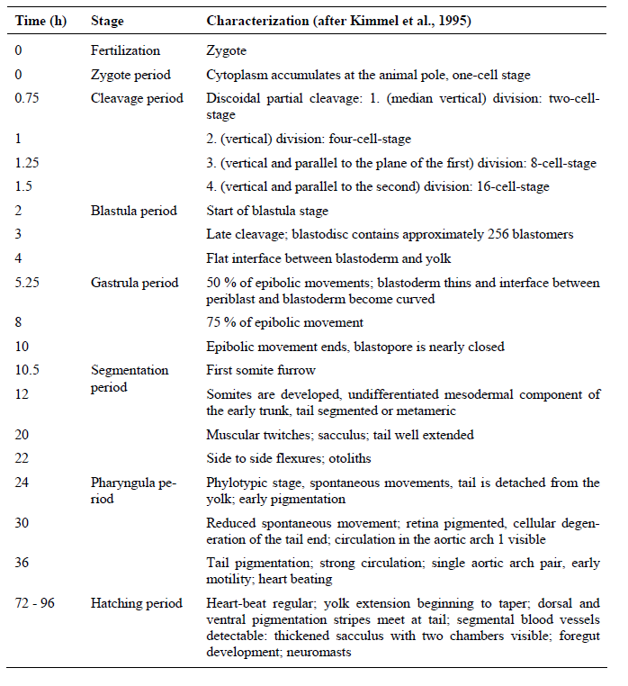

## Appendix II: Materials and substances required for the short-chronic ELS test.

### Materials:

* Any glass or chemically inert vessel (e.g. beakers). Dimensions are completely dependent on the loading amount;
* Standard 24-well plates (depth≈20 mm, filling capacity=2.5-5 mL/well, glass or polystyrene);
* Self-adhesive foil (parafilm);
* Incubator or air-conditioned room (maintaining a 26±1oC in well-plates);
* Binocular (10x magnification);
* Plastic pipette (≥ 4 mm diameter);
* Automated pipette;
* Teasing needle;
* Petri dish;
* pH-meter;
* Oxygen meter;
* Water hardness measuring kit;
* Thermometer.

### Test-solutions:

* Standard freshwater (SFW-Daphnia), which is prepared by use of the Daphtox-kit F media, dissolved in 2 L of milli-Q water;
* Standard freshwater (SFW-EPA), which is prepared by use of the EPA tox-kit media dissolved in 1 L of milli-Q water;
* Potassium dichromate (K2Cr2O7);
* Copper (with CuSO4);
* Sodium dodecyl sulphate (C12H25O4S·Na);
* If possible, solvents should be avoided. Examples of solvents that can be used are acetone, ethanol, methanol, dimethylformamide and triethylenglycol. This solubilising agent should not exceed a concentration of 0.1 mL/L in any of the test vessels;
* When solvent is used no significant adverse effect on survival of the embryos should be present. This is tested by using a solvent control in which the maximum solvent concentration applied is tested.

## Appendix III: Experiment set-up.

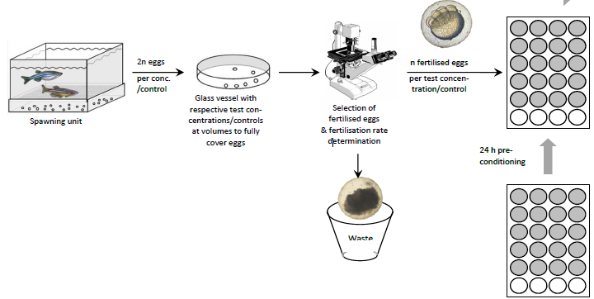

Figure 18: Schematic of the zebrafish embryo test procedure, starting with the production of eggs, followed by the collection of eggs, pre-exposure immediately after fertilisation in glass vessels, selection of fertilised eggs with an binocular and distribution of fertilised eggs into 24-well plates prepared with the respective test concentrations/controls. n=number of eggs required per test concentration/control, which is 20-24 (OECDb, 2013).

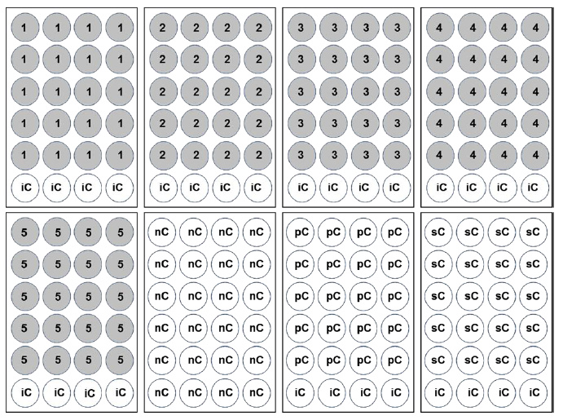

Figure 19: Layout of the 24-well plates where: 1-5=five test concentrations/chemical; nC=negative control (dilution water); iC=internal plate control (dilution water); pC=positive control (4mg/L of 3,4-DCA); sC=solvent control (OECDb, 2013).

## Appendix IV: Lethal endpoints for the short-chronic zebrafish embryo toxicity tests.

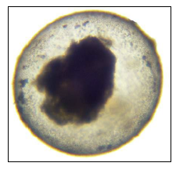

Figure 20: Coagulation of the embryo; under bright field illumination, coagulated zebrafish embryos show a variety of in transparent inclusions. A significant loss of translucency and change in colouration can be observed, leading to a white (black under the binocular) opaque appearance; usually observed between the 24 h and 96 h point (OECDb, 2013).

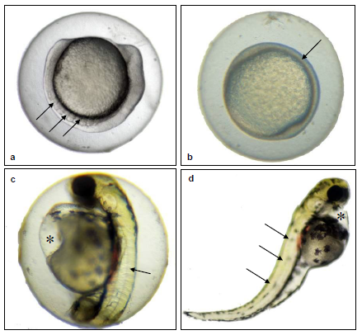

Figure 21: Lack of somite formation; (a) Although retarded in development by approximately 10 h, the 24 h old zebrafish embryo shows well-developed somites (arrows). (b) The embryo in this figure does not show any sign of somite formation (arrow). (c) Although showing a pronounced yolk-sac oedema (*), the 48 h old zebrafish embryo shows distinct formation of somites (arrow). (d) This 96 h old zebrafish embryo does not show any sign of somite formation (arrows), note also the spinal curvature (scoliosis) and the pericardial oedema (*) in this last embryo. Somites should be developed at latest at the 48 h point. (OECDb, 2013).

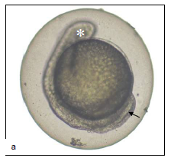

Figure 22: Non-detachment of the tail bud in lateral view (arrow), 96 h old zebrafish embryo; note also the lack of the eye bud (*); no further posterior elongation of the embryonic body will take place (OECDb, 2013).

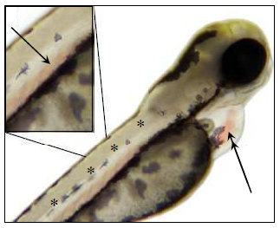

Figure 23: Lack of heartbeat is, by definition, difficult to illustrate in a micrograph. Lack of heartbeat is indicated by non-convulsion of the heart (double arrow). Immobility of blood cells in e.g. the aorta abdominalis (single arrow) is not an indicator for lack of heartbeat. Note also the lack of somite formation in this embryo (*, homogenous rather than segmental appearance of muscular tissues). The observation time to record an absence of heartbeat should be at least of one minute with a minimum magnification of 80x. The heartbeat can usually be observed from the 48 h point and onwards (OECDb, 2013).

## Appendix V: Analytical formulas

**Non-linear regression analysis (sigmoidal):**

$y=Bottom+\frac{(Top-Bottom)}{1+{10}^{(logEC50-x)∙HillSlope}}$

Where:

Bottom = y-value at the bottom plateau

Top = y-value at the top plateau

LogEC50 = x-value when the response is halfway between Bottom and Top.

Hill’s Slope= The steepness of the curve. Also known as the slope factor or Hill coefficient. If it is positive, the curve increased as x increased. If it is negative, the curve decreases as the x increases.

A standard sigmoid dose-response curve has a Hill’s Slope of 1.0; when the Hill’s Slope is less van 1.0, the curve is shallower. When the Hill’s Slope is greater than 1.0, the curve is steeper (Graphpad-Software, 2019).

**Abbott’s formula:**

$$P=100-[\frac{C-P^{'}}{C}∙100\%]$$

Where:

P = corrected % survival;

P’ = % survival observed in the test concentration;

C = % survival in the control.

**Tukey HSD:**

$$SE=\frac{{Ms}_{w}}{n}$$

Where:

SE = standard error

Msw = mean squared within groups

n = sample size

$$q=\frac{∆{means}_{i-j}}{SE}$$

Where:

q = dimensionless unit;

Δmeansi-j = difference in means between the two concerned groups.

**Tukey-Kramer:**

$$SE=\sqrt{\frac{1}{2}{Ms}_{w}(\frac{1}{n_{i}}+\frac{1}{n_{j}})}$$

Where:

SE = standard error;

Msw = mean squared within groups;

ni = sample size of group *i*;

nj = sample size of group *j.*

$$q=\frac{∆{means}_{i-j}}{SE}$$

Where:

q = dimensionless unit;

Δmeansi-j = difference in means between the two concerned groups.

**Shapiro-Wilk:**

$$W=\frac{(\sum_{i=2}^{n}{a_{i}x_{(i)})^{2}}}{\sum_{i=1}^{n}{(x_{i}-\overline{x})^{2}}}$$

Where:

x(i) = the order statistic in the sample *i*;

xi = x-value belonging to sample *I*;

x ̅ = the sample mean;

a­i = coefficients generated form the covariances, variances and means of the sample size from a normally distributed sample;

n = number of observations.

$$\overline{x}=\frac{x_{1}+…+x_{n}}{n}$$

$${(a}_{i},…,a_{n})=\frac{m^{T}V^{-1}}{C}$$

Where:

C = a vector norm $=\left\|V^{-1}m\right\|=(m^{T}{(V}^{-1})^{2}m)^{1/2}$;

m = the vector $=(m_{l},…,m_{n})^{T}$;

V = the covariance matrix of the normal order statistics.

## Appendix VI: Q-table used for the Tukey and Tukey-Kramer post hoc tests

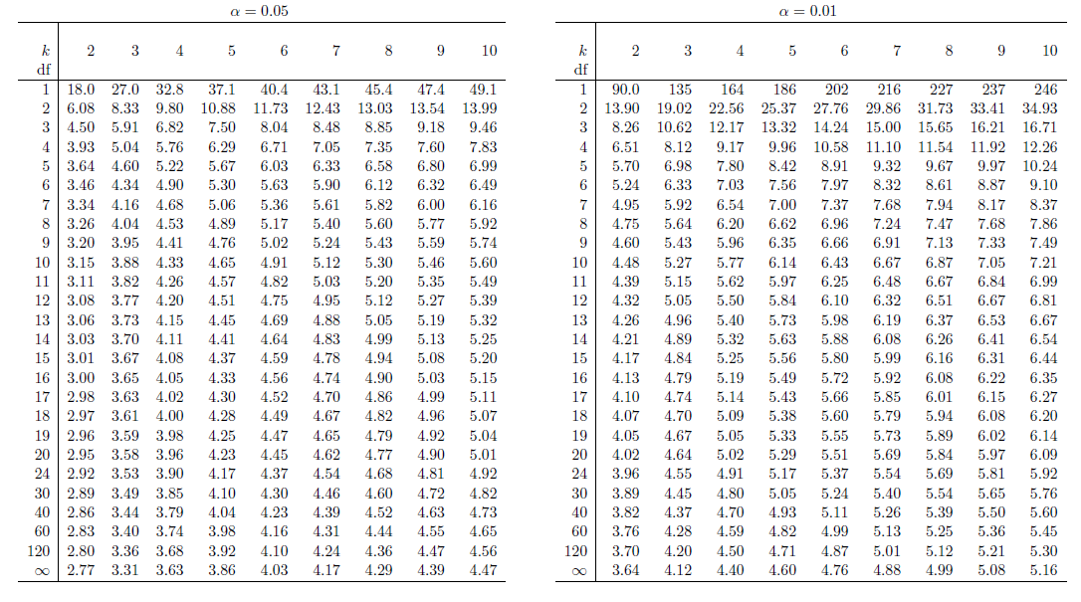

Table 6: critical Q scores for the Tukey method (Sokal & Rohlf, 1995)

## Appendix VII: lengths of the larvae at day 7

Table 7: Length measurements of zebrafish larvae at t=7 dpf at different concentration of PDC and SDS.

**Test Compound C0 C1 C2 C3 C4 C5**

DR-02 Potassium dichromate *4.12 4.01 3.9 3.84 - -*

*±SD 0.02 0.03 0.033 0.026 - -*

Sodium dodecyl sulphate *4.12 4.09 4.1 4.02 - -*

*±SD 0.02 0.022 0.014 0.035 - -*

DR-04 Potassium dichromate *4.1 3.97 3.88 3.84 3.81 -*

*±SD 0.023 0.016 0.035 0.026 0.034 -*

Sodium dodecyl sulphate *4.1 3.97 4.03 - - -*

*±SD 0.023 0.011 0.009 - - -*

Table 8: Growth retardation in larval zebrafish caused by PCD and SDS treatment.

**Compound Test Concentration (mg/L) Growth retardation (mm)**

Potassium dichromate DR-02 250 0

300 0.22

350 0.28

DR-04 250 0

300 0.22

350 0.25

370 0.29

Sodium dodecyl sulphate DR-02 0.5 0

1 0

5 0

DR-04 5 0.13

6.2 0

## Appendix VIII: Water quality of the tap water used for experiments

Table 9: Consistency of tap water in the area of Den Helder (PWN, 2018).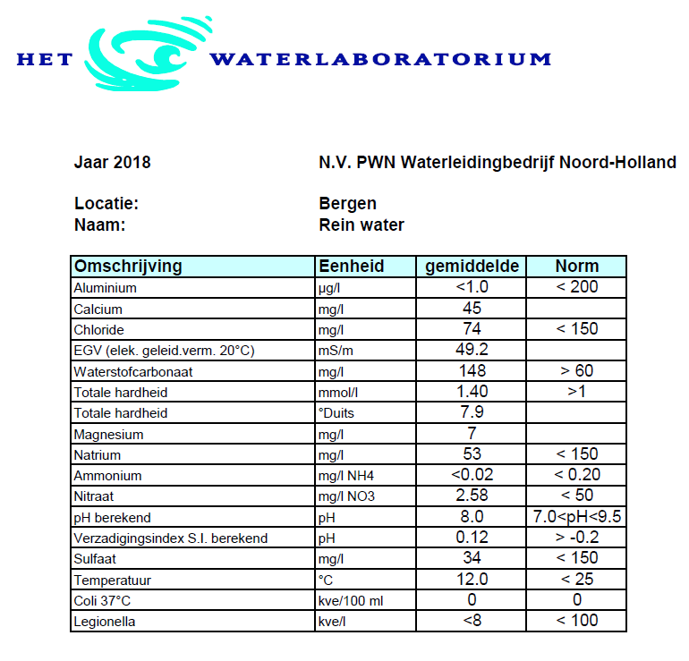

Table 10: Salt content of the standard freshwater media, expressed in mg/L.

**Medium NaHCO3 MgSO4·7H2O KCl CaCl2·2H2O CaSO4·2H2O**

Daph Tox-kit 64.75 123.25 5.75 294 -

EPA Tox-kit 96 123 4 - 60

Table 11: Chemical content of the different types of water, expressed in mg/L.

**Substance EPA Tox-kit Daph Tox-kit Tap water**

Aluminium 0 0 <1.0*

Calcium 13.97 81.43 45

Chloride 1.9 144.5 74

Hydrogen carbonate69.7 47.03 148

Magnesium 12.13 12.15 7

Natrium 26.27 17.72 53

Ammonium0 0 <0.02

Nitrate0 0 2.58

Sulphate81.42 48.03 34

*unit in µg/L