

*C. maenas* predation on the *R. philippinarum*

Assessing the relationship between different sizes of Carcinus *maenas* predating on the *Ruditapes philippinarum* in different temperatures

Research group Aquaculture

21-6-2017

Gratitude

Herewith I am expressing my gratitude to the ‘research group aquaculture’ of the HZ University of Applied Sciences for giving me a chance to experience how it is to work as a researcher in this field of expertise.

Due to the great support and the time being made available to me, I have been enabled to complete my research project: ‘predation of the *Carcinus maenas* on the *Ruditapes philippinarum’*, which I am herewith submitting*.*

I want to thank Ms E. Hartog for helping me with the ample supply of *Carcinus maenas* and for connecting me with the fisherman. Secondly, I want to thank the examiner Mr A. Verkruysse for guiding me in how to develop/create an appropriate thesis project and for accommodating the various meetings. Furthermore, Finally, I want to give a special thanks to Mr M. Trommelen for guiding me and providing the necessary support and feedback on this research project.

*C. maenas* predation on the *R. philippinarum*

Assessing the relationship between different sizes of *Carcinus maenas* predating on the *Ruditapes philippinarum* in different temperatures

HZ University of Applied Sciences

Research group Aquaculture

Researcher: M. Trommelen

1st Examiner: A. Verkruysse

Research report

Version 1.0

Samuel Sisselaar

Vlissingen, The Netherlands

Edisonweg 4a, 4382NW

21 Jun. 17

Summary

**Duration of the investigation:** February 2017 till June 2017

**Place of action:** Laboratory of Hz university of applied science

This investigation tries to give more insight in the relation between the *Carcinus maenas,* acting as predatorin this part of the food chainand the *Ruditapes philippinarum,* being hunted by the Carcinus maenas.

The focus in this investigation has been based on the occurrence of the different sizes of the Carcinus maenas in relation to the different sizes of *Ruditapes philippinarum* measured in different water temperatures. Due to the increasing demand for aquaculturally produced food, fish-farmers need more answers in their efforts to optimize their productions and to obtain higher profits. To minimize losses, they want to know more on how much and due to what cause they lose most of their *R. philippinarum* spat due to predation by the *C. maenas.* The results of this investigation are based on three separate lab experiments conducted at the facility of the HZ University of Applied Sciences.

The main research question being investigated and being expanded on in this report is: What is the relationship between the size of *R. philippinarum* spat predated by the different size of *C. maenas* in different temperatures in the Zeeuwse delta?

In order to find answers to this question, *C. maenas* has been separately placed in aquariums under present groundwater conditions. Each aquaria was filled with 30 *R. philippinarum* shells and one *C. maenas*. The *C. maenas* used in the experiment where starved for 48 hours prior of the experiment. When the *C. maenas* where placed in one of the aquaria they could predate 24 hours on those shellfish. Their where three experiment conducted. Different parameters for those experiments where used, those parameters where crab size, shellfish size and water temperature.

The observations in the first experiment showed no statistical differences between the preferred shellfish size by the *C. maenas*, the tested shell sizes where ranging between 3 and 12mm. Although there is no particular size preference by the *C. maenas* in this size range.

The second experiment showed differences in consumption rates between the different sizes of *C. maenas* used in the experiment*.* It seems that *C. maena*s with a carapace width bigger than 50mm consume higher amount of shellfish than *C. maenas* with a carapace width smaller than 40mm. Expected is that when carapace width increases, energy demand rises and therefore higher predation rates on *R. philippinarum* occurs.

Finally, the effect of temperature on the consumption rate of the *C. maenas* was tested the temperatures used where 4℃, 8℃ and 14℃. The results do not show significant differences but they show a higher average consumption at higher temperatures.

Those three experiment led to the conclusion that there is too much difference in in the results to say something about the behaviour of the *C. maenas* when predating on *R. philippinarum,* the only proven fact is that bigger *C. maenas* requires more energy and they’re for consume higher biomass of R. *philippinarum.* It is recommended that farmers should protect their *R. decussatus* spat against the *C. maenas* since it is shown in those experiment that *C. maenas* with a carapace width lower than 40mm are able to crush *R. decussatus* spat up to 12mm.

1. Introduction 7

1.1. Saline productions 7

1.2. Increasing demand of Ruditapes 7

1.3. Problem description 8

1.4. Research questions 8

2. Theoretical framework 9

2.1. Ruditapes Philippinarum 9

2.2. Spat 9

2.3. Carcinus maenas (Common Shore crab) 10

2.3.1. Predation size 11

2.3.2. Red and green morphs 11

2.4. Temperature 12

2.5. Hypotheses 13

2.5.1. Hypotheses main question 13

2.5.2. Hypothesis sub question 1 13

2.5.3. Hypothesis sub question 2 13

2.5.4. Hypothesis sub question 3 14

3. Method 15

3.1. Nursing Ruditapes Philippinarum 15

3.2. Nursing Carcinus maenas 15

3.3. The experiments 16

3.3.1. Experiment 1 effect on spat size on predation by C. maenas 17

3.3.2. Experiment 2 effect of different size C. maenas on the predation rate 17

3.3.3. Experiment 3 effect of temperature on the predation rate 18

3.4. Data analysis’s 19

3.5. Determining dry weight biomass/condition index 19

4. Results 20

4.1. Relationship between shell size and amount of eaten shells 20

4.2. Relationship between shell size and carapace width 22

4.3. Relationship between predation rate and temperature 24

5. Discussion 25

5.1. Relationship between shell size and amount of eaten shells 25

5.2. Relationship between shell size and carapace width 26

5.3. Relationship between predation rate and temperature 27

6. Conclusion 28

6.1. Sub question 1 28

6.2. Sub question 2 28

6.3. Sub question 3 28

6.4. Main question 29

7. Recommendation 30

8. Bibliography 31

9. Appendix 33

10. Appendix 33

10.1. Appendix 1 33

Seawater media NHN 33

10.2. Appendix 2 35

10.3. Appendix 3 36

10.4. Appendix 4 37

10.5. Appendix 5 38

10.6. Appendix 6 41

10.7. Appendix 7 42

# Introduction

This report describes the results of a research focussing on the impact of predation on the *Ruditapes* *philippinarum* (clam), by the*Carcinus maenas (shore crab).*

## Saline productions

Aquaculture is currently the fastest growing food production sector. It is expected that the growth keeps increasing, and will compensate for the decreasing catches in the fishing industry (Saba, 2012). Aquaculture provided 48% of the total marine production in 2009 according to figure 1. Between 1970 and 2009, the average consumption of food produced in aquaculture went up from 0,7 to 7.8 kg per capita per year worldwide (Costa-pierce, 2002). This growth resulted in an annual production of 52.5 million tonnes worldwide (FAO, 2010). At the end of the year 2000, mollusc production totalled 30 million tonnes, the bivalves are the main principal component of all those cultured molluscs (Saba, 2012). Currently, the oyster (32%), the Venus clams (venerids) (25%) and the mussels (12%) are the main cultivated molluscs. The growing population on the planet combined with the worldwide consumption results in a rising demand for the molluscs, especially the market for the bivalves is currently huge.

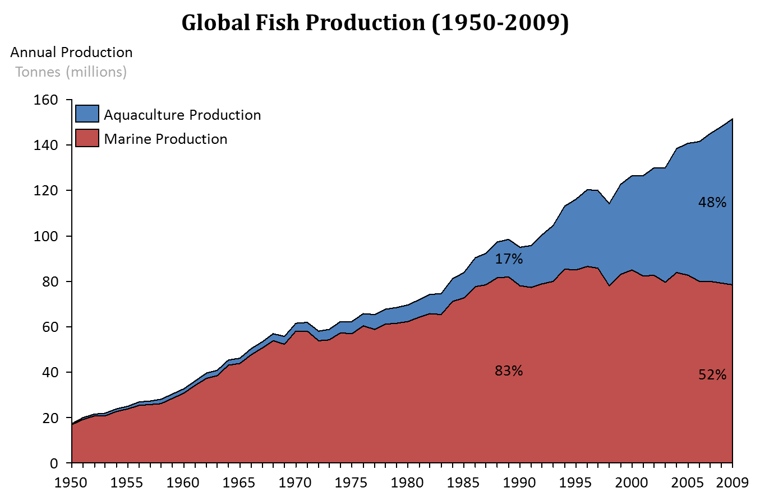

Figure 1 origin of marine production (1950-2009) FAO FISHSTAT. Excludes freshwater wild capture landings and higher order ISSCAAP groups from wild capture landings

The increasing demand for aquaculturally produced food also increases the demand for knowledge on aquaculture. To increase and provide knowledge about aquaculture a project called “Saline productions” was started. Saline productions are a project executed by the research group Aquaculture from the Delta Academy of the HZ University of Applied Sciences combined with Wageningen Marine Research institute, Dalhousie University and the innovative shellfish growers from the south west Delta of the Netherlands.

## Increasing demand of Ruditapes

The native species *Ruditapes decussatus* is one of the most lucrative mollusc for aquaculture companies and fishery’s in the Mediterranean areas (FAO, 2017). Fisheries of *Ruditapes decussatus* could not cope with the high demand and the fishing led to depletion. Due to the lack of *Ruditapes decussatus* combined with the increasing demand and high market value, cultures were started in the Mediterranean area. In the early 1980, the *Ruditapes decussatus* was replaced by the closely related exotic species Ruditapes *philippinarum.*

Successes of *Ruditapes* farmers in the Mediterranean arose the interest of Dutch entrepreneurs. However, due to strict environmental rules in the Netherlands, Dutch farmers are limited to native species *Ruditapes decussatus.*

## Problem description

The increasing demand for *Ruditapes* clams in combination with the high market value causes an increasing interest for the culturing of *Ruditapes* species in the fishery sector of the Netherlands. This resulted in increasing demands for knowledge on the improvement of the production and the quality of their clams.

Unfortunately, the knowledge concerning the cultivation of *Ruditapes clams* in the Zeeuwse delta is still limited. One of the main problems the farmers are being confronted with, is the considerable loss of *Ruditapes* clam’s due to predation on them, by the *Carcinus maenas* mainly during the spat phase. For another common cultured bivalve, the mussel, the production loss, caused by crab predation, is estimated between 9,5% and 52% per plot.

The impact of crab predation on other mollusc species seems to decrease rapidly when molluscs grow in size (Murray, Seed, & Jones, 2007).

The goal of the present investigation is to find out whether similar factors do apply to the production losses among the *Ruditapes* clams, caused by the predatory behaviour of the *Carcinus maenas* in the estuary area which they are sharing. Within this network of related factors, the farmers want to find out if there are differences in survivability between the different spat sizes of the *Ruditapes* clams and whether the water temperature is as well a factor which affects the predation on spat. With the knowledge about the relation between the sizes of *Ruditapes philippinarum* and the size of the *Carcinus maenas* farmers will be in a better position of deciding the most efficient spat size that they should obtain from the hatchery. Choosing the right size spat could lead to a higher profit.

The spat can be bought in varied sizes and is acquired at a hatchery where prices increase when the size of spat increases. The farmers have to choose between different spat sizes they are able to buy spat ranging between ≈3-16mm (depending on the hatchery), The questions that the aquafarmers face is if they should buy high amounts of small spat or less spat from a bigger size.

The knowledge about the seawater-temperature will also provide insight in which season the *Ruditapes* clams will have the highest chance to avoid predation of the *C. maenas*.If temperature effects the predation rate of the *C. maenas* on the *Ruditapes* clams, farmers might consider some shifts within the season when they seed the spat.

The Dutch aquafarmers are being limited within their choice of species due to restrictions of using exotic species. The *Ruditapes decussatus* is the preferred researched species for the Dutch farmers. Unfortunately, due to a lack of availability of the *R. decussatus* this research will be done with *R. philippinarum. R. philippinarum* is a phenotypical similar shell, and it is therefore expected that *C. maenas* will behave the same way on both shells.

In order to obtain the required information in support of the above mentioned situation, the following research questions are being stated:

## Research questions

Main question:

What is the relationship between the size of *Ruditapes philippinarum* spat, being predated by the different sizes of *C. maenas* at different temperatures in the Zeeuwse delta?

Sub questions:

1. What is the effect of varied sizes *Ruditapes philippinarum* spat (3-8mm,6-8mm and 8-12mm) on predation rate when predated by *Carcinus maenas?*
2. Is predation on *R. philippinarum* spat with a size of 6-8mm effected by the sizes of the *Carcinus maenas.*
3. What is the effect of the temperature of the seawater on the predation rates by the *C. maenas* on *R. philippinarum*?

*Hypotheses are being discussed in chapter 2.3. due to the fact that they are based on background information.

# Theoretical framework

To introduce the reader into the subject, some basic background will be given on the organisms being used and to support the researched hypotheses.

## *Ruditapes Philippinarum*

In 1926 intense fishing on the *Ruditapes decussatus* in the Mediterranean areas began. Due to the high increase in fisheries on the *R. decussatus,* the species was almost depleted. Strict regulations on fisheries were made to prevent depletion of *R. decussatus.* Due to those restrictions on fisheries, the aquaculture sector started to cultivate *R. decussatus* to fulfil the need of *Ruditapes* shellfish. When in 1972 the exotic species *Ruditapes philippinarum* was introduced in France, farmers noticed that this exotic species grew faster than the native *R. decussatus* (FAO, 2017)*.* Farmers then focused on *R. philippinarum* cultivationto increase their production.

The *R. philippinarum* is a native bivalve species from the Western Pacific. Due to high commercial values *R. philippinarum* was introduced all over the word*.* The *R. philippinarum* occurs now also in the tempered climate areas in Europe, the Pacific coastline of the United States and Hawaii. Unfortunately, due to the exotic status of the *R. philippinarum* it is not allowed to cultivate this species in the Netherlands. Thus, the Dutch farmers are being restricted to only cultivate the native species (FAO, 2017).

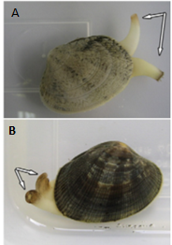The *R. philippinarum* and *R. decussatus* are phenotypical similar species belonging to the *Veneridea* family which is widely reared along the Mediterranean sea (Aru, Sarais, Savorani, Engelsen, & Cesare Marincola, 2016). Due to those similarities, it is expected that the predation behaviour of the *Carcinus maenas, the shore crab,* will be the same towards both species. On basis of shell morphology, the two shells are being part of the same taxonomic genus. The similarity is so close that it is very difficult to do morphological identification on specimens with intermediate or low characteristics (Aru et al., 2016). One of the biggest differences of the two shells in their morphology are their syphons. The syphons of the *R. decussatus* are separated and for the *R. philippinarum* the syphons are fused together (picture 1).

picture 1 A: R. decussatus B: R. philippinarum

## Spat

From the moment *Ruditapes larvae* start to settle on the ground it will be called spat. Spat is a term used for bivalve larvae that have settled and undergone their metamorphosis. Hatchery’s provide the spat in different sizes to the farmers, the farmers will grow them till consumption size. Hatcheries work with closely controlled conditions to maintain high survival rates and optimum conditions for the larvae to develop to spat. The hatchery’s need to sell the spat as soon as possible to reduce the cost. Cost rises significantly when the spat size is increasing. The ‘grow out’ farmer needs to choose which spat size he will buy. The small, cheap and vulnerable spat with higher mortality rates or the more expensive but bigger spat with potentially a lower mortality rate (Helm & Neil, 2004).

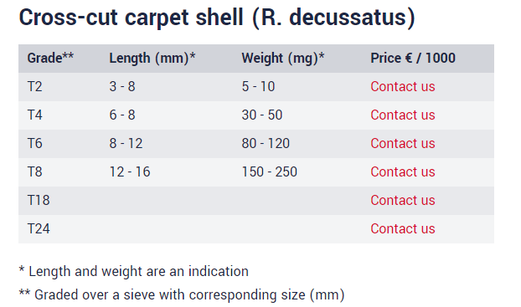

Table 1: Spat sizes of R. decussatus the roemhatchery http://roemhatchery.nl/prijslijst/

The spat being used in this investigation was bought at the hatchery of the Roem van Yerseke. They have done some research on different bivalve species. First, they focused on mussels, later they also included more economical interesting species such as *Ruditapes.* The spat is being bought in different sizes; the size classes are indicated with a T grade (Table 1) the T grade stands for the sieve size that is used to divide the spat in their classes.

## *Afbeeldingsresultaat voor Carcinus maenas distributionCarcinus maenas* (Common Shore crab)

Figure 2 distribution of C. maenas http://www.aquaticnuisance.org/wordpress/wp-content/uploads/2009/01/greencrab-map-world.jpg

The common shore crab is widely distributed, and occurs on soft and hard substrate. The shore crab’s habitat ranges from intertidal areas to shallow subtidal areas. The *C. maenas* prefers calm flowing waters and tries to avoid direct wave activity (Crothers, 1966). The *C. maenas* tends to move to deeper areas when water temperatures start to drop. The distribution of the *C. maenas* around the world can be found in figure 2.

The *C. maenas* is originally a species occurring in west Europe and northwest Africa. The fact that the C*. maenas* possesses relative strong claws compared to other crustaceans made it that the C*. maenas* is outcompeting other crustacean resulting in a worldwide distribution of the *C. maenas.* Among the most important components of the *C. maenas diet* are varied species of molluscs. *C. maenas* has become a serious plague for the commercial shell fish industry. They are capable of ruining complete bivalve beds because of their high consumption of spat. Due to their high abundance around the world, combined with the high consumption of molluscs, *C. maenas* is held responsible for the collapse of the soft-shell industry in both New England and Nova Scotia. Partly due to this the *C. maenas* earned in both New England and Nova Scotia the 18th place in the top 100 of worst invasive species (Fishing, 2017).

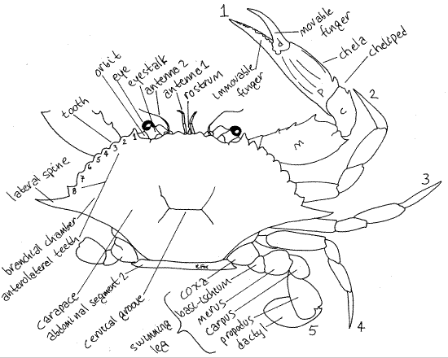Figure 3 shows the basic anatomy of the *C. maenas.* When *C. maenas* searches for prey, he probes its chelae and walking legs into the soil. When he detects a possible prey, the prey will be brought towards the mouth. There are three main tactics observed that the *C. maenas* uses to open several types of bivalves. The first method is by placing the bivalve between the dactylus and propus of the big chela, the bivalve will than simply be squished by the chelae. When the mollusc cannot be crushed by squishing a different approach will be taken. The *C. maenas* will than hold the bivalve with the first pair of its walking legs, the cutter chela and the maxillipeds. Then the *C. maenas* will apply force till the bivalve is broken. When the first two methods fail the *C. maenas* will switch to a third method. The *C. maenas* will try to insert the tips of both dactyli between the edges of the shell valves. When this is done successfully the valves of the mollusc will be pulled apart. Earlier research done about the total time of consumption of cockles including time to break the shell showed that there is an exponential connection between cockle size and consumption time (Crothers, 1966).

Figure 3 C. maenas anatomy http://lanwebs.lander.edu/faculty/rsfox/invertebrates/callinectes.html

### Predation size

Research done on *C. maenas* predation on cockles indicated that larger crabs clearly required progressively less time to handle cockles of any shell height than smaller *C. maenas* (Sanchez-Salazar, Griffiths, & Seed, 1987a)*.* As result of this the larger *C. maenas* can consistently contain higher ingestion rates than smaller crabs. Their larger and more powerful chelae can crush bigger prey with more ease. It appears that there is an optimum prey size for each *C. maenas.* Prey larger that the capable handling size of the *C. maenas* require more energy than the flesh of the cockle provides. The total time taken by crabs of any given size to handle increasingly larger prey rises exponentially as the critical prey size was approached (Crothers, 1966). Predation on mussels showed the same patterns as for predation on cockles however the total energy required is lower for mussels. This could be because of variations is shell morphology (Elner, 1978).

### Red and green morphs

*C. maenas* occurs in a wide range of colours, ranging from pale green to dark red. It was found that red morphs possess generally larger and thicker carapace (Mcgaw & Naylor, 2014). The red morphs must deal more often with parasites and lost limbs. The main influential factor of the difference in colour depends on the time spent in-between moulting (Crothers, 1966). *C. maenas* that moult frequently turns out pale green in colour and those prolonged inter-moults or terminal anecdysis ranging from orange to dark red (Reid, Abelló, Kaiser, & Warman, 1997) The difference in colour also indicates differences in behaviour. Green coloured *C. maenas* were found more at intertidal areas and red coloured *C. maenas* occurred more in subtidal areas. This behaviour exhibition created the idea that green *C. maenas* where more tolerant to environmental stressors such as hypoxia (Crothers, 1966). In 1988 it was confirmed that red morphed *C. maenas* contained a poorer ability to compensate for hypoxia than green morphed *C. maenas* (Aldrich, 1986)*.* Also, the ability to deal with different salinities was significant higher under green morphed *C. maenas* than under the red ones. The red *C. maenas* lives mainly in the subtidal area and must deal a lot less with those fluctuations of salinity and oxygen. The red *C. maenas* moults a lot less than the green crab and will spend more energy in creating a thicker skin which gives it his red collar. Red *C. maenas* also has bigger and stronger chelae. Both those characteristics will give him the benefit of outcompeting green *C. maenas* in food and in competition for females (Mcgaw & Naylor, 2014). In fact, this means that red *C. maenas* focus more on reproduction by spending more energy in malting and adapting for competitive success and green morphed *C. maenas* focus more on growth by frequently moulting, allowing their bodies to grow and be more adaptable to environmental stress factors.

## Temperature

Earlier research indicated that the *C. maenas* acclimatized at 24 degrees Celsius 2.4 times as much as the *C. maenas* being acclimatized to water of 10 degrees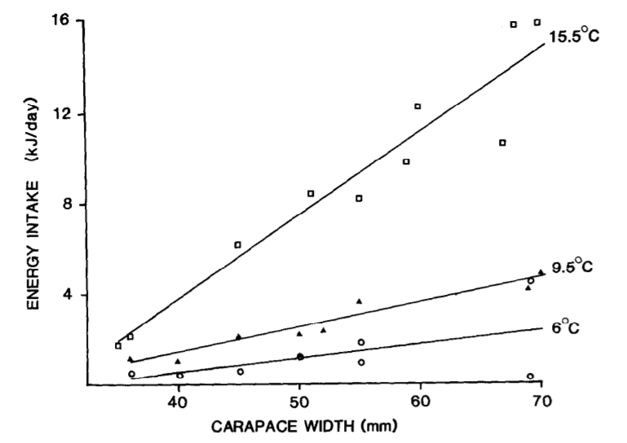 (Wallace, 1973). A study done on the predation on mussels mentioned that although the water temperature undoubtedly affected crab feeding rates (Figure 4), it appeared to have no effect on the preferred mussel size (Elner, 1978). Except from the temperature, other factors do affect the feeding rate of *C. maenas.* For example, feeding rates degrease when the *C. maenas* is moulting*.* The average water temperature in the Zeeuwse Delta ranges between a temperature of a minimum of 4 degrees and a maximum of 22 degrees. At the optimum temperature of 24 degrees a *C. maenas* of 5.5-7.0 cm carapace width can consume 6 mussels with a size of 1.0-2.8 cm in 2 hours (Cunningham, 1984).

Figure 4 relationship between energy intake and temperature on cockles (Elner, 1979)

The cultivation of *R. philippinarum* is most common in the Mediterranean basin where the temperature is lowest in February (around 10 degrees near Venice), and highest in August near Tel Aviv with a maximum of 28 degrees. The temperatures in the North Sea vary from 5 degrees to a maximum of 20 degrees. This difference in temperature may affect both the cultivation rate of the *R. philippinarum* and the predation rate of the *C. maenas.*

## Hypotheses

In this chapter, the expected hypothesis of the main and the three sub questions stated in chapter 1.3.1.will be discussed. The hypotheses are based on a H0 (no effect) and a H1 (effect) outcome. Expectations based on the literature are mentioned below the hypothesis.

### Hypotheses main question

What is the relationship between the size of the *philippinarum* spat predated by the different sizes of *Carcinus maenas* in different water temperatures in the Zeeuwse Delta?

**The null hypothesis (H0)** for the stated main research question is that there is no relationship between the size of *Ruditapes philippinarum* being predated by the *Carcinus maenas* in different temperature in the Zeeuwse delta.

**The one hypothesis (H1)** for the stated main research question is that there exists a relationship concerning the size of *Ruditapes philippinarum* being predated by the *Carcinus maenas* in different temperature in the Zeeuwse delta.

Based on earlier research it is predicted that the predation rate of *C. maenas* increases when the water temperatures start to rise due to the increased metabolic rate in a warmer environment (Sanchez-Salazar, Griffiths, & Seed, 1987b). Although the predation rate may increase, research done to other molluscs such as cockles *Cerastoderma edule* and mussels *Mytilus edulis* states that the effects of temperature does not significantly affect the preferred prey size (Elner, 1980).

### Hypothesis sub question 1

What is the effect of varied sizes *R. philippinarum* spat (3-8mm, 6-8mm and 8-12mm) on predation rate when predated by *C. maenas?*

**The null hypothesis (H0)**assumes that there will be no relationship between *Ruditapes* *philippinarum* sizeand *Carcinus maenas* size.

**The one hypothesis (H1)** expects that there will be a relationship between *Ruditapes* *philippinarum* sizeand *Carcinus maenas* size.

In similar research, a relationship was found between the sizes of the bivalve (cockles and mussels) and the size of the *Carcinus maenas.* The bigger the *Carcinus maenas* the bigger the preferred bivalve (Sanchez-Salazar et al., 1987b).

### Hypothesis sub question 2

What is the effect of different sizes *C. maenas* on the predation rate occurring to the *R. philippinarum* spat (6-8mm)*?*

**The null hypothesis (H0)** expects that the predation rate does not differ for varied *C. maenas* sizes

**The one hypothesis (H1)** expects that the predation rate will differ for varied *C. maenas* sizes.

Similar research predicts that larger *C. maenas* will lead to a higher consumption rate on spat in the size range of 6-8mm. Due to the higher energy demand more spat will be consumed to obtain the needed energy demand (Sanchez-Salazar et al., 1987b).

### Hypothesis sub question 3

“What is the effect of temperature on predation rate of the *C. maenas*?”

**The null hypothesis (H0)** there will be no difference in predation rates at different temperatures by the *C. maenas.*

**The one hypothesis (H1)** there will be difference in predation rates at different temperatures by the *C. maenas.*

Study done on the predation size of the mussels mentioned that although temperature undoubtedly affected crab feeding rates (Graph 2), it appeared to have no effect on the preferred mussel size (Elner, 1980).

# Method

Three experiments were conducted to give a statistically underpinned answer on the main and subsections stated in chapter 1.3.1. While conducting those experiments, living organisms were being used. Those living organisms that were used are the *Ruditapes Philippinarum*, the *Carcinus maenas* and an algae species called *Tetraselmis suecica*. In this chapter, the methods of the three experiments are being described including the nursing/treatment of the organisms required for performing the experiments. The treatment of the organisms being investigated was always the same for each of the three conducted experiments.

## Nursing *Ruditapes Philippinarum*

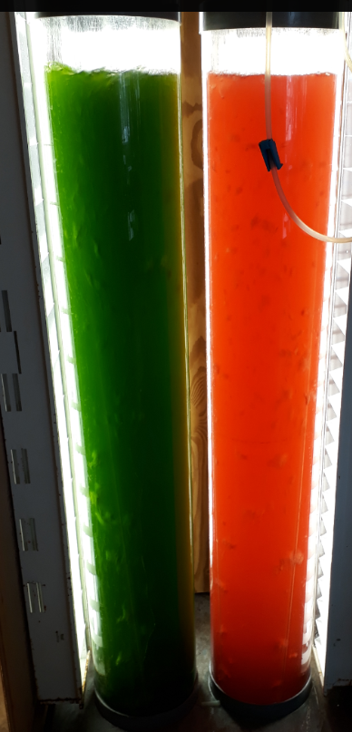In order to conduct the experiment, the *Ruditapes Philippinarum* of three sizes (3-8mm, 6-8mm and 8-12mm.) were ordered from the Roem van Yerseke B.V. Their hatchery grows the shellfish until they can be sold to the farmers. The shellfish can be bought in varied sizes to meet the demand of the farmer. The shellfish re coded with a T code. The T code stands for the sieve size that is used to divide the shells in their size classes. From now on the *R. philippinarum* size will only be indicated with their T class. The corresponding sizes with those T values can be found in Table 1 (page 10).

Figure 5 Bubble columns filled with Tetraselmis suecica (left) and Rhodomonas baltica (right)

The shellfish were placed in an aquarium hanging in small nets. The aquarium was equipped with air supply and a cooler. The water temperature was maintained at 14 degrees Celsius as recommended by the hatchery. The main feeding source for the *R. philippinarum* clams was *Tetraselmis suecica* which is a green algae species. 2 litres of the *Tetraselmis* culture was fed to the *R. philippinarum* once every two days figure 5. The algae where cultivated in a so-called bubble column. To keep the algae culture fresh and healthy one third of the column was refreshed daily to prevent the culture from collapsing. The volume that was taken out was replaced by filtered groundwater. Per litre of added groundwater 1ml of grow medium was added. The content of the medium can be found in Appendix 1.

The shells where checked daily and the aquarium was cleaned when needed, based on the state of the aquarium.

## Nursing *Carcinus maenas*

The *Carcinus maenas* (shore crab) used for the experiment were collected by fishermen in the Ooster Schelde from subtidal areas. The *C. maena*s were stored in one big tank located at the SEAlab of the HZ University of Applied Sciences. This tank was filled with cleaned sand and groundwater and some bricks to give the crabs an opportunity to hide and become more comfortable inside the holding tank. The crabs were fed with mussels about once every two days. When crabs were needed for the experiments they were transferred to the climate chamber where they were separately placed in one of the darkened aquariums and starved for 48 hours. This was done to give them time to adjust to the experimental conditions and set comparable hunger levels. After the starvation period, the crabs were ready to be used for one of the experiments. Every crab has undergone the same pre-treatment and handling before any of the experiments being executed.

The crabs for the experiments were selected according to the following criteria:

* Sex should be male
* Contain all their limbs (legs and claws)
* Should be red morphed
* Show active behaviour (respond to fishing net)

If a crab met all those criteria, it was taken out of the holding tank and transferred to the aquariums in the climate chamber. The criteria are chosen to compare the obtained data with other experiments conducted with *C. maenas*. Many experiments in literature conducted with *C. maena*s where done with healthy males (Murray et al., 2007; Sanchez-Salazar et al., 1987).

## The experiments

At the start of an experiment, 9 crabs were selected and transferred from the storage tank to the climate chamber. First the 9 selected crabs were placed in separate aquaria for 48 hours without food. All the aquaria in the climate chamber where 40x30x23cm (L, B, H) of size. Those 48 hours where used to standardize hunger levels. Two hours before the starvation period was finished the *R. philippinarum* shells were placed in the aquaria that were prepared for the experiment. The length of the shells that were used were measured with a ruler (length is longest side of shell). The reason to do this two hours in advance was to give the *R. philippinarum* enough time to settle in to the sand. After the starvation period, the crabs were transferred to the aquariums containing the *R. philippinarum*. Finally, some *Tetraselmis* were added to the tank to stimulate the shellfish to extend their syphon. The idea behind this was that the *R. philippinarum* at an aquaculture patch also would extend their syphon most of the time as natural behaviour.

All the aquaria were located in the climate chamber and filled with 8cm of cleaned sand with a grain size of maximum 2 mm. Every basin was equipped with a small air stone. The temperature inside the climate chamber was maintained at 14 degrees Celsius, this is the temperature at which the Hatchery stocks their carpet shells. While conducting experiment 1 and 2 water was not heated or cooled and was 14±0,5℃. An overvieuw of the expermental setup is given in Figuur (6)

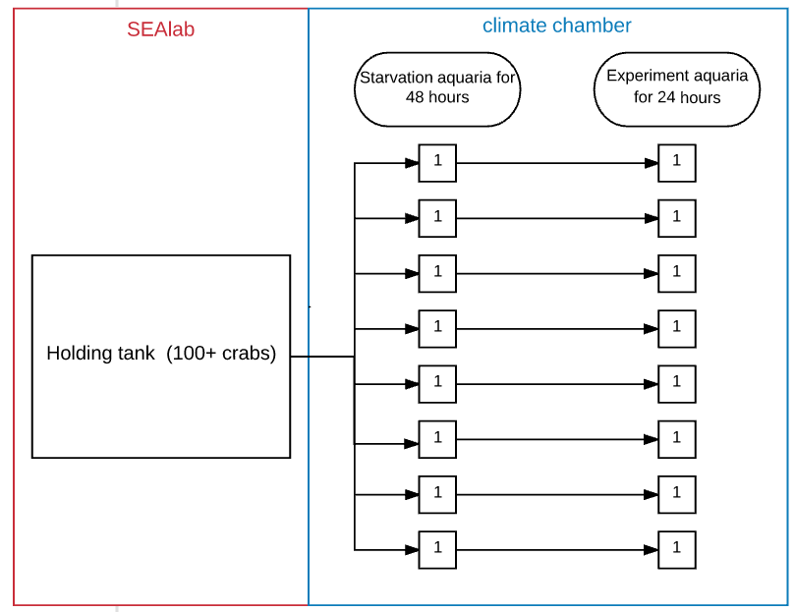

Figure 6 Experimental setup

Collecting the data was done by sieving sand through a 2mm sieve. This is a size that is bigger than the grain size but smaller than the smallest shell size that was used. By using this sieve size undamaged shells would stay behind in the sieve, by subtracting the undamaged shells from the total amount of added shellfish the number of predated shellfish could be determined. Sieving was done with the help of water, by continuous spraying the sand with water the sand grains flushed quickly through the sieve. After sieving the experimental setup was reset again for the next run. Al the experiment were done in triploid, this resulted in 27 samples per experiment.

### Experiment 1 effect on spat size on predation by *C. maenas*

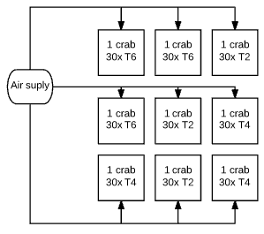The goal of experiment one was to find out if there is a relation between the amount of eaten shells and the size of the shellfish. 9 aquariums were filled with one of the 3 sizes of *R. philippinarum* (30 shells per aquarium). Placement of the shells and crab was randomized.

* 3 aquaria contain 30 shells of size T2
* 3 aquaria contain 30 shells of size T4
* 3 aquaria contain 30 shells of size T6

The crabs used in this experiment had an average carapace width of approximately 55mm the variation was between the 40 and 65mm wide. The placement of the shells and crabs was randomized. Figure (7) shows a schematic overview of the experimental set up. Exact sizes of the used *C. maenas* can be found in appendix 2.

### Experiment 2 effect of different size *C. maenas* on the predation rate

Figure 7 Experimental setup exp. 1

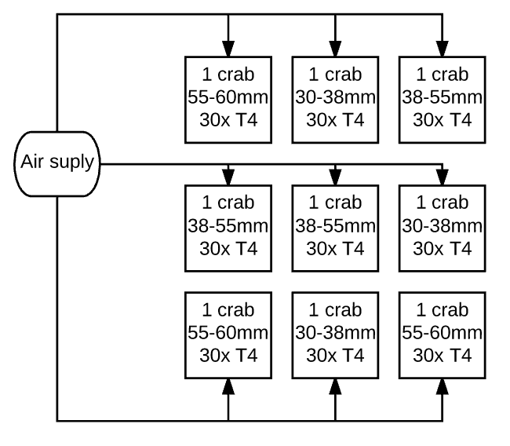The goal of the experiment was to research if there is a link between the size of the *C. maenas* and the predation rate on the *R. philippinarium.* Experiment 2 uses the same set up as in experiment one. This time al the aquaria were filled with the same sized shellfish. Al nine aquaria contained 30 shells of size class T4 (6-8mm). Now the size of the crabs was the variable. Three size classes of crabs were randomly divided over nine aquaria.

Figure 8 Experimental setup exp. 2

* 3 aquaria contain 30 shells of T4 and a crab with a carapace width between 30mm and 38mm
* 3 aquaria contain 30 shells of T4 and a crab with a carapace width between 38mm and 55mm
* 3 aquaria contain 30 shells of T4 and a crab with a carapace width between 55mm and 60mm

In this experiment difference in feeding amount could be tested between different crab sizes. A schematic overview is given in Figure (8).

### Experiment 3 effect of temperature on the predation rate

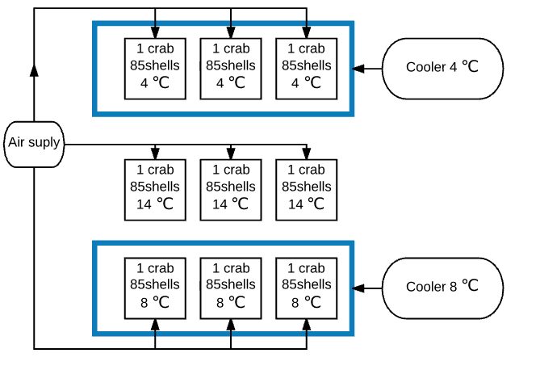The goal of experiment 3 is to see if there is a relation between temperature and predation. This may be of value to choose the proper season of placement of the *R. philippinarum* spat. For experiment three a different set up was chosen. This was needed to obtain the right abiotic factors. In this experiment, all the aquariums where filled with 40 shells of T2, 30 shells of T4 and 15 shells of T6. The carapace width of the crabs used for this experiment was between the (45-55mm) the exact sizes can be found in Appendix 4.

Figure 9 Experimental set up exp. 3

Because this experiment focused on the water temperature, coolers were needed. Because of the limited availability of coolers it was not possible to give each aquarium a separate cooler. To minimize the amount of needed coolers the aquariums were placed in big basins. Those big basins were filled with (fresh) water. The fresh water was surrounding the aquariums used for the experiment. The surrounding water was cooled by a cooler to the desired temperature and by heat transmission the water inside the aquariums also cooled down to the wanted temperature. The experimental setup is shown in Figure (9).

The chosen temperatures for this experiment were 14℃, 8℃ and 4℃, which are comparable with temperatures used in literature. An extra benefit of choosing 14 degrees was that the water did not needed extra cooling, furthermore the results could be compared since al the previous experiments were done at 14℃.

## Data analysis’s

All data analyses and processing was done in excel. After conducting the first experiments it was concluded that sometimes all the 30 shellfish were predated. To solve this problem the data was standardized.

$$Standardized data=\operatorname{asin}\left(SQRT\left(ratio\right)\right)$$

$$ratio=\frac{eaten shells}{Total shells }$$

All statistical analyses were done with the standardized values. To find possible statistical differences between the experiments an ANOVA test was done. If the P value of the post-hoc ANOVA was below 0.05 a T-test between the separate groups would be conducted.

If all shells were found back the data was not used for conducting statistic test. It is assumed that if there were zero shellfish eaten something was wrong with either the crab or with the experimental setup and would indicate an untrusty value. This is done with the assumption that every healthy crab eats at least something after 48 hours of starvation. By taking out those values the possibility of dealing with data from stressed/ill individuals is taken away.

## Determining dry weight biomass/condition index

In experiment 3 “effect of temperature on the predation rate” different T sizes were used. Comparing the amount of eaten shells would give an unreliable result due to different energy supply. To compare the consumption of the *C. maenas* it was decided to compare the consumption in grams. By determining average amount of dry weight of each T class the total consumption amount in grams could be calculated.

Dry weight was determined according the manual in appendix 5 The crucibles were placed in the wet dry oven for 24 hours at 80℃ followed by 24 hours in the dry oven at 80℃.

The dry weight was used to calculate consumed grams. The average weight of a shell class will be multiplied with the amount of eaten shells of that specific class to know how much the consumption of the *C. maenas* was in grams.

$$Consumed grams=amount of eaten shell of size class \left(x\right)*average dry weight of size class (x)$$

After determining the dry weight, it was established that the average weight for the three T size are as followed. The averages will be used to calculate the consumed gram for the results of experiment 3.

T2= 0.04 gram/shellfish ±0.06grams/shellfish

T4= 0.12 grams/shellfish ±0.3grams/shellfish

T6= 0.21 grams/shellfish ±0.1grams/shellfish

# Results

In this chapter, the results that were obtained during the experiments are presented. Remarkable patterns and observations will be pointed out in this chapter. The results will be shown in the same order as the experiments were conducted.

## Relationship between shell size and amount of eaten shells

The main goal of experiment 1 was to see if there is a statistical correlation between the size of the shells and the amount of eaten shells by the *C. maenas*. According to figure 10 it seems that the *C. maena*s preferred larger shells. although the trend line shows a preference for the bigger sizes the R2 indicates that there is a high variation range between the samples and that there is no real trend between the size and the amount of eaten *R. philippinarum.*

**T2**

**T4**

**T6**

Figure 10 Amount of eaten shells by C. maenas with a carapace width of ≈ 55mm

To check if there is any significant difference between the data sets a ANOVA - variation-analyse was done between the three shell size classes. The ANOVA gave a P-value of 0,115. This indicates that there is no significant difference between the data sets. The ANOVA table can be found in appendix 8.

Figure 11 gives an overview of the collected data it shows the average amount of eaten shells per size group with the standard deviation. It can be seen that the standard deviation is overlapping a lot showing that the data does not differ much between the groups.

Figure 11 Average data + standard deviation experiment 1

## Effect of different carapace widths on the predation at spat with a sizes of 6-8 mm

The purpose of experiment 2 was to find out if there is some form of correlation between the size of the *C. maenas* and the amount of eaten shells. Al the shells used in this experiment came from the same size category T4.

**Crab <40mm**

**Crab 44-55mm**

**Crab >55mm**

**T6**

Figure 12 Relation between size of C. maenas and amount of eaten shells with a length of ≈ 7,5mm

Figure 12 the size of the *C. maenas* and the amount of eaten shells from size category T4 are shown. The data from experiment 1, done with shell size T4 is also processed in this data due to the fact it contained the same experimental setup and conditions. The total average shell size used for this experiment is 7,51 mm. All data can be found in Appendix 3.

According to the trendline in graph 4 it seems that there is a higher demand of *R. philippinarum* by *C. maenas* with a larger carapace width. Although it seems there is an increasing demand of shells for bigger *C. maenas* the R2 value indicates that there is big variation between the obtained data. Due to the fact it is closer to 0 instead of 1.

To see if there is any significant difference between the amount of eaten shells per size class of the *C. maenas* statistical tests were performed. A post hoc ANOVA was performed to see if there is any possible significant difference between the groups. The P value was 0.038 which is <0.05 indicating that a statistic difference may be present.

According to the P value in the Anova table a possible significant difference between the groups may occur. T-test between the separate groups are done to see between which groups a significant difference may occur. The P values resulting from the individual T-tests are displayed in appendix 7.

|  |  |
| --- | --- |
| Groups | P-value |
| <40mm and 40-50mm | 0,170 |
| 40-50mm and >50mm | 0,147 |
| <40mm and >50mm | 0,021 |

Table 7 Results T-test between the groups

The T-test indicted that between the data set of <40mm and >50 mm a significant difference occurs. What means that *C. maena*s bigger than 50mm in carapace width ate significantly more shellfish of T4 than *C. maenas* width a carapace with of <40mm.

Figure 13 Average data + standard deviation

In figure 13 the average consumption of eaten shells per *C. maenas* size category and the corresponding standard deviations are shown. The stars indicate that between the group with a carapace width smaller than 40mm and the group width a carpacae with bigger than 50mm significat differnce occures.

## Relationship between predation rate and temperature

The purpose of the final experiment was to find a relation between temperature and predation rate. Figure 14 shows the relation between the carapace width and the amount of predated grams of *R. philippinarum.* The graph also shows the possible relation between temperatures and predation rate. It is clear that the trend lines in figure 14 show a similar increase as in experiment two. It seems that when carapace width of the *C. maenas* increases consumption of *R. philippinarum* increases with it. Consumption is shown in grams in figure 14 in order to compare the different shell sizes.

Figure 14 indicates that there is a possible relation between consumption rate and temperature. The trendlines indicate that the consumption amounts at 14℃ of *C. maenas* is higher than the consumption of *C. maenas* at 4 degrees Celsius*.*

Figure 14 Consumed grams of R. philippinarum in different temperatures by C. maenas

A post hoc test was done for the data set of the different temperatures, the standardized data can be found in appendix 4 the ANOVA table gives a P value of 0.185 this means that there is no statistical difference between the data sets, when assumed that P should be <0.05 to do further statistical analysis.

# Discussion

The experiments were conducted to find answers on critical information about predation on *R. philippinarum* for future and current *R. decussatus* and *R. philippinarum* farmers. In this chapter, the results will be reflected and used to find answers on the stated research questions.

## Relationship between shell size and amount of eaten shells

Figure 10 shows a slight increase in the amount of eaten shellfish when the shell size increases. Although there is no significant relationship between the amount of eaten shellfish and shell length in this experiment. The increase occurs also in similar experiments with other bivalve species conducted by (W. Elner, 1980; Sanchez-Salazar et al., 1987).

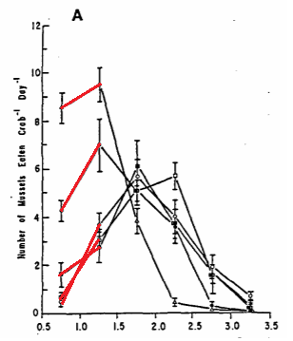Figure 15 shows the results of a research about *C. maenas* predation on mussels, it shows an increase of eaten mussels between 0.5-1.7cm by *C. maenas* with a carapace with between 5.0 to 7.0 mm. This increase occurs up to a mussel size of 1.7±0.5 cm. After they reached ≈1.7 cm the amount of predated mussels by the *C. maenas* decreases rapidly. A possible explanation is that all *C. maenas* with a carapace width of 50mm or bigger can easily crush mussels with a size of ≈17mm in length. This means that in this experiment the size up to ≈17mm is not a limiting factor for predation by the *C. maenas* on the mussel. (Elner, 1978) found in his research that mussels up to 1cm were crushed with ease, it also found that *C. maena*s were capable to crush mussels up to 3cm, when the mussel became bigger other techniques were used to open the mussel.

Figure 15 Mean daily mussel consumption plotted against length for five crab size categories at 17°C: (A) males, crabs 5.0-5.5 cm; • crabs 5.5-6.0 cm; O crabs 6.0-6.5 cm; • crabs 6.5-7.0 cm. Mean and standard errors indicated. (Elner, 1980)

If the same applies for *R. philippinarum* it could explain why shellfish of size class T6 are eaten slightly more than shellfish of size class T2. If energy input is almost the same for both sizes but the obtained energy for shellfish of size class T6 is higher, it would explain the slight preference of shellfish of size class T6. However, there is a slight difference between the consumption amounts of shellfish of size class T2 and T6 there is no statistical proof that the *C. maenas* prefers shellfish of T6 over shellfish of T2 and T4.

In research about cockle size and predation pressure of the *C. maenas* the same trend occurred, although there was also no significant proof (Sanchez-Salazar et al., 1987b). There was a small increase in consumed cockles when cockle size is increasing up to 7±1 cm. As soon as cockle size reached 7±1 cm the consumption amounts dropped rapidly (figure 16).

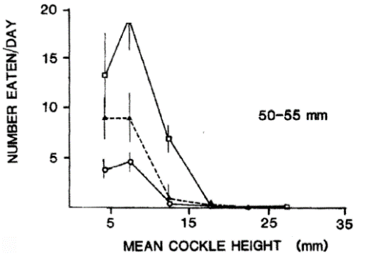

Although there is no statistical proof for the relation between the size of *R. philippinarum* and the amount of consumption, it is possible that consumption of *R. philippinarum* is highest around shells with a length of ≈10mm. to make a better comparison with the data of (Elner and Sanchez-Salazar et al., 1987) the experiment should be repeated and should include bigger sized *R. philippinarum* to see at what specific size the amount of eaten shells starts to decrease.

Figure 16 Mean size-frequency distributions of cockles consumed per day by shore crabs of three different size classes when held at temperatures of 6.0 (0). 9.5 (A), and 15.5 “C (0). Vertical bars denote f 1 SD. (Sanchez-Salazar et al., 1987)

## Effect of different carapace widths on the predation at spat with a sizes of 6-8 mm

The data obtained from experiment 2 shows that there is statistical difference on the consumption of *R. philippinarum* between *C. maenas* with a carapace with smaller than 40 mm and bigger than 50 mm (p=0.021). In similar research conducted by (Sanchez-Salazar et al., 1987b) it was found that when carapace width increases energy uptake from *C. maena*s on mussels also increases (Figure 17). Metabolic rate of the *C. maenas* and the energy demand of the *C. maenas* generally increases when body weight becomes bigger (Nagy, 2005). This will explain why bigger s consumed more *R. philippinarum*. This result indicates that when a *C. maenas* with a carapace width of >50mm will result in a higher loss of R*. philippinarum* due to predation, than whit a *C. maenas* smaller than 40mm.

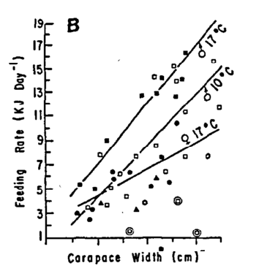

Figure 17 Shore crab feeding rate, mussels per day, compared against carapace width for male, female and sub optimally feeding males at 10°C and 17°C

## Relationship between predation rate and temperature

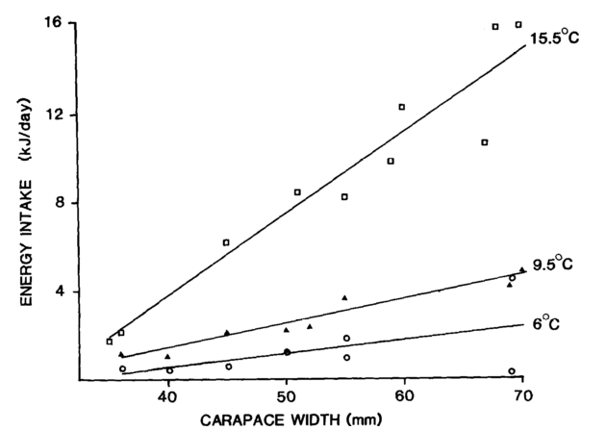It seems in experiment 3 that predation rate increases when the temperature starts to rise, although statistical proof does not occur. The p-value of the post-hoc ANOVA is 0.185. Indicating that the result is to random to see if there is indeed a correlation between temperature and predation rate. However, there is no significant proof. Similar research done about predation rate and temperature of *C. maenas* on another bivalve species the cockles also shows increased consumption when temperatures increase. It is noticeable that higher temperatures result in higher consumption of cockles(Elner, 1980).

Figure 18 Daily rates of energy intake (Ei) plotted against carapace width (cw) for shore crabs maintained at three temperatures. R. Elner

The correlation between the carapace width and energy intake is increasing in the conducted experiment, when carapace width increases consumption is also increasing. This is also the case in the experiments with cockles done by (Sanchez-Salazar et al., 1987). Although there is no statistical proof, it seems that the highest consumption will occur at warmer temperatures and will be caused by *C. maenas* with a big carapace width. The lack of statistical proof can be caused due to the temperature range. The temperatures used in the experiment conducted for this report are lower than in the research conducted by Sanchez (1987) who used temperatures of 6℃, 9.5℃ and 15.5℃.

Although Sanchez used cockles for his experiment it is clearly that the energy intake of the *C. maenas* is increasing by higher temperatures. The predated bivalve should not be able to influence the energy intake by the *C. maenas* unless the predated bivalve species has the capability to protect itself better at higher water temperatures.

# Conclusion

After discussing the results, the main and sub questions stated in chapter 1 should be answered, first the conclusion of the sub questions will be answered and finally the main question will be discussed. The main and sub questions were:

**Main question:**

What is the relationship between the size of *R. philippinarum* spat predated by the different size of *C. maenas* in different temperatures in the Zeeuwse delta?

**Sub questions:**

1. What is the effect of *varied sizes R. philippinarum* spat (3-8mm,6-8mm and 8-12mm) when predated by *C. maenas?*
2. What is the effect of different sizes *C. maenas* on the predation rate of *R. philippinarum* spat (6-8mm)*?*
3. What is the effect of temperature on predation rates by the *C. maenas* on *R. philippinarum*?

## 6.1. Sub question 1

What is the effect of varied sizes *R. philippinarum* spat (3-8mm,6-8mm and 8-12mm) on predation rate when predated by *C. maenas?*

After evaluating the results there is a small trend that indicates that the H1 hypothesis could be true, although due to lack of statistical differences the H0 Hypothesis should be accepted. The H0 Hypothesis states: that there is no relationship between Ruditapes *philippinarum* sizeand *Carcinus maenas* size.

## 6.2. Sub question 2

Is predation on *R. philippinarum* spat with a size of 6-8mm effected by the sizes of the *Carcinus maenas.*

At first sight, the data shows a relation between carapace width and the number of consumed *R. philippinarum.* Statistical test shows a statistical relation between carapace with and predation rate on spat of 6-8mm. It was statistically proven that *C. maenas* with a carapace width of <55mm eat more *R. philippinarum* spat in 24 hours than *C. maenas* with a carapace width of >38mm. With this proof, we can accept H1, H1 expected that predation rate will differ for different *C. maenas* sizes

## 6.3. Sub question 3

What is the effect of temperature on predation rates by the *C. maenas* on *R. philippinarum*?

The graphs show nicely layered trendlines with the lowest temperature of 4 degrees at the bottom of consumed grams per *c. maenas* followed by the trendline of 8 degrees, and 14 degrees at the top of the graph with the highest consumption per individual. For hypothesis H1 the statistical proof lack to accept H1 this means the H0 should be accepted. The H0 says that there will be no difference in consumption between different temperatures by the *C. maenas.*

## 6.4. Main question

Following the results of the experiments, for experiment 1 and 3 the H0 should be accepted as there was no significant differences in any of those two experiments that were conducted. For experiment 2 (effect of different size *C. maenas* on the predation rate) there was statistical proof that bigger *C. maena*s ate more shellfish of shell size class T4.

For the stated main question, the following hypothesises where made:

**What is the relationship between the size of *R. philippinarum* spat predated by the different size of *C. maenas* in different temperatures in the Zeeuwse delta?**

**The null hypothesis (H0)** for the stated main research question is that there is no relationship between the size of *Ruditapes philippinarum* predated by the *Carcinus maenas* in different temperature in the Zeeuwse Delta.

**The one hypothesis (H1)** for the stated main research question is that there is a relationship the size of *Ruditapes philippinarum* predated by the *Carcinus maenas* in different temperature in the Zeeuwse Delta.

After conducting the three experiments it is hard to say in what extend a relation occurs, it is proven that bigger crabs eat more shellfish of size class T4. Although there is no relationship between shell size and amount of eaten shell or predation rate in different temperatures.

So, to conclude: there is no detected or proven relationship between temperature and predation rate, however when the carapace width increases of the *C. maenas* they will consume more amounts of shellfish. Although they will consume more shellfish there is no relationship with in the size of shellfish they will mainly consume.

# Recommendation

For a follow-up research, it would be recommended to use bigger shellfish to find out where the critical point is for a certain sized *C. maenas* to open a certain sized *R. philippinarum*. With that information, it might be possible to find a correlation between the *C. maenas* that occur in the area and shell losses. In this research, it seemed that the shells that were used could be crushed by almost every size *C. maenas*. When conducting research on finding the critical breaking point shell sizes bigger than T6 should be used. A similar experimental set up might use shellfish sizes in the range of 8-12mm (T6) 12-16mm (T8) and 16-20mm. Once the critical point is found, farmers know until what size their *R. philippinarum* is vulnerable for most *C. maenas* sizes. The farmers can put in extra effort and money to protect their *R. philippinarum*. This also means they can cut the cost on protection against predation when they reached the size where they are more resistant to predation.

For the farmers, it is recommended to put at least some effort in the protection of their spat up till the size of 8mm (in experiment two, al *C. maenas* sizes where able to crush the *R. decussatus* spat from size class T4). When a farmer decides to buy spat from this size or smaller, they should be aware that almost all *C. maenas* sizes that are entering their plot form a potential threat to their *R. philippinarum* stock.

In this research, it is not proven that temperature effects the predation rate on *R. philippinarum.* Although this fact has not been proven, *C. maenas* are coldblooded and activity will rise when temperatures do increase. To avoid high spat losses due to high activity in predation habits it is recommended to seed the *R. philippinarum* spat in a season with lower water temperatures (Sanford, 2002).

For the farmers cultivating in the Dutch delta estuary a similar research on *R. decussatus* would be useful. Due to high restrictions on the use of native species those farmers are limited to the *R. decussatus.* Or additional research to compare the two species of *Ruditapes* shellfish could be done. In a follow-up research project, there could be looked into the preferred *Ruditapes* species by the *C. maenas* and into the amount of eaten shells. And into how many *R.* *decussatus* shells of a certain size will be eaten by the *C. maenas* in a certain predetermined time span. By conducting those experiments, a more complete picture of the predation behaviour of the *C. maenas* on the *Ruditapes* will be created.

# Bibliography

Aldrich, J. C. (1986). The influences of individual variations in metabolic rate and tidal conditions on the response to hypoxia in Carcinus maenas (L.). *Comparative Biochemistry and Physiology Part A: Physiology*, 53–60. https://doi.org/http://dx.doi.org/10.1016/0300-9629(86)90087-3

Aru, V., Sarais, G., Savorani, F., Engelsen, S. B., & Cesare Marincola, F. (2016). Metabolic responses of clams, Ruditapes decussatus and Ruditapes philippinarum, to short-term exposure to lead and zinc. *Marine Pollution Bulletin*, 292–299. https://doi.org/https://doi.org/10.1016/j.marpolbul.2016.03.054

Costa-pierce. (2002). Ecology as the paradigm for the future of aquaculture in ecological aquaculture: the evolution of the blue revolution. *Oxford: Blackwell Science*.

Crothers, J.. (1966). The biology of the shore crab, Carcinus maenas the life of the adult crab. *Dale Fort Field Centre*.

Cunningham, P. N. (1984). Carcinus maenas feeding rate on mussels and dogwhlks, [Inter-Research Science Center](http://www.jstor.org/publisher/interresscicent?refreqid=excelsior%3A067f732c8a753356170954e77e4c6ccf) *16*, 21–26.

Elner, R. W. (1978). The mechanics of predation by the shore crab, Carcinus maenas (L.), on the edible mussel, Mytilus edulis L. *Oecologia*, 333–344. https://doi.org/10.1007/BF00348059

Elner, R. W. (1980). The influence of temperature, sex and chela size in the foraging strategy of the shore crab, *Carcinus maenas* (L.). *Marine Behaviour and Physiology*, 15–24. https://doi.org/10.1080/10236248009386968

FAO. (2010). The state of world fisheries and aqauculture. FAO Fisheries and Aquaculture Department, 197.

FAO. (2017). Species Fact Sheets Ruditapes decussatus (Linnaeus, 1758). *Food and Agriculture Organization of the United Nations*. http://www.fao.org/fishery/species/3542/en

Fishing, british sea. (2017). Common Shore Crab. http://britishseafishing.co.uk/common-shore-crab/

Helm, M. M., & Neil, B. (2004). Hatchery culture of bivalves. *Nova Scotia, Canada*.

Mcgaw, I., & Naylor, E. (2014). Salinity preference of the shore crab Carcinus maenas in relation to coloration during intermolt and to prior acclimation, https://doi.org/10.1016/0022-0981(92)90059-J

Murray, A. L. G., Seed, R., & Jones, T. (2007). Predicting the impacts of Carcinus maenas predation on cultivated mytilus edulis beds, 1089–1098.

Nagy, K. A. (2005). Field metabolic rate and body size. *Journal of Experimental Biology and Ecology*, 1621–1625. https://doi.org/10.1242/jeb.01553

Reid, D. G., Abelló, P., Kaiser, M. J., & Warman, C. G. (1997). Carapace Colour, Inter-moult Duration and the Behavioural and Physiological Ecology of the Shore CrabCarcinus maenas. *Estuarine, Coastal and Shelf Science*, 203–211. https://doi.org/http://dx.doi.org/10.1006/ecss.1996.0212

Saba, S. (2012). Bivalve culture optimisation of three autochthonous species (Ruditapes decussatus, Mytilus galloprovincialis and Ostrea edulis) in a central-western Mediterranean lagoon. *Porto Pozzo, Northern Sardinia*.

Sanchez-Salazar, M. E., Griffiths, C. L., & Seed, R. (1987). The effect of size and temperature on the predation of cockles Cerastoderma edule (L.) by the shore crab Carcinus maenas (L.). *Journal of Experimental Marine Biology and Ecology*, 181–193. https://doi.org/10.1016/0022-0981(87)90054-2

Sanford, E. (2002). Water Temperature, Predation, and the Neglected Role of Physiological Rate Effects in Rocky Intertidal Communities1. *Integrative and Comparative Biology*, 881–891. http://dx.doi.org/10.1093/icb/42.4.881

Wallace, J. C. (1973). Feeding, starvation and metabolic rate in the shore crab Carcinus maenas. *Marine Biology*, 277–281. https://doi.org/10.1007/BF00354271

# Appendix

## Appendix 1

Medium used to grow algae stock

|  |  |  |  |  |
| --- | --- | --- | --- | --- |
| Seawater media NHN |  | | | |
|  |  | | | |
|  | | | | |
|  | | | | |
| **Trace mineral stock** | **Conc. In medium** | **per liter stock solution** | | **Control** |
| Na2EDTA*H2O | 282 µM | 45 g | |  |
| FeSO4, 7 H2O | 108 µM | 30 g | |  |
| MnCl2, 2H20 or:  MnCl2, 4H2O | 11 µM  11 µM | 1.71 g  2.09 g | |  |
| ZnSO4, 7 H20 | 2.3 µM | 0.66 g | |  |
| Co(NO3)2, 6 H20 | 0.24 µM | 70 mg | |  |
| CuSO4, 5 H20 | 0.1 µM | 24 mg | |  |
| Na2MoO4,2H20 | 1.1 µM | 242 mg | |  |
| Deion wat ad tot vol 1.0 L | | | | |
| Solution not clear, pH adjusted to 4 with NaOH to dissolve everything |  | | | |
|  | | | | |
|  | | | | |
| **Urea-Substrate** |  | **per liter substrate** | | **Control** |
| urea | (N: ) 50 mM | 150 g | |  |
| KH~~2~~PO4 | 1.7 mM | 23 g | |  |
| Na2EDTA | 282 µM | 6 g | |  |
| Trace mineral stock |  | 100 ml | |  |
| Deion wat ad tot vol |  | 1000 ml | |  |
| pH adjust to 7.5-7.6 with NaOH |  |  | |  |
|  |  |  | |  |
| **Nitrate-substrate** | Conc. In medium | **per liter substrate** | | **Control** |
| NaNO3 | 50 mM | 212 g[1] | |  |
| KH~~2~~PO4 | 1.7 mM | 11.5 g | |  |
| Na2EDTA | 173 µM | 3 g | |  |
| Trace mineral stock |  | 50 ml | |  |
| Deion wat ad tot vol |  | 1000 ml | |  |
| pH adjust to 7.5-7.6 with NaOH |  |  | |  |
|  |  |  | |  |
|  | | | | |
| **Dosage** | | | | |
|  | **Substrate per liter medium** | | | **Control** |
| **Phaeomed 5 - urea** | 10 ml | | |  |
| **Phaeomed 5 - nitrate** | 20 ml | | |  |
|  |  |  |  | |
| *Notes:*  *The substrates can be dosed into natural or artificial seawater. The medium is composed to support a biomass of up to* ***10 g DW per liter, based on Nannochloropsis or similar high N:P strains.*** *With urea as N-source, it is assumed that both N-atoms can be used. EDTA present in high concentrations to help preventing wall growth. Trace minerals present in rather high concentration: 2-5 times those of the Zou medium, for example Zou, N. and A. Richmond (1999). "Effect of light-path length in outdoor flat plate reactors on output rate of cell mass and on EPA in Nannochloropsis sp." Journal of Biotechnology* ***70****: 351-356.*  *Concentrations in medium are calculated at indicated dosage. Dosage may be doubled for higher yield cultivations (tested on Nannochloropisi).*  *Preparation:*  *Trace metal solution may be filtered before storage to prevent precipitation. (N.B. all components must in that case be completely dissolved before filtration)*  *pH adjustment must be done slowly under good mixing and with low concentration NaOH to avoid precipitation during the adjustment.* | | | | |

## Appendix 2

Data of experiment 1



## Appendix 3

Data of experiment 2



## Appendix 4

Data experiment 3

## Appendix 5

1. ONDERWERP EN TOEPASSINGSGEBIED

Dit werkvoorschrift beschrijft het verassen van schelpdiermateriaal ten behoeve van biomassa en conditie bepaling.

2. TERMEN EN DEFINITIES

Asvrijdrooggewicht (AFDW): het organische deel van het drooggewicht.

3. BEGINSEL

Schelpdieren worden met of zonder schelp gedroogd en verast met behulp van droogstoven en een moffeloven.

4. Apparatuur er hulpmiddelen

4.1 Moffeloven bereik tot minimaal 600 °C

4.2 Droogstoof minimaal 150 °C

4.3 Exicator met actieve silicagel

4.4 Analytische balans

4.5 Hitte bestendige bakjes of kroezen, genummerd.

4.8 Hittebestendige handschoenen

4.9 Metalen tang om bakjes mee vast te pakken

5. Werkwijze

Voorbereiding

Maak een lijst in Excel met daarin de: sample, kroes nr., as1, netto as1. Bijv.:

|  |  |  |  |  |  |  |
| --- | --- | --- | --- | --- | --- | --- |
| **Sample** | **Crus nr.** | **As1** | **Netto As1** | **As2** | **Netto As2** | **Verschil** |
|  |  |  |  |  |  | 0 |

Let erop dat het kroesgewicht en het drooggewicht van de samples al bepaald is en genoteerd staat. (zie werkvoorschrift drooggewicht bepalen bij schelpdieren).

Verwerking samples

Zet de moffeloven aan en stel deze in op 560°C.

Zet de te bepalen samples voorzichtig voor in de moffeloven.

De oven warmt zich langzaam op tot de juist ingestelde aantal graden terwijl de samples al in de moffeloven staan

De samples moet gedurende 4 uur bij 560°C, nadat de moffeloven opgewarmd is, in de moffeloven blijven staan.

Na de 4 uur kunnen de kroezen uit de moffeloven gehaald worden, LET OP; de oven zal warm zijn. Gebruik dan hitte bestendige handschoenen en tang.

De kroezen met as moeten, voor gedurende 60 minuten, teruggeplaatst worden in de droogstoof van 80°C.

Hierna kunnen de kroezen 30 minuten afkoelen in de exicator. Laat de exicator zich vacuüm trekken door het ventiel 30 sec. open te houden en daarna weer dicht te draaien.

5.3 Weging samples

Hierna kan het ruwe as gewogen worden op de analytische balans, zorg dat recht staat en dat deze getarreerd is.

Zet vervolgens de kroesjes terug in de moffeloven bij 560°C voor 2 uur.

De kroezen met as moeten, voor gedurende 60 minuten, teruggeplaatst worden in de droogstoof van 80°C.

Hierna worden de kroesjes naar de exicator geplaatst waar ze voor 30 minuten afkoelen. Zorg ervoor dat de exicator vacuüm trekt.

Weeg daarna de kroesjes met het sample voor de tweede keer. Bereken het netto gewicht van het sample.

Zet de gevonden waarden in het Excel bestand en bereken het netto verschil uit in procenten.

**(((Netto as1 – Netto as2)*100)/ Netto as1) = verschil tussen as1 en as2 in %**

Is er een afwijking gevonden die groter is dan 1% dan moet de kroes nog 2 uur in de oven verhit worden op 560°C. LET OP; de oven zal warm zijn. Gebruik dan hitte bestendige handschoenen en tang.

De kroes gaat daarna 60 minuten in de stoof en vervolgens 30 minuten in de exicator.

Hierna kan het ruw as gewicht berekend worden.

De stappen vanaf 5.2 worden herhaalt tot de afwijking minder dan 1% is.

Berekeningen

**6.1 Netto asvrijdrooggewicht:**

**Bruto drooggewicht – gewicht kroes**

**6.2 Percentage afwijking:**

**(((Netto as1 – Netto as2)*100)/ Netto as1) = verschil tussen as1 en as2 in %**

**6.3 Asgewicht**

**Asvrijdrooggewicht - Drooggewicht**

**6.4 Voorbeeld spreadsheet:**

|  |  |  |  |  |  |  |  |  |  |
| --- | --- | --- | --- | --- | --- | --- | --- | --- | --- |
| **Sample** | **kroes (=nr)** | **Gewicht kroes (g)** | **Gewicht kroes + asgewicht Sample 1 (g)** | **Netto asgewicht Sample 1 (g)** | **Gewicht kroes + asgewicht Sample 2 (g)** | **Netto asgewicht Sample2 (g)** | **Verschil (%)** | **Asvrij droog**  **gewicht** | **Asgewicht** |
| bv: meep 8 | 5 | 20.01 | 31.22 | =(31.22-20.01) | 30.11 | =(30.11-20.01) | =(((11.21-10.10)*100)  /11.21) | 10.1 | =(20.01-10.10) |

7. BIJLAGEN EN VERWIJZINGEN

|  |  |
| --- | --- |
| **Literatuur** | **Titel** |
| Drooggewicht | WERKVOORSCHRIFT VOOR DROGESTOF BEPALING BIJ SCHELPDIEREN |

## Appendix 6

Dry weight data:

-Sample number

-Crucible number

-Crucible weight in grams

-Crucible weight + shell weight in grams

-Shell dry weight

-Crucibles + ashes weight in grams

-Ashes weight in grams

-Size class

-Size in mm



## Appendix 7

**T-test experiment 1**



**T-test experiment 2**



## Appendix 8

**ANOVA table experiment 1: Relationship between shell size and amount of eaten shells**



**ANOVA table experiment 2: Relationship between shell size and carapace width**



**ANOVA table experiment 3: Relationship between predation rate and temperature**



## Appendix 9

**Materials**

A list with the needed materials for the conducted experiments are given in this chapter.

**Nursing Ruditapes Philippinarum**

* *Ruditapes Philippinarum*
* Aquarium
* Water cooler
* Air stone
* Bubble column
* *Tetraselmis suecica* stock
* Algae medium
* (Cartridge) Water filter
* Filtered, de-ironed groundwater

**Nursing Carcinus maenas**

* *Carcinus maenas*
* Holding tank
* Continuous groundwater flow
* Air stone
* Food supply
* Sand (grain size smaller than 2mm)

**Conducting experiments**

* *Ruditapes Philippinarum*
* Carcinus maenas
* Air-supply for each aquarium
* Water Cooler (2)
* Aquarium/boxes (9)
* Holding aquarium/boxes (9)
* Sand
* Sieve (2mm)

**Dry weight determination**

* Crucibles
* Ruditapes Philippinarum
* Wet/dry oven (80 degrees)
* Dry oven (80 degrees)
* Ash oven (580 degrees)
* Heat resisted gloves
* Digital Analytical Scale

1. For starter culture, 106 g NaNO3 is used, for production culture medium, 53 g NaNO3 is used per liter