

06/06/2019

[](https://www.google.com/url?sa=i&rct=j&q=&esrc=s&source=images&cd=&ved=2ahUKEwiQzrXFlqriAhXMEVAKHb67CC8QjRx6BAgBEAU&url=https%3A%2F%2Foriginmedia.nl%2Fhomepage%2Flogohz%2F&psig=AOvVaw0nUmlidigJQFYFPw6O6C9j&ust=1558444012643952)

Validation of direct analysis of nickel in organic matrix by F-AAS

Graduation internship 2019

Supervisor: Dr. G. Mol  
Mentor: Dr. J. Bollyn

Tonnon, Nicolas

HZ University of Applied sciences

Table of Contents

Abbreviations 3

Abstract 4

Introduction 4

Theoretical framework 5

Microwave digestion 5

Atomic absorption 6

Method 7

Reference method: microwave digestion and F-AAS 7

Dilution solvent 8

Standards and samples 8

Sample preparation 8

Sample analysis 9

Cobalt precipitation 9

Nickel spike in high cobalt samples 9

Scanning Electron Microscopy (SEM) 10

Validation 10

Calibration range 10

Limits of Detection and Quantification 11

Reproducibility 11

Repeatability 12

Recovery and bias 12

Results 14

Calibration range 14

LOD/LOQ 15

Repeatability 16

Reproducibility 16

Recovery & bias 17

Cobalt precipitation 20

Discussion 22

Calibration range 22

LOD/LOQ 22

Repeatability 22

Reproducibility 22

Recovery & bias 23

Cobalt precipitation 24

Conclusions 25

Recommendations 26

References 27

Appendix A: CSM samples 29

Appendix B: validation criteria – AAS guidelines 30

Appendix C: determination of the working range 33

Appendix D: Grubb test, regression analysis 35

Appendix E: Grubb test, recovery 37

Appendix F: SEM imagery of cobalt precipitate 39

# Abbreviations

$∆c$– difference in concentration between a spiked and unspiked sample

AAS – atomic absorption spectroscopy

Abs – absorbance, unit of the signal of AAS

ACC – analytical competence centre, the location of the internship work

$b_{c}$– bias

CRM – certified reference method, microwave digestion + aqueous AAS

CSM – cobalt specialty materials, a business unit of Umicore

G – calculated value for the Grubb outlier test

L – linearity factor

LOD – limit of detection

LOQ – limit of quantification

$s$– standard deviation

$s_{r}$– standard deviation under repeatability conditions

$s_{R}$– standard deviation under reproducibility conditions

$T_{∆c,i}$– recovery of $∆c$ for measurement *i*

$\overline{T}$– mean recovery

$n$– number of data points

n/a – not applicable

ppm – part per million, refers to mg/kg unless otherwise specified

$x$– measurement value

$\overline{x}$– mean of multiple measurement values

$x_{i}$– the *i-*th measurement in a series of measurements

$x_{c,i}$– concentration of the *i*-th unspiked sample

$x_{∆c+c,i}$– concentration of the *i*-th spiked sample, where the spike is $∆c$

# Abstract

A method for directly analysing the nickel content of organic samples by flame atomic absorption is validated. This method is developed to bypass the conventional preparation step for aqueous atomic absorption, which is microwave digestion. The working range of the method is 0 – 30 ppm. The limits of detection (LOD) and quantification (LOQ) of the instrument are determined to be 0.35 ppm and 0.71 ppm respectively. The relative standard deviation (RSD) of the repeatability parameter is 0.32%, while the RSD of the reproducibility varies between 2% and 6%, with the application of a successive dilution leading to an increase in reproducibility RSD. The mean recovery of the method is 100.8%, leading to a bias of 0.8%. Successive dilutions cause a greater deviation from the 100% recovery baseline than singular dilutions. Precipitation occurs when high cobalt samples are diluted 10x. Measuring these samples immediately after dilution gives a nickel value that is comparable to the reference method.

# Introduction

Umicore is a multinational company based in Belgium. Over the years its focus has shifted from extracting and refining metal ores, to recycling and creating specialized intermediary goods. The company is headquartered in Brussels, Belgium, and is present on every continent.

Due to the varied application of precious metals the company is active in a variety of sectors: the automobile industry, with their catalysts; the pharmaceutical industry, with their organometallic Active Pharmaceutical Ingredients; the electronics industry, with their high purity metallo-organic precursors; and the chemicals industry with products ranging from electroplating solutions to fine chemicals catalysis. The main products at the Olen site are solar panel elements and precursors for battery material, both conventional and rechargeable.

Because of the constant drive for innovation, there is a lot of research being performed at many scales across the various business units. Group R&D investigates new approaches, of which a select few of those are scaled up, then the most successful are upgraded to being part of existing Production lines. This means there is constant demand for developing and updating analytical methods. The Analytical Competence Center (ACC) provides analyses, mainly for the Olen site but also in support of the labs in Bruges, Antwerp, and worldwide.

Nickel and cobalt are materials of interest for batteries, as they form the basis of the cathode. Detection of these important elements can be done in multiple manners, such as Inductively Coupled Plasma (ICP), Inductively Coupled Plasma-Mass Spectrometry (ICP-MS), X-Ray Fluorescence (XRF), Atomic Absorption Spectroscopy (AAS) and more. While ICP(-MS) is very suited to detecting many compounds simultaneously, it is also a lengthy and expensive process. When quantifying 3 or fewer elements, AAS is a desirable replacement to ICP as it is faster, cheaper and robust. In addition, flame AAS is tolerant of organic solvents, unlike ICP. Since cobalt and nickel are difficult to separate in aqueous media, their separation is commonly performed in organic phases (Vale, et al., 2004) (Flett, 2004) (Jones, et al., 2010).

The current method for analyzing cobalt and nickel in organic samples involves a microwave digestion step. During this step samples are digested in acid, with heat being provided in the form of microwaves. This is a labour-intensive process, and each new material requires its own preparation steps. To address this, an intern from the Thomas Moore Hogeschool (Geel, BE), investigated the direct analysis of cobalt in an organic matrix, which significantly reduces the preparation time in a manner which can be applied to all organic samples, regardless of their origin.

The present work continues these findings, investigating and validating the determination of nickel in organic samples. The current microwave digestion method is an intermediary step in the sample preparation which takes time and resources, while the method being validated consists exclusively of a dilution of the sample, followed immediately by analysis. Therefore, removing the bottleneck that is the microwave digestion helps improve the department’s response speed to analytical demands for nickel content.

The research question and sub-questions are:

* Can the nickel present in organic samples be determined by direct dilution in an organic solvent, followed by analysis by flame-AAS?
  + What are the repeatability and reproducibility factors?
  + What is the calibration range?
  + What is the bias of the method?
  + Are the results comparable to those of the reference method?
  + Which factors are most critical to the validation?

# Theoretical framework

## Microwave digestion

Microwave digestion consists of a sample dissolved in acid being heated by microwaves. Where a conventional application of heat is dependent on the thermal conductivity of the wall material & of the solvent, as well as being dependent on the depth of sample being heated, microwave heating instead uniformly delivers energy across the sample. Microwave heating arose as an alternative to open-air hot plate digestion, which helped reduce preparation time of samples from hours to minutes. It also has the advantage of taking place in a closed environment, which minimizes atmospheric contamination as well as volatilization of the sample (Kokot, King, Keller, & Massart, 1992) (Chakraborty, Das, Cervera, & de la Guardia, 1996) (Haswell & Barclay, 1992).

However, microwave digestion is a batch process, which makes it vulnerable to loss of accuracy due to volumetric transfers. The most significant drawback of the method is that it is impossible to prescribe a generic pre-treatment step, as every material has its own requirements. This makes microwave digestion an inflexible technique (Chakraborty, Das, Cervera, & de la Guardia, 1996).

The samples being digested must have matrices which absorb the heat provided in a similar manner, to prevent an over-pressure of the closed digestion vessels. The digestion also requires less than 0.2 grams of sample, and thus samples are analysed in duplicate to reduce the likelihood of poor measurements. These two factors, combined with the limited space within the microwave, impose strict limitations on the throughput of samples that require digestion. After digestion, the Teflon vessels require rinsing and drying which adds to the overall preparation time of digestion samples (Kingston & Jassie, 1988).

The current method of analyzing organic samples is to digest them in nitric acid, before diluting in ultrapure water and analyzing by atomic absorption (see Reference Method in the Method section below for details).

## Atomic absorption

Atomic absorption is a direct, destructive method of analysis in which a mixture of carrier gasses transports a solution through a capillary. The solution is atomized on a glass bead and, optionally, baffles. Droplets that are too large to be transported by the carrier gasses condense and are removed through the drain. In the flame, the analyte becomes atomized and interacts with the optical beam, set at a particular wavelength. Each element has a number of particular wavelengths which will cause it to absorb the energy before releasing it, as outer electrons transition between energy levels. This release is then measured by the detector, which is set to the same wavelength as the optical beam. The intensity of the signal measured is proportional to the concentration of the analyte. Background absorption is compensated for with the use of a deuterium lamp, which serves as a reference signal (Fernandez & Pereiro, 2018).

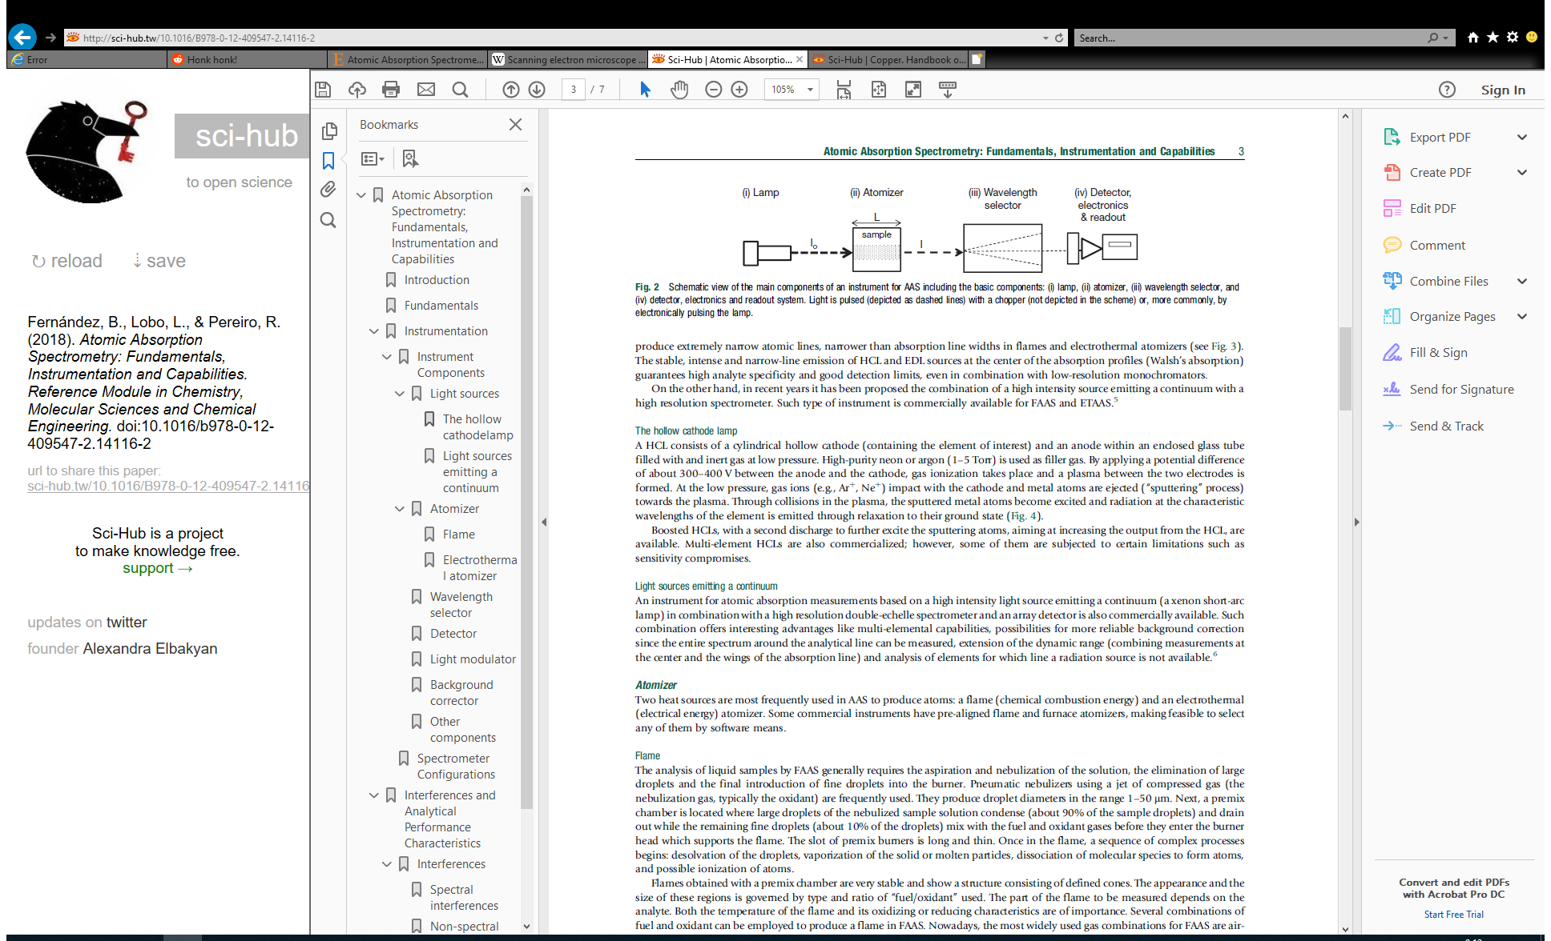

Figure 1: Schematic view of the key components of Atomic Absorption Spectroscopy: (i) lamp, (ii) atomizer, (iii) wavelength selector, (iv) detector. Adapted from Atomic absorption spectrometry: fundamentals, instrumentation and capabilities by B. L. Fernandez (2018).

Atomic absorption spectroscopy (AAS) includes several methods to combust the sample: flame (F-AAS), graphite furnace (GF-AAS) or electro-atomization (E-AAS). All measurements performed at the Analytical Competence Centre are done by F-AAS, including the method presented in this report.

As long as there are no solids present, which risk blocking the atomizer or capillary, then a liquid sample requires only to be diluted prior to analysis. This makes F-AAS a simple technique to implement, and this is an improvement over the current limitations present in microwave digestion. This means that the sample preparation and measurements can be performed faster, while also making the microwave available for sample preparation of techniques which cannot accommodate organic solvents, such as ICP (Gonzalez, Rodriguez, & Gonzalez, 1987).

The limitations of F-AAS are its low sensitivity when compared to more advanced techniques such as ICP-MS, as well as being unsuitable for high viscosity liquids, and having some metal elements form oxides which cannot be volatilized and therefore cannot be analysed. High viscosity samples can be analysed by adding a solvent, while the oxidation problem can be bypassed by changing the fuel : oxygen composition of the flame so that it is a reducing flame. The key limitation of AAS compared to other methods such as ICP is that atomic absorption can only analyse one element at a time (Gonzalez, Rodriguez, & Gonzalez, 1987) (Varian, 1983).

It is possible for signal to be dampened by other interfering elements. Known interferences are listed in cookbooks, such as nickel signal being inhibited by iron, chromium and cobalt; however these interferences are determined in aqueous solutions and may not be present in organic solutions. (Agilent Technologies, 2013) (Varian, 1983).

# Method

This method is built on previous research, in which a direct determination of nickel and cobalt in organic samples by flame atomic absorption spectroscopy (F-AAS) was investigated. However, the majority of the work was focused on finding a suitable organic matrix for the analyses, and thus the researcher was only able to create a method for the determination of cobalt. The organic matrix needed to be miscible with both the organic samples and the aqueous standards used in the calibration curve. Preference was given to solvents which were not hazardous to health. Of the options which met this criteria, ethanol, ethanol/water and ethanol/cyclohexanol were investigated, and only ethanol/cyclohexanol had an acceptable recovery of added cobalt in the range of 90 – 110% (Stessens, 2016-2017).

This project will make use of his solvent determination as a basis for the determination and subsequent validation of nickel in company samples.

## Reference method: microwave digestion and F-AAS

The sample is weighed and 0.15 grams are added to the Teflon container. 7 mL of 65% nitric acid and 1 mL of hydrogen peroxide is added to the container, which is then screwed shut. The nitric acid is NORMAPUR grade from VWR chemicals (Fontenay-Sous-Bois, FR). The preparation is done in duplicate, to prevent errors associated with the low weights. The samples are then added to the microwave, where they are irradiated in a slowly ramping fashion between 200 and 700 Watts. The complete heating program lasts half an hour, including the cool-down period.

After digesting in the EthosOne laboratory microwave by Milestone (Brondby, DK), the resulting colourless solution is diluted in ultrapure MilliQ from an Advantage A10 filtration device (Merck, DE). The diluted sample is then analysed by aqueous AAS at a wavelength of 232.0 nm, with a 0.2mm slit width. The measurements are performed on a Varian AA 280-FS with a 10 mA FeCoNiMnCuCr multi-element lamp from Agilent Technologies. The gases are an air/acetylene mixture, 13.5 L/min and 2.5 L/min respectively. The burner height is set to 13.5mm. The measurement time is 8 seconds.

## Dilution solvent

In the previous research on which this method is based, it was determined that a mixture of 45% ethanol and 55% cyclohexanol (v/v) is suitable to dissolve the aqueous nickel standard as well as the organic samples from Cobalt Specialty Materials (CSM). The ethanol is EMSURE reagent grade from Merck (Darmstadt, DE) and the cyclohexanol is 99% purity from Alfa Aesar by Thermo Fisher Scientific (Kamdel, DE). In this work, dilution solvent is understood to mean a mixture of ethanol and cyclohexanol in a 45 - 55 volumetric ratio.

## Standards and samples

Nickel standards are prepared from a stock solution of 1,000 mg/L Certipur by Merck (Darmstadt, DE). Standards are distributed at even intervals across the calibration range.

The samples to be analysed for nickel content originate from CSM. The samples belong to the monthly inventory analyses of December 2018. The samples have various concentrations of cobalt and nickel that have been determined by the certified reference method (CRM).

The samples are divided in two categories: “C1” and “C3”, which refer to the organic matrix of the samples. “C1” matrix consists of solvents A and B, while “C3” matrix consists of solvent C and D. The exact nature and ratio of the CSM solvents is proprietary information.

Table 1 shows an excerpt of the data provided about the CSM samples. The full table can be found in Appendix A.

Table 1: example of the samples to be analysed by F-AAS

|  |  |  |  |
| --- | --- | --- | --- |
| **Batch ID** | **Description** | **Co** | **Ni** |
| B-2018-0082478 | C101 | 8.4 g/L | 0.30 g/L |
| B-2018-0082485 | C308 | 22 g/L | < 0.30 g/L |
| B-2018-0082487 | C313 | < 0.30 g/L | 5.0 g/L |

## Sample preparation

The calibration curve is made by using an Eppendorf automatic pipet (1,000 µL; 5,000 µL) to transfer a known quantity of 1,000 ppm aqueous nickel standard (Merck, Darmstadt, DE) and filling volumetric flask with the dilution solvent. Samples are prepared in a similar fashion, but the automatic pipet is replaced with a Blau Brand glass pipet and the samples are prepared in a fume hood.

For both the calibration standards and the prepared samples, the weight is measured on a Mettler-Toledo balance for the empty flask, after the addition of sample, after the addition of a nickel spike (if applicable), and after filling with solvent. Using this information, the concentration of nickel is calculated in mg/kg. In this report, *ppm* always refers to mg/kg as opposed to mg/L, unless the contrary is specified.

## Sample analysis

The samples are analysed on a Varian AA 280-FS with a 10 mA FeCoNiMnCuCr multi-element lamp from Agilent Technologies. The gases are an air/acetylene mixture, 13.5 L/min and 2.5 L/min respectively. The burner height is set to 14.5mm. The measurement time is 10 seconds, and the wavelength is set to 232.0 nm with a 0.2mm slit width. The path of the burner is aligned in parallel with the optical beam.

Other settings such as aspiration rate, atomizer position, burner depth and burner angle along the optical beam are adjusted by hand during the signal optimization step, until the signal obtained is the highest possible.

## Cobalt precipitation

During the experimental procedure, samples containing high cobalt and low nickel showed precipitation after dilution. This occurred for samples which require low dilution to be brought within calibration range. To assess the cobalt concentration at which precipitation occurs, the samples are arranged from high to low cobalt concentration and diluted 10x, then inspected for signs of precipitation.

All the samples with high cobalt concentrations have nickel concentrations below the reference method’s limit of quantification (LOQ), reported as <300 ppm (see Appendix A). A portion of these samples, at least 25 mL, is separated and spiked with additional nickel, to bring the total nickel content above the reference method’s LOQ. The spiked samples can then be measured by the CRM in a manner that produces a meaningful result, as opposed to the current <300 ppm. This allows for comparison of the results obtained by the method being validated to those obtained by CRM.

These spiked samples are measured at two intervals: immediately after being diluted ($t=0$), and after allowing enough time for precipitation to occur ($t≥2h$). For the second measurement, the precipitate is removed by filtration prior to measuring. The residue is dried, weighed, dissolved in nitric acid, diluted in MilliQ and analysed by the reference method to determine the amount of nickel present in the residue. A portion of the residue is also separated and analysed by Scanning Electron Microscopy (SEM) to independently confirm the amount of nickel present in the residue.

The filtration is performed with a Millipore filter. The filter paper is weighed on a Mettler-Toledo balance and dried at 105°C in an oven over a minimum period of 3 days.

### Nickel spike in high cobalt samples

The spiking of high cobalt samples is performed successfully by using an inventory sample with high nickel content. When measured, the nickel content of high cobalt samples is very close to the base line, indicating that a greater dilution factor to remediate the precipitation would cause the nickel to become entirely negligible. All high cobalt and high nickel samples share the same C3 matrix, guaranteeing that they will mix.

To prevent the nickel content from being lower than the limit of quantification, nine samples are spiked with additional nickel to investigate the precipitation, but they are also used in other parts of the validation to represent the high cobalt samples. Where spiked samples are mentioned in conjunction with high cobalt content, this refers to an organic spike of nickel originating from a high nickel sample, as opposed to being an aqueous spike of nickel as used in the Recovery & Bias section.

### Scanning Electron Microscopy (SEM)

One residue of sample from Cobalt Precipitation is analysed by SEM to provide an independent estimation of the nickel present in the precipitation. After drying, the residue is coated with graphite powder to make it electrically conductive and inserted in the SEM. The model is a JSM-6480 A (Tokyo, JP). The results from the SEM analysis are compared to analyzing the residue by the reference method.

## Validation

The validation of the method is performed according to company guidelines. This document, *Operationale procedure: validatie van analysemethodes* is an in-house confidential script. It is written based on the works of Dr. Klaessens, 2008, but the exact document cannot be shared outside of the company.

### Calibration range

The AAS cookbook (Varian, 1983) and the F-AAS Analytical Methods Manual (Agilent Technologies, 2013) are used as a starting point for the linear range of the calibration curve: 0 – 20 ppm. The previous research mentions a strong dampening effect on the signal by the solvent, so the initial calibration curve will be expanded to 0 – 50 ppm instead.

The calibration range is determined according to two criteria. The first is AAS guidelines (Appendix B), written by an experienced AA technician, the second is an in-house validation criteria (Klaessens, 2008). From the first, a linearity factor is determined:

$$L=\frac{{Abs}_{5}-{Abs}_{4}}{{Abs}_{1}-{Abs}_{blank}}≥0.7$$

Where *blank, 1, 2, 3, 4, 5* are calibration curve standards. This equation represents the ratio of the slope of the upper 20% of the graph compared to the bottom 20% of the graph. If L = 1, then the calibration curve is a perfect straight line. The starting calibration range will be set from 0 – 50 ppm, then iterated using the above equation until *L* ≥ 0.7.

Once the calibration range is established, the relationship between analyte concentration and signal measured is established by preparing standards across the expected range. These standards are measured against an independent calibration range. The standards are measured once each in ascending order, then the calibration is renewed and the measurement is repeated. This is performed a total of 5 times.

To identify possible outliers, a Grubb test is performed on each standard. For a sample population of 5 data points per measurement, the Grubb critical value is 1.715 for a confidence level of 95%. The Grubb value *G* is determined as follows:

$$G=\frac{\left|x-\overline{x}\right|}{s}$$

Where $x$ is the value suspected of being an outlier, $\overline{x}$ is the average of the measurements for that data point, and $s$ is the standard deviation of the measurements for that data point. Both $\overline{x}$ and $s$ are calculated with the suspect value included, as the null hypothesis presumes that there are no outliers (Miller & Miller, 2010).

Once outliers have been identified and removed, the relationship between analyte and signal is determined by two regression analyses. To determine a relationship, the p-value of the regression analysis must be lower than 0.05 for a 95% confidence level.

The first regression is performed between the signal measured and the analyte concentration. This will determine whether there is a relationship or not. The second regression is performed between the signal measured, the concentration of the analyte, and the square of the concentration of the analyte. This will indicate whether the relationship between concentration and signal is linear or quadratic.

### Limits of Detection and Quantification

The limits of detection & quantification are determined by measuring blank dilution solvent. At least 8 measurements are performed, under reproducibility conditions (see Reproducibility below). The standard deviation of these measurements is calculated and used to determine the LOD and LOQ of the instrument.

$$LOD=3×s_{R}$$

$$LOQ=6×s_{R}$$

Multiplying the LOD and LOQ with the dilution factor will then give the LOD and LOQ for the method.

### Reproducibility

Reproducibility is determined by analyzing real samples. The LOD and LOQ calculations make use of $s_{R}$ as calculated by this method. The intent is to maximize the variations that may occur during analysis: different operators, different times, different dates, different machines, …

In this manner, one singular dilution of a real sample is made and analysed a minimum of 8 times, with each analysis being performed on a different day. The standard deviation is then calculated in the following manner:

$$s_{R}=\sqrt{\frac{1}{n-1}\sum_{i=1}^{n}{{\left(x_{i}-\overline{x}\right)}^{2}}}$$

Where $x_{i}$ is one of the measurements, $\overline{x}$ is the mean of all measurements performed and $n$ is the number of measurements performed, 8 or more. The reproducibility is reported by calculating the Relative Standard Deviation (RSD) as such:

$${RSD}_{R}=\frac{s_{R}}{\overline{x}}*100\%$$

Company guidelines dictate that a RSD value lower than 2% is desirable, but up to 5% is acceptable. The RSD can also be referred to as the coefficient of variation.

### Repeatability

Repeatability is determined by analyzing a real sample. As opposed to reproducibility, the intent here is to minimize the variations that occur across measurements. This is achieved by performing 8 or more measurements of the same solution in quick succession, performed by the same operator, on the same machine, in the same manner.

$$s_{r}=\sqrt{\frac{1}{n-1}\sum_{i=1}^{n}{{\left(x_{i}-\overline{x}\right)}^{2}}}$$

As above, $x_{i}$ is one of the measurements, $\overline{x}$ is the mean of all measurements performed and $n$ is the number of measurements performed. Although this is the same equation as for $s_{R}$, the values will be different due to variations during the measurements.

Repeatability is reported by calculating the Relative Standard Deviation (RSD) as such:

$${RSD}_{r}=\frac{s_{r}}{\overline{x}}*100\%$$

Company guidelines dictate that a RSD value lower than 2% is desirable, but up to 5% is acceptable. The RSD can also be referred to as the coefficient of variation.

### Recovery and bias

The bias of the method is determined by measuring the recovery of nickel. Real samples are diluted in duplicate, and one of the two dilutions receives an addition of a known amount of nickel. The nickel spike comes from the Certipur 1,000 mg/L stock solution (Merck, Darmstadt, DE). The spike volume is 0.25 mL in a total dilution volume of 25 mL, resulting in a 10 mg/L spike. After converting to ppm, this is equivalent to a 11 ppm spike.

The difference in measured concentration indicates the recovery, as follows:

$$T_{∆c,i}=\frac{x_{∆c+c,i}-x_{c,i}}{∆c}×100\%$$

Where $x_{c,i}$ is the measured concentration of the regular sample, $x_{∆c+c,i}$ is the measured concentration of the spiked sample, and $∆c$ is the spike amount. Once a minimum of ten data points are created, the average recovery is then calculated as follows:

$$\overline{T}=\frac{\sum_{i}^{n}{T_{∆c,i}}}{n}$$

Where $\overline{T}$ is the overall recovery and $n$ is the number of data points. From this, the bias is determined:

$$b_{c}=\overline{T}-100$$

The bias of the method and the standard deviation of the measurements should be no greater than 5% for the method to be acceptable.

# Results

## Calibration range

The calibration range is estimated to be 0 – 30 ppm (details in Appendix C). As a result, the calibration standards are evenly divided across the range as indicated in Appendix B (0, 6, 12, 18, 24, 30 ppm) and the measured standards are made to cover the range while avoiding overlap with the calibration values as much as possible: 0, 2, 5, 8, 10, 15, 20, 22, 25, 28 and 30 ppm.

Performing the Grubb outlier test, none of the data points exceed *Gcrit*, therefore none of the data points are outliers (data in Appendix D). Therefore, a regression analysis can be performed on the entire range of data.

Table 2: Regression analysis between signal measured and analyte concentration for 11 data points measured in quintuplicate across a range of 0 – 30 ppm nickel in ethanol/cyclohexanol.

|  |  |  |  |  |  |  |
| --- | --- | --- | --- | --- | --- | --- |
| SUMMARY OUTPUT | |  |  |  |  |  |
|  |  |  |  |  |  |  |
| *Regression Statistics* | |  |  |  |  |  |
| Multiple R | 0.9970 |  |  |  |  |  |
| R2 | 0.9940 |  |  |  |  |  |
| Adjusted R2 | 0.9939 |  |  |  |  |  |
| Standard Error | 0.0133 |  |  |  |  |  |
| Observations | 54* |  |  |  |  |  |
|  |  |  |  |  |  |  |
| ANOVA |  |  |  |  |  |  |
|  | *df* | *SS* | *MS* | *F* | *Significance F* |  |
| Regression | 1 | 1.5316 | 1.5316 | 8640 | 1.746 x10-59 |  |
| Residual | 52 | 0.0092 | 0.0002 |  |  |  |
| Total | 53 | 1.5408 |  |  |  |  |
|  |  |  |  |  |  |  |
|  | *Coefficients* | *Standard Error* | *t Stat* | *P-value* | *Lower 95%* | *Upper 95%* |
| Intercept | 0.0160 | 0.0032 | 5.006 | 6.740 x10-6 | 0.0096 | 0.0225 |
| Concentration | 0.0166 | 0.0002 | 92.95 | 1.746 x10-59 | 0.0162 | 0.0169 |

*: 55 observations were planned, one sample was spilled during measurement, leading to the omission of 1 data point.

A second regression analysis is performed on the signal measured vs the analyte concentration and the analyte concentration squared.

Table 3: Regression analysis between signal measured, analyte concentration and analyte concentration squared for 11 data points measured in quintuplicate across a range of 0 – 30 ppm nickel in ethanol/cyclohexanol.

|  |  |  |  |  |  |  |  |
| --- | --- | --- | --- | --- | --- | --- | --- |
| SUMMARY OUTPUT | |  |  |  |  |  |  |
|  |  |  |  |  |  |  |  |
| *Regression Statistics* | |  |  |  |  |  |  |
| Multiple R | 0.9988 |  |  |  |  |  |  |
| R2 | 0.9976 |  |  |  |  |  |  |
| Adjusted R2 | 0.9976 |  |  |  |  |  |  |
| Standard Error | 0.0084 |  |  |  |  |  |  |
| Observations | 54 |  |  |  |  |  |  |
|  |  |  |  |  |  |  |  |
| ANOVA |  |  |  |  |  |  |  |
|  | *df* | *SS* | *MS* |  | *F* | *Significance F* |  |
| Regression | 2 | 1.537 | 0.7686 |  | 10798 | 9.7730 x10-68 |  |
| Residual | 51 | 0.0036 | 0.0001 |  |  |  |  |
| Total | 53 | 1.541 |  |  |  |  |  |
|  |  |  |  |  |  |  |  |
|  | *Coefficients* | *Standard Error* | *t Stat* |  | *P-value* | *Lower 95%* | *Upper 95%* |
| Intercept | 0.0003 | 0.0027 | 0.1190 |  | 0.906 | -0.005 | 0.006 |
| Concentration | 0.0204 | 0.0005 | 45.2870 |  | 7.371 x10-43 | 0.020 | 0.021 |
| Concentration2 | -0.0001 | 0.0000 | -8.8604 |  | 6.748 x10-12 | 0.000 | 0.000 |

Performing a shorthand linearity calculation results in an L factor of just above 0.7, which is deemed acceptable for the AAS.

## LOD/LOQ

Blank solutions were measured ten times under reproducibility conditions (Table 4). The standard deviation is 0.118 ppm, giving a LOD of 0.35 ppm and a LOQ of 0.71 ppm.

|  |  |
| --- | --- |
| Sample: blank | |
| Dilution: n/a | |
| Measurement | Concentration (ppm) |
| 1 | 0.074 |
| 2 | 0.122 |
| 3 | -0.168 |
| 4 | 0.090 |
| 5 | 0.029 |
| 6 | 0.024 |
| 7 | 0.228 |
| 8 | 0.048 |
| 9 | -0.144 |
| 10 | -0.026 |
| Average: 0.028 ppm | |
| Std. deviation: 0.118 ppm | |
| LOD: 0.35 ppm | |
| LOQ: 0.71 ppm | |

Table 4: Measurements of ten blanks to determine the Limits of Detection and Quantification

## Repeatability

Sample 478 is diluted 20x and measured ten times under repeatability conditions. The same sample is measured in two manners: one is performed on a dirty burner (Table 5a), the other on a burner that has just been cleaned (Table 5b). The RSD is 0.82% for a dirty burner and 0.32% for a clean burner.

Table 5: Ten measurements of sample 478 diluted 20x, performed under repeatability conditions on a dirty burner (left) and a clean burner (right)

|  |  |
| --- | --- |
| Sample: 478 | |
| Dilution: 20x | |
| Measurement | Concentration (ppm) |
| 1 | 15.758 |
| 2 | 15.793 |
| 3 | 15.784 |
| 4 | 15.841 |
| 5 | 15.728 |
| 6 | 15.862 |
| 7 | 15.872 |
| 8 | 15.839 |
| 9 | 15.778 |
| 10 | 15.863 |
| Average: 15.812 ppm | |
| Std. deviation: 0.050 ppm | |
| RSD: 0.32% | |

|  |  |
| --- | --- |
| Sample: 478 | |
| Dilution: 20x | |
| Measurement | Concentration (ppm) |
| 1 | 14.525 |
| 2 | 14.804 |
| 3 | 14.794 |
| 4 | 14.476 |
| 5 | 14.661 |
| 6 | 14.604 |
| 7 | 14.741 |
| 8 | 14.818 |
| 9 | 14.771 |
| 10 | 14.710 |
| Average: 14.690 ppm | |
| Std. deviation: 0.121 ppm | |
| RSD: 0.82% | |

## Reproducibility

Sample 478 is diluted 20x and measured ten times under reproducibility conditions (Table 6). The standard deviation of the measurements is 0.318 ppm and the RSD is 1.96%.

Table 6: Ten measurements of sample 478 diluted 20x, performed under reproducibility conditions

|  |  |
| --- | --- |
| Sample: 478 | |
| Dilution: 20x | |
| Measurement | Concentration (ppm) |
| 1 | 16.356 |
| 2 | 16.065 |
| 3 | 15.883 |
| 4 | 16.725 |
| 5 | 16.743 |
| 6 | 15.845 |
| 7 | 16.456 |
| 8 | 16.063 |
| 9 | 16.219 |
| 10 | 16.418 |
| Average: 16.277 ppm | |
| Std. deviation: 0.318 ppm | |
| RSD:1.96% | |

As part of the Recovery determination, two other samples have enough measurements performed to be eligible for reproducibility determination: 488 (Table 7) and 502 (Table 8).

Table 7: Eight measurements of high nickel sample 488 diluted 1250x, performed under reproducibility conditions

|  |  |
| --- | --- |
| Sample: 488 | |
| Dilution: 1250x | |
| Measurement | Concentration (ppm) |
| 1 | 4.307 |
| 2 | 4.262 |
| 3 | 4.836 |
| 4 | 4.849 |
| 5 | 4.879 |
| 6 | 4.836 |
| 7 | 4.323 |
| 8 | 4.667 |
| Average: 4.620 ppm | |
| Std. deviation: 0.275 ppm | |
| RSD: 5.95% | |

Table 8: Eight measurements of low nickel sample 502 diluted 12.5x, performed under reproducibility conditions

|  |  |
| --- | --- |
| Sample: 502 | |
| Dilution: 12.5x | |
| Measurement | Concentration (ppm) |
| 1 | 14.831 |
| 2 | 15.591 |
| 3 | 16.448 |
| 4 | 15.819 |
| 5 | 15.659 |
| 6 | 15.763 |
| 7 | 15.591 |
| 8 | 15.666 |
| Average: 15.671 ppm | |
| Std. deviation: 0.440 ppm | |
| RSD: 2.81% | |

## Recovery & bias

Due to the occurrence of precipitation of high cobalt samples, the cobalt samples spiked with additional nickel are used to represent the high cobalt samples. The nickel spike’s purpose is to prevent cobalt precipitation upon dilution, see Cobalt Precipitation below.

A Grubb outlier test is performed on the data points. The lowest value of 81% recovery is found to be an outlier as its G-value exceeds Gcrit. After discarding the outlier and repeating the Grubb test, no further outliers are identified (see Appendix E).

All diluted samples receive the same spike volume and after accounting for dilution factor, these are calculated back to an equivalent spike in the sample (Table 9).

Table 9: Recovery of nickel spike and spread of measurements, arranged by spike range

|  |  |  |
| --- | --- | --- |
| Spike range (ppm) | Recovery (%) | n |
| 50 - 150 | 97.0 (3.3)* | 24 |
| 250 - 500 | 102.0 (2.1) | 14 |
| 500 - 600 | 104.2 (5.1) | 7 |
| 3,000 - 5,000 | 102.1 (4.5) | 3 |
| 15,000+ | 105.8 (4.2) | 9 |

*: Standard deviation of the measurements shown in parentheses

The same data is presented in the form of a box plot for visual interpretation (Figure 2). The 3,000 – 5,000 and 15,000+ ranges have been collated together, to account for the fact that the 3,000 – 5,000 range only has 3 data points. The new range of 3,000+ ppm has a median recovery of 104.6% and a standard deviation of 4.4%.

Figure 2: box plot of the recovery across different spike ranges. Spike ranges of 3,000 – 5,000 and 15,000+ combined together.

The same recovery data can be presented for individual samples rather than for spike ranges, presented in the tables below. Both tables show the concentration as determined by this method, the concentration as determined by the reference method, as well as the average recovery & the standard deviation of the recovery measurements. Table 10 consists of original CSM samples, whereas Table 11 consists of samples that have been spiked with nickel (see Cobalt precipitation). The value for CRM measurements is dated 19th December 2018, except where otherwise indicated.

Table 10: Measured concentration and reference concentration of samples, along with recovery of nickel spikes, arranged by sample ID.

|  |  |  |  |  |
| --- | --- | --- | --- | --- |
| ID | Concentration (ppm) | CRM concentration (ppm) | Recovery (%) | n |
| 478 | 330 | 330a | 103 (3.6)* | 2 |
| 479 | 51 | 68 | 97 (2.3) | 3 |
| 487 | 6030 | 6450a | 104 (0.8) | 2 |
| 488 | 6300 | 6200a | 106 (5.2) | 8 |
| 489 | 270 | 220 | 102 (0.8) | 3 |
| 490 | 5500 | 4600 | 101 | 1 |
| 496 | 240 | 210 | 101 (3.0) | 2 |
| 502 | 200 | 190a | 98 (2.7) | 8 |
| 508 | 97 | 61 | 95 (6.3) | 3 |
| 511 | 5 | 3.6 | 96 (0.7) | 3 |
| 512 | 1 | -12 | 95 (3.2) | 3 |
| 513 | 2 | -18 | 98 (3.4) | 2 |
| 514 | 1 | -5 | 99 (4.2) | 2 |

a: CRM performed in May 2019  
*: Standard deviation of the measurements shown in parentheses

Table 11: Measured concentration and reference concentration of high cobalt samples, along with recovery of nickel spikes, arranged by sample ID.

|  |  |  |  |  |
| --- | --- | --- | --- | --- |
| ID | Concentration (ppm) | CRM concentration (ppm) | Recovery (%) | n |
| 479+ | 224 | 234a | 102 (0.9)* | 2 |
| 480-2+ | 387 | 386a | 106 (6.4) | 2 |
| 481-2+ | 322 | 320a | 103 (4.7) | 7 |
| 483+ | 453 | 410a | 101 | 1 |
| 484+ | 386 | 338a | 103 | 1 |

a: CRM performed in May 2019  
*: Standard deviation of the measurements shown in parentheses

The average recovery of all samples is 100.8%, leading to a bias of 0.8%. The standard deviation of all measurements is 4.86%.

## Cobalt precipitation

Samples with high cobalt which require a low dilution factor for nickel experience precipitation. A range of cobalt concentrations is investigated to determine when precipitation no longer occurs (Table 12).

Table 12: outcome of cobalt precipitation for decreasing cobalt concentration

|  |  |  |
| --- | --- | --- |
| Cobalt content (g/L) | Cobalt precipitation (10x dilution) | Time to precipitation |
| 23 | Yes | < 1 min |
| 22 | Yes | < 1 min |
| 19 | Yes | 20 min |
| 12 | Yes | 45 min |
| 8.8 | No | n/a |
| 5.8 | No | n/a |
| <1 | No | n/a |

SEM imagery is performed on the precipitate to determine the loss of nickel (Table 13). See Appendix F for the complete SEM report.

Table : SEM imagery of precipitated cobalt residue (left) and table of element composition in mass percent at the measured points (right)



Mass%

O P S Co Ni Total

001 34.81 36.50 28.69 100.00

002 49.20 19.19 6.70 24.72 0.19 100.00

003 47.10 9.22 13.30 30.39 100.00

004 29.14 33.26 5.81 31.79 100.00

9 samples with high cobalt concentration are separated and spiked with various amounts of nickel by using a high nickel organic sample. Various amounts of nickel are added, to determine the impact on the precipitation. Two analyses of each sample are performed: one at t = 0, before precipitation occurs; and one at t > 2h, after filtering out the precipitate. Table 14 below shows the outcome of this test.

Table 14: analysis of spiked samples, before and after precipitation

|  |  |  |  |  |  |
| --- | --- | --- | --- | --- | --- |
| ID | Dilution | Analysis | Concentration (ppm) | CRM  (ppm) | Nickel lost to precipitation (% of CRM value) |
| 479+ | 15 | t = 0 | 211 | 234 | 1.5 |
| t ≥ 2 | 235 |
| 480-2+ | 20 | t = 0 | 368 | 386 | 0.4 |
| t ≥ 2 | 419 |
| 481-1+ | 20 | t = 0 | 371 | 393 | 0.3 |
| t ≥ 2 | 457 |
| 481-2+ | 20 | t = 0 | 332 | 320 | 0.4 |
| t ≥ 2 | 403 |
| 482+ | 20 | t = 0 | 360 | 383 | 0.4 |
| t ≥ 2 | 424 |
| 483+ | 25 | t = 0 | 432 | 410 | 0.2 |
| t ≥ 2 | 498 |
| 484+ | 25 | t = 0 | 417 | 338 | 0.3 |
| t ≥ 2 | 501 |
| 485-1+ | 20 | t = 0 | 420 | 419 | 0.1 |
| t ≥ 2 | 526 |
| 485-2+ | 25 | t = 0 | 481 | 469 | 0.2 |
| t ≥ 2 | 575 |

# Discussion

### Calibration range

The p-value for *intercept* and *concentration* are both below 0.05, as is appropriate for a 95% confidence level. This indicates that the intercept is significant, and that there exists a correlation between concentration of analyte & signal registered by the F-AAS.

The p-value for *concentration2* is below 0.05, as is appropriate for a 95% confidence level. This indicates that the correlation between concentration of analyte & signal registered is quadratic in nature.

As the burner becomes fouled from use, the calibration curve becomes more parabolic in nature which gives a visual indicator that the burner requires cleaning.

### LOD/LOQ

The LOD and LOQ of the instrument are 0.35 ppm and 0.71 ppm respectively. This is different for aqueous AAS, where the LOD and LOQ are 0.02 and 0.04 mg/L instead. However, this increase in LOD and LOQ does not have an impact when measuring samples with a high nickel content.

The LOD and LOQ provided must be multiplied by the dilution factor to show the limits of the method. Current practice in ACC labs is to dilute by factors of ten, leading to LOD values of 0.35 ppm, 3.5 ppm, 35 ppm, and so on.

### Repeatability

The relative standard deviation changes from 0.82% for a dirty burner to 0.32% for a clean burner. This is indicative of the loss of signal that occurs when the burner is fouled from repeated use and emphasizes the need to clean the burner at regular intervals.

However, as company guidelines indicate desirable RSD values as being lower than 2%, both of these measurement conditions meet the criteria.

### Reproducibility

Sample 488 has a high nickel content, which requires two successive dilutions (50x 🡪 25x) to bring the sample within calibration range. As a result, the relative standard deviation of 5.95% is higher than the other two values of 1.96% and 2.81%, which are obtained by a single dilution step.

The lower RSD values of samples 478 and 502 are obtained by single dilution, and are close to the desired value of 2%. The RSD value for sample 488 is just over 5%, which is commonly used as a limit of acceptable RSD values. This indicates that the high nickel samples are more susceptible to variations across measurements due to the successive dilutions during the sample preparation.

### Recovery & bias

While individual recovery values can vary from the 100% mark by almost 15%, such as the minimum value of the 50 - 150 ppm range or the maximum value from the 500 – 750 ppm range, once multiple measurements are performed the average values come within 5% of the 100% mark. The range with lower standard deviations shown in Table 9 have the narrowest inter-quartile range in the box plot, represented in blue. The inter-quartile range represents 50% of the sample population.

The 3,000-5,000 and 15,000+ ranges are made by two successive dilutions, as they represent dilutions between 500x and 1500x. Their spread is greater than the single dilution range, for reasons already highlighted in the reproducibility section, but their average recoveries of 102.1% and 105.8% are comparable to the average recoveries of single-dilution measurements.

When assessing recovery of individual samples as opposed to spike ranges, the majority of them are located within 5% of the 100% mark, in a similar fashion to the spike range data. This is true for high nickel samples such as 487, 488, 490, and it is also true for samples with a negligible amount of nickel such as 510 – 514.

Tables 10 and 11 highlight the impact of time on the concentration of nickel in the samples. The CRM values in Table 10 date from the 19th of December 2018, except where indicated otherwise. There is a noticeable and consistent discrepancy between the (old) CRM concentration and the concentrations as measured by this method. The newer CRM values are far more similar to the measured values than the old CRM, indicating a steady evaporation of the solvent which results in an apparent increase in concentration. The largest difference between measured concentration and the CRM concentration is for sample 488, one of the two high nickel samples. This is due to the successive dilutions used during the sample preparation, as mentioned earlier.

During normal operation, the inventory samples are analysed & reported within five working days, so the gradual evaporation of solvent will not hinder measurements in the future.

The recovery data and standard deviations presented are produced with aqueous nickel spikes, indicating that the method is suited to identifying nickel from aqueous sources. The data from Table 11, which shows the similarity in determined concentration by this method and the CRM, is equally well suited to identifying nickel which originates from organic sources.

### Cobalt precipitation

Several experimental setups were tested to achieve a successful nickel spike in the aforementioned high cobalt samples. The purpose of the nickel spike is to raise the nickel levels above the reference method’s LOQ, as all high cobalt samples are reported as <300 ppm (see Appendix A). This will provide a real value to which the organic method can be compared, to ascertain the deviation between the two methods. Once a real value is obtained by CRM, the change in nickel concentration before and after precipitation can also be investigated, so as to determine the best time frame to conduct measurements when precipitation is involved.

In a first experiment, spiking was done with an in-house highly concentrated nickel solution, prepared by dissolving pure nickel in concentrated nitric acid (c = 100 g/L). A small volume of spike solution was added to 50 mL of high cobalt sample and mixed vigorously, with an expected increase in nickel of 1,000 ppm. However, the measured nickel concentration increased by less than 50 ppm, indicating that there is very little transfer of nickel from the aqueous phase to the organic phase.

Following this, spiking was attempted with an organometallic standard from Conostan Ltd., 1,000 ppm nickel in a hydrocarbon matrix. However, the organometallic spike didn’t dissolve easily in nitric acid, and a large volume of standard was required to provide the desired spike. It was decided not to use this as spike material due to concerns of altering the matrix composition to a point where it is no longer representative of the inventory samples.

For the higher values of 22, 23 g/L, precipitation occurs within minutes of diluting. For the lower values of 12, 19 g/L, precipitation becomes noticeable within 45 minutes. It appears that the limit for precipitation of cobalt is around the 1,000 ppm mark, post-dilution.

SEM imagery performed on precipitate proves that it is cobalt, predominantly made of sulphate and phosphate compounds. The nickel in this residue accounts for less than 1/100th of a percent, determined by aqueous AAS, and only appears on one of the measurement points. The full SEM reports are presented in Appendix F.

Based on the experimental data, taking the measurement immediately after dilution ensures the closest match to the concentration determined by CRM. For the company’s purposes, even *t ≥ 2* values are close enough to the CRM to be used. However, precipitation is likely to block the atomizer within the AAS and the filtration is one additional step in the preparation. As such, it is preferable to analyse immediately after diluting. The amount of nickel lost to precipitation decreases as the amount of nickel in the sample increases.

As evidenced by the 9 samples of Table 15, nickel concentration always increases after the precipitation occurs. No nickel is being added to the diluted sample, which implies it is a loss of solvent causing this increase in concentration. When determining the nickel present in the filtered residue, there is always some solvent left in the residue. This is visible as a droplet of oil after dissolving the residue in nitric acid and diluting with water. This occurs even after drying the residue at 105°C for ten days. This indicates that some solvent is trapped in the precipitate, leading to the apparent increase in nickel.

After consulting with company personnel specialized in organics, the current hypothesis is that water present in the sample coordinates within the alcohol, reducing the selectivity of the mixture with regards to cobalt. The cobalt then precipitates out of solution until equilibrium is achieved. Practical tests have shown that, for low dilutions ( ≤10x), precipitation of cobalt occurs twice: once within minutes of dilution, and once more after filtration. This secondary precipitation can take hours before occurring.

# Conclusions

The method is suited to direct determination of nickel in organic solvents. Recovery of added nickel ranges from 81% to 112%, with most values being found between 95 – 105%. The global bias of the method is 0.8%. The limit of detection is 0.35 ppm, the limit of quantification is 0.71 ppm. These are the limits of the instrument, and must be multiplied by the dilution factor used before representing the limits of the method.

The calibration range is shown to be between 0 – 30 ppm. The relationship between signal measured and analyte concentration is quadratic in nature, which the AAS software can account for by using the New Rational curve fitting technique.

The repeatability of measurements is determined as a relative standard deviation of 0.32%. The reproducibility ranges between 2.0% for single-dilution preparation and 6.0% for successive dilution preparation, indicating that successive dilutions decrease the accuracy of the method.

Samples that are high in cobalt will precipitate if there is 1,000 ppm or more in the diluted solution. Measuring such samples immediately after dilution gives a measurement that is comparable to the reference method. Measuring after filtering out the precipitate gives values that may still be used, however, there is a greater difference between the measured concentration and reference concentration.

The nickel lost to precipitation ranges between 0.3% for the samples with the most spiked nickel and 1.5% for the samples with the least added nickel. The factors that are critical to the method are time and dilution factor, and this is only when analysing samples with high cobalt content and low dilution factors. In practical terms, the cobalt precipitation will not affect measurements

# Recommendations

It is recommended to reduce the calibration range from 0 – 30 ppm to 0 – 20 ppm. This reduced range still fits within the regression analysis, and is still quadratic in nature. Analysing a multitude of samples with high concentration, be it nickel or cobalt, leads to a pronounced increase in the curvature of the calibration range. Reducing the calibration range will lessen the impact on signal caused by fouling of the burner, allowing for a longer period of use before cleaning is required.

The cobalt precipitation can be dealt with in two manners: either measuring the diluted sample immediately, or diluting the sample to the point where precipitation no longer occurs. Once an operator has experience working with this organic method, it becomes easy to assess whether or not a diluted sample is going to precipitate based on the opacity of the volumetric flask.

The main reason these high cobalt samples precipitated is because they were diluted in such a way as to keep the nickel concentration meaningful within the calibration range. Were these samples to be diluted as unknown nickel concentrations, the higher dilution level would prevent precipitation of cobalt & result in nickel being reported as “<300 ppm”, as is the case for many samples.

However, should there be a need to bypass this precipitation altogether, other solvents can be investigated. Since the theory is that the water present in the sample dissolves in the ethanol and then causes precipitation of the cobalt, the samples should instead be diluted in a completely non-polar solvent such as hexane.

Performing a few test dilutions with hexane, n = 5, which range from 5x to 25x dilution, it appears that cobalt does not precipitate even after upwards of 72 hours. One sample containing high nickel was also diluted in hexane and the nickel did not precipitate either. This indicates that hexane has the possibility of being an acceptable substitute solvent.

The most likely issue with this change in solvent is the inability to use aqueous nickel solutions to create the calibration curve. However, this easily be redressed by using organometallic nickel solutions to prepare the standards instead.

# References

Agilent Technologies. (2013). *Flame atomic absorption spectrometry.*

Agilent Technologies. (2019, February 12th). Not the AA lamp again! Troubleshooting HC lamps and other tips for AAS. Melbourne, Victoria, Australia.

Chakraborty, R., Das, A. K., Cervera, M. L., & de la Guardia, M. (1996). Literature study of microwave-assisted digestion using electrothermal atomic absorption spectrometry. *Journal of Analytical Chemistry*, 99-111.

Fernandez, B. L., & Pereiro, R. (2018). Atomic absorption spectrometry: fundamentals, instrumentation and capabilities. Dans P. Worsfold, C. Poole, A. Townshend, & M. Miro, *Encyclopedia of Analytical Sciences* (pp. 137-143). Amsterdam: Elsevier Ltd.

Flett, D. S. (2004). Cobalt-nickel separation in hydrometallurgy: a review. *Chemistry for sustainable development*, 81-91.

Gonzalez, M. C., Rodriguez, A. R., & Gonzalez, V. (1987). Determination of vanadium, nickel, iron, copper, and lead in petroleum fractions by atomic absorption spectrophotometry with a graphite furnace. *Microchemical Journal*, 94-106.

Grubbs, F. E., & Beck, G. (1972). Extension of sample sizes and percentage points for significance tests of outlying observations. *Technometrics*, 847-854.

Haswell, S. J., & Barclay, D. (1992). On-line microwave digestion of slurry samples with direct flame atomic absorption spectrometric elemental detection. *Analyst*, 117-120.

Jones, D. L., McCoy, T. M., Mayhew, K. E., Cheng, C. Y., Barnard, K. R., & Zhang, W. (2010). *A new process for cobalt - nickel separation.* Perth, Australia: ALTA.

Kingston, H. M., & Jassie, L. B. (1988). *Introduction to microwave sample preparation.* United States of America: American Chemical Society.

Klaessens, J. W. (2008). *Statistiek, validatie en meetonzekerheid voor het laboratorium.* Arnhem: Syntax Media.

Kokot, S., King, G., Keller, H. R., & Massart, D. L. (1992). Microwave digestion: an analysis of procedures. *Analytica Chemica Acta*, 267-279.

Limbek, B., & Rowe, J. (2010). *Curve Correction in Atomic Absorption.* Agilent Technologies.

Miller, J., & Miller, J. (2010). *Statistics and Chemometrics for Analytical Chemistry* (éd. 6th). Harlow: Pearson.

Stessens, J. (2016-2017). *Rechtsreekse analyse van kobalt en nikkel in organische stalen met AAS.* Geel, BE: Thomas More Hogeschool.

Vale, M. G., Damin, I. C., Klassen, A., Silva, M. M., Welz, B., Silva, A. F., . . . Heitmann, U. (2004). Method development for the determination of nickel in petroleum using line-source and high-resolution continuum-source graphite furnace atomic absorption spectrometry. *Microchemical Journal*, 131-140.

Varian. (1983). Introducing Atomic Absorption Analysis. Dans P. A. Bennet, & E. Rothery, *Introducing Atomic Absorption Analysis.* Mulgrave: Varian Techtron Pty Limited.

# Appendix A: CSM samples

|  |  |  |  |  |
| --- | --- | --- | --- | --- |
| Batch ID | Description | Batch creation date | Co (g/L) | Ni (g/L) |
| B-2018-0082478 | C101 | 2018-12-15 | 8.4 | < 0.30 |
| B-2018-0082479 | C302 | 2018-12-15 | 12 | < 0.30 |
| B-2018-0082480 | C303 | 2018-12-15 | 19 | < 0.30 |
| B-2018-0082481 | C304 | 2018-12-15 | 22 | < 0.30 |
| B-2018-0082482 | C305 | 2018-12-15 | 23 | < 0.30 |
| B-2018-0082483 | C306 | 2018-12-15 | 23 | < 0.30 |
| B-2018-0082484 | C307 | 2018-12-15 | 23 | < 0.30 |
| B-2018-0082485 | C308 | 2018-12-15 | 22 | < 0.30 |
| B-2018-0082486 | C312 | 2018-12-15 | < 0.30 | 4.8 |
| B-2018-0082487 | C313 | 2018-12-15 | < 0.30 | 5.0 |
| B-2018-0082488 | C314 | 2018-12-15 | < 0.30 | 4.9 |
| B-2018-0082489 | C102 | 2018-12-15 | 8.6 | < 0.30 |
| B-2018-0082490 | C315 | 2018-12-15 | < 0.30 | 4.6 |
| B-2018-0082496 | C103 | 2018-12-15 | 8.8 | < 0.30 |
| B-2018-0082502 | C104 | 2018-12-15 | 8.6 | < 0.30 |
| B-2018-0082508 | C105 | 2018-12-15 | 5.8 | < 0.30 |
| B-2018-0082511 | C106 | 2018-12-15 | 0.92 | < 0.30 |
| B-2018-0082512 | C107 | 2018-12-15 | < 0.30 | < 0.30 |
| B-2018-0082513 | C109 | 2018-12-15 | < 0.30 | < 0.30 |
| B-2018-0082514 | C108 | 2018-12-15 | < 0.30 | < 0.30 |

“C1” and “C3” refer to the matrix of the sample. C1 consists of organic solvents A and B, while C3 consists of organic solvents C and D.

# Appendix B: validation criteria – AAS guidelines

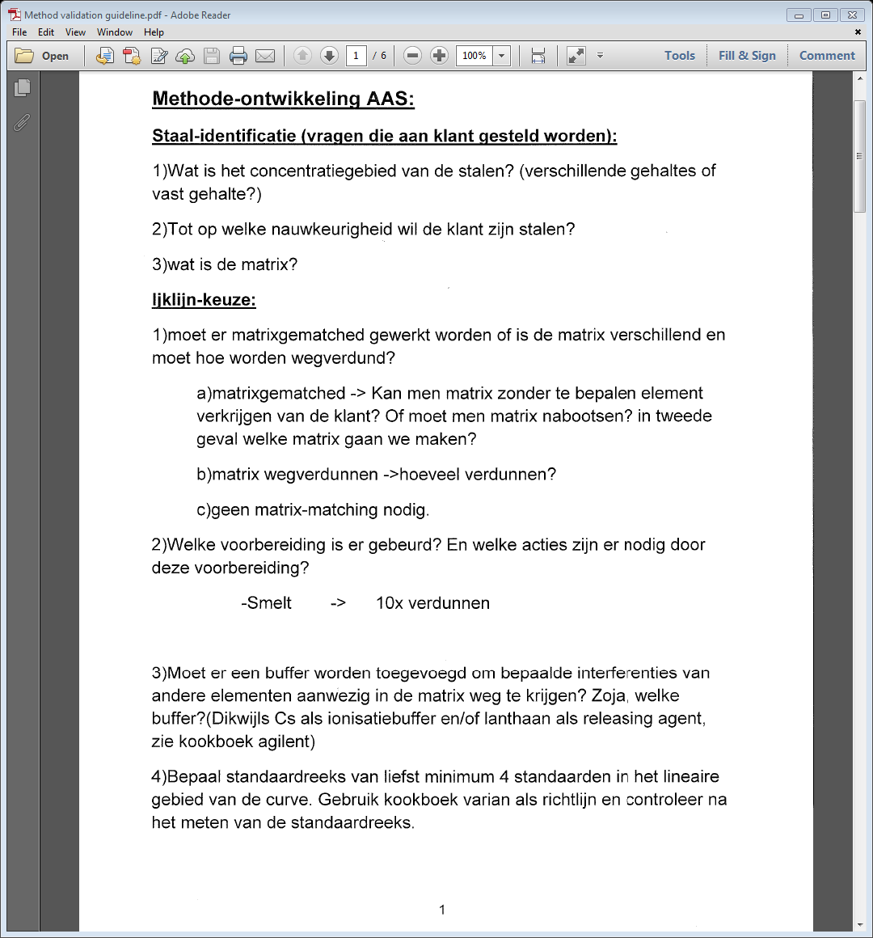

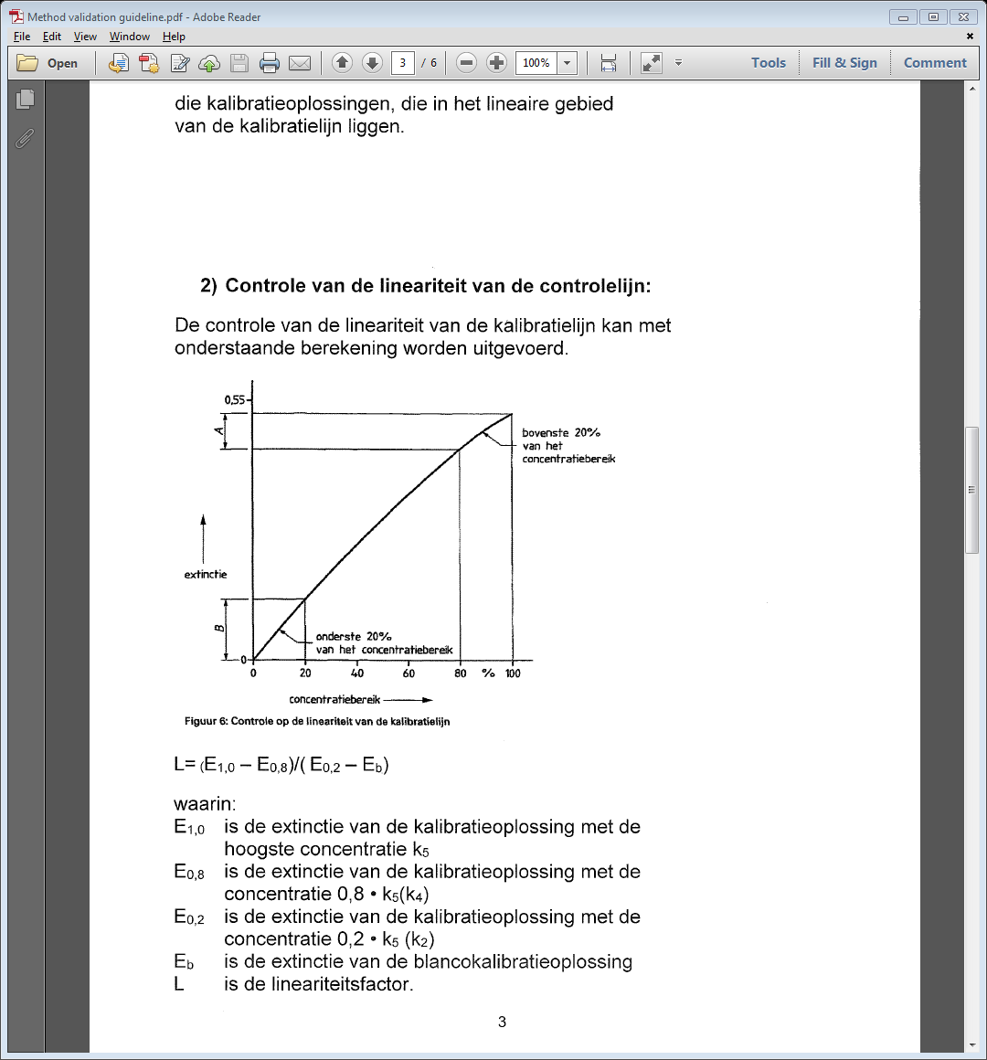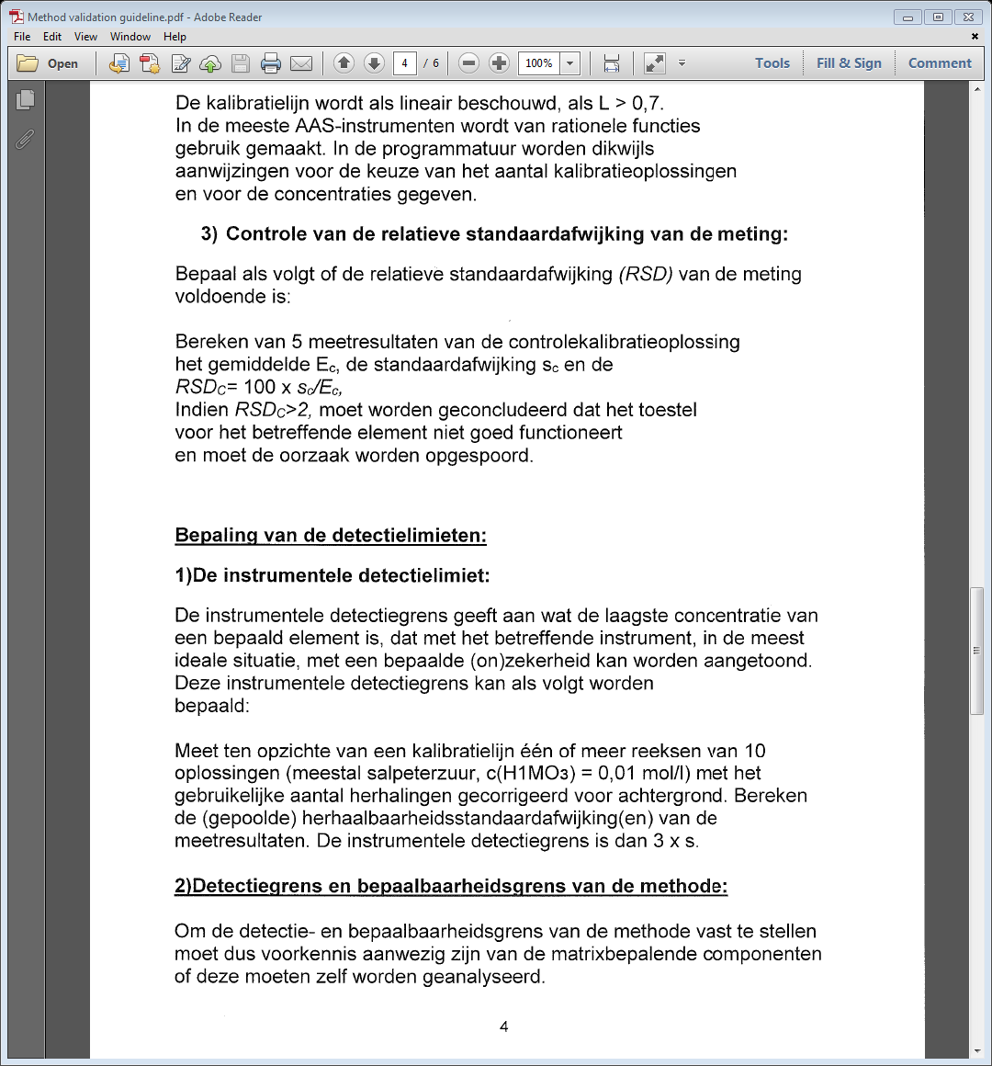

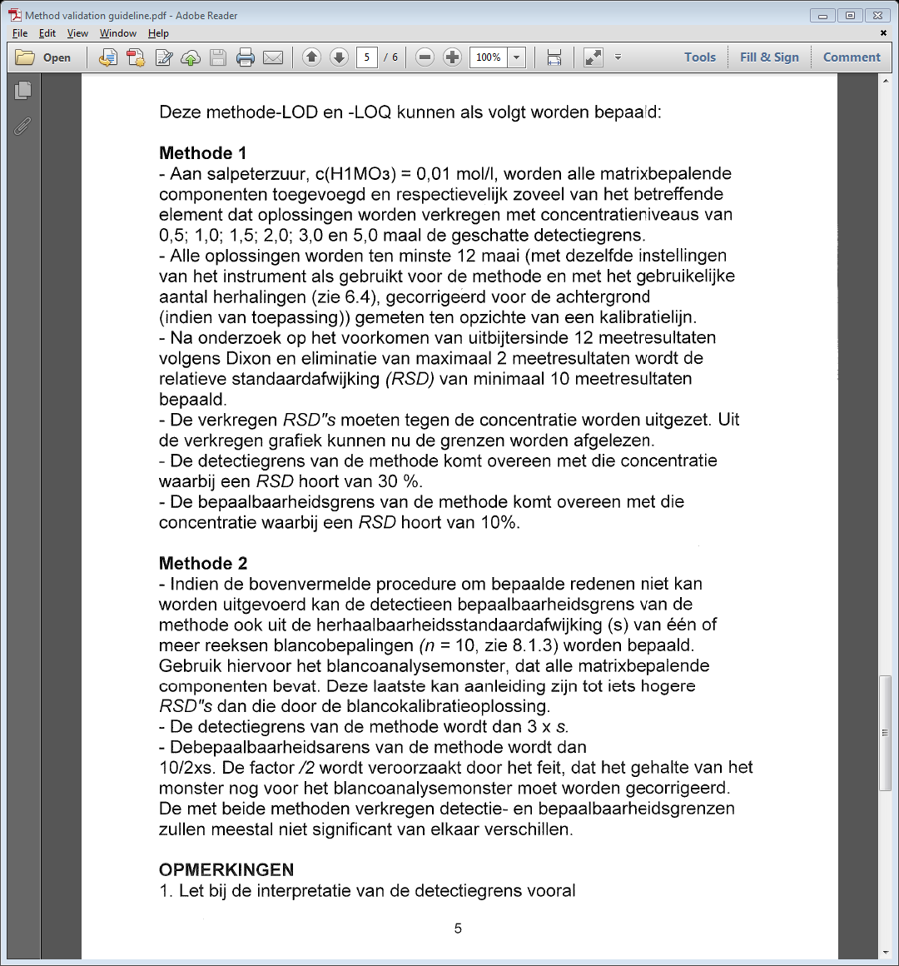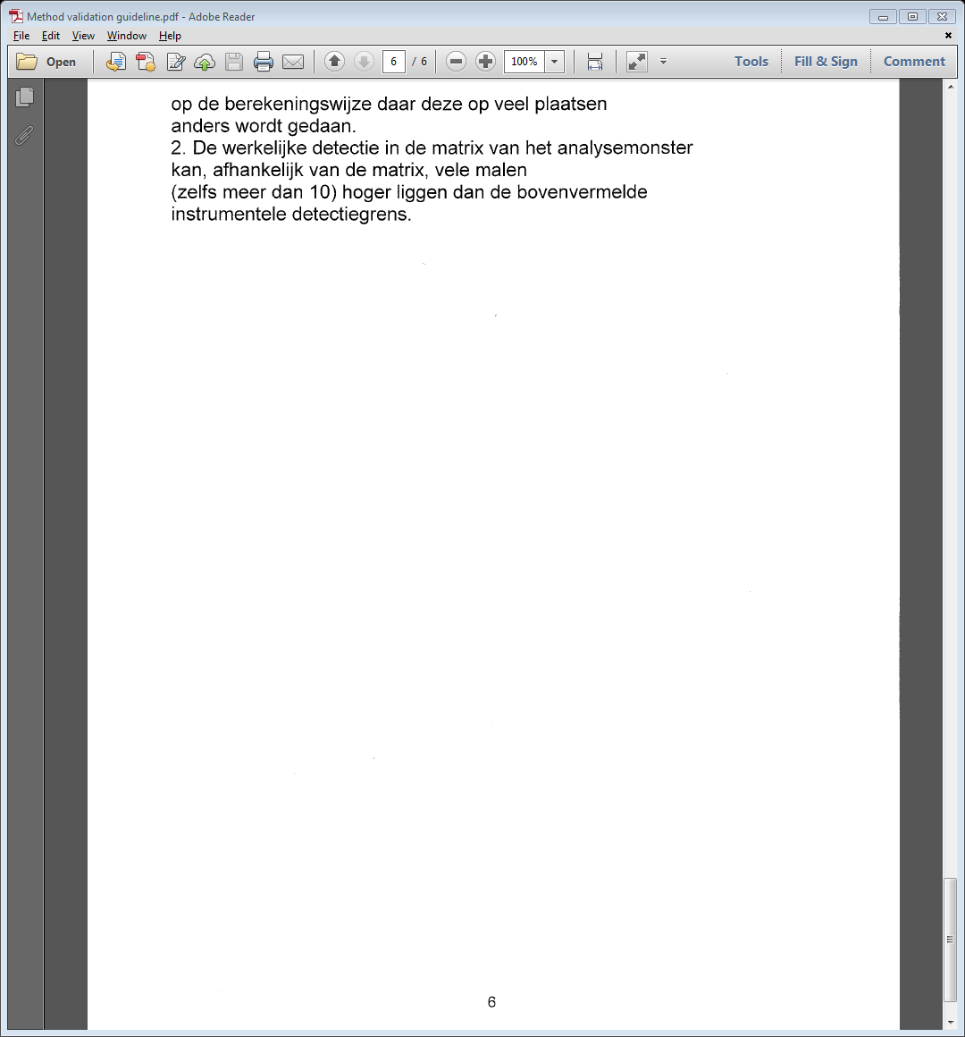

# Appendix C: determination of the working range

From the Agilent design document for the New Rational calculation, the linear range can accommodate for gentle sloping of the working range as long as all measurements are performed within the calibration range & the standards are evenly divided across the calibration range (Limbek & Rowe, 2010).

From the AAS guidelines (see Appendix A.1), the sloping of the working range should be:

$$L=\frac{{Abs}_{5}-{Abs}_{4}}{{Abs}_{1}-{Abs}_{blank}}≥0.7$$

Where *blank, 1, 2, 3, 4, 5* are calibration curve standards. This equation represents the ratio of the slope of the upper 20% of the graph compared to the bottom 20% of the graph. If L = 1, then the calibration curve is a perfect straight line.

As reported in the previous work, the ethanol:cyclohexanol dilution solvent may cause dampening of the signal (Stessens, 2016-2017). As a result, the working range is initially set as 0 – 50 ppm to serve as an estimate of the sloping of the range.

|  |  |  |  |
| --- | --- | --- | --- |
| Standard | Concentration (ppm) | Absorbance | Linearity |
| Blank | 0 | -0.0011 | L = 0.509 |
| 1 | 10.08 | 0.1464 |  |
| 2 | 20.06 | 0.2767 |  |
| 3 | 29.66 | 0.3889 |  |
| 4 | 39.92 | 0.4865 |  |
| 5 | 49.34 | 0.5616 |  |

Since the linearity is not greater than 0.7, 0 – 50 ppm is not an appropriate range for the calibration curve. The experimental data is then plotted on a graph to obtain the quadratic trendline of the dataset. This is then used to predict the linear range: the concentrations are set as fractions of one variable, while the calculated absorbance exclusively depends on the fraction of this variable. We define α as the highest concentration standard in a calibration of 5 standards.

The concentration range is then [ 0, $\frac{1}{5}$ α, $\frac{2}{5}$ α, $\frac{3}{5}$ α, $\frac{4}{5}$ α, α ] and the calculated absorbance (demonstrated for $\frac{1}{5}$ α) is ${{-9}_{×10}}^{-5}{\left(\frac{1}{5} α\right)}^{2}+0.0157×\left(\frac{1}{5} α\right)-0.0018$, where -9x10-5, 0.0157 and -0.0018 are the terms obtained from the trendline.

As there is only a singular variable for the entire calibration range, the Excel Solver can be used to determine the maximum allowable value of α with the constraint that L must be greater than or equal to 0.7.

Repeating this for three independent sets of 0 – 50 ppm experimental data shows the theoretical working range to be 0 – 30 ppm.

The image below shows a calibration curve where L is greater than 0.7, obtained on a clean burner.

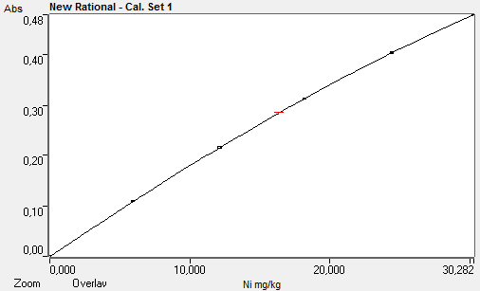

As the burner becomes fouled from use, the calibration curve shows the loss of signal, evidenced below. The following calibration curves are created from the same standards on the same day.

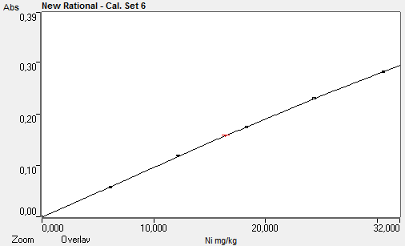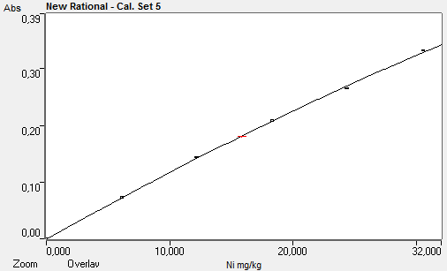

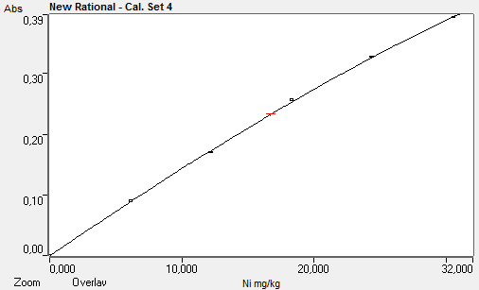

# Appendix D: Grubb test, regression analysis

|  |  |  |  |
| --- | --- | --- | --- |
| conc | absorbance | Grubb test | Gcrit |
| 0 | 0,0015 | 1,59 | 1,72 |
| 0 | 0,0004 | 0,30 |  |
| 0 | -0,0002 | 0,40 |  |
| 0 | -0,0003 | 0,51 |  |
| 0 | -0,0007 | 0,98 |  |
| 2 | 0,0398 | 0,17 |  |
| 2 | 0,0388 | 1,22 |  |
| 2 | 0,0394 | 0,59 |  |
| 2 | 0,0406 | 0,67 |  |
| 2 | 0,0412 | 1,30 |  |
| 5 | 0,0968 | 1,21 |  |
| 5 | 0,0983 | 0,72 |  |
| 5 | 0,1003 | 0,07 |  |
| 5 | 0,1033 | 0,92 |  |
| 5 | 0,1038 | 1,08 |  |
| 8 | 0,1500 | 1,08 |  |
| 8 | 0,1505 | 0,98 |  |
| 8 | 0,1562 | 0,20 |  |
| 8 | 0,1587 | 0,71 |  |
| 8 | 0,1608 | 1,15 |  |
| 10 | 0,1875 | 1,12 |  |
| 10 | 0,1888 | 0,88 |  |
| 10 | 0,1944 | 0,16 |  |
| 10 | 0,1966 | 0,58 |  |
| 10 | 0,2003 | 1,27 |  |
| 15 | 0,2653 | 1,21 |  |
| 15 | 0,2684 | 0,82 |  |
| 15 | 0,2775 | 0,31 |  |
| 15 | 0,2788 | 0,47 |  |
| 15 | 0,2850 | 1,24 |  |
| 20 | 0,3462 | 1,28 |  |
| 20 | 0,3530 | 0,66 |  |
| 20 | 0,3613 | 0,10 |  |
| 20 | 0,3666 | 0,59 |  |
| 20 | 0,3739 | 1,25 |  |
| 22 | 0,3711 | 1,25 |  |
| 22 | 0,3767 | 0,77 |  |
| 22 | 0,3889 | 0,28 |  |
| 22 | 0,3914 | 0,49 |  |
| 22 | 0,4001 | 1,24 |  |
| 25 | 0,4167 | 1,15 |  |
| 25 | 0,4249 | 0,49 |  |
| 25 | 0,4386 | 0,60 |  |
| 25 | 0,4440 | 1,04 |  |
| 28 | 0,4559 | 1,21 |  |
| 28 | 0,4629 | 0,70 |  |
| 28 | 0,4744 | 0,13 |  |
| 28 | 0,4784 | 0,42 |  |
| 28 | 0,4914 | 1,36 |  |
| 30 | 0,4794 | 1,28 |  |
| 30 | 0,4863 | 0,77 |  |
| 30 | 0,5024 | 0,42 |  |
| 30 | 0,5030 | 0,46 |  |
| 30 | 0,5127 | 1,18 |  |

None of the values exceed Gcrit for n=5, indicating that there are no outliers in this data range. Value for Gcrit at n = 5 obtained from literature (Miller & Miller, 2010).

# Appendix E: Grubb test, recovery

|  |  |  |  |
| --- | --- | --- | --- |
| ID | recovery % | G | Gcrit |
| 478+ | 81,0 | 3,6 | 3,0 |
| 508 | 87,8 | 2,3 |  |
| 512 | 91,1 | 1,7 |  |
| 502 | 93,7 | 1,2 |  |
| 479 | 94,1 | 1,2 |  |
| 512 | 95,4 | 0,9 |  |
| 514 | 95,5 | 0,9 |  |
| 511 | 95,6 | 0,9 |  |
| 513 | 95,8 | 0,8 |  |
| 502 | 96,2 | 0,8 |  |
| 502 | 96,3 | 0,8 |  |
| 511 | 96,4 | 0,7 |  |
| 511 | 96,9 | 0,6 |  |
| 488 | 96,9 | 0,6 |  |
| 512 | 97,2 | 0,6 |  |
| 502 | 97,3 | 0,6 |  |
| 508 | 97,5 | 0,5 |  |
| 479 | 98,0 | 0,4 |  |
| 479 | 98,1 | 0,4 |  |
| 481-2+ | 98,1 | 0,4 |  |
| 481-2+ | 98,9 | 0,3 |  |
| 496 | 99,3 | 0,2 |  |
| 502 | 99,3 | 0,2 |  |
| 508 | 99,7 | 0,1 |  |
| 496 | 100,2 | 0,0 |  |
| 502 | 100,3 | 0,0 |  |
| 488 | 100,6 | 0,0 |  |
| 513 | 100,6 | 0,0 |  |
| 490 | 100,8 | 0,1 |  |
| 502 | 100,8 | 0,1 |  |
| 478 | 100,9 | 0,1 |  |
| 480-2+ | 101,1 | 0,1 |  |
| 483+ | 101,3 | 0,2 |  |
| 502 | 101,3 | 0,2 |  |
| 514 | 101,5 | 0,2 |  |
| 479+ | 101,7 | 0,2 |  |
| 489 | 101,7 | 0,2 |  |
| 489 | 102,2 | 0,3 |  |
| 481-2+ | 102,4 | 0,4 |  |
| 484+ | 102,7 | 0,4 |  |
| 479+ | 102,9 | 0,4 |  |
| 478+ | 103,0 | 0,5 |  |
| 481-2+ | 103,0 | 0,5 |  |
| 488 | 103,2 | 0,5 |  |
| 487 | 103,2 | 0,5 |  |
| 481-2+ | 103,3 | 0,5 |  |
| 489 | 103,3 | 0,5 |  |
| 487 | 104,4 | 0,7 |  |
| 496 | 104,8 | 0,8 |  |
| 481-2+ | 104,9 | 0,8 |  |
| 488 | 105,0 | 0,8 |  |
| 478 | 106,1 | 1,0 |  |
| 488 | 108,1 | 1,4 |  |
| 488 | 108,6 | 1,5 |  |
| 480-2+ | 110,1 | 1,8 |  |
| 488 | 110,7 | 1,9 |  |
| 488 | 111,8 | 2,1 |  |
| 481-2+ | 112,4 | 2,2 |  |

The data point for 81% recovery (sample: 478+) exceeds Gcrit, indicating that this point is an outlier. Performing the Grubb test after removing this outlier does not produce any further outliers, indicating that the data range between 87.8% and 112.4% recovery can be used.

The Gcrit value for n = 58 and n = 57 are obtained from literature (Grubbs & Beck, 1972).

# Appendix F: SEM imagery of cobalt precipitate

360358

Mass%

O P S Co Ni Total

001 34.81 36.50 28.69 100.00

002 49.20 19.19 6.70 24.72 0.19 100.00

003 47.10 9.22 13.30 30.39 100.00

004 29.14 33.26 5.81 31.79 100.00

Title : IMG1

---------------------------

Instrument : 6480(LA)

Volt : 20.00 kV

Mag. : x 1,200

Date : 2019/04/11

Pixel : 512 x 384

370368

Mass%

O Si P S Cl Co Total

005 1.36 17.19 81.45 100.00

006 73.43 10.93 4.18 11.45 100.00

007 60.41 21.49 4.18 13.92 100.00

008 42.43 31.01 1.67 24.89 100.00

009 26.13 1.54 38.01 1.12 33.20 100.00

Title : IMG1

---------------------------

Instrument : 6480(LA)

Volt : 20.00 kV

Mag. : x 1,000

Date : 2019/04/11

Pixel : 512 x 384

380378

Mass%

O Si P S Cl Ca Ti Co As Total

010 53.52 44.46 0.69 0.75 0.59 100.00

011 40.11 6.70 23.98 3.72 25.49 100.00

012 60.46 17.11 1.48 2.91 0.91 13.69 1.65 1.78 100.00

Title : IMG1

---------------------------

Instrument : 6480(LA)

Volt : 20.00 kV

Mag. : x 1,000

Date : 2019/04/11

Pixel : 512 x 384