Extending the lifespan of a Semi-Submersible Drilling Rig
Improve safety, redundancy, downtime and workload on the Frida 1
Thesis

Author: J.W. Zoutendijk Date: 29-06-2021
Course: Graduation internship Version: 3.0
Education: Maritime officer all ships
Academic year: 2020-2021
Semester: 6
Institution: HZ University of Applied Sciences
Accompanying teacher: A. de Groot
Internship Company: OOS Energy Rig Management Services B.V.
Internship supervisor: R. Bosselaar
Place of publication: Serooskerke

Extending the lifespan of a Semi-Submersible Drilling Rig
Improve safety, redundancy, downtime and workload on the Frida 1
Thesis

Place of publication: Serooskerke
Date: 29-06-2021
Student number: 77889
Academic year: 2020-2021
Semester: 6
Study component: Thesis
Accompanying teacher: A. de Groot
Internship supervisor: R. Bosselaar
Version: 3.0

Preface
In front of you lies the thesis "Extending the life span of a Semi-Submersible Drilling Rig" which completes my bachelor's degree in maritime officer at the HZ University of Applied Sciences. This thesis concerns the research that was carried out for OOS Energy Rig Management Services B.V. (referred to as, OOS Energy) at Serooskerke. For OOS Energy I conducted this research on the possibility of converting the open-loop cooling system of the SSDR Frida 1 to a closed loop system. Graduating has been a very instructive process, in which I have gained a lot of new knowledge and skills.

I would like to thank a number of people who motivated and helped me during the entire process. First of all I would like to thank OOS Energy itself for the internship and the visit to the Bahamas. The inspection of five jack-up drilling rigs at the Bahamas was an experience that I learned a lot from and will remain an extraordinary memory forever. In addition to that I would like to thank my internship supervisor R. Bosselaar for his commitment, flexibility, patience and cooperation. I would also like to thank the staff of OOS Energy and International for their time and hospitality when I had any questions. In addition, I would like to thank my accompanying teachers Mr. de Groot and Mrs. Ooms-de Waal. Their positive feedback, knowledge, thinking along, time and effort that have contributed to the successful completion of this research. I would also like to thank the external party Alfa Laval for helping with calculations and quotations I could not have done it without their help. At last I would like to thank my parents, family and friends for the motivational words and thinking along. This helped me a lot.

I hope you enjoy reading.

Jip West Zoutendijk

Serooskerke, 29 June 2021
Executive summary
OOS Energy Rig Management Services B.V is specialized in reactivating stranded assets. OOS Energy is mainly involved in oil and gas extraction. As rig manager OOS Energy is the connecting link between rig owner and Oil Company. The Semi-Submersible Drilling Rig Frida 1 is one of the rigs currently managed by OOS Energy. At the moment the Frida 1 is operational in the Gulf of Mexico. When she was built in 2011, she was equipped with a cooling system which is fully cooled by outboard water. Now that the Frida 1 is operational at the Gulf of Mexico, she struggles with the disadvantages of such an open-loop system.

In the past a project had started to convert her open-loop system to a closed-loop system. This project was in an advanced stage, plans had been approved by the classification society and purchases such as heat exchangers and pumps were made. Unfortunately execution of this project never took place. The effects from the flaws of the old system are, a lower safety and redundancy and a higher downtime and workload. Many pipelines are replaced due to corrosion or clogging up. Dozens of filters need cleaning weekly to keep the system operational. Currently the rig is 10 years old and is built with a life span of 15 years. This means that the rig will reach the end of its life time in 5 years, OOS Energy would like to extend her life span by undertaking these kind of projects.

The accompanying question is:
How can the current plan to fit the SSDR Frida 1 with a closed-loop cooling water system be implemented?

The purpose of this research is to increase safety and redundancy and to decrease downtime and workload. For this research desk research and quantitative research have been conducted. It has emerged that multiple mistakes are made by the previous intent of conversion. This has led to insufficient capacity of the plate heat exchangers and an incorrect design.

For the Four columns system the calculations show that an additional 60 plates per heat exchanger will provide enough capacity to operate with a sea water temperature of 32°C. The carrying bars and tightening bolts need replacement because they cannot house the additional 60 plates. For the mid ship system it is impossible to solve this problem by adding plates, therefore a different solution should be investigated. This answer could lay in the operation of the drilling braking resistors.

New designs are made to improve the operation and maintenance of the systems. With the new design the probability of cavitation on the impellers of the pumps is reduced to a minimum. Because of costs, maintenance, corrosion resistance and weight, Glass Reinforced Epoxy is the recommended material to use for piping.

The results show that the minimal investment costs for the conversion of the Four Columns systems are € 345.581. It is recommended to install new gaskets which costs are € 19.030. For the Mid Ship system the minimal investment costs are €123.856. Although not necessary it is recommended to install new gaskets and an additional 28 plates per heat exchanger. These costs are € 23.914 and €41.559.
Table of content
Explanation of used abbreviations 1
1. Opening 2
2. Theoretical framework 4
2.1 Requirements classification society 4
2.2.1 Commissioning process 4
2.2.2 Involvement in commissioning 6
2.2.3 Requirements related to marine, utility and safety systems 7
2.2.4 Documentation 7
2.2.5 Design regulations 8
2.2 Design 9
2.2.1 Valves 9
2.2.2 Sensors 9
2.3.3 Filtration 10
2.3 Hardware 11
2.3.1 Corrosion 11
2.4.2 Piping 12
2.3.3 Marine Growth Prevention System 16
2.3.4 Cathodic protection 17
2.3.5 CIP-unit 17
2.3.6 Filters 18
2.3.7 Cooling water treatment 19
2.4 Calculations 21
2.4.1 Equations 21
2.4.2 Data 22
2.5 Installation 23
2.5.1 Commissioning 23
2.5.2 Costs 23
2.5.3 Man hours 25
2.6 Conceptual framework 26
2.7 Notions and definitions 27
3. Method of research 28
3.1 Method per sub-question 28
3.2 Reliability and validity 29
3.2.1 Reliability 29
3.2.2 Validity 29
4. Results 30
4.1 DNV 30
4.2 Designs 31
4.2.1 New design 31
4.2.2 P&ID’s 31
4.3 Calculations 32
4.3.1 Heat exchangers 32
4.3.2 Four Columns 33
4.3.3 Mid Ship 34
4.3.4 Verification of calculations 38
4.3.4 Header tank 39
4.4 Costs and parts 41
4.4.1 Parts 41
4.4.2 Four Columns 43
4.4.3 Mid Ship 43
5. Discussion 44
6. Conclusion 45
7. Recommendations 46
Bibliography 47
Appendix 1: Schematic overview old design 52
Appendix 2: Detailed overview old design 53
Appendix 3: List of ordered parts 54
Appendix 4: Old calculation Four Columns 55
Appendix 5: Old calculation Mid Ship 56
Appendix 6: Explanation of symbols 57
Appendix 7: Conversion table pipe diameter 58
Appendix 8: Conversion table for standardised pipe diameters 59
Appendix 9: New P&ID design Mid Ship 60
Appendix 10: New P&ID design Port aft Column 62
Appendix 11: New P&ID design Port FWD Column 63
Appendix 12: New P&ID design STBD aft Column 64
Appendix 13: New P&ID design STBD FWD Column 65
Appendix 14: Technical drawing Four Columns plate heat exchanger 66
Appendix 15: Technical drawing Mid Ship plate heat exchanger 67
Appendix 16: New parts list Four Columns 68
Appendix 17: New parts list Mid Ship 70
Appendix 18: Parts and price lists Four Columns 72
Appendix 19: Parts and price lists Mid Ship 75
Appendix 20: Quotation Alfa Laval plate heat exchangers 79

Explanation of used abbreviations
Abbreviation | Explanation
CIP | Cleaning in place
DN | Diameter nominal
ESD | Emergency shut down
F&G | Fire and gas
FRP | Fibre reinforced plastic
FW | Freshwater
FWD | Forward
GRE | Glass reinforced epoxy
GRP | Glass reinforced plastic
GRV | Glass reinforced
ICCP | Impressed Current Cathodic Protection
MC | Mechanical completion
MGPS | Marine growth protection system
NPSHa | Net positive suction head available
NPSHr | Net positive suction head required
P&ID | Piping and instrumentation diagram
PSD | Process shutdown
PTFE | Polytetrafluoroethylene
QSP | Quality survey plan
RTRP | Reinforced Thermosetting Resin Pressure Pipe
SS | Stainless steel
SSDR | Semi-Submersible Drilling Rig
STBD | Starboard
SW | Seawater

1. Opening
The issue:
The Frida 1 is a Semi-Submersible Drilling Rig (SSDR) operational in the Gulf of Mexico. When she was built in 2011, she was equipped with a cooling system which is fully cooled by outboard water. Now that the Frida 1 is operational at the Gulf of Mexico, she struggles with the disadvantages of such an open-loop system. In the past a project had started to convert her open-loop system to a closed-loop system. This project was in an advanced stage, plans had been approved by the classification society and purchases such as heat exchangers and pumps were made (see appendix 3). Unfortunately execution of this project never took place and the current status is not clear.

The effects from the flaws of the old system are, a lower safety and redundancy and a higher downtime and workload. Many pipelines are replaced due to corrosion or clogging up. Dozens of filters need cleaning weekly to keep the system operational. Currently the rig is 10 years old and is built with a life span of 15 years. This means that the rig will reach the end of its life time in five years, OOS Energy would like to extend her life span by undertaking these kind of projects.

Objectives:
This research is a recommendation to OOS Energy on how to convert the cooling water system of the Frida 1 to a closed-loop system. This conversion has the objection to improve safety, redundancy, maintainability, life span, downtime and workload.

The current system in place consists out of eight separate Seawater (SW) systems. The rig floats on two pontoons one on starboard (STBD) and one on port. On each end of a pontoon, forward (FWD) and aft, there are two azimuth thrusters with their cooling system. This makes a total of eight thrusters and four cooling systems. On the aft port and STBD side the pumps for the engine cooling system are located. On the FWD port and STBD side the pumps for all the auxiliary equipment are located. This last system is a large and complex system which reaches all over the rig. This system is referred to as the Auxiliary Cooling System. The other systems are relatively small and straight forward. SW is not only used to cool machinery but also for sanitary, freshwater (FW) generator, mud shakers, etc. when the SW is used it goes directly overboard.

The plan of converting from SW to FW is only for the auxiliary cooling system. The other cooling systems will be disregarded. The auxiliary cooling system are divided in five separate systems (see appendix 1) the four columns port FWD, STBD FWD, STBD aft, port aft and one for the mid ships equipment. The four column systems are identical designs as they all serve the same purpose of cooling the transformers, frequency drives, AC’s and condenser at each column. The mid ship system consist out of: transformers, frequency drives, AC’s and braking resistors for the drilling equipment and AC units.

Main question:
How can the current plan to fit the SSDR Frida 1 with a closed-loop cooling water system be implemented?

Sub-questions:
- Which rules and requirements from the classification society apply to the conversion?
- Which modifications are needed to the current design?
- Which additional materials should be ordered for optimal operation of the system?
- How can parameters of the new design be checked and calculated?
- Which measures should be taken when commissioning the system?
- What are the costs for the conversion?

The main question is answered by answering the sub-questions. All the theories available and relevant for this research are summed up in the theoretical framework. This framework contains the regulations, calculations, requirements etc. which are the lead to answering the questions.

Preconditions:
In order to realize the system, it will have to meet a number of conditions. The system must be built with a small budget. Future maintenance, weight and volume of the system must be taken into account. The system must be standardized and safe. The installation should be carried out with as little downtime as possible.

Reading guide:
The theoretical framework starts with the regulations from DNV for a closed loop cooling system on SSDR’s. Next the design properties and the hardware needed for such a system is investigated. The following part contains theory from other closed loop systems and the formulas to calculate such. Now that the complete process is well understood, an estimate on the costs can be made. The conceptual framework in 2.6 is a visual representation of the expected cause-effect relationship in this research and what relationships are expected between variables and how they relate to each other.

The methods used to collect all the data that answer the questions are listed and explained in the chapter “Methods”. In addition to this the reliability and validity of the data is analysed.

All the results from the research conducted are listed in chapter 4. These findings are the answers to the sub-questions. The reliability of these findings is discussed in chapter 5. The conclusions that can be drawn from the findings are explained in chapter 6. As a closure in chapter 7, the recommendations towards OOS Energy for conducting the conversion are discussed.

2. Theoretical framework
In this theoretical framework contains relevant concepts, definitions, models, theories related to the research topic and al information available to answer the sub-questions.

2.1 Requirements classification society

2.2.1 Commissioning process
Chapter 2.2.1 refers to class guideline DNVGL-CG-0170 page 9 to 12 (DNVGL, 2015). With all steps from design to commissioning the classification society is taken along. DNV has set a nine step commissioning process, see Figure 1, that they highly recommend using. 2.2.1 Explains these steps one by one. While the requirements for the testing and commissioning are clearly specified in various applicable DNV standards, how exactly the commissioning activities should be carried out is largely left to the builder/owner of the mobile offshore units. For instance, there will be dependencies between the different packages. It is however a DNV requirement to prove that the testing requirements mentioned in the rules are carried out during commissioning.

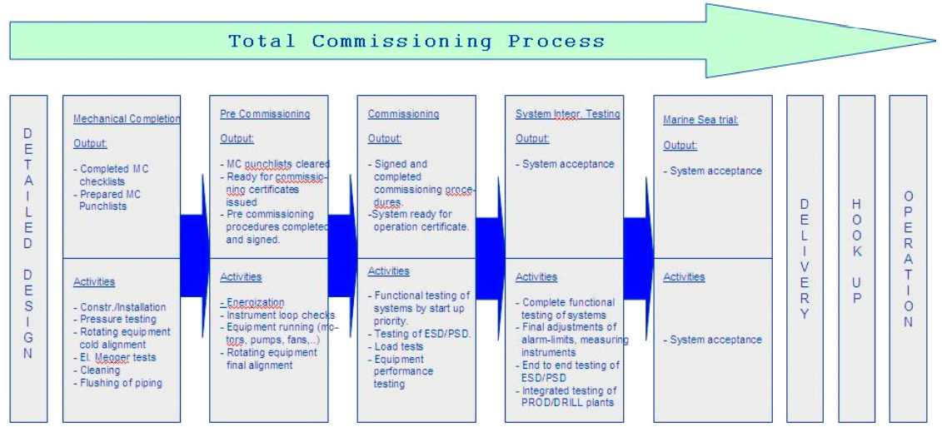
Figure 1 Total commissioning process (DNVGL, 2015)

Detailed designs
After this step the project transfers from the desk to the field. OOS Energy has the responsibility of providing detailed designs which are fully completed, reviewed and approved. It is important that designs are approved before manufacturing as changes in design can be demanded by the class. DNV advises to have the design engineers available during the commissioning stages. The design engineer can then confirm completion of the design activities and advise what needs to be rectified, redesigned and followed up on.

Mechanical completion
A mechanical completion checklist covers all activities that need to be accomplished to finish the mechanical completion (MC) stage. Only some parts of MC are covered by the DNV Offshore standards and is thus formally DNV scope of work. The class maintains oversight on most of the MC activities by doing unscheduled surveys. The quality survey plan (QSP) lists certain activities of MC where the presence of a surveyor is mandated. Some examples are:

- Pressure testing
- Alignment
- Cable installation
- Megger tests

These dynamic tests are limited to non-energized tests. The evidence of the required certification of equipment should be verified during the MC stage. MC is accomplished when construction and installation of equipment has been demonstrated as physically complete.

Pre commissioning
This stage involves the verification of functional operability of parts or full systems. This means energizing of equipment and adding fluids to the system. Although there are test performed in this phase which are required by the rules a surveyor may not be present. The surveyor will therefore make sure these tests are executed during the commissioning phase. Pre commissioning typically includes:

- Loop testing
- Motor no load runs
- Equipment final alignment

Commissioning
For classification the commissioning phase refers to final checks, inspection and tests that every operational component or system goes through to confirm operational readiness, working as intended and the requirements by the rules are met. This typically consists out of:

- Functional testing of systems by start-up priority
- Testing of Emergency shut down (ESD)/Process shut down (PSD) and fire and gas system (F&G)
- Load tests and other equipment performance testing

For this step a procedure should be submitted to the classification society for review/approval an example can be found in section four of guideline DNVGL-CG-0170.

System integration testing
System integration testing is testing and commissioning of more than one system to ensure compliance with project requirements. Often tests are carried out during marine sea trails as relevant systems may be required to be operational. This testing is mend to cover the following but not limited to:

- Complete functional testing of systems across equipment boundaries
- Final adjustments of alarm-limits, measuring instruments
- End to end testing of ESD/PSD and F&G
- Integrated testing of production/drill plants

For this step a procedure should be submitted to the classification society for review/approval an example can be found in section four of guideline DNVGL-CG-0170.

Operation
Once the unit is in operation, there should not be any major outstanding class and statutory items.

2.2.2 Involvement in commissioning
DNV’s involvement in testing and commissioning is limited to the requirements of statutory and class rules. DNV surveyor will attend testing and commissioning to the extent specified in applicable QSP.

The survey scope is categorized as followed:
- Category 1: Statutory and essential systems for safety, normally increased attendance by DNV.
- Category 2: Main systems/functionally important, for main and additional classification notations.
- Category 3: Normal limited or no attendance required by surveyor.

Category 1 systems for commissioning (for integration)
No. | Name of system | Integrated with
5 | Seawater cooling system | Consumer capacity test
6 | Thruster Seawater Cooling System | S/T
18 | Column and Pontoon Machinery Rooms Ventilation Systems | ESD

Category 2 systems for commissioning (for integration)
No. | Name of system | Integrated with
4 | Auxiliary Cooling Fresh Water System (#2) | S/T & SIT
5 | 460V LV Switchboard | S/T
6 | 230V LV Switchboard | S/T

Category 1 systems for commissioning (as independent systems)
No. | Name of system
13 | Emergency SWBD

Category 2 systems for commissioning (as independent systems)
No. | Name of system
10 | Seawater cooling system
12 | Thruster Seawater Cooling System

Category 3 systems for commissioning (as independent systems)
No. | Name of system
8 | Aux. cooling FW system
14 | MGPS (Marine Growth)
16 | 460V LV Switchboard (or equivalent)
17 | 230V LV Switchboard (or equivalent)

2.2.3 Requirements related to marine, utility and safety systems
(DNVGL, 2015)

System / equipment description | DNV OS / rule reference
Fabrication and testing of offshore structures
Corrosion protection systems | DNVGL-OS-C401 Ch.2 Sec.5 [1.5]
Marine and machinery systems and equipment
All systems / equipment | DNVGL-OS-D101 Ch.3 Sec.1 [5.1 to 5.3]
All piping systems | DNVGL-OS-C301 Ch.2 Sec.2 [3.2]
 | DNVGL-OS-D101 Ch.2 Sec.1 [1.7]
 | DNVGL-OS-D101 Ch.2 Sec.2 [5.2]
 | DNVGL-OS-D101 Ch.2 Sec.6 [6.1/6.2]
 | DNVGL-OS-D101 Ch.2 Sec.6 [7.1]
Pump hydrostatic testing | DNVGL-OS-D101 Ch.2 Sec.2 [4.2]
Pump capacity testing | DNVGL-OS-D101 Ch.2 Sec.2 [4.3]
Electrical installations
Electrical distribution systems | DNVGL-OS-D201 Ch.2 Sec.3 [3.1]
 | DNVGL-OS-D201 Ch.2 Sec.10 [4.3]
 | DNVGL-OS-D201 Ch.2 Sec.10 [4.4]
Parallel connected cables | DNVGL-OS-D201 Ch.2 Sec.2 [10.6]
Cooling and anti-condensation | DNVGL-OS-D201 Ch.2 Sec.3 [4.2]
Instrumentation and telecommunication systems
Failure response | DNVGL-OS-D202 Ch.2 Sec.1 [3.2]
On-board testing | DNVGL-OS-D202 Ch.2 Sec.1 [5.5]
 | DNVGL-OS-D202 Ch.2 Sec.2 [1.4]
 | DNVGL-OS-D202 Ch.2 Sec.4 [4.1]
DNV survey scope for production
Drainage systems | DNVGL-OS-E201 Ch.2 Sec.2 [7.1]

2.2.4 Documentation
(DNVGL, 2016)
All changes in piping systems, which are covered by the scope of class, are subject to approval and survey. All changes shall be specified. This applies for new, existing systems or addition of class notations. Systems shall always be in compliance with the latest edition of the rules. The submitted documents shall be:

- Updated engine room arrangements
- Schematic drawings of piping systems with clear identification of modifications
- In case of a new class notation documents required by the rules shall be submitted

2.2.5 Design regulations
(DNVGL, 2018)

Marine and machinery systems and equipment, DNVGL-OS-D101
Chapter 2, Section 1 | Design principles
 | Construction and function
 | Personnel protection
Chapter 2, Section 2 | General piping design
 | Design conditions
 | Pumps
 | Detachable pipe connections
 | Socket welded joints and slip-on sleeve welded joints
Chapter 2, Section 4 | Machinery piping system
 | General
 | Cooling systems
Chapter 2, Section 5 | Machinery and mechanical equipment
 | General marine equipment
Chapter 2, Section 6 | Pipe fabrication, workmanship, and testing
 | Welding
 | Brazing of copper and copper alloys
 | Pipe bending
 | Joining of plastic pipes
 | Hydrostatic tests of piping
 | Functional testing
Chapter 3, Section 2 | Certification of materials and components
 | Principles

2.2 Design
(Farmerie, 2018) Explains how to optimize a closed-loop system. All closed-loop systems basically have the same lay-out. Figure 2 is a good example of a basic closed-loop system. The expansion tank is connected at the inlet of the pumps to maintain sufficient Net Positive Suction Head Available (NPSHa). When a heat exchanger starts fouling this will result in a flow restriction and there for a large pressure difference over the cooler. If the heat exchanger would be connected on the inlet side of the pump this would result in a high vacuum which can lead to cavitation. There for the plate heat exchanger is installed on the outlet of the pump. After the coolant is cooled it is distributed to the machinery from where it will return to the pumps and circulate continuously. Appendix 1&2 show the previous design.
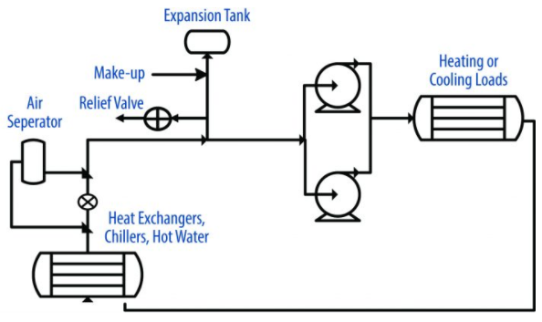
Figure 2 Closed-loop cooling system (Farmerie, 2018)

2.2.1 Valves
Valves are used to stop fluid passing through. Many types of valves are used in several locations for multiple purposes. Figure 3 shows the application of closing valves and check valves on three pumps installed in parallel. In normal running conditions the closing valves will be in an open position. The check valves prevents the duty pumps, pumping into the standby pump. (Robinson, 2019) The idea behind parallel connected pumps is the ability to add or subtract flow capacity and provide redundancy to the system (Kaila, 2016).
Figure 3 pumps installed in parallel (Robinson, 2019)

If the outlet and inlet of a heat exchanger are connected via a pipe and valve as in Figure 4 it is possible to back flush the cooler. Back flushing is the reversal of flow for a short period of time. This will flush out matter that has gathered on the inlet. Doing this on a regular basis will contribute to many years of trouble-free service (Laval, N.D.).
Figure 4 Back flushing (Zoutendijk, 2021)
Figure 5 Normal operation (Zoutendijk, 2021)

2.2.2 Sensors
Sensors are parameters that give an indication, at different stages, on the functioning of the system. Level, temperature and pressure sensors are the three most commonly used sensors. Sensors can either be digital or analogue. Important data will digitally be visible in the engine control room and are guarded with an alarm (Farmerie, 2018).

Level
It is important to be able to monitor the level of coolant inside the expansion tank. This can be done, analogue and accurately, by a magnetic level indicator. Or digitally as a safety feature with float switches as in Figure 6. These level switches are low cost and easy to install and there for the most suitable for this application (Musasino, N.D.).
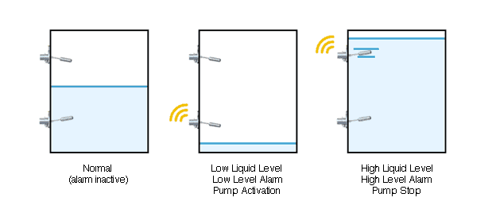Temperature
Figure 6 Level switches in expansion tank (Musasino, N.D.)
Temperature sensors give an indication on the functioning of the heat exchangers. Therefor it is important to fit at least an analogue temperature sensor before and after the heat exchangers. (Bader, N.D.) Recommends to install temperature sensors directly at the in- and out-let. Of great importance is the temperature of the feed and returning coolant of the machinery. Therefor it is recommended to have a digital sensor at the feed and return line and analogue temperature sensor at every outlet of a machine.

Pressure
The pressure difference between the in- and out-let of a filter or heat exchanger gives an indication of the resistance coolant experiences to pass through. If the pressure difference rises this is an indication of increased fouling. To reduce this, cleaning will be necessary on a regular basis. To be able to perceive this it is necessary to have one analogue pressure gauge before and after every filter and heat exchanger. Most pumps are manufactured with a pressure gauge on the in- and out-let flange. These two pressures indicate the functioning of the pump and are therefore important parameters (McMillan, N.D.).

2.3.3 Filtration
A filter removes particles that the fluid takes along. (GCF, 2015) Separates filters and strainers by: “Filters remove particulates that are smaller than 40 microns and strainers remove particulates that are larger than 40 microns.” In a research (Thomas, 1979) advises to use a mesh size of 14 till 35, which corresponds with 1.4 to 0.5 mm, to use for fine filtration of sea water and coolant. For this mesh size a strainer can be used. (Supply, N.D.) The function of a strainer is to remove larger unwanted particles from the fluid. And with that protecting downstream equipment, like pumps and heat exchangers, from damage and fouling.

2.3 Hardware

2.3.1 Corrosion
The main problems the system is dealing with are corrosion and fouling of pipelines and coolers. The forms of corrosion and the possible prevention methods in various piping systems according to (Engineering, N.D.) are:

Uniform corrosion:
- Cathodic protection
- Inhibitors
- Protective coatings
- Selecting proper materials

Galvanic corrosion:
- Provide electrical insulation between the metals
- Choose alloys closer in the galvanic series
- Provide design in structure so as to make anodic to cathodic ratio extremely large
- Coat both anode and cathodic areas. Otherwise coat only the cathode
- Protect the corroding metal with a sacrificial anode, which is anodic to the corroding metal

Crevice corrosion:
- Avoid riveting, go in for welding
- Design for proper drainage
- Go for stainless steels (SS) high Mo content (316,317 and Haste alloys) reduces crevice corrosion
- Remove deposits
- Use solid non-absorbent gaskets

Pitting corrosion:
- Eliminate the specific ions responsible for pitting ( halides in the case of SS)
- Choose alloy resistant to pitting. In SS high Mo promotes resistance (haste alloys, duplex SS)
- Mild steels serve better in chloride environment than SS if certain amount of uniform corrosion is tolerated. Monel has more resistance in this environment.

Selective leaching:
- Addition of any one of the elements namely Sn, As, Sb and P
- Al addition reduces overall corrosion and to some extent dezincification

Intergranular corrosion:
- Choose low carbon and extra low carbon stainless steels (such ss are 3041, 3161, 3171)
- Choose Ti or Ta and Nb containing alloys (321,347)
- Provide a solutions treatment to re dissolve the carbides (1050 °C, 30 m)

Erosion corrosion:
- Reduce the velocity of the medium
- Choose hard materials
- Avoid sharp turns
- Provide hard coatings

Stress corrosion cracking:
- Select the alloy that is not susceptible to the environment
- In the case of SS control either Cr or O2. As seen from the we can keep either one of them low
- Apply load lower than the threshold stress
- Provide compressive stresses by sand blasting. or shot blasting
- Avoid stress concentration

Cavitation damage (Rodelta, ND):
- Low liquid temperatures. At higher temperatures the probability of cavitation increases due to the higher vapour pressure
- High inlet pressure. At higher pressures the probability decreases because the margin with the vapour pressure increases
- Use of exotic materials which are more resistant to cavitation.
- A good hydraulic design
- a well-developed inlet flow

According to (Anderson Process, 2020) cavitation occurs when the temperature and pressure of the liquid at the suction of the impeller equals the vapour pressure. This is also called inadequate NPSHa. This type of cavitation occurs when a centrifugal pump imparts velocity on a liquid as it passes through the eye of the impeller. Ways to prevent cavitation due to vaporization from happening are:

- NPSHa > NPSHr + 3 foot or more safety margin
- Lower temperature
- Raise liquid level in suction vessel
- Change out pump type
- Reduce motor RPM
- Use impeller inducer
- Increase diameter of the eye of impeller

The Net Positive Suction Head Required (NPSHr) is a function of the pump design determined by a pump test at the manufacturer and listed on the pump curve. As the liquid goes from the inlet flange to the inlet of the impeller in the pump, the speed increases and the pressure decreases. There are pressure losses due to turbulence when the fluid hits the impeller. The centrifugal force of the impeller blades increases the speed even more, reducing the pressure even further. The NPSHr is the positive height, expressed in absolute meters of water column, on the suction side of the pump that is required to compensate for these pressure losses in the pump and to ensure that the liquid remains above its vapour pressure. The NPSH is always positive as it is expressed in absolute liquid height. The NPSHr is independent from the specific gravity of the liquid. The NPSHa must always be higher than the NPSHr for the pump to function properly. (Revisie, 2020).

2.4.2 Piping
According to (Piping-World, 2019) there are three options for piping, Reinforced Thermosetting Resin Pressure Pipe (RTRP), ferrous and non-ferrous piping. (DHF, N.D.) Adds Polytetrafluoroethylene (PTFE) lined pipes to this list. Each type has its own advantages and disadvantages. The most suitable material for a piping system depends on many factors, such as:

- Easy availability of materials
- Suitability for the design
- Life span
- Corrosion resistance
- Compatibility of material with the process fluid
- Suitability of the material for the design temperature and pressure and cyclic loading
- Suitability of materials for the environmental conditions
- Potential ultraviolet degradation of the materials
- Past experience with material for similar applications
- Additional requirements for corrosion protection such as cathodic protection, chemical injection, inspection, corrosion monitoring and any environmental impact due their implementation
- Weight reduction
- Fabrication, Inspection, Installation and maintenance costs
- Evaluation of failure probabilities, failure modes and consequences

RTRP (Reinforced thermosetting resin pressure piping)
Glass reinforced plastic (GRP), Glass reinforced epoxy (GRE) and Glass reinforced vinylester (GRV) are abbreviations for types of RTRP also known as fibre reinforced plastic (FRP). These types differ on the type of resin systems used for manufacturing. It is a composite material consisting of glass fibre reinforcements, thermosetting plastic resins and additives. The piping gains its strength from the glass fibre. Pipes with polyester resin, known as GRE, have a service temperature range of 50 to 75°C. Vinylester resin, known as GRV, has a range of 75 to 100°C. The great advantages of RTRP piping are:

- corrosion resistance to SW
- much lighter than steel piping 1/6 of the weight
- low friction coefficient which results in les friction losses and energy consumption of pumps
- no need for external corrosion and cathodic protection
- does not provide nourishment to marine life and hence fouling is not common
- cheaper and faster to install than carbon steel

The classification society has additional standards and regulations for the production and use of RTRP piping. DNV has adopted the guideline IMO Resolution A.753(18) for the application of plastic pipes on ships (Piping-World, 2020).

FRP has a Low elastic modulus. The elastic modulus of FRP is 10 times smaller than that of steel (E=2.1×106). Because of this low elastic modulus it cannot be used in structural applications. FRP is susceptible for heat and cannot be exposed to high temperatures for a long time. The strength of polyester FRP decreases when reaching temperatures above 50°C, and is generally used under temperatures of 100°C. Resins resistant to high temperatures make it possible to operate in temperatures of 200-300°C. The phenomenon of aging is a common defect of plastics as well as FRP. Its performance will be reduced because of ultraviolet. Special resins that are ultraviolet resistant can be used to eliminate this problem (World iron&steel, 2020).

GRE is often used for ballast and brine pipes. The use of plastic pipes elsewhere in a system is restricted because of the requirement to pass a standard test for fire-resistance. It is not usual for plastic pipes to be constructed in a way that will enable them to pass the most stringent, level 1, fire test. If plastic pipes are to be used, the fire-resistance rating and classification society rule requirements must be checked first (Murdoch, 2012).

Thermal expansion of fiberglass piping is two to five times that of steel. Axial modulus of elasticity is less than 1/10th of that of steel. This results in fiberglass piping being significantly more flexible than steel pipe. This property makes offset legs in fiberglass piping systems very effective at absorbing thermal expansion of the piping (Piping-World, 2020).

FRP pipe is more susceptible to impact damage due to the brittle nature of the thermoset resin. Installing FRP requires, in comparison to steel piping, more preparation due to other joining methods, handling, transportation and installation techniques. Because of the flexibility FRP piping system require specific support brackets. To join FRP with another type of material, a flange would be the most appropriate way. Flanges can be drilled according most of the relevant standards. When a flanged FRP pipe section is joined with a metal pipe section, the metal section must be anchored to avoid transmission of loads and displacements to the FRP pipe sections (Wavistrong, N.D.).

Ferrous
Carbon Steel
Low carbon steel contains 0.05% to 0.25% of carbon. This low percentage of carbon makes it easy to cut, form, and weld. It is the cheapest steel of the carbon steels to produce and buy, and has a wide variety of uses. It is mainly used in the production of car parts, pipelines, and ornamental uses. In comparison to other steels carbon steel is more susceptible to rust and corrosion. Therefore needs additional protection (Monroe, 2018).

Stainless Steel
Depending on the alloys stainless steel has good resistance to rust and corrosion. Because of its high melting temperature and low thermal conductivity stainless steel is not easy to weld. Depending on the quality stainless steel can be expensive in acquisitioning costs compared to other steels. Another dis advantage could be weight, stainless steel is relatively heavy (steelpipes, 2018).

Duplex Steel
Duplex steel is made from two types of metals, austenitic and ferritic. This gives the metal a high chromium (19–28%) and molybdenum contend (up to 5%), and a lower nickel content than other stainless steels. This type of steel is mainly used in the oil, gas, nuclear and chemical processing because of its high corrosion resistance. The austenitic and ferritic properties of duplex steel give the metal a higher strength, good weldability, toughness and resistance to stress corrosion cracking. Above 250°C deleterious intermetallic phases are likely to form, therefor special welding procedures are needed. (Materials, N.D.) (Alloys, N.D.)

Cast Iron
Because of its low costs, excellent resistance to wear, good castability, having three to five times more compression strength compared to steel and having the property to be given any complex shape and size without using costly machining operations, cast iron is the preferred metal for manufacturing pipes, machines, car parts and anchors. On the other hand cast iron is prone to rust and corrosion, needs protection against corrosion on the in- and out-side, has poor tensile strength, poor impact resistance, high weight to strength ratio, high brittleness and failure of parts is sudden and total. (Club-Technical, 2019)

Ductile Iron
Ductile iron is mostly used in drinking water transportation. The presence of nodular graphite in the metal gives it flexibility. Compared to cast iron is has double the tensile strength, corrodes les quickly, good impact resistance and still retains good casting properties. On the down side it is Heavy, prone to rust and corrosion, needs protection against corrosion on the in- and out-side, Likely to deform during heating and more expensive than cast iron (Willman-Industries, N.D.).

Non-ferrous
Copper
Copper has the ability to withstand a wide range of temperatures due to its high melting point and high thermal conductivity. The biggest advantage of copper is its natural resistance to corrosion and biofouling. On the other hand copper is a rather expensive chose. Because copper needs to be soldered assembling pipes requires a great deal of skills. To have sufficient strength in a pipe, a thick wall is required which makes it heavy and expansive. Because copper is ductile and relatively weak it is prone to erosion (Copper Development, N.D.).

Copper-Nickel
Of the copper alloys, copper-nickels have the best resistance to SW flow velocity. As with all copper alloys, it is important that flow rates remain below the recommended design velocity to avoid erosion corrosion. The maximum flow rate for 90-10 Cu-Ni is normally about 3.5m/s. As with normal copper Copper-nickels have a high resistance to corrosion and biofouling. The addition of nickel to copper improves the alloy's strength and durability, The mechanical properties of copper-nickel alloys show a combination of good tensile strength and excellent ductility when annealed (Copper Development, N.D.).

Inconel 625
Inconel 625 was originally developed for steam piping to be able to cope with high temperatures, high acidic environments and maintain high strength, corrosion and oxidation resistance with good weldability. The downside of Inconel 625 is its price, it is highly expensive. (Corrotherm, 2019)

Titanium
Titanium has the highest strength to weight ratio of any metal. It can cope with high temperatures while maintaining its strength. Titanium is naturally highly resistant to rust and corrosion. Due to difficult and risk full manufacturing processes, not castable and hard to machine titanium is a highly expensive material (SGS, N.D.).

Aluminium
Aluminium is light, has high heat conductivity, good casting properties, in expensive, available with a wide range of properties and well corrosion resistant when treated with the correct surface finish. But expensive to steel of the same strength not easy to weld, relatively weak, soft and has a low pressure rating (Crucial-Engineering, 2019).

Hot-dip Galvanizing
With hot-dip galvanizing a part is submerged in a bath full of molten zinc. When taken out a thin layer of zinc has formed a protective layer around the Part. The self-sacrificing metal acts as anode and the object coated as cathode. The part will gain a double protection against corrosion by cathodic protection and a barrier between the part and the corrosive environment. Most of the ferrous materials are suitable for hot-dip galvanizing. Galvanizing has a lower overall cost compared to other coatings, less maintenance, long life protection and outstanding resistance to mechanical damage in transport, installation and service (Galvanizers, N.D.).

The size of a part that will be galvanized is limited by the maximum transportation size and size of the bath it will be submerged in. For a pipe system this means it needs to be chopped up in smaller pieces. When a piece is fabricated on board it needs to be send a shore to be galvanized. This brings in extra time and expenses for transportation. This can be avoided by taking accurate measurements on board and doing accurate manufacturing a shore, from where it is send-off to be galvanized and delivered on board (AGA, N.D.).

Galvanized coatings are still subject to chipping, cracking, and similar damages. Damaged coatings cannot be repaired to its full protection capabilities. Only by re galvanizing the same level of protection can be achieved. Welding directly on the zinc layer is not possible. The layer needs to be removed to bare metal, this will damage the protection layer and make it prone to rust and corrosion (Sunny, N.D.).
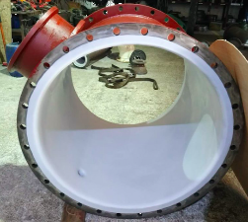
PTFE lined
PTFE is a monomer compound of low molecular weight to form a polymer and is described specifically as a fluoropolymer consisting of carbon and fluorine atoms. The product is applied on the inside and/or outside of a carbon steel pipe see Figure 7. For small diameter piping it is possible to use compact lining equipment for on-site lining. PTFE is highly resistant to corrosion and wear and has a high electrical resistance. The non-polar nature of the surface also minimizes contamination by marine growth. It can cope with high pressures and high temperatures -100 to 260℃ with a pressure of 1.0Mpa. Provide durable low maintenance alternatives to exotic metal alloys and last longer than regular carbon steel pipe.
Figure 7 PTFE lined pipe (CRP, N.D.)

Because of manufacturing processes a pipe is limited to a length of 6000mm with a bore up to 150mm. Perfluoroalkoxy (PTFA) is a mechanically weak product and without reinforcement cannot be used for construction. PTFE is expensive because refining is complex, dangerous and requires large amounts of energy. PTFA is an alternative but, it costs roughly two to three times that of PTFE, it is difficult to process and matches performance with PTFE in almost every aspect. A lined pipe is considerably heavier than regular carbon steel pipe. To prevent erosion flows in the pipe should not exceed 15 m/s (CRP, N.D.).

2.3.3 Marine Growth Prevention System
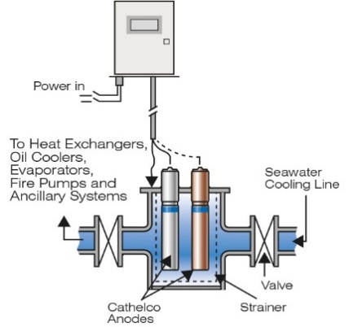
Marine Growth Prevention System (MGPS) protects the SW system from biofouling. The system consist of pairs of copper and aluminium anodes, mounted in sea chests or strainers, connected to a control panel see Figure 8. The control panel supplies the anodes with impressed current. In operation, the copper anode produces ions which are carried by the flow of SW through piping and machinery systems, creating an environment where barnacles and mussels will not settle or multiply. Less than 2 parts per billion is enough to prevent marine life from settling. The action of the copper ions is assisted by aluminium hydroxide that is created by the aluminium anodes flocculating the released copper from the copper anodes. This highly gelatinous copper-aluminium hydroxide floc is carried throughout the system and tends to spread into the slow-moving areas close to the pipe surfaces, where marine larvae are most likely to settle. Another advantage is that a cupro-aluminium film builds up on the internal surfaces of the pipes to suppress corrosion. In this way the system has a dual action, protecting SW pipework against both biofouling and corrosion. MGPS systems form the basis of a well operating and maintained SW system. And therefore needs to be in good operating condition at all time (Evac, N.D.).
Figure 8 MGPS layout (Evac, N.D.)

2.3.4 Cathodic protection
When two dissimilar metals are electrically connected and are in contact by an electrolyte, a galvanic cell is created and a potential difference forms over the two metals. In this bimetallic couple, the metal with the lowest potential, the anode, will start to corrode. The more noble metal will behave as a cathode, and its surface will remain unaffected. The potential of a metal depends on the characteristics of the electrolyte. In plate heat exchangers, galvanic corrosion can exist at welded, brazed, or soldered joints. It is possible for the carbon steel to become anodic to the titanium plates.

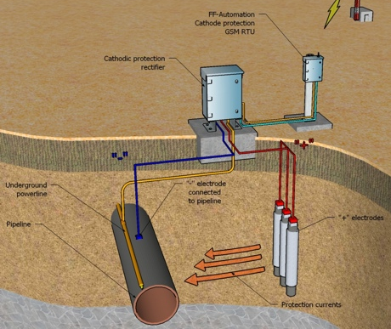
Corrosion of a part can be avoided by changing the circumstances such that the protected surface becomes a cathode. This cathodic protection can be done by reducing the corrosion potential and can be achieved by passive or active protection. For passive protection a sacrificial anode can be installed see Figure 9. This part is made from a metal that is less noble in the galvanic series than the protected part and will corrode instead of the protected metal. Zinc and magnesium are mostly used for this application. When consumed it is simply replaced by a new one. This option is easy and cheap, however the provided protection is uncontrollable and might need to be replaced frequently. The second option, active protection, is to use Impressed Current Cathodic Protection (ICCP). The protected structure is connected to an anode through an external power source. Because of the electric current, impressed by this power source, the protected structure is catholically polarised. Because of the anodic polarisation, anode materials with a passive surface in the electrolyte are preferred to limit the metal dissolution and the anode consumption rate see Figure 10 (Lecompte, 2018).
Figure 9 Sacrificial anode
Figure 10 Active cathodic protection

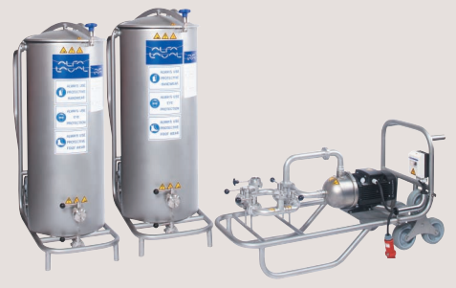
2.3.5 CIP-unit
Figure 11 CIP 400 unit (Alfa-Laval, N.D.)
A Cleaning In Place (CIP) unit is a device which cleans a heat exchanger without taking it apart see Figure 11. Alfa Laval's CIP systems connect directly to the heat exchangers and circulate a mixture of heated non-toxic cleaning agents that effectively remove scale, product deposits and biological contaminants. This ensures clean process surfaces and restores the performance of the heat exchanger (Alfa-Laval, N.D.).

Alpacon Descalant II is a concentrated, liquid cleaning agent for the removal of scale, magnetite, algae, humus, mussels, shellfish and crustaceans, lime, rust and other deposits in water systems such as plate heat exchangers and centrifugal pumps. Cleaning a heat exchanger with a CIP-unit is as simple as the following steps (Alfa-Laval, 2021):

- Isolate heat exchanger
- Connect the CIP unit to the heat exchanger
- Mix the cleaning agent with water in the tank and heat it up
- Circulate the cleaning solution for a few hours
- Drain and rinse
- Disconnect the CIP unit
- The heat exchanger is back to full performance capacity

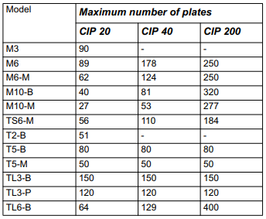
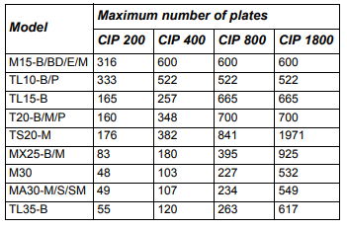
Alfa Laval has a variety of CIP units available. According to Table 2for the T20-PFG heat exchanger with 194 plates a CIP 400 is recommended. For the smaller M10-MFG with 49 plates Table 1 recommends using a CIP 40.
Table 1 CIP unit recommendation table (Alfa-Laval, N.D.)
Table 2 CIP unit recommendation table (Alfa-Laval, N.D.)

2.3.6 Filters
Port filter
A port filter is a long cylindrical strainer inserted on the SW inlet side of a plate heat exchanger see Figure 12. The Alfa Laval port filter is used to ensure thermal efficiency of the heat exchanger by preventing foreign objects from entering and causing clogging of the heat exchanger. A port filter is available for most standard heat exchanger types with connection size Ø100 mm (4”) and larger. The mesh size of port filters is Ø1.5-2.2 mm with an open surface of 37% (Alfa-Laval, 2019).
Figure 12 Port filter (Alfa-Laval, 2019)

Strainer or filter
The key difference between strainers and filters is the size of the particles they remove. Strainers typically remove larger particles that are visible in a liquid or gas, while filters remove contaminants that are often so small, they cannot be seen with the naked eye. The purpose of a strainer is to remove larger, unwanted suspended particles from a liquid, primarily to protect downstream equipment, like pumps, from damage. Strainers are designed for easy removal and cleaning Filters are typically used when the liquid or gas passing through the system must be free of most contaminants. When choosing whether to utilize a filter or a strainer, the following essential points should be considered (Supply, N.D.):

• The type of liquid or gas
• Size and shape of particulates to be removed
• Whether the system can be shut down for cleaning and maintenance
• Flow rate and pressure
• Pipeline size and configuration

2.3.7 Cooling water treatment
Water added to the system should only be demineralized (distilled) water with proper treatment. This is necessary to keep effective cooling and prevent corrosion in the system. Although distilled water matches best to the requirements for cooling water, it is still necessary to add corrosion inhibitor. Untreated distilled water absorbs carbon dioxide from the air and becomes corrosive. The cooling water should be checked periodically, preferably once a week. Laboratory tests are recommended regularly at least every three months. All checking results should be recorded and kept for trend evaluation. Make up water should be checked and treated to stratify the figures in Table 3before adding corrosion inhibitor (Firoz, 2018).

Table 3 Make up water properties (Firoz, 2018)
Property | Typical level
pH | 7 to 9
Total hardness as CaCO₃ | Max. 75 ppm(mg/l)
Chloride | Max. 50 ppm(mg/l)
Sulphate | Max. 100 ppm(mg/l)
Silicate | Max. 150 ppm(mg/l)
Residue after evaporation | Max. 400 ppm(mg/l)
Salinity | Max. 4 ppm(mg/l)

Cooling water treatment should include (Firoz, 2018):

- Form a protective film of calcium carbonate on the metal surface using the natural calcium and alkalinity in the water
- Remove the corrosive oxygen from the water, either by mechanical or chemical de aeration
- Add corrosion inhibitors

Weekly controlled cooling water properties should stratify the figures in Table 4 (Wärtsilä, 2001).

Table 4 cooling water properties (Wärtsilä, 2001)
Property | Typical level
pH | 8-11
Nitrite (NO₂) | 500-2500 ppm
Chlorides (CI) | <40 mg/l
Sulphate (SO₄) | < 100 mg/l

Corrosion control
The three most reliable corrosion inhibitors for closed cooling water systems are chromate, molybdate, and nitrite materials. Chromate treatments in the range of 500-1000 ppm as Cr4O2¯ are too satisfactory unless bimetallic influences are present. When present chromate treatment levels should be increased to exceed 2000 ppm. Maximum inhibitor effectiveness can be achieved if the pH of the systems is kept between 7.5 and 9.5.

Molybdate treatment provides effective corrosion protection and is a more environmentally acceptable alternative to chromate. Nitrite- molybdate-azole blends inhibit corrosion in steel, copper, aluminum, and mixed-metallurgy systems. Molybdates are thermally stable and can provide excellent corrosion protection in both soft and hard water. System pH is normally controlled between 7.0 and 9.0. Recommended treatment control limits are 200-300 ppm of molybdate as MoO42¯. Molybdate inhibitors should not be used with calcium levels greater than 500 ppm.

Nitrite is another widely accepted non chromate closed-loop cooling water inhibitor. Nitrite concentrations in the range of 600-1200 ppm as NO2- will suitably inhibit iron and steel corrosion when the pH is maintained above 7.0. Systems containing steel and copper couples require treatment levels of 5000-7000 ppm. If aluminium is present, the corrosion problem is intensified, and a treatment level of 10,000 ppm may be required. In all cases, the pH of the circulating water should be maintained in the alkaline range, but below 9.0 when aluminium is present. When high nitrite levels are applied, acid feed may be required for pH control.

Glycol antifreezes are not compatible with chromate-based treatments, non-chromate inhibitors should be used (Suez, N.D.).

Glycol
Glycol is a compound that belongs to the alcohol family. By mixing glycol with water, its freezing point can be reduced to as low as -50°C. This serves a number of uses, the most obvious one prevent pipes from freezing in cold weather. It needs no further chemical treatment as it is formulated with anti-corrosion additives. Glycol systems are closed and dirt-free, no filtration is required. This eliminates the costs of filter maintenance. Antifreeze decreases the specific heat capacity of the cooling water by 10%. This can be compensated by increasing the flow. When added in quantity’s more than 20% it can cause damage to machinery. Glycol knows two types of high quality antifreeze Monopropylene glycol and Monoethylene glycol. It is recommended to use Monopropylene glycol, because it is more environmental friendly (Tower-Water, 2020).

2.4 Calculations
The previous calculations made can be found in appendix 4 and 5.

2.4.1 Equations
See appendix 6 for an explanation on the used symbols in the equations.

Piping
A pipe has a maximum flow that is limited by the diameter of the pipe. The following equations are needed to calculate the minimum diameter and flow losses of a pipe (Smit, 1989).
$V=m∙v$ $A=\frac{V}{Vmax}$ $D=\sqrt{4∙A∙π}$

$A=\frac{m∙v}{c}$ $D=\sqrt{\frac{4∙A}{c}}$

$$Vloss=\frac{r^{4}·π·Pd}{Lp·8·visc}$$

Heat exchanger
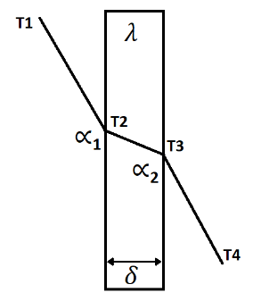
The functioning of a heat exchanger depends on many factors. The calculations will prove that the capacity of the pumps and heat exchanger is sufficient and temperatures will stay within limitations. Figure 13 shows the gradient of temperature through a plate of a heat exchanger. The following equations are needed to calculate these parameters (Smit, 1989).
Figure 13 Temperature progression through a wall (Zoutendijk, 2021)

$K=\frac{1}{\frac{1}{∝1}+\frac{δ}{λ}+\frac{1}{∝2}}$ $Q=m∙c∙∆T$ $Q=K∙A∙∆Tm$

$∆Tm=\frac{∆Tmax-∆Tmin}{ln\frac{∆Tmax}{∆Tmin}}$ $T1=T2+\frac{q}{∝1}$ $T2=T3+\frac{δ∙q}{λ}$

$T3=T4+\frac{q}{∝2}$ $q=K∙∆Tmax$ $q=\frac{Q}{A}$

$$λ=\frac{P∙δ}{A∙∆T}$$

Expansion tank
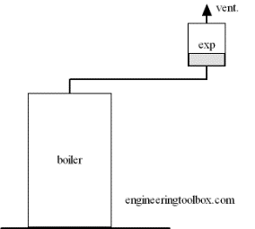
When cooling water heats up it expands, as the system is open to the air the level inside the expansion tank will rise. To prevent the tank from over flowing it is needed to calculate the required volume for the expansion tank. A safety factor of 2 is commonly used. The Required volume can be calculated with the following equation (Engineering-Toolbox, N.D.):
Figure 14 Expansion tank (Engineering-Toolbox, N.D.)

$$Vet=k∙Vw∙(\left(\frac{v1}{v0}\right)-1)$$

Required height for expansion tank
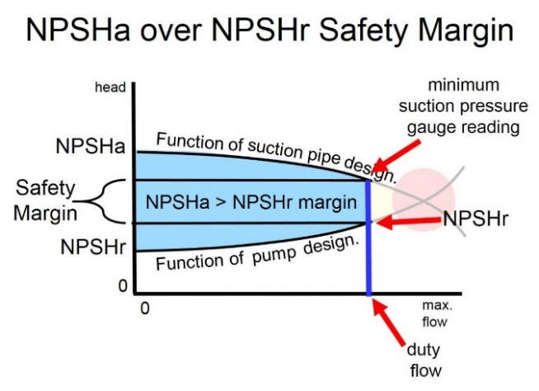
To function well, pumps need to have sufficient NPSHa. The NPSHa should always be greater than the NPSHr. The NPSHr is provided by the manufacturer in the pump curve. The NPSHr at duty flow should always be used as a reference to the NPSHa. The NPSHa depends on many factors, the easiest way to create sufficient NPSHa is to have enough water column available to the pump. The water column depends on the water level inside the expansion tank. When the flow of a pump increases the NPSHr increases but the NPSHa decreases as seen in Figure 15. To make sure the NPSHa stays larger than NPSHr it is recommended to have a sufficient safety margin. NPSHa can be calculated by the following equation (Bachus, 2020):
Figure 15 NPSHa over NPSHr safety margin (Bachus, 2020)

$NPSHa>NPSHr$ $NPSHa=Hs+Hp-Hvp-Hf-Hi$

2.4.2 Data
On 15-04-2021 at the Gulf of Mexico the SW temperature was 27°C. Naval architecture operations manual report mnh01060 of the Frida 1 state that SW temperature shall be based on 0° to 32 °C. (Desco, N.D.) Advises to add a 10% margin on the capacity of the heat exchangers. (Bachus, 2020) Advices to use for H_{i} a standard value of 0.6 m, this also functions as a safety factor. Table 5 shows the maximum flow through a pipe for several diameters.

Table 5 maximum flow and velocity for specified pipe diameters (The Engineering Toolbox, N.D.)
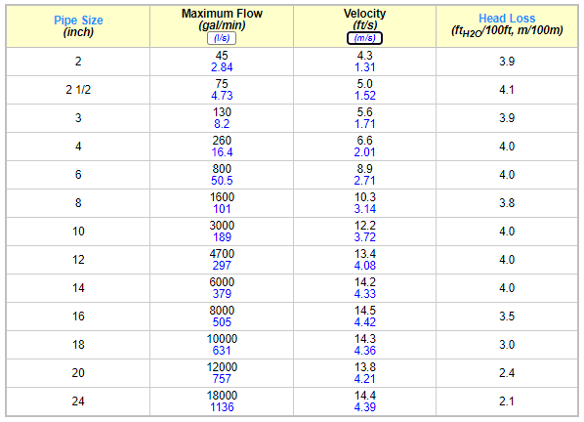

As a guide, allowable pressure drops between 20 and 100 kPa are accepted as normal for water/water duties. Alfa Laval plate heat exchangers can be used for flow rates from 0.05 kg/s to 1,400 kg/s. In terms of volume, this equates to 0.18 m³/h to 5,000 m³/h in a water application. A k-value which under favorable circumstances can be in the order of 9,000 W/m² °C. A typical k-value water/water for a plate heat exchanger is 6,000-7,500 W/m² °C. (Alfa-Laval, 2004)

2.5 Installation

2.5.1 Commissioning
Seals from plate heat exchangers, at a temperature of 18℃, can be saved for three years in a warehouse when stored transparent plastic packaging (Grano, N.D.). New and refurbished systems need to be pre-cleaned properly. In all new systems, pre-cleaning can utilize normal surfactants and dispersants, but in a refurbished system, you may need to include more aggressive cleaners to remove old deposits and foulants (Farmerie, 2018).

2.5.2 Costs
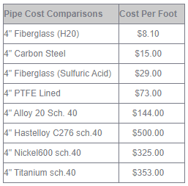
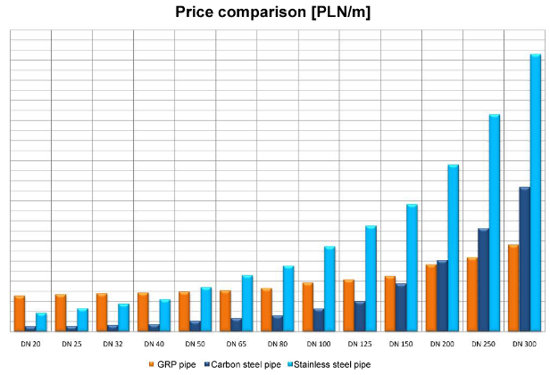
For calculations OOS Energy sets the costs of man ours to 25 U.S. dollars per hour. The purchase and installation costs will be an important factor when choosing the type of pipe. This will be one of the largest expenses for this project. Exact pricing can only be achieved by quotation but an estimate can be made by consulting sources on pipeline pricing. (Thermotech, N.D.) Did a price comparison on GRP, Carbon steel and stainless steel piping for several diameters. Results clearly depend on the pipe diameter see Figure 16. Diameters of pipes are indicated in inches or millimetres diameters nominal (DN) in the appendix 7 a conversion table is added. (Plastic-Systems, N.D.) Did a research on costs per foot for 4” piping see Table 6. Interesting to see is that depending on the resistance to H₂O or Sulfuric acid fiberglass is less expansive or more expansive than carbon steel piping. The Sulfuric acid resistant piping is mainly used on ships for the discharge of the De-SOx tower. (Irl, 2018) Compares GRE and PTFE lined steel for 22m of pipe, 16 flanges and 8 elbows at specified diameters see Table 7 these costs are for the full installation process with materials for use in a De-Sox tower. (Venegas-Reyes, 2019) Investigated the price of schedule 40 carbon steel pipe of 6.1m for specified dimeters see Figure 17 . (Neelcon, N.D.) Also investigated the price of carbon steel pipe for specified diameters and several manufacturers from India but per ton see appendix 8. Neelcon also says that the costs for hot dip galvanizing are 400$/Tons. The chart from (The Engineering Toolbox, N.D.) shows the installation costs for several materials based on a 100m DN 50 pipe see Figure 18.
Table 6 Cost per foot for 4" pipe (Plastic-Systems, N.D.)
Figure 16 Price comparison GRP, carbon steel and stainless steel pipe for specified diameters (Thermotech, N.D.)

Table 7 price comparison GRE and PTFE lined
steel pipe (Irl, 2018)
Pipe Diam | GRE | PE lined steel | Savings
50A | $2,220.00 | $1,436.46 | $783.54
100A | $2,925.00 | $2,931.90 | -$6.90
250A | $8,061.00 | $6,998.97 | $1,062.03
300A | $11,487.00 | $9,242.84 | $2,244.16
350A | $14,245.50 | $11,940.44 | $2,305.06
Total | $38,938.50 | $32,550.60 | $6,387.90
% Savings over GRE |  | 20%

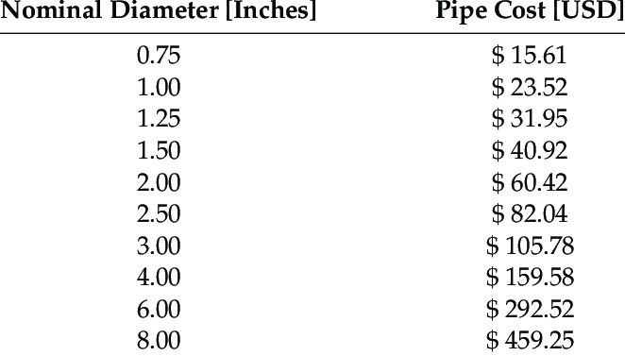
Figure 17 Cost for 6.1m of carbon steel pipe (Venegas-Reyes, 2019)

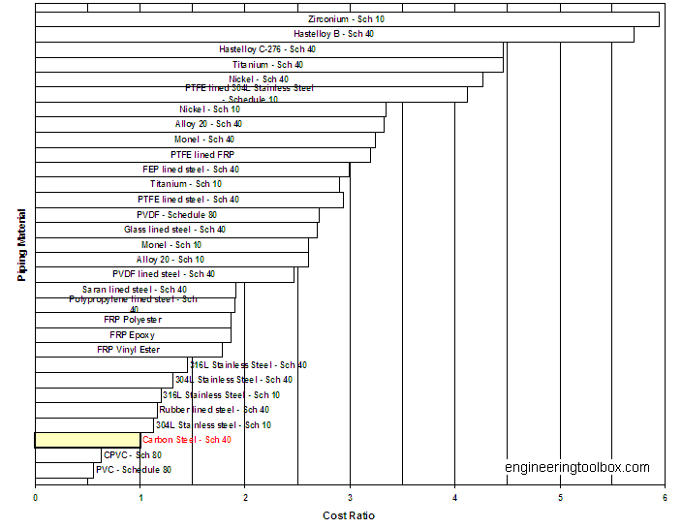
Figure 18 Installation costs for multiple piping materials (The Engineering Toolbox, N.D.)

2.5.3 Man hours
(Butler, 2012) Has done research on the man hours needed to install new pipe work on board of a ship. These hours include only pipes in straight lengths and no branches with two flanges and only readily accessible pipe. Access work and cleaning work is not included. Table 8 shows the man hours per pipe diameter.

Table 8 Man hours per meter for several pipe diameters (Butler, 2012)
Pipe Diameter | Man hours per meter
0.5 | 2.3
1 | 2.6
1.5 | 3.9
2 | 5
2.5 | 6.5
3 | 8
4 | 10
5 | 13
6 | 16
8 | 21
10 | 26
12 | 31
14 | 37
16 | 42

2.6 Conceptual framework
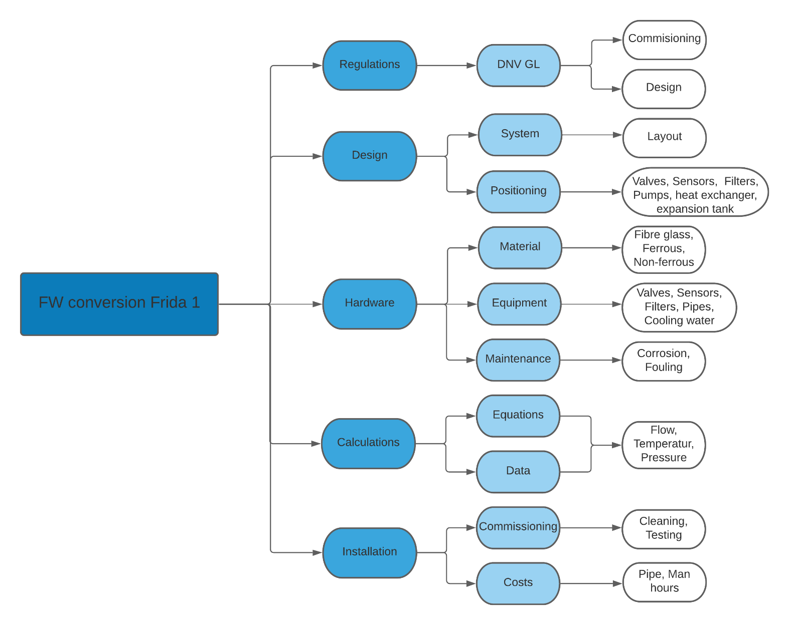
The conceptual frame work shows the six sub questions and how they will be answered.

2.7 Notions and definitions

Notion | Definition
Closed-loop system | A closed-loop cooling system circulates coolant and rejects heat using heat exchangers in such a manner that the coolant does not come into direct contact with the environment at any time. The coolant remains clean, uncontaminated, and does not cause fouling, scaling, corrosion or erosion of heat transfer surfaces.
Redundancy | The duplication of critical components or functions of a system with the intention of increasing reliability of the system.
Maintainability | The ease with which a product can be maintained.
Life span | The period of time for which it is expected to work properly or to last.
Downtime | The time a system is not working due to failure of equipment
Auxiliary | Equipment and machinery which is supportive to the main operation of the vessel
Classification society | A non-governmental organization that establishes and maintains technical standards for the construction and operation of ships and offshore structures
Commissioning | The process of assuring that all systems and components of a major piece of equipment, a process, or similar are designed, installed and tested according to the operational requirements of the classification society or final client
Parameters | A numerical or other measurable factor forming one of a set that defines a system or sets the conditions of its operation

3. Method of research
The methods used to answer the questions consist of internal desk research, external desk research and quantitative research. Internal desk research is research done on documents that come from internal sources of OOS Energy. External research is research done on documents that come from external sources. These document analyses are done on existing and factual information. The documents for internal desk research are mostly technical specifications of the Frida 1, examples are: Piping and instrumentation diagrams (P&ID) of the current SW system, technical data of machinery, internal experts, and the documentation from the previous plan of conversion. Examples of frequently used sources for external desk research are: scientific research platforms, educational books and external Experts. Because calculations are made to answer sub-questions 4 and 6 this research is also quantitative. The substantial numerical data for these calculation is obtained by the two methods above.

3.1 Method per sub-question
1. Which rules and requirements from the classification society apply to the conversion?
DNV is the classification society of the Frida 1. All the applicable regulations are downloaded from the DNV website. Relevant information such as: class attendance during commissioning process, methods, technical requirements, principles and acceptance criteria, are filtered out of the documents. A list with references to these regulations is made so it can be implemented on the commissioning process, equipment, designs, calculations and installation process.

2. Which modifications are needed to the current design?
The current design is the design as made during the previous conversion plan (see appendix 1&2). The current system is the system as it is currently in place on the Frida 1. The new design is the result of this research. Data that is available are the P&ID’s of the current system and drawings of the current design (appendix 1&2). Both are analysed and desk research is done on closed loop cooling systems. Sources such as (Farmerie, 2018) and (Kaila, 2016) explain how to optimize the operation of a closed loop system. The observations made and lessons learned forms the new design. This new design is evaluated by an internal expert (Technical support manager).

3. Which additional materials should be ordered for optimal operation of the system?
OOS Energy imposes on using the parts that are already in stock, therefore a stocktaking is made. This information comes from the old purchasing lists. To know what parts should be ordered the parts needed for the new design are compared with the parts in stock. The gap between these two have resulted in a list of parts that need to be ordered. These parts are available with a wide variety of characteristics. All the options will be investigated by doing desk research. The pros and cons are listed in the theoretical frame work so a well-considered decision can be made.

4. How can the parameters of the new design be checked and calculated?
Calculations need to be performed to check if the capacity of the system is sufficient and correct. The equations used for these calculations come from educational books such as Hulpwerktuigen deel 2. Data for the calculations came from various sources. Internal documents provide information about the system, such as: pump and heat exchanger capacity. Alfa Laval provided the standards the system has to comply with. The calculations will be made by an external expert (Application Engineer, Alfa Laval) and verified to ensure correctness.

5. Which measures should be taken when commissioning the system?
Making the conversion from SW to FW will bring some additional challenges such as: marine growth, fouling and corrosion. The measures to install the system are investigated by doing desk research. This resulted in a list of actions to take in mind when installing the system. When the system is operational maintenance should be performed. Desk research is conducted on what kind of maintenance is required to keep the system in good condition and to prevent marine growth, fouling and corrosion from happening. For example: Alfa Laval advises to periodically clean plate heat exchangers with a CIP unit.

6. What are the costs for the conversion?
The implementation costs for the new system depend on the results from the previous sub-questions. Price is an important factor for OOS Energy when choosing between several options for products. Prices of small components, such as: pressure gauges, temperature sensors and level switches where easily found on websites of suppliers. The price of more expensive components are obtained precisely by quotations from third parties. For products for which the price cannot be obtained by quotations desk research was conducted. This resulted in an Excel file with costs that shows the total investment to realise the project.

3.2 Reliability and validity
Reliability is about how consistently a method measures data. It is important that the results will be the same if the analysis or entire study is repeated in exactly the same way. Validity concerns the question of whether the results of this thesis are correct and whether firm conclusions can be drawn from this. Thus, the results of a valid study corresponds to the real properties, phenomena and variations in the physical and social world.

3.2.1 Reliability
The used instruments during this research are: internal desk research, external desk research and quantitative research. Information for internal desk research came from internal sources of OOS Energy and information for external desk research from external sources. For each statement in the theoretical frame work multiple sources are checked to increase reliability. These sources are used to check and replenish the internal data. Sources used are noted in the bibliography and its reliability is checked. Internal information is raw data, this can be relayed on as correct. To increase reliability of the internal information calculations where recalculated and the data checked by internal experts. Designs and calculations for the new system are validated and checked by internal and external experts. A similar study with which to compare has not been found. The calculation made by Alfa Laval are checked by recalculating and verifying the correctness of the outcomes.

3.2.2 Validity
If a measurement is reliable, this is no guarantee that it is also valid. In contrast, if a measurement is not reliable, it is also not valid. Probability and social desirability will play no role in this study. In addition, internal and external experts are used to ensure validity. During the research the interim results were presented and discussed multiple times with those involved. The feedback obtained was then incorporated into the report.

4. Results
This chapter contains the most important results of this research. These results form the answers to the sub-questions. Conclusions and recommendations are drawn from this information.

4.1 DNV
Chapter 2.1 covers all the rules and regulations implemented on by DNV for this project. Additional to the information listed in 2.1 is the following: The piping that will be used for this project categorizes as Class III (3). Thus piping used needs to be incompliance with the rules set for class 3 piping. For fire endurance the piping classifies as L3. This means, Fire endurance test in wet conditions for 30 minutes, this originates from Appendix 2 of IMO Res. A.753(18). Testing pressure of equipment should not be less than 1.5 times that of the working pressure.

4.2 Designs

4.2.1 New design
The schematic overview in Figure 19 is a simplified version of the new design. The old design can be found in appendix 1 and 2. The changes made are: the coolers and pumps have been swapped around and the header tank has been connected to the inlet side of the pumps. This results in a decreased probability of cavitation. As a safety feature a high and low level alarm is fitted on the header tank and a temperature transmitter in the feed and return line. Two extra lines and valves are added on the SW side to each cooler to be able to backflush the cooler and filter. Multiple pressure and temperature gauges are installed before and after the coolers to monitor its functioning. The non-return valve is placed directly after the pump so in case of a failing non-return valve it can easily be isolated and repaired.

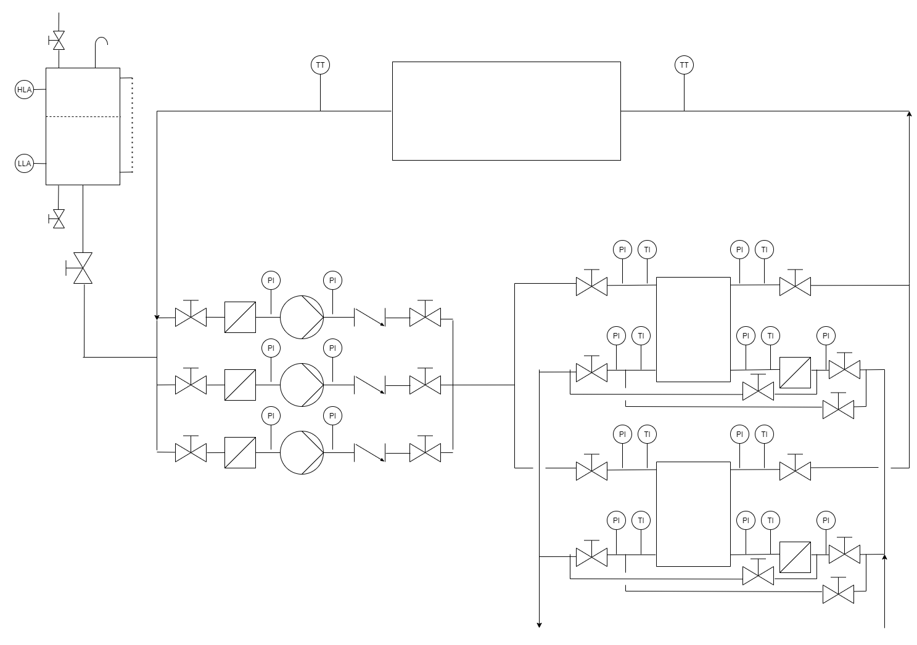
Figure 19 New design of cooling system

4.2.2 P&ID’s
The new designs have been integrated with P&ID’s of the current system. These drawings include: the STBD FWD, STBD aft, Port aft and Port FWD Column systems and Mid Ship System. The drawings can be found in appendix 9, 10, 11, 12, and 13.

4.3 Calculations

4.3.1 Heat exchangers
The old calculations (see appendix 4 & 5) are checked and recalculated. Several mistakes are obtained. These mistakes are shown in Figure 20 and Figure 21. These mistakes are: wrong type of fluid on cold side for Mid Ship, for both systems a SW temperature of 22°C and incorrect flow. The type of fluid used for the calculations should be SW. SW has a lower specific heat capacity than freshwater. The heat transferred according to the calculation does not represent the operational condition which is about 10% les. The Frida 1 (and ships in general) are designed for a maximum SW temperature of 32°C. The SW temperature on 15-04-2021 at the Gulf of Mexico was 27°C this is already above the old value. The inlet temperature on the hot side of the heat exchanger should be maintained below 40°C but, periodically may rise up to 45°C. The capacity of the coolers are not sufficient to maintain this 40°C by a SW temperature of 32°C and there for need additional plates. The system is designed to run with two out of three pumps. The flow of two pumps is double the flow used in the old calculations of the Columns. For the Mid Ship the flow can be raised up to 454 m³/h.

Figure 20 Old calculations of Four Columns
Figure 21 Old calculations of Mid Ship

4.3.2 Four Columns
To maintain an inlet temperature of 40°C on the hot side with a SW temperature of 32°C the number of plates installed need to be extended by 60. This calculation is shown in Figure 22. With eight plate heat exchangers this sums up to a total of 480 new plates that need to be ordered. The current carrying bars cannot house the extra plates. The carrying bars and tightening bolts will run out of length therefore longer ones should be ordered. Two carrying bars, and four tightening bolts should be ordered per cooler. This sums up to a total of 16 carrying bars and 32 tightening bolts. For the technical drawing of the new situation see appendix 14.

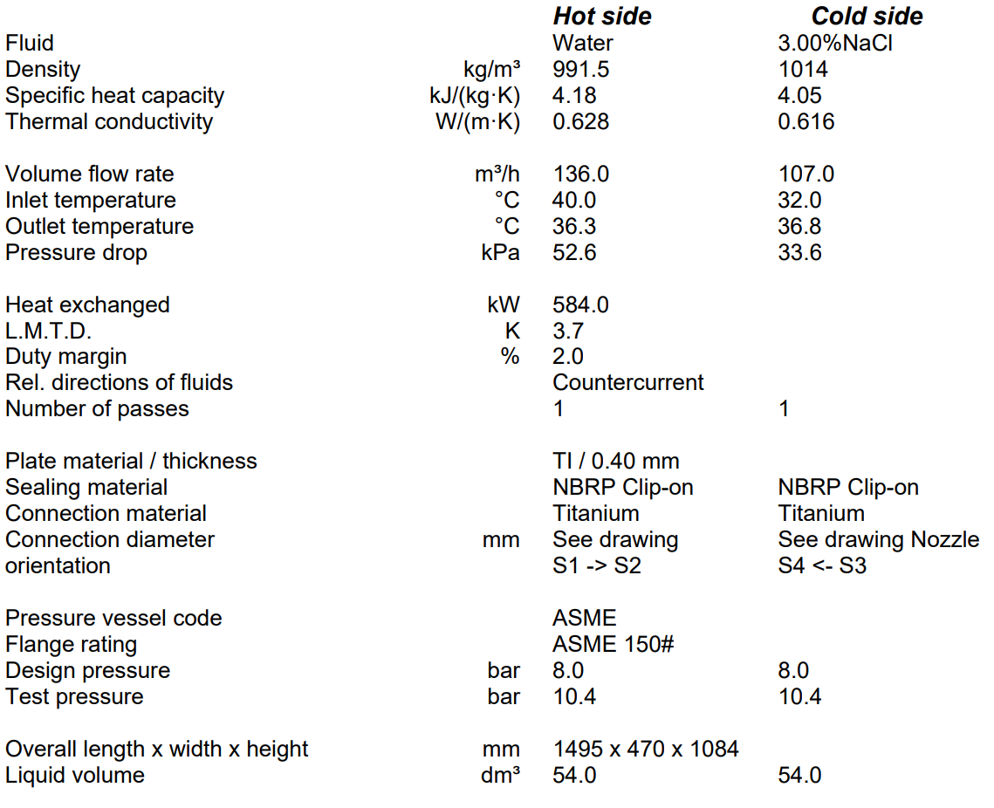
Figure 22 New Calculation for Four Columns with extension from 49 to 109 plates

4.3.3 Mid Ship
The mid ship system needs to have a cool capacity of 6000 kW with the current number of plates and 32°C SW temperature and increased flow the hot side inlet temperature will rise up to 47.5°C and pressure drop up to 193 kPa, see Figure 24. Due to the characteristics of the system there are several ways of approaching this problem. 4800 kW of the 6000 kW comes from the drilling braking resistors. The drilling braking resistors are only active during the lowering of the top drive which is not a continuous process. The amount of kW depends on the speed of lowering and the weight hanging from the top drive. As the hot side inlet temperature may periodically rise up to 45°C this could be a solution to make the system operate with acceptable parameters.

Figure 23 shows the system operating with the drilling braking resistors offline. Figure 24 shows the system operating with the drilling braking resistors online. Figure 25 shows the maximum cooling capacity of the system. Due to the raised flow the pressure drop increased to 193 kPa this is relatively high and can be decreased to the value of the old calculations by adding 28 plates. For the technical drawing of this new situation see appendix 15. Figure 26, Figure 27 and Figure 28 show the same calculations but with plate extension. With 28 plates extra and 6000 kW the hot side inlet temperature drops with 0.5°C to drop another 0.5°C an extra 94 plates are needed. This calculation is shown in Figure 29.

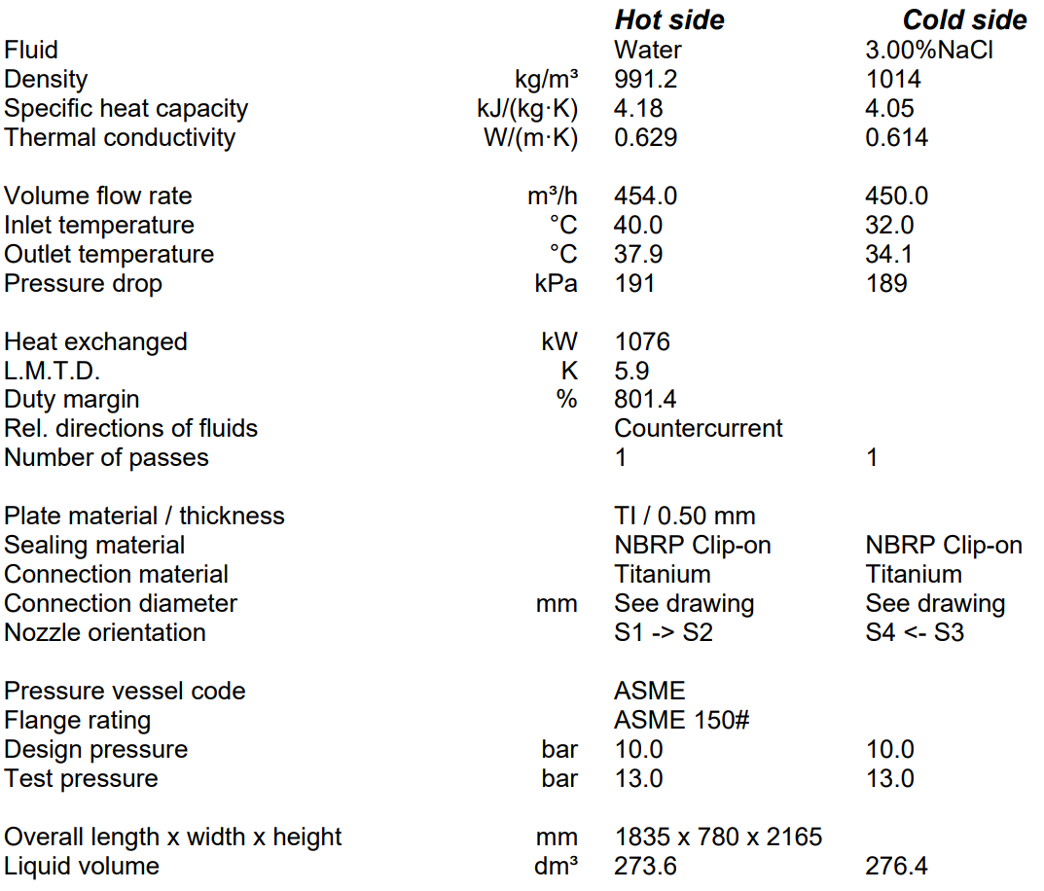
Figure 23 Calculation for Mid Ship with 1076 kW and no plate extension

Figure 24 Calculation for Mid Ship with 6000 kW and no plate extension

Figure 25 Calculation for Mid Ship with 3152 kW and no plate extension

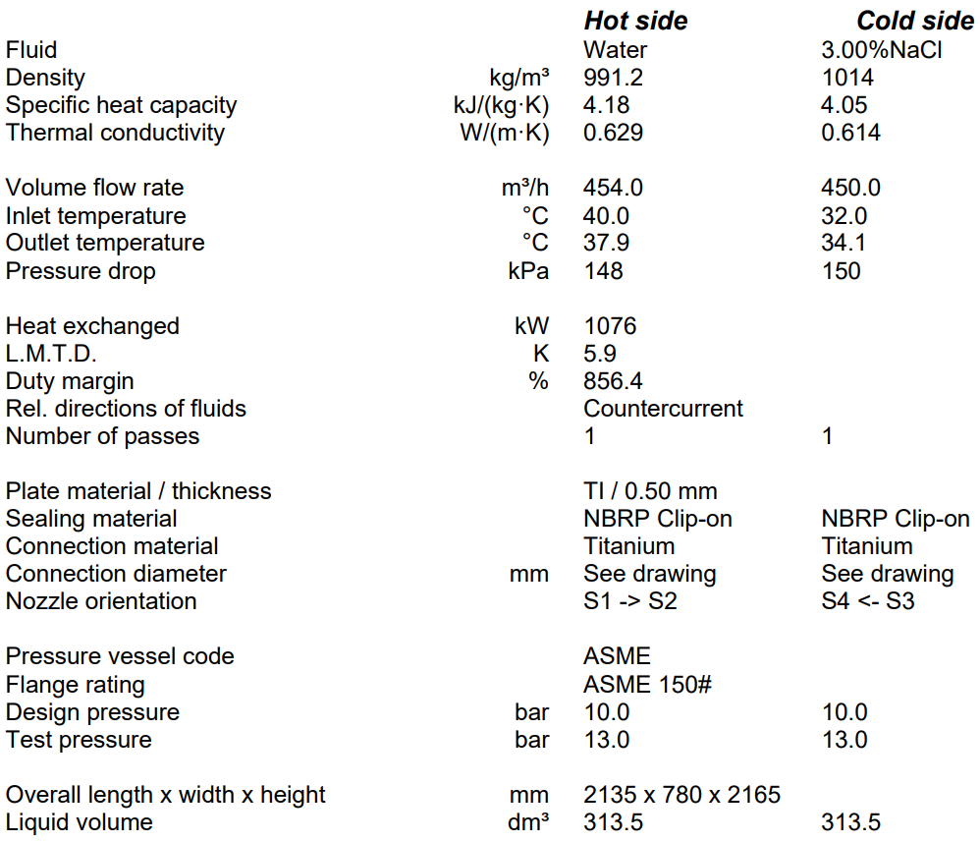
Figure 26 Calculation for Mid Ship with 1076 kW and extension of 28 plates

Figure 27 Calculation for Mid Ship with 6000 kW and extension of 28 plates
Figure 28 Calculation for Mid Ship with 3152 kW and extension of 28 plates

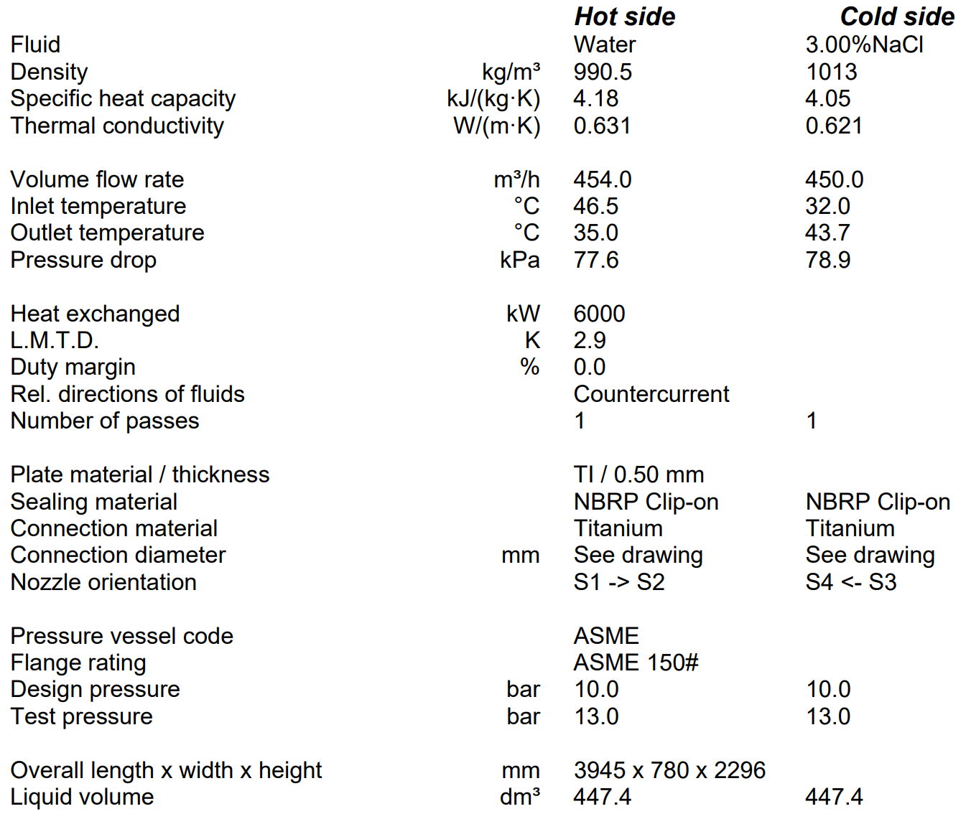
Figure 29 Calculation for Mid Ship with 6000 kW and extension of another 94 plates

4.3.4 Verification of calculations
The verification of the calculations is done by checking the K-value of the made calculations if this value is reasonable it can be relied on as correct. Under favorable circumstances a K-value can be in the order of 9,000 W/m² °C. A typical k-value for a plate heat exchanger are 6,000-7,500 W/m² °C. Table 9 shows the K-values of the made calculations.

Table 9 K-values of different scenarios
Calculation reference | K-value
Figure 22 | 6675
Figure 23 | 1067
Figure 24 | 9004
Figure 25 | 9460
Figure 26 | 936
Figure 27 | 9057
Figure 28 | 8295
Figure 29 | 7495

4.3.4 Header tank
The required height for the header tank could not be calculated due to the lack of information. Height could not be determent because H_{s}, H_{p}, Hv_{p} and H_{f} are unknown. For the Four Columns system height of the header tank will not be a problem as the header tank will most likely be located on the main deck above the columns. This has a vertical distance of 13.4 meters (44 foot) see Figure 30. For the Mid Ship system its location is unknown. The tank volume for the Four Columns system is sufficient as shown by the calculations in Table 10 and Table 11. The sufficiency of the tank volume for the Mid Ship system could not be checked because the volume of the system is unknown. The correctness of the previous made design (Figure 31) could therefore also not be checked.

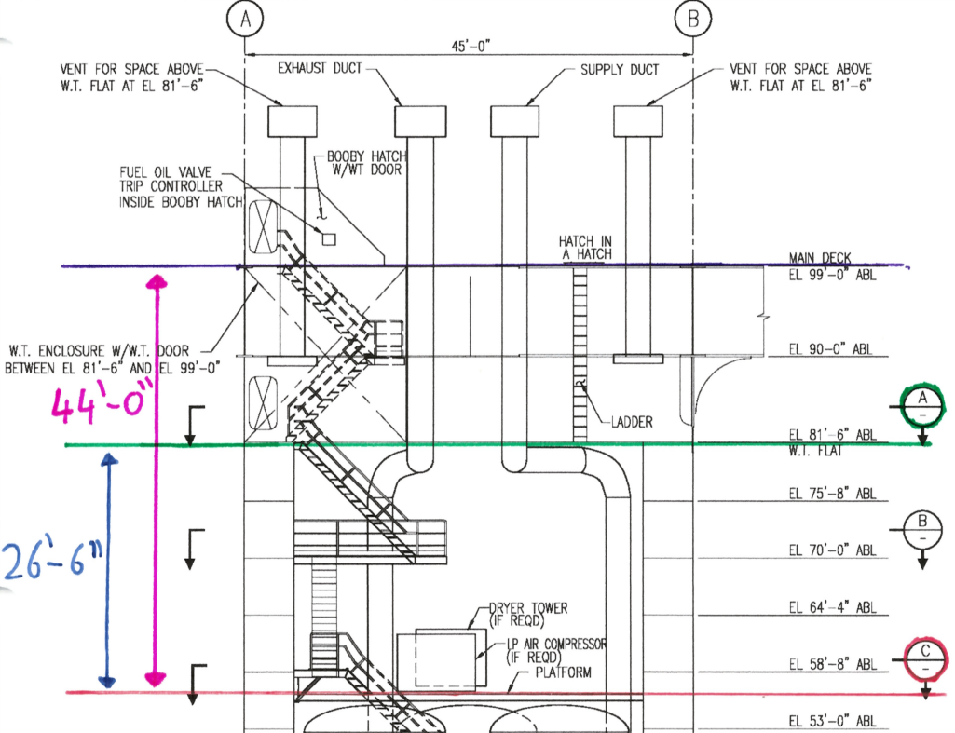
Figure 30 Vertical distances from pumps to header tank and machinery in Columns

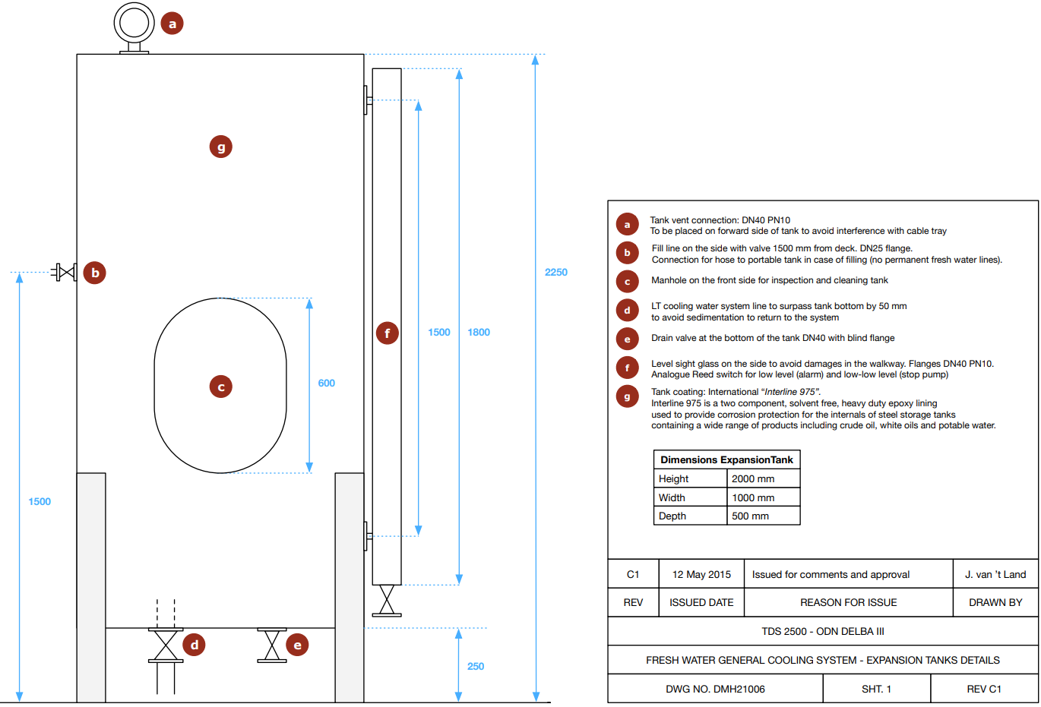
Figure 31 Previous design for header tank
Table 10 Four columns system volumes
 | Diameter | Unit | Length | Unit | Volume | Unit
3" pipe | 0.08 | m | 17.5 | m | 0.087965 | m³
4" pipe | 0.1 | m | 30 | m | 0.235619 | m³
6" pipe | 0.15 | m | 112.5 | m | 1.988039 | m³
Cooler |  |  |  |  | 0.10912 | m³

Table 11 Four Columns header tank expansion volume
Volume at 20°C | 2.420743 | m³
SV of water at 20°C | 0.001002 | m³/kg
SV of water at 45°C | 0.00101 | m³/kg
Safety factor | 2
Expansion volume | 0.039049 | m³
Header tank volume | 1 | m³

4.4 Costs and parts
All the parts that are needed for the new design of the Four Columns and Mid Ship system can be found in appendix 16 and 17. The costs of these parts are calculated or come from quotations. Several price options are made for both systems. These can be found in appendix 18 and 19.

4.4.1 Parts
A multi-criteria rating has been made for the four most suitable piping materials. These four options are RTRP, Copper-Nickel carbon steel pipe and hot-dip galvanized carbon steel pipe. As shown in Table 12 RTRP has the highest score. Because of weight, costs and maintainability RTRP is the preferred material. Within the category RTRP, GRE pipe is the most suitable option because it’s the cheapest and still meets all requirements. Table 13 shows the price per meter of pipe calculated with data from the different sources noted in chapter 2.5.

Table 12 Multi-criteria rating for RTRP, Copper-Nickel, Carbon steel and Galvanized carbon steel
 |  | RTRP | Copper-Nickel | Carbon steel | Galvanized | Importance
1 | costs | 10 | 5 | 8 | 5 | 10
2 | Easy availability of materials | 7 | 7 | 8 | 6 | 7
3 | Suitability for the design | 8 | 7 | 8 | 8 | 9
4 | Life span | 10 | 8 | 6 | 9 | 10
5 | Corrosion resistance | 10 | 7 | 4 | 9 | 10
6 | Compatibility of material with the process fluid | 10 | 10 | 6 | 9 | 7
7 | Suitability of the material for the design temperature and pressure and cyclic loading | 10 | 10 | 10 | 10 | 9
8 | Suitability of materials for the environmental conditions | 9 | 7 | 5 | 8 | 6
9 | Potential ultraviolet degradation of the materials | 4 | 10 | 10 | 10 | 4
10 | Past experience with material for similar applications | 9 | 6 | 6 | 9 | 5
11 | Additional requirements for corrosion protection such as cathodic protection, chemical injection, inspection, corrosion monitoring and any environmental impact due their implementation | 10 | 8 | 5 | 8 | 8
12 | Weight reduction | 8 | 7 | 0 | 0 | 10
13 | Fabrication, Inspection, Installation and maintenance costs | 9 | 5 | 6 | 4 | 8
14 | Evaluation of failure probabilities, failure modes and consequences | 6 | 4 | 8 | 6 | 6
 |  | 68.86 | 50.86 | 48.29 | 54.43

Table 13 Costs of piping material per meter
Source | Pipe size, type | Price | Unit | Price | Unit
(Plastic-Systems, N.D.) | 4", fibre glass H2O | 8.10 | $/ft | 21.79 | €/m
(Plastic-Systems, N.D.) | 4", fibre glass Sulfuric Acid | 29.00 | $/ft | 78.00 | €/m
(Plastic-Systems, N.D.) | 4", Carbon Steel | 15.00 | $/ft | 40.34 | €/m
(Venegas-Reyes, 2019) | 3", carbon Steel | 105.78 | $/6.1m | 17.34 | €/m
(Venegas-Reyes, 2019) | 4", Carbon Steel | 159.58 | $/6.1m | 26.16 | €/m
(Venegas-Reyes, 2019) | 6", Carbon Steel | 292.52 | $/6.1m | 47.95 | €/m
(Venegas-Reyes, 2019) | 8", Carbon Steel | 459.25 | $/6.1m | 75.29 | €/m
(Irl, 2018) | 4", fibre glass, Sulfuric Acid | 2925.00 | $/22m of pipe, 16 flanges and 8 elbows | 109.02 | €/m

Table 14 Price of GRE pipe
Pipe size | Price per m
3" | € 14.82
4" | € 21.79
6" | € 39.22
8" | € 61.01

With the CIP Unit 400L it is possible to clean both the M10-M and T20-P plate heat exchanger.

Table 15 Costs for CIP Unit
Description | Maker | Maker's ID | Qty. | Unit price | Discount | Total price
CIP Unit | Alfa Laval | CIP 400L | 1 | € 17,500.00 | 0% | € 17,500.00

4.4.2 Four Columns
The parts needed for the new design can be found in appendix 16. In appendix 18 three detailed price options are shown. The first option contains new plate gaskets and the extension of plates. Because the use of new gaskets is not mandatory but recommended the second option does not contain new gaskets. The third option does not include the new gaskets and plate extension this is a fictive price because the system cannot be operated without the plate extension. The quotation from Alfa Laval for the extension of the plate heat exchangers and new gaskets can be found in appendix 20.

The length of pipe needed for the conversion is determent by measuring the distance from the location of the coolers to the location of the equipment see Figure 30. Other lengths are estimated.

4.4.3 Mid Ship
The parts needed for the new design can be found in appendix 17. In appendix 19 four detailed price options are shown. The first option contains new plate gaskets and the extension of plates. Because the use of new gaskets is not mandatory but recommended the second option does not contain new gaskets. The third option only contains the new gaskets. The fourth option contains no new gaskets and no plate extension. The quotation from Alfa Laval for the extension of the plate heat exchangers and new gaskets can be found in appendix 20.

As the location of the Mid Ship system is unknown lengths could not be measured. For each pipe half a ship length is taken to be on the safe side and to have some idea of the final price.

5. Discussion
This research regards the possibility of converting the cooling water system of the Frida 1 to a closed loop system. Implementing a closed loop system has only favourability’s. This has been proven many times before and is therefore used on almost all ships. Therefore the purpose of the research was, not to find things that made it impossible to install a closed loop cooling system but to investigate the things needed to make it possible. This research only addresses the preliminary research and the possibilities that arise for converting the open loop system to a closed loop system and not the actual implementation on the Frida 1.

A previous research on this topic was not found. This comparison material should confirm the correctness of the used method. To enlarge the reliability and validity internal and external experts are used. Calculations are made by Alfa Laval and to ensure correctness are verified. Drawings and costs are checked by the internal expert.

Existing data from the Frida 1 was used to map out the current situation. This has led to an Excel file with information of the system and traced out P&ID’s. This was the correct first approach to gain understanding of the system. Because it was not possible to analyse the system by doing observations on sight all information came from manuals, P&ID’s and the previous research. As some data from the previous research turned out to be incorrect it is possible that other data used in this research is also incorrect.

It was expected that the work done in the previous research on this conversion was based on more solid data and that more information would be available. Therefore a lot of information had to be retrieved. This has led to more reliable results. This is assured by making use of internal and external experts who have checked the results on validity.

The limitations of this research lie in the lack of information. This is mostly applicable for the costs of piping and men hours. The exact price and amount of pipe needed could not be determent, therefore neither could the hours needed to install the systems. Other costs are determent by quotations and thus are highly accurate.

Data used is based on the least favourable situation. This increases the reliability of the system and eliminates the impact of errors. Would the system be operating with a SW temperature of 27°C, the capacity of the systems will be more than sufficient.

Further research should be conducted on the actual functioning of the drilling braking resistors. The inlet temperature on the hot side from the plate heat exchanger of the Mid Ship system reaches 47.5°C when on maximum load. This figure is unacceptable high but may only be a fictive situation as the drilling braking resistors may function differently than accounted for. A thorough research on this subject may result in new perspectives. If the outcome would not differ from this research a different solution other than extending the amount of plates should be found. As shown in the calculations to lower the inlet temperature by 0.5°C an extension of 94 plates is needed, therefore this would not be a solution.

Because the placement of coolers and pumps for the Mid Ship system is still unknown an investigation on the ideal placement for this system should be conducted as well. The old location is now unavailable as other equipment has taken in this space. This placement was planned on the STBD side in the open air. These conditions are unfavourable for the system as rust and deterioration will quickly occur.

6. Conclusion
During the research, an attempt was made to find an answer to the main question by consulting literature, analysing system processes and calculating parameters. This involved quantitative research and desk research. The accompanying question is:

How can the current plan to fit the SSDR Frida 1 with a closed-loop cooling water system be implemented?

1. Which rules and requirements from the classification society apply to the conversion?
For the new situation GRE pipe is the most suitable piping material as price and weight are its biggest advantage. This GRE pipe needs to be incompliance with the fire resistance requirements of L3 classed piping. The testing pressure of the system should be at least 1.5 times that of the working pressure. References to the rules and regulations applicable to the conversion can be found in chapter 2.1.

2. Which modifications are needed to the current design?
It is concluded that the modifications needed tot the current design are: Swapping the coolers and pumps around and connect the header tank to the inlet side of the pumps to decrease the probability of cavitation (Figure 19). As a safety feature a high and low level alarm needs to be fitted on the header tank and a temperature transmitter in the feed and return line to the equipment. Two extra lines and valves need to be added on the SW side of each cooler to be able to backflush the cooler and filter. Multiple pressure and temperature gauges need to be installed before and after the coolers to monitor its functioning. Non-return valves need to be placed directly after the pump so in case of a failing non-return valve it can easily be isolated and repaired. The new design can be found in Figure 19 and appendix 9, 10, 11, 12 and 13.

3. Which additional materials should be ordered for optimal operation of the system?
From the results of the previous sub-question a list of parts that need to be ordered is made. This list can be found in appendix 18 and 19.

4. How can parameters of the new design be checked and calculated?
The equations used are shown in chapter 2.4. From the outcomes of these calculations it can be concluded that the capacity of the systems are not sufficient as a result of miscalculations in the previous research. For the Four columns system this can be solved by adding 60 plates per heat exchanger. For the Mid Ship system it is not possible to reach sufficient capacity by extending the number of plates. Another research should be conducted on the solution to this problem. Besides this it is still recommended to install an additional 28 plates per heat exchanger to lower the backpressure.

5. Which measures should be taken when commissioning the system?
From the research done it can be concluded that flushing the system thoroughly with a cleaning agent that removes all the fouling , replacing the old gaskets, regularly cleaning of the coolers with a CIP unit and the use of glycol as cooling medium are the best measures that can be taken when commissioning the system.

6. What are the costs for the conversion?
It can be concluded that the minimal investment costs for the conversion of the Four Columns systems are € 345.581. It is recommended to install new gaskets which costs are € 19.030. In appendix 18 the list with the costs for all parts is shown. For the Mid Ship system the minimal investment costs are €123.856. Although not necessary it is recommended to install new gaskets and an additional 28 plates per heat exchanger. These costs are € 23.914 and €41.559. In appendix 19 the list with the costs for all parts is shown.

7. Recommendations
Before commissioning the system, it is recommended to thoroughly flush the system with Alpacon Descalant II or a product of this kind to remove scale, magnetite, algae, humus, mussels, shellfish, crustaceans, lime, rust and other deposits that have formed during the operation with SW. This will further promote the lifespan of the cooling water and the heat transaction in the closed loop system. Because Glycol is already used for the main engines, the volume of the closed loop systems is relatively small and pipes and coolers are made from non-corroding material glycol would be the preferred cooling medium. To prevent the growth of algae on the SW side of the system a well-functioning MGPS is necessary at all times. With a CIP unit it is possible to clean the coolers without taking them apart. As the coolers are located in a small space where maintenance is hard to carry out this is a big advantage. Within years the investment will be recovered.

Because of price, weight, corrosion resistance, and life span GRE pipe is the most suitable pipe for this application. Therefor it is recommended to use GRE pipe for the new installed pipes and to replace as much pipe as possible with GRE.

After three years of storage gaskets are deteriorated and recommended not to be used. If not, leaks are likely to form. A complete set of new gaskets costs € 42.944,93. Although it comes at a high cost it is recommended to be replaced. If not it is likely that after some time they need to be replaced anyway. Taking apart the heat exchangers at this stage will only increase the total costs.

For the Four Column systems extending the amount of plates with 60 plates per cooler is not only recommended but necessary. If not the system will not be able to operate with a SW temperatures of 32°C. Even SW temperatures of 27°C, where the Frida 1 is currently in operating, will be too high.

For the Mid Ship system an extension of 28 plates and further research is recommended. Without plate extension the Mid Ship system has a maximum cooling capacity of 3152 kW. This is not sufficient to keep the hot side inlet temperature below 40°C at a SW temperature of 32°C. With 6000kW this will raise up to 47.5°C. According to the manufacturers of the equipment periodically the hot side inlet temperature may rise up to 45°C. 4800 kW of the 6000 kW comes from the drilling braking resistors. As the resistors are active with intervals and the kW depends on the weight hanging from the top drive and the speed it is lowered the 47.5°C might never be reached and only rise above 40°C periodically. Extending with 28 plates will lower the back pressure by 0.5 kPa and the 47.5°C only by 0.5°C. To lower this to 56.5°C an additional 94 plates are needed. Extending the coolers with more than 28 plates would not have any purpose.

For the new design it is recommended to use the designs as shown in appendix 9, 10, 11, 12 and 13. In comparison to the old design the coolers and pumps are swapped around and the header tank has been connected to the inlet side of the pumps to decrease the probability of cavitation. As a safety feature a high and low level alarm is fitted on the header tank and a temperature transmitter in the feed and return line. Two extra lines and valves are added on the SW side to each cooler to be able to backflush the cooler and filter. Multiple pressure and temperature gauges are installed before and after the coolers to monitor its functioning. The non-return valve is placed directly after the pump so in case of a failing non-return valve it can easily be isolated and repaired.

Bibliography
AGA. (N.D.). Dissimilar Steel Chemistries. Retrieved from American Galvanizers Association : https://galvanizeit.org/design-and-fabrication/design-considerations/dissimilar-steel-chemistries#:~:text=Most%20ferrous%20materials%20are%20suitable,series)%20also%20can%20be%20galvanized.
Alfa-Laval. (2004). The theory behind heat transfer. Alfa-Laval.
Alfa-Laval. (2019, May 27). Plate heat exchanger . Retrieved from Alfa Laval: https://www.alfalaval.com/globalassets/documents/local/united-states/data-centers/phe-port-filter-leaflet.pdf
Alfa-Laval. (2021, February 5). Cleaning chemicals. Retrieved from Alfa Laval: https://www.alfalaval.com/service-and-support/service-overview/maintenance-services/cleaning-services/cleaning-in-place-pays-for-itself/
Alfa-Laval. (N.D.). Cleaning-in-Place betaalt zichzelf terug. Retrieved from Alfa Laval: https://www.alfalaval.nl/nl/service-en-support/service-overzicht/onderhoud/reinigings-services/cleaning-in-place-betaalt-zichzelf-terug/
Alloys, L. (N.D.). What are the advantages and disadvantages of duplex stainless steel? Retrieved from Langley Alloys: https://www.langleyalloys.com/en/knowledge-advice/what-are-the-advantages-and-disadvantages-of-duplex-stainless-steel/
Anderson Process. (2020, August 18). Retrieved from How To Prevent Pump Cavitation: https://www.andersonprocess.com/how-to-prevent-pump-cavitation/
Bachus, L. (2020, June 15). Everything You Need to Know about NPSH, and Some Things you Didn’t. Retrieved from Empowering pumps & equipment : https://empoweringpumps.com/everything-you-need-to-know-about-npsh-and-some-things-you-didnt/
Bader, R. (N.D.). Sensor Installation Handbook. UK: Siemens PLC.
Butler, D. (2012). A Guide to Ship Repair Estimates in Man-hours. Waltham: Elsevier Ltd.
Club-Technical. (2019, May 6). Cast Iron Types, Advantages, Disadvantages, Uses, Properties. Retrieved from Club Technical : https://clubtechnical.com/cast-iron
Copper Development, A. I. (N.D.). Copper-Nickel Alloys. Retrieved from Copper Development Association Inc.: https://www.copper.org/applications/marine/cuni/
Corrotherm. (2019, November 7). Mechanical properties of INCONEL alloy 625. Retrieved from Corrotherm International: https://www.corrotherm.co.uk/blog/mechanical-properties-of-inconel-alloy-625
CRP. (N.D.). Lined Equipment Basics. Retrieved from CRP: http://www.crp.co.uk/technical.aspx
Crucial-Engineering. (2019, May 25). Advantages and disadvantages . Retrieved from Crucial Engineering: https://crucialengineering.co.uk/aluminium-fabrication-advantage-and-disadvantage/
Desco. (N.D.). Optimum Design of a Plate & Frame Heat Exchanger. Retrieved from Desco: http://descoglobal.net/wp-content/uploads/2016/01/DESCO-Plate-Frame-Design-Parameters-FK-Version.pdf
DHF. (N.D.). Polyethylene lining. Retrieved from DHF: http://www.dhf.co.jp/eng/products/pipe/lining/
DNVGL. (2015). Offshore classification projects - testing and commissioning. DNV GL.
DNVGL. (2016). Conversion of ships. DNVGL.
DNVGL. (2018). Marine and machinery systems and equipment . DNV GL.
Engineering, P. (N.D.). 10 Different forms of corrosion in various piping systems. Retrieved from Piping-engineering.com: http://www.piping-engineering.com/forms-of-corrosion-in-piping-systems.html
Engineering-Toolbox. (N.D.). Sizing Hot Water Expansion Tanks. Retrieved from Engineering-Toolbox: https://www.engineeringtoolbox.com/expansion-tanks-d_885.html
Evac. (N.D.). Cathelco marine growth prevention systems technology description. Retrieved from Evac: https://evac.com/solutions/marine-growth-prevention/technology/
Farmerie, J. (2018, October 3). How to Perfect Your Closed-Loop Systems. Retrieved from Empowering pumps & equipment: https://empoweringpumps.com/psg-neptune-how-to-perfect-your-closed-loop-systems/
Firoz. (2018, October 28). Cooling Water Treatment for Diesel Engines on Ships. Retrieved from Marinne engineering study materials: https://marineengineeringonline.com/cooling-water-treatment-for-diesel-engines-on-ships/
Galvanizers. (N.D.). 10 Real Benefits Of Galvanized Steel. Retrieved from Galvanizers: https://gaa.com.au/10-real-benefits-of-galvanized-steel/
GCF. (2015, March 11). The Difference Between Filters and Strainers. Retrieved from Gulf Coast Filters: http://www.gulfcoastfilter.net/strainers/difference-between-filters-strainers/#:~:text=The%20primary%20difference%20between%20filters,the%20particulates%20they%20are%20removing.&text=In%20simpler%20terms%20the%20word,term%20%E2%80%9Cfilter%E2%80%9D%20is%2
Grano. (N.D.). The Temporary Processing Method of Plate Heat Exchanger Gaskets Aging. Retrieved from Grano : https://grano-heat.com/service-support/the-temporary-processing-method/
Irl. (2018, September 21). Cost Comparison Between GRE and PE Lined Steel Pipes. Retrieved from Irwin: https://www.irwin.com.hk/cost-comparison-between-gre-and-pe-lined-steel-pipes/
Kaila, N. (2016, February 17). Check valve applications. Retrieved from Pump Industry : https://www.pumpindustry.com.au/check-valve-applications
Laval, A. (N.D.). Plate heat exchanger. Retrieved from Alfa Laval global assets: https://www.alfalaval.com/globalassets/documents/local/united-states/data-centers/phe-port-filter-leaflet.pdf
Lecompte, S. (2018). Corrosion and corrosion prevention in heat. De Gruyter. Retrieved from https://core.ac.uk/download/pdf/196519648.pdf
Materials, S. P. (N.D.). Duplex stainless steel. Retrieved from Special piping materials : https://www.specialpipingmaterials.com/materials/duplex/#:~:text=Heat%20Resistance%3A%20Duplex%20stainless%20steel,that%20ferritic%20grades%20of%20steel
McMillan, G. K. (N.D.). How do you calibrate a thermocouple transmitter. Retrieved from Interchange: https://blog.isa.org/how-to-calibrate-thermocouple-termperature-transmitter-sensor?__hstc=16245038.29ec54eef412aafb1a6da3f1296f4a1f.1619083121605.1619083121605.1619083121605.1&__hssc=16245038.1.1619083121605&__hsfp=3850565730
Monroe. (2018, october 10). Monroe. Retrieved from Pros and Cons of Carbon Steel: What You Should Know: https://monroeengineering.com/blog/pros-and-cons-of-carbon-steel-what-you-should-know/
Murdoch, E. (2012). A Masters Guide To Ships Piping . London: Standard Club.
Musasino. (N.D.). float switches . Retrieved from Musasino: https://www.musasino.biz/product/float-switch
Neelcon. (N.D.). Carbon steel pipe price list India. Retrieved from Neelcon steel industries : https://www.neelconsteel.com/carbon-steel-pipe-price-list.html
Piping-World. (2019, august 23). Piping Material Selection. Retrieved from Piping-World: https://www.piping-world.com/piping-material-selection-piping-material-list-with-astm-grades
Piping-World. (2020, april 18). RTRP (GRE GRP GRV) Piping Specification & Performance Testing. Retrieved from Piping-World: https://www.piping-world.com/rtrp-gre-grp-grv-piping-specification-performance-testing
Plastic-Systems, D. (N.D.). Fiberglass Pipe Comparison. Retrieved from Design Plastic Systems: http://www.designplasticsystems.com/fiberglass-pipe-comparison
Revisie, P. (2020, August 12). Pompcurves van centrifugaalpomp: ‘Meter vloeistofkolom’ en wat is NPSH? Retrieved from Pomp Revisie : http://www.pomprevisie.nl/2010/08/12/npsh/
Robinson, R. (2019, January 29). The Basics of Parallel Pump Control. Retrieved from Pumps & Systems : https://www.pumpsandsystems.com/basics-parallel-pump-control
Rodelta. (ND). Pump cavitation what happens and what causes it? Retrieved from Rodelta: https://www.rodelta.com/pump-cavitation/
Sel-Tec. (N.D.). ND to inches. Retrieved from Sel Tec: http://www.seltecuae.com/pages/conversion-table-for-diameter-nominal-dn-to-inches
SGS. (N.D.). Titanium Advantages and Disadvantages. Retrieved from SGS: https://kyocera-sgstool.co.uk/titanium-resources/titanium-information-everything-you-need-to-know/titanium-advantages-and-disadvantages/
Smit, W. (1989). Hulpwerktuigen deel 2. Urk: Smit & Wytzes.
steelpipes, D. (2018, July 25). Pros and Cons of Stainless Steel Pipes You Need to Know About. Retrieved from DS steelpipes: https://www.dssteelpipe.com/pros-cons-stainless-steel-pipes-need-know/#:~:text=The%20advantages%20of%20using%20stainless,obvious%20choice%20for%20many%20industries
Suez. (N.D.). Handbook of Industrial Water Treatment. Retrieved from Suez water technologies & solutions: https://www.suezwatertechnologies.com/handbook/chapter-32-closed-recirculating-cooling-systems
Sunny, S. (N.D.). Disadvantages of Galvanized Steel pipe. Retrieved from Sunny Steel: http://www.sunnysteel.com/disadvantages-of-galvanized-steel-pipe.php
Supply, C. F. (N.D.). Strainers vs. Filters: How They Differ. Retrieved from Commercial Filtration Supply: https://www.commercialfiltrationsupply.com/education/difference-between-strainers-and-filters.html#:~:text=The%20key%20difference%20between%20strainers,seen%20with%20the%20naked%20eye
The Engineering Toolbox. (N.D.). Installation cost ratios of common piping materials. Retrieved from The Engineering Toolbox: https://www.engineeringtoolbox.com/piping-materials-cost-ratios-d_864.html
Thermotech. (N.D.). Comparison between GRP and steel conduit pipes. Retrieved from Thermotech: https://termotech.info.pl/en/technical-description/termotech-duroplasty-2/structure/comparison-between-grp-and-steel-conduit-pipes
Thomas, D. L. (1979). A review of water intake screening options for coastal water users with recommendations for ocean thermal energy conversion plants. Philadelphia: Argonne.
Tower-Water. (2020, November 9). Glycol use. Retrieved from Tower Water: https://www.towerwater.com/what-is-glycol/
Venegas-Reyes, E. (2019). Parametric Methodology to Optimize the Sizing ofSolar Collector Fields in Series-Parallel Arrays. MDPI.
Wärtsilä. (2001). Cooling water treatment and analysing. Wärtsilä.
Wavistrong. (N.D.). Installation guide for gre pipe systems. Retrieved from Future pipe industries: https://futurepipe.com/wp-content/uploads/2018/07/WavistrongInstallationGuide.pdf
Willman-Industries. (N.D.). What is Ductile Iron? Retrieved from Willman Industries : https://willmanind.com/what-ductile-iron/
World iron&steel. (2020, april 14). Retrieved from The Advantages And Disadvantages Of Fiberglass Reinforced Plastic Pipe: https://www.worldironsteel.com/news/the-advantages-and-disadvantages-of-fiberglass-33158825.html
Zoutendijk, J. (2021). Zierikzee.

Appendix 1: Schematic overview old design
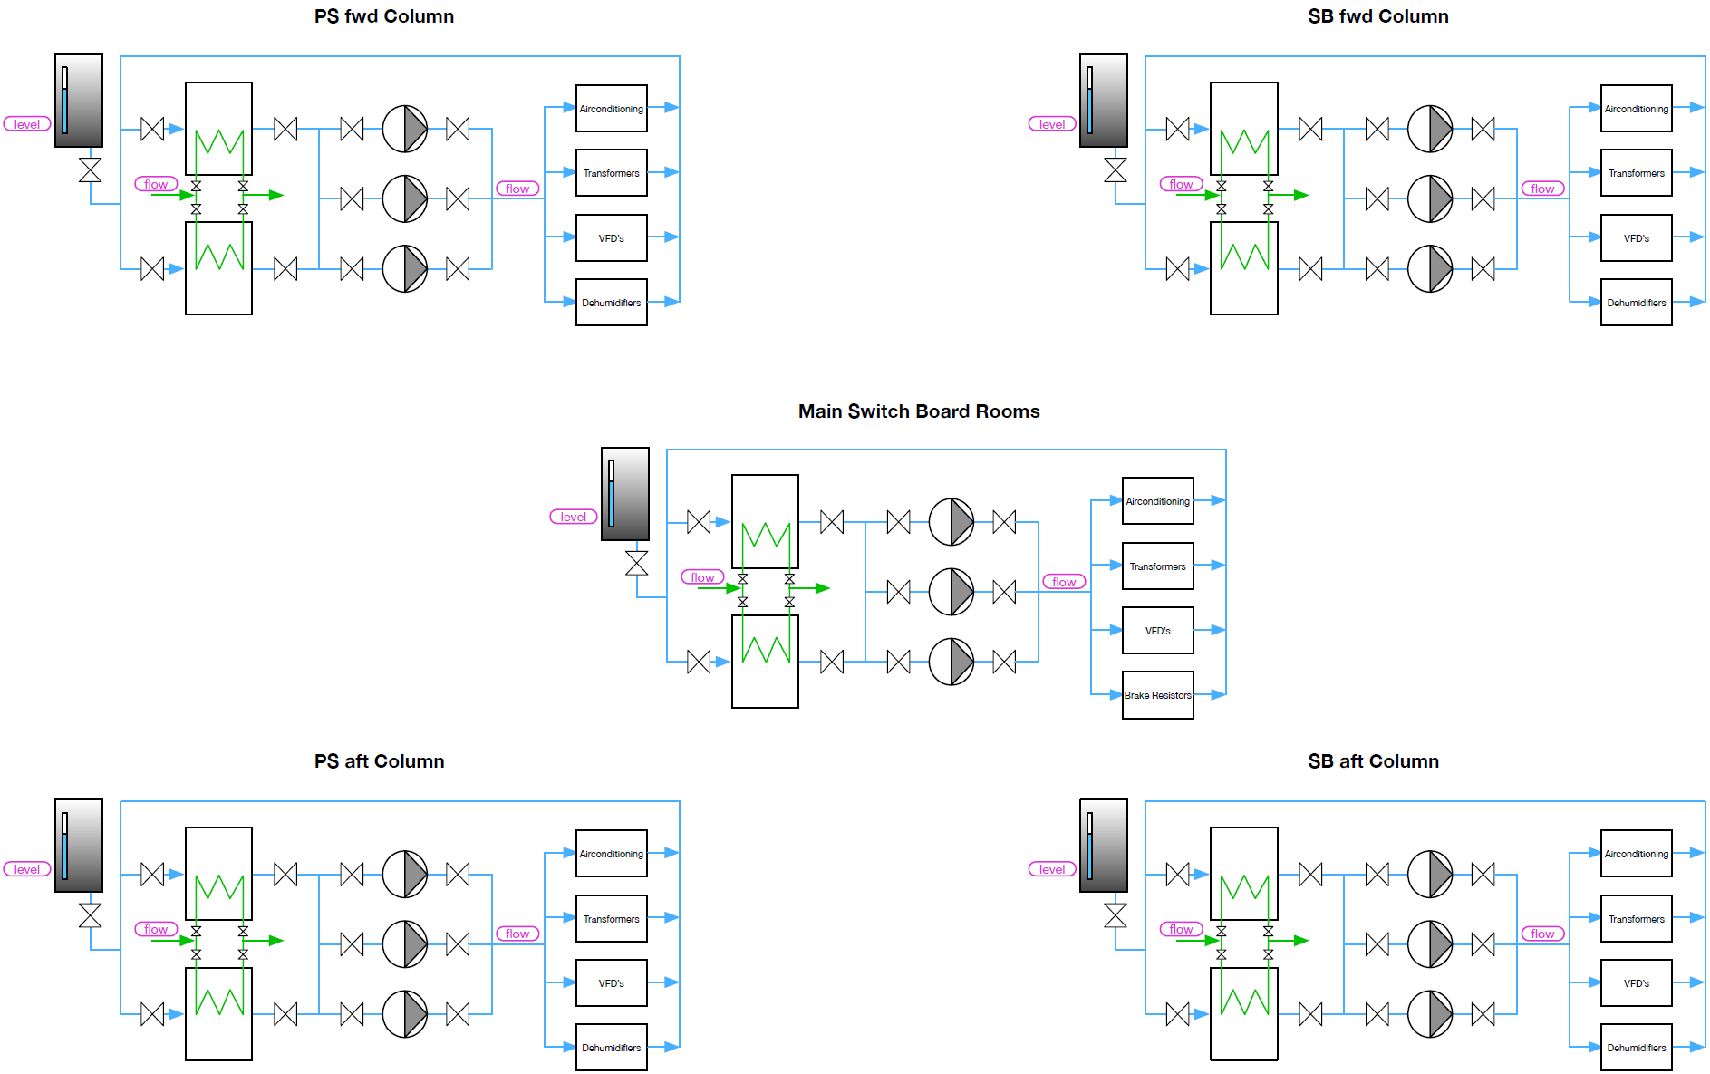

Appendix 2: Detailed overview old design
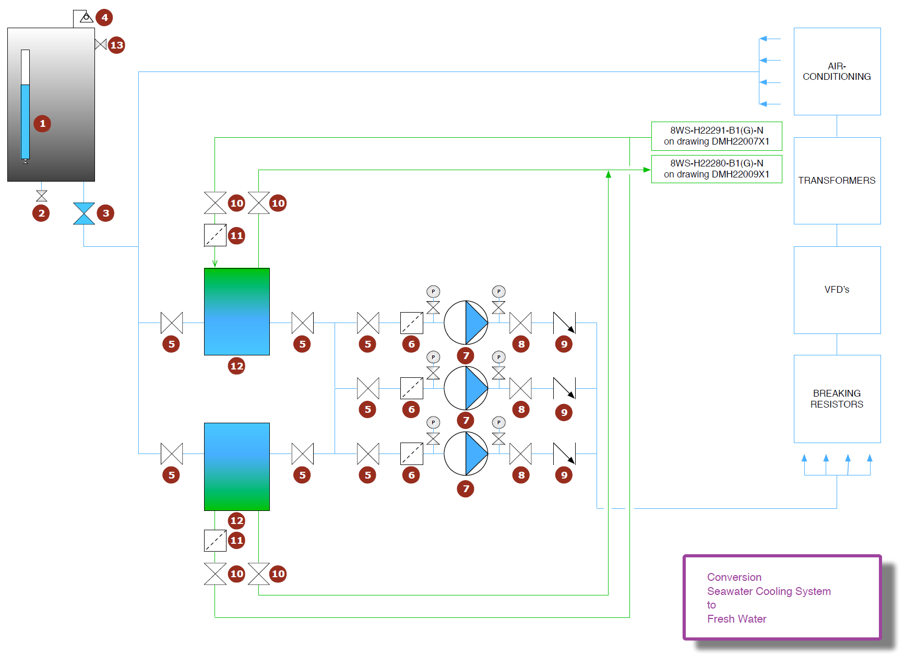

Appendix 3: List of ordered parts
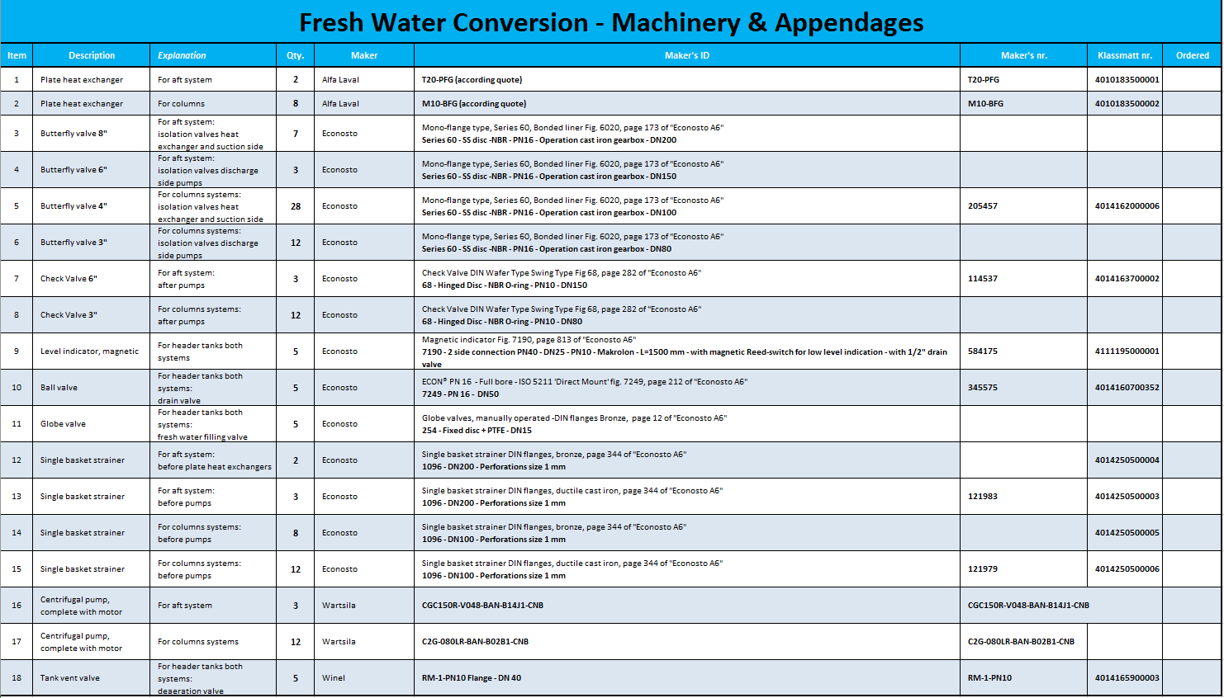

Appendix 4: Old calculation Four Columns

Appendix 5: Old calculation Mid Ship
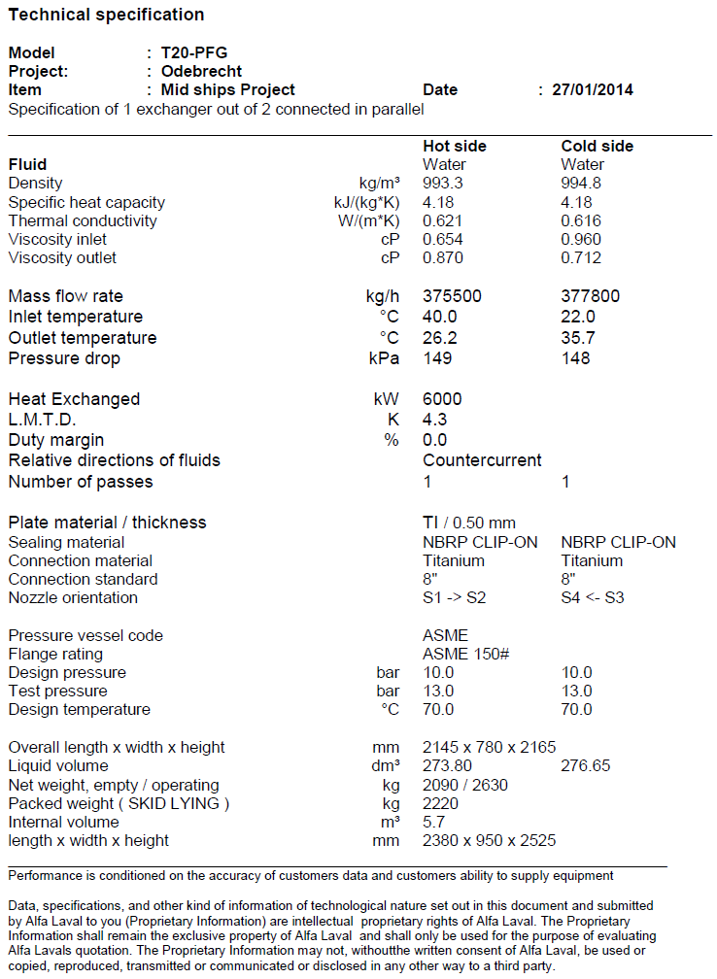

Appendix 6: Explanation of symbols
Symbol | Name | Unit
m | Mass flow | kg/s
v | Density | m³/kg
c | Velocity | m/s
A | Surface | m²
D | Diameter | m
V_{max} | Maximum volume flow | m³/s
V_{loss} | Volume flow losses | m³/s
r | Radius | m
p_{d} | Pressure drop | Pascal
L_{p} | Pipe length | m
Visc | Viscosity
T | Temperature | °C
∆T | Temperature difference | °C
K | Heat transfer coefficient | W/m²·k
∝ | Heat transfer coefficient | W/m²·k
δ | Wall thickness | m
λ | Thermal conductivity | W/m·k
Q | Heat transfer | kJ/s
q | Heat transfer per m² | kJ/s/m²
P | Transferred power | W
V_{et} | expansion tank volume | liter
k | Safety factor
V_{w} | Water volume of system | liter
v₁ | Specific volume of water at operating temperature | m³/kg
v₀ | Specific volume of water at initial temperature | m³/kg
NPSHa | Available head | m
NPSHr | Required head | m
H_{s} | Suction static head, elevation of the liquid above the pump | m
H_{p} | Suction pressure head, the atmospheric pressure | m
H_{vp} | Vapor pressure of liquid | m
H_{f} | Friction head, friction losses in the suction pipe | m
H_{i} | Inlet head losses in the eye of the impeller | m

Appendix 7: Conversion table pipe diameter
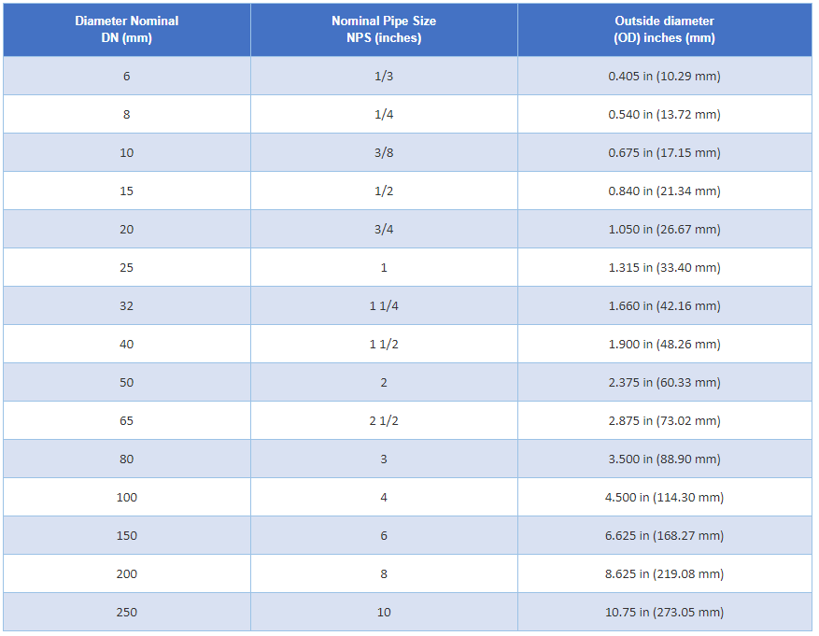
(Sel-Tec, N.D.)

Appendix 8: Conversion table for standardised pipe diameters
SIZE" | SIZE NB | MSL | ISMT | JSL | USL | BAO | Lontrin | SMTM | TNRS | V&M | Wuzi
1/2 | 15 | 1,323.53 | 1,316.18 | 1,330.88 | – | 1,029.41 | 1,036.76 | 1,470.59 | 1,397.06 | 1,426.47 | 1,022.06
3/4 | 20 | 1,102.94 | 1,095.59 | 1,110.29 | – | 955.88 | 963.24 | 1,250.00 | 1,176.47 | 1,205.88 | 948.53
1 | 25 | 955.88 | 948.53 | 963.24 | – | 882.35 | 889.71 | 1,102.94 | 1,029.41 | 1,058.82 | 875.00
1.25 | 32 | 911.76 | 904.41 | 919.12 | – | 852.94 | 860.29 | 1,058.82 | 985.29 | 1,014.71 | 845.59
1.5 | 40 | 808.82 | 801.47 | 816.18 | – | 808.82 | 816.18 | 955.88 | 882.35 | 911.76 | 801.47
2 | 50 | 794.12 | 786.76 | 801.47 | – | 617.65 | 625.00 | 941.18 | 867.65 | 897.06 | 610.29
2.5 | 65 | 794.12 | 786.76 | 801.47 | – | 617.65 | 625.00 | 941.18 | 867.65 | 897.06 | 610.29
3 | 80 | 794.12 | 786.76 | 801.47 | – | 617.65 | 625.00 | 941.18 | 867.65 | 897.06 | 610.29
3.5 | 90 | 794.12 | 786.76 | 801.47 | – | 617.65 | 625.00 | 941.18 | 867.65 | 897.06 | 610.29
4 | 100 | 794.12 | 786.76 | 801.47 | 735.29 | 617.65 | 625.00 | 941.18 | 867.65 | 897.06 | 610.29
5 | 125 | 794.12 | 786.76 | 801.47 | 735.29 | 617.65 | 625.00 | 941.18 | 867.65 | 897.06 | 610.29
6 | 150 | 794.12 | 786.76 | 801.47 | 735.29 | 617.65 | 625.00 | 941.18 | 867.65 | 897.06 | 610.29
8 | 200 | 794.12 | 786.76 | 801.47 | 735.29 | 647.06 | 654.41 | 941.18 | 867.65 | 897.06 | 639.71
10 | 250 | 794.12 | 786.76 | – | 735.29 | 647.06 | 654.41 | 941.18 | 867.65 | 897.06 | 639.71
12 | 300 | 852.94 | – | – | 735.29 | 647.06 | 654.41 | 1,000.00 | 926.47 | 955.88 | 639.71
14 | 350 | 852.94 | – | – | 735.29 | 661.76 | 669.12 | 1,000.00 | 926.47 | 955.88 | 654.41
16 | 400 | 882.35 | – | – | – | 661.76 | 669.12 | 1,029.41 | 955.88 | 985.29 | 654.41
18 | 450 | 882.35 | – | – | – | 676.47 | 683.82 | 1,029.41 | 955.88 | 985.29 | 669.12
20 | 500 | 882.35 | – | – | – | 676.47 | 683.82 | 1,029.41 | 955.88 | 985.29 | 669.12
22 | 550 | – | – | – | – | 705.88 | 713.24 | 1,176.47 | 1,029.41 | 1,132.35 | 698.53
24 | 600 | – | – | – | – | 705.88 | 713.24 | 1,176.47 | 1,029.41 | 1,132.35 | 698.53

(Neelcon, N.D.)

Appendix 9: New P&ID design Mid Ship
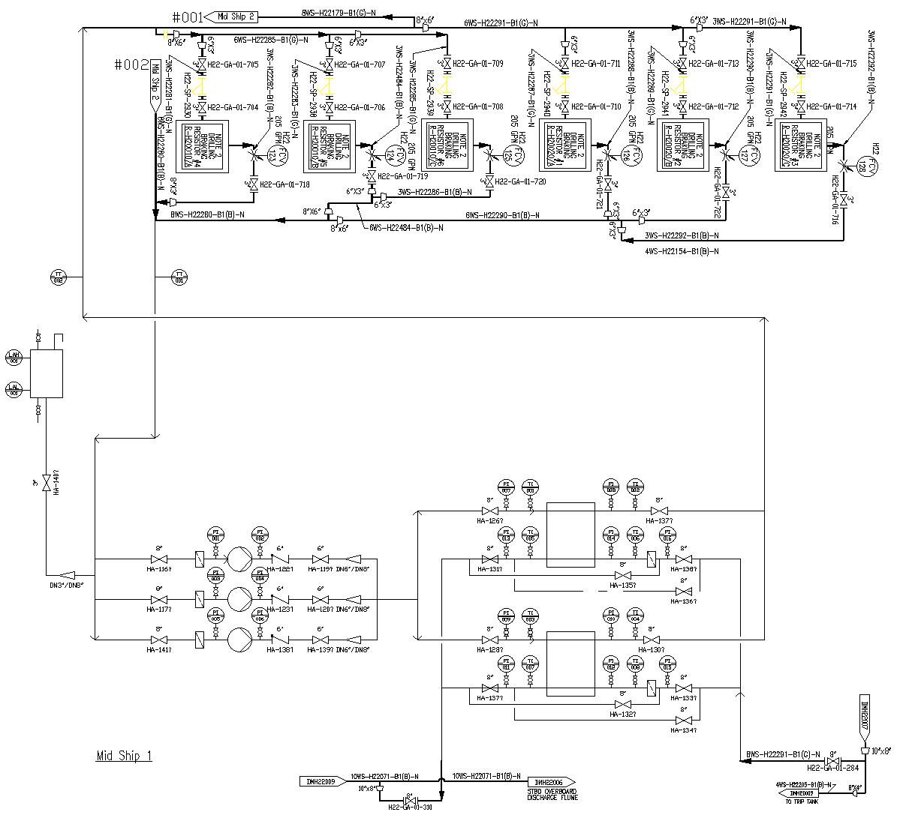
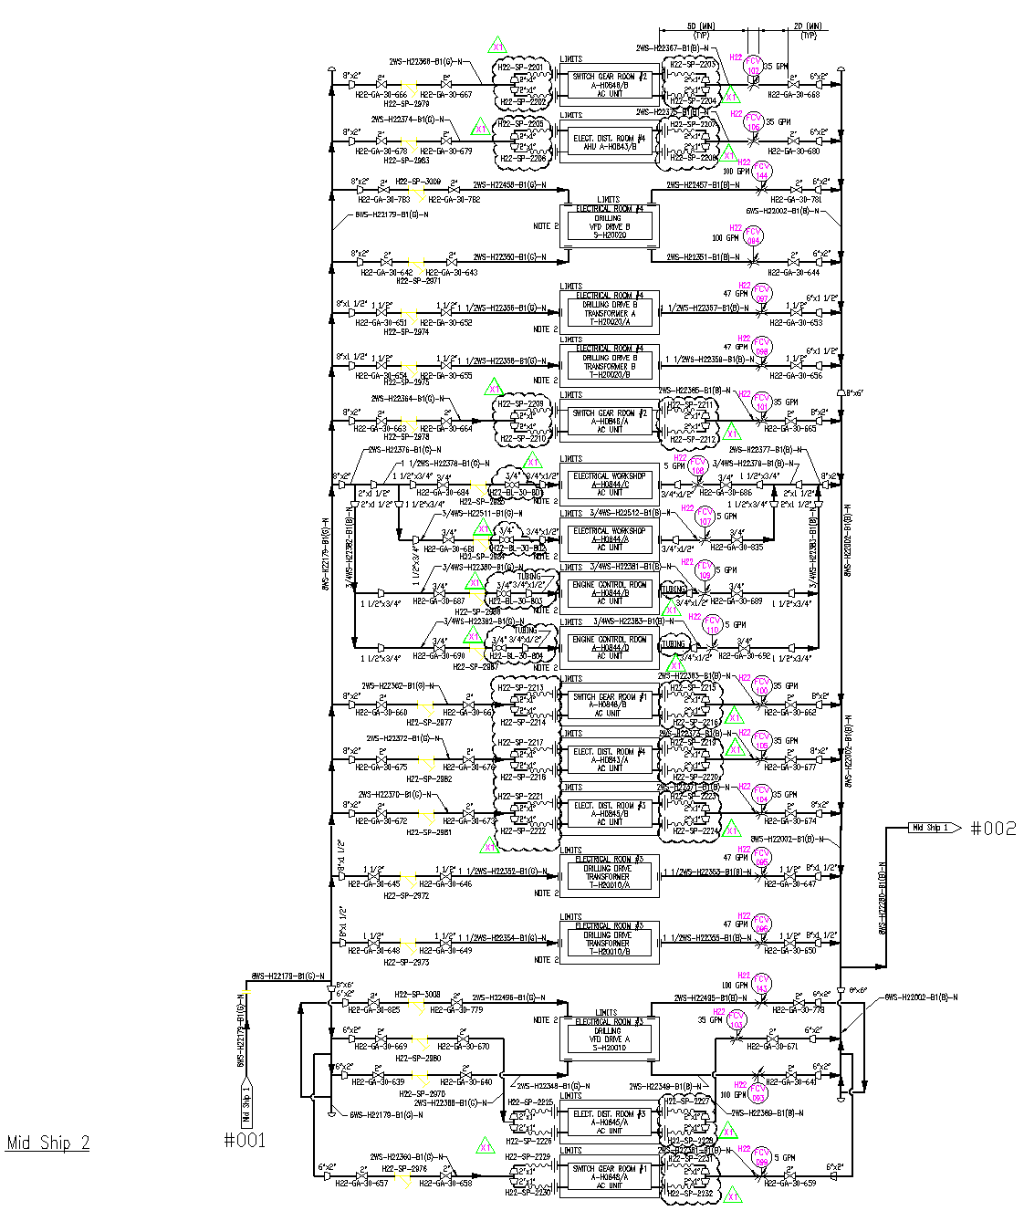

Appendix 10: New P&ID design Port aft Column
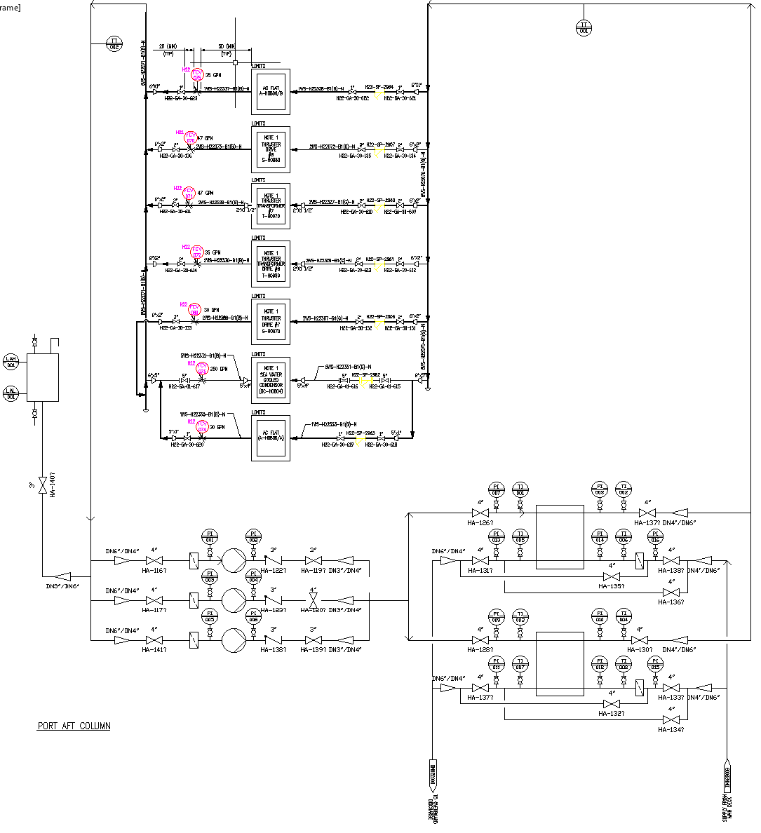

Appendix 11: New P&ID design Port FWD Column
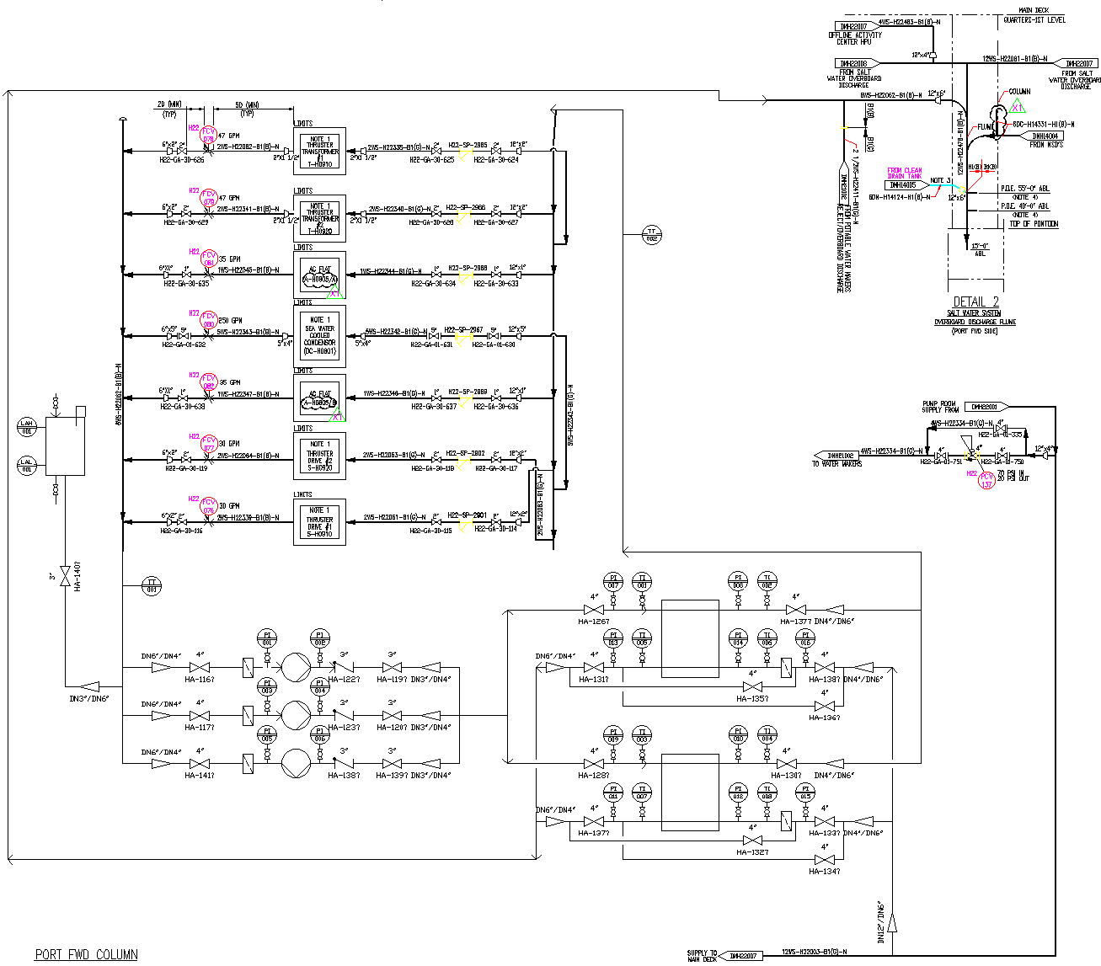

Appendix 12: New P&ID design STBD aft Column
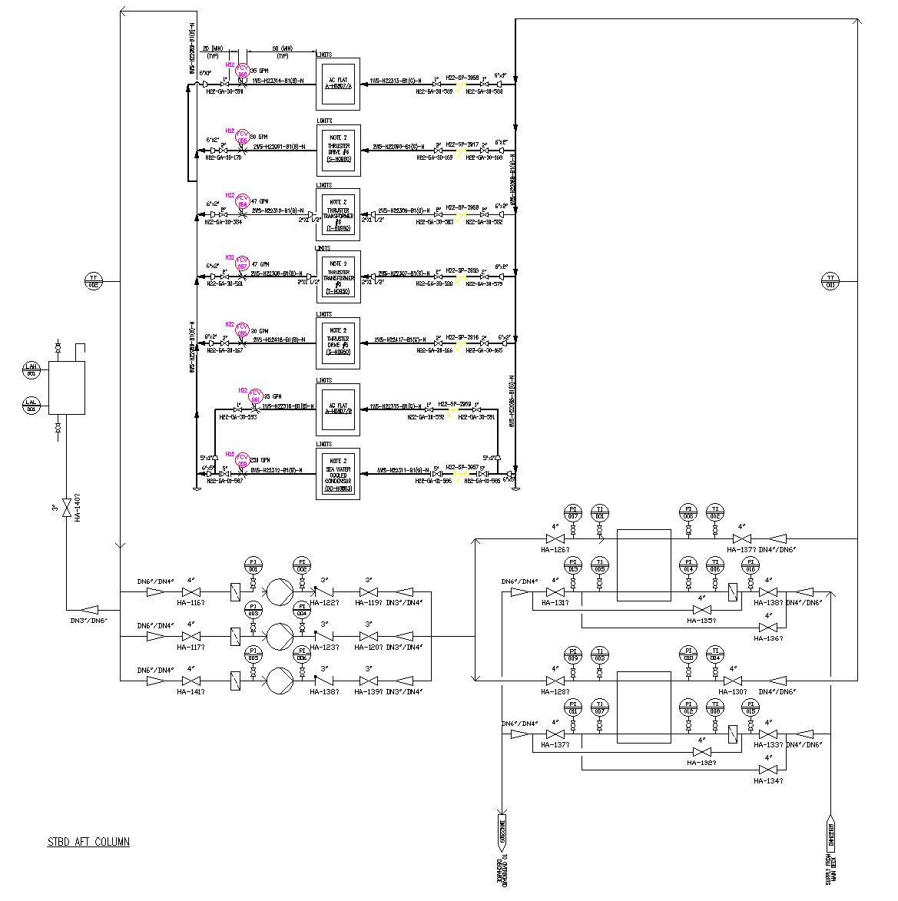

Appendix 13: New P&ID design STBD FWD Column
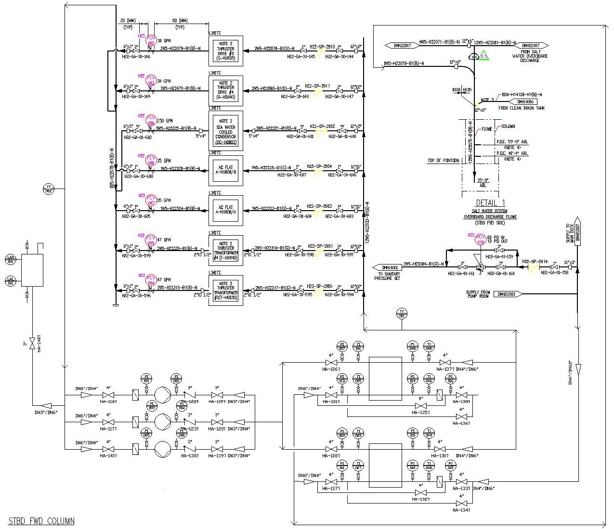

Appendix 14: Technical drawing Four Columns plate heat exchanger
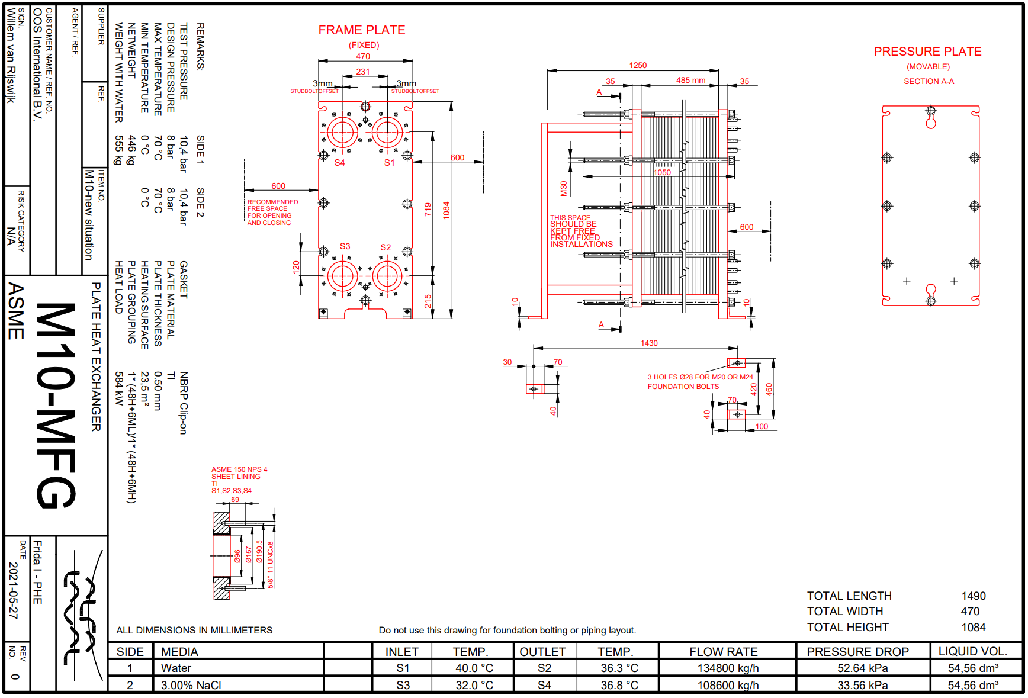

Appendix 15: Technical drawing Mid Ship plate heat exchanger
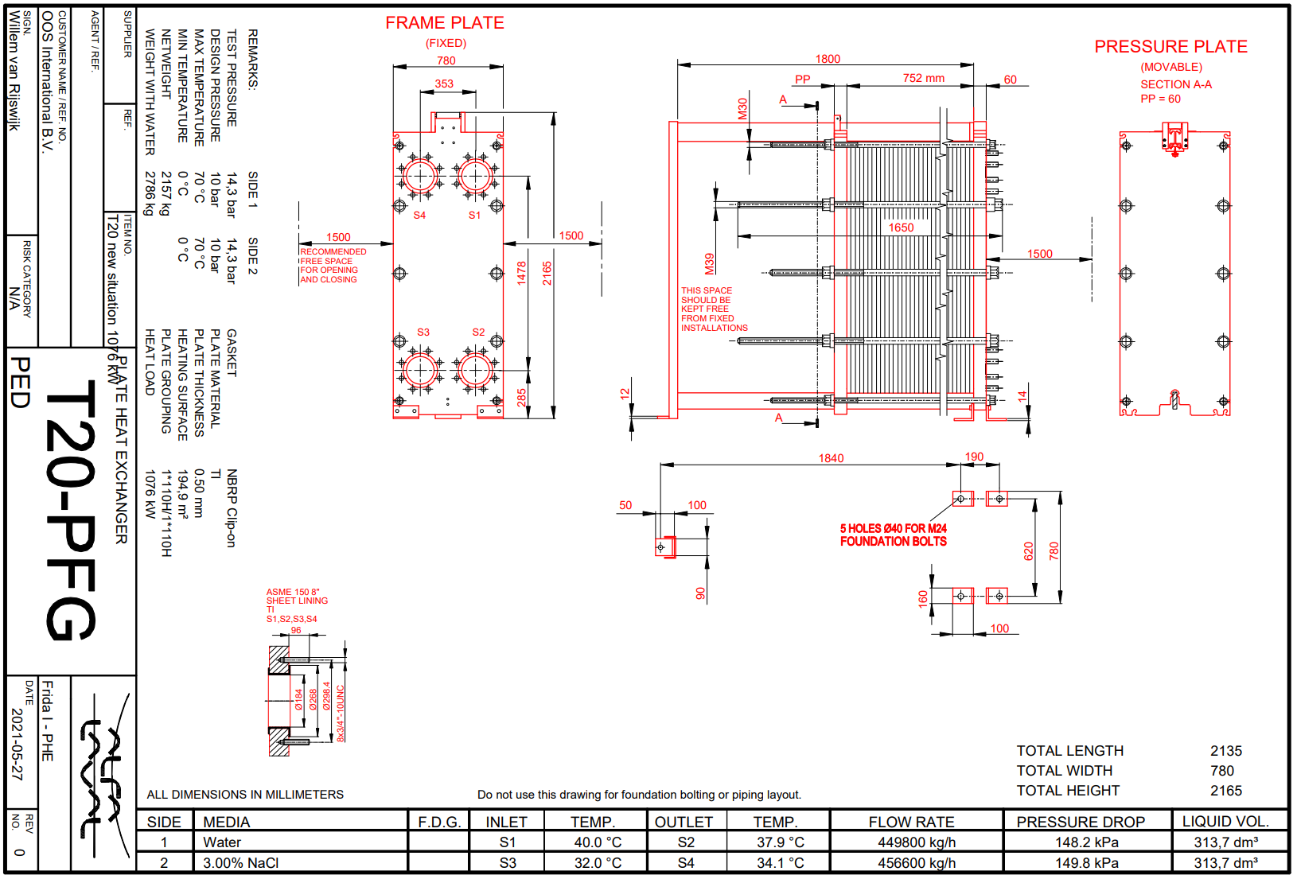

Appendix 16: New parts list Four Columns
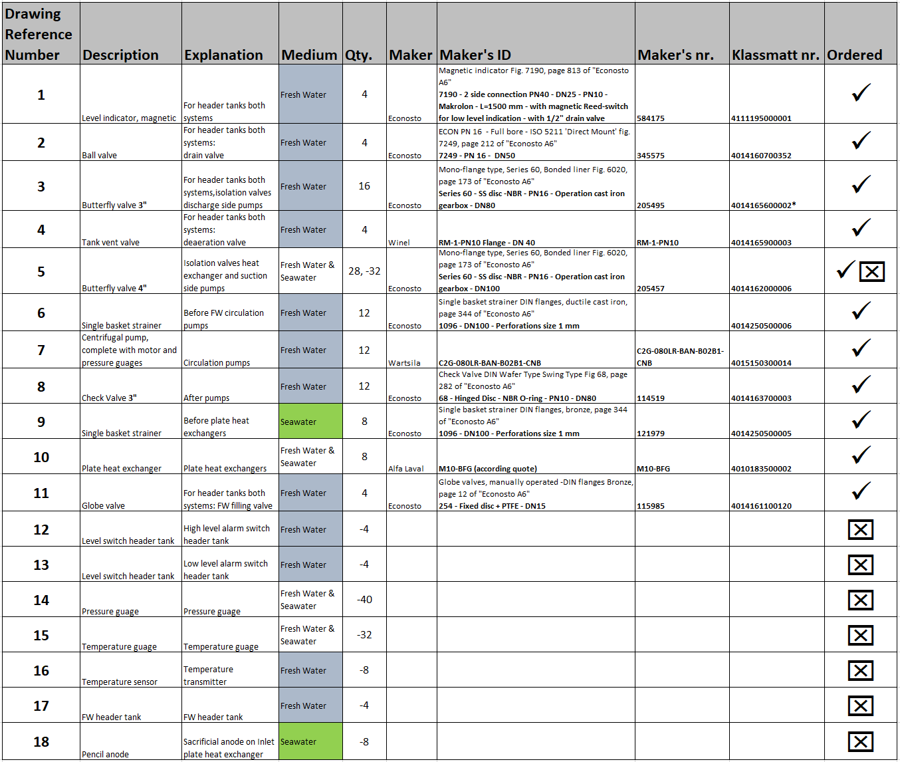
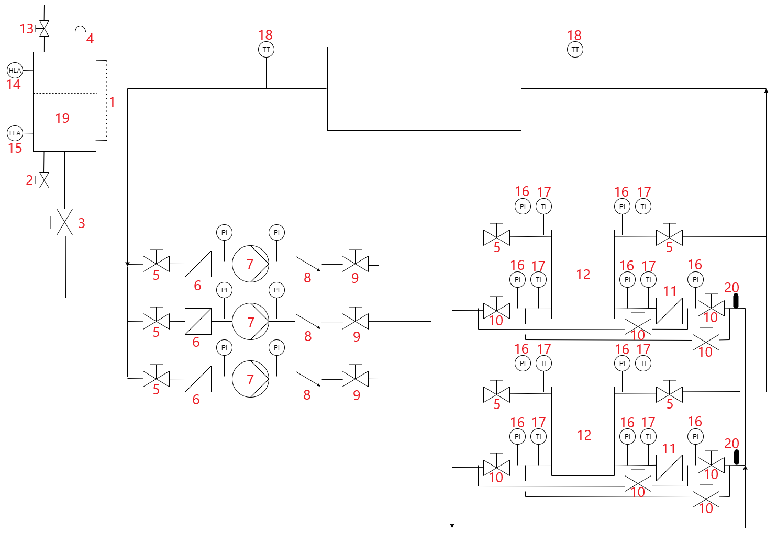

Appendix 17: New parts list Mid Ship
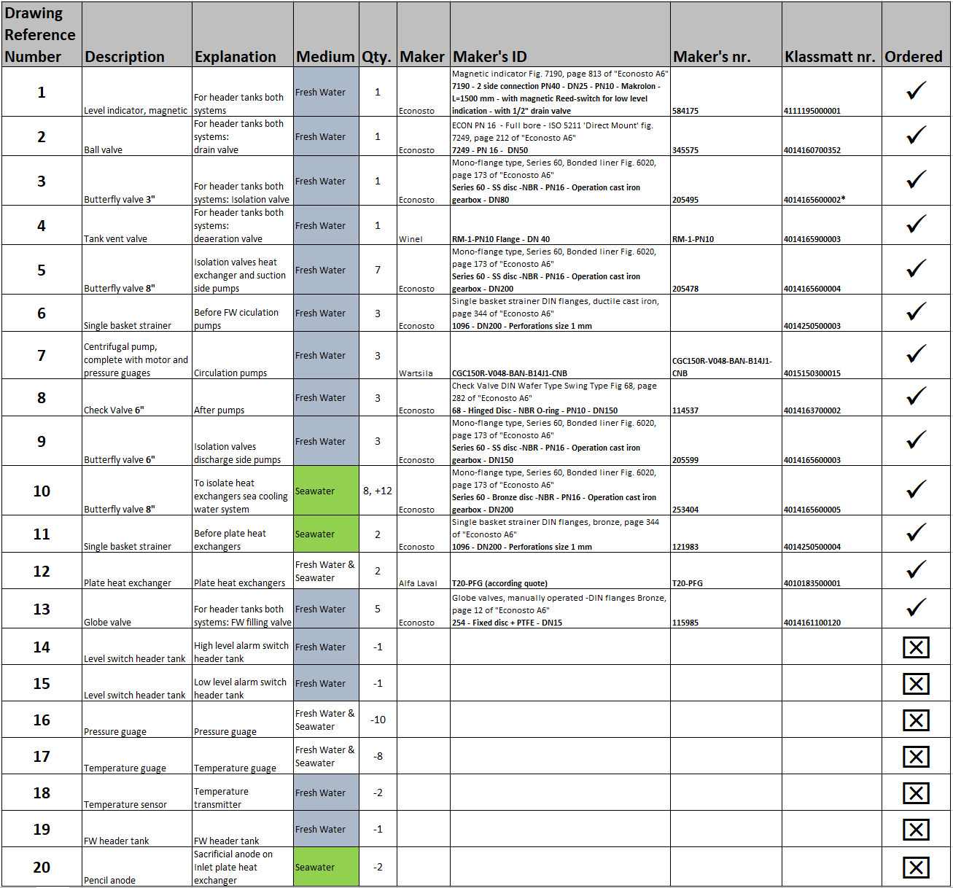

Appendix 18: Parts and price lists Four Columns
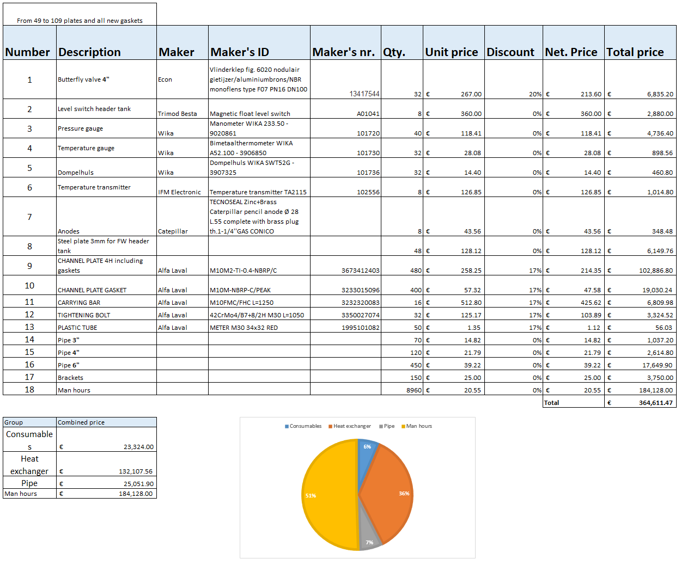

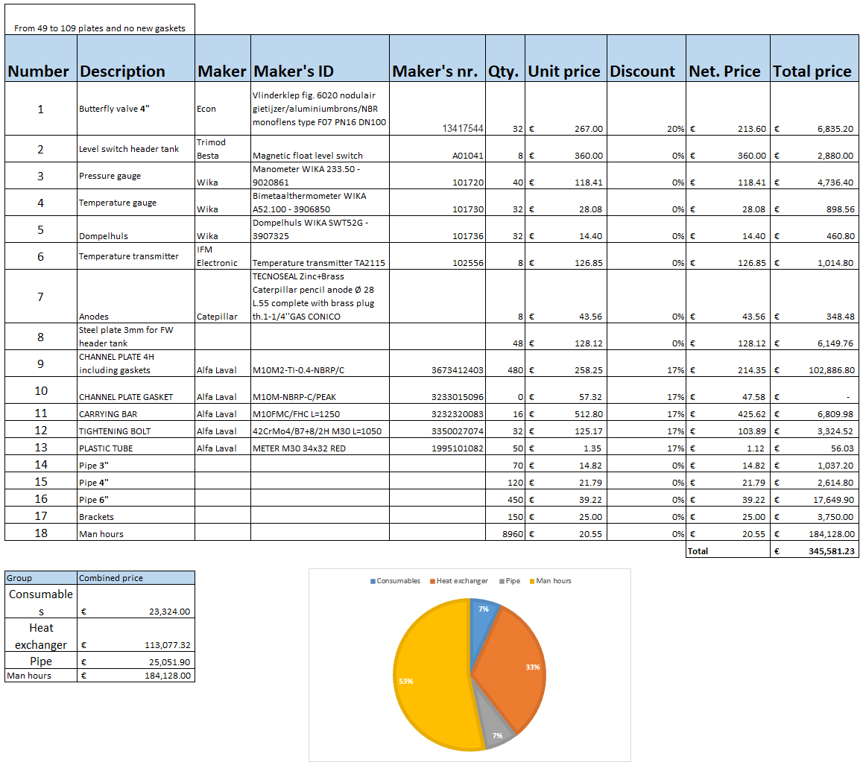

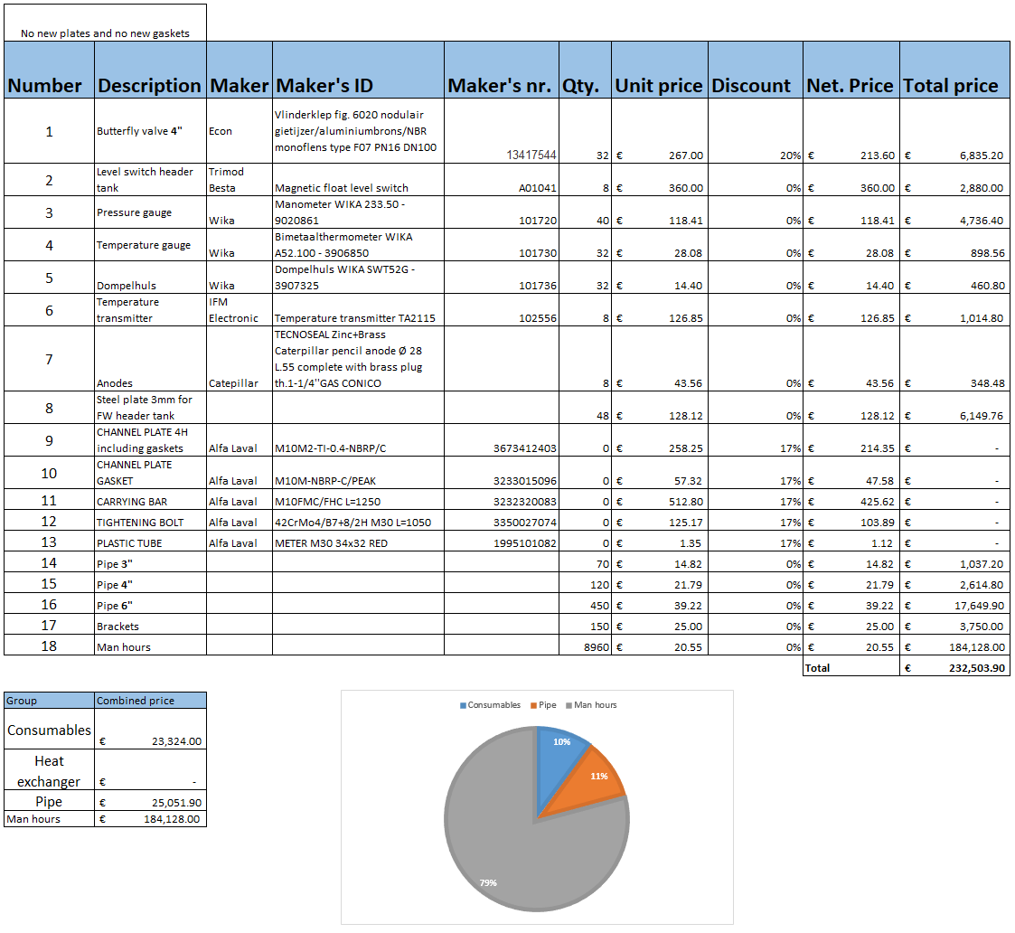

Appendix 19: Parts and price lists Mid Ship
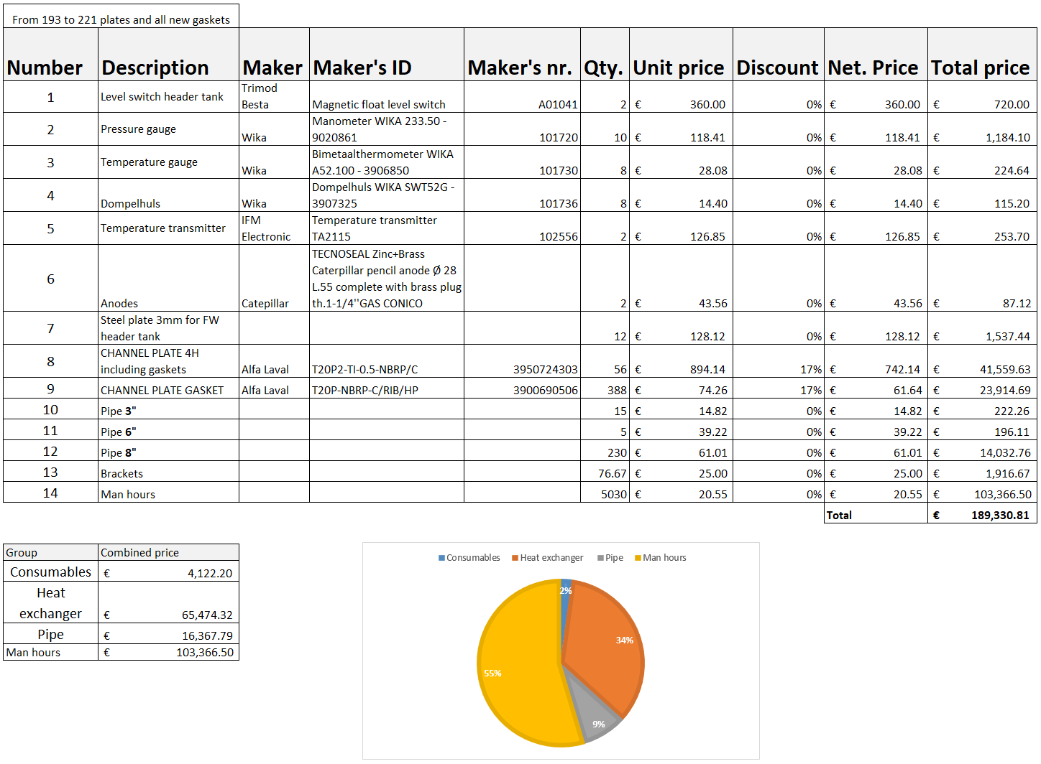
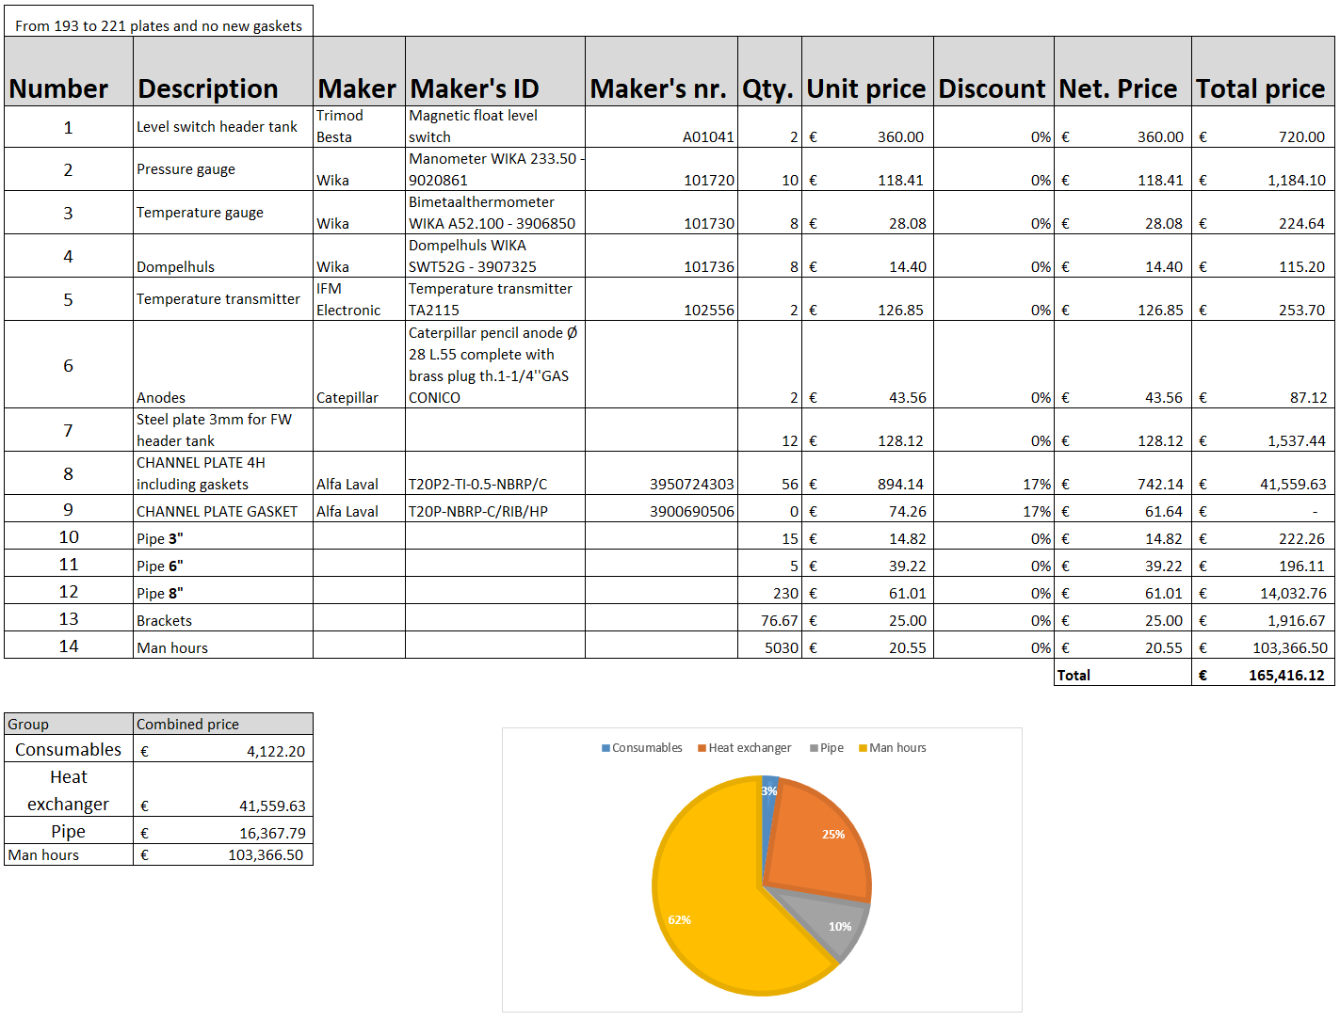

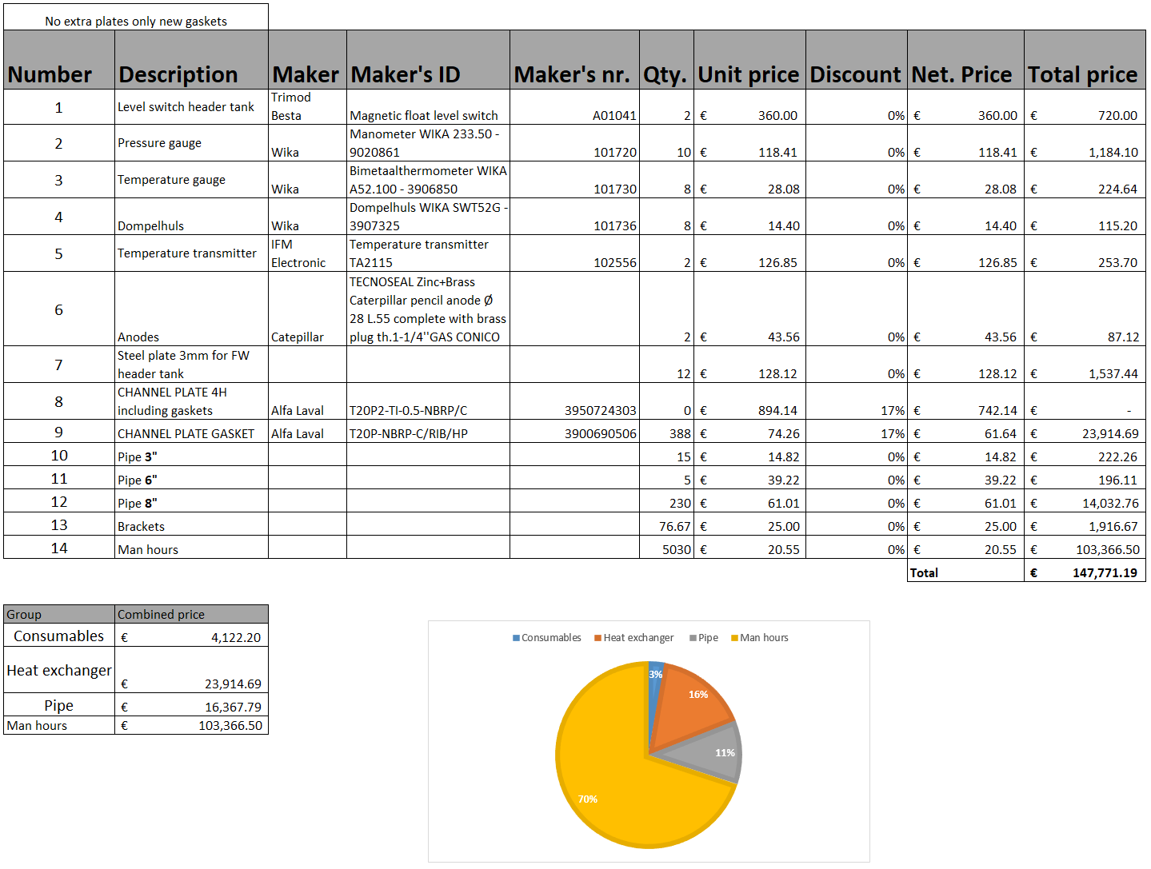

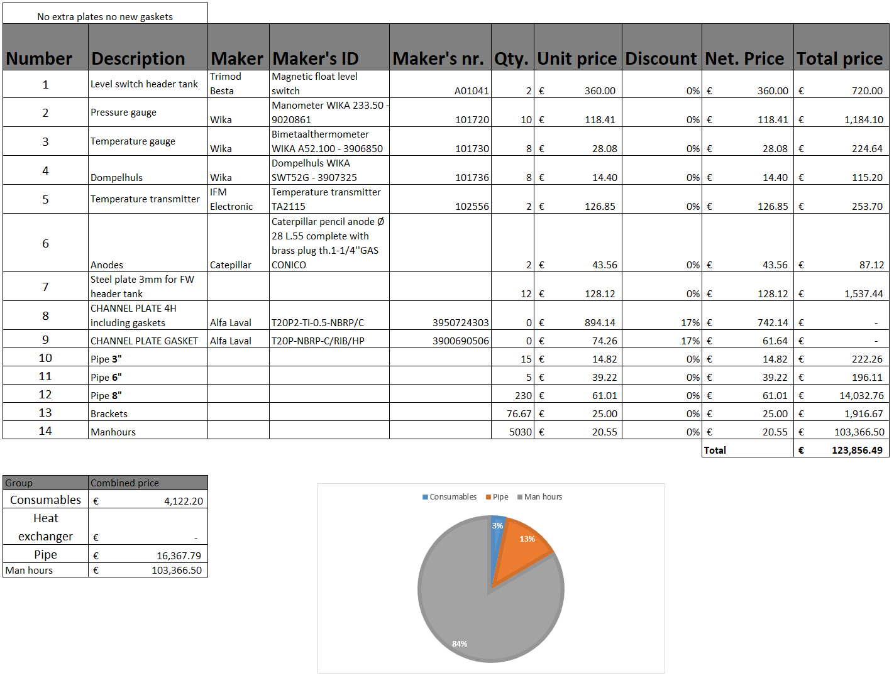

Appendix 20: Quotation Alfa Laval plate heat exchangers
