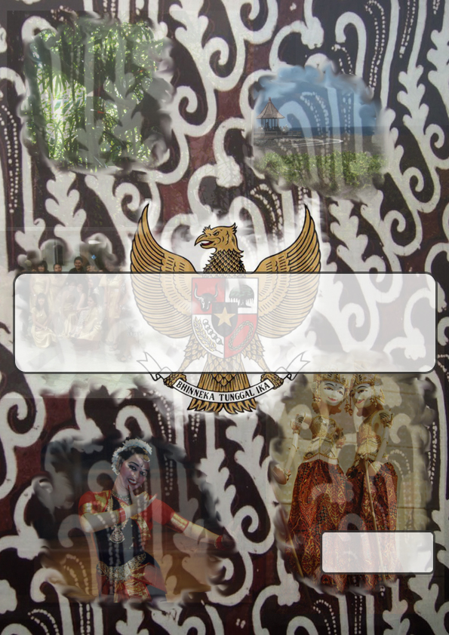
Dot.us Indonesia
Erik Stolman
1533667
Remko’s Forum for Nokia
Developing mobile website interfaces in a third world country

Remko’s Forum for Nokia
Developing mobile websites interfaces in a third world country
By Erik Stolman
Graduation Thesis
Remko’s Forum for Nokia
Developing mobile website interfaces in a third world country
By Erik Stolman,
Student Digitale Communicatie

Guided by Marjon Westra
Docent Digitale Communicatie

Thesis submitted on June 10th 2011
To Hogeschool Utrecht
In Utrecht

Short abstract

This thesis describes the process of making an existing forum for Android, BlackBerry and the internet available on Nokia smartphones by adapting the internet version and dynamically changing the website lay out to fit use on smartphones using launcher applications that are spreadable via smartphone application stores.

Keywords

mobile development, websites for mobile devices, usability, dynamic interface generation

All Remko’s Forum data, names and products are the property of Remko Weingarten and by extension Dot.us Indonesia.

Foreword

The writing of this report has been the result of my international internship at Dot.us, based in Indonesia. The assignment has resulted in the improvement and implementation of Remko’s Forum for Web, which is a part of Remko’s Forum, a Blackberry and Android based mobile application.

During my stay in Indonesia I have worked and lived under conditions sometimes unknown to the Netherlands, which includes like any long term period, good and bad (learning) experiences.

Good experiences in example include friendly people, very accessible and cheap public transport, always warm weather befitting the tropical country that Indonesia is, unexpected access to internet outside of the office via a USB modem, an air-conditioning system, which is a must for me, at my house of residence, and small lizards named cicak (pronounced tsjietsjak) who frequented my house of residence on regular basis (I counted about two every day) and eat mosquitoes, which can be seen as a big plus in Indonesia.

Learning experiences in example include visible poverty (both in adults and children) as the country of Indonesia does not have social security and living standards as we are used to in the Netherlands, frequent power outage which sometimes lasts up to several hours for entire city blocks, not having access to hot water at my house of residence, very slow and limited internet access, the occasional extreme rain falls, mosquitoes, the open sewers and the vermin that populates them, in example rats and wild cats.

As a result of my internship in Indonesia and my stay in the country in general I feel I have grown in terms of experiences, understanding and appreciation of my own privileged situation in the Netherlands. These are things I will carry with me far beyond the reaches of this internship and the following thesis.

I would like to extend a word of gratitude towards the Hogeschool Utrecht for guiding my development so far. Furthermore I would like to thank the following people in person; Marjon Westra for guiding me in the process of my graduation internship, Dick van ‘t Hof for providing information and helping me in the process of getting my internship request approved, Maratien de Vries for taking over as my “SLB-er” (Education Career Guide) after Joris Kurpershoek stepped down from that role.

Also I would like to extend my word of gratitude towards Dot.us for giving me an internship at their office in Indonesia. Foremost I wish to thank Remko Weingarten and Ari Murdiati Nugraheni for accepting my internship, providing product information and statistics, reviewing my work and helping me getting settled. Furthermore I wish to thank Jethro Goovaart for his support and advice, Lala Latifah for expressing her wishes in improvement of the Remko’s Forum for Web user interface and vocally translating user feedback gathered from the Indonesian sections of Remko’s Forum, and all my colleagues at Dot.us in general for putting up with me and supporting me for the duration of my internship.

Table of contents

1 Preface 2
1.1 Problem statement 2
1.2 Research methods 3
1.3 Thesis structure 4
2 Dot.us 5
2.1 Information about the company 5
2.2 Products 6
2.2.1 Products of Dot.us 6
2.2.2 Products of Easy Prima Solusi 6
2.2.3 Products of Mobile Prima Solusi 7
2.3 Mission statement and business strategy 7
3 The project 8
3.1 General information about Remko’s Forum 8
3.2 Project description 9
3.3 Project restrictions 10
3.3.1 Time restrictions 10
3.3.2 Assignment restrictions 10
3.3.3 Usability research restrictions 11
3.4 Project management 11
3.4.1 Project management situation 11
3.4.2 Employee mentality in Indonesia 12
3.4.3 Consequences for western management methods 12
3.4.4 Creating an effective way of management 13
3.5 Project risks 13
3.6 Planning 16
3.6.1 Timeframe available for the graduation internship 16
3.6.2 Tasks and estimated time needed 17
3.6.3 Planning per week 17

4 Remko’s Forum for Nokia 18
4.1 Development method 18
4.1.1 Operating systems on Nokia smartphones 19
4.1.2 Comparing available development methods 19
4.1.3 Demo testing and results 20
4.2 Back end system research 20
4.2.1 Application to server communication 20
4.2.1 Application layer 21
4.2.2 Data layer 21
4.2.3 Server layer 22
4.2.4 Database layer 22
4.3 Graphic design 22
4.3.1 Old interface of Remko’s Forum for Web 23
4.3.2 New interface of Remko’s Forum for Nokia 24
4.3.3 New interface of Remko’s Forum for Web 25
4.3.4 New interface of Remko’s Forum for Tablets 27
4.4 Functional design 28
4.5 Implementation 30
4.5.1 Setting up the separate test environment 30
4.5.2 Modifying Remko’s Forum for Web 30
4.5.3 Writing the launcher application for the Nokia OVI Store 31
4.5.4 Making Remko’s Forum suited for use on tablets 31
4.6 Usability 32
4.6.1 Expert assessment 32
4.6.2 Indexing user wishes and feelings 35
4.6.3 Interviewing a Remko’s Forum moderator 35

5 Conclusion; answering the problem statement 36
5.1 Application requirements 36
5.2 Target groups 36
5.3 Functionalities 37
5.4 Interface 38
5.5 Usability 39
5.6 Development method 41
5.7 Technical structure 42
5.8 Answering the problem statement 44
5.9 Conclusion 45
Recommendations 46
Glossary 48
Reference list 50
Internet sources 50
Literature sources 53
Appendix 54

Abstract

The internship assignment “Remko’s Forum for Nokia” included researching user experience and wishes, technical requirements and restrictions of Nokia smartphones, functionalities of the current Remko’s Forum applications, usability errors in the old version of Remko’s Forum for Web, and data structure of the existing back end systems of Remko’s Forum. Research methods that were used to gather information on these points were: desk research, interviewing and expert assessment.

After examining and discarding several approaches to develop Remko’s Forum for Nokia, a separated approach was chosen. The main forum application was developed as a website, an improvement on the old Remko’s Forum for Web, which had very limited functionalities and had a large number of usability errors.

Remko’s Forum for Web was updated in its functionalities, had its usability improved based on usability research and was expanded with a dynamic CSS style sheet generator and interface, so that the interface could be adapted for use on smartphones dynamically.

The other part of the separated approach was to write a launcher application using Java2ME, a development method that is supported by Series 40 and Series 60 (Symbian) smartphones from Nokia. This launcher application is responsible for identifying the user and opening the Remko’s Forum for Web website, while the user identification data was sent as a secured parameter.

This launcher can be spread via the Nokia OVI Store, and can easily be recreated using a different development method to add it to the application store of a different smartphone manufacturer.

In the final weeks of the Remko’s Forum for Nokia project, by request of Remko Weingarten, the dynamic CSS generator and the Dynamic interface of Remko’s Forum for Web have been adapted so that they also work for connecting tablet computers, and this has been tested on the Playbook tablet of Research In Motion.

1 Preface

Dot.us as a company has been known to me for nearly two years via a connection in my network, who has also done an internship there. When I visited Indonesia last year on vacation, I took the initiative to acquire information about the availability of a project fit for my graduation thesis from Dot.us. Remko Weingarten, who is the director of the company, provided me with the following information.

At Dot.us a wish was formed to expand one of their existing mobile products in the form of new mobile platform. This product, Remko’s Forum, at the time existed as both a Blackberry and a Android application. The aim was to set one specific target device for the new mobile application to be available on, but as a secondary objective it was decided that support for multiple devices and manufacturers also had a big priority in the project.

This resulted in the internship assignment “Remko’s Forum for Nokia”, which includes research into the current versions of Remko’s Forum for identifying layout, functionality, user demography, data processing and additional usability research, Nokia OVI Store requirements research and programming method research. The results of these researches have been applied to Remko’s Forum for web and have resulted in the building of a “launcher application” that can be spread via the Nokia OVI store.

Problem statement

The result of which is the following thesis, in which the following problem statement has been central;

How can the existing interface and functionality of the current Remko’s Forum application be improved by usability research and which steps need to be taken to make a version of Remko’s Forum available on mobile devices from Nokia (this solution has to be spreadable via the Nokia OVI Store), while implementing the results from the usability research.
The purpose of this thesis is to identify problems with- and improve the usability of Remko’s Forum, resulting in a new version of Remko’s Forum to be released or improved for one or more new mobile platforms. This in turn should lead to an increase in the amount of registered users on Remko’s Forum by at least 10% in two years. The amount of users using Remko’s Forum is over 481.000, based on the BlackBerry and Android download data ¹.

To further give direction to this thesis, the following questions have been set to formulate an answer to the problem statement;

- What are the requirements that Dot.us has specified for the new application of Remko’s Forum?

- What is (are) the target group(s) of Remko’s Forum and what are the attributes that are typical for these groups?

¹ See Appendix IV: Statistics from Remko’s Forum, under the header “application download statistics for Remko’s Forum”, on page 30 of the appendix documentation, for the statistics interface of the given user amount. Statistics last updated on 25th of May, 2011.
- What functionalities are available in the current version of Remko’s Forum for Android, Blackberry and Web? Are there improvements or new functions that can be made to these functions to improve the usability / user experience and what are they?

- Are there points of attention definable in the old interface of Remko’s Forum and what are those points?

- Which results and conclusions can be drawn from a usability research on existing Remko’s Forum applications and how can these results be implemented in a new version of the Remko’s Forum application?

- Which development methods can be used to build an application for mobile devices from Nokia? And for what Nokia operating system do these methods apply? And what are the effects of this on available development methods for the different types of Nokia Devices? Which of these methods is most suited to build a new version of Remko’s Forum on Nokia, in a way that a wide reach of other devices (not restricted to Nokia devices only) is also supported?

- What is the current technical structure of the back end server and the front end application layer on which Remko’s Forum is based, and what improvements need to be made in order to make Remko’s Forum available for Nokia and other mobile devices?

1.2 Research methods

During the graduation internship several research methods have been used to gather information on; user experience and wishes, technical requirements and restrictions of Nokia smartphones, functionalities of the current Remko’s Forum applications, usability errors in the old version of Remko’s Forum for Web, and data structure of the existing back end systems of Remko’s Forum. Research methods that were used to gather information on these points where; desk research, interviewing and expert assessment.

For the Remko’s Forum for Nokia project, there were three major restrictions in place; the existing database structure was not to be changed, all database requests should be made through the data layer, and the interface design style was not allowed to deviate from the current styles that are used in the BlackBerry and Android versions of the applications. Therefore there was no point in making a technical design for a database structure, and the interfaces of Remko’s Forum for Nokia and Remko’s Forum for Web have a similar look and feel as the BlackBerry and Android applications.

This thesis has been primarily written for Dot.us Indonesia. Secondarily this thesis has been written as part of my graduation process of my education, Digitale Communicatie at Hogeschool Utrecht.

1.3 Thesis structure

The thesis structure is as follows;

Chapter two: Dot.us provides general information about the company where the internship that this thesis is based on was conducted, and its products, its mission statement, and its business strategy.

Chapter three: the project, provides information about Remko’s Forum, and about the assignment that was given by Dot.us. It also includes the project restrictions set for this internship, based on available time, the assignment and usability research. The management method used for the project, the project risks and the project planning have all been included in this chapter as well.

Chapter four: Remko’s Forum for Nokia, describes how all the assignment tasks from Dot.us for Remko’s Forum have come to completion. It starts telling about choosing the development method to realize the project in, and then the chapter continues about the research that has been done about the existing back end systems. This is followed by information about the graphical design. After that, the functional design of Remko’s Forum for Web based on the functions identified in the existing Remko’s Forum applications is discussed, the implementation process is described and the results of the usability research are listed.

Chapter five: Conclusion; answering the problem statement, will answer all the sub questions that have been defined in chapter 1.1 of this preface. At the end of the chapter it concludes this thesis.

After chapter five, recommendations are given to Dot.us to improve the usability, data security and maintainability of Remko’s Forum for BlackBerry, Remko’s Forum for android, Remko’s Forum for Nokia and Remko’s Forum for Web.

2 Dot.us

The graduation internship that this thesis was based on, was conducted at Dot.us, located in Jakarta, Indonesia. This chapter offers additional information about Dot.us, its products and its mission statement and its business strategy.

2.1 Information about the company

Dot.us was founded in 2005 by Remko Weingarten and is based in Indonesia. Its primary product is website development, website design and development of mobile applications. Also in the past year, two daughter companies have been founded. Dot.us has 14 full-time employees who work either on Dot.us projects or on projects of one of the daughter companies.

Dot.us uses a number of development languages for creating software. These languages are; PHP, MySQL, AJAX, XHTML, XML, CSS. For mobile development they use JAVA2ME (Micro Edition), JAVA CLDC (Connected Limited Device Configuration) and JDK 6 (Java Development Kit 6).

The first daughter company of Dot.us is Easy Prima Solusi, which is responsible for all mobile development within Dot.us. The second daughter company; Mobile Prima Solusi, has been founded for a single project by different shareholders. This project is currently under a non disclosure agreement; hence this report will not contain the project contents or description.

In general the 14 employees of Dot.us are divided over these three branches; website, mobile applications and the project from Mobile Prima Solusi (EPS). Due to the subject for my thesis, which is Remko’s Forum, I have been working at EPS. EPS is currently responsible for maintaining and updating Remko’s Forum Applications, even though it was originally created by Dot.us.
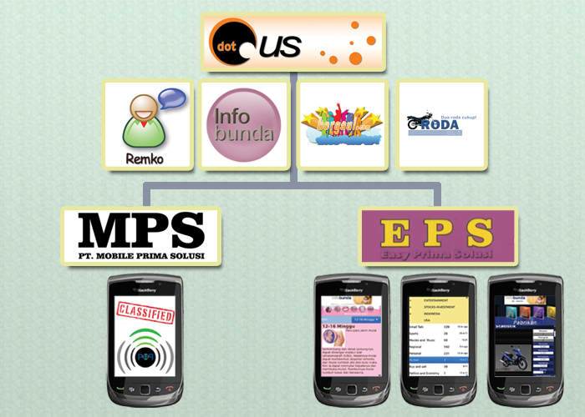

Image 1: Dot.us company structure and products

2.2 Products

2.2.1 Products of Dot.us
Dot.us specializes in website development and currently owns several in-house products, besides having developed multiple websites for external clients. Among their products are:

- Remko’s Forum; a mobile forum launched in March 2010, with the philosophy of being strictly moderated, and tying a user account to the unique identification number (IMEI, UUID) found on the mobile phone, reducing content and user account clutter. The purpose of the forum is to offer a broad digital platform on which members can discuss any topic that is within the forum rules and regulations with other members from all over the world. In January 2010, a web version with limited functionality has been added to the existing Blackberry and Android versions, for which one can request a password via the applications on Android or Blackberry. Its main purpose is currently to become a large community, advertisement plans have not yet been implemented, but these plans are currently on hold until a larger user base is formed. This application has over 481.000 unique users on May 25th, 2011 ¹.

- Infobunda; a website launched in the year 2005, with information for pregnant woman. It is the largest source of pregnancy information on the internet for Indonesia. As part of the website strategy, a doctor is employed by Dot.us who answers questions via live chat on two days of the week. The primary source of income for the website comes from advertisements. The current amount of registered users totals above 57.800 and the total amount of monthly visitors is over 250.000 on may 16th, 2011.

- Bergaul; the social network website of Dot.us. Having lost the battle for main competitor on this internet market for Indonesia to Kaskus.us, the website still sports an active community, but cannot be considered a cash cow on advertisement income for Dot.us.

- RodaDua; a website with motorcycle information that was launched in October 2009, including a forum and marketplace. Currently, the website has 85.000 monthly visitors in total on May 16th, 2011.

2.2.2 Products of Easy Prima Solusi
The reason why Easy Prima Solusi (EPS) was separately founded from Dot.us was that different shareholders hold a stake in the company. It is effectively a part of Dot.us in terms of using the same employees and being housed in the same building, while the difference is only in those who founded and financed the company. The main development target of EPS is the different models of BlackBerry smartphones.

- Remko’s Forum; created before the foundation of EPS, Remko’s Forum is officially a Dot.us product in March 2010, but responsibility for updating and expanding the application now lies with Easy Prima Solusi. It currently has over 476.000 BlackBerry users and over 4.300 Android users ¹.

¹ See Appendix IV: Statistics from Remko’s Forum, under the header “application download statistics for Remko’s Forum”, on page 30 of the appendix documentation, for the statistics interface of the given user amount. Statistics last updated on 25th of May, 2011.
- Infobunda mobile application; this application has been requested to be built by Dot.us and was launched in November 2010, based on the Infobunda website and database. It currently has over 60.000 users.

- RodaDua mobile application; this application has been requested to be built by Dot.us and was launched in December 2010, based on the RodaDua website and database. It currently has over 7.500 users.

2.2.3 Products of Mobile Prima Solusi
Mobile Prima Solusi (MPS) has been founded on the same principles as Easy Prima Solusi (EPS), namely because there are different shareholders who invest in the daughter company and its projects. The difference with EPS is that MPS was founded with a single mobile project as realization target.

However, current signals indicate that follow-up projects will also be assigned to MPS concerning technology MPS already developed for its first project. As this project, codename POP/IndoLBS, is still under a non disclosure agreement, there will be offered no details of the project in this thesis.

2.3 Mission statement and business strategy

The mission statement of Dot.us is to support and educate the Indonesian consumer by developing digital information channels that are widely accessible.

The business strategy is to gather select user groups on multiple platforms that offer information and were developed at both own- and third party requests. Through these platforms, each targeting a specific user group, advertisements are offered based on those user groups.

Hence, Dot.us does not have a general user group or business profile as a target group. These target groups are decided separately for every project, but in general the projects conform to the following points:

- Projects are mainly targeting consumers

- Business to Business projects are only developed by third party requests

- All projects are targeting large audiences

Other than that, the internal projects are expected to either result in profit by advertisement or by selling the project to an investor. External projects result in profits equal to what has been agreed on in the project contract.

3 The project

The project that is central to this thesis is Remko’s Forum for Nokia. The purpose of this project is porting the existing Remko’s Forum applications on BlackBerry and Android, to a Nokia application.

3.1 General information about Remko’s Forum

Remko’s Forum is an application for Blackberry and Android based mobile devices. The purpose of the forum is to offer a broad digital platform on which members can discuss any topic that is within the forum rules and regulations with other members from all over the world. The unique selling points of this forum application consist out of its high level moderation, community size, Community activity, location based information, cross media and cross device access, and a worldwide community.

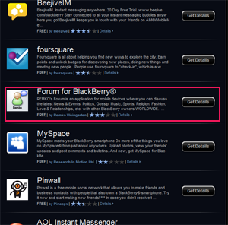
The most important part of the forum consists of its moderation. Each user account is identified based on the unique identifier for the mobile device that is used to access the forum application. This number, the Universally Unique Identifier (UUID) or the International Mobile Equipment Identity (IMEI), is registered to a single mobile phone, and is always unique.

Because Remko’s Forum accounts are created based on this unique identifier, a permanent ban from the forum can only be undone by changing to or buying a different mobile device. Because of this it is more effective than moderating a community based on an Email Account ban as a new email account can easily be created, or a ban based on an IP (Internet Protocol) Address, which can be circumvented by several different methods. An example of this would be using Dynamic IP addresses, another example is using a proxy server to connect to the forum.
Image 2: Application list (sorted by popularity) on the Blackberry App World shows Remko’s Forum(highlighted in red) in the top 25 on the 19th place, outranking AOL and MySpace Applications in the category for IM & Social Networking ¹.

As a result of registering users to their smartphone’s unique identifier, moderation is very accurate and it ensures that IP clusters like universities and campuses, or large firms are not excluded from use of the application when a single user in the cluster is banned from access to the forum.

There is also a web version of Remko’s Forum available via www.remkosforum.com, which is accessible with login data that is acquired via either the Blackberry or the Android application. There is no registration possible on the web version of the forum itself. In later versions of Remko’s Forum for Nokia it will also be possible to request a web version password.

¹ See Reference List: reference 1 for the image source and detail specification
² See Appendix IV: Statistics from Remko’s Forum, under the header “application download statistics for Remko’s Forum”, on page 30 of the appendix documentation, for the statistics interface of the given user amount.
The main version of the forum, the Blackberry application is, at the time of writing the version of the application that has the most functions, best interface and the least amount of bugs, followed by the android version. The web version is still partially in development. All the Remko’s Forum applications together total to over 481.000 registered users ². The purpose of the forum is to offer a broad digital platform on which members can discuss any topic that is within the forum rules and regulations with other members from all over the world.

“Remko’s Forum is considered the official BlackBerry forum in Indonesia” - Remko Weingarten, on the 8th of February, mentioned in a exploration conversation about Remko’s Forum.

On the forum there are separate children and adult sections, plus other sections based on country, job, social media, technology, sport, expert advice and entertainment. Because of this, Remko’s Forum offers a wide selection of interests that can be discussed globally.

The following rules apply to the forum and are enforced by the moderators. Usually breaking these rules results in a warning at first, but if no changes are made the user account is permanently banned.

- Using pornographic or erotic profile pictures is forbidden

- Posting pornographic content is forbidden

- Posting the PIN number for blackberry messenger outside the pin share topic is forbidden

- Spamming or flooding (posting the same message several times) is forbidden

- Racism is forbidden

- Insulting or bullying is forbidden

3.2 Project description

To expand the Remko’s Forum to a new mobile platform, Dot.us has indicated that it wishes to have Remko’s Forum available on Nokia smartphones as well. At the time the project “Remko’s Forum for Nokia” was defined, the following assignments were given by Dot.us in order to achieve that goal.

One of our most successful products is ‘Remko’s Forum for mobile’ (available on BlackBerry and Android) with over 215.000(!) active members (mostly in the United States, Great Britain and Asia). We wish to port this application to Nokia, a mobile platform we are unfamiliar with, so a lot of the research involved will be individual.

The assignment:

- Do research to define which development method is most suited, has the biggest reach of mobile devices and has the possibility to implement the technical functions that Remko’s Forum requires to function. This method must be primarily available on all Nokia smartphones. Examples are WRT, Java, web based applications and C++.
- Find out whether the back end systems of Remko’s Forum (the MySQL /XML server) require changes in order to connect the new client to the back end software.
- Make a design of that client based on the existing design of Remko’s Forum for mobile and do research into improving the usability of Remko’s Forum.
- Make a functional design of that client.
- Implement that client in a way that it is spreadable via the Nokia OVI store.
- Test the usability of the new client.

This thesis and graduation internship have been based on these assignments from Dot.us. The original assignment included a request for a technical design. However, this meant a database design, and the technical database structure for Remko’s Forum has already been implemented for the existing Remko’s Forum applications. It was agreed with Remko Weingarten that there will not be any changes to the database structure, because the other Remko’s Forum applications are dependent on the current data structure. As a result of this, it was decided by Remko Weingarten that the technical design was not required and the available time could be better spent working on extra functionalities of Remko’s Forum for Web.

3.3 Project restrictions

In order for the “Remko’s Forum for Nokia” project to be effective, it requires applying restrictions to the project to ensure that it does not become inefficient by sidetracking from the original assignments laid down by Dot.us.

3.3.1 Time restrictions
The project is restricted by the time available to execute the project. In the case of the project “Remko’s Forum for Nokia”, the time restriction applies to the period from the 1st of February 2011 to the 3rd of June 2011 for research, designing, development, evaluation and reporting. This period is the result of deadlines set by the Hogeschool Utrecht for the thesis to be turned in at the 3rd of June, 2011 and the
start of the third part of the school year at the start of February. The working hours at Dot.us are from 08.30 hours in the morning to 18.00 hours in the afternoon. The lunch break is 30 minutes long. That means that the working time each day for the project is 9 hours.

3.3.2 Assignment restrictions
The project “Remko’s Forum for Nokia” is also restricted to the following parameters to ensure that the project is guided to the wishes of Dot.us.

- The application must be able to be implemented on Nokia smartphones primarily
- The application must be able to spread the application via the Nokia OVI store
- The application must support as much functionality of the Remko’s forum API as possible
- The application must run on as many other brands of smartphones as possible, of which Apple’s iPhone is the most important. Nexian (a popular low budget Asian brand) is also a preferred device. Blackberry and Android smartphones are not a priority, as there are already native applications that exist for these devices.

- The application style must be similar to existing Remko’s Forum applications

- The changes that are made to the back end server must not affect the working of the existing applications.

At the start of May it was requested by Remko Weingarten that the most important devices to support changes from where Apple’s iPhone and the Playbook from Research In Motion (RIM). As the latter is a tablet and not a smartphone, the “other brands of smartphones” restriction was widened from “smartphones” to “mobile devices”.

3.3.3 Usability research restrictions
Because of the wide internship assignment and it is a one man project, time must be carefully allotted for all parts of the assignment, both from the company wishes and the educational facility wishes. Therefore the time available for usability research is more limited than was preferred before starting the graduation internship.

Also, Dot.us has indicated that it prefers more time being spent on technical realization than on extensive usability research. Another point to consider is that most Indonesian people do not speak English, which limits options for inviting users to test on. Because of these factors, choices have been made about what parts of usability research to include in this thesis. Usability testing for this thesis has been limited to:

- Expert assessment beforehand

- Gathering user feedback through the forum application and application stores Remko’s Forum is spread through.

- Interviewing a Remko’s Forum moderator about the updated functions in the web interface.

3.4 Project management

The management method involved in the project “Remko’s Forum for Nokia” has been put together by selecting the most suited elements from different management methods to suit the work environment and mentality of co-workers in Indonesia.

3.4.1 Project management situation
The management method that was best suited for the project “Remko’s Forum for Nokia” was difficult to define at first, even though the project was based on a one man assignment without project team. This situation usually requires using an “Agile Software Development” management method such as SCRUM or Extreme Programming.
The SCRUM management method is suited for small project teams working in iterations to show results by phase, ensure that project members bring their relevant talents and knowledge to a project and provide direct feedback on the work. Extreme Programming is best used in one or two man assignments.

In the case of the project “Remko’s Forum for Nokia”, there were contact moments with an employee responsible for moderation on Remko’s Forum and with Remko Weingarten to request additional information or discuss changes and user feedback, but no project team was formed for this project.

3.4.2 Employee mentality in Indonesia
Due to the project team based focus from the educational facility of Hogeschool Utrecht, the project “Remko’s Forum for Nokia” has been managed in the way it would have if it involved a project team of multiple employees from the start. This is also the reason why Extreme Programming has not been implemented, as it is not a project team based method even though it is most suited to the current business situation. Because of the assumption of there being a project team, the nationality of these fictional employees working on in this project team is assumed to be Indonesian.

This assumption presents difficulty in terms of the working mentality, because the Indonesian professional mentality is not the same as in western countries. While they put in more effort, as opposed to the western nine to five mentality, the working attitude of Indonesian employees within a project is different from the attitude western employees in the same situation.

The main example is that Indonesian employees will not provide their own input to a project in a team where there is a project leader appointed, but instead they will follow the leader’s orders down to the letter. This can be explained by the difference in status and the respect owned by employees to someone who is placed above them in an organization. It is similar to a caste system, where orders from people situated in a higher caste are absolute. This is resembled mostly by a waterfall management system, where the higher layers of the organization decide the orders for the underlying layers.

3.4.3 Consequences for western management methods
The result of this difference in working mentality is that it reduces the flexibility of the project by a great amount. As the project leader’s expertise in all project fields is being depended on too heavily, and members of the project team follow the instructions for tasks set by the project leader to the letter instead of providing input or corrections to errors, it is easier to make mistakes while working on the project. Another negative effect is that the project risks increase in terms of success rate and the usability improvements tend to be absent in the finished product.

The working mentality also makes “Agile Software Development” management methods such as SCRUM impractical, because one of its main components is for each project member to bring his or her strengths into a project. The Indonesian waterfall method and caste mentality is preventing the effectiveness when employees have to work as a team.

However, a project such as “Remko’s Forum for Nokia” is also not on a big enough scale to implement PRINCE 2 as a management method, while the process driven structure divided by careful planning is more suited for implementation in the Indonesian waterfall mentality. However, vital roles as the user, supplier and customer are difficult to fit into a one man project. Layers of management would become ineffective, and reporting inefficient.

3.4.4 Creating an effective way of management
To create an effective management method for this scenario, it was vital to combine the elements from existing management methods to make the most effective way of project management to fit into the Indonesian culture.
The planning elements from the Prince 2 methods, which include planning the largest part of the project in the early phases, sorting the planned tasks by MOSCOW priority and making dependency time tables, were taken to structure the project for the project leader.

The top down instruction from the traditional waterfall management method were combined with the short time cycles found in SCRUM to define weekly or biweekly targets and issuing tasks, and modified by daily reviews of the progress as seen in SCRUM meetings. On a day to day basis the orders from the waterfall methods can be adapted with forced feedback to a specific process and made to fit the global planning from the PRINCE 2 method. This also allows quick product updates when parts are finished, as seen in SCRUM and Extreme Programming.

Risk analysis was taken from PRINCE 2 and combined with the weekly or biweekly targets and tasks to keep the project leader aware of the points of attention every week while counting on the extended effort mentality of Indonesian employees to make up for project parts that were going outside of the planning.

From PRINCE 2 the quality review meeting was combined with the SCRUM meetings methods once a week on Friday for finished products. The SCRUM board was added to this to keep track of the project progress, sorting and assigning tasks, and to have a physical way to experience project progress.

The total of these elements makes the western management methods more suitable for use in the Indonesian culture.

After being notified by Marjon Westra that this method has a lot of similarities with the DSDM management method, it seems that the general concept of this management method was already known. However, the management method that was used during the graduation internship differs on some points, for instance direct user participation is not a must throughout the project.

3.5 Project risks

There is a certain amount of risk involved in the project “Remko’s Forum for Nokia”. This is mostly due to the data layer that is already being used by other Remko’s Forum applications, which already have over 481.000 registered users in total ¹, connecting from all over the world.

The three major hotspots for Remko’s Forum for Web users to connect from are: Indonesia (Asia), Great Britain (Europe) and the United States of America ².

¹ See Appendix IV: Statistics from Remko’s Forum, under the header “application download statistics for Remko’s Forum”, on page 30 of the appendix documentation, for the statistics interface of the given user amount.
² See Appendix IV: Statistics from Remko’s Forum, under the header “Origin of Remko’s Forum users”, on page 33 of the appendix documentation, for locations and world map of countries that users connect from to the web application.
In the project description, found in chapter 3.2: Project Description on page 9, it was already stated that these hotspots also apply to the mobile application. Therefore there are no safe time zones in which web traffic is low, to enable maintenance and testing to the data layer or the database. If something were to go wrong, it would be is certain that a big amount of users will experience problems with their application, irrelevant of time and location.

Therefore the risks have been defined to make sure they are kept in check and real time users will not be inconvenienced by work done for the “Remko’s Forum for Nokia” graduation project. The listed risks are displayed on the next page.

The column “Risk” defines the risk that the project faces. “Effect” describes what will happen if the risk occurs. “Chance” displays the likeliness of the risk effect happening if no countermeasures are implemented. “Countermeasure” describes what is being done to control the risk. “Chance after” displays the likeliness of the risk effect happening after implementation of the countermeasure. “Threat” is the level of threat the risk poses, defined from 1 – very serious to 4 – mild inconvenience.
Table 1: mapped risks within the Remko’s Forum for Nokia project

Risk | Effect | Chance | Countermeasure | Chance after | Threat
Data layer error | Errors in existing applications | 99 % | Changes are made on a new level in the data layer | 0 % | 1
Live data in Remko’s Forum is changed by testing admin functions | Real user data is changed | 20 % | Administration functions are tested in a special test forum under the support topic. Accounts tested on are owned by Dot.us | 0 % | 1
Implementing changes takes longer than planned | Planning does no longer match | 60 % | The planning is updated weekly to ensure goals stay realistic | 10 % | 3
Requests from project owner add extra pressure to the project | Less time is available for planned items in the effected week | 30 % | Define project restrictions to counter requests | 20 % | 4
Language barrier prevents  proper usability research | Usability research is downsized | 80 % | Asking a colleague to help translate texts and answers | 40 % | 3
Project is not completed before the internship deadline | Product cannot be launched | 60 % | Using small release cycles to provide continuous updates rather than a bit release | 0% | 1
Launcher application is not added to the OVI store before the internship deadline | Nokia users cannot download the application | 80 % | Remko Weingarten will add the application when he finds the registration id for his company, needed for Nokia OVI store. | 0 % | 2
Data layer error, Live data in Remko’s Forum is changed by testing admin functions: Because the data layer system is implemented in all Remko’s Forum applications, it is not possible to work with a local database. This poses a risk in two ways as all the data loaded is data that is being used by over 481.000 real users worldwide. Firstly there is the risk of real changing data during the testing of administrator functions, and secondly there is the risk of causing errors in the existing applications of Remko’s Forum. This was addressed by specifying a test topic on the forum, and testing on Dot.us Accounts, and by creating a new level in the data layer where only Remko’s Forum for Web connects to.

Implementing changes takes longer than planned: In software engineering, there are a lot of factors that can cause a program, page or script to returns errors and stop working. Solving these problems takes extra time, which may cause an item in the planning to go over its allotted time frame. This problem has been solved by redefining and updating the planning in every weekly cycle from the management method implemented in the project. See chapter 3.4.4: Creating an effective way of management, on page 13, for further information on the management method used.

Requests from project owner add extra pressure to the project: During the project there have been several requests from Remko Weingarten to design general promotional material, business cards, and t-shirts. Other requests were to make a promotional video for a classified project from one of the daughter companies of Dot.us, Mobile Prima Solusi and update the Dynamic CSS generator of Remko’s Forum for Nokia so that it can adapt to connections from tablets as well. Of these requests, only the request to design promotional t-shirts has been declined because the time needed to do this could not be compensated within the project planning. Updating the dynamic CSS generator was too much time intensive and both that request and the request to design the t-shirts were made in the last four to five weeks of the graduation internship. These weeks have been allotted for writing this thesis and making too many concessions might endanger the project progress.

Language barrier prevents proper usability research: Because most Indonesian people do not speak English, performing usability research is more limited than usual, because it is more difficult to conduct user testing. Usability testing in case of this thesis has been limited to expert assessment beforehand, gathering user feedback through the forum application, and asking for moderator experiences while using updated functions in the web interface.

Project is not completed before the internship deadline: “Remko’s Forum for Nokia” is a very wide assignment including: functional, technical and user based research about a large existing application, design for multiple devices and implementation on multiple devices. Because it is very wide, there is a reasonable risk that the project will not be completed within the set 18 weeks that are available for the project. To counter this, the management method includes room for periodical improvements to the product. Remko’s Forum for Web was already available to the users of Remko’s Forum in limited form from 26th of January, 2011, which is before the graduation internship started.

Launcher application is not added to the OVI store before the internship deadline: The launcher application for the Nokia smartphones has to be added to the Nokia OVI Store, but for that a Nokia Developer account needs to be registered. In order to create such an account, a business registration number from the country company management instance is needed. Remko Weingarten did not have this number available at the time that the application could be added to the Nokia OVI Store. Therefore it has been decided that he will add the application himself to the OVI Store after he gets the required information. In retrospect, a Playbook launcher application by Remko Weingarten has been added to the BlackBerry App World and had over 500 downloads in its first 6 days of release ¹. As a proof of concept, this indicates that the launchers are working in combination with Remko’s Forum for Web.

3.6 Planning

In this chapter the planning for the graduation assignment is shown. The planning was updated after every week, to match the weekly targets used in the management method. See chapter 3.4.4: Creating an effective way of management, on page 13, for the explanation of the management method used.

The planning will show the real time spent per subject within the workweek, and percentages, content and planning have been adjusted to the spent time at the end of the week.

3.6.1 Timeframe available for the graduation internship
The time frame of the graduation assignment and thesis that applies to Indonesia starts from the arrival in Indonesia on Sunday, the 30th of January, 2011. The first workday, meaning the first day included in the planning, was Monday, the 1st of February, 2011. The planning goes on until Friday, the 3rd of June, 2011, which is the last workday, and departure from Indonesia is set for Sunday, the 5th of June, 2011.

This means that there are 18 weeks available for working on the graduation assignment in Indonesia. Each week is being counted with having 5 workdays. Because work times are from half past eight in the morning to six ‘o clock in the evening, with a half hour lunch break included, there are nine hours per work day or 45 work hours per week that can be spent on the graduation assignment and this thesis. The total sum of available time is 18 workweeks, 90 workdays or 810 work hours.

This timeframe applies only to the time spent in Indonesia. Preparation before, or final improvements on the thesis after arriving back in the Netherlands are not included in this planning. Time not included is roughly 80 hours, or two Dutch workweeks worth of work. Private time spent while working on the graduation assignment or the thesis is not included in this planning, because it is not a part of the 45 hours that are available in every workweek.

¹ See Appendix IV: Statistics from Remko’s Forum, under the header “Playbook launcher download statistics for Remko’s Forum”, on page 31 of the appendix documentation, for the download statistics of the playbook launcher application.

3.6.2 Tasks and estimated time needed
Tasks are not displayed in order of execution, but are sorted on subject.

Development method research total : 63 hours or 7 work days

Functionality research total : 45 hours or 5 workdays

Graphical Design total : 18 hours or 2 workdays

Technical research total : 36 hours or 4 workdays

Bug checks total : 28 hours or 3 workdays and 1hour

Usability total : 54 hours or 6 workdays

Implementation total : 413 hours or 45 workdays and 8 hours

Thesis total : 153 hours or 17 workdays

-----------------------------------------------------
Total time needed : 810 hours or 90 workdays ¹

3.6.3 Planning per week
The weekly planning has been made to support the weekly or biweekly development cycles in the management method used in the Remko´s Forum for Nokia project, based on the time needed as it is mentioned above. A more detailed explanation of this management method can be found in chapter 3.4.4: Creating an effective way of management on page 13 of this thesis. The weekly planning, completion percentage per week, hours spent working on a task per week and the total amount of time needed for the tasks in that week, can be found in Appendix IX: Project planning, under the header “Planning per week”, on page 73 of the appendix documentation.

¹ See Appendix IX: Project planning, under the header “Tasks and estimated time needed”, on page 71 of the appendix documentation, for full breakdown of separate tasks and the time needed per task

4 Remko’s Forum for Nokia

The thesis assignment “Remko’s forum for Nokia” has been formulated by Remko Weingarten from Dot.us. It can be viewed in chapter 3.2: Project Description, on page 9. This chapter will describe the process of completing the sub assignments described there.

4.1 Development method

Original sub assignment:

Do research to define which development method is most suited, has the biggest reach of mobile devices and has the possibility to implement the technical functions that Remko’s Forum requires to function. This method must be primarily available on all Nokia smartphones. Examples are WRT, Java, web based applications and C++.

The entire process of selecting a development method is described in “Appendix I: internal documentation on programming method decision”, on page 5 in the appendix documentation. The following answer is based on that document.

In chapter 3.3.2: Assignment Restrictions, on page 10, the requirements requested by Dot.us for the application to comply to. The chosen development method must fit within these requirements. They are listed as:

- The application must be able to be implemented on Nokia smartphones primarily
- The application must be able to spread the application via the Nokia OVI store
- The application must support as much functionality of the Remko’s forum API as possible
- The application must run on as many other brands of smartphones as possible, of which Apple’s iPhone is the most important. Nexian (a popular low budget Asian brand) is also a preferred device. Blackberry and Android smartphones are not a priority, as there are already native applications that exist for these devices.

- The application style must be similar to existing Remko’s Forum applications

- The changes that are made to the back end server must not affect the working of the existing applications.

4.1.1 Operating systems on Nokia smartphones
Nokia has divided their smartphones into two categories with two different operating systems, the low budget smartphones, which run the “Series 40” operating system (S40) and the full function smartphones that run the Symbian operating system (Symbian or S60).

The application that will be built is tested on a Series 40 device, in specific the Nokia C-03 ¹. The development methods available for the S40 smartphones are more limited than the S60 smartphones. The following table will show which development methods are suited for each operating system.

Development Method | S40 |  | S60
Symbian C++
Open C / C++
Java 2 Micro Edition (ME)
Python
Qt
Flash Lite
Web Applications
Mobile Browsing
Table 3: Development methods supported by Nokia S40 and S60 Smartphones ².

4.1.2 Comparing available development methods
Based on the restrictions listed earlier in this answer; Symbian C++, Open C / C++, Python and Qt are not relevant options for this project because they are not supported on all Nokia Smartphones. As the testing device is a Series 40 smartphone, the primary solution must be available on both Series 40 and Series 60 smartphones.

Flash Lite has also not been considered as a relevant option because it is not compatible with Apple devices such as the iPhone and the iPad, which are requested as main secondary devices the application should be available to.

Java 2 ME at first also was not considered a relevant option because it is not supported for the same reason, but in the end it was part of the solution to the development method question.

Web Applications was the first choice to build a small demonstration application with before choosing it as a definitive development method. Based on the research described in “Appendix I: internal documentation on programming method decision”, on page 5 of the appendix documentation, the programming framework for the Web Application selected was PhoneGap.

¹ See Reference List: reference 2 for the Nokia C-03 device specification.
² See Reference List: reference 3, reference 4 and reference 5 for the data this table was based on.

4.1.3 Demo testing and results
After testing with a demo application it was concluded that Phonegap, as well as the other frameworks researched were having trouble making a version for the iPhone, requiring a launcher application to get the unique identifier from the iPhone. The main reason for choosing PhoneGap was that none of the documentation indicated it was dependent on such a launcher application to resolve such an identifier.

The result of this conclusion was that the best way to comply with the assignment restrictions was to expand the existing Remko’s Forum website, found at remkosforum.com. The application was set up in a way that the interface can adapt to a mobile browser. This is done by generating dynamic CSS modifications. The UUID / IMEI will be resolved by building a launcher application in Java 2 ME (for Nokia only). As this launcher is a very small application with very few functions, it can easily be written in different programming languages. Its main purpose is to open a browser and send the user identification to the remkosforum.com server ¹.

4.2 Back end system research

Original sub assignment:

Find out whether the back end systems of Remko’s Forum (the MySQL /XML server) require changes
in order to connect the new client to the back end software.

Based on the conclusion in chapter 4.1: development method, it was decided to expand the current existing version of Remko’s Forum for web. Initially this would mean that the existing MySQL / XML server did not need to be adapted. However after mapping the current functions in both the BlackBerry and the Android versions of the Remko’s Forum application ², several expansions and improvements could be made to the back end system, for instance regarding functionality and data security.

4.2.1 Application to server communication
There are four layers involved in the communication between a version of Remko’s Forum and the Remko’s Forum server. These layers are:

- Application layer

- Data layer

- Server layer

- Database layer

¹ See “Appendix I: internal documentation on programming method decision”, on page 5 of the appendix documentation, for the full development method selection process description.
² See “Appendix III: Android and BlackBerry function analysis”, on page 25 of the appendix documentation, for the functions found in the existing Remko’s Forum applications and their MoSCoW priority in the Remko’s Forum for Nokia project.
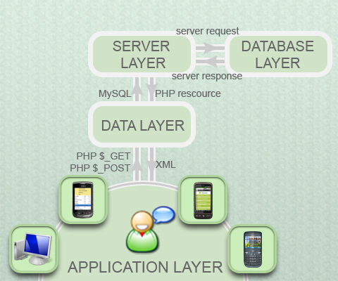
All devices connecting to Remko’s Forum either use a mobile application or a browser to send requests to the data layer, handle returning data in XML format, and fill their interface with the returning data.

The data layer handles incoming requests from all devices and sends the appropriate MySQL queries to the server layer. It also handles the PHP resources sent back by the server and converts them to XML format responses that the different devices in the application layer can handle.

The server layer receives the server request and sends back the PHP resource to the data layer. The database layer receives the server request and sends out a server response with the required data.
Image 3: General server communication model of the back end for Remko’s Forum.

4.2.1 Application layer
The application layer is the front end of the system. The connecting device can either be a smartphone, a computer or a tablet. In case of BlackBerry or Android smartphones which have native applications available in which the file resources for the forum are available on device and only the data is loaded from the data layer.

The other applications connecting to the data layer are versions of Remko’s Forum for Web, which is browser based. During the graduation internship that this thesis is based on the web version of Remko’s Forum, Remko’s Forum for Web, was enhanced to accept three kinds of connecting devices. Before, it only supported browsers connecting from a computer. Other connecting devices were shown the same interface as the web version. At the time of writing this thesis, it supports connecting computers, smartphones and tablets.

Because these versions of Remko’s Forum are web based, the application resources are stored
server-side and the application is run fully on the website of Remko’s Forum, www.remkosforum.com.

4.2.2 Data layer
The data layer is responsible for handling incoming request from the application layer and returning requested data in XML format or executing an action. It consists of 62 separate PHP files that each are designed to execute their own specific function, I.E. saveprofile.php handles requests to save changes to profile information.

For the analysis and explanation of all files in the data layer, see “Appendix II: data layer file analysis”, on page 17 of the appendix documentation.

The data layer is already in use for the BlackBerry and Android versions of Remko’s Forum. Confirming to the Assignment Restrictions as listed in “chapter 3.3.2: Assignment Restrictions”, any changes must be made in a manner that they do not affect the current data layer to prevent crashes to or errors in the existing applications that also communicate with the data layer.

Because of this, a new level was created in the data layer in which the files that need to be updated are overwritten with the new files. It also includes the old files, and can accept new files. Only the applications based on Remko’s Forum for Web will access the new level, so existing applications will not be effected by the changes made in the new level of the data layer.

4.2.3 Server layer
The server environment runs on a cPanel environment, which is installed on a Linux server. It is responsible for handling incoming requests from the data layer and sending the data to the database. It will send back the requested information to the data layer as a PHP resource.

4.2.4 Database layer
The database layer is essentially a MySQL database with a PhpMyAdmin management panel.

Remko Weingarten indicated after discussing with him that the database will only be adapted after a need from the data layer. Also, there was no need to change or adapt existing database tables for the current functions available in the data layer in Remko’s Forum at the time of discussion, which took place in late February.

4.3 Graphic design
Original sub assignment:

Make a design of that client based on the existing design of Remko’s Forum for mobile and do research into improving the usability of Remko’s Forum.

In order to make an effective design for the web based interface, there were a few points to take into account. The interface of Remko’s Forum for BlackBerry was made in a different style as Remko’s Forum for Android. Also, the interface of Remko’s Forum for web has been based on the style from the android application, but has a web layout which is unsuited for mobile screens because of its size, positioning and mouse based interaction.

Moreover, it had a few identifiable usability problems like an illogical pagination system that opens the last page of a topic and works with a “last page, previous page, next page, first page” system in that order, reversing the meaning of last page to the first page, a breadcrumb navigation that shows every page as one level under the home page instead of the pages they are normally listed under, and buttons that look like hyperlinks.

In order to make the system more user friendly and give both BlackBerry and Android users recognizable parts in the application, the designs that were made combined elements from the two. The general color layout of the Android application was added to the web interface, which included the colors of title bars and lists, the posting layout and the friend list layout.
From the BlackBerry application the menu style and button style were taken and fitted into the design. The general grey and white theme from Remko’s Forum for Web, found in the banner, sidebar, footer and the standard and alternative row colors of postings were kept as part of the new interface. The decisions made in this chapter are based on usability research, conversations with Remko Weingarten and Lala Latifah, the functional design of Remko´s Forum for Nokia and knowledge acquired during the Digitale Communicatie education. For information on the wireframes and style choices made for Remko’s Forum for Web and Remko’s Forum for Nokia, see “Appendix V: graphical design of Remko’s Forum”, on page 35 of the appendix documentation.

4.3.1 Old interface of Remko’s Forum for Web
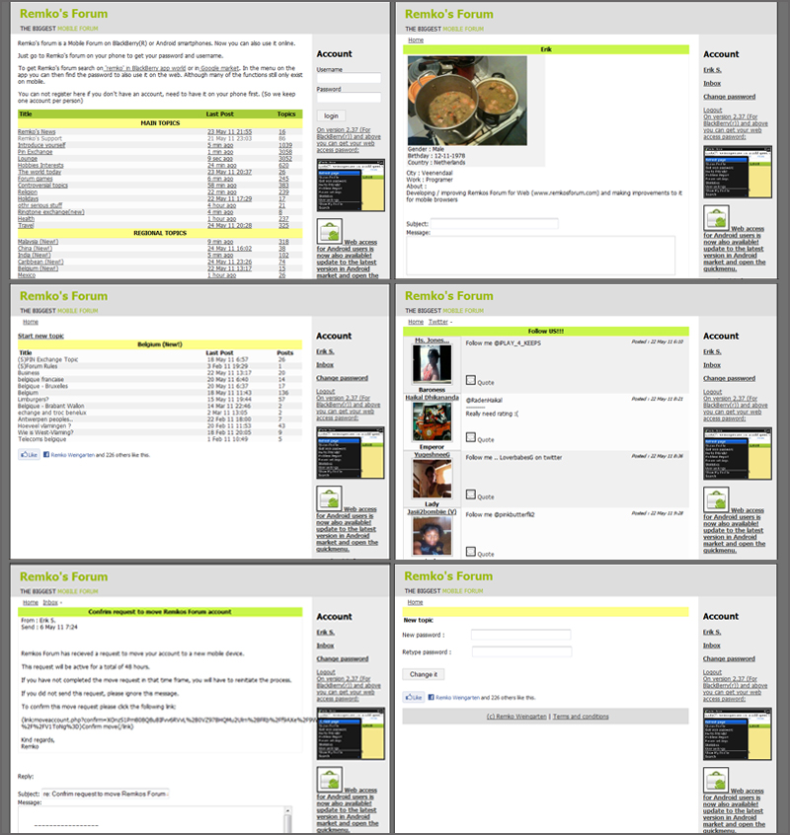

Image 4: the old layout of the web version. The images shown were taken on the 07th of February. From left to right; first row: main page, profile second row: topics, posts
third row: message detail, change password

The old web version, which was launched on the 26th of January, 2011, missed a lot of functionalities and pages that Remko’s Forum for BlackBerry and Remko’s Forum for Android already incorporated. Among others, functionalities such as searching, editing a profile, status messages, setting status updates (which is similar to the Facebook wall) and displaying or truncating forum lists were not yet added to the website. Also there were still a lot of usability errors that needed to be fixed.

4.3.2 New interface of Remko’s Forum for Nokia
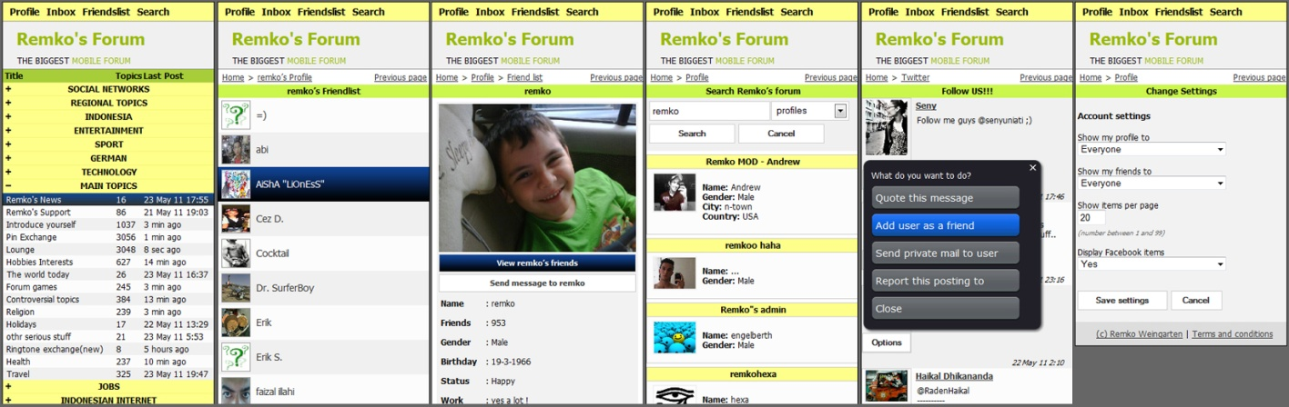
Image 5: the layout that was designed for Nokia and other smartphones. From left to right:
first row: main page, friend list, profile, search, posts, account settings

The main point to identify a mobile device was decided to be the screen resolution. A smartphone will have a resolution lower than the standard minimum of 800x600 pixels that Remko’s Forum for Web complies to. The above images are taken from the mobile interface of Remko’s Forum for Web. This is the version that is used on Nokia Smartphones and is set up to adapt to the given width of the screen resolution from the connecting mobile device.

In considering the design for the mobile version of Remko’s Forum for web, there was another limitation. The S40 devices that this application must also run on, have limited functionality and no touch screen. In general their screen has a lower resolution. Because of this, mobile version opens the main forum list with all topics closed to prevent unnecessary scrolling.

The Nokia C-03 smartphone with which this application is tested does not have a touch screen, but works with a mouse pointer for its browser. This makes scrolling harder, and with a screen resolution of 320 x 240 there is limited screen space to show elements. Furthermore, mobile internet (especially in Indonesia) is slower than the regular internet. Hence using too many images will make a page take too much extra time to load.

The final design of the Remko’s Forum for Web on a mobile phone has been optimized to load only profile images, the popup menu buttons and hovering effects. The banner, menu, footer and most other general elements where designed to use XHTML and CSS styling without background images to decrease the loading time. The various elements with which the user interacts where made big enough for the user to reach with a mouse pointer while still allowing as much of the original content on the screen.

Because not all smartphones, like the Apple iPhone, include a physical button to go back, a “previous page” button was added to the top right corner of the breadcrumb bar. Also, the mobile version does not load the Facebook plug-ins that are enabled in the web version. These plug-ins connect to the external Facebook server, which increases the data traffic to mobile devices greatly.

4.3.3 New interface of Remko’s Forum for Web
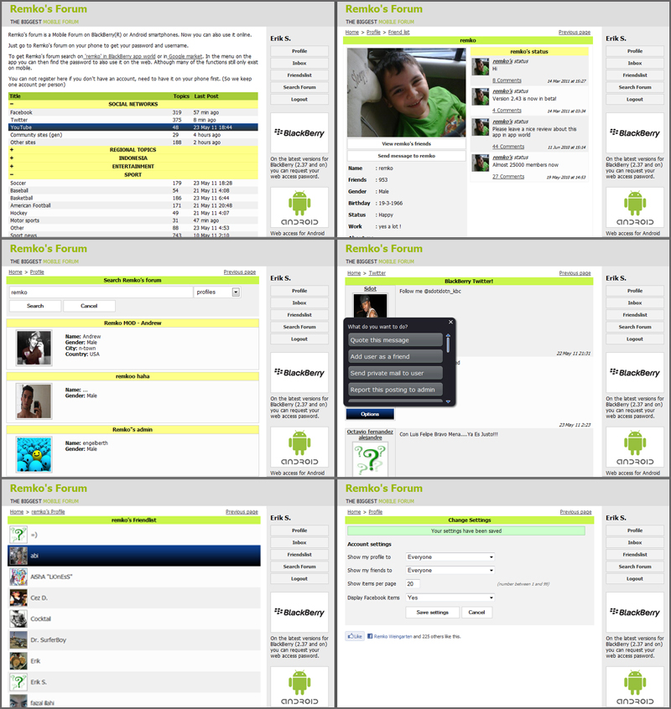
Image 6: the improved layout of the web version. From left to right; first row: main page, profile
second row: search, posts third row: friend list, account settings

The default version of Remko’s Forum for Web, reached through www.remkosforum.com, is the web interface that users from the mobile versions can request a login account for. This version required only usability adaption and also was updated in styling to the new mix style between the BlackBerry, Android and old web version.

Major changes in this version are;

- the main page forum categories can be expanded or truncated

- the breadcrumb navigation is expanded with extra depths, and a previous page button

- the side bar has buttons where buttons are expected instead of text links, one general styling has been used to make the BlackBerry and Android application links and images look similar

- A friend list is added that will show the profile picture and user name of a friend, similar to the android version of the application

- The search page will be changed from a Google search component to a custom search page that will be able to search in topic, posts and profiles

- A settings screen where the user can set account settings for the amount of items to load on a page, whether to show Facebook plug-ins or not, to hide the users profile from people who are not logged in, and to set who can view the friend list of the user

- Post options will be shown as buttons in a fake pop-up instead of being shown inline under the post

- Sending will be created as a separate page under the inbox in site structure, and will not be shown on the profile anymore

- Feedback messages will be given to the user after performing an action
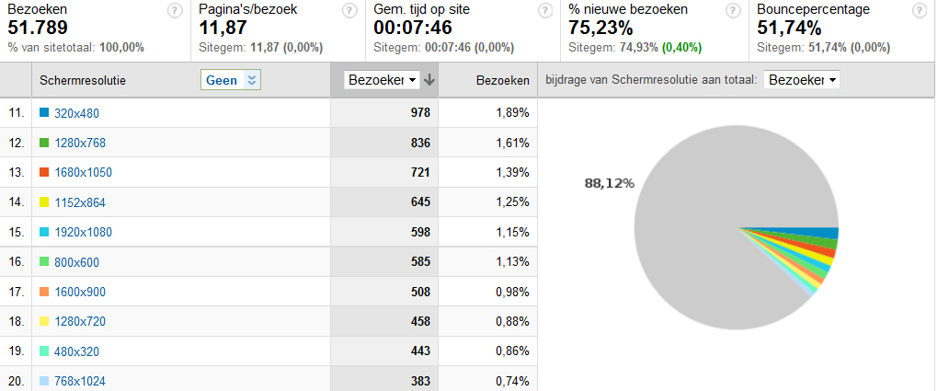
Image 7: Google analytics shows screen resolutions used to view Remko’s Forum for Web,
Image was take on 24-05-2011

The website interface has been made cross-browser compatible for Internet Explorer, Firefox 2, Firefox 3, Firefox 4, Chrome 5, Safari and Opera 11. It has a width of 800 pixels, which is the same as in the old version of Remko’s Forum for Web to make sure all connecting computers can show the website properly. Image 7 (previous page) still shows 1,13%, or 598 unique visitors visiting the website to have an 800 x 600 pixel resolution at the 16th position for common resolutions visiting the website.

Even though 1,13% is a low percentage of the total unique visitors, this still represents a substantial part of all connecting users to the website. Hence the minimum width has not been upgraded to the western standard of 1024 x 756 pixels.

4.3.4 New interface of Remko’s Forum for Tablets
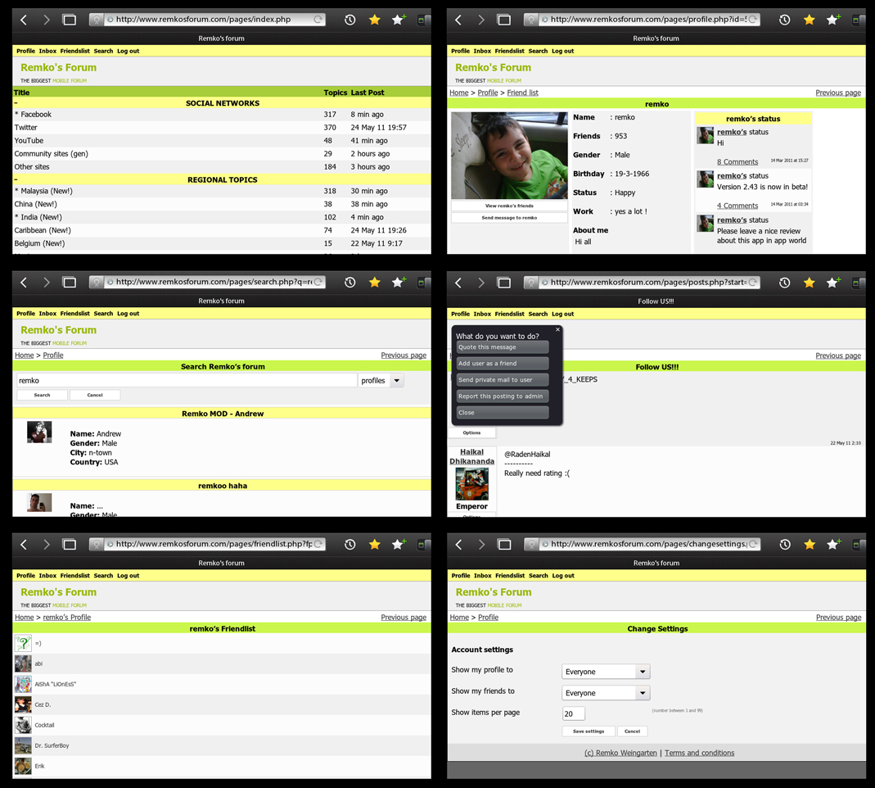
Image 8: the layout that was designed for the Playbook and other tablets. From left to right; first row: main page, profile second row: search, posts third row: friend list, account settings

By request from Remko Weingarten, in the last weeks of the graduation internship the interface and dynamic CSS generator of Remko’s Forum for Nokia was updated to also accept tablets. Looking at this change from a design point of view, it is exactly the opposite of a smartphone.

The Playbook from Research In Motion, which is the first tablet that Remko’s Forum for Web based applications will support, has a screen resolution of 1024 x 600 pixels. Instead of downsizing the interface, as happens when a smartphone connects to Remko’s Forum for Web, the interface now has to be stretched out to be presented full screen, as this is expected from mobile applications. Doing this increases the available horizontal space from 800 pixels in the website version to 1024 pixels in the tablet version.

Factors that need to be changed are;

- Font size and click / press areas need to be enlarged

- Dynamic resizing must accept maximum values for elements to prevent elements being too big

- Profile interface needs to make better use of available space by showing more information above the fold, increasing the amount of data columns to three

- Log out function must be made available because early versions of the launcher application for the Playbook will not support automatic log in. The consequence of this is that a user expects to log out after having to manually log in

- The main forum listing should not open with its entries truncated, but show all available forums

4.4 Functional design
Original sub assignment:

Make a functional design of that client.

In order to map all functions in the existing Remko’s Forum Applications and make a functional design of the functions that will be included in the improvements implemented in Remko’s Forum for Web, all the functions in the current Remko’s Forum applications have been manually checked, listed and ordered by MoSCoW priority ¹.

After the functions have been mapped, the “Must have” functions will be specified in the functional design ². The other functions are designed during the development process. The functions listed in the MoSCoW priority list are the functions that have been identified in the Remko’s Forum for BlackBerry and Remko’s Forum for Android applications. New functions have been added in the process of developing the application, and are not listed in the functional design due to time limitations on the Remko’s Forum for Nokia project.

¹ See “Appendix III: Android and BlackBerry function analysis”, on page 25 of the appendix documentation, for the function mapping document that the MoSCoW list is based on.
² See “Appendix VI: functional design of Remko’s Forum”, on page 46 of the appendix documentation, for the functional design that was made for Remko’s Forum for Nokia
Must have |  | Should have
View inbox |  | Load advertisements and save statistics
View private message |  | Search profiles
Delete private message |  | Search topics
Reply to private message |  | Search postings
Send private message |  | View status messages
Truncate forums list (truncate / expand) |  | Add status message
Add new topic |  | Delete status message
Add new post |  | Show / hide post options menu
View posts in topic |  | About forum information
View topics in forum |  | Report problems
View forums on main page
Quote user post
Navigate topics (paging)
Navigate posts (paging)
View profile
Edit profile
Change user settings
Add friend
Delete friend
Accept/decline friend request
View friend list
Block user
Report post to admin
Delete topic
Delete post
Ban user
Unban user
Make topic sticky
Make topic admin only

Table 2: MoSCoW priority of functions identified in existing Remko´s Forum applications

Could have |  | Won’t have
Get web password |  | Save topic as favorite
Mail Remko |  | View history of visited topics
Move topic to other forum |  | Automatically save topic in history on visit
Share on Facebook |  | Create private forum
Mail post to email address |  | Change private forum name
Follow us on Facebook
Join us on twitter
Invite friends via email
Refresh status messages
Show posts made by user
Show hot topics
Upload attachment (image or sound)
Show recent posts on forum by all users

4.5 Implementation

Original sub assignment:

Implement that client in a way that it is spreadable via the Nokia OVI store.

4.5.1 Setting up the separate test environment
To make sure no current users of Remko’s Forum for Web were inconvenienced during the testing phase of the development, a separate server was used as a development environment to live test the changes made each time. The changes made were implemented each two weeks when possible.

All the changes and additions were tested on Wampserver, a local PHP simulation application, before being tested on the development environment.

Due to the connection with the data layer instead of a database, all the information viewed, added, updated and deleted was also changed in the database on www.remkosforum.com. Hence all public functions that were changed, where tested in a separate support category on Remko’s Forum that was only used for testing purposes.

Also, a new level (sub folder) in the data layer of Remko’s Forum was made, in which new functionalities could be placed, and other existing functionalities be overwritten safely, without causing errors in the existing applications.

4.5.2 Modifying Remko’s Forum for Web
The first step in the modification process was to make the website detect the screen resolution of the connecting device, and adapt to a smaller layout that is optimized for mobile use if the connecting device has a screen resolution that is lower than the minimum width of the website, which is 800 pixels.

Based on the connecting devices screen resolution, Remko’s Forum for Web dynamically generates CSS code to modify the elements on the website that need to be resized for use on a smartphone. An alternative CSS style sheet with additional styling for mobile devices is loaded to reposition and resize elements that do not need to change their size dynamically.

The final part of the modifying is done in the template framework that was already being used by Remko’s Forum for web, the Smarty framework. Checks in each template assure that parts of the website system are hidden, made visible or moved when a mobile device opens the website.

After the existing design was successfully adapted for use on the testing device, functionalities were added to Remko’s Forum for Web because it lacked functions that where available on both the BlackBerry and Android versions. It was also set up accept and decode the encoded information from a launcher application, and automatically register or log the user in based on the IMEI / UUID which is included in the data sent by the launcher application. Afterwards, the usability of the application was examined and improved based on desk research.

4.5.3 Writing the launcher application for the Nokia OVI Store
The launcher is a small application that has very few functions. Its main reason for existence is to make Remko’s Forum for Nokia spreadable via the OVI store, which is a major part of the thesis assignment. It is written in Java 2 Micro Edition, which is supported by both S40 and S60 devices from Nokia.

The launcher will execute the following functions;

- Resolve screen width and height

- Resolve UUID / IMEI

- In case an UUID / IMEI request fails, get the unique Bluetooth address of the smartphone
- Resolve device manufacturer

- Put this data in a string and use a custom writing encoding method to secure the data

- Open a browser and send the secured data to the server to automatically log the user in and generate the new interface.

To create a launcher application for new smartphones or tablets, it is only needed to implement similar functions in the development method that the new target device and application store support.

The current launcher will be added to the OVI store later, by Remko Weingarten. To add the launcher application to the OVI store, a Nokia Developer Account must be registered, and part of that registration process is providing the registration ID of the company with the countries company management institution (similar to the “Kamer van Koophandel” in the Netherlands). As this registration id was not available during the period in which this thesis and the launcher application were written, the launcher application could not yet be added to the Nokia OVI Store.

4.5.4 Making Remko’s Forum suited for use on tablets
In the final weeks of the graduation internship this thesis was based on, Remko Weingarten requested that the Remko’s Forum for Web applications could also be adapted to work on tablets, in specific his newly acquired Playbook from Research In Motion (RIM).

Because the system that took care of dynamically modifying the interface to a mobile version was set up for shrinking instead of enlargement to full screen use and detecting on smaller screen resolution, the Remko’s Forum for Web was modified again to detect tablets based on their connecting user agent information, which currently only detects the RIM Playbook, but is set up to be easily expandable.

After a tablet is identified as the connecting device, the dynamic CSS generator will increase font and click areas, and load a CSS style sheet that contains the styling for elements of the website that do not need to be dynamically generated on a tablet.

Remko Weingarten wrote a limited launcher application for the Playbook which does not automatically logs a user in. The reason for this is that Research In Motion does not yet have an Application Programming Interface (API) that supports resolving the IMEI / UUID. This application has placed it in the BlackBerry App world on the 19th of May, 2011 and has been downloaded over 500 times in the first six days after release ¹.

4.6 Usability

Original sub assignment:

Test the usability of the new client.
The usability research was somewhat limited by the available time, but was divided into three segments. First, an expert assessment of the old Remko’s Forum for Web interface has been carried out by the internee. Second, an indexation of user wishes through the BlackBerry App world comments, comments on Android Zoom, and feedback submitted to the Remko’s Forum feedback topic has been reduced to points of attention, which in turn have been converted to functions that were suggested to Remko Weingarten for approval. Third, a short concluding interview was emailed to one of the Remko’s Forum moderators that use Remko’s Forum for Web for moderation, to review changes made to the Web interface and acceptance of the new options ².

This usability research is on a smaller scale than preferred, due to the language barrier, time restriction versus workload, and working on an application that already has its styling and form defined by applications that are used worldwide by over 481.000 users which raises expectations on look and feel and functionalities.

4.6.1 Expert assessment
The expert assessment has been carried out on the old interface of Remko’s Forum for Web, that has been online since the 26th of January, 2011. During the assessment, 25 points of improvement have been defined in the old interface of Remko’s Forum for Web, which was very limited in its functionality and with a wide range of errors, but has been used as a live application by Remko Weingarten none the less.

The identified points that needed improvement were;

- The forum list style on the main page should be clearly shown as a list with rows instead of underlined hyperlink columns.

- Expand and Truncate functions for the forum categories in the forum list on the main page is a required implementation, because the function is available in both the BlackBerry and Android applications of Remko’s Forum, and is a necessity if Remko’s Forum for Web will be used on Nokia smartphones.

¹ See Appendix IV: Statistics from Remko’s Forum, under the header “Playbook launcher download statistics for Remko’s Forum”, on page 31 of the appendix documentation, for the download statistics of the playbook launcher application.
² See Appendix VII: Usability research on Remko’s Forum, on page 55 of the appendix documentation, for the full documentation of the usability research
- Use generic styling for elements with the same function, such as advertisements in the sidebar in order to make the user understand in one glance that the content serves the same purpose. Currently 3 different styles are used on two different elements in the sidebar.

- Avoid using confusing or incorrect terminology in options and titles, such as listing “Account” as the title for the log in interface.

- Use a column order based on user expectations so users can recognize the application layout from existing forms of the application, or other popular forum software such as PHPBB.

- The implemented breadcrumbs navigation contains errors for some page positions, does not indicate a page depth level by using directional separators.

- On pages with an extra option, like the topics page, the interface jumps down 20 pixels to make room for the button. An interface that does not keep its elements on the same position, breaks the continuality a user expects when using an application.

- Options in the sidebar are shown as hyperlinks, which usually indicate a link to informational content or a reference. A button would indicate clickability in a better way and it would fit user expectations for option access better than a hyperlink. Also, the log out button uses the advertisement link style instead of the options link style.

- Date and timestamp placement in posts is in a conflicting (overlaying) position with the post text. It would be better to move the position from the upper right corner to the lower right corner of a forum post to avoid unreadable text.

- The quote option is not aligned to any element in the post and has not been properly styled. It looks like a hyperlink instead of a button while it offers access to functionality.

- The breadcrumb navigation is shown twice on the post page while a visitor will expect the breadcrumbs navigation in one place, or in two places but on all pages with the breadcrumb navigation. A good replacement would be a “back to top” button, to give the user some extra functionality on the page and prevent unnecessary scrolling.

- The pagination system is based on a confusing and time consuming “first page, previous page, next page, last page” navigation. Users have no means of determining on which page they currently are and the navigation step size is always set to one page or the absolute first or last page of the requested content.

- The title on the posts page above the add post text fields is underlined, which is generally recognized as a hyperlink style instead of a title style.

- Input forms are not standardized. The Layout varies on every input field, which is a chaotic way of presenting content.

- The button name on the create topic page is confusing for a user because the button description “post” does not match the button action “create”, that comes with creating a topic. Post is the action of adding a post to a topic.

- The footer is not in the same place on all pages, which breaks the continuous style of the interface.

- The dimensions of the profile data container do not match the width of the content it is supposed to contain, and it has a fixed size, instead of a size that adapts based on the content that is put into it. This causes half the data to be in the container while the other half is in whitespace, which will confuse the user and is not considered clean styling

- There is nonfunctional whitespace on the profile page that takes up half the content container width. It makes the profile look empty, which can be solved by adding another content container to the profile, with extra data and functions like the status updates as seen in the BlackBerry application.

- The title bar that usually holds the page title on the change password page as part of the pagination is empty where the user will expect the page title as continuously has been done throughout the application.

- The wrong title appears (outside the title bar) on the change password page, claiming that it is the “create new topic” page.

- The tone of voice used in the button for changing the password is different from the rest of the options; the default is functional language, while the “change it” button on the change password page is a popular language tone of voice.

- The sender of a message in the inbox where the sender name can’t be retrieved (such as system messages) is listed as “Array”, while this is an object name from PHP. System messages can be better indicated with “Remko” instead, to avoid user confusion.

- The website contains a development printout line on the inbox page, which should have been removed before putting the application live; this is a bad example of error checking and should be removed immediately.

- The message detail page has no clear separation between sender, data / time of that the message was sent and the message content. Also it contains a grammatical error by showing “send” as the title for the date and time the message was “sent”.

- The message field does not break long strings of content that go outside the container area, which goes against the user perception of field purposes.

These points have been taken in to account during the implementation of Remko’s Forum for Web and Remko’s Forum for Nokia. Most of these points have been incorporated in the new interface. The only exception is the duplicated breadcrumb navigation, which has not been replaced by a ”back to top” button, but has plainly be removed. A “back to top” button for the posts page will be part of the final recommendations, so that the continuous style of only one breadcrumb navigation per page will not be broken, and that the user will not be needlessly confused. Also this will make navigating a long page easier, as a “back to top” button will prevent unnecessary scrolling.

4.6.2 Indexing user wishes and feelings
In order to find out what the users of Remko’s Forum want and expect from their applications, comments, feedback messages and suggestions were gathered from the BlackBerry App Store, Android Zoom and the English and Indonesian “Suggestions / Feedback” topics on Remko’s Forum. These have been used to summarize known errors in the existing applications, user wishes and user expectancies. These were then translated to functions that can be added to Remko’s Forum for Web and Remko’s Forum for Nokia.

These functions, 25 in total, have been suggested to Remko Weingarten for implementation into Remko’s Forum for Nokia and Remko’s Forum for Web. In some cases, functions have also been suggested for the BlackBerry and Android applications of Remko’s Forum. As Remko Weingarten has the final vote in deciding whether or not to implement functions, some of the suggestions like the “delete post” function for moderators were discarded, while other suggestions like the “make topic visible to administrators only” function for moderators, are now planned for new releases of Remko’s Forum for BlackBerry and Remko’s Forum for Android.

The functions that were approved by Remko Weingarten and that fitted into the timeframe of the planning from the graduation internship, have been realized for Remko’s Forum for Nokia and Remko’s Forum for Web. The functions that did not fit within the time span available for implementation, were offered to Remko Weingarten as recommendations. These recommendations will be listed in the conclusion of this thesis.

The full report can be viewed in Appendix VII: Usability Research on Remko’s Forum, in the chapter “User feedback from BlackBerry App world, Android Zoom and Remko’s Forum”, on page 55 of the appendix documentation.

4.6.3 Interviewing a Remko’s Forum moderator
At the end of the implementation period, a short interview was sent by email to the two moderators who use Remko’s Forum for moderating the forum. Because only one of the two moderators replied, the research was conducted on a too small a scale to get more than a personal opinion. However it did seem that the moderator in question, Lala Latifah, who works at the Dot.us office in Jakarta and who was involved in the implementation process of Remko’s Forum for Nokia and Remko’s forum for Web, is content with the changes that were made to the user interface.

She also indicated that she liked the double breadcrumb navigation on the posts page due to the amount of scrolling that needs to be done to reach the top of the posts page after reading. Because the double breadcrumb navigation was not intended to be implemented that way, a suggestion would be to implement a “back to top” button on the bottom of the posts page, to prevent breaking the continuation of having only one breadcrumb navigation at the top of the page above the title bar. The “Back to top” button will be added as a recommendation in the conclusion of this thesis.

The full report can be viewed in Appendix VII: Usability Research on Remko’s Forum, in the chapter “interview with a Remko’s Forum moderator”, on page 66 of the appendix documentation.

5 Conclusion; answering the problem statement

Central to this thesis is the problem statement, which will offer conclusion to this thesis. The defined problem statement and sub questions can be viewed in chapter 1.1: Problem Statement, on page 2. In this chapter the conclusion of this thesis will be reached by answering the sub questions supporting the problem statement first and then answering the problem statement.

5.1 Application requirements

Original sub question:

What are the requirements that Dot.us has specified for the new application of Remko’s Forum?

The requirements that Remko’s Forum for Nokia must comply to are listed as the following;

- The application must be able to be implemented on Nokia smartphones primarily
- The application must be able to spread the application via the Nokia OVI store
- The application must support as much functionality of the Remko’s forum API as possible
- The application must run on as many other brands of smartphones as possible, of which Apple’s iPhone is the most important. Nexian (a popular low budget Asian brand) is also a preferred device. Blackberry and Android smartphones are not a priority, as there are already native applications that exist for these devices.

- The application style must be similar to existing Remko’s Forum applications

- The changes that are made to the back end server must not affect the working of the existing applications.

5.2 Target groups

Original sub question:

What is (are) the target group(s) of Remko’s Forum and what are the attributes that are typical for these groups?

Remko’s Forum targets BlackBerry- and Android smartphone owners in all age categories around the world. That target profile will be expanded by the graduation internship to include Nokia smartphone owners and Playbook tablet owners. Statistics from Remko’s Forum for Web show that most users originate from Indonesia, followed by Great Britain, with the United States of America on the third spot ¹.

¹ See Appendix IV: Statistics from Remko’s Forum, under the header “Origin of Remko’s Forum users”, on page 33 of the appendix documentation, for locations and world map of countries that users connect to the web interface from.
Time zone wise, the forum activity continues around the clock, 24 hours a day. The three major hotspots are divided over Asia, Europe and America. Also, there is no specific age group, gender or race that the forum attracts.

The best definable differences are in the technical resources field. The first limitation on the user group is that they must have a smartphone that can support one of the Remko’s Forum applications. The users of Remko’s Forum either posses a BlackBerry smartphone, a smartphone with the Android operating system, a Nokia smartphone or a Playbook tablet.

In the western world, which includes Great Britain and America, smartphones have become a commonplace item for most inhabitants, from the young children in preschool to the occasional senior citizen.

Indonesia however is a third world country, where there are more people connecting to the internet via their smartphone than via a personal computer, and where having a smartphone means that you are part of the richer upper-class of people who can afford one. The status of having a BlackBerry smartphone in Indonesia is similar to having an iPhone or one of the Android smartphones in the western world.

This diversity in users is why Remko’s Forum offers forum categories for the top 3 countries where users come from, and 20 separate forums for the most common other countries that users connect from, under the “Regional topics” forum category.

The main target group is best defined as “Owners of a BlackBerry-, Android- and Nokia smartphones and the Playbook tablet, that have internet access on their mobile device”.

5.3 Functionalities

Original sub question:

What functionalities are available in the current version of Remko’s Forum for Android, Blackberry and Web? Are there improvements or new functions that can be made to these functions to improve the usability / user experience and what are they?

Based on the BlackBerry and Android function analysis, 29 identified functions have been defined as “Must Have” for Remko’s Forum for Nokia and Remko’s Forum for Web on the MoSCoW importance scaling. These functions have been included in the functional design that was submitted to Remko Weingarten before the implementation of Remko’s Forum for Nokia. 10 functions have been labeled as “Should Have”, 13 functions have been submitted as “Could have” and 5 functions have been marked in the category “Won’t have”. The majority of these functions were not yet available in Remko’s Forum for Nokia and Remko’s forum for Web

There have been 58 functions defined in total during the functionality research, divided over 8 categories; private messaging, history and favorites, posting and browsing, profile, social, moderation, menu, and private forum. The full list of functions can be viewed in Appendix III: Android and BlackBerry function analysis, in the chapter “Identification of functions”, on page 25 of the appendix documentation.
Another source or information for this sub question is the usability research, in which an expert analysis has been executed on the old interface of Remko’s Forum for Web, and user feedback was analyzed. Based on the information gathered, 25 points of interface improvement and a total 25 new functions or improvements of functions have been defined.

An example of functionality improvements that have been suggested to Remko Weingarten for use in the BlackBerry and Android applications of Remko’s Forum, and that has been implemented in Remko’s Forum for Web and Remko’s Forum for Nokia, is the Numerical pagination. The function has been the result of user feedback and the expert analysis from the usability research.

Another example of a new functionality that was suggested and approved by Remko Weingarten was the “My recent posts” page, on which all the posts made by the user are accessible and shown in a list on the page. The function was based on user feedback from the usability research.

The full reports can be viewed in Appendix III: Android and BlackBerry function analysis on page 25 of the appendix documentation, Appendix VI: functional design of Remko’s Forumon page 46 of the appendix documentation, and Appendix VII: Usability Research on Remko’s Forum on page 55 of the appendix documentation.

5.4 Interface

Original sub question:

Are there points of attention definable in the old interface of Remko’s Forum and what are those points?

During the usability research by means of expert assessment, 25 points of attention in the old interface of Remko’s Forum for Web have been identified. The limited functionalities of the old interface that are included in that list have not been added the answer to this sub question.

The points of attention can be summarized into the following categories;

- Elements that are styled to look like they serve a different purpose than they are intended for

  - Headers that look like hyperlinks
  - Rows that look like separate lists
  - Options that look like hyperlinks

- Elements that have the same function but do not look the same

  - Banners in a single part of the website with the same function have very different styles
  - Account options that have one link that is styled like it’s part of an advertisement link
  - On one page, the page title is not in the title bar, but on the page itself
  - Input forms do not have a standardized field styling
  - On some pages the footer is in a different position and has different dimensions

- Titles, Button texts and instructions that do not match their assigned purpose

  - Two tones of voice, popular and functional, are mixed on some buttons texts
  - Misleading button texts, where the described action does not match its function
  - The title on the create topic page is in the wrong position and lists the wrong page title
  - The wrong title is used to describe the log in panel in the sidebar
  - Sender of messages where the sender is not an account are shown as “Array”

- Interface consistency that is broken

  - The breadcrumb navigation doesn’t list the profile functionalities under the profile page
  - On pages with an extra button above the title bar, the content interface is in a different position

- Elements that are not in the right place, size or order

  - Date and time in posts is shown on an overlapping position with the post text
  - Forums in the forum list show the amount of posts after the last post data and time
  - The quote and administration options in the posts page are not aligned to any element
  - On the posts page, a second breadcrumb navigation is placed at the bottom of the page
  - The profile page information container does not scale and is too wide for the content
  - A testing printout was found on the inbox page
  - The message detail interface shows no clear separation between sender, date and message
  - The message detail text field does not prevent long content from going over its borders

Most of these points have been improved or dealt with in the new Remko’s Forum for Web interface and have been added to the Remko’s Forum for Nokia interface. The other functions have been suggested to Remko Weingarten as improvements to be implemented in Remko’s Forum for Web and Remko’s Forum for Nokia, because the timeframe was too short to implement all improvements.

5.5 Usability

Original sub question:

Which results and conclusions can be drawn from a usability research on existing Remko’s Forum applications and how can these results be implemented in a new version of the Remko’s Forum application?

After the usability research of existing Remko’s Forum applications, consisting of an expert assessment of the old interface of Remko’s Forum for Web and an indexation of user wishes based on user feedback through various media, it can be concluded that the old interface of Remko’s Forum for Web was not very user friendly. Some of the user feedback were about points of attention in Remko’s Forum for BlackBerry or Remko’s Forum for Android. Examples of this are that the old pagination system of “first page, previous page, next page, last page” did not offer users a quick way to get to the page within the topic that users were interested in.

Another specific point of user feedback is that some functions or user interface elements such as indicators in Remko’s forum for BlackBerry are not self-explanatory, and also receive no additional explanation when first opening the application.

A few user feedback points on the BlackBerry version of Remko’s Forum are;

- The data structure is not organized

- Some functions need extra explanation or can’t be found by users

- The application has some lag, and some alert messages can’t be deleted from the inbox

A few user feedback points on the Android version of Remko’s Forum are;

- Users would like to have a search function added to their forum application

- Android friend list only shows accounts starting with an “a”, without showing the other friends

- Editing profile data is incomplete

- Loading speed needs to be improved

The points mentioned above can be implemented into Remko’s Forum for Nokia and Remko’s forum for Web by improving the underlying problems in the user interface.

The organization of the data structure can be improved by correctly implementing the breadcrumb navigation, the page title, and added the previous page button, to give the user extra means of determining his location within the application structure, and also giving the user to go back one page, even if he or she did not enter the page via the parent page as shown in the breadcrumb navigation.

The functions that are unclear or can’t be found by users, can be solved by changing the position of the functions to a more eye catching position, and styling the functions as buttons to improve clickability and differentiate them from hyperlinks, titles and content. The functions of which the purpose is unclear to some users, can be improved by creating a “frequently asked questions” page to offer extra explanation. This page should offer different explanations for BlackBerry, Android, Nokia, Tablet and Web applications.

The application lag and loading time can be decreased by changing the amount of graphical content that need to be loaded into the applications, to images and colors that are generated on the device via the code language the application is written in.

The lack of a search function can be improved by implementing it in the Android, Nokia, Tablet and Web applications. The BlackBerry application already has this function available and the data layer files needed to handle search requests, have already been created.

Incomplete data or functionalities should be avoided and can be solved by doing periodical checks on all systems that can be used to access the application.

5.6 Development method

Original sub question:

Which development methods can be used to build an application for mobile devices from Nokia? And for what Nokia operating system do these methods apply? And what are the effects of this on available development methods for the different types of Nokia Devices? Which of these methods is most suited to build a new version of Remko’s Forum on Nokia, in a way that a wide reach of other devices (not restricted to Nokia devices only) is also supported?

Nokia smartphones have a number of different development methods that can be used to develop applications for them. Among these are Symbian C++, Open C / C++, Java2ME, Python, QT, Flash Lite, Web Applications (WRT) and mobile browsing.

Nokia smartphones use two operating systems, Series 40 and Series 60 / Symbian at the time of writing. Windows mobile was not yet an official operating system for Nokia smartphones when this thesis was written and because of that, hasn’t been mentioned in this analysis. Series 40 is the operating system Nokia uses on its low budget smartphones, and Series 60 / Symbian is the operating system that is used for the high end smartphones.

Development Method | S40 |  | S60
Symbian C++
Open C / C++
Java 2 Micro Edition (ME)
Python
Qt
Flash Lite
Web Applications
Mobile Browsing
Not all development methods are available for both operating systems. As the Remko’s Forum application launcher needs to be available on both the Series 40 and the Series 60 / Symbian smartphones, development methods that are not supported by all two operating systems will not be chosen. Furthermore, programming methods that take too much time to port to other smartphones or tablets, like Apple’s iPhone and Research In Motion’s Playbook, are also discarded.

These restrictions remove Symbian C++, Open C / C++, Python, QT and Flash Lite as possible development methods. Choosing one of those development methods will result in only being able to launch the Remko’s Forum for Nokia application for Series 60 devices, or in limiting the amount of other smartphones and tablets the application can be easily be ported to.

After this initial reduction of development methods, Java2ME, Web Applications and Mobile browsing are left as a possibility. By request of Remko Weingarten, Web Applications were tried as the development method first. Additional research in this field was done on “Multiple Phone Web Based Application Frameworks” ¹, because of the ability to implement this development method on most major smartphones and smartphone brands. However during testing, this method turned out to offer no additional advantages and portability as compared to Remko’s Forum for Web combined with a launcher application. The application framework had the same concept with an application launcher for the secondary development smartphone: the iPhone.

¹ See Appendix I: internal documentation on programming method decision, on page 4 of the appendix documentation, for the research done on Multiple Phone Web Based Application Frameworks
Also, the most interesting feature of the Multiple Phone Web Based Application Frameworks, namely getting the IMEI / UUID number from the smartphone, didn’t work during the testing phase. Hence it was decided to incorporate the launcher application concept to be able to spread Remko’s Forum via the applicable application stores, and improve the existing version of Remko’s Forum for Web. The main advantage of this was that the launcher application could be manually written so that the data retrieved, data sent and security protocols could be customized to the need of Dot.us. Also, the dependencies on other providers were reduced.

As the launcher application is a relatively small application it can easily be recreated while using a different development method to make it accessible from a different application store for a different smartphone brand, while the content it accesses is a website, which does not need to be duplication for every smartphone and smartphone model, but is dynamically adjusted to the screen dimensions of the connecting smartphone. For Remko’s Forum for Nokia, this launcher application was written in Jave2ME, because it is available on both Series 40 and Series 60 / Symbian devices.

5.7 Technical structure

Original sub question:

What is the current technical structure of the back end server and the front end application layer on which Remko’s Forum is based, and what improvements need to be made in order to make Remko’s Forum available for Nokia and other mobile devices?

The current front end application layer of Remko’s Forum is divided in three sections; lib, pages and templates. Lib contains all website functions, the Smarty framework files and the CURL files. Pages contains all PHP files of the pages that are available on the website. Templates contains the template cache, the template files (.tpl), the images and the CSS style sheets used by the website.

The Smarty framework is called and configured from the PHP pages, and loads a .tpl file from the templates directory to display its information in a HTML view. The CURL files are used to contact the data layer to request and handle information from it.

The current technical structure of the back end server consists of the data layer, the server layer and the database layer. The data layer handles incoming information requests from all Remko’s Forum application, by requesting the information from the server layer and database layer. The data that is returned to the data layer from the server layer and database layer, is converted to XML or string output, and sent back to the requested application. The data layer consists of 62 PHP files that each has its own assigned purpose or purposes.

Both the server layer and database layer have not been changed during the graduation internship that this thesis is written for, because the current structure is used on the BlackBerry and Android applications, and making changes in the database or server environment might cause errors in the existing applications. The server layer is run on a cPanel environment. The database structure has not been mapped, because all information handling is being done in the data layer, and the Remko’s Forum data should be the same for all applications. Because the database structure was already implemented, it was not changed or expanded.

Also, the BlackBerry and Android versions of the application are built to communicate with the current data layer; changes to the data layer might cause errors or crashes in those versions. To prevent this from happening, a new temporary level will be created in the data layer on the server, in which added or updated files will overwrite the original files, and new files can be added. Only the application based on Remko’s Forum for Web will use the new level, so there is no danger to the BlackBerry and the Android versions.

The following points are general suggestions for improvement that will be presented as suggestions in the recommendations of this thesis, as there is not enough time and resources available during the internship to implement these points. During the implementation of the new level in the data layer, examples will be added that suggest a better work method.

- Increase the security of the data layer; the current data layer allows external parties to connect to it without checking if it goes via an application. Also the pin number (the unique number for account profiles) is sent in its usable form via PHP $_GET methods. By catching this pin, a random user can request all the profile information from the data layer or perform actions on accounts or content owned by other users.

- Use a programming style when building parts of the data layer; the original files are messy, they contain vague terms and there are no comments given to what functions do or what variables mean. This decreases the maintainability of the code greatly.
- Generalize feedback messages; in the current version of the data layer, a lot of the feedback messages are different. Examples are “OK”, “OKE”, “SUCCESS” and “RATEOKE”. Choosing one response string or value improves the maintainability of the data layer.

Also there will be some files that need to be updated and added to the new level in the data layer, because the old files are not supporting functions needed from the new func.php file, or because they do not provide the information needed to work with the new functions. This applies to the following files;

- admin.php; needs to be updated because there are new administrator functions that will be added to the administration accounts on the web version

- func.php; needs to be updated because there will be new functions added and updated files in the new level of the data layer

- postingresult.php; needs to be updated because the file did not return the total amount of pages, needed for pagination functions

- saveprofile.php; needs to be updated because the profile image upload needs to be updated

- search.php; needs to be updated because the file did not return the total amount of pages, needed for pagination functions

- topicresult.php; needs to be updated because the file did not return the total amount of pages, needed for pagination functions

- topics.php; needs to be updated because extra indication tags will be added to the topics. Currently there is only a tag for sticky messages (S), but the function exists to make a topic “admin only”, while those topics are not marked.

5.8 Answering the problem statement

Problem statement:

How can the existing interface and functionality of the current Remko’s Forum application be improved by usability research and which steps need to be taken to make a version of Remko’s Forum available on mobile devices from Nokia (this solution has to be spreadable via the Nokia OVI Store), while implementing the results from the usability research.
The usability research has been conducted on the old Remko’s Forum for Web interface, and defined points of interest that need to be changed when updating this application. Also user feedback on all Remko’s Forum applications have been gathered to index user experience and wishes. These points have all been converted to point of interest, which in turn have been converted to new functions and functionality updates that where implemented in the current version of Remko’s Forum for Nokia and Remko’s Forum for Web.

To implement Remko’s Forum for Web in a way that it will also be spreadable through the Nokia App store, the following order has been applied;

- A new styling and layout has been designed to fit both the Nokia smartphones and computer monitors

- The functionalities of Remko’s Forum for Web have been updated or added to, so that it can compete with the BlackBerry and Android versions

- A dynamic CSS generator has been written to adjust the width of several elements based on smaller varying screen widths, in combination with elements that do not change width

- The Smarty framework templates need to be adapted in a way that if a smartphone is detected, a different layout is shown, with elements in different positions, and a different CSS style sheet is loaded for smartphones.

- The launcher application must be written, so it resolves the IMEI / UUID, opens www.remkosforum.com and sends the IMEI / UUID to the website in a secure manner

- The website needs to be changed so it accepts and decodes the IMEI / UUID sent by the launcher application, and automatically logs the connecting user in

As a result of a request from Remko Weingarten in the final weeks of the internship, to make the dynamic CSS generation also work for tablets, the process above was expanded;

- Adapt the dynamic CSS generator to allow increasing the screen width as well

- Adapt the Smarty framework template files to allow extra repositioning of elements when a tablet connects, and load a CSS style sheet that has been optimized for use on tablets.

By following these steps, Remko’s Forum for Nokia has been realized in a way that is spreadable via the Nokia OVI Store for all Nokia smartphones. The launcher application and the dynamic CSS generator that makes this possible, also causes the application to be portable to other smartphone brands and models with a minimum of development time needed.

The usability research and bug checking have been used in the development process to make sure that the application will perform more user-friendly by implementing feedback from users and identifying points of attention in an expert assessment. During the development, the application has been checked for bugs and styling errors multiple times to ensure that users will not be bothered with inconsistencies and user experience is enhanced ¹.

To conclude the implementation, a textual interview has been executed with one of the Remko’s Forum moderators who uses the Remko’s Forum for Web interface for moderation, to see whether the changes that have been made where an improvement to the old situation in her opinion, and whether there were more improvements that she could name. The small scale of this research was due to time limitations, but in the end fitted its purpose, though not on the proper scale.

5.9 Conclusion

By completing the research and implementation of Remko’s Forum for Web during the time that was available in the graduation internship, the usability of the old Remko’s Forum for Web interface has improved greatly. The functions the application contains were expanded by new functions or have been improved based on the old functionalities, using user feedback, expert assessment and supporting literature to justify the changes.

The application has been implemented in a way that it will have a customized layout based on dynamic CSS generation and adapted templates, and the launcher application has been developed to send the user to the website while being automatically logged in.

The launcher application has been created and provides a method of spreading Remko’s Forum via the Nokia OVI Store. The realized product has been adapted to also allow tablet computers to connect to the application, making the application suited for all mobile devices in general with every limited effort.

Remko Weingarten was satisfied with the project progress, methods used and final results. My only regret is that I did not have one or two more months to work on this application to finish all the functionalities I suggested for implementation, and proper conduction of concluding usability research. All in all I am satisfied with the results I have achieved.

¹ See Appendix VIII: Bug check report of Remko’s Forum, on page 68 of the appendix documentation, for one of the bug check reports as submitted to Remko Weingarten after the bug fixing process.

Recommendations

As a result of research, design, and implementation, a fair amount of changes have been made to Remko’s Forum for Nokia, and Remko’s Forum for Web. Because of the time limitations, not all suggestions that where approved by Remko Weingarten could be implemented in Remko’s Forum.

Because of the restricted time, the functions that were not finished at the end of the internship will be added as recommendations. Also, the functions that have been suggested for the BlackBerry and Android versions that have not yet been implemented will be listed as suggestions.

- Add a back to top button on the posts page to prevent unnecessary scrolling on both the web and the smartphone versions of Remko’s Forum.

- Hide topics that are set as “show to administrators only” from the forum list, unless the user is a moderator, and add a function for moderators to make a topic “show to administrator only” or “make sticky and show to administrator only” for the BlackBerry and Android applications.

- Implement a numerical pagination in the BlackBerry and Android versions of Remko’s Forum to improve the navigation for users.

- Implement a “jump to page” function in the pagination system of Remko’s Forum for BlackBerry, Remko’s Forum for Android, Remko’s Forum for Nokia and Remko’s Forum for Web.

- Allow users to order their forum list, and choose which forum categories are shown to them after log in, in the Remko’s Forum for Nokia and Remko’s Forum for Web application.

- Add a Frequently Asked Questions information page to the BlackBerry-, Android-, Nokia, tablet-, and Web applications, so that the user can look up how to access functions he or she cannot find, explain interface elements, or to help him or her getting started with Remko’s Forum.

- Separate the “send a private message” interface from the profile and add it to the inbox for the BlackBerry and Android versions of Remko’s Forum. Add a “Send a private message to this user” button on the profile to compensate for that the user can no longer send the private message directly from the profile after moving the send private message interface from the profile page.

- Add user settings for the BlackBerry and Android versions so they can decide who has access to their friends list and whether or not they see the Facebook plug-ins.

- Implement a “Rate this user” function in Remko’s Forum for Nokia and Remko’s Forum for Web, because this function is already available in the other Remko’s Forum applications which will cause Web users to expect a “rate user” function, and it adds a social aspect to the application.

- Add a “block profile” option to Remko’s Forum for Web and Remko’s Forum for Android, for users that wish to prevent other users from sending private messages and status updates while they are blocked.

- Add a “create private forum” and a “rename private forum” function in Remko’s Forum for Nokia and Remko’s Forum for Web.

- Add the “delete private message” to Remko’s Forum for BlackBerry and Remko’s Forum for Android.

- Implement a function that will break down long continuous text lines in the message detail page to prevent long content from going outside of the assigned message content field.

- Increase the security of the data layer; the current data layer allows external parties to connect to it without checking if it goes via an application. Also the pin number (the unique number for account profiles) is sent in its usable form via PHP $_GET methods. By catching this pin, a random user can request all the profile information from the data layer or perform actions on accounts or content owned by other users.

- Use a predefined programming style when building parts of the data layer; the original files are messy, they contain vague terms and there are no comments given to what functions do or what variables mean. This decreases the maintainability of the code greatly if other people need to update or change the code.
- Generalize feedback messages that are sent back through the data layer; in the current version of the data layer, a lot of the feedback messages are different. Examples are “OK”, “OKE”, “SUCCESS” and “RATEOKE”. Choosing one response string or value improves the maintainability of the data layer.

- Always style the elements used in an interface to its purpose; make buttons and options look like buttons, make titles look like titles and make page links look like page links. Define one style for each of the elements needed and stick to those styles throughout the application to avoid confusing users.

- Always check all functionalities and pages at least once before releasing products to users, and make sure every element has a purpose in the application, even whitespace.

- Have someone periodically check on user feedback, both via the forum itself and via the distribution channels like the BlackBerry App Store and the Android App Market. There sometimes are good suggestions available there and listening to what users want never hurts.

By implementing these recommendations into the Remko’s Forum applications, it should be possible to increase the usability of Remko’s Forum, and it should be mandatory to improve the security of the data layer. Examples of improving the security have been implemented in the launcher application for Nokia smartphones and in the “move profile” function of Remko’s Forum for Web. By setting one code styling that includes comments and a clean code format the maintainability of the data layer files should increase.

Glossary

Application Layer All Remko’s Forum applications, their technical structure and
their files together form the application layer of Remko’s Forum

Data Layer A part of Remko’s Forum that is responsible for handling
incoming requests for information from the Remko’s Forum applications

Database Layer The database behind Remko’s Forum, it is managed with PhpMyAdmin

Development method The combination of programming languages that are used to develop an application, website or software package

Operating System (OS) The software that is installed on a computer or smartphone to render the graphical user interface (GUI) and perform functions.

Pagination Navigation method used to reduce the amount of data shown to
a user at once, it lets the user browse sub pages of the current page

Paging See Pagination

Phonegap A Multiple Phone Web Based Application Framework, used in
web based smartphone applications

QuickConnectFamily Framework A Multiple Phone Web Based Application Framework, used in
web based smartphone applications

Remko’s Forum for Web Remko’s Forum application that can be visited via a personal computer with internet connection and a browser

Remko’s Forum for Nokia Remko’s Forum launcher application that can be downloaded and installed on a Nokia S40 or S60 smartphone

Remko’s Forum for BlackBerry Native Remko’s Forum application that can be downloaded and
installed on a BlackBerry smartphone

Remko’s Forum for Android Native Remko’s Forum application that can be downloaded and
installed on an Android smartphone

Remko’s Forum for Tablets Remko’s Forum launcher application that can be downloaded
and installed on a tablet computer

Rhodes A Multiple Phone Web Based Application Framework, used in
web based smartphone applications

Series 40 (S40) The Series 40 operating system is one of the two major
operating systems that Nokia uses on its smartphones. The
Series 40 operating system used on low budget smartphones.

Series 60 (S60) The Series 60 operating system is one of the two major operating systems that Nokia uses on its smartphones. The Series 40 operating system used on high end smartphones.

Server Layer The server environment of Remko’s Forum, it is configured with
the cPanel server software

Smartphone A modern mobile phone variant that commonly supports
applications, (mobile) internet and social functions.

Symbian See Series 60 (S60)

Worklight A Multiple Phone Web Based Application Framework, used in
web based smartphone applications

Reference list

Internet sources

Reference 1:

Type: image

Image depicted in this thesis shows the ranking of Remko’s forum in the blackberry app world, when ordered by application popularity.

appworld.blackberry.com/webstore/category/51?licenseType=3&lang=en (17 February 2011)

Reference 2:

Type: information

Written by Nokia, no publishing date specified. The page provides the device specifications for the
Nokia C-03 smartphone.

http://www.forum.nokia.com/Devices/Device_specifications/C3-00/ (24 February 2011)

Reference 3:

Type: information

Written by Nokia, no publishing date specified. Provides general information about development on Series 40 devices.

http://www.forum.nokia.com/Devices/Series_40/ (24 February 2011)

Reference 4:

Type: information

Written by Nokia (last edited on 7 April 2011). Description of development methods available on Nokia devices with the S40 operating system.

wiki.forum.nokia.com/index.php/Development_options_for_Series_40 (24 February 2011)

Reference 5:

Type: information

Written by Nokia (list of programming methods, no date given). Lists the available development methods for Symbian (Devices with S60 OS) as portal to subject pages, no general information page available from Nokia.

wiki.forum.nokia.com/index.php/Portal:Programming_Languages (24 February 2011)

Reference 6:

Type: information

All references reviewed to find information about programming a launcher application for Nokia smartphones. All these sources were accessed for research purposes between 01-02-2011 and 11-02-2011. Most of these sources were also accessed between 02-05-2011 and 06-05-2011 for referencing to Java2ME programming methods. Others concern additional points or research such as C++ programming, which is only available on Series 60 operating systems.

Resolving the IMEI or other unique ID

http://wiki.forum.nokia.com/index.php/How_to_get_IMEI_in_Java_ME
http://ashnatechnologies.blogspot.com/2010/01/how-to-get-device-imei-number-using.html
http://discussion.forum.nokia.com/forum/showthread.php?71661-IMEI-or-Secure-Unique-ID
http://stackoverflow.com/questions/3838964/a-unique-identifier-for-cell-phone-other-than-imei-or-imsi

Opening a browser on Nokia

http://www.hecl.org/docs/midlet_platformrequest.html
http://developers.sun.com/mobility/midp/ttips/platformRequest/

MIDlet data streaming (GET/POST)

http://developers.sun.com/mobility/midp/articles/network/

J2ME sun profile information

http://java.sun.com/products/cldc/wp/KVMwp.pdf

System specifications for J2ME hardware

http://developers.sun.com/mobility/getstart/articles/intro/

The definition of MIDlet applications for Nokia

http://www.wordiq.com/definition/MIDlet

Information about MIDlet applications and development tutorials

http://www.ibm.com/developerworks/java/tutorials/wi-nokia/section8.html
http://www.mobilefish.com/developer/eclipse/eclipse_quickguide_j2me.html
http://www.autexier.de/jmau/dev/j2me/j2me.html
http://eclipseme.org/docs/jadeditor.html
http://freecode-freecode.blogspot.com/2007/06/urlencoder-for-j2me.html

Browser simulation code

http://wiki.forum.nokia.com/index.php/CS000974_-_Using_eSWT_Browser_in_Java_ME
http://www.eclipse.org/swt/eclipse.php
http://www.eclipse.org/ercp/SDK.php

Creating a C++ development environment

http://www.ibm.com/developerworks/opensource/library/os-eclipse-stlcdt/

Content guidelines for publishing applications on the OVI Store

https://publish.ovi.com/account/content_guidelines

Java API’s that are supported by Nokia smartphones

http://wiki.forum.nokia.com/index.php/Java_ME_API_support_on_Nokia_devices
http://wiki.forum.nokia.com/index.php/Additional_APIs_available_for_Java_ME
http://wiki.forum.nokia.com/index.php/Java_ME

Nokia C3-00 specifications

http://www.forum.nokia.com/Devices/Device_specifications/C3-00/
http://www.forum.nokia.com/Devices/Series_40/

Packaging and signing information for Nokia applications

http://www.forum.nokia.com/Distribute/Packaging_and_signing.xhtml#article0
http://wiki.forum.nokia.com/index.php/Java_ME_signing_for_dummies
http://blog.javia.org/signed-midlets/
http://j2start.com/
http://browndrf.blogspot.com/2006/06/build-and-install-singed-midlet.html

API clearance for a 3rd party developer

http://wiki.forum.nokia.com/index.php/API_access_rights_on_phones,_Series_40_6th

Nokia smartphone development methods

http://wiki.forum.nokia.com/index.php/Portal:Programming_Languages
http://wiki.forum.nokia.com/index.php/Development_options_for_Series_40

Literature sources

David Benyon (2010). Designing Interactive Systems. 2nd print Edinburgh Gate: Pearson Education Limited.

William Lidwell et al (2006). Universele Ontwerpprincipes. 1st print Amsterdam: BIS Publishers

Hedwyg van Groenendaal (2006). Webdesign, van concept tot realisatie. 2nd print Den Haag: Sdu Uitgevers bv.

Appendix

The appendix volumes can be found in the separated document “Appendixes of Remko’s Forums for Nokia, a collection of nine appendixes for Remko’s Forum”. These appendixes have been separated from the main thesis to ensure readability of this document, and for the mental health of the assessor for this thesis.

Appendixes of Remko’s Forum for Nokia
A collection of nine appendixes for Remko’s Forum

Dot.us Indonesia
Erik Stolman
1533667

Contents

Appendix I: internal documentation on programming method decision 3
Appendix II: Data layer file analysis 16
Appendix III: Android and BlackBerry function analysis 24
Appendix IV: Statistics from Remko’s Forum 29
Appendix V: graphical design of Remko’s Forum 34
Appendix VI: functional design of Remko’s Forum 45
Appendix VII: Usability research on Remko’s Forum 54
Appendix VIII: Bug check report of Remko’s Forum 68
Appendix IX: Project planning 70

Appendix I: internal documentation on programming method decision
The step-by-step decision path
for choosing a programming method to port Remko’s
Forum to Nokia
For Dot.us Indonesia

By Erik Stolman
09-02-2011

General information about Remko’s Forum

Remko’s Forum is an application for Blackberry and Android based mobile devices. The unique selling points of this forum application consist out of its high level moderation, community size, Community activity, location based information, cross media and cross device access, and a worldwide community.

The most important part of the forum consists of its moderation. Each user account is identified based on the unique identifier for the mobile device that is used to access the forum application. This number, the Universally Unique Identifier (UUID) or the International Mobile Equipment Identity (IMEI), is registered to a single mobile phone, and is always unique.

Because Remko’s Forum accounts are created based on this unique identifier, a permanent ban from the forum can only be undone by changing to or buying a different mobile device, and is more effective than moderating a community based in an IP (Internet Protocol) Address, which can be circumvented by several different methods, I.E. by using Dynamic IP addresses, or using a proxy server Image 1: Application list (sorted by popularity) on to connect to the forum.
the Blackberry App World shows Remko’s Forum
(highlighted in red) in the top 25 on the 19th place, As a result, moderation is very accurate, and
outranking AOL and MySpace Applications in the ensures that IP clusters like universities, or large
category for IM & Social Networking¹. firms are excluded from use of the application
when a single user in the cluster is banned from
access to the forum.

There is also a web version of Remko’s Forum available via www.remkosforum.com, which is accessible with login data that is acquired via either the Blackberry or the Android application. There is no registration possible on the web version of the forum itself.

The main version of the forum, the Blackberry application is, at the time of writing the version of the application that has the most functionalities, best interface and the least amount of bugs, followed by the android version. The web version is still partially in development.

The forum application currently has over 350.000 registered users, of which an approximate of 100.000 users are active members.

¹ See Sources, source 7 for accessed information on popularity of the Remko’s Forum app.
Step 1: Requirements of the application conversion

Application requirements

The following practical requirements apply to the result of porting of Remko’s Forum to a mobile version for Nokia.

- The application must be able to be implemented on Nokia smartphones primarily
- The application must be able to spread the application via the Nokia OVI store
- The application must support as much functionality of the Remko’s forum API as possible
- The application must run on as many other brands of smartphones as possible, of which Apple’s iPhone is the most important. Nexian (a popular low budget Asian brand) is also a preferred device. Blackberry and Android smartphones are not a priority, as there are already native applications that exist for these devices.

- The changes that are made to the back end server must not affect the working of the existing applications.

To achieve these requirements, the first point of research is multi phone web based application frameworks. These frameworks excel in being universal and provide easy methods to be used on multiple platforms. In the next chapter (Step 2: Considering multi phone web based application frameworks), there will be a comparison of a few of the more popular frameworks.

The decision for this to be the first item of research has been made by the owner of Dot.us; Remko Weingarten. If this proves to be a valid option, using a multi phone web based application framework is the company preference for a porting method. If it proves to be inconvenient, further options will be researched.
Step 2: Considering multi phone web based application frameworks

List of application frameworks

The following list is compiled using Wikipedia¹, as a source of information. The listed frameworks are a selection by the company from the same source as listed above.

The frameworks are compared on the following points of interest:
- Functionality
- Supported mobile operating systems
- Is the application framework open source software
- Is the application framework free to use
- Supported programming languages

The information gained from the Wikipedia source is cross checked by referencing the original framework developer’s website, user commenting and support requests. After listing the frameworks, the most serious option is explored and augmented.

Phonegap ¹
Is the framework open source | Yes, the application framework is licensed as MIT open source software.
Is the framework free to use | Yes
What kind of applications can the Framework support | Embedded applications ²
Which development languages are supported by this framework | HTML5, CSS3 and JavaScript. The application will convert the written code to a compatible format for the selected mobile devices.
How many mobile phone platforms (OS) are supported by this framework | Phonegap supports 6 platforms: iOS (Apple), Android (Google), Blackberry (Research In Motion), Palm WebOS (HP), Symbian (Nokia) and Windows Mobile (Microsoft)
Which functionalities does the application framework support, either by direct API support or AJAX workaround | File uploading, access to local phone image library, email sending, possible to run entirely local without connecting to the internet, supports web services like SOAP/JSON/AJAX, web access from mobile phone, geo location support, vibration of the mobile device, can access the blackberry accelerometer , play and record sound, has access the camera of the mobile device, supports Extensible Messaging and Presence Protocol (XMPP), file system IO support, possible to use with gesture and multi-touch input.  Phonegap can request the current device motion / and set the orientation on the iOS, Android, and Blackberry (version 5 and above). Also, native User Interface (UI) components can be accessed. Furthermore the Phonegap API supports SMS, telephone, maps, contacts and orientation changes. It also supports SQLite, but it is not supported by blackberry.
Positive and negative point by point comparison of Phonegap
Positive |  | Negative
Supports Symbian (Nokia) mobile devices |  | Does not support use outside of a mobile device environment (web, personal computer etc.)
Supports all other major OS for mobile devices
Phonegap API is open source software
Phonegap API is free to use
Supports a wide array of control / device information functionalities
Has an extensive API documentation
Features an active community
Show stoppers: none
Serious option: yes

WorkLight ³
Is the framework open source | No, the application framework is not licensed as open source software and is not allowed to be adapted by a third party without purchasing the rights to do so.
Is the framework free to use | No
What kind of applications can the Framework support | Embedded applications ² and  Enterprise Applications ⁴
Which development languages are supported by this framework | HTML, JavaScript, CSS, native code for the chosen platform or a combination of the native programming language with the web based application framework
How many mobile phone platforms (OS) are supported by this framework | WorkLight supports 4 platforms: iOS (Apple), Android (Google), Blackberry (Research In Motion) and Palm WebOS (HP).  The version of Worklight that supports Symbian (Nokia) and Windows Mobile (Microsoft) mobile devices is still in development.
Which functionalities does the application framework support, either by direct API support or AJAX workaround | Enterprise data synchronization, email sending, application distribution support, distribution analytics, possible to run entirely local without connecting to the internet, supports mobile APIs, web access from mobile phone, geo location support, vibration of the mobile device, can access the accelerometer , play and record sound, has access the camera of the mobile device, supports Extensible Messaging and Presence Protocol (XMPP), file system IO support, possible to use with gesture and multi-touch input.  Also, native User Interface (UI) components can be accessed, the WorkLight API supports SMS, telephone, maps, contacts and orientation changes. It also supports SQLite.
Positive and negative point by point comparison of WorkLight
Positive |  | Negative
Offers support for publishing the application |  | WorkLight API does not yet support Symbian (Nokia).
Allows enterprises to maintain an extensive intranet. |  | WorkLight API is not open source software
 |  | WorkLight API is not free (the price is roughly $20.000 for a few thousand users, primary reason for the business orientated conclusion).
 |  | It seems like the WorkLight API is primarily intended for intranet usage within medium to large scale companies.
 |  | WorkLight does not allow access to major functionalities of the phone needed, such as rotation / orientation, or access to the local image library.
 |  | Does not support multi threading
Show stoppers: Buy in price makes framework an unreal option.
Serious option: No

QuickConnectFamily Framework⁵
Is the framework open source | Yes, the application framework is licensed as MIT open source software.
Is the framework free to use | Yes
What kind of applications can the Framework support | Embedded applications ² and  Enterprise Applications ⁴
Which development languages are supported by this framework | HTML5, CSS3 and JavaScript for mobile and desktop apps. Objective-C, C++, PHP, Java and Erlang can be used for desktop and server applications.
How many mobile phone platforms (OS) are supported by this framework | QuickConnectFamily Framework supports 4 platforms: iOS (Apple), Android (Google), Blackberry (Research In Motion), Palm WebOS (HP)
Which functionalities does the application framework support, either by direct API support or AJAX workaround | Enterprise data synchronization, multi-threading, file uploading, access to local phone image library, email sending, application distribution support, distribution analytics, possible to run entirely local without connecting to the internet, supports web services like SOAP/JSON/AJAX, supports mobile phone API’s, allows web access from mobile phone, geo location support, vibration of the mobile device, can access the accelerometer , play and record sound, has access the camera of the mobile device, supports Extensible Messaging and Presence Protocol (XMPP), file system IO support, possible to use with gesture and multi-touch input.  QuickConnectFamily Framework can request the current device motion / and set the orientation and supports the native date. Also, native User Interface (UI) components can be accessed. Furthermore the Phonegap API supports SMS, telephone, maps, contacts and orientation changes. It also supports SQLite, and has Native Language Application Development support and graph library support.
Positive and negative point by point comparison of Phonegap
Positive |  | Negative
Contains all listed functionality segments listed in the source location contributed at the start of this chapter, and is the most complete functionality wise of all the frameworks listed. Most the extra functionalities are not required for porting the Remko’s forum API. |  | Does not support Symbian (Nokia). The framework used to support it, but QuickConnectNokia was discontinued after it was not included by the developer in the QuickConnectFamily
Has both desktop, mobile and web possibilities.
The QuickConnectFamily API is open source software
QuickConnectFamily API is free to use
Show stoppers: Does not support Symbian (Nokia)
Serious option: No

Rhodes ⁶
Is the framework open source | Yes, the application framework is licensed as MIT open source software.
Is the framework free to use | No, for business use as intended, the sales department has to be contacted to make a contract.
What kind of applications can the Framework support | Embedded applications(see glossary for more information)
Which development languages are supported by this framework | HTML and Ruby
How many mobile phone platforms (OS) are supported by this framework | Rhodes Framework supports 5 platforms: iOS (Apple), Android (Google), Blackberry (Research In Motion), Symbian (Nokia) and Windows Mobile (Microsoft)
Which functionalities does the application framework support, either by direct API support or AJAX workaround | Enterprise data synchronization, camera, vibration, file I/O, SMS support, Telephone support, geolocation, play sounds, Contact support, SQLite support, contacts API support.
Positive and negative point by point comparison of Phonegap
Positive |  | Negative
Generates native applications per platform |  | Does not offer support documentation for Symbian. The other documentation is not very extensive and requires an account to view.
 |  | Has limited functionality
 |  | A commercial license costs $ 500 for every separate application.
Show stoppers: low functionality and lack of support for Symbian (Nokia)
Serious option: No

¹ See Sources, source 1 and 2 for accessed information on the term Phonegap
² See Sources, source 1 and 3 for accessed information on the term Embedded application
³ See Sources, source 1 and 3 for accessed information on the term WorkLight
⁴ See sources, source 1 and 4 for accessed information on the term Enterprise Application
⁵ See Sources, source 1 and 4 for accessed information on the term QuickConnectFamily
⁶ See Sources, source 1 and 5 for accessed information on the term Rhodes
Step 3: Choosing a framework and consequences

After comparing the Phonegap- , WorkLight- , QuickConnectFamily - and the Rhodes framework to each other, one can come to the conclusion that there are advantages and disadvantages to every framework, but some more than others.

By discussing the previous framework options with Remko Weingarten (company director), and making an analysis of possible “Show stoppers” (reasons to discard the framework as not suited for the purposes of Dot.us) together, the final conclusion for the mobile application framework was Phonegap for the following reasons.

- Phonegap has the least disadvantages
- Phonegap has no obvious showstoppers
- Phonegap supports all the major mobile platforms
- Phonegap contains all the functionality needed for porting Remko’s Forum to Symbian
- Phonegap is free to use
- Phonegap is Open Source software

Choosing Phonegap means that the application will consist of a native shell application that will launch a browser (WRT) application that is web-based, but can access the internal functionalities of the mobile device via the Phonegap JavaScript framework. The advantage of this is that it will make writing an application for multiple mobile devices depend on the light shell application instead of the main application, with a generalized part consisting of HTML, CSS, JavaScript and AJAX to form the application.
Step 4: Using Phonegap application framework, and consequences

After the choice for the Phonegap application framework I started sorting through its API documentation. After this I started building a demo application for using Phonegap. During this process I came across several disadvantages of Phonegap, which did not show in the initial desk research.

The framework tools that are used to convert files into a working widget application for Symbian (Nokia), was not able to make a direct version for iOS (Apple). Instead there is a separate system needed for each application, because the method of requesting the Universally Unique IDentifier (UUID) or International Mobile Equipment Identity (IMEI) is different for each device. For iOS this is done by making a shell launcher application, which will launch a browser and send the IMEI to it.

The main reason however that the use of Multiple Mobile Device Web Based Application Framework was requested, was to resolve this unique identifier for mobile devices. If the Phonegap framework already requires a shell launcher application to launch on an iOS device, the second most important target of the porting assignment, then there is no reason left not to resolve the UUID / IMEI code with a native shell launcher application for each target device, and make modifications to the web based versions of Remko’s Forum.

After discussing this with Remko Weingarten, there was an agreement on the modifications and using the web based version of Remko’s Forum.
Step 5: Modifying the web based version of Remko’s Forum

The current web based version of Remko’s Forum is built to support the users who have already registered an account on either the Blackberry (Research In Motion) or an Android (Google) device. Via the native forum applications on these devices, a login name and password can be requested to use the web version of Remko’s Forum.

The first step to making the web based version of Remko’s Forum accessible via a mobile device or Smartphone is adjusting the interface based on screen size. The current version of the web based forum has a default width of 800 pixels, which is too big for a mobile device. Also the web based interface needs to change based on whether the user is visiting the forum through the shell launcher, or through a personal computer.

After the initial interfacing of the forum is converted to a format that will fit the use on small mobile devices dynamically, using a combination of PHP, JavaScript and AJAX; the remaining functionality of the forum will be made to match the functionality to match the current blackberry version.

Then a usability research will be executed to pinpoint improvements to the website, and make suggestions for usability improvements on the native applications for Blackberry and Symbian devices.

To conclude the usability research, the prominent results will be added / changed in the web based versions and then the shell launcher applications for the Symbian and iOS based devices will be written.
Glossary

1: Embedded application
“An application that permanently resides in an industrial or consumer device. Providing some type of control function and/or user interface, the software is typically stored in a non-volatile memory such as ROM or flash memory. Contrast with a general-purpose computer that can be used to run all kinds of applications.”

2: Enterprise application
“Enterprise software, also known as enterprise application software (EAS), is software used in organizations, such as in a business or government, as opposed to software chosen by individuals (for example, retail software).
Services provided by enterprise software are typically business-oriented tools such as online shopping and online payment processing, interactive product catalogue, automated billing systems, security, content management, IT service management, customer relationship management, resource planning, business intelligence, HR management, manufacturing, application integration, and forms automation.”

See Sources, source 6 for explanation of the terms in this glossary
Sources

- List of available Multi phone web based frameworks and their properties http://en.wikipedia.org/wiki/Multiple_phone_web_based_application_framework
Used for gathering data on all the required frameworks

- Information about the Phonegap framework
http://phonegap.com
Used for cross checking information and filling in the unknown fields in source 1 for Phonegap

- Information about the WorkLight framework
http://www.worklight.com
Used for cross checking information and filling in the unknown fields in source 1 for WorkLight

- Information about the QuickConnectFamily framework
http://quickconnextfamily.org
Used for cross checking information and filling in the unknown fields in source 1 for QuickConnectFamily

- Information about the Rhodes framework
http://rhomobile.com
http://wiki.rhomobile.com/index.php/Rhodes
http://en.wikipedia.org/wiki/Rhodes_Framework
http://groups.google.com/group/rhomobile/browse_thread/thread/1e26b0e16d5f4335/458b03f03fb01552?lnk=gst&q=blackberry+geolocation#458b03f03fb01552
Used for cross checking information and filling in the unknown fields in source 1 for Rhodes
- Information needed to explain terms in the glossary
http://encyclopedia2.thefreedictionary.com/Embedded+application
http://en.wikipedia.org/wiki/Enterprise_software
Used for finding the definition of glossary terms
- Image of the current popularity of Remko’s Forum on the Blackberry App World
http://appworld.blackberry.com/webstore/category/51?licenseType=3&lang=en
taken on 17-02-2011, shows the ranking of Remko’s forum when ordered by application popularity

Appendix II: Data layer file analysis
Analysis of the current data layer for Remko’s Forum applications
For Dot.us Indonesia

By Erik Stolman
22-02-2011

Data layer files that are supporting other files or provide general information

Data layer file | Description | What happens after execution
index.php | logs a root directory entry to the data layer and redirects the user based on the received user agent information | automatic redirect
connect.php | connects to the database and contains XML output functions | Connects to the database, is included by other files in the  data layer
cron.php | cleans up log files and debug files every day | script waits another day before executing itself again
cronlowprio.php | spreads out low priority bulk mail over a period of 12 hours to prevent system crashes due to  overload. | Script runs in the background until the bulk mail has completed sending after 12 hours.
func.php | contains most of PHP data layer functions for Remko's Forum | Allows the execution of main functions, is included by other files in the  data layer
about.php | file with general information about Remko’s Forum | returns description as a HTML string

Data layer files that provide interface data

Data layer file | Description | What happens after execution
friendlist.php | retrieves the page information for the friend list interface from the database | returns the friend list information as  XML data
fullinbox.php | retrieves the page information for the message inbox list interface from the database | returns the message inbox information as  XML data
getmessage.php | retrieves the message information for the message detail interface from the database | returns the message detail information as XML data
posts.php | retrieves the page information for the posts interface from the database | Returns the post detail information for a topic as XML data
profile.php | retrieves the page information for the profile information interface from the database | returns the profile information as  XML data
status.php | retrieves the page information for the status messages interface from the database | Returns the status message information as XML data
top.php | retrieves the page information for the forum main page interface from the database | returns main page information (the forum list) as XML data
topics.php | retrieves the page information for the topics interface from the database | returns the topic list information for a forum as XML data

Data layer files that handle action requests

Data layer file | Description | What happens after execution
accept.php | accepts or declines friend requests | returns "OKE" as success parameter OR shows SQL error
addfriend.php | sends friend request to inbox of the recipient to accept or decline | returns "OKE" as success parameter OR shows SQL error
admin.php | handles administrator functions | returns "OK" as success parameter
blocklist.php | adds a user pin to or removes a user pin from the block list | user is added or removed from the block list, no feedback is given
changepassword.php | changes a user password | password is changed, no feedback is given
deletestatus.php | deletes a user status message | returns "SUCCESS" as success parameter OR shows SQL error
deletefriend.php | removes a friend connection between 2 users | returns "OKE" as success parameter OR shows SQL error
delmes.php | deletes archived notification messages | returns "OK" as success parameter
delpm.php | deletes private messages between users | returns "OK" as success parameter
delpost.php | allows an admin to delete a post on the forum | returns "OK" as success parameter
delprof.php | allows an admin to delete a profile on the forum | returns "OK" as success parameter
error.php | stores error data in the database | returns "OK" as success parameter
favorite.php | marks a profile as "favorite" for the requesting user | returns "OK" as success parameter
getwebac.php | generates a username and password to use on the web based version of Remko's Forum | returns the web address of Remko’s Forum, the username and the password in string format
lastRSS.php | converts RSS data to a PHP array | returns RSS data array
maintain.php | updates website counter information | returns "OK" as success parameter
makeprivate.php | makes a public forum private, or a private forum public | returns XML data of the forum in question
newpost.php | adds a new post to a topic | returns "OK" as success parameter
newtopic.php | adds a new topic to a forum | returns "OK" as success parameter
newusername.php | adds a new user to the database | returns true on success, false on failure
notify.php | sends a message to the user when the user is banned | returns banned user XML data
optimize.php | executes the optimize table SQL command, which cleans and defragments a database table | logs the statistics for the optimization
postpm.php | adds a private message from one user to the other | returns "OK" as success parameter
pushcancel.php | sends a cancel action to the blackberry push server to cancel pushing a message | returns the cancelation confirmation
pushstatuscheck.php | checks the status of a push message on the blackberry push server | returns the push status
rating.php | allows users to rate a profile | returns "RATEOKE" as success parameter OR shows SQL error
report.php | reports a post to an administrator | returns "OK" as success parameter
saveprofile.php | saves changes to profile information | returns "OKE" as success parameter OR shows SQL error
sendforum.php | sends an email to notify registered testers for BlackBerry applications of new Remko’s Forum updates | returns "yep, made it till the end" as success parameter
sendsound.php | uploads a sound file and saves a sound on the forum for use | returns "Sound successfully saved" as success parameter or upload error in case of failure
sharestatus.php | adds a status message to wall | returns "SUCCESS" as success parameter OR an SQL error
temp.php | sends private messages with the username and password for stored web interface requests | returns the amount of messages sent in one session
thumb.php | generates a thumbnail for an image on Remko's Forum | returns a thumbnail image

Data layer files that handle information requests

Data layer file | Description | What happens after execution
adboard.php | loads Android advertisements and keeps statistics about them. | returns advertisements as XML data
banner.php | loads BlackBerry advertisements and keeps statistics about them. | returns advertisements as XML data
bbnews.php | loads Remko's forum news based on country | returns news as XML data
formove.php | allows users to sort their own forum order on the main forum list | returns new forum list as XML data
forumgroup.php | creates a forum group, either as public or private (for private forums) | returns the new forum group as  XML data
getpassword.php | retrieves the stored web password from the database | returns the password as a string
getrss.php | automatically adds new RSS feed messages as a post on Remko's Forum | RSS information is posted on Remko’s Forum
hasprofile.php | checks if a profile exists | returns "yes it has" as success parameter OR "no" as failure parameter
logincheck.php | checks if the user submitted the right username and password for login | returns "OKE" as success parameter OR "NO" as failure parameter
postingresult.php | executes search requests in posts | returns search results as XML data
search.php | executes search requests in profiles | returns search results as XML data
static.php | Gathers forum statistics data | returns statistics as XML data
statuspost.php | gets all user titles, which are based on the amount of posts made by a user | returns titles as XML data
statusprofile.php | Retrieves the status messages for a profile | returns status messages as XML data
topicresult.php | executes search requests in topics | returns search results as XML data

Analysis of the data layer and suggestions for improvement

At current, the data layer has a few points of interest that can be improved. Also with expanding the current version of Remko’s Forum for Web, a few new files will have to be added to the data layer and some old files will have to be updated.

Because the BlackBerry and Android versions of the application are built to communicate with the current data layer, changes to the data layer might cause errors or crashes in those versions. To prevent this from happening, a temporary level will be created in the data layer on the server, in which changed files will overwrite the original files, and new files can be added. Only the application based on Remko’s Forum for Web will use the new level, so there is no danger to the BlackBerry and the Android versions.

The following points are general suggestions for improvement that will be presented as suggestions in the final thesis, as there is not enough time and resources available during the internship to implement these points. During the implementation of the new level in the data layer, examples will be added that suggest a better work method.

- Increase the security of the data layer; the current data layer allows external parties to connect to it without checking if it goes via an application. Also the pin number (the unique number for account profiles) is sent in its usable form via PHP $_GET methods. By catching this pin, a random user can request all the profile information from the data layer or perform actions on accounts or content owned by other users.

- Use a programming style when building parts of the data layer; the original files are messy, they contain vague terms and there are no comments given to what functions do or what variables mean. This decreases the maintainability of the code greatly.
- Generalize feedback messages; in the current version of the data layer, a lot of the feedback messages are different. Examples are “OK”, “OKE”, “SUCCESS” and “RATEOKE”. Choosing one response string or value improves the maintainability of the data layer.

Also there will be some files that need to be updated and added to the new level in the data layer, because the old files are not supporting functions needed from the new func.php file, or because they do not provide the information needed to work with the new functions. This applies to the following files;

- admin.php; needs to be updated because there are new administrator functions that will be added to the administration accounts on the web version

- func.php; needs to be updated because there will be new functions added and updated files in the new level of the data layer

- postingresult.php; needs to be updated because the file did not return the total amount of pages, needed for pagination functions

- saveprofile.php; needs to be updated because the profile image upload needs to be updated

- search.php; needs to be updated because the file did not return the total amount of pages, needed for pagination functions

- topicresult.php; needs to be updated because the file did not return the total amount of pages, needed for pagination functions

- topics.php; needs to be updated because extra indication tags will be added to the topics. Currently there is only a tag for sticky messages (S), but the function exists to make a topic “admin only”, while those topics are not marked.

Appendix III: Android and BlackBerry function analysis
Analysis of the current functions in Remko’s Forum for Blackberry
and Remko’s Forum for Android
For Dot.us Indonesia

By Erik Stolman
17-02-2011

Identification of functions
To get an overview of the functions that are currently missing in Remko’s Forum for Web, an indexation of the current functions in the existing applications had to be taken. The following functions have been identified after analyzing the functions that regular users have access to.

Private messaging
View inbox
View private message
Delete private message
Reply to private message
Send private message
Accept/decline friend Request

History and favorites
Save topic as favorite
View history of visited topics
Automatically save topic in history on visit

Posting and browsing
Quote message
Load advertisements and save statistics
Truncate forums list (truncate / expand)
Add new topic
Add new post
View posts in topic
View topics in forum
View forums on main page
Show recent posts on forum by all users
Navigate topics (paging)
Navigate posts (paging)
Upload attachment (image or sound)
Search profiles
Search topics
Search postings
Show posts made by user
Show hot topics

Profile
View profile information
Edit profile
Change user settings

Social
View status messages
Add status message
Delete status message
Refresh status messages
Add friend
Delete friend
View friend list
Share on Facebook
Mail post to email address
Follow us on Facebook
Join us on twitter
Invite friends via email

Moderation
Block user
Report post to admin
Delete topic
Delete post
Ban user
Unban user
Make topic sticky
Make topic admin only
Move topic to other forum

Menu
Show / hide post options menu
About forum information
Get web password
Mail Remko
Report problems

Private forum
Create private forum
Change private forum name

Functions listed with the MoSCoW Priority method

Must have |  | Should have
View inbox |  | Load advertisements and save statistics
View private message |  | Search profiles
Delete private message |  | Search topics
Reply to private message |  | Search postings
Send private message |  | View status messages
Truncate forums list (truncate / expand) |  | Add status message
Add new topic |  | Delete status message
Add new post |  | Show / hide post options menu
View posts in topic |  | About forum information
View topics in forum |  | Report problems
View forums on main page
Quote user post
Navigate topics (paging)
Navigate posts (paging)
View profile
Edit profile
Change user settings
Add friend
Delete friend
Accept/decline friend request
View friend list
Block user
Report post to admin
Delete topic
Delete post
Ban user
Unban user
Make topic sticky
Make topic admin only

Could have |  | Won’t have
Get web password |  | Save topic as favorite
Mail Remko |  | View history of visited topics
Move topic to other forum |  | Automatically save topic in history on visit
Share on Facebook |  | Create private forum
Mail post to email address |  | Change private forum name
Follow us on Facebook
Join us on twitter
Invite friends via email
Refresh status messages
Show posts made by user
Show hot topics
Upload attachment (image or sound)
Show recent posts on forum by all users

Errors that were found during the testing of existing applications

During the test of existing applications, a few errors have occurred.

Description : Application crashes if you load friends list (yours or others) which is empty
OS : android 2.2
Device : HTC Desire
Version : Remko’s forum 1.33 for android

Description : Change image / uploading profile picture doest work
OS : android 2.2
Device : HTC Desire
Version : Remko’s forum 1.33 for android

Suggested improvements for the current applications

Android:

- Friends

Add check to friends list and show a “no friends found” message if the friendlist is empty

- Private Messaging

Add send private message to inbox, based on friends list

Add outbox to see which messages you have sent.

Change button of reply form to above form as well, icon bar

Add clear difference between text you’re replying too, add a separator and move it down a few lines. Or show as plain text.

- Posting

Post message icon is not clear for posting. When I press an arrow icon I expect a menu.

Blackberry:

- Clarity of information

Order menu options better. All functions are mixed in illogical order.

Change top button from “post in” to “posted in” to use the correct grammar.

Appendix IV: Statistics from Remko’s Forum
Statistics Reference for Remko’s Forum applications
For Dot.us Indonesia

By Erik Stolman
25-05-2011

Application download statistics for Remko’s Forum
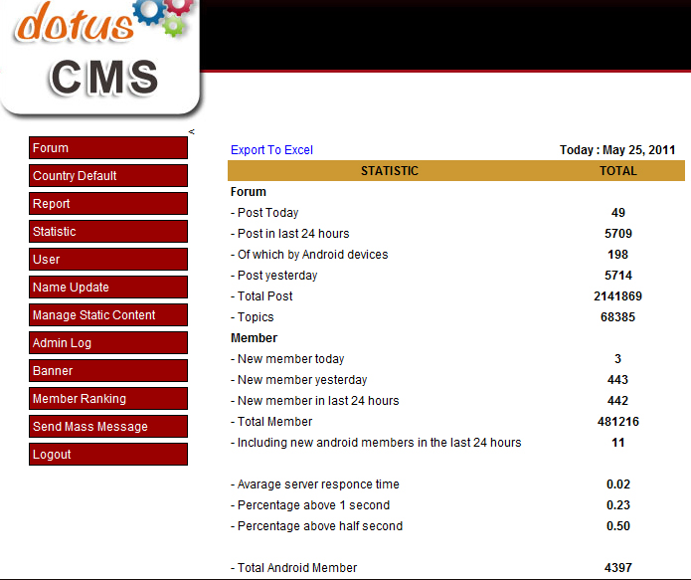
Image is a screenshot from the Dotus CMS which keeps statistics for the BlackBerry and Android applications
Image was taken on 25-05-2011, at the start of the day.

As the above image shows, the total android members are counted as 4.397 on the 25th of May, 2011. The total amount of members is counted as 481.216 users, which is rounded to 481.000+ users.

According to Remko Weingarten, who built the Dotus CMS, this number includes the Android users as well. Therefore the total amount of BlackBerry users is 481.216-4.397 = 476.819 users, which is rounded to 476.000+ users.

Playbook launcher download statistics for Remko’s Forum
Chart shows downloads of the launcher application for the playbook tablet of Research In Motion, Statistics were taken from the first 6 days after the launch of the application, starting at 19-05-2011
Data comes from XML report generated by BlackBerry on 25-05-2011; the source file can be downloaded from www.erikstolman.nl/downloads/remkosforum-19.05.2011-25.05.2011.csv

Visit statistics for Remko’s Forum for web

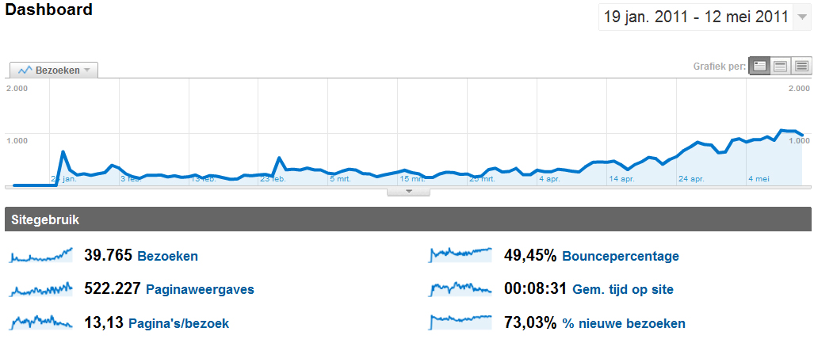
Statistics taken from Google Analytics. It shows the amount of visits to Remko’s Forum for web in the period of the 19th of January to the 12th of May.

The graphic above shows the amount of visits the Remko’s Forum for Web since its launch on the 26th of January to the 12th of May. Between the continuous growth upward in visits per day, there is one big initial visit spike on the day the application was launched and announced via the existing Remko’s Forum applications.

This spike can be explained by the people who tried the web version (which was very limited at that time) and stopped using it afterwards. A small spike was registered on the second of February, which was most likely due to a post from Remko Weingarten on Remko’s Forum about the web version.

The last spike on the 26th of February is probably due to a small amount of improvements made to the web version, as a part of the graduation internship. Remko Weingarten posted a status update message on his profile about the updates.

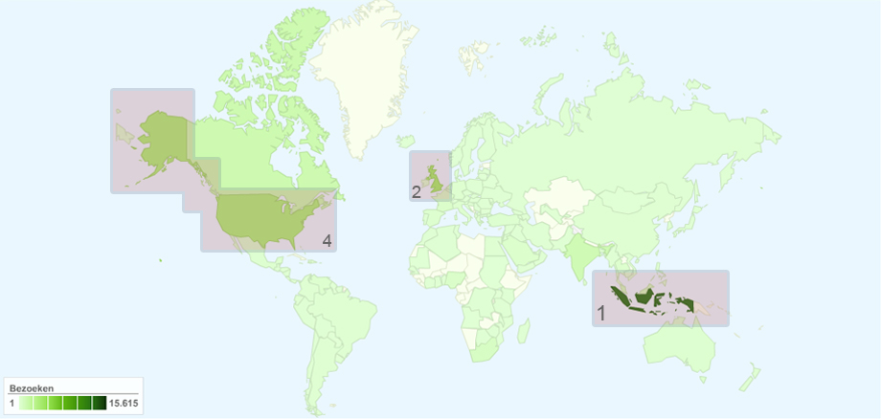
Origin of Remko’s Forum users

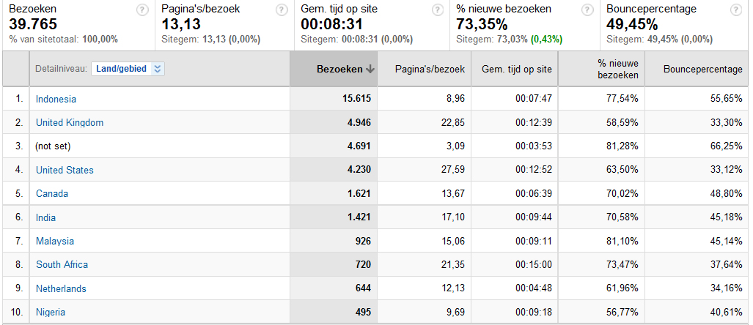
Statistics taken from Google Analytics. It shows the origins of users connecting to Remko’s Forum for Web on www.remkosforum.com. The statistics shown are between the 19th of January and the 12th of May

The statistics above show that the largest user group visiting the Remko’s Forum website originate from Indonesia, followed by the United Kingdom. The third position is claimed by the United States, because (not set) indicates a group that cannot be defined.

Appendix V: graphical design of Remko’s Forum
The graphical design of Remko’s Forum for Nokia and Remko’s Forum for Web
For Dot.us Indonesia

By Erik Stolman
02-03-2011, styling updated on 25-05-2011 to show results
of implementation

Wireframes that have been made and accepted by Remko Weingarten of Dot.us The major source of inspiration was the existing layout, combined with usability improvements.

Main forum page, index on web version
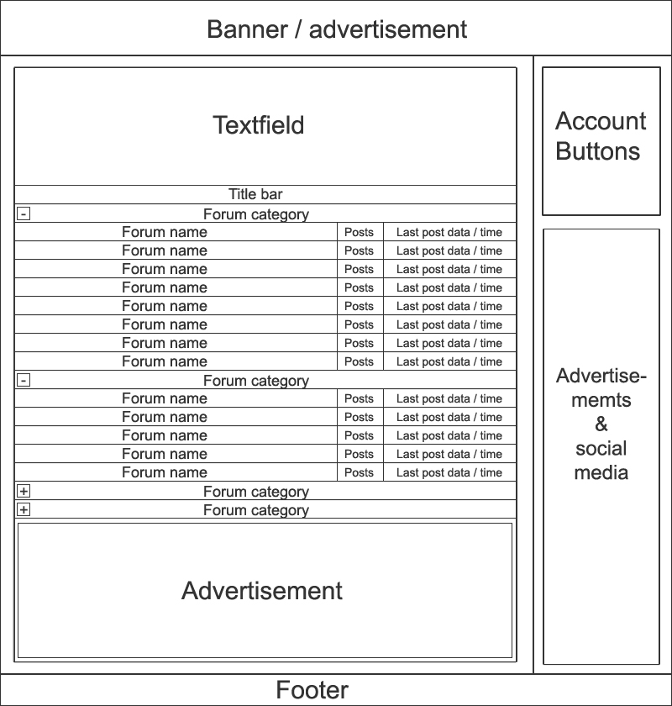

The most important feature of the main page is its list of forums and forum categories. Originally it was not possible to truncate the forum categories, but the function was needed to implement the forum on a mobile device. It was also inspired by the availability (and hence expectation) of the function in the BlackBerry and Android applications.

The wireframe is 800 pixels wide as a result of visitors connecting to the website that still have an 800 x 600 pixel resolution. There are three banner / advertisement slots on the main page; the top banner (which is available on all pages), the sidebar banners which currently feature the Android market and BlackBerry App World pages of the Remko’s Forum Applications. And the bottom banner which is also a bigger version of the advertisement banner in the sidebar referring to the Remko’s Forum for BlackBerry application page in the BlackBerry App World. The sidebar also features a social media (Facebook) plug-in. These features have been added from the old version of Remko’s Forum for Web, before the graduation internship started.

The sidebar also contains the account pages buttons and log in panel. The top text field above the forum list features information on how to get a username and password for Remko’s Forum for Web. The footer holds copyright and about information. The title bar contains the forum list field descriptions.

Elements within the banner, footer and sidebar stay the same on all pages and are not mentioned in the description of the following wireframes of different pages.

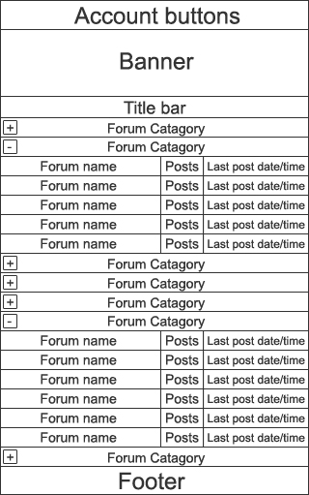
Main forum page, index on mobile version
The mobile version of the web application will open with its forum list truncated, so a user will first select the required information to reduce scrolling.

The wireframe has a 320 pixel width, which is similar to the screen width of the Nokia C-03 smartphone, with its Series 40 operating system.

The sidebar has been removed because there is not enough space on the screen to properly support it. Also removing the sidebar means that the BlackBerry and Android marketplace links for the applications are not shown, as these became redundant when the application is viewed on a Nokia smartphone. This also saves loading time, which needs the be reduced as much as possible due to slow mobile internet speeds in Indonesia.

In order to improve the loading speed even more, the Facebook plug-in in the sidebar has been removed from the interface. The account buttons from the sidebar have been positioned above the banner to give them a visible location within the application, and to make the application look more like an application and less like a website (which often is associated with the classical design order of
banner - navigation - content - footer).

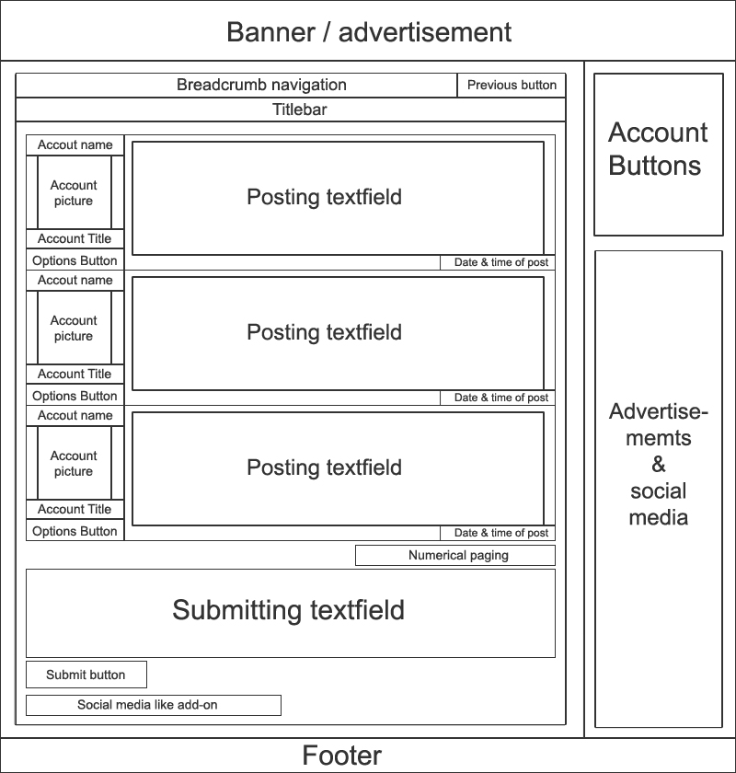
Postings page, posts on web version

The sub pages differ from the index page, to allow the user extra navigation options (breadcrumbs and a back button). Also the text field was removed because it is only meant as a notification on the index page.

The old version of the postings page was mostly edited on the additional features. The main feature, the post list only changed on the account picture and the options button (which was originally only a quote function). Most changes are made to the side features, in example updating the “first page, previous page, next page, last page” navigation into a numerical navigation, because the old system switched the next / previous page meaning, while opening on the newest page when newly accessed, causing confusing effects. A numerical pagination is based on a logical order which is better understandable in this situation, and the numerical paging will show quick navigation to up to 10 pages, were the old navigation only offered 4 pages.

The old breadcrumb navigation showed all pages as one level below the homepage and used a dash (“-“) to separate pages. In the new breadcrumbs version this has been updated to a greater than symbol (“>”) to indicate page order. The new breadcrumbs system also shows profile functions as being under the profile page, as opposed to under the home / main page in the old version.

The previous page button has been added to the breadcrumbs bar on the right side to offer additional navigation and assist mobile devices that do not have a physical “go back” button as featured on all BlackBerry and most Android smartphones.

Postings page, posts on mobile version

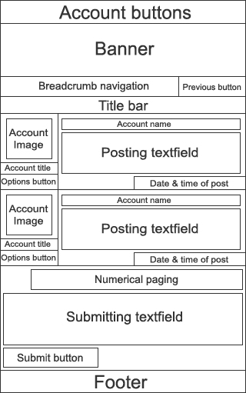
The major challenges with designing an effective wireframe for the mobile version of Remko’s Forum for Web are due to the large amount of data a post can contain. As the length of a posting is not limited, available space must be divided efficiently.

To allow posts smaller than 5 lines of text of a length decided by the screen size to take up only the default post size, would result in compensation for the long posts. The original from the web interface was 8 lines. To achieve this, the width and height of the side image was downsized 60 x 60 pixels, from 80 x 80 pixels, and the account name was moved above the post.

All elements in the dynamically generated interface change their width based on the solid elements in the design and the available screen space. Solid items on this page are the account images, account title, options button, numerical paging, submit button and the previous page button.

The other elements scale in width based on the screen width.

Profile page, profile information on web version
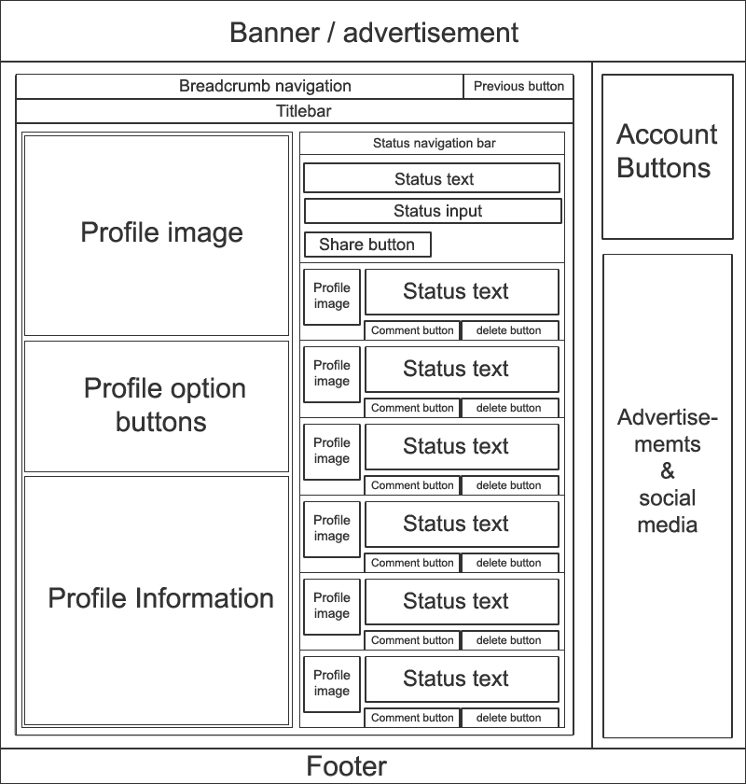

The main purpose of the profile page is defined in two ways, firstly it is a collection of data about -, or a personalization of a user profile on Remko’s Forum. Secondly, it is home to the status updates, were the user can view his / her friends and his / her own status updates, and add new updates or provide new comments. Logically a user can only delete his / her own comments, so the delete button is only available when viewing their own status updates. Based on this the content screen is divided in two columns, the left column for the profile and the right column for status updates.

In the left column the profile image is shown first, to give visitors an “above the fold” look at the personification of the viewed profile. The image here is resized to fit the column in width, but will take the correct ratio in adjusting its height.

The profile option buttons are shown below the profile image to offer quick access op multiple options. The option buttons listed here will vary based on whether the user is viewing his /her own profile or not, whether the profile that is being viewed belongs to a friend or not, and whether the user has administrator rights or not.

The profile information field lists all user information that was entered as profile data by the account owner. Examples are the first name, last name, birth date, city of residence and country of residence. The amount of friends is added automatically.

The right column contains the profile status updates, and through the navigation in the status navigation bar, the user can also see the updates of all friend accounts. Status updates are often relatively small updates, similar to messages on the Facebook Wall, or Twitter and any status update can be commented on. The interface shows the profile image, message and a comment button.

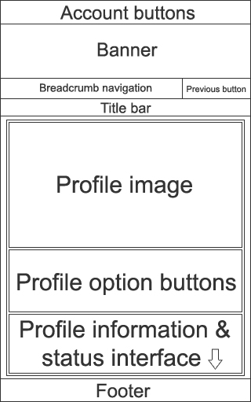
Profile page, profile information on mobile version
The mobile version of this page, has the same layout and features, but instead of two columns there is one long column, containing all the information.

The choice for this rests on two factors: the limited screen size does not allow to show both columns at the same time, and separating the status updates from the profile page will not be feasible within the amount of time available for the project, as it requires extensive updates on the dynamic CSS generator.

In the wireframe of profile information on the mobile version, the design has become very long by showing two columns beneath each other, hence the arrow symbol at the bottom symbolizes the continuation of the interface, which is the same as shown in the wireframe for the web version of the profile page.

Edit page, general layout to change settings or information on web version
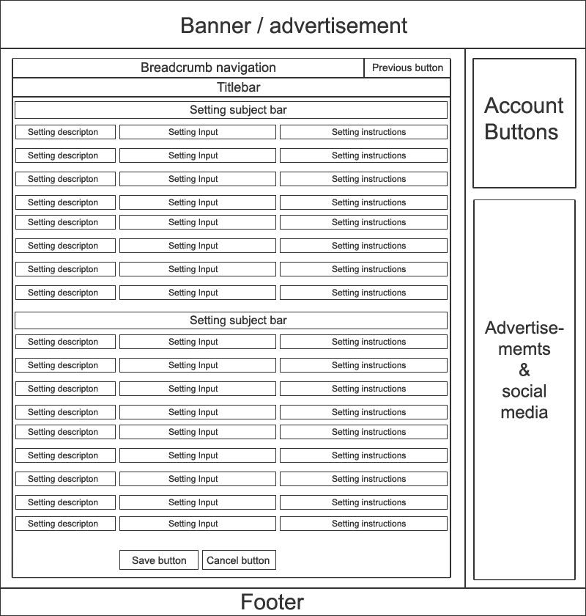
The edit pages for password, profile settings and profile information are identical in buildup, but they are separated because they serve different purposes. The setting description indicates what the setting is for; the setting input is either a text line, an image with upload / change possibility, a select box, or a text area. The setting instructions can contain extra text too to clarify the input format. The save button has been added to save the content, and the cancel button has the same functionality as the previous page button, but offers the user the ability to abort the action on page.

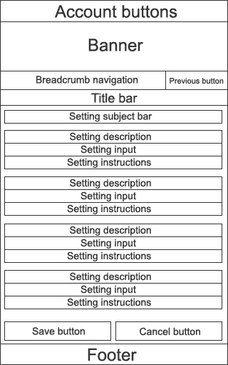
Edit page, general layout to change settings or information on mobile version
In the mobile version, the setting description, setting input and instructions have been placed under each other to make all information can be displayed properly.

The dynamic CSS generator is responsible for resizing the mobile page and the allotted room can resize up to the minimum space needed for the settings interface.

Defining the graphical style for the wireframes.
Remko’s Forum for BlackBerry and Remko’s Forum for Android both have different styles In order to set a style that both the BlackBerry and Android users can recognize them. The old web interface already offered a frame of banner, sidebar and footer, of which the sidebar has only changed on content style, while the frame itself could remain the same.

The main forum list style has been taken from the BlackBerry application, as well as the title bar style and the alternative title bar style (as seen below on the forum list) the while the hover effect of the BlackBerry menu’s was incorporated.
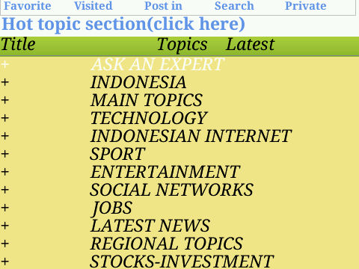
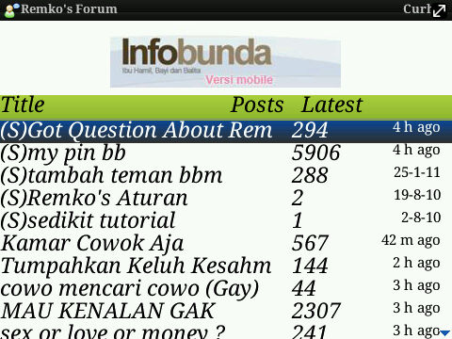

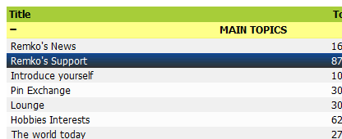

Also the Android version friend list, which main feature is that it shows the friends profile picture while the BlackBerry version only showed the friend name was combined with the blackberry hover style.

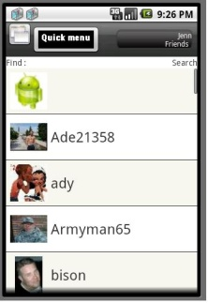

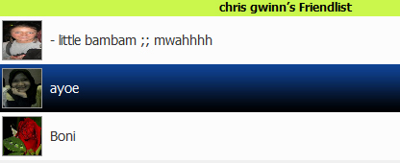

The new pop up options menu on the posts page was based on the options menu from Remko’s Forum for BlackBerry, but the presentation has been improved.

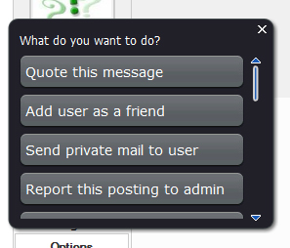

The wireframes for the tablet versions have not been drawn up, because the request to make the dynamic CSS generator accept tablet connections gave no time for a structural approach.

Appendix VI: functional design of Remko’s Forum
The functional design of Remko’s Forum for Nokia and Remko’s Forum for Web
For Dot.us Indonesia

By Erik Stolman
04-03-2011

Background information
The functions listed in this functional design have been based on research done on the existing functions in Remko’s Forum for BlackBerry and Remko’s Forum for Android. The functions are mentioned as they are incorporated into Remko’s Forum for Web and Remko’s Forum for Nokia.

Actors of Remko’s Forum

- Users
- Moderators
- Advertisers (in the future)

Requirements of Remko’s Forum

 | Business Requirements
B.01 | The system must be easily accessible
B.02 | The system must not take too much time to load

 | Content Requirements
C.01 | Users must be able to view forums, topics and posts
C.02 | Users must be able to view their own profile or view other user’s profiles
C.03 | Users must be able to view their own inbox
 | Technical Requirements
T.01 | The system must be able to handle a large amount of data requests per minute, up to a 1000 requests at any given point of the day
T.02 | The mobile interface must load a posts page within 10 seconds via GPRS connection

 | Functional Requirements
F.01 | Add post | Users and moderators can add a post (reply) to topic
F.02 | Add topic | Users and moderators can add a topic to a forum by submitting the first post to the topic
F.03 | View posts in topic | Users and moderators can view all posts in a topic
F.04 | View topics in forum | Users and moderators can view all topics in a forum
F.05 | View forums on main page | Users and moderators can view all forums on the main page
F.06 | Navigate post pages (paging) | Users and moderators can navigate through the posts within a topic by using the numerical paging
F.07 | Navigate topics pages (paging) | Users and moderators can navigate through the topics within a forum by using the numerical paging
F.08 | Truncate / expand forums list | Users and moderators can truncate or expand the forum lists on the main page based on forum categories
F.09 | View profile | Users and moderators can view a users profile information
F.10 | Edit profile | Users can edit their own profiles
F.11 | Change profile settings | Users can change their profile settings
F.12 | View friend list | Users and Moderators can view their own or other users  friend lists
F.13 | Add friend | Users and moderators can add other profiles to their friend list
F.14 | Delete friend | Users and moderators can remove other profiles from their  friend list
F.15 | View inbox | Users and moderators can view their private message inbox
F.16 | Accept/decline friend request | Users and moderators can accept or decline friend requests
F.17 | Send private message | Users and moderators can send private messages to other users
F.18 | View private message | Users and moderators can view received private messages
F.19 | Reply to private message | Users and moderators can reply to received private messages
F.20 | Delete private message | Users and moderators can delete received private messages
F.21 | Quote user post | Users and moderators can quote a post when replying on a topic
F.22 | Report post to admin | Users can report a post to moderators
F.23 | Block user | Users can block another user account from sending status updates or private messages
F.24 | Ban user | Moderators can permanently ban a user account
F.25 | Unban user | Moderators can unban a banned user account
F.26 | Make topic sticky | Moderators can make a topic in a forum sticky
F.27 | Make topic admin only | Moderators can change the topic permission to only allow moderator posts
F.28 | Delete topic | Moderators can delete a topic from a forum
F.29 | Delete post | Moderators can delete a post from a topic

1: view forums on main page, Truncate / expand forums list , view topics in forum, navigate topics pages (paging), add topic, view posts in topic, navigate post pages (paging), quote user post, add post
Summary | A user opens the forum on the main page, and expands a relevant forum category before selecting a forum to view. In the resulting topics list the user navigates the existing topics in the forum before deciding to add a new topic, and then views the new topic after several hours. There the user navigates through the replies to the topic and quotes a message that was replied within the topic, and posts a reply to it.
Requirements | F.01, F.02, F.03, F.04, F.05, F.06, F.07, F.08, F.21
Actors | The user
Perquisites | The user has been logged in by the launcher application
Process description | 2) The user expands a truncated forum category  4) The user chooses a forum to view  6) The user browses to the next topics page in the forum using the pagination  8) The user creates a new topic by filling in a title and message  10) After a while the user opens the new topic to see the replies to it  12) The user navigates the topics using the pagination  14) The user selects a post and quotes the message  16) The user writes the reply and posts the message | 1) The system shows a truncated list of forum categories on the main page  3) The system shows a list of forums under the category that has been expanded  5) The system shows a list of topics within the forum, which can be navigated with a pagination system  7) The system shows the next topics page for the chosen forum  9) The system adds the topic and first message to the topics in the forum  11) The system shows the posts made in the topic  13) The system shows the next posts page for the chosen topic  15) The system copies the message into the post field  17) The system adds the reply to the topic
Exceptions | The user is visiting the website without the launcher, and has to log in before being able to add topics, quote posts or add posts
Result | The user has navigated the forum, added a topic and posted a reply to a quoted message

2: view profile, edit profile, change profile settings
Summary | The user views the own profile, and then chooses to edit some of the profile data. Afterwards the user updates the profile settings.
Requirements | F.09, F.10, F.11
Actors | The user
Perquisites | The user has been logged in by the launcher application  The user has navigated to the profile page
Process description | 2) The user navigates to the edit profile page  4) The user updates the profile information and saves the changes  6) The user navigates to the change settings page  8) The user changes the profile settings and saves the changes | 1) The system shows the profile information page  3) The system loads the profile information from the database and shows the edit settings page  5) The system stores the profile changes in the database  7) The system loads the profile settings from the database and shows the change profile settings page  9) the system stores the settings changes in the database
Exceptions | The user is visiting the website without the launcher, and has to log in before being able to edit the profile or change the account settings  The user is not viewing the own profile, but the profile from a different user. The user has to view the own profile before being able to edit the profile or change the account settings
Result | The user has updated the own profile and changed the profile settings

3: add friend, view friend list, remove friend
Summary | The user sends a friend request to another user. After this the user views his friend list and removes an existing friend.
Requirements | F.12, F.13, F.14
Actors | The user
Perquisites | The user has been logged in by the launcher application  The user has navigated to the posts page in a topic OR  The user has navigated to the profile page of the target user
Process description | 2) The user selects a post and clicks the option button next to the post, then chooses “add user as a friend”  OR  3) The user clicks on the “invite as a friend” button on the profile page of the target user  5) The user adds an invitation message and sends the friend request  7) The user navigates to the friend list  9) The user chooses to delete an existing friend  11) the user confirms the delete | 1) The system shows the posts page of the selected topic  4) The system shows the options popup  6) The system sends the friend request to the targeted user  8) The system shows the friend list page  10) The system request confirmation to delete the friend from the friend list  12) The system deletes the user as a friend
Exceptions | The user is visiting the website without the launcher, and has to log in before being able to add or remove friends
Result | The user has added a new friend and deleted an old friend

4: view inbox, view private message, accept/decline friend request, delete private message, send private message, reply to private message
Summary | The user opens the inbox and views a friend request that was sent to the user’s account. The user accepts the friend request and deletes the friend request private message. The user then sends a private message to a friend and replies to another message.
Requirements | F.15, F.16, F.17, F.18, F.19, F.20
Actors | The user
Perquisites | The user has been logged in by the launcher application  The user has navigated to the inbox page
Process description | 2) The user selects a friend request message  4) The user accepts the friend request  6) The user chooses to send a new message  8) The user chooses a friend to send the message to, writes a subject and a message and sends the message  10) The user selects an old message from the inbox  12) The user chooses to delete the selected message | 1) The system shows the inbox page  3) The system shows the detail message  5) The system adds the user as a friend and sends the user back to the inbox page  7) The system shows the send message page  9) The system sends the message to the selected friend, and send the user back to the inbox page  11) The system shows the detail message  13) The system deletes the message
Exceptions | The user is visiting the website without the launcher, and has to log in before being able to see the inbox
Result | The user has accepted a new friend, sent a private message and deleted an old private message

5: report post to admin, block user, ban user, unban user
Summary | The user reports a post to a moderator, who blocks the user for 24 hours. The moderator then bans a different user and unbans a third account.
Requirements | F.22, F.23, F.24, F.25
Actors | The user, The moderator
Perquisites | The user and moderator have been logged in by the launcher application  The user and moderator have navigated to the posts page
Process description | 2) The user reports an abusive post to the administrators  4) The user blocks the account that posted the message  6) The moderator receives the abusive post report via email and navigates to the profile page of that user  8) The moderator bans the profile  10) The moderator has been ordered to unban a different profile because mistakes were made, The moderator navigates to the profile page in question  12) The moderator chooses to unban the profile | 1) The system shows the posts page of a topic  3) The system sends an email to the responsible moderator for the topic.  5) The system adds the posting account as blocked so it will not be able to send private messages or status updates to the users profile  7) The system shows the requested profile page  9) The system adds the user account as banned  11) The system shows the requested profile page  13) The system removes the profile from the banned list
Exceptions | The user and moderator are visiting the website without the launcher, and have to log in before being able to report a post, block, ban or unban an account
Result | The user has reported an abusive post, the moderator has blocked one account for 24 hours, the moderator has permanently banned a different account, and the moderator has unbanned a third account

6: make topic sticky, make topic admin only, delete post, delete topic
Summary | The moderator makes a topic with important information sticky, and makes an abusive topic admin only, before deleting separate posts. Afterwards, the moderator deletes an old topic
Requirements | F.26, F.27, F.28, F.29
Actors | The moderator
Perquisites | The moderator has been logged in by the launcher application  The moderator has navigated to the posts page
Process description | 2) The moderator chooses to make the topic sticky  4) The moderator navigates to a different abusive topic  6) The moderator chooses to make the topic admin only pending cleanup  8) The moderator chooses to delete an abusive post  10) The moderator confirms deleting the post  The moderator judges the entire topic to be abusive and removes the topic  10) The moderator confirms deleting the topic | 1) The system shows the posts page of a topic  3) The system prioritizes the topic by making it sticky  5) The system shows the posts page of the new topic  7) The system changes to topic so that only moderators can post in the topic  9) The system asks for confirmation  11) The system deletes the post  13) The system asks for confirmation  15) The system deletes the topic
Exceptions | The moderator is visiting the website without the launcher, and has to log in before being able to make topics sticky or admin only, or to delete posts and topics.
Result | The moderator has made a topic sticky, and has made an abusive topic admin only, so that only moderators can post there. Afterwards posts have been deleted from the topic, until the moderator decided to delete the entire topic.

Appendix VII: Usability research on Remko’s Forum
The usability research preformed on Remko’s Forum users about Remko’s Forum for Web
For Dot.us Indonesia

By Erik Stolman
02-03-2011, updated on 12-05-2011

Expert assesment of the old Remko’s Forum for Web interface
During the expert analysis the usability problems of the existing Remko’s Forum for Web interface have been identified as points that can be improved during the Remko’s Forum for Nokia project.

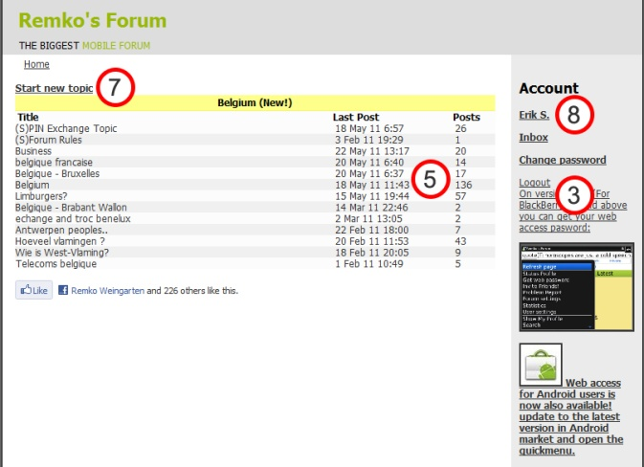
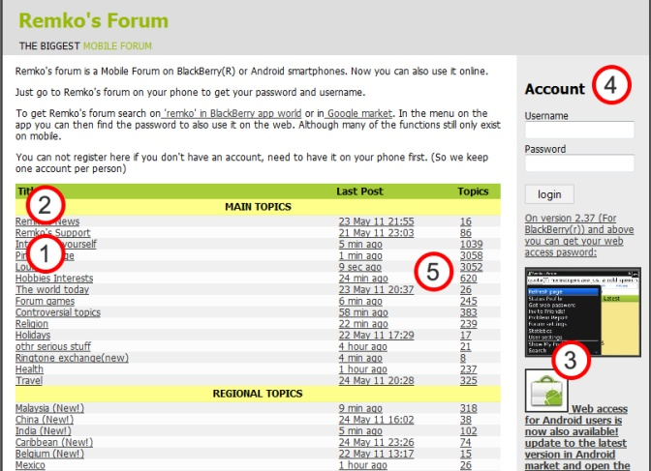
Index/main page Topics

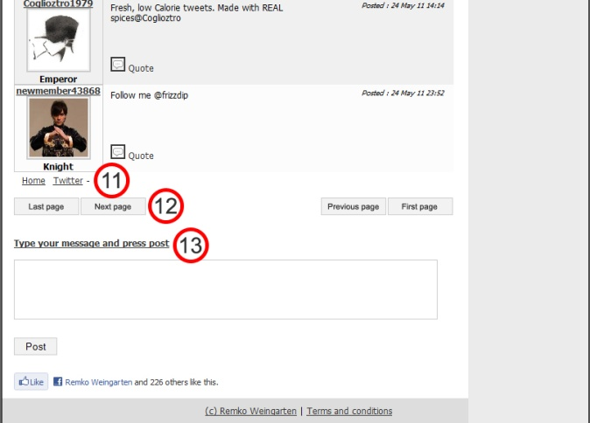
Posts - top Posts - bottom
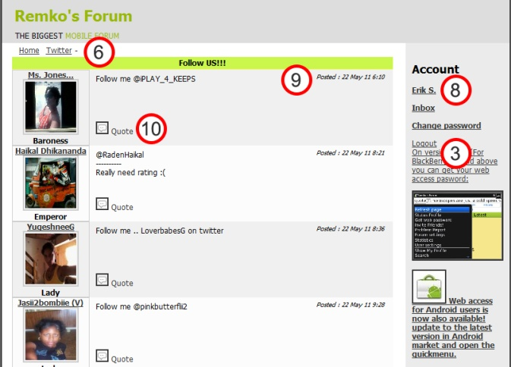

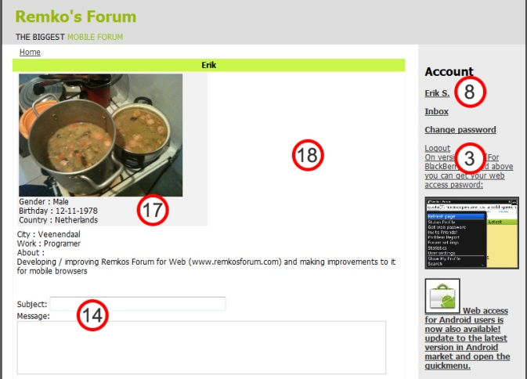
New topic Profile
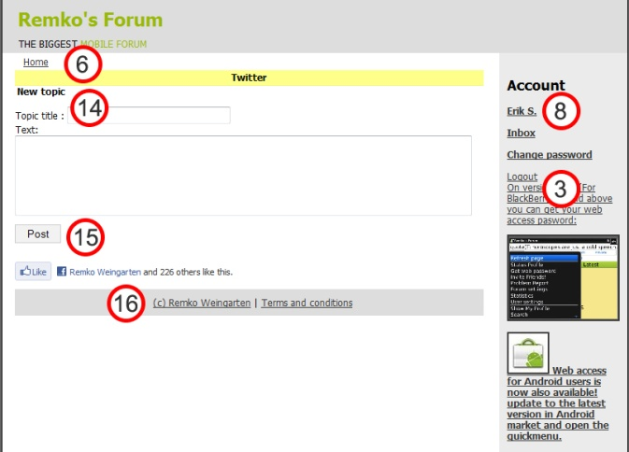

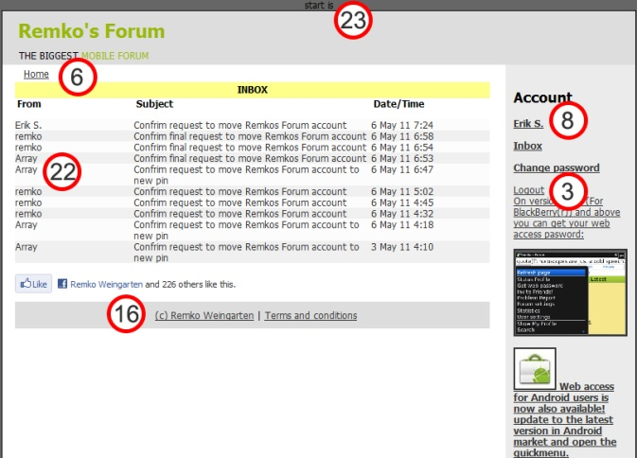
Change password Inbox
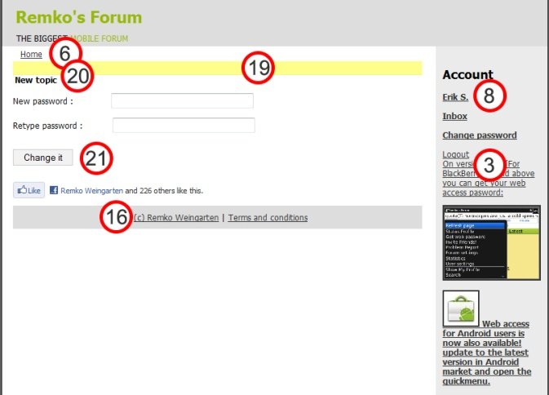
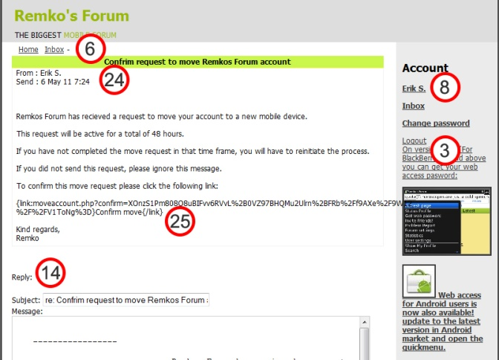
Get message detail

1) The forums are listed with underlined text. This causes the user to interpret the forum title, topic count and the last post as separate links to new pages due to the gestalt law of similarity (quoted at point 3 of this chapter). This defies the purpose of the alternative repeating row and the column design, that are meant to be shown as a list navigation, because it follows the example of the Gestalt law of good continuation;

“Elementen op een rechte lijn of een vloeiende curve worden als groep gepercipieerd. Ze vertonen meer onderlinge samenhang dan elementen die daar niet op liggen”
From: ‘Universele Ontwerpprinciepes’, William Lidwell et al., page 98, published in 2006.

This can be translated to English as;

“Elements that are shown on a straight line or flowing curve are seen as a group. They show more connection to each other than elements that are not on that same line or curve”

And the design principal of affordance;

“Affordance: Design things so it is clear what they are for; for example, make buttons look like buttons so people will press them. Affordance referrers to the properties that things have (or are perceived to have) and how these relate to how the things could be used. Buttons afford pressing, chairs afford sitting on and Post-it notes afford writing a message on and sticking next to something else”
From: ‘Designing Interactive systems’, David Benyon, page 90, published in 2010.

The underlining in this case causes the viewer to see columns instead of rows. Rows afford to be used as a whole, while three columns indicate three separate lists.

2) The forum list is a big page in a list model, and the categories of the list indicate grouping. Based on the group a user will expect to be able to truncate the large amounts of data, especially since these functions are available in the BlackBerry and Android applications of Remko’s Forum.

3) The sidebar advertisements for the BlackBerry App world and android market serve the same purpose, but look differently in image style, text style and alignment. It is preferred to have elements that serve the same function, look similar to each other. The principal of this lies in the Gestalt law of similarity;

“Elementen die als vergelijkbaar worden gepercipieerd, zijn sterker verwant dan andere elementen”
From: ‘Universele Ontwerpprinciepes’, William Lidwell et al., page 184, published in 2006.

This can be translated as;
“Elements that are seen as similar, are related more strongly compared to other elements”

4) Account is confusing terminology as it is placed above a log in screen, instead of account related information or options. A better suggestion would be “Log in” or “Account log in”, as it describes the purpose of the field below it better

5) Column order is not in the right order of importance. The viewer will expect the amount of topics in the forum after the forum name, as this is a property forum users are used to from using other popular standardized forums such as PHPBB and the BlackBerry and Android applications of Remko’s Forum. Reorganizing column order will improve the user recognition of the software as a forum.
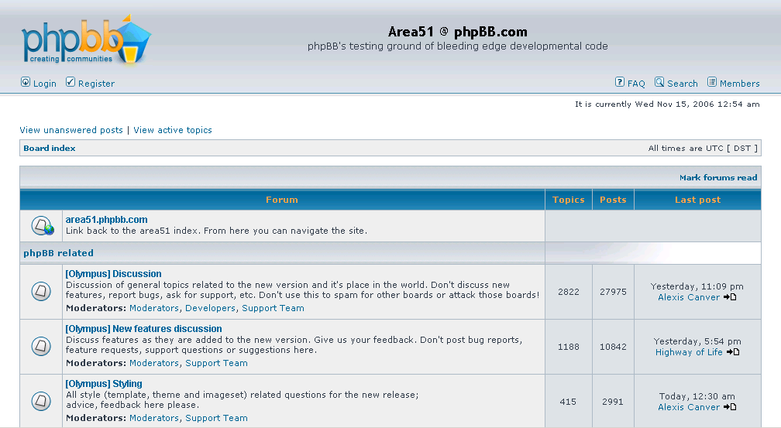

Image source: http://phpcms.info/2011/01/phpbb/
6) Breadcrumbs were already implemented in the old version Remko’s Forum for Web, but it lists some page, in example profile pages as part of home, instead of profile, and it lists new topic as part of home instead of the current forum. Also the connector icons (dashes, -) between pages do not indicate information flow, like an arrow. Hedwyg van Groenendaal justifies the use of breadcrumbs as following;

“Het is belangrijk dat een bezoeker de weg binnen een site niet kwijt raakt. Een goede menustructuur is essentieel, maar ook de manier waarop aan wordt gegeven waar een bezoeker zich bevindt”
From: ‘Webdesign, van concept tot realisatie’, Hedwyg van Groenendaal, page 186, published in 2006.

Implementing flow indication and correct page paths will offer the user a better sense of location and page depth that the current breadcrumbs system does.

7) The “start new topic” option places the title bar 20 pixels lower compared to pages without this option. When a visitor navigates from a default page to the topics page, the interface will jump down, and when the visitor navigates to the next page, the interface will jump up again. This breaks the continuality of the interface. Ideally the placing of returning elements on pages should be placed in the same place, unless the effect is on purpose (as shown on the index page, where a text field has been fitted above the title bar). Making sure the main elements of the page (breadcrumbs, title bar and content field) start at the same position on each applicable page should improve the visitors experience with using the application interface.

8) The sidebar has a number of errors concerning account option navigation. First of all, the options listed under account look like hyperlinks. In user experience, hyperlinks refer to information pages (bridge to information). The purpose of the links in the sidebar however, is to give the user access to options within the system. The visitor identifies an option element with a button. Option buttons are a familiar principal from existing computer software that users learned to recognize. Also a button indicates clickability more.

Second of all, the log out button uses the same style as the advertisement text of Remko’s Forum for BlackBerry, which makes it look like a part of the advertisement instead of a user option. Styling the options to look the same, and making them look like buttons should improve user experience.

9) The date and time information of each post on the posts page is listed in the upper right corner, which will conflict with post texts that need the entire text field width. Also, visitors do not prioritize this information, so it does not hold merit to display this information on an important position, according to the Gutenberg diagram. A better solution would be to place this information in the lower right corner.

10) The quote option (and all administration options awell) is not aligned to any element of the post message, thus breaking uniform post style. Also it is an option of the post, but displayed as a hyperlink. The option icon has a border around the image, making it look separated from the option. The solution to this would be combining all post options that the BlackBerry and Android application versions incorporate into the website, and implement an options button to access an options menu to indication option grouping and purpose.

11) The post page features a second breadcrumbs system beneath the posts. The purpose of a breadcrumb navigation is to show the current location on a website, and offer additional navigation options to a visitor. This is expected once per page above the content as this is the usual place to implement the breadcrumb navigation feature, or in the case that two breadcrumb navigations is being preferred, it should be implemented on all pages that have the breadcrumb navigation for continuality, instead of being an exception on one page only. If extra navigation is needed at the bottom of the page, a “go back to top” link should offer a better solution than the additional breadcrumb navigation, because it offers additional functionality that the user can relate to.

12) The “first page, previous page, next page, last page” pagination is offering confusion to the visitors, because the post page opens on the last page, but it lists it as the first page. Also it offers the visitor no way of telling on which page he or she currently is. A numerical pagination solves these problem with a clear indication of position, plus it will offer up to ten available pages per content page, versus 4 pages in the current system. Numerical order is a more solid concept in logical order that visitors can refer to compared to the old pagination.

13) The title is underlined; making it look like it’s a hyperlink while it is not. Making the title bold for all insert titles will uniformly set a style that is recognizable as a title.

14) The form format for input fields is not standardized. Titles can be standardized by making them bold and removing the colon ( “:” ) symbol behind the title. Input fields like text areas and text lines can be standardized by putting them one line below the input title.

15) The button does not show the name of the option it represents, because a topic is not posted, but created. Using the right description on a button will reduce the chance that users can get confused when using the application.

16) The footer has been misplaced by a programmatically error. The uniformity of the design (banner – content / sidebar – footer) is broken, which may confuse the visitor.

17) The dimensions of the content pane do not match the dimensions of the data that it is supposed to contain. While its width does not match its content width, it is based on half the content container width, however in its height there is a clear problem; the height is fixed on a certain size while it is supposed to contain dynamic content of varying height. Hence the meaning of a containing field (grouping content that belongs together, based on the Gestalt law of similarity) is lost. Correcting the container will solve the problem.

18) The whitespace shown offers no clear function or purpose, but still takes up half the content container width. This can be solved by adding content, or displaying the information under the profile picture there.

19) The title bar is empty and the page title is shown at the 20) marker, while normally the current page is shown in the title bar. Users expecting that pattern might be confused by the misplacement of the page title, as it is a continuation of the breadcrumbs navigation. The problem can be solved by showing the page title in the title bar instead of the content field.

20) The title of the page is “new topic” while it is on the “change password” page. Its nature probably lies in a copy/paste error that should not occur in a live version of a product. Solving the problem is a matter of changing the page title to “change password”

21) The button text reads “Change it”, and while this describes the function, it is not the standardized button format for a website, and mixing two types of language used on a website; functional (create, save, update, delete) and popular (create it, name me, change it, remember it, remove it) will cause a conflicting tone of voice from the website. The solution is choosing one tone of voice to use in options and functions throughout the entire application / website.

22) The sender of this private message is read as “array” (which is de default variable type in the data layer if there is no usable data found, in example if it is a system message), and it is an error in data handling. The solution would be to add the default “Remko” as a sender to private messages where the sender is not defined.

23) The top of the page shows “page number is” above the website container and is a test parameter from local tests that has been overlooked before placing the product “Remko’s Forum for Web” online and simply has no justification for being there at all. It can be solved by removing the test parameter from the application

24) The message from the inbox has no clear separation to indicate message details and message contents. The message details also contain the grammatical error “send”, which comes from the present tense of “sending”, while it is supposed to be “sent”, which is the past tense of “sending” to indicate at what date and dime the message was sent. The separation of elements can be solved by a horizontal line, or a different background.

25) The content is running outside the content field, which is not confirming to visitor perception of field assignments. This can be solved by breaking long character sequences down to a new line if the maximum allowed amount of characters for a text field line is passed, based on the space the character “m” takes, as it needs the most width of all the characters in the Latin / UTF-8 character set.

User feedback from BlackBerry App world, Android Zoom and Remko’s Forum
The following information posts are used to identify user opinions and gether information for functions to add to Remko’s Forum. Feedback on a medium is meant for that medium only, so posts on Android Zoom are meant for the Android application only. The feedback that is given only lists the constructional messages that can be used to draw feedback from. The majority of comments on the BlackBerry app world about Remko’s Forum are social messages instead of providing constructive feedback on the application. Examples are messages like “add me: <pin number>” or “looking for a date near area X”. Naturally these have not been included in the following list. Comments like “great” or “sucks” have also been excluded because they offer no explanation to what they like or dislike.

Android Zoom (http://www.androidzoom.com/android_applications/social/remkos-forum-for-android_kjcr_comments.html)
Sender | Comment
P  10/05/2011 | I hav at least 200 friends but this buggy app only shows the a letter ppl...i emailed and to no avail....it wuld b nice if they wuld fix the bugs!!!
Francisco 01/12/2010 | Great app, but needs a search function
JOC  24/02/2011 | Remko's doing better every day...keep the updates coming remko
Susan  07/02/2011 | Seems to have interesting and informative forums. Have to check it out better, but its lookin good so far.
Twan G. 04/02/2011 | The UI is cool but way to many FC and a lot of bugs can't even save my profile pic or most of my info needs a lot of work
corey  20/10/2010 | Very nice .. Organized . No trolls.. Its perfect would be 5*s though if it was faster.. But the biggest problem is the fc and screwyness .. Not stable
Aya  24/09/2010 | Too slow
Michelle 07/09/2010 | This is a pretty cool app. I enjoyed reading the religion thread. Mods do a great job keeping trolls out

Quick feedback points taken from these messages on Android Zoom

- Make sure people can reach all their content by correctly implementing pagination options (available for topic, posts, friends, inbox and search pages)

- Implement a search function to search content, profiles and topics

- Regular updating in intervals is preferred to large updates

- Do a complete bug check before releasing updates

- Fast loading speed is important for users, try to make to app as light as possible

- Good moderation is a strong point of Remko’s Forum

BlackBerry App World (http://appworld.blackberry.com/webstore/content/reviews/6461?lang=en)
Sender | Comment
duron08  May 31, 2011 Version 2.44 | Not the best app, but good to socialize with others. Follow me on twitter@ronsothoro
divinely  April 25, 2011 Version 2.44 | Als je nieuwe mensen wilt ontmoeten van over de hele wereld dan is dit de juiste app die je moet downloaden. Leuk tijdverdrijf. :)
Zolanijoka  April 18, 2011 Version 2.44 | Nice community, worth the download
whysprs  January 05, 2011  Version 2.35 | Yup, neat idea but not enough organization... In a word.. Sorry
bribear789  January 04, 2011  Version 2.35 | Figure out I have an indicator on my screen but I can't figure out how to see what it is on the app its confusing
mnamara  January 04, 2011  Version 2.35 | How do you see if someone has reopened back to something that you post?  This is really good had it on my blackberry
chepperx  December 16, 2010  Version 2.33 | Leuk om mensen te ontmoeten
fidel494  December 06, 2010  Version 2.32 | Could be slicker as UI requires updating but content variety good.
GiDeR  October 27, 2010  Version 2.2 | Perfect for ppl who want to share an opinion or just chat Downloaded today and got 6 new BBM contacts!! It does lag a bit and the alerts are hard to clear unless the come through ur mssg folder. But overall its good

Quick feedback points taken from these messages on BlackBerry App World

- Good data structure and logical navigation is important for good user experience

- Confusing elements should be removed, or be replaced by self explanatory elements

- Could use a F.A.Q. (frequently asked questions) page to cover function locations and operation orders for all devices.

- A catching user interface is preferred

- The application should run smoothly instead of lagging

- Messages can’t be deleted from the account inbox unless they come through the BlackBerry inbox

Remko’s Forum (http://remkosforum.com/pages/posts.php?topicid=1732&start=-1)
mixed BlackBerry, Android and Web feedback
Sender | Comment
dr.Hibari (V)  11 May 11 5:21 | Please add a feature so we can go to a certain page by typing the page number. Because I find it very time consuming to press next page until the page we want
Ace x Clover  7 May 11 23:27 | Can this forum add the 'page jump' feature?
Sir-Marcus  8 Mar 11 5:46 | Age suggestion: far too often I see new members claiming to be 14-15 yrs old and in adult chat. Perhaps a minimum age should be introduced for certain forum content and if anyone found under that age delete them.
Honey B  6 Mar 11 2:41 | I think there should b a set of instructions before u get staryed
MoMo_uk_mcr  27 Jan 11 13:15 | Remko why is our profie viewable to anyone and everyone on the web version without the need to log in? Sort it out!
byru  1 Jan 11 12:38 | I'm suggesting for android to have a user setting, like bb, so we can set the number of posts we see in each page.. and happy New year, Bear :)
Coglioztro1979  13 Jan 11 17:02 | 1) In the same tool bar as 'favourites/post in/search/etc...) how about a 'user created' ? Basically to see how some of the 'Topics' I've started have developed w/o having to 'Favourite' it and get an alert EVERY time someone post.  2) Maybe a log-in system of some sort. I've had to replace my BB Storm twice because of touch screen issues and thus starting a total of 3 different profiles, losing all previous post counts, friends,etc. Kinda sucked.  3) And I also don't understand the NO pin in ones 'personal' profile. Feel like its become a chore to find friends for BBM now. The pin share pages really do no good except get a lot of random ppl requesting you who have no idea where you have posted and less idea what interests you. I thought if it was in your profile, it was there for whoever who 'choose' to 'be exposed to' a pin and it couldn't be considered spamming. Confusing, is what I'm saying.  That's all I can think of for now. Other than that, its a must have app for BB junkies like myself. Cheers.
Seynuun  20 Oct 10 11:30 | I really don't like the new version!! Wtf every time i post something i see fking facebook login! I don't have a facebook and i don't want it! How can i switch it off?

Quick feedback points taken from these messages on Remko’s Forum

- Navigation improvements for browsing pages are requested, instead of the “first page, previous page, next page, last page” navigation. A jump to page number function is requested.

- Add age check to forums for forums that are made for a specified age group

- Could use a F.A.Q. (frequently asked questions) page to cover function locations and operation orders for all devices.
- Users wish to be able to set the privacy level of their accounts (public or private profile)

- Users wish to set the number of posts shown on a page

- There is a request to have an own list of separate topics created and posts placed

- There is a wish to be able to migrate profiles to a new pin number

- Not everyone likes the Facebook social media plug-ins, make it optional for users to remove them from the interface
The Indonesian feedback thread from Remko’s Forum has not been included because it was translated vocally by an employee of Dot.us. However, the feedback points are also included in the list below, showing the suggestions made based on the received feedback.

Function suggestions based on expert assesment and user feedback
All the following functions have been suggested to Remko Weingarten, A green check mark in “available” means that the function has been implemented in Remko’s Forum during the internship. A green check mark in “still planned” means that the function has been accepted but is not yet implemented. Hence it is presented as a suggestion. A red cross means that the function is not available or has been rejected by Remko Weingarten (if it is two red crosses in both the availability and the planning columns). The only platform that was included in the internship assignment, Remko’s Forum for Web / Nokia, could be modified as a result of the internship assignment. For Remko’s Forum for Blackberry and Remko’s Forum for Android, only suggestions could be given to Remko Weingarten.

Functions that have been suggested to Remko Weingarten for use in Remko’s Forum
Function name | Description | For | platform | available | planned
Delete topic | Allow admin to delete a topic | Admin | Web / Nokia | X | X
Move topic | Allow admin to move a topic to a different forum | Admin | Web / Nokia | X | X
Edit post | Allow admin to edit a post | Admin | Web / Nokia | X | X
Move post | Allow admin to move a post to a different forum / topic | Admin | Web / Nokia | X | X
Make topic visible for admin only | Allow admin to make a topic visible to admin accounts only | Admin | Web / Nokia  BlackBerry  Android | V  X  X | X  V  V
Make topic visible for admin only and sticky the topic | Allow admin to make a topic visible to admin accounts only and show topic at the top of all topics in a forum | Admin | Web / Nokia  BlackBerry  Android | V  X  X | X  V  V
Numerical paging | Navigated pages with pagination based on a number sequence instead of “first,previous,next,last” | Admin  User | Web / Nokia  BlackBerry  Android | V  X  X | X  V  V
Search function | search function with selection box for profile, topics, postings | Admin  User | Web / Nokia | V | X
Order of forum categories | Users can set the order of forum categories | Admin  User | Web / Nokia | X | V
Frequently Asked Questions | Add a Frequently Asked Questions / Getting Started page to explain users how functions and elements of Remko’s Forum work | Admin  User | Web / Nokia  BlackBerry  Android | X  X  X | V  V  V
Send PM button on profile page | Be able to send private messages from the profile page of the user using a button linking to the inbox | Admin  User | Web / Nokia  BlackBerry  Android | V  X  X | X  V  V
Hide profile from visitors | Privacy option that requires a log in before being able to see a profile with this setting | Admin  User | Web / Nokia | V | X
Add possibility to hide the friend list from visitors and regular users | Privacy option that either requires a log in, or being friends with the profile owner before being able to see the friend list of the profile owner with this setting | Admin  User | Web / Nokia  BlackBerry  Android | V  X  X | X  V  V
Items per page | Set the amount of items shown per page (posts, status updates, topics, inbox messages etc.) | Admin  User | Web / Nokia  BlackBerry  Android | V  X  X | X  V  V
Send private messages from the inbox | separate send message function and profile into a new page under the inbox | Admin  User | Web / Nokia  BlackBerry  Android | V  X  X | X  V  V
My topics list | Add my topics list that shows the topics the user has created | Admin  User | Web / Nokia  BlackBerry  Android | X  X  X | V  V  V
My posts list | Add my posts list that shows the posts the user has created | Admin  User | Web / Nokia  BlackBerry  Android | V  X  X | X  V  V
Import profile on new device | Ports the profile from pin x to pin y using the inbox system | Admin  User | Web / Nokia | V | X
Choose which forums the user will see | Allow users to choose which additional forums they see, instead of automatically filtering them in web version. | Admin  User | Web / Nokia | X | V
Disable Facebook plug-ins | option to disable showing Facebook functions / plug-ins | Admin  User | Web / Nokia  BlackBerry  Android | V  X  X | X  V  V
Rate a user | Rate a user function from one star to five stars | Admin  User | Web / Nokia | X | V
Block profile | Block a profile function from sending private messages and status updates to the visitor profile | Admin  User | Web / Nokia | X | V
Private forum | Create your own private forum on the main forum list that can be accessed by the user and the friends of the user | Admin  User | Web / Nokia | X | V
Delete private messages | Delete private messages from the account inbox | Admin  User | Web / Nokia  BlackBerry  Android | V  X  X | X  V  V
Jump to page | On a page with pagination, be able to specify a page number to be opened instead of navigating separate pages until the required page is reached | Admin  User | Web / Nokia  BlackBerry  Android | X  X  X | V  V  V

Interview with a Remko’s Forum moderator
The following short interview has been taken on the 12th of May, 2011. The questions have been submitted in writing via email to the interviewed person, and the moderator who was interviewed has submitted her answers in writing via email as well. The interview below has not been adapted, save for one comment to clarify a meaning in an answer. I have chosen not to edit the grammatical errors in English, because for an Indonesian person, this is a very good understanding of the English language. The Indonesian language, or Bahasa Indonesia, does not work with past tenses, has a simplistic form of multiplication and male and / or female versions of some words are not separated (in example, the word “dia” refers to both “he” and “she”, but “pria” refers to “man” and “wanita” refers to “woman”), and hence it is common for Indonesian people to make grammatical errors in languages that do not have these simplicities.

What is your name?
-> Lala Latifah

What is your age?
-> 29 years old

What is your relation to Remko's Forum?
-> I`m a moderator of remko`s forum

Have you worked with the web application of Remko's Forum in the period from the 26th of January to the 26th of February?
-> i`m not sure, but i think i already became an administrator of remko`s forum in the middle of that time.

Did you feel the interface and Functionalities from that time needed any improvements? Please name a few.
-> Yes, Lay out of member profile, change the information of own profile, pagination of thread/topic.

Were you satisfied with this interface?
-> No, but I like the navigation at the bottom of the page. (Erik: she means the duplicated breadcrumbs, and like in past tense: liked)

Have you worked with web application of Remko's Forum since the start of the month May?
-> Yes.

How do you feel about the changes made to the interface since the early versions, and why do you feel that way?
-> It`s more better because more easier to operate it for example we can direct send message, Banned, see the post with pagination and etc.

Are you satisfied with the new interface?
-> Yes.

What are the functions you still wish to see realized in Remko's Forum?
-> Mostly is enough for me but i think i wish have a function of delete the profile picture ... ^_^.

In total there are two moderators of Remko’s Forum that use Remko’s Forum for Web to moderate the forum, “Miss Moderator” and “HugMeDontHurtMe”. Of those two, only one replied to the interview questions that have been sent via email.

The moderator that replied, Lala Latifah (Miss Moderator) works at the Dot.us office in Jakarta, Indonesia, which is also the location where the internship took place. The method of communication was chosen to be email to be uniform for all replies, because the other moderator in question does not live in Jakarta.

In retrospect, a vocal interview would have been possible because the other moderator did not reply to the interview questions, but at the time that knowledge was not possible and at the time that it became clear that no reply would be arriving, the timeframe for usability research in the planning had already passed by a marginal amount.

Lala Latifah has also been asked to vocally translate the Indonesian feedback topic, and has helped in defining administration improvements for the Remko’s Forum for Nokia and the Remko’s Forum for Web interface.

From this single interview it can be concluded that she was not content with the old web interface, and likes most of the changes and decisions made in the new interface. She does mention the duplicated breadcrumb navigation on the posts page that has been removed in the new version of Remko’s Forum for Web, while she liked the extra breadcrumb navigation. Upon vocal inquiry, she commented that “navigating was easier if she didn’t have to scroll all the way back up the page again”. Because the breadcrumb navigation is intended in one place only, a solution would be to add a “go back to top” function that will be suggested to Remko Weingarten in the graduation thesis.

Appendix VIII: Bug check report of Remko’s Forum
A Bug checking report of
Remko’s Forum for Web and Remko’s Forum for Nokia
For Dot.us Indonesia

By Erik Stolman
27-04-2011

Remko’s Forum Bug check from 27-04-2011

Page | Firefox 4 | Firefox 3 | Firefox 2 | IE 8 | IE7 | Chrome | Safari 5 | Opera 11 | mobile
index.php
topics.php
posts.php | 3,12 | 3,12 | 3,10,12 | 3,12 | 3,12,14 | 3,12 | 3,12 | 3,12 | 3,12
newtop.php
profile.php | 3,4,7,9 | 3,4,7,9 | 3,4,7,9,11 | 3,4,7,9 | 3,4,7,9 | 3,4,7,9 | 3,4,7,9 | 3,4,7,9,11 | 3,4,5,7,9
editprofile.php | 1,2,16 | 1,2,16 | 1,2,16 | 1,2,16 | 1,2,16 | 1,2,16 | 1,2,16 | 1,2,16 | 1,2,16
search.php
changepassword.php | 6,15 | 6,15 | 6,15 | 6,15 | 6,15 | 6,15 | 6,15 | 6,15 | 5,15
friendlist.php |  |  |  |  |  |  |  |  | 8,17
fullinbox.php
getmessage.php | 13 | 13 | 13 | 13 | 13 | 13 | 13 | 13 | 13

- White screen for content after saving with empty last name (possibly to do with ‘ character in about me)
- Correction on about me field (removing ‘ and “) fails with incoherent characters
- Send private message option doesn’t scroll to message field (msg=1 isn’t doing anything, change to anchor)
- When logged out, status updates from all accounts is visible on their profile
- In mobile version, change password button and page is available while mobile version does not utilize password
- Error message for not matching password contains errors in terminology
- Profile status does not show a message, but only status title bar if there are no profile messages
- Profile images in friend list are not yet resized in the mobile style sheet
- My friends status shows the latest message as your own, even if it is a message from your friends
- Popup z-index error, shows other elements as overlay: options link and ReTopicBar
- Facebook like/login/message plugin below content errors: “The comments plugin requires an href parameter.”
- Popup options window has too much whitespace in scrolling field
- Spelling error: change ‘send:’ to ‘sent:’
- Posting background error F2 and FF class error
- There is no error message when sending empty fields to change password
- Saving your profile does not give success feedback
- Image shows blank for Remko while there is a profile pick for him on mobile

Legend
Black text means that the error that is described is unsolved
Orange text means that the error that is described cannot be duplicated
Green text means that the error that is described is solved

Appendix IX: Project planning
The project planning, project progress and time path of Remko’s Forum for Nokia
For Dot.us Indonesia

By Erik Stolman
07-06-2011

Tasks and estimated time needed
Tasks are not displayed in order of execution, but are sorted on subject.

Development method research

- Research Nokia smartphone specifications (2 hours)
- Research Nokia smartphone supported development methods (18 hours)
- Research portability of development method to other devices (16 hours)
- Test the selected development method (18 hours)
- Evaluation and reconsidering (9 hours)
Total : 63 hours / 7 work days
Functionality research

- Define functionalities in the BlackBerry and Android applications (18 hours)
- Make a functional design (18 hours)
- Define functional suggestions (6 hours)
- Make a list of functions to implement based on MoSCoW. (3 hours)
Total : 45 hours / 5 workdays
Graphical Design

- Make wireframes for website and mobile versions (14 hours)
- Define which styles to incorporate into the old web interface layout (4 hours)
Total : 18 hours / 2 workdays
Technical research

- Map the current technical structure of Remko’s Forum for Web (18 hours)
- Define a method of safely implementing changes to Remko’s Forum
without causing bugs to existing versions (18 hours)
Total : 36 hours / 4 workdays
Bug checks

- Check pages for bugs on the development device browser, IE7, IE8, Firefox 2, Firefox 3, Firefox 4, Chrome 5, Safari and Opera 11. (14 hours)
- Fix all bugs found (14 hours)
Total : 28 hours / 3 workdays+1hour
Usability research

- Define usability points of interest for the first implementation (18 hours)
- Make changes based on the usability research (18 hours)
- Research usability after implementations (18 hours)
Total : 54 hours / 6 workdays
Implementation

- Create the search page (18 hours)
- Create the settings page (18 hours)
- Create the friend list page (18 hours)
- Create the edit profile page (27 hours)
- Create the recent posts page (9 hours)
- Create the move profile page (27 hours)
- Improve the breadcrumb navigation and implement a back button on all pages (2 hours)
- Improve the sidebar by setting one style for images, text and buttons (2 hours)
- Improve the send message function by separating it from the profile and adding it to the
inbox (18 hours)
- Improve the profile page (27 hours)
- Improve the main page (18 hours)
- Improve the change password page (9 hours)
- Improve the topics page (14 hours)
- Improve the posts page (36 hours)
- Improve the new topic page (5 hours)
- Improve the inbox page (4 hours)
- Improve the message detail page (18 hours)
- Implement the dynamic CSS generator for smartphones (45 hours)
- Implement an example method for safely sending sensitive data (18 hours)
- Implement the pagination generically and give it a numerical style (9 hours)
- Implement posts options fake popup (9 hours)
- Implement extra administration functions (9 hours)
- Implement a truncate and show function for the forums list on the main page (4 hours)
- Add the data layer improvements to ensure that changes don’t cause errors in existing applications (4 hours)
- Create the launcher application for the Nokia OVI Store (18 hours)
- Improve dynamic CSS generator to accept tablets (27 hours)
Total : 413 hours/45 workdays+8 hours
Thesis

- Ordering separate documents and images (27 hours)
- Writing the thesis (108 hours)
- Quality checking and ordering (18 hours)
Total : 153 hours / 17 workdays

-----------------------------------------------------
Final : 810 hours / 90 workdays

Planning per week

Workweek 1, from 01-02-2011 to 04-02-2011
Assignment | Time spent | Total time | Completed
Research Nokia smartphone specifications | 2 hours | 2 hours | 100 %
Research Nokia smartphone supported development methods | 18 hours | 18 hours | 100 %
Research portability of development method to other devices | 16 hours | 16 hours | 100 %
Test the selected development method | 9 hours | 18 hours | 50 %

Workweek 2, from 07-02-2011 to 11-02-2011
Assignment | Time spent | Total time | Completed
Test the selected development method | 9 hours | 18 hours | 100 %
Evaluation and reconsidering | 9 hours | 9 hours | 100 %
Define usability points of interest for the first implementation | 4 hours | 18 hours | 22.2 %
Map the current technical structure of Remko’s Forum for Web | 2 hours | 18 hours | 11.1 %
Improve the main page | 6 hours | 18 hours | 33.3 %
Improve the profile page | 3 hours | 27 hours | 11.1 %
Improve the breadcrumb navigation and implement a back button on all pages | 2 hours | 2 hours | 100 %
Improve the sidebar by setting one style for images, text and buttons | 2 hours | 2 hours | 100 %
Define functionalities in the BlackBerry and Android applications | 8 hours | 18 hours | 0.44 %

Workweek 3, from 14-02-2011 to 18-02-2011
Assignment | Time spent | Total time | Completed
Define functionalities in the BlackBerry and Android applications | 10 hours | 18 hours | 100 %
Map the current technical structure of Remko’s Forum for Web | 11 hours | 18 hours | 72.2 %
Make wireframes for website and mobile versions | 9 hours | 14 hours | 64.2 %
Improve the main page | 6 hours | 18 hours | 66.6 %
Improve the profile page | 9 hours | 27 hours | 44.4 %

Workweek 4, from 21-02-2011 to 25-02-2011
Assignment | Time spent | Total time | Completed
Map the current technical structure of Remko’s Forum for Web | 5 hours | 18 hours | 100 %
Improve the main page | 6 hours | 18 hours | 100 %
Improve the profile page | 12 hours | 27 hours | 88.8 %
Check pages for bugs on the development device browser, IE7, IE8, Firefox 2, Firefox 3, Firefox 4, Chrome 5, Safari and Opera 11. | 1 hour | 14 hours | 07.1 %
Fix all bugs found | 1 hours | 14 hours | 07.1 %
Define usability points of interest for the first implementation | 3 hours | 18 hours | 38.8 %
Make wireframes for website and mobile versions | 5 hours | 14 hours | 100 %
Define a method of safely implementing changes to Remko’s Forum without causing bugs to existing versions | 12 hours | 18 hours | 66.6 %

Workweek 5, from 28-02-2011 to 04-03-2011
Assignment | Time spent | Total time | Completed
Define a method of safely implementing changes to Remko’s Forum without causing bugs to existing versions | 6 hours | 18 hours | 100 %
Define which styles to incorporate into the old web interface layout | 4 hours | 4 hours | 100 %
Define usability points of interest for the first implementation | 11 hours | 18 hours | 100 %
Make a functional design | 18 hours | 18 hours | 100 %
Make a list of functions to implement based on MoSCoW. | 3 hours | 3 hours | 100 %
Improve the topics page | 3 hours | 14 hours | 21.4 %

Workweek 6, from 07-03-2011 to 11-03-2011
Assignment | Time spent | Total time | Completed
Improve the topics page | 11 hours | 14 hours | 100 %
Improve the posts page | 18 hours | 36 hours | 50 %
Improve the new topic page | 5 hours | 5 hours | 100 %
Improve the profile page | 3 hours | 27 hours | 100 %
Add the data layer improvements to ensure that changes don’t cause errors in existing applications | 4 hours | 4 hours | 100%
Create the edit profile page | 4 hours | 27 hours | 14.8 %

Workweek 7, from 14-03-2011 to 18-03-2011
Assignment | Time spent | Total time | Completed
Create the edit profile page | 14 hours | 27 hours | 66.6 %
Create the friend list page | 18 hours | 18 hours | 100 %
Improve the change password page | 9 hours | 9 hours | 100 %
Improve the posts page | 4 hours | 36 hours | 61.1 %

Workweek 8, from 21-03-2011 to 25-03-2011
Assignment | Time spent | Total time | Completed
Improve the posts page | 5 hours | 36 hours | 75 %
Create the search page | 18 hours | 18 hours | 100 %
Implement a truncate and show function for the forums list on the main page | 4 hours | 4 hours | 100 %
Implement posts options fake popup | 5 hours | 9 hours | 55.5 %
Improve the posts page | 3 hours | 36 hours | 83.3 %
Improve the inbox page | 4 hours | 4 hours | 100 %
Check pages for bugs on the development device browser, IE7, IE8, Firefox 2, Firefox 3, Firefox 4, Chrome 5, Safari and Opera 11. | 3 hour | 14 hours | 28.5 %
Fix all bugs found | 3 hours | 14 hours | 28.5 %

Workweek 9, from 28-03-2011 to 01-04-2011
Assignment | Time spent | Total time | Completed
Implement extra administration functions | 9 hours | 9 hours | 100 %
Implement posts options fake popup | 4 hours | 9 hours | 100 %
Improve the posts page | 6 hours | 36 hours | 100 %
Create the settings page | 18 hours | 18 hours | 100 %
Improve the message detail page | 8 hours | 18 hours | 44.4 %

Workweek 10, from 04-04-2011 to 08-04-2011
Assignment | Time spent | Total time | Completed
Improve the send message function by separating it from the profile and adding it to the inbox | 18 hours | 18 hours | 100 %
Improve the message detail page | 10 hours | 18 hours | 100 %
Implement the pagination generically and give it a numerical style | 9 hours | 9 hours | 100 %
Create the edit profile page | 8 hours | 27 hours | 96.2 %

Workweek 11, from 11-04-2011 to 15-04-2011
Assignment | Time spent | Total time | Completed
Implement the dynamic CSS generator for smartphones | 45 hours | 45 hours | 100 %

Workweek 12, from 18-04-2011to 22-04-2011
Assignment | Time spent | Total time | Completed
Create the recent posts page | 9 hours | 9 hours | 100 %
Create the edit profile page | 1 hours | 27 hours | 100 %
Implement an example method for safely sending sensitive data | 18 hours | 18 hours | 100 %
Create the move profile page | 17 hours | 27 hours | 62.9 %

Workweek 13, from 25-04-2011 to 29-04-2011
Assignment | Time spent | Total time | Completed
Create the move profile page | 10 hours | 27 hours | 100 %
Check pages for bugs on the development device browser, IE7, IE8, Firefox 2, Firefox 3, Firefox 4, Chrome 5, Safari and Opera 11. | 6 hour | 14 hours | 71.4 %
Fix all bugs found | 6 hours | 14 hours | 71.4 %
Research usability after implementations | 18 hours | 18 hours | 100 %
Make changes based on the usability research | 5 hours | 18 hours | 27.7 %

Workweek 14, from 02-05-2011 to 06-05-2011
Assignment | Time spent | Total time | Completed
Make changes based on the usability research | 13 hours | 18 hours | 100 %
Create the launcher application for the Nokia OVI Store | 18 hours | 18 hours | 100 %
Improve dynamic CSS generator to accept tablets | 14 hours | 27 hours | 51.8 %

Workweek 15, from 09-05-2011 to 13-05-2011
Assignment | Time spent | Total time | Completed
Improve dynamic CSS generator to accept tablets | 13 hours | 27 hours | 100 %
Check pages for bugs on the development device browser, IE7, IE8, Firefox 2, Firefox 3, Firefox 4, Chrome 5, Safari and Opera 11. | 4 hour | 14 hours | 100 %
Fix all bugs found | 4 hours | 14 hours | 100 %
Define functional suggestions | 6 hours | 6 hours | 100 %
Ordering separate documents and images | 4 hours | 27 hours | 14.8 %
Writing the thesis | 14 hours | 108 hours | 12.9 %

Workweek 16, from 16-05-2011 to 20-05-2011
Assignment | Time spent | Total time | Completed
Ordering separate documents and images | 6 hours | 27 hours | 37.0 %
Writing the thesis | 38 hours | 108 hours | 48.1 %
Quality checking and ordering | 1 hour | 18 hours | 05.5 %

Workweek 17, from 23-05-2011 to 27-05-2011
Assignment | Time spent | Total time | Completed
Ordering separate documents and images | 11 hours | 27 hours | 77.7 %
Writing the thesis | 28 hours | 108 hours | 74.0 %
Quality checking and ordering | 6 hours | 18 hours | 38.8 %

Workweek 18, from 30-05-2011 to 03-06-2011
Assignment | Time spent | Total time | Completed
Ordering separate documents and images | 6 hours | 27 hours | 100 %
Writing the thesis | 28 hours | 108 hours | 100 %
Quality checking and ordering | 11 hours | 18 hours | 100 %

