Name: Taisiq Marchena
Student number: 1614933
First Examiner: Jan Koghee
Second Examiner: Paul Jaspers
Company: Students Inc.
Client: Iron House Co.
University: Utrecht University of Applied Sciences
Study: IBMS
Date: 13th of July, 2015

“Consumer loyalty program implementation for a startup”

Foreword
This research assignment was conducted in a 20 week period at StudentsInc in Utrecht under the guidance and supervision of Nils de Witte for students inc’s client Iron House Co. The main focus of this research is to find out which consumer loyalty programs can Iron House Co. implement at the fruition of the company in order to have a positive effect on their potential customers, thus increasing consumer loyalty. Iron House Co. is startup based in Utrecht that has a proven business model that has reaped tangible reward in the US and they are introducing this new intense fitness facility concept in the Netherlands.
Since this research assignment was written under the supervision of Mr. Nils de Witte and guidance was also provided from another coach within StudentsInc’s stakeholders, Mr. Maurice Bakker, founder of Holland startup, I would like to thank and provide my sincerest gratitude for both their guidance throughout this entire process and providing me with the tools and expertise for my research.
Furthermore, I would like to thank my academic supervisor, Mr. Jan Koghee, for his guidance throughout the process, which without I could not have completed this research successfully.
The last 20 weeks were quite the experience and I have learned a tremendous amount regarding the topic consumer loyalty and the startup process in the Netherlands. Since StudentsInc’s client is a startup that has not yet established itself in the market, information and data had to be found and analyzed from scratch but with the guidance provided from the company supervisor and extensive market research and consumer orientated approach, this deemed more than possible.

Executive summary
In the Netherlands, there is a large amount of people who exercise and a large variety of fitness facilities to satisfy that demand therefore it is imperative to have loyal customers in order to maintain incoming revenue streams and stimulate further growth of the company, thus increase the repurchasing of subscription contracts and referrals of the facility by its members. Iron House Co. is a new entry in the fitness industry of the Netherlands and as a startup, it is essential to differentiate themselves from the large chain competitors thus, consumer loyalty is an important component of their strategy in order to increase their customer base.
In order to inform and recommend the company a proper consumer loyalty program that they can potentially implement, this research was conducted. Firstly, to find the answer is that one must define consumer loyalty and how it is to measure this loyalty. Consumer loyalty concerns itself with two aspects; an emotional aspect of the consumer feels towards the company and the repurchasing behavior of consumers and potential customers. Secondly, The measurement of this loyalty is best approached by a loyalty metric, the Net Promoter Score (NPS), which consists of one golden rule to be asked to the clients and from this rating and the reasons why, the company can access the loyalty of each consumer and is able to possibly improve the service quality to reach satisfactory levels of consumer loyalty.
Thirdly, some competitors of this startup use a loyalty program and some do not but they use components that stimulate consumer loyalty behavior. The programs used by two competitors, Fit For Free and Sport City, is the “LedenDeals” loyalty program which consists of discounts on various articles for the members of the fitness facility. Another program used is a reward program by the competitor Train More, which is an incentive based reward program that operates under the concept “ The more you train, the less you pay”, therefore the more you frequent the facility the less one has to pay per month for their subscription.
Fourthly, as there are loyalty programs, there are components that influence and stimulate positive or negative consumer loyalty that are relevant in the fitness industry of the Netherlands, specifically Utrecht. Contract flexibility, qualified staff, pricing, trust and confidence in the facility’s service quality and staff, equipment quality, image and perceived value and pricing and location are these components. All of these components have an effect on the consumers loyalty towards their fitness facilities of choice, therefore should be held in account for a recommendation on the implementation of a loyalty program or tools that can be used.
Fifthly, the survey, interviews and focus groups that were conducted on 152 participants of the target audience of Iron House Co. have shown that there is room for improvement even though satisfaction rates outweigh dissatisfaction rates. Furthermore, the NPS has also been used and it has shown an interesting it has brought to light which components of consumer loyalty is imperative for the Dutch fitness industry thus depicting what should be focused on by the start up.
Lastly, three recommendations are made for the company on how to pursue this loyalty program to increase their client base by 2017. These recommendations are that Iron House Co. should not implement a traditional loyalty program but integrate the components, qualified personnel and service quality with regards to wider opening hours, equipment quality and contract flexibility. Furthermore, implementation of the NPS metric to measure consumer loyalty on a quarterly and semiannually basis is recommended and lastly the implementation of a reward program at a later date in the company’s life.

Contents
Foreword 1
Executive summary 2
I. Introduction 7
i. Research questions 7
ii. Target Audience 8
iii. Chapters and structure 8
II. Literature review 10
Consumer loyalty definition 10
Consumer loyalty measurement 11
Components that influence consumer loyalty 11
Fitness industry Netherlands trends 13
III. Methodology 14
i. Orientation 14
ii. Data collection 14
iii. Population and sample 16
iv. Limitations 16
v. Delimitation 17
vi. Ethics 17
IV. Findings 17
i. Consumer loyalty and measurements 17
ii. Current consumer loyalty programs and effectiveness 19
Staff, price and service quality 19
Trust and customer satisfaction 19
Equipment quality and brand image 20
Perceived value and image 20
iii. Competitor analysis 21
Fit for Free 21
Basic Fit 21
Train More 22
Sport City 22
Fit All Day 22
iv. Target audience findings 23
v. Best consumer loyalty stimulating tools 24
V. Discussions and conclusions 26
i. Consumer loyalty programs in the Netherlands 26
ii. Measurement of NPS and NPS results 27
iii. Target audience applicable loyalty components found 28
Contract flexibility 28
Customer satisfaction 29
Qualified personnel importance 29
Equipment quality and availability 30
Rules and restrictions 31
Location(s) and pricing 31
iv. Repurchase paradox 32
VI. Recommendations 34
i. First recommendation 34
ii. Second recommendation 36
iii. Third Recommendation 36
iv. Implications for future research 37
VII. References 38
VIII. Appendices 42
i. Business model canvas 42
ii. Treacy and Wiersema value disciplines 43
iii. Summary of interviews 44
iv. Summary of Focus groups 48
v. Questionnaires 52
vi. Figures from questionnaire 54
vii. Net Promoter Score 56
viii. Summary of Consumer loyalty program and tools used by competitors 56

Introduction
Iron House Co. is a new startup based in Utrecht, Netherlands with a vision to cater to the needs of the fitness enthusiasts who’s needs are not being met in the current commercial gym structure that exist in the Netherlands. The company is focused on creating an intense fitness facility that caters to the fitness disciplines, Bodybuilding, Powerlifting, Strongman, Olympic weightlifting and functional training. With this customer oriented concept, the company must consider what means they can apply to add value for the consumer, which is where consumer loyalty programs can provide a positive contribution (Banyte & Dovaliene, 2014).Consumer loyalty programs have been and still are a popular concept for the past 20 years and has shown fruitful results with large companies such as KLM and the flying blue premium membership card (flying blue, 2015). Furthermore, through the correct implementation of these programs, tangible rewards can be seen with regards to customer retention, repeat purchases and increases in sales volume.
The 21st century called upon a new generation of fitness enthusiasts, especially amongst the younger crowd. Fitness facilities have been built all around the world and the number of followers and participants have increased drastically, especially in Europe (Hakkers et al, 2012 ). Since 2007, The Netherlands has shown an increase in fitness facilities, sport fraternities and interest from the general public and fitness enthusiasts alike in fitness and dietary improvements to be healthy(Rabobank, 2015).Customer intimacy is one of the pillars a company can choose to focus on (Tracey & Wiersema, 1993), therefore Iron House Co. has implicitly chosen this pillar to differentiate themselves within the market as consumer loyalty is imperative to succeed in terms of potential customers to opt for the choice of Iron House Co. instead of their competitors. Therefore, this research is important for the company since a large subscription base, relative to their size as a startup, is the main source of income for the limited liability company (LLC) and consumer loyalty is one of the avenues that could potentially retain and attract new customers(Ferrand et al, 2010)

Research questions
The following research questions are established for this report, the main research question being: “How should Student Inc.’s Client, Iron House Utrecht, implement consumer loyalty programs in order to increase the amount of subscribers from 0 to 500 clients by 2017?”
In order to answer the main question and give the company a recommendation on the possible implementation of an effective consumer loyalty program, the following sub questions need to be answered:
- What is consumer loyalty and how can it be measured?
- Which consumer loyalty programs are currently available and which are most effective?
- Which consumer loyalty promotional tools are the competitors using (competitor analysis)?
- What is the opinion of the target audience with regards to commercial gyms in Utrecht’s price and quality and are they satisfied with their subscription?
- Which tools are best for Iron House to increase consumer loyalty?

Target Audience
The target audience used for this report will be the target audience of Iron House Co. Within the fitness industry, the company targets fitness enthusiast and the general public therefore a specific target audience demographic cannot be met due to vast differences in age, income, gender, religion, education etc. However, there are parameters and sects that can be applied to define the target audience, which are the following:
- Starters: New and potential fitness enthusiasts of the general public who are interested in different avenues for their fitness goals
- Upgraders: Fitness enthusiasts from commercial gyms that are in need of a specialized facility due to the lack of specialized equipment and environment in their current facility or simply are looking for an upgrade
- Experienced or recovering: professionals from different sports disciplines such as football, powerlifting, martial arts etc. that have the necessity for a specialized facility and are in need of an extension of the general commercial gym setup.
Furthermore, there are views and preconceptions the target audience, specifically the ones who are non “fitness enthusiasts” and are new to fitness in general, could have. These views are the price to quality ratio of the facility whether they are receiving value from this service, general opinion on athletes in the sports of bodybuilding and powerlifting can have a negative effect and one of the pillars of the company’s vision which is brotherhood and community whether they actually want it.

Chapters and structure
The following chapters will provide clarity in a concise matter on what the existing literature says about consumer loyalty and how that can be applied to Iron House Co. Furthermore, an analysis of the conducted questionnaires and focus groups will reveal which consumer loyalty tools the customers find the most important whether it is brand equity, pricing, premium membership cards, community etc. Ultimately, the results will be presented in a clear fashion and all sub questions will be answered thus aiding into answering the main research question then concluding with a recommendation and discussion to which consumer loyalty program tools Iron House Co. should implement.

Literature review
In this section the results from the literature will be presented in order to have a proper theoretical framework as a foundation and to be able to aid in finding the answers for the research questions. Furthermore, two models are of use as a base due to the components of consumer loyalty that will be delved into in this section. These two models are the Business Model Canvas (Osterwalder & Pigneur, 2013) and the Treacy and Wiersema value disciplines model (Treacy & Wiersema, 1993), (see appendix 1 and 2 : figure 1, 2, 3). The business model canvas consists out of 9 components and the components that are focused on throughout this entire research are the value proposition, customer relationship and customer segments components and their effects on the revenue stream component. With regards to the Treacy and Wiersema model, the customer intimacy value discipline is of use throughout this research and both these models deliver a connection to the following components of consumer loyalty.

Consumer loyalty definition
In order to proceed with the literature, one must identify first and foremost the proper definition of consumer loyalty. There are many definitions of consumer loyalty:
- “customer loyalty is both an attitudinal and behavioral tendency to favor one brand over all others, whether due to satisfaction with the product or service, it’s convenience or performance or simply familiarity and comfort with the brand” PR Loyalty solutions(2011)
- “Consumer loyalty is all about attracting the right customer, getting them to buy, buy often, buy in higher quantities and bring you even more customers”
- “Customer loyalty describes the tendency of a customer to choose one business or product over another for a particular need”
- “Customer loyalty is the degree to which customers experience positive feelings for and exhibit positive behaviors towards a company/brand” (Hayes, 2013)
Therefore there will be a combination of definition 2 and 4. (Hayes, 2013) argues that this definition leaves room for different characteristics and attributes that other loyalty definitions have, specifically targeting differences in loyalty such as attitudinal and behavioral components of loyalty which is an important influence on loyalty. Furthermore, the definition “consumer loyalty is all about attracting the right customer, getting them to buy, buy often, buy in higher quantities and bring you even more customers” (Hayes, 2013) provides the outcome that the companies are interested in, which is the repurchase of a product or service by existing and new customers. This aligns with various other studies that suggest that there are multiple facets and variations of consumer loyalty, therefore the choice for this definition.

Consumer loyalty measurement
Consumer loyalty programs is a continuously researched topic that has been around for over 25 years therefore certain standards and ways to measure the output of the consumer’s loyalty to a specific brand or organization has been established. In order to measure such a subjective topic, research suggests the following methods of measurement. Upon conducting desk research, one name kept coming up throughout articles and praise from consumer loyalty experts, Fred Reichheld, an expert in consumer loyalty, author of the ultimate question 1 and 2.0 and partner at Bain & Company is the person responsible for creating the Net promoter score(NPS)(Reichheld, 2003). The NPS is a measurement metric that systematically measures consumer loyalty through applying a structured survey of very few questions but ultimately the most important question is the following: “How likely would you recommend us (Company X) to a friend or colleague?” Furthermore, continuously measurement of the NPS and customer relationship, companies can rigorously measure this as they would traditionally measure profits thus creating a longer customer lifetime value. An indicator of a positive relationship for the measurement is based on three components:
- that the industry has a substantial amount of players therefore customers have an actual choice,
- Network effects are minimal and customers can easily switch providers
- Whether the industry is mature (Net Promoter System, 2015).
Therefore, if all components hold, the relationship for the NPS can be conclusive.
As the previous approach has been developed and continuously worked since the early 2000’s, there are other traditional consumer loyalty measures that have been established. However, these measurements have proven to be ineffective with understanding the root problems the consumer face with the product or service, therefore it was a matter of timing and luck. Ultimately, improvements cannot be made if the actual problem cannot be identified and consumer loyalty cannot be established as a measurable avenue. Traditional measurement tools are simple measurements of the increase or decrease of sales volume, additional new customers and repurchase contracts (loyalty Research Center, 2012)

Components that influence consumer loyalty
A number of researches (Ferrand et al, 2010) (Hanover research, 2011) (Green & Mei-Lien, 2009) agree that there are various important characteristics of a consumer loyalty program that actually adds value for the consumer. These characteristics are staff, service quality, and trust, and customer satisfaction, social media, price to quality and perceived value and image. Not only do these characteristics propose a value proposition but most importantly there is a positive correlation with repeat purchases, referrals and contract renewals especially in the fitness industry.
(Ferrand et al. 2010) suggests that there is a direct correlation found with consumers that frequently attend a particular facility with customer satisfaction. It is apparent that the focus on service quality, satisfaction and the image of the establishment are the determining factors in customer retention and the concept of retaining customers is fundamental to the success of an organization. Since these dimension correlate directly to loyal customers, one can deduce that this is in fact paramount for the profitability and success of an organization.
Furthermore, this research stipulates that there are three conceptualizations that the loyalty is based on, Behavioral perspective concerning repeat purchases, attitudinal perspective which concerns the degree to which a consumer favors a service or company and the last is a two dimensional scope of both behavior and attitude. However, they are being criticized by other studies due to the lack of understanding the reason to this repeat purchase behavior. This does directly reflect the concept of consumer loyalty stipulated in the previous paragraph with regards to different aspects of consumer loyalty and how there needs to be room for speculation regarding trust, loyalty and general consumer feelings towards the product or service.
(Ferrand et al.,2010) proposes some justified findings that are of interest with consumer loyalty in the fitness industry and a concerning concept labeled as the “repurchase Paradox”. Overall satisfaction of the facility positively impacts the frequency of attendance that leads to repurchasing, therefore frequent users display loyalty behavior and have a higher intention to repurchase and renew membership contracts. Customer relations service attributes such as the responsiveness of staff, the keeping of promises, price to quality ratio and customer orientation have a positive impact on the repurchase which is also supported by Cerri, (2012).
Lastly, the longer the member is with the organization the more likely the member will repurchase a membership which is also supported by Oliver, (1999) The repurchase paradox implicates that if the clientele capacity of the organization increases, loyalty will decline because the service factors mentioned will also decline therefore the customer intimacy aspect of an organization will decrease, therefore a paradox is created due to the fact that more customers increase profits but consumer loyalty will decrease which in turn will decrease profits. Furthermore, Cerri (2012) also reinforces this statement that there is a growing importance in a competitive market place in the retail industry and the relationship between these three factors (satisfaction, service quality and image) with the added dimensions of trust and store loyalty is paramount to have a competitive advantage in a saturated market and the success of an organization.

Fitness industry Netherlands trends
The current fitness industry in the Netherlands is a saturated market with many competitors from large chains of gyms such as Fit for Free and Basic fit, to independent smaller gyms for specialized purposes such as, Unscared Crossfit (Unscared Crossfit 2015) (Rabobank,2015). Up until 2007 there has been a massive growth in the participation of fitness in the Netherlands but from 2008 and upwards there has been a stabilization of the fitness participation. Therefore, there are 3.2 million fitness participants and of those there 2 million with a membership to a fitness facility (Hakkers et al, 2012) which in terms of relativity to the population size over 20% of the population between ages of 5-79 years old participate in a form of fitness. Furthermore, Rabobank(2015) suggests that there will be an increase in the demand for personal trainers and small group instructional participation, flexible contracts and a healthier lifestyle by the public thus creating room for existing fitness to expand to a higher demand or startups to enter the market. This information is coupled with the need that consumers have to spend less capital on their memberships, therefore reverting to low-budget fitness centers. The Netherlands falls under one of the countries where fitness is most exercised, where there are over 1600 fitness facilities and per facility there are approximately 1600 members on average. However, this clientele base is only applicable for the larger chains than the independent facilities that have a lower clientele. (Rabobank,2015)()(Hakkers et al, 2012)( Sociaal en Cultureel planbureau, 2014).

Methodology

Orientation
Consumer loyalty is a widely researched area and specific programs for various industries have been developed. However, there are not many implications that small business owners can use, especially one with a customer oriented service business model as Iron House Co. Thus, the plan of approach for this company is to collect market research conducted by other facilities in the Netherlands with regards to fitness trends and collect data that from the target audience that will ultimately add value for the potential customers of the company. In order to answer the sub questions, the type of research needed has to be defined. For this research, qualitative and quantitative research methods will be conducted for data collection as Westerman (2014) suggest, that a participatory method of approach provides more detailed understanding of local issues, in this case the target audience in Utrecht. Thus it is recommended to use both qualitative and quantitative data collection methods. The qualitative collection method refers to observational approach to research and the desk research conducted and the quantitative refers to the questionnaires and focus groups data to be analyzed.

Data collection
In order to answer the main research questions, answers must be found for the 5 sub questions, not only to answer the main question but to find the relevance of different elements with regards to consumer loyalty i.e. pricing, premium membership, customer satisfaction etc. that the company should consider.
The first research sub question is the following: “What is consumer loyalty and how can it be measured?” the purpose of this question is to find one definition of consumer loyalty that can be applied for this research for Iron House Co. and when defined, the different ways to measure loyalty needs to be assessed because the output of the research has to be tangible. This will be done through extensive desk research on the topic and the measurement of the topic. The question will provide a detailed view on the measurability of the combined attributes of a loyalty program in which Iron House Co. can use as a base point to review their marketing strategy and expenses and the success of their customers satisfaction.
The second research sub question is the following: “Which consumer loyalty programs are currently available and which are most effective?” The answer to this question will provide various tools that a consumer loyalty program consists of and which approach the literature suggests will be optimal for a startup. In order to answer this particular question, extensive desk research concerning various existing programs, influences for the criteria involved and which tools are most effective, will also have to be conducted. This is a vital question for Iron House Co. because this topic is not new but it is imperative to understand which tools are available and which ones are the most applicable in a service oriented startup business. Furthermore, since this a very specific industry this company is in, being the Health and Fitness Industry, general consumer loyalty approaches in the retail industry are not completely relevant but correlations can be found, therefore literature of consumer loyalty in this industry must be analyzed in order to answer this question from multiple views.
The third research sub question is the following: “Which consumer loyalty promotional tools are the competitors using (competitor analysis)?” This question is meant to provide the information of what competitors of Iron House Co. in the Dutch market are currently using and whether they are actually successful depending on their own brand image. Since the number of competitors, mainly commercial gyms, which is defined as Iron House Co. defines them, “A chain of fitness facilities owned by a corporation in which the gym structure is segmented in the majority of cardio equipment and basic and limited strength equipment”, is high, the most commonly used consumer loyalty programs or tools they are using will be presented. This will be researched through extensive desk research by gathering information on the competitors’ sites and also field research through facility visits and participation and usage of the facility. Furthermore combining this information with the existing literature, it will provide which loyalty tools have not been used by the competitors and how Iron House Co. can be utilize the missing pieces and create a competitive advantage. This is crucial for Iron House Co. in order for their value proposition of their business model to be successful. It is meant as a stepping stone to learn from the success or failures of the competitors and what can be applied on the practical front.
The fourth research sub question is the following: “What is the opinion of the target audience with regards to commercial gyms in Utrecht’s price and quality and are they satisfied with their subscription?” This question is arguably the most important question that needs answering due to the nature of the company’s revenue model which in laments terms is subscriptions in volume, thus the more customers within the facility’s maximum capacity, the more revenue that will be generated and the livelihood of the company is intact. Answers will be derived from conducting field research through the means of questionnaires and focus groups primarily and as a secondary measure, desk research, in order to get into the mind of the customers on the general consensus on commercial gyms in the Netherlands.
The fifth research sub question is the following: “Which tools are best for Iron House to increase consumer loyalty?” Lastly, the 5th question is to provide the best and most effective promotional tools that Iron House Co. should use to increase consumer loyalty. This is done through combining what the literature says about the topic and what are the best tools, the field research that is conducted in the perspective of the target audience satisfaction and views on commercial gyms and what the competitors are currently. Therefore, it is combining the findings of sub questions 1, 2, 3 and 4, which makes it possible to give a concise and reasonable recommendation based on the research to Iron House Co. on which tools they should combine to create a long lasting and sustainable consumer loyalty program that will prove to be fruitful.
To conclude, all questions will be thoroughly conducted side by side with existing literature, competitor desk and field research and data derived from questionnaires and focus groups. The results will ultimately provide useful information in order to provide Student Inc’s client, Iron House Co. on which tools should be implemented in their consumer loyalty program in order to increase their client base.

Population and sample
The population used is based on the target audience of the company itself. Refer to the target audience criteria for the specific criteria involved in this research. Iron House Co. has an estimated maximum capacity of approximately 800 subscribers with the target to be reached in a 5 year course. Therefore the target audience population size for this facility is 1000 people. Furthermore to ensure reliability and validity of the results, a confidence level of 90% will be used with a 7% margin of error which resulted in a sample size of 152 respondents which will be reached through a combination of questionnaires, interviews and possibly focus groups (Survey Monkey, n.d.). Furthermore, the sampling method used will be simple- random due to the nature of the target audience of the company. As this sample has the potential to represent the general consensus of what specifically is missing from their current fitness facilities, Iron House Co. can further integrate the missing links in their facility in order to reach the goal of 500 members by 2017. However, the results will be based on the potential target audience that can only be served by this company’s capacity field research in combination with the desk research, therefore it should be noted that the basis of this research is limited thus can hinder the validity of the outcome if the sample size is not reached.

Limitations
The limitations that can be found in this research are primarily the limitation of availability of consumer loyalty programs competitors are using, therefore one must analyze the clear value proposition the competitors propose on their websites and contracts such their pricing schemes, discounts through memberships, multiple facility usage through the Netherlands and other means. Furthermore, the specific target market of Iron House Co. in Utrecht is quite a small but is directly linked to the potential customers needed in order for the company to continue operations and make a profit after breaking even. In addition, the spread of the target audience participants can be too wide in the sense that there can be too many general fitness enthusiasts and students and too little experienced and specialized fitness enthusiasts. Lastly, the questionnaires must be structured in a way that the target audience does not feel that the questions are too personal.

Delimitation
Availability of the consumer loyalty programs are not clearly stated as consumer loyalty but through logical and deductive reasoning, the websites and other information readily available online and field research at the facilities themselves can provide which tools and pricing schemes the competitors are using. The sample of 150 participants are directly linked as potential customers and provide other possible clients through word of mouth, aside from the pre-sign up of the facility and the online fans and traction that the company has through their social media platforms, therefore this limitation is reasonable. Lastly, questionnaire structure can become tedious and might be too personal for customers but can be managed by a simple structure and non-invasive but yet direct questions.

Ethics
The data collection will be done with full transparency and anonymity. Ethical issues concerned will be that participants will have to take voluntary participation in the research but due to the full anonymity, there will be no consequences for them personally regardless of the results of both the questionnaires and focus groups. Furthermore, the participants will be briefed beforehand what the goal of the research is and that the data provided will be used for these purposes with full confidentiality.

Findings
The first sub research question is “What is consumer loyalty and how can it be measured?” which is to provide what the existing literature defines as consumer loyalty and how it can be measured in order to see tangible results.

Consumer loyalty and measurements
The existing literature provided various definition of the concept of consumer loyalty (PR loyalty solutions, 2011) (Hayes, 2013). This definition is of importance in for this research because in order to be able to measure something, the parameters of the definition will construct which measurement approach one should use. Therefore, the best definition is a combination for this research and Iron House Co. are the following definitions “Customer loyalty is the degree to which customers experience positive feelings for and exhibit positive behaviors towards a company/brand.” and “all about attracting the right customer, getting them to buy, buy often, buy in higher quantities and bring you even more customers” (Hayes, 2013)
These definitions are chosen because of two parameters it provides, which are that the attitudinal and behavioral aspects that construct how various elements of person or the context of the behavior effects consumer loyalty and the outcome companies are interested in, the repurchasing of products and services. Now that consumer loyalty has been defined and the parameters of its influences are known, we can pursue further with the question of how to measure this loyalty.
Traditional measurements of consumer loyalty have been proven void and ineffective according to the existing literature (Dickinson, 2006) (Loyalty research center, 2012) (Ferrand et al, 2010) due to the nature of the measurement in question. The literature provided that the most common way of a traditional measurement is simply an increase in sales or repurchasing, therefore stipulating that there is no clear correlation whether the loyalty and satisfaction of consumer has increased or decreased and due to this the sales have increased or decreased. (Hanover research, 2011), also suggests that traditional means of measurement provide lacking information on the satisfaction and loyalty of a consumer. However, throughout empirical research one expert in consumer loyalty’s measurement matrix comes up which leads to the discovery of the Net Promoter Score (NPS). The NPS is based on one golden question, “How likely are you (the consumer) to recommend the product or service (of company X) to a colleague, friend or family member?” the answers are based on a scale of 1-10(10 being the highest) and from the scores, specific categories of loyalty and satisfaction are assigned to a customer’s behavior towards the company. The categories are promoters (score 9-10) are loyal enthusiasts who will repurchase and refer the company to others, Passives (score 7-8) are satisfied but unenthusiastic and are vulnerable to competitive offerings and Detractors (score 0-6) are unhappy customers who can damage the brand and impede growth through negative word of mouth (Richards, 2012) (Reichheld, 2003) (Net Promoter System, 2015). The NPS calculation is simple; the percentage of promoters minus the percentage of detractors which is a number a company can track for the entire company and business units, therefore continuous improvements can be made as the clientele base grows.

Current consumer loyalty programs and effectiveness
Which consumer loyalty programs are currently available and which are most effective?
Throughout the desk research it became clear that there are various consumer loyalty programs, but the nature of the program is based on the context of the business. Therefore, consumer loyalty programs for a supermarket, airlines or a bank cannot be implemented in the fitness industry. Examples of consumer loyalty programs are Flying Blue from KLM, Air miles, Amazon Prime, Albert Heijn Bonus Cards and American Express “Plenti” program. However, the literature suggested components of these programs that will have impact in the fitness industry with other studies in the fitness industry in France and Australia that do reinforce these claims (Ferrand et al, 2010). The following components can have a positive or negative effect on consumer loyalty and if executed properly, as the literature suggests, will be effective.

Staff, price and service quality
The price aspect of the marketing mix is argued to be the only tangible aspect that consumers have a concise thought over prior to buying a product or service (Hanover research, 2011). The research found that effects on price perceptions on consumers with regards to a cheaper price, they are more likely to reuse the product. However, in service oriented research, it has shown that a low price perception, in other words the actual perceived added value the customer has with the service provider, led to switching from service providers (Ferrand et al, 2010).In addition to these pricing results, consumers also react positively towards loyalty due to having an elite membership thus having a special price relative to the normal price(Dzulkipli et al, 2014). Furthermore, service quality has a positive influence on trust, loyalty and satisfaction as these components are all intertwined with another in the service industry, especially fitness industry(Cerri, 2012)(Ferrand et al, 2010). Ferrand et al (2010) suggests that the service quality is dependent on the staff; therefore the facility should invest in qualified staff, staff training, the equipment and maintenance. This is due to feeling of security and confidence a consumer has about the facility, thus increasing satisfaction and loyalty.

Trust and customer satisfaction
Cerri, (2012) and Hanover research, (2011) Suggests that customer satisfaction has a positive influence on customer loyalty and is one driver of recommendation and repeat purchases of a product or service. It is also an indicator that a customer’s expectations are met or have exceeded expectation, therefore the statement can be made that when the consumers’ needs and expectations are met or exceeded, the company provided this added value increases the likelihood of long term consumer loyalty. Furthermore, in the past decade trust has been discussed vigorously amongst marketers. Trust is defined as the willingness to rely on an exchange partner in whom one has confidence. Trust is also another component that increases loyalty as the study suggest, and is further reinforced that within the construct of service quality and staff of a facility in the fitness industry is an imperative component to create customer satisfaction and loyalty Ferrand et al, (2010).

Equipment quality and brand image
The most tangible and real part of any fitness facility is the equipment it has to offer therefore the largest brand names ranging from LifeFitness, Precor, Matrix and Technogym are used throughout the Netherlands, but more specifically in the large commercial gym chains. Other specialized facilities use different brands due to the difference in equipment and training regimes their clients follow. Research suggests that the equipment quality has a positive correlation with the image of the facility, therefore fitness facilities should consider this aspect due to its effects on consumers and repeat purchases. Furthermore, the brand image also has an effect on the customers satisfaction, which correlates heavily with the following topic of perceived value, and thus these facilities should opt for advertisements on the importance for using health and fitness clubs (Ferrand et al, 2010)( Green & Mei-Lien, 2009)(Bodet, 2012)

Perceived value and image
Green & Mei-Lien, (2009) suggests that perceived value of the customer is critical to drive market share and increase consumer loyalty in the current market place where the consumers face a widespread of purchase alternatives. The perceived value is created by the company’s marketing strategy positioned properly with the right target market segment. There are monetary and non-monetary sacrifices for the consumer therefore the added value of the company must outweigh these sacrifices through their reward program and superiority of the product or service. Monetary sacrifices refer to the financial costs a consumer would pay for a product and non-monetary sacrifices refers to the time and efforts with regards to convenience that add value to the consumer. Therefore, would the added value of the product and most importantly for this research the reward based incentives that the consumer receive outweigh the effort and time to purchase the product. Furthermore, this research suggests that the management of the consumer’s expectations is imperative for their satisfaction and in turn their loyalty to the facility because as a facility promises to deliver high quality equipment, guidance and extra benefits, they must deliver otherwise expectations are not met thus lead to non- loyal consumer behavior. However, surpassing the expectations of consumers will do the contrary and stimulate consumer loyalty behavior and increased satisfaction because the price to quality ratio is exceeded.

Competitor analysis
The purpose of the third research question, “Which consumer loyalty promotional tools are the competitors using (competitor analysis)?” is to find which consumer loyalty tools that form the program of Iron House Co.’s competitors and see what the literature says about their approaches. This will give insight into what programs work or not in the Dutch fitness industry and will provide further instruction for sub question 5.
The startup has three main competitors in Utrecht which are Fit For Free, Basic Fit and Train More. Furthermore, there are other competitors but they are not fully part of the commercial gym setup that has been previously defined in the methodology or are not currently in the Utrecht market but have the means to enter. However, their loyalty programs, if any, can be of use thus the most commonly used loyalty program will also be researched from “other competitors” mainly Fit All Day and Sport city. Therefore, the following paragraphs portray the loyalty programs that are currently being implemented in the Dutch Fitness Industry, mainly the top chains of commercial gyms.

Fit for Free
The official loyalty program, “Ledendeals”, of this establishment is a shared program with another big player in the fitness industry, SportCity. This program entails that the members of these facilities have the privilege to receive price discounts on numerous articles ranging from electronics, sport and fitness accessories, travel, house and garden accessories, fashion and insurance and financing. The discount percentage ranges per category. However, this program is based on providing advertisements for the facility with regards to delivering more clients and exposure for the establishment by its members. Furthermore, to increase loyalty and satisfaction of their members, Fit for Free provides their members with a phone application of the gym and randomly selected “win-promotions” that entail that members can win prizes such as scooters, cars, travel and vacation trips etc. (Fit For Free, n.d.) (Leden Deals, n.d.) (Rabobank, 2015)

Basic Fit
The components of a consumer loyalty program are in use with this company but they do not have a program designed for their consumers. The component focused on here is the low pricing and flexible contract which entails that upon paying a higher price per month, the added benefit of having the option to discontinue your membership contract is presented and there is the possibility for joint usage of the card under one contract i.e. for family members of a member.(Basic Fit, n.d.)

Train More
This facility does not use a typical loyalty program but does use certain components of a loyalty program, specifically a member reward program. The basic incentive program they use falls under the concept of “the more you train, the less you pay”, which entails that any member who decides to choose for the program will be rewarded on how often they frequent the fitness facility with a reduced price per month. However, in the fine print this comes with the clause that it will be determined after 3 months of participation with a regular fee. Therefore, if a member frequents the facility an X amount of times depending on amount of visits, different prices per week and thus per month will be established upon determination after the first three months. Furthermore, they offer the Possibility to upgrade personal training and other promotional tactics such as advertising certain weeks one can receive a free week pass and seasonal discounted membership offers. (Train More, n.d.)

Sport City
This establishment does not currently have a location in Utrecht, however, it is a large chain in the Netherlands and the loyalty program used can bear proper information regarding loyalty programs and they can enter the Utrecht region at a future point in time. The same construct used by Fit for Free loyalty, “Ledendeals”, they also use this specific program, therefore the offering the same loyalty program as their competitor however their prices are not the same but no additional tool or avenue to increase consumer loyalty is not present therefore other components are present with regards to service quality, staff and equipment to increase satisfaction rates. (Sport City, n.d.)

Fit All Day
This chain is primarily focused in the southern region of the Netherlands and their loyalty program consists of the following components. As with the “Ledendeals” offered by Sport City and Fit for Free, they offer a similar concept by providing Discounts at specific providers (Such as Avizo insurance, Care Vision, Cosmo Beauty center etc.) throughout the regions by simply being a member. Furthermore, another in house incentive program they offer to their members is a means of referral or providing the gym with a new member. The way that it works is that a current member can offer a prospective member, usually a family member or friend, with a month free pass to one of their gyms and if the prospective member decides to join, the one who referred the facility will receive one month free. The more new members subscribe to the facility through a current member, the less that the member has to pay and can go up to a year of free membership.(Fit All Day, n.d.)
Lastly, the loyalty and customer satisfaction increasing tool that all of these facilities offer and have in common is having multiple facilities that members have access to spread out throughout the Netherlands with their membership card. Furthermore, another commonality found is that all these facilities advertise high quality equipment and instructors for the customers which is another factor in the customer satisfaction aspect which is linked to consumer loyalty. However, research suggest(Van Spronsen & partners, 2013) that gym members to large chains in the Netherlands are not necessarily loyal to one specific gym but it is a matter of convenience based on price and location which is also supported by other research due to the maturity of the market and homogenous companies(Reichheld, 2003)(Net Promoter System, 2015)
Please refer to appendix 8for a concise overview of the loyalty tools provided.

Target audience findings
The fourth sub question is “What is the opinion of the target audience with regards to commercial gyms in Utrecht’s price and quality and are they satisfied with their subscription?”. The purpose of this sub question was to find the general consensus how the target audience views their price to quality ratio of their current fitness facility through the means of questionnaires and interviews and focus groups. Furthermore, this will simultaneously be done to collect the satisfaction rates of the target audience.
The survey conducted has received 152 participants and the following results have been collected to answer this question:
75.7% of the participants deem the price to quality ratio acceptable with their current fitness facility and 24.3% do not find the price to quality ratio acceptable. Furthermore, 61.2% of the participants are satisfied with their current fitness facility with the most common reasons being “good price to quality ratio with regards to the equipment and facility, Convenient location and easily reachable by public transport and group lessons offered”. While, 38.8% percentage are not satisfied with their subscriptions with their current fitness facility due to “lack of equipment, impersonal feeling with the staff and facility, overcrowding during certain hours, unnecessary rules and restrictions” being the most common reasons. However, even the participants that are satisfied with their gym subscriptions find that there is room for improvements which will be discussed further in the following chapter.(see figures 7 and 9, appendix 6)
Furthermore, three focus groups of 4-5 people per group was conducted to discuss how satisfied customers were with their current gym subscription and to find out the general opinion of the participants regarding their loyalty behavior towards their own fitness facility. The most common responses were that there is loyalty for their fitness facility but that it is due to the convenience of the location, the time of the participants have been with the facility and the price they pay for the facility are the main reasons found to staying with the facility. Therefore, the actual service quality and added benefits from the facilities loyalty program, mainly Train More, Basic Fit and Fit for Free provided very little to no reason as the cause for their loyalty, thus loyalty is not established due to actual loyalty programs or tools that the facilities use. However, the reasons found in the focus groups show that the loyalty to a fitness facility is purely circumstantial and for the convenience of the consumer, therefore there is no preference to other gyms or loyalty to a gym. (Refer to appendix 4)
In addition to the focus groups, interviews with 15 people were conducted to further understand the general consensus of their satisfaction and loyalty to their own gym. The most common responses were that some of the subjects are satisfied with the actual facility due to the same reasons as the focus group, mainly being the location, price and the actual workout they can do with equipment present at the gym. However, the focus groups and interviews also provided the information that customers are not satisfied because of the lack of equipment and guidance provided in the gym, price not being too much of a factor as long as the facility provides the qualities (equipment, environment and qualified and easy to approach staff). (Refer to appendix 3, figure 4)

Best consumer loyalty stimulating tools
The last sub question is “Which tools are best for Iron House to increase consumer loyalty?” and the purpose of this question is to compile the best applicable tools the company can use to stimulate consumer loyalty behavior through what the literature suggests and the findings from the target audience.
From the literature of Ferrand et al, (2010)Hanover research,( 2011) Green & Mei-Lien, (2009)Loyalty research center, (2012)Cerri, (2012)Dzukipli et al,( 2014), various components have been suggested that increase consumer loyalty behavior and that has been tested through the questionnaires and focus groups to see whether this is also applicable in the fitness industry of the Netherlands, mainly with the target audience of Utrecht, where Iron House Co. will potentially open their first hardcore fitness facility. However, since the findings have a limited amount of participants, further research should be conducted upon opening the facility in order to increase reliability and validity. In addition, there is also the possibility that the spread of participants is too broad, namely that the majority of the findings were from students and starters and not enough specialized fitness enthusiasts, but fitness enthusiasts and practitioners of general fitness. Therefore, the findings and the literature show the current tools applicable for a company in the fitness industry to increase consumer loyalty behavior are: Qualified personnel and service quality, pricing, perceived value and image for the management of the consumers’ expectations, the keeping of promises with regards to equipment quality, weight volume and community feeling (for the customer intimacy perspective), flexibility of contracts and wider span of opening hours.
Furthermore, from the literature also suggested that there are tools that are not effective and do not promote consumer loyalty behavior in the context of a fitness facility in the Netherlands. These tools are the traditional tools such as adapting currently used loyalty programs that a company purchases such as Air miles, Multi Garant loyalty programs and Leden Deals because of the high costs and their applicability to a fitness facility.

Discussions and conclusions
In this chapter we will further discuss what was found during the data collection phase regarding the literature and the findings and how these relate to one another after have been analyzed thoroughly. Furthermore, interesting topics, some controversial and further reinforced by the literature, will be presented and lastly coming to a conclusion regarding the consumer loyalty approach that is best for the company, Iron House Co.

Consumer loyalty programs in the Netherlands
In the fitness industry in the Netherlands there are over 1600 fitness facilities all over and Utrecht itself, the three main competitors found were Basic Fit, Fit for Free and Train more along other smaller fitness facilities but for the purpose of consumer loyalty programs, only the large chain gyms will be held into account with the possibility of other large chains who can enter the Utrecht region, Fit all Day and Sport City. The findings show that only 2 of these large chains, Fit for Free and Sport City actually use a loyalty program. However, since the most used loyalty programs are a reward program, train more also use such a program with their “train more, pay less” incentive based program. This begs to question whether consumer loyalty programs are even needed since the largest chains do not use an actual loyalty program. However, the findings did provide the information that these facilities do use components of a loyalty program that influence customer loyalty behavior. (refer to the appendix 8, figure 14 for the most commonly used loyalty programs or loyalty tools used) This opens up the discussion on the topic that Ferrand et al, 2010 suggests that these components are imperative and can be compared to the results of the target audience questionnaires and interviews have provided.
Green & Mei-Lien, 2009 suggested that if the expectations of the consumers are met or better yet, surpassed, it will have a positive effect on the customers’ satisfaction and loyalty. The findings in the interviews and focus groups further reinforce this due to the common answer of the participants that they found that one important factor in their satisfaction and this dissatisfaction is whether the fitness facility they frequent upholds their promises regarding the service quality and equipment quality. The participants avidly proposed that if one starts a gym such as Iron House Co., one must really consider well what they are promising and being able to uphold that promise because that is the image being portrayed and one must deliver. Therefore, the management of the consumers’ expectations must carefully be considered in order for customer’s to be satisfied with what they have been promised therefore increasing the likelihood of their loyalty and repurchasing of the product or service which is further reinforced by (Ferrand et al, 2010).

Measurement of NPS and NPS results
The net promoter score is an easy and viable option for any startup in a service oriented company due to it only being 2 questions that must be asked to the consumers to measure their loyalty. However, it will be a time consuming task as the clientele grows but this is a necessary task in order to validate and measure the membership repurchases and referrals of the fitness facility. Furthermore, if the survey is structured properly regarding the necessary components that are of importance in a fitness facility, such as the quality of staff and equipment, whether the environment stimulates the customers to exercise, locations and overcrowding during peak hours, this will provide the reasons to their loyalty or disloyal behavior towards the company.
In the survey with a 152 participants, the Net Promoter Score metric has been taken from the literature and applied to the target audience in order to test how consumers feel about their fitness facility(see appendix 6, figure 6). The results have shown that:
- 16.5% are promoters, thus meaning that these participants are loyal enthusiasts of the fitness facility who will repurchase or renew their contracts and refer others to the facility, therefore fueling growth.
- 34.2% are passives, thus meaning that these participants are satisfied but unenthusiastic with their current facility, therefore they are vulnerable to competitive offerings.
- 49.3% are detractors, thus meaning that this percentage are unsatisfied customers who can damage the image of the facility through bad word of mouth and are very susceptible to changing gyms, thus are not loyal.
Therefore the NPS of the sample is 16.5% promoters – 49.3% detractors = NPS -32.8 %( see appendix 7, figure 13)
The NPS indicates from the sample size the consumers that are actually loyal to their fitness facilities, therefore the higher the percentage, a higher consumer loyalty behavior result. A negative NPS is possible because an average firm has an NPS between 5 to 10 percent and a negative score indicates that the firm is creating more detractors than promoters therefore impeding growth. The qualitative question to answer why the participants feel this way and would or would not recommend their current facility has shown the following most common responses.
Participants who do recommend their facility:
- Good price to quality ratio
- Optimal location
- Availability of extra services such as group lessons and personal training
- Good staff and personnel

Participants who do not recommend their facility:
- Lack of equipment and quality
- Rules and restrictions in the facility
- Unqualified and impersonal staff
- Non stimulating environment
However, it must be noted that a Net Promoter Score of 152 participants regarding mainly 3 large chain fitness facilities with an incredibly large combined client base does not provide enough evidence that these facilities NPS are in fact this percentage. In addition, these are based on the facilities in Utrecht while these chains have locations all over the country. This was an effective and applicable tool that can measure the loyalty of consumer that is only best applied to one specific gym throughout their entire clientele base. This NPS result does however provide the indication that this sample size is for the most part passive consumers and detractors which indicates that there is room for improvement in the current commercial gym structure and the possibility of new entrants into the market.

Target audience applicable loyalty components found

Contract flexibility
The findings have shown that contract flexibility is an incredibly important factor with regards to the satisfaction of the consumers at the fitness facilities in Utrecht, therefore with the relation that satisfaction has on consumer loyalty(Ferrand et al, 2010)(Cerri, 2012), it is imperative for this topic. The satisfaction rates for the participants involved were 61.2% and dissatisfaction rates were 38.8%(see appendix 6, figure 9). However, 73.7% have stipulated that the contracts of their current facilities can be more flexible with regards to the time frame of the contract and 24.3% find the current contracts acceptable(see appendix 6, figure 8). This result gives the indication that even that the participants have shown satisfactory levels for their current facilities, contract flexibility can still be improved. (Rabobank, 2015) also suggests that this contract flexibility is an increasing trend, therefore the findings for this component has been forecasted and supported by the literature.

Customer satisfaction
As previously stated, the satisfaction rates of the findings are 61.2% and dissatisfaction 38.2%(see appendix 6, figure 9). As the literature suggests (Ferrand et al, 2010) (Cerri, 2012) (Hanover research, 2011) (Loyalty research center, 2012), customer satisfaction leads loyalty behavior from consumers. However, the results of the findings paint a different picture for the clientele in the Netherlands because even though the customers are satisfied with their gym, there is much room for improvement on various components which begs the question whether they are actually loyal to said facility. Therefore, the interviews and focus groups could be of use in this matter where the participants have shown a lack of loyalty to a specific facility but due to the lack of a better alternative, price of membership, easily accessible locations and stagnation of their own long term membership at the facility, they remain at the current facility(see appendix 3 and 4). As a result, these reasons of loyalty are purely circumstantial. The qualitative data and quantitative data collection of the surveys does provide an interesting correlation due to the most common improvements that could be made are:
- Wider span of opening hours(especially on weekends) at 55.3%
- More equipment and weight in general at 52.6%
- Better staff in terms of knowledge and openness 41.4%
- Less rules and restrictions 38.8%
- More specialized equipment 38.2%
This correlation show that even with the satisfaction rates provided by the sample, these components are lacking. (See appendix 6, figure 12)

Qualified personnel importance
The literature states that this is one of key components for customer satisfaction and loyalty due the intimate feeling and attention that customer feels at an establishment. The findings show that this component is lacking because it was one of the most common improvements that could be at the participants own fitness facility. Participants were given three options to rank the importance level of this component towards their entire experience at a facility. 60.5% found this to be very important, 32.2% found this of average importance, 7.2 % not important at all (See appendix 6, figure 11). The most common reasons found as a follow up question are:

Important:
- Friendliness and easy to approach because it stimulates a welcoming attitude
- Provide guidance and coaching when necessary
- Enhances the experience at the gym since they are the core of the gym
- Encouragement
Not important and average importance:
- Simple exercises, no need for their guidance
- Prefer to exercise alone
Furthermore, out of the 152 satisfied and dissatisfied participants, 64 participants (41.4%) have opted for the option that this component is lackluster at their fitness facility of choice and could use improvement(see appendix 6, figure 12). This compilation suggests that the importance of this component is evident in the Dutch Fitness Industry and is applicable to the target Audience of the company, however, it can also be seen that a portion of the target audience does not find this as important as the other components.

Equipment quality and availability
The findings from the focus group and interviews revealed that the equipment quality in their current fitness facilities, mainly Fit For Free, Basic Fit and Train more are lackluster with a mixed response. The majority of the participants for the focus groups were experience fitness enthusiasts that delve deeper in their own respective fitness disciplines therefore, are in need of specialized equipment. However, the totality of this finding was that it is not necessarily the quality that is the issue, but the lack of equipment in the facility is. Furthermore, due to being part of a large chain, during certain peak hours in the facility it is a tedious process to be able exercise due to the amount of subscribers in the gym at that moment, that information combined with a lack equipment will lead to longer lead times that subscribers can actually use the equipment, therefore lowering their customer satisfaction.
The surveys of the 152 participants also show a correlation with this statement. As previously mentioned, the second most selected improvement that can be made in the gym was to have more equipment and weight in general ((see appendix 6, figure 12). These two findings correlate with what the literature suggests regarding a large client base will decrease customer satisfaction due to these reasons.(Ferrand et al, 2010)

Rules and restrictions
Out of the 152 participants, 38.8 % opted for the choice to improve the rules and restrictions at their current fitness facility. Furthermore, 53.9 % find that their current facility’s rules restrict their entire workout experience and 46.1% find that the rules are satisfactory and do not hinter their time at the facility (see appendix 6, figure 6 and 10) . From the interview and focus groups(see appendix 3 and 4) it could be seen that the rules majorly effect the experienced and a specialized fitness enthusiasts, therefore in combination with the information from the survey it can be seen that the there is room for improvement in this area. However, it is mostly catered to the experienced and specialized lifters because general practitioners of fitness are not hindered by these rules in general terms.

Location(s) and pricing
Each potential competitor of Student Inc’s client, mainly Fit For Free, Train More and Basic Fit has multiple locations throughout the entire country at the lowest prices possible. This component has not been discussed through the literature regarding fitness facilities and the relation to consumer loyalty but it is one of the key selling points that all of these chains have in common. However, the findings of interviews, questionnaires and focus groups do depict that this key selling point they offer do stimulate satisfaction, through the evidence that participants expressed that one of the main reasons they have opted for a certain facility was the location it is in and the prices they offer and that they can train in other cities and other locations within their own city if deemed possible by the chain(see appendix 3 and 4). Furthermore, as previously mentioned in chapter 4, the findings show that 75.7% of the participants find that the amount they pay for their subscription per month equal the quality received and 24.3% amount find the contrary(see appendix 6, figure 7). However this also provides an indication that due to the price paid, the target audience expects a certain type of quality of the facility, therefore if they pay more for a facility, the also expect more and if they pay less they will receive inferior quality thus there is an expectancy from their current facility to provide this level of service and equipment.
This information is of use for Iron House Co. because there is absolutely no point trying to compete with these chains in terms of pricing and multiple locations as a startup company. These chains are focused on operational excellence and as a secondary value discipline, product leadership (Treacy and Wiersema, 1993), thus keeping costs lower over their widespread locations over the country and focus on large volumes of sales. However, this comes with the side effect that consumer loyalty and satisfaction will be decreased which leads to the following topic in the next paragraph, “The Repurchase Paradox”.

Repurchase paradox
(Ferrand et al, 2010) proposes an interesting topic regarding a large clientele base and customer satisfaction and loyalty. The repurchase paradox follows the trail of thought that if the client base increases, loyalty and satisfaction will in turn decrease due to the lack of customer intimacy with regards to the keeping of promises, staff and service quality and amount of space and equipment within the facility that can be used. This was also discovered in the questionnaires and interviews that even though the satisfaction rates from the questionnaire shows that consumer are satisfied with their gym for their own purpose of use, a common answer among participants were that they feel as if they are a number and prefer smaller facilities. Out of the 152 participants, 41.4% have opted for the choice to increase qualified staff, 32.9 % for improved service quality and 38.8% for less rules and restrictions within their own current facilities, thus indicating a consumer behavior that is passive and not loyal to a facility (see appendix 6, figure 12). This preference is based on the feeling of impersonal connections with the facility and their staff because the staff cannot adhere to such a large client base. Furthermore, the facility becomes overcrowded during specific hours of the day due to the large clientele base, thus enhancing the feeling of solitude and being a number. Therefore, the findings show that there is a lack of qualified and friendly staff that provides guidance towards the gym members which in turn decreases the service thus further reinforcing the impersonal experience.
However, what can be done to counter this repurchase paradox is integrate the loyalty components in the entire culture of the company, specifically regarding the staff, which is the core in such a service oriented business in the fitness industry. Therefore, to counteract the paradox, there must be a rigorous interview procedure and a trial period in order to employ the best suitable employee for the company based on their qualifications but most importantly, their communication skills with the customers and openness to approach in the fitness facility. As the application process is deemed satisfactory and the company accepts the employee, this could be done numerous times in order to have a larger staff that is still equipped to satisfy the needs of the consumers. Furthermore, this will not ensure that the repurchase paradox will not occur but it will decrease the possibility of happening, thus is a contingency to the problem.

To conclude, there are several findings that are best applicable for Iron House Co. and startups entering the fitness industry with regards to consumer loyalty in the Netherlands. The findings show that a viable measurement metric that can be used is the Net Promoter Score due to its ease of implementation and continuous improvements by application , thus delivering a the areas that should be focus on, whether they are aspects that are positive or negative to the company. Furthermore, the components that are most effective in the fitness industry in the Netherlands are contract flexibility, qualified staff and personnel, service quality with regards to opening hours, fewer rules and restrictions, extra services such as group lessons and personal training, equipment quality and the management of their expectations. These components ensure whether the price to quality ratio is satisfactory for the customers of the facility, therefore increasing satisfaction and consumer loyalty. Therefore, these findings primarily show practical implications for a startup entering the fitness industry but also current fitness facilities on how to improve the customer satisfaction of their members and increase loyalty to their facility.

Recommendations
Throughout this research, several topics have been found in the literature, extensive desk research on the usage of consumer loyalty programs of the competitors of Iron House Co. and the desk research. By analyzing the collected data and understanding the implications of the benefits and useful components applicable in the fitness industry, the main question “How should Student Inc.’s Client, Iron House Utrecht, implement consumer loyalty programs in order to increase the amount of subscribers from 0 to 500 clients by 2017?” can be answered. Therefore the following recommendations will answer this question and other recommendations that are applicable for this company.

First recommendation
The initial purpose of this research was to find a way to implement a consumer loyalty program for this company that is supported by the literature and field research findings. The findings have shown that the usage of consumer loyalty programs can be beneficial with regards to attracting new customers, customer retention and satisfaction and repurchase of the product or service, which in this case is the renewal of subscriptions. In the case of Iron House Co. it is not recommended to implement a consumer loyalty program due to the nature of the startup, however, it is recommended to apply components that stimulate consumer loyalty behavior in the company culture of Iron House Co. The reasoning behind this recommendation is that in order to be a viable candidate in the fitness industry, the company needs to be different than the rest of the large chain commercial fitness facilities. They cannot compete against loyalty programs such as LedenDeals, low pricing models and multiple locations that the competitors are using at the fruition of the company. However, as a loyalty program should not be implemented the possibility of a reward, incentive based program can, which will be seen in the third recommendation.
The following components are recommended in order for Iron House Co. to increase consumer loyalty by not creating a program, but integrating these components in their company culture.
- Qualified Personnel
- Contract flexibility
- Service quality: wider span of opening hours
- Equipment quality and volume
- Less rules and restrictions
- Management of expectations and perceived value.
Now that the components are known, the following three step approach on how to implement during the startup phases will be given, thus answering the main question.
Firstly, the company should focus on being able to provide these components by having a rigorous job application process to hire employees that embody qualities such as, openness and friendliness, look the part of a hardcore gym with regards to their physique, qualifications such as standardized personal training certificates such as the Fitvak! Fitness trainer A and B(Fitness Opleiding, n.d.-a) certificate and have experience in their specific discipline. Experience in another fitness facility would be an added value because they would know exactly how they operate and thus know how it should not be conducted at Iron House Co. Another option that the company has is to outsource personal trainers to be able deliver personal training to their clients but this would be costly. However, it is also possible and advised that the company invests into personal training certificates, specifically the certificate accredited by the National Commissions for Certifying Agencies (NCAA) (Fitness Opleiding, n.d.-b) for each employee, specifically an international certificate that is recognized everywhere, which would cost approximately 1700 Euros per certificate but will be beneficial in the long term.
Secondly, equipment quality should be up to par, therefore the best brands such as Hammerstrength, Matrix, Rogue, Eleiko should be considered in this phase and the quantity of equipment should be enough as well in order to differentiate from commercial gyms with regards to overcrowding. This will however have a higher costs but this can be minimized if substitutions for squat racks and Olympic benches are chosen for such as a large rig, which is a piece of equipment that has 6 stations suited for these exercises in one machine.
Thirdly, wider span of opening hours should be considered on how to implement these longer time frames and how the workforce will be divided in order to be able to comply with longer opening hours. Furthermore, contract flexibility is a relatively easy component to implement just like opening hours but must be considered how they will conduct this. It is recommended to have 1, 3, 6 month contracts and 1 year contracts with the added 2 week passes to access the facility.Furthermore, rules and restrictions can be adapted freely during the course of the operations but the main findings show that the rules and restrictions that should be adapted for the consumers experience are: acceptance for the use of chalk, dropping weights in the facility, the ability to wear certain clothes such as hats and tank tops.
Fourthly, Iron House Co. should properly manage the expectations of their consumers in this phase in order to surpass or meet their expectations to have customer satisfaction and loyalty. This can be done through updates on their social media avenues on the progress, their website and not promising something they cannot deliver, which will be established through the previous executions of this phase.
Lastly, during the operations, the company has done their due diligence on all aspects that stimulate consumer loyalty behavior but now the delivering of promises and meeting the expectations of the potential members is imminent. Therefore, the company must implement consumer loyalty measuring metric which leads to the second recommendation in order to see if the components do in fact stimulate the desired loyalty behavior.

Second recommendation
As could be seen in the questionnaire that was conducted for this research, such a questionnaire can be easily implemented as a quarterly or semiyearly questionnaire in order to ensure the satisfaction and loyalty of the members at a low cost. This metric can provide useful information for the company in terms of how many promoters, passives or detractors they have and how it is they can improve their entire gym experience, with the goal of having more promoters of the facility than the fitness facility. Furthermore, this can be tracked through the entire operations of the facility and after the first year, objectives can be set for the facility with regards to the loyalty of their members and how to continuously keep improving the value proposition of Iron House Co. with the NPS as a template for the consumers satisfaction and in turn their loyalty.
However, it must be noted that the data collection process can be tedious and requires a lot of time, which startups do not usually have an excess of, but this is a viable option since it is not costly and it asks the most important questions for a fitness facility. Therefore, the recommendation is that Iron House Co. should implement the NPS metric through an online and physical survey to their current members on a semiyearly basis in the first year and as the clientele increases, to execute them on a quarterly basis to ensure consumer loyalty to the fitness facility.

Third Recommendation
The last recommendation that is of use for Iron House Co. is possibly to implement a similar reward program such as the Fit All Day reward program due to the ease of implementation, low costs and direct repurchasing and referral effects that can be monitored after the startup has gained traction and a reasonable membership amount. The reward program consists of current members referring friends, colleagues and family members to the fitness facility by use of a free one month trial, with no consequence towards the current member or the referred potential member. However, the member will be rewarded a month free membership if the potential member signs up for a one year contract and the more members the current member refers with the intention to purchase and the potential members actually purchase a one year contract, the more months the current member receives for free, which can lead up to a year of free membership by a certain amount of new members through the current member.
Therefore, in terms of membership repurchases and referrals this can be measured with the NPS metric, but also through usage of membership cards, therefore the company can track which member referred which potential members and thus upon purchasing of a new membership, they can be rewarded. Furthermore, this would be an easily accessible reward program that any member can decide to do partake in, which is also less demanding on the members or potential members with regards to the obligation of having to purchase a subscription without even trying the facility properly, thus giving members and potential members alike the freedom of choice.
In addition, there is a financial benefit for this reward system ,which is are that the one revenue stream from one subscriber can potentially lead to 3 or 4 new incoming revenue streams but at the cost of the initial revenue streams, therefore still increasing revenue by the new purchases and referrals. The cost of this reward program is also minimal because it is an in house reward program for current members only; therefore to be implemented, costs will be low through only advertisement inside the facility and through social media.
This potential program is chosen because a startup company in the fitness industry such as Iron House Co. cannot compete with the lowest price models the large chains are using and a loyalty programs such as Leden Deals because of the high cost of implementation. Furthermore, Train More’s reward based program of “train more, Pay less” could be implemented but this could have negative effects by inherently copying a competitors main marketing campaign and could prove to be difficult in terms of administration, determining the new subscription prices and thus compete with the lowest price models other chains are using and satisfaction rates.

Implications for future research
This research should be continued in the future by Iron House Co. specifically with regards to their target audience since there were some limitations from this research. A larger sample size could be used to increase the reliability and validity of the output and the spread of the target audience should be more narrow. The 152 participants in this research have shown more general practitioners of fitness than specialized fitness enthusiasts that cater more to the concept of Iron House Co., therefore more of a focus on specialized fitness enthusiasts should be conducted. Furthermore, the net promoter score metric that was used on the target audience should be applied not only to the members of Iron House Co. once the operations of the business has started but also on the fitness enthusiasts of other gyms prior to the start of the fitness facility. However, unlike this research, the focus should be one specific gyms in order to have satisfaction rates and a NPS of each gym, which would provide a more concise overview of the NPS scores of their competitors, therefore knowing which consumers will be more likely to switch from gym memberships when their contracts have expired. Lastly, this research can be used as a template for other fitness facilities that are entering the market, specifically Utrecht, in order to be used as part of their literature review and see how this can be applied to their specific situation with regards to consumer loyalty.

References

Banyte, J. & Dovaliene, A. (2014) Relations between Customer Engagement into Value Creation and Customer Loyalty. 19th International Scientific Conference “Economics and Management 2014 Procedia – Social and Behavioral Sciences, (156), 484- 489 doi:10.1016/j.sbspro.2014.11.226

Basic Fit. (n.d.). Retrieved from: www.basic-fit.nl .Accessed on: July 1st, 2015

Bodet, G. (2012) Loyalty in Sport Participation Services: An Examination of the Mediating Role of Psychological Commitment. Journal Of Sport Management [serial online]. January 2012;26(1):30-42. Available from: Academic Search Premier, Ipswich, MA. Accessed June 28, 2015.

Çerri, S. (2012). Exploring the Relationships among Service Quality, Satisfaction, Trust and Store Loyalty among Retail Customers. Journal Of Competitiveness, 4(4), 16-35. doi:10.7441/joc.2012.04.02
Dickinson, J.(2006). Customer loyalty: A multi-attribute approach. Research in Business and Economics Journal. Retrieved from http://www.aabri.com/manuscripts/131680.pdf

Dzulkipli, M.R., Osman, M.A.F., Othman, A.K., Rahman B.Ab., Yunus, N.A.M & Zakaria, I. (2014). The relationship between loyalty program, customer satisfaction and customer loyalty in retail industry: A case study. Procedia - Social and Behavioral Sciences, 29, 23-30. doi:10.1016/j.sbspro.2014.03.643.

Ferrand, A., Robinson, L., & Valette-Florence, P. (2010). The Intention-to-Repurchase Paradox: A Case of the Health and Fitness Industry. Journal Of Sport Management, 24(1), 83-105.
Fit All Day.(n.d.). Retrieved from: www.fitallday.nl .Accessed on: July 1st, 2015

Fit For Free. (n.d.). Retrieved from: www.fitforfree.nl/voor-leden/ Accessed on: July 1st, 2015

Fitness Opleiding.(n.d.-a). Retrieved from: http://www.fitness-opleidingen.nl/verkort-rijkserkend-fitnesstrainer-ab .Accessed on: July 1st, 2015

Fitness Opleiding.(n.d.-b). Retrieved from: http://www.fitness-opleidingen.nl/personal-trainer-cursus .Accessed on: July 1st, 2015

Flying blue(2015). Retrieved from www.flyingblue.com accessed on: June 25th, 2015

Green, R.D. & Mei-Lien, L.(2008). A mediating influence on customer loyalty: The role of perceived value. Journal of Management and Marketing Research. Retrieved from http://www.aabri.com/manuscripts/10627.pdf accessed on: June 25th, 2015

Hakkers, S., Hovers, P. & Machartzki-Elling, A.(2012) Sports Media: fitness in cijfers. Accessed on: July 1st, 2015

Hanover Research.(2011). Consumer loyalty programs. Hanover Research – Sales and Marketing Practices. Retrieved from http://www.hanoverresearch.com/wp-content/uploads/2011/12/Consumer-Loyalty-Programs-Membership.pdf accessed on: June 25th, 2015

Hayes, B.( 2013). What is Customer Loyalty? Part 1.Customer experience management, customer loyalty, customer metrics. Retrieved from: http://businessoverbroadway.com/what-is-customer-loyalty-part-1 .Accessed on: 26th of June, 2015

Leden Deals.(n.d.). Retrieved from: www.ledendeals.nl .Accessed on: July 1st, 2015

Loyalty research center. (2012). Measuring customer loyalty. Retrieved from http://loyaltyresearch.com/wp-content/uploads/2012/12/Measuring-Loyalty.pdf accessed on: February 4th, 2015

Markey, R. & Reichheld, F.(2011) The Ultimate Question 2.0. retrieved from www.bain.com accessed on: June 26th, 2015

Oliver, R.L.(1999). Whence Consumer Loyalty?. Journal of Marketing. Fundamental issues and Directions for marketing, 63, 33-44. DOI: 10.2307/1252099

Osterwalder, A. & Pigneur, Y. (2013) Business Model Generation. John Wiley & Sons

PR Loyalty Solutions. (2011). Retrieved from: http://prloyaltymarketing.com/customer-loyalty/what-is-customer-loyalty/ . Accessed on: 26th of June, 2015

Rattanaphinanchai, S. & Rittichainuwat, B.(2015) Applying a mixed method of quantitative and qualitative design in explaining the travel motivation of film tourists in visiting a film-shooting destination. Tourism Management, 46, 136-147. doi:10.1016/j.tourman.2014.06.005

Reichheld, F.(2003) The One Number You Need to Grow. Harvard Business Review, December Issue. Retrieved from www.hbr.org accessed on: June 26th, 2015

Richards, D.(2012). How to Measure Consumer Loyalty. Advisor Perspectives. Retrieved from www.advisorperspectives.com accessed on: June 26th, 2015

Tracey, M. & Wiersema, F. (1993) Customer intimacy and other value disciplines. Harvard Business review, 71, 84 – 93.

Van Spronsen & partners, (2013). Horeca- advies, Het fitnesscentrum. Retrieved from:www.spronsen.com accessed on: July 4th, 2015

Westerman, M.A.(2014). Examining arguments against quantitative research: “Case studies” illustrating the challenge of finding a sound philosophical basis for a human sciences approach to psychology. New ideas in psychology,23,42-58. doi:10.1016/j.newideapsych.2013.08.002

Won-moo , H. & Seongho, K. (2012). Interaction effects of the three commitment components on customer loyalty behavior. Social Behavior & Personality: An International Journal, 40(9), 1537-1541.

Sociaal en Cultureel planbureau. (2014). Rapportage sport 2014. Accessed on: July 4th, 2015

Sport City.(n.d.). Retrieved from: www.sportcity.nl .Accessed on: July 1st, 2015

Survey Monkey. (n.d.). Retrieved from: https://www.surveymonkey.com/mp/sample-size-calculator/ .Accessed on: 6th of July, 2015

Train More.(n.d.). Retrieved from: www.trainmore.nl .Accessed on: July 1st, 2015

Unscared Crossfit (2015). Retrieved from: www.unscaredcrossfit.com .Accessed on: July 1st, 2015

Appendices

Business model canvas
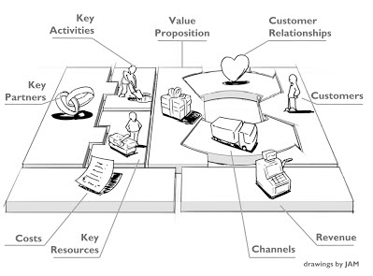Figure 1
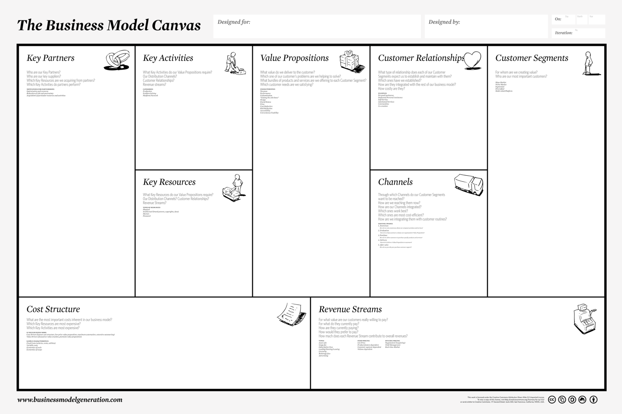
Figure 2

Treacy and Wiersema value disciplines
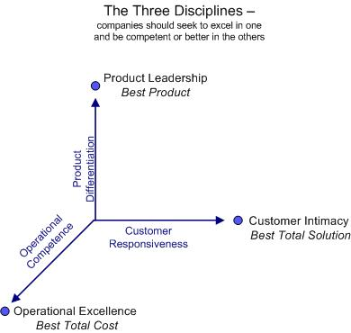
Figure 3

Summary of interviews
The interviews were constructed in a manner where the participants felt more comfortable and at ease with the questioning without diving into an uncertain territory of feeling too personal, therefore for ethical reasons an informal approach was taken for the interviews. The interviews were conducted at the Fitness Facilities of the participants, mainly being Fit For Free and Train More. Furthermore, interviews were also conducted at a powerlifting competition and the campus of Utrecht University of Applied Sciences and the time frame was a 5 to 10 minute interview. The interviews were among fitness enthusiast of different levels of experience in their particular sport, therefore the structure became between 7 specialized fitness disciplines practitioners and 8 general fitness practitioners. The most common responses of the 15 interviews conducted will be presented below with the manner it was approached to receive these questions, therefore a question and answer table will be provided.
Questions | General fitness practitioners | Specialized Fitness disciplines practitioners
Which gym do you frequent? | Train More, Fit for Free, Basic Fit, Olympos | Train More, Fit for Free, crossfit boxes
What disciplines do you practice? | Bodybuilding, general fitness, cardio and zumba | Powerlifting, bodybuilding, crossfit
Are you satisfied with the current gym and why? | A mixed response at this question due to satisfaction was only based on the price paid for the ones practicing general fitness and the convenience of the location of the facility.  Another component was a matter of the locations available in various cities therefore being able to partake in sport activities for the most part in other cities in the Netherlands.  Providing general exercises routines that their fitness facilities played a role due to being an entry point for their routines.  Group lessons offered with regards to zumba, kickboxing and other group class setups also provide a satisfactory feeling. | Firstly, all of the participants at one point went to a commercial gym in Utrecht, mainly Fit for Free and Train More and upon deciding to enter a different discipline that cannot be practiced properly at a commercial, they switched to other gyms, mainly crossfit boxes.  The participants have shown dissatisfaction towards their current fitness facility due to a lack of equipment and weight: there is not enough equipment and weight to facilitate all the members where they had the experience that for one their exercises since they are using more weight the average person, they have to use the majority of the weight plates in the facility thus leaving the rest with very minimal weights.  Unnecessary rules and restriction that hindered their workouts: not being able to drop weights, use of chalk or other accessories that should be available at the gym therefore being approached by staff to not drop weights and hurry up with their exercises because they are using too much weight.  Environment: a stimulating factor in a gym is the music being played and the members around you to stimulate a hardcore lifting experience which is lacking in their experience.  feeling of being a number and lack of assistance: when working with a heavier amount of weight, assistance could be offered by staff in order to secure the lifting in a safe manner, however this does happen and they are treated as if they are a number that should adhere to the rules, therefore feeling as if one is an outcast and impersonal.
Is there something missing from your gym? If so, please explain. | Even for the general purpose that they use the equipment at their current fitness facilities, there was a lack of equipment especially with regards to weight plates, barbells and dumbbells.  Trust was also a missing factor due to a lack of assistance from the staff. The participants did not trust the staff out of a vanity aspect because the staff did not “look” like they know what they are preaching. Therefore, their physique did not aspire trust in the participants that they practice what they preach.  In addition, one specific problem arose from the female perspective which is the problem they face with regards to the male members of their facility. They have expressed that they feel discomfort from going towards the strength training area of the gym because the men keep staring at them and they constantly feel objectified which is an incredibly discomforting feeling. | From the previous question it was evident what was missing which are:  Equipment quality and volume of equipment and weights  Necessity for less rules and restrictions  Qualified staff and openness to approach freely or offering assistance when necessary  Community and group feeling that one can receive at a more specialized facility or other sports such as soccer, basketball etc.
Would it matter if you changed gyms? Please explain. | As instructed from the first question, price and location are the main motivators for this sect of the target audience. Therefore, the participants responded that if the location is still promising with regards to their reachability by public transport and the price is equal to their current facility or lower, they would change, thus suggesting loyalty has not been established to their gym but convenience is of more importance. Furthermore, the location was also more of a factor than the actual price, as long as the travel time is decreased and the equipment in the facility is satisfactory for their purpose, they would not mind paying more, but only to a certain extent. | The participants expressed that the location is convenient for them but traveling extra to go to a gym that does cater to their needs is acceptable if their needs are in fact being met by the various component stated in the previous question that need improvement. Furthermore, price is a factor but if the price to quality ratio is deemed worth the added benefits, they will move.  However, they have also expressed that it would not be much different to move from their current gym to a different gym with the same commercial gym structure since it is basically the same to them.
Would the concept Iron House Co. interest you?  Please explain | These participants have expressed an interesting opinion regarding the concept of Iron House Co. Since they have never been into a “hardcore” gym, they have preconceived ideas regarding these type of facilities which they have gotten through mass media(youtube, television, facebook and other social media platforms). These ideas are that only really large bodybuilding and intimidating type of men are in these facilities in which they will feel uncomfortable. Furthermore, they do not find that it is a necessity for them because their current facility is enough for their fitness purposes. However, some participants expressed that they would try it out and if the company delivers what they promise with regards to equipment quality, community feeling, contract flexibility etc. they will consider a subscription. | The participants expressed that they would be interested if the company holds up their promises to deliver the community, equipment quality and volume, environment, contract flexibility and the extra added value that is expected, they will be interested in this concept becoming reality.
Figure 4

Summary of Focus groups
Three focus groups were conducted of 4-5 people of the target audience as defined in the target audience segment of this research. Unlike the interviews, the focus group particularly focused on fitness enthusiasts that are experienced in their fitness disciplines and more of a beneficial added value towards to the concept that Iron House Co. will be offering since they are more closely related to the issue with the commercial gym setup. The nature of a focus group requires more time therefore the time frame for these focus groups varied but were between 30-45 minutes. The following results will present the findings for these focus groups. The first 2 questions were just to get the general consensus for which gyms are being frequented and what do the participants do there for their fitness purposes.
Which gyms do you currently frequent?
The participants frequent the following gyms: De workout, Fit For Free, Train More, Olympos, Basic-Fit, Unscared Crossfit and Gold’s Gym.
Which fitness disciplines do you practice?
Primarily Bodybuilding, powerlifting, Olympic lifting, functional training and CrossFit
Now that this has been established and the focus group participants are more acquainted with one another, the following questions delved deeper into the exact specifics that are missing and what their current gyms are doing well.
What is specifically missing in your gym with regards to Equipment, staff and service quality and other important factors that in your opinion is essential in a gym?
Equipment:
The participants expressed that there are not enough out these following equipment to suit the entire facility, definitely not during peak hours:
Squat racks, Olympic benches (flat, incline decline), barbells, dumbbells above 40 kilograms, deadlift platforms, enough weight plates, specialty bars, accessories such as: dipping belts, chalk, supporting belts, accessories for resistance training such as chains and speed bands.
Staff and service quality:
The participants expressed a lack of qualified personnel and engagement from the staff. The personnel does not show interest in the members growth with regards to their fitness goals and does not provide assistance, specifically the participants suggested a lack of trust towards the staff members from their facility because they either do not know enough about the fitness discipline they are interested in or cannot provide proper assistance in terms of form checks, assistance during an exercise or a stimulating conversation regarding working out in general. In addition to this, fitness has an vanity aspect towards it with regards to how a person’s physique looks like, therefore there is a visual aspect that the staff must “look” the part and practice what they preach which is not always the case but is a form of recognition and trust in the staff’s knowledge. Regardless, openness and knowledgeable staff is a lacking component that the participants have expressed.
Members of the facility have an effect on each other, specifically in terms it will decrease the image of the facility of the members do various exercises improperly and seasoned members will know when the exercise is not being executed properly. The participants have shown concern for this topic due to the ramifications that it can have on that said members well being by doing a movement improperly for a prolonged period of time. Furthermore it has shown that the staff does not show actual concern over these participants or they themselves do not know that they are executing the exercise improperly which does not boost their confidence in the staff but actually, it does the contrary.
Furthermore, the fitness community has large avenues to connect with another through social media, mainly Facebook, Instagram, forums and other websites dedicated to share information with the community. The fitness facilities they attend do use some of these avenues but for the most part there is more usage of other means to get to this information which they feel is could be improved as an extra service attribute.
Less rules and restrictions:
Contract flexibility: All the participants have shown that the contracts of the facility need improvement. This is of course varying from each facility but the general consensus regarding the contract flexibility is that the these facilities only provide standard contracts of 1 year and in some cases 3 months but there cannot be a personalized contracts due to the magnitude of the facility’s size. In addition, the participants whom are students expressed that if the go abroad for their studies, they must maintain a subscription at their current fitness facility or they must cancel their contracts and start and entirely new 1 year contract upon return, therefore the hassle of cancelling forces them to just leave it as is and keep the contract, which is a nuisance.

Furthermore, free trials are possible but only by online registrations and in some cases needing a staff member and is a one-time possibility only, which usually is a negative point of the gym because friends of the current member would like to exercise with their friend but that is not possible due to these restrictions.
Opening hours:
The opening hours topic rose but that was mostly an issue for the participants whom are already in the workforce, specifically they would want the option to be able to exercise in the morning hours prior to their jobs who usually start between 8 – 9 AM but this is not possible since their facility opens at 7 thus not giving them enough time. Furthermore, all participants have shown that the weekends are an issue due to the later opening hours and earlier closing hours, therefore limiting their schedule.
Environment:
Aspects of the environment that the participants suggested were that the music does not provide a stimulating atmosphere for the facility, the other members lack of know how further reinforces that this facility is not properly equipped for their type of training and the constant staring from the other members when lifting heavy and that the rules hinder the actual work out. Rules such as not being able to drop weight, use of chalk, cannot grunt or yell, cannot wear certain clothes in the facility such as tank tops and hats, going heavy is frowned upon and lack of support from all stakeholders in the facility.
What is your current facility doing properly?
The purpose of this question was to start a discussion in the focus group to see what it is they do find positive from their own current fitness facility but since the focus group only consisted of experienced lifters from different disciplines; this did not provide any useful data. The only data that was useful to answer this question and form a general consensus from the focus group was that they also find that the price to quality ratio of the facility is good because a low price also delivers less quality therefore, they found they are receiving what they are paying for and that the locations they offer are also a benefactor.

Did you know that your current fitness facility, if it is train more of Fit For Free have loyalty programs? Please explain.
Surprisingly, the participants that attended train more knew about the reward program because it is one the main points of advertising that their fitness facility executes. However, participants that attended Fit For Free did not know about the loyalty program that they offer because it is not heavily advertised and were not in agreement that this actually promotes consumer loyalty. One must note that this could also be because there is a bias towards FFF due to the dissatisfaction they have with their facility.

Questionnaires
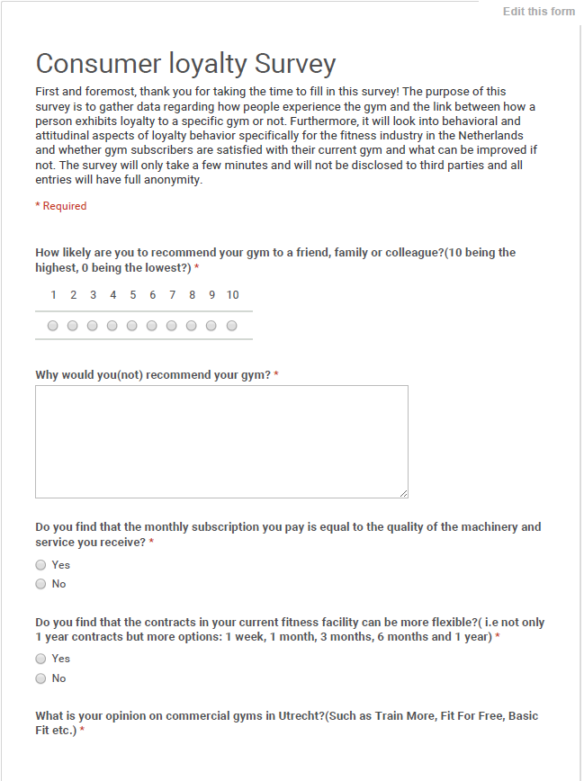
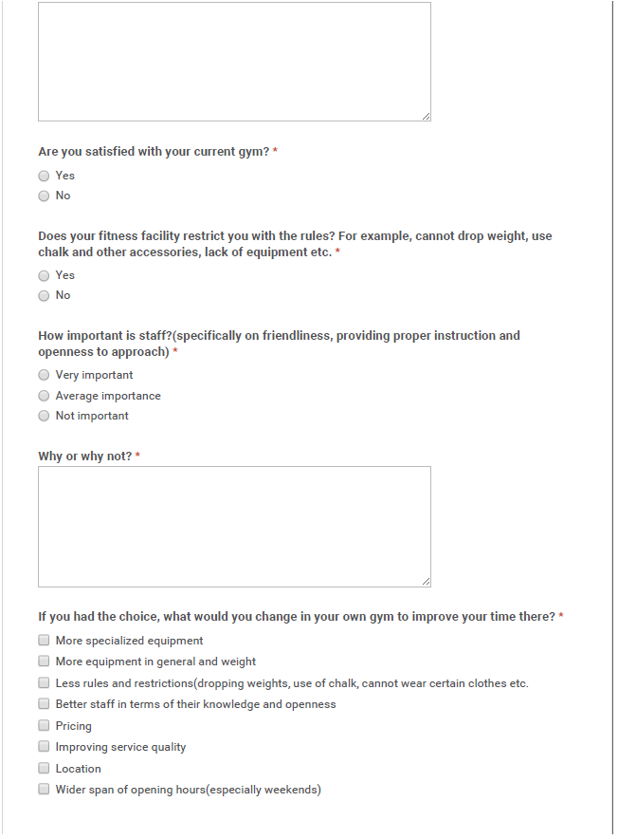
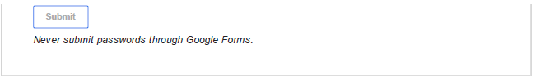
Figure 5

Figures from questionnaire
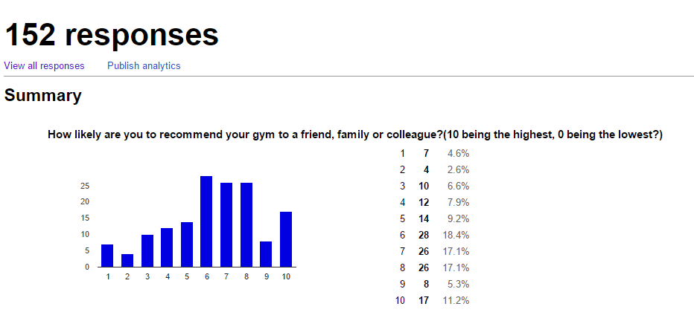
Figure 6
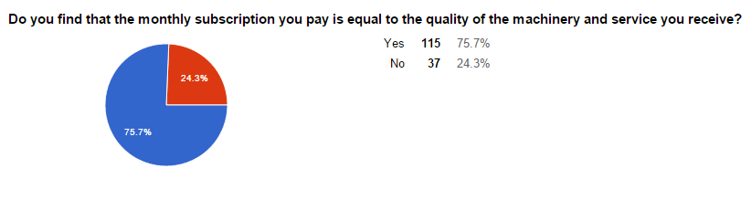Figure 7
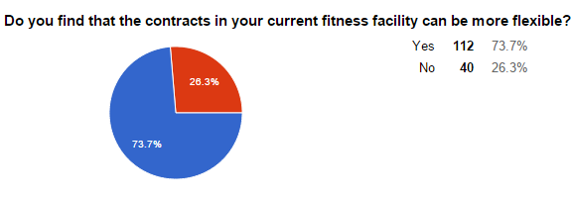
Figure 8
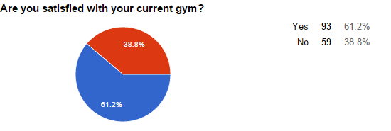Figure 9
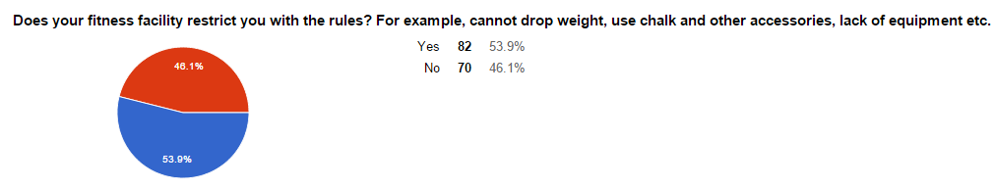Figure 10
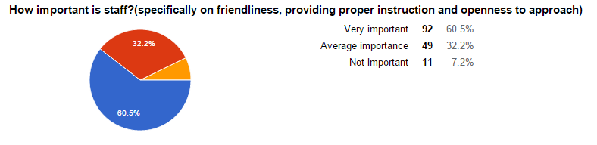Figure 11
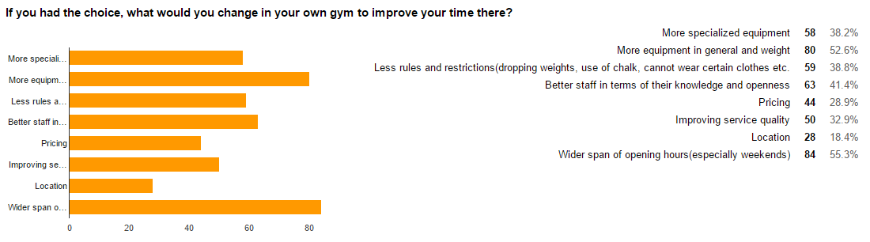Figure 12

Net Promoter Score
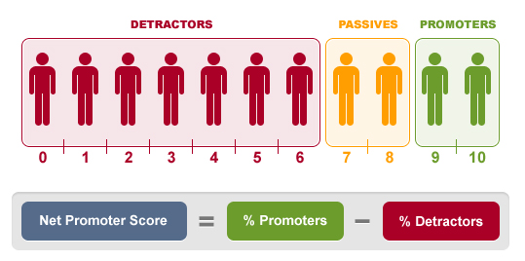
Figure 13

Summary of Consumer loyalty program and tools used by competitors
Fitness facility | Consumer loyalty program or tools used
Fit For Free | - Ledendeals loyalty program: Subscribers receive discounts on assortment of products and services, Travel, fitness accessories and electronics  - “win-promotions” through the FFF application
Basic Fit | - No loyalty program, makes use of promotional tools such as lowest prices and contract flexibility  - Loyalty through multiple use of the membership card by family members
Train More | - Reward system: “train more and pay less” incentive based program where subscribers pay less the more they frequent the facility
Sport City | - Ledendeals loyalty program: Subscribers receive discounts on assortment of products and services, Travel, fitness accessories and electronics
Fit All Day | - A reward system similar to LedenDeals, subscribers receive discounts in various product and service categories.
Figure 14

