SOCIAL MEDIA AND SMALL CLOTHING E-TAIL

BY

Veselina Nedelcheva
1586685

GRADUATION ASSIGNMENT SUBMITTED IN PARTIAL FULFILLMENT OF THE
REQUIREMENTS FOR THE DEGREE OF BACHELOR OF COMMUNICATIONSYSTEMS OF
THE INSTITUTE OF COMMUNICATION AT THE UTRECHT UNIVERSITY OF APPLIED
SCIENCES

UTRECHT, 10 June 2014

Author: Veselina Nedelcheva
Student Number: 1586685
University: Hogeschool Utrecht – Faculty of Communication and Journalism
Program: International Communication and Media, Utrecht
Supervisor: Ivonne Louw-Dekker

"Over the years I have learned that
what is important in a dress is
the woman who is wearing it"

~ Yves Saint Laurent ~

Management Summary
More and more fashion brands are seeing Social Media as a marketing tool. One of the biggest benefits is creating a relationship with the customers. However, small online clothing e-tailers do not or ineffectively use Social Media.
The main purpose of this report was to uncover what type of content creates engagement and helps to build a relationship with (potential) customers. The resulting advice presents a posting strategy, with specific types of content as well as best-suited social networks. This was achieved through a literature review and the examination of the research data through the resulting theoretical framework. Uses and Gratifications theory and Social Exchange theory were used to analyse the attitudes of respondents as well as characteristics of the most engaging content.
A mixed method of Quantitative and Qualitative research was used. The research was carried out in two phases. The first was an observation of two competitors, successful on social media. For the observation, HM and Fashionfruits NL were chosen. The two clothing brands' Social Media postings were observed for a period of one week across two channels. The two channels were chosen Facebook and Instagram, based on relevancy for the apparel industry.
The second phase was a customer survey. The survey was distributed online and the target group, Dutch women 20-30 years of age, were encouraged to participate. The goal of the survey was to explore the findings of the observation but also to uncover women's feelings and opinions on specific types of content.
It was uncovered that the best social media channel, used both by brands and by customers, is Facebook. The second channel of importance to clients is Instagram. Furthermore, best days and times to post were identified. In addition, women from the target group generally do not spend a lot of time on clothing brands' pages. That is why it is important to have a strategy when and what to post in order to achieve maximum results among the target group. Main affective reasons to visit a clothing brand's page were for distraction, for fun or to look for new pieces. The most favoured content were product images, either location- or studio-shot. Regardless of the type of content chosen to be posted, it must always be new (non-repetitive, unless it is a promotion), useful and interesting.

Table of Contents
Chapter 1: Introduction 1
1.1. Introduction and Background 1
1.1.1. Trends in fashion clothing e-tail 2
1.1.2. Background of fashion e-tail in the Netherlands 3
1.2. Problems of small clothing e-tailers 4
1.2.1. Justification of the problem 5
1.2.2. Problem formulation 6
1.3.Operationalization 6
1.3.1. Content Marketing vs. Social Media Marketing 6
1.3.2. Social Media Content 7
1.3.3. Small clothing e-tailers 7
1.3.4. Social Media Engagement metrics 7
1.3.4.1. Conversation Rate 8
1.3.4.2. Applause rate 8
1.3.5. Categories Content 8
1.3.5.1. Customer- centric content 8
1.3.5.2. Product-centric content 9
1.3.6. Type of images 9
1.3.6.1. Product studio-shot images 9
1.3.6.2. Product location-shot images 9
1.3.6.3. Mood images 9
1.4. Restrictions and limitations of the research 10
1.4.1. Restrictions of the research 10
1.4.2. Limitations of the research 10
1.5. Structure of the report 11
Chapter 2: Theoretical framework 12
2.1. Introduction 12
2.2. Uses and Gratifications Theory 12
2.3. Social Exchange Theory 14
2.4. The Stimulus-Organism-Reaction model and Online Consumer Engagement 15
2.5. Proposed Conceptual Model 17
Chapter 3: Methodology 19
3.1. Introduction 19
3.2. Research Purpose 19
3.2.1. Exploratory Study 19
3.2.2. Descriptive Study 20
3.3. Research Design 20
3.3.1. Quantitative vs. Qualitative Research 20
3.3.2. Research Instruments and Population Samples 21
3.3.2.1. Research Instruments 21
3.3.2.2. Population Sampling 22
3.4. Data Analysis 24
3.4.1. Observation 24
3.4.2. Survey 25
3.5. Conclusion 25
Chapter 4: Results and Analysis- Observation 26
4.1. Introduction 26
4.2. Stylefruits NL and HM- general observation 26
4.3. Posting strategy 27
4.3.1. General Conversation rate 28
4.3.1.1. Facebook 28
4.3.2.2. Instagram 29
4.3.2. General Applause rate 29
4.3.2.1. Facebook 29
4.3.2.2. Instagram 30
4.4. Type and category of content 31
4.4.1. Stylefruits NL- Type of content 31
4.4.1.1. Customer- centric content 31
4.4.1.2. Product- centric content 32
4.4.2. HM- Type of content 34
4.4.2.1. Customer- centric content 34
4.4.2.2. Product- centric content 35
4.5. Consumer observations 36
4.6. Conclusion 38
Chapter 5: Results and Analysis- Survey 39
5.1. Introduction 39
5.2. Best channel 39
5.3. Present behaviour 40
5.4. Observation-specific 43
5.5. Attitudes of target group 46
5.6. Most interesting content 48
5.6.1. Desired content 48
5.6.2. Favourite content 48
5.6.3. Responses to interesting content 49
5.7. Other 50
5.8. Conclusion 52
Chapter 6: Recommendations, discussions and conclusions 53
6.1. Introduction 53
6.2. General posting strategy 53
6.2.1. Network of choice 53
6.2.2. Time to post 54
6.2.3 General post design 55
6.2.4. Reasons to visit a clothing brand's page 56
6.3. Categories of content 57
6.3.1. Consumer-centric content 57
6.3.2. Product-centric content 58
6.3.3. Recommendations 58
6.4. Specific types of content 59
6.4.1. Product-centric content- images 59
6.4.1.1. Product location-shot images 59
6.4.1.2. Product studio-shot images 60
6.4.1.3. Mood images 61
6.4.2. Consumer-centric 61
6.4.2.1. Contests 61
6.4.2.2. Include the followers- relationship building 62
6.4.3. Other important content 63
6.4.4. Conclusion 63
6.5. Opportunities for further research 64
Bibliography 66
Appendix 1: Observation results 71
1.1. General results 71
1.2. Stylefruits NL- specific metrics 73
1.3. HM- specific metrics 74
Appendix 2: Questionnaire 78
Appendix 3: Questionnaire results 83
Appendix 3.1. Frequency tables and graphs 83
Appendix 3.2. Relationship tables 105
Appendix 4: Image examples 111

List of Figures and Tables

Figure | Title | Page
Figure 1 | The Mehrabian-Russel Model (1974) | 15
Figure 2 | Proposed Conceptual Model | 18
Figure 3 | Comparison of similar Facebook posts | 35

Chapter 1: Introduction

Chapter 1: Introduction

1.1. Introduction and Background
Social Media is a relatively new marketing tool, but more and more brands are starting to see its benefits when it comes to engaging their audiences and creating a relationship with them. The main benefits that companies see from Social Media Marketing include more business exposure, lead generation, easy gathering of market intelligence and marketing expenses reduction. (Dyer, 2013)
A crucial aspect of customer engagement through these channels is content. (Hutchinson, 2014) Content is the heart of Social Media as it is the driver of all interactions. Content is the aspect that serves as an engagement basis with any audience. (Cohen, 2012). Multiple researches and sources show how it can be used to create brand advocates, generate leads and sales, provide better customer service and manage a brand's image and reputation (Myers, 2013). Some examples of lead generation are the creation of interesting posts with links to a landing page on your website. This is often used in fashion e-tail where the brand posts a clothing piece and provides a link in the description, leading to the page where you can actually purchase it. Another example from clothing e-tail is providing better customer service. Brands do this by posting answers to frequently asked questions, for example. They present the answer in an attractive post, aimed at drawing attention, being fun and informative at the same time. For example, HM often posts information about their sustainability, which has a dual purpose, to inform and address any question clients have and to boost the image of the brand.
The primary goal of every company, but most specifically of clothing retailers is to build a rapport and a relationship with their audience. Social Media allows fashion retailers to do that in the easiest and most cost effective way than any other media. Also, it is effective in getting feedback from their audience and potential consumers, further involving them in the brand building process.
Social Media has a great influence on people's behaviour and buying choices. This is especially true to when it comes to clothing purchases. There are many Facebook, Pinterest, Twitter and blog pages dedicated to fashion trends and styling tips that have a great following and influence. In fact, women most often turn to blogs and message boards (such as Pinterest) for inspiration or purchase advice. (Edison Research, 2013). They provide interesting and useful content to their audience and encourage their participation and even ask for their opinion. Although they are not a retailer, they influence the buying decisions of customers in way that many brands strive for.

1.1.1. Trends in fashion clothing e-tail
A very important trend has been emerging in the past years among clothing retailers- e-commerce. Many new clothing shops are being created solely online and every big fashion brand has a web shop. Many of the new start-ups make use of social networks to promote their products by building a community, integrating Social Media in the online shopping experience to allow comments, voting and discussions among consumers, their friends and the brand.
Furthermore, clothing sales online in Europe have been growing in the past years. Fashion and clothing are now on the top of best sold goods online. In 2012, clothing were best sold items in countries like Germany, Denmark , Norway and Austria, among others. Predictions for the future of e-commerce say that by 2016, at least 7% of Europe's GDP will come from the Internet economy. (Ecommerce Europe, 2013).
Another trend that shows the power of social networks is "buying a blogger's closet'. The start was in 2010 and it has grown to a legitimate e-tail business. At present, this trend has evolved to more of blog, turned e-tail shop that has a strong Social Media orientation. Chictopia is the best example. The site allows fashion lovers to create their own mini fashion blog, and even sell on it.

1.1.2. Background of fashion e-tail in the Netherlands
The history of online clothing retail is not a long one, but it has seen a considerable growth in the Netherlands between 2005 (1.9 % of income compared to previous year) and 2007 (6.5% of income compared to previous year). With the beginning of the financial crisis, income fell down to -4.3% of income compared to previous year. Since then it has slowly been gaining back its momentum and in 2012, 80% of 12.3 million internet users have made an online purchase (7.1 million being frequent e-shoppers) (CBS Nederland, 2013). The statistics show that the most bought product is in the category 'clothing and sport gear', where women shop most often (63-64 % of all online frequent e-shoppers). In 2013 14% (the most sold segment online) was clothing (worth € 395million). This shows that the sector is stably growing. (Steinz, 2013)
A 2013 research Globalwebindex shows that 63% (6 million) people in the Netherlands are online buyers and 72% of internet users have published online about a purchase in the past month. Globally, 53% percent have bought clothes online in Q2 of 2012; this is the second most bought category after books. In the Netherlands, however, clothing was the most bought category online (21% of online purchases).
Furthermore, in 2013 35% (8.1 million) of participants from the Benelux "have bought online from abroad at some time" (PostNord, 2014). The 2014 report shows that clothing and footwear are the best selling category in Europe as well, 6.5 million people (38 %) in the Benelux bought clothing/footwear goods in 2013. 46% of respondents in the Benelux said that it is important to have the lowest price possible when they are buying online. Respectively, 9 million of all participants have bought something online from the Netherlands in 2013, the biggest part (5.3% or 3.8 million) of buyers being from Germany, followed by the UK (3.3% or 1.7 million). (PostNord, 2014).
When it comes to services, associated with buying clothing online, 44% of Benelux consider fast delivery time (maximum 3 days) very important. The majority of these consumers 62% expect the delivery to come within 3-5 days, 18%- in 1-2 days.
The fashion e-tail in the Netherlands, according to Blauw Research, was €555 million in 2010 and marked a 16% growth in 2011. The research also gives the total worth of all e-commerce- 8.2 billion euro. This makes fashion e-tail responsible for 6.8% of all e-commerce in the Netherlands. (ING Economisch Bureau, 2011). In 2012, the Fashion e-commerce was estimated at €630 Million and 51% of online shoppers were women. (MakesYouLocal, 2013)
A 2012 study, conducted in the Netherlands by Ponders showed that 33.3% of small business owners saw no need for their using Social Media, 11.7% said they had no knowledge and 10.5% said they never thought about it. (Pondres, 2012). This lack of understanding and knowledge leads to many missed chances for them to grow their business. Pondres did another research in 2013 and found that 45% of the small companies consider Social Media very important, 38% started using Social Media less than a year ago and 34% do not see any use of Social Media. Although small businesses are getting on board more and more, they still lack the experience and expertise in Social Media Marketing- 44% of employees interviewed said that the small company they work for has average level of expertise. (Pondres, 2013).

1.2. Problems of small clothing e-tailers
An important marketing problem of small online clothing businesses is low budgets and lack of expertise that force them to prioritise their expenses. They do not use the free tools they have access to at all or they use it ineffectively, Social Media in particular. Therefore, there are many missed chances to engage their customers. By missing these chances, the businesses are failing to create and sustain clients and, thus, to generate income.
The core problem is that many do not realize how effective Social Media can be in obtaining basic goals such as customer engagement and increasing profits. Small fashion e-tailers can benefit the most of well-balanced Social Media content. First, it is important to achieve a balance between content that is there to purely help or entertain and content that advertises. Second, it is important to post various, non-repetitive types of content, which spans between several categories (Promotions, Interesting information, News, New products, Fun and entertainment, Tips, About the company, Meet the personnel etc.).

1.2.1. Justification of the problem
Many small clothing businesses use Social Media content without great success due to lack of focused message and clearly set Social Media goals and strategies. Furthermore, they make a string of mistakes such as infrequent posts, repetitive and uninteresting content. (Sethlui, 2014) . Many small clothing companies post only once or twice a week on Social Media, sometimes even less. Often the content is limited to two-three categories, which are mostly aimed at selling products rather than engaging on a personal level, one-way communication in place of interaction. Therefore, the content becomes too receptive, very similar and clients lose interest in the brand. One such small clothing e-tailer is Drezzstore.com. They post content every 3-4 days, sometimes with gaps of over two weeks with no posts at all. Their content is mainly orientated in selling, rather than engaging with the clients they have. Most of their posts are images of new items they have, supported by no more text than "new' or "Just in".
In addition, small clothing e-tailers often resort to having only a Facebook and maybe a Twitter account. While these considered must-have platforms, interested customers might be better reached on other platforms as well. (Sethlui, 2014). Netbase's 2013 report on channels of influence for apparel showed that blogs/messages boards, Pinterest and Instagram are channels to be considered along with Facebook. Twitter was shown as ineffective, unless the brand has celebrity advocates. (Edison Research, 2013).
In addition, due to limited funds, small clothing e-tail cannot afford to have competent Social Media Marketers staff or specific strategy drawn, but by learning the basics of Social Media content creation and management, they can easily achieve good results by themselves.

1.2.2. Problem formulation
After presenting and justifying the problem that is the focus of this research, the following Policy question was formulated:
How can small clothing e-tailers in the Netherlands use Social Media content to engage and build a relationship with women aged 20-30?
This Policy question is supported by a Research question:
What type of Social Media content can increase customer engagement between small clothing e-tailers and women aged 20-30?
Sub- questions were finally formulated in order to give a deeper and more detailed answer of the Research question.
Sub questions:
- Which Social Media channels do clothing brands use to communicate with customers?
- What can small clothing e-trailers learn from clothing brands, successful on Social Media, in terms of engagement through content?
- What Social Media content, posted by clothing brands, do customers find most interesting?

1.3.Operationalization
The following boundaries and clarifications of terms used were established. This aims to make the research feasible, but also establish clear concepts for the reader.

1.3.1. Content Marketing vs. Social Media Marketing
While the two terms are very similar, it is important for this research to clarify the key differences. Content marketing involves Social Media, but its focus is a brand's website. It uses Social Media content as "a distributor of links back to the content on the brand’s website — not as containers of the content itself" (Content Marketing Institute, 2014). Exactly here lays the key difference, Social Media Marketing utilizes and places content WITHIN the network itself.
We will explore Content (the focus of this research) through the prism of Social Media Marketing and all strategies developed and researched as well.

1.3.2. Social Media Content
In order to define Social Media Content we first must define content itself. For the purpose of this research, one definition has been chosen as appropriate: "Information made available by a website or other electronic medium" (Oxford Dictionary, 2014). From here, Social Media is defined: "forms of electronic communication (as Web sites for social networking and micro blogging) through which users create online communities to share information, ideas, personal messages, and other content (as videos)" (Merriam Webster, 2014). Therefore, Social Media Content is defined by the combined meaning the two separate terms.
It is important to make a distinction between Content Marketing and Social Media. Content marketing is defined as:"content marketing is the art of communicating with your customers and prospects without selling. It is non-interruption marketing." (Content Marketing Institute, 2014).

1.3.3. Small clothing e-tailers
Small clothing e-tailers in this context mean companies who employ less than 10 people and operate at least on-line (physical stores not applicable).

1.3.4. Social Media Engagement metrics
These are metrics that focus specifically on the effect the posted content has on the target audience. For the purpose of this research Conversation rate and Applause rate metrics were sued and the formulas these metrics use are explained below, in each corresponding section.

1.3.4.1. Conversation Rate
This metric measures whether the message (content) a brand is publishing on Social Media networks 'connects' with the audience intended. In essence, it is a way of measuring the engagement the content creates with the target group.
Conversation rate: # of replies or comments/total # of tweets or posts
This formula is applicable to any Social Media channel as well as able to work for measuring a single post when adjusted:
Example: Facebook: #of comments per post/total # of posts (Radojevic, 2013)

1.3.4.2. Applause rate
This metric was designed to discover what type of content does the audience of a brand like the most. It is used to gain a deeper understanding of the type of content is attractive to an audience. When it is coupled with the Conversation Rate metric it gives a better view on how engaging that content is as well.
Applause rate overall: # of favourites or likes/total # of tweets or posts
This formula is applicable to any Social Media channel as well as able to work for measuring a single post when adjusted:
Example: Facebook: # of likes per post/total # of posts

1.3.5. Categories Content

1.3.5.1. Customer- centric content
Customer- centric content typically provides some type of value for the customer that leads to a sale, rather than directly selling to the customer as this puts them off. (Collier, 2012). An example of customer-centric content includes an image of the product in use (in a situation) or contests.

1.3.5.2. Product-centric content
Product-centric content typically revolves around showing the product itself. It is more related to selling, while being not so obvious about it. This type of content is predominantly visual in nature.

1.3.6. Type of images
In the questionnaire, respondents are asked to evaluate their feelings towards three different types of images- product studio-shot images, product location- shot images and mood images. Examples of all three types and variations could be seen in Appendix 4.

1.3.6.1. Product studio-shot images
These are photographs of clothing items, which are typically shot individually on a white background. A studio-shot image can also show a model, wearing the clothing items, but the photograph is shot in a studio, typically in front of a white background. This type of shot focuses on the items itself and provides no context to its use in a situation.

1.3.6.2. Product location-shot images
These are typically photographs of models, wearing the clothing items, but the image is taken on a specific location, that provides a context to the use of the product. The focus, however, is still on the item. For example, a model could be in an office to show work clothing or on the beach for summer clothing etc.
This type of image could also be of individual items (not worn by models), but instead of being shot on a plain background, the items are accessorised so that their context of use is clear. The items could also be shot with a location as a backdrop.

1.3.6.3. Mood images
This type of image is similar to the location-shot photographs, but the focus is not so much on the specific items as on the context they are presented in. Editorial photographs are an example for this type of image. The goal is to emphasise the affective attributes and feelings the items may provide the consumer.

1.4. Restrictions and limitations of the research
The following restrictions and limitations to the research were identified.

1.4.1. Restrictions of the research
The main restriction of this study is the sample size of questionnaire respondents. Due to the limited amount of research time and the specific target group, it has been difficult to achieve a large amount of survey responses. As these have been analysed with the use of statistics, it is required to have "a larger sample size to ensure a representative distribution of the population" (University of Southern California, 2014). Because of the time limitation, a bigger margin of error (±10%) was established, then the initially desired ±5%.
Another restriction to the research is the measure used for data collection. After the data was collected and analysed, it became apparent that there could have been other questions asked that could clarify and explore certain aspects of the topic. These aspects, like the specific importance of imagery, were not identified to be as significant as the respondents stated they were. This however, provides topics for further research.

1.4.2. Limitations of the research
The researched companies are limited to one Local and one International one. This ensures a more in depth look into their Social Media content usage rather than taking a big sample and performing a more general analysis. The goal is to procure detailed results on engagement creation through the usage of specific content. This will then serve in the creation if the Advice. Therefore, by looking at a smaller sample the advice can be made more detailed.
Another limitation was put in place in order to achieve more detailed results is the type of engagement that customers have with the content. This research will look at the three most common types of engagement- Like, Comment and Share. This will benefit the intended audience (small e-tailers) by providing an advice based on the basic interaction, rather than something that might be too specific and of no use for a small, inexperienced company.

1.5. Structure of the report
This paper starts by introduction of the topic and current trends in the field of fashion e-tail, followed by background information in the Netherlands. Further, the problem and justification is presented together with explanation of the key concepts. Following, the restriction of the research are presented.
In chapter 2, the Theoretical framework is presented. It encompasses the theories and models used in this research. Following is the Methodology and research methods used. In chapter 4 and 5, the results from the research are presented. This includes, not only findings from analysis and questionnaire but also conclusions drawn based on these findings.
Finally, in chapter 6, the Advice is given. This is followed by a list of sources used. This paper finishes with an Appendix where related tables and graphs, as well as examples of the findings can be seen

Chapter 2: Theoretical Framework

Chapter 2: Theoretical framework

2.1. Introduction
In Chapter 1 an introduction to the topic was presented, the problem statement was described and justified. In this chapter several theoretical perspectives and models, which have bearing on this study, are discussed as follows. The chapter begins with the Uses and Gratifications theory, followed by Social Exchange theory and Stimulus-Organism-Reaction model. The theories, which will be discussed and applied to this study, are presented below.

2.2. Uses and Gratifications Theory
The Uses and Gratifications theory has been widely applied to the use of social media by consumers. Close (2012) used this theory to look at online consumer behaviour on Social Networks, advertising and e-tail. The theory was used to aid in the pinpointing of specific themes and patterns, which emerge in relation to online consumer behaviour and identity development in the context of Social Media, Advertising and e-tail. One of the findings concerns brand visibility on social media and how it does not rely on brand value, but rather on how social the brand is.
Orchard, Fullwood, Morris and Galbraith's 2014 paper uses this theory to explore users' Facebook experiences. Other authors, who have applied the theory to different aspects of new media and the Internet are Webster and Lin, 2002; Perse and Dunn, 1998; Livingstone, 2002.
The Uses and Gratification Concept was first formulated by Katz, Blumler and Gurevitch in 1974. They used previous researches to stipulate that users seek gratifications from media exposure and content and the social context that these are experienced in. The assumption is that "audiences actively seek out media to fulfil their individual needs and goals." and these are actually seen as usage motivations. (Orchard, Fullwood, Morris, & Galbraith, 2014). These goals may be seeking information, entertainment, and companionship- generally psychological or social needs, which are described as emotional or cognitive. (Leung, 2013). McGuire, 1974 suggested a more psychological version of the theory and applied it to human needs. He distinguished between cognitive and affective needs. This led to 16 types of different needs across four main categories of motivations, applicable to media usage. The four categories are Cognitive Preservation motives, Cognitive Growth methods, Affective Preservation Motives and Affective Growth motives.
McQuail (2010) establishes a central question of the Users and Gratifications Theory: Why and for what are people using media? The functionalist sociology (Write, 1974 in (McQuail, 2010) view of media as catering to needs led to the presupposition that people use media for relaxation, personal guidance and information among others. (McQuail, 2010). However, this approach has been criticized for being too behaviourist- grouping gratifications into categories, but ignoring the frequency distribution and ignoring the psychological and societal origins of the needs (Ruggiero, 2000). McQuail points out that it is best applied to specific type of content rather than to a general media use as it fails to predict successfully media use and choice. It does, however, successfully apply to new media, the Internet specifically.
Leung, 2009 explored motivations that connect specifically to user-generated content. A wide array of motivations were derived from this and previous studies on gratifications from computer-mediated technologies. Some include conversation, entertainment, socializing and information exchange. (Leung, 2013).
For the purpose of this research, the following 'needs' (as mentioned in McQuail, 2010) will be used in the analysis of content from the perspective of the audience.
- "Personal guidance" is a personal integrative need that is characterised by people using media in order to gain credibility and assurance that they have a status in society. It is aimed at social acceptance and integration.
- "Relaxation and diversion" are two needs that are typically characterized by the usage of media for escapism, to relieve tension, relax, to forget problems and duties.
- "Information" is a cognitive need where the reason for people use to media is to acquire information, new knowledge and stay up-to-date with current events.

2.3. Social Exchange Theory
George Homans first introduced the Social Exchange Theory in 1958 when he proposed that social exchange is a tangible or intangible activity, which is somewhat rewarding or costly, between at least two individuals. His work stresses on the individual's behaviour towards others when in interaction. Homan's came up with propositions, below stated by Emerson (1976), regarding Social Exchange:
1. The Success proposition states that when a person performs an action that is subsequently rewarded, they are more likely to repeat this action again. The more often the action is rewarded, the more likely repetition will follow.
2. The Stimulus Proposition formulates the idea that when a particular stimulus or stimuli have been rewarded often in the past, the more prone a person is to respond to similar stimuli in a similar fashion in the present.
3. The Deprivation–satiation proposition states that the more often a reward is received the less valuable the same reward becomes when given in the future.
The theory has been used to analyze customer interactions in a branding context as well as been linked to theories exploring social status, influence, interactions on social networks, affect and emotion. (Cook & Rice, 2012). The study explores the relationships between the two as well as explains how Social Exchange theory influences social status. It also defines the links with recent developments in economic sociology and social networks.
Social Exchange theory will be used to analyse the type of content and the relation it has to the Response part of the proposed Conceptual Framework. Two of the tree propositions will be used in order to determine a relationship between a specific type of content, published on clothing brands Social Network pages and the response from consumers. The two are The Stimulus Proposition and The Deprivation Proposition.

2.4. The Stimulus-Organism-Reaction model and Online Consumer Engagement
An important aspect of this research is the engagement with consumers online. There has been some adaptation and further examination done on existing research in order to accommodate the changed environment (from offline to online).
The Stimulus-Organism-Reaction model (SOR model) shows how specific characteristic of the environment (Stimulus) can trigger an emotional response (Organism) that then provokes certain behaviour/s (Response).
Wilson and Mollen (2010) use the internal portion of the SOR model to propose a conceptual framework that is dynamic and tiered (interactivity, telepresence and engagement for the 'Organism' (Pleasure and Arousal) dimension of the model). The authors propose that engagement is both "cognitive and affective commitment to an active relationship with the brand" (Wilson & Mollen, 2010). This adds an emotional dimension to engagement with a brand. The consumer does not only have to have a rational motivation to communicate, but also has to have deeper, visceral, feelings in order to engage with a brand.
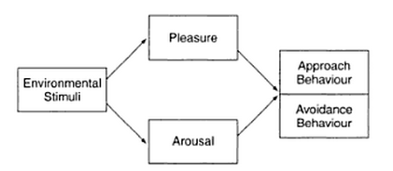
Figure 1. The Mehrabian-Russel Model (1974) Invalid source specified.

Furthermore, Mollen and Wilson determine three main reoccurring themes when talking about engagement. The first proposes that "engagement is a mental state that is accompanied by active and sustained, even complex, cognitive processing" (Wilson & Mollen, 2010) , discussed most recently by Marci, 2006. The second reoccurring theme stipulates that engagement is related to the gratification of usefulness and relevance (most recently discussed by Rappaport, 2007). The third one says that engagement involves emotional bonding, likeness or impact as well as pleasure and satisfaction (discussed by (Rappaport, 2007) and (Mathwick & Rigdon, 2004)). The authors go on to propose a definition of online engagement:
"Online engagement is a cognitive and affective commitment to an active relationship with the brand as personified by the website or other computer-mediated entities designed to communicate brand value. It is characterized by the dimensions of dynamic and sustained cognitive processing and the satisfying instrumental value (utility and relevance) and experiential value (emotional congruence with the narrative schema encountered in computer-mediated entities)." (Wilson & Mollen, 2010), p. 923.
In essence, engagement is more than a rational decision, taken by the customer. It has an affective dimension as well. Engagement is the commitment that a user has towards, in the case of this study, content. It is characterised by the way a person processes content and the experiential value that a brand's content carry. As brands "strive...., to generate dynamic, pleasurable state in consumers" (Wilson & Mollen, 2010) conformity is an important part of engagement. Furthermore, engagement is a separate construct from involvement, due to its instrumental and experiential values.
Babin et al. applied the SOR model to advertising in 1998 applying the theory of emotions to their exploration into consumer emotions, more specifically, Negative emotions and market research. They built their research based on the Pleasure and Arousal dimensions of Mehrabian ans Russel's model. (Babin, Darden, & Babin, 1998). Pavlechak, Antil, and Munch in 1988 and Olney et al. did other similar significant studies in 1991.
The SOR model has been used in consumer behaviour context as well.

2.5. Proposed Conceptual Model
An adaptation to the S-O-R model (Stimulus- Organism-Reaction) is proposed. The adaptation is based on the iterated version of this model, proposed by Mollen and Wilson (2010) as describe above. The Organism part is defined as "Customer reaction" for the purpose of this research defined by the term 'Telepresence':
"Telepresence is deﬁned as the psychological state of ‘being there’ in a computer-mediated environment, augmented by focused attention. It is characterized by cognitive and sensory arousal, control, and immersion (deﬁned as perceiving oneself to be steeped in and interacting with an environment that sustains a continuous stream of stimuli and experiences)." (Wilson & Mollen, 2010)p. 921
The term and its definition are applied to the context of 'Content' (communicated material) rather than a website or a computer-mediated linkage. The manner in which this term is defined, it relates closely to another term, 'Enjoyment', due its affective, emotional dimension. For the purpose of this research the term is understood to carry the meaning given to it by Monsuwe, Dellaert and de Ruyter in their literature review on the subject of consumer driven online shopping, published in the international Journal of Service Industry Management. (Monsuwe´, Dellaert, & de Ruyter, 2004). There they focus on three dimensions of 'Enjoyment' in the context of shopping online- Escapism, Pleasure and Arousal. Furthermore, these two terms relate to the Use and Gratifications theory, presented in the beginning of this chapter.
"“Escapism” is reﬂected in the enjoyment that comes from engaging in activities that are absorbing, to the point of offering an escape from the demands of the day-to-day world. “Pleasure” is the degree to which a person feels good, joyful, happy, or satisﬁed in online shopping, whereas “arousal” is the degree to which a person feels stimulated, active or alert during the online shopping experience" (Monsuwe´, Dellaert, & de Ruyter, 2004)p. 109.

The final part of the model, Response, is related to Mollen and Wilson's third aspect of the Organism section of the S-O-R model- Engagement. It aims to show the type of desired engagement with the Social network page content.
Figure 2. Proposed Conceptual Model

Chapter 3: Methodology

Chapter 3: Methodology

3.1. Introduction
In the previous chapter several theoretical perspectives and models, which have bearing on this study, were discussed as follows. In this chapter, the research purpose, design and methodology of the study will be presented.

3.2. Research Purpose
In order to carry out a valuable research we need to define a direction. A research purpose provides a basic outline for the direction. The purpose of this research has been exploratory and descriptive. Saunders et al, 2009 recognizes one more research purpose category.

3.2.1. Exploratory Study
As stated above, this research follows a mix of two research approaches; one being exploratory. The reasons for doing an exploratory study are presented in the next paragraph.
An exploratory study typically aims at finding new/insights or clarification into a research question. It is an essential part of any study as it shows whether there is need for further research or if the topic is viable and researchable. This type of research is very suitable when the researcher is unfamiliar with the subject of their study as well as helps them obtain a narrower focus. It is also suitable for gaining understanding into previously unexplored subjects. This makes it useful for the identification of specific patterns and trends. (Mark Saunders, 2009).

3.2.2. Descriptive Study
As stated above, this research follows a mix of two research approaches; one being descriptive. The reasons for doing a descriptive study are presented in the next paragraph.
Descriptive studies are used to provide an accurate image of the researched subject (situation, event or person). It is used as means of describing these situation and events. Doing a descriptive research on its own, however, fails to provide any insights into the subject matter. That is why it is used as an extension to an exploratory or explanatory research in order to have a clear understanding of the subject of the study before proceeding to the actual data collection. (Mark Saunders, 2009).

3.3. Research Design

3.3.1. Quantitative vs. Qualitative Research
In this study, a mixed approach is followed. Below is a discussion on the reasons for choosing a mixed research method.
In order to understand properly the positives and negatives of the two approaches we need to look firstly into their purpose and then into the outcome they provide. This comparison will provide an insight into the methods these approaches utilise for data collection and analysis. It will also provide the foundation for the research instrument choice.
Quantitative research is based around collecting numerical data and analysing it via statistics. This provides some limitations as not all data can be quantified by the use of research instruments. However, quantitative research has long been deemed less subjective than qualitative data collection. The data collected is usually less biased in the way it is collected and analysed. Furthermore, this data collection method is useful when cause and effect needs to be measured. (Muijs, 2011).
On the other hand, quantitative research is more rigid in its data collection style. Its goal is to "confirm hypotheses about phenomena" (Mack, Woodsong, Macqueen, Guest, & Namey, 2005). This means that the research must have a supposition about the outcome and the quantitative instruments are used to prove it. This, while recognized as the more empirical method, has many limitations when it comes to truly exploring a situation and finding the correlations between events.

Qualitative data is often put on the opposite spectrum of research to the quantitative approach. It is more open in its purpose- to simply explore the given phenomena or situation. While there is a chance that a researcher's personal feelings and opinions might bias the study, this method gives more freedom and flexibility to the study. (Mack, Woodsong, Macqueen, Guest, & Namey, 2005). Although qualitative research might provide flexibility and possibility for adjustment according to the situation, it is also difficult to produce data that can be generalized to all population or every situation researched. This comes from the time-consuming nature of the approach and the need to use smaller samples. (Johnson, 2006).
In order to make the present study as valid as possible, a mixed research method was used, as stated above. Data was collected in both quantitative and qualitative manner in order to ensure that the information gathered was valuable to the study. Findings from the qualitative approach were used to create a quantitative survey. The goal of the survey was to explore further the findings of the qualitative data.
A different population sample was drawn for each of the qualitative and quantitative instruments used in this research. These samples are explained in the following paragraph, together with the instruments chosen. The next paragraph also goes in depth into the instruments used in order to collect the necessary data, as well as the stages of the research.

3.3.2. Research Instruments and Population Samples

3.3.2.1. Research Instruments
For the initial stage of the research, the qualitative tools 'Observation' was used in order to gather information and insights into some big fashion brands, competitors to small clothing e-tailers. The observation was carried out online, on the selected sample's Social media pages.
This research instrument was chosen because of its strengths as mentioned by Mack et al., 2005. This method allows the researcher to gain insights into "context, relationships and behaviour" (Mack, Woodsong, Macqueen, Guest, & Namey, 2005). It is considered one of the most important steps to acquiring new information for a research project. Some downfalls are that it heavily relies on the memory and discipline of the researcher as well as their objectivity. Doing an online observation has similar outfalls, as if data is observed information is not recorded properly, it might be lost or it might change if further need into finding it back occurs. In general, though, this type of observation is 'safer'.
The second stage of the research comprises of the development of a survey, based on the findings of the competitor's observation. The survey is quantitative, based on a 5-point Likert scale (1 represents negative opinions and 5 represents positive opinions) and multiple-choice questions that allow one or more answers.
The goal of the survey is to gain insight in customers' opinions, attitudes, interactions, likes and dislikes of curtain type of content, published by clothing brands. The insights from the Observation will help with determining these categories. The survey also aims to determine what type of engagement women presently have and what engagement they desire to have with clothing companies. Another goal of the questionnaire is to determine the best Social Media channel for clothing brands to disperse their content. This is based on findings and insights from the observation research. All the theories in the theoretical framework of this research were also used in the creation of the survey, questions being specifically asked to test the statements of these theories against the answers of the population sample.

3.3.2.2. Population Sampling
The target group of the present researches has been identified as younger females: 20-30 years old. They are Dutch or live in the Netherlands, are educated or still studying, technologically experienced, employed or have other source of income. They can be described as Brand Connected Consumers. (Ogilvy Action, 2013) This means that they shop, seek and post information about brands more frequently. Furthermore, they are individuals who like to be up-to-date with latest trends and are likely to favourite certain brands, engage with them even if they are not going to buy anything at the moment. This woman seeks new products and is more likely to share it with others online. Furthermore, she engages with the brand "at all times throughout the path-to-purchase" (Ogilvy Action, 2013).
Secondary target group was identified in order to get a deeper understanding in the consumer's opinions, feelings and desires. These are individuals who match the same general description as the primary target group, but are not necessarily trends seekers or Brand Connected Consumers.
  - 3.3.2.2.1. Observation
For the purpose of the observation research, two e-tailers were selected based on statistical research into their level of engagement. These e-tailers have a similar target group to the one that this research is targeting. Furthermore, they showed the highest level of engagement with their consumers. In order to make the sample more valid, one Dutch and one International e-tailer were included.
The Dutch e-tailer chosen was Stylefruits NL. The retailer has a fan-growth of over 12 000 Facebook fans per month. It is the overall most popular page in the Netherlands when it comes to local fans. It has over 40 000 local fans more than KLM. There is no other fashion retailer or fashion brand in the top 10 Facebook pages in the Netherlands. (Social Bakers, 2014). Furthermore, 96.7% of its fan base is situated in the Netherlands, followed by Belgium, Morocco, Germany and Poland (each 0.2%) and 2.5 % from not yet specified countries. (Social Bakers, 2014)
The International competitor chosen was H&M. It was chosen for its popularity among the targeted age range of 20-30. It is one of the biggest apparel companies in the Netherlands. It currently has 130 stores and the country is in H&M's top 10 markets. (Hennes & Mauritz AB, 2014). Furthermore, Social Bakers identified that H&M has almost 180 000 Facebook fans in the Netherlands and the amount continues to grow with close to 2000 new subscriptions per month.
  - 3.3.2.2.2. Survey
For the questionnaire, a convenience sampling strategy was used, the sample drawn from the primary and secondary target group of this research. It is aimed at two specific audiences within the target group or any mix thereof. The first is female students. The reason for choosing students is not only because they readily available to the researcher, but also because of their "propensity to become fans of brands online, and willingness to engage with brands" (Burns, 2010).
The other convenient sample audience was drawn by chain referral sampling (snowball sampling) technique in order to acquire more participants. This type of sampling asks participants to recruit other participants among their contacts, people who fit the study. (Changing Minds, 2014) Although it is considered a qualitative method of sampling, it is a suitable method to use for reaching audiences that are not readily available. (Berg, 2006) The recruiting of appropriate candidates was done in the researchers own network of contacts. Individuals from this network, who have a large female fashion- acute following, matching the target group of this research, were asked to recruit suitable candidates.

3.4. Data Analysis

3.4.1. Observation
The data of the qualitative approach was analysed with the help of Social Media Engagement Metrics, more specifically, Conversation and Applause Rate. These were explained in the operationalization part of Chapter 1.
These two metrics focus specifically on the effect the posted content has on the target audience. These two metrics are available through specially designed tools such as True Social Metrics. However, these tools are often paid. True Social Metrics is one of the leading metrics tools, providing a wide range of analytic options as well as a clear overview through multiple pages. It is also possible to measure individual posts as well as general page measurements. Because of this, it was used for a part of the data analysis.
Note: The results of these metrics will be used to aid the creation of a quantitative survey, concerning consumer preferences research.
Furthermore, the data collected was then analysed with the help of the theories in the theoretical framework of this research. Findings were compared against statements of the theories in order to determine whether the engagement and behaviours of customers follows a pattern, described in these theories. The Proposed conceptual model and the Social Exchange theory were theories applied in the analysis.

3.4.2. Survey
The consumer survey was analysed with statistical software and was purely quantitative based. Graphs and tables were produced to represent the findings. These were analysed, looking for patterns and groupings. Furthermore, the findings were referred to the corresponding theory they were exploring. The questions explored the feelings and opinions respondents had for specific type of content, which they typically see on clothing brands' pages as well as actions previously performed on such pages. For example, respondents were asked to state the frequency with which they visit clothing pages or whether they have liked, read or commented on content, posted on these pages. The full survey could be found in Appendix 2.

3.5. Conclusion
The combination of quantitative and qualitative methods used in the research aim at producing a more comprehensive data set. This will help with creating a more in-depth Advice. Using Social Media Engagement metrics for the data analysis helps with identifying significant results with greater accuracy. Furthermore, these findings were explored by a consumer questionnaire, which aimed at confirming as well as identifying new important data. A statistics analysis was then used to help draw conclusions. The resulting Advice was then produced based on all findings, analysis and previous research.

Chapter 4: Results and Analysis- Observation

Chapter 4: Results and Analysis- Observation

4.1. Introduction
This chapter presents and describes the findings of the online observation of two competitors to small clothing e-tailers. Following, is an analysis of the findings in the context of the theoretical framework, established in chapter 2. More specifically, the Proposed Conceptual Model will be used in order identify and classify observed behaviours. Furthermore, Social Exchange theory will be applied in order to determine the response clients have to specific content. Uses and Gratification theory will be applied with the same purpose, but also to determine whether the content, posted by these brands and the findings of the observation provide the four gratifications chosen for this research.
The two clothing brand's posting was observed for a period of one week- 24 April 2014- 30 April 2014. During this time, every post was noted down and categorized and the type of customer response (as per the Proposed Conceptual Model) was marked (Like, Share, Comment). The observation was done across two Social Media channels deemed amongst the most relevant for apparel- Facebook and Instagram (Edison Research , 2013). After this initial observation, True Social Metrics, an online analytics' software, was used, to gain deeper insight in the engagement behaviour of the audience, as well as identify patterns and posting strategies.

4.2. Stylefruits NL and HM- general observation
Stylefruits NL is a clothing retailer with mainly Dutch audience, bigger that the Dutch audience KLM has. (Social Bakers, 2014). However, their social media presence is weak, comparing to the other chosen competitor HM. While HM has presence on Facebook, Twitter, YouTube, Google+, Pinterest and Instagram (as well as having a blog), Stylefruits NL has only a Facebook and Twitter accounts. When we look at the research conducted by Edison Research, concerning social media channels of influence for the apparel industry, it becomes clear that Twitter is an effective channel only if the brand or company has affiliation with a famous or influential individual. (Edison Research, 2013). HM works with many famous people, most recently with model Gisele Bündchen and famous DJ- Bob Sinclar, as well some influential bloggers. On the other hand, Stylefruits NL has no such affiliations.
HM uses four of the four most influential channels for apparel- Blog, Facebook, Instagram, Pinterest, while Stylefruits uses only one- Facebook. This is a missed opportunity for Stylefruits NL. For the purpose of this observation two channels were chosen - Facebook and Instagram. Although Pinterest scores higher than Instagram in Edison's research, the nature of the channel and the type of interactions possible, makes it very hard to analyse via social media metrics. The consumer survey, however, will explore the extent of popularity of all three channels.
Both companies use URL shortening software in order to avoid long and cumbersome links and make them more manageable. This provides better experience for the user. Furthermore, these services often provide tracking such as when and where the link was clicked. This helps companies to see not only from which geographic region most clients are coming, but also when they are coming and which content is most interesting. (Parr, 2009)

4.3. Posting strategy
The posting strategy of the two companies varies significantly. While HM posted 35 times (including individual images in albums) for the period of one week, Stylefruits NL posted 173 times (including individual images in albums). Furthermore, HM posts 3-4 days in the week, approximately 2-3 posts a day. In comparison, Stylefruits NL posts 7 days a week approximately 6- 7 times a day (up to 30 individual posts a day). A research performed by Social Bakers showed that "the ideal number is between 5 – 10 posts per week as a brand" and "if you post more than 2 per day (as a brand) you will typically lose engagement." (Social Bakers, 2011). However, specialists like Chad Egeland from Social 360 recommend that a brand experiment until they reach the desired result. (Egeland, 2014). This is in line with the proposition that Social Exchange Theory makes in its Deprivation statement- the more a reward (in our case content) is offered the less valuable it becomes for the person.
Furthermore, the best days to post content were determined as Sunday and Monday between 15h and 19h and around 22h. In these days, the overall level of engagement is typically the highest for the Netherlands. This was calculated via True Social Metrics and was done for both HM and Stylefruits and for both Facebook and Instagram. Results were similar and the conclusion above is derived solely by the overlapping of best hours and days to post. See figure 4, 7 and 8 in Appendix 1.2 and 1.3 for corresponding Facebook and Instagram results.
So in order to determine how successful the two posting strategies of HM and Stylefruits NL are, we need to look at engagement metrics first and compare them to the industry standard. See appendix 1.1 and 1.2 for corresponding Stylefruits NL and HM metrics results.

4.3.1. General Conversation rate
The Conversation rate metric measures the engagement that content creates with the audience.

4.3.1.1. Facebook
HM had a high general Facebook Conversation rate in the observation period (27.09) in comparison to Stylefruits NL (6.35). When it comes to measuring Conversation rate in relation to number of followers, HM's relative rate per post per 10 000 followers is 0.02 while that of Stylefruits NL is 0.1. This means that Stylefruits NL is engaging more followers per post than HM. When we couple this result with the observation that Stylefruits NL's posts consist mostly of photo albums that they repost for months, this metric alone does not provide us with a reliable insight. We need to rely on the industry standard and general metrics data in order to produce a valuable conclusion.
If we compare these results to the Facebook industry average, we find that HM performs at a rate of 69 % of the Benchmarked value- 39.08. However, if we compare them to best performing they perform at a rate of 3%, the industry Upper limit being 869.44.
Stylefruits NL on the other hand, performs only at a rate of 16%, the Benchmarked value being the same-39.08 and only 1% of the industry Upper limit- 869.44.
These results clearly show that HM is doing considerably better when it comes to engaging their audience with their content. This may be the result of the frequency of posting, type of content posted, quality of content or a combination of these. Further analysis of the observed results will try to find the reason for this difference.

4.3.2.2. Instagram
As Stylefruits does not have an Instagram page, only the results of HM will be presented. HM is engaging with their audience much more successfully on Instagram than on Facebook. The relative Conversation rate per post per 10 000 followers is 1.44, much higher than that on Facebook- 0.02.
While the Benchmarked industry standard is 56.02, HM performs at a level of 558%- 312.4- a lot above the average. They also perform better when it comes to comparing them to the Upper limit of the industry- 47%. Furthermore, the level of general engagement on Instagram is much higher (312.4) than that on Facebook (27.09).
The suitability of the channel itself or the suitability of the content to the channel as well as the type and frequency of posting may cause this significant difference.

4.3.2. General Applause rate
This metric was designed to gain a deeper understanding of the type of content that is attractive to an audience.

4.3.2.1. Facebook
According to this metric HM, again outperforms Stylefruits NL. HM's Applause rate is 2706.86, while Stylefruits NL's is 177.42. When we look at the relative values (per post per 10 000 followers), Stylefruits NL outperforms HM- 2.92 and 1.46 respectively. This, however, is not a reliable metric for the same reasons as stated above, in the Relative Conversation rate paragraph- Stylefruits NL reposts a lot of the content. Also, the manner in which they post predisposes followers to engage with the same content (albums) rather than the individual new posts (the images that are in the album).
When we look at the industry Benchmarked average, HM performs at a rate of 149%, the average being 1817.45. Stylefruits NL, however, underperforms at 10%. The Upper limit rate for the industry is 30560.02 and both companies underperform HM at a rate of 9% and Stylefruits NL -1%.
Further analysis will determine the cause for this, by looking into type of content and followers' responses as well as individual Conversation and Applause rates for content, posted between 24th and 30st April 2014.

4.3.2.2. Instagram
As Stylefruits does not have an Instagram page, only the results of HM will be presented. Instagram is mainly used to engage with the consumer on a very personal level. HM's content on Instagram is much more attractive than that on Facebook. The applause rate reflects this with a score of 32473. The relative Applause rate per post per 10 000 followers is 149.89. In comparison, Facebook's Relative applause rate is 1.46.
While the Benchmarked industry standard is 5667.77, HM performs at a level of 573%- 32473- a lot above the average. They, however, underperform when it comes to the Upper limit of the industry- 33%. Furthermore, the level of general attraction on Instagram is much higher (32473) than that on Facebook (2706.86).
This difference may be explained with the suitability of the content in relation to the channel as well as the overall attractiveness of the content, but also to the amount of noise Facebook has. This means that there is so much content that followers are provided with, that posts by individual companies are not shown to the users at all.

4.4. Type and category of content
In this paragraph the type of content, posted by the two companies will be listed and the engagement metrics for this content will be compared and analysed.

4.4.1. Stylefruits NL- Type of content
Stylefruits NL uses two type of categorized content: consumer-centric and product- centric. The latter is prevalent and some of the consumer-centric content can be categorized as product-centric as well. During the observed week, the most engaging individual post (wedding related) scored a Conversation rate of 2.28 and Applause rate of 9.6. Furthermore, the company does not place content, which is not accompanied with an image. Even if they share a link, an appropriate for the theme image is placed together with it. However, most of the content on the Facebook page is product, studio-shot images that are stand-alone items, not worn by a person. Furthermore, Stylefruits NL often reposts the same content. In the end of the observed week, they reposted five photo albums from the beginning of the same week.

4.4.1.1. Customer- centric content
Customer- centric content typically provides some type of value for the customer that leads to a sale, rather than directly selling to the customer as this puts them off. (Collier, 2012). An example of customer-centric content includes an image of the product in use (in a situation) or contests. While Stylefruits NL is using images to do that, their call-to-action is directly selling and they have never run a contest.
The consumer-centric content mostly revolves around posts that address a certain type of occasion- wedding, vacation, 'Skirt day' day, trip etc. Generally, these posts get a lower Conversation and higher Applause rate. These posts are presented as problem solving ("Invited to a wedding but still no dress? Click here." (Stylefruits NL, 2014)). One of the reasons that they might not be so popular is that they are obvious in selling, with the call-to-action they use. This will be examined in the next stage of the research. Furthermore, Stylefruits uses this particular type of content according to the coming season. For example, when spring began, they concentrated on wedding event related posts. As the summer approaches, the multitude of the weddings increased and so the frequency of these 'wedding' posts increased as well.
Other customer-centric content includes posts that use gratifications such as Information (trends update posts) and Personal guidance ('Buy your dream dress', outfits for going out, outfits for work etc). The company rarely uses the gratifications Relaxation and Diversion in their consumer-centric content. All posts in general are obviously and actively selling and none of them is providing content that can be classified as purely customer-oriented (no obviously selling call-to-action included).

4.4.1.2. Product- centric content
Product-centric content typically revolves around showing the product itself. It is more related to selling, while being not so obvious about it. This type of content is predominantly visual in nature. Instagram is one of the social networks that lends itself well to product-centric content.
Stylefruits NL posts mostly product-centric content, namely- images. These posts are put into context by categorizing them either as outfits for an occasion or by style (casual, dressy, for work, for going out, dinner etc.). However, the company does not use location-shot images to put the outfits into a situation, using the photographs themselves. Furthermore, they are also presented into categories such as skirts, jackets etc. Much less frequently, mood images (models wearing the items) are presented into a certain context such as vintage and flower themes.
Typically, product-centric images and content are said to work best, if they have a colour theme, focus on a print or present many vibrant colours. (Wishpond, 2014). Instagram is one social network that has received attention from clothing retailers and fashion-discerning people and bloggers because of its use of images only. This stimulates companies to be more inventive and cut through the noise of all other images.
Stylefruits does utilize colour and print themed posts, but the way these are presented is crowded and the amount of such images is overwhelming. While people do comment on such posts, giving their opinion, the amount of items posted causes Facebook to show not the individual photo, but the album the photo is posted in. As a result, the album receives all the engagement as opposed to the individual items. This is confusing to customers, judging by some comments, but it also gives no real idea about the tastes and preferences of the customer. It also makes social media metric unreliable.
The engagement that these posts get reflects the postulation of Social Exchange theory that the more often a reward (in this case content) is received the less valuable it becomes. Overall, every individual post and image gets engagement barely above zero. The albums get higher Conversation and Applause rates, but it is cumulative over a period of months (since they were created). However, as the albums are themed we can still make a judgement about what type of content is most popular.
The most popular post in the period of 24 April and 30 April was an album with outfits, which called for the followers to choose their favourite one. It got a cumulative Conversation rate of 13 and Applause rate of 423.5. Overall, this type of content gets most reactions via Like, Share and Comment on Stylefruits NL Facebook page. However, the company barely posts any other type of content and most call-to- actions are "which is your favourite". When the customer is prompted to choose and they like what they see, they would mostly react with a 'Like', as reflected by the Applause rate. Most comments name the set they like or ask where they can find a certain item (the link provided is to the general e-tail shop, not to the item itself). These posts are targeted at gratifications like Diversion and Relaxation. However, they also try to provide information and personal guidance, as most of them present outfits for a certain occasion like dinner, party, work, casual wear, weekend wear etc. It is because of combining these gratifications, that this category content is so popular.
Furthermore, the findings of some researchers show that visual information triggers a type of information coding called 'dual coding' (verbal and non-verbal codes are used simultaneously), which results into better memorability and stronger associations. (Suh, 1999). It, just like Uses and Gratifications theory and the S-O-R model, talks about the affective and cognitive routs that affect formation of beliefs and attitudes. This explains why visual images that bring some type of value have a greater impact on followers, than less value-loaded content (as the one described in the Customer-centric content paragraph above). See tables in appendix 1.3.

4.4.2. HM- Type of content
HM also uses consumer- and product- centric content. They post a very diverse selection of content, spread across both the consumer- and product-centric category. They also hold photo contests. The latter are posted only on Instagram, making it the cannel of choice for connecting with their customer on a personal level. This channel is very appropriate for these types of contests as it is easy for the customers to post images and at the same time, HM can easily track the responses. Participants must use a specific '# tag' for each contest, which is then tracked by the company.

4.4.2.1. Customer- centric content
Instagram is the channel where HM posts mostly customer-centric content. HM shows images of customers wearing their clothes on the street or at events like Coachella Music festival, results and entries in contests (HM's favourite entries). They also encourage people to show HM how they wear the items bought- best crop top, 3 ways to wear a skirt, updates on Coachella- (photos of people wearing clothes at the festival). Small videos of promotional material, mood images of products (must haves, outfits), style suggestions. This channel is for latest updates as well -Alexander Wang's collection for HM, messages from Gisele and Bob Sinclar etc. Instagram's Conversation and Applause rates are much higher than those on Facebook. Contests are a Customer-centric content that is not only popular among followers, but also creates engagement while giving back to the customers.
The most popular and liked content on Instagram in the week examined was of a trend update, showing two outfits for vacation travels. Its Interaction rate was the highest- 47496, which shows that fans liked it overall the most. The personal message of super-model Gisele also achieved a high overall engagement- Conversation rate of 212 and Applause rate of almost 18 600.
HM also shares some of this content on Facebook, and they use the same type of content as Stylefruits NL- 'which is your favourite item/outfit'. While Stylefruits NL use it more as a product-centric content, HM presents it as both customer- and product-centric. All the content they post carries an affective value for the customer and provides the gratifications, chose for this research- Information, Diversion and Relaxation and Personal guidance. The most popular post between 24 April and 30 April 2014 was 'choose your favourite item' post- Conversation rate of 113.33 and Applause rate of 6603.33. During that week, all content scored high, except for a question post about favourite weekend music- Conversation rate of zero and Applause rate of 2.33.

4.4.2.2. Product- centric content
As mentioned above, HM uses Product-centric content in a more customer-oriented manner. The text that accompanies some of their posts, showing product, is not so aggressive in selling, as the texts Stylefruits utilises. To give an example, a comparison of two similar posts follows:
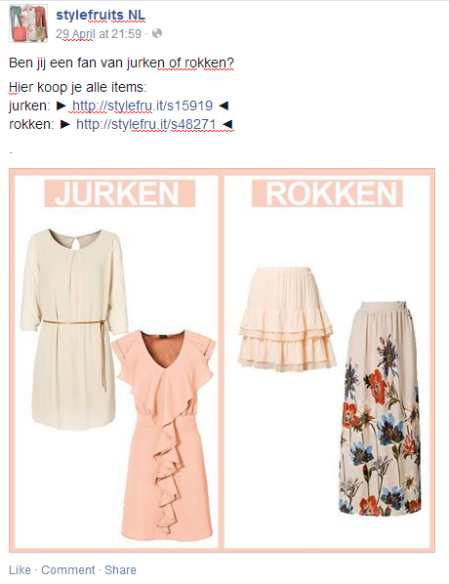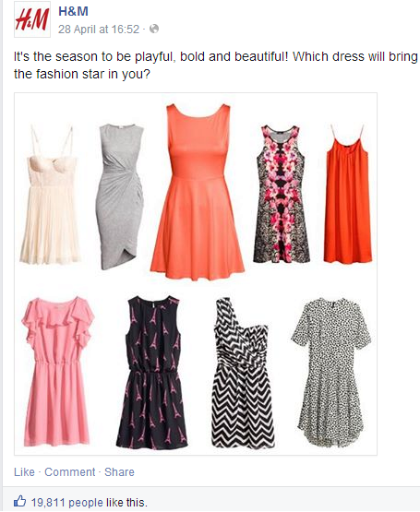Picture sources: (HM, 2014) and (Stylefruits NL, 2014)
Figure 3. Comparison of similar Facebook posts

While Stylefruits NL only poses a question to their audience, HM describes the way that the dresses will make their audience look, providing a benefit and the gratifications Identity formation and confirmation and Personal guidance. If a woman wants for feel like a "fashion star", she knows that one of the shown items will achieve that. Stylefruits poses a direct question and gives links to where the customers can buy the items, thus providing only the gratification Information.
Other product-centric content includes posting images of new items and looks, shot on location or in a studio. They also post new trend and style information as well as a selection of 'fashion finds', items that they think their audience will like from the current trends. All these posts show images of products, mostly worn by models. These posts are among the most popular on their Facebook and Instagram pages. They achieve Applause rates in the thousands- as high as 6603.33. Trend updates also get a lot of attention- 4023.5 Applause rate. When it comes to Conversation rate, they score much less, but nevertheless, more than Stylefruits NL.
All tables and graphs could be found in Appendix 1.

4.5. Consumer observations
In this paragraph, some observations made on consumer behaviour are presented. The observations were made with theories from the theoretical framework in mind. Specific behaviours and reasons for these behaviours were subsequently analysed.
Following the S-O-R model, proposed in chapter 2, reasons for people to 'share' and 'comment' were looked at. The term 'Like' was not explored in this section as it is self explanatory- the action means that the people like what they see.
The main reason to 'comment' was to express an opinion, like or dislike, or to ask a question. Stylefruits comments were mostly answers to a posed question or complaints about not finding an item they saw in the post. Few were expressing the degree to which they liked the item; they would only state the number, given by Stylefruits NL.
On HM's pages, however, people would not only answer the question, if one was posed, but also express how much they like the item (or which item they like, if it was a whole outfit showing) and how they cannot wait to buy it. Responses to consumer-centric content, like images of fans who wear HM clothes, also got a lot comments. They would express how much they like the style, the clothes, the looks of the girl and where could they get a certain item.
A new way of sharing on Facebook was discovered as well. People would tag a friend into a comment under post when the follower thought their friend might like it. This new way of sharing on Facebook is something that is typical for Instagram. There people would tag someone in a comment much more often, as the channel has no share option similar to Facebook. Rather, they provide a share link, which can be pasted on other social media.
If the content were shared according to the normal Facebook way- by clicking the share button, the sharers would mostly not specify a reason. If they did, it was always because they liked what HM or Stylefruits NL posted.
Looking at Uses and Gratifications theory, the most commented on posts were those where clothing items were shown and a specific question was asked- providing Distraction and Personal Guidance .HM's post from the example in the previous paragraph got the most responses- 340 comments. Posts that relate to the gratification Information had the least engagement. (Example from HM's Facebook feed: Information on HM's sustainable efforts- an Event called "Conscious New World" got no comments and share and only 17 likes.) Another example of low performing post that appeals on Information, but also on Relaxation and Diversion is one that calls for followers of HM to download the new music single of Gisele and Bob Sinclar. The post also received mixed comments- some being negative about the model's singing.
As mentioned above, with Stylefruits NL comments, although receiving more than HM's post, engagement is not as deep. In addition, these were accumulated over a period of months, often more than six. The posts that were posted for the first time received very few reactions, if any type.

4.6. Conclusion
Looking at the results from the Social Metrics, it appears that women responded best to posts that show new products, ones that are in trend and in style for the next season. Posts that contained or were images (photographs of clothing pieces in particular) were most popular among the target population. Other popular posts were on trend and style updates for the next season. Furthermore, posts that used the gratification Personal Guidance, Relaxation and Diversion, in combination with images and other visual material, were among the most engaging content. A new gratification, not taken into consideration by this study was identified as one that women, followers of clothing brands pages, react positively to- Identity formation and confirmation. This new gratification sought was examined in the context of the gratification Personal guidance, as they were observed in combination. This, together with the other insights gained in this observation was tested with a consumer survey.

Chapter 5: Results and Analysis- Survey

Chapter 5: Results and Analysis- Survey

5.1. Introduction
For the second part of the research, an online questionnaire was designed and distributed among the target audience of women, followers of clothing brands on social media. A complete copy of the questionnaire can be found in Appendix 2. In total, 115 people (all living in the Netherlands) filled out the questionnaire, which was distributed on social media and via references as mentioned in Chapter 3. 78 of the respondents were individuals that represented the target group of women between 20 and 30 years old. Results of individuals who do not represent the target group have been excluded from the analysis.
In this chapter, the most important and relevant results from this questionnaire are presented. The chapter is structured in accordance with the theoretical framework proposed in Chapter 2 as well as the findings from the observation, presented in Chapter 4.
Tables and graphs presenting the overall outcome of the survey can be found in Appendix 3.1. Tables, presenting the relationships between several important questions can be found in Appendix 3.2. As the demographics were predetermined by the research, no graphical representation was needed. The first two questions of the survey asked about the gender and age of the respondent. The answers determined if they were eligible to be included in the data analysis or not.

5.2. Best channel
Question 3 in the questionnaire was aimed at discovering which channel females in the Netherlands use for visiting clothing brands and retailers. The respondents could choose between Facebook, Twitter, Instagram, Pinterest and Fashiolista and rate their usage on a Likert scale- 1- Never, 2- Very Rarely, 3- Rarely, 4- Occasionally and 5- Frequently. The network with the highest score was Facebook- 38.5% would use it Frequently and 26.9 %- Occasionally. No other social network received such positive scores. For example, 69.4% said that they Never used Twitter to visit clothing brands, 18.1%- Very rarely. The only other channel that had somewhat positive frequency of use was Instagram- 19.2% would use it Occasionally and 6.8%- Frequently.
Facebook's Median was 4, but the Mode was 5, which means that while the average answer was Occasionally, most women answered Frequently.
The desk research uncovered a research performed in the United States of America by Edison Research, 2013 for Netbase. The report showed that Facebook was a top channel of influence for the apparel industry. The questionnaire confirmed that this finding is also true for the Dutch audience of women 20-30 years old. However, the report also showed that Pinterest and Instagram were also in the top 4 most important social networks (Pinterest above Instagram). Most of the respondents in our survey would Never (58.9%) and only Rarely or Occasionally (both 13.7%) use Pinterest for visiting clothing pages. Only 5.5% would Frequently use it. Similar results were show for Instagram, as shown above. This somewhat coincides with the discoveries of Edison research, 2013, but overall, Dutch female audiences use Pinterest and Instagram less than their American counterparts.

5.3. Present behaviour
Six questions in the survey were designed specifically see the present behaviours on clothing brads' pages of the women tested. The respondents could choose the Likert items, dependent on the question: 1- Never or Strongly Disagree; 2- Very rarely or Disagree; 3- Rarely or Undecided; 4- Occasionally or Agree; 5- Frequently or Strongly agree. These were aimed at measuring frequencies and attitudes.
  - Survey Question 4
The first question in this section was aimed at discovering how much time a woman in the target group would spend per week on a clothing brand's social media page. The majority of women would spend either less than an hour or 1-2h (29.5 % for both). However, the dispersion here was varied- 15.4% would spend between 3-5h a week, but 25.6% would rarely visit such page. This shows the diversity of respondents.
  - Survey Question 5
The second question in this section presents the specific type of actions that women in the target group perform while on the social media page of a clothing brand. The most performed action was browsing images- 41.6 % would do it Frequently and 33.8% - Occasionally. The average of all answers was Occasionally and the most frequent answer was Occasionally as well.
Other noteworthy actions were Read content and Look for promotions and deals. While the average of all respondents answered Rarely, the Mode shows that the most often given answer was Occasionally. This shows that women in our target group would not only look at images, but also engage in a deeper level with the brand.
Furthermore, this question was testing the observation made in the first phase of the research, This observation showed that customers of clothing brand HM and clothing e-tailer Stylefruits NL have the strongest engagement with content that is visual (namely, images of products). The results of this question show that that is indeed the case.
  - Survey Questions 6
This question was designed to measure attitudes towards specific reasons to visit clothing brands and retailers on social media. For the purpose of this research, a positive attitude is the combined percentage of people who answer Agree and Strongly agree.
The biggest reason for visiting clothing social media pages was for Distraction and Just for fun, which shows that Diversion and Relaxation are important gratifications, which drive engagement. 60% had a positive attitude towards looking for new clothing pieces, 60.6 % towards Distraction and 67.1%- Just for fun.
In the previous stage of the research, the observation showed that the gratifications Information and Personal guidance were an important engagement factor as these post had some of the highest engagement rates. The question tried to confirm that and a significant amount of the target group said that they do visit these pages for information on new trends and to look for new clothing pieces (respectively 52% and 60% had a positive attitude). However, the gratification Personal guidance received lower positive attitude- 32.4% would visit a page for advice on how to dress this season and 40.3% for advice on a specific outfit. However, the Median showed that the average of all respondents is undecided and the Mode showed that most agreed that this is a reason to visit a clothing brand's page.
Another observation made was that images are the most engaging content. 46.6 % of the respondents had a positive attitude (the agreed or strongly agreed) towards the statement that they like looking at beautiful images and that is why they visit such a page. The Median and Mode showed, however that most are undecided.
  - Survey Question 7
This was an important question, as it directly asked what the favourite content that clients have on clothing brands' pages was. The question measures the level of agreement to the statement: My favourite type of content on clothing brands' and retailers' Social media pages is...." Then they were given 10 options. The items were chosen in accordance with the observation results as well as suggestions for engaging social media content published by Salesforce Marketing Cloud, 2013. For the purpose of this research, a positive attitude is the combined percentage of people who answer Agree and Strongly agree.
The items with highest Median and Mode (both 4-'Agree') were product image- studio and location shot, product mood image and style advice posts. 56% of the respondents had a positive attitude towards product studio shot photos; 78.7%- product location shot images and 61.1%- product mood images; 51.3%- Style advice post. Inspirational post and got 46.1% positive attitude.
'Choose your favourite item' post were the most popular content on Stylefruits NL page, but the respondents with positive attitudes were only 24% , 52% had a negative attitude towards the statement that it is their favourite content. The Median and Mode reflect this as the average of all respondents said that they Disagreed, which was the most often given answer as well. This type of content was also very popular on HM's Facebook page. The difference of result may come from the fact that in the survey this option was not put into context of any gratifications. The addition of gratifications to the call- to-action was what made this content very popular on HM's page over Stylefruits NL's page. The result of the survey reflects the fact that these types of posts are only popular if they provide extra value (a gratification like Identity formation and confirmation). This gratification was tested in questions 9, 12 and 13, where the option given for evaluation reflected the specific situation that it was observed in- a post that provides the gratifications Information, Personal guidance and Identity formation and confirmation combined.
Humoristic posts also received an overall positive attitude- 44.7% of respondents agreed or strongly agreed that it is among their favourite content. 32.9%, however, were undecided.
  - Survey Question 11
This question wanted to see what kind of actions the respondents have already performed on clothing brad pages and the frequency with which they were performed.
Most people had read posts by the company: 32.9 %- Occasionally and 15.8%- Frequently. No strong positive answer was given to rest of the options, which concerned interactions with other fans and the company itself (including comments). 52.6% had not responded or rarely responded to posts of the company by liking or commenting.

5.4. Observation-specific
Three questions in this questionnaire were specifically designed to test the findings of the observation form the previous stage of the research. The respondents could choose the Likert items, dependent on the question: 1- Never or Strongly Disagree; 2- Very rarely or Disagree; 3- Rarely or Undecided; 4- Occasionally or Agree; 5- Frequently or Strongly agree. These were aimed at measuring frequencies and attitudes. For the purpose of this research, a positive attitude is the combined percentage of people who answer Agree and Strongly agree.
  - Survey Questions 12 and 13
These questions were designed to test some findings of the observation as well as the propositions of the Uses and Gratifications theory as well as the Proposed conceptual model (the responses 'like' and 'comment', 'share' was omitted due to the results of the observation) . The respondents had to express the frequency with which they would possibly like or comment on certain type of content if it fell into certain type. The possible options that the respondents could evaluate and the results corresponding to them are present below.
Quite a big percent of respondents (between 25 and 22) did not answer the questions and marked them as Not Applicable (N/A). This is consistent with the low results of the other question, that concerned the 'comment' response of the Proposed Conceptual model (Questions 5 and 11).
1. If it is new- This is one of the high scoring options when it come to the response 'like'. 53.9 % would Occasionally or Frequently like if the content was new content. However, 24.2% would Frequently or Occasionally comment under the same circumstances.
2. If it Ii useful- A similar pattern is observed in this category as well, 78.9% would 'like' and 23.9% would 'comment' if the content was useful.
3. If it were interesting- Similar results emerged here as well, 82% would Frequently or Occasionally 'like' (42.3% of which Frequently). However, 38.7% of the people would Rarely comment versus 19.4% which would do it Occasionally.
These three items were specifically put to represent the gratifications Information, Personal guidance and like Identity formation and confirmation. These items are all presenting combinations of the gratifications, which are associated with content seen on clothing brand pages. There was not context provided (in term of the gratification mix) in order to let the respondents makes their own associations.
4. If it is exciting- 80.7% of respondents would Frequently or Occasionally 'like' if content was exciting and 9% would Rarely do it. 22.6% would Very rarely and 39.7% would Rarely comment.
5. If it were absorbing 49.3% (the lowest from all 10) of respondents would Frequently or Occasionally 'like' if content was absorbing, but only 26.7% would 'comment'. Furthermore, 35% would Very rarely 'comment' if content was absorbing.
6. If it makes me smile- 84.6% would Frequently or Occasionally 'like' content that possibly makes them smile and 14.5% would Frequently and 29% would Rarely comment.
7. If it makes me think- 68.4% of respondents would Frequently or Occasionally 'like' content if it makes them think as opposed to 30% which would 'comment'. 26.7% would Rarely 'comment'.
Items 3 to 7 where related to both the Uses and gratifications theory (Relaxation and diversion gratification) as well as the Organism part (Enjoyment through Escapism, Pleasure and Arousal) of the Proposed conceptual model. This part concerns the reasons for a consumer to respond to a certain type of content, which is what these two questions aim at discovering.
  - Survey Question 14
This question was aiming at discovering the attitude women from the target group had towards the new way of sharing information with their friends, discovered in the observation. It is also testing two traditional for social media ways of sharing.
The highest percent on either of the options was 37.5% Agree that they would tag a friend in a comment. 25.7% were undecided whether they would share the link on their wall and 30% Agree and 37.1% Strongly agreed that they would message the link to their friend.

5.5. Attitudes of target group
  - Survey Question 8
This question was examining the Deprivation statement of Social Exchange theory, which states that the more the same category content is presented to a person, the less valuable it becomes to them. This was somewhat congruent with findings of the observation of Stylefruits NL.
The question also tested the Stimulus proposition at the same time. The way the question was asked gave the possibility to test both propositions. If people would disagree then the Deprivation statement was correct, is they agreed- the Stimulus proposition was. This was done by proposing different situations and contexts, in which respondents had to state their feelings towards repetitive content.
37.8% had a negative attitude towards the statement that as long as repetitive content was to their liking, it was not annoying. However, 45.9 % had a positive attitude towards it. This shows an almost even distribution between respondents when it comes to their feelings. The response with highest percentage respondents was 29.7% Agreed, the average of all respondent (the Median), however was Undecided.
The next statement was concerning appropriateness of content for the season, current events and trends. 30.6% had a positive attitude and agreed that in that context, content is not annoying. The highest percentage-41.7% had a negative attitude and said that nevertheless, repetitive content is annoying in this situation. The highest individual percentage (27.8%) was undecided.
The third statement wanted to see the attitude towards aggressive selling-type of posts (something observed on Stylefruits NL). 52.1 % showed positive attitude, thus proving that if content is repetitive, but NOT obvious or aggressive in selling the respondents did not find it annoying. However, 30.1% Strongly disagreed, which shows that they do not mind aggressively selling content. 20.5 % of Strongly disagreed that this type of content is not annoying.
The final option gave the possibility to state their feeling towards the value, carried by repetitive content. 50.7% agreed that it carries no value for them, 31.5% said it does. However, 31.5 % strongly agreed that it does not carry any value to them and it is annoying.
The specific result of this question confirms the Deprivation statement has more affect in this specific situation then the Stimulus proposition does. This means that repetitive content can alienate followers rather than engage them, even if it is a popular and liked type. This is also in congruence with the findings of the observation where Stylefruits NL would post and repost the same content. On this content, they would get many likes and comments over a period on over six months, while HM gets similar or higher engagement within hours of posting. HM does not post repetitive content.
  - Survey Question 9
This was an important question, as it aimed at finding which content women from the target group liked and to what extent.
66.3% were positive that they want interesting information, 61.5%- helpful content, 63.7%-exciting content, 73.1%- enjoyable content and 33.8%- absorbing content. Enjoyable content got the strongest positive attitude (37.2% Strongly agreed). Interesting also got a positive reaction, but not as strong as enjoyable content- 37.7% Agreed that they want enjoyable posts.
  - Survey Question 10
This question was exploring the specific consumer-centric content- contests. The observation showed that it is one of the best engagement types of content. The question explored contests that provide a specific amount of effort and type of gratifications.
35.7 % Disagreed and 21.4% Strongly disagreed that they would participate in a contest that that asked them to do something unusual to them. 70% said they would participate in a contest if it is something easy to do (40% Agreed and 30% Strongly agreed). If a contest is exciting and fun and it asks for something easy to do, 47.3% Agreed 27% Strongly agreed. However, if the contest was fun and exciting, but need to effort then only 4.3% Strongly agreed and 32.9% agreed that they would participate.
The option 'I wouldn't participate in a contest' was also given and 36.4% of all respondents answered with Not Applicable (which shows that they would participate), only 10.2% Strongly agreed with the statement and 16.3% Agreed.

5.6. Most interesting content
In this paragraph, relationships that show what content respondents find most interesting are presented.

5.6.1. Desired content
What percentage of females, who use Facebook to visit clothing brand pages the most, want to see interesting and enjoyable content? These variables were selected, as they got the most positive reactions in the questionnaire. (Appendix 3, Table 14)
50% of frequent Facebook users Strongly agree and 20% Agree that they want enjoyable content. 42.9% of Occasional Facebook users Strongly agree and 38.1% Agree that they want enjoyable content. These strong positive responses received the bigger amount of respondents.
40% of Frequent Facebook users Strongly agree that they would like clothing pages to provide interesting content and 55% of Occasional Facebook users Agreed.

5.6.2. Favourite content
What content do females, who use Facebook to visit clothing brands' pages the most, like and to what extent? The five types of content chosen are the ones that had the biggest amount of positive response in the questionnaire. (Appendix 3, Table 15)
The most favoured type of content was location-shot product images. 46.7% of Frequent Facebook users Strongly agree that it is among their favourite content, while 40% Agreed.
The second most liked content was product studio-shot images. 36.7% of Frequent Facebook users Strongly agree that this among is their favourite type of content. The same amount Agreed.
The third most favoured content was product mood images. 35.7% of Frequent Facebook users Agreed and 40% of Occasional users also agreed.
The fourth was Inspirational posts. Here 40% of Occasional users Agreed. Furthermore, Frequent users were Undecided whether it was among their favourite content or not- 36.7%. However, 26.7% Agreed and 16.7% Strongly agreed. Although most of the respondents were undecided, it still does not show negative attitude towards the content. Furthermore, the combined percentage of positive attitudes is 43.4%, which is a substantial part of the sample.
The fifth and final content type was Style advice. Here again 33.3% of Frequent users were Undecided and the combined percentage of positive attitudes 46.7%. However, 26.7% Agreed and 20 % Strongly agreed that style advice is among their favourite type of content.
The overall results put the last two types of posts at the same general level. The specific attitude measures, however, show that Style advice has a slightly stronger positive influence.

5.6.3. Responses to interesting content
  - 1. What percentage of women who frequently and occasionally write comments on a post would also Frequently or Occasionally comment if the content is interesting, absorbing or makes them think? (Appendix 3, Table 16)
12.5 % of people who Occasionally comment on posts, would Frequently comment if the post were interesting and 25% would Occasionally and 50% would Rarely do it.
12.5 % of people who Occasionally comment on posts, would Frequently comment if the post were absorbing and 50% would Occasionally do it. However, 23.5 % of respondents who rarely comment would both Occasionally and Rarely comment if the post was absorbing, 35.3 % would Very Rarely do it.
25% who would Occasionally comment, would Frequently do it if posts would make them think. Furthermore, 52.9% of those who rarely comment would Occasionally do it under the same conditions.
None of the respondents would Frequently comment on any of the above mentioned circumstances.
  - 2. What percentage of women who would 'like' content if it is interesting, have an overall positive attitude towards sharing it through a comment tag, a share or a link? (Appendix 3,Table 17)
72.4% of women who Frequently would 'like' content if it were interesting have a positive attitude towards sharing it by tagging their friend in a post.
56.6% of the same group have a positive attitude towards sharing the content as a link on their friend's wall. 62.1% would send the content as a message to their friend.

5.7. Other
  - 1. What percentage of women who are looking for new clothing pieces on social media favourite Product images shot on location and in studio? (Appendix 3,Table 18)
The reason to choose these two types of content was that the observation showed that this is the type of image that is mostly used by HM to show new products.
54.6 % of women who said that they visit clothing brand's pages, looking for new clothing items also strongly agreed that their favourite type of content is images shot in a studio. 78.7% of the same group said they strongly favoured location product images. However, 50% of those who only agreed that they are looking for new clothing also agreed that studio images are their favourite. The corresponding amount for location images is 66.7%.

  - 2. What percentage of women who look for discounts and deals find that repetitive content that sells aggressively is annoying? (Appendix 3, Table 19)
61.6% of women who only agreed that are looking for deals and promotion said that they find this type of content acceptable. However, 38.5 % of women who are Strongly agree that they are looking for discounts on social media express a strong feeling towards repetitive content being annoying.
Respectively 57.1% of women who Strongly disagreed that they are looking for deals find repetitive aggressively selling content annoying. 45.7% of those who only said they Disagree said this type of content is annoying.
This shows that women, looking for deals on social media, tend not to mind if there is a lot of aggressively selling content. This percentage is however not so high as to say with certainty for the whole population of women who like looking for deals. The same conclusion is derived on the basis on the percentage of women, who do not shop for deals and find repetitive content annoying.
  - 3. What percentage of women who looks at images on social media would like them if they were new? (Appendix 3,Table 20)
41.2% of women who Strongly agreed that studio image is among their favourite content would Frequently 'like' if the content were new. 29.4% of the same group would only do it Occasionally. Furthermore, 32% of those who only Agreed also said they would Frequently 'like' such content, but 36% of those who only Agreed said they would rarely 'like' new content. Furthermore, 33.3% of those who were Undecided whether they favourite this type of content on not said that they would Frequently 'like'.
45.8% of the respondents who Strongly agreed that location image content is among their favourite, also said the they would Frequently 'like' if content was new.16.7% of the same group would maybe do it Occasionally. Furthermore, 25.7% and 22.9% of those who only Agreed that this type of content is among their favourite also said that they would, respectively, Frequently and Occasionally 'like' new content. Also, 40% of women from the same group said that they would rarely 'like' if they saw new content.
42.9% of women who said they favourite mood images would Frequently 'like' if content was new, but 40% of those who Disagreed would also 'like' Frequently. Furthermore, 26.7% of those who only Agreed say that they favourite this type of images also said that they would Frequently 'like' if it was new content. 39.1% and 30.4% of the Undecided whether mood images are among their favourite or not, would Occasionally and Frequently 'like' if they came across new content. 35.7% and 40% of those who respectively Strongly agreed and Agreed would Rarely give a 'like' if they saw new content.
These results show that more likely than not, women would like new product images. This is also what the observation of the two brands discovered.

5.8. Conclusion
Overall, the findings of the observation were confirmed by the consumer survey. Images were indeed the most strongly favoured content. Furthermore, the level of the gratification Identity formation and confirmation was measured. The result was that this gratification is most important when the company is adding a call-to-action that aims at selling. Social Exchange theory was also explored and the Deprivation statement had a greater validity than the Stimulus proposition. However, this depended on the type of person and situation (people who are shopping for deals on social media are positively influenced by repetitive content that provides what they are looking for, thus confirming the Stimulus proposition).
In the following chapter, the Advice is given and areas for further research are identified. The Advice is given through recommendations, which are also discussed in detail.

Chapter 6: Recommendations, discussions and conclusions

Chapter 6: Recommendations, discussions and conclusions

6.1. Introduction
In this chapter, the advice to small clothing e-tailers is presented. The advice is based on the main research question and consists of the answers of three sub-questions. As these are answered, the advice is formulated. Furthermore, the advice is in relation to the theoretical framework established at the beginning of the research. The result is a general outline of what content could small clothing e-tailers use on social media to create engagement and build a relationship with women aged 20-30 in the Netherlands.

6.2. General posting strategy

6.2.1. Network of choice
Through observation and questionnaire research, it was uncovered that the best social media channel, used both by brands and by customers, to visit clothing brands' pages is Facebook. The channel receives the most visits by customers and is the first channel they use when they want to visit a particular clothing brand.
The second channel of importance to clients is Instagram, according to respondents of the survey. A paper by Edison Research, as mentioned in previous chapters supports this as well. The research found that Facebook was the social media network of greatest importance to the apparel industry. The research also established that Instagram and Pinterest are also networks, women said they used when looking for clothing pieces, style advice or fashion news. Which of these two channels they visited, with these purposes in mind, depended on the type of clothing they were looking for. However, Facebook was the primary channel of choice. (Edison Research , 2013).
All the findings show that a small clothing e-tailer must have at least a Facebook page. A large proportion of the survey respondents (65.4%) use this network to visit clothing pages on a regular basis. Instagram and Pinterest (the former used slightly more often), are not as popular among Dutch females aged 20-30, but still get used on occasion. Although these channels are not per say necessary for small clothing brands, it is advisable to use them in order to further boost engagement and accommodate customer needs and desires. Research showed that Instagram is often used by successful clothing brands like HM in order to connect with consumers on a more personal level. This is why this social network is also recommended to small clothing e-tailers.

6.2.2. Time to post
Through the observation conducted and with the help of social media metrics it became apparent that Sunday and Monday are days that receive the largest amount of engagement in the apparel industry in the Netherlands. Furthermore, the research uncovered that the best time to post is generally between 15h and 19h or around 22h in the evening.
Social Media specialist Chad Egeland recommends to experiment with posting at different times and days of the week, but even then, one must start with an initial strategy. (Egeland, 2014). The days and times mentioned above are a good start. As the research shows, these showed the highest engagement.
Furthermore, scheduling software can be used. One of the most popular is Hootsuite. It is an online software that allows content to be posted at desired times to Facebook and a number of other social networks. It also gives options like monitoring, listening and location targeting of buyers and decision makers. Using such a program streamlines workflows, helps the company react to potential/clients in an easy and timely manner. It also offers basic social metrics like clicks, comments, shares and likes, which further helps to evaluate the effectiveness and level of engagement of content. (Hootsuite, 2014)
As results of the questionnaire showed, women in the Netherlands, aged 20-30, generally do not spend a lot of time on clothing brands' pages. This is why it is important to have a strategy when and what to post in order to achieve maximum results. This is aimed at posting at times when potential clients are on social media. This betters the chances that they will see the posts and engage with the content and, thus, with the company.

6.2.3 General post design
Two important general points, associated with post design, emerged from the observation of HM and Stylefruits- aggressively selling call-to-action and repetitive content. The two companies have a very different approach to the way they present their content and that is reflected in the general Conversation and Applause rates.
When the company's goal is to stimulate engagement and interaction that leads to a relationship, resulting in a sale, then a less aggressively selling strategy (similar to that of HM) is the better option. Posts must be designed to sell in a more indirect manner, with no straightforward call-to-actions and no multiple re-posting. The posts must use the gratifications Personal guidance; Relaxation and diversion; and Identity formation and confirmation in combination with a call-to-action 'Buy'. This will provide extra value and show personal consideration for the customer but at the same time will stimulate the buying behaviour.
Results from the questionnaire showed that over half of the women who are not specifically looking for discounts and promotions on social media find repetitive aggressively selling content off-putting. However, these women are still shopping for clothing and are willing to pay full. In order to engage these women the above-described strategy would work best. However, if the company wants to engage women, shopping for discounts and promotions of social media, then a slightly different approach might work better.
A large portion of respondents to the survey, who are looking for deals on social media, said that they do not mind repetitive aggressively selling content. Although the majority did not express strong positive feelings towards this type of posts, 61.6% said, they Agree they do not find it annoying. In this situation, a slightly more aggressive call-to-action might work better. It is good to use the same gratifications (Personal guidance; Relaxation and diversion; and Identity formation and confirmation), as research showed that they are important for engagement, but stress more on the monetary value attribute rather than the other gratifications. A periodic reposting of these posts can yield better results with women who are looking for deals and promotions. A better solution is to use the same or similar call-to-actions, previously posted, and use a different visual representation. In this way, content is familiar, but visually different (over 50% of women, who participated in the survey said they visit clothing pages for new information).
Another important point, discovered through the observation of consumer behaviour on clothing brands' pages concerns the links, provided on post. The research showed that when these links do not lead the client to the point of purchase of the item, displayed in the post, they tend to get annoyed, confused and complain. This can be easily avoided by linking the items to their corresponding pages on the e-shop. Furthermore, long links can be cumbersome and hinder user experience. A URL shortening service such as goo.gl or bitly.com can help better customer experience on social media. It can also assist the company in tracking when and where the link was clicked. This helps with seeing not only from which geographic region most clients are coming from, but also when they are coming and which content is most interesting to them. (Parr, 2009).

6.2.4. Reasons to visit a clothing brand's page
In order to be able to draw up a complete and useful posting strategy, we need to look at the present most important reasons for women to visit a clothing social media page. If we know what those main reasons are, the strategy can be tailored to fit the needs and wishes, which leads to a greater engagement and sales.
The main affective reasons to visit, according to respondents of the survey, were for distraction or for fun. These represent two of the gratifications sought (or needs) that were determined as important for the target group. This shows that Escapism (part of the Proposed Conceptual model as well as the gratification Distraction), which showed to be not as important for the content itself, is a main reason to visit the page of the company. This means that people may visit a clothing page to distract themselves, but that does not mean the content they like and want to see has to provide the same gratification.
Another important reason for women to visit clothing pages was to look for new pieces. This shows that women in the Netherlands can be categorised as Social shoppers (they shop on social media and buy online or in-store). 60% of the questionnaire respondents said that that is a reason for them to visit a clothing brand's page. 21.3% were Undecided, but this shows that they are still potential customers.

6.3. Categories of content

6.3.1. Consumer-centric content
Consumer-centric content was the category that showed the highest level of engagement with customers. This type of content, as mentioned in the operationalization section of chapter 1, typically involves the company adding some type of benefit or value for the customer rather than simply presenting a product or trying to sell it. A simple way to incorporate this category content is to understand the needs of the customers and provide them with content that appeals to those needs. The survey discovered that Pleasure and Arousal, as described in the Proposed Conceptual model, were very important to the target group of the research. These are presented by the needs (or gratifications sought) Personal guidance; Relaxation and diversion; and Identity formation and conformation. When content is created and those gratifications are incorporated, the customer is more likely to engage with the content as it brings value to them. Furthermore, customer-centric content can be used and is the easiest way to build a relationship with the consumer audience as it shows that the company is concerned with the customer and has similar tastes and ideals.
The gratification Information was least important from the ones explored, nevertheless, it was of some importance to the survey respondents. The majority said that they want to see content that is both interesting and enjoyable. They would also engage with new and intellectually challenging posts. This shows that they do appreciate and look for information, but it needs to appeal to other needs as well. By using combination of gratifications, that appeal to the audience the brand provides an even stronger value. For example, a post that uses the gratification Information and Personal guidance may be an article on new important seasonal fashion trends. It provides them with new content and gives them a guide on how to be fashionable next season. This type of posts, typically, also uses the gratification Identity formation and conformation.

6.3.2. Product-centric content
This category of content was also one that audiences of HM and Stylefruits NL engaged with. However, if value-bearing meaning did not support it, it was not as popular. This became apparent from the observation of Stylefruits NL. Furthermore, the consumer survey confirmed it when 78.7% of respondents who shop for new clothing displayed strong positive feelings towards location-shot images, which are typically providing a combination of the gratifications Personal guidance and Identity formation and conformation. This shows that when the product -centric content is infused with characteristics of the consumer-centric content, it becomes a better engagement creator.
An example of product-centric content, not using any gratifications is a studio-shot image of an item. As it typically focuses on the product itself, the image does not carry any benefit. However, gratifications can be included in the accompanying text, as HM does in the example in chapter 4. This is not as efficient as the images itself carrying the value, but is more engaging than the content being only centred around the product.
The survey also showed that 50% of women looking for new clothing pieces do appreciate product-centric content. However, as shown above, a larger number favour the combination between consumer- and product-centric content.

6.3.3. Recommendations
In order to build a relationship with the consumer a company can use consumer-centric content with greatest success. A combination between consumer- and product- centric content can also build a relationship and engage the audience. The latter type is best used for a more active stimulation of the consumer to buy. The former has a more long-term benefit as it promotes building a personal relationship with the brand. This may lead to a purchase in the future as well as to acquiring return customers as the consumer begins to identify with the brand on a personal level.
In the following section an in depth advice on specific types of content is given. These are based on the category content, identified in the present section. Specific examples are also given as a means of illustration and better understanding to concept presented.

6.4. Specific types of content

6.4.1. Product-centric content- images
The most important type of content for a clothing company is images. They are what customers and followers appreciate and engage with the most (also according to responses of the questionnaire). The three most performed actions concerning content on a clothing brand's page, according to the survey, were brows image, read content and look for deals and promotions. Any type of message can be visualised by an image, which results into "better memorability and stronger associations". (Suh, 1999). In the following section, a breakdown of different types of images is presented together with recommendations for achieving optimum level of engagement. Furthermore, the section presents examples of accompanying text that contains the most important gratifications, which can boost both engagement and build a relationship with the customer.

6.4.1.1. Product location-shot images
These were the most favoured type of image content according to the survey responses. When taking all findings connected to Product-centric and Consumer-centric content, also related to the Uses and Gratification theory, the following type of posts emerge as most engaging and relationship building.
Product location-shot photographs typically show clothing, worn by a model in a particular situation or context. The image in itself already provides the gratification Personal guidance as it gives an example of the situation where the outfit can be worn in. This gratification can easily be reinforced by using it in the text, accompanying the image. HM uses this strategy (see figure 3 in chapter 4). The accompanying text states: "Go natural chic this summer, with easy pieces for the effortless summer style. Pick your summer look! http://bit.ly/1o8FBa3" (HM, 2014). (see image in Appendix 4, image 5). This shows concern for the clients and desire to be helpful, which helps with building relationship with the client. This is an example for a mix-content strategy. Furthermore, the call-to-action is not aggressive, but still motivating enough for the client to engage. HM also uses the URL shortener bit.ly in order to better customer experience.
The research shows that women, who are looking for new clothing pieces on social media, are attracted to these type of images and would engage by 'liking' if they are new. This shows the importance of new and fresh content on a company's social media page. This is further confirmed by another result of the survey where 50.7% of women said that they have negative feelings towards repetitive content and 17.8% were undecided. However, if the goal was to attract and engage with women who are looking for a discount, reposting content does not have such a strong negative impact, as long as it is attractive.

6.4.1.2. Product studio-shot images
This is another highly desired type of content. It typically shows items of clothing on white background, either individually shot or worn by a model. These types of images typically are purely product-centric and focus on selling the product. However, if the image is accompanied by text that incorporates the gratifications Personal guidance or Identity formation and conformation, it will make it more engaging. Although the studio-shot images were the second most favoured content, adding such gratifications helps build a relationship with the client as well. This can be done by accompanying the photograph with a text, similar to the text-example in chapter 4 (HM's observation: "It's the season to playful, bold and beautiful. Which dress will bring the fashion star in you" (HM, 2014). This type of content can also be asking the followers a question, as in the example. This particular question is aimed at finding consumers' preferences, but it also shows that the company cares for what their clients think and feel. This is the type of additional content creates engagement and builds a relationship between the two parties. It is also an example of a mix between product- and consumer- centric content.

6.4.1.3. Mood images
These were the third most favoured image type by the survey respondents. Mood images are a mix between product- and consumer-centric content. They should carry the above-mentioned gratifications in themselves. However, adding an extra gratification like Information can be more stimulating. Furthermore, these are the perfect type of image to engage on a personal level with the audience. One example, is HM's use of mood images to ask their audience questions "To which festival do you plan to go this summer? P.S. In our shop you have a chance for festival tickets with purchase of 20€ from H&M Divided" (translated from Dutch, see image in Appendix 4, image 6).) (HM, 2014). The image they used shows three young girls have fun, dancing together. When using such thematic mood images, the company not only steers the client towards feeling good about the summer, but also selling their Divided line, by addressing the audience it was intended for.

6.4.2. Consumer-centric
Having purely consumer-centric content is import for relationship building. This was a type of content that was very popular on HM's social media pages and appears to be favoured by the respondents of the questionnaire. In the following section the two most engaging type of consumer-cantered content are presented, accompanied by examples from the HM observation. Recommendations are given as to what is most appropriate for an inexperienced small clothing e-tailer.

6.4.2.1. Contests
The most engaging consumer-centric content on HM's page was contests. This is a typical type of content for the consumer-centric category content. It is a great way to provide the customer with some tangible benefit (typically a gift voucher to spend in the store for the winner) while creating large exposure for the brand. Fashion-related contests also usually allow consumers to express their fashion sense and personality. The company incorporates the gratification Identity formation and conformation to stimulate further participation. The survey uncovered that women from the target group would participate in a contest if it were fun but also easy to do. Few would engage if it required more effort. Overall, most (74.7%) said that they would participate in a fun easy contest. Although HM's contests typically require a bit more effort, they do keep in line with their customer's daily life. For example, a contest that urged followers to show HM their best party denim was relatively easy to do for the participants, as they could take a picture of the outfit they would go out with that night or during the weekend. It did not require a lot of effort, as they would dress like that in the next few days anyway. These contests are very targeted to a specific type of woman. One time it may be a younger girl, who like to go to festival, another, a young executive (asking to show her best work outfit). They are also tailored to upcoming mass events (festivals, holidays, big events etc.).
Small clothing e-tailers would profit the most of holding a contest that asks their followers for something easy and fun to do. Much like HM's strategy, ask them to show their favourite summer outfit (if it is summer), or best party or Christmas outfit (in the weeks before Christmas). This will help build a relationship, remind the customer for the coming holiday, thus stimulating buying behaviour. If the contest uses wording that incorporates the gratification Identity formation and conformation, this will additionally stimulate engagement.

6.4.2.2. Include the followers- relationship building
Posting images followers sent in for the contest and showing them on the social media page will also help build a relationship and the image of a caring company. HM, for example, shows their favourites and writes what they like, giving compliments to the sender but also up selling the garment. In some cases, they provide a link to where the item can be bought. This is a good strategy for small clothing e-tailer as well, as it will flatter the customer, but also help with selling the items. It also provides the gratification Personal guidance for the other followers, as they can get inspiration for their outfits, but also shows them that the company is concerned with their client base.
HM posted a series of images of people on the street or at Coachella festival wearing HM and put their names in the post. Small clothing e-tailers can use the same strategy to create and strengthen relationships with their customers. This also helps to create engagement with potential clients, especially from the friend network of existing customers, featured on the brand's social network.

6.4.3. Other important content
Style advice and Inspirational posts were also favoured types of content by the respondents of the questionnaire. They are both aimed at providing the gratifications Personal guidance and Identity formation and confirmation. These were needs, important to the target audience, but the two posts were not among the most important. However, these types of posts are important for relationship building.
Although they do not need to be posted as often as product-images, it is important to have Style advice content. When it is accompanied with suitable images, this will reinforce the effect of the content. It is useful, if the e-tailer uses content from fashion style blogs, popular in the Netherlands and among their target audience. This not only omits the need for the company to create their own content, but also engages the blogger's audience. Here, audience preferences are very important and the e-tailer needs to know what their specific target group likes and wants.
Self-created content, however, is also important. Starting a fashion blog is a good way to provide extra value for the customer. Someone in the company, but also an already experienced fashion blogger could write it. Furthermore, Inspirational post are the type of content that can be easily created in-house. This type of content works best if it provides the gratification 'Identity formation and confirmation', a key need, as shown by the observation and the questionnaire results. Although, it does not need to be posted regularly, it is important, for example, to post inspirational quotes from style icons like Coco Chanel, Marilyn Monroe or some iconic fashion designers. These must not be used very often as they tend to be very popular and others post them too. Therefore, it is important to use these type of posts only when they can be associated with the company's morals and beliefs or when they fit with other content, posted around the same time.

6.4.4. Conclusion
Regardless of the type of content chosen to be posted, it must always be new (non-repetitive, unless it is a promotion), useful and interesting. Questionnaire respondents said they would engage the most with these content attributes, mostly by liking. This makes the importance of links to product on the e-commerce website even more important. Furthermore, by posting interesting content, the company can stimulate women who would only 'like' to share the content by tagging a friend in the comment section. The research discovered that this is the best strategy to have their content shared. Typically, respondents said, they would rarely or never comment, however, they would comment to tag a friend in a post they think is interesting to the other. If, however, the content were intellectually stimulating, thus prompting a discussion, 30% of the respondents would comment on it, to express their opinion. This is useful, when the company wants to post content with the goal of discovering customer opinions.

6.5. Opportunities for further research
As the present research was conducted in a limited amount of time and on a relatively small scale, a number of opportunities for further research can be identified. First, the observation of competitors can be done for more companies, both international and local. Now the focus was one e-tailer and one fashion, but further research could be conducted solely on e-tailers or brands. Furthermore, the observation was done in detail only in the duration of one week. If extended, it can yield more concrete results and detailed results.
Second, the research only focused on women between the ages 20-30, but another important age group in women between 30 and 40. It would be valuable to know the similarities and differences of opinions between these age groups.
Third, the questionnaire was conducted only among 78 women due to the specific target group and the limited amount of time. If the research is conducted with more participants, then the results will be more statistically significant and conclusions that are more precise could be drawn. Furthermore, the questionnaire could be revised to include specific questions, exploring each gratification more in depth.
Fourth, the responses to the survey leave some aspects of content rather vague. For example, further research could be done into specifically the types of images, that create the greatest engagement and the effects they have on purchasing decisions. Furthermore, the responses about repetitive content were very controversial. Different type of followers had different opinions on the types of repetitive content. The only strong opinion emerged from aggressively selling content, where women who were looking for promotions had a general positive attitude towards it. Therefore, further research could be done whether this type of repetitive content has a positive or negative effect on engagement and which type of followers have positive or negative attitude towards it.
Another possibility for further research is the examination of strategies for Instagram and Pinterest as channels of importance for the apparel industry. Possible avenues may include specific types of content for the channels as well as posting strategies.
Lastly, the research uncovered reluctance among the target audience to comment on clothing brands' posts. This presents opportunity for further research on the matter. Possible dimensions of the research could be reasons, situations and context where followers would or would not engage by commenting.

Bibliography
Babin, B. J., Darden, W. R., & Babin, L. A. (1998). Negative Emotions in Marketing Research:Affect or Artifact? Journal of Business Research , 42 (3), 271-285.
Berg, S. (2006). Sequential Estimation of the Mean in Finite Populations to Steiner's Most Frequent Value. John Wiley & Sons, Inc.
Burns, K. (2010). Brands among friends: An examination of brand friending and engagement on Facebook. 94th Annual Conference of the Association for Education in Journalism and Mass Communication. Denver,Co.
CBS Nederland. (2013, 7 1). Steeds meer mensen kopen online. Retrieved 2 8, 2014, from cbs.nl: http://www.cbs.nl/nl-NL/menu/themas/vrije-tijd-cultuur/publicaties/artikelen/archief/2013/2013-3850-wm.htm
Changing Minds. (2014). Snowball sampling. Retrieved 3 14, 2014, from http://changingminds.org: http://changingminds.org/explanations/research/sampling/snowball_sampling.htm
Cohen, H. (2012, 3 19). The three S's of content marketing: social media, search, and sales. Retrieved 3 9, 2014, from http://www.clickz.com/: http://www.clickz.com/clickz/column/2161609/content-marketings-3s-chart
Collier, M. (2012). The Value of Creating a Customer-Centric Social Media Strategy. Retrieved 5 12, 2013, from http://www.mackcollier.com/: http://www.mackcollier.com/the-value-of-creating-a-customer-centric-social-media-strategy/
Content Marketing Institute. (2014). Content Marketing vs. Social Media Marketing: What’s the Difference? Retrieved 4 9, 2014, from http://contentmarketinginstitute.com: http://contentmarketinginstitute.com/2012/02/content-marketing-vs-social-media-marketing/
Content Marketing Institute. (2014). What is Content Marketing? Retrieved 4 9, 2014, from http://contentmarketinginstitute.com/: http://contentmarketinginstitute.com/what-is-content-marketing/
Cook, K., & Rice, E. (2012). Social Exchange theory. In K. Cook, & E. Rice, Handbook of Social Psychology (pp. 61-88). Dordrecht: Springer Netherlands.
Dyer, P. (2013, 7 1). The Top Benefits of Social Media Marketing [INFOGRAPHIC]. Retrieved 3 9, 2014, from http://socialmediatoday.com/: http://socialmediatoday.com/pamdyer/1568271/top-benefits-social-media-marketing-infographic
Ecommerce Europe. (2013). Europe B2C Ecommerce Report 2013. Brussels: Ecommerce Europe.
Edison Research . (2013). Social Channels of Influencefor APPAREL. NetBase.
Edison Research. (2013). Social Channels of influence for APPAREL, a consumer study. NetBase.
Egeland, C. (2014, 3 10). How Often Should I Post? The Answer May Surprise You. Retrieved 4 10, 2014, from http://socialmediatoday.com/: http://socialmediatoday.com/chad-egeland/2238176/how-often-should-i-post-answer-may-just-surprise-you
Hennes & Mauritz AB. (2014, 3 27). Three-month report 1 December 2013 — 28 February 2014. Retrieved 4 30, 2014, from http://about.hm.com/: http://about.hm.com/content/dam/hm/about/documents/en/cision/2014/03/1310224_en.pdf
HM. (2014, 4 28). Facebook image- Favourtie dress. n.d. Retrieved from https://www.facebook.com/21415640912/posts/10152051445610913
HM. (2013, 11 20). Facebook image- holiday themed mood image. Retrieved from https://www.facebook.com/photo.php?fbid=10151750819930913&set=a.10151750819645913.1073741943.21415640912&type=3&theater
HM. (2014, 5 22). Facebook image- location mood image-Gisel. n.d. Retrieved from https://www.facebook.com/photo.php?fbid=10152095374110913&set=pb.21415640912.-2207520000.1402090015.&type=3&theater
HM. (2014, 4 30). Facebook image- location shot model. Retrieved from https://www.facebook.com/photo.php?fbid=10152055225710913&set=pb.21415640912.-2207520000.1402263413.&type=3&theater
HM. (2014, 5 13). Facebook image-festival mood image. n.d. Retrieved from https://www.facebook.com/photo.php?fbid=10152079824630913&set=pb.21415640912.-2207520000.1402161147.&type=3&theater
HM. (2014, 5 28). Facebook image-stuio shot model image. Retrieved from https://www.facebook.com/photo.php?fbid=10152106798930913&set=pb.21415640912.-2207520000.1402263049.&type=3&theater
HM. (2014, 5). Instagram image- location shot individual items.
Hootsuite. (2014). Platform. Retrieved 5 30, 2014, from https://hootsuite.com/: https://hootsuite.com/products/platform
Hutchinson, A. (2014, 2 3). Why Is Social Media Engagement So Important Anyway? Retrieved 3 4, 2014, from http://socialmediatoday.com/: http://socialmediatoday.com/adhutchinson/2137386/why-social-media-engagement-so-important-anyway
ING Economisch Bureau. (2011). Fashion E-volutie. Netherlands: ING.
Johnson, R. B. (2006, 10 6). Strengths and Weaknesses of Qualitative Research. Retrieved 4 21, 2014, from http://www.southalabama.edu/: http://www.southalabama.edu/coe/bset/johnson/oh_master/Ch14/Tab14-02.pdf
Leung, L. (2013). Computers in Human Behavior , 29 (3), 997-1006.
Mack, N., Woodsong, C., Macqueen, K. m., Guest, G., & Namey, E. (2005). Qualitative Research Methods: A Data Collector’s Field Guide. Research Triangle Park: USAID.
MakesYouLocal. (2013, 1). THE NETHERLANDS E-COMMERCE. Retrieved 4 9, 2014, from http://makesyoulocal.com/: http://makesyoulocal.com/wp-content/uploads/2013/01/E-commerce-statistics-the-Netherlands.pdf
Mark Saunders, P. L. (2009). Research Methods for Business Students (5th ed.). Harlow: Pearsons Education Limited.
Mathwick, C., & Rigdon, E. (2004). Play, ﬂow, and the online search experience. Journal of Consumer Research , 31 (2), 324-332.
McQuail, D. (2010). Mass Communication Theory (6 ed.). London: Sage Publication LTD.
Merriam Webster. (2014). Social Media. Retrieved 4 9, 2014, from http://www.merriam-webster.com: http://www.merriam-webster.com/dictionary/social%20media
Monsuwe´, T., Dellaert, B. G., & de Ruyter, K. (2004). What drives consumers to shop online? A literature review. International Journal of Service Industry Management , 15 (1), 102-121.
Muijs, D. (2011). Doing Quantitative Research in Education with SPSS (2nd ed.). Thousand Oaks, CA: SAGE Publications Ltd.
Myers, K. (2013, 8 3). The Not Overwhelming Guide to Social Media for Small Business. Retrieved 2 16, 2014, from http://socialmediatoday.com: http://socialmediatoday.com/kenm/1643906/not-overwhelming-guide-social-media-small-business
Ogilvy Action. (2013, 1 17). Brand Connected Consumer Research. Brand Connected Consumer Research . United States: Geometry Global.
Orchard, L. J., Fullwood, C., Morris, N., & Galbraith, N. (2014, 4 2). Investigating the Facebook experience through Q Methodology: Collective investment and a ‘Borg’ mentality. New media & society , 1-19.
Oxford Dictionary. (2014). Content. Retrieved 4 9, 2014, from http://www.oxforddictionaries.com/: http://www.oxforddictionaries.com/definition/english/content
Parr, B. (2009, 4 5). Retrieved 5 15, 2014, from mashable.com: http://mashable.com/2009/04/05/url-shorteners/
Pondres. (2012). #SMO_12. Retrieved 2 5, 2014, from http://socialmedia-onderzoek.nl/: http://socialmedia-onderzoek.nl/SMO_12.pdf
Pondres. (2013). #SMO_13. Retrieved 2 6, 2014, from http://socialmedia-onderzoek.nl/: http://socialmedia-onderzoek.nl/onderzoek
PostNord. (2014). E-commerce in Europe 2014. Nordic Region: PostNord.
Radojevic, R. (2013, 12 17). Lesson 5_3_Alternative Engagement Formulas (extra material. not obligatory). Social Media Marketing Lectures . Utrecht, Utrecht, Netherlands: Hogeschool van Utrecht.
Rappaport, S. D. (2007). Lessons from online practice : new advertising models. Journal of advertising research , 47 (2), 135-141.
Ruggiero, T. E. (2000). Uses and Gratifications Theory. MASS COMMUNICATION & SOCIETY , 3 (1), 3-37.
Sethlui. (2014, 1 23). SOCIAL MEDIA MISTAKES THAT SMALL BUSINESSES MAKE. Retrieved 2 8, 2014, from http://sethlui.com/: http://sethlui.com/11-social-media-mistakes-that-small-businesses-make/
Sethlui. (2014, 1 23). SOCIAL MEDIA MISTAKES THAT SMALL BUSINESSES MAKE. Retrieved 2 8, 2014, from http://sethlui.com/: http://sethlui.com/11-social-media-mistakes-that-small-businesses-make/
Social Bakers. (2011). How often should you post on your Facebook pages? Retrieved 5 10, 2014, from http://www.socialbakers.com/: http://www.socialbakers.com/blog/147-how-often-should-you-post-on-your-facebook-pages
Social Bakers. (2014, 4 30). March 2014 Social Marketing Report: Netherlands Regional. Retrieved 4 30, 2014, from http://www.socialbakers.com/: http://www.socialbakers.com/reports/regional/march-2014-social-marketing-report-netherlands-regional
Social Bakers. (2014, 4 30). stylefruits NL verified Facebook Page Statistics. Retrieved 4 30, 2014, from http://www.socialbakers.com/: http://www.socialbakers.com/facebook-pages/436841093040615-stylefruits-nl/last-month
Steinz, J. (2013, 9 16). E-Commerce groeicijfers 2013 Nederland 1ste helft: omzet webshop verkoop groeit maar 8%. Retrieved 2 8, 2014, from http://www.tritac.com/: http://www.tritac.com/bp-39-e-commerce-groeicijfers-2013-nederland-1ste-helft-omzet-webshop-verkoop-groeit-maar-8
Stylefruits NL. (2014, 4 29). Facebook photo. n.d. Retrieved from https://www.facebook.com/436841093040615/posts/699973790060676
Stylefruits NL. (2014). Facebook post. n.d. Retrieved from https://www.facebook.com/stylefruits.nl?fref=ts
Suh, T. (1999). Visual Persuasion. Communication Research Trends , 19 (3), 3-48.
Top shop. (2014, 5). Instagram image.
True social metrics. (2014). Graph. n.d.
University of Southern California. (2014, 5 28). Limitations of the study. Retrieved 6 3, 2014, from http://libguides.usc.edu/: http://libguides.usc.edu/content.php?pid=83009&sid=616083
Wilson, H., & Mollen, A. (2010). Engagement, telepresence and interactivity in online consumer experience:. Journal of Business Research , 63 (9-10), 919-925.
Wishpond, S. P. (2014). 5 Best Types of Instagram Photos to Drive Engagement. Retrieved 5 11, 2014, from http://blog.wishpond.com/: http://blog.wishpond.com/post/56884222190/5-best-types-of-instagram-photos-to-drive-engagement

Appendix 1: Observation results

1.1. General results
Table 1. General metrics
HM | Facebook | Instagram |  | Stylefruits NL | Facebook
posts | 35 | 5 |  | posts | 173
comments | 948 | 1562 |  | comments | 1072
shares | 1487 | 3341 |  | shares | 536
likes | 94740 | 162365 |  | likes | 30693
conversation rate | 27.09 | 312.4 |  | conversation rate | 6.35
applause rate | 2706.86 | 32473 |  | applause rate | 180.84

Table 2. Relative metrics
HM | Facebook | Instagram |  | Stylefruits NL | Facebook
followers | 18551838 | 2166481 |  | followers | 607099
posts | 35 | 5 |  | posts | 173
comments | 0.511 | 7.21 |  | comments | 17.66
shares | 0.808 | 15.42 |  | shares | 8.83
likes | 51.07 | 749.44 |  | likes | 505.57
conversation rate* | 0,02 | 1,44 |  | conversation rate* | 0.1
applause rate* | 1,46 | 149,89 |  | applause rate* | 2.92
*per 10 000 |  |  |  | *per 10 000

Stylefruits NL | Posts with pictures | Posts with links | With Zero comments | Posts with shares
 | facebook | facebook | facebook | facebook
posts | 158 | 15 | 29 | 24
comments | 993 | 79 | 0 | 724
likes | 29600 | 1093 | 954 | 24707
conversation rate | 6,28 | 5.27 | 0 | 30.17
applause rate | 187,34 | 72.87 | 32.9 | 1029.46
HM | Posts with pictures | Posts with links | With Zero omments | Posts with shares
 | facebook | facebook | facebook | facebook
posts | 33 | 1 | 5 | 24
comments | 937 | 0 | 2 | 893
likes | 94261 | 7 | 485 | 92498
conversation rate | 28.39 | 0 | 0 | 37.21
applause rate | 2856.39 | 7 | 97 | 3854.08
HM | Posts with pictures | Posts with links | With Zero comments | Posts with shares
 | instagram | instagram | instagram | instagram
posts | 5 | 0 | 0 | 5
comments | 1562 | 0 | 0 | 1562
likes | 162365 | 0 | 0 | 162365
conversation rate | 312.4 | 0 | 0 | 312.4
applause rate | 32473 | 0 | 0 | 32473
Table 3. General metric per segment

1.2. Stylefruits NL- specific metrics
Table 4. Engagement on Facebook page per day
Date | Replies | Reshares | Likes | Followers | Engagement rate | Relative eng. rate
24-04-14 | 155 | 106 | 5933 | 605520 | 6194 | 102.29
25-04-14 | 78 | 6 | 1164 | 606046 | 1248 | 20.59
26-04-14 | 56 | 4 | 1296 | 606584 | 1356 | 22.35
27-04-14 | 82 | 13 | 1635 | 607109 | 1730 | 28.5
28-04-14 | 303 | 231 | 9211 | 607625 | 9745 | 160.38
29-04-14 | 150 | 58 | 4097 | 608156 | 4305 | 70.79
30-04-14 | 248 | 118 | 7357 | 608677 | 7723 | 126.88
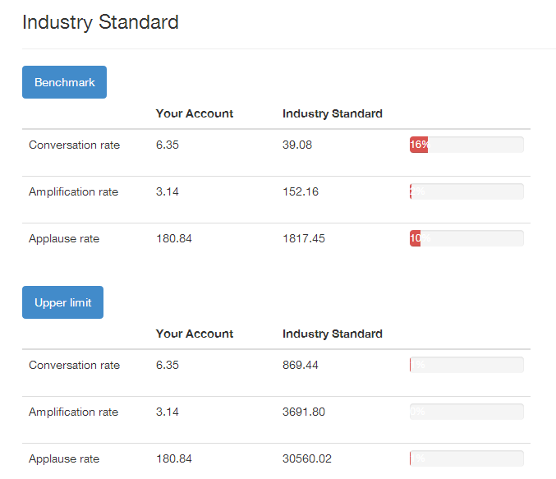
Figure 3. Facebook industry standard - Stylefruits NL (True social metrics, 2014)
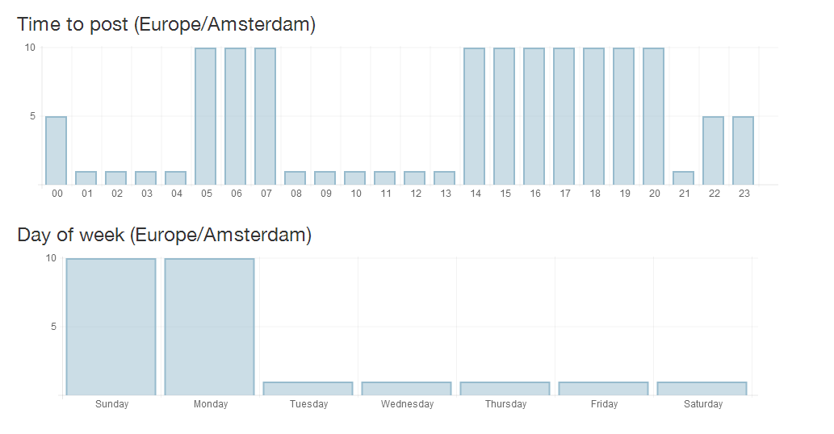
Figure 4. Best time to post on Facebook- Stylefruits NL (True social metrics, 2014)

1.3. HM- specific metrics
Table 5. Engagement on Facebook page per day
date | replies | reshares | likes | followers | engagement rate | relative eng. rate
24-04-14 | 93 | 192 | 14010 | 18519201 | 14295 | 7.72
25-04-14 | 49 | 105 | 5044 | 18545838 | 5198 | 2.8
26-04-14 | 0 | 0 | 0 | 1 | 0 | 0
27-04-14 | 0 | 0 | 0 | 1 | 0 | 0
28-04-14 | 406 | 499 | 31164 | 18599930 | 32069 | 17.24
29-04-14 | 214 | 560 | 31547 | 18594098 | 32321 | 17.38
30-04-14 | 186 | 131 | 12975 | 18589116 | 13292 | 7.15

Table 6. Engagement on Instagram page per day
date | replies | reshares | likes | followers | engagement rate | relative eng. rate
24-04-14 | 1142 | 2689 | 129526 | 1491389 | 133357 | 894.18
25-04-14 | 0 | 0 | 0 | 1 | 0 | 0
26-04-14 | 0 | 0 | 0 | 1 | 0 | 0
27-04-14 | 0 | 0 | 0 | 1 | 0 | 0
28-04-14 | 233 | 363 | 18599 | 2194944 | 19195 | 87.45
29-04-14 | 187 | 289 | 14240 | 2192652 | 14716 | 67.12
30-04-14 | 0 | 0 | 0 | 1 | 0 | 0

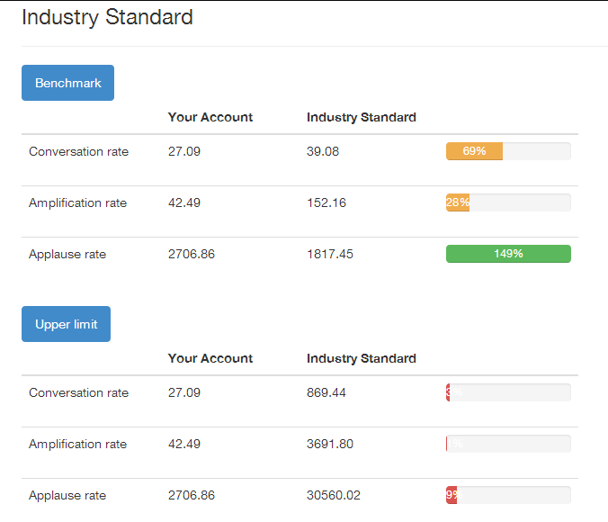
Figure 5. Facebook industry standard - HM (True social metrics, 2014)

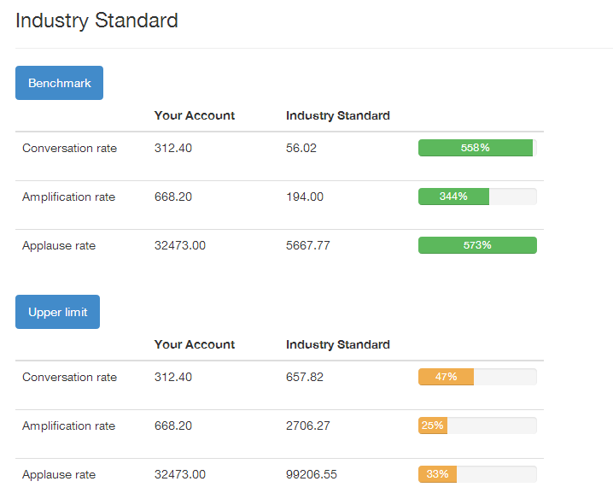
Figure 6. Instagram industry standard - HM (True social metrics, 2014)

Figure 7. Best time to post on Facebook - HM (True social metrics, 2014)
Figure 8. Best time to post on Instagram - HM (True social metrics, 2014)
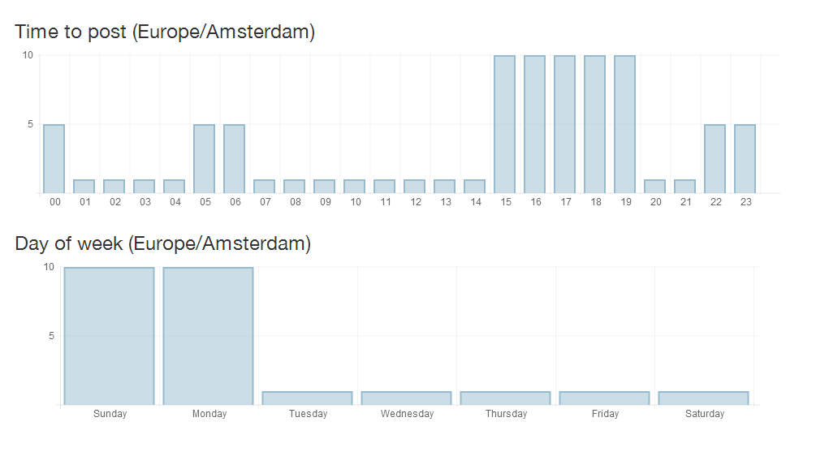
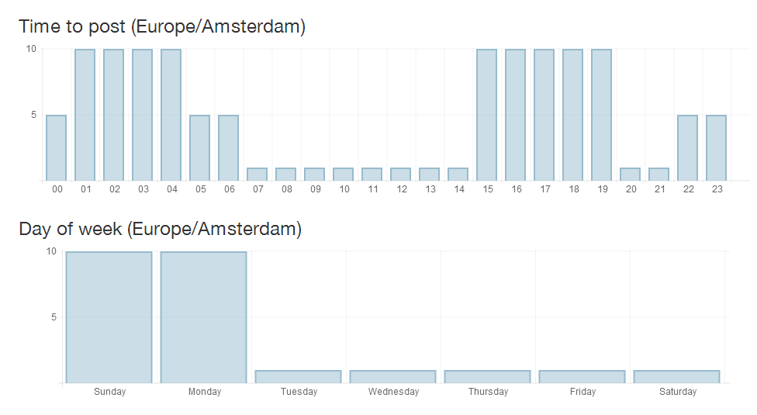

Appendix 2: Questionnaire
  - Content, published by clothing brands on Social Media
Hello All,
My name is Veselina Nedelcheva and this questionnaire is part of the research I am doing for my graduation assignment. The purpose is to discover the opinions and feelings of women about content that clothing brands publish daily! This survey is meant for all, who live in the Netherlands! It contains 15 questions and should not take more than 10 minutes.
I have arranged a gift voucher for a photo shoot at a professional studio (make-up included) for those you who want it!
The information, obtained by this survey will be used ONLY for the purpose of the research of the graduation assignment.
Thank you for deciding to fill in the survey!

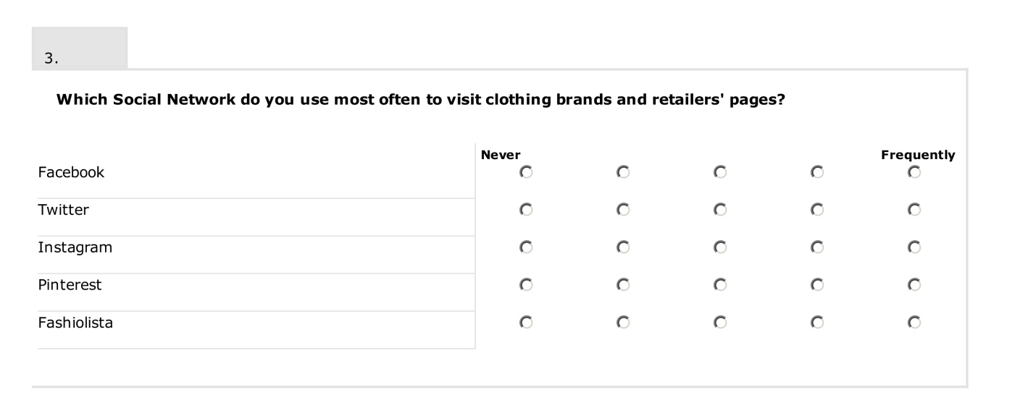
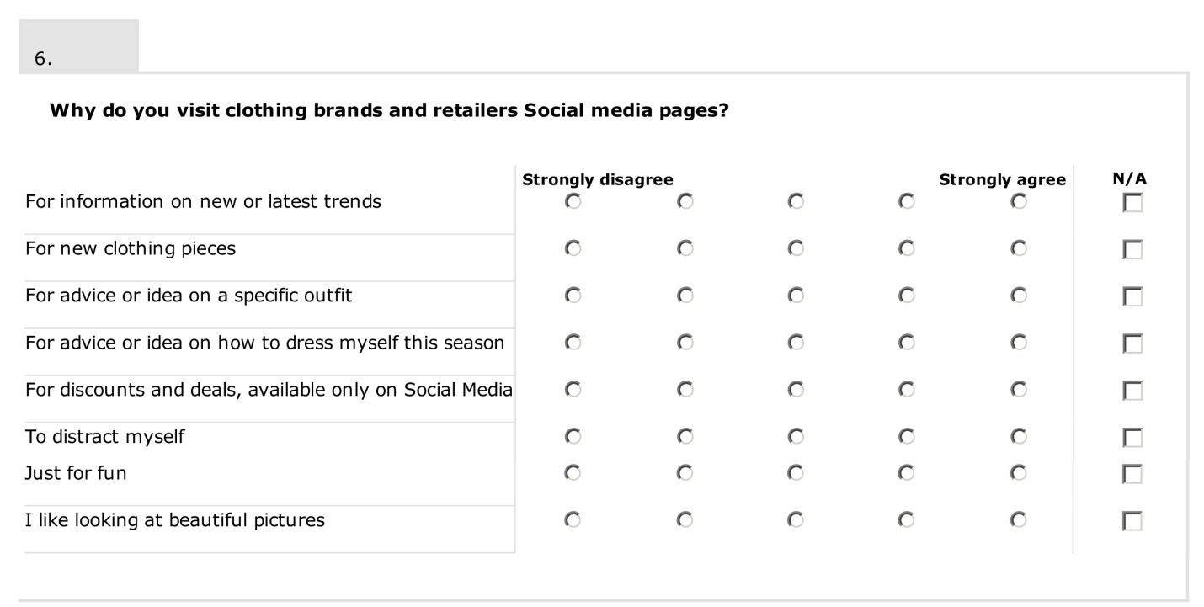
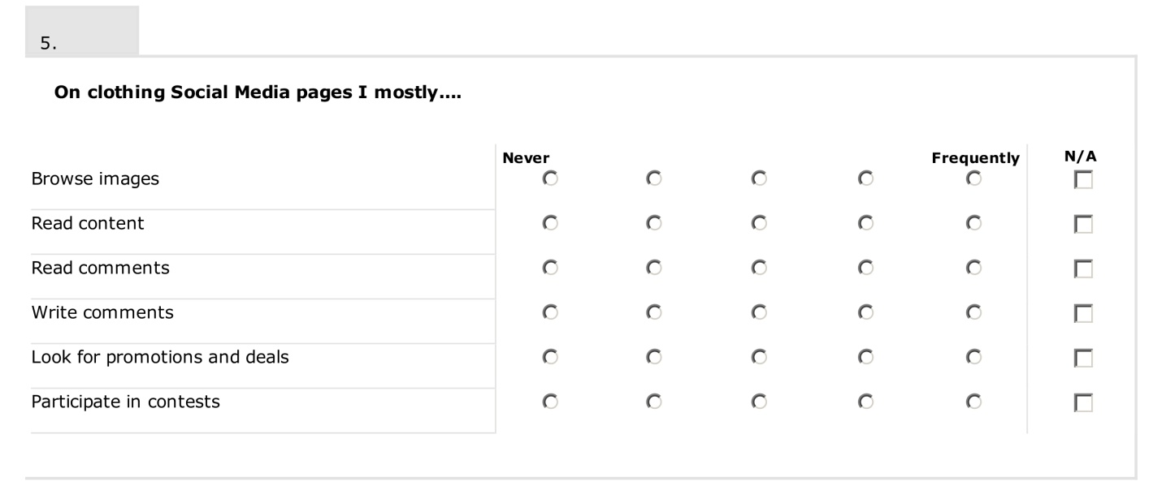
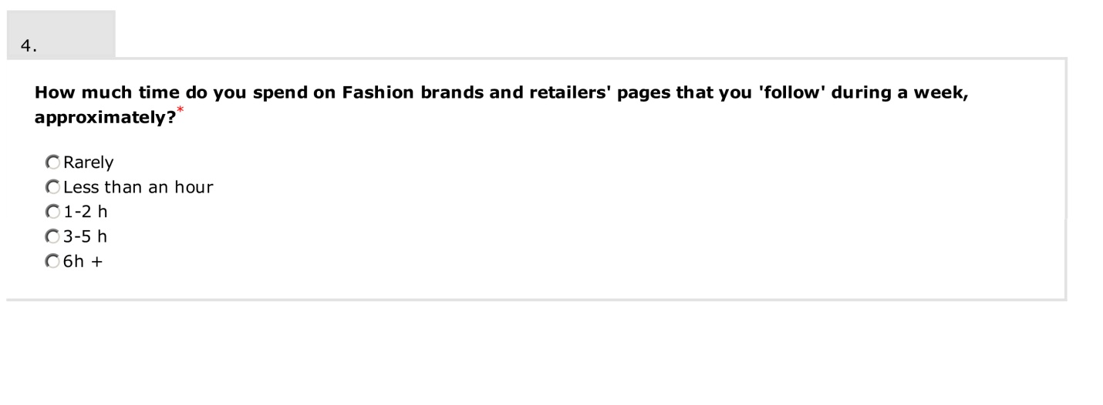
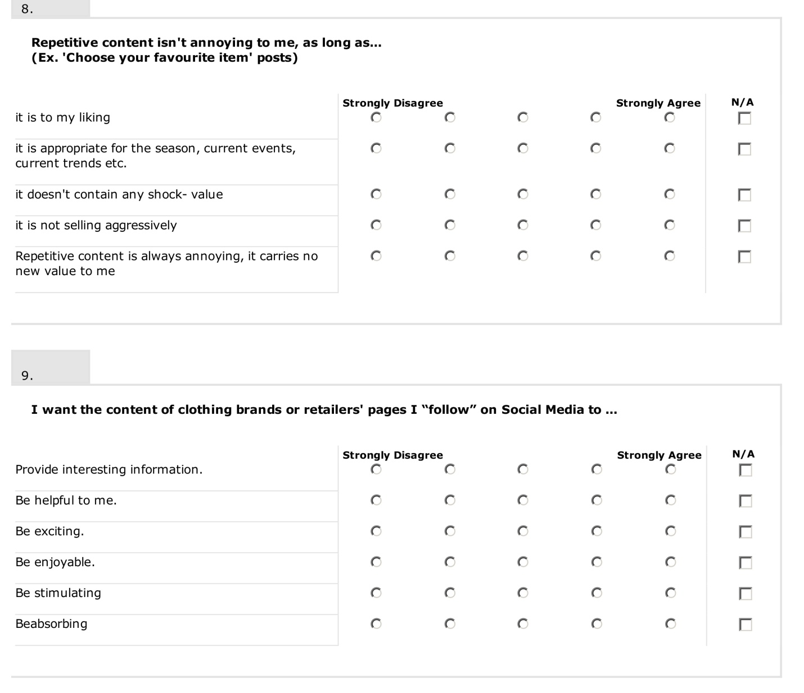
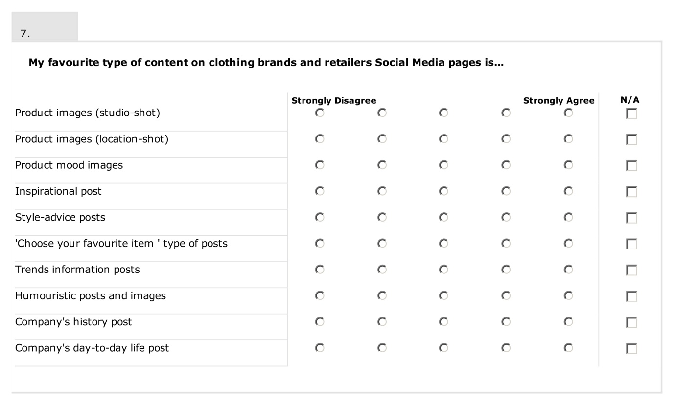
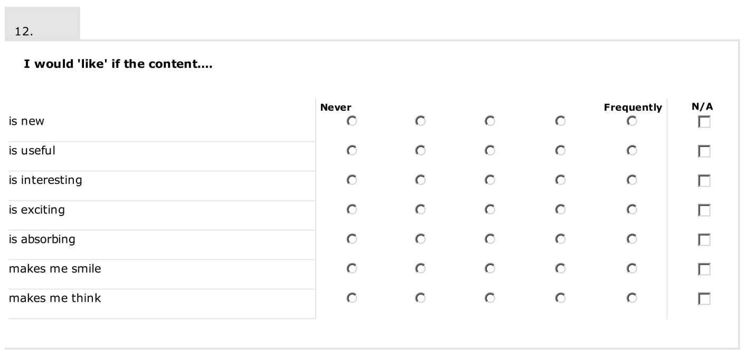
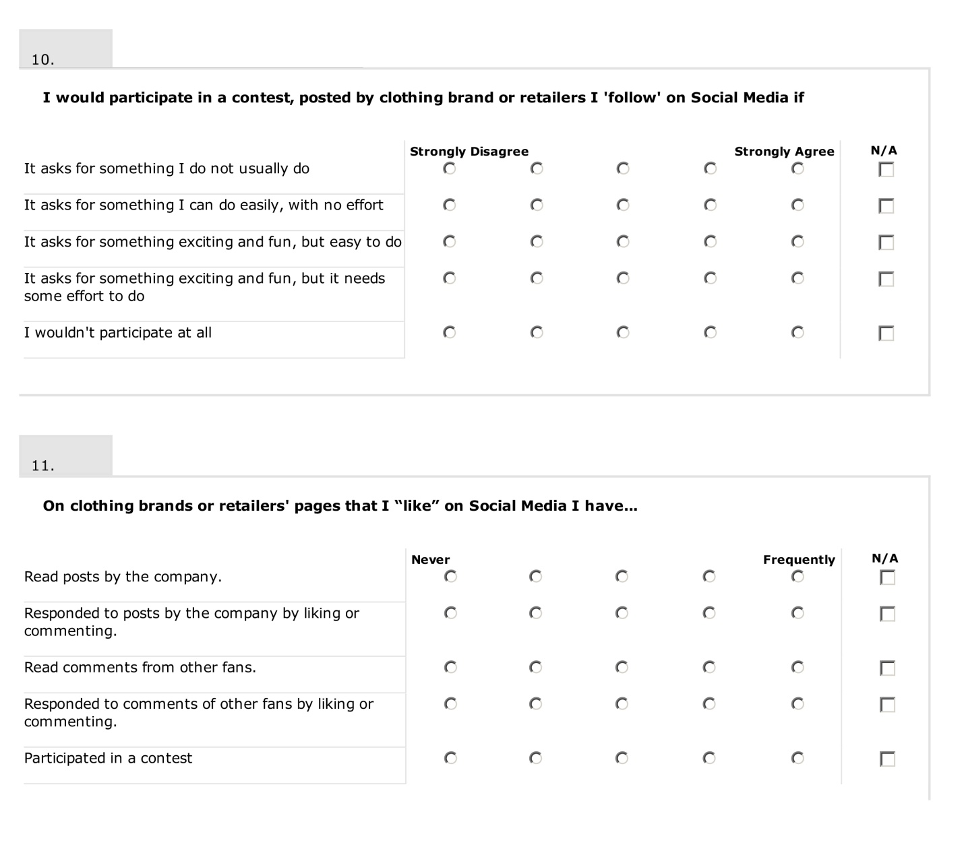
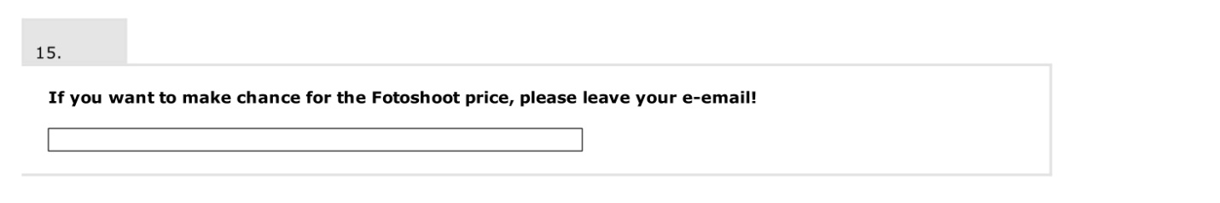
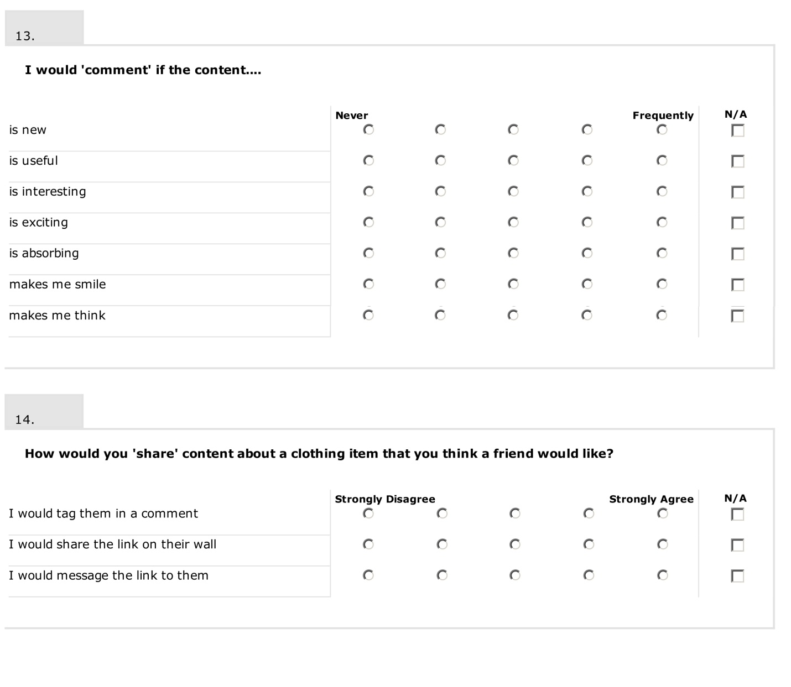

Thank you for participating!

Appendix 3: Questionnaire results

Appendix 3.1. Frequency tables and graphs
Table 1. Age of respondents
 |  | Count | Column N %
age | 20-25 | 58 | 74.4%
 | 26-30 | 20 | 25.6%
 | Total | 78 | 100.0%

Table 2. Social Network usage for visiting clothing brands' pages
 |  | Count | Column N %
Facebook | Never | 4 | 5.1%
 | Very rarely | 10 | 12.8%
 | Rarely | 13 | 16.7%
 | Occasionally | 21 | 26.9%
 | Frequently | 30 | 38.5%
 | Total | 78 | 100.0%
Twitter | Never | 50 | 69.4%
 | Very rarely | 13 | 18.1%
 | Rarely | 4 | 5.6%
 | Occasionally | 5 | 6.9%
 | Frequently | 0 | 0.0%
 | Total | 72 | 100.0%
Instagram | Never | 41 | 56.2%
 | Very rarely | 7 | 9.6%
 | Rarely | 6 | 8.2%
 | Occasionally | 14 | 19.2%
 | Frequently | 5 | 6.8%
 | Total | 73 | 100.0%
Pinterest | Never | 43 | 58.9%
 | Very rarely | 6 | 8.2%
 | Rarely | 10 | 13.7%
 | Occasionally | 10 | 13.7%
 | Frequently | 4 | 5.5%
 | Total | 73 | 100.0%
Fashiolista | Never | 59 | 81.9%
 | Very rarely | 9 | 12.5%
 | Rarely | 0 | 0.0%
 | Occasionally | 3 | 4.2%
 | Frequently | 1 | 1.4%
 | Total | 72 | 100.0%

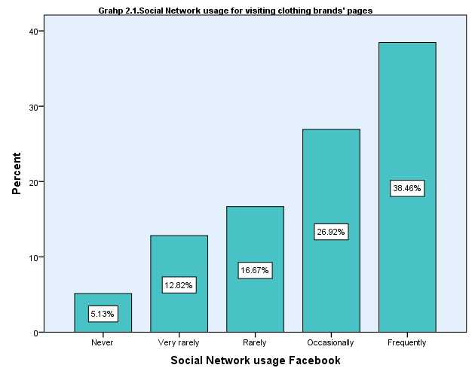

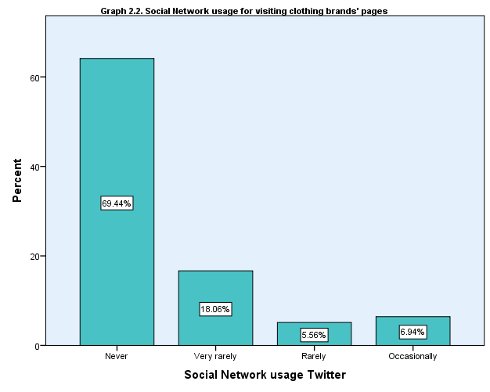

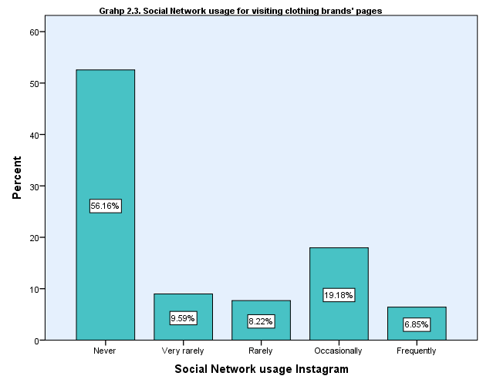

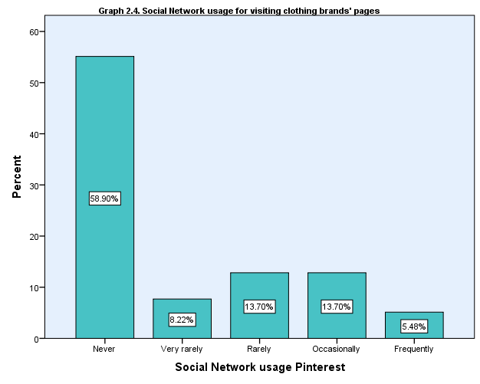

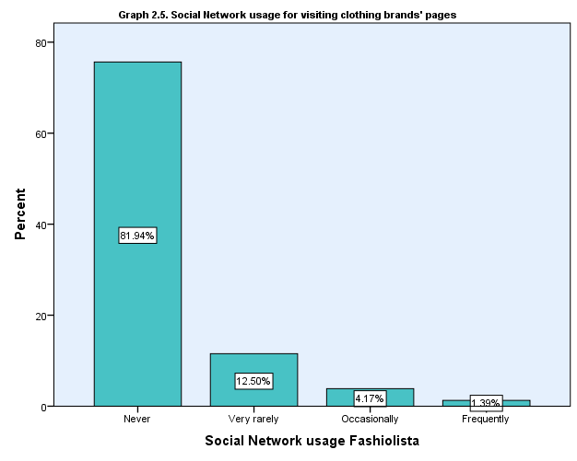

Table 3. Time spent on clothing brands' pages
 |  | Count | Column N %
Time spent of clothing brands' pages | Rarely | 20 | 25.6%
 | Less than an hour | 23 | 29.5%
 | 1-2h | 23 | 29.5%
 | 3-5h | 12 | 15.4%
 | 6h + | 0 | 0.0%
 | Total | 78 | 100.0%

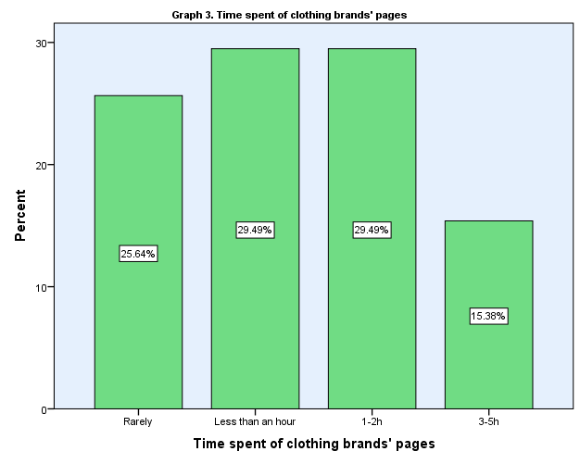

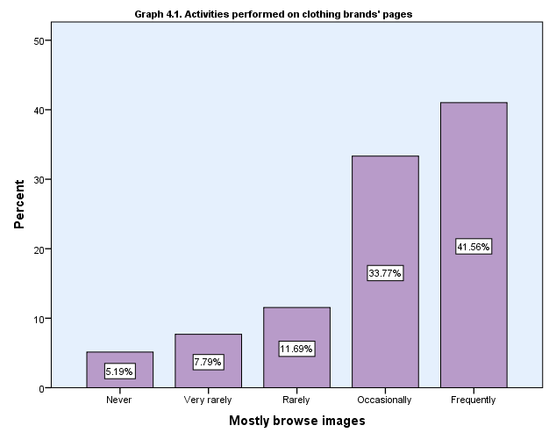
Table 4. Actions performed on clothing brands' pages
 |  | Count | Column N %
Mostly Browse images | Never | 4 | 5.2%
 | Very rarely | 6 | 7.8%
 | Rarely | 9 | 11.7%
 | Occasionally | 26 | 33.8%
 | Frequently | 32 | 41.6%
 | Total | 77 | 100.0%
Mostly Read content | Never | 11 | 14.5%
 | Very rarely | 14 | 18.4%
 | Rarely | 18 | 23.7%
 | Occasionally | 26 | 34.2%
 | Frequently | 7 | 9.2%
 | Total | 76 | 100.0%
Mostly Read comments | Never | 16 | 21.6%
 | Very rarely | 18 | 24.3%
 | Rarely | 22 | 29.7%
 | Occasionally | 13 | 17.6%
 | Frequently | 5 | 6.8%
 | Total | 74 | 100.0%
Mostly Write comments | Never | 28 | 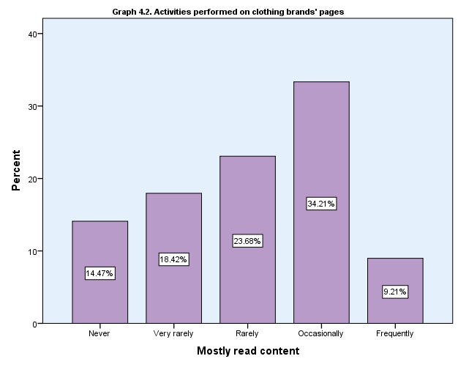  36.8%
 | Very rarely | 23 | 30.3%
 | Rarely | 17 | 22.4%
 | Occasionally | 8 | 10.5%
 | Frequently | 0 | 0.0%
 | Total | 76 | 100.0%
Mostly Look for promotions | Never | 9 | 12.2%
 | Very rarely | 15 | 20.3%
 | Rarely | 17 | 23.0%
 | Occasionally | 22 | 29.7%
 | Frequently | 11 | 14.9%
 | Total | 74 | 100.0%
Mostly Participate in contests | Never | 36 | 49.3%
 | Very rarely | 15 | 20.5%
 | Rarely | 13 | 17.8%
 | Occasionally | 4 | 5.5%
 | Frequently | 5 | 6.8%
 | Total | 73 | 100.0%

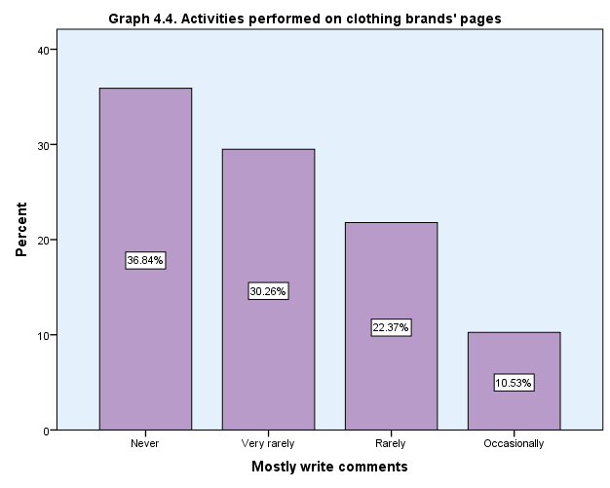
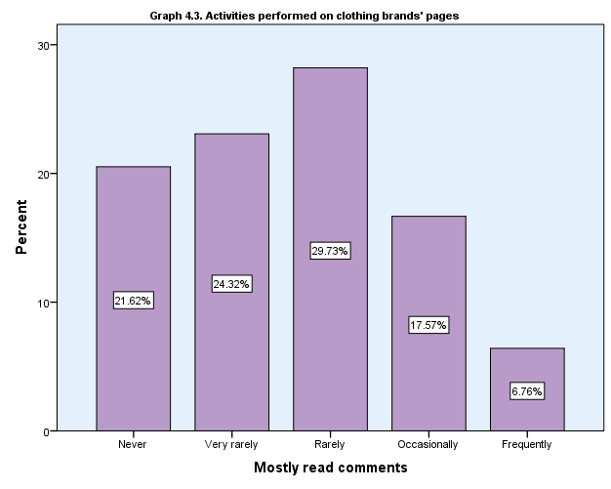

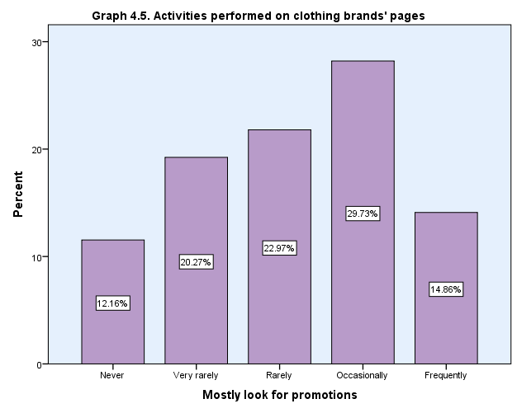

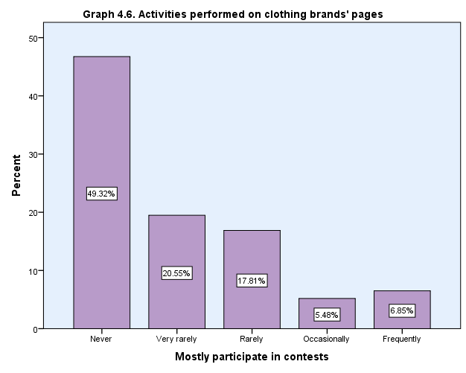

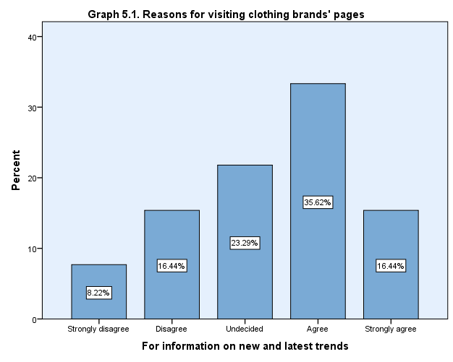
Table 5. Reasons for visiting clothing brands' pages
 |  | Count | Column N %
For information on new or latest trends | Strongly disagree | 6 | 8.2%
 | Disagree | 12 | 16.4%
 | Undecided | 17 | 23.3%
 | Agree | 26 | 35.6%
 | Strongly agree | 12 | 16.4%
 | Total | 73 | 100.0%
For new clothing pieces | Strongly disagree | 5 | 6.7%
 | Disagree | 9 | 12.0%
 | Undecided | 16 | 21.3%
 | Agree | 25 | 33.3%
 | Strongly agree | 20 | 26.7%
 | Total | 75 | 100.0%
For advice or idea on a specific outfit | Strongly disagree | 15 | 20.8%
 | Disagree | 14 | 19.4%
 | Undecided | 14 | 19.4%
 | Agree | 21 | 29.2%
 | Strongly agree | 8 | 11.1%
 | Total | 72 | 100.0%
For advice or idea on how to dress myself this season | Strongly disagree | 14 | 19.7%
 | Disagree | 20 | 28.2%
 | Undecided | 14 | 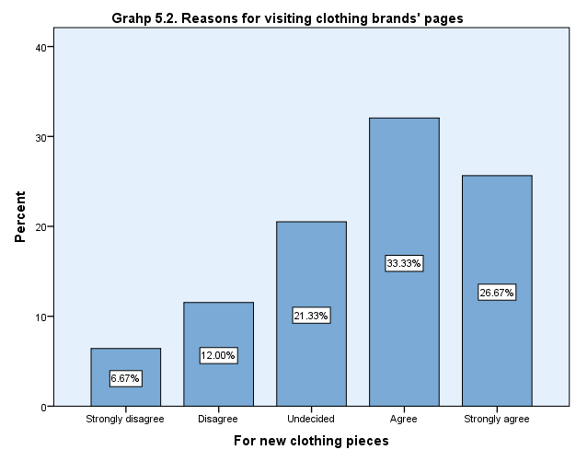  19.7%
 | Agree | 13 | 18.3%
 | Strongly agree | 10 | 14.1%
 | Total | 71 | 100.0%
For discounts and deals, available only on Social Media | Strongly disagree | 7 | 9.5%
 | Disagree | 17 | 23.0%
 | Undecided | 23 | 31.1%
 | Agree | 14 | 18.9%
 | Strongly agree | 13 | 17.6%
 | Total | 74 | 100.0%
To distract myself | Strongly disagree | 8 | 10.5%
 | Disagree | 9 | 11.8%
 | Undecided | 13 | 17.1%
 | Agree | 29 | 38.2%
 | Strongly agree | 17 | 22.4%
 | Total | 76 | 100.0%
Just for fun | Strongly disagree | 4 | 5.3%
 | Disagree | 6 | 7.9%
 | Undecided | 15 | 19.7%
 | Agree | 29 | 38.2%
 | Strongly agree | 22 | 28.9%
 | Total | 76 | 100.0%
I like looking at beautiful pictures | Strongly disagree | 6 | 8.2%
 | Disagree | 12 | 16.4%
 | Undecided | 21 | 28.8%
 | Agree | 16 | 21.9%
 | Strongly agree | 18 | 24.7%
 | Total | 73 | 100.0%
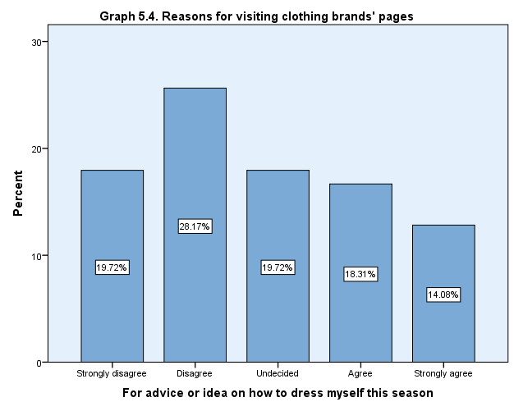
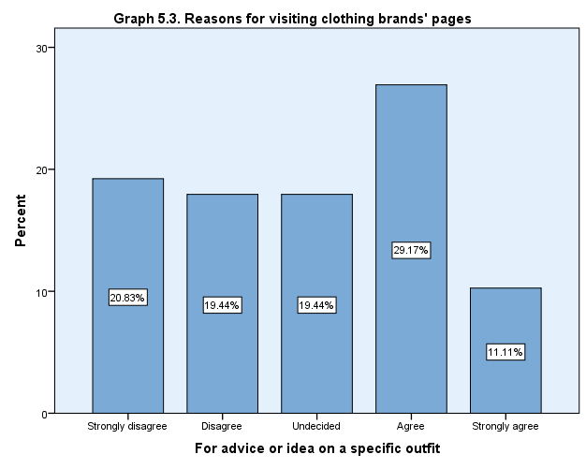
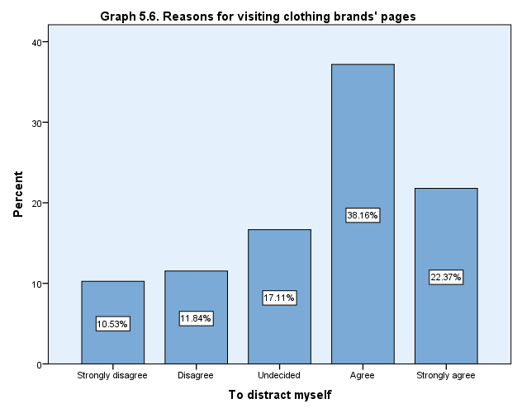
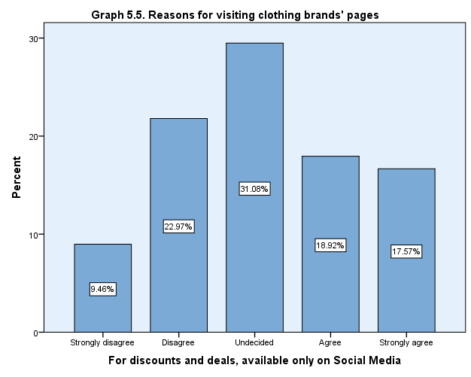
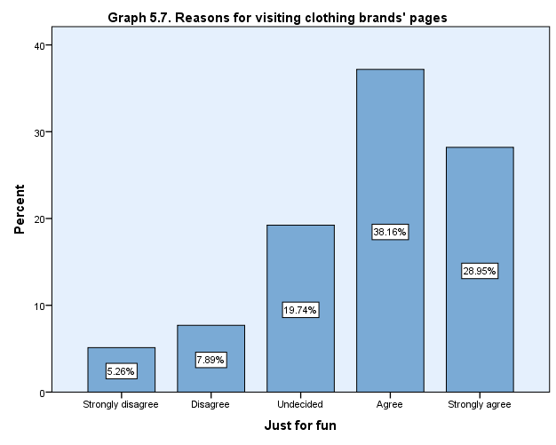

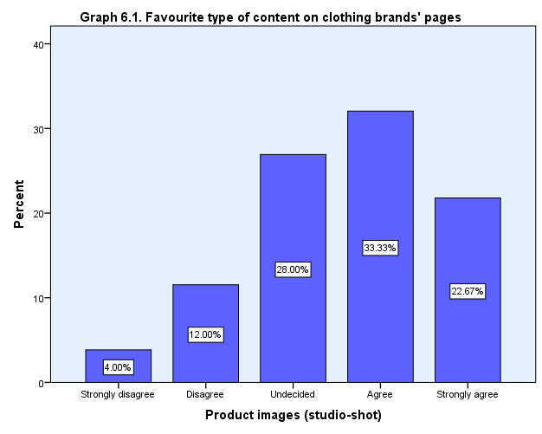
Table 6. Favourite type of content on clothing brands' pages
 |  | Count | Column N %
Product images (studio-shot) | Strongly disagree | 3 | 4.0%
 | Disagree | 9 | 12.0%
 | Undecided | 21 | 28.0%
 | Agree | 25 | 33.3%
 | Strongly agree | 17 | 22.7%
 | Total | 75 | 100.0%
Product images (location-shot) | Strongly disagree | 0 | 0.0%
 | Disagree | 2 | 2.7%
 | Undecided | 14 | 18.7%
 | Agree | 35 | 46.7%
 | Strongly agree | 24 | 32.0%
 | Total | 75 | 100.0%
Product mood images | Strongly disagree | 0 | 0.0%
 | Disagree | 5 | 6.9%
 | Undecided | 23 | 31.9%
 | Agree | 30 | 41.7%
 | Strongly agree | 14 | 19.4%
 | Total | 72 | 100.0%
Inspirational post | Strongly disagree | 4 | 5.3%
 | Disagree | 16 | 21.1%
 | Undecided | 21 | 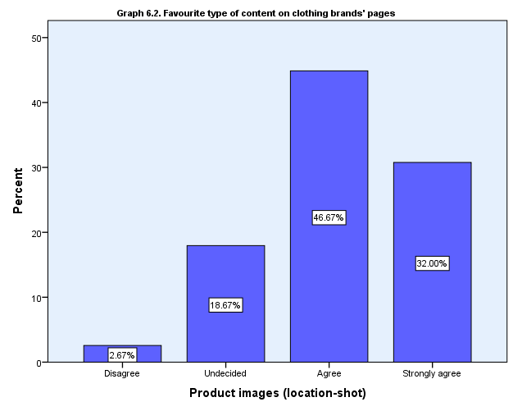  27.6%
 | Agree | 24 | 31.6%
 | Strongly agree | 11 | 14.5%
 | Total | 76 | 100.0%
Style-advice posts | Strongly disagree | 0 | 0.0%
 | Disagree | 15 | 19.2%
 | Undecided | 23 | 29.5%
 | Agree | 25 | 32.1%
 | Strongly agree | 15 | 19.2%
 | Total | 78 | 100.0%
'Choose your favourite item ' type of posts | Strongly disagree | 10 | 13.3%
 | Disagree | 29 | 38.7%
 | Undecided | 18 | 24.0%
 | Agree | 14 | 18.7%
 | Strongly agree | 4 | 5.3%
 | Total | 75 | 100.0%
Trends information posts | Strongly disagree | 3 | 4.0%
 | Disagree | 9 | 12.0%
 | Undecided | 32 | 42.7%
 | Agree | 22 | 29.3%
 | Strongly agree | 9 | 12.0%
 | Total | 75 | 100.0%
Humouristic posts and images | Strongly disagree | 5 | 6.6%
 | Disagree | 12 | 15.8%
 | Undecided | 25 | 32.9%
 | Agree | 25 | 32.9%
 | Strongly agree | 9 | 11.8%
 | Total | 76 | 100.0%
Company's history post | Strongly disagree | 17 | 23.3%
 | Disagree | 34 | 46.6%
 | Undecided | 16 | 21.9%
 | Agree | 6 | 8.2%
 | Strongly agree | 0 | 0.0%
 | Total | 73 | 100.0%
Company's day-to-day life post | Strongly disagree | 14 | 19.4%
 | Disagree | 22 | 30.6%
 | Undecided | 26 | 36.1%
 | Agree | 8 | 11.1%
 | Strongly agree | 2 | 2.8%
 | Total | 72 | 100.0%

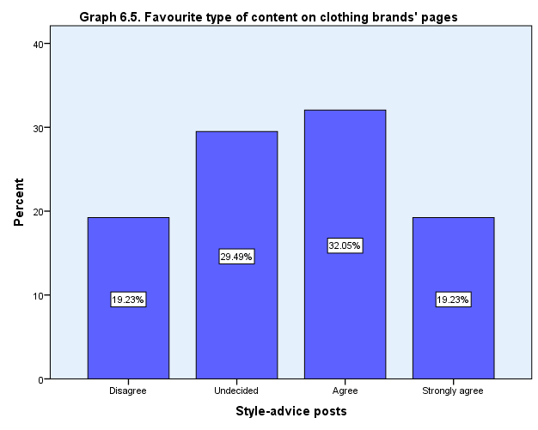
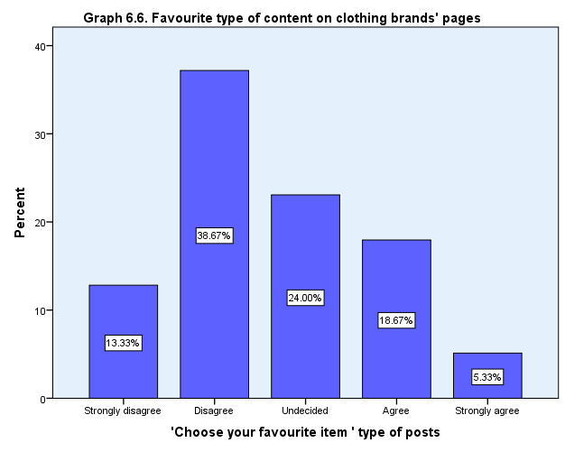
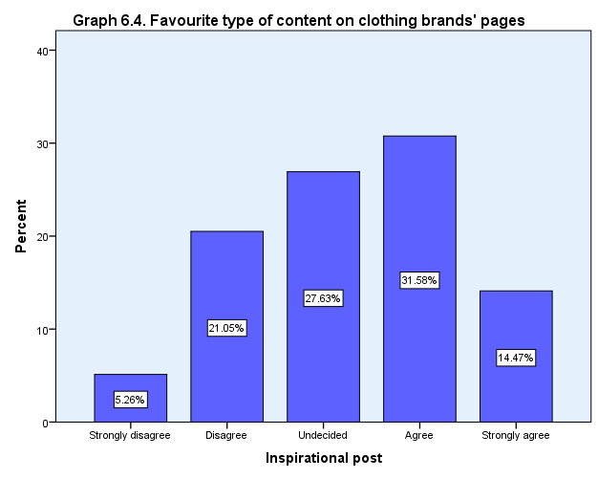
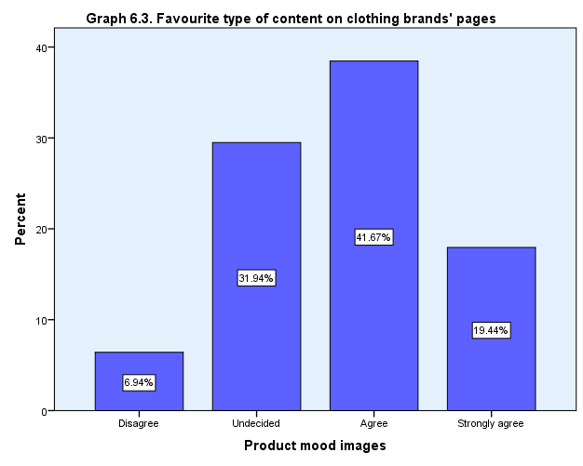

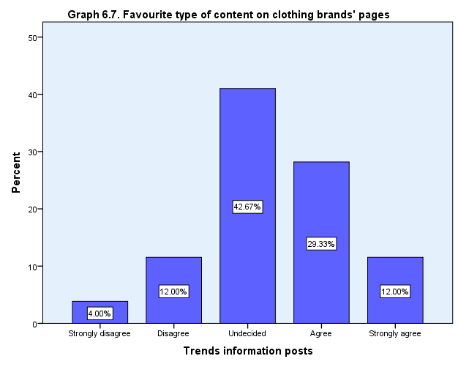
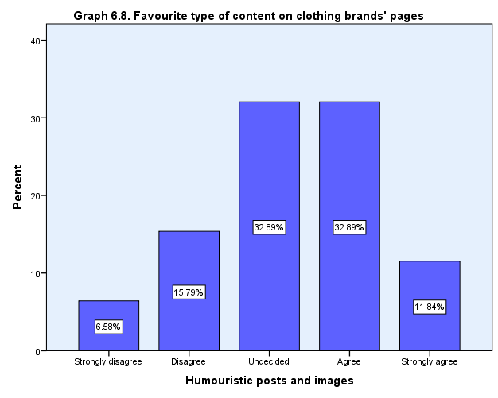

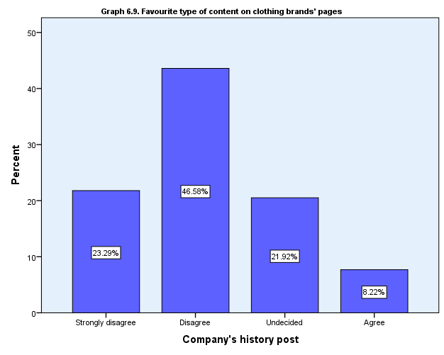

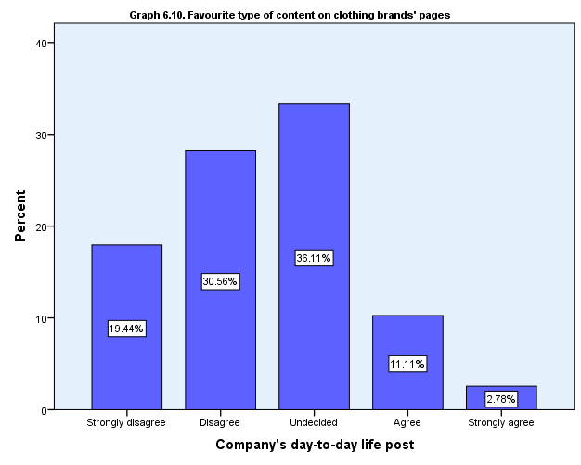

Table 7. Attitudes towards types of repetitive content
 |  | Count | 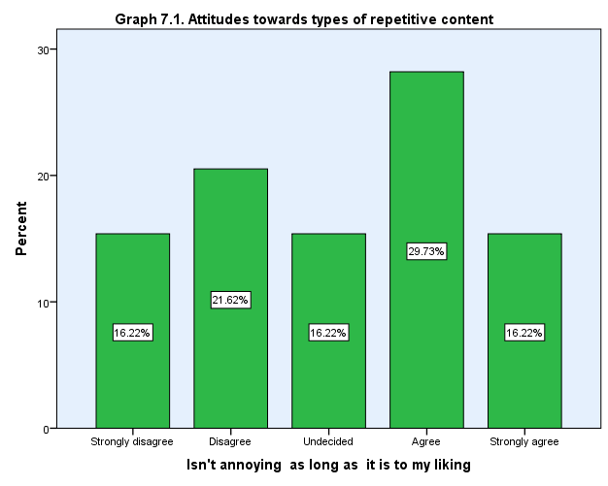  Column N %
Repetitive content isn't annoying as long as it is to my liking | Strongly disagree | 12 | 16.2%
 | Disagree | 16 | 21.6%
 | Undecided | 12 | 16.2%
 | Agree | 22 | 29.7%
 | Strongly agree | 12 | 16.2%
 | Total | 74 | 100.0%
Repetitive content isn't annoying as long as appropriate for the season, current events, current trends | Strongly disagree | 12 | 16.7%
 | Disagree | 18 | 25.0%
 | Undecided | 20 | 27.8%
 | Agree | 19 | 26.4%
 | Strongly agree | 3 | 4.2%
 | Total | 72 | 100.0%
Repetitive content isn't annoying as long as it is not selling aggressively | Strongly disagree | 15 | 20.5%
 | Disagree | 7 | 9.6%
 | Undecided | 13 | 17.8%
 | Agree | 21 | 28.8%
 | Strongly agree | 17 | 23.3%
 | Total | 73 | 100.0%
Repetitive content is always annoying, it carries no new value to me | Strongly disagree | 10 | 13.7%
 | Disagree | 13 | 17.8%
 | Undecided | 13 | 17.8%
 | Agree | 14 | 19.2%
 | Strongly agree | 23 | 31.5%
 | Total | 73 | 100.0%
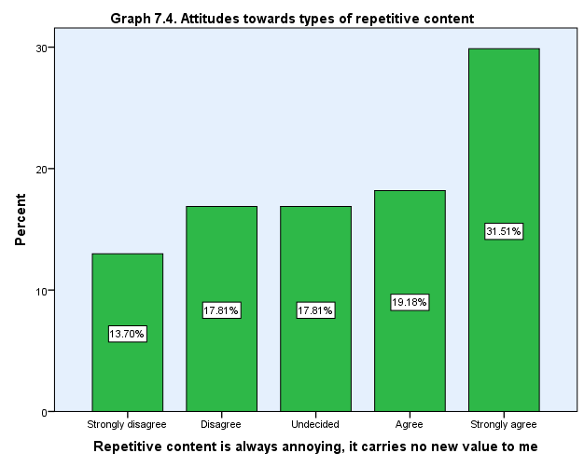
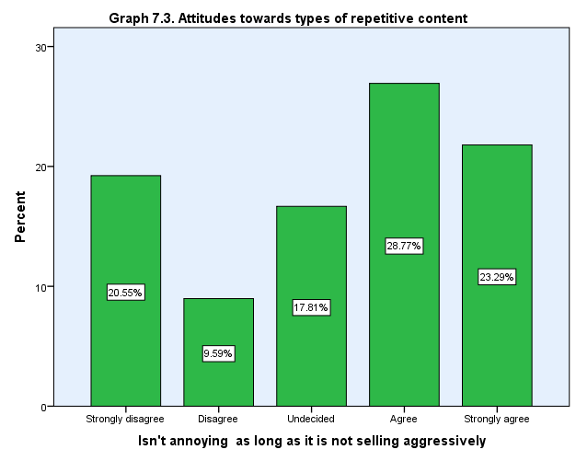
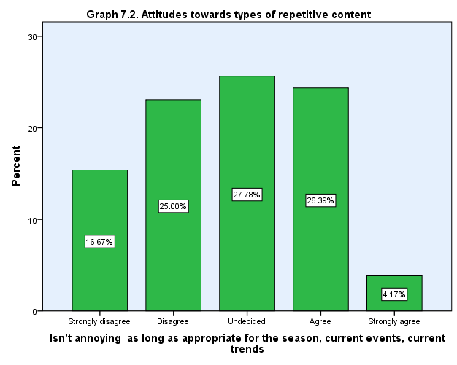

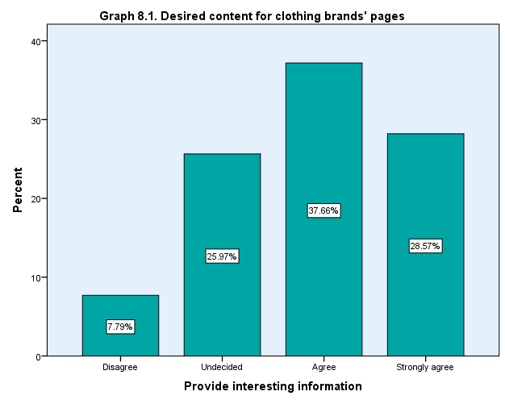
Table 8. Desired content for clothing brands' pages
 |  | Count | Column N %
Provide interesting information | Strongly disagree | 0 | 0.0%
 | Disagree | 6 | 7.8%
 | Undecided | 20 | 26.0%
 | Agree | 29 | 37.7%
 | Strongly agree | 22 | 28.6%
 | Total | 77 | 100.0%
Be helpful to me | Strongly disagree | 1 | 1.3%
 | Disagree | 13 | 16.7%
 | Undecided | 16 | 20.5%
 | Agree | 31 | 39.7%
 | Strongly agree | 17 | 21.8%
 | Total | 78 | 100.0%
Be exciting | Strongly disagree | 2 | 2.6%
 | Disagree | 11 | 14.3%
 | Undecided | 15 | 19.5%
 | Agree | 27 | 35.1%
 | Strongly agree | 22 | 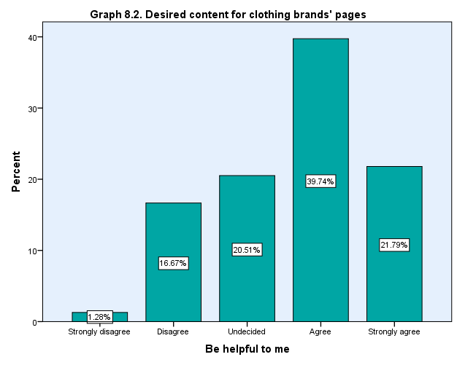  28.6%
 | Total | 77 | 100.0%
Be enjoyable | Strongly disagree | 2 | 2.6%
 | Disagree | 10 | 12.8%
 | Undecided | 9 | 11.5%
 | Agree | 28 | 35.9%
 | Strongly agree | 29 | 37.2%
 | Total | 78 | 100.0%
Be stimulating | Strongly disagree | 2 | 2.6%
 | Disagree | 13 | 16.7%
 | Undecided | 14 | 17.9%
 | Agree | 27 | 34.6%
 | Strongly agree | 22 | 28.2%
 | Total | 78 | 100.0%
Be absorbing | Strongly disagree | 3 | 4.1%
 | Disagree | 19 | 25.7%
 | Undecided | 27 | 36.5%
 | Agree | 14 | 18.9%
 | Strongly agree | 11 | 14.9%
 | Total | 74 | 100.0%

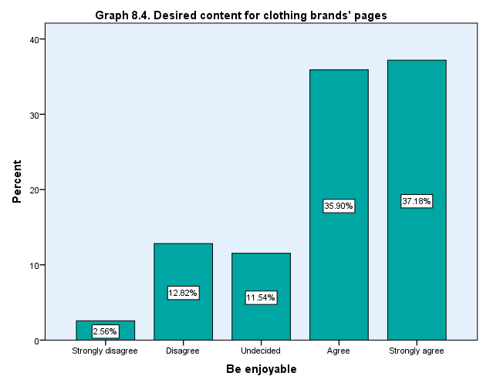
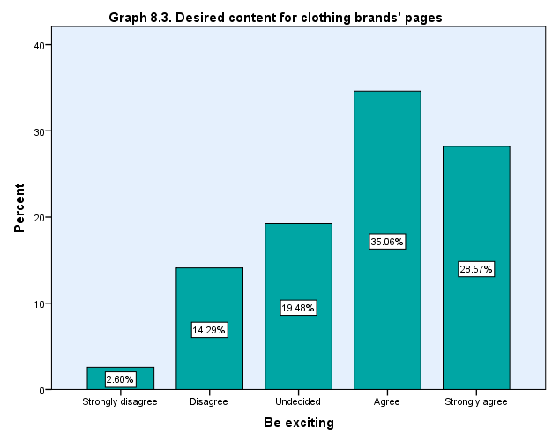

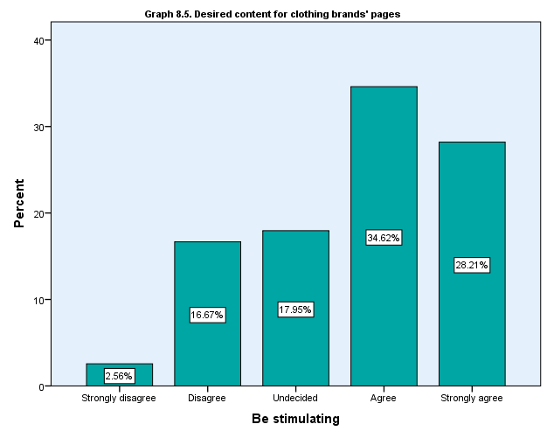

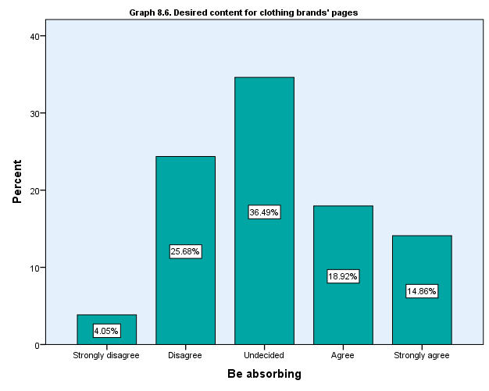

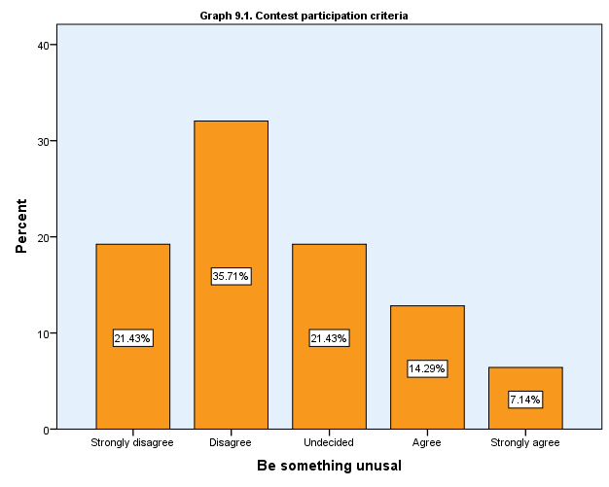
Table 9. Contest participation criteria
 |  | Count | Column N %
Something unusual | Strongly disagree | 15 | 21.4%
 | Disagree | 25 | 35.7%
 | Undecided | 15 | 21.4%
 | Agree | 10 | 14.3%
 | Strongly agree | 5 | 7.1%
 | Total | 70 | 100.0%
Something easy to do | Strongly disagree | 5 | 7.1%
 | Disagree | 9 | 12.9%
 | Undecided | 7 | 10.0%
 | Agree | 28 | 40.0%
 | Strongly agree | 21 | 30.0%
 | Total | 70 | 100.0%
Exciting and fun, but easy to do | Strongly disagree | 4 | 5.4%
 | Disagree | 8 | 10.8%
 | Undecided | 7 | 9.5%
 | Agree | 35 | 47.3%
 | Strongly agree | 20 | 27.0%
 | Total | 74 | 100.0%
Exciting and fun, but needs some effort | Strongly disagree | 14 | 20.0%
 | Disagree | 18 | 25.7%
 | Undecided | 12 | 17.1%
 | Agree | 23 | 32.9%
 | Strongly agree | 3 | 4.3%
 | Total | 70 | 100.0%
Wouldn't' t participate | Strongly disagree | 13 | 26.5%
 | Disagree | 9 | 18.4%
 | Undecided | 14 | 28.6%
 | Agree | 8 | 16.3%
 | Strongly agree | 5 | 10.2%
 | Total | 49 | 100.0%

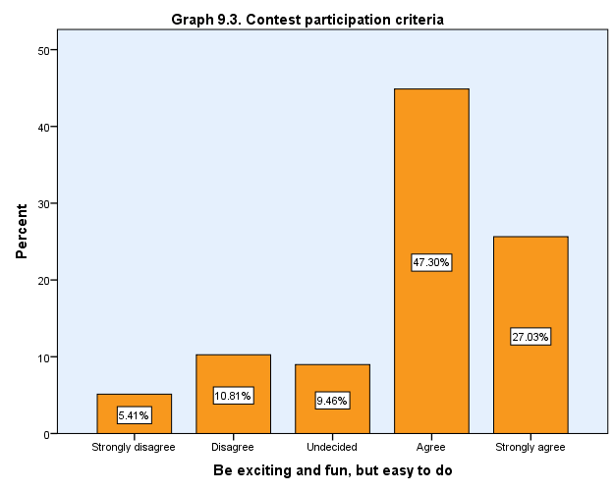
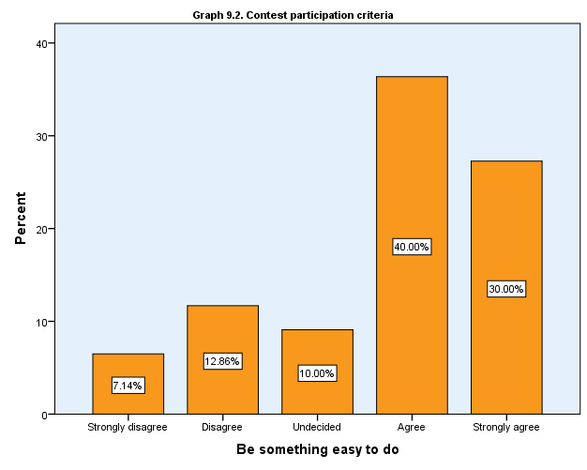

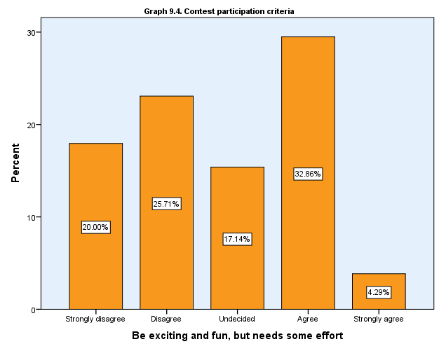

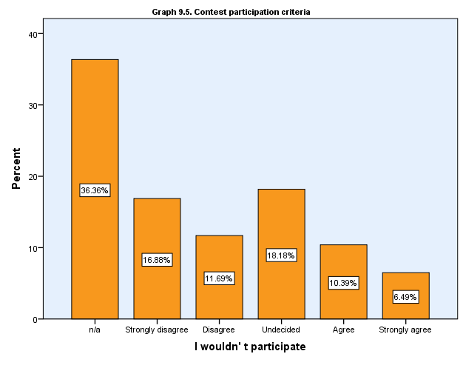

Table 10. Activities performed in the past on clothing brands' pages
 |  | Count | Column N %
Read posts by the company | Never | 10 | 13.2%
 | Very rarely | 12 | 15.8%
 | Rarely | 17 | 22.4%
 | Occasionally | 25 | 32.9%
 | Frequently | 12 | 15.8%
 | Total | 76 | 100.0%
Responded to posts by the company by liking or commenting | Never | 22 | 28.9%
 | Very rarely | 18 | 23.7%
 | Rarely | 12 | 15.8%
 | Occasionally | 21 | 27.6%
 | Frequently | 3 | 3.9%
 | Total | 76 | 100.0%
Read comments from other fans. | Never | 12 | 15.8%
 | Very rarely | 20 | 26.3%
 | Rarely | 21 | 27.6%
 | Occasionally | 16 | 21.1%
 | Frequently | 7 | 9.2%
 | Total | 76 | 100.0%
Responded to comments of other fans by liking or commenting | Never | 38 | 50.0%
 | Very rarely | 18 | 23.7%
 | Rarely | 13 | 17.1%
 | Occasionally | 4 | 5.3%
 | Frequently | 3 | 3.9%
 | Total | 76 | 100.0%
Participated in a contest | Never | 25 | 32.9%
 | Very rarely | 13 | 17.1%
 | Rarely | 24 | 31.6%
 | Occasionally | 5 | 6.6%
 | Frequently | 9 | 11.8%
 | Total | 76 | 100.0%
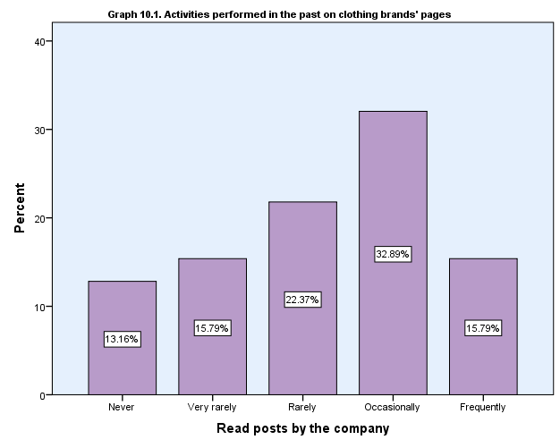

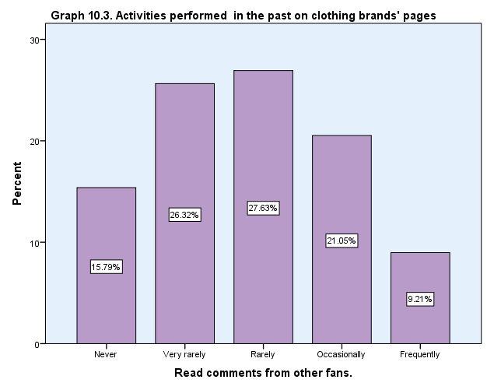
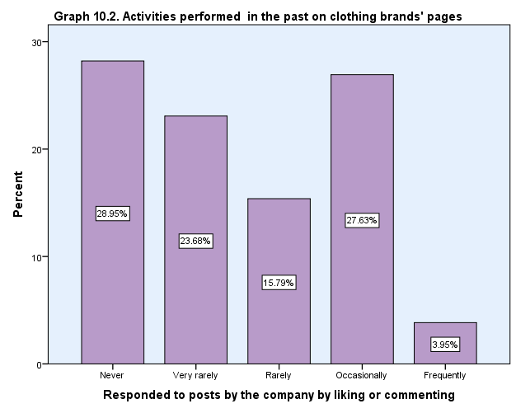

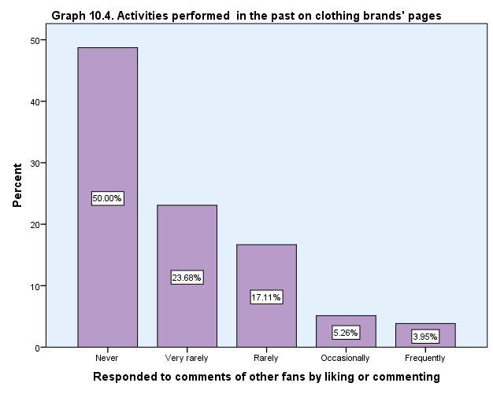

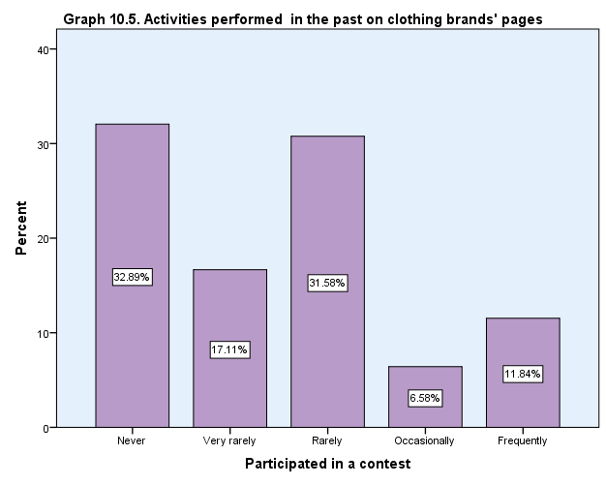

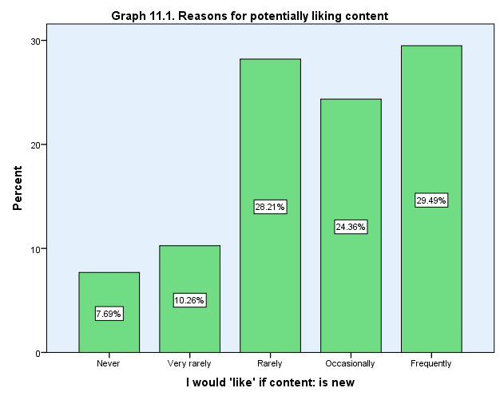
Table 11. Reasons for potentially liking content
 |  | Count | Column N %
If content: is new | Never | 6 | 7.7%
 | Very rarely | 8 | 10.3%
 | Rarely | 22 | 28.2%
 | Occasionally | 19 | 24.4%
 | Frequently | 23 | 29.5%
 | Total | 78 | 100.0%
If content: is useful | Never | 2 | 2.8%
 | Very rarely | 5 | 7.0%
 | Rarely | 8 | 11.3%
 | Occasionally | 33 | 46.5%
 | Frequently | 23 | 32.4%
 | Total | 71 | 100.0%
If content: is interesting | Never | 2 | 2.6%
 | Very rarely | 5 | 6.4%
 | Rarely | 7 | 9.0%
 | Occasionally | 31 | 39.7%
 | Frequently | 33 | 42.3%
 | Total | 78 | 100.0%
If content: is exciting | Never | 3 | 3.8%
 | Very rarely | 5 | 6.4%
 | Rarely | 7 | 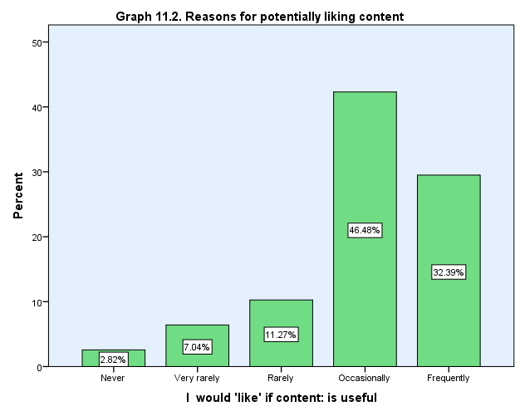  9.0%
 | Occasionally | 37 | 47.4%
 | Frequently | 26 | 33.3%
 | Total | 78 | 100.0%
If content: is absorbing | Never | 8 | 11.0%
 | Very rarely | 8 | 11.0%
 | Rarely | 21 | 28.8%
 | Occasionally | 25 | 34.2%
 | Frequently | 11 | 15.1%
 | Total | 73 | 100.0%
If content: makes me smile | Never | 2 | 2.6%
 | Very rarely | 3 | 3.8%
 | Rarely | 7 | 9.0%
 | Occasionally | 34 | 43.6%
 | Frequently | 32 | 41.0%
 | Total | 78 | 100.0%
If content: makes me think | Never | 4 | 5.3%
 | Very rarely | 7 | 9.2%
 | Rarely | 13 | 17.1%
 | Occasionally | 33 | 43.4%
 | Frequently | 19 | 25.0%
 | Total | 76 | 100.0%
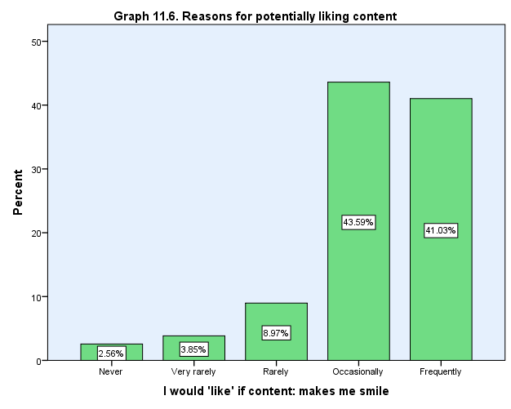
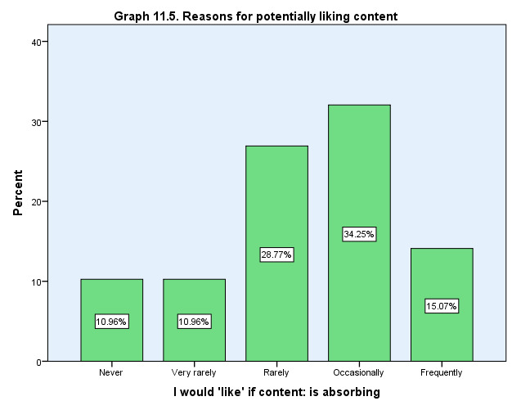
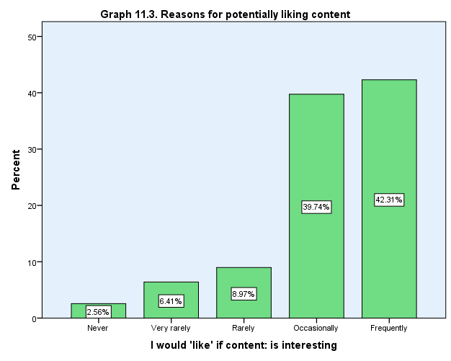
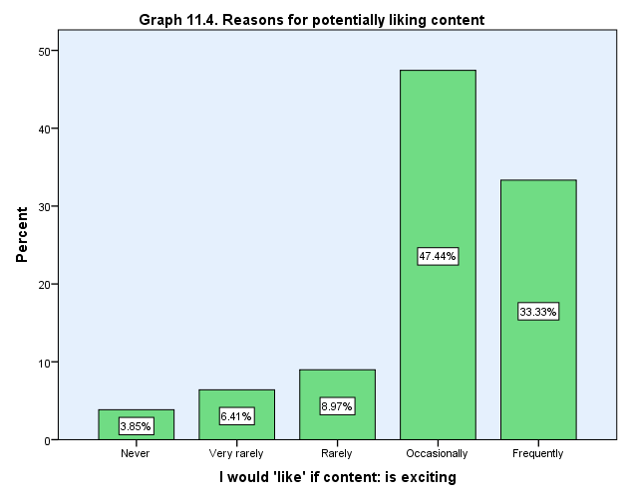
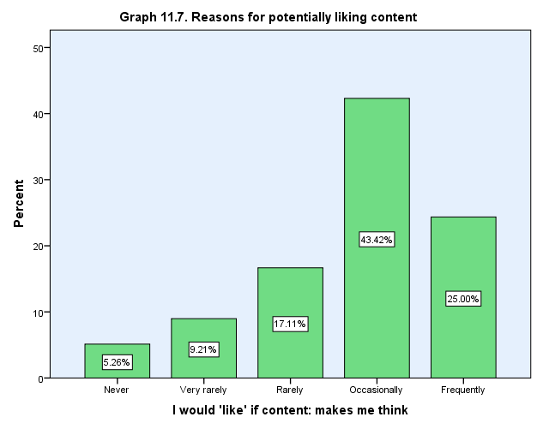

Table 12. Reasons for potentially commenting on content
 |  | Count | Column N %
If content: is new | Never | 11 | 19.3%
 | Very rarely | 18 | 31.6%
 | Rarely | 15 | 26.3%
 | Occasionally | 4 | 7.0%
 | Frequently | 9 | 15.8%
 | Total | 57 | 100.0%
If content: is useful | Never | 7 | 11.3%
 | Very rarely | 21 | 33.9%
 | Rarely | 19 | 30.6%
 | Occasionally | 8 | 12.9%
 | Frequently | 7 | 11.3%
 | Total | 62 | 100.0%
If content: is interesting | Never | 8 | 12.9%
 | Very rarely | 14 | 22.6%
 | Rarely | 24 | 38.7%
 | Occasionally | 12 | 19.4%
 | Frequently | 4 | 6.5%
 | Total | 62 | 100.0%
If content: is exciting | Never | 10 | 16.1%
 | Very rarely | 18 | 29.0%
 | Rarely | 14 | 22.6%
 | Occasionally | 16 | 25.8%
 | Frequently | 4 | 6.5%
 | Total | 62 | 100.0%
If content: is absorbing | Never | 15 | 25.0%
 | Very rarely | 21 | 35.0%
 | Rarely | 8 | 13.3%
 | Occasionally | 13 | 21.7%
 | Frequently | 3 | 5.0%
 | Total | 60 | 100.0%
If content: makes me smile | Never | 14 | 22.6%
 | Very rarely | 17 | 27.4%
 | Rarely | 18 | 29.0%
 | Occasionally | 4 | 6.5%
 | Frequently | 9 | 14.5%
 | Total | 62 | 100.0%
If content: makes me think | Never | 11 | 18.3%
 | Very rarely | 15 | 25.0%
 | Rarely | 16 | 26.7%
 | Occasionally | 12 | 20.0%
 | Frequently | 6 | 10.0%
 | Total | 60 | 100.0%
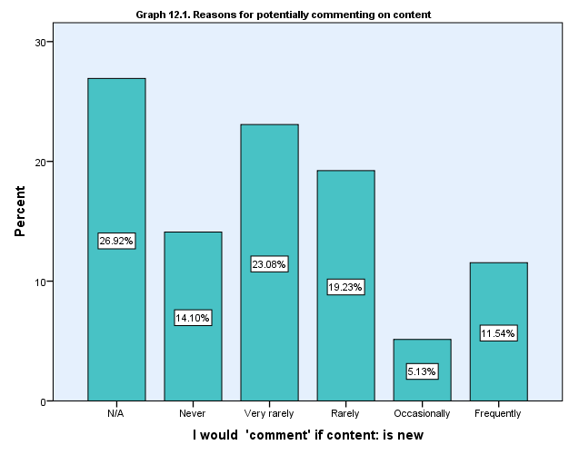

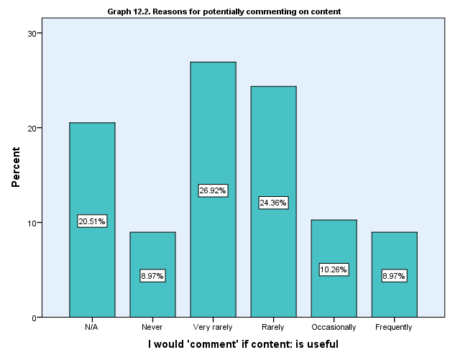

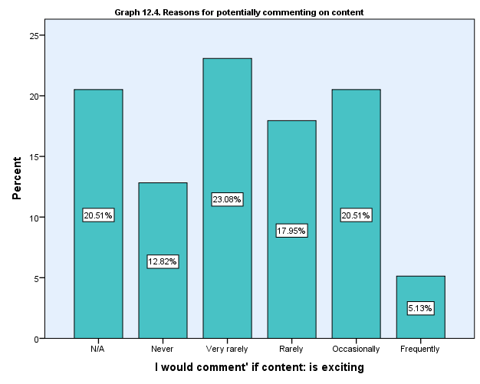
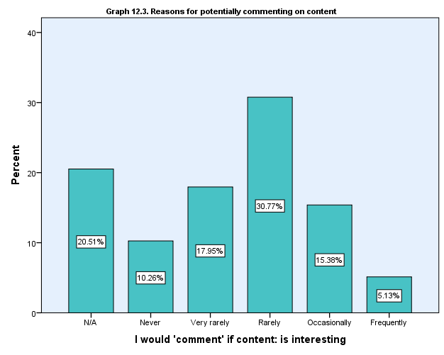

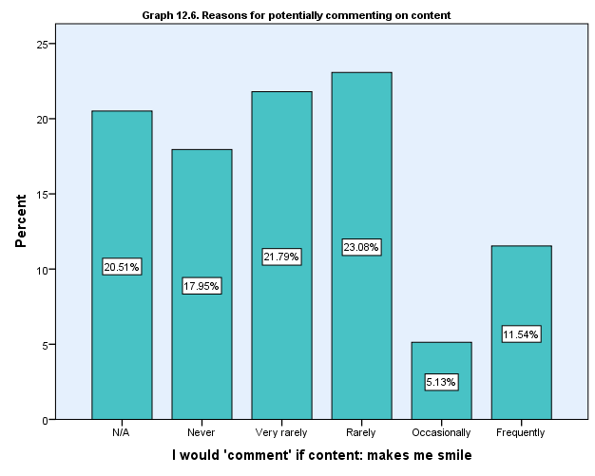
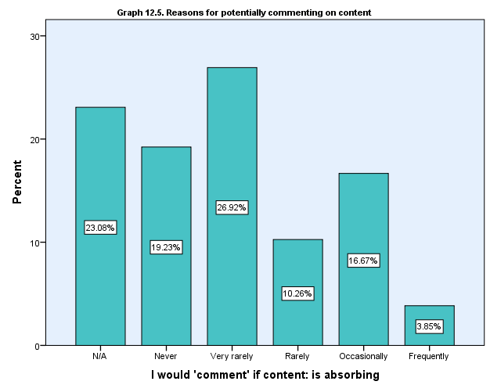
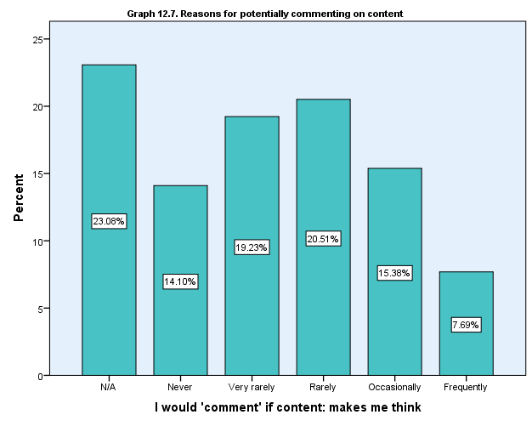

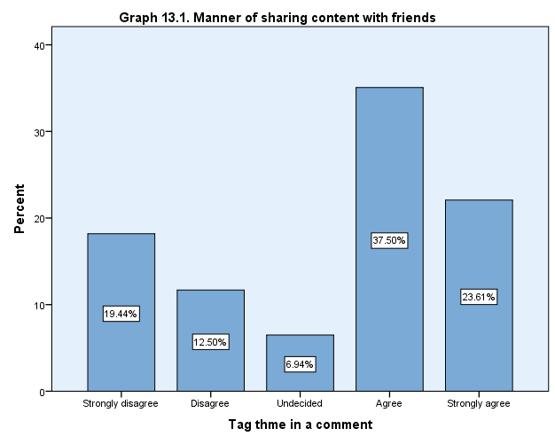
Table 13. Manner of sharing content with friends
 |  | Count | Column N %
Tag them in a comment | Strongly disagree | 14 | 19.4%
 | Disagree | 9 | 12.5%
 | Undecided | 5 | 6.9%
 | Agree | 27 | 37.5%
 | Strongly agree | 17 | 23.6%
 | Total | 72 | 100.0%
Share the link on their wall | Strongly disagree | 14 | 20.0%
 | Disagree | 9 | 12.9%
 | Undecided | 18 | 25.7%
 | Agree | 16 | 22.9%
 | Strongly agree | 13 | 18.6%
 | Total | 70 | 100.0%
Message the link | Strongly disagree | 5 | 7.1%
 | Disagree | 17 | 24.3%
 | Undecided | 8 | 11.4%
 | Agree | 21 | 30.0%
 | Strongly agree | 19 | 27.1%
 | Total | 70 | 100.0%

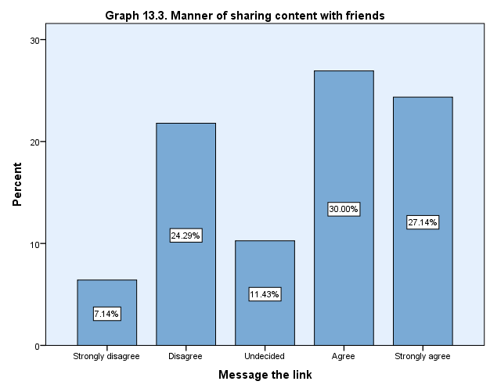
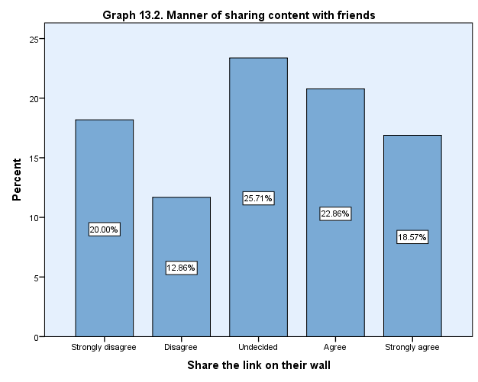

Appendix 3.2. Relationship tables

Table 14. Facebook clothing pages visitors VS. content with gratifications
 |  | Social Netowrk usage Facebook
 |  | Never | Very rarely | Rarely | Occasionally | Frequently | Total
 |  | Column N % | Column N % | Column N % | Column N % | Column N % | Column N %
Desired content- Provide interesting information | Strongly disagree | 0.0% | 0.0% | 0.0% | 0.0% | 0.0% | 0.0%
 | Disagree | 0.0% | 0.0% | 0.0% | 5.0% | 16.7% | 7.8%
 | Undecided | 75.0% | 40.0% | 30.8% | 15.0% | 20.0% | 26.0%
 | Agree | 0.0% | 40.0% | 53.8% | 55.0% | 23.3% | 37.7%
 | Strongly agree | 25.0% | 20.0% | 15.4% | 25.0% | 40.0% | 28.6%
 | Total | 100.0% | 100.0% | 100.0% | 100.0% | 100.0% | 100.0%
Desired content- Be enjoyable | Strongly disagree | 0.0% | 0.0% | 0.0% | 4.8% | 3.3% | 2.6%
 | Disagree | 25.0% | 20.0% | 7.7% | 14.3% | 10.0% | 12.8%
 | Undecided | 25.0% | 20.0% | 7.7% | 0.0% | 16.7% | 11.5%
 | Agree | 50.0% | 50.0% | 53.8% | 38.1% | 20.0% | 35.9%
 | Strongly agree | 0.0% | 10.0% | 30.8% | 42.9% | 50.0% | 37.2%
 | Total | 100.0% | 100.0% | 100.0% | 100.0% | 100.0% | 100.0%

Table 15. Facebook clothing pages visitors VS. top favorite content
 |  | Social Netowrk usage Facebook
 |  | Never | Very rarely | Rarely | Occasionally | Frequently
 |  | Column N % | Column N % | Column N % | Column N % | Column N %
Favourite type of content Product images (studio-shot) | Strongly disagree | 0.0% | 10.0% | 9.1% | 0.0% | 3.3%
 | Disagree | 50.0% | 10.0% | 27.3% | 0.0% | 10.0%
 | Undecided | 50.0% | 50.0% | 36.4% | 30.0% | 13.3%
 | Agree | 0.0% | 20.0% | 9.1% | 55.0% | 36.7%
 | Strongly agree | 0.0% | 10.0% | 18.2% | 15.0% | 36.7%
 | Total | 100.0% | 100.0% | 100.0% | 100.0% | 100.0%
Favourite type of content Product images (location-shot) | Strongly disagree | 0.0% | 0.0% | 0.0% | 0.0% | 0.0%
 | Disagree | 25.0% | 0.0% | 9.1% | 0.0% | 0.0%
 | Undecided | 25.0% | 20.0% | 36.4% | 15.0% | 13.3%
 | Agree | 50.0% | 60.0% | 36.4% | 55.0% | 40.0%
 | Strongly agree | 0.0% | 20.0% | 18.2% | 30.0% | 46.7%
 | Total | 100.0% | 100.0% | 100.0% | 100.0% | 100.0%
Favourite type of content Product mood images | Strongly disagree | 0.0% | 0.0% | 0.0% | 0.0% | 0.0%
 | Disagree | 0.0% | 0.0% | 0.0% | 15.0% | 7.1%
 | Undecided | 50.0% | 22.2% | 27.3% | 40.0% | 28.6%
 | Agree | 0.0% | 77.8% | 45.5% | 40.0% | 35.7%
 | Strongly agree | 50.0% | 0.0% | 27.3% | 5.0% | 28.6%
 | Total | 100.0% | 100.0% | 100.0% | 100.0% | 100.0%
Favourite type of content Inspirational post | Strongly disagree | 25.0% | 0.0% | 0.0% | 10.0% | 3.3%
 | Disagree | 25.0% | 40.0% | 8.3% | 25.0% | 16.7%
 | Undecided | 25.0% | 30.0% | 33.3% | 10.0% | 36.7%
 | Agree | 25.0% | 30.0% | 33.3% | 40.0% | 26.7%
 | Strongly agree | 0.0% | 0.0% | 25.0% | 15.0% | 16.7%
 | Total | 100.0% | 100.0% | 100.0% | 100.0% | 100.0%
Favourite type of content Style-advice posts | Strongly disagree | 0.0% | 0.0% | 0.0% | 0.0% | 0.0%
 | Disagree | 0.0% | 40.0% | 7.7% | 19.0% | 20.0%
 | Undecided | 50.0% | 20.0% | 23.1% | 28.6% | 33.3%
 | Agree | 25.0% | 40.0% | 46.2% | 28.6% | 26.7%
 | Strongly agree | 25.0% | 0.0% | 23.1% | 23.8% | 20.0%
 | Total | 100.0% | 100.0% | 100.0% | 100.0% | 100.0%

Table 16. Women who comment VS. type of content they would possibly comment on
 |  | Mostly Write comments
 |  | Never | Very rarely | Rarely | Occasionally | Frequently | Total
 |  | Column N % | Column N % | Column N % | Column N % | Column N % | Column N %
I would 'comment' if content: is interesting | Never | 21.4% | 0.0% | 5.9% | 0.0% | 0.0% | 10.3%
 | Very rarely | 7.1% | 39.1% | 11.8% | 12.5% | 0.0% | 17.9%
 | Rarely | 10.7% | 39.1% | 47.1% | 50.0% | 0.0% | 30.8%
 | Occasionally | 7.1% | 17.4% | 23.5% | 25.0% | 0.0% | 15.4%
 | Frequently | 0.0% | 4.3% | 11.8% | 12.5% | 0.0% | 5.1%
 | Total | 100.0% | 100.0% | 100.0% | 100.0% | 0.0% | 100.0%
I would 'comment' if content: is absorbing | Never | 28.6% | 21.7% | 11.8% | 0.0% | 0.0% | 19.2%
 | Very rarely | 10.7% | 34.8% | 35.3% | 37.5% | 0.0% | 26.9%
 | Rarely | 3.6% | 13.0% | 23.5% | 0.0% | 0.0% | 10.3%
 | Occasionally | 3.6% | 17.4% | 23.5% | 50.0% | 0.0% | 16.7%
 | Frequently | 0.0% | 4.3% | 5.9% | 12.5% | 0.0% | 3.8%
 | Total | 100.0% | 100.0% | 100.0% | 100.0% | 0.0% | 100.0%
I would 'comment' if content: makes me think | Never | 25.0% | 13.0% | 0.0% | 0.0% | 0.0% | 14.1%
 | Very rarely | 14.3% | 26.1% | 17.6% | 25.0% | 0.0% | 19.2%
 | Rarely | 7.1% | 34.8% | 23.5% | 25.0% | 0.0% | 20.5%
 | Occasionally | 0.0% | 8.7% | 52.9% | 12.5% | 0.0% | 15.4%
 | Frequently | 0.0% | 13.0% | 5.9% | 25.0% | 0.0% | 7.7%
 | Total | 100.0% | 100.0% | 100.0% | 100.0% | 0.0% | 100.0%

Table 17. Reasons to like interesting content VS. manners of sharing content
 |  | I would 'like' if content: is interesting
 |  | Never | Very rarely | Rarely | Occasionally | Frequently | Total
 |  | Column N % | Column N % | Column N % | Column N % | Column N % | Column N %
How would you share with a friend: tag thme in a comment | Strongly disagree | 0.0% | 40.0% | 28.6% | 20.7% | 13.8% | 19.4%
 | Disagree | 0.0% | 40.0% | 14.3% | 13.8% | 6.9% | 12.5%
 | Undecided | 0.0% | 0.0% | 14.3% | 6.9% | 6.9% | 6.9%
 | Agree | 0.0% | 0.0% | 42.9% | 41.4% | 41.4% | 37.5%
 | Strongly agree | 100.0% | 20.0% | 0.0% | 17.2% | 31.0% | 23.6%
 | Total | 100.0% | 100.0% | 100.0% | 100.0% | 100.0% | 100.0%
How would you share with a friend: share the link on their wall | Strongly disagree | 100.0% | 40.0% | 42.9% | 26.9% | 0.0% | 20.0%
 | Disagree | 0.0% | 0.0% | 0.0% | 23.1% | 10.0% | 12.9%
 | Undecided | 0.0% | 20.0% | 0.0% | 26.9% | 33.3% | 25.7%
 | Agree | 0.0% | 20.0% | 57.1% | 15.4% | 23.3% | 22.9%
 | Strongly agree | 0.0% | 20.0% | 0.0% | 7.7% | 33.3% | 18.6%
 | Total | 100.0% | 100.0% | 100.0% | 100.0% | 100.0% | 100.0%
How would you share with a friend: message the link | Strongly disagree | 0.0% | 40.0% | 0.0% | 7.1% | 3.4% | 7.1%
 | Disagree | 50.0% | 0.0% | 50.0% | 21.4% | 24.1% | 24.3%
 | Undecided | 0.0% | 20.0% | 0.0% | 14.3% | 10.3% | 11.4%
 | Agree | 0.0% | 40.0% | 33.3% | 39.3% | 20.7% | 30.0%
 | Strongly agree | 50.0% | 0.0% | 16.7% | 17.9% | 41.4% | 27.1%
 | Total | 100.0% | 100.0% | 100.0% | 100.0% | 100.0% | 100.0%

Table 18. Women who look for new clothing pieces VS. types product images
 |  | Why visit clothing brands' pages: For new clothing pieces
 |  | Strongly disagree | Disagree | Undecided | Agree | Strongly agree | Total
 |  | Column N % | Column N % | Column N % | Column N % | Column N % | Column N %
Favourite type of content Product images (studio-shot) | Strongly disagree | 20.0% | 11.1% | 0.0% | 0.0% | 5.3% | 4.1%
 | Disagree | 0.0% | 11.1% | 25.0% | 12.5% | 5.3% | 12.3%
 | Undecided | 80.0% | 33.3% | 18.8% | 25.0% | 21.1% | 27.4%
 | Agree | 0.0% | 22.2% | 31.3% | 50.0% | 26.3% | 32.9%
 | Strongly agree | 0.0% | 22.2% | 25.0% | 12.5% | 42.1% | 23.3%
 | Total | 100.0% | 100.0% | 100.0% | 100.0% | 100.0% | 100.0%
Favourite type of content Product images (location-shot) | Strongly disagree | 0.0% | 0.0% | 0.0% | 0.0% | 0.0% | 0.0%
 | Disagree | 0.0% | 0.0% | 0.0% | 4.2% | 5.3% | 2.7%
 | Undecided | 40.0% | 11.1% | 37.5% | 8.3% | 15.8% | 19.2%
 | Agree | 40.0% | 55.6% | 37.5% | 66.7% | 21.1% | 45.2%
 | Strongly agree | 20.0% | 33.3% | 25.0% | 20.8% | 57.9% | 32.9%
 | Total | 100.0% | 100.0% | 100.0% | 100.0% | 100.0% | 100.0%

Table 19. Women who look for discounts and deals VS. attitude towards repetitive aggressive selling
 |  | Why visit clothing brands' pages: For discounts and deals, available only on Social Media
 |  | Strongly disagree | Disagree | Undecided | Agree | Strongly agree | Total
 |  | Column N % | Column N % | Column N % | Column N % | Column N % | Column N %
Repetitive content- isn't annoying as long as it is not selling aggressively | Strongly disagree | 57.1% | 14.3% | 4.3% | 15.4% | 38.5% | 20.0%
 | Disagree | 0.0% | 21.4% | 13.0% | 0.0% | 7.7% | 10.0%
 | Undecided | 0.0% | 0.0% | 34.8% | 23.1% | 15.4% | 18.6%
 | Agree | 28.6% | 35.7% | 21.7% | 23.1% | 38.5% | 28.6%
 | Strongly agree | 14.3% | 28.6% | 26.1% | 38.5% | 0.0% | 22.9%
 | Total | 100.0% | 100.0% | 100.0% | 100.0% | 100.0% | 100.0%

Table 20. Reasons to 'like' content VS. favorite type of product images
 |  | I would 'like' if content: is new
 |  | Never | Very rarely | Rarely | Occasionally | Frequently | Total
 |  | Row N % | Row N % | Row N % | Row N % | Row N % | Row N %
Favourite type of content Product images (studio-shot) | Strongly disagree | 66.7% | 0.0% | 33.3% | 0.0% | 0.0% | 100.0%
 | Disagree | 0.0% | 33.3% | 22.2% | 33.3% | 11.1% | 100.0%
 | Undecided | 4.8% | 14.3% | 38.1% | 9.5% | 33.3% | 100.0%
 | Agree | 4.0% | 4.0% | 36.0% | 24.0% | 32.0% | 100.0%
 | Strongly agree | 11.8% | 5.9% | 11.8% | 29.4% | 41.2% | 100.0%
 | Total | 8.0% | 10.7% | 29.3% | 21.3% | 30.7% | 100.0%
Favourite type of content Product images (location-shot) | Strongly disagree | 0.0% | 0.0% | 0.0% | 0.0% | 0.0% | 0.0%
 | Disagree | 0.0% | 100.0% | 0.0% | 0.0% | 0.0% | 100.0%
 | Undecided | 7.1% | 14.3% | 28.6% | 28.6% | 21.4% | 100.0%
 | Agree | 2.9% | 8.6% | 40.0% | 22.9% | 25.7% | 100.0%
 | Strongly agree | 16.7% | 4.2% | 16.7% | 16.7% | 45.8% | 100.0%
 | Total | 8.0% | 10.7% | 29.3% | 21.3% | 30.7% | 100.0%
Favourite type of content Product mood images | Strongly disagree | 0.0% | 0.0% | 0.0% | 0.0% | 0.0% | 0.0%
 | Disagree | 0.0% | 0.0% | 40.0% | 20.0% | 40.0% | 100.0%
 | Undecided | 4.3% | 17.4% | 8.7% | 39.1% | 30.4% | 100.0%
 | Agree | 13.3% | 6.7% | 40.0% | 13.3% | 26.7% | 100.0%
 | Strongly agree | 0.0% | 14.3% | 35.7% | 7.1% | 42.9% | 100.0%
 | Total | 6.9% | 11.1% | 29.2% | 20.8% | 31.9% | 100.0%

Appendix 4: Image examples

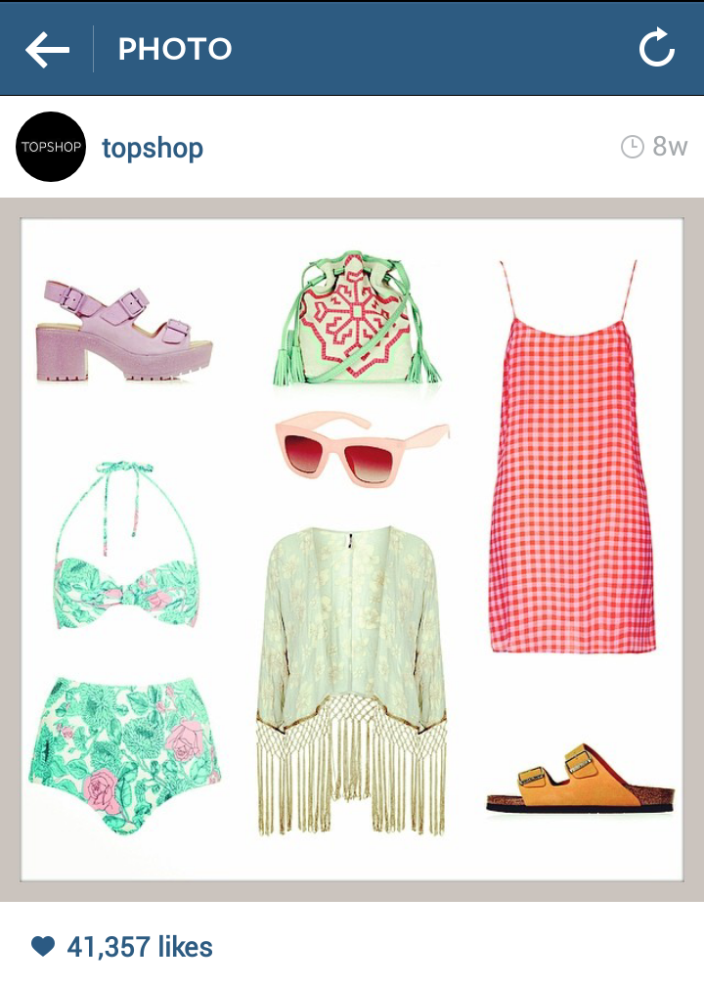
Image 1. Example of a studio-shot individual items (Top shop, 2014)

Image 2. Example of a studio-shot image with model (HM, 2014)

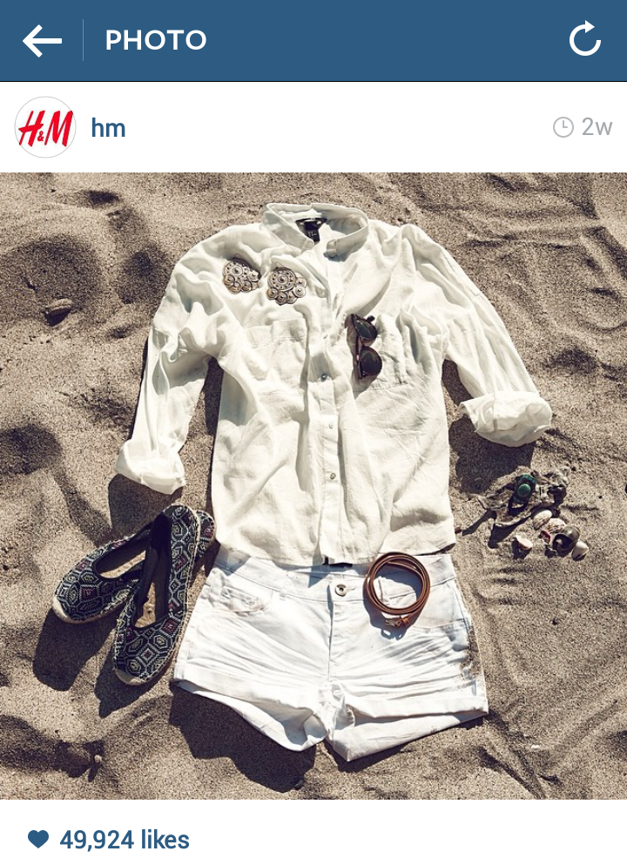
Image 3. Example of a location-shot of individual items with context (HM, 2014)

Image 4. Example of a location shot with model (HM, 2014)

Image 5. Example of a location mood image (HM, 2014)

Image 6. Example of a mood image (HM, 2014)

Image 7. Example of a mood image (HM, 2013)

The other is Explanatory Purpose

