‘What should Rabobank North America advice the dairy clients in its client portfolio to remain profitable in the California dairy sector?’

School Hogeschool Utrecht: University of Applied Sciences
Program International Business and Management Studies
Supervising Lecturer Mrs. C. Rau
Student Ruud Kuijpers
Student Number 1539334

Internship Company Rabobank North America
Department Food and Agriculture Research and Advisory
Company Supervisor Vernon M. Crowder

Date August 2011

Acknowledgements

Numerous individuals within the Food and Agriculture Research and Advisory department at Rabobank North America have facilitated this research. I would like to extend special thanks to Vernon Crowder, Vice President and Agricultural Economist at Rabobank North America. In the function of company supervisor Vernon Crowder has facilitated the internship and provided access to numerous resources, which have proven to be of great value during the internship and this research. Through conventions, meetings, events and frequent contact with the client of Rabobank North America, the research did not lose touch with business practice. The second department within the Rabobank Group that has facilitated this research is the Food and Agriculture Research and Advisory department within Rabobank International in Utrecht. Finally, I would like to thank all interview participants whose responses have formed an integral element of this research.

Executive Summary
This research is conducted for the Food and Agriculture Research and Advisory department at Rabobank North and is designated for internal use only. The research is constructed from desk research and field research by means of interview responses from participants active in various parts of the California dairy sector. These participants were selected based on their corporate function, authority and experience in the California dairy sector.

A vast proportion of the clients in the California client portfolio of Rabobank North America are active in the dairy sector. Volatile milk prices and rapidly changing feed prices have, and are expected to, affect the profitability of dairy operations in California. This research is intended for Rabobank North America to manage the exposure of its clients to the uncertain dairy sector.

The two integral elements in the research are the volatility of the California milk price and the instability in feed costs. The volatility of the milk price causes uncertainty in the dairy sector in terms of revenue to dairy operations. The combination of this volatile revenue stream and rapidly moving feed costs creates uncertainty in profitability to California dairy operations. Such uncertain profitability will eventually impose a credit risk to financial service providers active in the California dairy sector, like Rabobank North America.

To ensure profitability of their business, dairy operations in California should consider a diversification strategy. Although different forms of diversification are feasible for dairy operations in California, it is important that the management does not lose focus of the core business, i.e. milk production. The most effective diversification strategy is growing own feed on continuous bases on excess, or newly purchased land; this will decrease the exposure of the dairy operation to volatile feed costs. Diversification in other crops is also possible; this could potentially create another revenue stream to the dairy operation which could compensate for less profitable years in the dairy sector.

It is recommended that dairy operations in California diversify by growing their own feed. This will mitigate the risk of increasing and volatile feed costs, and in the long-term stabilize profitability to dairy operations. Excess feed can be sold on the market with a profit. Furthermore, it is recommended that dairy operations stay with their core-business as the dairy sector is becoming increasingly complex. In this respect the use of features to lock in crop prices is not recommended because it is a potentially costly strategy, and not easily applicable to a volatile market. Factors such as management and team effort will become increasingly important. Furthermore, dairy operations should milk their dairy cows three times a day to achieve to achieve the lowest average costs of production per hundredweight of milk. The surviving dairy operations in the California dairy sector will eventually benefit from emerging stable export markets, which are expected to substitute for the reduced demand resulting from the outflow of milk processors in California.
Contents
Acknowledgements 2
Executive Summary 3
Glossary of terms 5
1 Introduction 6
2 Methodology 8
3 Findings 9
3.1 California dairy sector 9
3.2 What have been the recent challenges in the California dairy sector? 10
3.3 How will the milk price in the California dairy sector develop in the future? 14
3.4 How vulnerable are California dairy operations to volatile milk prices? 14
3.5 How will the costs of production for California dairy operations develop in the future? 15
3.6 How can diversification mitigate the risk caused by volatile costs of production? 16
3.7 What are the expected challenges in the California dairy sector in the future? 19
4 Discussion 20
4.1 Finding 1: Feed Costs 20
4.2 Finding 2: Milk Prices 22
4.3 Finding 3: Processing Capacity 25
4.4 Finding 4: Long-term Planning and Hedging 25
4.5 Finding 5: Diversification 26
4.6 Finding 6: Unfavourable strategies 26
5 Recommendations 28
6 Conclusion 29
7 References 30
8 Appendix 31
8.1 Interviews 31
8.1.1 Vernon Crowder 31
8.1.2 Bill van Dam 32
8.1.3 Frank DeJong 34
8.1.4 John DeRuiter 35
8.1.5 Michael Barcelos 36
8.1.6 Eric te Velde 38
8.2 Cost Comparison Summary 40
8.3 United States Ethanol Program 41
8.4 United States Interest Rate 42
8.5 Chicago Mercantile Exachange Dairy Hedging 43
8.6 California Gas Prices 44

Glossary of terms

CWT: Hundredweight (= 45.36 Kilogram)

Dairy operations: Milk producing clients of Rabobank North America operating in the California dairy sector.

FAR: Food and Agriculture Research department within Rabobank North America.

Mailbox price: The mailbox price of milk deducts the costs of marketing and assessments associated with the sales process; this is thus the actual net price a dairy operation receives for a hundredweight of milk (= 45.36 Kilogram).

Milk processor: A California based corporate entity dedicated to the processing of bulk milk into consumer products.

Milk producer: A California based corporate entity dedicated to the production of bulk milk.

Client portfolio: Clients of Rabobank North America operating in the California dairy sector.

U.S. Ethanol Program: An United States government program mandating the allocation of corn for the production of bio-fuel.

RNA: Rabobank North America, subsidiary of the Rabobank Group.

Ton: 902.7 Kilogram

Introduction

Rabobank North America, a subsidiary of the Rabobank Group, has a vast number of dairy operations in its California client portfolio. Over the past decades the California dairy sector has experienced severe volatility in milk prices. As a result, many dairy operations experienced continuous annual losses, threatening the continuity of their business. This research is aimed at providing insight in how the dairy operations in California can become less vulnerable to changing market conditions. Stabilized profitability for the California dairy operations in the client portfolio of Rabobank North America is desirable. In the recent decades California has experienced a shift from many smaller dairy operations to fewer larger dairy operations, the portfolio of Rabobank North America contains almost exclusively larger dairy operations, this will thus be the focus of the research.

The problem definition for this research is:
‘What should Rabobank North America advice the dairy clients in its client portfolio to remain profitable in the California dairy sector?’

The sub questions for this research are:
- What have been the recent challenges in the California dairy sector?
- How will the milk price in the California dairy sector develop in the future?
- How vulnerable are California dairy operations to volatile milk prices?
- How will the costs of production for California dairy operations develop in the future?
- How can diversification mitigate the risk caused by volatile costs of production?
- What are the expected challenges in the California dairy sector in the future?

Researching the dairy sector to provide strategic advice to the dairy operations in its client portfolio is important to Rabobank North America. All dairy operations in this client portfolio generate revenue for Rabobank North America in terms of interest payments. Thus, the interest of Rabobank North America in the prosperity of these dairy operations is paramount.

The primary audience of this thesis is the Food and Agriculture department at Rabobank North America. Its interest in this research, or the value to Rabobank North America, is gaining insight vulnerability of its clients. There are no identified biases on part of the audience, as Rabobank North America is very involved with their clients and knowledgeable of the California dairy sector. However, Rabobank North America must realize that a vast proportion of their client base is rooted in the dairy sector.

The research methodology used in this research is triangulation. Findings from interview responses, personal observations and literate review are the fundamentals for the recommendations made to Rabobank North America.

This advice recommended in this research is limited to dairy operations. Furthermore, the geographical restriction of this research is California. Within these boundaries the research can function as an instrumental tool in advising the dairy operations in the client portfolio Rabobank North America.

This research will identify the biggest challenges dairy operations have faced in the recent years. Subsequently a prediction will be made on how these challenges are currently approached by dairy operations in the client portfolio of Rabobank North America and how these matters are expected to evolve in the future. The focus points of this research, and integral topic of discussion to form an answer to the research question, is the volatility of the milk price and the costs of feed during the recent years and the expected trends in the years to come.

Methodology
For this thesis both field research and desk research form an integral element of the research. For the findings in this research it is necessary to conduct qualitative interviews in opposition to quantitative interviews because authority, completeness of information and depth of the responses is essential to present the challenges the dairy operations in California are encountering.
Six participants have been selected for the interview based on their corporate function, authority and experience in the California dairy sector. All participants in have been interviewed individually. The diversity of the interview participants will provide a reliable insight in the Californian dairy sector.
The interview participants selected for this research are:
- Vernon Crowder – Rabobank North America VP / Agricultural Economist Food & Agriculture Research
- John DeRuiter – Rabobank North America SVP / Regional Agribusiness Manager
- Michael Barcelos – Rabobank North America Ag / Field Collateral Inspector II
- Bill van Dam – CEO Alliance of Western Milk Producers
- Frank DeJong – Owner and manager of a large-scale California dairy operation
- Eric te Velde – Owner and manager of a large-scale California dairy operation, and important client to Rabobank North America

The literature review for the research is based on up-to-date literature from reliable sources and authors. Most literature used in the research is specifically applicable to the California dairy sector.

Findings

California dairy sector
According to the California Department of Food and Agriculture, the California dairy sector consists of roughly 1,600 dairies, with an average of 1,000 milking cows per dairy. Some California dairy operations milk their cows twice a day and some milk them three times a day. These milking cows produce an average of 28.5 litres of milk per cow daily. This makes California the largest milk producing state in the United States, accounting for 21% of the domestic production.

Over the recent years the California dairy sector has experienced strong industry consolidation. As presented in graph 3.1, the number of dairy operations in the California dairy market has decreased strongly. In 2001 the California dairy sector consisted of roughly 2300 dairy operations, where in 2009 only 1752 dairy operations remained active, this accounts for a 24% decrease.

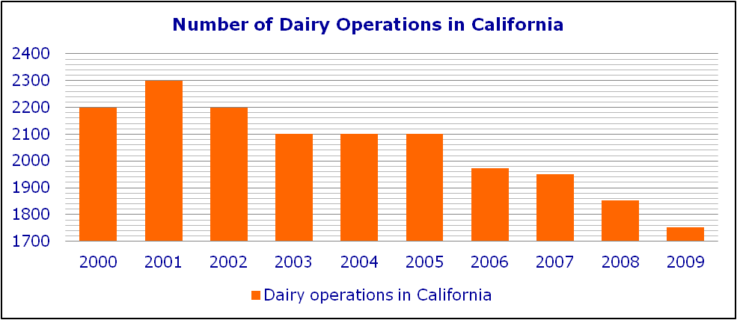
Graph 3.1 (United States Department of Agriculture, 2011)

As presented in graph 3.2, the average number of dairy cows per dairy operation has steadily increased from 2000 to 2009 with 47%. There is a relationship between the dairy operations growing in size, measured by the number of dairy cows, and the declining number of dairy operations in California. This reverse correlation results from the fact that fewer dairy operations are supplying the demand side of the market.
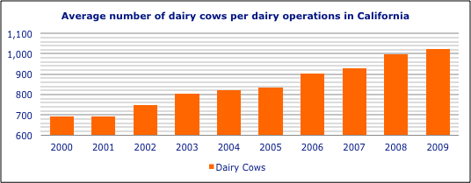
Graph 3.2 (California Department of Food and Agriculture, 2011)

As increasingly large dairy operations dominate the market, the smaller dairy operations have no means of survival. The cost of production of the larger dairy operations is often lower because they have the ‘economies of scale’ advantage. This advantage is identified in a Congressional Research Report (Shields, 2010), stating ‘Larger operations tend to have lower per-unit costs. As firms reduce their costs, they become more competitive and can increase sales and market share at the expense of less profitable firms.’ Furthermore, these dairy operations have the opportunity to grow their own feed, which makes them less vulnerable to volatile feed prices. Finally, the capital reserve of the larger dairy operations is more extensive and facilitates the dairy operation to ‘sit out the storm’.

What have been the recent challenges in the California dairy sector?
Evolvements on both the revenue side and the cost side of the dairy operations are factors of consideration when making forecasts about the future. Three integral factors in the dairy sector have been identified as challenges; milk prices, feed costs and government intervention.

The milk price, as shown in graph 3.3, is the single most important determinant for the revenue stream of the dairy operation. In this research milk prices are considered as the mailbox price in United States Dollars per hundredweight. The mailbox price is the net amount the producer receives on his bank account, no further costs occur. In the dairy sector, the measurement ‘hundredweight’ (45.36 Kilogram) is a commonly used to measure the amount of fluid.

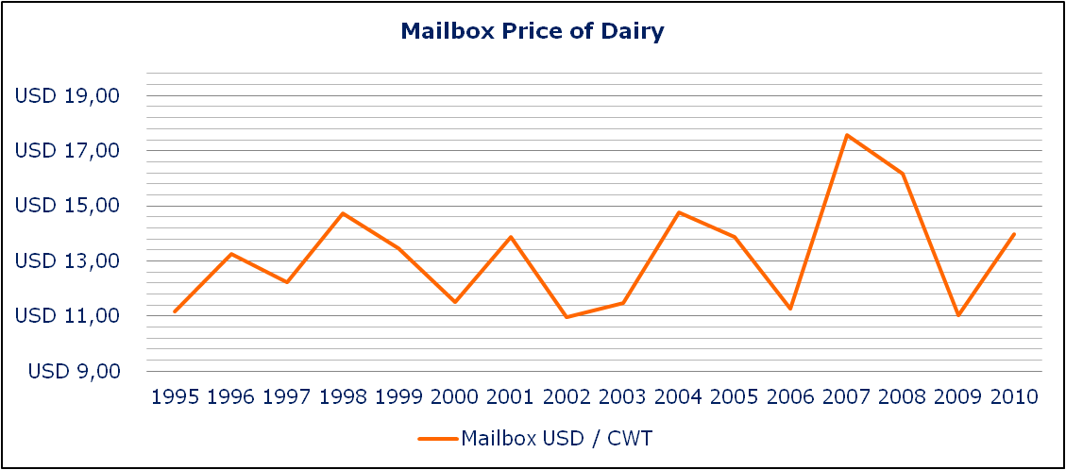
Graph 3.3 (California Department of Food and Agriculture, 2011)

The supply and demand movements in the California milk market have become more intense due to government regulation and increased dependency on inter-state processing activities, this is explained in section 3.3. As a result, presented in graph 3.3, the milk price in California is, and has been, very volatile. Bill van Dam (CEO Alliance of Western Milk Producers) states that in the case of inflated milk prices, milk producers tend to increase production. Vernon Crowder (Agricultural Economist and Vice President to Rabobank North America) supports the observation Bill van Dam has made by stating that unusually high milk prices encourage excessive production growth. Bill van Dam mentions two negative effects of increase in production. First, an increased supply in milk saturates the market as the demand remains constant. This consequently results in decreasing milk prices for the dairy sector in total. Secondly, the increased supply of milk cannot be processed in the existing processing plants and additional costs for dairy operations occur in the transportation, and even dumping, of milk. Volatile revenue as mentioned by Bill van Dam and Vernon Crowder can vary greatly from one farm to the next according to Michael Barcelos (Field Collateral Inspector to Rabobank North America), stating that revenue from milk accounts for approximately 85% of the total revenue on most dairy farms. Therefore, Michael Barcelos considers it to be important that dairy operations strive to achieve as high volumes of milk per cow as possible to decrease the average costs of production per hundredweight of milk, and consequently maximize profit to the dairy operation.

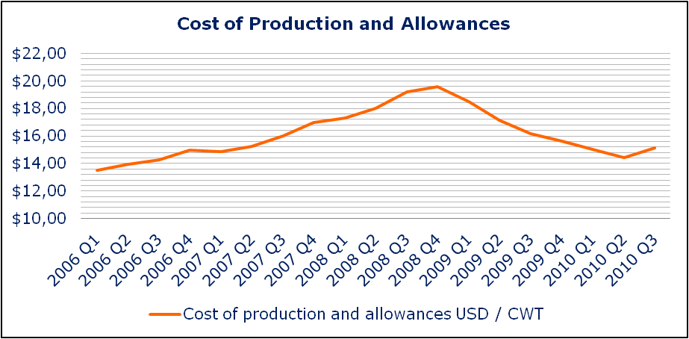
Graph 3.4 (California Department of Food and Agriculture, 2011)

The other major factor determining the profitability of dairy operations is the cost of production, presented in graph 3.4. The allowances added to the costs of production comprise of return on management and return on investment, similar to a salary and a financial return for capital invested in a business.

The production costs comprise of the following elements:
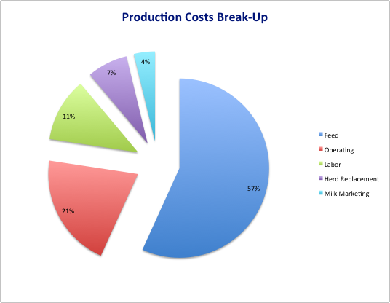
Graph 3.5 (California Department of Food and Agriculture, 2011) Appendix 8.2

The composition of each element of the costs of production is described in Appendix 8.2

As presented in graph 3.5, in the first quarter of 2011 the feed costs are the predominant cost element in the total costs of production with a 56.8% share. Vernon Crowder states that high and volatile feed costs has been one of the major challenges for California dairy operations as they rely heavily on purchased feed. Reliance on purchased feed exposes the dairy operation to the prevailing market prices. Vernon Crowder concludes that this makes profits for dairy operations less certain. According to Eric te Velde (California Dairy Operation Owner and Manager), the major factor of high feed prices in the California dairy sector has been a government mandate regarding the production of ethanol from corn, the United States Ethanol Program. Bill van Dam concurs to the argument Eric te Velde presents about the United States Ethanol Program pushing the price of feed upwards. Also according to Bob Cropp (U.S. Farmers, 2007) the most important reason for the increased mailbox price of milk during 2007 were the high feed costs, as a result of the government mandated allocation of corn, soybean and hay towards energy production in the form of ethanol and bio-diesel.

John DeRuiter (Regional Agribusiness Manager and Senior Vice President to Rabobank North America) focuses on another factor that is expected to increase the costs of production, the interest rate level. He states that the forecasted increase in interest rates will increase the cost of capital for dairy operations. The state-wide cost comparison summary (Appendix 8.2) concurs with this statement as interest rate expense, as part of the total operating costs, eventually effect (20.6%) of the total cost of production.

The three remaining factors in the total costs of production are Labor costs (11.5%), Herd Replacement costs (7.3%) and Milk Marketing costs (3.8%). These factors have a very modest weight, even an extraordinary change in one of these factors would just marginally effect the total costs of production.

The challenges of volatile milk prices and feed costs in combination with government intervention, have both negative effects for dairy operations and for financial service providers such as Rabobank North America. Eric te Velde mentions that with volatile prices it is hard for producers to plan ahead, making it difficult to judge when it is best to lock in milk prices to minimize risk. John DeRuiter identifies similar difficulties on part of the financial service providers, as extreme variations in price swings will affect planning and budgeting.

How will the milk price in the California dairy sector develop in the future?
Bill van Dam expects increase in demand volume from the Western United States and from foreign accounts as the world will need United States dairy products for several more years. Consequently Bill van Dam expects an increase in the milk price resulting from this increased demand. The California cost of production annual 2010 published by the California Department of Food and Agriculture (Ross, 2010) supports these expectations by stating that: ‘prices improved substantially in 2010’ and that ‘increased global demand for dairy products, a cheaper U.S. dollar, and lower-than-expected production in Oceania led to record levels of U.S. dairy exports’. In addition, this is in unity with an article published by ‘California Farmer’ in 2009, stating that dairy export is expected to rebound. In addition, the article mentions that ‘dairy products have suffered due to worldwide recession’. This implies that the United States agricultural economy is becoming increasingly interlinked. Also Eric te Velde and Michael Barcelos expect the dairy industry to continue struggling with volatile prices, they concur that the world economy is interlinked more than it has ever been before and with certain countries doing well and others doing poorly, it is hard to know what is going to happen. Vernon Crowder agrees with these expectations and mentions that more volatility in milk prices will result from the increased interaction with foreign markets. He mentions that such markets are new to California dairy processors and that they are vulnerable to more efficient exporters. In contradiction, John DeRuiter presents a more optimistic forecast, expecting that the milk prices will continue to increase until April 2012 based on forecasts made by Rabobank North America. However, John DeRuiter does recognize that the milk prices will depend on global supply and demand in combination with the domestic milk production.

How vulnerable are California dairy operations to volatile milk prices?
The article ‘Risk management in agriculture’ (Schaffnit-Chatterjee, 2010) scales the extent of risk by identifying two factors: the frequency of occurrence and the magnitude of the impact. As presented in graph 3.3 a strong volatility in California milk prices has been prevailing frequently for years.

Presented in graph 3.6 is the profitability of the California Dairy sector from 2006 to 2010. An extrapolation line is drawn to indicate the expected price development according only to movements in price and costs of production over the years.

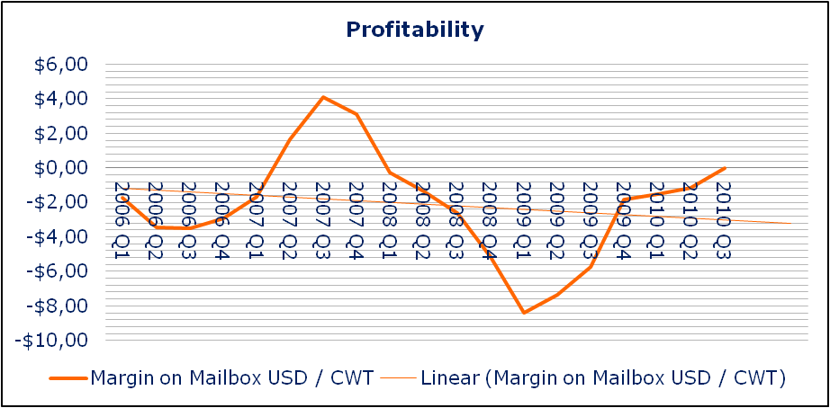
Graph 3.6 (California Department of Food and Agriculture, 2011)

As a strategy for profitable growth, Bill van Dam states that the California milk producers must always strive to be the low-cost milk producer in order to leave margin for volatile milk prices. Furthermore, he mentions that these dairy operations could implement a hedging strategy by exercising put options to protect the business against the down side in prices. Frank DeJong (California Dairy Operation Owner and Manager) and John DeRuiter have similar thoughts. John DeRuiter also mentions that the hedging of milk will become increasingly important in the near future. In addition, he expects that the reduction of milk production will be elementary to mitigate risk in the milk price risk. This expectation is based on the theory of supply and demand, where decreased supply will inevitably lead to higher prices. Eric te Velde already applies these theories in his dairy operation. By doing so, he recognizes that decreasing milk prices are not necessarily bad, as long as the feed cost go down with it, accounting for a certain margin between the milk prices and costs of production, that is profitable to producers. This strategy can be accomplished by hedging milk prices and feed costs using the CME (Chicago Mercantile Exchange) as a trading platform. Michael Barcelos identifies another strategy, growing most of your own feed to minimize your risk to market price volatility. There are even opportunities of to profit from prevailing market conditions by taking advantage of the futures markets to hedge risk.

How will the costs of production for California dairy operations develop in the future?
Having identified that the main variable cost in the costs of production is the feed costs, Vernon Crowder mentions that higher and more volatile feed costs can be expected due to increased global demand for grains and increasing transportation costs due to rising fuel prices. As presented in the graph in appendix 8.5, the California fuel prices have increased 75% from 2005 to 2011. Michael Barcelos concurs, mentioning that he also expects the costs of production to heavily increase due to the costs of major feed including alfalfa hay and corn, being at record high-level prices in 2011. Frank DeJong expects the government-mandated allocation of corn to the production of ethanol to continue increasing costs of production.

Another factor, identified by John DeRuiter, is the increase in overall cost of operation due to increasing interest rates. Eric te Velde recognizes the possibility of increasing interest rates and expects a slight increase in costs of production due to the subsequent increase in cost of capital when sourcing capital from financial institutions. This can subsequently affect all elements of the costs of production such as feed costs, operating costs, herd replacement costs, labor costs and milk marketing costs.

How can diversification mitigate the risk caused by volatile costs of production?
According to a research for Deutsche Bank (Schaffnit-Chatterjee, 2010) risk can be defined as the potential deviation between expected and real outcomes. Two types of risks identified by the author of the article are prevailing in the California dairy sector according to interview participants. These types of risks are price and market risk, and regulatory risk. The first type of risk, price and market risk, is associated with variability in the output price and with input price variability. The author continues, stating that the degree to which a dairy operation is impacted depends on the level of integration in the supply chain. In this respect, diversification in feed material for use in the own dairy operation would mitigate risk, as there is a higher level of backward integration in the supply chain.

Bill van Dam mentions that diversification, except for growing your own feed such as corn and alfalfa, will always be a distraction from the core-business, i.e. milk production. Vernon Crowder concurs, mentioning that even counter-cyclical profits can be derived from growing feed, as not only does the dairy operation not have to buy from the potentially inflated market but excess feed can also be sold against the prevailing high prices in this market. Vernon Crowder suggests that diversification by also growing corn and alfalfa silage, as the costs of this feed also remains volatile to be a feasible strategy. John DeRuiter agrees with Bill van Dam and Vernon Crowder, stating that diversification in terms of production of feed for the own dairy operation can reduce dependency on outside feed sources and the inherent price risk. Although diversification can form a distraction from the core business as Bill van Dam mentioned, Frank DeJong has a more opportunistic view of diversification and states that growing almonds could be a way to diversify and maximize profitability. Almond trees can be planted for the production to start with immediate affect. Profit derived from this could subsequently compensate for potential financial losses from the dairy operation. John DeRuiter supports the strategy brought forward by Frank DeJong, stating that diversification in crops like nuts or grapes can enhance profitability under the condition that land, capital and management expertise is available. Furthermore, Eric te Velde also states that diversification in other crops, mentioning that with the right farmland and a sufficient water supply there are many options of diversification that will result in decreasing cost of production and consequently higher profits. This is consistent with a survey conducted by the California Department of Food and Agriculture, published in the California Cost of Production Annual (Ross, 2010): ‘In 2010, most dairy producers that participated in the CDFA cost surveys experienced a lower cost of production’.

For a diversification strategy to take effect in a dairy operations several steps have to be taken. First, the dairy operation has to purchase farmland. As presented in graph 3.7, the farmland values in California have increased from 1997 to 2008, and are experiencing depreciation in 2009 and 2010.
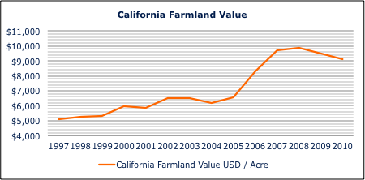
Graph 3.7 (California Department of Food and Agriculture, 2011)

The second step in the process of implementing the diversification strategy is planting the crops, this can be done with immediate effect. In this research, diversification in term of growing corn for use as feed in the own dairy operation is used as an example. The historical market price for corn is presented in graph 3.8.
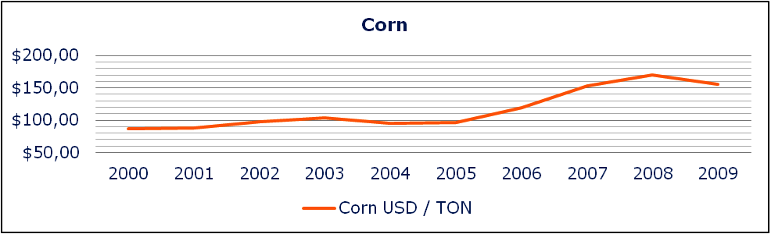
Graph 3.8 (California Department of Food and Agriculture, 2011)
In this lower-bound scenario, based on year 2009;
- The farmland value is USD 9,500 per acre
- The California corn yield is 26 ton per acre
- The cost to grow corn is USD 634 per acre per month (three months)
- The market price of corn is USD 155 per ton
The production costs of corn are (USD 634 * 3 months) USD 1902 per Acre. One acre of corn yields 26 ton of corn, thus the production costs of corn are (USD 1902 / 26) USD 73.15 per ton. The prevailing market price of corn is USD 155 per ton. The difference in price for between purchasing corn and producing corn is (USD 155 – USD 73.15) USD 81.85.

The initial investment is accounted for in this calculation in terms of depreciation of equipment. The price of farmland is USD 9,500 per acre, this cost is not accounted for in the calculation. However, with a profit of ( (26 * USD 155) – (3 * USD 634) ) USD 2,128 per acre the investment in farmland is earned back in five years. Resulting in the following cash flow.

Year | Income | Expense | Cash flow
0 | $0 | $9,500 | -$9,500
1 | $3,875 | $1,902 | $1,973
2 | $3,875 | $1,902 | $1,973
3 | $3,875 | $1,902 | $1,973
4 | $3,875 | $1,902 | $1,973
5 | $3,875 | $1,902 | $1,973
5-year return per acre of corn, including investment in farmland |  |  | $365

What are the expected challenges in the California dairy sector in the future?
According to the interview responses, changing market conditions and government legislation keep on introducing new challenges for dairy operations in California. Interview respondents mention that it is important to identify these challenges in an early stage, so that dairy operations can plan their strategy in advance.

One of the most important changes in the dairy sector is the decreasing processing capacity for milk, according to Bill van Dam the throughput capacity of milk in processing facilities is insufficient. To cope with the California milk supply he expects the need for another 5 to 10 million pounds of milk throughput facility. Bill van Dam mentions that in case of insufficient processing facilities the product mix in the dairy sector will be affected. Vernon Crowder recognizes this problem and suggests that California milk processors need to focus on exporting and build stronger relationships with their importers by providing products they demand. This will increase the demand for milk and subsequently provide incentive to these organizations to construct additional processing facilities. Michael Barcelos expects the growth in the California dairy sector to stagnate unless more milk processing plants are built.

Discussion

Finding 1: Feed Costs
Feed costs are the most significant cost element in the costs of production for dairy operations, accounting for 56.8%. In California these feed costs are high and volatile, and are forecasted to remain so in the next years. This is a result of the United States Ethanol Program, the forecasted increase in interest rates and the rising fuel prices increasing the cost of transport.

The cost of production for dairy operations comprises of feed (56.8%), operating costs (20.6%), labor (11.5%), herd replacement (7.3%), and marketing (3.8%) –costs. According to he findings, the feed costs for dairy operations are volatile. The operational costs are affected by numerous factors, such as the interest expense, and therefor also volatile. The feed costs and operating costs account for 77.4% together, leaving only 22.6 accounted for by labor, herd replacement and marketing costs. The latter three cost elements have little impact and are steady costs.

Another element that is considered a cost by dairies is the ‘allowances’, these comprise of return on management and return on investment, similar to a salary and a financial return for capital invested in a business. This means that if the dairy operation would realize a break-even profit, the management of the dairy operation still earns money. There is a strong spread of the cost of production and allowances among the dairy operations in California. This spread results from the fact that some dairies produce their own feed material, which provides a cost advantage to these dairy operations. Especially when the price of feed material is at the top-end of the market, in periods of drought for example, these dairy operations manage to be more profitable than competitors who have to buy feed from the market against prevailing market prices.

The first factor inflicting high feed costs is the United States Ethanol Program, this is in correspondence with the statements of John Sununu in an article published in 2008. According to the article ‘Corn prices worldwide have increased by 50% over the past year. John Sununu, a Republican senator opposed to farm subsidies, says corn prices have risen in part because America is using increasing amounts of corn to produce fuel for automobiles’. This concurs with data from the California Department of Food and Agriculture presented in graph 3.6. These prices are not expected to decrease in the future as the incentive is too high for the United States government according to a statement by Joseph DePardo in ‘Challenges and Opportunities for California's Dairy Economy’: ‘The ability to produce ethanol from low-cost biomass will be key to making ethanol competitive with gasoline.’ The combination of these different sources provides solid grounds that the United States Ethanol Program is indeed a strong factor in the costs of production and will continue to be so for the next years. As a vast proportion of the corn production will be allocated towards this program, California farmers will plant more corn to increase the supply. This leaves fewer acres for other crops and thus making the other feed material more costly. The price of corn is presented in graph 4.1. United States ethanol producers are on track to use potentially 40% of the total U.S. corn production. Year-to-year ethanol production, from January through November 2010, was up 23% compared to the previous year (Reidy, 2011).

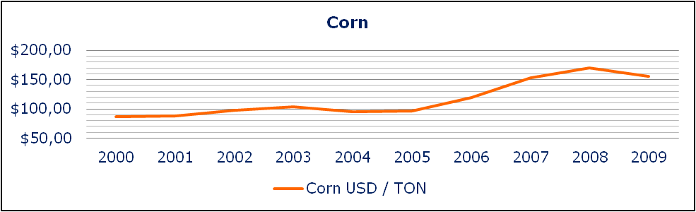
Graph 4.1 (California Department of Food and Agriculture, 2011)

The second factor, identified by John DeRuiter, involves the forecasted increase in interest rates. Increasing interest rates will consequently increase the costs of feed. The United States interest rate is now at 0.25%. This interest rate percentage is at record low-level due to prevailing economic condition and is bound to increase, resulting in an increased cost of capital for dairy operations and consequently increasing the costs of production to the dairy operations.

The third factor, identified by Vernon Crowder, is the rising fuel prices increasing the costs of transportation of the milk. As a result, the total costs of production will increase for California dairy operations. This is in correspondence to observations made by the ‘California Gas Price Monitoring’. This is expected to be an increasing problem as the California dairy sector is becoming more reliant on export markets substituting for the shortage of milk processing plants.

Finding 2: Milk Prices
Milk prices are highly volatile, continuously affecting the profitability of dairy operations.

The average profitability of the dairy sector in California, as assumed in this research, is calculated by subtracting the cost of production and allowances from the mailbox price of milk. To forecast the profitability of the Californian dairy sector, in graph 4.2 a linear trend line has been extrapolated over the data ranging from 2006 to 2010. The linear line indicates an average decrease in profitability over the selected range of years, based on events occurred in the past.

Graph 4.2 (California Department of Food and Agriculture, 2011)

Bill van Dam identifies the decreasing milk prices result from increased production. This is in correspondence to the data from the California Department of Food and Agriculture and the United States Department of Agriculture. For example, graph 4.3 presents increased production from 2006 to 2007, the price of milk decreased from 2007 to 2008, as the production continues to increase from 2007 to 2008. In 2009 and 2010 the price of milk correlates to the production, this is due to increased demand. The milk price reacts to the changing domestic dairy production with some delay.

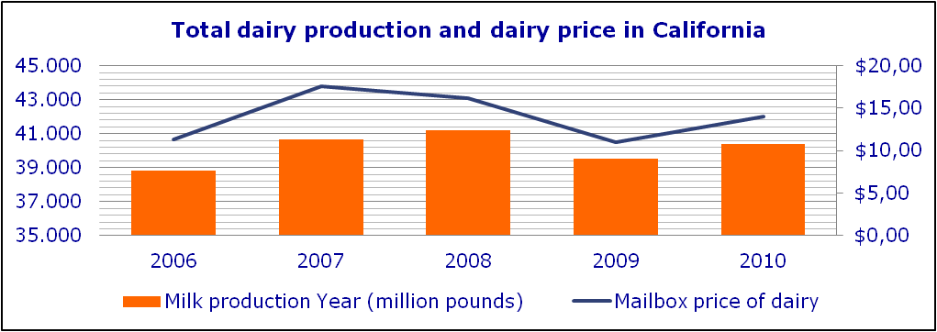
Graph 4.3 (California Department of Food and Agriculture / United States Department of Agriculture, 2011)

Vernon Crowder states that the strong production growth, as mentioned by Bill van Dam, will not only decrease milk prices but also cause more volatility in the milk prices. Data from the California Department of Food and Agriculture supports the observation made by Vernon Crowder. In graph 4.4 the total dairy production in California is presented. The graph shows an increase from 2000 to 2008. Subsequently graph 4.5 presents an increasingly volatile mailbox price of milk for the same range of years.

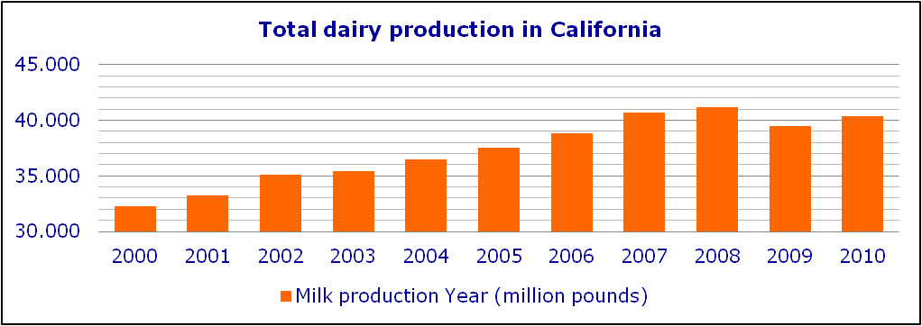
Graph 4.4 (California Department of Food and Agriculture, 2011)

Graph 4.5 (California Department of Food and Agriculture, 2011)

To maximize profit, Michael Barcelos suggests that the dairy operations must try to achieve as high volumes of milk per cow as possible. Comparing the milk production per dairy cow from 2006 to 2010 as presented in graph 4.6 to the profitability of dairy operations from 2006 to 2010 as presented in graph 4.2, there is a strong correlation between the dairy production per cow and the profitability of the dairy operation. Therefore, it is feasible that maximizing milk production per cow increases profit to dairy operations through decreased average costs of production per hundredweight of milk. This can be achieved by milking dairy cows three times a day instead of two times a day, for example. The dairy operations can than produce with a smaller herd, and inherently lower costs of production as cost elements such as grazing land, milking machine slots and herd replacement and a substantial portion of the operating costs will decrease.

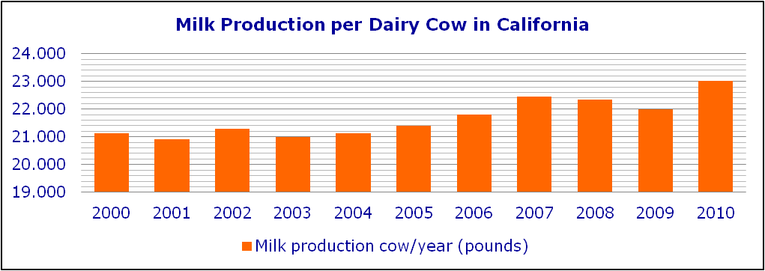
Graph 4.6 (California Department of Food and Agriculture / United States Department of Agriculture, 2011)

Finding 3: Processing Capacity
The capacity of the milk processing plants in California is insufficient to cope with the current milk production, resulting in excess milk in the market and consequently decreasing milk prices. The production of milk should be limited for milk prices to increase.

Bill van Dam identifies plant capacity as a major challenge for the California dairy sector; the throughput of milk in processing facilities is insufficient. This concurs with the article by Eric Erba published by UC Davis, stating: ‘Closures of existing milk processing facilities in California have had enormous implications for the amount of milk that can be processed in the state.’ The shortage of milk processing capacity is also recognized in the article ‘California needs to roll out the red carpet, not red tape’ (Marsh, 2008). Michael Marsh states ‘plant capacity dwindled within the state even as milk production has continued to expand’, he continues: ‘various dairy processors including Kraft, Nestle and Leprino Foods have no intention of investing in capital infrastructure within California’. This implies that the processing capacity of California dairy processors is decreasing. The excess milk has to be transported outer-state leading to increased cost of transportation and subsequently increased total costs of production.

Michael Barcelos expects that theseouter-state export markets will have to substitute for the leaving processors. John DeRuiter expects the milk output to level off, however dairy operations would probably not produce less in the hope their colleagues to join them in increasing the milk prices in this manner. In this sense it is difficult to move all dairy producers to decrease production for the greater good of higher milk prices.

Finding 4: Long-term Planning and Hedging
Due to high volatility in milk prices it becomes difficult for dairy operations to lock in milk prices to minimize risk. For financial service providers the price swings affect planning and budgeting.

Bill van Dam mentions a hedging strategy to protect the dairy operations against the downside in milk prices. This concurs with a statement Justin Ellerby presented in a paper released by the California Center for Cooperatives in 2010: ‘Hedging lowers the net profits a producer can hope for by the amount of the cost of the future contract’s premium, but guarantees a price they can live with, regardless of any changes in the market.’ Eric te Velde already applies such a hedging strategy to his dairy operation, using the CME (Chicago Mercantile Exchange) as trading platform.

Finding 5: Diversification
Growing own feed reduces the costs of production leaving margin for profit in a market with volatile milk prices. In addition, it provides for more stable costs of production because the dairy operation is less dependent on the volatile feed market.

Opinions on the best strategy for diversification vary. There is a clear distinction in opinions between specialists from the corporate side of the dairy sector and the dairy farm managers. Where specialists most often suggest diversification by means of growing own feed, dairy operation management is more opportunistic and has a preference for other profitable crops that could compensate for losses in the dairy operations in less profitable years. For example, Steve Maddox (Manager of Maddox and RuAnn dairy operations in California) states that roughly the profit yielded from one acre of fruit or grapes is needed to compensate the financial loss resulting from dairy production of two dairy cows in the same period. The suggestion made by Bill van Dam is broadly supported by the interview participants, milk producers should develop their skills and concentrate on managing their dairy operation well as dairying is a very complex business and is becoming ever more complex in the future. A strong California dairy operation demands extensive management expertise and requires team effort. In conclusion, the safest way to increase and stabilize profitability for the dairy operation is to diversify only by the growing of feed used for the production of milk.

In the findings a scenario is presented for the diversification strategy by growing corn. The scenario is lower bound, meaning that the yield and profitability is presented at conservative levels. The calculation concludes that production of corn is possible at USD 73.15 per ton, USD 81.85 lower than the market price. This yield account for a significant cost reduction in the production process of milk. In addition, the dairy operation is not dependable on the supply and demand effects on the market for corn, and thus has a more stable cost of production.

Finding 6: Unfavourable strategies
Diversification in irrelevant crops and hedging using features is likely to cause distractions from the core business of dairy operations, which are becoming increasingly complex. In addition, both strategies can impose financial risk to the dairy operation.

Milk producers in California should diversify only in feed material needed in the dairy operations. This diversification mitigates their risk to increasing and volatile feed costs, stabilizing cost of production on the long-term. Although diversification in other produce, almonds for instance, can be very profitable (Gale, 2011) dairy operations risk losing focus of their core-business. This would subsequently cause a problematic situation, as the dairy sector is turning into an increasingly complex environment in which management and team effort are becoming mandatory to be profitable.

Furthermore, both strategies impose financial risk to the dairy operation. Diversifying in irrelevant crops requires an initial investment and the return on the investment is dependent on the market. In addition, highly capital-intensive nature of some high value crops, small and marginal farmers may find it difficult to invest in these crops (Sharma, 2010). Hedging the costs of feed and the price of milk also imposes financial risk, when the price of the commodity changes other than in the predicted direction, the feature becomes worthless.

Recommendations
Based on the research presented in this thesis the following recommendations can be made to the Food and Agriculture Research and Advisory department at Rabobank North America to advice the dairy operations in their California client portfolio on stabilizing profitability:

- Advice dairy operations in the California client portfolio to milk their cows three times instead a day of two times a day to decrease the average costs of production per hundredweight of milk. Cost elements such as grazing land, milking machine slots, herd replacement and a substantial portion of the operating costs will decrease.
- Advice dairy operations in the California client portfolio to diversify their dairy operation by also growing their own feed required for the production of milk. Highly recommended crops are corn and hay as these have significantly increased in price over the years. The dairy operations should use available farmland or purchase farmland for this diversification. Excess production of feed, which is not used by their dairy operation, can be sold on the market.
- Advice dairy operations in the California client portfolio not to diversify in other produce than required for the production of milk to ensure that the dairy operations management does not lose focus of their core-business, i.e. milk production.
- Do not advice clients in the California client portfolio on hedging strategies as it is difficult to lock in prices in volatile markets, the price could easily develop in the unpredicted direction turning the hedge-option into a cost element. This would subsequently decrease profit. In addition, hedging strategies are thought to distract attention from the core-business, i.e. the production of milk, which is becoming ever more complex on its own due to government regulation, market volatility, etc.

Conclusion

From this research can be concluded that feed costs are the most significant cost element in the costs of production for dairy operations. Feed costs in California are high and volatile, and are forecasted to remain so for the next years. This is a result of the United States Ethanol Program, increasing fuel costs for transport and the forecasted increase in interest rates.

On the revenue side of the dairy operations milk prices are highly volatile, continuously affecting the profitability of dairy operations. Due to these volatile milk prices it becomes difficult for dairy operations to lock in milk prices to minimize risk. In addition, volatile milk prices affect financial service providers as the volatile milk prices make planning and budgeting difficult. Furthermore, the capacity of the milk processing plants in California is insufficient to cope with the current milk production, resulting in excess milk in the market and consequently decreasing milk prices. The milk production in California has to decrease for milk prices to increase.

Diversification by growing own feed reduces the costs of production to leave margin for profit in a market with volatile milk prices. In addition, it provides for more stable costs of production because the dairy operation is less dependent on volatile feed prices on the market.

Diversification in irrelevant crops and hedging using features is likely to cause distractions from the dairy operation, which is becoming increasingly complex. In addition, both strategies impose financial risk to the dairy operation.

References

California Farmer. 2009. USDA Expects Dairy Demand to Rebound. [ONLINE] Available at: http://californiafarmer.com/story.aspx?s=32267&c=0. [Accessed 25 July 11].

Campbell Mathews, M. Et al., 1999. Sample Costs to Produce Corn Silage. California: UC Davis.

Claire Schaffnit-Chatterjee, C, 2010. Risk management in agriculture. Deutsche Bank Research, Pages 4-6.

Cropp, B, 2007. Factors causing fluctuations in All Milk Price Received by U.S farmers. University of Wisconsin.

DiPardo, J, 2004. Outlook for Biomass Ethanol Production and Demand. Energy Information Administration, 1.

Ellerby, J, 2010. Challenges and Opportunities for California's Dairy Economy. California Center for Cooperative Development, Page 32.

Eric M. Erba. 2010. Dairy Situation and Outlook 2010. [ONLINE] Available at: http://alfalfa.ucdavis.edu/+symposium/proceedings/2010/10-09.pdf. [Accessed 15 June 11].

Gale, J, 2011. California needs massive almond output to meet insatiable demand. The Public Ledger, 27, Page 1.

Merlo, C, 2010. California at the Crossroads. Dairy Today.

Reidy, S, 2011. Coarse grains. Biofuels Business, 4, 12 - 13.

Ross, K, 2010. Cost of Production. California Cost of Production 2010 Annual, 52.

Sharma, A.K. Et. Al, 2010. Agriculture Diversification. 1st ed. New Delhi: I.K. International Publishing House.

Shields, D, 2010. Consolidation and Concentration in the U.S. Dairy Industry. CRS Report for Congress, 7-5700, Page 2.

Appendix

Interviews

Vernon Crowder
• What do you think have been the two biggest challenges for dairy operations in the recent 5 years, and why?

Volatile milk prices, because unusually high prices encourage excessive production growth and such prices are not correlated with feed costs.

High feed and volatile feed costs, because California depends more on purchased feed and such costs make profits less certain.

• What do you expect to be the biggest challenge for dairy operations in the next two years, and why?

Mitigating the volatility in both milk prices and feed costs, because CA dairies have limited opportunities to grow their own feed.

• How do you expect the California milk price to evolve in the next two years, and why?

It will continue to be more volatile, because of the increased reliance on foreign markets. Such markets are new for CA processors and vulnerable to more efficient exporters and the future appreciation of the US $.

• What do you think is the best way for a dairy operation to decrease vulnerability to decreasing milk prices, and why?

It is absolutely essential for dairy products to increase their flexibility, because of the volatility on both sides of their profit statement. They can do this by reducing debt and managing their production level to minimize losses when milk prices and/or feed move against them. costs

• If you had to diversify as a dairy producer, what produce would you choose, and why?

Corn and Alfalfa silage, because such would mitigate their feed costs risks and provide them counter-cyclical profits. It would also give them more area for waste water discharge.

• How do you expect the cost of production for dairy operations to evolve in the next two years? And what element is predominant in this evolvement?

Higher and more volatility feed costs, because of global demand for grains, less water for foreign crops and higher transportation costs.

• Do you have any other comments on the California dairy sector relating to the topic of the thesis?

CA processors need to focus on exporting and building stronger relationships with their importers by providing products they want.

Bill van Dam

• What do you think have been the two biggest challenges for dairy operations in the recent 5 years, and why?

Ethanol: The run up in feed costs driven by a corn-based ethanol program in the US. This happened right when Oceania was in the depth of a drought which caused world prices to soar. California producers responded to the favorable price. But the rain fell again in Oceania and they once again could fill their share of the world demand. US prices crashed but feed costs did not follow because the demand for corn was driven mostly by the ethanol program needs.

Government Programs: Producer programs (MILC and DLAP) are heavily skewed toward aiding smaller producers located mostly in the Midwest and East while barely providing assistance to the Western producer. The market signals to the Midwest producers failed to impact them and all and they increased production while California producers were responding as the economics demanded – they cut production.

Plant capacity: High prices drove increased production but that production could not be handled in existing plants. Huge costs for moving milk and some dumping resulted.

• What do you expect to be the biggest challenge for dairy operations in the next two years, and why?

Plant capacity: Very soon California will not have the capacity to handle all the milk producers will be producing. Someone (most plausibly CDI) will have to build a new big (5 to 10 million pounds) plant.

Product mix: This is different than point one. Once plant capacity is constrained because of overall volume the only option is to produce the products with the highest throughput. As shown in the past year there is better profitability in tailoring product to market demand but nearly all of these opportunities come with limits on throughput.

• How do you expect the California milk price to evolve in the next two years, and why?

California milk prices will move up and down with world prices. Most other areas of the world are constrained in some way and will not be able to respond to market signals like California can. Other Western States can also respond but are not as well located to take advantage of the export potentials but their volume increases will serve to replace domestic accounts now served by California. It is likely the world will need US product for several more years and thus will have to generate a high enough price to get California to respond. Prices should be quite favorable.

• What do you think is the best way for a dairy operation to decrease vulnerability to decreasing milk prices, and why?

They must always strive to be the low cost producer! This is the group that always wins.

As circumstances allow, use puts to protect the down side in prices.

• If you had to diversify as a dairy producer, what produce would you choose, and why?

Diversification (except for the possible exception of growing your own corn and alfalfa) will always be a distraction. Dairymen must never lose sight of the “low cost producer” goal.

• How do you expect the cost of production for dairy operations to evolve in the next two years? And what element is predominant in this evolvement?

As a matter of self-preservation increasingly producers will raise their own feed. They need this to be assured that the nutrients generated by the dairy are properly used to limit the environmental impact and to maximize the benefits of the nutrients to the dairy. As long as corn and ethanol are linked this will also lower the costs of production for the California producer. The good news is that if the US ethanol program is modified even just a bit to decouple corn prices from crude oil prices there could be a substantial reduction in feed costs and there could be a year or two of excellent margins for producers

• Do you have any other comments on the California dairy sector relating to the topic of the thesis?
Dairymen need to focus on the cows and getting the best results there. Diversification may be nice but the risk of losing sight of the dairy task is great. Develop a skill and concentrate on doing it well. Dairying is a very complex business and is becoming more complex. A proper California dairy enterprise demands a great deal of management expertise and requires a team effort.
The part about plant capacity is not to be overlooked. Producers alone have the incentive to improve the over-all capacity of the plants in this state. Cheese companies are no longer building big plants in California. Our opportunity is in other products, mostly powders, and in this world it is hard to find business enterprises willing to invest hundreds of millions in powder plants. To my way of thinking the only bankable producer is one who ships to a cooperative that is well run and actively investing in facilities to handle growing milk supplies as long as the dollars that can be paid to the producers cover the cost of production to the producers.

Frank DeJong
• What do you think has been the two biggest challenges for dairy operations in the recent 5 years, and why?
The government becoming more and more involved in how we run our dairy, both locally and nationally. Washington politicians making laws and rules that sound good but have bad consequences for farmers.
• What do you expect to be the biggest challenge for dairy operations in the next two years, and why?
The wild up and down swings in the price of milk and feed. You can find yourself upside down very quickly if you make a wrong decision. Government intervention. Government decides to mandate the use of corn for ethanol and corn prices double in less than a year. Here in California water for fish is more important than water for farmers.
• How do you expect the California milk price to evolve in the next two years, and why?
I think prices will have to go up for dairies to survive. Costs continue to keep rising.
• What do you think is the best way for a dairy operation to decrease vulnerability to decreasing milk prices, and why?
Probably to lock in milk prices and feed costs at a profitability rate. Price swings have become too wild and unpredictable.
• If you had to diversify as a dairy producer, what produce would you choose, and why?
Where we are located in California, Almonds would be the best way to diversify. Our neighboring properties grow almonds. This is ideal almond growing land.
• How do you expect the cost of production for dairy operations to evolve in the next two years? And what element is predominant in this evolvement?
If government mandates regarding ethanol continue costs will continue to rise. More corn will be planted leaving less acres for other crops, making everything more costly. I think government involvement will have an impact on what happens.
• Do you have any other comments on the California dairy sector relating to the topic of the thesis?
Maybe our cooperatives should work closer together to control the supply of milk. Also as the world seems to be getting smaller things and weather happening in other countries effect us more and more.

John DeRuiter

• What do you think have been the two biggest challenges for dairy operations in the recent 5 years, and why?

Milk price volatility: Extreme variations in price up and down create issues not only with profitability but also with planning/budgeting including for lenders.

Production cost increases: Not only feed, but other products and services. Interest rates have been reasonable but most likely will go up in the future.

• What do you expect to be the biggest challenge for dairy operations in the next two years, and why?

Manage their costs: Especially feed which will require being very efficient so as not to affect milk yields. Also contracting and hedging their commodity feeds.

Milk price volatility: Price will depend on global factors plus U.S. milk production – supply must be in line with demand. Milk hedging will be more important.

• How do you expect the California milk price to evolve in the next two years, and why?

Milk prices very strong currently and expected to continue – RNA projections thru 4/12 remain strong based on numerous qualified projections. Following 12 months will depend on global supply and demand plus what milk production in the U.S. does. Need to find way to match production with consumption.

• What do you think is the best way for a dairy operation to decrease vulnerability to decreasing milk prices, and why?

Milk hedging will be increasingly important going forward. Dairymen (and their lender) must reduce vulnerability to milk price decreases. Find way to reduce (or eliminate) milk over production periods. Dairymen must be able to cut some production costs (feed) during lower milk price periods but still maintain their efficiencies and milk yields.

• If you had to diversify as a dairy producer, what produce would you choose, and why?

Grow more of your own feed to reduce dependency on outside feed sources. If land, capital & management expertise available, diversify into cash crops like nuts or grapes.

• How do you expect the cost of production for dairy operations to evolve in the next two years? And what element is predominant in this evolvement?

Some costs will rise, but feed may soften depending on supply & demand - especially grains (current ethanol legislation is important to corn market). Interest rates will increase.

• Do you have any other comments on the California dairy sector relating to the topic of the thesis?

Dairy industry in California is major segment of our ag economy. Expect industry (# cows, total milk output) to level off, but number of operators to reduce with larger operations.

Michael Barcelos
• What do you think have been the two biggest challenges for dairy operations in the recent 5 years?
Milk revenue can vary greatly from one farm to the next. Altering the protein/fat ratio can influence returns. Tighter profit margins plus high quota values will force producers to maximize returns from their milk quality. Milk revenue accounts for approximately 85% of the total revenue on most dairy farms.
Again, there is a tremendous range in cost of production to produce milk. Producers should track the performance of each enterprise such as dairy, herd replacements and crops to determine what segment of the operation performs best. Well managed, low cost operations will be better positioned to compete in the future.
• What do you expect to be the biggest challenge for dairy operations in the next two years?

No comment.

• How do you expect the California milk price to evolve in the next two years, any why?

I feel that the California Milk Price will continue to be volatile as it has been. The key to California milk prices will be the emergence of more export markets. California is well situated to produce the worlds needs they just need to make a product that the world wants.

• What do you think is the best way for a dairy operation to decrease vulnerability to decreasing milk prices?

Dairymen need to constantly be aware of the market conditions and take advantage of the futures markets whether contracting milk through their cooperative or buying puts on the futures market to hedge risk. Also taking advantage of feed forward contracts will help considerably.

• If you had to diversify as a dairy producer, what produce would you choose and why?

I think dairymen need to begin to secure land in California as the value of other crops (and the safety of payment) has driven farmers away from producing forage crops for sale to dairies in California. As the value of other crops (almonds, pistachios, grapes, grain corn, wheat grain) have gone up more and more land has been dedicated to these crops. The more land that goes into permanent planting the less that will be available for forage crop production for at least 20 – 25 years depending on the crop.

• How do you expect the cost of production for dairy operations to evolve in the next two years? And what element is predominant in this evolvement?

The costs of production will be heavily driven by the costs of major feedstuffs including alfalfa hay, and corn. These both have been at record high prices in 2011. One could only expect these to cycle downward, but milk prices will more than likely follow suit.

• Do you have any other comments on the California dairy sector relating to the topic of the thesis?

Expansion in California in my opinion is probably over unless more milk plants are built, and the majority of California agrees that agriculture is good for the state. The California dairy industry is very underappreciated in the state, which has forced some operators to leave in recent years. California has the ability to produce a stable, high quality product for years to come. I do believe the key will be export markets.

Eric te Velde

• What do you think have been the two biggest challenge for dairy operations in the recent 5 years?

With Volatile prices it is hard for producers to plan ahead. It is difficult knowing when or if producers should lock in prices, whether they are feed prices or milk prices, to minimize risk.

The second challenge is the many regulations put in place, and basically the overall mindset of the environmental group. As our country begins to move from a Christian nation to a more secular nation, a lot of ideals have changed with that. Instead of man being made in the image of God and put in charge of earth. People now think everything on earth is equal. For example, in California there is little tiny fish called the “delta smelt” that they say is getting cut up in big pumps that supply the southern have of California with not only drinking water but with irrigation water for millions of acres on the west side of the central valley. So even though we were in a drought in 2009-2010 the government decided to keep the pumps off and let a lot of water flow to the ocean. Many acres had to go fallow meaning farmers lost money and had to lay off employees and less food was produced. This is just one example. They have put many regulations on dairies as well. This fundamental change of thinking will make it hard for us to compete with countries like China and Brazil, which are expanding rapidly. This shift also takes people from a mindset of self dependency to a selfish mindset of dependency or socialistic thinking. Thus requires higher taxes which results in less money available for expansion and less incentives to work. Another problem is the government mandated production of ethanol from corn. By trying to make gas cheaper they are making food more expensive. And the process is actually very inefficient. It takes more energy to make the ethanol then what you get out. So as a result the price of corn has skyrocketed causing all other feeds to come up in price as well.

• What do you expect to be the biggest challenge for dairy operations in the next two years?

In the next two years I expect the dairy industry will continue to struggle with volatile prices. Our world economy is interlinked more than it ever has before and with certain countries doing well and others doing poorly it is hard to know what is going to happen. The producers that will be able to handle these price swings are the people that can become vertically integrated in their operation, and operate on a business friendly environment.

• How do you expect the California milk price to evolve in the next two years, any why?

I expect the milk price to fluctuate a lot in the coming years. We will probably see higher highs and with that lower lows. Unless we get a different pricing plan in place in CA that minimizes the risk.

• What do you think is the best way for a dairy operation to decrease vulnerability to decreasing milk prices?

There are a few ways to decrease vulnerability to lower milk prices. And actually decreasing milk prices may not necessarily be bad if your feed costs and cost of production goes down with it. So the goal is to keep a certain margin producers can be happy with. One way to do that is to lock milk in at a certain price while also locking your feed prices in. By using the CME (Chicago Mercantile Exchange) you can do both of those things. Another way is to grow most of your own feed and hedge your feed costs that way. By doing this you minimize your risk to market volatility.

• If you had to diversify as a dairy producer, what produce would you choose and why?

Diversifying as a dairy producer is a hard question because it depends on a lot of different situations. A logical direction would be into something related to agriculture. If you have good ground and good water there are many possibilities. Something like wine grapes is a good option because you can lock in long term contracts at a good price.

• How do you expect the cost of production for dairy operations to evolve in the next two years? And what element is predominant in this evolvement?

I expect the cost of production to stay steady with a possibility of a slight increase. The reason is that I think its going to take a while for our economy to bounce back so our interest rate might increase a little but i don’t think it will be significant. Feed costs will be the big question. It will depend on how much of your ration you grow, or how well you can lock low feed prices in.

• Do you have any other comments on the California dairy sector relating to the topic of the thesis?

No comment

Cost Comparison Summary

(California Department of Food and Agriculture, 2011)

United States Ethanol Program

May 07, 2008
Economists Blast US Corn Ethanol Program
Washington
The U.S. program subsidizing the use of corn for the production of fuel ethanol came under sharp criticism at a Senate hearing Wednesday. Economists told the panel the program leads to higher food prices. VOA's Barry Wood has more.
Corn prices worldwide have increased by 50 percent over the past year. John Sununu, a Republican senator opposed to farm subsidies, says corn prices have risen in part because America is using increasing amounts of corn to produce fuel for automobiles.
"When you're diverting a third of the [corn] crop to ethanol it has a real impact on prices," said Senator Sununu. "To produce a gallon of ethanol takes 1700 gallons of water. Thirty million acres of land, going to produce the corn for ethanol."
Calling the US ethanol program a disaster, Sununu said it is replete with taxpayer subsidies as both farmers and ethanol producers receive tax breaks from the government. In addition, he said, imports of cheaper sugar-based ethanol are blocked by high tariffs.
David Beckmann, the president of a church-based anti-hunger agency, says US farm subsidies should be abolished. Such a move, he says, would help bring down food prices.
"To have a more dynamic, responsive [subsidy free] agriculture, that is going to bring down food prices in the medium term," said David Beckmann.
Both Beckmann and Sunnunu spoke at a hearing of the Senate Homeland Security and Governmental Affairs Committee. Other experts told the committee ending the ethanol program could reduce corn prices by about 15 percent.
Josette Sheeran, the head of the Rome-based United Nations World Food Program, says the high price of oil has boosted the demand for food-based alternative fuels. This, she says, has contributed to the overall rise in food prices.
"And so what we're finding is that often energy bidders can outbid food buyers and consumers, and the higher the price of oil is the higher the price the energy producers are willing to pay," said Josette Sheeran.
Sheeran said in Africa palm oil and cassava are increasingly being used as alternative fuels.

(http://www.voanews.com/english/news/a-13-2008-05-07-voa79-66647967.html)

United States Interest Rate

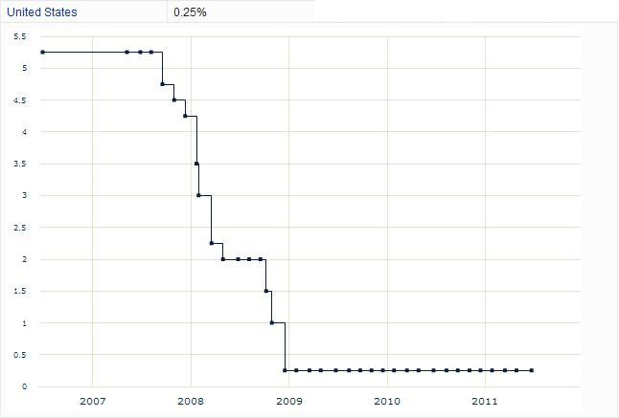

(http://www.fxstreet.com/fundamental/interest-rates-table/)

Chicago Mercantile Exachange Dairy Hedging
(http://gpvec.unl.edu/bcpms/files/Feedlot&PRM/CME_MooreReports2008/AC-167_MooreDairyFinal.pdf)

California Gas Prices

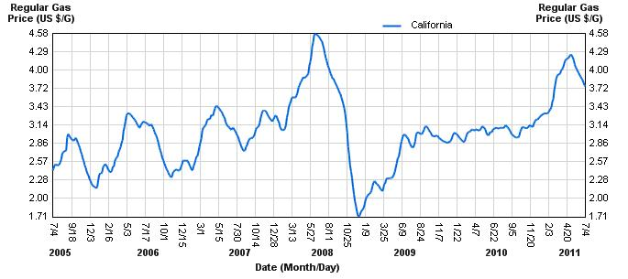

(http://www.californiagasprices.com/retail_price_chart.aspx)

California Department of Food and Agriculture (Graph 3.7)
UC Davis / Campbell Mathews et al.
UC Davis / Campbell Mathews et al.
California Department of Food and Agriculture (Graph 3.8)
Appendix 8.2
Appendix 8.3
Appendix 8.4
Appendix 8.6
Appendix 8.5

