[KellySearch logo](http://www.chemiepack.nl/film/index.html)

**New possibilities for enlarging Tigro’s brand awareness on the Dutch market**

**Preface**

First of all I would like to thank Tigro for giving me the opportunity to practice my internship in this worldwide operating company. I would like to show my appreciation especially to Sylvain Moors who guided me during these 20 weeks on a daily basis and who has given me the opportunity to get involved in this interesting industry. I have never thought it would be this interesting to work in the chemical industry. A lot of people are not aware of the huge impact that the chemical industry has on their daily life.

Secondly, I would like to thank my colleagues who always had time to answer my questions and who gave me explanations or advices. It was a pleasure working with all of you.

Thirdly, I would like to thank my supervisors from school, Drs. B.A.M. Derlagen – van Haaren (Bijke) and Mr. Roland Wastiaux who have guided me during these weeks.

And last but not least, I would like to thank the Hogeschool van Utrecht for teaching me during these past 4 years. It was a pleasure to follow this study wherein the possibilities of experiencing other cultures abroad was offered also. It was certainly a great instructive journey which I did not wanted to miss.

*Andrea Czuprynski*

*Belgium, June 2009*

**Introduction**

Tigro is a worldwide operating company. They are the specialists when it comes to distribution, blending , formulating, drying, packing, repacking, micronising, storage as well as the import, export of (dangerous) chemicals worldwide. Tigro offers these services for the chemical sector (agricultural, automotive and others) and for the pharmaceutical sector (food, drugs, cosmetics and others). Their portfolio mainly consists of long-term relationships and requires to be expanded. Especially during the current difficult worldwide economical situation, makes it a even greater motive to achieve this goal.

Currently Tigro does not practice a lot of marketing activities. Their main focus is word-of-mouth marketing. Because of that a lot of potential clients cannot be reached by Tigro, which makes it even harder for them to expand their portfolio and gain a higher turnover.

The main purpose of this report is discovering new marketing tools possibilities which can be

used by Tigro to reach their potential Dutch clients as well as what kind of improvements/

adjustments can be carried out in their already existing marketing activities.

The problem definition for the marketing research for Tigro will be as follows:  
  
 ***‘What other kind of resources then word-of-mouth marketing can enlarge Tigro’s***

***brand awareness in The Netherlands and how can they realize their marketing   
objectives?’***

**Objective of Tigro**

Which potential marketing tools can Tigro use to enlarge its brand awareness on the Dutch market?

**Applied searching methods**

For executing a clear, relevant and effective research it is important to use two researching methods, namely desk- and field research. These two methods are mainly relevant for answering the problem definition.

*Desk research:* internal information as buying, selling, extraction of Tigro’s customer’s portfolio et cetera are involved.

*Field research:* The field research consists of information which are obtained from external sources, such as: Internet, industry information, official statistics of the Dutch market, ‘direct’- and indirect’ competitors, interviews, customer satisfaction survey, visiting trade fairs et cetera.

The aim for using the field research method is to gather additional information which normally cannot be obtained by using desk research only. Next to the earlier mentioned external sources, the field research will also consist of a quality research which consists of a questionnaire and interviews. The interview for instance, can be held with an organizer of a trade fair such as Utech *Europe*. In such a way it is possible to obtain important information which can be used to analyze whether a trade fair can be an effective mean for Tigro.

**Executive Summary**

This report is a result of a 20 weeks internship at Tigro and it has the aim to enlarge the brand awareness on the Dutch chemical market. This executive summary includes all the important information wherewithal analysis are being executed. These are required to give an effective and good advice.

**The competitors**Within The Netherlands there is no company which provides exactly 100% the same services as offered by Tigro. Even if there would be a company which could provide the same services, they would require having several special licenses for the handling of hazardous chemicals or pharmaceuticals. Due the fact that such licenses are rarely issued, they strengthen the market position of companies who do posses such.

Tigro’s top 5 ‘direct’ competitors in order of competition threat:

1. **Katoen Natie Netherlands**
2. **Dow Chemicals Nederland**
3. **Vopak**
4. **Chemie Pack**
5. Loodet BV

The first four competitors are the most important competitors of Tigro when it comes to the competitive threat and their usage of marketing tools. These competitors use all kinds of media tools to enlarge their brand awareness. Their website is used optimally, by exhibiting their slogan online and putting video content on their website. Besides that, all of them try to reach their potential customers by publishing an ad in magazines. None of those mentioned marketing tools are currently used by Tigro, however it is wise to keep up with this trend. Before applying these adjustments or starting to use these new media tools, it is advisable to first of all make a clear view of how Tigro wants to represents itself to potential clients. Equally important is to know how it can help to create a positive and distinguished image from others.

**Customer survey which is carried out on the existing clients**

During these months, the already existing clients of Tigro were approached to fill in a customer satisfaction survey (Chapter 8 - 5. Customer survey). The outcome was positive. The clients in general have given Tigro an average final grade between de 7 and 8. Despite of the positive grades there was a negative thing on which has to be worked on, namely the internal communication. It has to work more fluently, quicker and everybody should have the knowledge of the agreements which are made with the clients. Next to this, Tigro has to continue its maintaining and enlarging its brand awareness. Currently 57% of the existing customers have found Tigro through their business partners and 50% had found them through other resources such as Direct Marketing which was started up by Tigro itselves. And at last an other important data came out. Tigro’s existing customers have chosen this company by its service (57%) and quality (43%).

**Hall, Kluckhohn and Hofstede**The Dutch are different from the Belgians. This analysis does not only important for personal contacting but is also for starting up an advertising campaign. It has to fit in the values and standards of the Dutch culture.

To start a successful campaign it is necessary to take these differences in account. Before carrying out a campaign, the most important data that a company needs to know about is the mentality of Dutch business.

- are feminine unlike the Belgians -> carrying for each other.

- a low power distance unlike the Belg. -> boss; is almost at equal level as the employees.

- live in a low context culture -> love to get a lot of information.

- live in monochromic time -> deadlines, seldom lent something to others, do   
 one thing at one time.

- short-time thinking ->‘time is money’, decisions have often to made   
 quickly.

- past-orientated/present -> learning from the past, living at present.

One last thing that should be noted, is that the Dutch in general value solving complains quickly as well as a good service. When a company provides those two important things, it is likely that the client will come back.

**SWOT-analysis**

|  |  |
| --- | --- |
| **Strengths** | **Weaknesses** |
| **S1** Tigro operates in 6 sectors, thus their reputation is spread among   different sectors.  **S2** Tigro’s portfolio consists of companies which all are selling/ providing   different kind of services/ products.   **S3** Good reputation. The existing customers of Tigro do recommend their   other ‘business partners’ to start a co-workship with Tigro.  **S4**  A lot of personal contact by visiting or calling clients, which makes the   contact personal.  **S5** Unique in its ‘one stop service’. This a very important data to underline and   needs to be communicated to the potential costumer very well.  **S6** Owns a lot of licenses for (un)dangerous chemicals, some are hard   to get. Only a few companies are currently in possession of such.  **S7** Maintenance of long-term business relationships  **S8** High quality of service (On- Time).  **S9** Because of the high security measures in the building, makes it reliable for   the client to store, re-pack et cetera their goods at Tigro.  **S10** Works independently (all in one package not interruption third party)  **S11** Owns two establishments (Lommel and Overpelt)  **S12** All employees are in possession of certificates  **S13** Brand name internationally easily rememberable | **W1** Currently Tigro does not practice other marketing activities except   visiting the customers or calling them, so-called Word-of- mouth   marketing.  **W2** Tigro does not do a lot to maintain and enlarge their brand   awareness. Tigro has to gain greater brand awareness. A greater   brand awareness will make it even easier to gain new customers.  **W3** There are a few companies which are providing a similar service   package as Tigro does, which makes it harder to promote the company   as an entirely ‘unique’ service company.  **W4**  At present Tigro only offers 2 languages on its website as well as in   their brochures, namely Dutch and English. Not all of the countries   do speak or read English, as a result that they cannot reach all of   their existing and potential clients.  **W5** New content on the website such as a film which the competitor   Chemie Pack applied on its website, costs time and money.  **W6** Currently there is no slogan available which can be used for getting   attention to the company. |
| **Opportunities** | **Threats** |
| **O1** Not a lot indirect competitors on the market  **O2** There is no 100% direct competitor  **O3** ‘Outsourcing’ is the new trend | **T1** Current economic situation has also impact on the chemical industry  **T2** Wider range of services which Tigro offers, makes it more difficult to   communicate towards the potential customers. |

***Figure 1. SWOT-analysis***

This model gives a perfect overview of Tigro’s Strengths, Weaknesses, Opportunities and Threats. The most important outcomes are:   
Tigro has a lot of strengths which must be used to distinguish itself from others. The most important ones are the ‘unique one-stop service’, the already existing of a good reputation, being in the possession of licenses which are hard to get, high quality (on time), international remember able name and independent working. These strengths have to be mentioned in all of the marketing tools which are going to be used. Besides that the latest trend outsourcing should be mentioned also. All these points together can perfectly be used to support an important weakness of Tigro, namely using only word-of-mouth marketing. To obtain greater brand awareness, other competitors use several marketing tools. These strengths and this opportunity are the perfect match which has to be clearly communicated to its existing and potential customers.

|  |  |
| --- | --- |
| Legenda (Rating) | |
| ++  +  0  -  -- | 100  75  50  25  0 |

**Maba-model**

The MABA-model stands for ‘*Market Attractiveness, Business Assessment’* and is developed by McKinsey. Its intension is to analyze the Dutch market based on the successfulness as well as the attractiveness and indicates Tigro’s business strengths which are needed to succeed on this market.

**Figure 2. Market attractiveness and business strengths of Tigro’s services** **Figure 3. Market competitive attractiveness and position of   
 Tigro’s services, on the Dutch Market**

|  |  |  |  |  |
| --- | --- | --- | --- | --- |
|  |  | **Weight** | **Rating** | **Value** |
| **Market attractive-ness** | Market size | 0.15 | 50 | 7.5 |
| Market growth | 0.2 | 50 | 10 |
| Competitive Intensity | 0.1 | 75 | 7.5 |
| Buyer power | 0.2 | 100 | 20 |
| Price sensitivity | 0.20 | 50 | 10 |
| Barriers of entry | 0.15 | 75 | 11.3 |
| **Total 1** | | | **66.3** |
| **Business strength** | Image/ reputation | 0.40 | 100 | 40 |
| Knowhow | 0.35 | 75 | 26.3 |
| Communication | 0.25 | 50 | 12.5 |
| **Total 1** | | | **78.8** |

|  |  |  |  |
| --- | --- | --- | --- |
| **Business Strength** Strong Medium Weak | | | |
| **Market Attractiveness**    Low Medium High  **33 67 100** | E:\Media\Contacten\Andrea Czuprynski\Tigro Industries\Afstudeerverslag Tigro Industries\Maba\CircelDiagram_01.png |  |  |
|  |  |  |
|  |  |  |
| **0/100 67 33 0** | | | |

When it comes to image/ reputation, knowhow and communication, these are the important strengths for a company which is operating on this particular market. These three support the brand awareness and can take care for a enlargement of the brand awareness.

When the market attractiveness and business strengths of Tigro services is taken together, it shows that for Tigro it is certainly attractive to operate and search its potential customers on this market. This will not be a waste of money. The value score of the market attractiveness is namely 66.3 and the business strength is 78.8. It shows the position of Tigro services on the market (figure 2. Market attractiveness and business strengths of Tigro’s services, figure 3. Market competitive attractiveness and position of Tigro’s services, on the Dutch Market), which reaches a highly attractive position in the graphic.

**Marketing communication plan**

**Marketing communication objectives**

*Marketing objectives*Tigro would like to gather new Dutch clients, built up long-term relationships with them and want to preserve their (existing) clients.  
  
*Brand awareness*Currently there are not a lot of potential Dutch customers who have heard of the name ‘Tigro’ with the result that they never visited the website [www.tigro.com](http://www.tigro.com). The aim is to enlarge this brand awareness in The Netherlands.

*Brand knowledge*Tigro fulfills a high brand knowledge, but unfortunately only mainly between existing customers who know the name by heart and have the knowledge what Tigro does. Potential customers are not aware of Tigro’s existence and what they stand for.

*Brand attitude*The existing customers already have an opinion when it comes to the attitude of Tigro.

In case they are satisfied with Tigro’s service they will pass their positive experiences towards other business partners.

*Behavior*

From the internet, trade fairs and branch magazines, one can learn the behavior of the target group. For Tigro it is important to use an open proposition whereby visiting the website can be seen as the aim.

**Marketing communication target group**

Tigro target groups can be found in several different sectors, namely: cosmetic, automotive, chemical, pharmaceutical, agricultural and food. The potential clients of Tigro are looking for services that Tigro provides. Not only non-manufacturing companies, but also producing companies can be analyzed as a target group for Tigro. It is getting more and more common for them to outsource their activities. This latest trend is caused mainly due to two reasons:

1. to reduce their fixed costs (such as personnel and machine costs)
2. to maintain their storage rooms/buildings of which maybe half might be filled, which can lead to higher costs. This means that it can detriment a company’s profit. In such case the company is not earning enough money to cover all these costs and is it becomes more attractive to outsource these kind of activities.

**Marketing communication strategy**

**Positioning**Tigro wants to achieve a position on the Dutch market whereby the high quality, the ‘unique one-stop services’, the knowledge, flexibility and the quickness have to be remarked. Tigro wants to be known as the best when it comes in its services. To achieve such Tigro should use the *informational positioning,* because of the connection between the functional benefits of the use of Tigro and the functional characteristics of its services.

**Proposition**

Tigro does not have a slogan unlike to some of its competitors, which can under set the open proposition. The message that Tigro tries to communicate to its customers is:

‘Tigro is the unique one-stop service which consists of high quality, flexibility, safety, quickness and gives you the opportunity to outsource your activities. The aim is that you as a customer get the possibility to concentrate on your own core-businesses.’

**Marketing communication mix (4 P’s)**

*Product*The ‘product’ Tigro tries to sell to its potential customers is their ‘unique one-stop service’.

*Price*The price of Tigro can be seen in the category average/ high.

*Place*The subsidiaries are established in Overpelt and Lommel in Belgium. Each subsidiary has its perfect position when it comes to distribution and space. Since both towns are just across the Dutch border and have the benefit that the harbor of Rotterdam and Antwerp are both near.

*Promotion*

Tigro did not execute a lot of activities to promote their services. Only direct marketing by telephone was exectuted and an article was published in the regional newspaper.

**Usage of marketing tools**

Currently almost every house holding uses the internet on a daily basis, therefore companies are ‘forced’ to use this media effectively. Despite of the current market recession, companies do reduce their marketing budgets. However the basic marketing tools as a website et cetera are still attractive and do not need a huge investment to keep it attractive and up-dated.

*Tigro’s website statistics*

The website statistics of [www.tigro.com](http://www.tigro.com) have shown that there was a growth in the number of website visitors. Remarkable is that most of them found the website by typing the name : Tigro (40.8%), Tigro Industries 12.6% and other keywords but all of them contain the name Tigro (46.6%). From this we can conclude that most of the website visitors already had the knowledge of Tigro. Therefore the brand awareness is not extended.

*Search engines and Metatags*

During the research an important data came out, namely that if a potential customer is searching for Tigro’s website through online search engines, he or she will not find this particular website unless the name Tigro will be typed. That is why Tigro has to make its website findable so that it has a chance to get in the top 6 list (natural resources) in for instance Google, which is used by 95% (Dec. ’08) of the Dutch population. This trend also can be remarked on the website of Tigro, where the average linking percentage through Google was 86.5% (Nov. ’08 – Apr. ’09. Chapter 8 – facts and figures 9. Analysis of search engines linking to Tigro’s website.Currently Tigro does not have a chance to get in the top 6 list of the natural sources (SEO – Search Engine Optimization) on [www.google.nl](http://www.google.nl), which generally is read by 97.8% of the searchers! The perfect situation will be if Tigro will get in this top 6 and this without making any extra costs for online advertising such as Google Adwards.   
An example of how Google works is shown here below:

A This is where a person or company fills its keywords in to start a search

B This is the title of the webpage

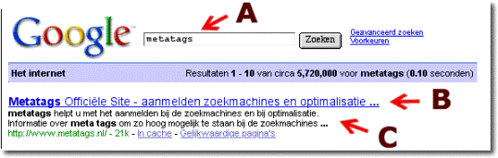C This is the description metatag and has regarding the website, the purpose to persuade a person/company to click on

***Figure 4. Explanation how an online search engine works Source:*** [*www.metatags.nl*](javascript:GetDescription('desc|New267%20%20|200807');)

To make the website findable it is recommend to make adjustments in the keywords by applying the following keywords and description. These should be written in several languages with the preference to Dutch, English, German and Spanish.

The current keyword use of [http://www.tigro.com/en/specialised-in/agriculture](javascript:GetDescription('desc|New267%20%20|200808');) is:  
<meta name="keywords" content="specialised-in/agriculture" />  
This should be extended with more keywords so that the website will be more findable on the internet. Some examples of potential keywords are:

<meta name="keywords" content="**Tigro, storage, repacking, grinding, mixing, formulating, distribution, advice, hazardous chemicals, harmless chemicals, ADR 3 5 6 7.3 9**" />

This also refers to the description on each subpage.

Besides the keywords and descriptions, Tigro should change its titles and make it more catchy. This is also a data which is shown by Google while searching (figure arrow C)and has to purpose to attract the visitor to click on it.

Since 60% of the search engine users make their choice in entering Tigro’s website based on the title and description of the search results. Tigro has to adjust these as soon as possible.

*Other website adjustments*

Tigro should apply the following website adjustments:

|  |
| --- |
| -adding different titles per subpage -add content: video - underline the image  - keep the website up-dated - add a contact form - offer more languages |

**Word-of- Mouth Marketing**

The only applicable word-of-mouth marketing is the ‘old fashion way’ namely face-to-face, by telephone or by e-mail.

**CRM**Tigro uses the *Dynamics* software program which includes the component CRM, but unfortunately it not being used. The CRM component is a perfect support for the sales, marketing and service processes.

**Kelly Search: The largest business seach site in the Netherland**  
This engine has the purpose for letting suppliers meet their needs in products and services. Kelly Search has monthly: Visitors 1,470,000 Google page rank 7

Visits 1,600,000 Visitors from the NL 86%

Returnings (visitors) 44%

Tigro already registered at Kelly Search, which is wisely since it is popular worldwide. Unfortunately Tigro did not signed in for the proper categories. They should also sign in for more categories which will make Tigro more easily findable.

**New possibilities***Advertising in a magazine*

The VNCI (Vereniging van de Nederlandse Chemie Industrie) is the best choice for Tigro to advertise in, since it has:

|  |  |
| --- | --- |
| A great and well-known reputation | Afterwards magazine published online |
| High credibility | Published once a month |
| Received donations from DSM, Dow 4.7 Billion (2008) | Editorial board includes huge companies and chances all the time |
| Often delivers 5 editions per company | Published 11 times a year |
| Has an average read frequency of 6 | 3,000 publications per edition |
| Reaches 18,000 professionals in the chemicals industry per edition | Advertisements costs are lower than in other branch magazines |
| Once a month free publication in the digital newsletter per banner | Subscription is low namely 70 euro per year |

If Tigro decides to advertise in the VNCI a couple of information’s should be underlined such as the ‘unique one stop service’, licenses, slogan, logo and suchlike. A second thing they can do is to put an editorial in the magazine together with one of Tigro’s clients, who can cite indirectly to Tigro by this article. A perfect partner for this will be Akzo Nobel, which is published a lot in this magazine.

*Dutch trade fairs (a possibility for in the future)*

Despite of the high costs, Dutch companies still have a positive opinion when it comes to the Dutch trade fairs. The international related trade fairs are the most attractive ones to exhibit at since the number of visitors and exhibitors have grown only here. Some potential trade fairs for Tigro are the ‘Kunststoffen 2009’ (Veldhoven) and CPHI (Pharmaceutical). An huge trade fair where Tigro can find its Dutch potential customers but also potential customers from all over the world is the K-Messe (Düsseldorf).

From this we can remark that a huge part of 85% still participates, but what attracts them exactly to continue or increase their participations on these trade fairs?

The main reason, that was answered by 59%, is obtaining new relationships/ clients. This is because every company has to maintain its database of customers and tries to extend by trying to attract new customers. The second reason that was given, is that this marketing tool is been used to sell or promote new products/ services, with a percentage of 51%. The third reason with 48%, companies participate on the fair with the intention to maintain its already existing relationships. Not far away from this comes the fourth most common reason, which is enlarging the brand awareness, with 45%.

**Future perspective (Moerdijk)**

A perfect possibility to enlarge the brand awareness even further, is by promoting a future new subsidiary of Tigro in Moerdijk by means of several marketing tools such as:

*Porthandbook->*This book is published for companies which are established in the Moerdijk region, but it can also be requested by other companies who are interested to get in contact with Tigro. It includes advertisements, articles, a company- and address list. Publication is for free. Chemie Pack, the competitor of Tigro is already established in Moerdijk and thus their name is written in this book.

*(Branch) Magazines*

If Tigro will open a new subsidiary, it should also mention this in its advertisements. There are a few magazines such as PetroChem and VNCI which meet the needs of Tigro, because they reach potential customers for Tigro.

*Press*

Tigro should approach the press and inform them that they will open their new subsidiary in Moerdijk. A few potential presses in the region are: HC Courant, Brabants dagblad, weekblad de Moerdijkse bode.

**Calculation**

|  |  |  |
| --- | --- | --- |
| **Marketing tool** | **Costs** |  |
| Adjustments: Website: Metatags  Titles | € 150,-  € 50,- |  |  |  |
| CRM software  Kelly Search  New possibilities: | € 0,-  € 0,- |  |  |  |
| Editorial VNCI  Advertisement in the VNCI (1/4 page \*6 months)  Video for on the website:  By students  By a professional | € 0,-  € 2100,-  € 0,- / € 2000,-  € 4553,- |  |  |  | |
|  |  |  |  |  |
| Exhibiting at a fair  The most expensive scenario | € 2640,-  **€ 6853,- € 9493,-** |  |  |  |
|  | (exl. Trade fair) (incl. trade fair) |  |  |  |

In the most expensive scenario without the cost of exhibiting on a trade fair, Tigro can take into account € 6853,-. It is certainly advised to practice these marking tools. Exhibiting is an option which should be considered in the future.

**Conclusions and Recommendations**

Marketing tools which are currently used by Tigro and the potential marketing tools which are examined in this report offer new possibilities for Tigro to reach its target group. Because of the current economic situation it is desirable to maintain a low marketing budget. Especially since in general there is not a lot of funds left to use for these kind of purposes. It does not matter if you are a small or a large company, everyone is trying to keep their heads above the water.

But how can this effectively achieved without making any huge investment?

Optimizing of marketing tools can easily be done by making a few adjustments. The most important marketing tool which Tigro can enlarge its brand awareness is the website: [www.tigro.com](javascript:GetDescription('desc|New267%20%20|200809');) .

First of all, the website should be easier to find by Google and other online search engines. Obtaining a top six position is crucial for a company. To achieve this goal, some basic website adjustments has to be made, such as:  
- using a lot and effective metatags ‘keywords’.

- using a clear and full metatags ‘description’.

- adding different kind of title on the subpages.

- writing the name Tigro as much as possible on the website wherefore the website can be   
 easier found.

Secondly, other adjustments such as: offering more languages, putting video content on the website and using a slogan, are used to underset the proposition in order to attract more potential visitors and extending the duration of their visit.

Thirdly, the internal communication should improve, in order to increase efficiency and quick service for the clients. Communication can easily be enhanced using the existing CRM software that comes with the Tigro’s current *Dynamics* software-solution. Unfortunately currently the CRM’s potential is poorly exploited.

There are also new possibilities for Tigro to enlarge in brand awareness in The Netherlands, namely advertising in a magazine and exhibiting on a fair. When it comes to advertising, the VNCI is the perfect match. The magazine reaches Tigro’s potential and existing customers and therefore it can enlarge their brand awareness.

At last but not least, as a future vision, exhibiting on Dutch trade fairs is an option for Tigro to meet their existing and potential clients. Despite of the high costs for exhibiting on Dutch (international) trade fairs, they are still attractive for companies to participate on. Especially the international trade fairs are doing well and are experiencing growth. This marketing tool is something which has to be used in the last scenario to enlarge the brand awareness on the Dutch chemical market. Since the costs are even higher than the other marketing tools.

The total costs for enlarging the brand awareness by these marketing tools is € 6,853 (excluding the fair). Since most of them should be applied on a short-time basis (figure 5 – annual plan), the procedure is:

- Making adjustments of the metatags/ descriptions/ titles,

- Adopting the CRM software,

* Making adjustments on Tigro’s account at Kelly Search.   
  All preferably in the month July.

At this point Tigro does not have to invest a lot of funds, since the costs for this is € 200,- excluding tax. Advertising in the VNCI magazine is advised to start in September, since a lot of employees, directors et cetera are on vacation during July and August. After having contacted several advertisement/marketing companies, the cost of developing an advertisement could not be calculated. Since this depends on the concept which is going to be used. For instance, developing a ‘normal’ and simple advertisement can be made by a company in a day and costs around € 65,- per hour \* 8 = € 520,- excl. But if you want more effects, the cost will increase tremendously. In order to control the costs Tigro has the possibility to settle a fixed-costs contract. In such case Tigro requires to know how this advertisement should look like. One thing is for shore and that is that the advertisement should be feminine and not as Chemie-Pack be masculine.

**Annual plan July ’09 till June ‘10**

|  |  |  |  |  |  |  |  |  |  |  |  |  |
| --- | --- | --- | --- | --- | --- | --- | --- | --- | --- | --- | --- | --- |
|  | **Jul. ‘09** | **Aug.**  **‘09** | **Sept.**  **‘09** | **Oct.**  **‘09** | **Nov.**  **‘09** | **Dec.**  **‘09** | **Jan.**  **‘10** | **Feb.**  **‘10** | **Mar.**  **‘10** | **Apr.**  **‘10** | **May**  **‘10** | **Jun.**  **‘10** |
| **Metatags changes** | **X** |  |  |  |  |  |  |  |  |  |  |  |
| **Title adjustments** | **X** |  |  |  |  |  |  |  |  |  |  |  |
| **CRM** | **X** |  |  |  |  |  |  |  |  |  |  |  |
| **Kelly Search**  **adjustments** | **X** |  |  |  |  |  |  |  |  |  |  |  |
| **Editorial in the VNCI** |  |  |  |  | **X** |  |  |  |  |  |  |  |
| **Film production** |  |  |  | **X** |  |  |  |  |  |  |  |  |
| **Advertise in the VNCI** |  |  | **X** | **X** | **X** |  | **X** |  | **X** |  | **X** |  |

**Bibliography**

*Dutch economic/ Statistics*

* <http://www.depers.nl/economie/286366/Werkloosheid-neemt-licht-toe.html>
* <http://www.penoactueel.nl/arbeidsrecht/deeltijd-ww-vanaf-deze-maand-mogelijk-3724.html>
* <http://www.penoactueel.nl/management/werkloosheid-loopt-op-tot-4-1-procent-3649.html>
* <http://www.volkskrant.nl/economie/article1105698.ece/Nederland_duikt_in_2009_in_recessie>
* [www.cbs.nl](javascript:GetDescription('desc|New267%20%20|200804');)
* [www.cbp.nl](javascript:__doPostBack('ctl00$ctl00$MainContent$MainContentDataMaster$TableView$pubGrid','move|G2');)

*Legislations*

* [http://www.ez.nl/Onderwerpen/Sterke\_consument/Digitale\_veiligheid/Spamverbod](http://www.abn.be/industry/tigro.htm)

*Competitors*

* http://[www.katoennatie.com](http://www.tigro.com/nl/over-tigro)
* [http://www.dow.com/](javascript:GetDescription('desc|New267%20%20|200810');)
* [http://www.vopak.nl/](http://searchenginewatch.com/3458351)
* <http://www.chemiepack.nl/nederlands/index.php>
* <http://www.loodet.nl/>

*Marketingtools*

* [www.ruscon.nl/modellen/Digitaal%20Porter%205-krachten%20model%20NL.xls](http://www.ruscon.nl/modellen/Digitaal%20Porter%205-krachten%20model%20NL.xls)
* [www.rtlz.nl](http://www.rtlz.nl)
* [http://searchenginewatch.com/3458351](javascript:GetDescription('desc|New267%20%20|200801');)
* [http://www.checkit.nl/nationalesearchenginemonitor.html](javascript:GetDescription('desc|New267%20%20|200811');)
* [www.kellysearch.nl](javascript:GetDescription('desc|New267%20%20|200812');)
* [www.vnci.nl](javascript:GetDescription('desc|New267%20%20|200901');)
* [www.sprengers.be](javascript:GetDescription('desc|New267%20%20|200807');)
* [www.cefic.be](http://www.metatags.nl)

*Website statistics of Tigro*

* [www.tigro.com](http://www.tigro.com)

**Reports**

CLC – Centrum voor Live Communication

Schakel, G. , Jenniskens, A., Boer, D. de, (15 januari 2009), *Rapport imago onderzoek vakbeurzen in Nederland*. Amsterdam: Lagroup

Checkit

Gisbergen, M.S. van, Most, J. van der, Aelen, P. *Checkit eyetracking Research Report*. In samenwerking met Marktonderzoekbureau De Vos & Jansen.

Nissen, J., Bruijn, E. de (2008). *Top 100 online vindbaarheid 2008*.

**Literature**

Floor, J.M.G en Raaij, W.F. van (2002). *Marketingcommunicatiestrategie*. 4th edition. Groningen: Stenfert Kroese

Oost, H. van Markenhof, A. (2002). *Een onderzoek voorbereiden*. 1 st edition. Baarn: HBuitgevers. (leren onderzoeken)

Braas, C en Couwelaar, R. van (2001). *Rapporteren*. 2nd edition. Groningen: Wolters Noordhoff. Taaltopics

Mooij, M.K. de (2005). *Global marketing and advertising: understanding cultural paradoxes*. 2e druk. London: Sage.

Rustenberg, Gb (2003). *Kernstof Nima B*. 3rd edition. Groningen: Wolters Noordhoff.

Kotler, P. (2003) *Principle van marketing.* 3rd edition. Prentice Hall Europe.

(Dutch version by Frank Broere)

Verhage, B. (2004). *Grondslagen van de marketing*. 4th edition. Groningen: Stefert Kroese.

**Interviews**

Mr. J. Loffeld (Jeroen) . Function: Department Chef. Company name: Goes & Roos.

Mr. M. Frankfort (Michiel). Function: Freelancer. Company name: Michiel Frankfort.

**Telephone contacts with potential magazines**

Petrochem Contact: Mr. Pascal van der Molen (Industrielinqs)  
 Tel. : +31(0) 20 3122088

VNCI Contact: Mr. Daan Mooijman (Daan Mooijman   
 Marketing and Sales)

Tel. : +31(0) 70 323 40 70

Buzzfacts Contact: Mr. Sandro van Wijk  
 Tel. : +31(0) 24 372 29 00

De Handelscourant Contact: Mrs. Robbin Hofman  
 Tel. : +31(0) 70 319 80 02

Bedrijvig Magazine Contact: Mrs. Anne-Marie Kamp (De Winter)

Tel. : +31(0) 41 333 93 95/ +31(0) 6 20 81 88 11

**Company film for on the website**

HKU – Hogeschool Contact: Mrs. Ingrid Mooy

Oude Amersfoortse weg 131 (Coordinator of the Xchange Professional)

1200 CL Hilversum E-mail : Ingrid.mooy@kmt.hku.nl

Tel. : +31(0) 35 683 64 64.  
Website: <http://xprof.hku.nl/clk/show>

Mood Media Contact : Mr. Roderick Goedhart

Rubberstraat 9 E-mail : r.goedhart@moodmedia.com

1411 AL Naarden Tel. : +31(0) 35 699 03 00

Website: <http://www.moodmedia.com/nl_nl/home/>

**Table of Contents**

Preface 2

Introduction 3

Executive summary 4

Conclusions and recommendations 12

Bibliography 14

Table of Contents 16

**Appendixes**

1. Introduction 18

1.1. Context 18

1.2. Description of the problem definition 18

1.3. Objective 19

1.4. The research method and bookmark anchor 19

2. Presenting the company 21

2.1. History 21

2.2. Mission, vision and values 21

3. Internal and external analysis 22

3.1. Internal analysis 22  
 3.1.1. Micro factors 22

3.1.2. Abell-model 23  
 3.2. External analysis 24  
 3.2.1. Meso factors 24  
 3.2.1.1. Competitors 24

3.2.1.2. Customer satisfaction survey 28

3.2.1.3. ABC – buyer’s analysis 29

3.2.1.4. The five forces model of Porter 31

3.2.2. Macro factors 32

3.2.3. Strategies 39

3.2.3.1. Maba – model 39

3.2.3.2. Ansoff – model 41

4. SWOT-analysis 42

4.1. SWOT – analyse 42

4.2. Confrontation matrix 43

5. Marketing communication plan 44  
 5.1. Marketing communication objectives 44  
 5.2. Marketing communication target group 44

5.3. Marketing communication strategy 45  
 5.3.1. Positioning 45

5.3.2. Proposition 45  
 5.4. Marketing communication mix (4 P’s) 45

6. Usage of the Marketing tools 46

6.1. Tigro’s website 47  
 6.1.1. Website statistics 47

6.1.2. Attracting and keeping the visitors on the website 49

6.1.3. Existing website texts adjustments 50

6.2. Search engines 51

6.2.1. Optimization of the online search engines 53

6.3. Word-of- Mouth Marketing 57

6.4. CRM 57

6.5. Kelly Search: the largest business search site in The Netherlands 58

6.6. New possibilities 59

6.6.1. Advertising in a magazine 59 6.6.2. Dutch trade fairs 61

6.7 Promoting the potential subsidiary: Moerdijk 66

7. Implementation and costs 67

8. Facts and Figures 70  
 1. Organization structure 70

2. Usage mediatools by competitors and by Tigro 71

3. Customer survey 77  
 4. Customer satisfaction survey + marks 80  
 5. Macro factors 82

6. Statistics number of visitors on the website (per month) 85

7. Opportunities to trace IP-addresses and identifying them 87

8. Visit duration 89

9. Analysis of search engines linking to Tigro’s website 90

10. Overview of Tigro’s most common keywords 92

11. Dutch trade fairs 93

**1. Introduction**

**1.1. Context**

Tigro is a worldwide operating company. The company’s portfolio possession mainly exists of long-term business relationships and requires to be expanded. Especially now, because of the worldwide economic situation, which makes it even a greater motive to achieve this goal.

Tigro does not practice a lot of marketing activities. At this moment, Tigro’s main focus lays on the word-of-mouth marketing. Sylvain and Bart Moors are the two representators of the company, which makes them the visiting cards of Tigro. Because only word-of mouth marketing is used, a lot of potential clients cannot be reached by them. Which makes it even harder to expand Tigro’s portfolio and gain a higher turnover.

**1.2. Description of the problem**

Discovering new marketing tools possibilities which Tigro can use to reach their potential

Dutch clients, is the main purpose of this report. Next to this I also want to find out what kind

of improvements/adjustments can be carried out in their already existing marketing activities.

Therefore, the problem definition for my marketing research for Tigro will be as follows:

***‘With which other kind of resources then word-of-mouth marketing can Tigro increase its***

***brand awareness in The Netherlands and how can they realize their marketing objectives?’***

During this research, the following sub questions are going to be answered:  
 **How does the current industrial chemical Dutch market looks like?**

* What are the market developments?  
    
  **What is Tigro current position on the Dutch market?**
* Who are their ‘direct’ and ‘indirect’ competitors?
* Concerning this market, to which extent does Tigro already has been known?
* With which kind of companies has Tigro already built up a long-term relationship?
* Is it for the potential customers easy to find Tigro?
* Who are the potential clients?

**How can Tigro obtain the attention of their potential clients?**

* How does Tigro distinguish itselves from their competitors?
* By which means of media could Tigro express its distinguishing?
* How can the potential customer be reached?

**Which media are suitable?**

* Which kind of media are the most attractive to use?
* Which media gets the most attention of the potential and existing customers?
* In which way can the resources be used?
* What kind of costs are involved?

**In what time path can I implementize my advice?**

**1.3. Objective**

By which means of potential marketingtools can Tigro enlarge its brand awareness on the Dutch market?

**1.4. The research method and bookmark anchor**

For executing a clear, relevant and effective research it is important to use the two research methods, namely desk- and field research. These two methods are mainly relevant for answering the problem definition.   
  
*Desk research:*

When it comes to desk research, internal information as buying, selling, extraction of Tigro’s customer portfolio et cetera are involved.

*Field research:*The field research consists of information which are obtained from external sources, such as:

* Internet,
* Industry information 🡪 (branch) magazines,
* Official statistics of the Dutch market 🡪CBS ‘*Centraal Bureau voor de Statistiek’* and  
  CPB ‘*Centraal Planbureau’,*
* Information of the ‘ direct’ and ‘ indirect’ competitors,
* Interviews,
* Customer satisfaction survey,
* Et cetera.

The aim for using the field research method is to gather additional information which normally cannot be obtained by using the desk research only. Next to the earlier mentioned external sources, the field research will also consist of a quality research which can be made by making a questionnaire and having interviews. An interview for instance, can be held with an organizer of a trade fair such as Utech *Europe*. In such a way it is possible to obtain important information which can be used to analyze if a trade fair can be an effective means for Tigro or not.

Areas

This subject fits perfectly in the areas as: general economics, sociology, market development, geography. Besides, it involves also the profession niche , namely in the field of chemics, pharma, food, cosmetics, agriculture and automotive.

Relevance

Nowadays every company has to keep its head above the water. A lot of small, medium and even the large sized companies have to respond to the present worldwide economic market developments. Currently companies do everything to survive. Copying from each other, changing core-businesses, maintaining/ gaining of the market distinguished position, building up/ improving or maintaining the (current) reputation, are certainly one of the most important and common things of which each company owner nowadays has to deal with.

At present, Tigro does not use other marketing tools then word-of-mouth marketing and has to consider to extend this by enabling other marketing tools such as an advertisement in magazines, exhibiting at a fairs, et cetera. Because of the current usage of marketing tools, Tigro misses its potential ‘meeting’ moments with its potential clients. That is why Tigro wants to examine with what kind of marketing tools they can reach and attract their potential clients effectively. All with the purpose to maintain the existing (long relationship) clients and obtain new (long relationship) potential clients. Enlarging the brand awareness is something which will fulfill a huge role with the purpose to obtain this.

Applicable marketing models

During this research several marketing models are used, namely:

***SWOT-analysis***(Strengths, Weaknesses, Opportunities, Threats) - This with the purpose to get a perfect global picture of the company. Hereby are the Strengths, Weaknesses, Opportunities and Threats of the company itself, discussed.

***Internal- and external analysis*** - This to get a clear overview of all the internal and external facts. In the external analysis for instance, data such as the market, the buyers and competitors, are examined. In the internal analyze, the positioning of the brand with respect to the competitors are compared.

***Confrontation matrix***  - A several combinations are made:

Oportunities - Threats

Strenghts - Threats

Weaknesess - Opportunities

Weaknesess - Threats

This with the purpose for getting a clearer view of what kind of options a company has when it comes to strategies which can be used to improve its current market position.

***Abell-model -*** Is used to define the core business definition of a company. The three axis being technologies, services and costumers group are examined for defects. Questions as: ‘For what kind of products are the costumers searching for?’ and ‘Who is my buying group exactly?’, will be answered.

***Growth model of Ansoff*** - This model is used with the purpose to determine the product marketing strategy of the company.

***Marketing mix (4 P’s)*** - The elements are: Product, Place, Price, Promotion. These 4 P’s are used to get a description in the strategic position of a product in a marketplace.

**P**roduct - The products/services on the market which are responding on the   
 customers need.

**P**rice - Is the price the customer pays for the product/service.

**P**lace - Represents the place where the costumer can buy the   
 product/service.

**P**romotion - Are the communications which a company can use to promote its   
 product/service, it exists of *advertising, public relations, word-of-  
 mouthmarketing and the point of sale.*

***Five forces model of Porter*** – (also called: ‘The competitive-forces-model). This model is used to determine the market potential profit and the competitor intensity. Five elements are hereby discussed:

1. The supplier power.
2. The buyer power.
3. The availability of the substitutes and products.
4. Threat of new entrants to the market.
5. Internal competition of players on the market.

***Maba-analysis*** – Hereby a product-market analysis is executed. There are two axis:

1. The features of the market is discussed.
2. The power of competition is discussed.

The market attractiveness and the company’s ability to compete successfully on the market are assessed.

**2. Presenting the company  
  
2.1. History**

Tigro was founded in 1984, in Overpelt (Belgium). Sylvain Moors, the founder who nowadays still fulfills his function as director, started his first activity: selling of (house hold) detergents. In 1989 Tigro bought its first ground on the Nolim Park in Overpelt and built their first office and warehouse. During all those years the core-business activity of the company have moved gradually to what Tigro stands for today. They are the specialists when it comes to distribution, mixing , packing, repacking, micronising, storage as well as the import, export of (dangerous) chemicals worldwide. Tigro offers these services for all kind of sectors such as chemical (agriculture, automotive and others) and pharmaceutical sector (food, drugs, cosmetics and others).

The company currently holds 4 different warehouses with a reception (of goods), a packing room, special repacking rooms, a computer room and offices for the administration and the management. The company expanded by opening a new complex in Lommel in October 2008. This complex is highly secured and is equiped with a hyper modern ‘foaming’ system provides safety security for its employees and stored goods.

In case of a fire, it only takes a minute to fill the whole complex with this foam. The advantage is that this foam does not damage the stored materials as happens with conventional firefighting methods.

**2.2. Mision, vision and values**Mission and goals  
Tigro wants to be a "unique one stop service provider' for its customers on the industrial market, specialized in sectors such as chemicals, pharmaceuticals, nutrition, cosmetics, agricultural and automotive. Tigro pursuits provision of high quality, trustworthy, safe and efficient solutions concerning storage, distribution and the handling of products. Thanks to outsourcing of these activities to Tigro, customers can focus completely on their own core business.

**Vision  
Tigro tries to achieve their mission and goals by building up a solid long term relationship with their customers, suppliers and other business partners. For that, they have built up a strong team of employees, who all are brilliant in business knowledge and engagement. In realizing their goal, they are taking the full responsibility for the obtained quality level and other indicators of customer contentment. Tigro is constantly looking for new techniques and opportunities to make their competition position more solid and to pursuit maximum profit.**

**Values  
Tigro handles several norms and values which have to speak for themselves in all aspects of the company. The company is transparent, honest and it has integrity. At any time they show respect to their colleagues, customers, suppliers and partners. And above all, they respect the environment and their social environment. The employees of Tigro have a passion for their job and professionalism always comes first.**

**3. Internal and the external analysis**

**3.1. Internal analysis**

**3.1.1. Micro factors**

The available resources can be divined in:

***Financial resources***

The turnover of this year is estimated at 16 million euro. 70% till 75% of the turnover consists of the fixed-/variable costs and investments. Till 2008 the liquidity of Tigro was positive which gave them the opportunity to function on their own funds. Tigro did not enabled a bank to finance a new project of founding a new subsidiary in Lommel (2008) since they had enough means to cover the costs. Despite of this huge investment, Tigro nowadays still maintains a solvability of 40% and foresees no loss of the existing costumers and a company growth of 5%. Because of this huge investment it is certainly important to greater the reputation without using too much funds, so that it can be used for other purposes.  *(****source Sylvian Moors – Director Tigro)******Commercial resources***Till now the company used different kind of media such as free publicity from a interview which were carried out by a newspaper/ magazines et cetera, Tigro’s website   
([www.tigro.com](http://www.tigro.com) ), brochures (available in 3 languages: English, Dutch, Romanian) and direct marketing which are carried out through the telephone.

***Technical resources***  
Tigro has a license for the Dynamics Software, which streamlines your business process. This software provides you all kind of services such as making and printing out of a tender, tracking the logistics data of the warehouse(s), works perfectly together with Outlook/Excel/ Word and helps you to manage your portfolio as a strategic asset.

***Natural resources***

The company tends its own energy supply. Generating of electricity is done through the solar panels which are mounted on the roof of the subsidiary in Lommel. Tigro initiative to use and supply green electricity can be used for the enlarging of the brand awareness.  
 ***Personnel resources***

Nowadays, after opening the new subsidiary in Lommel (October 2008), Tigro contains 49 employees which can be categorized in:

* Office employees devided in :

Departments: marketing, distribution, sales, administration, acquisition, documentation and production.

* Storage room(s) employees.
* Employees who work outside the Tigro subsidiaries, such as truck drivers.

For further description see Chapter 8 -Fact and Figures 1 - Organization structure.

**3.1.2. Abell - model**

***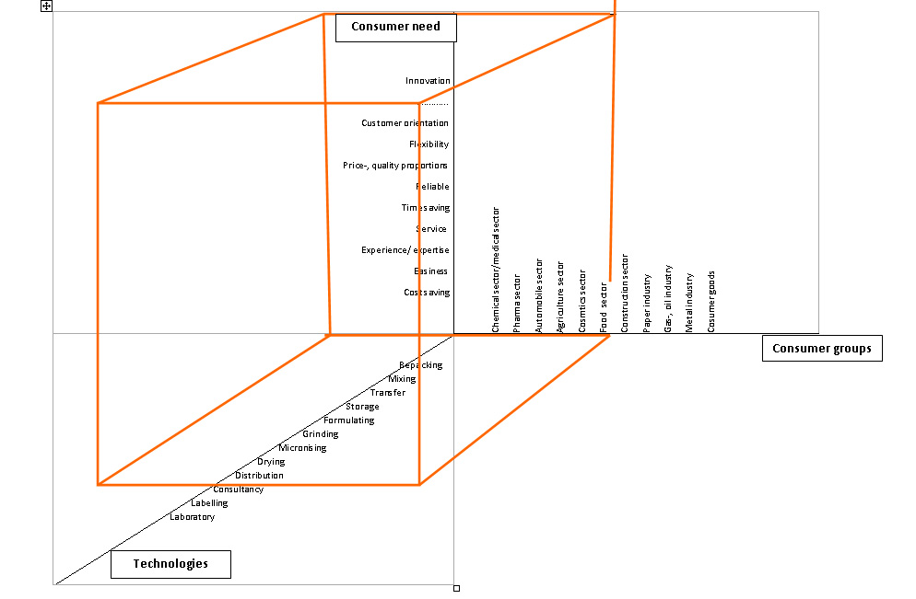Figure 1: Abell - model – Tigro***

The above mentioned model , is the framework from the Harvard professor Derek F. Abell and has the purpose to define the business of a company. In this occasion we are talking about the business definition of Tigro. The 3 axes which are examined are: *who, what and how.* In general, Tigro covers the whole model. But there are a few little points in which they might not meet to the needs for technology. During the existence of Tigro the 6 sectors are chosen consciously.

Other sectors, for example the petrol sector cannot be seen as a good option for them, because of the strong dependency of the worldwide petrol market. The prices per barrel fluctuates at all times. In other words one time the market price can be very attractive and in other times it might not. In this case Tigro can barely influence the prices which will put them in the situation that they have to follow the rest. Everybody will ask for the same prices for this service, what eventually will decrease the turnover of the providing company.  
From this model it can be remarked that Tigro is fulfilling its customer needs in services, but their technologies and consumergroups are not. A few gaps are found which should be taken into consideration for future perspectives.

**3.2. External analysis**

**3.2.1. Meso Factors**

**3.2.1.1. The competitors**  
When it comes to the competitors, Tigro is a company which is hard to analyze. The competition can be marked as a brand/ product type competition. There is not a company which provides exactly 100% the same services as Tigro does. Even when you analyze a company which provides the same services for the same sectors, it does not automatically means that they can offer exactly the same services and possibilities for its customers. Sometimes they might give you the impression that they can handle or store every dangerous chemical product, but such is not necessarily true. Take Peroxide for instance, you might think that every company which is promoting the fact that they can store dangerous chemicals could also store peroxides. But in reality most of the time such companies can not provide such a service since a special licence is required. Such licensis are extremely difficult to obtain. Peroxide is one example, but there are thousands of dangerous chemicals which make it even harder to find direct competitors. From this we can conclude that there is no one which can be seen as a 100% direct competitor of Tigro since every company is in the possession of several licenses and tries in such a way to distinguish itself from others.  
  
Tigro’s ‘direct’ competitors are mentioned here below in order of competition threat:

**1) Katoen natie** - (http://[www.katoennatie.com](javascript:GetDescription('desc|New267%20%20|200809');)) **2) Dow Chemicals Nederland** - (http://www.dow.com/) **3) Vopak -** (http://www.vopak.nl/ ) **4) Chemie-pack -** (http://www.chemiepack.nl/nederlands/index.php)

**5) Loodet BV** - (http://www.loodet.nl/)

The comparisons between these 4 competitors all include their media usage. Next to the comparisons questions such as: ‘Which marketing tools do those companies use for enlarging their brand awareness?’ and ‘With what kind of information do they try to get the attention of their potential customers?’, are going to be answered.

|  |  |
| --- | --- |
| **Media** | **Applied** |
| *Website* | **vinkje-blauw copy** |
| *Video on the website* | **vinkje-blauw copy** |
| *Registered at Kellysearch* |  |
| *Exhibits at the fair* | **vinkje-blauw copy** |
| *Sponsorship* | **vinkje-blauw copy** |
| *Free publicity* | **vinkje-blauw copy** |
| *Own magazine* | **vinkje-blauw copy** |
| Advertisements in magazines | **vinkje-blauw copy** |

**Katoen Natie Netherlands**

Kantoen Natie is the largest ´direct´ competitor of Tigro.   
They provide the same services as Tigro does, namely:  
- Warehousing & Storage,  
- Packing & Packaging (consumer, liquid, petrochemical,   
 industrial packaging/repacking),  
- Transport & Distribution,

-Value-added Services (blending, heating, homogenizing,   
 kitting, drying, grinding, filtering et cetera),  
- Port operations.

Licenses: owns almost all the available licenses.



Slogan: *‘Our people make the difference’*

|  |  |
| --- | --- |
| **Media** | **Applied** |
| *Website* | **vinkje-blauw copy** |
| *Video on the website* | **vinkje-blauw copy** |
| *Registered at Kellysearch* | **vinkje-blauw copy** |
| *Exhibits at the fair* | **vinkje-blauw copy** |
| *Sponsorship* | **vinkje-blauw copy** |
| *Free publicity* | **vinkje-blauw copy** |
| *Own magazine* | **vinkje-blauw copy** |
| Advertisements in magazines | **vinkje-blauw copy** |

**Dow Chemicals Nederland**

Is a worldwide operating company and has also a subsidiary

in The Netherlands. Dow produces essential products for

the consumer market, such as:

-Food,

-Maintenance and construction of buildings,

-Transportation,

-Paper and Publicity,

-Maintenance and improvements of housing,

-Personal and household care,

- Health and Medicine,

- Water purification,

-Electronics and Entertainment,

Licenses: Own almost all the licenses

Slogan: *‘Living. Improved Daily’*

The image they try to achieve is ‘ being green’. In other words being good for the environment and

responsible production. Currently, they are participating in a official Responsible Care program

wherein an aim of a ‘zero vision’ is settled. ‘ Zero vision’ stands for: 0 accidents, 0 injuries, 0 damages

to the environment.   
  
Dow settled its sustainability objectives for 2015:

1) sustainable chemistry, 2) developing products for solving worldwide problems, 3) energy efficient use,

4) approach of the changing climate, 5)involvement in product safety, 6) local protection of Public Health

and environment. These objectives are adjusted, monitored and then at the end tested. Hereby it is giving Dow a good impression of what they have accomplished and on what they have to work on further.

|  |
| --- |
|  |
|  |

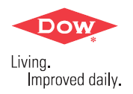

**Vopak**

|  |  |
| --- | --- |
| **Media** | **Applied** |
| *Website* | **vinkje-blauw copy** |
| *Video on the website* | **vinkje-blauw copy** |
| *Registered by Kellysearch* | **vinkje-blauw copy** |
| *Exhibits at the fair* |  |
| *Sponsorship* | **vinkje-blauw copy** |
| *Free publicity* | **vinkje-blauw copy** |
| *Own magazine* |  |
| Advertisements in magazines | **vinkje-blauw copy** |

A worldwide operating company, specialized in petrochemical

and chemicals for over 400 years. Their subsidiary in The

Netherlands is established in Dordrecht.

-storage of chemicals (temperature controlled),

- mixing,

- distribution,

- storage of petrochemicals.

Slogan: ‘*We aim to achieve excellence in everything that we do*’



**Chemie Pack**

A Dutch company which owns two subsidiaries in

The Netherlands.  
-reaches all kind of industries, such as: chemical-, rubber-,

agricultural-, coating/dye-, navigation, logistic, packaging.

-services: filling of liquids, filling of powders and granulates,

mixing of powders and liquids, air-freight, storage, help by

incidents.

Licenses: ISO9001, ISO2000, ISO14001, ISO2004.

Slogan: ‘*Vertrouwde omgang met Chemische producten’  
*Extra on the website: photo album of the new subsidiary in Roosendaal, search function, film of the

opening of the new subsidiary. This competitor is the most similar to Tigro when it comes to the amount of personnel, capacity and number of subsidiaries.

|  |  |
| --- | --- |
| **Media** | **Applied** |
| *Website* | **vinkje-blauw copy** |
| *Video on the website* | **vinkje-blauw copy** |
| *Registered at Kellysearch* | **vinkje-blauw copy** |
| *Exhibits at the fair* |  |
| *Sponsorship* |  |
| *Free publicity* |  |
| *Own magazine* |  |
| Advertisements in magazines | **vinkje-blauw copy** |

**Loodet BV**

|  |  |
| --- | --- |
| **Media** | **Applied** |
| *Website* | **vinkje-blauw copy** |
| *Video on the website* |  |
| *Registered at Kellysearch* | **vinkje-blauw copy** |
| *Exhibits at the fair* |  |
| *Sponsorship* | **vinkje-blauw copy** |
| *Free publicity* |  |
| *Own magazine* |  |
| Advertisements in magazines |  |

A Dutch company with a subsidiary in Breda.

-storage, transshipment and logistics,

-rebranding, repacking, labeling, customization, rush orders.

Licenses: ISO9001, GMP+, BRC, IFS.

They do not have a slogan.

Unique on the website: playing with the letters LOODET.

For instance, when you click on the L you are going to be linked

to an subpage which has the title ‘**L**ourier’.   
  
 For a comprehensive overview see: Facts and figures 2 - Usage mediatools by competitors and by Tigro.



|  |  |
| --- | --- |
| **Media** | **Applied** |
| *Website* | **vinkje-blauw copy** |
| *Video on the website* |  |
| *Registered at Kellysearch* | **vinkje-blauw copy** |
| *Exhibits at the fair* |  |
| *Sponsorship* | **vinkje-blauw copy** |
| *Free publicity* | **vinkje-blauw copy** |
| *Own magazine* |  |
| Advertisements in magazines |  |

**Tigro**

For examples of Tigro’s media usage see: Chapter 8 - Facts and figures 2. Usage media tools by competitors and by Tigro.

|  |  |
| --- | --- |
| In possession of the following licenses: | Image: |
| ISO9000, ISO14000, ISO18000 (ISO – International Organization for Standarization)  ADR 3, 4, 5, 6, 7.3, 9 (Distribution - hazard classification - Accord européen relatif au transport international des marchandises Dangereuses par Route)  PGS15 (Storage of hazardous chemicals)  OHSAS (Health and Safety – Occupational Health & Safety Advisory Services) | Concerns the safety of the environment  Concerns the safety and health of its employees  ‘ Green image’ -> own solar panels on the roof of the subsidiary in Lommel. The remaining energy is sold to an energy supplier  High quality and quickness |

Conclusion

We can conclude that the competitors are using all kinds of media tools to enlarge their brand awareness on a market. The most remarkable things are that all the five mentioned competitors have launched a website, use a slogan and have put a video/film on their website. Currently Tigro does not use all these marketing tools but it would be wise if they would consider to do the same. An last and important marketing tool is advertising in magazines, since this is used by almost all the competitors. Before executing these marketing tools, Tigro has to think through how they can enlarge their brand awareness whereby creating a positive and distinguished image is required.

**3.2.1.2. Customer satisfaction survey**  
In these months a customer’s analysis has been made. Of the 21 approached existing costumers, 15 have responded on this and cooperated by filling in the quantitative survey, which consisted of 13 questions.  
From this we can analyze that from the services which Tigro provide, 71% of the customers store their good at Tigro warehouses, and that 57% of the costumers are letting them handle their goods. The biggest group which has a score of 57%, is using the services once or twice per quarter of a year. The second biggest group with 21% is using the services 8 or more times per quarter of a year.

Contact  
The already existing customers mostly found the Tigro through their **business partners** (57%) or through other resources such as **Direct Marketing** which was started by Tigro itself (50%) at that time.

Why Tigro

The two most important reasons which most of the respondents have given, are the **service** (57%) and the **quality** (43%). These are also the two most important elements on which Tigro is focusing and want to maintain.

Most important comments

‘I have chosen this company only for their licenses for stocking dangerous chemicals, which a lot of companies do not own.’   
  
‘Unfortunately, Tigro internal communication does not always work smoothly. Sometimes I have to call back to make sure something is done.’  
‘Once the information was delivered to the proper person, the handling went good.’  
‘Most of the contacts are handled by e-mail…it would be pleasant if someone could send a short message that he received the mail/ order et cetera. It will also be pleasant if the CMR would be sent to us upon shipment of the material from the warehouse. Because then we can send this CMR to our customer and keep them updated regarding the status of the shipment.  
  
‘Always a pleasant and good contact with Sylvain Moors. In principle we are colleagues in the market.’

‘Concerning the storage reports I would like to compliment the improvement of these. Another improvement would be, to send those reports automatically to me (the costumer) so we can finish our monthly accounts closing.’

Important to keep in mind  
Firstly, Tigro has to work hard on its internal communication. This weakness was already earlier noticed and is again confirmed by the outcome of this survey. Secondly, up 71% of the respondents do store their goods also at other companies. This is a huge percentage of which Tigro has to be aware of and certainly have to respond to . This way they can gain more tenders which can lead to more contracts which finally will lead to a higher turnover for the company. At least, 93% of the respondents would advise their contacts to use Tigro´s services. Which means that a chance that a word-of-mouth marketing will take place can be estimated as high.

Grade

The final average grade for professionalism, internal communication, fastness and reliability lays between the 7 to 8. With a tendency to a 8, which is a score that companies in general try to achieve.

The customer satisfaction survey and the list with marks can be found in Chapter 8 - facts and figures 3. Customer survey, facts and figures 4. Customer satisfaction survey + marks.

**3.2.1.3. ABC – buyer’s analysis**

An ABC – buyer’s analysis is certainly a very important indicator which should be carried out by every company. As an company you will (1) obtain a clear vision of the buyer’s attitude, (2) will have an indication about the turnover and buying share of the buyer, (3) you can find out who your customers loyalties are. These 3 indicators are the most important information’s that a company can obtain and gives them the opportunity to, for instance, change the behavior of their customer. This by having even more direct contact with them, but also by tracking the customer’s latest developments on which the company can respond to. A good example for this nowadays can be found on practically daily basis. Most companies are getting more and more causiouss in hiring new employees. They rather want to find a new solution for solving their problems without taking high risks. That is why ‘outsourcing’ has become one of the biggest new developments which a lot of companies consider.

Categories

The buyers who are using the business services of Tigro, can be categorized in 3 levels, namely A, B or C.

|  |  |
| --- | --- |
| **Category** | **Clarification** |
| **A** | Are the customers who regularly use the business services of Tigro. This group has the biggest part when it comes to the number of acquisitions and their measurement. |
| **B** | Are the customers who use the business services of Tigro on average basis. When it comes to the number of acquisitions and their measure, this group of customers can be measured as the average purchaser. |
| **C** | Are the customers who use the business services of Tigro on irregularly basis. They do not use these services often. In other words, this group uses Tigro´s services sporadically in which small measures are bought. |

This analysis has been carried out on the same buyers list which was also used in the previous ´customer satisfaction survey´.

|  |  |
| --- | --- |
| **Category A :** M.P.I. Chemie BV (A) CPH Chemicals BV (A)  Vesta Intracon BV (A)   Chemtech BV (A)  Sappi Maastricht BV (A)  Akzo Nobel Functional Chemical (A)  **Category B:** Megatrax Benelux (B)  JPB Logistics BV (B) Octa Chemie BV (B) Cookson Electronics Assembly (B) Rebain International BV (B)  Intermarc (B)  **Category C:**  Soylent (C) Shin Etsu Silicones Europe BV (C) Antonides (C)  Kommer Biopharm BV (C) Van Hees (C) Denka International BV (C) Rodachem  BV (C) | chemtech logohttp://vesta-intracon.com/templates/intracon/images/index_01.pnghttp://www.denka.nl/nl/images/foto_home_01.jpghttp://www.shinetsu.info/images/General_pictures/Navigator_top.gifhttp://www.rodachem.com/site/images/logo.gifhttp://www.rebain.co.nz/images/logo.gifhttp://www.megatraxbenelux.nl/engels/pics/logo_1.gifCookson Electronics[MPI Chemie](javascript:GetDescription('desc|New267%20%20|200805');)http://old.rrc-thun.ch/image/partner_logo/Swiss_Lack_AKZO-Nobel_2006.JPGhttp://www.dsm.com/en_US/images/dfi/cph1.gif |

Conclusion  
From this we can conclude that the customers of Tigro three mentioned categories are practically equally divided. Conspicuously that a huge organization as Akzo Nobel does play a major role when it comes to enabling Tigro services. Also Vesta Intracon BV and Chemtech are companies who already established a great brand awareness in The Netherlands. Robain, Megatrax and Cookson Electronics are also huge companies which should not be forgotten. Overall we can say that Tigro portfolio of the ABC-analysis can be regarded as an attractive one and has to consider to use these contacts to greater and stronger their brand awareness in The Netherlands.

**3.2.1.4. The five forces model of Porter**The Porter model is created by Micheal Porter, an American professor who taught at the Harvard Business School. This model is known as: ‘Five Forces Model’ or ‘Competitive Forces Model’ and is used with the purpose to indicate the market attractiveness of the industry.

The profitability and the intensity of the competition are the two topics   
which are analyzed hereby.

**Threat of new entrants  
4.9**

1 = low chance (positive)  
 10 = high chance (negative)

**Bargaining power of suppliers  
5.8**

**Bargaining power of buyers  
7.8**

**Threat of substitutes products and service  
2.8**

**Rivalry under excisting firms  
4.8**

**Figure 2 The five forces of Porter**

*Threat of new entrants*

The score hereby is 4.9 which means that it tends more to the positive site. There are some barriers to enter the market and provide the same services as Tigro does. Topics as start-up costs, government legislation, becoming a specialist, no ‘concept’ protection, high fixed costs, the relative long time for applying for licenses et cetra. The Netherlands are trying to stimulate companies to start an establishment in one of the many just built as well as in future industrial areas, since this sector is one of the largest and most important for the Dutch economy.

*Bargaining power of buyers*

The buyer power scores very high namely a 7.8. In other words, the customers force is negative for Tigro. The buyer stands in a very positive position when it comes to negotiating. Previous Tigro might had the control of its prices but it had to adjust in connection with the current market situation, whereby every company has to deal with the difficult times. Every company does everything to take care for its continuing of existence. This is especially apparent in the amount and the sizes of the orders. Even when a customer has signed a contract for handling a certain amount of goods, he might not always have the possibility to fulfill the contract since the demand has also decreased for this company. Resulting that he does not need that many means anymore. In this situation Tigro has two possibilities: 1) he can push his customer to maintain the contract. If the customer will not enforce the contract, Tigro can dissolve the contract and lose the customer. 2) Tigro negotiates again with its customer whereby a new amount et cetera will be negotiated so that Tigro will maintain its customer.

*Threat of substitutes products and services*

This topic has a low score of 2.8 which is positive. Tigro does not have a high threat when it comes to the substitutes products and services. There are not a lot of companies who provide almost the same services as Tigro does. The only threat is that nowadays more and more companies want to provide its consumer ‘environmentally friendly products’ whereby dangerous chemicals will be less needed. Which is negative for Tigro because they prefer handling, stocking et cetera of dangerous chemicals since these products will provide more revenues than harmless chemicals.

*Bargaining power of suppliers*

The score is 5.8 which means that it tends to the negative side. The supplier is in the position to earn more probability than the selling industry. But also Tigro is one of the few companies who has the ownership of some licenses for handling or stocking of hazardous chemicals, which in general are hard to get.

*Rivalry under existing firms*

This topic scores a 4.8. Currently companies are trying to extend their portfolio, which most of the time means that they have to convince a potential customer to change their supplier, in other words taking the customers away from your competitors. Also between the rivalries, the products resemble each other. But in Tigro´s case it can distinguish itself perfectly from others since they have the permission to store or handle a wide range of hazardous chemicals which other companies may not.

Conclusion  
Overall we can say that the Dutch industrial market is certainly an attractive market for Tigro. The profitability and the competition on this market is healthy and does not score too high. Tigro is not the only company who provides these services, it is therefore advised to continue to respond to the current market situation and do not ask too high prices for its services.

**3.2.2. Macro factors  
 *Economics***At present there have been many changes on the Dutch economic market. Shifting not only takes place on the Dutch market, but is something that takes place everywhere around the world. Large companies such as DSM, Akzo Nobel, Aalberts Industries, Lyondell Chemical Company and Basell are also feeling this huge economical impact that threatens the profitability of these companies. This recent development will probably continue during this prospective year. Moreover the purchase numbers have declined in general and the customer-portfolio’ s have decreased. Further more some companies have gone bankrupt or do not comply with their payments. An other thing that should not been forgotten is that some industries might have been shifted or have been closed completely.

When we analyze the car industry and its relatives for example, their adapting strategy concerning the economic recession are noticeable. The whole attention to produce new cars has been moved to producing new car components. This because of the latest economic development, where the consumer’s attitude has been changed.

Nowadays the consumer postpones its ‘ luxurious’ purchases, such as buying a new car. People are bringing their car rather to a garage to repair it, than buying a new one. This way there are able to save money, which can be used for other important purposes as food, school or can be saved for later on.

Employment   
Since 2008, the period that the economic crisis started, the CPS (Centraal Plan Bureau), CBS (Centraal Bureau voor Statistieken) and the UWV Werkbedrijf have been speculating about the number of unemployed people in The Netherlands. The forecast, which was made in December 2008 already exceeded. Currently we are already nearby the predicted 4.5%, namely 3.9%. This means that the predicted unemployment number of 400,000 has been exceeded in January 2009 with 444,200 persons. Right now they even calculated that there will probably be an unemployment percentage number of 5.5 instead of the 4.5 this year. Also the predicted 6.5% in 2010 will probably increase to 8.75% and will lead to an unemployment number up 600,000 persons from the workforce (figure 3: Anticipated movements during the crisis)!

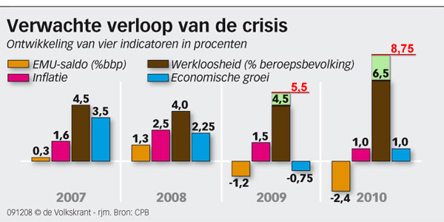  
***Figure 3: Anticipated movements during the crisis. Source:***[*www.cps.nl*](http://www.cps.nl)

When we are looking further the development of the unemployment numbers and we will make a distinction between women and men, then you can note that they are strongly different from each other. The number of unemployment women have decreased with 26,000 integers according to census. The unemployment of men on the other hand has increased with 19,000. A lot of women are already working or try to switch their jobs to work in the health or education sector. But the men are mostly working in the typical ‘men professions’ like the transport and technique sector, where currently a lot of persons were fired and send home.

In these days the young aged group of jobseekers to the age of 27, have increased with 14.5%. The group which ranges from 45 years and higher, the increase number is the lowest from all age groups with a percentage of 4.1%. We can conclude that in these days it is getting harder and harder to get a job, especially for the young person’s who do not have a lot of working experience.   
The UWV Werkbedrijf also noticed that in January 2009 in reference to January 2008, the number of vacancies decreased with 30%. Hereby we can conclude that companies in general are trying to spare their fixed costs by having less personnel. The consumer is buying less products which means that the production of these goods will decline and will lead to an excess.

*The WW (Werkloosheidswet – Unemployment act) part-time maintenance*Since April 2009 employers are having the possibility to let their employees work less hours than what they have signed for. This is a exception and has the aim to support both the employers as well as the employees. This temporarily act gives the employer the opportunity to save his company and to keep the employee’s job. The maximum diminishment which can be obtained is half of the salary for which the employee has signed for. In this situation the employer must pay half of the salary of the employee and the other half is paid by the WW-maintenance of the employee. The dearness of receiving this maintenance depends on the working years of the employee. The longer he has worked, the longer he can receive its maintenance.

The advantage of this situation is that people can retain their jobs and when the market attraction will go up again they will resume their ‘old’ working hours. But there are 2 disadvantages, namely: Firstly, as an employee you are building less WW-maintenance up than normally, because you are working less hours. Secondly, you have to give in your already built WW-maintenance years.

Confidence of consumer

In the previous years, the confidence of the consumer has diminished. Between the month February and March 2009, it decreased from -30 to -34. The cause of this can be related to a lot of things as the general economic growth, unemployment et cetera. Furthermore from the statistics of CBS (Centraal Bureau voor Statistieken) we can conclude that the consumer is seeing its near future very gloomy. The trust in the Dutch economic market development also decreased from -62 to -68, which makes it the depth point of this history.

Because of this, the Dutch consumers is thinking negatively concerning its own finance in these upcoming months. Thus the indicator has fallen further from -8 to -16. Which means that this will lead to, that the consumer will be even more ‘ careful’ in spending his money. He will spent less money on a new car, a new computer and other luxurious goods and will search for other alternatives to save money.

Savings

Nowadays saving money is becoming more and more important. The consumer is trying to create this buffer so that he can easily endure through the possible difficult months. In general, in January 2008 238,569 million euro have been saved and increased to 256,099 million euro (Chapter 8 - facts and figures 5. Macro Factors -Savings). Lately there has been a huge increase in the number of accounts for saving money through the internet. In 2006 there were 5,348,000 accounts and it increased to 5,738,000 accounts. Despite of that, the total amount of online money saving did not increase what implies that people are saving smaller amounts of money. Nowadays it is ‘ normal’ to live with the idea that one day you have a job and the other day you might be sent home.

Consumer credit

In these days banking services as a consumer credit are harder to obtain. Lenders are more conscious about the risks of lending money. Every day more and more people are uncertain about their future and are hoping that they can retain their job. Unfortunately, some of them have becomed unemployment already.

The current economic situation can also be noted in the number of promised limits:

January 2007: 10.063 (x1000)

January 2008: 10.244 (x1000)

January 2009: 8.932 (x1000)

Which means that the number of promised limits decreased about 1100 (x1000) limits in 3 years. Also the developments in repayments have decreased a lot, from € 1112 mln (2007),

€ 991 mln (2008), to € 854 mln (Chapter 8 - facts and figures 5.Macro factors – Consumer credits). This means that for a lot of them it is getting harder to repay their loans.

But not only the consumers are having problems to repay their loans. Currently this also takes place in many companies. When we follow the news of the last months, the percentage of bankruptcies have increased with 42%!

The economic share of the chemical industry

The Dutch chemical industry takes a huge share in the Dutch economic market. The last couple of years (2003-2008) there has been a continual growth in the market share, which was influenced by the general national and worldwide economic market situation. The Dutch chemical industry turnover in 2007 was € 50 billion.  ***Legislations***

As a company you have to take into account that there are strict rules of using marketing tools such as a website, advertisements et cetera. There is a possibility that rules regarding legal marketing means can be changed by law and become illegal. Examples of such is the mailing of spam mail.

SPAM messages  
These messages are unwelcome e-mails which are used for marketing purposes and can be send by e-mail, fax or other electronic technologies. Since some years it became illegal to send Spam messages to consumers, but this legacy does not apply for sending Spam messages to companies. But from 1st July 2009, this is going to change. From that day it will be illegal to send to both of these parties. From that moment, the ‘Spam company’ has to ask permission to the person or company for sending marketing messages.

If a person or company wants to receive messages, they have to confirm this by for instance signing up for this ‘service’ on the website of the sender. If you do not keep to this legislation and the OPTA (the Independent Post- and Telecom authority) catches you, you can risk a fine with a maximum of € 450,000.

***Institutional environment*DNV - (Services for Managing Risk)**ISO registeredTigro is currently a registered at this association, which since 1864 have the purpose of safeguarding life, property and the environment. They are the international leader when it comes to managing risks and are giving companies advise how to manage their risks instead of eliminating them. **Essenscia** ‘where chemistry meets life sciences’ (Belgische Federatie van de Chemische Industrie en Life Sciences) This umbrella organization represents almost all the activities from the chemistry and life sciences sector. Almost 800 companies are connected to this organization and are carrying for over the 95% of the total turnover of the sector.

**Cefic (European Chemical Industry Council)**Represents the European Chemical Industry. About 29,000 large, medium and small chemical companies are represented directly or indirectly by this Council. 1.3 million people are employed and account for nearly a third of the world’s chemical production.

**Responsible Care (a global initiative of the International Council of Chemical Associations)**They try to connect all the companies which are operating in the chemical industry, with the aim to improve the health, environment and safety among each other.  
  
If Tigro will decide to start a new subsidiary in The Netherlands, the following two associations which care for the health- and environment safety might be interested for them:   
**VNCI – Vereniging van de Nederlandse Chemie Industrie** - [http://www.vnci.nl/](http://www.metatags.nl)  
The branch association of the chemistry industry of the Netherlands which exists already for over more than 90 years.   
 ***Nederlandse Aerosol Vereniging -*** [http://www.nav-aerosol.nl/](http://www.mpi-chemie.com/index.php) ***connected with the FEA (Federation of European Aerosol Associations)***  
Is established on 29th May 1967 and looks after the Dutch Aerosol Industry. This with regards to the authorities, European organization, environmental, consumer organizations et cetera.   
The companies and manufacturers which are involved in this association are:   
1) Manufacturers of metal and aluminum, of tin cans, the ingredients and propellants.  
2) Manufacturers of the end products as a third part. Functioning as a filler.  
3) Companies which are selling aerosols to users and consumers   
The aim they try to achieve is to advance the growth of the sustainable production and sales of aerosols in The Netherlands. The few important things that they want to pursue are: safety and a responsible living environment, the environment and the consumer.   
  
Conclusion   
All these Associations are for Tigro interesting to join in. They all have important tasks when it comes to safety, environment et cetera. When Tigro will take part in for example the VNCI organization by becoming a member, it will give them a positive image.

***Social-cultural developments***When we analyze the cultural values of The Netherlands, we can bring the theories of Geert   
Hofstede, Clyde Kluckhohn and Edward Hall all together to create a perfect picture.  
If you want to do business in The Netherlands, there are some certain things you need to take in account. In the first place you might think that Belgians have the same cultural values as a Dutchmen, but you will be surprised about the results.  
  
***Figure 4: Dimensions of Hofstede. Source: Marieke de Mooij – Global marketing and advertising: understanding cultural paradoxes’***

Hofstede  
Here above in figure 4 the uncertainty avoidance, the power distance, individualism and masculine are being disclosed. This graphic can be used as an indication of the two countries. The first thing we can remark is that when it comes to individualism the Dutch are nearly the same as the Belgians. Obtaining your own success and thinking firstly about yourself before others are some of the findings you can notice in individualism.   
 *Uncertainty avoidance*  
The other indicators are very different from each other. The greatest remark that can be found is the uncertainty avoidance. The Belgians have scored a 94 and in respect to the Dutchmen who have scored a 53. This means that the Belgians like to live in a culture where formal rules, predictability and hard working (gives them security) are very important. In The Netherlands people do not like to live by rules. The fewer rules, the better they feel. Flexibility, starting a conflict, competition and low stress can be noticed. But also deviant behavior in respect to the Belgians is accepted.

*Masculine/ feminine*The Dutch are not comparable to the Belgians when it comes to masculinity. Belgians have a greater tendency to a masculine culture (score 54). The Dutch score a 14 on this subject, which means that they are a very feminine country. Equality between different genders, quality of life and looking after each other are the main things you can observe in The Netherlands.

*Power distance*

The Belgians score a 65 when it comes to power distance. Hierarchy is something you can notice immediately. When we analyze this on the workingplace, in Belgium the Chef/ Director is giving his employees instructions and making your own initiatives is something which is not appreciated. You must honor the hierarchy, your Chef/ Director is the person who has to give you a final approval. In The Netherlands (score 38) your Chef/ Director is like a colleague to you, own initiatives are appreciated and most of the time you will not have to ask for any approvals from your Chef/ Director.

Hall and Kluckhohn

By analyzing The Netherlands and its culture, Hall and Kluckhohn cannot be forgotten. Here below you can find the most important values, which are essential to provide a total picture:

The Dutch: - live in a low context culture:  
 They love to get a lot of information, tasks are more important than   
 relationships, they are focussed on rules (if something is forbidden they will   
 not break the rules), are more focused on verbal communication than non-  
 verbal, there is a high flexibility.  
 - live in a monochromic time:  
 They do one thing at the time, they make a lot of plans so that they   
 can finish their task on time, they keep their deadlines in mind, they   
 seldom lent something to an another person.

- have a short-time thinking:

Decisions often have to be made quickly, they take the expression : ‘time is   
 money’ quite literally in their daily lives.

- are past-orientated/ present:

They have learned from the past and have learned from their mistakes,   
 they live at this moment.  
- live in a linear time:

An assignment has to be finished in a certain time, they work with a lot of   
 plans and clear structures.

- live in a do-culture:

Performances and executing task are very important, results are   
 important, they love to be appreciated by their managers by receiving   
 bonuses, salary increase, extra free days et cetera.

One last thing that should be noted is, that Dutchmen in general values a quickl solving of complaints and a good service. When a company provides those two important things, it is likely that the client will come back.

ConclusionWe can conclude that the Dutchmen are different from the Belgians. Tigro has to keep this in mind. This analysis does not only consist of the personal contacting but also is an indicator of starting a campaign. Your campaign has to fit in the values of a culture. Important things as environment friendly, caring for each other, individualism, past/ present orientated, monochromic time and low context culture has to be taken into the planning and executive of the campaign. This way the campaign have the greatest chance to success.

**3.2.3. Strategies**

**3.2.3.1. MABA-model**The MABA-model stands for ‘*Market Attractiveness, Business Assessment’* and is developed by McKinsey. Its intension is to analyze the Dutch market based on the successfulness as well as the attractiveness and indicates Tigro’s business strengths which are needed to succeed on this market.

|  |  |
| --- | --- |
| **Legenda (Rating)** | |
| ++  +  0  -  -- | 100  75  50  25  0 |

When it comes to the market attractiveness, information such as market size, market growth, competitive intensity, buyer power, price sensitivity, barriers of entry, are for Tigro the most valuable informations which have to be examined. In the business strength, image/reputation, knowhow and communication comes along as the most important information pieces to analyze this strength correctly.

***Figure 5. Market Attractiveness and business strengths of Tigro’s services* *Figure 6. Market competitive attractiveness and position***

***of Tigro’s services, on the Dutch Market***

|  |  |  |  |  |
| --- | --- | --- | --- | --- |
|  |  | Weight | Rating | Value |
| Market attractive-ness | Market size | 0.15 | 50 | 7.5 |
| Market growth | 0.2 | 50 | 10 |
| Competitive Intensity | 0.1 | 75 | 7.5 |
| Buyer power | 0.2 | 100 | 20 |
| Price sensitivity | 0.20 | 50 | 10 |
| Barriers of entry | 0.15 | 75 | 11.3 |
| **Total 1** | | | **66.3** |
| Business strength | Image/ reputation | 0.40 | 100 | 40 |
| Knowhow | 0.35 | 75 | 26.3 |
| Communication | 0.25 | 50 | 12.5 |
| **Total 1** | | | **78.8** |

|  |  |  |  |
| --- | --- | --- | --- |
| **Business Strength**  Strong Medium Weak | | | |
| **Market Attractiveness**    Low Medium High  **33 67 100** | E:\Media\Contacten\Andrea Czuprynski\Tigro Industries\Afstudeerverslag Tigro Industries\Maba\CircelDiagram_01.png |  |  |
|  |  |  |
|  |  |  |
| **0/100 67 33 0** | | | |

*Market size*

The chemical industry is one of the largest industries in The Netherlands and obtains a total anual turnover of 50 billion euro. The chemical industry is responsible for 10% of the employment when it comes to the total Dutch industry and is after the stimulants- and the food industry the largest industrial branch in The Netherlands. The Dutch industrial market operates worldwide and obtained a World Summit position with its coatings, basic chemicals, food ingredients and high-performance materials.

*Market Growth*

There has always been a growth in the years 2003 – 2008. Unfortunately, the current economic situation influenced these positive figures which can be seen from the comparison between March 2008 in comparance to March 2009. The turnover of the total chemical industry decreased with 30%. The turnover in the rubber- and synthetic industry decreased with 13%. Also the values of the incoming orders of the whole chemical industry have decreased with 30%. The only sector which did manage to increase its turnover is the pharmaceutical sector namely with 1%. The average daily production of the oil-, chemical-, rubber-, and synthetic industry decreased this March in comparance to March 2008 with 15%. But still even when it comes to the Dutch chemical industry, they produce more (23%) compared to the other foreign countries (20%).

*Competitive Intensity*

The Dutch market consists of a lot competitors which can be divined in different kind of sectors. It depends per sector of how large the competitiveness is. Hereby a clear comparison can be made, namely there are a lot of companies who buy and sell abroad. But when we look at the services which Tigro offers and also if the licenses are taken into account, Tigro has fewer competition. Outsourcing (contracting a company to take some tasks over) is the trend of the last few years. For instance, when a storage room is not fully stocked, the costs of maintaining this space are pretty high, therefore it can be interesting to sell or sublet it to other companies . But also some companies who own a storage room where they can stock their own goods, sometimes outsource another company which enables them to create more space in their own storage room and use it for other purposes. So in general but also in the direction where Tigro is operating, the competitive intensity can be seen as a healthy development and has no negative influence.

*Buyer Power*

Currently every company tries to get through the market situation and fights for its existence. Everybody has to respond to the latest market developments. Companies are trying to maintain their costumers but at the same time try to extent their customers portfolio. A thing that they have to take into account is that these existing- and potential customers currently are in a more favorable position. The customers have also gone through difficult times and search not only for good quality of service but also for a as low as possible prices. Another point is that the existing customers most of the time cannot fulfill the total volume of the signed contracts. In this case a company gets the opportunity to get rid of the customer, but it is mostly smarter to maintain this customer for instance by reducing the amounts (see figure. Porter 5 forces for further information).

*Price sensitivity*

Every company has to be aware and take notice that in the current time, every company has to fluctuate its prices. But the most important thing is maintaining the high quality and keeping the trust of the customer. Even when a company offers a lower price to a customer, quality and trust always come first.

*Barriers of entry*

The barriers of entry are not that high. When it comes to licenses et cetera it is hard to obtain them. But when it comes to start a business in general the Dutch market is a good market to start on. As earlier mentioned, despite of the current economic market situation this industry is still very attractive to operate on. Because of the market attractiveness there are even more industrial areas built and some of them are planned to be built in the near future. In other words the Dutch government loves to gain more chemical companies in The Netherlands and tries to stimulate such by building these industrial areas.

*Image/reputation*

These two are very important and certainly have to be maintained and built up slowly without falling back. A positive image and a great reputation is something the customers do take notice of. They are also more tended to use a company who already proved its position than a company which do not have a lot of references or bad references.

When the image and reputation is viewed as positive, you as a company have a great chance that these costumers will start a word-of-mouth marketing inside its customers portfolio or friends whereby they will advice to enable your company.

*Knowhow*

In the Dutch chemical market, the knowhow plays a major role. Huge companies such as Akzo Nobel, Dow Chemicals and Novartis are the first names you will come up with. When a customer is searching for a company which provides a certain service in this branch these are the companies he will come up first and might consider to contact with. Tigro has to try to obtain such position when it comes to the specific services they offer.

*Communication*

Communication is certainly also a very important matter which does have a huge influence on the customers satisfaction. When the communication is not working fluently, the customer might be tended to use another company for these services.

Conclusion

The above mentioned figure 5 -The market attractiveness and business strengths of Tigro services, shows that for Tigro it is certainly attractive to operate and search its potential customers on this market and that it will not be a waste of money. The value score of the market attractiveness is namely 66.3 and the business strength 78.8 and shows the position of Tigro services on the market (figure 6 -Market competitive attractiveness andposition of Tigro’s services, on the Dutch Market), which reaches the best attractive position you can have in the graphic.

**3.2.3.2. Ansoff-model**

|  |  |  |  |  |
| --- | --- | --- | --- | --- |
| |  |  | | --- | --- | | **Market penetration** | **Product development** | | **Market development** | **Diversification** |   **Current products New products**  **Current markets**    **New markets**  ***Figure 7. Ansoff model*** |

The outcome of the MABA-model creates a perfect framework for the Ansoff model whereby the strategy growth is determined. This model gives a company a good impression of what the opportunities are when it comes to increasing the turnover through analyzing of the current products and markets.

The market penetration is the growth strategy which can be applicable to Tigro. It consists of current products and current markets. The company concentrates on:

* customers who never used other companies for these services (for instance because they had their or still have their own capacity et cetera for it)
* customers who used the same services from other companies

Hereby Tigro tries to find more potential customers by offering the current services on the Dutch market. In other words the aim of expanding its activities on the Dutch market. Tigro should get the attention of these customer by using different kinds of marketingtools.

**4. SWOT - analysis  
  
4.1. SWOT-analysis**

|  |  |
| --- | --- |
| **Strengths** | **Weaknesses** |
| **S1** Tigro operates in 6 sectors, thus their reputation is spread among   different sectors.  **S2** Tigro’s portfolio consists of companies which all are selling/ providing   different kind of services/ products.   **S3** Good reputation. The existing customers of Tigro do recommend their   other ‘business partners’ to start a co-workship with Tigro.  **S4**  A lot of personal contact by visiting or calling clients, which makes the   contact personal.  **S5** Unique in its ‘one stop service’. This a very important data to underline and   needs to be communicated to the potential costumer very well.  **S6** Owns a lot of licenses for (un)dangerous chemicals, some are hard   to get. Only a few companies are currently in possession of such.  **S7** Maintenance of long-term business relationships  **S8** High quality of service (On- Time).  **S9** Because of the high security measures in the building, makes it reliable for   the client to store, re-pack et cetera their goods at Tigro.  **S10** Works independently (all in one package not interruption third party)  **S11** Owns two establishments (Lommel and Overpelt)  **S12** All employees are in possession of certificates  **S13** Brand name internationally easily rememberable | **W1** Currently Tigro does not practice other marketing activities except   visiting the customers or calling them, so-called Word-of- mouth   marketing.  **W2** Tigro does not do a lot to maintain and enlarge their brand awareness.   Tigro has to gain greater brand awareness. A greater brand awareness   will make it even easier to gain new customers.  **W3** There are a few companies which are providing a similar service   package as Tigro does, which makes it harder to promote the company   as an entirely ‘unique’ service company.  **W4**  At present Tigro only offers 2 languages on its website as well as in   their brochures, namely Dutch and English. Not all of the countries   do speak or read English, as a result that they cannot reach all of their   existing and potential clients.  **W5** New content on the website such as a film which the competitor   Chemie Pack applied on its website, costs time and money.  **W6** Currently there is no slogan available which can be used for getting   attention to the company. |
| **Opportunities** | **Threats** |
| **O1** Not a lot indirect competitors on the market  **O2** There is no 100% direct competitor  **O3** ‘Outsourcing’ is the new trend | **T1** Current economic situation has also impact on the chemical industry  **T2** Wider range of services which Tigro offers, makes it more difficult to   communicate towards the potential customers. |

***Figure 8. SWOT-analysis***  
This model is giving a perfect overview of what Tigro’s Strengths, Weaknesses, Opportunities and Threats are. The most important outcomes are that:   
Tigro has a lot of strengths which must be used to distinguish itself from others. The most important one are the ‘unique one-stop service’, the already existing of a good reputation, being in possession of liceses which are hard to get, high quality (on time), international rememberable name and working indepently. These strengths have to be mentioned in all of the used marketingtools. Besides that the latest trend outsourcing should be mentioned also. All these points together can perfectly be used to support an important weakness of Tigro, namely using only word-of-mouth marketing to enlarge its brand awareness, since other competitors use several marketing tools to accomplish that.

These strengths and the opportunity are the perfect match which have to be clearly be communicated to its existing and potential customers.

**4.2. Confrontation matrix**

|  |  |  |  |  |  |  |
| --- | --- | --- | --- | --- | --- | --- |
|  | | **Opportunities** | | | **Threats** | |
| **O1** | **O2** | **O3** | **T1** | **T2** |
| **Strenghts** | **S1** | ++ | + | ++ | ++ | + |
| **S2** | ++ | + | ++ | - | ++ |
| **S3** | + | ++ | ++ | ++ | 0 |
| **S4** | + | ++ | ++ | ++ | 0 |
| **S5** | ++ | ++ | ++ | ++ | ++ |
| **S6** | ++ | + | ++ | + | - |
| **S7** | 0 | ++ | O | + | 0 |
| **S8** | 0 | ++ | ++ | ++ | ++ |
| **S9** | 0 | + | ++ | - | 0 |
| **S10** | ++ | + | ++ | + | 0 |
| **S11** | + | ++ | ++ | ++ | 0 |
| **S12** | 0 | + | ++ | - | 0 |
| **S13** | 0 | ++ | ++ | ++ | 0 |
| **Weaknesses** | **W1** | -- | -- | -- | -- | ++ |
| **W2** | -- | -- | -- | -- | ++ |
| **W3** | ++ | ++ | -- | -- | 0 |
| **W4** | - | - | - | + | 0 |
| **W5** | - | - | - | 0 | 0 |
| **W6** | -- | -- | -- | 0 | 0 |

|  |
| --- |
| Legenda |
| **++ Very favorable** |
| **+ Favorable**  **- Less favorable**  **-- Not favorable**  **0 Has nothing to deal with   each other** |
|  |
|  |
| Pens |
| Pencils |
| Highlighter |
| Scissors |

***Figure 9. Confrontation Matrix***

**Conclusion**

There are a lot of favorable and very favorable points coming out this model. Tigro has a lot of strengths wherefore they can use to improve their position on the Dutch market by using these strengths effectively. Tigro is in a favorable position when it comes to the three opportunities (O1, O2,O3). **O1** -> At first, Tigro has to communicate its strengths more to its (potential) clients. They have to show their ‘uniqueness’ and distinguishing itselves from indirect competitors which can easily be practiced. **O2** -> The strengths of Tigro comes out strongly because of the providing of different services and these never seem to be the same as those offered by their competitors. These opportunities can be underlined strongly. Tigro should use this opportunity to get a greater brand awareness.

**O3**-> Currently the trend for outsourcing has appeared. More and more companies are outsourcing some of their activities to spare money, time or simlpy because they want to use their capacity for other purposes. This is a great opportunity for Tigro to get in touch with its potential client. Enlarging the brand awareness should also be supported by other media tools then word-of-mouth marketing only. At this point it is also important to underline its ‘one-stop unique service, its high quality et cetera. **T1** -> The current market situation can interpreted as favorable. It is a good opportunity for Tigro to show its strengths to its potential clients. All the strengths should be communicated clearly to them.

**W1 + W2** -> Tigro can make these two weaknesses positive by using more media tools to enlarge its brandawareness. The strengths are needed to distinguish and underline Tigro’s ‘unique one-stop services’.

**5. Marketingcommunication plan**

**5.1. Marketing communication objectives**

*Marketing objectives*Tigro would like to bring in new Dutch clients, built up long-term business relationships with them and want to preserve their (existing) clients.  
  
*Brand awareness*At this moment the brand awareness of Tigro is not large. Currently there are not a lot of potential Dutch customers who heard of the name ‘Tigro’ with the result that they never have visited the website [www.tigro.com](http://www.nVidia.com). The aim is to enlarge this brand awareness in The Netherlands.

*Brand knowledge*Currently Tigro fulfills a high brand knowledge but unfortunately is only mainly known between existing customers of Tigro who know the name by heart and know what they do. Potential customers are not aware of Tigro’s existence and what they stand for.

*Brand attitude*The existing customers have a opinion when it comes to the attitude of Tigro and do tell forward when they have the knowledge that his business partner or friend is searching for a company who provides certain services such as Tigro does.

*Behavior*

From the internet, trade fairs and branch magazines, one can learn the behavior of the target group. For Tigro it is important to use an open proposition whereby visiting the website can be seen as the aim.

**5.2 Marketing communication target group**

Tigro target groups can be found in several different sectors, namely: cosmetic, automotive, chemical, pharmaceutical, agricultural and food. The potential clients of Tigro are looking for services such as:

* Storage of dangerous chemicals
* Storage of harmless chemicals
* Re-packing
* Mixing
* Micronising
* Drying
* Formulating
* Distribution

Not only non-manufacturing companies, but also producing companies can be analyzed as a target group of Tigro. It is getting more and more common for them to outsource their activities. This latest trend is caused mainly due to two reasons:

1. to reduce their fixed costs (such as personnel and machine costs)
2. to maintain their storage rooms/buildings of which maybe half might be filled, which can lead to higher costs. This means that it can detriment a company’s profit. In such case the company is not earning enough money to cover all these costs and is it becomes more attractive to outsource these kind of activities.

**5.3. Marketing communication strategy**

**5.3.1. Positioning**Tigro wants to achieve a position on the Dutch market whereby the high quality, the ‘unique one-stop services’, the knowledge, flexibility and the quickness have to be remarked. Tigro wants to be known as the best when it comes in its services. To achieve such Tigro should use the *informational positioning,* because of the connection between the functional benefits of the use of Tigro and the functional characteristics of its services.

**5.3.2. Proposition**

Tigro does not have a slogan unlike to some of the competitors which can underset the proposition. The message that Tigro tries to communicate to its customers is:   
‘Tigro is the unique one-stop service which consists of high quality, flexibility, safety and quickness and gives you the opportunity to outsource your activities with the aim that you as a customer can concentrate on your own core-businesses.’

**5.4. Marketing communication mix (4 P’s)**

*Product*The ‘product’ Tigro tries to sell to its potential customers is their ‘unique one-stop service’. Because of the ownership of a lot of licenses for storage, distribute and/or handling of harmless and hazardous chemicals, Tigro can provide a complete package to the customer.

*Price*The price of Tigro can be seen in the category average/ high. Even though Tigro does not always have a a lot of competitors for the service which it provides. Never the less, for certain activities it does have to compete against its competitors.

*Place*The subsidiaries are established in Overpelt and Lommel in Belgium. Each subsidiary has it perfect position when it comes to distribution and space. Since both towns are just across the Dutch border and has the benefit that the harbor or Rotterdam and Antwerp are both near.

*Promotion*

Tigro did not executed a lot of activities to promote their services. Direct marketing is executed through the telephone.

**6. Usage of the Marketingtools**The last 3 years the development of digital media use has increased tremendously. This can be remarked from the number of internet users who are listening to the radio through the internet as well as from the number of households (47%) who read their newspaper nowadays online. This development has also a huge influence on the business market. Previous companies had to reach their potential clients though the traditional ways as magazines and fairs, but now these tools are mostly not seen as necessity but as an extra tool .  
  
It is remarkable that in 2008, the gross media spending had increased with 1.7%, which all together brought it to a great amount of 6.2 billion euro. Unfortunately as a result of the credit crisis, these spending have decreased with 3.5 % in the fourth quarter of 2008 in respect to a year earlier. Some medium types had to give in their medium market share and others had the opportunity to grow. The research which was carried out by ‘ Nielsen’ has shown that during 2008 the internet, radio, flyers and out of home all have shown a growth which are above the market average of 1.7%. The most important marketing tool has become the Internet and it is the only medium which has grown in the last quarter of 2008 with a percentage of 6.3%. Something else what is remarkable is that sponsored magazines, public and branch magazines and newspapers had to give in their market share.

***Figure 10. Gross media spendings in percentages of the year 2008.***

***Source: www.*** [*http://www.mediainsight.nl/leesverder.php?selected=7517*](http://www.mediainsight.nl/leesverder.php?selected=7517)

We can conclude that as a result of the current economic situation, most of the marketing communication budgets which are settled by the companies themselves, mostly have a different destination when it comes to use a medium. Besides that a lot of marketing communication budgets have been reduced. Take for instance the car producer Honda, which for years participated in the worldwide most watched car racing (Formule 1). But as a result of the economic situation, had to step out which lead that their marketing communication budget had decreased. All this shows that small but also even large companies are currently very cautious with their spending on marketing tools. Questions as:  
- Which marketing tools might fit into our company image and marketing communication   
 budget?  
- Who is my target group?

- Which of the existing ‘ fitting’ marketing tools can be used to reach my target group in the   
 most efficient way?

- What kind of costs are hereby involved and what will it cost eventually?

- How long do I have to use this marketing tool to achieve my purposes?

**6.1. Tigro’s website**

**6.1.1. Website statistics**Because of the latest developments as mentioned befor, nowadays more and more companies are ‘forced’ to launch a website. Even small businesses try to reach their potential customers by using this largly grown media tool. Currently almost everybody uses the internet on a daily basis. Whether it comes to banking, mailing or information gathering, this medium certainly cannot be forgotten. It has proven that it fulfills the worldwide role as the number 1 marketing tool which can be used for all kinds of different purposes such as: for advertising your company through online advertisements, for increasing your brand awareness et cetera. The figures of 2008 have shown that 87 % of the persons between 12 and 75 years old do have a internet connection and are using it.

***Figure 11. Internet Excess. Source: CBS***

Tigro website statistics

In November 2007, Tigro launched its website: [www.tigro.com](http://www.tigro.com). To analyze Tigro’s website in a correct way, the analyzing point starts 3 months later from the launched date. The reason for this is very simple. During the first months the website might have had some defects which you mostly only can and will notice after it had been launched online. It therefore is possible that during these first months the website might have be taken out from the internet to adapt changes. That is why the date of analyzing start at 1st of January 2008.   
  
Figures 2008: Number of visits  
Total number of visits in 2008 7,306  
Average number of visits per month 609  
  
Figures 2009: Number of visits

Total number of visits till May 2009 2,973

Average number of visits per month 743

Growth 743 – 609 = 134 more visits per month compared to 2008.

Figures 2008: Number of unique visitors  
Total number of unique visitors in 2008 4,122

Average number of unique visitors per month 344

Figures 2009: Number of unique visitors  
Total number of unique visitors till May 2009 1,767

Average number of unique visitors per month 419

Growth 419 – 344 = 75 more unique visitors each month compared to 2008.  
  
From these figures we can conclude that almost twice as much visitors are the already existing costumers of Tigro. The number of unique visitors should be increased. For further detailed information see Chapter 8 – facts and figures 6. Statistics number of visitors on the website (per month).

*Analyze of the visitor’s identity through IP-addresses*

Unfortunately, despite that the IP-addresses are traceable fromTigro’s website, they cannot be used for further investigation (Chapter 8 - facts and figures 7. Opportunities to trace IP-addresses and identifying them). After having consulted two professionals in order to make sure what legally is allowed and what not, the following interesting information came out:

* In general it is allowed to save IP-address, but you may not sell them further.
* Even when you are able to obtain all the visited IP-addresses it cannot help you to analyze who your website visitor is. An IP-address is a number whereat no personal data are connected to. Previously in the time of the telephone modems, it was usual that a modem had its one IP-address which at that time gave the computer a fingerprint which was traceable. Nowadays broadband modems are functioning external from a box. This box owns its own IP-address and sends it further to the computer instead of the previous method where the modem was placed in the computer itself. The modern broadband (ADSL, cable et cetera) are working according the DHCP (Dynamic Host Configuration Protocol), whereby circulating of IP-addresses is executed on a regular basis.
* A lot of companies do not have a server of their own. After using for instance an IP-address search engine such as: <http://www.voelspriet.nl/domeindossier.htm> the actual identification of a person or a company cannot be confirmed or shown. There is a big chance that the information will not include personal data. The only information which can be given is the location in where the website visitor is found and the internet provider who provides the internet to the visitor.

|  |
| --- |
| route:        213.46.32.0/20  descr:        UPC.nl Network Services descr:        Chello.nl Customers descr:        The Netherlands origin:       AS8209 notify:       \*\*\*\*\*\*\*\*@upc.nl mnt-by:       UPCNL-MNT changed:      \*\*\*\*\*\*\*\*\*@chello.nl 20010112 source:       RIPE inetnum:      213.46.0.0 - 213.46.255.255 org:          ORG-CB6-RIPE netname:      NL-CHELLO-991108 descr:        Chello Broadband country:      NL admin-c:      MG111 tech-c:       HTK1-RIPE status:       ALLOCATED PA mnt-by:       RIPE-NCC-HM-MNT mnt-lower:    CHELLO-MNT |

***Figure 12. Example of a IP-address searching result***

*Number of pages per visit*  
When we take the the amount of visitors who have visited Tigro’s website and we divined it with the total pages that the visitors have been watching, the average number of visited pages per visitor can be calculated as follows:

2008 -> 2,487 / 609 = 4.08 pages per visit

2009 -> 3,017 / 743 = 4.06 pages per visit

Which means that people did not have the attraction to watch more pages on the website in respect to last year. There is also not a trigger with the purpose to let them stay longer on the website. Mostly all of the website visitors are only staying between the 0 – 30 seconds on the website (Chapter 8 – facts and figures 8. Visit duration). How can the website be more attractive with the purpose of longer visiting time?

**6.1.2. Attracting and keeping the visitors on the website**

After making comparisons between Tigro Url-pages in the period 2007 till 2009, a top 5 Tigro’s most visited web pages has appeared:

1. <http://www.tigro.com/>
2. [http://www.tigro.com/nl/](http://www.cbs.nl)
3. [http://www.tigro.com/nl/vacatures](http://www.vnci.nl/)
4. [http://www.tigro.com/nl/over-tigro/contact](http://www.tigro.com)
5. [http://www.tigro.com/nl/over-tigro](http://www.kmopme.be/news/17277_wat_maakt_iemand_tot_een_goede_kmo-manager)

This does not mean that the other subpages are not important because visitors do also visit the other subpages. Only these pages are the most attractive and will bring more benefits with them and they can be used as a perfect opening to get the attention of the visitor. This with the purpose to let the visitor will stay longer on the website. This can be managed, for instance by creating a website where the visitor will be entertained and where the visitors attention and/or fascination will be drawed to.

Important components or text that should be added on the website, are:

* A contact form, almost every company who has a website nowadays offers the ‘potential’ customer the possibility to get in contact with the company by this form.  
  Tigro’s current website was launched without an contact form. In order words, Tigro does not offer the potential customer the opportunity to contact Tigro easily by using such contact form.
* Tigro should offer more languages on the website: at least German, Spanish.
* Create an environment friendly image (Tigro’s own solar panels for instance).
* Tigro should consider to add more content on the website. Why are they not ‘promoting’ the huge new establishment which consists of 30 hectare ground with among other a lorry park, a tank storage, its secure and safe building where a foam extinguishing system is built in et cetera? They could add pictures of the new establishment or even better could make a short film of it. This film should not take too long so that the potential or existing customer will not stop the film before it ends.   
  To keep the costs of producing a film as low as possible, it is certainly interesting to enable students who study at an art and/or audio visual university. These students and schools are actually looking for potential clients for such assignments. The students are carrying out these kind of assignments to obtain school points (ECTS – European Credit Transfer System). The number of points depends on the time that they have spend to develop and create this product. The only two things are 1) as an company that adopts students, you can guide the students through the process but also you have to leave personal space for them to use their creativity. This is one of the conditions that a company must accept 2) the expenses have to be covered by Tigro. This covers expenses as printing costs, hiring a video camera, travelling costs to a certain location in a weekend or outside the country itself, et cetera.

Next to the earlier mentioned huge projects, which are appointed by the school, the students have to earn 10 of the 60 ECTS by themselves. Obtaining these 10 ECTS is done by carrying out school activities which are held outside the school. All details are going to be discussed between the student, the school and Tigro. Costs as printing et cetera do not necessarily need to be paid by Tigro. It depends on the conditions which are made by both parties.

An high recommended school is the HKU (Hogeschool voor de Kunsten)

Xchange, a separate organization which mediates between companies and students   
when it comes to enabling students and ex-students for projects.  
[http://xprof.hku.nl/clk/show](http://www.tigro.com)   
Contact: Ingrid Mooy, coordinator of the Xchange Professional.   
E-mail: [Ingrid.mooy@kmt.hku.nl](http://www.tigro.com). Telephone: +31(0) 35 683 64 64.

**6.1.3. Existing website texts adjustments**Besides adding new components or text on the website, it is important to keep in mind that the website should remain to be clear for the website visitor so that he can find his necessary information quickly and easily.

* Currently, main titles and subtitles are published in the same order where the main titles should be written in capital letter.This would make it easier for the visitor to find its information.
* Tigro should keep the website up-to-date. Till now, the text has not been changed. They are still writing that the subsidiary in Lommel shall be opened in 2008. But the official opening already took place in October 2008, which is already more than 6 months ago. An up-date will give the potential customers the impression that this company is good organized and that it likes to have work settled out correctly.

It also shows that the company is still operating very actively and by updating the information it wants to inform its clients.

* On the main page should contain the announcement that the new establishment has been opened. They should ‘promote’ their new establishment. A new establishment means more capacity, and company growth. Potential customers will be even more confronted with the fact that Tigro is doing well on the market. The fact that they opened a new establishment means that there is a lot of demand for their services and that the previous establishment was too small.
* Tigro should add more languages on the website. By all means, French, Spanish and German should be offered on the website. Nowadays you still cannot expect that every company has the knowledge to speak and/ or write Dutch or even English. There are even some companies in The Netherlands who only speak German. Besides that, Belgium consists of a part called Wallonia and the other part Flanders. Which means that there are two mother tongue languages in that country whereby it is necessary to offer them both on the website.

**6.2. Search Engines**

The connection with the website can be made though different ways, for instance by the Dutch/international search engine, by external pages as [www.bigfinder.de](http://www.bigfinder.de) or by its customers websites such as [www.mpi-chemie.com](http://www.mpi-chemie.com).

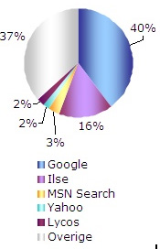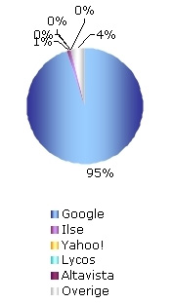But the largest group visitors (almost all of them) find the Tigro ‘s Industries website through search engines.   
  
The current top 5 international search engines is:

*Dec. ‘08 May ‘02  
Source:* [*Checkit*](http://www.vopak.nl/)*&*[*RM Interactive*](http://www.rminteractive.nl/)

***Figure 13. top 5 most frequently used***

***Dutch search engines***

1. Google
2. Yahoo Search
3. MSN Search
4. Ask Jeeves
5. Lycos

The current top 5 most frequently used Dutch search engines is:

1. Google (95%)
2. Ilse (1%)
3. Rest ‘overige’ (4%)
4. Yahoo (0%)
5. Altavista (0%)

Google has grown tremendously worldwide. In The Netherlands in may 2002 the market share was only 40%. It has grown step by step to what Google stands for today, being 95%.

This trend can also be applied on Tigro and its website. Statistics show that during those 2 years these visitors mostly found the website by using the search engine Google. The average usage percentage is namely 86.5% (Nov. ’08 – Apr. ’09), which is based on the number of pages which came in through Google (Chapter 8 – facts and figures 9. Analysis search engines linking to Tigro’s website).

*The use of keywords on Tigro website*  
Currently the average of Tigro’s website visitors had found the website of Tigro by typing in the keyword ‘Tigro’ on a online search engine being 40.8 %. Which means that a huge part of the website visitors are already aware of Tigro. This marketing tool has not lead to an enlargement of their brand awareness. On the second place of most used keyword is ‘Tigro’, with an average number of 12.6%. The remaining 46.6% are the other keywords which almost always include the name Tigro, for instance: ‘Tigro.com, Tigro chemie, Tigro Lommel, Tigro Overpelt’. These are the most commonly used keywords by the website visitors (Chapter 8 – facts and figures 10 -Overview of Tigro’s most common keywords).

From this we can conclude that a huge part of the website visitors already heard or knew Tigro while searching through the online search engine.

*Other general important figures*  
The latest statistics of ‘ Checkit’ and ‘RM Interactive’ has also shown that 98% of the internet users are using the online search engines (Multiscope), for all other kind of purposes. But there are also other remarkable and relevant information available from this study such as:

* 81% of all the internet users search through online search engines since they think this is the best way to find information (Forrester Research)
* 77% of the internet users are finding websites through the online search engines (National Search Engine Monitor)
* 85% of the consumers considers a brand which can be found in a top position of the search results, as a top brand (National Search Engine Monitor)
* 90% of the search engine users do not look further then the first 30 search results (National Search Engine Monitor)
* 60% of the search engine users makes his choice to enter the website based on the title and the description of the search results (National Search Engine Monitor)
* 68% of the potential buyers had acquainted with new providers through the online search engines.
* 87% compares the products and services on the internet (National Search Engine Monitor)

*Eyetracking*Checkit also executed an other research in cooperation with De Vos & Jansen (Market Research Agency) where ‘viewing behavior’ of online search engines were examined. This eyetracking research includes online search engines such as Google, Windows Live Search (MSN), Ilse, Kobala and Lycos.

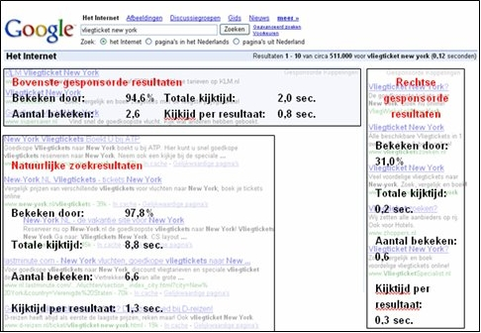

***Figure 13. Eyetracking - Source: Checkit and De Vos & Jansen***

Remarkable is that the organic search (SEO – Search Engine Optimization) for which companies do not have to pay for are in general mostly watched and they reaches an average percentage of 97.8% views. This is even higher than the average percentage view of the so called sponsored results for which you as an company have to pay for (SEA – Search Engine Advertising ). These sponsored results can be found above the organic search results or on the right side of this page (figure 13 – Eyetracking).

Tigro has to focus on the organic search list and obtain a position in de top 6 on the first page on Google. A high position in the organic search gives the respondent the impression that the information is actual, that the company has a great brand awareness and that it is reliable. To achieve this position it is necessary to use metatags keywords, metatags descriptions, titles with the purpose to attract the viewer to click on the link.

**6.2.1. Optimization of the online search engine**  
 ***Adjusting the Meta-Keywords***

*Web designer vs. Customer…*

When creating a website, there are two mayor factions: The client and the web designer. The web designer understands websites and all that comes with it. The client, in this case Tigro, understands what Tigro stands for, what they want to accomplish with their site and how they want to be represented by the site. Although web designers are responsible for all the technical ‘matters’, they usually do not fully understand their clients, internet search-engines or their algorithms. They are responsible for the fact that the site should be findable by the mayor online search-engines, but don’t take responsibility for ‘placing the website in the market’, increasing hit results by optimizing for search engines, making use of advertisement, etc.

For example: The designers most likely will ask what kind of meta-keywords Tigro wants on their website, and will most likely explain why such are needed. Looking into the source code of the main page of [www.tigro.com](http://www.checkit.nl/nationalesearchenginemonitor.html), it can be noted that the meta-keywords (the words and phrases that for example google will use to associate tigro with and compare search-input with) are: “*Tigro, opslag, herverpakken, malen, mengen, formuleren, distributie, advies" (Tigro, storage, re-packaging, grinding, formulate, distribution, advice).*

Now, just ask yourself: Which words will I use to ‘Google’ if I were a potential client? Advice? Distribution? Storage?.... no, words as ‘chemical storage’, ‘dangerous commodity distribution’, ‘safe legal Water-peroxide storage and distribution’ or something like that would probably be the word you would use. Lets look into one of the Dutch keywords which are currently used: “*advies” meaning advice in English*… what does advies mean? Do we want that all of the people who are looking for advice should find Tigro? Advice could for example mean: Mental advice, computer problem advice, et cetera. It literally could be anything. In Tigro’s case, a relation between chemicals, storage, handling and advice is needed. Looking at the current string of key-words Tigro uses, there cannot be found a relation between chemicals and advice. This for two reasons:

1) Within the entire string of keywords *“chemicals”* or “*commodity*” do not appear, and the *“advice”* on its own, could be applied to all kinds of braches.

So the bottom line is: Web designers do not know who Tigro’s customers are and where to find them. Therefore Tigro cannot anticipate whereupon the (potential) customer will search. In fact, that is something web designers do not want to be responsible for. By doing so a web designer is taking a excessive risk because Tigro could be associated with the wrong kind of keywords or a wrong context could be made.That is why usually the designers asks its customers what kind of keywords they want to use.

2) Coming-up with good keywords requires imagination, anticipation and in-depth knowledge about the clients that will look for the site.

The earlier discussed customer survey and website research, revealed that [www.tigro.com](http://www.tigro.com/en/specialised-in/agriculture) was mostly found through word-of-mouth marketing and direct knowledge of Tigro’s existence and its website. We can interpret these findings as follows: currently not a lot of the website visitors finds the website of Tigro, except existing customers who are visiting the website every now and then. But also almost no one ended-up at [www.tigro.com](http://www.tigro.com) after searching through a search engine for a company who offers the same services as Tigro. In either case, we can conclude that the website did not lead to an extensive brand-awareness nor new customers.

*Language and further in-depth anticipation*

Although most Dutch companies use both Dutch and English terms to search on search engines, the entire internet is based on the English language. Therefore by using English terms most of the time you will find even more information than when you will search with Dutch terms only. In other words, adapting some extra English keywords and even French keywords might help a lot, since Tigro is stationed in Belgium, a country with two languages. Also the company already has its costumers from all over the world, implying that people from all over the world might be looking for a company as Tigro…

*Correct Meta-Keywords and beyond*

After the creation of a good meta-keywords list, the keywords must be applied in a correct manner. For convenience sake, lets first define a ‘website’ and all that comes with it. **Tigro.com** is a website, a group of web pages online, embodying the domain called [www.tigro.com](javascript:GetDescription('desc|T|Key55%20%20%20');). Basically, when referring to the website, we mean [www.tigro.com](javascript:GetDescription('desc|T|Key47%20%20%20');) and all the subpages, photo´s, and content that belongs to the domain [www.tigro.com](http://www.tigro.com)

The main page and all of the subpages are little web pages on their own. This means that all subpages, for example <http://www.tigro.com/nl/specialisatie/landbouw> is a webpage that has its own Url (see above), its own name, and…. its own keywords! A mayor flaw emerges when analysing [www.tigro.com](http://www.tigro.com) in-depth. Google for example works as follows: It downloads all that is [www.tigro.com](http://www.tigro.com), meaning: all of its subpages and all of its content. Then Google analysis’s each page in order to find relations between (meta-key) words on each page. This means that when looking for “hazardous chemical storage” in Google, the page that is most relevant to this search-phrase will end-up on top of the search-results in Google. The fundamental problem with Tigro’s website lies not only within the keywords themselves, but also in the missing relation between the main page and its sub pages. For example: <http://www.tigro.com/nl/specialisatie/landbouw> has the following keywords: *“specialisatie/landbouw” (figure 14. Metatags keywords from Tigro’s subpage ‘Landbouw’)* Again, what does this mean? Could be anything, any company, any kind of “landbouw specialisatie”… Besides, thanks to the slash ( / ) and missing spaces, Google will most likely think it is a one word.

<meta name="description" content="specialisatie/landbouw" />

<meta name="keywords" content="specialisatie/landbouw" />

<meta name="robots" content="index, follow" />

<meta name="follow" content="all" />

***Figure 14. Metatag keywords from Tigro’s subpage ‘landbouw’***

Remember, Google allows users to ‘deep-link’ directly to a subpage of Tigro, but only if that subpage corresponds with the requested search-phrase a Google searcher uses. For example, correct keywords on the “landbouw” page could lead to increased “hits”. As mentioned before, if keywords are correctly applied on each subpage, it also makes the entire [www.tigro.com](http://www.katoennatie.com) more likely to be the suitable site for Google’s user, because there will be many (sub)pages corresponding with the overall search phrase, and therefore placing [www.tigro.com](http://www.cbp.nl) on top of list, because of its increased relevancy.

Looking into the source-code of a few of the [www.nvidia.com](javascript:GetDescription('desc|New267%20%20|200806');) subpages. On most subpages, the same keywords were used as shown in the main page its source code. Even though some pages contain zero info about their products, most of them used: “*drivers,driver,nvidia,download,geforce,nforce,quadro,tesla,cuda,download,developer”*, the services and products nVidia is known for and people will search for on the internet. Again, this will tribute to the position of [www.nVidia.com](http://www.katoennatie.com) within Google’s findings, after searching for “geforce” for example.

*Example how Google’s search engine works*

The picture here below illustrates perfectly how Google actually works:

***Figure 15. Explanation how an search engine works Source:*** [*www.metatags.nl*](javascript:GetDescription('desc|New267%20%20|200601');)

A This is where a person or company fills its keywords in to start a search

B This is the title of the webpage

C This is the description metatag and has regarding the website, the purpose to persuade a person/company to click on

**

*Other methods for controlling the metatags*

There are possibilities to make a verification of your website for free, where after analyzing, your advices which are given by them, are shortly being discussed. A website which provides these kind of services in different countries such as The Netherlands and Belgium, is for instance [www.metatags.nl](http://www.metatags.nl) . The only information that has to be given is the completely Url of the website is as follows: <http://www.tigro.com>

In the first place they control the status of the web server of the hosting provider. Secondly, they search through the source codes, to find where the metatags can be found, which metatags are used, what kind of length they have and which kind of characters contain.  
  
The following is encountered:

|  |  |  |
| --- | --- | --- |
| **Metatags** | **Lengte** | **Karakters** |
| Titel: | 8 | No Title |

The metatags descriptions and keywords are the two important things which have the priority for Tigro. Another remarkable thing is that Tigro is using titles for each page in its source code, but they are not catchy. It has to be catchy because all the search engines are copying these titles 1-on-1, which means that the influence to convince a person to visit the website hereby is huge. The title is namely mentioned on the search engine and has the purpose to convince the ‘potential visitor’ to take action, this by clicking on it. There is not a title currently mentioned. The potential website visitor sees only <http://ww.tigro.com> or **no title** whereby he is not attracted by clearly and attempting titles.

Tigro currently uses the following title on its mainpage:

<title>Tigro - storage, handling, distribution and advice</title>

The following title can be found in the search code of the page where the activity handling is discussed:  
<title>our-activities/handling</title>

The title on all the pages are very short which is good, but they are not giving the full information about this particular page. It is advised to use a maximum number of 100 characters in a webpage title. In other words, Tigro can easily complete its title by adding some words.

For instance, it is very important and smart to use the words ‘Tigro’ on every webpage in the title. This way the titles are very clear and persons know from whom the website comes from. Another thing that should be mentioned in the title are the words ‘hazardous and harmless chemicals’. When a potential visitor finds Tigro through Google for instance, and the title includes these words, it will give the visitor a better impression about who Tigro is and what is does. Which can mean that the important potential customers can find you easier or will not accidentally pass your website because clearness of the title.

*Do’s and don’ts*

It is very important to follow the rules of which the online search engines ask you to obey. If you will not follow the rules these online search engines are in the possibility to exclude you for a lifetime. You have to be aware what you can or cannot do without taking any risks. One thing is for sure and that is that manipulation is forbidden.

*Do’s:*  
- you can built a website with metatags and content as text and pictures.  
- you can use relevant keywords and use these in your text with the purpose of getting a

higher position in the online search engine.

- you can sign in your website at the online search engines

*Don’ts:*  
- you are not allowed to mislead persons/ companies by using wrong keywords

- do not use capital letters

*Conclusion*After analyzing all the facts and figures a clear picture has appeared. Almost everybody in The Netherlands uses the online search engines whereby the use of online search engines by companies should be optimized. This important marketingtool can easily put an company on a map. Currently Google is the number one online search engine worldwide but also in The Netherlands. Because of the usage of Google well known worldwide reputation, a company as Tigro should think how they can utilize this marketingtool without making too high costs. The optimization depends on which metatags you use. Tigro should use more metatags keywords on the main-homepage but also on the subpages. The metatags should consist of more keywords in different languages, with on the first place preference to Dutch and English. Words as Tigro, chemicals, hazardous chemicals, storage, crushing, mixing, are the words which at least should be used in it. The more keywords are used, the bigger the chance that a potential costumer can and will find the website and the higher it will get rated on the list of Google.

A good impression of how the metatags can be improved and enlarge the brand awareness of Tigro, can be found here below:

|  |
| --- |
| <meta name="description" content="Tigro, active in storage, handling and transport of various goods from branches such as chemics, pharmaceutics, cosmetics, automobile, food, agriculture, etc." />  <meta name="keywords" content="Tigro, storage, repacking, grinding, mixing, formulating, distribution, advice, hazardous chemicals, harmless chemicals, ADR 3 5 6 7.3 9" /> |

|  |
| --- |
| <meta name="description" content="Tigro, actief in de opslag, behandeling en het transport van diverse goederen uit sectoren als chemie, farma, cosmetica, automobiel, voeding, landbouw, enzovoort." />  <meta name="keywords" content="Tigro, opslag, herverpakken, malen, mengen, formuleren, distributie, advies, gevaarlijke chemicaliën, ongevaarlijke chemicaliën, chemicalien, ADR 3 5 6 7.3 9" /> |

Next to the metatags are the titles which have to be changed also. This contains not only the main page but also the subpages. A clear and catchy title with a maximum of 100 characters is the perfect formula.

|  |
| --- |
| <title>Tigro - storage, handling, distribution and advice in dangerous and harmless chemicals</title> |

|  |
| --- |
| <title>Tigro – offereert opslag, behandeling, distributie en geeft advies (**betreft)** gevaarlijke en ongevaarlijke chemicaliën</title> |

**6.3 Word-of- Mouth Marketing**

Word-of-mouth marketing is the only marketingtool Tigro currently is using. When we look at the latest trends such as Web 2.0 (web start-ups Facebook, YouTube, MySpace) which is used for buzz marketing by merging the social networks they have developed. This latest trend is not applyable for Tigro because their existing and potential clients cannot be reached here. The only applyable word-of-mouth marketing is the ‘old fashion way’ namely face-to-face and telephone.

**6.4 CRM  
  
"Customer Relationship Management (CRM) is the true business of every company: make customers, keep customers and maximize customer profitability (Peter Drucker)."**

Tigro is using a Dynamics software program which includes the component CRM. Unfortunately the CRM component is not being used by Tigro. Currently they send mailings to other colleagues to keep them up to date about the latest developments considering the clients portfolio. This by writing a short report whereby agreements, events et cetera are written. This procedure is not always executed wherefor not everybody is updated regarding the developments. With the result that the intern communication of the company is negatively affected.

If Tigro uses the CRM component it:

- Forces the employees to write everything down, wherefor everybody who has the ability to   
 enter this component can see the whole history of a client.

- Because of the clear administration everything can be found in a short time whereby the   
 existing client can be helped quicker.

- It supports the personal contacting between Tigro and its clients and has the benefit that it   
 increases its trust of the company and illustrates the professionalism.

[KellySearch logo](http://www.chemiepack.nl/film/index.html)In other words, using the CRM component will support Tigro with its sales, marketing and service processes.

**6.5 Kelly Search: The largest business search site in The Netherlands**

Kelly Search is the largest B2B search engine platform in The Netherlands where it has been founded and operates worldwide. This engine has the purpose for letting supplier meet in their needs in products and services. It does not matter if you search a supplier in the Netherlands or in another country, Kelly Search has a database of suppliers from all over the world.   
  
*General month figures of Kelly Search*Pageviews 3,305,000

Visitors 1,470,000

Visits 1,600,000

Links percentage 51%  
New visitors 56%

Returnings (visitors) 44%

Google page rank 7

Visitors from The Netherlands 86%

Tigro already registered at Kelly Search, but unfortunately did not signed in to the proper category. It also should sign in for more categories, this way it will have a greater chance that the company will be found by the searcher. Kelly Search provides 200.000 categories. These are the categories in which the competitors already signed in for and which Tigro should certainly sign up for:  
- Opslag Gevaarlijke Materialen, Warehousing *(Vopak)*  
- Opslag en Distributie *(Vopak)*  
- Opslagruimtes en faciliteiten, Warehousing  *(Vopak)*  
- Gecombineerde Opslag en Distributie, Services, Warehousing (*Vopak)*

- Chemische en verwante producten *(Chemie-Pack)*  
- Magazijn en Opslag, diensten *(Loodet BV)*  
The better and simpler the potential customer can find Tigro, the greater the reach will be which eventually can lead to more clicks to the website. Take for example Vopak the competitor of Tigro, they signed in for 18 categories. Their reach is greater than that of Tigro (Figure 16. Tigro and Vopak account figures of Kelly Search).

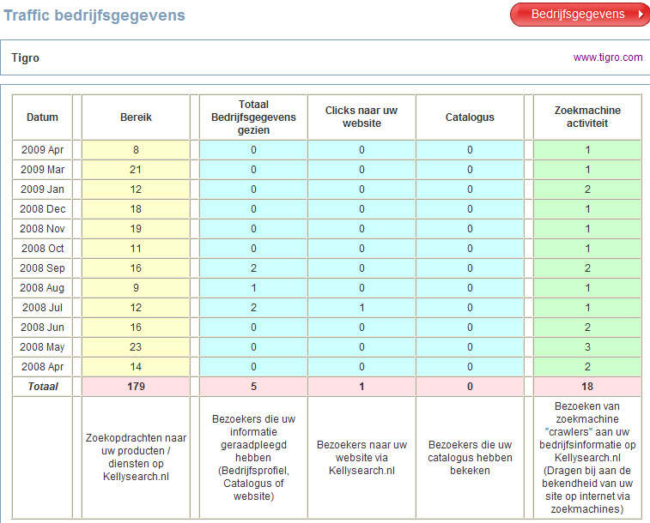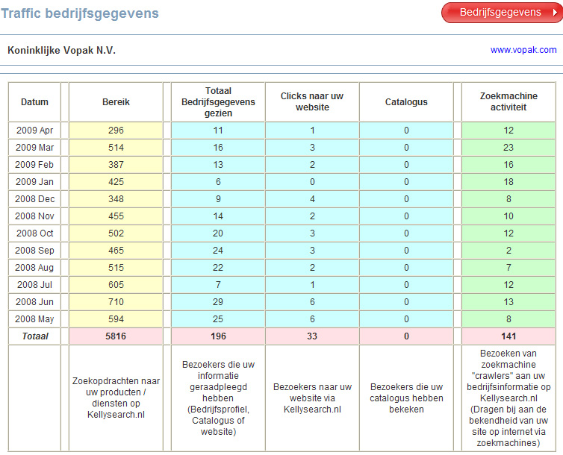

***Figure 16. Tigro and Vopak account figures of Kelly Search***

The best part of this all is that there are no costs involved with the registration of a company on Kelly Search and you have the possibility to change your profile whenever you want. When Tigro adapts at least the earlier mentioned categories, the chance will be bigger that a potential Dutch supplier will find Tigro, since 86% of the Kelly Search visitors is from The Netherlands. Last but not least is that the higher Tigro will get in the top list, the more clicks they will achieve.

**6.6. New possibilities**

**6.6.1. Advertising in a magazine**

Besides changes of the marketingtools such as the website and the B2B search engine (Kelly Search), it is important to keep other potential possibilities in mind. A great example hereof is: advertising in a branch magazine and/or standing on a Dutch trade fair.

*Dutch branch magazines*

It is for Tigro interesting to advertise in branch magazines wherein their potential customers do like to read in. After having conversations with these several magazines such as: buzzfacts, De Handelscourant, Petrochem and VNCI an clear analyze could be made. The magazine VNCI (Vereniging van de Nederlandse Chemie Industrie) is the magazine which fits perfect in Tigro’s requirements. Some important facts about this magazine are:

|  |  |
| --- | --- |
| Has a great and well-known reputation | Afterwards magazine published online |
| High credibility | **Published once a month** |
| Received donations from DSM, Dow 4.7 Billion (2008) | **Editorial board includes huge companies and chances all the time** |
| Often delivers 5 editions per company | **Published 11 times a year** |
| Has an average read frequency of 6 | **3.000 publications per edition** |
| Reaches 18,000 professionals in the chemicals industry per edition | **Advertisements costs are lower than in other branch magazines** |
| Once a month free publication in the digital newsletter per banner | **Subscription is low namely 70 euro per year** |

|  |  |  |  |  |
| --- | --- | --- | --- | --- |
| Publishing | 1x | 3x | 6x | 11x  *Advertising sizes*  1/1 🡪 185 x 267 mm  ½ 🡪 185 x 130/ 90 x 267 mm  ¼ 🡪 185 x 62/ 90 x 130 mm |
| 1/1 | € 1355 | € 1235 | € 1100 | € 950 |
| ½ | € 745 | € 665 | € 630 | € 560 |
| ¼ | € 415 | € 380 | **€ 350** | € 300 |

***Figure 18. Costs per publication. No extra charges for full color. Rates are excluding tax.***

If Tigro decides to advertise in the VNCI a couple of things should not be forgotten, namely:

* They have to underline its ‘unique one stop service’
* Describe their package of activities
* Describe the all the licenses they own ‘ISO9000, ISO14000, ISO18000,   
  ADR 3, 4, 5, 6, 7.3, 9, PGS 15, OHSAS’(they can distinguish themselves from others with this)
* Write their slogan down
* The logo has to be properly displayed
* Using attractive images this to attract the reader to your advertisement

It is certainly effective for Tigro to advertise in this particular magazine. Publishing on regular basis is the most effective way to increase your brand awareness. Once in two months can be seen as an effective way of advertising . In Tigro’s situation it is not necessary to publish a 1/1 advertisement. The size of ¼ is enough. The competitor of Tigro, Chemie-Pack uses also the ¼ size (Chapter 8 – facts and figures 1. Usage media tools by competitors and by Tigro).  
 The only thing Tigro has to do is to create an advertisement which is more noticeable than that of Chemie-Pack. The costs for this kind of advertisement are shown in figure 18 – Cost per publication.

*Developing an advertisement*

After having contacted several advertisement/marketing companies, the cost of developing an advertisement could not be calculated. Since this depends on the concept which is going to be used. For instance, developing a ‘normal’ and simple advertisement can be made by a company in a day and costs around € 65,- per hour \* 8 = € 520,- excl. But if you want more effects, the cost will increase tremendously. In order to control the costs Tigro has the possibility to settle a fixed-costs contract.

*Editorial*

There is also another option which should be considered. Huge worldwide companies as Akzo Nobel and Dow Chemicals are frequently mentioned in the magazine, mostly through editorials. It is for Tigro certainly important to consider to contact with an Tigro’s important A customer, such as Akzo Nobel for instance, to discuss possibilities to be published in an editorial. The VNCI does not publish editorial which are ‘directly’ connected with commercializing. But if Akzo Nobel for instance says in the editorial that they solve their problem of storage lack and then refers to Tigro it is not seen as a commercializing. There are no costs bounded with advertorials. Only time and the approval of the editor to this subject. The person who can help Tigro to pursued the editor is, Daan Mooijman. *Contact:* Mooijman Marketing & Sales, Daan Mooijman, Tel. 070-3234070, E-mail. [info@mooijmanmarketing.nl](http://www.kellysearch.nl).

**6.6.2. Dutch trade fairs**

Tigro previous exhibited on several trade fairs, but without much success. The aims they had settled at the time were in their vision not obtained. The results were disappointing, example by the number of new obtained customers and gathering of new large orders to gain a higher yearly turnover. One thing that should not be forgotten is that till now companies are still frequently using this marketing tool. Of which everyone of them uses it for different kind of purposes.

The CLC (Centrum voor Live Communication) which is established in Breukelen, has published a report on January 15th 2009, which was made by the LA Group and consists of a couple of researchers. This report includes facts and figures which are based on the Dutch trade fair market , which are taking place everywhere in this country. For a clear overview see Chapter 8 –facts and figures 11. Dutch trade fairs. From the 2.630 exhibitors, 200 of them co-operated with them till the end. This means that these figures cannot be used as a statistic fact but as a perfect indicator with the aim for giving a good impression of how the Dutch trade fair market currently in general look like.

The CLC also enabled Respons in service, which is an organization that executes orders which consists of analyzing different kind of researches for the companies that enabled them. Unfortunately after having contact with both of the parties, there was not a possibility to receive figures from each executed trade fair per sector. There are no studies available and that is why this second part of the report is also based on the general figures of all the sectors together. Important figures as number of exhibitors, number of visitors, cost per m2 et cetera are hereby discussed. Both reports are brought together to make a short but clear analysis of this marketing tool.

**General important data**   
There are some data which should be taken into consideration before a company decides to take part in a trade fair or several trade fairs, which are held in The Netherlands. Data such as, quality, customer friendliness, obtaining new customers, maintain the relationships with the existing customers, average cost for a stand, number of visitors et cetera. These are the important data which are going to give Tigro a clear vision.

**General picture of the Dutch fair**In Tigro’s situation it is very important to keep in mind that for them international and/or national trade fairs are the only two options they should consider. This because their potential and existing customers can be found everywhere in The Netherlands. By taking part in a regional trade fair the number of reach will be too low for them, but also the costs are going to be tremendous, because in this situation Tigro have to participate in several other trade fairs to gain new customers and enlarge its brand awareness.

During the researches, which were based on the last 3 years (2005-2007) and were executed in commission of the CLC. Some important data can be highlighted.

*The number of trade fairs*: The number of international trade fair(s), has increased in the last 3 years. There was a decrease in 2006, but in 2007 the numbers increased and currently lays at the same level as in 2005, namely 67 trade fairs. When it comes to the national trade fairs in 2007 in respect to 2006 there has been an increase to 34, but still did not come to the same level as in 2005 with an number of 40. This means that national trade fairs became less attractive for companies to exhibit on.

*Number of exhibited trade fairs in The Netherlands*: The biggest part of all the exhibitors, has exhibiting between the one and seven times in the last 3 years. 37% of them have been exhibiting between one and three times on a trade fair and the other big part of 31% had exhibited between four and seven times. The average number of exhibitions per exhibitor in those years was 5.8 times. This means that an exhibitor rounded top exhibits two times per year. Which means that a lot of companies do participate trade fairs but not that often.   
Remarkable is that a very strong increase of 34% has occurred when it comes to the frequency of the number of participation in Dutch trade fairs in respect to the other years and that nearly half of the exhibitors (46%) never have been on a foreign trade fair. Which means that 54% have been exhibiting on foreign trade fairs. 16% of them have chosen the foreign trade fair above the Dutch one. The biggest reason for this was that there is a bigger reach (46%), there are more relevant visitors (41%), it has a better appearance (30%) and the costs are lower (22%). It also can be noted that 29% of the exhibitors who have exhibited on a foreign trade fair, exhibit between one and three times in the last three years.

***Number of Exhibitors*:***International trade fair*

The number of 19,146 exhibitors who are exhibiting on Dutch international trade fairs in 2007, has in respect to 2006 decreased with 1,378 exhibitors. Despite all that, the number of the total exhibitors in respect to 2005 is still much higher and show a discrepancy of 4,113. This means that the average number of exhibitors in 2005 is 224, which was much lower in respect to 2007 which at that time was 286. In other words, when we put it all together, the number of trade fairs has remained unchanged but per trade fair in general the amount of exhibitors who are willing to exhibit there has increased in proportion to 2005 tremendously.  
 *National trade fair*

As earlier discussed the number of national trade fairs never came back to the same level as in 2005. But despite all of that, the proportion of the number of visitors has been changed in a positive way. In 2007 the total number of exhibitors was 6,713 in respect to 8,154 in 2005. In other words, there were less national trade fairs organized but the average number of visitors has increased. For example, in 2007 the average number was 197 in respect to 204 in 2005. The discrepancy between the participated exhibitors is very small, which means that there are more exhibitors on a trade fair than previous.   
***Number of Visitors*:***International trade fair*

To make a perfect comparison it is handy to look at the numbers of 2007 in respect to 2005, this because they show that number of trade fairs which were held were equal, namely 67. In 2005 the average number per trade fair visitors was 13,988 and in 2007 13,891. Which means that the reach per fair trade has decreased with 97 visitors. The average reach number of an exhibitor in 2005 was 62 and decreased a little in 2007 to 49 visitors. This is an discrepancy of 13 visitor per exhibitor, per fair trade.

*National trade fair*

To make an equal comparison with the international trade fair, the average number of visitors at the national trade fair should also be compared with the same years being 2005 and 2007. Hereby it can be remarked that the number of visitors has decreased tremendously, namely from 11,131 (2005) to 8,340 (2007). This is partly influenced by the number of trade fairs which were held in The Netherlands which also decreased in numbers. Another thing that can be noted is that the average number of visitors per exhibitor has also decreased a lot, from 55 (2005) to 42 (2007) visitors per trade fair.  
  
**Score and impressions**  
The average number which was given by the respondents is 6,9. This is a good score but it could be better. It probably depends of different factors as foreign competition, expenses and other things. When it comes to the positive things which are good cared of such as professionalism (83%) and customer friendliness (61%), they score high. But when it comes to affordability (21%) and flexibility (27%) which has been answered with yes, most of them answered neutral which cannot be seen as a very good score.   
 **Why companies participate on a trade fair**There are still a lot of companies who previously have exhibited on Dutch trade fairs and still do. 34% of the respondents who participated the survey (exhibitors) enlarged the number of participation on trade fairs. 51% kept its participation equally and 15% has reduced its participation. From this we can remark that a huge part (85%) still participates, but what attracts them exactly to continue or increase their participations on these trade fairs?

The main reason, that was answered by 59%, is obtaining new relationships/ clients. This is because every company has to maintain its database of customers and extend it by trying to attract new customers. The second reason that was given, is that this marketing tool is being used to sell or promote new products/ services, with a percentage of 51%. The third reason with 48%, is that companies participate on the fair with the intention to maintain its already existing relationships. Not far away from this comes the fourth and most common reason, which is enlarging the brand awareness, with 45%. An other thing that can be noticed is that a lot of exhibitors do participate on trade fairs, this because 72% of them use the ‘ invitation of the trade fair’ as an source of information. On the second place comes the Internet (47%), followed by the trade journals (42%).

***How do the companies decide to participate on a trade fair?***  
This is mostly based on the 3 factors. 55% of the respondents answered that it depends on the expenses, 44% based their participation on the short-term objectives and 40% on the long-term objectives.

***Why companies stopped or do not participate on trade fairs***From all the reasons, the expenses are the most important reason to stop or to impede a start of participating on a trade fair (61%). Which usually are high, such as the rent costs per square meter (76%) and the price for a stand (40%). The second main reason which is given is that they have experienced that participating does not bring a lot of profits with it (50%.) Followed with 38% who all join the opinion that there are to less visitors, concerning these trade fairs.

***The latest development in hiring an exhibit***International Trade Fairs*:*

The cost for a stand can be very high and has a direct influence on the average size of a stand on a trade fair. There has been a huge increase in the price per square meter on a international trade fair, in 2006. In 2006 the price increased in respect to 2005 with 18 euro per square meter. This is a lot and had the consequence that it influenced the average size of a stand in general. Exhibitors were hiring less square meters this can be noticed by the huge discrepancy of 11 square meter per exhibiter which took place after the price increase. That is why in 2007 the price per square meter reached the bottom price again and was almost similar to the price which was settled in 2005.

The discrepancy between 2005 and 2007 was only 4 euro and influenced the average number of hired square meter of a stand. The number lays only 1 square meter from each other, which means that the companies were again more interested toward hiring a bigger stand place. This leaded to that there were more exhibitors in 2007 with an number of 321 compared to 2006 which attracted 286 exhibitors. In order words, when the price is lower, more exhibitors are willing to exhibit on trade fairs and do hire more square meter per trade fair. Another thing when it comes to the almost equal amount of rented square meters in 2005 in respect to 2007 is that the proportions are different from each other. Despite that there is a 1 square meter discrepancy between those two years, namely the rented square meter in 2007 of 35 in respect to 2005 which was 35. The average number of exhibitors have increased tremendously from 224 (2005) to 286 (2007). In order words, the total number rented square meters was 8,064 (2005) and increased to 10,010 (2007)! From this and the increased visitor numbers, we can conclude that the international trade fairs which are organized in The Netherlands are still attractive for companies to participate on.

National Trade Fairs:

The average rented square meter per exhibitor in 2005 was 38 and had decreased in 2007 tremendously to 28 square meter per trade fair. But also as earlier mentioned, the number of exhibitors decreased from 204 (2005) to 197 (2007). Also the average number of visitors per exhibitor went down and reached the bottom with 42 visitors. This shows that national trade fairs are getting less and less attractive to participate on it.

**Average costs**

The average rent price for a stand on a international trade fair cost:  
2005 172 euro per square meter

2006 190 euro per square meter

2007 176 euro per square meter

The average rent price for a stand on a national trade fair cost:  
2005 121 euro per square meter

2006 121 euro per square meter

2007 152 euro per square meter

These figures can be used as an indication to calculate how much it costs to participate on a trade fair. Mostly large companies as Akzo Nobel do hire a huge stand of >50 square meters and smaller companies who have less than 50 employees on average hire a smaller stand. It is not necessary for Tigro to have a huge stand, a small stand is also a good option for them. For instance 15 square meter (see all the figures together: Chapter 8 - facts and figures 11. Dutch trade fairs).

**Potential trade fairs for Tigro**

*In the Netherlands:*  
Kunststoffen 2009  
Date: Wednesday and Thursday 23rd en 24th September 2009

Place: NHI Conference Centre Koningshof- Veldhoven

Entrance price: € 0,-

CPHI (Pharmaceutical)

Date: 13th till 15th October

Place: every year different location, last year Milan, this year Madrid, few years ago The Netherlands

|  |
| --- |
|  |
|  |

*Abroad:*  
K-Messe (Düsseldorf) – K2010 International Rubber and Plastic industry

Date: 27th October – 3rd November

A lot of international companies including Dutch companies visit this huge trade fair.

Conclusion

It is certainly interesting for Tigro to contact with its largest and well-known customers such as Akzo Nobel to get an editorial in a magazine such as the VNCI. This magazine reaches the potential customers of Tigro (reach 18.000 per edition) and it does not cost anything, only the investment of time. Next to the editorial, placing an advertisement in the magazine is also an attractive thing to do. The more frequent you publish your advertisement the less the cost per publications are. Once in the two months is a good frequency. Another important marketingtool of which Tigro should consider about is the fair trade, which still 45% of the respondents specified as fourth reason to participate on a trade fair with the purpose to enlarge its brand awareness. The top 3 of reasons to participate on trade fairs are: obtaining new clients (59%), to promote product or services (51%) and to main their existing relations with clients (48%). Also the figures has shown that national related fairs are not that attractive to exhibit on meanwhile international related fair trades are still the most attractive ones to exhibit on and they have the biggest reach of visitors. Unfortunately it involves a lot of investment to attend such a fair trade. Therefore it is adviced to firstly apply the earlier mentioned marketingtools before considering to apply this marketing tool. But it is certainly recommend to visit these important trade fairs anyhow, especially to contact and maintain the relations with customers.

**6.7. Promoting the potential subsidiary: Moerdijk**

Currently Tigro is only using word-of-mouth marketing where it is advised to apply the previous mentioned potential marketingtools, but also the currently used marketingtools have to be optimalized . Because of the advice to Tigro for building up a new subsidiary in The Netherlands, to be more specific in Moerdijk, it is advised to use this situation as a new possibility to enlarge the brand awareness. This by applying the following tools:

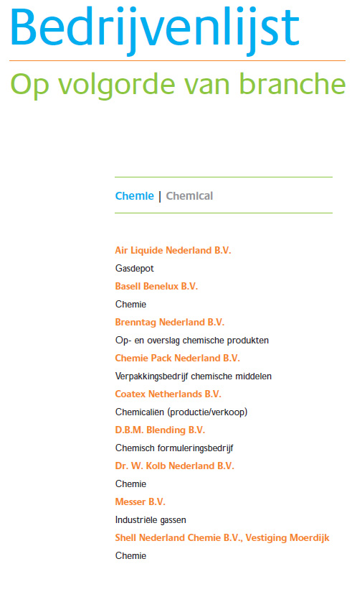

*Porthandbook*

This book is published for companies which are established in this region, but can also be requested by other companies who are interested to get in contact with them. It includes advertisements, articles, a company- and address list. As shown in figure …. Chemie Pack, the competitor of Tigro it has already established in Moerdijk. This makes it even more important to get the attention of the new- and existing clients of Tigro to make them aware of its existence.

When the subsidiary is established an article can be

Published for free, where the opening of the subsidiary and the ‘one stop service’ can be discussed. In other words, Free Publicity.

*(Branch) Magazines*

When Tigro opens its new subsidiary it should also mention this in its advertisements. There are a few magazines such as PetroChem and VNCI which meet the needs of Tigro, because they reach potential customers for Tigro.

*Press*

Tigro should approach the press and let them know that they will open their new subsidiary in Moerdijk. A few potential presses in the region are: HC Courant, Brabants dagblad, weekblad de Moerdijkse bode.

**7. Implementation and costs**

|  |  |  |
| --- | --- | --- |
| Media | Duration | Costs |
| **Necessary**  Website changes: |  |  |
| Metatags | 3 hours | € 150,- (€ 50,- per hour) |
| Titles  CRM software  Editorial in the VNCI magazine | 1 hour  0 hours  (already in possession of this software)  1 publication | € 50,-  € 0,-  € 0,- |
|  |  |  |
| Kelly Search (adjustments) | 0,30 hour    Total necessary costs | € 0,-  **€ 200,-** |
| Making a film for the website  Cheap scenario  Most expensive scenario  New possibilities  Advertising in the VNCI magazine  (full color and includes a once a month free publication in the digital newsletter, per banner)  **Possibilities (future related)**  Exhibiting at a Dutch Trade Fair  (Kunststoffen - 15m2)  **The most expensive senario** | Students who study this study or just graduated in this area  Professional made by a specialized company  6 publications (publication every 2 months, during one year)  One time, average cost per m2 € 176,- | Costs are depending on the agreement between the school and Tigro, but also the way the concept is going to be executed. Tigro can adopt students to make a film and pay them a salary per hour for it. That is why it is hard to estimate the costs. It is estimated between **€ 0,- / € 2000,-**.  **€ 4553,-** (excluding concept development)  (the costs are based on a 3 minutes during film)  These costs consists of:   * Voice-over € 500,-  (a voice from their database) * Studio € 130,-   (one hour)   * Cameraman € 600,-   (per day)   * Steadycam € 550,- * Travelling costs € 90,- * Editing € 2100,-   (4 days, adjustments included)   * Animation € 600,-   (1 day, logo’s, titles)   * Music € 0,-  (from the library) * 1 DVD and flash site € 0,-   € 2100,- (excluding tax)  **€ 2100,-**  **€ 2640,-**  **€ 6853 € 9493,-**  (exl. trade fair) (incl. trade fair) |

**Annual planning July ’09 till June ‘10**

|  |  |  |  |  |  |  |  |  |  |  |  |  |
| --- | --- | --- | --- | --- | --- | --- | --- | --- | --- | --- | --- | --- |
|  | Jul. ‘09 | Aug.  ‘09 | Sept.  ‘09 | Oct.  ‘09 | Nov.  ‘09 | Dec.  ‘09 | Jan.  ‘10 | Feb.  ‘10 | Mar.  ‘10 | Apr.  ‘10 | May  ‘10 | Jun.  ‘10 |
| Metatags changes | **x** |  |  |  |  |  |  |  |  |  |  |  |
| Title adjustments | **x** |  |  |  |  |  |  |  |  |  |  |  |
| CRM | **x** |  |  |  |  |  |  |  |  |  |  |  |
| Kelly Search  adjustments | **x** |  |  |  |  |  |  |  |  |  |  |  |
| Editorial in the VNCI |  |  |  |  | **x** |  |  |  |  |  |  |  |
| Film production |  |  |  | **x** |  |  |  |  |  |  |  |  |
| Advertise in the VNCI |  |  | **x** | **x** | **x** |  | **x** |  | **x** |  | **x** |  |

**Chapter 8. Facts and Figures 1: Organization Structure**

Directeur

Sylvain Moors

Afd.Inkoop/verkoop

Sylvie

Afd.Transport/logistiek

Christoph

Afd. Boekhouding

Astrid

Afd. Documentatie

Lindsay

Afd. Marketing

Afd. productie

Frank

Secretaresse

Astrid

General manager

Bart moors

GCM 8 vrachtwagen-

Chauffeurs

Ingrid

2 marketing

medewerkers

Receptioniste

Voorraadbeheerder

Eindverantwoordelijke, laat zich informeren en informatie overbrengen nr medewerkers, coördineren, neemt besluiten, overleg intern/extern. Onderhoudt ontwikkelingsproces, vergaderingen, coachen medewerkers, contracten, offertes binnenhalen, klanten, lange termijnrel, Sturing bedrijf, mond tot mond reclame.

Leidinggevende lommel, geeft advies, informatie overbrengen personeel, overleg intern/extern, vergaderingen, coachen medewerkers, klanten binding, geeft advies, mond tot mond reclame.

Telefoon, brieven,verslagen, offertes doorvoeren, mailingen, data invoer, klanten bestanden, agendabeheer, inkomende-uitgaande post, notuleren, klanten contacteren, archiveren

Telefoons, klanten ontvangen, administratieve werkzaamheden, gastvrouw, visitekaartje, distributie e-mail fax, tel. Ondersteuning secretariaat, mailingen, data invoer etc.

Verwerking inkoop, verkoop, planning, nieuwe producten, invoeren van kostreducerende maatregelen voor inkoop, inkoopbeleid, budgettering, kosten, relatiebeheer, administratieve verwerken offertes, contact bedrijven/klanten. Marktontwikkeling, Communicatie met leverancier, alles in orde verloopt, dossier info leveranciers, producten,diensten

Planning transport, wie, wat, waar, hoelaat, wanneer, tijdsplanning, dienstregeling chauffeurs, samenwerken met transporteurs zoals essens. Tariefberekening

Werkvoorbereiders

Magazijnmedewerkers

Administratiesysteem magazijn, welke goederen waar, je beheert de voorraad, planning,

**Facts and Figures 2: Usage mediatools by competitors and by Tigro  
  
Katoen Natie***Standing at trade fairs*K-Messe (Düsseldorf)Source: <http://www.katoennatie.com/News/PressReleases/tabid/150/Default.aspx>

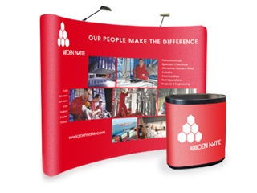

Katoen Natie Pop-up stand – [www.sprengers.be](http://www.tigro.com/nl/)

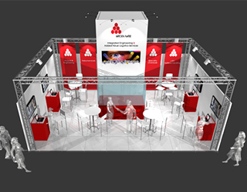

Stand of the Katoen Natie on the

K-Messe - [www.sprengers.be](http://www.ez.nl/Onderwerpen/Sterke_consument/Digitale_veiligheid/Spamverbod)

*Free publicity*

* [http://www.logistiek.nl/productie/verpakken-etiketteren/nid7833-katoen-natie-print-etiketten-met-zetes.html](http://www.sprengers.be)
* [http://www.agd.nl/1072740/Nieuws/Artikel/Cacaobedrijf-Univeem-overgenomen.htm](javascript:GetDescription('desc|New267%20%20|200808');)

*Own magazine*

Kantoen Natie has its own news paper (hardcopy).

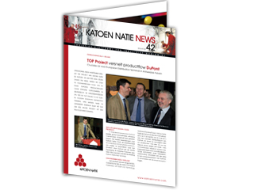

Katoen Natie newspaper (hardcopy) –

Source: [www.sprengers.be](http://www.sprengers.be)

*Cooperate brochure with logo and slogan on it*

*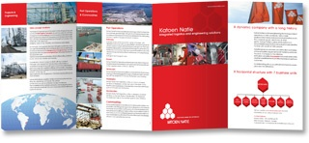*

Source : [www.sprengers.be](http://www.sprengers.be)

*Magazine advertisement*

|  |  |  |  |  |  |  |
| --- | --- | --- | --- | --- | --- | --- |
| |  |  |  | | --- | --- | --- | | [www.sprengers.be](http://www.sprengers.be)  Katoen Natie | http://www.sprengers.be/beelden/stippellijn2.jpg | Advertentie optical sorting | | http://www.sprengers.be/upload/project/192_1_1199452559.jpghttp://www.sprengers.be/beelden/stippenlijn_hori2.jpg | | |   *Sponsoring* Scholarships awards (2001 / 2003 – pacific Asia source: [http://www.tliap.nus.edu.sg/dmp/adm/routes/sas.aspx](http://www.vnci.nl)  *Video content on the website* |
| **Dow Chemicals Netherlands**  *Exhibits on a fair* K-Messe 2007 (Düsseldorf)  [www.katoennatie.com](http://www.katoennatie.com)  <http://www.katoennatie.com/CorporateVideo/tabid/277/Default.aspx>  *Sponsoring* Blue Planet Run 2007 – 20 athletes participate in a 20,000 kilometers ‘estefette’ around the world. Aim: to make people conscious of the fact that 1,1 billion people worldwide do not have clear water.  *Free publicity* <http://www.mvonederland.nl/nieuws/6052>  *Video content on the website* There are a lot of videos available on the website. These videos are made worldwide. You can find videos which are made in for instance the United States of America, but also in The Netherlands.  An example of a Dutch orientated Dow Video is:  [http://energy.dow.com/news/video.htm](http://www.tigro.com)  **Vopak**  *Sponsoring*   * Mainsponsor of the four Rotterdam’s Erasmus University students. The aim is to cross the Atlantic Ocean in 55 days by using the ‘Vopak Victory’ rowing boat. source: [http://www.vopak.com/oceanfours/142\_492.php](http://www.tigro.com) * Mainsponsor of the Vlaardings Loggerfestival, a city festival in and around the harbors of Flanders * Sponsor of waterpolo institution Z&PC de Schelde Terneuzen * Sponsoring an orchestra with the aim to help them touring through Azia. Tour took place from June 17th till 27th and included Yannick Nézet-Séguin (2008) * Sponsor of the World Championship Rowing (WK roeien 2006) * Sponsor of the RopaRun – Team 125. This is a Relay races which start in Paris and ends in Rotterdam with the aim to collect money for cancer patients.   *Free Publicity*  During the two days ( September 2nd and 3rd) ‘Wereldhavendagen’ in Rotterdam, Vopak had organized a tour through their chemical terminal in Rotterdam Botlek. Source: [www.vopak.com](http://www.nvidia.com)   *Video content*  *Opening of the new terminal in Europoort, The Netherlands* <http://oilrotterdam.vopak.com/news/137_546.php>  **Chemie-Pack**  Chemie-Pack.jpg Source: VNCI magazine - November 20th 2008  *Free publicity* [www.pakblad.nl](http://www.pakblad.nl)  *Magazine advertisement*    *Video content on the website* source: [http://www.chemiepack.nl/film/index.html](mailto:Ingrid.mooy@kmt.hku.nl)  **Loodet BV** *Sponsoring* - Sponsoring of the fancy fair / artists  - Sponsor of the soccer institution hazerdswoudseboys  **Tigro**  *Sponsoring* - BBC Geel Basketbalclub  *Free publicity* [http://www.unizo.be/limburg/viewobj.jsp?id=226115](http://www.tigro.com) [http://www.abn.be/industry/tigro.htm](mailto:info@mooijmanmarketing.nl)  [http://www.kmopme.be/news/17277\_wat\_maakt\_iemand\_tot\_een\_goede\_kmo-manager](http://www.tigro.com)  [http://www.prebes.be/risicobeheer.shtm](http://www.dow.com/)  [http://www.prebes.be/risicobeheer.shtm](http://www.checkit.nl/)  <http://www.nieuwsblad.be/Article/Detail.aspx?articleID=me1e3mh8> *Press  unizolimburg*   PERSBERICHT  **Jonge ondernemer-eigenaars onder paraplu van UNIZO-Limburg**  **UNIZO-Limburg start vandaag een werking voor de jonge ondernemers-eigenaars. Uniek aan deze werking is dat de doelgroep allemaal jongeren zijn die zelf een bedrijf leiden en er de beslissingen nemen. UNIZO bewijst hiermee nog eens echt voor en door de ondernemers te zijn, gezien de werking er komt op initiatief van de jonge ondernemers zelf. UNIZO-Limburg heeft een goede traditie in het geven van kansen aan jongeren.**  In het Koetshuis in Bokrijk kwam vanmiddag de allereerste stuurgroep van de Jongerenwerking van UNIZO-Limburg samen. De werking is ontstaan op initiatief van een aantal jonge UNIZO-leden die elkaar ontmoetten binnen het Peterschapsproject OVO (Ondernemers Voor Ondernemers).  **Voor en door de jonge ondernemers-eigenaars**  OVO is een jaartraject waarbinnen een vaste groep van jonge groeibedrijven onder het peterschap van een ervaren KMO-bedrijfsleider maandelijks bijeenkomen in kleine werkgroepen. In het spoor van OVO werden al een filmbezoek, drie Full Power Party’s (400 deelnemers in 2006) en een 5-daagse winteradventure in Slowakije georganiseerd. Om deze initiatieven meer structuur te geven ging vandaag een stuurgroep van start. Doelstelling van de jongerenwerking wordt het gericht ondersteunen van jonge ondernemers via netwerking en ervaringsuitwisseling. Frank Vols, directeur UNIZO-Limburg: “UNIZO-Limburg wil en moet een organisatie voor én door ondernemers zijn. We proberen altijd in te spelen op de noden en opportuniteiten die onze leden ons zelf signaleren. Bovendien is er bij ons ook altijd ruimte voor initiatief. Binnen OVO is er zo een dynamiek ontstaan dat we er echt iets mee moesten doen en er een structuur aan geven. Het unieke aan deze werking is dat we jonge ondernemers-eigenaars zelf bereiken. Dit zijn jongeren die zelf een bedrijf leiden en er de beslissingen nemen.“  **Kansen aan jongeren**  Dat UNIZO-Limburg altijd al kansen aan jongeren heeft gegeven bewijst Bart Moors, 30 jaar, voorzitter van de stuurgroep en eigenaar van Tigro Industries en GCH: “Ik was eigelijk nog maar net actief binnen UNIZO en OVO toen Frank Vols me vroeg om deel uit te maken van de stuurgroep van KMO Contact. En van daaruit ben ik dan snel in de Raad van Bestuur van UNIZO-Limburg terecht gekomen. De aanwezigheid van jongeren op strategische posities binnen UNIZO is heel belangrijk.”  Frank Vols:”Inderdaad, voor ons is niet alleen de dynamiek en de eigen zienswijze van deze jongeren cruciaal. Als we deze mensen kunnen enthousiasmeren en binden aan UNIZO, is onze toekomst verzekerd.”  UNIZO-Limburg begeleidt bijna 1.500 starters per jaar, waaronder heel wat jongeren. Zo is er een begeleiding van starters in groep binnen Startmentor (minder dan 2 jaar geleden gestart). Daarnaast is er ook Startscout, gratis individuele begeleiding van de prestart tot 2 jaar na opstart. Tenslotte is er ook OVO, netwerking en infosessies voor jonge ondernemers (2 tot 7 jaar actief).  Als bijlage: overzicht van de leden van de stuurgroep  Hasselt, 15 maart 2006  *Voor meer informatie: contacteer Nele Schoofs, communicatieverantwoordelijke UNIZO-Limburg, tel. 011/26.30.13 of 0476/58.60.11*  **Leden van de stuurgroep**  Michaël Bartels, 29 jaar, mede-zaakvoerder **Dialex Biomedica nv** (groothandel medisch materiaal, 4 werknemers), Zeilstraat 19 in Hasselt, tel. 011/22 43 89  Jonas Coenen, 28 jaar, zaakvoerder van **DVR bvba** (sinds 1998, import en distributie, 3 werknemers) **Nascom nv** (sinds 2003, IT-sector, 17 werknemers), Wetenschapspark 5 in Diepenbeek, tel. 011/56 20 00  Jorgen Lenaerts, 37 jaar, zaakvoerder **Schevenels Profurn bvba** (sinds 2005, inrichting horeca), Dellestraat 49 in Heusden-Zolder, tel. 013/53 93 92  Els Meekers, 36 jaar, mede-zaakvoerder van **Fiscaplus bvba** (sinds 1993, fiscaliteit en boekhouding, 5 werknemers), Prof. Asnongstraat 3 in Alken, tel. 011/26 28 60  Kurt Meers, 34 jaar, zaakvoerder **Nota Bene bvba** (sinds 2004, communicatiebureau), Gouverneur Verwilghensingel 8 bus 5A in Hasselt, tel. 011 27 17 77  Bart Moors, 30 jaar, zaakvoerder **GCH bvba** (sinds 1998, transport, 15 werknemers) en **Tigro Industries nv** (sinds 1987, logistiek van chemische producten, 20 werknemers), Europalaan 37 in Overpelt, tel. 011 66 13 75  Mieke Nickmans, 28 jaar, zaakvoerster van **Grema bvba** (sinds 2001, uitbating **Proxy Delhaize**, 10 werknemers), Sint-Maartenplein in Stevoort, tel. 011/31 13 82  Kris Vinken, 29 jaar, mede-zaakvoerder van **Vinken Verzekeringen bvba** (sinds 2002, verzekeringen voor particulieren en KMO's), Deusterstraat 61 in Peer, tel. 011/63 15 71  **Facts and Figures 3: Customer survey**  **Klantentevredenheidsonderzoek Tigro NV**  Vanuit de Hogeschool van Utrecht doen wij een onderzoek naar de klantentevredenheid van Tigro. Wij hebben hiervoor een kwantitatieve vragenlijst opgesteld. Wij zouden bij dezen graag uw medewerking willen vragen, om een zo goed mogelijk beeld te krijgen van uw ervaringen met de diensten van Tigro.  Aan de hand van de resultaten die we hieruit verkrijgen kan Tigro de werking op een gerichte manier aanpassen om u in de toekomst nog beter van dienst te zijn.  Het invullen van de enquête zal ongeveer 3 minuten van uw tijd innemen.  De resultaten van het onderzoek zullen anoniem worden verwerkt.  Het aankruisen van meerdere antwoorden is mogelijk.   1. In welke sector bevindt uw bedrijf zich?  * Chemie * Pharma * Cosmetica * Automotive * Voeding * Landbouw  1. Van welke diensten maakt u gebruik bij Tigro?    * + Distributie      + Opslag      + Behandeling van producten ( van herverpakken tot het mengen van producten) 2. Hoe vaak per kwartaal maakt u gebruik van Tigro’s diensten?    * + 1 > 2 maal      + 3 > 4 maal      + 5 > 6 maal      + 7 > 8 maal      + 8 of meer 3. Op welke manier bent u in aanraking gekomen met Tigro?    * + Via zakenpartners      + Via zoekmachines      + Via bedrijvengids      + Anders, via ……. 4. Waarom heeft u voor de diensten van Tigro gekozen? Zet een kruisje bij één of meerdere vakjes die juist zijn.  |  |  | | --- | --- | | Kwaliteit | 0 | | Prijs | 0 | | Imago | 0 | | Service | 0 | | Bekendheid | 0 |  1. Hoe beoordeelt u de volgende punten?  |  |  |  |  |  |  | | --- | --- | --- | --- | --- | --- | |  | **Zeer goed** | **Goed** | **Redelijk** | **Slecht** | **Zeer slecht** | | Samenwerking | 0 | 0 | 0 | 0 | 0 | | Dienstverlening | 0 | 0 | 0 | 0 | 0 | | Communicatie | 0 | 0 | 0 | 0 | 0 | | Betrouwbaarheid | 0 | 0 | 0 | 0 | 0 | | Betrokkenheid | 0 | 0 | 0 | 0 | 0 | | Klantgerichtheid | 0 | 0 | 0 | 0 | 0 | | Flexibiliteit | 0 | 0 | 0 | 0 | 0 | | Deskundigheid | 0 | 0 | 0 | 0 | 0 | | Innovativiteit | 0 | 0 | 0 | 0 | 0 | | Prijs-kwaliteit | 0 | 0 | 0 | 0 | 0 |  1. Bent u tevreden over de dienstverlening van Tigro?  |  |  |  |  |  |  | | --- | --- | --- | --- | --- | --- | |  | **Zeer tevreden** | **Tevreden** | **Neutraal** | **Ontevreden** | **Zeer ontevreden** | | Afhandeling offerte | 0 | 0 | 0 | 0 | 0 | | Afhandeling documentatie | 0 | 0 | 0 | 0 | 0 | | Levering  “ on time” | 0 | 0 | 0 | 0 | 0 | | Snelle levering | 0 | 0 | 0 | 0 | 0 |  1. Welke zaken kan Tigro volgens u aan zijn dienstverlening verbeteren? 2. Hoe vindt u de communicatie verlopen?  |  |  |  |  |  |  | | --- | --- | --- | --- | --- | --- | |  | **Zeer tevreden** | **Tevreden** | **Neutraal** | **Ontevreden** | **Zeer ontevreden** | | Telefonisch contact | 0 | 0 | 0 | 0 | 0 | | Schriftelijk contact | 0 | 0 | 0 | 0 | 0 | | Contact met aanspreekpartner | 0 | 0 | 0 | 0 | 0 |  1. Vindt u het belangrijk om regelmatig contact te hebben met uw aanspreekpartner?    * + Zeer belangrijk      + Belangrijk      + Redelijk belangrijk      + Onbelangrijk      + Geheel niet belangrijk 2. Welk cijfer van 0 -10 geeft u voor het imago van Tigro   Professioneel --- Niet professioneel  Intern gericht --- Klantgericht  Snel --- Traag  Betrouwbaar --- Onbetrouwbaar   1. Zult u Tigro bij vrienden/bekenden/zakenpartners aanbevelen?    * + Ja      + Nee 2. Doet u verder nog aan opslag bij andere bedrijven?    * + Ja      + Nee 3. Zijn er mededelingen die u kwijt wilt?   **Hartelijk bedankt voor uw medewerking!** |

**Facts and Figures 4 : Customer satisfaction survey + marks**

|  |  |  |  |  |  |  |  |  |
| --- | --- | --- | --- | --- | --- | --- | --- | --- |
| **Criticism of the Tigro Dutch existing customers in %** |  |  |  |  |  |  |  |  |
| **Bedrijfssector** | **Chemie** | **Pharma** | **Cosmetica** | **Automotive** | **Voeding** | **Landbouw** | **Proces** | **Bouw** |
|  | 79 | 29 | 7 | 7 | 7 | 7 | 7 | 7 |
| **Gebruikmaking van diensten bij Tigro** | **Distributie** | **Opslag** | **Behandeling van producten** | **Afvullen/ompakken** |  |  |  |  |
|  | 21 | **71** | **57** | 14 |  |  |  |  |
| **Aantal maal gebruikmaking van diensten bij Tigro per kwartaal** | **1>2 maal** | **3>4 maal** | **5 >6 maal** | **7>8 maal** | **8 maal of meer** |  |  |  |
|  | **57** | 7 | 7 | 7 | 21 |  |  |  |
| **Manier van contactlegging met Tigro** | **Via Zakenpartners** | **Via Zoekmachines** | **Via Bedrijvengids** | **Anders** |  |  |  |  |
|  | **57** | x | x | **50** | x |  |  |  |
| **Keuze Tigro** | **Kwaliteit** | **Prijs** | **Imago** | **Service** | **Bekendheid** |  |  |  |
|  | 43 | 36 | 14 | 57 | 29 |  |  |  |
| **Beoordeling** | **Zeer goed** | **Goed** | **Redelijk** | **Slecht** | **Zeer slecht** |  |  |  |
| **Samenwerking** | 29 | **79** | x | x | x |  |  |  |
| **Dienstverlening** | x | **86** | 21 | x | x |  |  |  |
| **Communicatie** | 7 | **57** | 29 | 7 | x |  |  |  |
| **Betrouwbaarheid** | 14 | **71** | 14 | x | x |  |  |  |
| **Betrokkenheid** | 14 | **50** | 29 | x | x |  |  |  |
| **Klantgerichtheid** | 21 | **50** | 29 | x | x |  |  |  |
| **Flexibiliteit** | 29 | **50** | 14 | x | x |  |  |  |
| **Deskundigheid** | 29 | **50** | 14 | x | x |  |  |  |
| **Innovativiteit** | 29 | **36** | 29 | x | x |  |  |  |
| **Prijs-kwaliteit** | 14 | **43** | 29 | 7 | x |  |  |  |
| **Tevredenheid Dienstverlening** | **Zeer tevreden** | **Tevreden** | **Neutraal** | **Ontevreden** | **Zeer ontevreden** |  |  |  |
| **Afhandeling offerte** | 7 | **79** | 14 | x | x |  |  |  |
| **Afhandeling documentatie** | 7 | **73** | 21 | x | x |  |  |  |
| **Levering “ on time”** | 29 | **43** | 21 | x | x |  |  |  |
| **Snelle levering** | 29 | **57** | 21 | x | x |  |  |  |
| **Communicatie Beoordeling** | **Zeer tevreden** | **Tevreden** | **Neutraal** | **Ontevreden** | **Zeer ontevreden** |  |  |  |
| **Telefonisch contact** | 14 | **71** | 14 | x | x |  |  |  |
| **Schriftelijk contact** | 14 | **50** | 29 | x | x |  |  |  |
| **Contact met aanspreekpartner** | 36 | **50** | 7 | 7 | x |  |  |  |
| **Belangrijkheid van regelmatig contact met aanspreekpartner** | **Zeer belangrijk** | **Belangrijk** | **Redelijk belangrijk** | **Onbelangrijk** | **Geheel niet belangrijk** |  |  |  |
|  | **21** | **50** | 14 | 14 | x |  |  |  |
| **Cijfer beoordeling imago van Tigro** | **Cijfer 1-2** | **Cijfer 3 -4** | **Cijfer 5-6** | **Cijfer 7-8** | **Cijfer 9-10** |  |  |  |
| **Professioneel** | x | x | x | **71,4** | 21 |  |  |  |
| **Intern gericht** | x | x | 7 | **64** | x |  |  |  |
| **Snel** | x | x | x | **93** | x |  |  |  |
| **Betrouwbaar** | x | x | x | **93** | x |  |  |  |
| **Tigro aanbevelen bij anderen** | Ja | Nee |  |  |  |  |  |  |
|  | **93** | 7 |  |  |  |  |  |  |
| **Opslag bij andere bedrijven** | Ja | Nee |  |  |  |  |  |  |
|  | **71** | 21 |  |  |  |  |  |  |

**Facts and Figures 5: Macro factors** *Savings*

|  |  |
| --- | --- |
| Onderwerpen**[Verplaats variabele naar de voorkolom](javascript:__doPostBack('ctl00$ctl00$MainContent$MainContentDataMaster$TableView$pubGrid','move2stb|T');)** | Spaartegoeden |
| Maandcijfers |
| [Totaal spaartegoeden](javascript:GetDescription('desc|T|New3260%20');) |
| [Stand per eind verslagperiode](http://www.sprengers.be) |
| Perioden**[Verplaats variabele naar de tabelkop](http://www.nav-aerosol.nl/)** | mln euro |
| 2006 januari | 213 446 |
| 2007 januari | 223 411 |
| 2008 januari | 238 569 |
| 2008 februari | 238 865 |
| 2008 maart | 239 164 |
| 2008 april | 240 418 |
| 2008 mei | 243 635 |
| 2008 juni | 245 798 |
| 2008 juli | 246 862 |
| 2008 augustus | 247 512 |
| 2008 september | 244 956 |
| 2008 oktober | 246 702 |
| 2008 november | 247 378 |
| 2008 december | 251 258 |
|  |  |
| 2009 januari | 256 099 |
| © Centraal Bureau voor de Statistiek, Den Haag/Heerlen 24-3-2009 | |

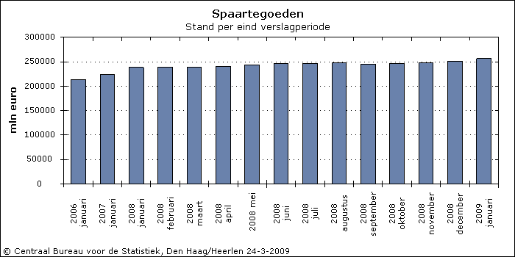*Consumer credits*

|  |  |  |  |  |  |
| --- | --- | --- | --- | --- | --- |
|  | Onderwerpen**[Verplaats variabele naar de voorkolom](javascript:__doPostBack('ctl00$ctl00$MainContent$MainContentDataMaster$TableView$pubGrid','move2stb|T');)** | Totaal kredieten | | | |
| Aantallen | Bedragen | | |
| [Uitstaande contracten](http://www.prebes.be/risicobeheer.shtm) | [Verstrekt krediet](javascript:GetDescription('desc|T|Key47%20%20%20');) | [Aflossingen](javascript:GetDescription('desc|T|New136%20%20');) | [Uitstaand saldo](javascript:GetDescription('desc|T|Key46%20%20%20');) |
| Kredietverstrekkers**[Verplaats variabele in de richting van de gele pijl](javascript:__doPostBack('ctl00$ctl00$MainContent$MainContentDataMaster$TableView$pubGrid','move|G1');)[Verplaats variabele naar de tabelkop](http://www.nav-aerosol.nl/)** | Perioden**[Verplaats variabele in de richting van de gele pijl](http://www.tigro.com/nl/vacatures)[Verplaats variabele naar de tabelkop](http://www.tliap.nus.edu.sg/dmp/adm/routes/sas.aspx)** | x1000 | mln euro | | |
| Kredietverstrekkers totaal | 2005 februari | 4 588 | 782 | 964 | 18 039 |
| [2006 januari-II](http://www.prebes.be/risicobeheer.shtm) | 4 440 | 822 | 916 | 17 629 |
| 2007 januari | 3 908 | 848 | 1 122 | 17 293 |
| [2008 januari\*](http://www.agd.nl/1072740/Nieuws/Artikel/Cacaobedrijf-Univeem-overgenomen.htm) | 4 035 | 848 | 991 | 17 524 |
| [2008 februari\*](javascript:GetDescription('desc|New267%20%20|200802');) | 4 019 | 845 | 978 | 17 536 |
| [2008 maart\*](javascript:GetDescription('desc|New267%20%20|200803');) | 4 059 | 854 | 978 | 17 553 |
| [2008 april\*](javascript:GetDescription('desc|New267%20%20|200804');) | 4 022 | 917 | 1 036 | 17 583 |
| [2008 mei\*](javascript:GetDescription('desc|New267%20%20|200805');) | 4 008 | 900 | 1 051 | 17 579 |
| [2008 juni\*](javascript:GetDescription('desc|New267%20%20|200806');) | 3 980 | 870 | 1 067 | 17 531 |
| [2008 juli\*](http://energy.dow.com/news/video.htm) | 3 956 | 1 045 | 1 179 | 17 546 |
| [2008 augustus\*](http://www.vopak.com/oceanfours/142_492.php) | 3 919 | 935 | 1 061 | 17 570 |
| [2008 september\*](http://www.sprengers.be) | 3 894 | 921 | 978 | 17 666 |
| [2008 oktober\*](http://www.logistiek.nl/productie/verpakken-etiketteren/nid7833-katoen-natie-print-etiketten-met-zetes.html) | 3 901 | 895 | 987 | 17 724 |
| [2008 november\*](javascript:GetDescription('desc|T|New3268%20');) | 3 879 | 755 | 887 | 17 743 |
| [2008 december\*](javascript:__doPostBack('ctl00$ctl00$MainContent$MainContentDataMaster$TableView$pubGrid','move2hdr|G1');) | 3 872 | 784 | 930 | 17 743 |
| [2009 januari\*](http://www.vopak.com) | 3 834 | 730 | 854 | 17 767 |
| © Centraal Bureau voor de Statistiek, Den Haag/Heerlen 24-3-2009 | | | | | |

|  |  |  |  |  |  |  |  |
| --- | --- | --- | --- | --- | --- | --- | --- |
|  | Onderwerpen**[Verplaats variabele naar de voorkolom](javascript:__doPostBack('ctl00$ctl00$MainContent$MainContentDataMaster$TableView$pubGrid','move2stb|T');)** | Totaal kredieten | | | | | |
| Aantallen | Bedragen | | | | |
| [Toegezegde limieten](http://www.tigro.com) | [Verstrekt krediet](http://www.cefic.be) | Rente | | [Aflossingen](javascript:GetDescription('desc|T|New136%20%20');) | [Uitstaand saldo](javascript:GetDescription('desc|T|Key46%20%20%20');) |
| Kredietverstrekkers**[Verplaats variabele in de richting van de gele pijl](javascript:__doPostBack('ctl00$ctl00$MainContent$MainContentDataMaster$TableView$pubGrid','move|G1');)[Verplaats variabele naar de tabelkop](http://www.nav-aerosol.nl/)** | Perioden**[Verplaats variabele in de richting van de gele pijl](http://www.tigro.com/nl/vacatures)[Verplaats variabele naar de tabelkop](http://www.tliap.nus.edu.sg/dmp/adm/routes/sas.aspx)** | x1000 | mln euro | | | | |
| Kredietverstrekkers totaal | 2006 maart | 10 399 | 891 | 129 | 1 037 | | 17 576 |
| 2006 april | 10 425 | 839 | 129 | 964 | | 17 581 |
| 2006 mei | 10 555 | 866 | 130 | 1 106 | | 17 471 |
| 2006 juni | 10 303 | 798 | 128 | 1 019 | | 17 378 |
| 2006 juli | 10 196 | 924 | 128 | 1 047 | | 17 382 |
| 2006 augustus | 10 199 | 976 | 127 | 1 068 | | 17 418 |
| 2006 september | 10 141 | 873 | 127 | 997 | | 17 421 |
| 2006 oktober | 10 131 | 909 | 131 | 1 012 | | 17 449 |
| 2006 november | 10 110 | 853 | 130 | 967 | | 17 466 |
| 2006 december | 10 056 | 801 | 126 | 963 | | 17 429 |
| 2007 januari | 10 063 | 848 | 139 | 1 122 | | 17 293 |
| 2007 februari | 10 081 | 800 | 135 | 988 | | 17 240 |
| 2007 maart | 9 892 | 882 | 135 | 990 | | 17 267 |
| 2007 april | 10 001 | 805 | 135 | 902 | | 17 305 |
| 2007 mei | 10 021 | 855 | 136 | 1 052 | | 17 244 |
| 2007 juni | 10 066 | 829 | 137 | 1 013 | | 17 197 |
| 2007 juli | 10 097 | 1 004 | 140 | 1 072 | | 17 270 |
| 2007 augustus | 10 138 | 988 | 142 | 1 022 | | 17 379 |
| 2007 september | 10 155 | 850 | 140 | 940 | | 17 429 |
| 2007 oktober | 10 217 | 942 | 143 | 1 041 | | 17 472 |
| 2007 november | 10 259 | 857 | 142 | 942 | | 17 529 |
| 2007 december | 10 332 | 786 | 134 | 925 | | 17 525 |
| [2008 januari\*](javascript:GetDescription('desc|New267%20%20|200801');) | 10 244 | 848 | 142 | 991 | | 17 524 |
| [2008 februari\*](javascript:GetDescription('desc|New267%20%20|200802');) | 10 283 | 845 | 145 | 978 | | 17 536 |
| [2008 maart\*](javascript:GetDescription('desc|New267%20%20|200803');) | 10 198 | 854 | 140 | 978 | | 17 553 |
| [2008 april\*](https://my.kellysearch.nl/main.aspx) | 10 274 | 917 | 150 | 1 036 | | 17 583 |
| [2008 mei\*](http://www.unizo.be/limburg/viewobj.jsp) | 10 079 | 900 | 146 | 1 051 | | 17 579 |
| [2008 juni\*](http://www.tigro.com/nl/over-tigro/contact) | 9 990 | 870 | 149 | 1 067 | | 17 531 |
| [2008 juli\*](javascript:__doPostBack('ctl00$ctl00$MainContent$MainContentDataMaster$TableView$pubGrid','move2hdr|G2');) | 10 061 | 1 045 | 149 | 1 179 | | 17 546 |
| [2008 augustus\*](http://xprof.hku.nl/clk/show) | 9 955 | 935 | 150 | 1 061 | | 17 570 |
| [2008 september\*](javascript:GetDescription('desc|T|Key45%20%20%20');) | 9 228 | 921 | 153 | 978 | | 17 666 |
| [2008 oktober\*](javascript:GetDescription('desc|New267%20%20|200810');) | 9 030 | 895 | 150 | 987 | | 17 724 |
| [2008 november\*](javascript:GetDescription('desc|New267%20%20|200811');) | 8 999 | 755 | 150 | 887 | | 17 743 |
| [2008 december\*](javascript:GetDescription('desc|New267%20%20|200812');) | 8 946 | 784 | 147 | 930 | | 17 743 |
| [2009 januari\*](javascript:GetDescription('desc|New267%20%20|200901');) | 8 932 | 730 | 148 | 854 | | 17 767 |
| © Centraal Bureau voor de Statistiek, Den Haag/Heerlen 24-3-2009 | | | | | | | |

**Facts and Figures 6: Statistics number of visitors on the website (per month)**

Legenda

: unique visitors

: number of visits  
 : number of viewed pages

Data January – December 2008

|  |  |  |  |  |  |  |  |  |  |  |  |  |  |
| --- | --- | --- | --- | --- | --- | --- | --- | --- | --- | --- | --- | --- | --- |
|  | Unique visitors: 373Number of visits: 566Pages: 2115 | Unique visitors: 312Number of visits: 506Pages: 2277 | Unique visitors: 367Number of visits: 642Pages: 2700 | Unique visitors: 299Number of visits: 559Pages: 2212 | Unique visitors: 327Number of visits: 553Pages: 2501 | Unique visitors: 354Number of visits: 608Pages: 2609 | Unique visitors: 320Number of visits: 545Pages: 3040 | Unique visitors: 271Number of visits: 587Pages: 2104 | Unique visitors: 343Number of visits: 686Pages: 2596 | Unique visitors: 422Number of visits: 753Pages: 2426 | Unique visitors: 432Number of visits: 732Pages: 2999 | Unique visitors: 302Number of visits: 569Pages: 2265 |  |
|  | Jan 2008 | Feb 2008 | Mar 2008 | Apr 2008 | May 2008 | Jun 2008 | Jul 2008 | Aug 2008 | Sep 2008 | Oct 2008 | Nov 2008 | Dec 2008 |  |

|  |  |  |  |
| --- | --- | --- | --- |
| Month | Unique visitors | Number of visits | Pages |
| Jan 2008 | 373 | 566 | 2115 |
| Feb 2008 | 312 | 506 | 2277 |
| Mar 2008 | 367 | 642 | 2700 |
| Apr 2008 | 299 | 559 | 2212 |
| May 2008 | 327 | 553 | 2501 |
| Jun 2008 | 354 | 608 | 2609 |
| Jul 2008 | 320 | 545 | 3040 |
| Aug 2008 | 271 | 587 | 2104 |
| Sep 2008 | 343 | 686 | 2596 |
| Oct 2008 | 422 | 753 | 2426 |
| Nov 2008 | 432 | 732 | 2999 |
| Dec 2008 | 302 | 569 | 2265 |
| Total | **4122** | **7306** | **29844** |

|  |  |  |  |  |
| --- | --- | --- | --- | --- |
| Unique visitors: 385Number of visits: 714Pages: 2558 | Unique visitors: 393Number of visits: 678Pages: 2353 | Unique visitors: 462Number of visits: 775Pages: 3701 | Unique visitors: 435Number of visits: 806Pages: 2906 | Unique visitors: 92Number of visits: 137Pages: 549 |
| Jan 2009 | Feb 2009 | Mar 2009 | Apr 2009 | May 2009 |

Data January – April 2009

|  |  |  |  |
| --- | --- | --- | --- |
| Month | Unique visitors | Number of visits | Pages |
| Jan 2009 | 385 | 714 | 2558 |
| Feb 2009 | 393 | 678 | 2353 |
| Mar 2009 | 462 | 775 | 3701 |
| Apr 2009 | 435 | 806 | 2906 |
| May2009 | 92 | 137 | 549 |
| Jun 2009 | 0 | 0 | 0 |
| Jul 2009 | 0 | 0 | 0 |
| Aug 2009 | 0 | 0 | 0 |
| Sep 2009 | 0 | 0 | 0 |
| Oct 2009 | 0 | 0 | 0 |
| Nov 2009 | 0 | 0 | 0 |
| Dec 2009 | 0 | 0 | 0 |
| **Total** | **1767** | **3110** | **12067** |

**Facts and Figures 7: Opportunities to trace IP-addresses and identifying them**

**Stellingen:**

***(1) 'Er is een mogelijkheid om achter de IP-adressen van de websitebezoekers, die jouw   
 bedrijfswebsite hebben bezocht, te achterhalen. ‘  
  
(2) ‘Je kunt zelfs te weten komen hoe de namen van de personen en/of namen van bedrijven   
 luiden die je bedrijfswebsite hebben bezocht.’***

***(3)‘Het is legaal om de IP-adressen van je websitebezoekers te achterhalen zodat er vervolgens   
 precies kan worden achterhaalt wie deze personen/bedrijven zijn. Deze ingewonnen   
 gegevens kunnen vervolgens voor een websitebezoekersanalyse worden gebruikt.’***

Uw aparte onderbouwingen van iedere stelling waarom iets wel of niet kan. En hoe iets (legaal) eventueel achterhaalt kan worden:

(1) :

Ja dit is mogelijk. Wel moet rekening worden gehouden met het feit dat het slechts een nummer is (192.168.0.1) waar geen verdere informatie aan gekoppeld is. Vroeger (in het tijdperk van de telefoonmodems) was het zeer gebruikelijk dat een modem slechts 1 IP-adres heeft, wat dus als ‘vingerafdruk’ van een computer (niet persoon of bedrijf) kan dienen. Tegenwoordig (breedband modems) wordt dit extern, vanuit een kastje geregeld. Deze heeft een IP-adres en geeft het internet signaal door naar een computer, ipv een modem die in een computer zelf zit. Bovendien werken vrijwel alle moderne breedband (ADSL, kabel, etc) met een DHCP (Dynamic Host Configuration Protocol) waarbij om de zo veel tijd tussen verschillende IP-Adressen wordt gerouleerd.

Dit impliceert dat de binnenkomende IP-Adressen niet langer 1 persoon vertegenwoordigd, gezien het feit dat een breedbandmodem vaak wordt ingezet om meerdere computer te voorzien van internet. Daarnaast wisselt het IP-Adres regelmatig waardoor niet langer kan worden achterhaald of de bezoeker voor de eerste keer de pagina bezoekt of vaker is geweest. Met name resultaten van bijvoorbeeld de provider of website-host moeten hierdoor met een korrel zout worden geïnterpreteerd.

(2) :

Ja dit kan, maar niet via een IP-adres (gezien hier geen extra beschikbare informatie aan gekoppeld is), maar via bijvoorbeeld een digitaal enquête (niet verplicht, dus niet waterdicht), via (al dan niet verplichte) registratie en inlogmogelijkheden (denk aan een mailbox, forum, etc).

Er kan wel redelijk nauwkeurig een plaats worden bepaald aan de hand van een binnenkomend signaal en daarvoor zijn inmiddels programma’s op de markt. Deze programma’s kunnen in kaart brengen waar een bezoeker ongeveer zit en daarmee globaal laten zien uit welk land/regio er meeste interesse is. Deze software is echter erg prijzig en de resultaten vallen niet controleren.

(3) :

Je mag (en voor sommige softwaretoepassingen moet) IP-adressen achterhalen, daar is niets illegaals aan. Opslaan, verhandelen en ‘ misbruiken’ van dergelijke gegevens staan naar mijn mening in de databanken-wet beschreven als illegale praktijken, al is men nog steeds niet geheel helder wat er nu wel en niet onder ‘misbruik’ valt. IP-adressen gebruiken om een computer te hacken (en dus persoonsgegevens achterhalen!) is duidelijk illegaal, een IP-adres gebruiken voor het lokaliseren van te uploaden bestanden, remote-desktop-viewing, etc niet. Alles daar tussen

|  |
| --- |
| **Naam** : Michiel Frankfort  **Bedrijfsnaam** : Z.Z.P. (M. Frankfort - Kvk)  **Functie** : Freelancer – webdesign & animatie  **Opleiding**  : EMMA (European Master of Media and Arts) Open Universiteit Londen   (MA) -&- MBO Multimedia Technologie niveau 4 |

in is wat ‘vaag’.

**Stellingen:**

***(1) 'Er is een mogelijkheid om achter de IP-adressen van de websitebezoekers, die jouw   
 bedrijfswebsite hebben bezocht, te achterhalen. ‘  
  
(2) ‘Je kunt zelfs te weten komen hoe de namen van de personen en/of namen van bedrijven   
 luiden die je bedrijfswebsite hebben bezocht.’***

***(3)‘Het is legaal om de IP-adressen van je websitebezoekers te achterhalen zodat er vervolgens   
 precies kan worden achterhaalt wie deze personen/bedrijven zijn. Deze ingewonnen   
 gegevens kunnen vervolgens voor een websitebezoekersanalyse worden gebruikt.’***

Uw aparte onderbouwingen van iedere stelling waarom iets wel of niet kan. En hoe iets (legaal) eventueel achterhaalt kan worden:

(1) : Dit is inderdaad mogelijk. Je kunt de IP adressen detecteren en dit opslaan in een database zodat je het later kan raadplegen. Het is echter voor een gebruiker wel mogelijk om zijn/haar IP adres te maskeren (te ‘spoofen’)

(2) : Je kunt de namen van personen meestal niet achterhalen. Je kunt eventueel wel aan de ‘vhost’ zien via welk bedrijf een gebruiker internet gebruikt. Grote bedrijven zoals IBM of Sun hebben vaak een eigen ISP (internet service provider) en daardoor is ook het bedrijf waar de gebruiker werkt te achterhalen.

|  |
| --- |
| **Naam** : Jeroen Loffeld  **Bedrijfsnaam** : Goes & Roos  **Functie** : Afdelingshoofd  **Opleiding**  : MBO Multimedia |

(3) : Dit is een beetje een grijs gebied. Volgens mij mag je IP adressen wel bewaren voor een bepaalde tijd (je mag immers ook bepaalde IP adressen blokeren) maar je mag deze informatie niet doorverkopen zonder daarvoor vooraf toestemming te vragen aan de bezoeker/gebruiker.

**Facts and Figures 8: Visit duration**Visit duration of Tigro’s website visitors:

**Facts and figures 9: Analysis of search engines linking to Tigro’s website**

|  |  |  |  |  |  |  |  |  |  |  |
| --- | --- | --- | --- | --- | --- | --- | --- | --- | --- | --- |
| Online search engine | **nov '07** | **nov '07** | **dec '07** | **dec '08** | **jan '08** | **jan '08** | **feb '08** | **feb '08** | **march '08** | **march '08** |
|  | **pages** | **percentage** | **pages** | **percentage** | **pages** | **percentage** | **pages** | **percentage** | **pages** | **percentage** |
| Google | 87 | 77,6 | 140 | 82,3 | 191 | 84,5 | 227 | 90 | 200 | 83,6 |
| Unknown | 18 | 16 | 28 | 16,4 | 25 | 11 | 15 | 5,9 | 27 | 11,2 |
| MSN search | 4 | 3,5 | 1 | 0,5 | 4 | 1,7 | 7 | 2,7 | 9 | 3,7 |
| Yahoo! | 3 | 2,6 |  |  | 6 | 2,6 | 1 | 0,3 | 2 | 0,8 |
| AltaVista |  |  | 1 | 0,5 |  |  | 1 | 0,3 |  |  |
| Baidu |  |  |  |  |  |  | 1 | 0,3 | 1 | 0,4 |
| Windows Live |  |  |  |  |  |  |  |  |  |  |
|  |  |  |  |  |  |  |  |  |  |  |
| Online search engine | **apr '08** | **apr '08** | **may '08** | **may '08** | **june '08** | **june '08** | **jul '08** | **july '08** | **aug '08** | **aug '08** |
|  | **pages** | **percentage** | **pages** | **percentage** | **pages** | **percentage** | **pages** | **percentage** | **pages** | **Percentage** |
| Google | 194 | 85 | 237 | 87.7 | 199 | 79.9 | 184 | 82.5 | 182 | 91.4 |
| Unknown | 27 | 11.8 | 2 | 0,7 |  |  |  |  |  |  |
| MSN search | 4 | 1.7 | 4 | 1.4 | 1 | 0.4 | 3 | 1.3 | 3 | 1.5 |
| Yahoo! | 3 | 1.3 | 1 | 0.3 | 1 | 0.4 | 1 | 0.4 |  |  |
| AltaVista |  |  |  |  |  |  |  |  |  |  |
| Baidu |  |  |  |  |  |  |  |  |  |  |
| Windows Live |  |  | 24 | 8.8 | 45 | 18 | 31 | 13.9 | 11 | 5.5 |
|  |  |  |  |  |  |  |  |  |  |  |
| Online search engine | **sept '08** | **sept '08** | **oct '08** | **oct '08** | **nov '08** | **nov '08** | **dec '08** | **dec '08** | **jan '09** | **jan '09** |
|  | **Pages** | **percentage** | **pages** | **percentage** | **pages** | **percentage** | **pages** | **percentage** | **pages** | **percentage** |
| Google | 249 | 84.9 | 309 | 91.6 | 246 | 93.8 | 200 | 90.9 | 273 | 83.7 |
| Unknown |  |  | 4 | 1.1 |  |  |  |  |  |  |
| MSN search | 1 | 0.3 | 1 | 0.2 |  |  | 1 | 0.4 | 2 | 0.6 |
| Yahoo! | 1 | 0.3 |  |  |  |  |  |  |  |  |
| AltaVista |  |  |  |  |  |  | 2 | 0.9 | 2 | 0.6 |
| Baidu |  |  | 1 | 0.2 |  |  |  |  |  |  |
| Windows Live | 29 | 9.8 | 15 | 4.4 | 9 | 3.4 | 16 | 7.2 | 31 | 9.5 |

|  |  |  |  |  |  |  |
| --- | --- | --- | --- | --- | --- | --- |
| Online search engine | **feb '09** | **feb '09** | **march ‘09** | **march ‘09** | **apr ‘09** | **apr ‘09** |
|  | **pages** | **percentage** | **pages** | **percentage** | **pages** | **percentage** |
| Google | 278 | 93.2 | 352 | 84.2 | 321 | 92.7 |
| Unknown | 2 | 0.6 | 5 | 1.1 | 2 | 0.5 |
| MSN search |  |  |  |  |  |  |
| Yahoo! |  |  | 111111111 | 0.2 |  |  |
| AltaVista | 4 | 1.3 |  |  |  |  |
| Baidu |  |  |  |  | 1 | 0.2 |
| Windows Live | 6 | 2 | 27 | 6.4 | 6 | 1.7 |

**Facts and figures 10: Most common keywords**

The most common Keyphrases and Keywords which have been used in the search engine by the website visitors, to search for Tigro’s website

|  |  |  |  |  |  |  |  |  |  |  |  |  |
| --- | --- | --- | --- | --- | --- | --- | --- | --- | --- | --- | --- | --- |
|  | Jan. | Feb | Mar | Apr. | May | Jun. | Jul. | Aug. | Sept. | Oct. | Nov. | Dec. |
| Keyphrases |  |  |  |  |  |  |  |  |  |  |  |  |
| Tigro | x | x | x | x | x | x | x | x | x | x | 75.0 | 62.5 |
| Tigro | X | x | x | x | x | x | x | x | x | x | 4.4 | 8.3 |
| Tigro.com | X | x | x | x | x | x | x | x | x | x | 3.5 | 4.1 |

**2008 (figures in percentages)**

|  |  |  |  |  |  |  |  |  |  |  |  |  |
| --- | --- | --- | --- | --- | --- | --- | --- | --- | --- | --- | --- | --- |
|  | Jan. | Feb. | Mar. | Apr. | May | Jun. | Jul. | Aug. | Sept. | Oct. | Nov. | Dec. |
| Keyphrases |  |  |  |  |  |  |  |  |  |  |  |  |
| Tigro | 42.6 | 41.6 | 45.7 | 38.3 | 37.9 | 44.4 | 39.1 | 40.9 | 35.7 | 33.4 | 27.6 | 35.9 |
| Tigro | 12.0 | 20.6 | 11.4 | 13.6 | 14.2 | 12.2 | 12.9 | 15.0 | 15.6 | 15.3 | 9.3 | 11.6 |
| Tigro.com | 3.1 | 1.9 | 2.1 | 4.5 | 3.0 | 1.2 | 3.6 | 1.0 | 2.5 | 2.1 | 3.5 | 3.7 |
| Tigro Overpelt | 6.2 | 5.1 | 6.7 | 4.5 | 6.3 | 4.4 | 7.8 | 6.2 | 8.3 | 2.4 | 5.8 | 4.2 |
| Tigro chemie | 6.2 | 5.5 | 3.3 | 5.9 | 4.1 | 1.2 | 7.8 | 6.7 | 3.6 | 5.8 | 5.0 | 10.7 |
| Tigro Lommel | 1.7 | 4.7 | 3.8 | 4.5 | 6.7 | 6.5 | 5.0 | 3.6 | 7.2 | 10.7 | 7.7 | 6.0 |
|  | **Jan.** | **Feb.** | **Mar.** | **Apr.** | **May** | **Jun.** | **Jul.** | **Aug.** | **Sept.** | **Oct.** | **Nov.** | **Dec.** |
| Keyphrases |  |  |  |  |  |  |  |  |  |  |  |  |
| Tigro | 35.6 | 34.3 | 33.6 | 34.2 | 37.2 | x | x | x | x | x | x | x |
| Tigro | 13.8 | 6.2 | 14.4 | 22.4 | 6.7 | x | x | x | x | x | x | x |
| Tigro.com | 1.9 | 1.7 | 2.4 | 0.9 | 1.6 | x | x | x | x | x | x | x |
| Tigro Overpelt | 7.0 | 5.9 | 5.0 | 3.0 | 1.6 | x | x | x | x | x | x | x |
| Tigro chemie | 5.7 | 8.3 | 2.6 | 1.8 | 6.7 | x | x | x | x | x | x | x |
| Tigro Lommel | 4.1 | 5.2 | 5.0 | 4.8 | 13.5 | x | x | x | x | x | x | x |

**Facts and figures 11: Dutch trade fairs**

General picture of the Dutch trade fair (figures are based on the market research which was executed in 2007. Published April 2008.

Total number of trade fairs

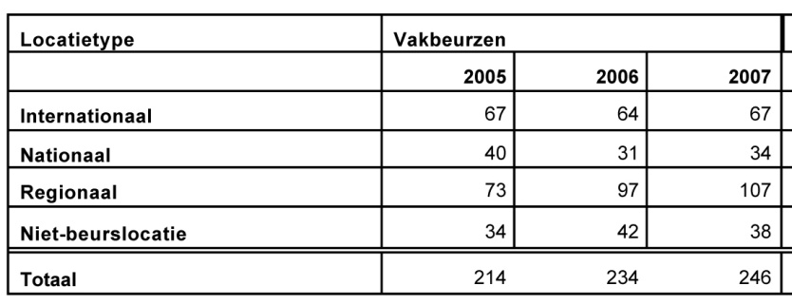

Exhibited numbers on the fair trade in The Netherlands and abroad

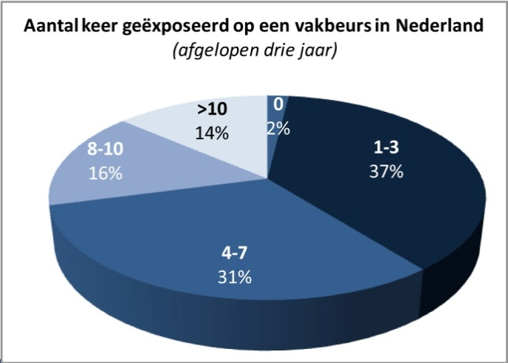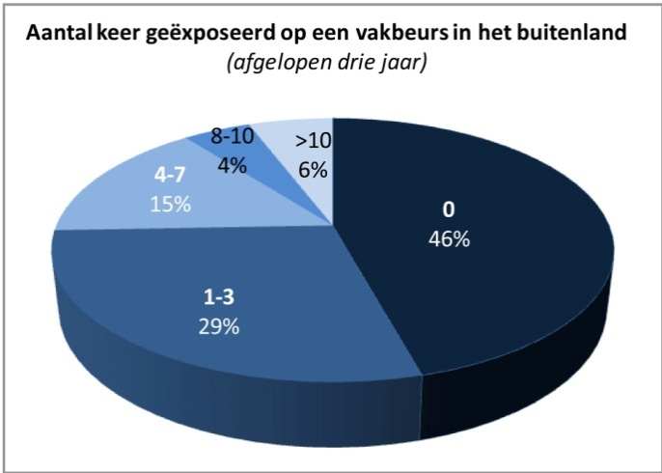

Reason of participation

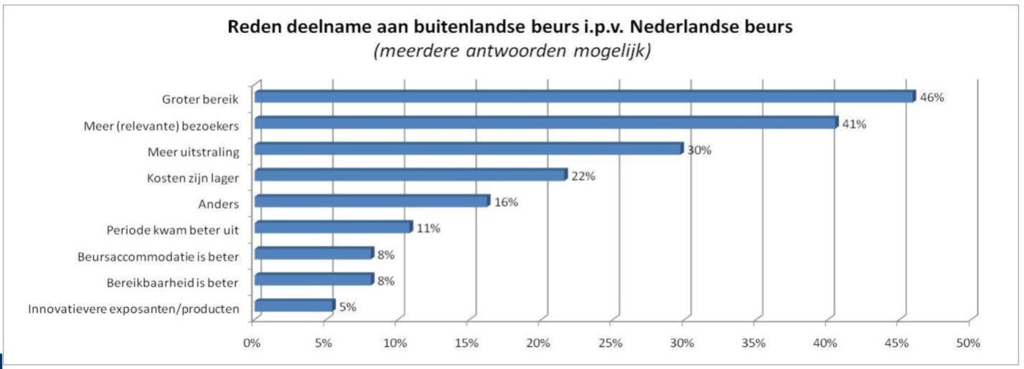

General picture of the Dutch trade fair (figures are based on the market research which was executed in 2007. Published April 2008.

Total number of exhibitors

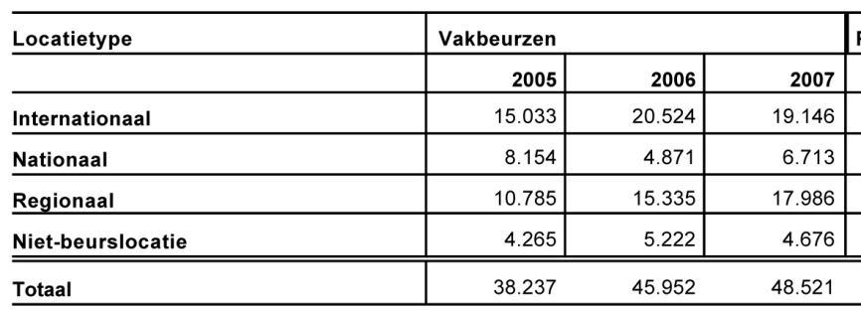

Average number of exhibitors

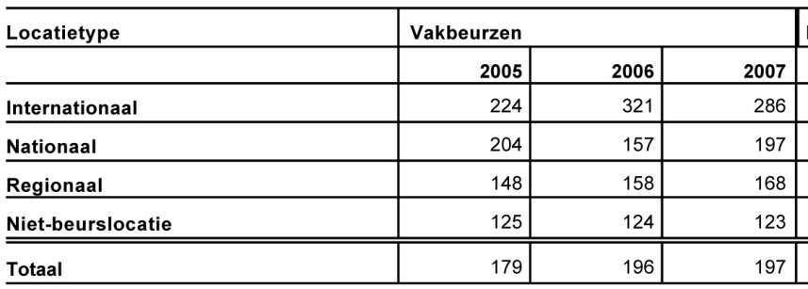

Average number of trade fair visitors

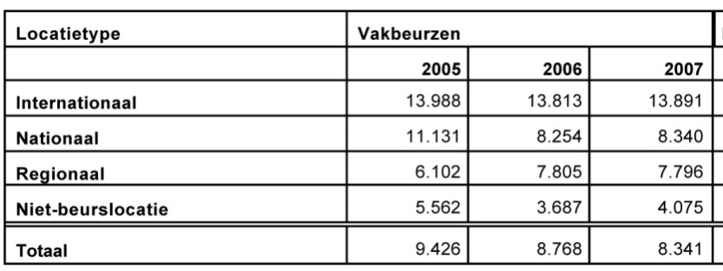

Average number of trade fair visitors per exhibitor

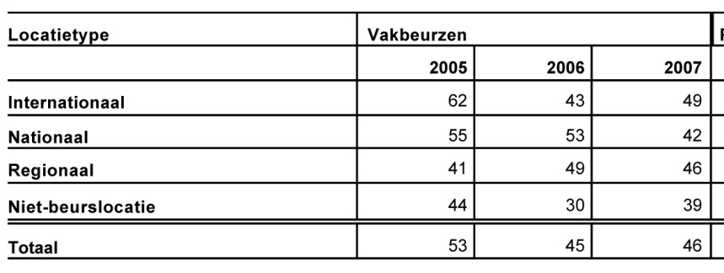

Dutch trade properties

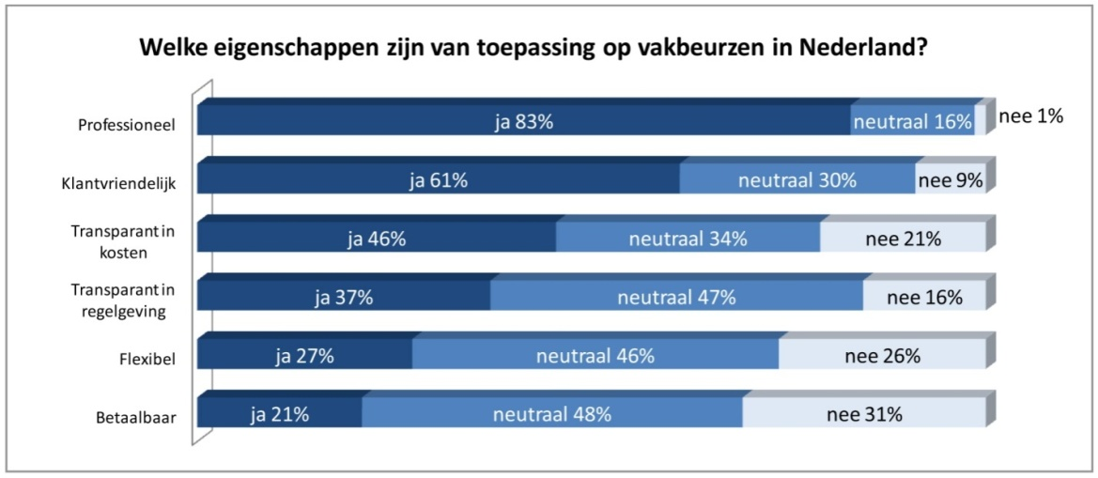

Why companies do participate on trade fairs

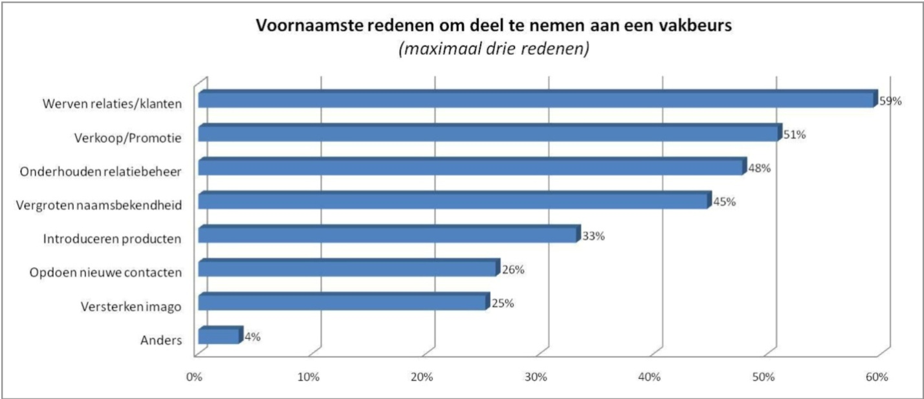

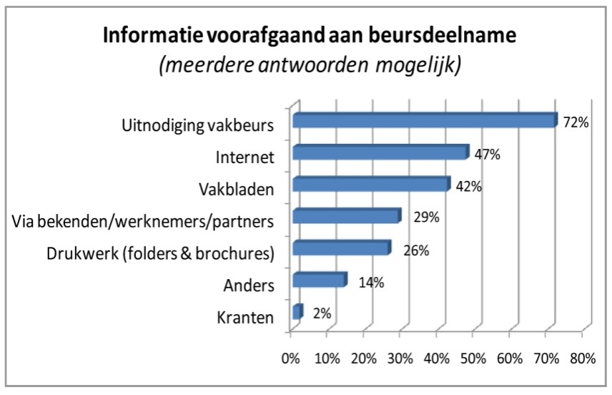

Evaluation

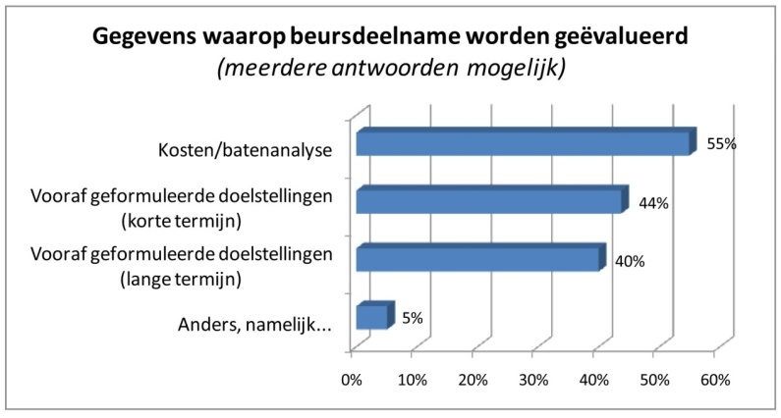

Why companies stopped or do not participated on trade fairs

