Can the delta of Mg be used as a proxy for the reconstruction of the paleo temperature?

(Developing a chemical procedure for determining Mg isotope ratios in foraminifera shells.)
Bridget Zoetemelk
2019-2020

Can the delta of Mg be used as a proxy for the reconstruction of the paleo temperature?

(Developing a chemical procedure for determining Mg isotope ratios in foraminifera shells.)

Bachelor Thesis

Bridget Zoetemelk

Student number: s1099793
First of August until first of May 2020

Internship Institute

Royal Netherlands Institute for Sea Research; Koninklijk Nederlands Instituut voor Onderzoek der Zee (NIOZ)
Department: Ocean systems (OCS)
Address: Landsdiep 4, 1797 SZ Den Hoorn
Supervisor: B. van der Wagt (Ing. and MSc.)
Telephone: 0222369464

Education Institute

Institute: Hogeschool Leiden
Address: Zernikedreef 11, 2333 CK Leiden
Faculty: Science and Technology
Bachelor of Chemistry; Specialization: Analytical Chemistry
School supervisor: Dr. K.A. (Karsten) Kaspers.

Summary (Dutch)

In de afgelopen jaren is er steeds vaker gezocht naar nieuwe methodes om het klimaat van het verleden te kunnen reconstrueren. Voor temperatuur bepalen wordt er onderzocht of Mg isotoop ratio’s hier een indicator voor kunnen zijn. Het verschil tussen twee isotoop ratio’s wordt uitgedrukt in de delta (δ²⁶Mg) en deze waarde is mogelijk te gebruiken voor de temperatuur reconstructie (Equation 1). Deze Mg isotoop ratio’s worden onderzocht in foraminifera, die hun cel opbouwen uit calciumcarbonaat. Foraminifera zijn grote eencellige schelpdieren. Tijdens het bouwen van de schelp worden er vervuilingen meegenomen, dit zijn andere elementen die ook voorkomen in zeewater, waaronder Na en Mg.

Het doel van dit onderzoek was om een Cation Exchange Chromatography scheidingsmethode te ontwikkelen om het Mg van Na en Ca te kunnen scheiden, zodat de Mg isotopen gemeten kunnen worden op de Multicollector ICP-MS. Er was al een methode aanwezig, deze werd verbeterd en geoptimaliseerd. Om de toepasbaarheid van de methode aan te tonen was het mogelijk om samples van foraminifera te analyseren, deze foraminifera waren op het NIOZ gekweekt.

Er moesten een aantal experimenten gedaan worden, welke tot de uiteindelijke scheidingsmethode leidde. Om tot een optimale recovery te komen werd de Mg stap in de scheidingsmethode aangepast. Er bleek bij het eerste experiment al dat Na en Ca volledig gescheiden waren van Mg. Na het aanpassen van de methode bleek deze een goede recovery te geven voor de standaard, maar niet voor de complete foraminifera matrix. Om voor de complete foraminifera matrix een goede recovery te krijgen werd de Mg stap verlengd. Na het aanpassen van die Mg stap werden nog niet de goede waarden gevonden voor δ²⁶Mg. De δ²⁶Mg van zeewater is vrij goed bekend, met de verbeterde methode werd het zeewater geanalyseerd. De resultaten van het zeewater waren vergelijkbaar met eerder gepubliceerde data.

Uiteindelijk werd een goeie optimale scheidingsmethode gevonden, welke gebruikt kon worden voor de foraminifera. Er zal voor meer zekerheid wel nog meer gevalideerd moeten worden. Uit de sample metingen was gebleken dat het mogelijk is om met de ontwikkelde methode verschillen in δ²⁶Mg te zien bij op verschillende temperatuur gekweekte foraminifera, er zal nog verder onderzoek ernaar gedaan moeten worden.

Index
Summary (Dutch) 3
List of abbreviations 5
1. Introduction 6
2. Theory 8
2.1. Cation Exchange Chromatography 8
2.2 The Multi Collector ICP-MS. 10
3. Experimental 14
3.1 Standard and foraminifera preparation. 14
3.1.1 Standards 14
3.1.2 The foraminiferas 14
3.2 Cation Exchange Chromatography 16
3.2.1 The column chemistry 16
3.2.2 ICP-MS analyses for the recovery calculations. 17
3.3 Analysis of the isotope ratios using MC-ICP-MS 18
3.3.1 The optimization of the MC-ICP-MS measurements 19
4. Results and discussion 20
4.1 The Cation Exchange Chromatography 20
4.2 the optimization of the MC-ICP-MS analysis 27
4.3 Sample measurements 31
5. Conclusion (and recommendations) 32
References 33
List of Figures, Tables and Equations 35
Appendix A schematic figures 36
A.1 ESA module 36
A.2 Multicollector Module 37
Appendix B 37
B.1 List of Chemicals 37
Appendix C: The example calculations 38
C.1 The calculation of the Delta 38
C.2 Calculations for the t-test between NFHS-1_E2 and NFHS-1_E3 38

List of abbreviations
Abbreviation
Mg | Magnesium
Na | Sodium
Ca | Calcium
MC-ICP-MS | Multicollector inductively coupled plasma mass spectrometer
HR-ICP-MS | High resolution inductively coupled plasma mass spectrometer
HNO₃ | Nitric Acid
CV | Column volumes
DSM-3 | Dead sea magnesium
RF | Radio Frequency
ESA | Electrostatic analyzer
kV | Kilo volt
keV | Kilo electron volt
SSB | Standard-Sample bracketing
FF | Foraminifera faker
NFHS-1  NFHS-1_E2 (etc) | NIOZ Foraminifera House Standard  NIOZ foraminifera House Standard _ experiment 2
Fin leg vial | Conical interior 5 ml vial with fin legs
UP | Ultra-Pure water
NASW | North Atlantic Seawater
CPS | Counts per second
sd | Standard deviation (sometimes 2sd; two times the standard deviation).

1. Introduction

In studies of paleoclimatology, the climate of the past is reconstructed. Paleo temperature reconstruction is one of the studies performed in the paleoclimatology. In the past years, many methods to reconstruct paleo temperatures have been developed. One of the ideas was to use the difference in the Magnesium (Mg) isotope ratios in foraminifera, because it is thought that the incorporation of Mg could be based on temperature[1] and foraminifera are well preserved in the sediments. Foraminiferas are large single-celled organisms, up to 1 mm in size and they live in or on the seafloor sediment. The cell of most species is protected by a shell that is divided into several chambers. Every time the cell grows, a new chamber is added. There are two main species of foraminifera, planktonic and benthic. The specie used in this research are A.lessonii, this is a benthic foraminifera. These foraminifera build their shells out of calcium carbonate (CaCO₃) and this process is called biomineralization. The formation of CaCO₃ shells plays a significant role in ocean biogeochemical cycles and, more importantly, the fossil remains in sediments of calcifying foraminifera are widely used to reconstruct past ocean chemistry and environmental conditions[2]. During biomineralization when CaCO₃ is formed, impurities as Mg, sodium(Na) and trace metals are incorporated in the shell [3]. The incorporation of Mg isotopes depends on different factors. The most important factors are the temperature and the salinity of the seawater in which the foraminifera grew and lived [4]. Mg has three stable isotopes ²⁴Mg, ²⁵Mg and ²⁶Mg, with a natural abundance of 78.99%, 10.00% and 11.01%[5]. It takes less energy to incorporate lighter isotopes, so when it gets colder it becomes increasingly more difficult to incorporate the heavier isotopes in the shell. The process of preferential incorporation of isotopes with a different mass is called isotopic fractionation and, for magnesium, is expressed in the isotope ratios ²⁵Mg/²⁴Mg and ²⁶Mg/²⁴Mg [4]. The isotopic ratios of Mg in the world oceans are stable and do not change significantly due this uptake, because of the very small amount that is incorporated in shells versus the relative high concentration in seawater (<1 ppm vs 1290 ppm).

The aim of this research is to develop a cation exchange separation method for the separation of Mg from the foraminifera shell matrix. There was a not yet finished method available at NIOZ for the separation of Mg from Ca and Na and this needed to be improved, optimized and validated for the matrix of the foraminifera shell.

The cation exchange chromatography method must separate Mg from Ca and Na, because Ca and Na are the main interfering elements during the measurements of Mg isotopes with the MC-ICP-MS (multicollector inductively coupled plasma mass spectrometer). The MC-ICP-MS is used to measure isotopic ratios of stable isotopes. Since the interaction of the isotopes with the cation exchange resin strongly depends on acid concentration, it is important that the acid used for the elution has the optimal concentration to achieve the best separation possible[6]. Furthermore, since lighter isotopes elute earlier than the heavier isotopes it is important to collect between 98 and 100% of the samples, to prevent isotopic fractionation. Data for the calculation of the recovery was measured using a single quadrupole mass spectrometer with a collision cell, ICP-MS (Inductively coupled plasma mass spectrometer).

The MC-ICP-MS is used for the measurements of Mg isotopic ratios measurements, because it can obtain high precise ratio measurements in small samples, like Mg in foraminiferal carbonates[7][8]. The separation of the isotopes in the MC-ICP-MS is based on mass/charge (m/z). Ca has an isotope with a mass of 48. In the plasma a doubly charged isotope can be created, doubly charged ⁴⁸Ca²⁺, which interferes with the measurement of ²⁴Mg. This is called an isobaric interference. Na can cause fractionation inside the MC-ICP-MS at a certain amount, during the measurements of Mg; this is called non-isobaric interference. Non-isobaric interference during the isotopic separation in the MC-ICP-MS can cause that smaller isotopes are pushed towards the outside of the ion beam and do not described the curve correctly, which causes loss of the isotopes.

The measured isotope ratios are used to calculate a delta value(δ (‰)) (Equation 1).The δ is the relative difference between the isotope ratio of a sample and the isotope ratio of the standard. The commonly used zero δ standard ( of which per definition δ²⁵Mg and δ²⁶Mg are zero ‰ ) is DSM-3 (Dead sea magnesium) [9]. Since this standard is no longer commercially available, an inhouse standard was used as the zero δ standard (standard Mg solution Alpha Aeser for ICP measurements). This relative difference between a standard and a sample will only change when the zero δ point changes and the offset from zero is known. To calibrate the inhouse standard against the DSM-3 standard, the inhouse standard was send to AWI (Alfred Wegener institute) in Bremerhaven to determine the relative difference against the DSM-3 standard. The inhouse standard was found to have a δ²⁵Mg of -0.77‰ (±0.04‰, 2sd) and δ²⁶Mg of -1.48‰ (±0.06‰, 2sd) (personal comment dr. I van Dijk).

$$Delta \left(δ^{25}\right)=\left( \frac{\left(\frac{25Mg}{24Mg}\right)sample}{\left(\frac{25Mg}{24Mg}\right)standard}-1\right)*1000=… ‰$$
Equation 1 The calculation of the δ^{x}Mg, with δ²⁵Mg as example.

2. Theory

2.1. Cation Exchange Chromatography

Cation exchange chromatography is a form of ion exchange chromatography, which is used to separate cations based on their surface charge. Ion exchange chromatography generally consists of two phases, the mobile phase and the stationary phase. The sample is dissolved in the mobile phase, which is then added to the stationary phase. The ions in the sample interact with the stationary phase and distribute themselves between the two phases according to their relative affinities toward each phase. This allows the separation of different ions of the sample solution[10].
When performing cation exchange chromatography, a negative charged ion exchange resin is used. The cations are separated based on their affinity with the negative charged ends in the resin. Also, an important factor is the concentration of the acid that is used for the elution of the cations. When the acid has a higher concentration, it is harder for the ions to stick longer to the negative ends of the resin. A Kd value describes the affinity of the cation with the resin based at a specific concentration of the elution acid. Every element has their own distribution coefficient (Kd value). When the Kd value of an element is high, the affinity with the resin is large. When the affinity with the resin is large the time needed to elute this element becomes longer. For the separation of Mg from Ca and Na a chromatographic column was made using AG50W-X12 as resin. The AG50W-X12 resin is a strong cation exchanger with a high cross linkage. Strelow et al[6] did research to determine the Kd values of different elements with nitric acid as an elution acid. The Kd values of Mg and Ca are very alike (Table 1 The Kd values of Mg, Ca and Na, when using HNO3 as an elution acid[6]). This can cause that the separation between these two elements is not optimal. Based on their Kd value, Na was expected to elute first, followed by Mg and Ca. When the acid concentration is too high, the Kd value of Ca becomes lower than the Kd value of Mg, which causes a change in the separation process. An example image of the separation process is shown in Figure 1.
The amount of elution acid that is used is expressed in column volumes (CV). A column volume is the liquid equivalent of the amount of resin in the conditioned column.

Table 1 The Kd values of Mg, Ca and Na, when using HNO3 as an elution acid[6].
Ion | Kd value 1.0N HNO₃ | Kd value 2.0N HNO₃ | Kd value 3.0N HNO₃ | Kd value 4.0N HNO₃
Mg | 22.9 | 9.1 | 5.8 | 4.1
Ca | 35.3 | 9.7 | 4.3 | 1.8
Na | 6.3 | 3.4 | 2.0 | 1.3
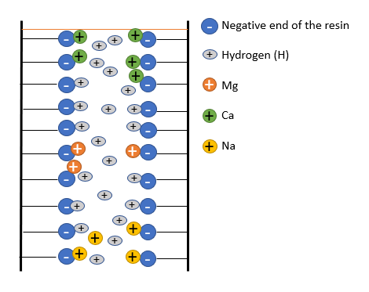
Figure 1 Example of Cation Exchange Chromatography. Image is self-made.

2.2 The Multi Collector ICP-MS.

During this study a Thermo Finnigan Neptune HR-MC-ICP-MS was used. The MC-ICP-MS is a double focusing, high resolution mass spectrometer for high precision isotope ratio measurement using a reversed Nier-Johnson geometry. The MC-ICP-MS consist of three modules. The ICP module, the ESA (Electrostatic analyzer) module and the multi collector module. The ICP Module consist of the inlet system, plasma generation and the ion generation. The ESA module covers the focusing and accelerating of the ions. The multi collector module consist of a magnet, zoom optics and a detector array (the multi collector). The layout of the MC-ICP-MS is shown in Figure 2.

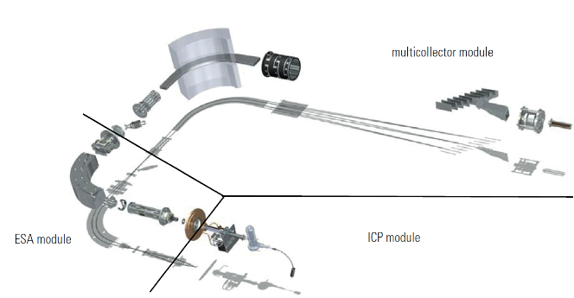

Figure 2 A Layout of the Neptune plus MC-ICP-MS

The MC-ICP-MS is equipped with a continuous inlet system for more stable measurements. The sample is fed into the nebulizer, where an argon/sample aerosol is generated. After the nebulizer the sample is guided into the spray chamber. The purpose of the spray chamber is to remove large droplets produced by the nebulizer, which reduces the formation of oxides. The spray chamber connected to the MC-ICP-MS is a double pass cyclonic spray chamber which increases efficiency, precision and washout. Next, the argon/sample aerosol is directed into the injector of the plasma torch. In the plasma the argon/sample aerosol is heated and ionized. The plasma is generated by a very intense RF field (~27.12 MHz, Radio Frequency), the plasma temperature in the center is about 10,000 K.
After ionization in the plasma the ions pass the first cone, the sample cone. The main gas stream goes into the interface pump while the ions pass through the second cone, the skimmer cone. A differential pumping system is used to pump down the atmospheric pressure at the sample cone, this causes fewer collision with the argon gas, so the possibility to form double charged cations is smaller and the sensitivity is greatly increased. The ions then emerge from the skimmer cone, where they are directed through the ion optics. In Figure 3 there is a schematic image of the sample and skimmer cones, also called the interface. To reduce the effects of the high-temperature plasma on the cones, the interface
housing is water-cooled.
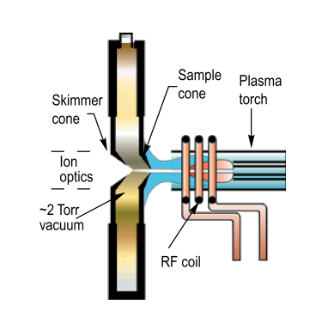
Figure 3 The Interface, the sample and simmer cone.
In the MC-ICP-MS two different sample cones and two different skimmer cones can be used. Several studies have investigated the effects of different combinations of sample and skimmer cones on the extraction efficiency of plasma ions and mass discrimination behavior using MC-ICP-MS. The two sample cones are the standard cone and the Jet cone. The two skimmer cones are the H and X skimmer cone. The cones can be used in different combinations. The difference of the cones is shown in Figure 4. The effects of the cone combination on the accuracy and precise of Mg-isotopic measurements is described by Gou et al [11]. It was shown that none of the combinations affected peak shape. The sensitivity of the cone combination Jet + X was the best (factor of 1.9 compared to the worst combination Standard +H), but the most stable measurements were obtained by the cone combination Jet + H (sensitivity factor of 1.4). The best cone combination for accurate and precise Mg isotopic measurements is Jet + H[11].

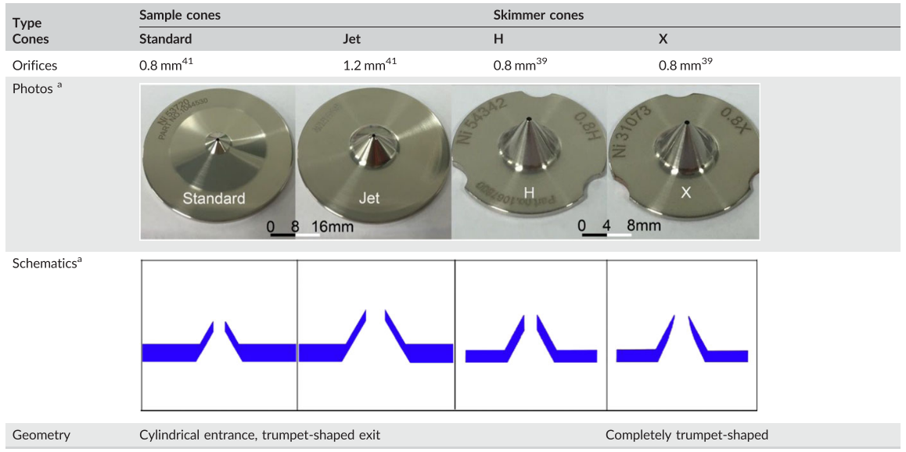

Figure 4 the differences between the cones, taken from Gou et al. [10]
After the cones the ions are fed into the Ion optics. In the ion optics the ions are extracted from the gas stream by the extraction lens and let into the transfer lens system. Inside the transfer lens system, the ion beam is accelerated to 5 keV (kilo electron volt) kinetic ion energy and shaped by the entrance slit by various lenses. The entrance slit can be set in low, medium or high resolution in order to let the correct ions based on their mass into the ESA. Resolution is normally defined as the width of a peak at 10% of its height. This is why low resolution is sufficient for Mg isotopes. After the entrance slit the ion beam enters the electrostatic analyzer (ESA). The ESA focuses ions emerging through the entrance slit with diverging angels into a cross over, to make sure all ions with different charges and size are presented to the multi collector module at the same time, this is one of the reasons the MC-ICP-MS is used for isotopic ratios. After the ESA there is an acceleration lens, where the ions are accelerated to an ion beam energy of 10 keV. In appendix A.1 is a more detailed layout of the ESA module.

In the multi collector module mass selection and detection of the ions takes place. In a magnetic field generated by a large electromagnet, the ions are traveling along a curve which is determined by their mass and charge. In the curve the heaviest ions are on the outside and the lighter ions are on the inside, because the heaviest ion describe a larger curve. The curve is based on the charge over mass (Equation 2). The ions of a certain m/z value will have a unique curve which can be determined if both magnetic field magnitude B, and voltage difference V for region of acceleration are held constant.

$$m/z= \frac{B^{2}*r^{2}}{2*V}$$
Equation 2 The equation that describes the curve the ions make in the magnetic field.

The detector is equipped with eight movable detector platforms and one fixed center platform. The platforms are motor-driven and can be precisely positioned. Each detector platform carries a Faraday cup. A faraday cup is designed to collect charged particles. Each Faraday cup is connected to a current amplifier. There are different amplifiers that could be used, but in this research, amplifiers containing 10¹¹ Ω resistors were used. For high precision and stability, the amplifiers are mounted in a doubly shielded, evacuated and temperature-controlled housing. The output signal of the amplifier is high linear voltage. In appendix A.2 there is a diagram of the multi collector module. For isotope ratio measurements the signal (voltage (V)) is required to be stable for accurate and precise measurements. To have accurate and precise measurements each measurement it is better to have symmetrical and flat top peaks. An example of a peak of ²⁵Mg is shown in Figure 5.

To monitor drift and correct the data for instrumental mass fractionation, the standard-sample bracketing (SSB) technique was used. SSB corrects for the instrumental mass bias, where the isotopic composition of the sample is referenced to the values obtained for the bracketing standard. Mass-dependent isotope fractionation occurs during the measurements. Various methods have been applied to evaluate the nature of isotopic fractionation in the MC-ICP-MS, the one used in this research is called a three-isotope plot. This method relies on visualizing the concurrent changes of two isotopes of an element[12].

Figure 5 The Peak of 25Mg in voltage.

3. Experimental

All labware used in this study was cleaned before use, to prevent contamination. With either two times distilled nitric acid or three times distilled hydrochloric acid. The PFA vials were cleaned with 7N two times distilled nitric acid. After every experiment the PFA vials were rinsed with ultra-pure water three times and then filled with the 7N nitric acid. The PFA vials filled with the nitric acid were put on a hotplate (130°C) for over the weekend, before use they were rinsed three times with ultra-pure water. The other labware that was used was rinsed with 7N hydrochloric acid, and before use with ultra-pure water.

3.1 Standard and foraminifera preparation.

3.1.1 Standards
The standard that was used for the optimization of the column chemistry was made of a solution of 1000 ppm Mg in 5% HNO₃(the inhouse standard). For the measurements it was diluted to a concentration of about 0.15 ppm, by diluting 4.5 µL in 30 ml 2% HNO₃.
The elution acid (HNO₃) for the cation exchange chromatography was titrated with NaOH and the acid strength was adjusted so the final concentration was 2.0N HNO₃.
For the development and optimization of the cation exchange chromatography a solution imitating the elemental composition of a typical foraminifera was prepared. From here on that is called Foraminifera Faker (FF) and contained the Mg Inhouse-Standard. The FF consisted of 3.33 ppm Mg, 8.33 ppm Na and 2500 ppm Ca.
In order to test the procedure on real foraminiferal material, the NIOZ foraminifera house standard (NFHS-1, Mezger et al 2016 [13]) was used. NFHS-1 is a mix of foraminifera fossils collected from sediments near Walvis ridge in the southern Atlantic Ocean. The details of the chemicals that were used are in Appendix B.1.

3.1.2 The foraminiferas
The foraminifera were collected from the reef aquarium of Royal’s Burgers Zoo (Arnhem), by scuba diving. The reef aquarium has constant living conditions. At the NIOZ the foraminifera were separated by species, then cultured and grown at three different temperatures, 18, 21 and 26°C and constant salinity (34 g/kg) until reproduction occurred. Salinity is the sum of all the dissolved salts in water. The species used in this research was A.lessonii (figure 6). Only the offspring, which had grown its entire shell in the controlled conditions of the experiment, was used for measurements. 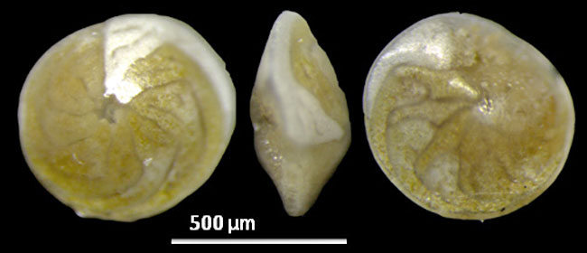
figure 6 The Benthic foraminifera, A.lessonii. http://www.foraminifera.eu/singlerw.php?no=1013532&aktion=suche

The cultured foraminifera were divided into groups of ten and then cleaned by rinsing six times in 300 µL methanol (99%) and three times in 300 µL ultra-pure water. After every step the foraminifera were put into an ultra-sonification bath (Frequency 80, Power 50%, room temperature, one minute). After the cleaning procedure the foraminifera were prepared for the column separation. Triplicate samples were prepared for each cultured temperature, each containing about 60 µg of foraminifera. Each sample was dissolved in 300 µL 1% HNO₃ (in Eppendorf tubes of 500 µL), the acid was added in small steps of 50 µL to prevent the loss of foraminifera, when CO₂(g) is formed in the tube (Equation 3).

CO₃²⁻ + 2 H⁺ H₂O_{(l)} + CO_{2 (g)}.
Equation 3 the formation of CO2

To ensure that the foraminifera were completely dissolved the vials were put in an ultra-sonification bath for 5 minutes (Frequency 80, Power 50%, room temperature) and centrifuged (10,000 rpm for 5 minutes). After centrifuging the samples, 280 µL of the supernatant was transferred to a separate 5 ml conical interior vial with fin legs made of PFA. After this the 280 µL was evaporated on a hotplate from Analab (130°C), until total dryness. After the evaporation, the samples were redissolved in 150 µL 2.0N HNO₃ and ready to be loaded on a column.[14]

3.2 Cation Exchange Chromatography

3.2.1 The column chemistry
The Mg in the samples was purified through a cation exchange column containing AG-50W X12 resin. The fifteen columns that were used had an aspect ratio of 14,2; diameter 4mm, length 56mm and were made in a modified PE Pasteur pipet containing a PE frit (1,5 mm thick, ~40-60 mm pore size). The CV of the AG-50W X12 resin was 900 µL and the elution acid used was 2.0N HNO₃. Before every experiment the resin was cleaned by eluting 4 CV 7N HNO₃ and 4 CV Ultra-pure water. After every column experiment the resin was cleaned by eluting 2 CV 7N HNO₃ and 2 CV Ultra-pure water. The eluted fractions were collected in 5 ml PFA fin legged vials. Before the final method (Table 3) was completed several experiments were conducted to optimize the original method.

The original method elution scheme consisted of 1 CV 2.0N HNO₃ for the conditioning. 4 CV 2.0N HNO₃ were eluted before the collection of Mg (pre-fraction). After this 3,5 CV 2.0N HNO₃ were eluted for the collection of Mg. To optimize this method several experiments needed to be conducted;
- The separation was tested by splitting the fourth, seventh and eight column volume in fractions of 150 µL. For this experiment three out of the fifteen columns were used. This resulted in a new separation method which consisted of 1 CV 2.0N HNO₃ for the conditioning. 3.5 CV 2.0N HNO₃ were eluted before the collection of Mg (pre-fraction).After this 3 CV 2.0N HNO₃ were eluted for the collection of Mg. The new set up was tested for the recovery with the FF by performing the column chemistry on five columns. After this all fifteen columns were tested. Three of them were used for the blank test. Six of them were used to check the recovery for the FF and six were used for the recovery of the NFHS-1. It was also tested for consistency with the NFHS-1. The consistency was tested by repeating the separation on a different day.
- The next experiment that was performed was to extend the Mg fraction from 3 CV to 3.5 CV. The extended version of the separation method was tested for consistency in of δ²⁵Mg and δ²⁶Mg.
- The last experiment that changed the separation method was to extend the conditioning step to 2 CV 2.0N HNO₃. The extended conditioning step was tested for consistency and precision with δ²⁵Mg and δ²⁶Mg. The NFHS-1 was used to test for consistency. The NFHS-1 separation was performed on three different days.
- The concentration of the sample or standard that were going to be loaded on to the columns was optimized by loading different concentrations of Mg. The loading concentration used for this test are listed in Table 2.
- NASW(North Atlantic Seawater) was used to test if the separation method gave the same results as the literature.

Table 2 The FF solutions that were used to test for the optimal and maximum concentration of the sample and standards
solution | Mg  (ng in 30µL) | Na  (ng in 30µL) | Ca  (ng in 30µL)
1 | 660 | 1500 | 450000
2 | 330 | 750 | 225000
3 | 110 | 250 | 112500
4 | 55 | 125 | 56250

After each column experiment the solvent in the collected fractions was evaporated overnight using a hotplate (130°C), until the samples were completely dry. The samples were then redissolved in 700 µL 2% HNO3 shortly before the measurements giving a concentration of about 150 ppb. For the ICP-MS measurements they were diluted ten times, by diluting 200 µL in 2 ml 2% HNO₃ resulting in a final Mg concentration of 15 ppb. [1][7]

Table 3 The final elution protocol of the Cation exchange chromatography method.
Day One | (1 CV is 900 µL) | Time (minutes)
Cleaning | 4 CV 7N HNO₃ | ~120
 | 4 CV Ultrapure water | ~120
Day Two
Cleaning | 1 CV 7N HNO₃ | ~30
 | 1 CV Ultrapure water | ~30
Conditioning | 2 CV 2.0N HNO₃ | ~60
Sample | 30 µL (110 ng Mg, 250 ng Na and 112500 ng Ca)
Procedure | 3.5 CV 2.0N HNO₃ pre-fraction (the last 0.5 CV was captured, for the recovery check) | ~105
 | 3.5 CV 2.0N HNO₃ Mg-fraction | ~105
 | 0.5 CV 2.0N HNO₃ After fraction (was captured for the recovery check) | ~15
Cleaning | 2 CV 7N HNO₃ | ~60
 | 2 CV Ultrapure water. | ~60

3.2.2 ICP-MS analyses for the recovery calculations.
For the optimization of the separation, the ICAP Q ICP-MS from thermo scientific was used. In these measurements the content of Na, Ca and the recovery of Mg from the column chemistry were determined. The recovery was monitored by measuring the FF without passing it through the column and by measuring the Mg content from the same sample after the column chemistry. The recovery was calculated by using the counts per second (CPS). The standard-sample bracketing technique was used for measurements with the ICP-MS.

3.3 Analysis of the isotope ratios using MC-ICP-MS

The operating conditions and sample measurement parameters are listed in Table 4. A blank correction was performed by subtracting the average of the two blanks surrounding the samples and standards [15]. To keep track of the influence of the Na and Ca on the measurement, an additional measurement with a different method designed to quickly monitor Ca and Na signal intensities was included in the measurements. After it was proven that the Mg was fully separated from the Na and Ca and the blank of the Na and Ca stayed low, the Na and Ca content measurements were left out.

Table 4 Instrumental operating conditions. *optimized on a daily basis for the sensitivity, but for Mg it is fairly constant.
rf Power | 1220 Watt
Acceleration Voltage | 10 kV
Sample gas | Argon
Sample Gas Flow rate (L/min)* | 0.950
Auxiliary gas flow rate (L/min)* | 0.95
Coolant gas flow rate (L/min) | 15.00
Fore vacuum pressure (mbar) | < 6E⁻⁴
High Vacuum pressure (mbar) | < 1E⁻⁷
Analyzer pressure (mbar) | < 8E⁻⁹
Sample uptake rate | ~60 µL/min
Typical ²⁴Mg sensitivity | ~73 V/ppm
Blank signal | 0.006V for 2% HNO₃
Sampling time | 45 repetitions of 4s
Baseline | 30 times 1.05s
Background time | One repetition of 30s.  (defocused: Baseline + Background)
Cone combination | Jet + H
Multi collector | Low mass side (L1): 24 Mg  Center cup (C): 25 Mg  High mass side (H1): 26 Mg

3.3.1 The optimization of the MC-ICP-MS measurements
The first test was to optimize the measurements for the lowest acceptable precision given the amount of sample available. In order to evaluate if results were more stable using less cycles, analysis consisting of 90 cycles of 4 seconds integrating time per sample compared with measurements 45 cycles of 4 seconds integrating time per sample.
Second, to evaluate the influence of Na and Ca on δ²⁵Mg and δ²⁶Mg measurements, small amounts of Na were added to standards. Also, Ca was added to the Mg inhouse-standard. Five standards were used. In Two of the standard Na was added, one of 10 ppb Na and one of 40 ppb Na and another two were used to add Ca. The Ca was also added in amounts of 10 ppb and 40 ppb.
Third, the effects of small variations of the acid concentration (aimed at being 2% HNO₃) between samples an standards were investigated. The inhouse standard was dissolved in 1%, 3% and 4% HNO₃ and measured as a sample against the same standard dissolved in 2% HNO₃.
Last, for the evaluation in the long term precision of the Mg analysis a single solution of SRM980 was used. SRM980 is a Mg standard, for the stability a 2sd is preferred below 0.1‰. To mimic the repeatability of real foraminifera samples that cannot be measured multiple times, NASW was processed over 15 columns and the Mg fractions were combined to enable reuse of the same sample in consecutive analytical runs.

4. Results and discussion

4.1 The Cation Exchange Chromatography

At first the recovery was tested for the original method. The recovery of Mg of the original method was proved to be not optimal, the recovery for ²⁵Mg was 89.0% (±2.0%, 2sd)(Figure 7). The results shown that a small amount of Mg is eluted before and after the Mg fraction. In the original method it was clear that the Mg was completely separated from Na and Ca. After this a small blank test of the columns was performed, to test if the cleaning procedure is sufficient. The results showed that the blank of the columns is as low as the acid blank, so the cleaning procedure is sufficient. Based on the bad recovery results the separation was tested.

Figure 7 The recovery’s of ²⁵Mg from the original method, ICP-MS measurements. The labels are percentage (%). (the percentage are presented with a comma instead of a point mark).

1)
The separation was tested by splitting the fourth, seventh and eight column volume (CV) in fractions of 150 µL. The results of the separation test show that the separation of Mg from Na and Ca was clearly visible (Figure 8). It appeared that most of the Mg elutes at CV 5 and CV 6, if these two are combined the recovery of ²⁵Mg has an average of 97.2% (± 0.5%, 2sd, n=3), which is still not optimal. The start of the Mg-fraction in the original method was at CV 5, but the elution of Mg starts slightly earlier. To improve the method, 0.5 CV before and after CV five and six were added to the Mg fraction. The new method consisted of 3.5 CV for the pre-fraction containing Na and 3 CV for the Mg-fraction.

Figure 8 The separation test of Mg from Na and Ca. The Na signal measured in the blank seems to be high but compared to the total signal it is lower than 10%.
Using this new method the recovery was tested, with FF (Foraminifera faker) as a sample. The recovery appeared to be improved compared to the previous experiment. The average recovery of the new method was 98% (±1.7%, 2sd, n=5). The average was proven to be optimal, but when using the total matrix of foraminifera this could be different, because of the matrix affect. To investigate what the recovery would do, the NFHS-1 (NIOZ Foraminifera House Standard) was performed with this method. The foraminifera standard NFHS-1 was used to test for the matrix effect.
In this experiment the recovery of NFHS-1 and the recovery of the FF had been investigated. This resulted for FF in a good recovery of 99.6% (±1.5%, sd, n=6) and for the NFHS-1 96.8% (±1.9%, sd, n=3), this was not optimal and this needs to be improved. The cause for the lower recovery can be the effect of the matrix of NFHS-1. The matrix effect can slow down the elution of Mg, because it contains more elements which interact with the resin. The FF consists of Na, Ca and Mg only, while the NFHS-1 consist of all the elements a foraminifera contains. So, for the total matrix of a foraminifera the Mg-fraction in the separation must be extended. These samples were also measured on the MC-ICP-MS.

These samples were also measured on the MC-ICP-MS. Within these measurements the bracketing standard showed a δ²⁵Mg of -0.0003‰ (±0.03‰, 2sd) and for δ²⁶ Mg -0.001‰ (±0.04‰, 2sd). This shows that the measurements of the MC-ICP-MS are stable and that the changes in mass fraction over time is low. The FF samples are shown in Figure 9 and the average is shown in Table 5. The optimal δ²⁵Mg and δ²⁶Mg for the FF is zero and it must fluctuate around zero. The FF gave a δ²⁵Mg and δ²⁶Mg of below zero. The reason for them to not have an optimal δ²⁵Mg and δ²⁶Mg, is that the recovery of the Mg was apparently not good enough. The NFHS-1 average are shown in Table 5. The measurements for the NFHS-1 that were performed had a good precision, but as there is no theoretical value for NFHS-1 δ²⁵Mg and δ²⁶Mg. The separation method was tested in duplo to check for the consistency of the resin with the total matrix.

Figure 9 δ²⁵Mg and δ²⁶Mg from the FF samples.

The NFHS-1 average results for δ²⁵Mg and δ²⁶Mg of both experiments (NFHS-1_E(experiment)2 and NFHS-1_E3) are shown in Table 5. The averages seem to be different based om comparing them with the standard deviation. To make sure the right conclusion can be drawn an unpaired-samples t-test was executed. The calculations of the T-test are shown in appendix C.2. The unpaired-samples t-test showed that the NFHS-1_E2 and NFHS-1_E3 are significantly different. The 3 CV Mg fraction might not be enough for the total elution of Mg, because it seems to give inconsistent results for the total matrix of the foraminifera and δ²⁵Mg and δ²⁶Mg did not have an optimal value of zero for the FF. The next step was to extend the Mg Fraction to 3.5 CV, to see if this resulted in δ²⁵Mg and δ²⁶Mg of zero for the FF and consistent results for the NFHS-1 (<0.15‰, 2sd).

Table 5 The averages from the MC-ICP-MS measurements of the first new method
The New Method | δ²⁵Mg (‰) | 2sd | δ²⁶Mg (‰) | 2sd
FF (n=6) | -0.02 | 0.03 | -0.04 | 0.03
NFHS-1 (n=3) | -1.17 | 0.06 | -2.27 | 0.06
NFHS-1_E2 (n=5) | -1.22 | 0.02 | -2.37 | 0.04
NFHS-1_E3 (n=5) | -1.16 | 0.03 | -2.25 | 0.04

2)
To test if the change in the size of Mg-fraction makes any improvements, the FF was used to see if δ²⁵Mg and δ²⁶Mg are zero and fluctuated around zero. The column procedure using all 15 columns was performed in duplo. Results from this experiment are listed in Figure 10. The average δ²⁵Mg and δ²⁶Mg of the duplo measurements are listed in Table 6. The results show clearly better overlap between two series, but the average δ²⁵Mg and δ²⁶Mg are offset from zero. A possible cause for the occurrence of this mas bias effect could be that 1 CV of 2.0N HNO₃ is not sufficient to condition the column after eluting UP-water. A new experiment using an extended conditioning step of 2CV 2.0N HNO₃ was performed using FF to test the hypothesis.

Table 6 The results of the foraminifera faker (FF), when the elution of Mg was extended.
Extension of the Mg fraction to 3.5 CV | δ²⁵Mg (‰) | 2sd | δ²⁶Mg (‰) | 2sd
FF
First series | -0.06 | 0.03 | -0.11 | 0.04
Second series | -0.05 | 0.03 | -0.09 | 0.04

Figure 10 The results from FF, after changing the Mg fraction form 3 CV to 3.5 CV

3)
The results from the test with the extended conditioning step to two CV are listed in Figure 11. The average δ²⁵Mg and δ²⁶Mg is shown in Table 7. Despite the fact that the standard deviation had increased slightly from 0.04 to 0.06, the results are better with averages values at or close to zero for the FF.
Figure 11 The results of the FF after changing the conditioning step to 2 CV.
In addition to the previous results the NFHS-1 was tested again for consistency of the column chemistry. The NFHS-1 separation was performed three times, on different days (NFHS-1_E4,E5 and E6). The results are shown in Figure 12 and Figure 13. The average and standard deviation of the replicates are in good agreement with each other (Table 7) and the 2sd when comparing all three results is below 0.15‰.

Table 7 The results of the NFHS-1 and FF after the extension of the Mg elution.
The extension of the conditioning step.
FF | -0.003 | 0.04 | -0.011 | 0.06
NFHS-1_4 | -1.20 | 0.04 | -2.30 | 0.04
NFHS-1_5 | -1.21 | 0.03 | -2.32 | 0.04
NFHS-1_6 | -1.21 | 0.04 | -2.32 | 0.05

Figure 12 NFHS-1 results for δ²⁵Mg to check if they gave a good consistent result.

Figure 13 NFHS-1 results δ²⁶Mg, for checking if they have a good constant result.

4)
The results show clearly that the matrix affect has a big influence on the column separation, this was proven by the difference between the FF and NFHS-1 separation. There for it is important to know what the optimal loading amount of the columns is, δ²⁵Mg and δ²⁶Mg are a good indicators for this. The FF is made of the Inhouse standard that is used as the bracketing standard, so δ²⁵Mg and δ²⁶Mg must be zero. The results are shown in figure 14. δ²⁵Mg and δ²⁶Mg gave the most optimal results with 110ng Mg, 250 ng Na and 1250 ng Ca as loading amount. This does not mean this is the maximum loading concentration, but that is the most optimal for the developed elution protocol. The range that is expected to work for the CaCO₃ and seawater samples is between 50 and 200 ng Mg.

figure 14 The graph showing the optimal loading concentration.
5)
Six columns were used to test NASW for consistency of published data by others[7][16]. When the averages (Table 8) are corrected for the DSM3 standard, the deltas and standard deviations are very similar to the published data (Table 8). This means that this final separation procedure delivers the same quality of separation as other groups that have reported Mg isotope ratios for NASW. For the robustness of the column chemistry separation the loading amount for the column was tested before the samples were purified with the column chemistry.

4.2 the optimization of the MC-ICP-MS analysis

When comparing measurements performed using 45 cycles with an integration time of 4s to 90 cycles with an integration time of 4s, there is no significant increase in the scatter of the data. The two standard deviation of 45 cycles is with 0.02‰ only slightly larger than with 90 cycles (0.01‰) and well within the required precision of 0.05‰. The advantage of less cycles is less sample consumption allowing higher Mg concentrations per measurements which would in turn improve the precision.
The influence of Ca and Na on the measurements was tested by adding small amounts of Ca and Na to the Inhouse standard (Figure 15). From this graph it is clear that even small amounts of Ca and Na (<10 ppb) in the measurements solution hamper the results. When more amount of Ca ions is added, δ²⁵Mg decreases even further, because more isobaric interference appears (more Ca²⁺ is formed). Na is a non-isobaric interference altering the mass bias of the instrument.

Figure 15 The results of adding Ca and Na to the inhouse standard. N=3 for the Ca and Na solutions.

The effects of small variations of the acid concentration (aimed at being 2% HNO₃) between samples an standards that was investigated are shown in figure 16. The results show that the standard dissolved in 2% acid concentration gave δ²⁵Mg and δ²⁶Mg of zero. When the acid concentration becomes lower there is no change in δ²⁵Mg and δ²⁶Mg When the concentration becomes lower, δ²⁵Mg and δ²⁶Mg changes slightly and when it the, but when the concentrations get higher δ²⁵Mg and δ²⁶Mg get lower and below zero. In order to eliminate differences between solutions, it is important to have all the measurement solutions of an analytical run in the same acid concentration.

figure 16 The acid concentration comparing test.
SRM980 (a standard and the NASW have been measured along on the MC-ICP-MS for the consistency of the MC-ICP-MS. Long-term data are well within the precision reported by other groups [7][9][1]. The results for the SRM980 and NASW are shown in Figure 17. The low standard deviations for SRM980 and NASW over two months are very promising (2sd <0.1). The results show consistent and precise measurements over two months. It is important to continue building on a long-term data set to monitor the performance of the developed method.

figure 17 The consistency and precision test of the MC-ICP-MS with SRM980 and NASW. From the end of January until the Half of May 2020.
In isotope research commonly used method to test whether the method can be used for further research is the three isotope plot[12]. The results of the measurements that have been performed with the latest column chemistry are plotted in a three isotope plot, this plot is shown in Figure 19. This plot should result in a theoretical slope of about 0.52, which was reported by Young and Galy (2004)[16] and Pogge et al. (2008) [7]. The slope of the measurement performed in this study resulted in 0.51 and had an R² of 0.9997. This means that the results measured on the MC-ICP-MS are theoretical correct and very consistent. To verify the consistency, the data of incubation samples (foraminifera) was included in the three isotope plot and fitted well with the data gathered from the standard measurements (Figure 19).

Figure 19 All the results of the measurements performed with the optimized cation exchange chromatography protocol. Slope= 0.51109, R²= 0.9996

Table 8 The delta averages for all the experiments, including the foraminifera samples. In this table it is clearly seen that after every change, δ²⁵Mg and δ²⁶Mg become more stable and have a good precision.
The New Method | δ²⁵Mg (‰) | 2sd | δ²⁶Mg (‰) | 2sd
FF (n=6) | -0.02 | 0.03 | -0.04 | 0.03
NFHS-1 (n=3) | -1.17 | 0.06 | -2.27 | 0.06
NFHS-1_2 (n=5) | -1.22 | 0.02 | -2.37 | 0.04
NFHS-1_3 (n=5) | -1.16 | 0.03 | -2.25 | 0.04
Extension of the Mg fraction to 3.5 CV
FF
First series | -0.06 | 0.03 | -0.11 | 0.04
Second series | -0.05 | 0.03 | -0.09 | 0.04
The extension of the conditioning step.
FF | -0.003 | 0.04 | -0.011 | 0.06
NFHS-1_4 | -1.20 | 0.04 | -2.30 | 0.04
NFHS-1_5 | -1.21 | 0.03 | -2.32 | 0.04
NFHS-1_6 | -1.21 | 0.04 | -2.32 | 0.05
NASW (n=6) | 0.33 | 0.02 | 0.63 | 0.04
NASW corrected for DSM3 | -0.44 | 0.02 | -0.85 | 0.04
NASW published by pogge et al [7]. (n=11) | -0.44 | 0.08 | -0.83 | 0.09
NASW published bij young and galy [16] (n=6) | -0.42 | 0.08 | -0.82 | 0.04
Sample measurements
(not corrected for DMS3)
A.lessonii (18°C) (n=2) | -0.39 | 0.03 | -0.73 | 0.01
A.lessonii (21°C) (n=3) | -0.43 | 0.07 | -0.84 | 0.02
A.lessonii (26°C) (n=3) | -0.50 | 0.01 | -1.01 | 0.08

4.3 Sample measurements

The foraminifera samples that were cultured at three different temperatures (18,21 and 26°C) at NIOZ were measured with the MC-ICP-MS. These measurements are shown in figure 18. The results show a clear connection between the temperature in which the foraminifera grew in and δ²⁶Mg. The species of foraminifera used in this research were benthic foraminifera and have not been used for temperature experiments before. What has been tested is δ²⁶Mg differences in planktonic foraminifera originating from sediment cores. Results published by Pogge et al (2008)[7] shown that there is no difference in δ²⁶Mg based on the seawater temperature in which the planktonic foraminifera grew. Planktonic foraminifera incorporate less magnesium than benthic foraminifera[2], maybe this is one of the reasons that the temperature difference can be seen in this species of benthic foraminifera and not in the planktonic foraminifera. Another reason can be that the foraminifera used in this research have grown their entire shell in a controlled environment and only lived in seawater, while the sediment core foraminifera also lived in the sediment.

The samples were measured a second time the day after. These measurements gave a significant different δ²⁶Mg as the same samples. The reason for significant different results could be due the evaporation of the acid during the night. Due external factors, this hypotheses could not be tested.

figure 18 The results of the incubation sample measurements.

5. Conclusion (and recommendations)

The aim of this research was to develop a cation exchange separation method for the separation of Mg from the foraminifera shell matrix. After several changes to the column chemistry separation the eventual method gave consistent and good results. The standard deviations of the measurements from the NFHS-1 purified for Mg on different days was lower than 0.15‰. The eventual method needs to be tested for repeatability over several months. This needs to be done because than it is clear if the method can be used long-term and δ²⁵Mg and δ²⁶Mg do not change over several months in between the separations due to the column separation. All the measured data after completing the optimization of the column chemistry was plotted in one graph, with a slope of 0.51. The slope of 0.51 indicates that the measurements were correct, the theoretical value of the slope is 0.52. When the foraminifera samples were measured an included in the graph the slope changed slightly but was still similar to the theoretical value. The cation exchange method was developed to measure the Mg isotopic ratios in foraminifera to reconstruct paleo climate temperature. Can the delta of Mg be used as a proxy for paleo temperature reconstruction? The results show a clear linear graph of the sample, a higher temperature resulted in a lower δ²⁶Mg, but it should be tested if the benthic species used in this research (A. lessonii), also describes a δ²⁶Mg change when it is not cultured in a lab but taken from sediments cores with known temperatures.

References
[1] V. T. C. Chang, A. Makishima, N. S. Belshaw, and R. K. O’Nions, “Purification of Mg from low-Mg biogenic carbonates for isotope ratio determination using multiple collector ICP-MS,” J. Anal. At. Spectrom., vol. 18, no. 4, pp. 296–301, 2003, doi: 10.1039/b210977h.
[2] D. Nooijer, L. J. De Nooijer, H. J. Spero, J. Erez, J. Bijma, and G. J. Reichart, “University of California Earth-Science Reviews Biomineralization in perforate foraminifera,” 2014, doi: 10.1016/j.earscirev.2014.03.013.
[3] V. T. C. Chang, R. J. P. Williams, A. Makishima, N. S. Belshawl, and R. K. O’Nions, “Mg and Ca isotope fractionation during CaCO 3 biomineralisation,” Biochem. Biophys. Res. Commun., vol. 323, no. 1, pp. 79–85, 2004, doi: 10.1016/j.bbrc.2004.08.053.
[4] C. Waelbroeck et al., “Sea-level and deep water temperature changes derived from benthic foraminifera isotopic records,” Quat. Sci. Rev., vol. 21, no. 1–3, pp. 295–305, 2002, doi: 10.1016/S0277-3791(01)00101-9.
[5] R. D. Berg, E. A. Solomon, and F. Z. Teng, “The role of marine sediment diagenesis in the modern oceanic magnesium cycle,” Nat. Commun., vol. 10, no. 1, 2019, doi: 10.1038/s41467-019-12322-2.
[6] F. W. E. Strelow, R. Rethemeyer, and C. J. C. Bothma, “Ion Exchange Selectivity Scales for Cations in Nitric Acid and Sulfuric Acid Media with a Sulfonated,” Anal. Chem., vol. 37, no. 1, pp. 106–111, 1965.
[7] P. A. E. P. Von Strandmann, “Precise magnesium isotope measurements in core top planktic and benthic foraminifera,” Geochemistry, Geophys. Geosystems, vol. 9, no. 12, 2008, doi: 10.1029/2008GC002209.
[8] A. Galy, N. S. Belshaw, L. Halicz, and R. K. O’Nions, “High-precision measurement of magnesium isotopes by multiple-collector inductively coupled plasma mass spectrometry,” Int. J. Mass Spectrom., vol. 208, no. 1–3, pp. 89–98, 2001, doi: 10.1016/S1387-3806(01)00380-3.
[9] A. Galy et al., “Magnesium isotope heterogeneity of the isotopic standard SRM980 and new reference materials for magnesium-isotope-ratio measurements,” 2003, doi: 10.1039/b309273a.
[10] M. Keynes et al., “15 . 7 Basics of Ion Exchange Chromatography for Selected Geological Applications,” 2014, doi: 10.1016/B978-0-08-095975-7.01408-X.
[11] L. F. Gou, Z. Jin, A. Galy, H. Sun, L. Deng, and Y. Xu, “Effects of cone combinations on accurate and precise Mg-isotopic determination using multi-collector inductively coupled plasma mass spectrometry,” Rapid Commun. Mass Spectrom., vol. 33, no. 4, pp. 351–360, 2019, doi: 10.1002/rcm.8356.
[12] L. Yang, S. Tong, and L. Zhou, “A critical review on isotopic fractionation correction methods for accurate isotope amount ratio measurements by MC-ICP-MS,” 2018, doi: 10.1039/c8ja00210j.
[13] E. M. Mezger, L. J. de Nooijer, W. Boer, G. J. A. Brummer, and G. J. Reichart, “Salinity controls on Na incorporation in Red Sea planktonic foraminifera,” Paleoceanography, vol. 31, no. 12, pp. 1562–1582, 2016, doi: 10.1002/2016PA003052.

[14] S. Barker, M. Greaves, and H. Elderfield, “A study of cleaning procedures used for foraminiferal Mg/Ca paleothermometry,” Geochemistry, Geophys. Geosystems, vol. 4, no. 9, pp. 1–20, 2003, doi: 10.1029/2003GC000559.
[15] M. S. Bohlin, S. Misra, N. Lloyd, H. Elderfield, and M. J. Bickle, “High-precision determination of lithium and magnesium isotopes utilising single column separation and multi-collector inductively coupled plasma mass spectrometry,” Rapid Commun. Mass Spectrom., vol. 32, no. 2, pp. 93–104, 2018, doi: 10.1002/rcm.8020.
[16] E. D. Young and A. Galy, “The isotope geochemistry and cosmochemistry of magnesium,” Rev. Mineral. Geochemistry, vol. 55, pp. 197–230, 2004, doi: 10.2138/gsrmg.55.1.197.

List of Figures, Tables and Equations
Figure:
Figure 1 Example of Cation Exchange Chromatography. Image is self-made. 9
Figure 2 A Layout of the Neptune plus MC-ICP-MS 10
Figure 3 The Interface, the sample and simmer cone. 11
Figure 4 the differences between the cones, taken from Gou et al. [10] 11
Figure 5 The Peak of 25Mg in voltage. 13
figure 6 The Benthic foraminifera, A.lessonii. http://www.foraminifera.eu/singlerw.php?no=1013532&aktion=suche 14
Figure 7 The recovery’s of ²⁵Mg from the original method, ICP-MS measurements. The labels are percentage (%). (the percentage are presented with a comma instead of a point mark). 20
Figure 8 The separation test of Mg from Na and Ca. The Na signal measured in the blank seems to be high but compared to the total signal it is lower than 10%. 21
Figure 9 δ²⁵Mg and δ²⁶Mg from the FF samples. 22
Figure 10 The results from FF, after changing the Mg fraction form 3 CV to 3.5 CV 23
Figure 11 The results of the FF after changing the conditioning step to 2 CV. 24
Figure 12 NFHS-1 results for δ²⁵Mg to check if they gave a good consistent result. 25
Figure 13 NFHS-1 results δ²⁶Mg, for checking if they have a good constant result. 25
figure 14 The graph showing the optimal loading concentration. 26
Figure 15 The results of adding Ca and Na to the inhouse standard. N=3 for the Ca and Na solutions. 27
figure 16 The acid concentration comparing test. 28
figure 17 The consistency and precision test of the MC-ICP-MS with SRM980 and NASW. From the end of January until the Half of May 2020. 28
Figure 19 All the results of the measurements performed with the optimized cation exchange chromatography protocol. Slope= 0.51109, R²= 0.9996 29
figure 18 The results of the incubation sample measurements. 31

Table:
Table 1 The Kd values of Mg, Ca and Na, when using HNO3 as an elution acid[6]. 8
Table 2 The FF solutions that were used to test for the optimal and maximum concentration of the sample and standards 16
Table 3 The final elution protocol of the Cation exchange chromatography method. 17
Table 4 Instrumental operating conditions. *optimized on a daily basis for the sensitivity, but for Mg it is fairly constant. 18
Table 5 The averages from the MC-ICP-MS measurements of the first new method 22
Table 6 The results of the foraminifera faker (FF), when the elution of Mg was extended. 23
Table 7 The results of the NFHS-1 and FF after the extension of the Mg elution. 24
Table 8 The delta averages for all the experiments, including the foraminifera samples. In this table it is clearly seen that after every change, δ²⁵Mg and δ²⁶Mg become more stable and have a good precision. 30

Equation:
Equation 1 The calculation of the δ^{x}Mg, with δ²⁵Mg as example. 7
Equation 2 The equation that describes the curve the ions make in the magnetic field. 12
Equation 3 the formation of CO2 15

Appendix A schematic figures

A.1 ESA module

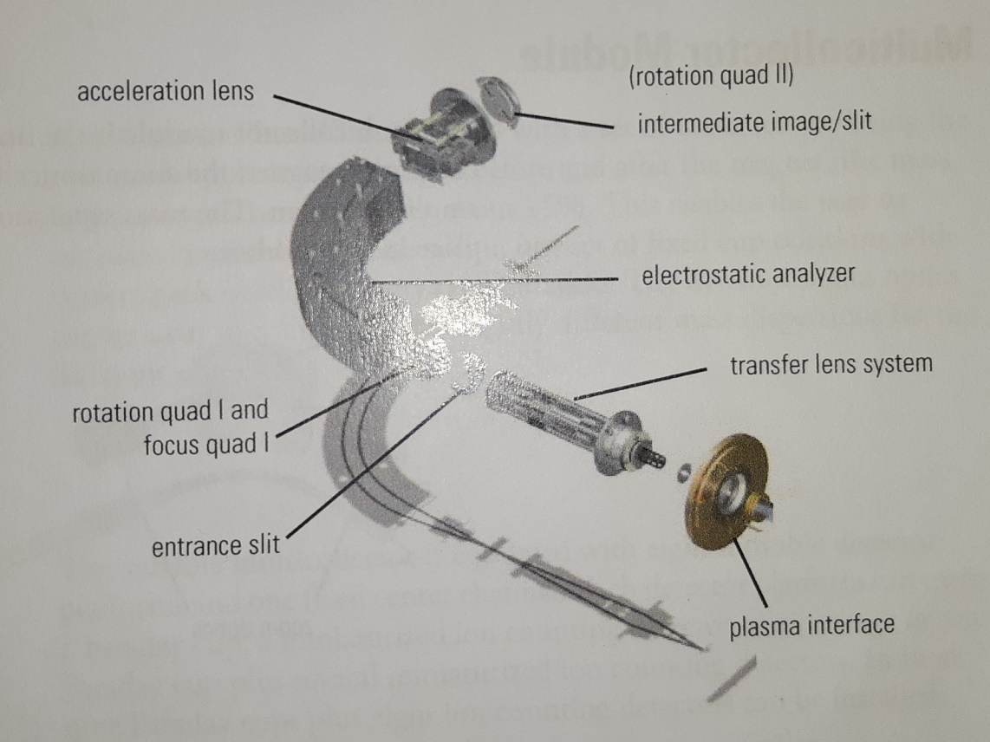

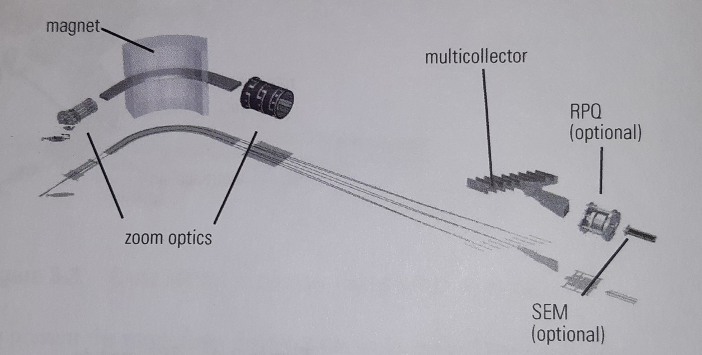
A.2 Multicollector Module

Appendix B

B.1 List of Chemicals

Chemical | Cas number | Purity | Supplier
Nitric Acid | 7697-37-2 | 68% | VWR
Foram Faker (FF) | - | - | Self-made
Ca, (CaCO₃) | 7440-70-2 | 10,000 µg/ml (5% HNO₃) | Alpha Aesar
Na | 7440-23-5 | 1000 µg/ml (5% HNO₃) | Alpha Aesar
Mg | 7439-95-4 | 1000 µg/ml (5% HNO₃) | Alpha Aesar
NIST® SRM® 980, isotopic standard (Mg) |  | 100% | Sigma Aldrich
Methanol | 67-56-1 | 99% | VWR
Hydrochloric acid (was used for pre- cleaning of bottles) | 7647-01-0 | 37% | VWR
Column chemistry resin:  AG50W-X12 |  | analytical grade cation exchange resin, hydrogen form, 12% crosslink-age, 100–200 dry mesh size, 106–250 µm wet bead size, ~400 MW limit | Bio-Rad

Appendix C: The example calculations

C.1 The calculation of the Delta

This calculation is from one of the columns. For the Isotopic ratio of the standard an average is taken from the two surrounding standards.
$$Delta \left(δ^{25}\right)=\left( \frac{\left(\frac{25Mg}{24Mg}\right)sample}{\left(\frac{25Mg}{24Mg}\right)standard}-1\right)*1000=… ‰$$
$$Delta \left(δ^{25}\right)=\left( \frac{1.3469Ε-01}{Average(1.3468Ε-01,1.3470Ε-01)}-1\right)*1000=-0.04 ‰$$

C.2 Calculations for the t-test between NFHS-1_E2 and NFHS-1_E3
To confirm that NFHS_2 and NFHS_3 are not the same an unpaired-samples t-test had been performed. For the calculation of this, the t value has to be compared to the critical value (k). In this calculation X stands for average. Sp is the combined standard deviation. In the calculation for de Sp, v is the number of measurements minus one and s is the standard deviation. The calculations were performed for the delta 26. The critical value is calculated by an excel function; F.INV.RECHTS (0.05;2;5) = 5.79. The NFHS_2 and NFHS_3 are not the same, the T value is higher than the critical value.

$$t=\frac{X_{NFHS_{3}}-X_{NFHS_{2}}}{Sp* \sqrt{\frac{1}{N_{NFHS_2}}+\frac{1}{N_{NFHS_3}}}}=\frac{(-2.25)-(-2.39)}{0.0021* \sqrt{\frac{1}{6}+\frac{1}{6}}}=19.67$$
$Sp=\frac{∑(v*s^{2})}{v_{NFHS_{2} }+ v_{NFHS_{3}}}= \frac{5*{0.019}^{2}+ 5*{0.020}^{2}}{5+ 5}=0.0021$

