HBO Analytical Chemistry Graduation Thesis 2018
Development and validation of a quantitative method for the analysis of Dimethicone and Dimethiconol deposited on the hair surface by ATR-FTIR

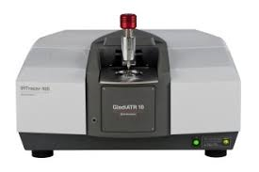

Student: Yves Murenzi
Student ID number: 1088503
Internship period: 18-03-2018 – 14-09-2018
Specialization: Analytical Chemistry
Date: 03-09-2018

Personalia
Student: Yves Murenzi
Student ID number: s1088503
E-mail: yvesmurenzi@yahoo.com
Module: Graduation project Analytical Chemistry
Study points: 42
Internship period: 18 March 2017 until 14 September 2018

College details

College of education: Hogeschool Leiden
Department: Applied Science
Specialization: Analytical Chemistry
Education: Chemistry
Address: Zernikedreef 11
2333 CK Leiden, The Netherlands
Graduation supervisor: Dr. André van Roon
Phone: +31648134071
E-mail: roon.van.a@hsleiden.nl

Company details
Company: Ashland Inc
Business Unit: Ashland Specialty Ingredients
Department: Application and Development Laboratory
Address: Noordweg 9
3336LH Zwijndrecht, The Netherlands
Graduation Tutor: Mr. Marco Broekhuizen
Phone: +31 (0) 786251259
E-mail: mbroekhuizen@ashland.com

Acknowledgment
This graduation report is the result of my graduation project at the Hair Care department of the Ashland’s A&D laboratory in Zwijndrecht.
After an internship of nine months, I have gained a lot of new experiences. I’m very grateful to have been allowed to do the last internship of my education period at this laboratory. It is a resourceful place where different and interesting types of researches are carried out.
The research that I worked on consisted of developing and validating an ATR-FTIR method to quantify the amount of dimethicone and dimethiconol deposited on human hair surface after a shampoo treatment. I’m happy that I have successfully completed my research.
I would like therefore to thank Mr. Marco Broekhuizen for offering me the opportunity to do my internship and graduation project at this laboratory. I also want to thank him for the guidance during my research, his willingness to think along and his valuable ideas and tips that have kept me going on during the research period.
I would like also to thank everyone from the A&D laboratory for their help, cooperation and all the pleasant time.
Moreover, I want to thank Dr. André van Roon for the good support from Hogeschool Leiden. Above all, I bless God for all the grace bestowed upon me throughout the whole period of my graduation year.
Yves Murenzi
Zwijndrecht, 23 august 2018

Samevatting
Siliconen, meestal dimethicone en dimethiconol, worden vaak gebruikt als conditioneringsmiddelen in shampooformuleringen. Ze zijn al effectief op zeer lage niveaus.
Siliconen bezitten een reeks unieke eigenschappen zoals smerend vermogen, lage intermoleculaire krachten, onoplosbaarheid in het water en een zeer lage oppervlaktespanning, zodat ze zich gemakkelijk over de meeste oppervlakken verspreiden om een uniforme, gladde hydrofobe laagje te geven. Om deze reden worden siliconen al jaren als superieure conditionerende middelen in haarverzorgingsproducten gebruikt. Het is van groot belang voor cosmetisch chemici om de hoeveelheid siliconen die op het haar worden afgezet na de behandeling met shampoo te weten. Hiermee kunnen ze de correlatie tussen productsamenstelling en sensorische evaluatieresultaten bestestuderen en de onderbouwing van claims aanzienlijk vergemakkelijken.
De hoeveelheid siliconen in de shampooformulering is erg laag. Het is dan noodzakelijk om te weten hoeveel van deze worden afgezet op het haar nadat het haar gewassen is met shampoo. In deze studie werd een ATR-FTIR methode onwikkeld en gevalideerd om de hoeveelheid dimethicone en dimethiconol die na een shampoobehandeling op het haar wordt afgezet te kwantificeren. De methodeontwikkeling werd op Natural Virgin brown hair gedaan.
De bereiding van de kalibratiestandaarden werd uitgevoerd door twee verschillende methoden voor het aanbrengen van kalibratieoplossingen op het haar. De eerste methode werd uitgevoerd door de standardoplossingen zorgvuldig op de lengte van het haar dat in een aluminiumschaal gelegd is aan te brengen en vervolgens de standardoplossing op het haar homogeen te verspreiden. Voor de tweede methode, werd er dezelfde procedure uitgevoerd, bovendien werden de kalibratieoplossingen in het haar gemasseerd om ervoor te zorgen dat alle siliconen homogeen over het haar verspreid worden. Beide methoden bleken significant niet verschillend te zijn. Elk van beide methode kan worden gebruikt om de kalibratiestandaarden voor te bereiden. De homogeniteit van de aangebrachte siliconen op het haar bleek echter redelijk goed te zijn. Om die reden moeten er meerdere metingen op het hele haaroppervlak uitgevoerd worden.
De voorbereiding van de monsters werd uitgevoerd met behulp van twee shampoo monsters namelijk een positieve en een negatieve controle shampoo. Om de afgezette hoeveelheid silicone op het haar uit een shampoo te quantificeren, werden haarlokken gewassen met 0.3 gram shampoo. De haarlok weegt 3 gram. De uiteindelijk hoeveelheid shampoo dat aangebracht is op één gram haar was gelijk aan 0.1 gram. De gedetailleerde procedure van monstervoorbereiding is verder duidelijk beschreven in dit rapport.
De ontwikkelde methode bleek lineair, herhaalbaar, reproduceerbaar en nauwkeurig te zijn. De lineariteit leverde een correlatiecoefficent op van 0.9961, wat goed overeenkomt met de verwachte correlatiecoefficent van > 0.9945. De herhaalbaarheid en reproduceerbaarheid leverden een bevredigende gemiddelde relatieve standaarddeviatie (% RSD) op van 8.06 en 8.68 % respectievelijk. De detectielimit bleek 116,6 ppm te zijn. De nauwkeurigheid van de methode werd bepaald door de resultaten van de ontwikkelde ATR-FTIR methode en een externe XRF methode te vergelijken. De resultaten bleken redelijk acceptabel te zijn. Er is bovendien waargenomen dat er meer siliconen worden afgezet op de haarwortel, gevolgd door het midden va het haar. Op het uiteinden (tip) van het haar werd een lagere afzetting waargenomen.
Uit de resultaten kan worden geconcludeerd dat de ontwikkelde ATR-FTIR methode met success is gevalideerd en daarmee geschikt is om de hoeveelheid dimethicone en dimethiconol die na behandeling met shampoo op het menselijke haar wordt afgezet.

Summary
Silicones, mostly dimethicone and dimethiconol are commonly used as conditioning agents in shampoo formulations. They are effective at very low levels.
Silicones possess a range of unique properties like lubricity, low intermolecular forces, water insolubility and a very low surface tension, such that they spread easily on most surfaces to give a uniform, smooth hydrophobic film. For this reason, silicones have been used for years as superior conditioning agents in hair care products. Knowing the amount of silicone deposited on hair surface after shampoo treatment is vitally important for cosmetic chemists. It allows them to study the correlation between product composition and sensory evaluation results, and to greatly facilitate claim substantiation.
However, as the levels of conditioning silicones in the formulation are very low, it is necessary to know how much of these are deposited on the hair surface after the hair is washed with shampoo. In this study an ATR-FTIR method was developed and validated to quantify the amount of dimethicone and dimethiconol deposited on human hair after a shampoo treatment. The method development was conducted on natural virgin brown hair.
The preparation of calibration standards, was conducted by examining two different methods of applying dimethicone and dimethiconol calibration solutions on the hair tresses. The first method, was conducted by carefully applying the standard solutions on the length of the hair tress placed in an aluminum bowl and then evenly spread the standard solution along the hair tress. For the second method, the same procedure was conducted, in addition to this, the calibration solutions were then massaged through the hair tress to make sure that all dimethicone and dimethiconol are evenly spread on the hair. Both methods were found to be not significantly different. Therefore, either method can be used to prepare the calibration standards. However, the homogeneity of the applied silicones along the hair tress was found to be reasonably good. For this reason, multiple measurements must be done along the entire hair tress.
The preparation of the samples was conducted using two shampoo samples namely, positive and negative control shampoos. To evaluate the deposited amount of silicone on hair from a shampoo, hair tresses were washed with 0.3 gram of shampoo. The hair tress weights three grams. The amount of shampoo applied on one-gram hair was therefore equal to 0.1 gram. The detailed procedure of the sample preparation is clearly outlined in this report.
The developed method was found to be Linear, repeatable, reproducible and accurate. The linearity had a correlation coefficient of 0.9961, which agrees well with the expected correlation coefficient of > 0.9945. The repeatability and reproducibility presented a satisfactory average relative standard deviation of 8.06 % and 8.68 % respectively.
The limit of detection was found to be 116.6 ppm. The accuracy of the method was determined by comparing the results obtained from the developed ATR-FTIR method and an external XRF method. The results were found to be reasonably acceptable. Furthermore, it was observed that more silicone is deposited on the root of the hair, followed by the middle of the hair. On the ending (tip) of the hair lower deposition were observed.
From the results, it can be concluded that the developed ATR-FTIR method is successfully validated and is fit to quantify the amount of dimethicone and dimethiconol deposited on human hair after shampoo treatment.

Contents
Acknowledgment 3
Samevatting 4
Summary 5
List of abbreviations 9
1.Introduction 10
1.1 Research topic background 10
1.2 The purpose of research 10
2. Theoretical background 12
2.1 Silicones 12
2.2 Preeminence of Silicones in personal care applications 13
2.3 Silicones in hair care applications 14
2.3.1 Dimethicone and Dimethiconol 14
2.4 The structure of human hair 15
3.4.1 The chemical composition of human hair 16
2.5 Shampoo ingredients and how they work 17
2.6 Silicone deposition on hair 18
2.7 Fourier Transform Infrared Spectroscopy (FTIR) 19
2.7.1 Theory of Infrared Absorption 19
2.7.2 Development of FTIR spectroscopy 20
2.7.3 The principle of FTIR spectroscopy 20
2.7.4 Issues surrounding traditional transmission sample preparation 21
2.7.5 Attenuated Total Reflectance (ATR) 22
2.7.6 ATR crystal materials 23
2.8 Quantitation 23
3. Validation ⁽²⁹⁾ 25
3.1 Specificity/selectivity 25
3.2 Linearity 25
3.3 Precision 25
3.3.1 Repeatability 25
3.3.1 Reproducibility 25
3.4 Accuracy 26
3.5 Limit of Detection (LOD) 26
4. Method Procedures 27
4.1 Materials 27
4.2 Instrumentation and Instrument Settings 27
4.3 Determination of solvent 27
4.4 Standards and control-samples 27
4.5 Hair tress samples preparation 28
4.6 Method for preparing calibration standards 28
4.7 Pick baseline correction method 28
4.8 Validation procedure 28
4.8.1 Specificity/selectivity 28
4.8.2 Linearity 29
4.8.3 Repeatability 29
4.8.4 Reproducibility 29
4.8.5 Accuracy 29
4.8.6 Limit of Detection (LOD) 30
5 Results and discussion 31
5.1 Method for preparing calibration standards 31
5.2 Pick baseline correction method 33
5.3. Specificity 33
5.3.1 Linearity 33
5.3.2 Linearity 34
5.4 Repeatability 35
5.5 Reproducibility 36
5.5 Accuracy 37
5.5 Limit of detection 38
6 Conclusion 39
7 Recommendations 39
Bibliography 40
Appendices 42

List of abbreviations

A&D- laboratory Application and Development Laboratory
ASI Ashland Specialty Ingredients
XRF X-ray fluorescence
ATR Attenuated Total Reflectance
FTIR Fourier Transform Infrared
AAS Atomic absorption spectrophotometer
ICP-OES Induced coupled plasma optical emission spectroscopy
DRIFTS Diffuse reflectance infrared Fourier transform spectroscopy
ESCA Electron spectroscopy for chemical analysis
PDMS Polydimethylsiloxane

1.Introduction

1.1 Research topic background
Ashland¹ is a multinational chemical company operating worldwide in more than 100 countries. The company provides the specialty chemicals, technologies and insights to help customers create new and improved products for today and sustainable solutions for tomorrow. The chemistry of Ashland is at work in a wide variety of markets and applications, including architectural coatings, automotive, construction, energy, food and beverage, pharmaceutical and personal care. One of the business units of Ashland, namely Ashland Specialty Ingredients (ASI), produces polymers which provides a wide range of functional properties such as water retention, adhesion, film-formation, stabilization of colloidal systems, rheology modification, conditioning and deposition of water-insoluble materials. Among others, Ashland produces deposition polymers like Guar hydroxypropyl trimonium chloride and others. These polymers are cationic and are mainly used in shampoo formulation to enhance the deposition of insoluble conditioning oils like silicones on human hair.
Silicone² oils like Polydimethylsiloxane and Dimethylsilanediol, better known as dimethicone and dimethiconol respectively in the world of cosmetics ⁽³⁾⁽⁴⁾, have represented solutions in haircare products for years. They are mostly used in shampoo formulation to improve the manageability and combability of hair by smoothening the surface of the hair. Despite the broad use of silicones, maximizing their deposition on hair and performance benefits continues to be an area of investigation. Exact knowledge of the amount of silicone deposited on hair after treatment with a shampoo, is an important tool for formulators, allowing practical correlation between product composition and sensory evaluation results. This information is also helpful for Ashland, as one of the leading producers of cationic polymers to get more insight on the silicone deposition properties of these polymers. To achieve this, a method must be developed to quantify the amount of silicon oils which are being deposited on the hair surface after the hair has been washed using a shampoo.

1.2 The purpose of research
The aim of this study is to develop and validate a method to quantify the amount of dimethicone and dimethiconol deposited on human hair after shampoo treatment. One of Ashland’s laboratory in china is currently using an indirect method with Infrared spectroscopy to quantify dimethicone. In this method, an extraction is first conducted using methylene chloride and deuterated chloroform to remove the deposited silicone from the hair. However, this method is time consuming and the chemicals used are not that healthy for both the people using the method and the environment to which these chemicals are discharged. A proposal was therefore made in the context of responsible care by Ashland center of excellence in Zwijndrecht, to develop an alternative method which is fast, easy and less chemically unfriendly, to quantify dimethicone and dimethiconol deposited on human hair after a treatment with shampoo. In the literature study it was found that a couple of analytical methods ⁽⁵⁾ have already been used to quantitatively assess silicone deposition. Both direct and indirect methods have been used. The indirect methods are methods in which steps of extractions are first conducted prior to the analysis of the analyte. The most commonly applied methods are X-ray fluorescence (XRF) and atomic absorption spectrophotometer (AAS). Also Induced coupled plasma optical emission spectroscopy (ICP-OES), Diffuse reflectance infrared Fourier transform spectroscopy (DRIFTS), Electron spectroscopy for chemical analysis (ESCA) and ATR-FTIR spectroscopy. However, there are some limitations associated with some of these methods. For instance, the accuracy of AAS measurements is strongly influenced by the efficacy of the extraction step and the FTIR detection limit is quite high. For this study, ATR-FTIR spectrophotometer ⁽⁶⁾⁽⁷⁾ was selected to be used since the Technique is available at the laboratory. Moreover, this Technique provides some special properties which results in better sample measurements. The Attenuated total reflectance (ATR), enables faster sampling, gives excellent sample to sample reproducibility and minimizes operator induced variations. Therefore, this study aims to develop and validate an ATR-FTIR method to quantify dimethicone and dimethiconol deposited on human hair surface. Furthermore, the method performance will be evaluated through a comparison study with a current method used by an external laboratory which uses X-ray fluorescence spectrophotometer.
In this graduation report, the theory behind the research is first explained in chapter two. Then in chapter three the validation of the method is described. The materials and method used are briefly described in chapter four. Chapter five contains the results and discussion of the research conducted. Subsequently, the conclusion and recommendations are mentioned in chapters six and seven respectively. Finally, the bibliography and the appendices are shown.

2. Theoretical background

2.1 Silicones
Silicones are general category of synthetic polymers whose backbone is made of repeating silicone to oxygen bonds (siloxane bonds) with organic side groups such as methyl, phenyl or vinyl (figure1).
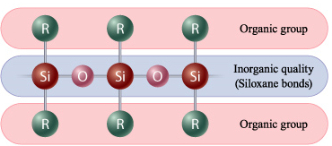
Figure 1: siloxane bond ⁽⁸⁾
The number of repeating units can range from one to several thousands. The word siloxane is derived from the words silicone, oxygen and alkane. This is the basis for the name silicones, which was assigned by Kipping based on their similarity with ketones, because in most cases there is on average one silicone atom for one oxygen and two methyl groups ⁽⁹⁾. However, Kipping was incorrect, silicone does not form double bonds with oxygen, and the silicones did not have properties analogous to ketones. This was suggested by Alfred Stock, a Germany inorganic chemist. During his investigations, he prepared numerous siloxanes and identified them for what they truly were, namely Si - O bonds and not Si = O bonds as Kipping had proposed. His nomenclature for silicone and siloxanes was part of his universal systematic nomenclature that was later adopted by the International Union of Pure and Applied Chemistry. One of Stock’s work which would be of a great value and importance to the future of siloxane polymers, was Stocks preparation and observation of polydimethylsiloxane in 1919⁽¹⁰⁾. Although few milligrams of the product were synthesized, it was enough to observe that the new material was a colorless, hydrophobic oil. Normally silicones are not compatible with organic polymers, but if a lager organic group is attached to a silicone, its properties are altered, and it can be blended with organic polymers. This approach offers a unique method to combine unique properties of silicones with traditional organic molecules.
Incorporation of organic groups on the silicone backbone is accomplished through a reaction step known as hydrosilylation ⁽¹¹⁾ ⁽¹²⁾. This is a chemical step where an allyl group is attached, through an addition reaction to SiH group on the siloxane backbone. In this process, platinum complex, Pt (0), such as karstedt’s is used as a catalyst ⁽¹²⁾. The reaction requires only parts-per-million catalyst and is selective. This limits the presence of catalyst residues and unwanted byproducts from side reactions which can be problematic in radical hydrosilylation. Hydrosilylation is the most fundamental reaction that has expanded application of silicones to wider field of applications. By blending the chemistry of silicone with that of carbon, it is possible to create polymers with unique properties and superior performance characteristics. Silicone polymers are widely used in water-based processes and applications. Most silicone polymers are not water soluble. For aqueous delivery they are usually formulated as an emulsion- a dispersion of small droplets of silicone oil within an aqueous surfactant solution. Silicone polymers formulated in this way are often used in cosmetics applications. The silicones usually bring functionality such as hair conditioning.

2.2 Preeminence of Silicones in personal care applications
There are various important reasons which makes silicones the right choice to be incorporated in personal care formulations. The organic portion in polydimethylsiloxane is the methyl group. The surface energy of any substance is a direct manifestation of the intermolecular forces between molecules. In the case of methyl group, these forces are almost the weakest possible among hydrocarbon molecules. The inorganic siloxane backbone (-Si-O-Si-) is the most flexible polymer backbone, due to high degree of electrovalent bonding character of -Si-O- bond available and this allows the methyl groups to be arranged and presented to their best effect. These effects are further enhanced by creation of helix structure of polydimethylsiloxane molecule with methyl groups facing outwards and oxygen facing inwards. Hence polydimethylsiloxane provides one of the lowest surface energies known. It is this unique surface behavior, coupled with molecular flexibility, imparted by Si-O- bond that makes silicones an ideal choice for a multiple of personal care applications ⁽²⁾. The figure below exhibits the history of silicones in personal care applications.
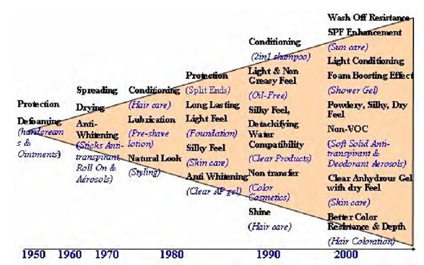
Figure 2. History of silicone uses in personal care ⁽¹³⁾

2.3 Silicones in hair care applications
Hair is known to be easily damaged by a variety of mechanisms including environmental exposure, mechanical abrasion and chemical processing. Hence hair damage is an inevitable fact of life. Damage is manifested by both degradation of the intrinsic keratin proteins, as well as by changes along the fiber surface. On a microscopic level, damage is known to involve mechanical degradation of the cuticle structure during grooming and both oxidative and UV-induced damage to the proteins and amino acids within the hair. In the early stages, these changes may be observed microscopically or spectroscopically ⁽¹⁴⁾ ⁽¹⁵⁾ ⁽¹⁶⁾. Continued degradation of the keratin structure leads to damage on a macroscopic level detectable by human eye. This damage includes split ends, a dull appearance, a rough feel, and hard-to-comb, flyaway hair. To overcome the symptoms of damaged hair, many people use conditioners and conditioning shampoos. Among the materials effective in conditioning hair are silicone oils. Specialty silicones can offer supreme conditioning and moisturization that repairs and restores smoothness, shine, combability and manageability. Silicones are well documented as great conditioning agents for hair. There are many types of silicone polymers commonly used in hair care applications. Among others, dimethicone and dimethiconol, as often called in cosmetic world, are widely used in shampoo formulations.

2.3.1 Dimethicone and Dimethiconol
Dimethicone, which is Polydimethylsiloxane (PDMS), is the most widely used silicon-based organic polymer and is particularly known for its unusual rheological properties. It is optically clear, and is generally considered to be inert, non-toxic and non-flammable.
It is available in a wide variety of viscosities and molecular weights. The most commonly used forms for personal care applications range from 350 mPas to 12500 mPas. High- viscosity dimethicones (60000 mPas to 100000 mPas) are commonly used in hair care products. It is generally true that conditioning effects improve with increasing viscosity, but higher viscosities may be more difficult to formulate. Dimethicone’s low surface tension enables it to spread thinly and evenly along the hair shaft producing an even-looking conditioning effect. When deposited on hair they quickly form protective films, locking in water, to optimize strength and prevent premature wash-out of hair dyes and tints ⁽³⁾. The chemical structure of dimethicone is shown in Figure 3.
Dimethiconol, also referred to as silicone gum, is a polymer like dimethicone where two chain-end methyl groups have been replaced by hydroxyl (-OH) groups. Dimethiconol’s unique properties are widely used in hair cuticle coats offering notable improvement from problems such as split-ends. Dimethiconol improves wet and dry combing and provides silkiness feel on hair after application ⁽¹⁸⁾. The chemical structure of dimethiconol is shown in Figure 4.
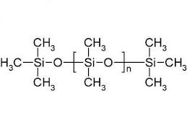
Figure 3. Chemical structure of Dimethicone¹⁷
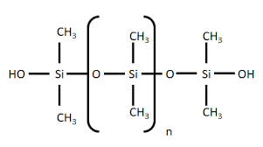
Figure 4. Chemical structure of Dimethiconol¹⁸

2.4 The structure of human hair
Human hair ⁽¹⁹⁾ ⁽²⁰⁾ is consisted of two distinct structures: follicle- the living part located under the skin and hair shaft- fully keratinized nonliving part above the skin surface. Hair shaft is consisted of three layers: cuticle, cortex and medulla (figure 5).
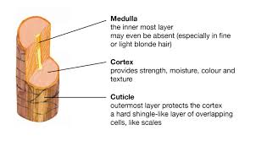
Figure 5: human hair structure
Cortex: Cortical cells are the major component of the mature human hair shaft. It contains spindle shaped cells that lie parallel along the fiber axis. These cortical cells were found to be approximately 1- 6 µm in diameter and 50-100 µm in length. In human hair, the cortical cells were observed to be divided into different regions namely, orthocortex, paracortex and mesocortex. The difference in distribution of these cells types is an important factor for determining the curvature of the hair fiber. Most of the cortical cells are composed of a protein known as keratin. There are two types of keratin that exist in hair namely, type I with acid amino residues and type II with basic amino residues.
Medulla: The center of the hair fiber is known as medulla. Studies of the medulla in human hair are complicated because it has poor solubility and is difficult to isolate. The medulla contains structural proteins that are markedly different from other keratins. However, in some hair types, the medulla may even be absent.
Cuticle: The cuticle is the outermost layer formed by flat overlapping cells. These cells are approximately 0,5 µm thick, 45 - 60 µm long and are found at 6 - 7 µm intervals. The outermost layer of the cuticle, the epicuticle, is a lipo-protein membrane that is estimated to be 10 – 14 nm thick. Beneath that is the A layer with high cysteine (proteinogenic amino acid) content and with a thickness of approximately 50 – 100 nm, the exocuticle with again high cysteine content and a highly variable thickness ranging from 50 to 300 nm and finally the endocuticle with a low cysteine content and a thickness also ranging from 50 to 300 nm.
In the context of hair care treatments, the cuticle is the most important of the hair fiber. This is the component on which materials such as hair sprays and conditioning materials are deposited. In undamaged hair, the cuticle provides a significant barrier to the penetration of cosmetic agents such as colorants into the cortex. Furthermore, the cuticle helps to protect the hair fiber from degradation. Figure 6 shows the healthy and damaged hair fiber.
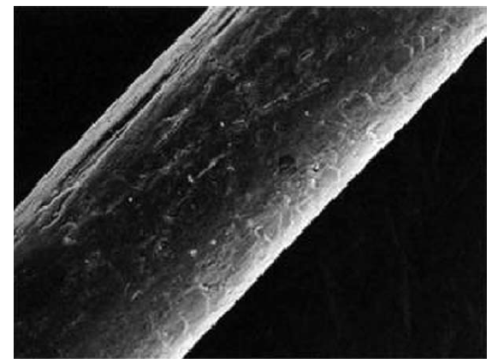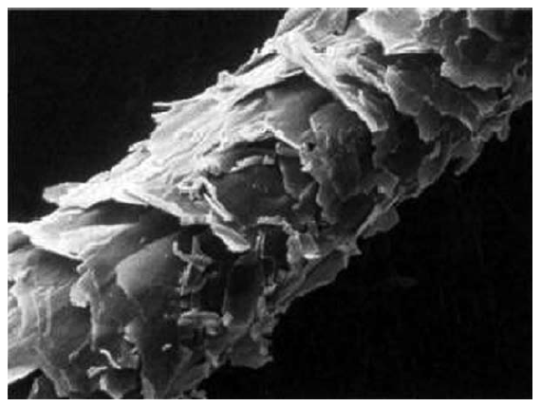
Figure 6. Healthy(left) and Damaged(right) hair fiber ⁽¹⁹⁾

3.4.1 The chemical composition of human hair
Table 1 shows that natural hair is composed mainly of protein and that significant amounts of protein -bound Sulphur are present. Lipids are associated mainly with the cell membrane complexes that separate the hair’s constituent hardened cells from each other. Zinc is present at a relatively high level and is a leftover from the enzymatic processes in the follicle responsible for the hardening of the fiber. Black hair contains as much as 4 % by weight of the pigment, melanin.
Component | Approx. content in weight % dry hair
Protein | 91
Lipid | 4
Sugars | 1.0
Protein-bound Sulphur | 4.7
Ash | 0.5
Zinc | 200 ppm
Table 1. Overall composition of human head hair ⁽¹⁹⁾.

2.5 Shampoo ingredients and how they work
Water: The largest portion of a shampoo is made up of water. It acts as a solvent for all other ingredients.
Surfactants: The next main ingredients of a shampoo, are a blend of surfactants. It is unusual for a shampoo to contain just one surfactant. Some are designed to improve cleaning whilst others improve lather and rinsing performance. All are chosen to be mild and not irritating to the eyes. Surfactants work by reducing the surface tension between water and the dirty (dust) so that it can be wrapped up and lifted from the hair. Surfactant molecules contain two distinct parts. First a polar head group that is attracted to water (hydrophilic) and second a fatty chain (lipophilic) that is attracted to the dirty. The fatty chains line up around the dirty particles with the polar head groups attracted to the water. As the surfactant molecules surround the dirty particle they eventually lift it away from the hair and disperse it in the water ⁽²¹⁾.
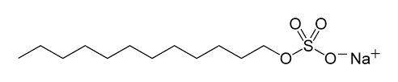
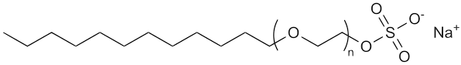
Figure 7. Sodium Lauryl Sulfate ⁽³²⁾ and Sodium Laureth Sulfate ⁽²²⁾
Conditioning ingredients: These normally include silicones and fatty alcohols. Silicones are well known for their lubricious properties and make the hair easier to detangle. They come in a wide range of viscosities as described in section 3.3.1. Fatty alcohols give condition and help to control static charge or fly-away. Guar Hydroxypropyl trimonium Chloride for instance, a product of Ashland is used in both shampoo and conditioners as a Conditioning and deposition ingredient.
Functional ingredients: All products, including shampoos, require ingredients to control their viscosity or thickness. Certain polymers are incorporated in a shampoo formulation to boost the viscosity of shampoo. Carbomer is an example of a rheology modifier used in shampoo. It improves the viscosity of a shampoo and helps to suspend other ingredients in the formulation. Sodium Chloride is also used to improve or rather modify the viscosity of shampoo. Preservatives are also added to the shampoo formulation to prevent microbial growth. Germal Plus TM a product of Ashland is used in shampoos as an anti-microbial ingredient. The shampoo may also contain additional ingredients for hair protection and strength. When exposed to the sun the hair, which has no natural means of repair, is partly protected by the addition of sunscreens to the shampoo.
Aesthetic ingredients: Besides color and pearlising agents to improve the appearance of the product, perfumes are also added. Although perfume has no influence on the performance of shampoos, it has a crucial influence on the customer perception and use of shampoo.

2.6 Silicone deposition on hair
The deposition ⁽¹⁶⁾ of some silicones on hair from shampoo can be significantly increased using specific cationic polymers that forms complexes with the anionic surfactant of the shampoo. In the shampoo, micelles are formed due to the higher concentration level of the surfactant. When the shampoo is diluted by the wet hair and rinse water, the micelle structure disintegrates as the surfactant concentration becomes lower than the critical micelle concentration. As a result, a complex of the cationic polymer, the insoluble material and the anionic surfactant is formed. Both the surfactant and the hair surface have an anionic charge and are attracted to the cationic polymer. The hydrophobic part of the insoluble materials (like silicone oils) interacts with the hydrophobic part of the surfactant, in the process the insoluble materials (silicone oils) are attracted to and deposited on the hair. However, the particle size of the insoluble materials plays a significant role during the deposition process. For fine particle size silicone fluids and emulsions, this mechanism ensures the most efficient deposition on the hair from a shampoo. Figure 8 shows a deposition mechanism of insoluble oils (like silicone oils) on human hair.
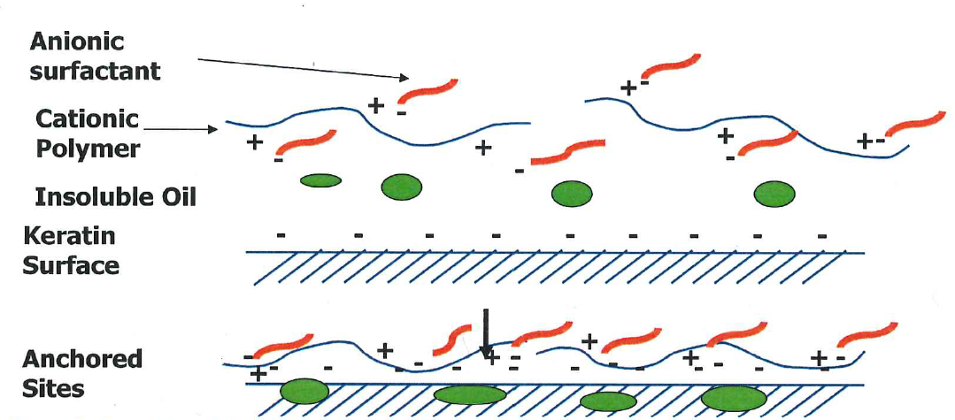
Figure 8. deposition mechanism of insoluble material (oils) on human hair (Source: Ashland Specialty Ingredient)

2.7 Fourier Transform Infrared Spectroscopy (FTIR)

2.7.1 Theory of Infrared Absorption
Infrared spectroscopy ⁽⁶⁾ uses the fact that molecules have specific frequencies at which they rotate or vibrate corresponding to distinct energy levels (vibrational modes). The far-infrared, approximately 400-10 cm⁻¹ , has low energy and may be used for rotational spectroscopy. The mid-infrared, approximately 4000-400 cm⁻¹ , the region of most interest for chemical analysis, which corresponds to changes in vibrational energies within molecules may be used to study the fundamental vibrations and associated rotational- vibrational structure. The higher energy near-IR, approximately 13300-4000 cm⁻¹ , can excite overtone or harmonic vibrations. Figure 9 shows an energy level diagram of transitions that are responsible for Infrared absorption.
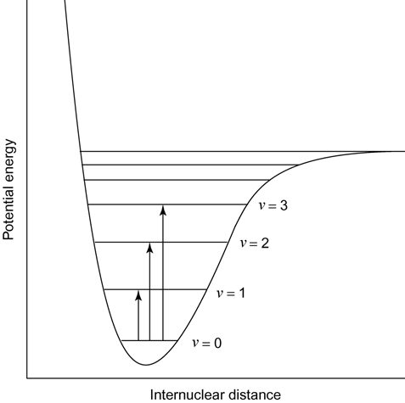
Figure 9. Vibrational energy diagram
These specific resonant frequencies are determined by the shape of the molecular potential energy surface, the masses of the bonded atoms and, eventually by the associated vibration coupling. For a vibrational mode in a molecule to be Infrared active, it must be associated with changes in the permanent dipole moment. Only those bonds that have a dipole moment that changes as a function of time are capable of absorbing infrared radiation. Symmetric bonds, such as those in H₂ or Cl_{2,} do not absorb infrared radiation. The simplest types or modes, of vibrational motion in a molecule that are Infrared active, are the stretching and bending modes. Stretching mode may appear in symmetrical (symmetric stretching) or asymmetrical (asymmetric stretching) form. In general, asymmetric stretching vibrations occur at higher frequencies than symmetric stretching vibrations; also stretching vibrations occurs at higher frequencies than bending vibrations. Figure 10 shows some of the vibrations in molecules.
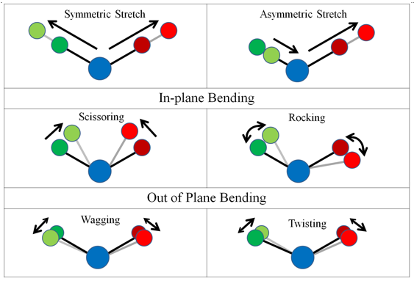
Figure 10. Stretching and bending vibrations in molecules (Source: http://nptel.ac.in/courses/102103044/module2/lec10/3.html)

2.7.2 Development of FTIR spectroscopy
The development of FTIR would have been impossible without the use of the Michelson interferometer (The instrument used to interfere the waves together) which was invented by Albert Abraham Michelson in 1880 ⁽²³⁾. Unfortunately, the time-consuming calculation needed to convert an interferogram into a spectrum made the usage of an interferometer to obtain spectra impractical. The invention of computers and advances in how computers perform mathematical operations made Fourier Transform Infrared a reality. The major advance in this area was made by J.W. Cooley and J.W. Tukey ⁽²⁴⁾ ⁽²⁵⁾, who invented Fast Fourier Transform (FFT, Cooley-Tukey Algorithm). This algorithm quickly performs Fourier Transforms on computer and the combination of FFT algorithm and minicomputers was the breakthrough that made FTIR possible. The first commercially available FTIRs were manufactured by Digilab, a company of Block Engineering in Cambridge, Massachusetts in 1960. Since the 1960s, many other companies have begun manufacturing and selling FTIRs.

2.7.3 The principle of FTIR spectroscopy
In Fourier Transform Infrared Spectroscopy ⁽⁶⁾ ⁽²⁶⁾ ⁽²⁷⁾ , infrared light from the light source passes through a Michelson interferometer along the optical path. This interferometer is used to process the energy sent to the sample. The Michelson interferometer consists of a beam splitter, a moving mirror and a fixed mirror. In the interferometer, the source energy passes through a beam splitter, this is a mirror placed at a 45˚ angle to the incoming source energy. The beam splitter allows the incoming radiation to pass through but separates it into two perpendicular beams. One beam, which is oriented at 90˚ goes to the fixed mirror and is returned to the beam splitter. The other beam which is not deflected goes to a moving mirror and is also returned to the beam splitter. The motion of the mirror causes the pathlength that the second beam traverses to vary. When the two beams meet at the beam splitter, they recombine, but the pathlength differences of the two beams cause both constructive and destructive interferences. The combined beam containing these interference patterns is called the interferogram and contains all the radiative energy coming from the source and has a wide range of wavelengths. The interferogram generated by combining the two beams is oriented toward the sample by the beam splitter. As it passes through the sample, the sample absorbs all the frequencies that are normally found in its infrared spectrum. The modified interferogram signal that reaches the detector contains information about the amount of energy that was absorbed at every wavelength (frequency). The measured signal is digitalized and processed using a computer by performing a mathematical Fourier Transform on this signal, which results in a spectrum. The final spectrum can be presented as transmittance (% T) or absorbance (Abs). The computer easily performs this. Figure 11 shows a typical FTIR instrumentation.
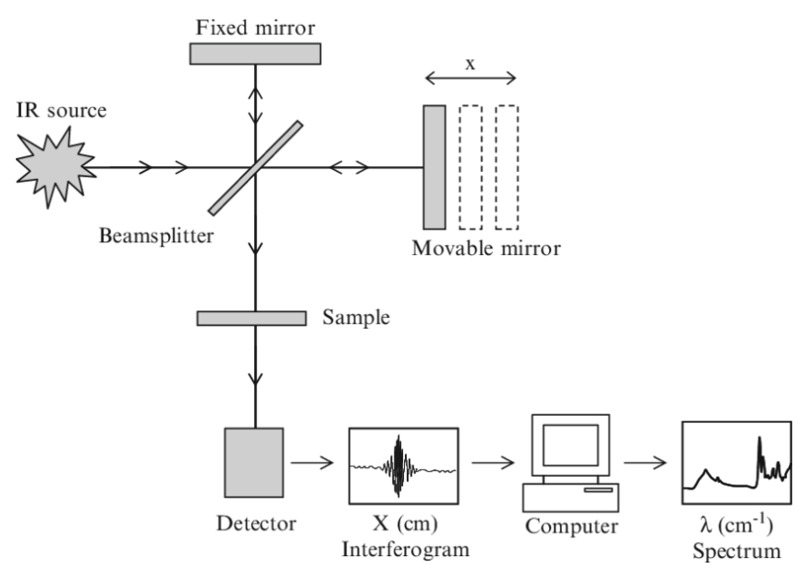
Figure 11. A typical FTIR instrumentation (source: https://www.researchgate.net/figure/Schematic-sketch-of-the-essential-features-of-a-Fourier-transform-infrared-FTIR_fig1_225065938)

2.7.4 Issues surrounding traditional transmission sample preparation
Traditionally IR spectrometers have been used to analyze solids, liquids and gases by means of transmitting the infrared radiation directly through the sample as described in section 3.7.3. However, this form of infrared analyses faces some challenges namely sample preparation and spectral reproducibility. The sample preparation for solids involves grinding the material to a powder and dispersing it in a matrix. Mineral oil like nujol is commonly used to create a paste which is then spread between two Mid-Infrared matrix materials. The matrices can be sodium chloride, potassium bromide and calcium fluoride. Liquids are traditionally analyzed as thin films in cells consisting of two IR transparent matrices. Overall, sample preparation is easier for liquid transmission studies when compared to solid transmission sampling, but both suffer from inevitable reproducibility issues given the complexity of the sample preparation methods. In addition, sample preparation is time consuming and is further complicated by difficulties in getting sample to matrix ratios correct and homogenous throughout the sample. Also, the materials involved are fragile and hydroscopic and the quality of measurements can be unfavorably affected if handled or stored incorrectly. To find a solution to the above-mentioned challenges which are faced by the traditional transmission sample preparation, the technique of Attenuated Total Reflectance (ATR) was developed.

2.7.5 Attenuated Total Reflectance (ATR)
Attenuated Total Reflectance ⁽²⁶⁾ ⁽²⁷⁾ is today the most widely used FTIR sampling tool. ATR generally allows qualitative and quantitative analyses of samples with little or no sample preparation, which greatly speeds sample analyses. This technique also improves sample-to sample reproducibility and minimizes user- to user spectral variation. The main benefit of ATR sampling comes from the very thin sampling pathlength and depth of penetration of the IR beam into the sample. This differs from traditional FTIR sampling by transmission where the sample must be diluted with IR transparent salt, pressed into pallet or pressed to a thin film, before the analysis to prevent totally absorbing bands in the infrared spectrum. In ATR, the IR beam contacts the sample by a diamond or other crystal. A beam of infrared light is passed through the ATR crystal with a high refractive index at a certain angle. This internal reflectance forms an evanescent wave (figure 12) that extends beyond the surface of the crystal into the sample held in contact with the crystal.
This evanescent wave penetrates the sample a few microns (0.5 µ – 5 µ) depending on the refractive index of the sample. In regions of infrared spectrum where the sample absorbs energy, the evanescent wave will be altered (attenuated). The attenuated energy from each evanescent wave is passed back to the IR beam and exits the opposite end of the crystal, where it is passed to the detector in the IR spectrometer. The computer then generates an infrared spectrum. However, for the technique to operate well, the sample must be in direct contact with the ATR crystal, because the evanescent wave extends only 0.5 µ – 5 µ beyond the crystal. The refractive index of the crystal must be significantly greater than that of the sample, otherwise the light will be transmitted rather than internally reflected in the crystal. Various ATR crystal characteristics are shown in table 3.

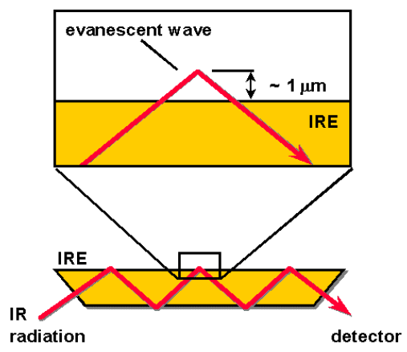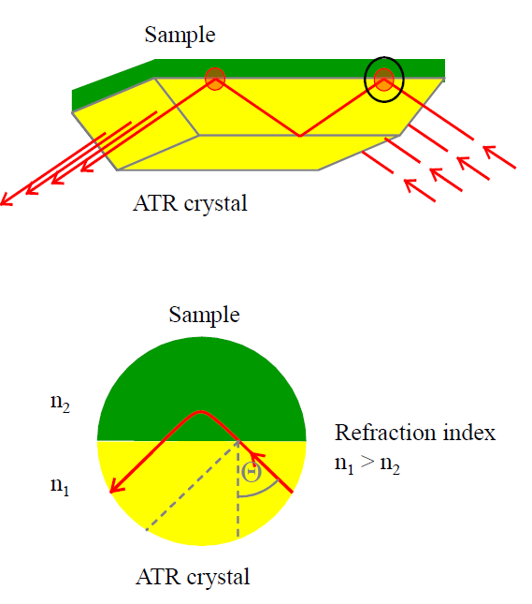
Figure 12: Evanescent wave and Depth of penetration ⁽²⁷⁾

2.7.6 ATR crystal materials
The selection of the ATR crystal characteristics should be matched to the type of samples to be analyzed. Selection can be made to control depth of penetration of IR beam, for hardness to prevent crystal damage and for acceptable pH range for acid or corrosive samples. Table 2 gives some guidelines for selection of ATR crystal.
Zinc Selenide (ZnSe) is a relatively low-cost ATR crystal material and is ideal for analyzing liquids and non-abrasive pastes and gels but it is not particularly robust with a working pH range of 5-9. ZnSe scratches quite easily and so care must be taken when cleaning the crystal.
Germanium has a much better working pH range and can be used to analyze weak acids and alkalis. Germanium has by far the highest refractive index of all the ATR materials available which means that the effective depth of penetration is approximately 1 micron. For most samples this will result in a weak spectrum being produced. However, this is an advantage when analyzing highly absorbing materials.
Diamond is by far the best ATR crystal material because of its robustness and durability. Diamond is harder than any other material and strong against scratching. It is used for analysis of a wide range of samples, including acids, bases, and oxidizing agents. It is also scratch and abrasion resistant.
AMTIR as a glass from selenium, germanium and arsenic, is insoluble in water, has similar refractive index to zinc selenide and can be used in measurements that involve strong acids.
Silicon is hard and brittle, chemically inert. It is only affected by strong oxidizers and is well suited for applications requiring temperature changes as it withstands thermal shocks better than other ATR materials. It is the hardest crystal material offered next to Diamond, which makes it well suited for abrasive samples that might otherwise scratch softer crystal materials.
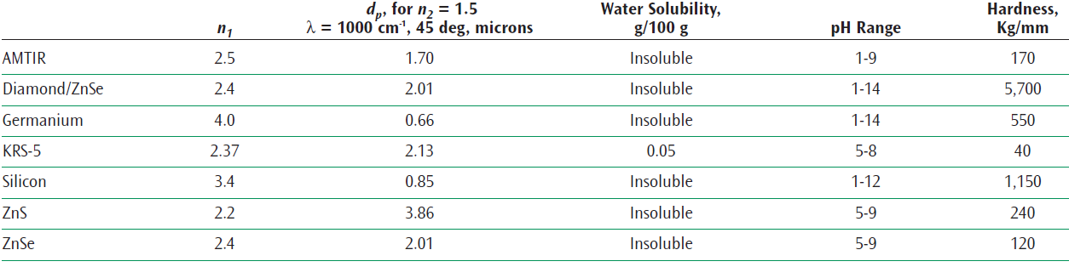
Table 2. ATR Crystal Characteristics for FTIR sampling ⁽²⁷⁾.

2.8 Quantitation
Of the quantitative methods based on light absorption, the calibration curve method is the most widely used and is not just limited to infrared analysis. This may be single or multi-point calibration curve method.
The calibration curve method uses Lambert-Beer’s law ⁽²⁸⁾ to quantify unknown samples by determining a regression equation (calibration curve) that represents the relationship between concentration and the peak intensity (peak height or area of the displayed absorbance) of the target component in the spectrum of a standard sample of unknown concentration. In this method, the creation of a calibration curve by measuring several points on a standard sample allows quantitative analysis to be performed easily.
However, in creation of a calibration curve, only an absorption peak of a target component that is mostly unaffected by other components (effects include peak overlaying) is required. When quantifying multiple components, a calibration curve must be created for each component by only using a peak from the corresponding component as described above.
Lambert-Beer’s law
When the intensity of incident light is I₀ and the intensity of transmitted light is I₁, the relationship between I₀ and I₁ can be described as follows:
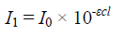
Where,
: absorbance coefficient
c: sample concentration
: cell pathlength
Transmittance (% T) and absorbance (abs) are defined as follows:
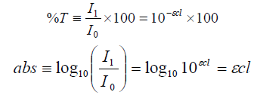
While there is an exponential relationship between transmittance and concentration, c, absorbance is proportional to sample concentration because and are constant when the sample and cell pathlength are known. For this reason, absorbance (Abs) mode is normally used to perform measurement in quantitative analysis.

3. Validation ⁽²⁹⁾
Every analytical method in a field of application must be suitable for its intended purpose. To demonstrate this fitness for purpose a method needs to be validated. If the results of the validation meet the set requirements, then the developed method can be ascribed as correct and the results of the analysis are reliable. A validation is carried out by examining different parameters, which are described in paragraph 3.1 to 3.5.

3.1 Specificity/selectivity
An analytical method is specific if it can only determine the component of interest. If the component to be determined can be distinguished from other components present, the method is selective. Blank samples and pure standards will be analyzed to check whether there are no other components that interferes with the component of interest.

3.2 Linearity
Linearity measures how well a calibration curve follows a straight line, showing that response is proportional to the quantity of analyte. The linearity will be tested by analyzing the Linearity test (“lack of fit”- test) and applying the method of least squares which will be calculated using excel function of data analysis. The correlation coefficient must be near 1 (> approx. 0.9945).
The “Lack of Fit” will be calculated using formula 1.
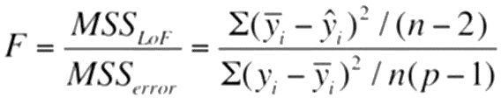 (1)
MSS _{LOF,} is mean sum of square due to the lack of fit. MSS _{error,} is the mean sum of square due to the error. The p in the formula denotes the measurement frequency of each standard solution. The limit value for F_{LOF}, with a 95 % reliability, is to be found in the literature. When F_{LOF} < F_{(Literature)}, there is no “Lack of Fit” and the calibration curve model can be considered linear.

3.3 Precision
Precision reflects the level of agreement between replicate measurements. Precision is subdivided into repeatability and reproducibility. Both repeatability and reproducibility will be expressed in relative standard deviation, which can be calculated using formula 2.
$RSD \left(\%\right)=\frac{Standarddeviation of measurements}{Mean value of measurements}*100 \%$ (2)

3.3.1 Repeatability
Is the degree of dispersion in measured values obtained with the same method, on the same sample, by the same analyst, with the same instrument, measured within time intervals that are close to each other.

3.3.1 Reproducibility
Is the variation of results between different analytical runs under different conditions. Conditions may be measuring at different laboratories, by different analysts or even at various times.

3.4 Accuracy
Accuracy is the degree of correspondence between the average of a series of measurement values and the actual value of the quantity to be determined. However, in this study accuracy will be analyzed by comparing results from two different analytical methods.

3.5 Limit of Detection (LOD)
The limit of detection is the smallest quantity of analyte that is “significantly different” from the blank. The limit of detection will be determined based on the measured absorbance of the standards from the calibration line. The calculation will be performed using the equation 3 below. Equation 3 will be used if the results of “lack of fit test (LOF)” has proved that the relation between x and y is well described with a linear model. Where b, is the slope of the calibration line, the standard error of the calibration line that is to be calculated using the standard error function of Excel.
$LOD=\frac{3*Standard error}{Slope}$ (3)

4. Method Procedures
Before any analysis can be performed, it is important that the correct method is developed. In this section, the materials and all experimental aspects which are used to set up the method will be described.

4.1 Materials
This paragraph discusses the chemicals which were used during the method development.
Dimethicone, from Sigma- Aldrich with a viscosity of 200 cst, under the following CAS- number; 9016-00-6. Dimethiconol, from Sigma- Aldrich with a viscosity of approximately 65 cst, under the following CAS-number; 70131-67-8. Ethyl acetate, also from Sigma- Aldrich with a purity of 99.8 %, under the following CAS- number; 141-78-6.
Isopropanol, from Sigma- Aldrich with a purity of 99,9 %, under CAS- number 67-63-0.
Positive control shampoo, with 1.5 % silicone and Negative control shampoo, with 0.0 % silicone.
Natural medium brown hair tress, # 4502981608 and Medium brown bleached hair, # 4502860907

4.2 Instrumentation and Instrument Settings
The method was developed using a IR Tracer- 100, Fourier Transform Infrared Spectrophotometer, with a Miracle 10, Single Reflection ATR Accessory. Both instruments are from Shimadzu. The weighing of the samples was carried out using a Metteler Toledo, AG 204 Deltarange. The following are the instrument settings of the method.
Measurement mode: Absorbance
Scans: 32 scans
Resolution: 2 cm⁻¹
Range: 700 cm⁻¹ to 1400 cm⁻¹
Background collection: every 20 minutes

4.3 Determination of solvent
Silicone oils are highly soluble in hydrocarbon solvents. However, there are insoluble in water. From the literature study, it turned out that silicones are also soluble in ethyl acetate and isopropanol. In this study both solvents were examined to make the right choice for the solvent to be used.

4.4 Standards and control-samples
For the creation of the calibration curves, pure dimthicone and dimethiconol were used. The standards dilutions were made in ethyl acetate. For the control- samples, positive and negative control shampoos were formulated. Known amount of silicone were incorporated in the positive control shampoo, and the negative control shampoo contained no silicone. The negative control shampoo was then assumed to be the blank sample.

4.5 Hair tress samples preparation
In this study, two samples were used namely, positive and negative control shampoos. To evaluate the deposited amount of silicone on hair from a shampoo, hair tresses were washed with 0.3 gram of shampoo. The hair tress weights three grams. The amount of shampoo applied on one-gram hair is therefore equal to 0.1 gram. The shampoo was applied on the hair tresses according to the following procedures:
Pre-wash of hair tresses before shampoo treatment
The hair tresses were first immersed in a surfactant solution (14% SLES solution) for an hour. The hair tresses were then washed with a 14 % solution of SLES. The washing was done by massaging the hair tress gently and then rinse the hair tresses under tap water of approx. 37 °C; 4L/min until all surfactants are removed. The hair tresses were left to dry in the climate control room.
Shampoo application
Before applying shampoo on hair tress, the pre-washed hair tress must be dry and detangled. The hair tress was first wetted under running tap water of 37°C, 4L/min. The hair tress was then squeezed to remove excess water. Then the hair tress was placed along the length of an aluminum bowl. Following that, 0.3-gram test shampoo was applied along the hair tress using s syringe. The shampoo was then massaged onto hair tress for 1 minute, while holding the hair tress in a vertical position. Subsequently the shampoo was rinsed from the hair tress under running tap water of 37°C, 4L/min for half a minute. Excess water was again squeezed out of the hair tress. The hair tress was then left to dry.

4.6 Method for preparing calibration standards
Two different methods of applying dimethicone and dimethiconol calibration solutions on the hair tresses were first examined. Method 1, was conducted by carefully applying the standard solutions on the length of the hair tress placed in an aluminum bowl and then evenly spread the standard solution along the hair tress. For method 2, the same procedure was conducted, in addition to this, the calibration solutions were then massaged through the hair tress to make sure that all dimethicone and dimethiconol are evenly spread on the hair.

4.7 Pick baseline correction method
The base line correction was performed using a 3-Point Baseline Correction by specifying a vertical axis value at three arbitrary wavenumber positions.

4.8 Validation procedure
This section outlines the procedure to validate the method.

4.8.1 Specificity/selectivity
A shampoo placebo, containing no added dimethicone and dimethiconol, was analyzed under the test method conditions. Interferences were examined near the absorbance bands of approximately 1260 cm⁻¹ . The same procedure was applied on dimethicone and dimethiconol pure standards.

4.8.2 Linearity
Ten dimethicone and dimethiconol standard solutions, ranging in concentration from 203.3 ppm to 4065.9 ppm, were prepared, applied on hair tresses and analyzed. The standard solutions were prepared in triple’s. The calibration standards are shown in table 3. Formula 4 has been used to calculate the concentration of the calibration standards.
C₁ x V₁ = C₂ x V₂ (4)
Where,
C₁ is the start concentration
C₂ is the end concentration
V₁ is the start volume
V₂ is the end or total volume.
The concentrations in table 3 were calculated based on a 10165 mg/l stock solution.
Volume pipet (ml) | Total volume (ml) | Concentration (ppm)
0.20 | 10 | 203.3
0.25 | 10 | 254.1
0.35 | 10 | 355.7
0.50 | 10 | 508.5
0.75 | 10 | 762.2
1.00 | 10 | 1016.7
1.50 | 10 | 1524.5
2.00 | 10 | 2033.0
3.00 | 10 | 3049.5
4.00 | 10 | 4065.9
Table 3. Calibration standards for linearity.

4.8.3 Repeatability
The repeatability of the method with respect to the shampoo formulation under this study was evaluated by analyzing six sample preparations of a positive control shampoo.

4.8.4 Reproducibility
The reproducibility of the method was demonstrated by analyzing a positive control shampoo in triplicate at different days, by different analysts.

4.8.5 Accuracy
The accuracy of the method was evaluated by comparing the results of silicone deposition of a positive control shampoo on natural virgin brown hair, analyzed using XRF and ATR-FTIR methods.

4.8.6 Limit of Detection (LOD)
The limit of detection was determined based on the measured absorbance of the standards from the calibration line. The calculation was performed using the equation 4. Equation 4 is to be used if the results of “lack of fit test (LOF)” has proved that the relation between x and y is well described with a linear model. Where b, is the slope of the calibration line, the standard error of the calibration line is to be calculated using the standard error function of Excel.

5 Results and discussion
In this research project, a unique ATR-FTIR method that utilizes one IR absorbance band (1259.54 cm⁻¹ ) to determine the amount of dimethicone and dimethiconol deposited on human hair after shampoo treatment has been developed. To demonstrate that the method developed is reliable, a comprehensive validation was designed and performed, and the method was found to be specific, linear, precise and accurate. The detailed validation results and discussions are described in the sections below.

5.1 Method for preparing calibration standards
Two methods of preparing calibration standards were evaluated and compared. In the first method, the calibration solution was applied on the length of the hair tress and then evenly spread along the hair tress without massaging the hair tress. The second method involved applying calibration solution on the hair tress and massaging the hair tress to ensure that all dimethicone and dimethiconol are evenly spread on the hair. However, the homogeneity of the applied silicones along the hair tress is reasonably good. For this reason, multiple measurements must be done along the entire hair tress. The comparison of the results of the two methods was performed using a Two-Sample T-test and One-way ANOVA. The Two-Sample T-test determines whether the mean between two groups significantly differ. The One-way ANOVA determines whether the means of two or more groups differ. The results are summarized in 4 below.
Two-sample T-Test/ One-way ANOVA
Method for dimethicone | Measurements | Mean Abs | StDev | P-value T-Test | P-value ANOVA
Method 1 lower concentration (ppm) | 36 | 0.00679 | 0.0052 | 0.946 | 0.943
Method 2 lower concentration (ppm) | 36 | 0.00671 | 0.0039
Method 1 middel concentration (ppm) | 36 | 0.0242 | 0.0092 | 0.360 | 0.360
Method 2 middel concentration (ppm) | 36 | 0.0263 | 0.0084
Method 1 upper concentration (ppm) | 36 | 0.0477 | 0.018 | 0.564 | 0.564
Method 2 upper concentration (ppm) | 36 | 0.0450 | 0.018
Method for dimethiconol
Method 1 lower concentration (ppm) | 36 | 0.00814 | 0.0025 | 0.537 | 0.537
Method 2 lower concentration (ppm) | 36 | 0.00847 | 0.0021
Method 1 middel concentration (ppm) | 36 | 0.0254 | 0.0057 | 0.518 | 0.517
Method 2 middel concentration (ppm) | 36 | 0.0267 | 0.011
Method 1 upper concentration (ppm) | 36 | 0.0486 | 0.012 | 0.738 | 0.738
Method 2 upper concentration (ppm) | 36 | 0.0496 | 0.014
Table 4: Two-sample T-Test and One-way ANOVA for calibration methods
Table 4 shows the results of the two different methods used to prepare the calibration curve. The H₀ hypothesis for Two-sample T-Test and One-way ANOVA assumed that if the P-values are greater than 0.05, the methods do not significantly differ. The H₁ hypothesis assumed there is a significant difference between the two methods if the P-values are lesser than 0.05. The results indicate that the P-values for the two methods, for both Two-sample T-Test and One-way ANOVA are greater than 0.05, hence the methods are not significantly different. Therefore, either method can be used to prepare the calibration curve. The calibration curves are shown in appendix 2.

5.2 Pick baseline correction method
The base line correction was performed using a 3-Point Baseline Correction by specifying a vertical axis value at three arbitrary wavenumber positions. The corrected intensity value (absorbance) is displayed in the yellow rectangle in the data table. This is visually shown in figure 13 below.
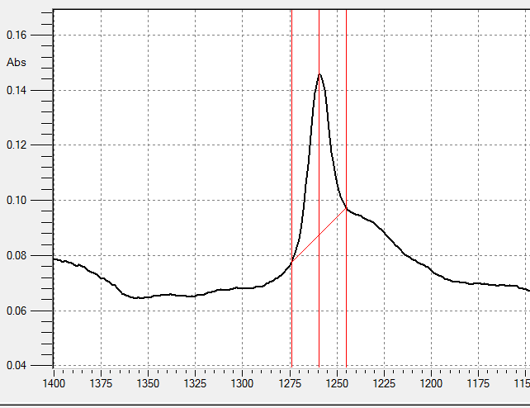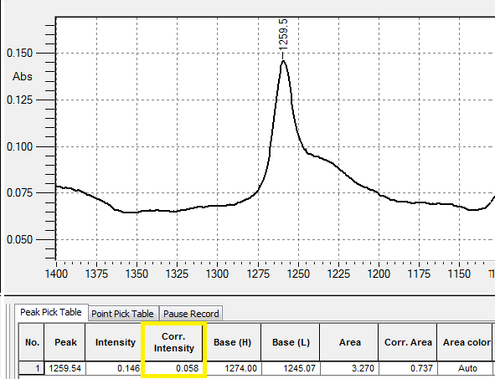
Figure 13. Pick baseline correction demonstration

5.3. Specificity
A shampoo placebo, containing no added dimethicone and dimethiconol, and pure dimethicone and dimethiconol standards were analyzed under the test method conditions. Interferences were examined near the absorbance bands of approximately 1259.54 cm⁻¹. No interferences were observed around the 1259.54 cm⁻¹ absorbance band region. The FTIR spectra of the standards, placebo and sample on hair tresses are presented in appendix 1.

5.3.1 Linearity
The linearity was determined for both dimethicone and dimethiconol using method 1 described in section 5.1 above. It was further noticed that the absorbances of dimethicone and dimethiconol in the same concentration range significantly correlates. The comparison was carried out using the regression analysis, Bland-Altman plot, Two-sample T-Test and One-way ANOVA. The results are shown below.
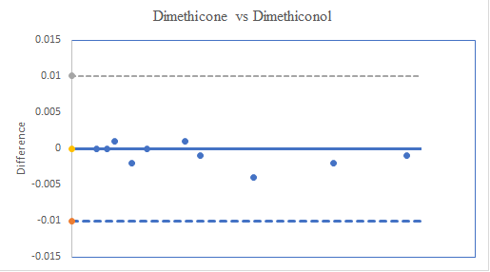
Figure 14. Regression plot and Bland-Altman plot of dimethicone and dimethiconol linearity data.
The regression plot was constructed to display the visual aspect of the relation between the two calibration models. Figure 14 shows that there is a good agreement. The r² of the line is 0.9956. Also, a Bland-Altman plot was created from the data in figure 14. In the Bland-Altman plot, the data are spread around the 0 point. However, a negative trend was observed as the concentration became high. In addition to the results of regression plot and Bland-Altman plot results, a Two-sample T-Test and One-way ANOVA were conducted, for a further investigation of the correlation of the two calibration sets. The results are as follows.
Standards | Mean Abs Cone | Mean Abs Conol | StDev Cone | StDev Conol | P-value T-Test | P-value ANOVA
1 | 0.00511 | 0.00536 | 0.0025 | 0.0026 | 0.676 | 0.676
2 | 0.00672 | 0.00658 | 0.0031 | 0.0032 | 0.854 | 0.854
3 | 0.00869 | 0.00838 | 0.0036 | 0.0030 | 0.684 | 0.684
4 | 0.0106 | 0.0126 | 0.0062 | 0.0064 | 0.207 | 0.207
5 | 0.0151 | 0.0155 | 0.0088 | 0.0079 | 0.866 | 0.866
6 | 0.0232 | 0.0224 | 0.0084 | 0.0068 | 0.667 | 0.667
7 | 0.0247 | 0.0256 | 0.012 | 0.0108 | 0.739 | 0.739
8 | 0.0344 | 0.0384 | 0.010 | 0.0150 | 0.255 | 0.255
9 | 0.0510 | 0.0529 | 0.016 | 0.0019 | 0.645 | 0.644
10 | 0.0659 | 0.0674 | 0.0207 | 0.0221 | 0.763 | 0.763
Table 5. Two-sample T-Test and One-way ANOVA for dimethicone and dimethiconol calibration curves
Table 5 shows the results of the calibration curves for dimethicone and dimethiconol. The H₀ hypothesis for Two-sample T-Test and One-way ANOVA assumed that if the P-values are greater than 0.05, the results do not significantly differ. The H₁ hypothesis assumed there is a significant difference between the two data if the P-values are lesser than 0.05. The results indicate that the P-values for the two data sets, for both Two-sample T-Test and One-way ANOVA are greater than 0.05, hence the data are not significantly different. Based on the above results, it was therefore concluded that one calibration curve can be created to quantify both dimethicone and dimethiconol.

5.3.2 Linearity
For the determination of linearity, ten dimethicone standard solutions, ranging in concentration from 203.3 ppm to 4065.9 ppm, were prepared and analyzed using the method conditions outlined in section 4.2 and method 1 outlined in section 5.1. The correlation coefficient was found to be 0.9961 for the absorbance response at 1259.54 cm⁻¹ . The F- calculated (0.032) for Lack of fit test was found to be lower than the tabulated value (2.19), meaning to say that the calibration model is correct. The results demonstrated a satisfactory linearity. The linearity results are presented in table 6 and figure 15.

 | Linearity
 | Value | Requirement | Satisfies
Slope | 0.0000157
Intercept | 0.00308
Correlation coefficient | 0.9965
Adjusted correlationcoefficient | 0.9961 | > 0.9945 | Yes
Standard Error | 0.001289
Lack of fit test | 0.032 | < 2.19 | Yes
Observations | 10
Table 6. Regression line data.

Figure 15. Regression line: y= 0.0000157 (+/- 0.00000076) x + 0.00308 (+/- 0.0014); Sy/x = 0.001289; n = 10; r2 = 0.9961; CI = 95 %

5.4 Repeatability
The repeatability of the method with respect to the sample formulation under this study was evaluated by analyzing six sample preparations of a positive control shampoo. The average relative standard deviation along the whole hair surface was found to be 8.06 %. The relative standard deviation of the dimethicone assay results was found to be 6.40 % at the root of the hair, 9.01% at the middle of the hair and 8.78 % at the hair tips for the six sample preparations. The higher the deposition of the silicone on the hair, the lesser the variation in replicate measurements, and hence the better repeatability. The results are summarized in table 7. The results demonstrated a satisfactory repeatability for the sample analysis.

Sample Replicate | Si deposition (ppm) at the hair root | Si deposition (ppm) at the middle of the hair | Si deposition (ppm) at the hair tips | Average per hair surface (ppm)
1 | 483.2 | 366.5 | 345.2 | 398.3
2 | 536.3 | 430.1 | 398.3 | 454.9
3 | 472.6 | 451.4 | 398.3 | 440.8
4 | 440.8 | 419.5 | 387.7 | 416.0
5 | 483.2 | 366.5 | 345.2 | 398.3
6 | 493.8 | 440.8 | 324.1 | 419.6
Average | 485.0 | 412.5 | 366.5 | 421.3
RSD % | 6.40 | 9.01 | 8.78 | 8.06
Table 7. Summary of repeatability results.

5.5 Reproducibility
The reproducibility of the method was demonstrated by analyzing a positive control shampoo in triplicate at different days, by different analysts. The average relative standard deviation along the whole hair surface was found to be 8.68 %. The relative standard deviation of the dimethicone assay results was found to be 4.30 % at the root of the hair, 9.44 % at the middle of the hair and 12.31 % at the hair tips for the nine sample preparations. The higher the deposition of the silicone on the hair, the lesser the variation in replicate, and hence the better reproducibility. The results are summarized in table 8. The results demonstrated a satisfactory reproducibility for the sample analysis.
 | Sample Replicate | Si deposition (ppm) at the hair root | Si deposition (ppm) at the middle of the hair | Si deposition (ppm) at the hair tips | Average per hair surface (ppm)
Analist 1 | 1 | 493.8 | 387.7 | 451.4 | 444.3
 | 2 | 515.1 | 387.7 | 355.8 | 447.9
 | 3 | 515.1 | 451.4 | 377.1 | 447.9
Analist 2 | 1 | 546.9 | 355.8 | 324.1 | 408.9
 | 2 | 505.5 | 355.8 | 419.5 | 426.9
 | 3 | 536.3 | 430.1 | 430.1 | 465.5
Analist 3 | 1 | 483.2 | 366.5 | 345.2 | 390.3
 | 2 | 493.8 | 440.8 | 324.1 | 419.7
 | 3 | 536.3 | 430.1 | 398.3 | 454.9
Average |  | 514.0 | 400.7 | 380.6 | 431.8
% RSD |  | 4.30 | 9.44 | 12.31 | 8.68
Table 8. Summary of reproducibility results.

5.5 Accuracy
The accuracy of the method was evaluated by comparing the results of silicone deposition of a positive control shampoo on natural virgin brown hair, analyzed using XRF and ATR-FTIR methods. The calibration standards and the samples were prepared and sent for XRF analysis to an external laboratory. The calculated sample results are shown in table 9 below. The calibration curve is shown in appendix 4. Figure 16 shows the silicone deposition results for the positive control sample on natural virgin brown hair obtained by XRF and ATR-FTIR methods. The results obtained by XRF method are quite lower compared to the competing method, especially the deposition on the hair endings (tip). The differences at the root and middle of the hair are slightly small because the deposition is quite high at the root and at the middle of the hair, hence less variations. In figure 17 the average silicone deposition results along the whole hair surface are shown. A difference with a factor of 1.5 roughly, is noticed. The lower values obtained by XRF method can be partially ascribed to the process of preparing the XRF cups with samples, where the loss of some deposited silicone due to sample handling and XRF cups filling is inevitable. The other factor might have been the process of sample transportation. However, more XRF measurements must be done to fully make a certain and final judgement of how accurate the method is.
Sample Replicate | Si deposition (ppm) at the hair root | Si deposition (ppm) at the middle of the hair | Si deposition (ppm) at the hair tips | Average per hair surface (ppm)
1 | 368.6 | 248.0 | 177.2 | 264.6
2 | 302.8 | 222.1 | < LOD | 216.4
3 | 472.6 | 293.4 | 210.7 | 383.0
4 | 314.3 | 330.2 | < LOD | 246.1
Average | 364.6 | 273.4 | 194.0 | 277.3
Table 9. Summary of XRF results of the positive control sample.

Figure 16. A comparison of the silicone deposition results for ATR-FTIR and XRF methods

Figure 17. The average silicone deposition results for ATR-FTIR and XRF methods.

5.5 Limit of detection
The limit of detection was determined based on the measured absorbance of the standards from the calibration line. The calculation was performed using the equation 4. The calculated limit of detection is 116.4 ppm as shown below. The limit of detection of an ATR-FTIR method is quite high.

$LOD=\frac{3*Standard error}{Slope}=> \frac{3*0.000609}{0.0000157}=116.4 ppm$

6 Conclusion
The purpose for this research project was to develop an ATR-FTIR method for quantification of dimethicone and dimethiconol deposited on human hair surface after a shampoo treatment. A calibration curve for dimethicone and dimethiconol, directly on human hair was created. Ethyl acetate was found to be a suitable solvent for dimethicone and dimethiconol and was successfully used to make calibration standards on human hair.
Hair sample preparation, namely the washing of the hair with shampoo was conducted in a way that comes close to the everyday use of shampoo by an average shampoo user. The hair tresses were washed once with shampoo.
The validation of the method focused mainly on linearity, repeatability, reproducibility, accuracy and limit of detection. From the results it can be concluded that the validation of the method is successful. The linearity had a correlation coefficient of 0.9961, which agrees well with the expected correlation coefficient of > 0.9945.
The repeatability and reproducibility presented a satisfactory average relative standard deviation of 8.06 % and 8.68 % respectively.
The limit of detection was found to be 116.6 ppm. The accuracy of the method, determined by comparing the results obtained from the developed ATR-FTIR method and an external XRF method, gave a reasonably acceptable result. A difference with a factor of 1.5 roughly, was noticed.
The lower values obtained by XRF method can be partially ascribed to the process of preparing the XRF cups with samples, where the loss of some deposited silicone due to sample handling and XRF cups filling is inevitable. The other factor might have been the process of sample transportation.
Furthermore, it was observed that more silicone is deposited on the root of the hair, followed by the middle of the hair. On the ending (tip) of the hair lower deposition were observed.
From the results, it can be concluded that the developed ATR-FTIR method is successfully validated and is fit to quantify the amount of dimethicone and dimethiconol deposited on human hair after shampoo treatment.

7 Recommendations
The calibration standards must be prepared on natural virgin brown hair. Due to higher value of the limit of detection and low concentration of the deposited dimethicone and dimethiconol on the hair after one-wash shampoo treatment, it can be recommended to carry out a two-wash shampoo treatment for higher absorbance and automatically high deposition, especially for the benchmark products where less deposition was observed.
For the determination of the accuracy of the method, more XRF samples must be analyzed to fully make a concrete judgement of how accurate the method is.

Bibliography
- Ashland Incorporated, Available: https://www.ashland.com; Accessed on 29-03-2018
- Bilson Shukla, Ravindra D. Kulkarni, “Silicone Polymers History & Chemistry”, Chemical weekly, February 26- 2008; Accessed on 27-03-2018
- Adriana Urrutia, “The basis of Perfect Formulation for Hair Care”, Dow Corning de Mexico S.A. de C.V. 2001; Accessed on 27-03-2018
- Judy Zhu, Isabelle Van Reeth, Bethany K. Johnson, “The Beauty of Silicone in hair Care Application”, Dow Corning Corporation 2016, Form No. 27-1550A-01; 29-03-2018
- Hans-Martin Haake, Helene Lagrene, Angela Brands, Wolf Eisfeld & David Melchior, “Determination of the substantivity of emollients to human hair” Journal of cosmetic science, 58, pp. 443-450, July/August 2007.
- Donald L. Pavia, Gary M. Lampman, George S. Kriz, James R. Vyvyan, “Introduction to Spectroscopy’, Fifth Edition, Cengage Learning, p.14-26, 2015.
- Walter M. Doyle, “Principles and Applications of Fourier Transform Infrared (FTIR) Process Analysis. Available: http://www.hellma-axion.com/pdf/technical_notes/AN-906.pdf
- Siloxane bonds, Available: https://www.shinetsusilicone-global.com/info/begin4.shtml, Accessed on 09-04-2018
- Kipping, F.S.; Lloyd, L.L.J. Chem. Soc, 1901, p. 449-459.
- Stock, A.; somieski, C. Ber. Dtsch. Chem. Ges. 1919, 52, 695, Available: https://scholarworks.umass.edu/cgi/viewcontent.cgi?article=2116&context=dissertations_2, Accessed on 09-04-2018.
- Daniel H. Flagg, Polyorganosiloxanes: Molecular Nanoparticles, Nanocomposites and Interfaces, University of Massachusetts Amherst, 2017.
- Platinum Catalysts Used in the Silicones Industry; Their Synthesis and activity in hydrosilylation, Larry N. Lewis, Judith Stein, Yan Gao, Robert E. Colborn and Gudrun Hutchins; GE Corporate Research & Development Center, General Electric Company, Schenectady, New York, 1997.
- J.L. Garoud, Silicones in Industrial Applications, Dow Corning Europe SA, Seneffe, Belgium., Accessed on 11-04-2018.
- Marinne D. Berthiaume, James H. Merrifield and Donna A. Riccio, GE Silicones, Journal of the society of cosmetic chemists, May 1994., Accessed on 11-04-2018.
- Tom Kuan Lem, Rob Houben, BRB Silicones; Malaysia & Netherlands, Selecting the perfect silicone for your formulation; Available: http://www.brb-international.com/uploads/markets/analysis-of-volatile-dimethicones-for-cosmetics-pc-mag-nov-2016.pdf, Accessed on 11-04-2018.
- Anthony J. O’Lenick Jr, “Silicones for Personal Care 2nd Edition”, Allured Publishing Corporation, p. 46-47, 2008.
- Dimethicone, Available: https://www.elveflow.com/microfluidic-tutorials/microfluidic-reviews-and-tutorials/the-poly-di-methyl-siloxane-pdms-and-microfluidics/, Accessed on 10-04-2018.
- Dimethiconol, Available: https://plasmatreatment.co.uk/news-events/bonding-adhesion-pdms-henniker-plasma-treatment/, Accessed on 10-04-2018.
- Bilgen Erdogan, “Anatomy and Physiology of Hair”, INTECH, Available: http://www.intechopen.com/books/hair- and- scalp-disorders, Accessed on 11-04-2018.
- Clarence R. Robbins, “Chemical and Physical Behavior of Human Hair”, Available: https://pdfs.semanticscholar.org/6cf6/ef685ae1b7fc8df9c35ffd4dce39a5ef43ff.pdf, Accessed on 11-04-2018.
- http://swiftcraftymonkey.blogspot.com/2010/04/surfactants-alkyl-sulfates.html, Accessed on 03-05-2018.
- https://commons.wikimedia.org/wiki/File:Sodium_laureth_sulfate_2.svg, Accessed on 3-05-2018
- http://www.newworldencyclopedia.org/entry/Albert_Abraham_Michelson, Accessed on 3-05-2018
- Daniel. N. Rockmore, “The FFT”, Departments of Mathematics and Computer Science, Dartmouth College, Hanover 03755, 1999. Available: http://www.cs.dartmouth.edu/~rockmore/cse-fft.pdf
- James W. Cooley and John W. Tukey, “An Algorithm for the Machine Calculation of Complex Fourier Series” p. 297-301, published by American Mathematical Society, 2013.
- Principle of Spectroscopy; Available: http://mtweb.mtsu.edu/nchong/Spectroscopy-CHEM6230.pdf, Accessed on 13-04-2018.
- Walter M. Doyle, “Principles and Applications of Fourier Transform Infrared (FTIR) Process Analysis, Hellma Axiom, Inc., Accessed on 13-04-2018.
- https://chem.libretexts.org/Core/Physical_and_Theoretical_Chemistry/Spectroscopy/Electronic_Spectroscopy/Electronic_Spectroscopy_Basics/The_Beer-Lambert_Law, Accessed on 03-05-2018.
- Daniel C. Harris, Quantitative Chemical Analysis, Eighth Edition, p. 83-85, 101-105, published by W.H. Freeman and Company, New York, 2010.

Appendices
- ATR-FTIR Spectra for ethyl acetate on hair tress, dimethicone standard solution on hair tress, positive control sample on hair tress and placebo sample on hair tress.
- Linearity data of non-massaging and massaging methods.
- Linearity of dimethicone and dimethiconol.
- Linearity data of the developed ATR-FTIR method.
- Linearity data of XRF method.
- Additional data of various measurements.

- Appendix 1. ATR-FTIR Spectra of ethyl acetate on hair tress, dimethicone standard solution on hair tress, dimethiconol standard solution on hair tress, positive control sample on hair tress and placebo sample on hair tress.
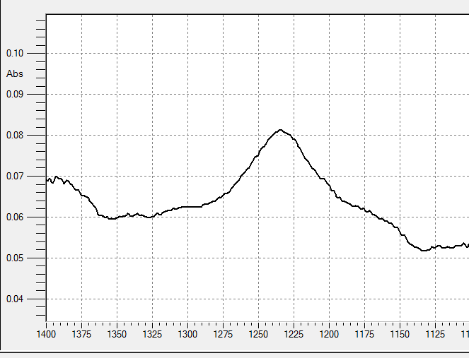
Figure 18. The ATR-FTIR Spectrum of ethyl acetate on hair tress
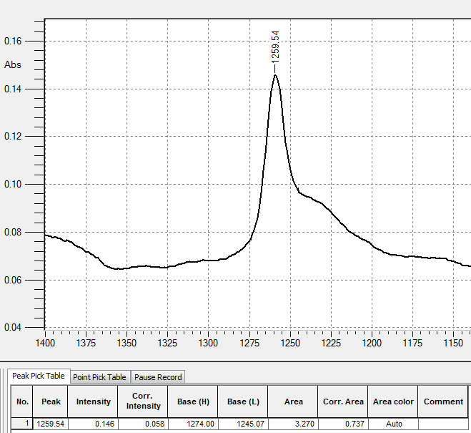
Figure 17. The ATR-FTIR Spectrum of dimethicone standard solution on hair tress
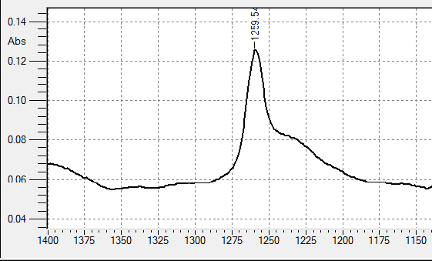
Figure 19. The ATR-FTIR Spectrum of dimethiconol standard solution on hair tress
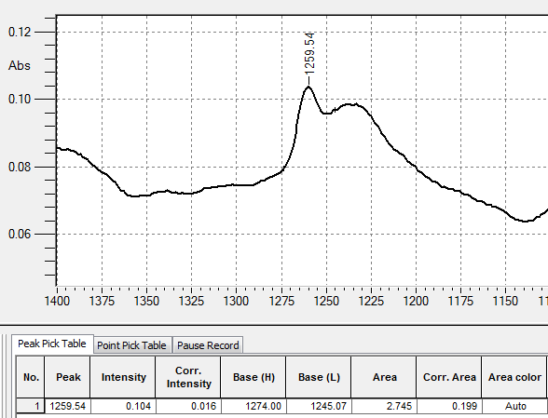
Figure 20. The ATR-FTIR Spectrum of positive control sample on hair tress
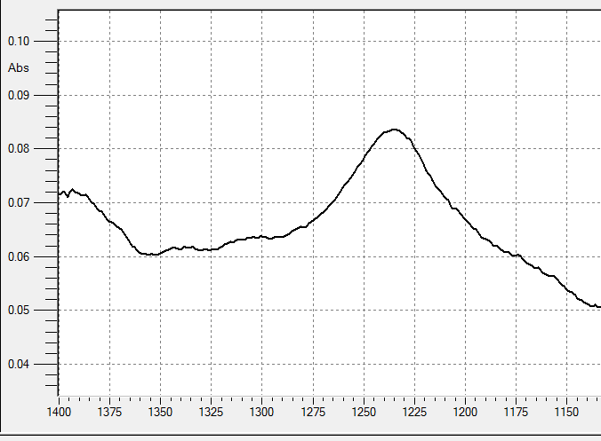
Figure 21. The ATR-FTIR Spectrum of placebo sample on hair tress

- Appendix 2. Linearity data of non-massaging and massaging methods.
Dimethicone concentration (ppm) | Absorbance at 1259.54 cm⁻¹
253.9 | 0.007
1022.1 | 0.022
2840.1 | 0.048

Dimethiconol concentration (ppm) | Absorbance at 1259.54 cm⁻¹
255.8 | 0.008
1024.6 | 0.023
2841.2 | 0.049

Dimethicone concentration (ppm) | Absorbance at 1259.54 cm⁻¹
254.4 | 0.008
1023.8 | 0.023
2840.9 | 0.048

Dimethiconol concentration (ppm) | Absorbance at 1259.54 cm⁻¹
256.5 | 0.008
1026.2 | 0.024
2842.2 | 0.051

- Appendix 3. Linearity data of dimethicone and dimethiconol
Dimethicone concentration (ppm) | Absorbance at 1259.54 cm⁻¹
206 | 0.005
254.2 | 0.007
360.5 | 0.009
508.9 | 0.011
772.4 | 0.015
1017.7 | 0.023
1544.8 | 0.025
2035.4 | 0.034
3053.1 | 0.051
4070.8 | 0.066

y= 0.0000155 (+/- 0.0000010) x + 0.00322 (+/- 0.00188); Sy/x = 0.001721; n = 10; r2 = 0.9928; CI = 95 %
Dimethiconol concentration (ppm) | Absorbance at 1259.54 cm⁻¹
205.8 | 0.005
254.7 | 0.007
360.4 | 0.008
509.4 | 0.013
771.6 | 0.015
1018.7 | 0.022
1544.6 | 0.026
2037.4 | 0.038
3056.1 | 0.053
4074.8 | 0.067

y= 0.0000160 (+/- 0.0000010) x + 0.00327 (+/- 0.00188); Sy/x = 0.00172; n = 10; r2 = 0.9933; CI = 95 %
- Appendix 3. Linearity data of the developed ATR-FTIR method
Dimethicone concentration (ppm) | Absorbance at 1259.54 cm⁻¹
203.3 | 0.005
254.1 | 0.007
355.7 | 0.009
508.5 | 0.011
762.2 | 0.014
1016.7 | 0.022
1524.5 | 0.027
2033.0 | 0.036
3049.5 | 0.050
4065.9 | 0.067

y= 0.0000157 (+/- 0.00000076) x + 0.00308 (+/- 0.0014); Sy/x = 0.001289; n = 10; r2 = 0.9961; CI = 95 %

- Appendix 4. Linearity data of XRF method
Concentration (ppm) | KCPS
204.52 | 10.95405
357.95 | 15.2118
511.35 | 17.65405
757.05 | 18.72695
1534.0 | 31.6892
2045.4 | 41.4061
3068.1 | 54.92465

y= 0.01524 (+/- 0.00128) x + 8.764 (+/- 1.99); Sy/x = 1.284; n = 7; r2 = 0.9937; CI = 95 %
- Additional data of various measurements
Sample Replicate | Si deposition (ppm) at the hair root | Si deposition (ppm) at the middle of the hair | Si deposition (ppm) at the hair tips | Average per hair surface (ppm)
2x wash positive control | 881.3 | 732.7 | 584.1 | 732.7
Positive control on damaged hair | 472.6 | 387.7 | 339.9 | 400.1
Dove shampoo with dimethiconol | 334.6 | 255.1 | 228.5 | 272.7
Fructis shampoo with dimethicone | 430.0 | 281.5 | 239.1 | 316.9
The data in this table are the average for several sample replicates.

