Convincing the Innovative SME
  - How to convince the innovative SME in the North of the Netherlands
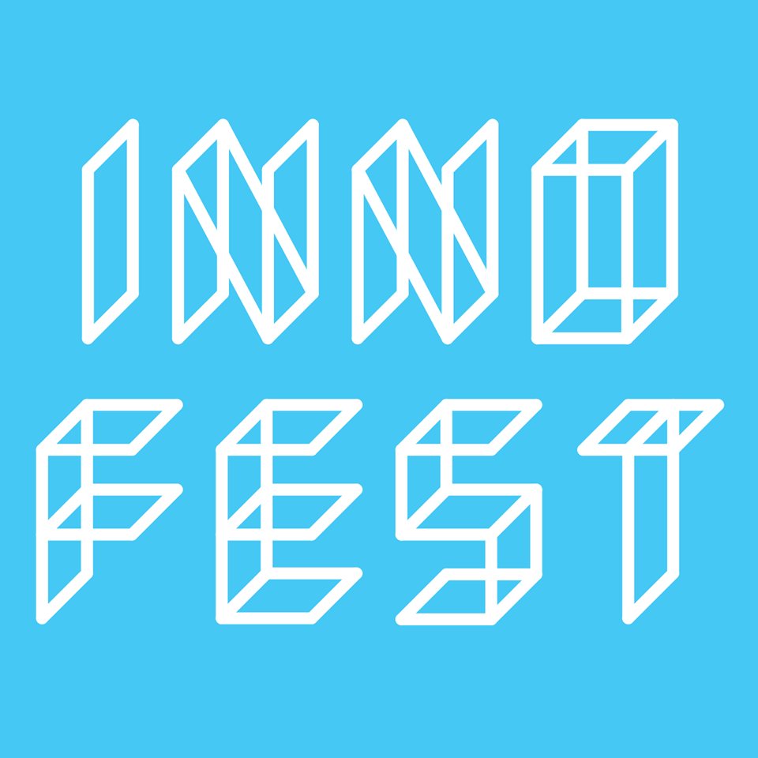
Graduation Assignment
Date of publication: 31/05/2017
Author: Mélanie Kamping – 316531
Assigned by: Innofest
First assessor: Pieter Swieringa
Second assessor: Anke van Haastrecht
Non-confidential
Word count: 16503

Convincing the Innovative SME
  - How to convince the innovative SME in the North of the Netherlands

Author: Mélanie Kamping
Student number: 316531
Class: ICV4C
Education programme: International Communication
Education programme: International Communication
Educational Institution: Hanze University
31/05/2016, Groningen

Executive Summary
This research report is created for Innofest. Innofest has indicated to experience a difficulty in convincing innovative SMEs to test their product with Innofest, though they believe to have a considerable amount of reach. Based on the problem presented by Innofest the selected goal of the research is: to provide recommendations on how the external communication can be improved in order to convince innovative SMEs based in the North of the Netherlands to test their product with Innofest by finding out what kind of channels they use, what kind of content is the most effective and how to eventually convince them, by undertaking in-depth interviews with potential and current cooperation partners and by using theories on thought leadership, customer value proposition, the Channel Expansion Theory and the AIDA model.
The main research question is: what has to be changed in the external communication in order to convince innovative SMEs based in the North of the Netherlands to test with Innofest? The preliminary research showed that face-to-face communication was a lot more effective in convincing innovative SMEs than online communication channels. Which led to the hypothesis that Innofest should focus more on offline communication.
In order to find the answer on the main research question, in-depth interviews were undertaken with current cooperation partners of Innofest, an online survey was conducted aimed at potential cooperation partners and desk research was used to create the questions and analyse the answers.
The research question was answered by analysing the stages of the AIDAS model (Awareness, Interest, Desire, Action and Satisfaction). For each stage a communication change was proposed to make it easier for the innovative SME to decide to test with Innofest. Awareness and interest seemed to be triggered best when using face-to-face communication. Social media turned out to be a good tool to create the desire to cooperate with Innofest. And when someone expresses the desire to cooperate with Innofest a direct approach is necessary to turn this desire into action. Finally, the results showed that people that have tested with Innofest would like a moment of reflection after the tests which leads to more satisfaction.
Twenty-nine people have tested with Innofest so far. Meaning that thirty-one percent of all Innofest’s current cooperation partners are spoken to. Which gives us the opportunity to generalize some of the answers and create an overall picture on how to convince the cooperation partner of Innofest. Though, it should be taken into account that the results could have been very different when nine other cooperation partners would have been interviewed. Thirty-three people filled in the online survey. Which does not seem like much. However, only a very small percentage of those SMEs are innovative. Traditional SMEs, such as bakeries, cafés, the swimming pool, are not relevant for the research.
Based on the survey, the interviews and the desk research, several recommendations were constructed. The first one is to create an event for current partners of Innofest with the aim of turning the partners into ambassadors. The second recommendation is to use highly targeted social media advertising and more out-of-the-box social media content to reach people that have already heard of Innofest and are interested in it. Thirdly, it is recommended to delete the application form on the website and put a contact form instead and to use a direct instead of a passive approach when people express the desire to cooperate with Innofest. The last recommendation concerns implementing a moment of reflection after each test to increase the satisfaction and stimulate partners to recommend Innofest to other innovative SMEs.
A good follow-up research could be to undertake research on a larger-scale and focus not only on the North of the Netherlands but on the Netherlands as a whole and on countries outside of the Netherlands. In order to see whether the results are any different from this research report.

Foreword
I asked Innofest whether I could write my graduation thesis for them because they seemed like a very interesting company where I would have to deal with many innovative entrepreneurs that want to change the world. I really wanted to expand my network in the area of idealistic enterprise and I did not want to work for a very big company, Innofest seemed perfect.
The research report is mainly written for Anna van Nunen, since she is the one that needs to agree on the changes in the communication. The other people from Innofest can use this report to implement the communication changes.
I want to thank Pieter Swieringa and Henk Rigter for giving me advice and helping me create this report. Furthermore, I want to thank Anna van Nunen for the possibility to write my graduation report for Innofest and the other people working for Innofest, for their time to answer my questions.
Mélanie Kamping, 31/05/17, Groningen

Content List

Research report
1. Project Context 7
1.1 Problem Analysis 7
1.2 Organization Context 8
2. Theoretical Framework 11
2.1 The research objective 11
2.2 Communication channels 12
2.3 Content of the communication 13
2.4 Convincing the innovative SME 13
3. Research Design 15
3.1 Research Framework 15
3.2 Conceptual Model 16
3.3 Research Questions 16
3.4 Research Strategy & Methodology 18
4. Results 19
4.1 Which communication channels are best to be used in order to reach the research objects? 21
4.1.1 Which communication channels are most often used by the research objects? 21
4.1.2 Where do the research objects use the different communication channels for? 22
4.1.3 Analysis and interpretation 24
4.1.4 Conclusion and recommendation 24
4.2 What aspects of Innofest should be communicated in order for it to be appealing for the research object? 25
4.2.1 What are the most appealing aspects of Innofest according to the 25
research objects? 25
4.2.2 What are aspects that can be improved according to the research objects 27
4.2.3 Analysis and interpretation 27
4.2.4 Conclusion and recommendations 28
4.3 How can Innofest become a Thought Leader in the field of innovative enterprise? 28
4.3.1 Results 29
4.3.2 Analysis and interpretation 30
4.3.3 Conclusion and recommendations 30
4.4 How can the potential cooperation partner best be led through the stages of the AIDA model? 30
4.4.1 How did the current cooperation partners of Innofest go through the stages? 30
4.4.2 How do potential cooperation partners of Innofest react when they hear about Innofest? 33
4.4. 3 Analysis and interpretation 34
4.4.4 Conclusion and recommendation 34
4.5 Conclusion………………………………………………………………………………………………………………………………………….34

The Advice
  - A step-by-step plan
1. Introduction 36
2. A step-by-step plan to convince the Innovative SME 37
2.1 Step 1: Face-to-face communication to create awareness & interest 37
2.1.1 Connection to the theory 37
2.1.2 Implementation 38
2.1.3 Effectiveness 40
2.1.4 Conclusion 40
2.2 Step 2: Online communication channels Innofest as a tool to create desire 40
2.2.1 Connection to the theory 40
2.2.2 Implementation 42
2.2.3 Effectiveness 44
2.2.4 Conclusion 44
2.3 Step 3: Turn desire into action by means of a direct approach 44
2.3.1 Connection to the theory 45
2.3.2 Implementation 45
2.3.3 Effectiveness 46
2.3.4 Conclusion 46
2.4 Step 4. Stimulate satisfaction through a reflection point after the tests 46
2.4.1 Connection to the theory 46
2.4.2 Implementation 47
2.4.2 Effectiveness 47
2.4.3 Conclusion 48
4. Communicating the policy changes 48
5. Facilitation in Communication 48
6. Planning and organising 49
7. Conclusion 53
Reference List 55

Appendix
Appendices 1 Preliminary Research 58
Appendix A Communication Plan Innofest 2017, Tessa Hagen 58
Appendix B Media Coverage Innofest 59
Appendix C Applications via The Website 60
Appendices 2: The research 64
Appendix A The interviews 64
1. Interview Marcel Bleeker 64
2. Interview Jacques ten Kate 66
3. Interview Boris Geheniau 68
4. Interview Rene Bolhuis 70
5. Interview Jan Melein 73
6. Interview Niels Schenk 76
7. Interview Lammert Stavast 78
8. Interview Ronald Mulder 81
9. Interview Joachim 84
10. Interview Sander Egbers 89
11. Interview Ton van de Klashorst 91
12. Interview Kirsten van den Bosch 93
13. Interview Maarten Bloemers 96
Appendix B The Online Survey 99

1. Project Context
The project context begins with analysing the communication problem. First, the possible reasons for the problem according to the staff of Innofest are discussed, then the communication-related problem according to the author is selected. The second part of this chapter explains what kind of company Innofest is and how their communication works at the moment.

1.1 Problem Analysis
The problem formulated by Anna van Nunen (personal communication, February 7, 2017) and former manager of Innofest’s communication, Tessa Hagen (personal communication, February 13, 2017), is that Innofest has a difficulty with convincing SMEs to apply, although it seems as if the organisation has a considerable amount of reach. Anna van Nunen mentions that it would be very useful to know what is withholding people from signing up (personal communication, February 7).
Several possible reasons for this arose to during meetings with the staff of Innofest. Henk Rigter argued that it could be because Innofest consists of people that work mostly independently and have their own idea regarding what Innofest is (personal communication, February 14, 2017). Friso Visser commented that it is because there is no clear communication strategy (personal communication, February 16, 2017). Ard Boer pointed out that it could be because there are simply no more innovative SMEs in the North or that people are confused because of some organisations that overlap (personal communication, February 16, 2017). Finally, Sterre Broekman suggests that the text on the website might not be clear enough or people do not read well enough, because often people do not understand the concept of Innofest when they sign up via the website (personal communication, March 9, 2017).

This research report will not focus on internal communication nor will it assume the problem is there because there are simply no innovative entrepreneurs anymore. The communication-related problem selected is the fact that Innofest assumes it reaches SMEs, but does not have the desired effect, which is more applications. Therefore, research has to be undertaken upon where the external communication needs to be improved in order for more innovative SMEs to apply. With the term external communication is meant all the communication aimed at external stakeholders of Innofest. The focus will be only on SMEs based in the North of the Netherlands since Henk Rigter experiences a difference in the behaviour between SMEs in the rest of the Netherlands (personal communication, April 10, 2017). The results of the research form a practical advice that can be implemented by Innofest.
The research will validate or invalidate certain assumptions Innofest already has regarding their way of communication. These assumptions are formulated in the communication plan of Tessa Hagen (short version in English can be found in appendix A). Hagen splits up SMEs in benevolent, innovative entrepreneurs and traditional, non-innovative SMEs and start-ups. This research focuses on innovative entrepreneurs and start-ups, since they will be easier to reach and are more likely to have an innovative idea that needs testing. The communication tools she thinks are most effective to reach SMEs are the website, newsletter, mesh shorts, reunions of entrepreneur associations, service clubs and commercial circles, and contact with other businesses and articles in entrepreneur magazines. Concrete actions she mentions are searching for the most innovative entrepreneur of the North together with the media of the North of the Netherlands, inviting benevolent entrepreneurs for a tour on a festival and talking at network reunions and service clubs. The main goal of the communication mentioned is convincing potential cooperation partners to sign up for Innofest, which is in line with the selection of the communication problem.

1.2 Organization Context
This section will explain what Innofest does and who are working on it, followed by an analysis of the current communication situation and a presentation of the characteristics of the innovative entrepreneur. This will be relevant for the project since it could help explain why certain types of communication, used at this moment, are or are not working. Subsequently, it can help communicating the change in communication based on the advice in the future. The characteristics of the innovative entrepreneur help to exactly define who the research object is, so the right kind of people are selected for the research.
The organisation was founded during the Eurosonic festival in January 2016 and is based in Leeuwarden. The main aim of Innofest is to use festivals in the North of the Netherlands as a regional infrastructure for innovation, to encourage the local economy (Nunen, 2016). Innofest does this by creating a place where students, start-ups and SMEs from different sectors in the economy work together and produce new products, develop solutions for social issues and test them at festivals. People do not need to pay for this.
At the moment, they operate at eight festivals: Eurosonic Noorderslag, Oerol, TT Assen, Festivalderaa, Welcome to The Village, Paradigm, Noorderzon and Into The Great Wide Open. In 2016, 29 organisations tested their product with Innofest on those festivals. They would like to have more applications and grow bigger. They consist of four programmers each in charge of one of the four different target groups: start-ups (Ard Boer), festivals (Govert Reeskamp), universities (Friso Visser) and small and medium-sized enterprises or SMEs (Herman Kopinga), a program coordinator(Sterre Broekman), a director(Anna van Nunen) and a communication manager (Henk Rigter). Everyone works for Innofest mostly independently. They come together every two weeks to discuss what they have done so far and what still needs to be done.
The company has a communication budget of 20.000 euros a year. Innofest uses this money to maintain the website, advertise on Facebook, print material, make videos and for the registration fees for conferences. Their communication channels are Facebook (1.804 followers), Twitter (388 followers), their website, their newsletter (600 subscriptions), press releases - appendix B shows the newspapers that wrote about Innofest - and they make use of the channels of their partners by providing them with a PR toolkit. There are two ways for SMEs to apply for Innofest: by means of the registration form on their website and through offline, face-to-face communication (see appendix C with the applications via the website and their result). 80 percent of the applications come in through face-to-face communication. This communication happens at conferences where Anna van Nunen talks about Innofest and by means of the network of the programmers. The applications through face-to-face communication are more often of higher quality than the applications via the website. Many people that apply on the website do not understand what Innofest actually is (personal communication, Sterre Broekman, March 3, 2017).
An explanation of the offline, face-to-face communication being more effective than online communication could be that the wrong online channels are used. The amount of people using Twitter has been decreasing over the last three years, amongst all age groups except 80 plus. Especially people in the younger age group: between 15 to 19 and 20 to 39 years stopped using Twitter (Meer; Veer; Sival, 2016). Another aspect that could explain why Innofest did get a considerable amount of exposure in the media but no extra applications could be because press releases alone do not improve the communication with the target audience according to Sprung (2013). This because there are so many stories available and people only quickly scan through the text. Another reason could be that the concept of Innofest is too new and complex for potential cooperation partners that only reading information about it online is not enough to convince them to sign up.
Job Franken and Judith Stoop (2009) write about the characteristics of innovative entrepreneurs. They undertook in-depth interviews with people from twelve innovative SMEs and analysed the information acquired. Although it is difficult to generalize this data because of the small size of the research, it does give a useful insight in the specific features of innovative SMEs which can be used in the course of the research. The fact that they write about needing a ‘partner plus’ is interesting for Innofest. Because they can offer knowledge of the market, a network and they can help to develop the prototype by offering the ability to test it in a very special environment. Another conclusion we can draw from the results of Franken and Stoop is that innovative entrepreneurs could be difficult to reach because of their busy lives and dedication to their product.

Figure 1: Characteristics of the Innovative Entrepreneur
In summary, Innofest works as an intermediary between the festival and the innovative entrepreneur. They consist of a mostly independent team of six people. Innofest gets a considerable amount of attention in the media and they use their different communication channels quite regularly. In addition, a fair amount of people are following what they do. However, the desired effect – more applications – does not occur. People can join Innofest by applying on the website or through face-to-face communication. Applications through face-to-face communications seem to be more effective. Finally, the characteristics of an innovative entrepreneur are described. They seem to be looking for a ‘partner plus’, which is something Innofest partly can offer.

2. Theoretical Framework
This chapter starts by describing the research objective. After that, the three research areas on which the research framework is built are explained. The descriptions are based on preliminary research and an analysis of the organisational literature (Verschuren & Doorewaard, 2013).

2.1 The research objective
This report will focus on practice-oriented research in the diagnostic phase of the intervention cycle. The diagnostic phase is chosen because, after having spoken with all of the people working for Innofest, a mutual agreement on the problem comes to for. Everyone acknowledges the fact that it is difficult to find more projects to test with Innofest. A background diagnostic research seems to be the most applicable form, since Innofest is a relatively new company and it is still somewhat unclear which aspects have the biggest impact on the problem.
The objective selected is the following:
To provide recommendations on how the external communication can be improved in order to convince innovative SMEs based in the North of the Netherlands to test their product with Innofest by finding out what kind of channels they use, what kind of content is the most effective and how to eventually convince them, by undertaking in-depth interviews with potential and current cooperation partners and by using theories on thought leadership, customer value proposition, the Channel Expansion Theory and the AIDA model.
The chosen key concepts of the theoretical framework are: communication channels, content of the communication and convincing the innovative SME. When it is known which communication channels are used for what purpose and which content is appealing for the innovative SME, focus should be on how to actually convince them to sign up for Innofest.

2.2 Communication channels
The first research area concerns which communication channels the research objects use and for what purpose. As the organization context states, offline, face-to-face communication is much more effective at this moment, compared to online communication. Making use of ‘richer’ media could help to avoid ambiguity and misunderstanding. Figure 2 shows the communication channels of Innofest ranked on richness (Daft & Lengel, 1986). The decision on which communication channel to use, however, can best be made after the interviews with the research object. Then, it will be clear for what purposes the research object uses what channels.
Figure 2 Adapted Media Richness Theory
A theory that can help Innofest define which communication channels are effective to use and which are not is the Channel Expansion Theory of Carlson and Zmud (1994). The theory is a combination of the Media Richness Theory, situational factors and social influence theories. They argue that an individual’s perception of a channel influences the use of it. This perception is developed through the experience of the user. Carlson and Zmud identify four types of experiences in knowledge-building: organizational context, topic, communication partner and the channel. When Innofest would use a channel the research object is familiar with, Innofest and the communication partner are known by the research object and the research object also has an understanding of the topic, the channel and the information would be perceived as very rich. This theory can be used to assess the effectiveness of all the media mentioned in figure 2 and other non-used channels, such as ambassadors or business fairs.
This is an outdated theory, focused mostly on internal email communication. However, D’Urso and Rains (2008) applied the theory on both new and traditional communication media and according to them, their research shows: “additional evidence that perceptions of media richness are socially constructed and related to one’s experience with one’s partner, the communication topic, the medium, and influential others in the organization”(p. 503). Finding out the perception of potential cooperation partners of Innofest on various channels is very useful, since it is a specific group, that needs a specific approach.
To conclude, an adapted of the Media Richness Theory might explain why it is face-to-face communication works so much better at this moment. Furthermore, the Channel Expansion Theory can be used to assess the perception the research object has on several channels based on their experience with the channel, organizational context, communication partner and topic. Though, both research being quite old, recent research has shown that it is still very useful today.

2.3 Content of the communication
When it is clear through what channels the innovative SME can be reached, it has to be decided what is going to be communicated. The content of the communication should be aimed at making people aware of Innofest and convincing the research objects to test their prototype with Innofest.
A way of doing this is via the Customer Value Proposition, a strategic instrument that helps a company to communicate in what way it adds value to customers (Anderson et al, 2006). This can help Innofest since many people do not know the difference between Innofest and overlapping initiatives (personal communication Ard Boer, February 16, 2017). In addition, before SMEs spend their time and attention on Innofest, the added value for them should be clearly communicated. Since they mostly do not have that much time. Innofest has several points where it adds value for the research object. However, finding out what aspect triggers the research object the most would help Innofest to know where the focus of the communication should be on.
Another theory on content communication is Thought Leadership. According to Brosseau and Kasawi (2013) an organisation is a thought leader when they are on the top of the mind when thinking about a particular topic. Being a thought leader helps to increase strategic visibility, it brings in more business, it gives authority which can be used to persuade people and moves things in a new direction. This is applicable to Innofest since they want to become the paragon of the innovative ability of festivals (Nunen, 2016). And when Innofest would be on the top of people’s mind when someone thinks of innovative enterprise and festivals, this would most probably bring in more people that want to test their idea with Innofest.
In summary, the customer value proposition helps to define what aspect of communication should be highlighted for the research object in order for them to see the added value of Innofest. Furthermore, Innofest should aim at becoming a thought leader in its field, in order to attract more cooperation partners and create an authoritative appearance.

2.4 Convincing the innovative SME
In order to know how the innovative SME can be convinced to test with Innofest, the steps current cooperation partners of Innofest undertook before they tested their product with Innofest should be registered and the way innovative SMEs can be convinced to do the same should be discovered. A way of doing so is finding out the customer journey. The journey people go through before testing with Innofest is different compared to the journey people go through when purchasing a product. The different phases, however, are mostly the same. The model used to track the customer journey is the AIDA model, which stands for Attention, Interest, Desire and Action. The model was developed by St. Elmo Lewis in 1898(sic!). Originally, the theory was created based on a research of the life insurance industry that explains the different stages of your mind before buying a new product (Michaelson & Stacks, 2011). Though, the theory being created a long time ago, it is still extensively used as a persuasive communication technique in the literature of marketing (Wiyaya, 2012). The model has been adapted several times the core of this model is still relevant (Michaelson & Stacks, 2011).
Innofest is focused on innovativeness, a model from 1898 could seem to be not in line with this. Yet, sometimes innovativeness is using old theories, to create creative recommendations. For Innofest, this model will be very valuable since it shows the customer journey of Innofest, which is often pretty complex, in four very basic steps. Mostly the awareness will happen before the desire occurs. But, it can be the case that someone wants to test something on a festival and does not know that this is possible with Innofest. In that case, desire comes before awareness. After action, there is a possibility of a fifth step, which is Satisfaction. Measuring the satisfaction someone has regarding Innofest and the tests afterwards could lead to possible improvement points in the future.
Figure 3 The AIDA(S) Model
In conclusion, the AIDA model can help Innofest to get a clear overview of the customer journey. This customer journey shows where the communication can be improved to convince more innovative SME to sign up for Innofest.

3. Research Design

3.1 Research Framework
The research framework is a graphic and schematic portrayal of the different stages in the research process before reaching the objective (Verschuren & Doorewaard, 2010).
Figure 4 The Research Framework
(A) (B) (C) (D)

In stage A of the research process different theories are analysed and applied to Innofest. Stage B tests the conceptual model (section 4.2) on the research objects. Stage C analyses and interprets the results of those tests. Based on stage C, stage D can come up with recommendations on an effective external communication plan.

3.2 Conceptual Model
The conceptual model is used to identify the research subjects and to show expected relationships between the core concepts (Verschuren & Doorewaard, 2013).
Figure 5 Conceptual Model
Figure 4 shows the conceptual model of this research. The model includes several independent variables derived from the theories that have an impact on the dependent variable. The level of perceived added value has an impact the dependent value because when a SME does not see the added value there is no point of doing it. In addition, the level of Innofest’s perceived thought leadership by the innovative SME has an impact because people are more likely to want to work together with Innofest when the perceived thought leadership is high. Furthermore, the research object has to be aware of Innofest before they can consider cooperating with them. Also, a high level of interest which eventually turns into the desire to test with Innofest has an impact on the dependent variable. Finally, the right information needs to be on the right places in order for the research object to find where they are looking for and eventually decide to join Innofest.

3.3 Research Questions
In order to acquire the information needed to answer the research objective, research questions are created per research area. For each research question it is explained how it will be achieved.
Main research question
What has to be changed in the external communication in order to convince innovative SMEs based in the North of the Netherlands to test with Innofest?
Communication Channels
- Which communication channels are best to be used in order to reach the research objects?
1.1. Which communication channels are most often used by the research objects?
1.2. Where do the research objects use the different communication channels for?
This research question is answered by asking both research objects to say which communication channels they use – can be on- and offline – and how often. In addition, the research objects are asked where they go when they want to find reliable information to develop their SME and where they find cooperation partners. This makes it clear for what the research objects use which channels. Research object 1: the current cooperation partner of Innofest is asked the questions whether they have visited the communication channels of Innofest and what they thought of them.
Communication content
- What aspects of Innofest should be communicated in order for it to be appealing for the research object?
To answer this research question, the current cooperation partners of Innofest are asked what they considered the most appealing aspect of Innofest and what they thought could be improved. Research object 2: the innovative SME is asked to rate the different aspects of Innofest on a scale of five, to indicate how attractive a certain aspect is for their SME. In addition, they are asked what would keep them from signing up for Innofest. The aspects that turn out to be most appealing are the aspects where the communication should be focused on. The improvement points mentioned can, when improved, also be used to enhance the communication.
- How can Innofest become a Thought Leader in the field of innovative enterprise?
In order to know how Innofest can become a thought leader, it has to be known who the research objects consider as being a thought leader and why. Additionally, knowing when the research objects consider someone as innovative helps too, since that explains how Innofest can best present itself.
Convincing the Innovative SME
- How can the research objects best be lead through the stages of the AIDA model?
4.1 How can Innofest raise awareness about what they do?
4.2 How do the research objects eventually become interested in Innofest?
4.3 What can trigger the research object’s desire to test with Innofest?
4.4 How can Innofest turn these desires into actions?
The current cooperation partners of Innofest are asked what the different stages were before they signed up for Innofest. The innovative SMEs that filled in the survey are asked the question whether they know Innofest and if so how. Subsequently they are asked whether they think Innofest is applicable for their company and why so or why not. This shows the stage of the process they are in. Since they are, in any case, in the awareness phase, because the concept of Innofest is explained to them.

3.4 Research Strategy & Methodology
In order to acquire the information necessary to answer the research questions three strategies are used: case study, survey and desk research.
Desk research
Desk research is used to acquire information that will help to create the in-depth interviews based on the theories and analyse them. The advantage of using desk research is the fact that it is mostly easy to access, there are not many costs involved and it takes less time than doing primary research. A disadvantage of desk research is that not all of the sources are available for everyone. It might just be the relevant source that is not available online and in the library in Groningen. In addition, attention needs to be paid to using relevant, up-to-date sources.
Case study
The comparative case study is used to acquire in-depth, qualitative information about the current cooperation partners of Innofest and about certain potential cooperation of Innofest. In this way, underlying reasons can be uncovered that were not thought about before. Interviews are conducted face-to-face or over the phone and take around twenty minutes. The interviewees are selected based on the list of current cooperation partners provided by Innofest.
Twenty-nine people have tested with Innofest so far. Meaning that 31 percent of all Innofest’s current cooperation partners are spoken to. Which gives us the opportunity to generalize some of the answers and create an overall picture on how to convince the cooperation partner of Innofest. Though, it should be taken into account that the results could have been very different when nine different cooperation partners would have been interviewed. Semi-structured, face-to-face and telephone interviews were conducted.
Survey
An online survey is conducted, targeted at innovative SMEs in the North. The strategy helps to generalize the results and provides quantitative information. A challenge that had to be dealt with when finding respondents for the survey was that ‘innovativeness’ was considered quite a subjective concept. Innofest also focuses on traditional companies that want to innovate. However, it was difficult to find out which traditional businesses are working on something innovative. Therefore, the surveys are mainly filled in by people that have an innovative core product. It would not be the right angle for this research report to ask traditional SMEs to fill in the survey, waiting for one to have an innovative idea, since this would, in almost all the cases, not be relevant for Innofest.
Thirty-three people filled in the online survey. Which does not seem like much when, according to the Chamber of Commerce (2017), there are 75.927 SMEs in the North of the Netherlands. However, only a very small percentage of those SMEs are innovative. Traditional SMEs, such as bakeries, cafés, the swimming pool, are not relevant for the research. The thirty-three innovative SMEs approached were selected based on the characteristics of an innovative SME, defined by Franken and Stoop (2009). They were found in the following ways:
- They were selected for the Innovation SME top 100 of 2016 (KVK, 2016), and based in the North of the Netherlands;
- They were on the subsidy list of SNN, who claims to be “stimulating innovative economic development in the North of the Netherlands” (SNN, n.d.);
- They were selected by Alex Sarfo, collaborator on innovation and a circular economy at the municipality of Drenthe;
- They were at the MAAK festival in Groningen. Where entrepreneurs showed their innovative products and ideas;
- Or they were named by other SMEs as innovative companies.
A mixed-method is used to analyse both the results of the case study and the survey.
In summary, desk research helps to create and analyse the results. The strategy case-study helps to come up with qualitative data which shows the underlying reason of the results. The survey is used to acquire quantitative data. All of the findings are analysed by means of the mixed-method.

4. Results
Based on the previous four chapters, research can be undertaken to answer the research objective:
To provide recommendations on how the external communication can be improved in order to convince innovative SMEs based in the North of the Netherlands to test their product with Innofest by finding out what kind of channels they use, what kind of content is the most effective and how to eventually convince them, by undertaking in-depth interviews with potential and current cooperation partners and by using theories on thought leadership, customer value proposition, the Channel Expansion Theory and the AIDA model.
Per research question the information is presented, analysed and interpreted. After that a conclusion is drawn and recommendations are made.
The interviewed current cooperation partners of Innofest and their SME are the following:
- Marcel Bleeker - Telsensor (personal communication, May 1, 2017);
- Boris Geheniau – Fundament All Me dia (personal communication, May 4, 2017);
- Jan Melein – Hydrowashr (personal communication, May 8, 2017);
- Lammert Stavast – Multicopy (personal communication, May 5, 2017);
- Ronald Mulder – Festihulp (personal communication, May 11, 2017);
- Joachim de Vries – WERC (personal communication, May 11, 2017);
- Sander Egbers – LoQit (personal communication, May 11, 2017);
- Kirsten van den Bosch – SoundAppraisal (personal communication, May 16, 2017);
- Maarten Bloemers – GutsTickets (personal communication, May 17, 2017).
All of the quotes and information of the interviewees are provided during the interview. They gave their consent to be recorded and to be included in the report.
The interviewees are all important people in their SME, most of them are the founder or the owner and they all created or had an important role in creating the product tested with Innofest. The bigger the company, the more likely that the interviewees work at the SME full-time. Fifty percent of the interviewees works part-time. Mostly they do want to spend more time on their SME but there is simply no budget available. Eight out of the nine interviewees started off with an innovative idea and made a business around it. Only one had a traditional business with an innovative idea as a part of that traditional business (Multicopy). All of the interviewees have a considerable amount of activities besides the SME, the amount of external activities does not differ between full-timers and part-timers. The interviewees are, overall, very socially involved and concerned with the world around them. And all of the interviewees have a passion for what they do, are open to try many new things and are not very afraid to take risks. The average age of the interviewees is 41 years old. An overview of the complete interview conducted can be found in appendix B.
Thirty-three people filled in the survey. A complete overview of the survey can be found in Appendix B. The majority of the respondents was called and the survey was filled in together over the phone. Around three quarter of the respondents are male and between 46 – 50 years old. 15 percent of the SMEs are based in Friesland, 44 percent in Groningen and 41% in Drenthe. Most of the SMEs interviewed consist of 0 to 10 people (65%) and exist three to five years(29%).

4.1 Which communication channels are best to be used in order to reach the research objects?
In order to answer this research question, the two sub questions selected need to be answered first. Based on the presentation, analysis and interpretation of this information, a conclusion and a recommendation can be made. In total, there were thirty-three respondents. Therefore, it should be taken into account that the results could have been different with a bigger research group.

4.1.1 Which communication channels are most often used by the research objects?
During the interviews with the cooperation partners of Innofest the question was asked which offline and online communication channels they used and how often.
The social media channels used the most were LinkedIn, Facebook, Twitter and YouTube. YouTube is used by 55 percent of the respondents, Facebook and Twitter are used by 66 percent and LinkedIn by 100 percent of the respondents. Channels such as Snapchat and Instagram were barely used. Mulder indicated to be very fanatic on Twitter: “I check and post something every day”. Bloemers, however, sees social media as a waste of time. Geheniau pointed out that it is very important for him to check all the social media channels every day, since he needs to know how the channels used in his marketing campaigns work.
Email is still an often used channel, mostly for the internal communication. However, two out of the nine respondents indicated to be using email less and less and prefers to use Slack. Additionally, Whatsap is a channel that is used by all the respondents, every day.
Most of the respondents go to network events, the reasons why they go and how often they go differ. Bleeker and van den Bosch mention that they only go to network events when they are invited to come. Stavast goes approximately five times a year to network reunions. Mulder explains that he does not like network reunions nor fairs when they are for the simple purpose of networking. He wants to really do something together. De Vries indicates to be the only person of his team that goes to network events because the other people simply do not have the time. He says: “A network reunion at the end of the day would be the most ideal, around three or four o’clock. Because then they can have their work done before the reunion.” Bloemers participates in many network activities with Gutstickets. They also organize them themselves via the app MeetUp. He mentions: “As a software company network activities are really important. We mostly share experiences and discuss about it.”
The online survey, aimed at potential cooperation partners or innovative SMEs, asked the respondents to rate, on a scale from one to five, how much they use various media where one is never and five is very often. The most often used channels are email (4,61 stars), calling (4,55 stars) Google (4,39 stars) and Whatsap (3,94 stars) The social media channels Facebook (3,78 stars) and LinkedIn (3,82 stars) are most often used, like figure 6 shows. The least used social media channels are Instagram (1,79 stars) and Snapchat (1,22 stars). Twitter is rated 2,33 stars.
Figure 6 Most often used social media channels
A physical newspaper is quite regularly read, only 24 percent never read a newspaper. 58 percent of the respondents never looked at the news online and 65 percent never listened to the radio.
Network events are often visited (3,76 stars) only one respondent never went to a network event. Fairs are a little less visited (3,21 stars).

4.1.2 Where do the research objects use the different communication channels for?
In order to find out where the two research objects used the communication channels for, questions were asked regarding where they mostly checked their news, where they acquired reliable information and where they found new cooperation partners. Only the current cooperation partners were asked whether they had visited the communication channels of Innofest and what they thought of the communication channels Innofest used.
The current cooperation partners of Innofest indicated that they checked the news mostly online (seven out of nine), rather than in a physical newspaper. Online channels to check the news are Twitter, NU.nl, NOS.nl, De Groene, Reddit, Correspondent and Google +. Mostly multiple channels are used to check the validity of the information. Kirsten van den Bosch: “I am not really impressed by the journalism that can be found in the Dutch newspapers nowadays”. Radio is also an often used channel for receiving the news (five out of nine), they all mentioned the channel BNR.
The interviewees mostly got their reliable information via their network, from craftsmen platforms, trade journals, network reunions, via people with a big network and Google. Geheniau considered LinkedIn as a source for reliable information because he knows all the people he is following. When the respondents would be looking for new cooperation partners they almost all of the time preferred face-to-face communication via someone they knew. This is important, according to Ronald Mulder, because “when you are doing something new, you do not know exactly what you are looking for.”
The communication channels of Innofest were visited by eight of the nine respondents that have tested with Innofest. However, not one of the interviewees had visited the channels of Innofest before they tested with Innofest. In addition, most of them had never heard of Innofest before they talked with someone about it. Most of the respondents comment that the website and the social media channels of Innofest are clear and interesting but that they do not know how people that are unaware of Innofest perceive the channel. De Vries sees the website as a: “communication channel towards the funders and for the SMEs that would like to cooperate with Innofest”. In addition, he mentions that he is interested in the development each project went through and that he misses this on the website. Egbers claims that: “the communication channels of Innofest are not for the projects that had a pilot on a festival, but for the broader audience and the festival organizers”. According to Mulder the way Innofest communicates could be a little crazier. “I think Innofest really has something to offer and is pretty special. So they could be a little crazier and stubborn in their communication, Innofest is more than only a business environment. I would include some of the crazy festival atmosphere in the communication”. De Vries misses a pre-made text that explains the concept of Innofest which he can send to other companies. For him this would help because he can indicate that WERC is a part of a bigger whole, which might be interesting for investors.
The respondents of the online survey were asked to write down where they found reliable information in order to further develop their company. Six of the respondents said their reliable information came from their network. Google was mentioned by four respondents. In addition, many respondents indicated that their reliable information came from research conducted by themselves or by other people (20%). Rene Bolhuis states: “I try to really rely on my feelings when I decide something. Because when you do something new there is always a risk.” (personal communication, May 4, 2017). A large majority finds new cooperation partners via their network (80%). Other channels mentioned were Google, fairs, investors and on congresses. One of the respondents was approached by Innofest, he started following Innofest’s online communication channels in order to stay updated and now when an interesting project for him comes along.

4.1.3 Analysis and interpretation
The results of research object 1 and 2 should not differ much because they both concern the innovative SME. However, there are some differences. The news for instance, research object 1 receives the news online or via the radio and research object 2 via the newspaper. An explanation of this could be that research object 2 consisted of a slightly older research group. 69 percent was older than forty, in the research group of research object 2, 55 percent was older than forty. Leesmonitor (2016) writes that there are significantly more older people reading the newspaper.
Face-to-face communication was, for both research objects, an often named aspect for acquiring reliable information and new cooperation partners. Geheniau indicated that LinkedIn is a reliable source for him because he knows the people he follows on that platform. This corresponds with the Media Richness theory, because the information on LinkedIn is considered richer because he is familiar with that are on the channel.
In addition, not one of the interviewees had looked at the communication channels of Innofest before they got in touch with Innofest. This might be because the research objects only really start to think about Innofest when it is communicated through ‘richer’ channels. Which is in line with the Media Richness Theory of Daft and Lengel (1986). In addition, it corresponds with the Channel Expansion Theory, since the research object’s experience with Innofest influences their social media usage. It could be that, after the innovative SME became aware of and interested in Innofest through face-to-face communication, this interest can be turned into the desire to test with Innofest by means of the online communication channels of Innofest.

4.1.4 Conclusion and recommendation
The two main social media channels for both of the research objects were Facebook and LinkedIn. It would be wise for Innofest to give the most attention to create a large follower base on those two channels. Besides Facebook and LinkedIn, Twitter and YouTube were also visited quite regularly. Being present on those channels would thus be beneficial for Innofest. Very intensive usage of Twitter and YouTube by Innofest, however, is not necessary. Since not a very big part of the research object is present on the channels.
Network reunions were visited quite regularly by all of the respondents, more than fairs. Therefore, going to network reunions should have priority. When Innofest would want to organize a network event themselves, the best time would be after four. Additionally, it would attract more visitors when participants have to do an actual activity rather than only to network.
Google is a very often used channel when searching for cooperation partners or reliable information. Search engine optimization would thus be a good investment, since potential partners are able to find Innofest more easily.
Face-to-face communication was mentioned as being the number one channel to find cooperation partners and a very important channel when searching for reliable information. Additionally, all of the interviewed current cooperation partners became aware of Innofest through face-to-face communication. Which leads to the recommendation to use face-to-face communication to raise awareness, rather than through online channels. Since, not one of the current cooperation partners had checked the channels of Innofest before they became aware of Innofest.

4.2 What aspects of Innofest should be communicated in order for it to be appealing for the research object?
Two sub questions, related the most appealing aspects of Innofest and the improvement points of Innofest, are to be answered before the main research question can be answered. The most appealing aspects selected by the research objects give an overview of where Innofest should focus its communication on and the improvement points mentioned indicate where it can improve in order for Innofest to be more appealing for the research object.
A limitation of this research question is that the answers are very subjective, both in the interviews as in the surveys – since it is an open question - which makes them difficult to generalize.

4.2.1 What are the most appealing aspects of Innofest according to the

research objects?
Multiple very different answers were given on the question asked to the current cooperation partners regarding which aspects of Innofest appealed to them the most during the test. Some aspects were repeated. The most highlighted aspects are mentioned here.
For Stavast, Mulder, de Vries and Bleeker Innofest functioned as a way of speeding up the development process. De Vries: “When this is decided for you externally you do need to make sure it is actually going to happen on that date.” Bleeker, Geheniau and Bloemers mentioned that the independence of Innofest was a very important asset. Geheniau: “The reason that I did not want to work with other people was because they always had political interests or hidden agendas. Innofest is really clear about what they stand for and why they do certain things.” Melein, Mulder and van den Bosch pointed out that testing on a festival with Innofest felt like a really safe place. Mulder: “There is a good atmosphere, everything does not need to be perfect. People understand that it is a test.” Bleeker , Melein, Stavast, Egbers and Bloemers saw their network growing because of the tests with Innofest. Partly because Innofest had arranged a great deal of publicity, which was surprising for many of the interviewees. And partly because Innofest has such a big network themselves. Bloemers: “I did not know any people in the festival industry before, because we worked together with Innofest a lot of doors opened.” Bloemers together with den Bosch also mentioned the benefit of Innofest being connected to eight festivals. This gave the possibility of being able to test the product in a great deal of different places and a chance of being able to implement the product at eight festivals. Other benefits mentioned were that all the facilities were provided – shelter, food etc. -, it was for free, it looks nice on the resume, Anna is a very nice person to work with, they are flexible and that Innofest has idealistic values.
Ard Boer (personal communication, February 16, 2017) expressed his concern that people might be confused because of overlapping initiatives such as SummerLabb. However, all of the current cooperation partners interviewed did not consider to test their product on festivals with another partner and they did not have any trouble with distinguishing Innofest from other projects.
In the online survey focused on potential cooperation partners of Innofest, the respondents were asked to rate different aspects of Innofest on a scale of one to five. Where one means the aspect is not attractive for their SME at all and five means the aspect is really attractive.
According to the respondents, the most appealing aspects of Innofest were: the free publicity (4,42 stars) and the availability to the network of Innofest (4 stars). The least appealing aspects, shown in figure 7, were the possibility to test a prototype at a scalable, self-contained environment (2,58 stars) and the safe space Innofest provides where you are allowed to make mistakes (2,97). The festival as a market received 3,12 stars and the possibility to cooperate with companies such as Omrin, Accenture, Rijkswaterstaat and Future Lab received 3,58 stars.
Figure 7 The least appealing aspects

4.2.2 What are aspects that can be improved according to the research

objects?
There were also some aspects the interviewees mentioned, which, when improved, would have added more value to the ‘Innofest experience’. Both Egbers and de Vries missed a reflection point a week after the tests. Egbers: “An important one is the aftersales and the service after the test. It is important to answer the question: ‘How to continue from here?’”
De Vries adds that Innofest could make a link between the question the SME still has and the people in their network that could help to answer this question. Melein and Egbers do not see a festival as a market that is very profitable. Melein: “I would rather test my product somewhere where there is the potential of selling the product, a camping for example.” The solution Melein finds for this is having the opportunity to invite camping owners to participate or have a look at his tests on the festival. Bloemers saw an improvement point in the planning. Because he really wanted to test a machine that was not ready in time because there was not much time between knowing that they were going to do the test and actually doing the test. He said: “It is quite complicated to build a software. We have done everything we could but we would have liked to do more.” Finally, van den Bosch thinks the ‘Innofest experience’ would have been more beneficial when they would have had more funding. So a little help from Innofest to arrange subsidies would have helped a lot.
The respondents of the online survey were asked the open question regarding what would keep them from participating with Innofest. Most of the respondents write down that they do not really want to test their product on a festival, they want to sell it there. Because they have their own test environment. Another important aspect often mentioned is that it takes time and they do not have time and that a festival is not the market they want to sell their product to.

4.2.3 Analysis and interpretation
It is particular that the two aspects regarding the possibility to test a prototype on a scalable self-contained environment and Innofest providing a safe space did not receive many stars. Since, this is what Innofest is all about. Innofest shows these aspects on their communication channels and tells them during face-to-face meetings. The free publicity and the availability of the network of Innofest were the most appealing aspects according to the potential cooperation partners. However, those aspects are not communicated very much.
The interviewees Egbers and de Vries indicated that they missed a reflection point after the tests. This could mean that the AIDA model is not enough. An S for Satisfaction could be an important aspect for Innofest, which is still missing at the moment.

4.2.4 Conclusion and recommendations
The most appealing aspects according to the current cooperation partners are: that it speeds up the development process, the political independence of Innofest, that it is a safe place to test a product, that it causes for an increase in network, the free publicity and that Innofest is connected with eight different festivals. The potential cooperation partners of Innofest rated the free publicity and the availability of Innofest’s network as the most appealing aspects.
The aspects regarding Innofest providing a scalable, self-contained environment where you are allowed to make mistakes and a safe space to test the prototype were not considered very attractive. Innofest should, of course, not let go of these aspects, since it is really a part of their core. However, they could change the way they present their services by focusing more on communicating their ability to develop a product by means of their contacts.
Reasons mentioned, that would keep respondents from testing with Innofest are: that they do not really have to test the product, they want to sell it - they already have their own test environment - and because they do not have time for it.
Aspects mentioned which could be improved are the following: a reflection point after the tests was missed, the festival is not a very interesting sales market and that some would have liked to know earlier when they were going to test their product so they could have done more preparation. A recommendation for Innofest can be to not forget the Satisfaction stage after all the stages of the AIDA model are completed. Since this also makes people more positive about their ‘Innofest experience’ and more likely to recommend other people to also test their product with Innofest.

4.3 How can Innofest become a Thought Leader in the field of innovative enterprise?
In order to find out how Innofest can become a thought leader in the field of innovative enterprise the following questions were asked to both research objects: “Who do you think of first when hearing the concept ‘innovative enterprise’ and why?” and “When do you consider an organization or a person innovative?” Innofest can learn from these answers and apply it to their own communication to become a thought leader themselves. A limitation regarding this research question was that people gave very diverse answers: some thought local, some global and some thought about technical innovativeness and some about innovativeness to think of social solutions. However, this might also be a strength, since it shows that innovativeness is a very diverse and subjective topic.

4.3.1 Results
The answers of the interviewed partners of Innofest on the questions about thought leadership were very diverse, but also had some overlap. All of the respondents said that they would definitely take advice from the people they considered as being thought very seriously. Bleeker mentioned Daan Roosegaarde, who produces art with which he also tries to change the world. Geheniau named Tim Faires, Gary Vaynerchuck and Spencer Rascoff. Geheniau says: “Those people that had an idea and went all-in. People did not believe in this idea at first, but they pushed through and became successful without compromises.” Jan Melein mentioned Mental Membrance, because they are innovative and close-by. He states: “I could say the guy from Tesla but I do not think that he is innovative, he does things other people also thought of, he only has a very good marketing plan.” Mulder names Mark Flatter, founder of Voys, and Stef van de Ziel. Just like Geheniau, he thinks someone is innovative when they had an idea and really pushed it through. Mulder states: “You do not only want the inventors but you also need people that are able to make it into a company.” Joachim de Vries top-of-mind innovative enterprises are (also) Voys and IBM. He thinks those companies are precursors in technical development. His definition of innovative enterprise is: “when someone takes a risk with a lot of time and money. And you actually deliver a product that works, in a different way than ever done before.” He thinks that new companies do not necessarily need more help on the innovative side, but more content wise. Sander Egbers has another opinion. He thinks that someone is truly innovative when the person keeps developing new products. Van den Bosch is very fond of the innovative companies in Groningen. Her opinion is that there are many ways to be innovative, it is a domain-crossing concept. Finally, Maarten Bloemers mentions GitUp, ASNL and Tesla as a top-of-mind innovative enterprise. He states that it does not necessarily need to be something new, you can combine two existing things, but it has to lead to a new result that is not yet there.”
The answers of the people that filled in the online survey to the question regarding the top-of-mind person or company when hearing the concept ‘innovative enterprise’ were also very distinct. It ranged from big companies such as Google, Tesla and Apple to people from the past, such as Hertog Jan, Thomas Edison and Enzo Ferrari. However, most of the people named local entrepreneurs (often people already interviewed for this research): Ditmar, Floris Maathuis, van Hulley, van de Bron etc. The second question asked was about when the respondent considered someone innovative. Different aspects were named, the following answers repeated itself mostly: doing something new, which really adds value for the customer; having a social goal in mind and achieving this in an innovative way and eventually making money out of it.

4.3.2 Analysis and interpretation
An explanation for the fact that both research object 1 and 2 mentioned local entrepreneurs that were already interviewed could be that many innovative entrepreneurs are connected through their network. Mostly the people active in creating technical innovations named the organizations that were doing the same and people active in finding innovative solutions for social problems were naming people in their area too. While it would, content-wise be beneficial it they would work together because they can learn a considerable amount from each other.

4.3.3 Conclusion and recommendations
Many respondents named local entrepreneurs as being the first ones to think about when hearing the concept ‘innovative enterprise’. It might be beneficial for Innofest to work together with some of the entrepreneurs who are considered to be thought leaders in the field, since this might cause people to see Innofest in the same way.
Additionally, interviewees mostly named respondents in their own fields, while socially innovative entrepreneurs and technical innovative entrepreneurs could learn a considerable amount from each other. Innofest could work as an overarching company that brings together people from different innovative fields. This makes it more interesting for the SME to cooperate with Innofest, because they are part of a bigger whole, which gives the opportunity to share information and help each other.

4.4 How can the potential cooperation partner best be led through the stages of the AIDA model?
In order to convince the research objects, they have to go through the stages of the AIDA model: Awareness, Interest, Desire and Action. By looking at how current partners of Innofest go through the stages, useful insights can be acquired to how potential partners can best be led through the stages. In addition, asking the potential cooperation partners, after an explanation about what Innofest does, whether they think Innofest is applicable for their organizations and what would keep them from joining could give valuable insights towards where the communication can be improved in order for more innovative SMEs to sign up for Innofest.

4.4.1 How did the current cooperation partners of Innofest go through the stages?
The process of the interviewees to eventually test their product with Innofest was mostly quite a natural process. The customer journey is explained per interviewee, and after that applied upon the AIDA model.
Marcel Bleeker – Telsensor
He did not decide that he wanted to test Telsensor. Only after he spoke with Innofest at a meeting for the TT festival he became interested in testing his product. He saw potential in his project and wanted to develop it.
- Awareness: Talking to Innofest on the TT meeting;
- Interest: : “Innofest is an interesting organization that has a lot of facilities available”;
- Desire: “I saw potential in my project”;
- Action: Testing the project with Innofest.
Boris Geheniau – Fundament All Media
“I was a part of a panel about a possible new festival with Eurosonic Noorderslag. I had a certain idea about this and before me Anna (van Nunen) spoke about her ideas and we matched exactly. So the decision was made quite quickly to work together. Anna was a person that I really wanted to work together with and fortunately she had a team behind her.”
- Desire: Making a different kind of festival.
- Awareness: “Anna spoke about her ideas.”
- Interest: “The idea matched exactly with mine and she had a team behind her.”
- Action: Working together with Anna.
Jan Melein – Hydrowashr
Someone from the Water Alliance Network (he does not know who it was anymore) proposed that he would join in a small competition between two other entrepreneurs with innovative ideas organized by Innofest. After the competition he had a talk with Innofest and they decided to test his product on a festival.
- Awareness: Someone of the water alliance pointed out Innofest.
- Interest: He joined a small competition on a festival and talked with Innofest about testing his idea on a festival.
- Desire: “It seemed like a lot of fun”.
- Action: Tested with Innofest.
Lammert Stavast – Multicopy
Someone from Welcome to the Village was at a TEDX event at the same time he was there. He talked with them, and after that I was called and that is how he got in touch with Innofest.
- Awareness: He spoke with someone from Welcome to the Village.
- Interest: “Welcome to the Village seemed like a very open environment were everything was possible.”
- Desire: “Innofest was a very good tool to speed up the development process.”
- Action: Tested with Innofest.
Ronald Mulder – Festihulp
“It went very fast because I know Ard Boer very well. I was drinking a beer with him and we started talking about the idea I had for Festihulp. He said that we had to test it on the festival ‘Into The Great Wide Open’. The festival was in two months and it was only an idea back then so we had to hurry a lot.”
- Awareness: He knew about Innofest because of Ard Boer;
- Desire: He spoke about his desire to develop a concept like Festihulp;
- Interest: Ard Boer said that it had to be tested on Into the Great Wide Open, which was an interesting opportunity.
- Action: Tested with Innofets
Joachim de Vries – WERC
“We are already involved before Innofest existed. We were one of the first to test the product with Innofest. We would also have tested it on the festival ‘Welcome to the Village’ when Innofest would not have been there. ”
Sander Egbers – LoQit
“I actually did not have any contact with Innofest at all. I got in contact via a shareholder, because we wanted to do a test on a festival since we already did a lot of tests on fixed locations. Via Innofest I got in touch with the director of Eurosonic Noorderslag. I met Innofest when I was already on the festival, before that we were not in contact with each other. Except for the fact that I applied and explained our concept.
- Desire: To do a test on a festival.
- Awareness: Became aware of Innofest after he spoke with a shareholder of Innofest.
- Interest: The concept of Innofest was interesting since they wanted to test on a festival already.
- Action: Tested with Innofest.
Kirsten van den Bosch – SoundAppraisal
“We would already test our product at Eurosonic and because Eurosonic is a part of Innofest we naturally also cooperated with Innofest. Thanks to Innofest we could test at the Paradigm festival too.” The contact with Eurosonic occurred because Kees van der Helm noticed them and thought the vision of the people from SoundAppraisal was really interesting and eventually proposed to test the idea on Eurosonic.
- Awareness: They became aware of the possibility to test on a festival through Kees van der Helm,
- Interest: “We noticed we were developing technology and knowledge that could be implemented in the community very well to improve the auditory environment. It was initially designed for people with a mental disorder but it was also implementable on many more aspects.” In addition, the ability to test on so many festivals was interesting for den Bosch.
- Desire: Improve the auditory environment on many festivals.
- Action: Test with Innofest.
Maarten Bloemers – Gutstickets
- Awareness/Interest/Desire: The initial plan was to test on a festival, because that was possible an interesting market.
- Action: “My partner arranged it at Eurosonic. We discussed what we could do and they thought it could work.”

4.4.2 How do potential cooperation partners of Innofest react when they hear about Innofest?
The potential cooperation partners of Innofest that filled in the survey were asked whether they had heard about Innofest before. 67 percent had never heard of Innofest, 9 percent said that they had heard of it but still needed explanation and 24 percent indicated to know Innofest.
The respondents were asked whether they understood the concept of Innofest, after the explanation. 75 percent says the concept of Innofest is clear now, 25 percent needs more explanation. There did not seem to be a relation between understanding Innofest and thinking Innofest would be applicable for the company in question. 64 percent said that Innofest might become applicable to their SME in the future (see figure 8). This may mean that the interest is raised by 64 percent of the respondents after hearing about Innofest. 9 percent indicated to want to test with Innofest.
Figure 8 Interview question applicability Innofest

4.4. 3 Analysis and interpretation
All of the interviewees got to know about Innofest through a face-to-face meeting with someone from Innofest or someone related to Innofest. Mostly, the awareness came first and after that the desire to test the product on a festival. Sometimes, however, the respondent had the desire to test on a festival and later became aware of Innofest.
To turn awareness into interest does not seem to be a very big step for the potential cooperation partners since 67 percent thinks that Innofest might be applicable for their product in the future. However, going from interest to desire seems to be a bigger step, since only three people expressed the desire to test their product with Innofest.

4.4.4 Conclusion and recommendation
All of the current cooperation partners became aware of Innofest through face-to-face communication. Face-to-face communication is the most effective tool to create awareness at this moment and it might be beneficial for Innofest to expand and explore this communication channel further to create more awareness.
Finally, the people that filled in the survey became aware about Innofest over the phone, not face-to-face but it is direct communication. Many people became interested quite easily. Though, creating desire was more difficult.
  - Conclusion
To conclude the communication channels that are best to be used to reach the research objects are Facebook and LinkedIn. Face-to-face communication is the number one channel to find cooperation partners and very important for finding reliable information. In addition, all of the partners of Innofest became aware of it through face-to-face communication. Face-to-face communication turned out to be a very good tool to create awareness.
The aspects of Innofest that should be communicated to be appealing for the research objects are that it speeds up the development process, the political independence of Innofest, that it is a safe place to test a product, that it causes for an increase in network, the free publicity and that Innofest is connected with eight different festivals. The potential cooperation partners of Innofest rated the free publicity and the availability of Innofest’s network as the most appealing aspects. An improvement point mentioned was a reflection point after the tests.
The final research question concerned the different stages of the AIDA model and how the research object could best be lead through those stages. Awareness and interest can best be triggered through face-to-face communication. Desire can best be triggered by means of the online communication channels of Innofest because most of the people visited the channels when they already were interested in Innofest. Furthermore, desire should be turned into action by means of an active rather than a passive approach. Finally after the test, the satisfaction phase can be triggered by means of a reflection point to answer the question “How do we go from here?”
The advice section explains the recommendations more in-depth.

How to convince the Innovative SME?
A step-by-step plan
(4467 words)

1. Introduction
Starting in February 2017 until this date, research is undertaken in order to give Innofest concrete recommendations on how the external communication can be improved in order to convince more innovative SMEs located in the North of the Netherlands to test their prototype with Innofest.
While creating the advice, the mission of Innofest – to improve the innovation and start-up ecosystem of the North of the Netherlands, to eventually create more activity and employment possibilities (project plan, 2016) – worked as a red line. Innofest is not a company with the main aim of making money, they really want to change something.
The people working for Innofest are all innovative entrepreneurs that are not afraid to take risks and very much focused on the content. Therefore, the research does suggest some drastic changes, but always with specific support from the research and a clear explanation.
The advice or communication strategy is structured in a four-step plan based on the AIDA model. Each step contains a change in the communication underpinned by the theory, a plan of action, and the step describes the effectiveness of the communication change measured by means of the consistency with the goals of Innofest, the acceptance of Innofest and the possible barriers. After the step-by-step plan, the communication of the policy changes are explained and a clear explanation of how the advice facilitates the communication is given. Subsequently, a plan is drawn up on how to plan and organise the proposed advice by means of budget, time and resources. In the end, a conclusion is made to finalize the research.

2. A step-by-step plan to convince the Innovative SME
The step-by-step plan to convince the innovative SME to test their prototype with Innofest presents four changes in the communication along the way of the AIDA model: Awareness, Interest, Desire and Action. In the last step, a fifth phase in the model is suggested: Satisfaction. Every step explains the connection to the theory, the implementation of the changes in the communication, the effectiveness and ends with a conclusion.

2.1 Step 1: Face-to-face communication to create awareness & interest
This step concerns the first two phases of the AIDA model. The recommendation is to use face-to-face communication as the main channel to create awareness and interest

2.1.1 Connection to the theory
During the research it came to for that all of the interviewed people that tested with Innofest became aware of and interested in Innofest through face-to-face communication. Either they talked with people working for Innofest or people that are somehow connected with Innofest. In addition, for the innovative SMEs interviewed going from awareness to interest did not seem to be a very big step. Since 59 percent of the innovative SMEs that had never heard of Innofest before, indicated that Innofest could be something for their SME in the future. Though, the survey was mainly filled in over the phone and not through a face-to-face conversation, it is still a ‘rich’ media. Which, according to Daft and Lengel (1986), helps to avoid ambiguity and misunderstanding.
At the moment, Innofest is already using face-to-face communication as a means to create awareness and interest. The six people working for Innofest have a very big network and talk about Innofest at different events. Six people, however, is not enough to create awareness on a larger scale. Therefore, the first recommendation is to use the people that have tested with Innofest (or cooperation partners) as ambassadors. They know exactly what Innofest yielded for them and they can recommend it to people around them. In order to turn the people that tested with Innofest into ambassadors they need to fulfil the following requirements:
- The test with Innofest was a positive experience.
- Innofest is on their mind.
- They need to feel like they are a part of Innofest.
The first requirement – the test with Innofest being a positive experience – can be met by the people of Innofest just doing their job. Which seems to be working out very well, because almost all of the partners interviewed had a positive experience. One recommendation to stimulate the positive experience even more is by implementing a reflection point at the end of a test. This is explored more in-depth in step 4. It is also important that Innofest is on the mind of the partners. Innofest has to be on the top-of-their mind, when someone tells them they have an innovative prototype that needs testing, in order for the partners to recommend Innofest. Thirdly, they need to feel like they are a part Innofest. Because being a part of something stimulates the need to help it develop.
Places where face-to-face meetings take place are network reunions and fairs. The research showed that both the potential and the current partners of Innofest preferred network reunions over fairs and would rather do something together and at the same time extend the network than going somewhere only increase their network.

2.1.2 Implementation
The goal of creating awareness through face-to-face communication by means of turning cooperation partners into ambassadors can be achieved by organizing a yearly event especially for partners of Innofest. This event facilitates both the second and the third requirement for turning people that have tested with Innofest into ambassadors since an event helps to keep Innofest on the mind of the cooperation partners. Plus, they get to know the other people that have tested with Innofest, with the aim of creating a sense of belonging and making the partners feel part of Innofest.
The people that have tested with Innofest have at least two things in common: they are innovative and they want to develop their product. Therefore, these two aspects should be combined in the event. The event will take place in the WolkenFabriek, an old former sugar factory, an inspiring location with a good ambiance. The event starts at 16:00, since de Vries indicated that this would be a good time for the busy entrepreneur to be able to participate because he or she can finish their tasks before the event (personal communication, May 11, 2017).
The schedule of the day is mentioned in figure 1. There will be a photographer present that makes pictures of the day, which will be send to all the cooperation partners after the event.
Time | Happening
15:30 – 16:00 | Walk in and have a drink, everyone receives a nametag, an Innofest notebook, sticky papers and a pen.
16:00 – 16:15 | Welcome by Anna van Nunen. Explain the goal of Innofest, what Innofest has done in the past, what it is doing at the moment, and the plans for the future
17:15 – 18:30 | Everyone that wants to can pitch their product and the challenges they face in two minutes
18:30 – 19:00 | Dinner together
19:00 – 19:30 | A paper is hung up for each pitched project with the dilemmas they face. People can write suggestions that could help them on sticky notes. (Innofest also hangs up a paper to receive improvement points).
19:30 – 20:30 | Formal ending by Anna, stimulate people to talk about Innofest with people that might be suitable for it and ask people to rate Innofest on Facebook (to support step 2) Ability to have drinks together and talk about the sticky notes.
Figure 1 Time planning event
A possible invitation is shown below (media product 1).
Media product 1 Invitation to the event

2.1.3 Effectiveness
This section describes the effectiveness of the communication change by looking at the relationship with Innofest’s goals, Innofest’s acceptance and possible barriers. The communication change supports Innofest’s goals since by making partners into ambassadors, the partners start to spread the same message as the programmers. This means that Innofest still keeps on stimulating innovativeness in the North only on a larger scale.
The goal of the event and the research behind it should be clearly formulated to the people working for Innofest, so they know why it is important the event is organized and will agree on organizing the event.
A possible barrier for this communication change can be that the people working for Innofest do not have many extra time to organize an event like this. A solution for this can be hiring an intern to organize the event. Furthermore, at the beginning of the research Henk Rigter mentioned that Innofest rather operates as an intermediary rather than organizing events themselves (personal communication, Februar 4, 2017). This event, however, is taking the intermediary role to a higher level to help Innofest develop.

2.1.4 Conclusion
In conclusion, face-to-face communication is used to create awareness and interest because it avoids ambiguity and misunderstanding. In addition, it is an effective way of easily going from awareness to interest because many of the potential cooperation partners interviewed over the phone expressed an interest for Innofest after they became aware about it. The current partners of Innofest can be used to expand the amount of people reached through face-to-face-communication. A way of turning potential partners into ambassadors is by creating an event where people get involved in what Innofest is doing at the moment and are able to help each other develop their products.

2.2 Step 2: Online communication channels Innofest as a tool to create desire
The third phase of the AIDA model is about creating desire. This section explains why Innofest is recommended to use social media as a main tool to creating desire, rather than as a tool to create awareness. Which is how social media is mainly used at the moment.

2.2.1 Connection to the theory
The research showed that not one of the interviewed cooperation partners of Innofest had looked at the communication channels before they planned on cooperating with Innofest. In addition, the potential cooperation partners interviewed that had already heard of Innofest, knew about it through face-to-face communication and checked the communication channels of Innofest only after they got to know about Innofest through face-to-face communication. At that moment in time the research object is very likely to be interested already, since otherwise they would not have made the effort of checking the social media channels. For instance, one of the potential cooperation partners that filled in the survey mentioned that he was approached for Innofest, but does not see a link yet. Therefore, he keeps an eye on Innofest’s social media channels to stay updated on their projects. Furthermore, according to Carlson and Zmud (1994) an individual perceives the information presented on a channel ‘richer’ when they have experience with organization context, the partner, the topic and the channel. In other words, when the potential cooperation partner knows Innofest, the people behind it and where Innofest is about they are much more likely to process the information posted on the social media channels of Innofest. The social media channels of Innofest seem to be visited mostly by people that either have tested their idea already with Innofest or are already interested in Innofest and are considering the option to cooperate with Innofest. Because of the second group, social media is a very good tool to trigger the desire to cooperate with Innofest. The first group, could help by triggering the desire by sharing content and interacting with Innofest on social media. In that way, more people that are interested in Innofest can be reached.
A way of stimulating desire on social media is communicating in such a way that innovative SMEs want to be a part of Innofest. According to the social media plan of Tessa Hagen (Appendix A), the main goal of Innofest’s communication channels is to convince. However, the reality is that the social media channels are used to inform about the current projects. Though, the social media of Innofest is of a very high quality with interesting content and videos, they would be more likely to trigger desire when their social media communication would be more ‘out-of-the-box’. In addition, more focus could be on Innofest’s role in the development of a certain project. Ronald Mulder states: “I think Innofest really has something to offer and is pretty special. So they could be a little more crazy and stubborn in their communication, it is more than only a business environment. I would include some of the crazy festival atmosphere in the communication.” (personal communication, May 11, 2017). In addition, highlighting the aspects of Innofest that really added value, according to the potential and current partners interviewed – such as the extension of the network and the publicity -, can stimulate desire.

Another point that needs to be taken into account, is being present on the right social media channels. It is recommended for Innofest to mainly focus on Facebook and LinkedIn as their main social media channels, since both research objects indicated to be spending a considerable amount of time on those channels. Two channels that do not need the most focus, but are still important are Twitter and YouTube. At the moment Innofest does not have a YouTube channel, while they do have a considerable amount of videos that can be put on the channel.

2.2.2 Implementation
Create two paid advertisements on Facebook and Twitter
The advertisements will be aimed at the innovative SME that already knows Innnofest. On Facebook this can be done in Facebook Business Manager. The aim of the advertisement is to trigger people to contact Innofest. In Facebook Business Manager ‘generating leads’ has to be selected as the goal of the advertisement. The ad is aimed at people with the following characteristics:
- They live in either Groningen, Drenthe or Friesland;
- They are between 18 and 64 years old. People from above 65 are not selected since the people targeted still need to work;
- Interested in: festivals, enterprise, innovation, start-ups, SMEs, corporate social responsibility and developing;
- Connection: friends from people that like Innofest’s page. Because one innovative entrepreneur is likely to know other innovative entrepreneurs.
For LinkedIn ‘Campagnebeheer’ can be used to create an advertisement. Similarly to Facebook ‘generating leads’ has to be selected as the goal of the advertisement. The targeted people are:
- People living in Friesland, Drenthe or Groningen;
- Function: company developer, product management or technique;
- Companies between 0 to 200 employees;
Below several types of advertisement for both Facebook and LinkedIn are shown. The appealing aspects mentioned by the interviewees are used as a guideline. Media product 2 is mostly aimed at young people, because the picture shows two people in their twenties and because it is highlighted that Innofest is free which is, over all, attractive for young people with not a considerable amount of money. The first advertisement also highlights the aspect of Innofest working as a tool to speed up the development process. Media product 3 highlights the aspect of Innofest being a safe, flexible space to test an innovation. Finally, media product 4 aims at triggering the desire to belong to Innofest and highlights that Innofest increases the network.
Media product 2
Media product 3
Media product 4

Producing more out-of-the-box content on Facebook and Twitter
Right now, the posts on Innofest’s social media channels are a either a video or a picture of a test, a link to a website that wrote a press release about Innofest or a post related to other people working on innovation. There is nothing wrong with this content, it looks very neat and professional and is therefore especially suitable for the business platform LinkedIn. On Facebook and twitter, however, more out-of-the-box content is possible.
The recommendation is to create one post that does not fit in the normal social media pattern at least once every two weeks. This can be anything, possible posts are:
- Making use of the Facebook Live feature when a test is going on, or when it is possible to film at another special place in relation to Innofest.
- Use the tests on festivals not only to create a video with information but also to create other interesting content, for instance: a short video of the Lilly on the water; show people working on setting up the test; show how the Hydrowashr works by making a video inside the machine (with a water resistant camera) etc.
- Show it when something goes wrong and show that Innofest is a safe space where something can go wrong.
- Post something which interacts with the people that follow Innofest. Such as media product 5, referring to the healthy fries tested by Innofest.
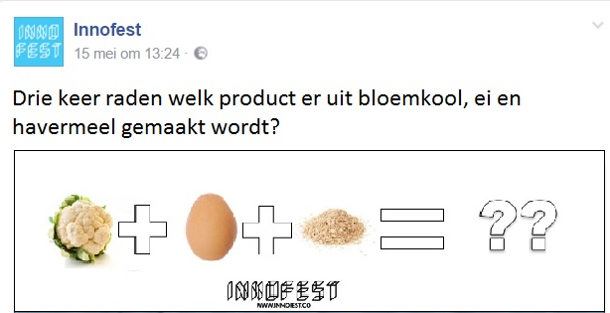
Media product 5 Interactive post

2.2.3 Effectiveness
This communication change is in accordance to the goals of Innofest because Innofest wants to trigger innovativeness in the North of The Netherlands. In order to do this they must be innovative themselves as well.
Using the online communication channels as a means to trigger desire and activating people to contact Innofest is a new approach, since right now the channels are mostly used to create awareness. Henk Rigter, the communication manager, might not accept it since it will take him more time to come up with something out-of-the-box every two weeks. However, the other programmers can help him and send him an original picture or movie when they are doing work for Innofest. A possible barrier can be that Innofest does not want to spend that amount of money on social media advertising (the costs can be found in chapter 6).

2.2.4 Conclusion
The communication channels of Innofest can best be used as a means to create the desire to cooperate with Innofest because all of the interviewed people looked at the social media channels only after they became aware and interested in Innofest. One way of doing this is by creating social media advertisements aimed at the innovative SME in the North of the Netherlands and by creating more out-of-the-box content.

2.3 Step 3: Turn desire into action by means of a direct approach
When the potential cooperation partner successfully completed all stages and the desire is expressed to cooperate with Innofest a direct approach is necessary.

2.3.1 Connection to the theory
This step concerns a policy change because, at the moment, people that expressed the desire to cooperate are referred to the application form on the website. However, it is a lot more personal and easier for the SME when Innofest would use a direct approach: ask the phone number of the SME; talk over the phone about the opportunities, and when there are enough opportunities for both parties; make an appointment to meet.
This is important since 80 percent of the applications come in through face-to-face communication and only 20 percent signs up on the website (personal communication Sterre Broekman, March 9, 2017). Only five out of the fifty-five applications on the website resulted in a cooperation with Innofest (Appendix C, preliminary research) and when it did result in a test with Innofest, people were less enthusiastic about their cooperation with Innofest. Which means they are less likely to become an ambassador. Sander Egbers (personal communication, May 11, 2017) for instance, someone recommended Innofest to him and he applied on the website. He mentioned to not have had any contact with Innofest before the test. He only met people of Innofest when he was already on the festival. He was significantly less positive about Innofest compared to the other interviewees.

2.3.2 Implementation
The recommendation is to delete the application form on the website and put a contact form instead, like media product 5 shows. It will make the step to contact Innofest smaller and will cause for less unusable applications. In addition, stimulating people on the website to contact Innofest by means of a pop-up can make it easier for the cooperation partner to contact Innofest.
Media product 5 Adapted website (without application button with a new pop-up)
Furthermore, when someone expresses to want to work together with Innofest through a face-to-face conversation someone should not be referred to the website: the phone number is asked and the potential partner is contacted.

2.3.3 Effectiveness
This step logically follows from the first two steps. Innofest is already using a direct approach in some cases and this has turned out to be very effective. Only, sometimes, the application form on the website is still used, which has turned out to not be very effective and not create a high level of satisfaction. One of the possible barriers of this communication change is that it takes time to call everyone that has contacted Innofest.

2.3.4 Conclusion
In summary, when someone expresses the desire to cooperate with Innofest they have to be approached directly because the indirect approach via the website did not turn out to be effective. Therefore, the application form can be deleted from the website and instead a contact form can be inserted together with a pop-up stimulating people to contact Innofest. And when someone expresses the desire through a face-to-face conversation, the contact details are written down and that person is called by someone from Innofest.

2.4 Step 4. Stimulate satisfaction through a reflection point after the tests
After the Action phase optionally follows a Satisfaction phase. Which focuses on the contentment of the partners of Innofest after they tested their prototype with Innofest.

2.4.1 Connection to the theory
The findings of the research showed that a moment of reflection is something that could make partners of Innofest more positive about Innofest after the test, which can help to turn them into ambassadors and recommend Innofest to other innovative SMEs. Several cooperation partners indicated that they missed a moment after the tests where the question “How do we go from here?” is answered. The results of the reflection points can be communicated via social media since it clearly shows Innofest’s role and the effect of testing a product with Innofest.
Figure 2 shows that the AIDA(S) model can be seen as a cycle. Since all the steps lead to satisfaction in the end and satisfaction of cooperation partners can stimulate awareness when the partners become ambassadors of Innofest and recommend other people to test with it as well.
Figure 2 A circular AIDAS model
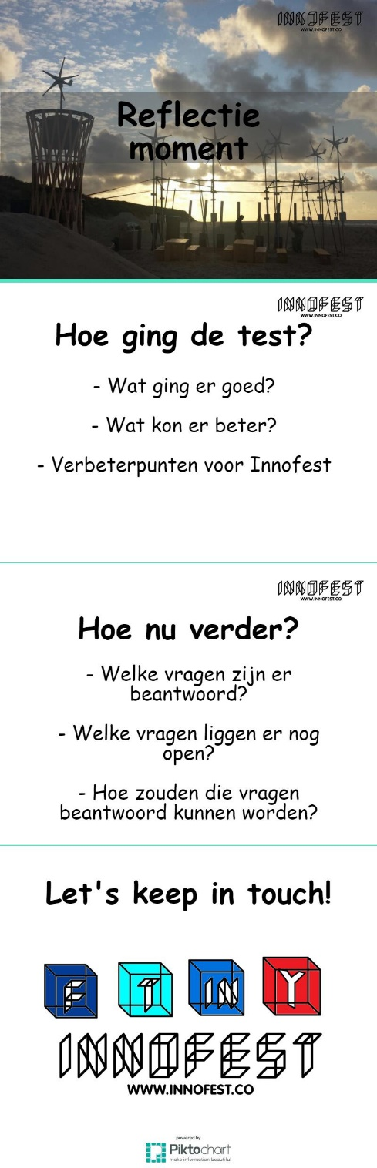

2.4.2 Implementation
The reflection point takes place no more than one week after the test with Innofest, because then it is still fresh in everyone’s mind. There will be at least two people available, one from Innofest and one person responsible for the product that is tested. The person from Innofest leads the meeting. The meeting will be – depending on the amount of things that need to be discussed – between fifteen and thirty minutes.
The meeting will first discuss how the tests went: what went well, what could be improved and what kind of aspects Innofest could have done better. After that the question: “How do we go from here?” will be answered. Which focuses on the questions that are answered during the tests and the questions that are still unanswered. Finally, Innofest’s spokesperson talks about staying in touch and updated on each other’s work, among others by means of social media. And the date of the event explained in step 1 will be told.

2.4.2 Effectiveness
This step of the communication strategy is in line with Innofest goals because Innofest really wants to develop someone’s product. When a reflection point would help someone with further developing their idea Innofest would definitely accept this policy change. Just like with the other communication measures a barrier here is that it costs time and the programmers of Innofest have a busy life.
Media product 6 Presentation reflection point

2.4.3 Conclusion
The last step concerns stimulating the satisfaction of cooperation partners by means of a moment of reflection after the tests. The internal aim of this reflection moment is the development of the partner’s prototype, the external aim of this moment is that the partner will be more satisfied about their experience with Innofest so the partner will be more likely to become an ambassador.

4. Communicating the policy changes
The different policy changes need to be communicated to the people involved in these changes. Otherwise miscommunication and confusion will take place. The results and the recommendations coming from this research project can be presented and discussed in the team meeting, which takes place once every two weeks. Emphasis should be on the third and fourth step. The people have to know that they need to react actively when someone expresses the desire to cooperate with Innofest, rather than act passively and refer them to the website. Sterre Broekman, responsible for the applications on the website, should be made aware of the replacement of the application form into a contact form and still be in charge of handling all the people that contact Innofest via the website. The people working for Innofest should also know that from now on, after a test they are responsible for scheduling a reflection point with the cooperation partner that has tested. The reason why this is happening should be clearly explained. The changes in the social media usage are mostly done by Henk Rigter, however, when someone encounters a funny fact or is at an interesting location for Innofest, it is important that they make a picture and send the information to Henk so he can post it. The first step concerns all of the people working for Innofest and the people working together with Innofest. Specific attention needs to be given to how the people are invited and what who’s role is in the organizing of the event.

5. Facilitation in Communication
The communication strategy should facilitate Innofest’s communication aimed at convincing innovative SMEs to sign up for Innofest. All the steps that are made that the potential partner of Innofest can go through all stages of the AIDA model more easily and subsequently see less barriers to cooperate with Innofest. How the communication exactly is facilitated is explained more in-depth in the sections 2.1, 2.2, 2.3 and 2.4. An overview of how the communication is facilitated can be found below.
The different steps selected facilitate the communication in the following ways:
- Step 1 – use face-to-face communication as a means to create awareness – makes sure that the people aware of Innofest have a clear understanding of what it is and no misunderstandings occur (more about this in section 2.1).
- Step 2 – use online communication channels as a means to create desire – facilitates the communication because more leads are generated and people will contact Innofest themselves (more about this in section 2.2).
- Step 3 – turn desire into action by means of a direct approach – makes it easier to apply to Innofest and therefore more people dare to take the step (more about this in section 2.3).
- Step 4 – stimulate satisfaction through a reflection point – facilitates in the communication by means of customer satisfaction and making the partners of Innofest into ambassadors (more about this in section 2.4).

6. Planning and organising
The recommendations for the communication strategy are aimed at improving the external communication in order to increase the amount of applications of innovative SMEs in the North of the Netherlands. In this chapter a planning for the implementation of the advice is presented and an indication is made on how the progress is going to be monitored. Furthermore, a communication strategy based on the research objective is build and divided into concrete steps for implementation.
Implementing the communication strategy will take five months. It is, however, an ongoing strategy that repeats itself: a yearly event for the partners of Innofest; social media as an ongoing tool to create desire; a constant direct approach to stimulate people to sign up and always a reflection point after a test. Though, it is of major importance that, after the five months, the effectiveness of the new communication strategy is measured and evaluated. Based on the evaluation, new improvements for the communication can be made. The time between July and November is an adequate timeframe to measure the effectiveness, since all the steps of the communication strategy have been implemented. The festivals in July and August are an excellent time to make out-of-the box content for social media to be used throughout the rest of the year. After the festivals, moments of reflection take place to increase the satisfaction. The event for the partners of Innofest in September is just after the festival season and just before the acquisition of new cooperation partners for Innofest and September, October and November can be used to recruit new cooperation partners by means of a direct approach. A complete overview of the planning of the communication strategy can be found in figure 6.
The strategy can be divided into three phases:
- The team briefing and first steps.
- The communication activities.
- The evaluation phase.
The first phase takes around a month, since it is of major importance that the people working for Innofest have to get used to the idea of the changes in the communication before the strategy is implemented. First, a team briefing is organized to inform everyone about the changes that will happen, explain why these changes are going to happen and how the changes affect them. At that meeting it is also decided who is in charge of what activity. After the meeting a vacancy is send out in order to find an intern to organize the event for the current cooperation partners of Innofest.
Furthermore, the finances need to be arranged. It needs to be known where the money comes from and if there are possibilities to do it cheaper. Meanwhile, Henk Rigter is working on creating out-of-the-box content for the social media. In the third week Henk will conduct interviews with several candidates for the intern position and select one.
The communication activities is the most important part of the communication strategy. Each action that needs to be undertaken for each step is explained.
The event for Innofest’s partners
The first step to convince the innovative SME is using face-to-face communication to create awareness and desire by means of turning partners into ambassadors through an event. The planning and organizing of the event goes as follows: after the team briefing and the first steps, the communication activities are implemented. The intern that organizes the event for Innofest’s partners starts on the first of August. He or she starts by making a list of all the invited people in consultation with Innofest and creating and sending an invitation to those people. After that, he or she needs to make sure the location and the catering is arranged. Furthermore, a good photographer needs to be found that can make and edit pictures of the event. A sound system needs to be arranged in order for people to be able to pitch their ideas through the microphone and all the necessary products such as a notebook, sticky notes, pens, sheets of paper etcetera need to be bought. The event will be held on the 14th of September. After the event the intern sends out a thank you e-mail with the photos made at the event.
The costs of the event will be €1,770 (see figure 3). The room in De Wolkenfabriek is hired between 15:00 to 20:30, dinner and three drinks are included plus tools to make notes and brainstorm for forty people. This is a pretty rough estimation, since the dinner can possibly be provided by Eva, who does the catering for Welcome to the Village, for a lower price. In addition, there might be someone available that wants to make pictures for free in exchange for participating in the event.
What | Price
Production costs (staff and rent of room and materials). The room is hired from 15:00 to 20:30 | €750
The dinner served for 40 people by Foodfellas | €600
Three consumptions for each person | €240
Photographer (a student) | €50
A notebook (€2), sticky notes (€0,50), pens (€0,25), sheets of paper (€0,50) per person times 40. | €130
Total | €1.770
Figure 3 Costs of events
Social media to create desire
The second step in the communication strategy is to use social media as a means to create desire, this is an ongoing process. The paid Facebook and LinkedIn advertising starts at the first of August and ends at the first of December. Before that, Facebook live is used to show the different tests on festivals for the social media of Innofest to trigger the desire of innovative SMEs. In addition, several brainstorm sessions are held in order to create out-of-the-box content for Innofest’s online communication channels.
A Facebook campaign targeted at generating leads for four months aimed at the innovative SME will, according to the statistics of Facebook, collect one to nine leads and reach between 360 to 1.900 per day. This means the advertisement will generate on average five leads per day and reach, on average, 1,130 people per day. Which means the advertisement would result in 610 and a reach of 137.860 people in four months.
LinkedIn is less specific in showing the amount of leads coming from the advertisement. They show that there are more than 5.000 people that reach the targeted of innovative SMEs in the North. As LinkedIn is still quite new with advertisement, advertising with it is still a test. After the first of December, the amount of money spent on LinkedIn can be decreased or increased depending on the effectiveness. An overview of the costs can be seen in figure 4.
What | Price
A highly targeted ongoing Facebook advertisement | €250
A highly targeted ongoing LinkedIn advertisement | €150
Total | €400
Figure 4 Costs social media advertising
Turning desire into action by means of a direct approach
The third step concerns turning the desire into action with a direct approach. This is also an ongoing approach with only the replacement of the application into a contact form and creating the pop-up on the website being fixed deadlines. There will be no costs involved for this step. Though, it does cost the programmers more time to call and meet with the people before the tests.
Stimulate by means of a reflection point
The final step is to stimulate satisfaction by having a reflection point after a test of a cooperation partner. Naturally this happens no more than two weeks after the festivals, because. The person of Innofest present at the reflection point is usually the one that has had the most contact with the partner. This step also does not involve many costs, except for the extra hours the people working for Innofest have to put into it.
After the communication activities have been conducted, the evaluation phase starts in November by measuring the amount of new, useful applications compared to last year. In week 44 the results of the measurements are discussed together with the satisfaction of the people working for Innofest regarding the changes in communication. Based on that meeting a conclusion is written to improve the communication of Innofest even further.
In figure 5 a visual presentation is shown of the time planning of the communication strategy of Innofest.
Figure 5 Communication strategy planning

7. Conclusion
The aim of this report was to make recommendations on changing the external communication in order for more innovative SMEs to sign up. The findings of the research and the recommendation coming from this research resulted into many interesting insights that could make a substantial improvement. The different stages of the decision making process were analysed and adapted based on the AIDA model. Based on that the following four changes in the external communication were recommended:
- To use face-to-face communication as a means to create awareness;
- To use social media as a tool to create desire;
- To turn desire into action by means of a direct approach;
- To stimulate the satisfaction phase by implementing reflection points.
It takes around five months to effectively implement the new communication strategy and measure the effectiveness. It is important for Innofest to keep reflecting on what they are doing and keep looking for possibilities to improve. Then, Innofest will have no problems with growing bigger and expanding its idea internationally. Innofest is a very flexible organization with very entrepreneurial people working for it with an open mind-set. If Innofest continues being like that it will definitely achieve its goals.

Reference List
Anderson, J., Narus, J., & Van Rossum, W. (2006). Customer value propositions in business markets.
Harvard Business Review, 84, 91– 99. htttp://doi.org/19707489/

Brosseau, D., & Kawasaki, G. (2013). Ready to be a thought leader? How to increase your influence,
impact, and success. San Francisco, CA: Jossey-Bass.

Carlson, J. & Zmud, R. (1999). Channel Expansion Theory and the Experiential Nature of Media
Richness Perceptions. The Academy of Management Journal, 42, 153 -170. http://doi.org/10.2307/257090

Daft, L., & Lengel, H. (1986). Organizational information requirements, media richness and structural
design. Management Science, 32, 554 – 571. http://doi.org/7020553

Dohen, M., Schwartz, J., & Bailly, G. (2010). Speech and face-to-face communication – An introduction.
Speech Communication, 52, 477 – 480. http://doi.org/10.1016/j.specom.2010.02.016

D’Urso, S., & Rains, S. (2008) Examining the Scope of Channel Expansion: A Test of Channel
Expansion Theory With New and Traditional Communication Media. Management Communication Quarterly, 21, 486 – 507. http://doi.org/10.1177/0893318907313712

European Commission (n.d.) What is an SME? Site:
http://ec.europa.eu/growth/smes/business-friendly-environment/sme-definition_en [retrieved on: 18/05/17]

Franken, J. Stoop, J. (2009). Bakfiets, garnaal en stormparaplu : over eigenschappen van innovatieve
ondernemers. Amsterdam: Business Contact.

Innofest (n.d). Hoe werkt het. Site: http://innofest.co/over/hoe-werkt-het/ [Retrieved on: 16/02/17]

Kamer van Koophandel (2017) Adressen downloaden. Site:
https://www.kvk.nl/handelsregister/adressenbestand/ [retrieved on: 24/05/2017]

Kamer van Koophandel (2016) MKB Innovatie Top 100. Site:
https://www.mkbinnovatietop100.nl/site/top-1002016 [retrieved on: 22/05/2017]

Leesmonitor (2016) Wie lezen er? Site: https://www.leesmonitor.nu/wie-lezen-er [retrieved on:
23/05/17]

Meer, I., Sival, R., & Veer, N. (2016). Nationale Social Media Onderzoek 2016: Newcom
Research & Consultancy B.V.

Michaelson, D., & Stacks, W. D. (2011). Standardization in public relations measurement and
evaluation standardization. Public Relations Journal, 5(2), Spring

Nunen, A. (2016). Project Plan Innofest: Festival Driven Innovation.

Patel, N. (2015). Do You Really Need More Facebook Likes? The Data Driven Answer: Kissmetrics.
Site: https://blog.kissmetrics.com/facebook-likes-data-driven-answer/ [retrieved on: 07/02/2017]

Sprung, R. (2013). When Press Releases Do (and Don't) Help Your Marketing: Hubspot. Site:
https://blog.hubspot.com/blog/tabid/6307/bid/34024/When-Press-Releases-Do-and-Don-t-Help-Your-Marketing.aspx#sm.00010xrk53csxcqvzdm13yieka6wl

Sun, X., Lin, H., & Xu, K. (2015). A social network model driven by events and interests. Expert
Systems with Applications, 42, 4229 – 4238. http://doi.org.proxy.hanze.nl/10.1016/j.eswa.2015.01.020

SNN (n.d.) Samenwerkingsverband Noord-Nederland. Site: http://www.snn.eu/ [retrieved on:
22/05/2017]

Verschuren, P., & Doorewaard, H. (2013). Designing a research project. The Hague: Boom Lemma
Uitgevers.

Westmeyer, S., DiCioccio, R., & Rubin, R. (1998). Appropriateness and Effectiveness of
Communication Channels in Competent Interpersonal Communication. Journal of Communication, 48, 27 – 48. https://doi.org/10.1111/j.1460-2466.1998.tb02758.x

Wiyaya, B. S. (2012). The development of hierarchy of effects model in advertising. International
Research Journal of Business Studies, 5(1), 73–85.

Appendices 1 Preliminary Research

Appendix A Communication Plan Innofest 2017, Tessa Hagen
This is not the complete communication plan, but only the points relevant to this research report:
- The main goal of the communication is to convince potential cooperation partners.
- In the end Innofest wants to be the example of the innovation power festivals have and an initiative that stimulates new activity in (the North of) The Netherlands
- Benevolent, innovative entrepreneurs: It is important to stimulate entrepreneurs of the North to share their ideas and test them. Convincing them to invest time (and money)in a test is not easy. Entrepreneurs are busy and do not know whether they can actually earn money from a test. The message of Innofest reaches them best through fellow entrepreneurs (who have tested something successfully) or via events where Innofest presents itself in a presentation.
Communication partners: business networks such as MKB Noord or NOM.
Goal: To convince benevolent entrepreneurs to test their idea on Innofest.
Most important communication tools: website, newsletter, mesh shorts, reunions of entrepreneurs associations, service clubs and commercial circles; contact with other businesses and articles in entrepreneurs magazines.
Concrete actions: Searching for the most innovative entrepreneur of the North together with the media of the North of The Netherlands; invite benevolent entrepreneurs for a tour on festivals; talk at network reunions and service clubs.
Example: a successful example is the chatbot that entrepreneurs built with Innofest.
- Traditional, non-innovative SMEs: more traditional entrepreneurs that do not necessarily want to innovate in their day to day business. Innofest wants to inspire them by showing them good examples of innovation.
Communication partners: business networks such as MKB Noord or NOM.
Goal: to inspire traditional entrepreneurs with good examples of innovations.
Most important communication tools: website, newsletter, mesh shorts, reunions of entrepreneurs associations, service clubs and commercial circles; contact with other businesses and articles in entrepreneurs magazines.
Concrete actions: Searching for the most innovative entrepreneur of the North together with the media of the North of The Netherlands; invite benevolent entrepreneurs for a tour on festivals; talk at network reunions and service clubs.
- Channels Innofest
a) Own channels.
Facebook content: innovation news from other people, Innofest news, case-videos, calls for actions, explanation of the different steps of innovation, sharing of relevant content partners, pictures and videos of tests on festivals, testimonials influencers, something ‘fun’. Updated twice a week.
Twitter content: Innofest news, news of partners, news of developments in the North of The Netherlands, call for action, retweets of partners or professionals on innovation. Update: five times a week.
Website content: no fixed content, Innofest news, new cases, testimonials of ‘influencers’ such as Martijn Aslander, Ronald Mulder. Update: once a month.
Content newsletter: Innofest news, testimonials of ‘influencers’. Update: when there is news (at least every two months).
Press releases: news relevant for the press, such as tests on festivals. Update: when there is relevant news.
b) Channels partners: all partners receive an Innofest PR kit
- Why join Innofest? As a start-ups, SME, creative person or entrepreneurial student you want to know whether your innovation works as soon as possible. Innofest helps to achieve this: Innofest takes care of networking at and around a festival with people that can help your innovation further; Innofest offers a temporary mini community with questions around energy, waste, water and more, to test the technical aspects of your innovation; Innofest gives access to an enormous amount of end users: festival visitors.
- Why testing? It is an indispensable part of the innovation process. A good idea gets each phase more concrete. Meanwhile there are various questions asked. Such as: which problem does this idea solve? What is the added value against already existing ideas? Who needs this idea? Who wants to invest in this idea? If I let go of condition A, B or C, does it still work? A test on a festival of Innofest can take place in various phases of the idea- or product development.

Appendix B Media Coverage Innofest
- GIC: http://www.gic.nl/wonen/drie-ton-subsidie-voor-innofest-innovatie-op-noordelijke-festival
- Gezinsbode: http://www.gezinsbode.nl/evenementen/64271/bewoners-omgeving-paradigm-festival-aan-het-woord-over-geluidsoverlast/
- Dagblad van het Noorden http://www.dvhn.nl/economie/Iedereen-zat-op-oud-frituurvet-21437075.html
- Numrush: http://numrush.nl/2016/01/14/innofest-nederlandse-festivals-willen-een-proeftuin-voor-innovatie-zijn/
- LC: http://www.lc.nl/friesland/Festival-proef-in-Groene-Ster-21460164.html
- Dagblad van het Noorden: http://www.dvhn.nl/groningen/Festivals-als-innovatieve-speeltuinen-21108138.html
- NOS: http://nos.nl/op3/artikel/2130012-misschien-was-jij-deze-zomer-ook-wel-festival-proefkonijn.html
- VPRO: http://3voor12.vpro.nl/lokaal/friesland/nieuws/2016/welcome-to-the-village-2016/Prominente-rol-voedselprogrammering-wttv.html
- FD: https://fd.nl/economie-politiek/1183025/programmeurs-werken-aan-chatbot-voor-festivalbezoekers

Appendix C Applications via The Website
Time of application | Name | Organization | Location | Idea + testing | Result
4/28/2016 | AXL Hofstede | Werkgroep OntwikkelingsTechnieken (WOT) | Enschede | A student association that wants to work on technical solutions for developing countries. They want to demonstrate their models and explain them to a broad audience | No result
4/30/2016 | Fleur Bakker | Refugee Company | Amsterdam | To connect refugees with companies. And to use festivals as a lab for these new entrepreneurs in The Netherlands | No result
5/3/2016 | Arno van Herwijnen | Dopper | Haarlem | A water wall as a solution for drinking water at festivals. | No result
5/11/2016 | M. Bloemenberg | De Kledingbibliotheek | Utrecht | They want to sell their products. | No result
5/17/2016 | Hans Peter Föllmi | Tiny Tim House | Haarlem | They want to show the second model of a Tiny Tim house on the festival Oerol. | Tested on Oerol 2016
5/17/2016 | Lex Rijkers Meinen | Support markt | The Hague | They want to reduce waste by working with returnable deficit on waste. They want to test how to organise this logistic wise behind the screens. | They pitched their idea on FestivalDeraa. They won the Smart Festival Award, to develop their idea further
5/22/2016 | Marieke Verdijk | Lapjestas | Groningen | They want to reduce the waste of textile by producing other products of textile that normally would be thrown away. | They pitched their idea on FestivalDeraa
6/2/2016 | Joris Hoeboe | Hemelwater | Amsterdam | They want to make people aware of the problem of intense weather conditions and provide them with solutions. They do this by making products of rainwater. | No result
6/6/2016 | Rutger Koffeman | Team Solar Drive | Delft | They want to help an entrepreneur in Ethiopia increase their capability of production. They want to test the idea they have for this. | No result
6/6/2016 | Marten Hylkema | MHB eventfacilities | Bolsward | Use natural energy sources during festivals and events. | No result
6/22/2016 | Steven Bakker | INCONTROL Simulation Solutions | Utrecht | They produced a tool to execute stimulation studies for visitor infrastructures on big events. In order to make evacuation easier. | No result
6/22/2016 | Chris Boer | CrowdEvents | Amsterdam | They want to test a tool that collects information of festival visitors anonymously to be used to make the festival safer. | No result
6/29/2016 | Rigt Oostenbrug | Simmerdeis (theater en muziekfestival Smallingerland) | Drachten | A festival that wants to cooperate with Innofest. | No result
7/8/2016 | Egbert Pikkemaat | 3DMail | Groningen | He wants to make a piece of art on a festival in a playful manner, using waste of the festival. | No result
7/12/2016 | Maarten Overeem | Idee101 | Assen | He has no particular idea but wants to be updated on news regarding Innofest. | No result
7/13/2016 | Faye Oosterhoff | dUH! | Delft | A coin that has value based on the environmental friendliness of the place where you are. | No result
7/15/2016 | Sander Egbers | LoQit | Drachten | To test a locker that can be opened with your mobile phone and reserved when you get your festival tickets. | Tested on Eurosonic 2017
7/20/2016 | Stijger | stijgerart.nl | Katwijk | Het wants to present his product. | No result
7/25/2016 | Cover-Tray | GEAK BV | Westervoort | They want to present their product: a beertray with several features | No result
7/30/2016 | Remy Angel | Remedy Services | Nijmegen | A movable roof for podiums for when it rains, that at the same time collects rainwater in order to reuse it. | No result
8/1/2016 | Mark van Esterik |  | Laren gld | A GPS bracelet in order to find your child. | No result
8/10/2016 | Albert Sterenborg | Zonactief BV | Emmen | Sun energy on location. | No result
8/13/2016 | Jacob van der Meer | Amsterdam RAI | Amsterdam | He wants to have a conversation | No result
8/18/2016 | James Zhou | Hesjamar V@platforms | The Hague | Web shop platforms | No result
8/22/2016 | Peter de Man | Symphony of Fire | Deventer | A sustainable form of fireworks | No result
8/26/2016 | Janneke Nijmeijer | Fairtrade Cocaine | Amsterdam | To produce a sustainable form of cocaine. | No result
8/29/2016 | Keshia van beusekom | - | Utrecht | She wants to help with the projects of Innofest. | No result
8/30/2016 | Ingi Mehus | Pocket Stories | Haarlem/Amsterdam | Replace the fear of immigrants with the same curiosity we have for traveling by means of a book. | No result
8/31/2016 | Laurent Hennekens | cafe de meister | Geleen | Social experiment | No result
8/31/2016 | Florian Wolff | Florian Wolff | Utrecht | He wants to develop his idea of the green machine (people cycling while he sings) more. | No result
9/1/2016 | Leonard Passchier |  | Rotterdam | To hang up the branches that fell of the tree again in the tree. | No result
9/6/2016 | Jasper Toeli | Jasper van den Elshout Producties | Den Bosch | To collect all the stuff that is left at the end of a festival and create something from it. | No result
9/7/2016 | Yoram Ish-Hurwitz | Oranjewoud Festival | Oranjewoud | They want to stimulate out-door classical music but still face challenges they want to brainstorm about. | No result
9/9/2016 | Dafne Wiegers |  | Amsterdam | A chair of cupboard. | No result
9/16/2016 | Lars Bodewes | 110% Lersjens | Groningen | An application that collects information to improve your organization. | No result
9/19/2016 | Ellen Hoek | Stichting BouwTalent Friesland | Leeuwarden | To let the students of construction work build a temporary artwork on a festival. | No result
9/22/2016 | Sebastian Kox | Stichting oneseconds | Utrecht | To stimulate people to think about faith by creating a blessing machine that you can program yourself. | No result
10/13/2016 | Derren de Jong | WasteWise | Emmen | A tool to separate waste more effectively | No result
 |  |  |  |  | No result
10/13/2016 | Jaap Adamse | Festival Duurzaam veranderen | Groningen | He wants to have a conversation about Innofest on his festival | No result
10/17/2016 | Inou Heideman | Loratec BV | Winterswijk | They want to track the flow of people and waste | No result
11/24/2016 | Gerrit Miedema | Festival de Opening | Emmen | They want to test their smart waste bin. | No result
12/19/2016 | Marcel Bleeker | Hanze Institute of Engineering | Assen | Counting the festival visitors | Tested on TT festival 2016
1/7/2017 | Chris Garrit | EM2 | Groningen | They build a sustainable concert hall in Groningen. They want to have a look at the test panels during Eurosonic. | No result
1/9/2017 | Nathan Van Gelder | Bevrijdingsfestival Drenthe | Assen | To create a sustainable festival | No result
1/23/2017 | Wouter Nijst | MAND | Groningen | A plastic cup that you can put around your belt. | No result
1/24/2017 | Jaime | Afwerking | Amsterdam | They want to develop the module they have created further. | No result
2/15/2017 | Natasja Bastein | FireFly Drone | Groningen | A drone that can provide light when necessary. And test this idea. | No result
2/21/2017 | Inger Weernink | Grunneger Power | Groningen | They want to create awareness of GP. | No result
2/27/2017 | Roel Bleumer | Volta Energy | Westervoort | They want to test their second prototype that is an energy bank with sun energy. | No result
3/1/2017 | Susan Ophorst | Hogeschool Van Hall Larenstein | Leeuwarden | She wants to bring fight dogs under attention | No result
3/1/2017 | Kneelis | Creatief | Purmerend | To generate energy with the amount of people on a festival | No result
3/2/2017 | Kimberly Kluskens | Memetica | Eindhoven | She wants to create a new image surrounding cannabis by means of an art installation | No result
3/19/2017 | Kneelis | Kneelis | Purmerend | A water pump that pumps by means of sun energy. | No result
Figure 2 Applications via the website

Appendices 2: The research

Appendix A The interviews

1. Interview Marcel Bleeker
Date: 01/05/2017 | Location interview: through Skype
Company: Telsensor | Duration: 27 minutes
Location SME: Groningen | Tested his product with Innofest
- Could you shortly explain what Telsensor does and what your role is?
We originally started for the municipality Groningen because they wanted to know how many people were getting on the train each day. After that it developed further. I work on it with one other boy.
- How far are you with the development of Telsensor?
We did a few tests already, but we would like to test Telsensor on a bigger scale.
- How much time per week are you spending on Telsensor?
Around four to five hours a week. Mostly because I like to work on it, not because I want to earn a lot of money.
- What kind of activities keep you busy besides Telsensor?
I am in school and I do voluntary work at the cemetery in Assen and I give advice about sustainable living in Veldhoven.
- Which online communication channels do you use?
Mainly email, Whatsap and Facebook. The rest I do not use because it costs me too much time. I check the news on NRC.nl or on TV. Mostly I check the channels every day, how often a day depends. Facebook I do not check that often but I do check email regularly.
- Which offline communication channels do you use?
I make a phone call every now and then, I listen to radio 1. I do not read the newspaper, nor send letters. I do not go to network reunions or other events on my own, but I mostly go when I am invited.
- Did you actively search for a way to test your prototype?
The decision to test the prototype actually came after I got in touch with Innofest. I met them on a meeting for the TT festival, a teacher had invited me to go there. Innofest was also present at that meeting, we started to talk and one thing led to another.
- How do you find cooperation partners for Telsensor?
I have a list of leads that I can call. First on my lead list are the event engineers that I met during the tests of Telsensor on Vlieland.
- Why did you eventually decide to test your product with Innofest?
I saw potential in my project and I wanted to expand it.
- Did you consider other options?
No I do not really know similar organizations.
- Was the concept of Innofest clear to you from the beginning?
Yes it was clear to me from the beginning that they wanted to help start-ups develop their innovation.
- Which aspect of Innofest appeals to you the most?
I liked it that they had all their facilities available, they knew people, arranged transport, places to sleep. And you did not have to pay, which was beneficial for us.
- What kind of expectations did you have before you started your tests with Innofest?
I did not really have clear expectations. I liked the experience and it would look nice on my resume. As a student, you do not have a lot to lose in a situation like that.
- What would keep your from testing your idea with Innofest?
For some people it might take too much time.
- Did you ever visit the communication channels of Innofest?
I scrolled through their website after I talked with them and I looked up my own interview. For the rest I did not really look at it.
- What do you think of the website?
It looks clear and neat to me.
- Which people/companies do you think of first when thinking about innovative enterprise?
I think Daan Roosegaard is interesting. He developed different very interesting art projects, including a cycling path laid in with glass who gives light at night. I do not like all of his projects, but some I like a lot.
- Do you know Innofest Plus?
No never heard of them.
- *Explanation Innofest Plus* Would you say Innofest Plus would be beneficial for Telsensor?
Help is always handy. But I always have a gut feeling that nothing is for free and you have to give them something back. This is different with Innofest because they are sponsored.

2. Interview Jacques ten Kate
Date: 02/05/2017 | Location Interview: through the phone
Company: DCP Ingredients | Duration: 23 minutes
Location SME: Groningen | Did not test with Innofest
- Could you shortly explain what DCP Ingredient does and what your role is?
DCP Ingredients develops proteins in an efficient way for the food industry. I am the CEO and founder. I saw that there was a market for easy to produce proteins. We have a patent on the way we produce proteins.
- How long does DCP Ingredients exist?
From 2012.
- How much time a week do you spend on DCP Ingredients?
I work full-time at DCP.
- Could you explain what an average working day looks like?
I am mostly a lot on the phone and also a lot on the road and in foreign countries because DCP Ingredients also operates internationally.
- What activities keep you busy besides DCP Ingredients?
Education related things, I am in the school board.
- Have you ever heard of Innofest?
No I have never heard of it.
- *Explains concept of Innofest* would it be an option for your company?
No because we mainly work business to business.
- What online communication channels do you use?
I look at LinkedIn three times a week and I use Whatsap daily.
- Which offline communication channels do you use?
I call a lot and I sometimes go to fairs.
- What information do you consider trustworthy?
Information I find on LinkedIn.
- Which channels do you use when searching for cooperation partners for DCP Ingredients?
I use my network, we work together with a gelatine company that we can contact a lot. In addition, I search on the internet or look on LinkedIn.
- How did you test your products?
We are constantly testing our products. We conduct these tests ourselves and we work together with experts in the branch that can help us move forward.

3. Interview Boris Geheniau
Date: 04/05/2017 | Location Interview: through the phone
Company: Fundamental Media | Duration: 18,13 minutes
Location SME: Groningen | Did a test with Innofest

- Could you shortly explain what Fundamental Media does and what your role is?
Fundamental media is an online marketing bureau. I am founder and shareholder. It was founded in 1999. Through the years we specialized in real estate communication. We are with 24 people.
- What do you do on an average working day?
We start with registering the hours of the previous day. To make sure all the projects can be controlled and finished within the agreed time. Then, the different teams or the function groups have a short stand-up. We have three function groups: account and sales, project management and technique. After that everyone works on their own projects.
- Do you have any hobbies or activities that you do besides your work?
Besides Fundamental Media I have a couple of other businesses. I founded them, I am still owner but they have their own management. I invest in some American start-ups. Furthermore, I have five children that need some attention. I am a musician, I like to drum. And all my children like to play football so that takes time.
- Which online communication channels do you use?
LinkedIn, Instagram, Twitter, Snapchat, YouTube, Medium (a blog platform), WeChat. All the channels are important since they are a part of the campaigns we sell to our customers. I use all the channels work related and private. Email I use less and less, I prefer Slack. I read the news online (nu.nl, Google+)
- How often do you use the channels you just mentioned?
Very often, sometimes I use one a little bit more than the other. Mostly I visit all of the channels daily, I do not post something every day.
- Which offline communication channels do you use?
Only mobile phone.
- When you are really looking for reliable information that could help Fundamental Media develop which channels do you use?
I often look at indman.com, The Verge, The Next Web, Vice, The Huffington Post and The Newyork Times.
- Information at which media do you not consider reliable?
The information that I consider the most irrelevant are on Twitter and Facebook and the more relevant channels are LinkedIn, also from a more professional perspective, you know the people on that platform which makes it more reliable.
- How did you eventually arrive at Innofest?
I was a part of a panel about a possible new festival with Eurosonic Noorderslag. I had a certain idea about this and before me Anna (van Nunen) spoke about her ideas and we matched exactly. So the decision was made quite quickly to work together. Anna was a person that I really wanted to work together with and fortunately she had a team behind her.
- Did you talk with other organizations before you spoke with Anna?
Yes it was a search.
- Which aspect of Innofest appealed to you the most?
The independence of Innofest, the own vision about how you should do something. The reason that I did not want to work with other people was because they always had political (belangen) or hidden agendas. Innofest is really clear about where they stand for and why they do certain things.
- What aspects of Innofest could be improved?
I cannot think of something. I mainly communicated with Anna and if she stands for the same things Innofest does: trust, initiative, enthusiasm and solution-based thinking.
Did you ever visit the communication channels of Innofest?
No.
- If you think about innovative enterprise which people or companies do you think of first?
I think Tim Fares is inspiring and innovative, Gary Vaynerchuck, Spencer Rascoff.
- Why do you think these people are innovative?
They have had an idea and went all-in for that idea. At the beginning people did not really believe in the idea, but they pushed through and became pretty successful and they did not want to make compromises.
- Would you take the advice of the people you mentioned seriously?
Absolutely, when they say something is good. I almost immediately believe them.

4. Interview Rene Bolhuis
Date: 04/05/2017 | Location Interview: Bedum
Company: Horus | Duration: 16,33 minutes
Location SME: Bedum | Did not test with Innofest
- Could you shortly explain what Horus does and what your role is?
I am the founder of Horus. I started off with the idea that I wanted to combine cameras and GPS so I could easily make comments from a photo. He saw that what he was looking for was not there so therefore he began with Horus.
- How long does Horus exist?
Horus officially started in 2011 and I started providing services in 2006.
- How many people are working at Horus at the moment?
25 people.
- What does a normal working day look like approximately?
My workdays vary greatly. One part is supervising the people that work for me. Another part is presales, I go to customers that want something but do not know exactly what. Besides that I try to assemble a product that a client thought of. And I supervise and build on actual end products. I have a very mixed working day with a lot of traveling which takes a great deal of time.
- Which activities keep you busy besides Horus?
I bought a boat and furthermore I have children.
- On which online communication channels are you active?
I do not use a lot of online communication channels, Horus is active on Twitter, Facebook and LinkedIn. But I am not. I have a LinkedIn account just because people can find me, but I do not use it. Email I use a lot, around fifty times a day.
- On which offline media are you active?
I call fifty to hundred times a day. I try to see the news once a day but I actually never read newspapers.
- When you are really looking for reliable information that could help Horus develop which channels do you use?
I try to really rely on my feelings when I decide something. Because when you do something new there is always a risk. I have a network of people around me that have knowledge about certain things. Especially when I doubt about specific subject I inform them. For instance I have a financial director that knows a lot about finance and I have someone else for marketing.
- Do you go to network reunions?
No I never go there.
- At a certain moment in time you had to test your product, how did you do that?
We were offering our service with the help of our product and developed our product while we were offering the service. In this way we got a lot of experience with the system and you know how to fix your own product. We did this for around two to three years. At a certain point in time we decided our product was ready to be sold.
- Did you use any external partners when testing your product?
Not really, only on the safety side, we asked the police and the army to test our product.
- Did you ever come across Innofest when you did the tests?
No never heard of them.
- *Explanation of Innofest* if I explain it like this does it seem like it has value for your company?
We are not really active in the area of festivals except for the fact that we recently started with some live stream products.
- It is not really the festival that is the most important, it is really focused on the entrepreneur and developing the prototype it does not necessarily need to be on the forefront.
Yes, it could be possible. But we mostly let the customer do its own tests, when they want to change something they come to us.
- How could Innofest change in order to be interesting for a company like Horus?
This is not an easy question since we do a lot of different things. You rather have someone else do the things that cost the most time and do not earn you money.
- So if Innofest would help with those things it would be attractive for Horus?
Yes definitely, if they could help with some practical aspects of the tests that would be very helpful. The biggest advantage for me would be extra people helping.
- What would really keep you from participating with Innofest?
To be honest I am actually up for anything that would be beneficial for both parties. But you do need to see an aspect where you could improve in by participating.
- Would you be interested in for instance participating in a competition for the most innovative SME of the North?
Well it is not really something I like a lot but we are deliberately participating in the SME top 100 for example. I like it to be in the news every once in a while. I think it is really important that innovation is very close by a paying customer. You often see with innovative things, that there is someone, a budget and a good belief but no paying customer. I think it is very difficult to assess it because it can all be great but someone needs to pay it. This is the reason why many innovative SMEs fail.
- What do you think about the statement that innovative SMEs mostly focus on their own product or idea and therefore more difficult to reach because they do not really think about how to communicate it to the outside world.
I think that is a true statement.
- If you think about innovative enterprise which people or companies do you think of first?
I think Innovative Technical Solutions(ITS), Drachten, they have a lot of knowledge about technique. Know exactly what exists in the world and above all they know really well what does not exist in the world and is actually quite easy to make. And they are able to find a buying client for this. When I think of innovative enterprise I think of people with vision that are able to have a successful business and can imagine the wants and needs of customers in the future. For instance Connection Systems.
- If the people that you consider leading in the area of innovative enterprise give a certain advice would you take it more seriously?
Yes often I would take those people more seriously instead of big multinationals, we work together with a lot of them and sometimes we brainstorm but you never come to creative solutions. But if other people have a good advice I mostly take this into consideration.

5. Interview Jan Melein
Date: 08/05/2017 | Location Interview: Warten
Company: Hydrowashr | Duration: 37,24 minutes
Location SME: Warten | Did a test with Innofest

- Could you shortly explain what Hydrowashr is and what your role is?
I founded Hydrowashr, it is a device with which you can wash and dry your hands. You do not need soap nor handtowels and only two millilitres of water.
- How did you think of this idea?
I wanted to do something, I was working at Wetsus ( European centre of excellence for sustainable water technology) and I was teacher. At Wetsus they were doing a lot of cool things which I wanted to do as well. At that time there was the Mexican fever so washing hands was very important.
- How long does Hydrowashr exist?
Officially from 2012.
- What does a normal working day look like approximately?
It varies greatly, in the morning we mostly start with a meeting to discuss what we are doing right now and what we are going to do. Then, I try to support that by buying the right things. Everyone works on the product development. And after that meeting I could be calling with potential clients, or I do accounting it really depends.
- Which activities keep you busy besides Hydrowashr?
I have a family, I live on a boat which need to be repaired every once in a while. I am involved in the sailing association, I sail myself and I help children sail. Furthermore, I work half a day per week at Wetsus. There I organize a laboratory day for secondary scholars.
- Which online media do you use?
Whatsap and Facebook, LinkedIn, email and I have an account on Twitter but I actually never use it. YouTube every now and then. I mostly look at the news online.
- Which offline media do you use?
Every Saturday I read the newspaper. I sometimes listen to the radio in the car (BNR). I gave an interview on the radio and I got quite a lot of response. I actually never watch television. I do not have time for that.
- Which channels do you use work related?
Not one actually at this moment, only email and phone.
- When you are really looking for reliable information that could help Hydrowashr develop which channels do you use?
I search a lot of things on the internet: Google. Materials for the Hydrowashr for example. I cannot imagine how you could design a device like this without internet.
- When you are looking for new cooperation partners, what channels do you use?
Via my network, we go network reunions where we have a stent. I am included in a network via the water campus. Partly also via Google, when we are looking for a particular component, we try to connect with the manufacturer as soon as possible.
- What were the first steps you undertook when you wanted to test Hydrowashr?
As a start-up it is quite easy to get media attention, which leads to people coming to us. There were a couple of places that reached out to us: Wetsus, the harbour here in Warten, the water alliance, the Amsterdam arena. They all wanted to test Hydrowashr.
- Innofest was one of the companies that reached out to you?
There was a small competition at an event where I could compete with two other initiatives. Someone told us, probably via the water campus, that it might would be interesting for us. Innofest has contacts with the water campus. We pitched our idea during the competition and there the idea came up to test the Hydrowashr on a festival. We displayed Hydrowashr in the tent of the staff.
- How were the results of the test?
They were actually the same as we predicted before. However, there are certain things that happen to the Hydrowashr when it is used a lot and it is important to get an insight into this in order to develop the product. And as a result of the test I got in contact with a company in Leeuwarden. I am going to meet with them to talk about what we could do on festivals. And we have the plan to take the test to another level by means of placing the Hydrowashr on the festival terrain at Psy-Fi.
- What was the main reason that you wanted to test your product with Innofest?
It seemed like a lot of fun. It was clear to me that the festival market did not consist of a lot of money. You cannot earn a lot of money with a product especially designed for festivals.
- It does not necessarily need to be a product that has to be sold on a festival. Festivals are more used as a living-lab.
Yes that is the idea, but I did not notice much of that. But that was maybe because the Hydrowashr was displayed in a staff tent. Because it is not ready yet to be put on the open field.
- What aspect of Innofest appeals to you the most?
It is a safe space because a test can always go wrong and at Innofest this is not really a big problem for Innofest but also not for the festival visitor.
- What aspect of Innofest appeals to you the least?
The fact that the festival market is not really financially attractive. As a start-up you are looking for a launch market, which is not too big but big enough to build a strong position. And that market provides you with enough income to make your product profitable. I would rather test my product somewhere where there is the potential of selling the product, a camping for example.
- Did you ever look at the communication channels of Innofest?
Afterwards I have checked the website. But before I started with Innofest I had never heard of it before.
- If you think about innovative enterprise which people or companies do you think of first?
A colleague of mine from Wetsus also has a company, Mental Membranes, we cooperate together a lot. Because they are very innovative and also close-by. I could say the guy from Tesla but I do not think that he is innovative, he does things other people also thought of he only has a very good marketing plan. You see that with a lot of ‘innovative’ entrepreneurs. While having good content is actually more important. I would take the advice of innovative entrepreneurs close by very serious.
- What do you think about the statement that innovative SMEs mostly focus on their own product or idea and therefore more difficult to reach because they do not really think about how to communicate it to the outside world.
Yes and no, you should not underestimate the importance of the product itself. A Hydrowashr approximately washes 7000 times a year, so it should work properly for 7000 times. It should never fail, and this is really a challenge. It really fluctuates whether we are more focused on the product or on selling the product. At a certain moment of time you have to show what you are doing. But at this moment we are developing a new version so we do not focus on the communication to the outside world a lot. So sometimes you need to test the product and receive feedback but sometimes it is better to only focus on your product.
- What would you think of an offline or online platform to share ideas with other innovative entrepreneurs?
I do not like that. I do not like online platforms, I prefer it when people meet. It would be interesting for me if my target group would be there. For example, when I would have the opportunity to invite a couple of camping owners to have a look at a festival where Hydrowashr is tested. But I do not know if they have the time for that. There are two types of testing: technical testing or to find out what the people in your target group think of a your product.

6. Interview Niels Schenk
Date: 09/05/2017 | Location Interview: Groningen
Company: BioBTX | Duration: 29,12 minutes
Location SME: Groningen | Did not test with Innofest
- Could you shortly explain what BioBTX does and what your role is?
We make BTX out of bio mass. Bio mass can be anything, wood, residual flows of bio based industries. And BTX stands for Benzene, Toluene and Xylene which are building blocks to create high performance material, plastics for example. Now BTX is drawn from oil but with our technology you can make it out of bio mass. I am not the owner but I am involved with BioBTX from the very beginning.
- How long does BioBTX exist?
We exist four years and five years ago we started with the first experiments.
- With how many people are you?
Five people work fulltime and with a lot more other people that are not paid by BTX but very involved.
- What does a normal working day look like approximately?
Either a lot of office work or a lot of talking with other companies. We have a couple of main tasks: 1) Research and development, 2) developing a pilot for a mini factory to study the process on a bigger scale, 3) business development.
- Which activities keep you busy besides BioBTX?
I have a family and my hobby is climbing. All the other hobbies I quit because I did not have the time.
- Which online media do you use?
A lot of email, Whatsap, LinkedIn, no Facebook, Twitter only to advertise yourself a little and to gather a little information. I use them all work related. I use Signal and email personally.
- How often do you use the channels?
LinkedIn three times a week, email daily.
- What offline channels do you use?
I read the newspaper, but I often think that it does not contain interesting business related information. In the car I listen to BNN or podcasts.
- When you are really looking for reliable information that could help Horus develop which channels do you use?
Google I use a lot, academic literature, a lot of the knowledge we have we develop ourselves. We do look at how the market develops itself, this information we mainly find on Twitter. There are some specific sources you can follow in order to stay up to date.
- How do you find cooperation partners for BioBTX?
At congresses, sometimes people call us and sometimes we call people when they place an announcement that they want something bio based. Mostly you can track the name and phone number quite easily.
- At a certain moment in time you had to test your product, how did you do that?
Via a subsidy we could get the means to start and create a machine that could convert crude glycerine into BioBTX. A lot of parties worked together to eventually create a small container. Eventually we worked nine months on this. But now we are the first to create polyester from a waste stream.
- Have you ever heard of Innofest?
No I have never heard of Innofest.
- *explanation Innofest* Do you think this would be something for BioBTX?
We develop the technology and not the end products so we are quite far from the consumer. Maybe when we are going to build a factory and create a lot of products it might become interesting, but at the moment not.
- What does Innofest need to have in order to become attractive for BioBTX?
On the one hand is it not really necessary to talk with a consumer because they are not our target group. On the other hand we do find it important that consumers or the community understands that we have to do thing differently and we have to stop making plastic of oil. A company is depended on the market, if no one wants green products you keep pumping oil out of the ground. I belief in the possibility of a high quality of life without destroying the planet. And in order to achieve that, we need innovation. And for me innovation is not necessarily thinking of new things but mainly to use technology that is available right now. We also use technology which was already available in the eighties.
- What do you think about the statement that innovative SMEs mostly focus on their own product or idea and therefore more difficult to reach because they do not really think about how to communicate it to the outside world.
It really depends on which phase you are in with the development of your company. You tell your story when it is necessary. Now we tell our story more than we did in the previous year. At first you need to create a certain awareness regarding BioBTX and now we try to create credibility.
- If you think about innovative enterprise which people or companies do you think of first?
I think of Avantium, they were very successful. They chose for a certain path and chose the right steps.
- Would you take it seriously when they would give you an advice?
Yes I would certainly take that seriously.

7. Interview Lammert Stavast
Date: 11/05/2017 | Location Interview: Through the phone
Company: Multicopy | Duration: 15,23
Location SME: Drachten | Did a test with Innofest
- Could you shortly explain what Fundamental Media does and what your role is?
I am the owner of Multicopy. We are originally a printing company, we are exploring new forms of communication and we try to specialize more on cardboard. We try to move forward and with Innofest we tried to speed this process up. Because Innofest deals with innovativeness and sustainability.
- In what phase of development is your company?
The company itself exists for 38 years. However, the graphic industry is developing, so we constantly have to look at new ways of earning money. Cardboard obviously fits the graphic industry really well but you need to be able to print and work on it.
- What does an average working day look like for you?
That varies from one customer that wants to make one copy to big customers and sales. From office work to meetings outside the door.
- What activities do you do besides your work?
I am active in the church.
- What kind of online communication channels do you use?
LinkedIn, Facebook, Twitter, Instagram, email, YouTube. I use all the channels both for work and personal use. I watch the news on NOS or NU.nl
- How often do you use the channels?
I look at them every day, and I am mostly active on LinkedIn.
- What offline channels do you use?
I listen to the news on the radio. I call every day. We go to around four or five network reunions per year.
- When you are really looking for reliable information that could help Multicopy develop which channels do you use?
I search a little on internet but after that mostly face-to-face.
- At a certain moment in time you decided that you wanted to develop and at some point you had to test this development, what were the first steps you undertook?
I like to craft things myself, so I tested myself a lot with trial and error.
- How did you eventually get in contact with Innofest?
People from Welcome to the Village (Sjoerds) were at TEDX. I talked with them, after that I was called and that is how I got in touch with Innofest.
- Why did you think ‘Innofest is a good way of testing our innovations’?
Because at Welcome to the Village they try everything, start with nothing and they give the opportunity to test to everyone. And that is also how Innofest does it. We tested a cardboard bench. Together with Jan Partijen of Kartent we looked at what else was possible with cardboard.
- Did the test give you valuable results?
Not directly, but I met people that I still work with right now to try out different things. So I got new contacts that I could move forward with.
- Is that why you tested your product with Innofest in the first place, because of the contacts?
Yes definitely.
- Besides the contacts, what aspect of Innofest really appeals to you?
The people of the innovation pact were at the festival and for them we produced portable crutches and I am going to use that again, so that is really handy.
- What does Innofest need to change in order to become more appealing to you?
It works like this, but it does not work for everything. For my normal production work it is not suitable. It is more a tool to speed up the process in the beginning. You get new ideas. And after that you have to continue with your own business, you should not cling onto Innofest.
- Did you ever visit the communication channels of Innofest?
I visited them a couple of times but now not anymore because I do not have time for that.
- Before you tested your product with Innofest, did you have a look at them?
No not before.
- If you think about innovative enterprise which people or companies do you think of first?
I cannot think of any.
- Do you know Innofest plus?
No
- *Explanation Innofest Plus*
Yes, those kind of things are always handy. For us that would be beneficial because people mostly have a certain image of Multicopy. They think we only print and make copies. We could use some help in changing this image.
- Did you experience any difficulty with distinguishing Innofest from other organisations?
No, it is clear what Innofest does and I did not examine other organisations.

8. Interview Ronald Mulder
Date: 11/05/2017 | Location Interview: Groningen
Company: Festihulp | Duration: 34,21
Location SME: Groningen | Did a test with Innofest

- Could you shortly explain what Festihulp does and what your role is?
I am doing Festihulp with one other person. It is first aid when you have bad luck on a festival. You are not at home, you do not know many people, you sleep there on a camping and something happens: your tent is broken for instance. Festihulp consists of a Whatsap group. First you ask if someone in the Whatsap group can help you. If they cannot help you, we are going to take a look at how we can help you. I had this idea because when a social ‘insurance’ like this would work on a festival it maybe would also work at other places as well. Festihulp is completely transparent. I like to make things more social and more simple by means of technology. Insurance is a pretty big market, you have a lot of possibilities. But you really need to know when something works, when is something a community. For instance, the way of communicating turned out to be very important. So a festival worked very good as a laboratory to test Festihulp.
- What do you do on an average working day?
No, it is always different. The only constant thing is that I start with mail and going through the social media accounts in the morning. I am either on the road, at the office or visiting clients.
- Is Festihulp a full-time job?
No it is a project. We have more projects that have to do with block chain. We also give readings about this. I am approximately working two days per week on Festihulp. It increases at the moment because the festival season is coming and we are going to do the second round of tests together with Univé, an insurance company. They saw us last year and they thought it was interesting so now we have a little more budget.
- Do you have any hobbies or activities that you do besides your work?
Eating and cooking I like a lot. I like writing, I am columnist at Dagblad van het Noorden. I like making radio, once a month I work at Oogradio.
- Which online communication channels do you use?
I am very fanatic on Twitter, I check and post something multiple times a day. I closed my Facebook account a couple of days ago because I do not understand why you see certain things and do not see other things. I think it is a very evil company. I also use email, Slack only when I have to. LinkedIn I use to find phone numbers. Whatsap I use too. I check the news online, mostly via Twitter too. I follow a lot of accounts that say interesting things.
- What offline communication channels do you use?
I do not listen to radio that often since the radio in the car broke. I listen to podcasts. I call two times a day. I never go to network reunions or fairs. I do not like to go there. I prefer doing something with people than only going somewhere to network. My partner organizes TedX, last year I organized the start-up weekend. With those events you also meet a lot of people and you really achieve something together.
- When you are really looking for reliable information that could help Festihulp develop which channels do you use?
I search to find the key websites in the area of insurance, Hanze Magazine for example. Twitter for more specific information and when you are searching for someone that have a certain position or knowledge. Google for more general issues. I do not have a lead list but I do know some people that know a lot of people. Martijn Aslander, Mark Flutter for instance are people that know a lot of other people with specific skills.
- What channels do you use when you are searching for cooperation partners?
Via other people that know me and have an idea about what I mean and whether the person with the knowledge I am looking for fits me. Because you do not know exactly what you are looking for.
- Eventually you tested your idea with Innofest, did you undertake any steps before you arrived at Innofest?
It went very fast because I know Ard (Boer) very well. I was drinking a beer with him and we started talking about the idea I had for Festihulp. He said that we had to test it on the festival ‘Into The Great Wide Open’.
- You did not look at any options before?
No actually it was only an idea and the conversation was only a month before the festival so we had to hurry a lot.
- Why did you think that Innofest was an interesting option for you?
It was the ideal match, the test group was perfect: people from around twenty, a little bit alternative easy to find. And we learned a lot.
- What did you learn from it?
We learned how to sell the product because that group mostly does not like insurance companies. So when we sold it as a social service to help each other people reacted more positively.
- Which aspect of Innofest appeals to you the most?
There is a good atmosphere, everything does not need to be perfect. People understand that it is a test. Furthermore, the flexibility of Innofest appealed to me a lot. For instance we decided one week before the festival that we wanted flyers to distribute. This was set up very fast. And they did a very good job in publicity, I did not do anything. There was an article about me in the ‘Financieel Dagblad’ I talked on BNN news radio, two camera crews came to the island to interview me.
- Did it reach your expectations?
I had some hypothesises beforehand regarding the testing of Festihulp. Mostly those hypothesises were correct. I did not have a lot of expectations regarding everything around the test and it turned out to be very valuable: the publicity, funders of Innofest were given a tour by Anna and I could tell my story.
- Are there any aspects that need to be changed in order to be even more attractive?
No I would not do that, I think you have to be cautious not to make it too big or wanting to do more things. Because Innofest’s power is their ability to improvise and it fits with the atmosphere on a festival and with innovation.
- Did you ever visit the communication channels of Innofest?
Yes I visited all. It has been a while that I looked at them. I do not know what the image is of the communication channels when you have never heard of Innofest.
- If you think about innovative enterprise which people or companies do you think of first?
I think that more social enterprises fit with the festival atmosphere. The people that go to the festivals of Innofest are not the average Dutch citizen. Mark Flatter van Voys, Stef van de Ziel. That are people with an innovative idea and really went through with it. You do not only want the inventors but you also need people that are able to make it into a company.
- Do you have any more remarks you want to share?
I think Innofest really has something to offer and it is pretty special. So they could be a little more crazy, stubborn, it is more than only a business environment. I would include some of the crazy festival atmosphere in their communication.

9. Interview Joachim
Date: 11/05/2017 | Location Interview: Groningen
Company: WERC | Duration: 40 minutes
Location SME: Groningen | Did a test with Innofest

- Could you shortly explain what WERC does and what your role is?
I am co-owner of WERC, it exists eight years. It is a collective of artists and designers. My function concerns the communication and acquisition. And I also think along when we are looking for new solutions.
- What does a normal working day look like approximately?
It varies greatly. We have a team meeting at the beginning. Besides that, it is really different each day. I often go outside to meet clients, look at locations where we will have a project. At the office, I am mostly working behind my computer. The other people I am working with also work mostly behind their computer, but we have a pretty creative studio where we can try out a lot of things. We work with 3D printers, small electronic devices etc. and we often film this to communicate to other people what we are doing and to justify to our sponsors that we are actually using the money the right way.
- How many hours a week do you spend on WERC approximately?
Full-time.
- Which activities keep you busy besides WERC?
I organize a festival, we work a lot in the weekend. I go to expositions a lot. I go to evenings where new music is exposed that I find interesting.
- On which online communication channels are you active?
Internal communication: Facebook, Instagram, Twitter, email, Whatsap. External communication WERC: Instagram, Twitter and LinkedIn a little.
- How often do you check the online communication channels you use?
On a day I am approximately fifteen times on Facebook. Facebook is easy to use when you need to find someone that you do not know.
- Do you use offline communication channels?
I barely read the newspaper, for news I use mostly digital media: nos.nl; de Correspondent. Sometimes I listen to the radio, but because of the particular music style of the festival I am organizing the channels I listen to are fairly obscure. Furthermore, I call around ten times a day.
- When you are really looking for reliable information that could help WERC develop which channels do you use?
This varies greatly in our case, from Marktplaats to Alie Express to Tumblr. We are with four people and I think we all have a really long list of websites we check every morning. We want to know what else is going on in the art genre. Therefore we check a lot of specific blogs of organisations.
- Which channels do you not rely on?
Facebook is not really trustworthy, only if you checked the source the information comes from. Personally I check everything multiple times because I studied media and I learned that you have to check something from multiple perspectives in order to know whether something works or not.
- When you are looking for cooperation partners for WERC how do you find them?
That is really the internal network, mostly not extern. It always goes via someone we already know because with the things we are working on we need very specific information. So we find someone through networks of different specialists that know someone that is better at something than they are themselves. But it is really a problem to easily get in touch with someone in your niche or with your problem. If we need a special material we are in contact with people from China on WeChat. This could cause for miscommunications.
- Is it also difficult to find cooperation partners in The Netherlands?
Yes in The Netherlands too, you have to join a certain network or ask an owner of a company from a company that does similar things.
- How are you doing it right now?
That is literally asking Herman (Kopinga) or Stefan (Kunst) or other business relations in The Netherlands that also deal with art or product development. On Facebook we stay updated on what they are doing at this moment so we know whether they can do something for us.
- And do you go to network reunions?
I do, but the rest of my team does not. They actually only go to exhibition openings.
- What are you looking for at a network reunion?
I am looking for an interesting network or a network that could lead to a new assignment or when they present new information that might be interesting for us. The gathering of all those people on one place is very handy because you can easily talk to a lot of people in a short time. The other people of WERC are too busy because it is in the middle of the day. A network reunion at the end of the day would be the most ideal, around three or four o’clock. Then they can think like, I had a good day of work now I can do some less intense work.
- At a certain point in time you had to test your product, did you immediately find Innofest or did you consider other companies before?
We are already involved before Innofest existed. We were one of the first to test the product with Innofest. We would have tested it anyway when Innofest would not have been there.
- Did it go any different because you tested your product with Innofest?
Yes definitely, there would have been less attention and less facilities for the research without Innofest. And we would not have had that much exposure and assignments that have helped us to continue developing the product.
- So Innofest mainly helped with publicity?
Yes publicity in the broader sense of the word and more specific in the presentations that Anna (van Nunen) gave she showed a video of us. So the results of our tests are seen by more than a thousand people. And it also helped a lot to specifically focus for one whole on the Lilly (their product). When this is decided for you externally you do need to make sure it is actually going to happen on that date. It helps to act very quickly in one week which also helps with producing good image material to be used for external communication.
- Besides that are there anymore aspects of Innofest that are attractive for WERC or maybe other SMEs?
External knowledge of the with Innofest connected network. When they hear our questions you can make very big steps because they know exactly who can help you with what. In this way Innofest works as a sort of accelerator. This is not really publicity more asking for advice content wise to a network. Invited companies come by on a festival to see what is going on and they have a reflection on the product presented to them. And that reflection could be very interesting for the people testing their product. But at the moment Innofest does not really ask those invited companies what their reflection is, so that could be a point of improvement. To give a short presentation for each of Innofest’s projects to companies that came by, by saying this is what we realized and this are the questions that still remain, do you maybe have an answer to those questions?
A reflection point after the week that you tested the product, maybe organized by Innofest, because as a small company you might forget it. Where you answer the answered questions, which can be positive or negative points. It would be very good when Innofest registers the questions that arise from those answers and look at the final question: how do we go from here?
- Do you have more things that when improved would make Innofest more interesting for innovative SMEs?
I think it would be interesting when, through the year, companies sponsor consultancy hours. We are working together with a company which we met through Innofest. It might be good that Innofest would remain an intermediary between us and the other company. For example we are trying out a new product right now, we need certain materials. If we could get those materials for a cheaper price because we are still in the test phase this would be very interesting. Innofest could go to an organization that has pointed out that they want to help start-ups and can ask them if they want to have a meeting with the start-up for two hours and sponsor a certain amount of money to realize the test. I think it is important that Innofest realizes this besides their other program, but the difficult thing is that this costs a lot of time. It would be interesting when there would exist a certain brochure that explains what Innofest is and where they stand for and if you want to contribute to this, contact our director.
- And this will be send to potential cooperation partners?
Yes or, when a partner of Innofest calls a company that is not yet a partner from Innofest. You can make yourself a part of a bigger whole which can be very interesting for the company you call with. Because in this way the company can communicate the fact that they help start-ups.
I tried to type already a couple of times to type the fact that WERC was a member of Innofest. But it would be better if there was an already prepared text which I could send and subsequently explain when I have a conversation with the company.
- When you tested Lilly were the results a surprise or did you expect them already?
The results were mostly as we expected. We were working on different researches with the same product. We wanted to realize a product which worked and we were working on a newer version. This has a positive side because you are forced to set up the newest version possible but on the other hand it divides the attention. Because you have to show something to the public which costs attention and you want to be concentrated behind your laptop and move forward. And because you are showing your product to the public to you get distracted.
- So you actually want to work on it until it is finished and then talk about it and show it to other people?
Yes, although for us something is mostly never finished. You can actually work on it forever.
- Did you ever look at the communication channels of Innofest?
I was quite active on the Facebook of Innofest because I have a shared enthusiasm about the test being successful and because we helped with spreading the idea of Innofest. On the website I do not look that often. It would make the website a lot more interesting when the development of the projects would be shown. It would make the website more innovative and progressive when it is always up-to-date. Or you show on the website when the information was updated last. This because mostly the projects develop very fast. For instance, if you could scroll through a timeline. Because WERC made very clear steps.
- For who do you think the communication channels of Innofest are meant?
I feel like it is a communication channel towards the funders and besides that for the SMEs that would like to participate in Innofest. It might be interesting for those SMEs that Innofest exactly explains how they contributed to the development of the projects explained. Although it is quite difficult to exactly measure the effect Innofest has had. But I think it is possible when you would regularly ask cooperation partners.
- What companies or people do you think of first when you think about innovative enterprise?
Voys, Groningen communicates itself really well. And IBM too, because it is a company that is a precursor in technical development. Furthermore, we mainly look at progressive artists such as James Farrell. Michel van Darten and Jan Miskel know art and technology.
- Why do you think someone is innovative?
Because someone takes a risk with a lot of time and money. When you actually deliver a product that works, in a different way than ever done before.
- From whom would you take an advice very serious?
Someone that looks at the entrepreneurial side but also at the realistic side. Is the market ready for this? Small companies do not necessarily need new ideas but more advice concerned at the content.

10. Interview Sander Egbers
Date: 15/05/2017 | Location Interview: Through the telephone
Company: LoQit | Duration: 14 minutes
Location SME: Groningen | Did a test with Innofest

- Could you shortly explain what LoQit is and what your role is?
LoQit thinks of smart electronic locks for lockers. I am director and shareholder of LoQit. It was founded in 2014 and around twenty people are working on LoQit.
- Could you explain to me what an average working day looks like?
There is no normal working day. I manage the internal organization as well as the external organization and export. So totally different each days.
- What kind of activities keep you busy besides your job?
Soccer, running, nice food and drinking wine with friends.
- On which online media channels are you active?
Facebook, Twitter, LinkedIn, email. Email I use around 100 times a day. And the other channels around one or two times per week. Facebook is for private use, LinkedIn I use business related and Twitter we only use with the company.
- On which offline media are you active?
The newspaper (Volkskrant), radio I listen to before or after or in the car, TV, I call ten times a day.
- When you are really looking for reliable information that could help LoQit develop which channels do you use?
A combination between desk research, internet and network. It really depends on the situation but mostly I search on the internet for a supplier, in trade journals.
- Do you go to fairs or network reunions?
I do go to fairs or make appointments straight away but I do not like network reunions so much.
- What else do you do to increase your network?
We are a member of ‘Culturele hoofdstad Leeuwarden’. Furthermore, is my network something I maintain constantly. I have a very active network, I have more than a thousand connections on LinkedIn and I know and maintain them all.
- At a certain moment in time you had to test your product, did you arrive at Innofest straight away or did you do a lot before?
No we did tests with an external bureau, intern, with our first client nearby. So we did that in a lot of different ways than via Innofest.
- How did you eventually end up at Innofest?
I actually did not have any contact with Innofest at all. I got in contact via a shareholder, because we wanted to do a festival because we already did a lot of tests on fixed locations. So I got in touch with the director of Eurosonic Noorderslag and actually I met Innofest when I was already on the festival, before that we were not in contact with each other. Except for the fact that I applied and explained our concept. Then, Anna got us in touch with the director of Eurosonic Noorderslag. Anna was sick in the first meeting and after that I just continued with Rachel.
- Why did testing on a festival appeal to you?
Because it is a new sector for us and an extra model for revenue. We sell lockers and locks for a fixed price and on a festival we just place it, it does not cost the festival organizer anything and we get money from the user.
- Did the results live up to your expectations?
We did gain contacts but we also decided not to continue with festivals.
- What do you consider a positive aspect of Innofest?
I did not deal with Innofest that much. But it is a lot easier to enter in a festival when you are connected to Innofest. You have the benefit of the doubt.
- Did you ever check the communication channels of Innofest?
The channels are not for the projects that had a pilot on a festival, but for the broader audience and the festival organizers.
- When do you think someone is innovative?
When you keep developing new products. And when you have something you immediately continue with the next product.
- Do you have anything that when that would have been different, your experience with Innofest would have been better?
An important one is the aftersales and the service after the test. It is important to answer the question: ‘How to continue from here?’. Especially smaller companies need this.

11. Interview Ton van de Klashorst
Date: 16/05/2017 | Location Interview: Through the phone
Company: Bionic Technology | Duration: 14,48 minutes
Location SME: Winschoten | Did not test with Innofest
- Could you shortly explain what Bionic Technology does and what your role is?
It is a company, founded in 2010. We make coatings to protect surfaces. We develop them together with our client.
- How many people work for your company?
At the Office working less than 10 people. In Netherlands are working 60 for us and in addition, there are also people in Europe working for us. We have a lot of indirect employment
- How long does your company exist?
Since 2010
- How did you test your product?
We have tested it ourselves. We test on the company itself, at the University or in laboratories from various agencies. We have trained and certified partners. They put our products in the market
- Are you familiar with Innofest?
Yes I have heard of it.
- Do you think it is applicable for your company?
Yes I definitely think so.
- Why do you think so?
Via kartent we have used Innovest. We would like to test things for free on festivals. Advantage of testing at a festival is that the material often violently. Also the duration of a festival is interesting because the stuff but 4 to 5 days have to stay good. Also in the area of lighting can we do nice things. We have products to prevent corrosion or moisture to ward off from electrical installations. We can do what. There's nothing keeping me to use Innofest.
- What would keep you from joining Innofest?
There's nothing keeping me and would like to come into contact with them.
- Which of these resources are you using and how often? (on a scale of 1 to 5, 1 is never and 5 is very often)
o Facebook, yes regularly several times a week
o LinkedIn, yes regularly several times a week
o Email
o the newspaper, yes daily
o Network meetings yes 4 times a year
o Scholarships Yes, 3 to 4 times a year
o instagram
o Snapchat
o Whatsap
o Telephone Yes, daily
o letters/post Yes, daily
o Google Yes, daily
o Twitter
o YouTube
o news App, such as Nu.nl
o Radio
o Slack
- Where do you get reliable information from for the further development of your company?
We receive especially market demands. On the basis of these questions we look what new products we need to develop. Search itself. We have partnerships with universities.

- How to find new cooperation partners for your business?
Through the own network
- what persons or companies come up first when it comes to innovative entrepreneurship?
We have many innovative people and companies in our network. We work with universities. There is not one person or company that emerges.

- When is a person/company you consider to be innovative?
Find solutions to problems in everyday life. For example, in the food industry where the production costs are reduced. In the construction world protection of facades and glass whereby the maintenance costs are reduced

12. Interview Kirsten van den Bosch
Date: 16/05/2017 | Location Interview: Groningen
Company: SoundAppraisal | Duration: 33,57 minutes
Location SME: Groningen | Did a test with Innofest

- Could you shortly explain what SoundAppraisal does and what your role is?
Officially I am the CEO of SoundAppraisal, however, we mostly do everything together. SoundAppraisal was initiated out of research from the Rijksuniversiteit Groningen and we deal with sound. We have a lot of knowledge about the philosophy behind it and how you process the sounds. We offer consultancy and we offer technology to support the consultancy. We work at festivals, nursing homes, highways etc. SoundAppraisal is officially founded in 2014 but we actually really started on January 2016.
- With how many people are you?
We are with six people, four shareholders and two students of artificial intelligence that help us program.
- Could you explain to me what an average working day looks like?
This really depends on the day, since everyone works part-time. Generally everyone of SoundAppraisal works on technology and I work mostly on management. So a typical SoundAppraisal day looks different for me than for the other people in the company. On Tuesday we come together and develop a stand-up to create a SCRUM. After that we have team meeting with the four of us about the leads, the finances and the management and after that everyone does his own job. I mostly fill my days with meetings, sending emails, calling people, giving interviews and talks etc.
- What kind of activities keep you busy besides your job?
I am researcher at the lectureship Euro Centre Design at the Hanze University and I give glasses. Everyone has a very busy schedule.
- On which online media channels are you active?
Way too less, I can be very simple about that. Because we work part-time, the work we do is mostly practical. I would really like to do more marketing and communication. External communication of SoundAppraisal is on Facebook and Twitter, the website. Internally we communicate via Slack, which is really nice because we barely send emails anymore. Personally I use Twitter, I look at it daily, Reddit, LinkedIn. Besides entrepreneurs we are also scientist so we use platforms like Research Gate where I get in touch with other scientists. I sometimes look at YouTube, SoundAppraisal has a YouTube channel.
- How do you find cooperation partners for SoundAppraisal?
The cooperation partners we have right now really existed out of the network we already have. The assignments we have with healthcare providers came out of the promotion research I did, because I worked together with them. And when I give a presentation it often gives us leads. So the main communication channel we use is face-to-face communication and to use the network we have to expand it further. When I have some new contact persons I often Google them or search them on LinkedIn. Some healthcare providers or municipalities are not really present on social media.
- Do you ever go to network reunions?
I try to do it more often. We go to Startersdag, I would have liked to go to the ‘Jonge Bedrijven Netwerk’, we will be joining the Hackathon in the UMCG. So we try to participate as much as possible in those kind of community network activities. I do not go to fairs, only when it is a congress where we are invited to speak. We actually have a budget to stand on fairs but we did not do it yet.
- How do you receive the news?
I do not have a physical newspaper. I have a subscription on the New Scientist and we mostly read research articles. Online I check De Correspondent, Reddit, De Groene. I am not really impressed by the journalism that can be found in the Dutch newspapers. I do not listen to the radio. People call me quite regularly.
- And how do you find reliable information?
It is in our blood to really check all the information that is given to us by multiple sources.
- Did you test your product anywhere else before you tested it with Innofest?
No, we actually did not test on any festivals before. We would already test our product at Eurosonic and because Eurosonic is a part of Innofest we naturally also cooperated with Innofest. Thanks to Innofest we could also test on Paradigm. Before we tested on Eurosonic we had tested the app at different healthcare providers. We did learn a lot from testing on the festivals because the usage was very different, less controlled, a lot of user feedback. We also obtained a lot of technical insights because the app was out in the open instead of inside a healthcare facility. So we could make some serious steps.
- How did you get in touch with Eurosonic?
We were invited by the action committee ‘feesten uit balans’, which consists of a group of people living around Stadspark experiencing noise disturbance, to join a meeting and share our knowledge there. Kees van der Helm from the municipality of Groningen was there, head of the event organizing in Groningen. We had a very interesting conversation with him and he thought we had useful information to say and he eventually proposed to test our idea on Eurosonic.
- Did you know Innofest before you started with it?
Maybe I heard about it via the Hanze University.
- Why did you think that a festival would be a good location to test your product?
We noticed we were developing technology and knowledge that could be implemented in the community very well to improve the auditory environment. It was initially designed for people with a mental disorder but it was also implementable on many more aspects. Before we started with Eurosonic we did not think we would get in touch with festival. We realized that it was actually very interesting and through Innofest we got the possibility to test on more festivals. Very soon we learned that the results of the test also really depend on the festival you test the product on. The user feedback really helped our product move forward. In addition we learned to process the data on a bigger scale. We hope that our product is implement through the whole country in many different situations so we needed the variability Innofest offered us.
- Do you have any more aspects that made your experience with Innofest valuable?
The attention and the visibility we got in the media was very important for us. The movie they made for us is really valuable. I think because of Innofest we got nominated for the Buma Music Mix Tech Awards during Eurosonic. I really like the philosophy of Innofest as in a festival being a temporary mini community. You can exactly measure what goes in and what goes out. Furthermore, Innofest provides a lot of openness. I was really charmed by the innovative, forgiving character of Innofest.
- What is an improvement point for Innofest?
For us it would have been more beneficial when Innofest would have a combination of financing. For instance, someone that could help SMEs with getting a fund. Because as a start-up you are not only looking for a place to test but you also need to develop. We could have done more projects with Innofest when there would have been more money available.
- Have you ever looked at the communication channels of Innofest?
Yes we have tweeted with each other and we share things of each other.
- Do you feel like the communication channels are meant for you?
I think the information is interesting and I feel like it is meant for me but I do not know how it is for companies that did not work with Innofest. Personally, I think it is nice to see which products they are testing. What is going on in Innofest, how is everything going?
- What companies or people do you think of first when you think about innovative enterprise?
What happens in The Big Building I consider the new way of innovative enterprise. In addition, Spindle and Voys. There are a lot of ways to be innovative it crosses domains.

13. Interview Maarten Bloemers
Date: 17/05/2017 | Location Interview: Through the phone
Company: Guts Tickets | Duration: 19, 42 minutes
Location SME: Amsterdam | Did a test with Innofest
- Could you shortly explain what Guts Tickets is and what your role is?
I am founder and co-owner of Guts Tickets. We make fraud with concert or festival tickets and unfair prices impossible, through block chain technology. We have four shareholders, from which three people are in the board and one investor. We exist 14 months.
- What does an average working day look like for you?
I do not have a normal working day fortunately. We are actually just a software company, so I am working on that regularly. Furthermore, I do the general guidance and I make sure we have enough money. So I conduct a lot of conversations with potential investors and I give talks, in order to create awareness for the idea. It is a fulltime job.
- What kind of activities do you do besides Guts Tickets?
I am also a layer, but I do not do a lot of cases. Furthermore, I spent my time on my family.
- On which online media channels are you active?
With the company we have a Twitter, Instagram, LinkedIn and Facebook account, we got a lot of press attention, we have our own website.
- And you personally?
I only have LinkedIn, I do not like to participate in social media, I think it is a waste of time. Slack we use internally and email I use a lot. YouTube I use because I never watch TV.
- On which offline media channels are you active?
I listen to radio regularly, mostly BNR or radio 1. And I read. I got Blendle and with that I read actually all of the newspapers. I call around 50 times a day.
- How do you find cooperation partners for Guts Tickets?
I have to say we are in the luxury position many people come to us.
- How do you find reliable information for Gutstickets?
We use IRQ, which is a precursor of Slack. Our developers have a lot of conversations with other developers. We organize Meetups, we are active in the community, we discuss on forums. As a software company this is really important. We mostly share experiences and discuss about it.
- Did you do any tests before you tested with Innofest?
At a hackathon in Ukraine we built a prototype. When we knew that was going to work we decided to develop it further. I think we tested like 15 times before we tested it with Innofest at business events, Meetups, at a student festival. So we try to test constantly, it never stops, we process the results and test it again.
- How did you get in touch with Innofest?
My partner arranged it at Eurosonic. We discussed what we could do and they thought it could work.
- Were you already planning on launching your product on festivals before?
To be honest, that was the original plan. But I start to realize more and more that it is not a very interesting market. Because between convincing a festival to use your product and the actual implementation of the product there is a lot of time.
- When you did not think the festival market was very interesting why did you still test it on a festival?
Because Innofest is not very commercially driven and I like that. They want to do it because they want a more honest ticket trade and we want to cooperate with this. And Innofest is working together with eight festivals so it would be great when we could work together with eight festivals. And I like it a lot because I agree with them that it is important that innovations are happening especially in the area of festivals.
- Besides that, are there more aspects of Innofest that are beneficial for Guts Tickets?
I do not know any people in the festival industry, so because we worked together with Innofest we were able to enter. They learned us a lot about the market.
- What aspect needs to be improved in order to make it even more interesting for Guts Tickets?
I do not know whether this has to do with Innofest, but we really wanted to test a device where you could distribute tickets on the spot at the festival ‘Here comes the summer’. But we did not build it yet back then, that was a pity. We had a shortage of manpower. So planning wise it could be improved, because we knew quite late that we were going to go to Here comes the summer and for us it would have been better when we knew it earlier. Because it is quite complicated to build a software. We have done everything we could but we would have liked to do more. For instance, the men from Bunk, they also did not manage to do their tests because their device did not work. So that could have been too because of the planning. I am not sure whether that is the case.
- Did you ever visited the communication channels of Innofest?
Yes for sure.
- Also before you cooperated with Innofest?
I did not, but my partners did. My partners are more into the festival scene than I am. But they were completely over the moon when we were talking with Innofest.
- Did you think the information on the website was interesting?
For me it was pretty clear what they did and how it worked. So for me it was a very good website.
- What companies or people do you think of first when you think about innovative enterprise?
Gitup, it is a very innovative company.
- Why do you think it is innovative?
They have made a control system which is very easy to use which works really well and they keep developing. They have a simple solution for a difficult problem. Furthermore, ASNL is a very innovative company, they are making chips in a different, ultraviolet way. And of course Tesla or SpaceX.
- What is your definition of innovative enterprise?
It does not necessarily need to be something new, you can combine two existing things, but it has to lead to a new result that is not yet there. Solving problems in a creative way.

Appendix B The Online Survey

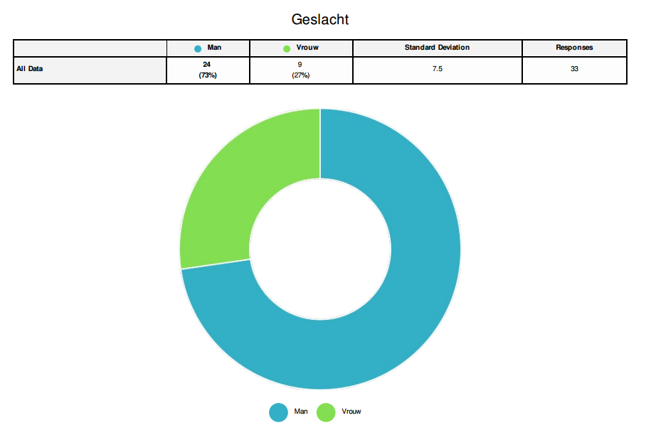

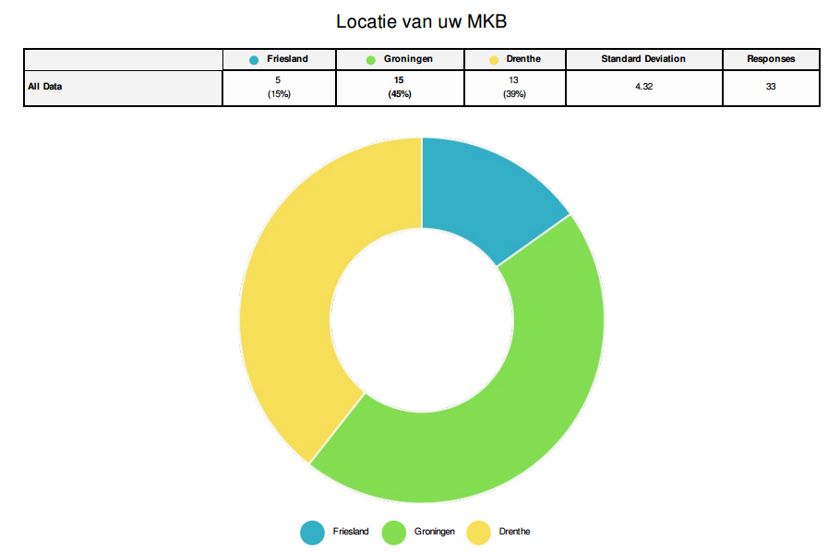

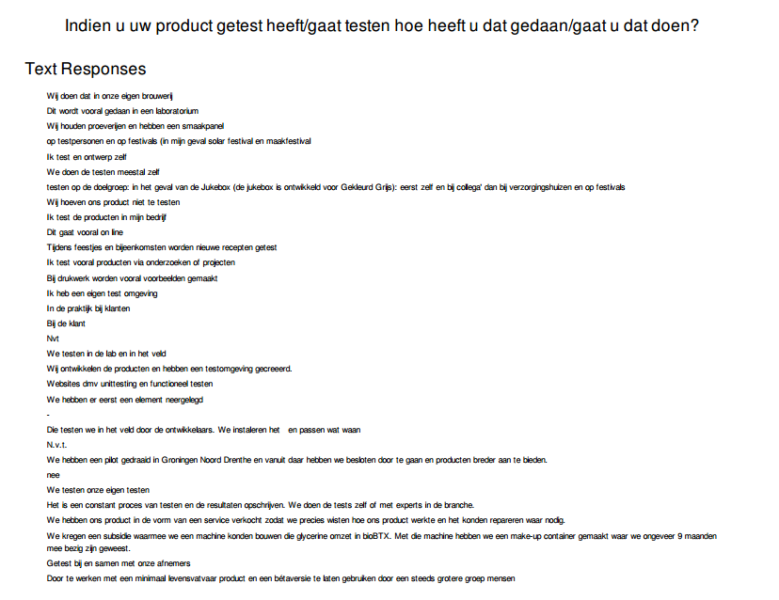

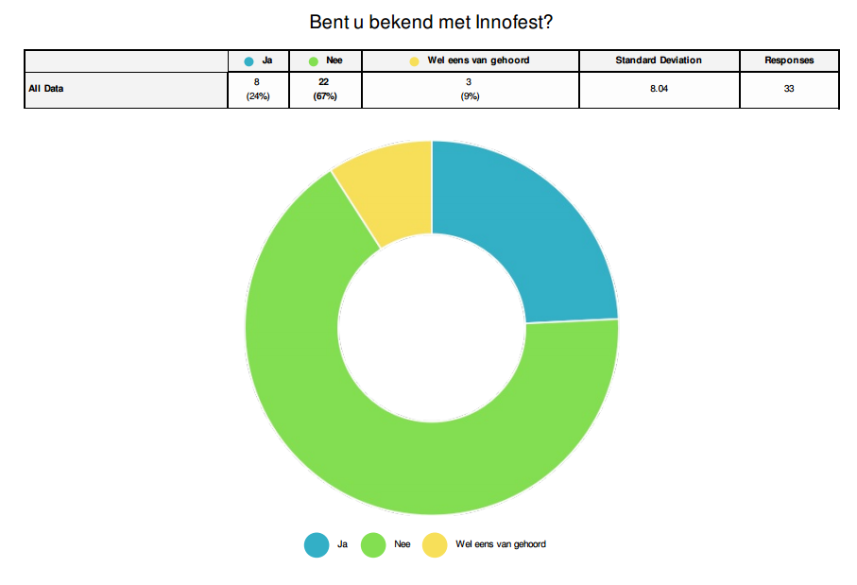

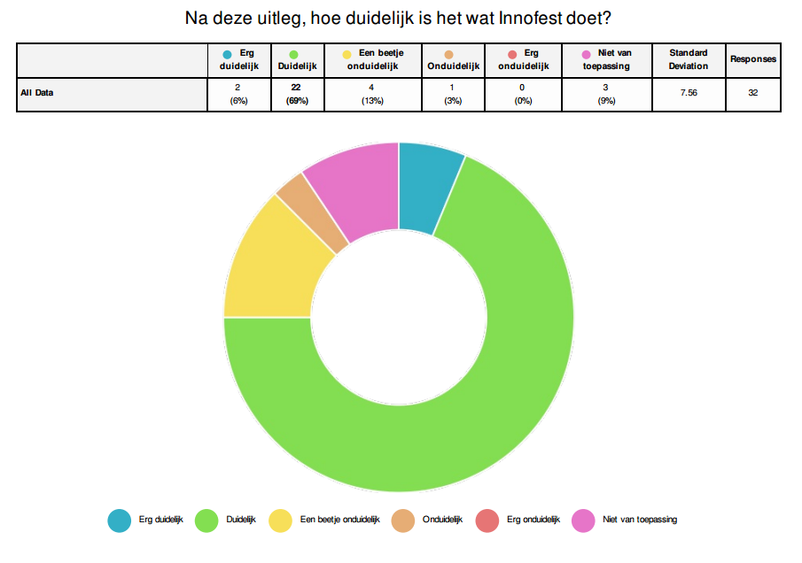

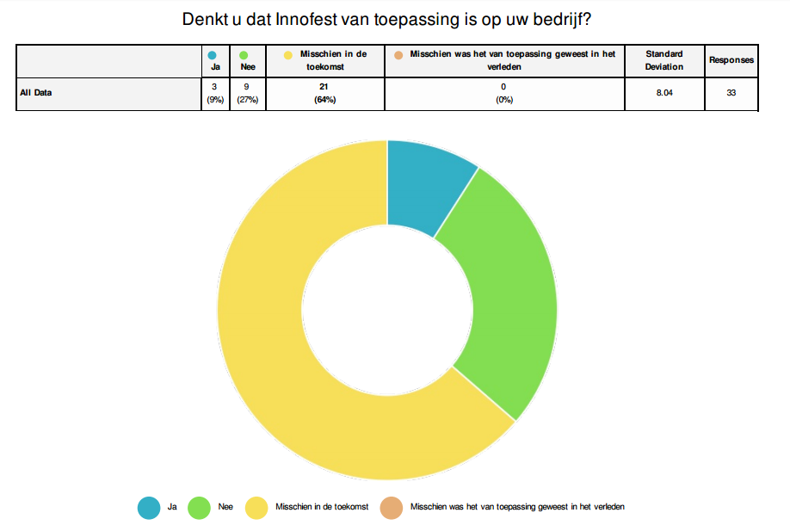

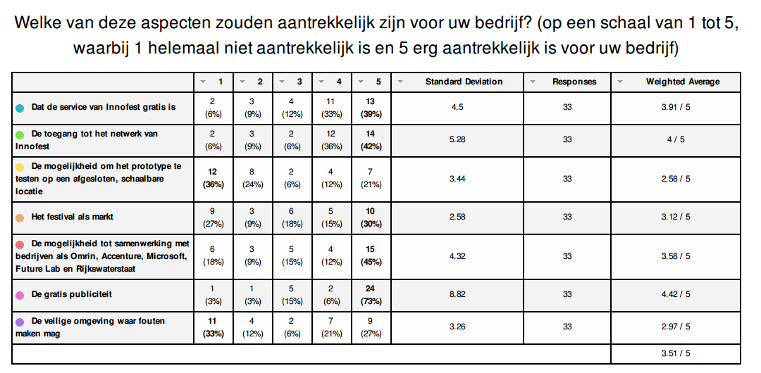

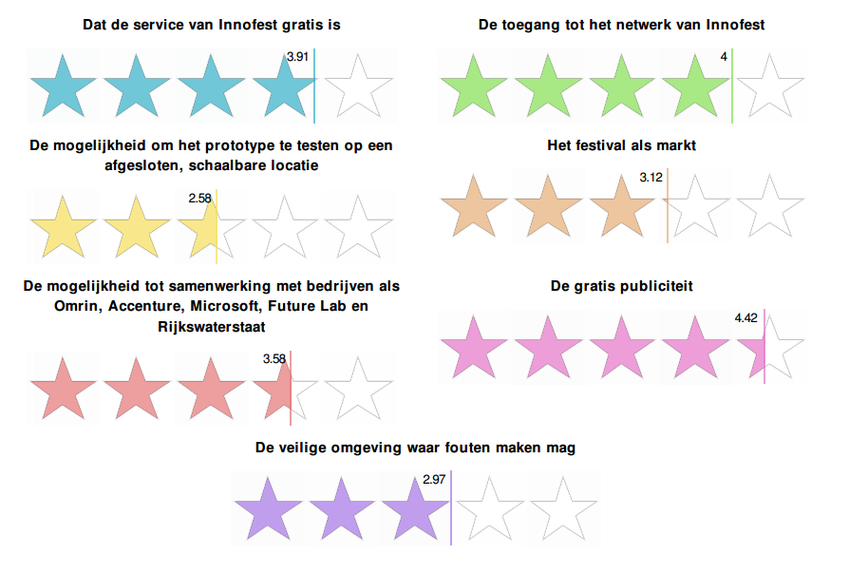

For instance: SummerLabb and Open House
Cooperation partners are the organisations and people that tested their idea with Innofest on a festival. Because they do not have to pay for this, they are called cooperation partners rather than clients.
Confidential information
An unofficial representative of Innofest

