Employer Branding
for Businesses in the Private Sector Seeking for Skilled Employees
Student: Ellen Joan Terpstra
Class: ES4-4
Student number: 15081338

Supervisor: Ms. Ariens
Second reader: Mr. Kuijpers
Hand-in date: 19-12-2019

The Hague University of Applied Sciences
Faculty of Management & Organisation
European Studies

Word count: 14.623

Foreword
This report is partly made possible by multiple people who I would like to thank. First and foremost, my supervisor Ms Ariens. She offered great support and I am truly grateful for her feedback and tips during the months of writing my thesis. Secondly, I want to thank my partner Bernardo ter Burg, who helped me during moments of stress and insecurity. Thirdly, I owe gratitude to my parents and brothers who had faith in me since the start of my educational career. Furthermore, I want to thank my good friend Sanne Beens for the walks in the forest and taking my mind off my thesis when necessary. I also want to thank Miriam van der Ouw, since I benefitted from debating my thesis topic with her and she gave me wonderful tips. Moreover, I want to thank Katie van der Wouden for reading my thesis and correcting my English where necessary.
Finally, I hope you enjoy reading my thesis.

Ellen Terpstra
19-12-2019

Abstract
Due to labour shortages it is a challenge to find skilled employees and many companies struggle to retain employees because of competing employers. In the Netherlands there are many international students and graduates who leave after receiving their degree. Therefore, this research aims to advise Dutch companies within the private sector on how to improve their employer branding to retain the international students and graduates in the Netherlands as an employee.
The research focusses on the international graduates and students in the Netherlands with a business related study. Desk research and quantitative and qualitative field research were conducted for this research. For the desk research, theories on employer branding were gathered and the theories of Geert Hofstede were analysed. Further, data of Universum was used, which was conducted among international students and graduates seeking for employment in the business sector. Moreover, for the quantitative field research, a questionnaire was held among 72 respondents with a non-response of 201 to find out what the preferences are of students and graduates when seeking employment. The qualitative field research exists of four interviews were held among employees of four companies that are in the top 50 of best rated Dutch employer for business-related positions.
The desk and field research were analysed and compared and concluded the following. Employers must take contractual, experiential and emotional factors into consideration to increase their value of employer branding in order to retain international business graduates. These factors exist out of: compensation through money and benefits, a good work-life balance, good future career options, secure employment, and an inspiring core purpose.
The main recommendation for employers is to use the advisory framework and to do further research.

Introduction
Unemployment and labour shortages are two subjects closely related, but on the other hand also each other’s opposites. During the European Debt Crisis that ended around 2012, unemployment rates were extremely high (Eurostat, 2019). However, after this crisis the unemployment rates decreased rapidly and changed to a market of labour shortages (European Migration Office, 2015). According to data of Eurostat at the beginning of the crisis around 2000, the EU-28 unemployment rates were 9.2 %. At the end of the crisis, this percentage of unemployment increased to 11 % of the total labour force within EU-28. At the end of 2018 this percentage decreased to a record low of 6.6 % among the European Member States (Eurostat, 2019).
The unemployment rates decreased massively after the crisis and this caused a change of situation of EU-28 with unemployment issues to EU-28 with labour shortages (Eurostat, 2019) (European Migration Office, 2015). Labour shortages are, just like unemployment rates, a European problem. Therefore, it is important to research possible solutions to lessen the labour shortages. For this research, the scope of the problems and solutions concerning labour shortages in Europe are narrowed down to a specific research question. This is carried out in order to obtain reliable, specific and feasible research. The research focusses on the methods and tactics that companies in the private sector can use to attract the interest of and retain international graduates with a Dutch business degree. This is to reduce the labour shortages of skilled employees that companies within the private sector in the Netherlands are faced with (NOS, 2018). The reasoning behind the further specifications of the scope is described below.
Firstly, the motive to choose the Netherlands as focus country. Research of van Berenschot, Performa and AFAS Software in the journal HR-research edition 2019/2020 demonstrates that 75 % of all companies in the Netherlands are struggling with the recruitment of new employees in the year 2019. Multiple sources confirm this matter and state that it is difficult for Dutch companies to find and retain skilled employees (Schrier, 2019) (NOS, 2018) (Consultancy, 2019). Furthermore, it is to be expected that this percentage will remain the same in 2020. This is a major increase, considering the percentage was only 36 % in 2016 (Consultancy, 2019). Moreover, in 2018, the Dutch Employee Insurance Agency (UWV) predicted 318.000 new job openings for the following two years (UWV, 2018).
Secondly, companies experience difficulties when seeking skilled employees to fill their open vacancies in the Netherlands (NOS, 2018). According to HRM specialist Pauline Drury, Employer branding can offer help to companies struggling with labour shortages, and Drury states ‘’Competition for a shrinking talent pool of younger workers means that employers need to focus on the things that make their company attractive to potential applicants’’ (Drury, 2016). Through improving the employer branding, companies can increase the interest of international students and graduates to remain and work in the Netherlands. In order to interest and retain future employees, the employer branding of companies must match the needs and wants of future employees. Therefore, this research focusses on how companies can improve their Employer Branding.
Thirdly, deducted from the research of Eurostat, the percentage of unemployment is higher for persons with lower levels of education (ec.europa.eu, 2019). This means that it is easier for a graduate to find a suitable job. Besides the level of education of employers, the employability of graduates is significantly higher. This is because graduates can ‘proactively develop, adapt and repackage their capabilities (or attributes)’ (St Jorre & Oliver, 2018). Moreover, according to Nuffic, between 2006-2013 around 85.880 international students graduated in the Netherlands and this number kept increasing at a faster pace in the following years. Almost 25% of these students remained in the Netherlands for at least five years and found a job.
Furthermore, the international students that graduated from the Dutch University of Applied Sciences are considered highly important when it comes to the labour market of knowledgeable employees within the Netherlands (Nuffic, 2017). This means that there is still an amount of around 75% of international students that left the Netherlands after graduating. These international students that left the country were potential skilled employees for companies in the Netherlands. Therefore, this research focusses on international graduates with a Dutch bachelor’s degree (St Jorre & Oliver, 2018) (Nuffic, 2017) (ec.europa.eu, 2019).
Moreover, according to studiekeuze123, an official website from the Dutch government concerning the choice of study, the Netherlands provides 2074 studies with English possibilities. The highest percentage of the studies with English courses are Business and Economic related, namely 219 studies (studiekeuze123, 2019). Therefore, this research focusses on the international graduates of Business and Economic related studies.
In order to find out which sort of employer branding tactics would retain the international students and graduates within the Netherlands as an employee, research and data must be contained. This research focusses on researching the wants and needs of international graduates with a Dutch business degree, to find out what they seek in a future employer. The answers on the central question and sub-questions form an advisory report and framework for Dutch companies within the private sector.
This research aims to consult companies within the private sector in the Netherlands on how they can solve their problem with labour shortages of skilled employees through finding out what kind of employer branding interests international graduates with a Dutch degree and makes them retain in the Netherlands. Therefore, the following sub-questions are created to provide a sufficient answer to the central question.
Central Question:
What are the best ways for Dutch companies in the private sector to increase the value of their employer branding to retain international business graduates within the Netherlands in order to go against labour shortages of skilled employees?
Sub-question 1: What kind of theory is available on employer branding and how can it be useful for this research?
Sub-question 2: What can we learn from Hofstede’s theory on Organisational culture and National culture?
Sub-question 3: What do companies in the private sector do in order to interest and retain graduates?
Sub-question 4: What are the motivations of international business graduates when seeking a job?

Content
Foreword 1
Abstract 2
Introduction 1
1. Methodology 5
1.1 Methods for Sub-question 1. 5
1.2 Methods for Sub-question 2. 6
1.3 Methods for Sub-question 3. 6
1.4 Methods for Sub-question 4. 6
1.5 Methods for the Central Question 8
2. Theories on Employer Branding 9
2.1 External Employer Branding 9
2.2 Internal Employer Branding 10
2.3 Employee Value Proposition (EVP) 10
3. Theories of Geert Hofstede 12
3.1 Differences between National Culture and Organisational Culture 12
3.2 Hofstede’s Organisation Culture 12
3.3 Hofstede’s National Culture 13
4. Theory of Universum 15
4.1 Survey World’s Most Attractive Employers 2019 15
4.2 Data of Universum its questionnaires 15
4.3 Employer Branding in 2019 17
5. Results 18
5.1 Results of the theories on Employer branding 18
5.2 Results of the Theories of Geert Hofstede 18
5.3 Results of Universum global 18
5.4 Results of the Comparison of companies in the private sector 19
5.4.1. Interviewee 1. Rijksoverheid 19
5.4.2. Interviewee 2. Bol.com 20
5.4.3. Interviewee 3. ING 20
5.4.4. Interviewee 4. ABN AMRO 20
5.5 Results of the Questionnaire 22
8. Analysis 26
8.1 Contractual Factors 26
8.2 Experiential and Emotional Factors 26
8.3 Communication Channels for Recruitment 28
8.4 Hofstede’s Theories 28
9. Conclusion 30
10. Recommendation 31
Advisory framework 31
Bibliography 35
Appendix 37
Appendix 1. WMAE Business students 37
Appendix 2. Career Goals Business students 37
Appendix 3. Top 10 preferences Business Students 38
Appendix 4. Top 10 Communication Channels 38
Appendix 5. Beyond the rankings 39
Appendix 7. EVP / employment promise 40
Appendix 8. World’s Most Attractive Employers Ranking 40
Appendix 9. Best rated Dutch employers for business-related positions 41
Appendix 10. Interview questions 42
Appendix 11. Interview Rijksoverheid 44
Appendix 12. Interview Bol.com 46
Appendix 13. Interview ING 48
Appendix 14. Interview ABN AMRO 49
Appendix 15. Questionnaire 51
Appendix 16. Abbreviations list 58
Appendix 17. Student Ethics Form 59
Appendix 18. Informed Consent Form 61

1. Methodology
To come to a well-argued conclusion and recommendation for Dutch companies in the private sector about how they can increase their employer branding in order to interest international business students and graduates to retain working in the Netherlands, quality results and information was obtained. This research aimed to address the problem both practically and theoretically. Therefore, for this research, desk research, qualitative research and quantitative research were conducted to answer the sub-questions which led to an answer to the central question.
The desk research provided the necessary information and data to research the theoretical part of this research. These parts of information were gathered from books, journals and websites. This, because there was not enough time available to only gather information through field research, and if there were, it is more reliable to compare several theories which were conducted by multiple academics. Furthermore, in order to create a good comparison, quantitative and qualitative data were gathered.
The field research was carried out through interviews and questionnaires. These methods were necessary because they made the research more reliable. The questionnaire provided first-hand and up-to-date information from the international business graduates and students. Furthermore, the interview provided inside information from four employees working at companies that belong to the top 50 best employers in the Netherlands. The research methods are further specified and explained per sub-question below.
Multiple sources were obtained to build a sufficient problem definition. The focus was on finding reliable sources with up-to-date information and data. For data concerning unemployment rates, the official, and therefore also reliable, websites of European and Dutch statistics were acquired; Eurostat and CBS. Furthermore, information from multiple public newspapers was conducted. Moreover, other state-owned sources were obtained, such as UWV and studiekeuze123. These are reliable because they are owned by the state and therefore harder to influence through stakeholders.

1.1 Methods for Sub-question 1.
Firstly, to answer sub-question one, only desk research was conducted. The focus was on researching which kind of theories there are on Employer Branding. The following keywords were obtained in order to find the right sources: recruitment, HRM, employer branding, marketing recruitment and labour market.
To provide a sufficient answer to sub-question one, the definition of Employer Branding was explained by Ambler and Barrow. Their definitions of Employer branding were chosen because they are the founders of the concept of Employer Branding. Ambler and Barrow published the Journal of Brand management. At that time, Ambler was a Grand Metropolitan Senior Research Fellow at London Business School and Simon Barrow was the Chairman and founder of the consultancy People in Business (PiB). Furthermore, as a brand manager with experience at Knorr and Colgate, Barrow created the concept of employer branding (Simon Barrow Associates, 2019).
To further advance the answer to sub-question one, part of the book of Caroline Welsing, ‘HRMarketing a new perspective on human resources management’, was extracted. Welsing is a consultant at Hay Group where she focussed on the development of HR professionals in organisations. With her experience in both marketing and HRM, she created a book were both came together. In her book, she describes two sorts of employer branding, which are explained in Chapter 2., paragraph one and two.
Furthermore, to complete the answer for sub-question one, Ambassify its theory on EVP (Employer Value proposition) was used. Ambassify is a platform that helps companies to develop and apply the employee engagement strategy. This source is considered as valid since many multinational companies use their platforms and all wrote positive reviews (Ambassify, 2019). Moreover, Ambassify its division between contractual (compensations and benefits), experiential (careers and well-being) and emotional (purpose) factors are conducted for the analysis. In order to create a sufficient comparison between the data that is gathered. This was necessary because the researched theories all place different sorts of compensation and benefits under different categories. Therefore, to create a clear comparison, the division in the analysis is based on Figure 2.3.1. of Ambassify (Ambassify, 2019).
To complete the answer for sub-question one, Universum Global was conducted. Universum is considered as a valid source because it is active in 60 markets globally in 20 different countries and has over 30 years of experience in the field of employer branding (Universum, 2019). Furthermore, Universum surveyed around 250,000 Business-, Engineering- and IT students in the world’s 12 largest economies from September 2018 to April 2019 (Röjdmark, 2019). Furthermore, this data is also obtained to form questions for the questionnaire created especially for this research.
With the findings of Ambassify, Welsing, Ambler and Barrow and Universum, an answer to sub-question one was completed.

1.2 Methods for Sub-question 2.
Thirdly, to answer sub-question two, Hofstede’s Corporate Culture and Organisational Culture were analysed. The first paragraph of Chapter 3. describes the difference between both theories. This was carried out to provide an insight on why both cultures differ. Furthermore, in the second paragraph Hofstede’s six dimensions for Organisation Culture were described. The third paragraph describes the dimensions of National Culture. The use of Hofstede its theory is reliable since it was formed by multiple professionals, namely, by Professor Geert Hofstede and his research team in Denmark and the Netherlands (Hofstede, n.d.). Moreover, the dimensions of the theories of Hofstede were conducted to formulate the statements in question 17 to 28 of the questionnaire (Appendix 6.).

1.3 Methods for Sub-question 3.
For sub-question three, the aim was to find out what companies in the private sector do in order to interest and retain graduates. In order to find an answer, four interviewees were interviewed by filling out a list of questions. This interview contained fourteen questions, whereof nine were most relevant. The questions were created with the help of the previously gained knowledge and insights about Employer Branding in chapter 2. and chapter 3. Furthermore, the interviewees all work for an employer that is listed in the top 50 best employers in the Netherlands (Figure 3.2.9.), namely Rijksoverheid, Bol.com, ING and ABN AMRO. All interviewees have a degree in a business-related study and work in a business-related position. These interviewees were chosen based on their accessibility since they are my acquaintances. The duration of employment of the interviewees varies from three months to one and a half year. Due to the short period of employment, only the first experiences of how it is to work for the employer were shared. However, that would always be the case when interviewing recent graduates. Furthermore, all interviewees specifically asked to remain anonymous and therefore they are mentioned with a pseudonym; Interviewee 1, Interviewee 2, Interviewee 3, and Interviewee 4.
It must be taken into consideration that these interviewees are just one employee of a company where many employees work. This interview is based on only their experiences with their employer, which means that the experiences of other employees can differ. This interview was meant to give an impression of what employers in the top 50 of the best employers in the Netherlands offer.

1.4 Methods for Sub-question 4.
To answer sub-question four, information regarding the students’ and graduates’ motivations to work was gathered and used to make a sufficient comparison. The questionnaire can be found in Appendix 6.
The theory on employer branding, Hofstede’s theories on National and Organisational Culture and Universum’s findings were used to create the questionnaire. The questionnaire was conducted among international students and graduates studying in the Netherlands with a study that is related to business. Generations Y and Z are most relevant to this research, since this age group contains the most students and recent graduates. The people from Generation Y are born between 1980 and 1994 and the people born between the year 1995 and 2015 belong to Generation Z (Kasasa, 2019). The number of responders was based on an average of around 12.300 international students graduating per year (Nuffic, 2017). According to the sample size test of SurveyMonkey, at least 373 questionnaires must be obtained in order to achieve 95% reliability (SurveyMonkey, 2019). However, this number corresponds to international students of all studies and this thesis focusses on students with a major in Business. In order to obtain reliable information and data, it was decided to aim for a minimum of 150 respondents in the research plan before December 2020. However, during the research, this did not seem feasible due to the available time and facilities. Therefore, after reaching the number of 72 respondents, it was decided to continue the research and accept the non-respondents. This meant that there are 201 non-respondents and the reliability of 95% was not achieved. The level of the reliability of the questionnaire decreased.
For this questionnaire, the tool Survio was used. This is a tool to create an online questionnaire. Beforehand, it seemed that the answers of each respondent could be viewed independently. However, it appeared to be impossible and therefore no correlations between answers could be made. Universum provides a difference between females and males when speaking about their career and compensation preferences. This was not taken into consideration with the interview and questionnaire of my research because it was not possible to do with the tool Survio. This makes the analyses of the questionnaire less relevant. On the other hand, the data of the questionnaire is still useful since it demonstrates the preferences of the target group.
The questionnaire was spread by means of the Survio-link on the internet. Firstly, my international contacts that study a business-related study in the Netherlands were contacted and asked to fill out the survey. Secondly, the international contacts were asked to forward the survey to their contacts with the same sort of profile. Thirdly, one contact person studies International Business at Windesheim (University of Applied Sciences in Zwolle) and she asked her international contacts to fill out the survey. Furthermore, the survey was posted on the official Facebook page of European Studies THUAS. The reason for choosing this Facebook page was as follows: European studies contain many international students and many graduates are still a member of this page.
It is noted that the group of respondents are not very diverse, since they are mostly my contacts or contacts of my contacts. However, with the time available for this research and the available tools, it is sufficient enough to use the data. Moreover, a part of the respondents are Dutch and therefore not completely relevant to this research. Their answers were gathered for this research because the tool used for this survey did not make it possible to cut these answers out. Furthermore, for question seven to question sixteen of the survey, all possible answers could be important to the respondents. However, only the top three of most chosen answers were taken into consideration for this research. In addition, for question 17 to question 28 of the questionnaire, the dimensions of Hofstede’s theory on National and Organisational Culture were used. The question consists of two examples of the dimensions of Hofstede’s theories. This means that the questions were based on statements relating to the dimensions of Hofstede. Therefore, it is not completely reliable, since the respondents did not know the full dimensions of these theories. Nevertheless, it was not possible to inform all respondents with the full theory, so the statements were considered sufficient enough for this research.
The questionnaire contained one open-question. The aim of the open question was to find out where the respondent came from. It was decided that this was easier than comprising a list of all the possible countries. However, one problem occurred, since some respondents answered the city that they are from. This was easily resolved by checking to which country the city belongs. Furthermore, the main reason for the use of multiple-choice questions in the questionnaire was that it made it easier to compare the results. The risk of open questions is that many different answers appear since people can interpret a question differently or think of completely different styles of answers.

1.5 Methods for the Central Question
The answer to the central question is derived from the following research methods. Firstly, through gathering and analysing the theories and data of Welsing, Ambassify, Ambler and Barrow, Hofstede and Universum. This information helped to create the questionnaire and the interview. The comparative analysis of the data from previously contained sources, the data of the questionnaire, and the data of the interviews a comparison was made. With this comparison, a conclusion was reached, which answered the central question. The conclusion was translated into a recommendation and advisory framework for the employers in the private sector that wish to attract and retain more international students and graduates with a Business-related degree.

2. Theories on Employer Branding
This chapter contains information regarding external employer branding, internal employer branding, and the Employer Value Proposition (EVP). The first paragraph focusses on the concept of external employer branding. The concept of employer branding is explained through quotes by Mr. Ambler and Mr. Barrow. Furthermore, information is gathered from the book ‘HRMarketing a new perspective on human resources management’ written by Caroline Welsing. The second paragraph contains information about internal employer branding. This information is also based on the theory of Caroline Welsing. The third paragraph mentions the different sorts of compensation a company can offer and explains the concept of the EVP.

2.1 External Employer Branding
The start of employer branding was in 1996 when Tim Ambler and Simon Barrow published the Journal of Brand management. As a brand manager, Barrow created the concept of employer branding (Simon Barrow Associates, 2019). Both authors describe the concept as follows:
‘We define the Employer Brand as the package of functional, economic and psychological benefits provided by employment and identified with the employing company’ (Simon Barrow Associates, 2019).
‘The main role of the employer brand is to provide a coherent framework for management to simplify and focus priorities, increase productivity and improve recruitment, retention and commitment’ (Simon Barrow Associates, 2019).
Based on the theory of the book ‘HRMarketing a new perspective on human resources management’ written by Caroline Welsing, the following information is gathered (Welsing, 2003). Branding is important for a company due to different factors. Firstly, according to Welsing, the market for services and products has changed to a place in which the possibilities and the number of providers are unlimited, which causes increasingly less distinctive products and services. This means that companies must distinguish themselves in other ways. For example, by emphasizing what is important in the heart and head according to customers. The idea and feeling that a customer associates with the company is influenced by the company’s branding. The brand of an organisation is about relationships and commitments. Based on this, promises are made towards customers (Welsing, 2003).
Branding is important for an organisation when finding skilled employees. Therefore, companies must work on their employer branding. One of the ways that Welsing describes employer branding is as follows: ‘it is the brand an organisation an employer stands for’. Another way that Welsing describes it is ‘unleashing marketing insights about the positioning of an employer in the labour market, it’s a brand formed by employers thoughts’ (Welsing, 2003). Furthermore, the employer brand helps to improve the communication towards current and future employees, which influences how the current and future employees look at the company (Welsing, 2003).
Some companies consider employer branding as a temporary task. When there is a shortage in the labour market, there is a need for employer branding and if not, employer branding is deleted from the agenda. The HRM department is often held responsible for the task of employer branding. Regarding employer branding, companies must consider their current employers as highly important since they represent the image of the company. Further, Welsing states that consistency is key. So, corporate communication must align with the way the company acts and wants to be seen. All of the streams must be consistent (Welsing, 2003).

2.2 Internal Employer Branding
Based on the theory of the book ‘HRMarketing a new perspective on human resources management’ written by Caroline Welsing, the following information is gathered (Welsing, 2003).
According to Welsing, internal branding is ‘about the translation of (external) brand values to (internal) organisational values’ (Welsing, 2003). The behaviour of the people working at the company must reflect the image the company wants project to the world. This causes a good employer branding foundation as well. Furthermore, Welsing states that there are many different opinions based on several interviews of the Marketing Tribune about internal employer branding. A few examples are stated below (Welsing, 2003).
Firstly, many think that internal employer branding is just a marketing hype. Secondly, others see internal branding as a solution to problems. When things are not going as planned, most companies start looking towards their employers to find out what is going wrong. This is to ensure that employers are acting according to the company’s wishes. Communication within the company is necessary when aligning the company’s new marketing strategies and to make sure that everyone had their eye on the same prize. Thirdly, that internal branding has one major aim, which is that the company’s attractiveness to employers and customers is only to stimulate business. Furthermore, that a company uses its brand to convey its meaning to customers (extern) and employees (intern). Finally, companies increase their chance for success by aligning the external brand with the values that are striven for internally (Welsing, 2003).

2.3 Employee Value Proposition (EVP)
According to Ambassify, there are different sorts of compensations that companies can offer when hiring a candidate. When candidates seek a new job, salary is not the only thing that they take into consideration. Factors like internal support systems, benefits, work culture, colleagues and more are also taken into account. The way that companies demonstrate these factors depends on their employer branding strategy. Ambassify states that EVP, in addition to employer branding, is also very important when hiring the right candidates. EVP demonstrates the value the employees receive for the work that they do. According to Ambassify, the following matters must be taken into consideration when deciding what to offer a candidate. Firstly, it is important to identify the perfect future employee by finding out what they value most and how this aligns with the company. Secondly, companies must define what they want to offer their employees. This can be tangible or intangible. Thirdly, it is good to talk to the employees that are currently working at the company and find out what they prefer and what they think that should be improved. Furthermore, companies are obligated to increase the wage based on contracts. However, there could be other companies that want to offer the candidate a higher wage. Therefore, managers must be more open regarding a future raise if they want their employees to stay. Moreover, it is good to communicate the EVP in one short sentence. For instance, Google its EVP is ‘’Do cool things that matter’’ (Ambassify, 2019). Finally, provide content around the company’s EVP. For example, social media/website posts, presentations, videos, and events (Ambassify, 2019).

According to Ambassify, companies must consider the following options:
Compensation: Salary satisfaction, compensation system satisfaction, raises, promotions, timeliness, fairness and an evaluation system.
Benefits: time off, holidays, insurance, satisfaction with the systems, education and flexibility.
Career: possibility and opportunity to progress and develop, stability, training, education at work, career development, college education, consultation, evaluation and feedback.
Work environment: recognition, autonomy, personal achievements, work-life balance, challenges, understanding of one’s role and responsibility.
Culture: understanding of firm’s goals and plans, colleagues, leaders/managers, support, collaboration, team spirit, social responsibility and trust. (Ambassify, 2019)
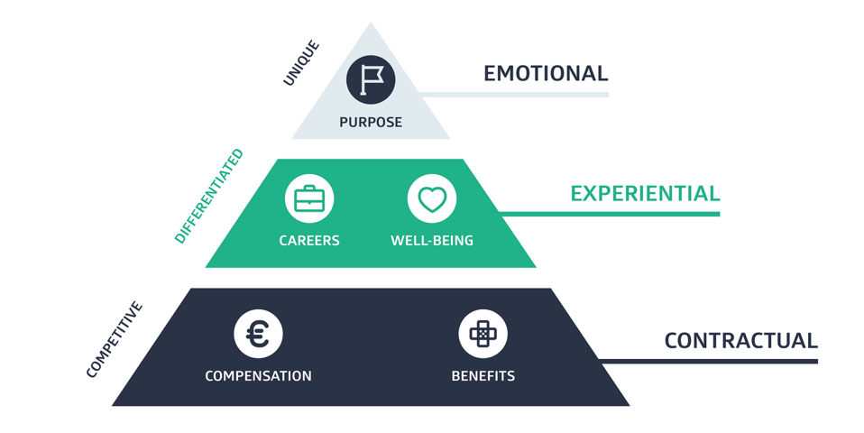

Figure 2.3.1. A Strong Employee Value Proposition Is Key to a Strong Employer Brand (Ambassify, 2019)
Figure 2.3.1. demonstrates the three levels of a strong employer brand. The first level focusses on what is in the contract between the employer and employee, what the decided compensation is and which benefits the employee will receive. The second level concerns the employee’s experiences while working at a company and if the employer cares about their well-being and career. The third and last level aims for the purpose of the company: does the employee agree with the purpose of the company or does the purpose of the company not matter to him or her.

3. Theories of Geert Hofstede
This chapter contains information about the kinds of organisational and national cultures there are according to Hofstede. The first paragraph focusses on explaining the differences between national culture and organisational culture. Next, Hofstede’s theory on organisational culture is described in paragraph two and the theory on national culture in paragraph three.

3.1 Differences between National Culture and Organisational Culture
Professor Hofstede defines the concept of culture as ‘the programming of the human mind by which one group of people distinguishes itself from another group’. This definition can be used explaining culture for both national culture and organisational culture (Hofstede-insights, 2019). However, the two types of cultural definitions are not simular.
Firstly, Hofstede defines national culture as follows. One’s personality is more visible in a small group since a person’s behaviour and characteristics have more room to be expressed. A national culture is harder to see in small groups, whereas it is clearly noticeable in a large group of people with the same nationality. When within a large group, individual qualities are less visible, which causes the more common (shared cultural) qualities to be clearer (Hofstede-insights, 2019).
Secondly, according to Hofstede’s definition of an organisational culture ‘is the result of many factors but tends to be more straightforward and precise to measure than National Culture. This is because most organisations have clear objectives and requirements.’ (Hofstede-insights, 2019). In an organisational culture, the number of employees matter as well as their personalities, since these factors influence the organisational culture. In general, it is harder to define national culture than an organisational culture (Hofstede-insights, 2019). Furthermore, the national culture focusses more on values, whereas an organisational culture focusses more on practices, the outside world, each other and their work. Which explains that, according to Hofstede, organisational culture can change by changing their practices and national cultures cannot (Hofstede-insights, 2019).

3.2 Hofstede’s Organisation Culture
Hofstede defines his theory on Organisational Culture as ‘the way in which members of an organisation relate to each other, their work and the outside world in comparison to other organisations. It can either enable or hinder an organisation’s strategy’ (Hofstede-insights, 2019). The aim of the theory is to provide insights into the match among the strategic direction and the actual current organisational culture. This theory mentions six dimensions which are explained below (Hofstede-insights, 2019).
Firstly, the dimensions of ‘Means-oriented vs. Goal-oriented’. This part is explained to be tightly associated to the effectiveness of the organisation. Companies that are Means-oriented focus on the question ‘how?’ whereas companies who are Goal-oriented identify more with the question ‘what?’. This can be explained through Means-oriented employees focussing on the way in which work has to be carried out, whereas the Goal-oriented focus mainly on how to achieve specific internal targets or results, not caring much about the risks involved. In a Means-oriented company, this is the opposite. Employees avoid risks, put less effort into their work and don’t mind all working days being mainly the same (Hofstede-insights, 2019).
Secondly, the opposites ‘Internally Driven vs. Externally Driven’ of the organisational culture. Internally Driven companies retain employees that know and believe that business ethics and honesty matter most. Therefore, they are greatly driven, recognize their assignments and have the best knowledge of what is best for the customers. On the other side, there are Externally Driven companies and employees. These consider results and pragmatic research as highly important. Based on these tactics these companies focus on meeting the customer’s requirements (Hofstede-insights, 2019).
Thirdly, this part concerns the amount of control, internal structuring, and discipline; ‘Easy Going Work Discipline vs. Strict Work Discipline’. When an organisation uses an Easy-Going Culture, it is most likely that there are many surprises and innovations. This culture demonstrates a lack of predictability, little discipline, a fluid internal structure and little control. On the contrary, in a Strict Work Discipline employees are very punctual, serious and cost-conscious (Hofstede-insights, 2019).
Furthermore, in the fourth dimension ‘Local vs. Professional’, there is a difference in how they direct the future. The local cultures are short-term directed, whereas the professional employees are long-term directed. In a professional company, the employees are determined by what kind of tasks they have and what name their profession has received. A local employee focusses on internal factors, for instance social control and compare themselves to fellow employees within the company (Hofstede-insights, 2019).
The fifth dimension is named ‘Open System vs. Closed System’ and focusses on the accessibility of a company. In a closed organisation, the new colleagues most likely do not feel welcome and the employees do not try to make them feel comfortable. However, in an open culture the focus is on making everyone feel comfortable and welcome (Hofstede-insights, 2019).
The final dimension ‘Employee-oriented vs. Work-oriented’ relates to management philosophy. In Employee-oriented companies, the focus is on the employees. These companies take care of the welfare and personal problems of employees. The well-being is considered to be highly important, sometimes even more important than the work itself. In a work-oriented organisation, there is no time for the well-being of the employees and the work itself is considered as the highest priority, even though this causes personal tension or problems for the employees (Hofstede-insights, 2019).

3.3 Hofstede’s National Culture
The six dimensions of national culture represent independent preferences of a country that distinguishes the country from other countries. It must be taken into consideration that the dimensions are relative and all humans are unique, so this model can only be used as a meaningful comparison method (Hofstede-Insights, 2019).
The first dimension is the Power Distance Index (PDI). The PDI demonstrates the degree of differences in power and inequalities and how society accepts this. When there is a high level of PDI, societies accept a high level of hierarchical order. In this order, everyone in the society knows their place and accepts this. When it is the other way around and the society had a low PDI, society does not agree with the inequalities and require justification (Hofstede-Insights, 2019).
Secondly, the dimension of Individualism vs. Collectivism (IDV). When a society lives with a high level of Individualism, everyone is focussed on taking care of themselves and the people nearby. However, in Collectivism the society takes care of all and is more loyal towards others. The individualistic culture focusses on ‘I’, whereas a collectivist focusses on ‘we’ (Hofstede-Insights, 2019).
Thirdly, the theory behind the dimension of Masculinity vs. Femininity (MAS). The masculine cultures are more competitive by the creation of a culture full of heroism, achievement, material rewards for success and assertiveness. The opposite is a feminine culture, where the emphasis lies more consensus-orientated by focussing on modesty, cooperation, quality of life and caring for the weak (Hofstede-Insights, 2019).
Moreover, Uncertainty Avoidance Index (UAI), which according to Hofstede demonstrates ‘the degree to which the members of a society feel uncomfortable with uncertainty and ambiguity’ (Hofstede-Insights, 2019). The emphasis is on how people within a society manage the expectations of the future, knowing that they cannot predict or control what will happen. Societies with high UAI have strict codes of behaviour and belief. Furthermore, these cultures are narrow-minded when it comes to unorthodox ideas and behaviour. On the contrary, societies with low UAI are considered more flexible and care more for practice than principles (Hofstede-Insights, 2019).
In addition, the fifth dimension of Long Term Orientation vs. Short Term Normative Orientation (LTO). All cultures have a past and a future. The difference between these dimensions is that both sides prioritize these differently. The Long Term Orientated societies score low on this dimension by maintaining time-honoured traditions and the Short Term Normative Oriented score high by taking a more pragmatic approach (Hofstede-Insights, 2019).
Finally, Indulgence vs. Restraint (IVR). A society with Indulgence stands for ‘relatively free gratifications of basic and natural human drives related to enjoying life and having fun’ (Hofstede-Insights, 2019). On the other hand, Hofstede explains that a Restraint society ‘suppresses gratification of needs and regulates it by means of strict social norms’ (Hofstede-Insights, 2019).

4. Theory of Universum
This chapter depicts the findings of the research company Universum. This organisation offers critical market insights regarding employees and employers. Universum has held many surveys with the aim of finding out what employers and employees desire (Röjdmark, 2019). For this chapter, the most relevant data from these surveys are depicted and described. Furthermore, this chapter mentions different Generations and it is important to understand the differences. Generations Y and Z are mostly relevant to this research. A different name for Generation Y is Millennials. The people from Generation Y are born between 1980 and 1994 and the people born between the year 1995 and 2015 belong to Generation Z (Kasasa, 2019).

4.1 Survey World’s Most Attractive Employers 2019
Universum surveys yearly over one million university graduates who are seeking to start a career. This research from Universum explains the motivations of university graduates as they enter the global workforce by answering the following question: ‘Which employers do students hold in the highest regard and what factors affect that decision?’ (Röjdmark, 2019).
Firstly, ’soon to be’ graduates worry about the economic situation and this influences the student’s view on employment. Another outcome of the survey is that especially women are looking for employment security these days. According to Universum, this might be because of the views on the employment outlook or just because of an increase in conservatism among Generation Z in comparison to Millennials. Secondly, the survey demonstrated that students are not that eager to find a job abroad compared to three years ago. Reasons for this could be stricter work permits and students preferring their home country over other countries. In addition, Generation Z seems to be more purpose-driven, innovative and entrepreneurial than the millennials. More students are interested in starting their own business and are confident to find innovative solutions for problems organizations are facing. Moreover, for women, industries like tech and banking have become more popular since companies started to attract more talented young women. Furthermore, the surveys demonstrate that companies must pay attention to clearly clarifying their core purpose, focussing on the entrepreneurialism character of graduates, and that multinational companies need to show that they are not only focussed on their international status but also on their local status (Röjdmark, 2019).

4.2 Data of Universum its questionnaires
According to Universum women prefer Management and Strategy Consulting as an industry to work in, while men prefer Financial services. In the top 5 preferred industries women state Media and Advertising, which are not named in the top 5 industries of men. Instead, men state E-commerce as one of their favourite industries to work in. Furthermore, women and men both highly prefer to have a good balance between work and life. Women prefer to have a stable and secure job almost as much as a good work/life balance and in the third-place women prefer to be a manager or leader of people. Men prefer to be a leader or manager of people first and then prefer to have a stable and secure job. Moreover, for the most desired employer attributes, women and men both mention high future earnings and professional training and development. Women prefer a friendly work environment, secure employment and a creative and dynamic work environment. Men prefer a competitive base salary, market success and leaders who support development (Röjdmark, 2019). Appendix 1. demonstrates a full overview of the division between the preferences of women and men regarding preferred industries, top career goals and most desired employer attributes which was created by Universum (Röjdmark, 2019).
Furthermore, Universum mentions the following career goals of business of the countries with the biggest economies as preferred. An overview of all career goals and the preferences per country can be found in Appendix 2. According to Universum, work/life balance is mostly chosen as important. Having a job that is stable and secure is important for business students, since it is in second place. Japan and China have ‘to be autonomous or independent’ as the third preference, whereas most other countries prefer ‘to be a leader or manager of people’ in the third-place. The three least favourite preferences are the career goals of being entrepreneurial, creative or innovative, the feeling of being dedicated to a cause and the feeling that the students are doing something good and the career of being a technical or functional expert (Röjdmark, 2019).
The top ten preferences of business students when seeking employment is listed in Appendix 3. The countries are chosen based on the size of their economy, since they have the largest economies in the world. Most students prefer high future earnings over all other options. Only students from Brazil, China, Japan and Korea list another preference as most important. The second most popular preference among students is professional training and development. The third preference differs mostly per country. The three least preferred options are secure employment, creative work and dynamic work environment, and a competitive based salary (Röjdmark, 2019).
Furthermore, in Appendix 4., the top ten communication channels where students prefer to learn about employers is demonstrated. The black bars are relevant for this research since these contain data for business students. The figure shows that social media is most popular. The employer websites are in the second-place, which is followed closely by career fairs with just a 1 % difference for business students (Universum, 2019).
Universum researched over a million students and professionals which led to the following data. The number one long term career goal of students and professionals is to have a good work/life balance, with the preference of working at a challenging job. The average salary of Generation X is 3.617 euro and of Generation Y is 3.005 euro monthly (Universum, 2019). The information behind de data of what students prefer in an employer can be found in Appendix 5.
According to Universum, the top three of key elements in the EVP of companies is: having an inspiring purpose, being innovative and being committed to diversity and inclusion. When looking at the size of the company, this top three differs. For a ‘small’ company it is more important to be team-orientated, whereas for a ‘medium-sized’ company and a ‘large’ company having an inspiring purpose is most important (Universum, 2019). The full comparison between the attractive factors of an employer with a large, medium or small company can be found in Appendix 6.
According to Universum., there have been changes over the years regarding the key elements of companies’ EVP. Firstly, having an inspiring purpose as a company was 24% less important in 2016 than in 2019. Secondly, innovation also started to play a more important role over the years since it increased with 10% between 2017 and 2019. Thirdly, the level of diversity and inclusion in an organisational culture increased with 14% in importance between 2017 and 2019. Furthermore, the professional training and development were rated higher in 2017 than 2019, by 18%. Finally, a company offering a clear path for advancement also decreased over the years, with a percentage of 13% (Universum, 2019). A full overview of the changing elements of EVP can be found in Appendix 7.
Universum created a top 50 of the World’s Most Attractive Employers (WMAE)based on the Global Business Rankings in 2019. The list is created based on the opinions of business students (Röjdmark, 2019). The top three of WMAE in the world is as follows: Google, EY (Ernst and Young) and PwC (PriceWaterhouseCoopers). The top 50 is depicted in Appendix 8. Furthermore, Universum created a lists of the best Dutch employers for business-related positions. The top three employers are Heineken, KLM and Rijksoverheid. The top 100 of best Dutch employers for business-related positions is demonstrated in Appendix 9.

4.3 Employer Branding in 2019
Universum held a survey interviewing over 1600 marketing managers, talent acquisition managers, HR managers and recruitment professionals of the World Most Attractive Employers (WMAE) regarding how they deal with employer branding and future aspirations. This international target group came from 45 countries and the survey was held during a period of three months at the beginning of 2019 (Universum, 2019).
According to Universum, the following trends are worth watching when wanting to improve employer branding. Firstly, employer branding must be seen as important, since there is a major lack of talent in the job market. Secondly, start-ups appear to be very attractive to Generation Y and Generation Z. Therefore, Universum recommends global brands to stop thinking that only their name is enough to attract new talent. Thirdly, companies must focus on recruiting diverse employees. The response for talent will be higher if they do so instead of staying in their traditional pool of talent. Furthermore, companies must have an inspiring purpose. Proposing statements like ‘professional training and development’ in a vacancy is not favoured by WMAE. Finally, the percentage of positivity towards Artificial intelligence (AI) in recruitment is 69 %. The use of AI for search and selection is expected to be the biggest game-changer regarding recruitment and marketing in 2019 (Universum, 2019).
Universum states that the war of talent is still very active and mentions the following results of their survey regarding this subject. The majority of employers think that the hiring environment is not getting easier and plan to put more hours into recruiting coming year. CEOs are afraid that the lack of talent will lead to them not fulfilling the targets and goals of the year. Universum states that larger companies and WMAE are trying to create an environment comparable to the ones of start-ups, which contains an atmosphere that has an informal and high energy workstyle. The book also mentions the tip of acknowledging the number of employers per department instead of the total amount of employers, making it seem more personal and more like the size of a start-up. Furthermore, according to Universum, WMAE increasingly prioritizes employer branding over other activities in 2019 compared to 2018 (Universum, 2019).

5. Results
In this chapter, the results of the previous chapter are formulated. The first paragraph contains the results of Chapter 2., which concerns the theory about employer branding. The second paragraph describes the results of Chapter 3., where Hofstede’s theories of National and Organisational Culture are explained. Furthermore, the results of Universum are described in paragraph three and are further explained in Chapter 4. The fourth paragraph demonstrates the results of the interviews held among four interviewees with an employer in the top 50 of best employers in the Netherlands. Finally, in paragraph five, the results from the questionnaire are described. The questionnaire was held among 72 students and graduates. The aim was to achieve a minimum of 150 respondents, however after achieving 72 respondents, it was decided to continue the research and not to wait on the remaining respondents. The questionnaire is still considered reliable and valid since it provides answers of the target group which are useable.

5.1 Results of the theories on Employer branding
Companies can improve their employer branding as a tool to find the right employees. For external employer branding, it is important that a company distinguishes itself from their competitors. This can be carried out through building a relationship with the employee and maintaining consistent streams of corporate communication (Welsing, 2003). Furthermore, for internal employer branding, the behaviour of the people working at the company must correlate to what the company wants to communicate to the world (Welsing, 2003). Moreover, according to Ambassify, companies must look at the EVP. When seeking a new employee, it is important that the employer asks what the current employees desire and then decides what they are willing to offer. Further, Ambassify advises to speak openly about wage increases, so current employers do not leave for another employer that offers a higher wage. A company can attract an employee by offering different options. Ambassify names compensation, benefits, career possibilities, a good work environment and a good corporate culture as such options (Ambassify, 2019).

5.2 Results of the Theories of Geert Hofstede
Employers can implement the theory of Hofstede’s Organisation Culture to provide insights into the match among the strategic direction and the actual current organisational culture. There are six dimensions, namely Means-oriented vs. Goal-oriented, Internally Driven vs. Externally Driven, Easy Going Work Discipline vs. Strict Work Discipline, Local vs. Professional, Open System vs. Closed System and Employee-oriented vs. Work-oriented (Hofstede-insights, 2019).
Companies can use the six dimensions of national culture when they seek international candidates. This theory represents the independent preferences of a country that distinguishes the country from other countries. The theory contains the following six dimensions; the Power Distance Index (PDI), Individualism vs. Collectivism (IDV), Masculinity vs. Femininity (MAS), Uncertainty Avoidance Index (UAI), Long Term Orientation vs. Short Term Normative Orientation (LTO) and Indulgence vs. Restraint (IVR) (Hofstede-Insights, 2019).

5.3 Results of Universum global
The results of chapter 4. are presented in this paragraph. According to Universum, the working conditions that their respondents prefer are as follows. Firstly, women seek a good work/life balance, secure employment and to be a manager or leader. Men seek a good work/life balance, to be a manager or leader and to have secure employment. Secondly, it appears that fewer students aspire a career abroad. Thirdly, Generation Z seems to be more purpose-driven, innovative and entrepreneurial than the millennials. Furthermore, companies must pay attention to clearly clarifying their core purpose, as many students mentioned this as an important factor when seeking an employer. Moreover, according to Universum, companies must be internationally and locally concerned. Also, the number one long term career goal of students and professionals is to have a good work/life balance with the preference of working at a challenging job. Finally, start-ups appear to be very attractive to Generation Y and Generation Z (Röjdmark, 2019) (Universum, 2019).
According to Universum, the students that they surveyed desire the following compensation: high future earnings, professional training and development, and secure employment. Furthermore, when an employer advertises to their market of future employees, the following communication channels appear to be preferred; social media, employer websites, and career fairs (Röjdmark, 2019) (Universum, 2019).
For the EVP, Universum mentions the following as important for employers. It is important to have an inspiring purpose, being innovative and being committed to diversity and inclusion. When looking at the size of the company, this top three differs. For a ‘small’ company it is more important to be team-orientated, whereas for a ‘medium-sized’ company and a ‘large’ company having an inspiring purpose is most important. Furthermore, to advance themselves, companies can use AI for recruiting. (Röjdmark, 2019) (Universum, 2019).

5.4 Results of the Comparison of companies in the private sector
Four short interviews with employees of Rijksoverheid, Bol.com, ING, and ABN AMRO were held. The full interviews including the answers of interviewees can be found in Appendix 10, 11, 12, 13 and 14. These companies are chosen since they are in the top 50 of best employers of the Netherlands for business-related positions (see Appendix 9). The interviewees asked to be anonymous and therefore they are mentioned with a pseudonym; Interviewee 1, Interviewee 2, Interviewee 3, and Interviewee 4.

5.4.1. Interviewee 1. Rijksoverheid
Interviewee 1. works at the Rijksoverheid, who is third in the top 50. She is 24 years old, Dutch, and has a master’s degree in business. She works at the Dutch Ministry of Justice and Security and has been employed at the Immigration- Naturalisation Service for three months. She desired a great location, reimbursement of travel expenses, at least an average amount of holiday days (25 days), flexibility in the planning of working hours and the possibility of working at home. According to interviewee 1., her employer offers all of these requirements.
The purpose plays a huge role for interviewee 1. since her purpose is to do socially relevant work. The political and social aspect of Rijksoverheid is an attractive factor for her. She mentions that the profit motive of a company or her salary/bonus is not something that drives her the most; it is the results they create for citizens and the country. She considers the number of holiday days as reasonable and thinks that, as an employee, you must have the opportunity to take a vacation. Furthermore, interviewee 1. names that the Rijksoverheid promotes cycling to work by providing cycling compensation. Also, additional vacation money and an additional month of payment are included as compensation.
According to the interviewee, the career options are endless. She is offered to work on different topics in different environments and to switch jobs within the organisation. During her traineeship, she gets to work at four departments and receives time to do educational courses. The Rijksoverheid offers flexible working hours, which she mentions as something positive. However, there is not always enough space to work and it is sometimes hard to concentrate when it is busy.
Interviewee 1. thinks that the Rijksoverheid could improve its employer branding in the following ways. Rijksoverheid could promote the opportunities to grow within the company and the diverse jobs that are offered. On the other hand, she thinks the Rijksoverheid already has a good connection with the labour market.

5.4.2. Interviewee 2. Bol.com
Interviewee 2. works at the Bol.com, which is sixth in the top 50. She is 27, Dutch and has a master’s in marketing. She has been working at Bol.com as a customer journey specialist for one and a half year. She searched for a big commercial retail player and a company with a straightforward Dutch working culture and Bol.com fulfils these requirements. According to interviewee 2., Bol.com sees their employers as entrepreneurs. Bol.com allows their employees to make mistakes, so the employees can learn from their mistakes. Interviewee 2. sees the company as an open organisation.
Interviewee 2. explains the aim of bol.com and mentions that this purpose matters to her because, as an employee, you may think of and suggest everything that could strengthen this aim. The aim is to improve the life of the customer by making it easier.
She names the compensation and benefits as outstanding. Bol.com offers the following: salary, more than the average holiday days, a bonus at the end of the year and after reaching goals, flexible working hours, the possibility to work at home, a gym, a minimum of three company parties including an artist, after-work drinks on Fridays and a taxi from Utrecht central station to the office, healthy lunches, events, possibilities to go to personal appointments during working hours (hairdresser), interesting speakers and games. According to interviewee 2., Bol.com does a lot to attract young people. Furthermore, she mentions the following career opportunities as outstanding: meetings with the HR-department when the employee seeks new opportunities and the possibility to discuss future steps within Bol.com with the managers, who also offer guidance.
The opinion of Interviewee 2. about Bol.com beforehand was that Bol.com is straight forward, open, transparent and a fun group where everything is possible. This opinion did not change afterwards. However, according to Interviewee 2., Bol.com could change their employer branding by providing a better mix between starters and professionals, so they can learn from each other and repetitive work is avoided.

5.4.3. Interviewee 3. ING
Interviewee 3. works at ING, which is 38th in the top 50. He has been working at ING for 2 years as a mortgage advisor and is 24 years old. He has a bachelor’s degree in Business Administration. Interviewee 3. wished for an employer that offered possibilities for growth and personal development. He finds the growth possibilities at his department disappointing and therefore he plans to leave. For interviewee 3., the purpose of his employer does matter. He points out that care for vitality, free fruit, and free snacks are an outstanding benefit of ING. Furthermore, Interviewee 3. states that ING offers growth possibilities at different levels of positions based on work experience and expertise. He thinks that it is important to focus on the difference between junior and senior positions. According to Interviewee 3., ING looks for possibilities for growth within the department through training and coaching. Moreover, the interviewee thought beforehand that ING has a huge importance in society and personally affects people. This opinion about ING did not change for the Interviewee. His opinion on how ING could improve its employer branding is that ING could try to be more sustainable regarding society and the business market.

5.4.4. Interviewee 4. ABN AMRO
Interviewee 4. works at ABN AMRO, which is 40th in the top 50. He has been working at ABN AMRO since April 2019 as a Know Your Client Analyst. Interviewee 4. is 25 years old and has a bachelor’s in Business Administration and management. He sought flexibility in work and private life. Also, he wanted flexible working hours and he preferred a big company with many growth possibilities, preferably a company that could guarantee diversity in work/positions. Interviewee 4. describes ABN AMRO as an organisation that focusses on creating a ‘great place to work’. This is carried out through activities like: workshops, events and offering an open culture. Most employees work independently and are responsible for their own work. Therefore, the working hours are flexible. According to Interviewee 4., ABN AMRO even has an employer branding department that puts additional focus on the well-being of the employees. When choosing an employer, Interviewee 4. does look at the purpose of the company, however, he mostly prefers flexible working hours, growth possibilities and to work independently.
When speaking about outstanding benefits and compensation system of ABN AMRO, interviewee 4. states the following. ABN AMRO has a foundation for employees, so they can do volunteer work during their ‘normal’ working hours. The company also offers a budget for improving the employee’s vitality, such as bikes with a huge discount, fitness subscriptions and fitness wearables. Furthermore, interviewee 4. works at ABN AMRO because it is a financial enterprise and offers many different job positions. For him, this is highly important, so he can try out working in different fields that interest him. According to interviewee 4. there are possibilities to have a trial at another department, to see if you enjoy the work. This is also written in the CEO of ABN AMRO.
Beforehand, interviewee 4. thought of ABN AMRO as an important economic organisation and this did not change over the time that he has worked there. He thinks that ABN AMRO could improve their employer branding by providing more possibilities for vitality, instead of just a budget.

5.5 Results of the Questionnaire
This paragraph demonstrates the data of the questionnaire held among students and graduates. Most students are foreign and 16% are Dutch. The questionnaire has 72 respondents and exists out of 28 questions. The reliability of the research is lower than 95% since there are 201 non respondents. The full questionnaire can be found in Appendix 15.
The first four questions focused on the demographics of the target group. The following data is gathered. The group exists out of 63 % students and 37 % graduates as Figure 6.1. demonstrates. Furthermore, the target group was divided into 31 % males and 69 % females as can be seen in Figure 6.2. Most of the students and graduates were between 22 and 24 years old, namely 46 %. The group of 19-21 years old and 25-27 were both around 25 %. This data can be found in Figure 6.3. Moreover, question three was an open question regarding the nationality of the respondents. The countries with the highest percentages are Spain, the Netherlands and Germany. The other nationalities can be seen in Figure 6.4.

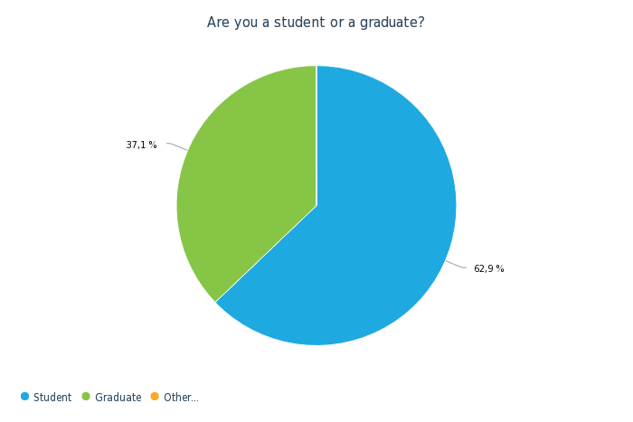
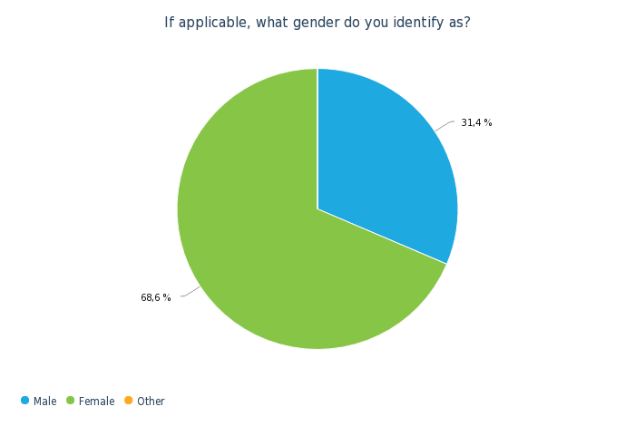

Figure 6.1. Student/graduate Figure 6.2. Gender

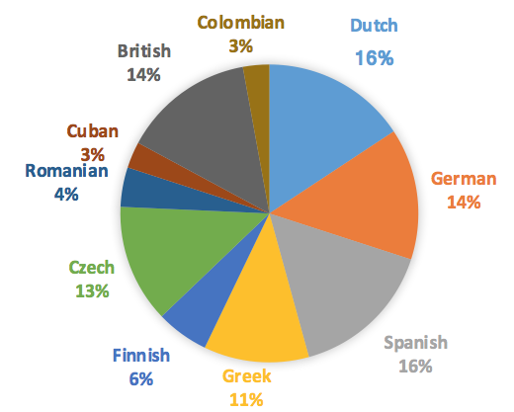
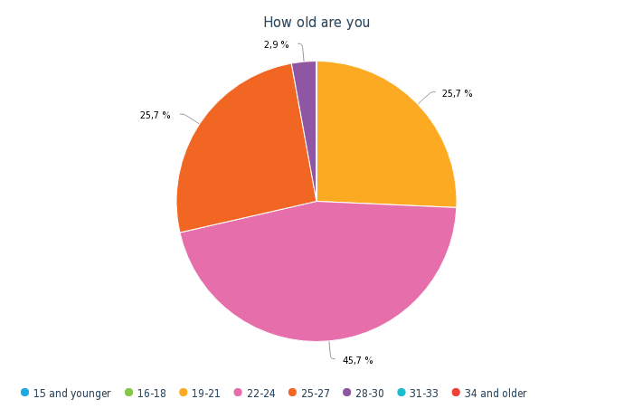

Figure 6.3. Age Figure 6.4. Nationality
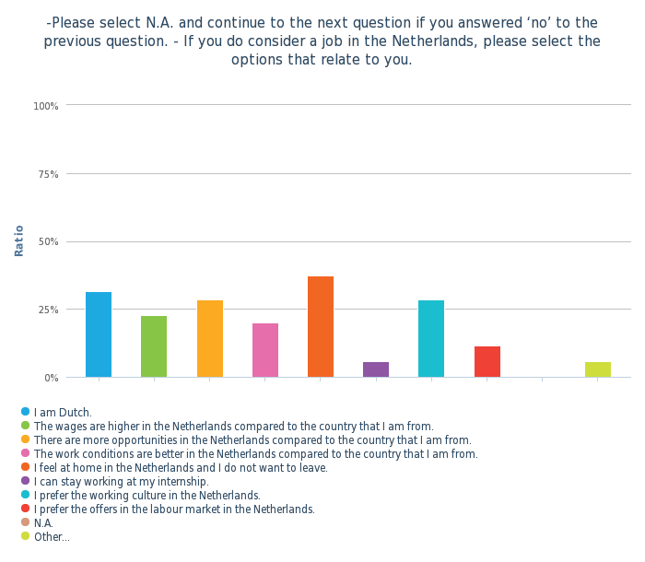
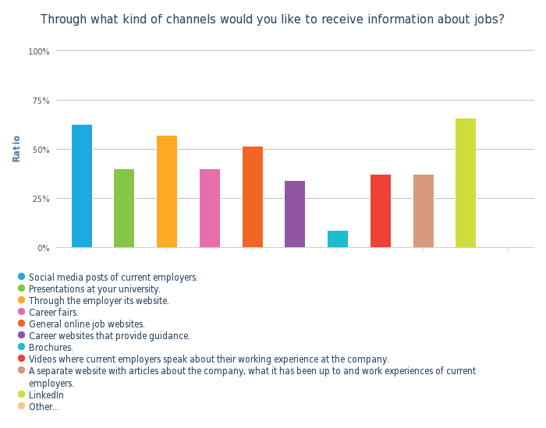
Question five demonstrates the studies and degrees of the respondents. Most respondents studied or graduated in European Studies, Business Administration, Engineering, HRM and International Business. Further, question six and eight are irrelevant to demonstrate since the answer demonstrated that all respondents are considering a job in the Netherlands. The reasons of why the respondents are considering a job in the Netherlands are demonstrated in Figure 6.5. In this question, multiple answers were possible. Most respondents answered that they feel at home in the Netherlands, that they prefer the working culture and that there are more opportunities and better work conditions in the Netherlands than in their country. Furthermore, the Dutch respondents gave their Dutch nationality as the reason.
Figure 6.5.

Question nine focussed on the communication channels that help to inform students and graduates about jobs. The most popular channel seems to be LinkedIn, closely followed by Social Media posts of employers. The employer website and general job sites are preferred as well. The overview of the outcome of the answers to this question is transferred to the graph demonstrated in Figure 6.6.

Figure 6.6.

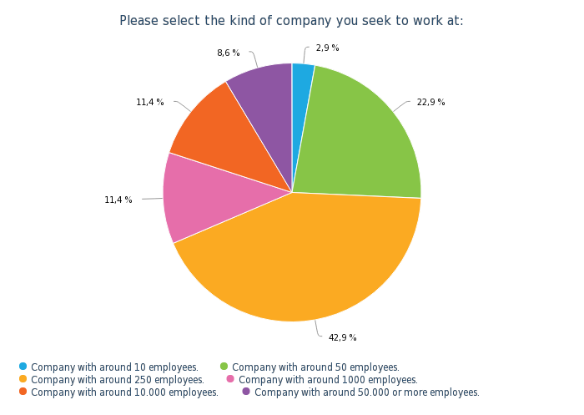
Question eight aims to find out what kind of business size classification, in relation to the number of employees, is preferred. The data demonstrates that, among the respondents, a company with 250 employees is most popular. This is followed by a company with around 50 employees. The smallest and biggest companies are both the least favoured. The overview of all answers can be seen in Figure 6.7.

Figure 6.7.
Questions eleven, twelve, thirteen, fourteen and sixteen aimed to find out what students and graduates prefer. The ranking is from top: mostly chosen, to bottom: least favourite. Question 15 demonstrates that students and graduates prefer to work in a team over working independently.
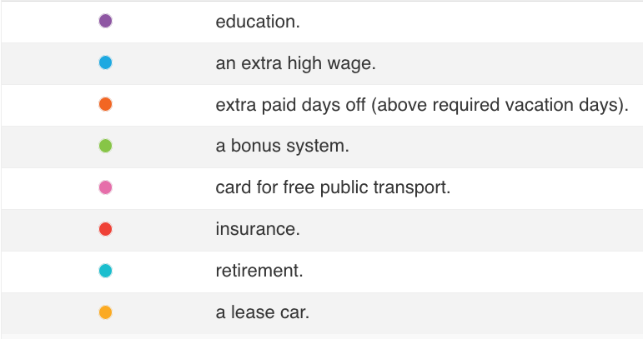
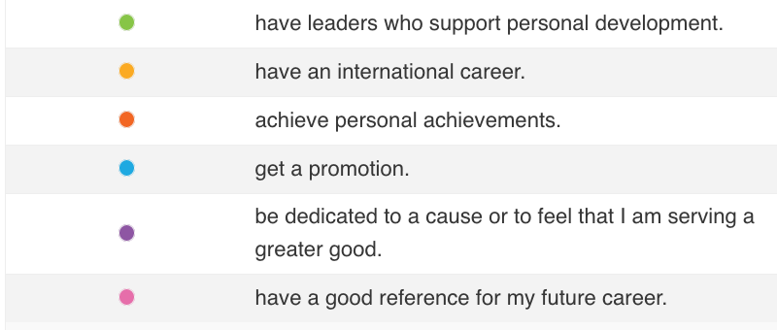
Figure 6.8. What do you seek in an employer?
My employer must offer compensation besides my wage in form of …
Figure 6.9. What do you demand of an employer?
I want to …

Figure 6.10. What do you demand of an employer?
My employer must …
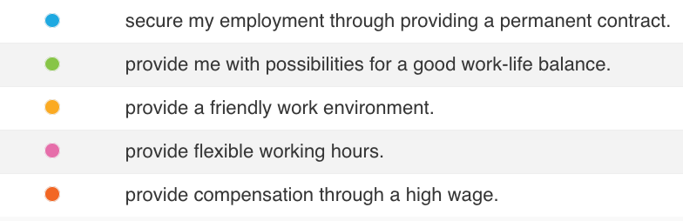
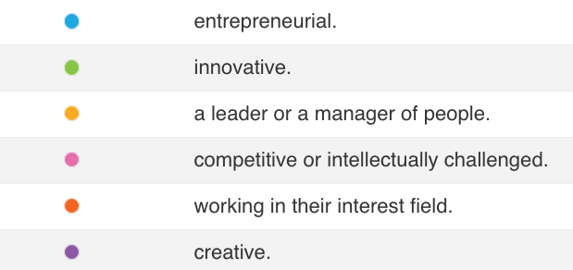
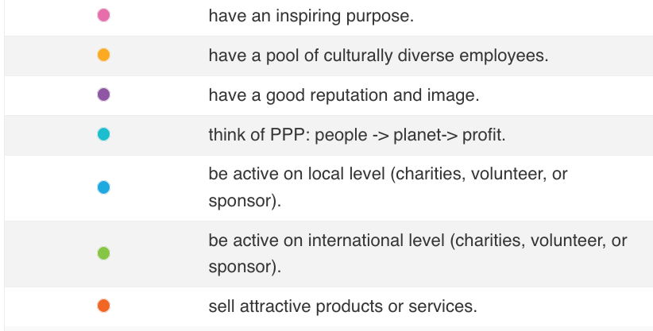
Figure 6.12. What do you prefer in an employer?
An employer must …

Figure 6.11. What must an employer offer?
My employer must provide possibilities for employees to be …

The national and organisational theory of Hofstede was the foundation of question 17 to question 28. Both theories exist of six dimensions. In each dimension, there are two opposites described (explained in chapter 3.). The respondents had to choose which situation they prefer.
For Hofstede’s Organisational Culture the following dimensions are preferred: Goal-orientated, Internally Driven, Easy-going work discipline, Professional, Open System and Employee-orientated. The following information describes the preferred statements that the respondents choose. Firstly, 80% of the respondents chose to work at a company where they get to achieve internal goals and results, even if it contains a lot of risks and effort. The other 20% went for a company where every day is mostly alike, not much risk is taken and a high effort is not needed. Secondly, the respondents chose that business ethics and honesty matter most (94%) and just 6% chose that customers must be prioritized. Thirdly, the respondents had to choose between the situation of an easy-going work culture with not much predictability, control and discipline or a situation in which a disciplined working method where people are punctual, serious and cost-conscious is preferred. The outcome is that the first situation is mostly preferred by the respondents, with 58%,. Furthermore, a quarter preferred to identify themselves with a manager and other co-workers and three-quarters preferred to identify themselves with their profession or content of the job. Moreover, the questionnaire demonstrates that the preference is almost equally divided. 50% of the respondents prefer to work at a company where everyone can work and no special qualities are needed. The other half prefers to work at a company where they have to try hard to fit in but when they do, they are part of a closed group. Furthermore, almost all respondents (94 %) chose for a workplace where personal problems are taken seriously and where the employer finds their welfare more important than the results they deliver. They chose this over the option of working at a company where the results of the organisation are more important than the employee’s welfare.
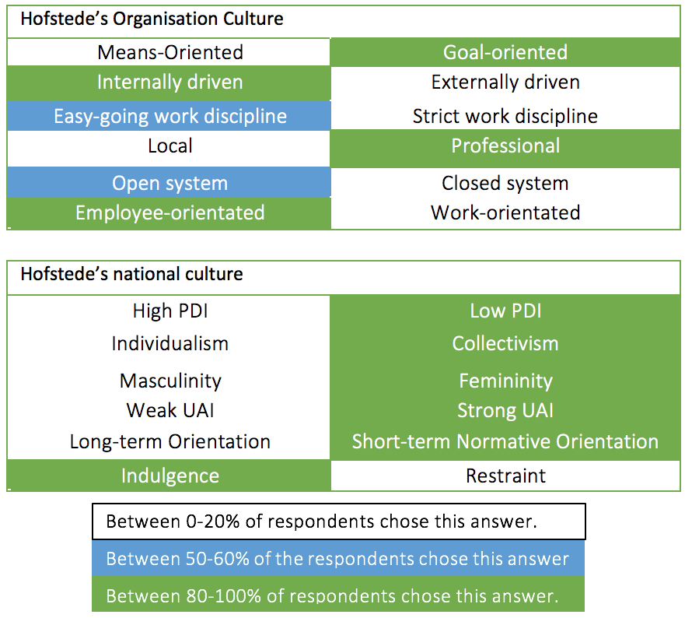
For Hofstede’s National Culture the following dimensions are preferred: Low PDI, Collectivism, Femininity, Strong UAI, Short-term Normative Orientation and Indulgence. The following information describes the preferred statements that the respondents chose. Firstly, all respondents chose a company where there is no hierarchical order over a company where there is a strict hierarchical order. Secondly, 86 % preferred an organisation that prefers the ‘we’ over ‘I’ and 14% choose a company where they prefer the ‘I’ over ‘we’. Thirdly, the choice was between a company with a lot of competition among colleagues and material rewards being normal (19%) and a company where cooperation, caring for each other, and having a quality personal life is most important (81%). The questionnaire aimed to answer if the respondents preferred a company with a clear view or with a flexible view of what they want to achieve in the future. A company with a clear view is preferred by almost 90%. Moreover, the questionnaire aimed to answer if the respondents preferred a company that stays true to old traditions or a company that keeps up with innovative happenings with their eye on the future. 91% preferred an innovative company. Finally, it was asked if the respondents preferred a company that requires responsible employees that are allowed to enjoy work or a company that regulates what the employees do, and desire the employees to be serious. The first option was chosen by almost 90% of the respondents.

Figure 6.13. demonstrates the dimensions of Hofstede’s Organisational and National culture. The figure shows which dimension was mostly chosen by the respondents (green), when the votes were almost equally divided (blue) and the significantly least chosen in white.

Figure 6.13. Hofstede’s Dimensions of the Organisation and National Culture.

8. Analysis
In this chapter, all information and data obtained during this research are analysed. This chapter provides a relation between findings, but also provides contradictions. It must be taken into account that the data of Universum Global are based on many more respondents than the data that is gathered through the questionnaire and interview in Chapter 5.4 and Chapter 5.5. Universum surveys yearly over one million University students and graduates who are seeking for the start of their careers (Röjdmark, 2019). The survey created for this research had 72 respondents and did not reach the expected 95% of reliability due to non-response. This questionnaire is still relevant since it was targeted directly to the target group (international students and graduates with a business-related degree/study). Furthermore, four interviews were conducted for this research. The interview and survey for this research were specifically aimed at the target group, therefore it is still relevant to compare this to the data of Universum Global.
In order to provide a sufficient comparison between the data which is gathered, a division between Contractual (compensations and benefits), experiential (careers and well-being) and emotional (purpose) factors are formulated. The researched theories all mention different sorts of compensation and benefits under different categories. Therefore, the division in this chapter is based on Figure 2.3.1. of Ambassify (Ambassify, 2019). Furthermore, when speaking about the interviews and questionnaires, it concerns the interview from Appendix 10. and the questionnaire from Appendix 15. When mentioning Universum, it refers to chapter 4.

8.1 Contractual Factors
Firstly, the four employees with an employer in the top 50 best companies in the Netherlands are offered an additional holiday payment, additional paid days off, reimbursement of travel expenses for home-work route and business trips, budget for vitality, curriculum activities besides work, meetings with professionals to discuss their future career and an additional month of payment at the end of the year. These are just the compensations mentioned by the interviewees; it is expected that there is more compensation offered but these are not named as outstanding by the interviewees.
Secondly, the respondents of the questionnaire would prefer education, an additional high wage and additional paid days off as compensation for their work. Universum mentions high future earnings, professional training and development and a competitive based salary. Furthermore, Ambassify states salary, raises, promotions and an evaluation system as important compensation. These answers are similar. Besides, additional days off is not named by Universum’s survey and by Ambassify. This could be because they did not offer it as a possibility during the questionnaire or it was irrelevant to mention it in the overview of the data. Another motive could be that Ambassify named it under another factor, namely under benefits.
Ambassify states time off, holidays, insurance, satisfaction with the systems, education and flexibility as important benefits for companies that want a strong employer brand. However, the data of the questionnaire demonstrated that insurance has not a high priority among the respondents (Figure 6.8). On the other hand, holidays, education and flexibility came forward in dissimilar words in other data sources as well.

8.2 Experiential and Emotional Factors
For this research, the experiential and emotional factors are the factors that influence the work experience of an employee. The data of Universum Global, from the questionnaire and interviews, mention the following career preferences of graduates and students:
Firstly, Universum’s research demonstrates that students and graduates prefer to be entrepreneurial and innovative, to be a leader or manager of people, to receive professional training and development, market success and to have a challenging job. The questionnaire demonstrates that students and graduates prefer to be entrepreneurial, innovative and a leader or a manager of people. The findings of all sources are mostly alike. However, some preferences are not named by all sources. This could be because different options were given when questioning the target group. Overall, it seems to be mostly important for students and graduates to be entrepreneurial, innovative, and a leader or manager of people. Further, Ambassify names the ability and chance to progress and develop, stability, training, education at work, career development, college education, consultation, evaluation and feedback as important for an employees’ career. These factors could influence becoming entrepreneurial, innovative and a leader or a manager of people.
Furthermore, a good balance between work and life is mentioned often. Universum names it when speaking about (long)term career goals of employees. It is in second place of what the respondents of the questionnaire demand of their employer and the interviewees indirectly mention it. For instance, interviewees mentioned that they want to have additional holiday days. The reason for this preference being named in all three data sources, could be because it is quite a broad concept. Creating a good balance between work and life relates to other factors, which are also mentioned as preferences. In order to create a better work-life balance, employers can offer flexibility in the planning of working hours (e.g. 4x9 hours), the possibility to work from home and to work over-time on account of more holiday days.
Secondly, according to Universum, ‘soon to be’ graduates worry about the economic situation and this influences the students view on stable and secure employment (Röjdmark, 2019). The questionnaire confirms this concern since having a secure employment is highly preferred by the respondents. This relates to other preferences named in the data of Universum, the interviews and questionnaires. Data from Universum and the questionnaire both demonstrate that a friendly work environment has importance. Furthermore, according to the questionnaire, offering a permanent contract also takes away the insecurities of employees.
Thirdly, career possibilities are mentioned in all the interviews, questionnaires, and the data of Universum. This relates to other preferences which are gathered during all research. Universum data and the questionnaire demonstrate that having leaders that support success is important. Furthermore, to provide possibilities for employees to be entrepreneurial and innovative is named as important by the interviewees, questionnaires and Universum. Moreover, the possibility to do courses, receive an education and promote personal development are also mentioned, just as the preference for the possibility of getting a promotion.
The data from the questionnaire demonstrated that the respondents aspire an international career, which makes sense, because all international respondents indicated that they consider a career in the Netherlands. However, according to Universum, the desire to work abroad has decreased over the last three years, since students prefer their home country over other countries (Röjdmark, 2019). This outcome makes sense, since the target group for the questionnaire was international students and graduates in the Netherlands, who were asked if they want to stay in the Netherlands, and the question was not if they wanted to work ‘abroad’. The way of asking this question could explain the difference in outcome.
The reasons that the respondents of the questionnaire want to remain in the Netherlands are because of the possibilities that the Dutch labour market offers, the Dutch working culture and the fact that there are more job opportunities in the Netherlands. One of the interviewees also mentioned that her employer offers the Dutch working culture. However, it is also preferred by the respondents to have a group of culturally diverse co-workers. This could be seen as opposites, however, an employer with a Dutch working culture can still have culturally diverse employees that enjoy the Dutch working style.
Furthermore, Universum’s data shows that a creative and dynamic work environment is important. Also, it demonstrates that start-ups are most popular. The questionnaire showed that companies with around 250 employees are most preferred and that working in small teams is most preferred. The survey also demonstrated a preference for culturally diverse co-workers. The preference for culturally diverse employees could be because international employees prefer not to be the only one who is not a native. One interviewee mentioned having her office at a good location and having enough flexible workspaces as important. Another interviewee named the Dutch corporate culture as attractive to her. However, she is Dutch, making it considered as less relevant for the international students and graduates. However, it does mean that Bol.com offers a Dutch culture and this could relate to the respondents naming the Dutch work culture as the third reason why they want to stay in the Netherlands. This could mean that having a Dutch corporate culture as an employer could help obtain international students and graduates.
According to Universum, it is important to clearly clarify the core purpose of the company and to focus on the national and international status of the company. Furthermore, it is important to have an inspiring purpose, to be innovative and to be committed to diversity and inclusion. For a ‘small’ company it is more important to be team orientated. For a ‘medium-sized’ company and a ‘large’ company it is most important to have an inspiring purpose (Röjdmark, 2019).
The interviewees’ mention having an inspiring purpose as important. Furthermore, one interviewee appreciates the communication from Bol.com regarding the conditions of the company. In addition, the respondents of the questionnaire value an inspiring purpose, a good reputation and image and PPP (People, Planet, Profit).

8.3 Communication Channels for Recruitment
Research is gathered over which communication channel the international students and graduates prefer to be contacted through by employers. The data shows that both the respondents of the questionnaire and the respondents of Universum chose social media, on-campus recruitment, employer websites and online job boards as their favourite communication channels when seeking a job. In the interview there is no question about the communication channels since the interviewees are Dutch. It could have been interesting to know how their employers addressed the interviewees since the companies are among the 50 best employers in the Netherlands.

8.4 Hofstede’s Theories
According to the 72 respondents of the questionnaire, the following dimensions of Hofstede’s Organisational and National Theory are preferred. Firstly, international students and graduates appear to prefer work which differs from day to day and an employer where internal targets/results can be achieved. These students and graduates care less about the risks that come with this style of work. The respondents do care about the business ethics of a company and about how honest an employer is. Furthermore, the employer must have a disciplined working method with predictability, but on the other hand spontaneity and surprises must be possible as well. Moreover, when a new colleague enters the company, it is preferred that they show an effort to fit in and that current employees welcome them. It is also expected that the well-being of employees comes before the turn-over. In addition, the respondents prefer a company with almost no hierarchy. Also, an employer with employees that feel responsible for their colleagues and prefer the ‘we’ over ‘I’ seems to be preferred. Further, cooperation, caring for each other, having a high-quality personal life and being modest is highly important. Besides that, a company with a clear view of what the company wants to achieve in the future has a preference. Moreover, an employer with a focus on modern and innovative happenings with an eye on the future is considered important. Finally, the respondents prefer a working place where the employees are responsible and are allowed to enjoy work and have fun.

9. Conclusion
For this research, field and desk research were gathered in order to answer the research question. Based on this research, the following can be concluded as ‘the best ways for Dutch companies in the private sector to increase the value of their employer branding to retain international business graduates within the Netherlands in order to go against labour shortages of skilled employees’. The best way of employer branding is by using internal and external employer branding, the preferred dimensions of Hofstede’s National and Organisational Culture, and the list of preferred contractual factors, experiential factors, and emotional factors. These are further detailed below, and examples can be found in Figure 10.1, 10,2, and 10.3 in the recommendation section (Chapter 10).
Firstly, based on findings of Welsing, Ambler and Barrow it can be concluded that there are different types of employer branding that are useful, namely external and internal employer branding. For internal employer branding it is important to align internal communication and behaviour of employees with what the company wants to communicate to the world. For external employer branding it is important to distinguish as an employer through offering a package of functional, economic and psychological benefits.
Secondly, it can be concluded that the following dimensions of Hofstede’s Theories on Organisational and National Culture are best to use when increasing the value of a company’s employer branding and motivate students and graduates to remain in the Netherlands. For the Organisational Culture ‘Goal-orientated, Internally Driven, Easy- and Strict- going Work Discipline, Professional Culture, Open and Closed System and Employee-oriented’ were preferred. For the National Culture ‘Low PDI, Collectivism, Femininity, strong UAI, Short-term Normative Orientation, and Indulgence’ were preferred. These dimensions were formulated into questions in the questionnaire held among 72 students and graduates. The preferred dimensions are based on the responses of the respondents of the questionnaire.
Thirdly, to find out what companies in the private sector do in order to interest and obtain graduates, four employees that work for an employer that is in the top 50 best employers of the Netherlands were interviewed. These employees receive the following in return for the work what they deliver. In short, these employers provide possibilities for growth and personal development. Furthermore, they offer a good work-life balance, have an inspiring purpose and are open about the conditions of the company.
Furthermore, the motivations of international Business graduates when seeking for a job are as follows. It can be concluded that, based on contractual factors, the target group appears to be interested in compensation in the form of money, which can be provided through different ways (see figure 10.2). Furthermore, professional training, development and additional holidays are desired. For the experiential and emotional factors, the students’ and graduates’ motivations can be concluded as follows. The students and graduates aspire a good work-life balance and to have future career options. They aspire to have a challenging job in which there is room for personal development. Another motivational factor is when the employer’s core purpose is inspiring and when the employer can offer a secure job. Moreover, it motivates the target group to work at an employer with a Dutch corporate culture that is open to culturally diverse employees and inclusion. These factors must be considered to improve the employer branding to obtain graduates and students in the Netherlands.
To conclude, Dutch companies in the private sector must have knowledge about the different sorts of employer branding and how to use them. Furthermore, these employers must change their Organisational and National Culture, as described above, according to Hofstede’s Theories. Finally, to increase their value of employer branding in order to obtain international business graduates, employers must take the desired contractual, experiential and emotional factors into account, which are: compensation through money and benefits, a good work-life valance, good future career options, secure employment and an inspiring core purpose.

10. Recommendation
Based on the desk research of the theory of Ambassify, Universum, Welsing, Ambler and Barrow in combination with the quantitative and qualitative field research, the following recommendations are created. First, the general recommendations that came forward in this research are named. Secondly, an advisory framework is created which contains recommendations divided in three figures (10.1, 10.2, and 10.3).
The following recommendations were not relevant enough to be in the framework but are good tips regarding improvement of the employer brand and recruitment. Firstly, it is recommended to look at the employers listed in the WMAE and in the Best rated Dutch employers for business-related positions, and to take these employers as an example. Secondly, the recommended communication channels to contact the international students and graduates about a job are: social media, on-campus recruitment, employer websites and online job boards. Thirdly, it is advised to communicate the EVP in one short sentence. Furthermore, employers could look into Artificial Intelligence for recruiting.
Finally, it must be taken into consideration that all employees and employers are different, and therefore these theories might not work in every situation. It is recommended to continue the research about employer branding and the best ways to retain international students and graduates in the Netherlands. The following is advised to keep into consideration when continuing this research. Gather more respondents for a questionnaire among students and graduates, and more interviewees from companies, such as companies of WMAE, to create a high percentage of reliability. It is recommended to do more research regarding theories on employer branding to create a sufficient comparison with the field research. Furthermore, it Is recommended to focus the research on one employer in order to achieve a specific advice.

Advisory framework
Companies can improve their employer branding as a tool to find the right employees. For the use of external employer branding it is recommended to distinguish as employer comparing to the competitors. This can be carried out through offering a package of functional, economic and psychological benefits. See Figure 10.2 for examples of contractual factors, experiential factors and emotional factors. Furthermore, to help the process of finding skilled employees it is recommended to create a coherent framework that focusses on the employer’s priorities when seeking for an employee. This can be considered in the recruiting process to attract the right candidates.
The recommendation when using internal employer branding is to start with aligning the behaviour of the current employees with what the company communicates to the world. This is carried out through having a clear line of communication between the employer and employee. When an employer has employees that positively promote the workplace in their surroundings, there is a higher chance that they will recruit new employees. Another recommendation is to retain the current employees satisfied with their future prospects within the company. Openness about growth possibilities must be communicated.
Figure 10.2 demonstrates the recommendations based on the contractual, experiential and emotional factors. It is advised to focus on compensation through money and benefits, a good work-life balance, good future career options, secure employment and an inspiring core purpose. Examples are named in the figure of how employers can offer these factors. Furthermore, the preferred dimensions of Hofstede’s theories on National and Organisational Cultures are listed in Figure 10.3. It is advised to create a work environment where these aspects show.

Employer branding | Employers must offer … | Very important to …
External employer branding | … competing advantages that distinguish them from competition in the form of a package of functional, economic and psychological benefits. | … have a coherent framework for management that focusses on the priorities and improves the process of recruitment.
Internal employer Branding | … openness about future growth possibilities of the current employees within the company. | … align behaviour of current employees with what the company communicates to the world.
EVP | … contractual, experiential and emotional factors at the level at which the employee values him-/herself and which are still feasible for the employer. | … ask what the current employees desire and then compare these desires with what the company is willing and able to offer.
Figure 10.1 External, internal employer branding, and EVP
Factors | Employers must offer … | For example, by offering…
Contractual Factors | … compensation through money. | … an extra high salary, extra holiday payments, extra paid days off, reimbursement of travel expenses for the home-work route and business trips, raises, promotions, a competitive based salary and an extra month of payment at the end of the year.
 | … benefits. | … education, professional training and development, a budget for vitality and extra activities besides work.
Experiential and Emotional Factors | … a good work-life balance. | … flexibility in the planning of working hours (e.g. 4x9 hours), the possibility to work from home and to work over-time on account of more holiday days.
 | … future career options. | … meetings with professionals to discuss their future career, being entrepreneurial and innovative, to be a leader or manager of people, professional training and development, having an international career market success and providing a challenging job.
 | … secure employment | … a friendly work environment, having leaders that support success, promoting personal development, offering a permanent contract, welcoming and including culturally diverse employees, offering small teams and a creative and dynamic work environment.
 | … an inspiring core purpose | … /having a good reputation and focusing on PPP.
Figure 10.2 Contractual factors, Experiential factors, and Emotional factors

Theories of Geert Hofstede | Creates a work environment where …
Goal-orientated | … working days differ and internal targets/results can be achieved, plus focus less on the risks.
Internally driven | … business ethics and honesty matter most.
Easy- and Strict- going work discipline | … there is room for a disciplined working method with predictability, but on the other hand spontaneity and surprises are possible.
Professional Culture | … the focus is long-term directed and employees can identify with their profession.
Open and Closed System | … new employees have to show effort to fit in but are also welcomed by the current employees.
Employee-oriented | … the well-being of employees comes before the turn-over.
Low PDI | … there is almost no hierarchy among the levels of employees.
Collectivism | … employees feel responsible for their colleagues and prefer the ‘we’ over ‘I’.
Femininity | … cooperation, caring for each other, having a high-quality personal life and being modest is most important.
Strong UAI | … there is a clear view of what the company wants to achieve in the future.
Short-term Normative Orientation | … the focus is on modern innovative happenings and on the future.
Indulgence | … employees are responsible and are allowed to enjoy work and have fun.
Figure 10.3 Theories of Geert Hofstede

Bibliography
Ambassify. (2019). Customers. Retrieved from Ambassify: https://www.ambassify.com/customers/
Ambassify. (2019). Employer Branding - 7 Tips For Building A Company People Want To Work For. Retrieved from Ambassify: https://www.ambassify.com/blog/employer-branding?campaignid=1708474013&adgroupid68201795178&device=c&keyword=%2Bemployer%20%2Bbranding&gclid=Cj0KCQjwjOrtBRCcARIsAEq4rW5rv7XJSMm39MYNr52IqJl3OcpNAtGCHrhF5WwMLO4T-y-MsFdqbJ4aAhIeEALw_wcB#Employee%20Value%20Proposition
Backhaus, K., & Tikoo, S. (2004). Conceptualizing and researching employer branding. Career Development International.
Consultancy. (2019, 06 11). Driekwart bedrijven worstelt met het vinden van personeel. Retrieved from www.consultancy.nl: https://www.consultancy.nl/nieuws/23717/driekwart-bedrijven-worstelt-met-het-vinden-van-personeel
Drury. (2016). Employer branding. Human Resource Management International Digest.
ec.europa.eu. (2019). Unemployment statistics and beyond. European Union.
European Migration Office. (2015). Determining labour shortages and the need for labour migration from third countries in the EU. EMO. Europe: European Commission.
Eurostat. (2019, 08). Unemployment statistics . Retrieved from ec.europa.eu: https://ec.europa.eu/eurostat/statistics-explained/index.php/Unemployment_statistics#Longer-term_unemployment_trends
Franca, & Pahor. (2012). The Strength of the Employer Brand:Influences and Implications for Recruiting. Journal of Marketing and Management.
Gudergan, Lings, & Wilden. (2010). Employer branding: strategic implications for staff recruitment. Journal of Marketing Management.
Hatton, A. (2000). The definitive guide to marketing planning: The fast track to intelligent marketing planning and implementation for executives. Londen: Financial Times Prentice-Hall.
Hofstede, G. (n.d.). Organisational Culture. Retrieved from Hofstede-insights: https://www.hofstede-insights.com/models/organisational-culture/
Hofstede-insights. (2019, 01 24). National Culture and Organisational Culture - how are they different? Retrieved from Hofstede-insights: https://news.hofstede-insights.com/news/national-culture-and-organisational-culture-how-are-they-different
Hofstede-insights. (2019). Organisational Culture. Retrieved from Hofstede-insights: https://www.hofstede-insights.com/models/organisational-culture/
Hofstede-Insights. (2019). The 6 dimensions of national culture. Retrieved from Hofstede-Insights: https://www.hofstede-insights.com/models/national-culture/
Kasasa. (2019, 04 22). Boomers, Gen X, Gen Y, and Gen Z Explained. Retrieved from Kasasa: https://www.kasasa.com/articles/generations/gen-x-gen-y-gen-z
Merk, J., & Buttgen, M. (2012). Employer branding: Sustainable HRM as a competitive advantage in the market for high-quality employees. Management Revue.
NOS. (2018, 06 26). Goed personeel steeds moeilijker te vinden. Retrieved from www.nos.nl: https://nos.nl/artikel/2238475-goed-personeel-steeds-moeilijker-te-vinden.html
NOS. (2018, 06 01). Recordaantal banen in Nederland, werkgevers steeds wanhopiger. Retrieved from www.nos.nl: https://nos.nl/artikel/2234554-recordaantal-banen-in-nederland-werkgevers-steeds-wanhopiger.html
Nuffic. (2017). Stayrate van internationale afgestudeerden in Nederland. Retrieved from www.nuffic.nl: www.nuffic.nl/stayrates
Röjdmark, M. (2019). World’s Most Attractive Employers 2019. In M. Röjdmark. Universum.
Schrier, M. v. (2019, 06 12). Het wordt steeds lastiger voor werkgevers om personeel te behouden. Retrieved from www.ad.nl: https://www.ad.nl/ad-werkt/het-wordt-steeds-lastiger-voor-werkgevers-om-personeel-te-behouden~ada87ccd/?referrer=https://www.google.com/
Simon Barrow Associates. (2019). History Simon Barrow Associates was started in January 2014. Retrieved from sbaemployerbrand: https://www.sbaemployerbrand.com/history
St Jorre, T., & Oliver, B. (2018). Want students to engage? Contextualise graduate learning outcomes and assess for employability. Higher Education Research & Development.
studiekeuze123. (2019). Opleidingen Alle erkende hbo- en wo-opleidingen van Nederland . Retrieved from studiekeuze123: https://www.studiekeuze123.nl/opleidingen
SurveyMonkey. (2019). Steekproefgrootte berekenen. Retrieved from SurveyMonkey: https://nl.surveymonkey.com/mp/sample-size-calculator/
Universum. (2019). Employer Branding NOW | 2019. In Employer Branding NOW | 2019 (pp. 1-29). Universum.
Universum. (2019). The Most Attractive Employers in the Netherlands. In Universum, The Most Attractive Employers in the Netherlands (pp. 1-13). Universum.
UWV. (2018, 06 01). UWV Arbeidsmarktprognose 2018-2019. Retrieved from www.uwv.nl: https://www.uwv.nl/overuwv/kennis-cijfers-en-onderzoek/arbeidsmarktinformatie/uwv-arbeidsmarktprognose-2018-2019.aspx
Welsing, C. (2003). HRMarketing. In C. Wesling, A new perspective on human resources management (pp. 29-33). Zeist: Prentice Hall.

Appendix

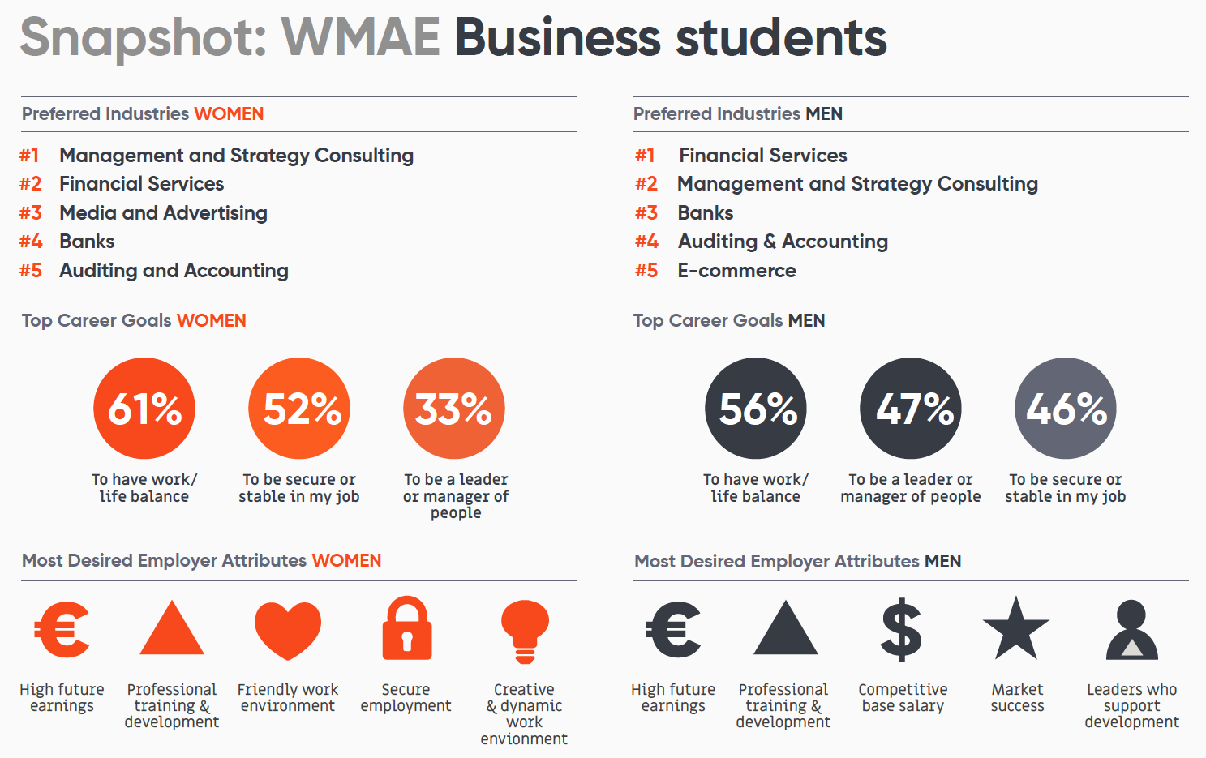
Appendix 1. WMAE Business students
(Röjdmark, 2019)

Appendix 2. Career Goals Business students
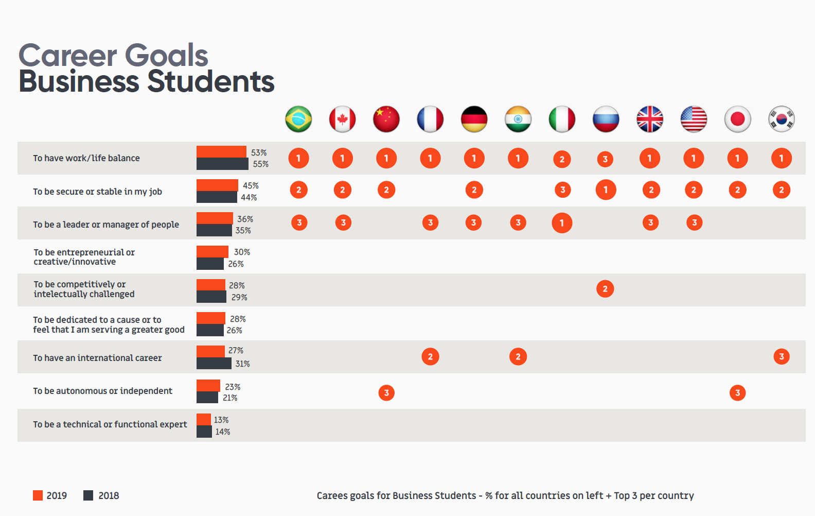
(Röjdmark, 2019)

Appendix 3. Top 10 preferences Business Students
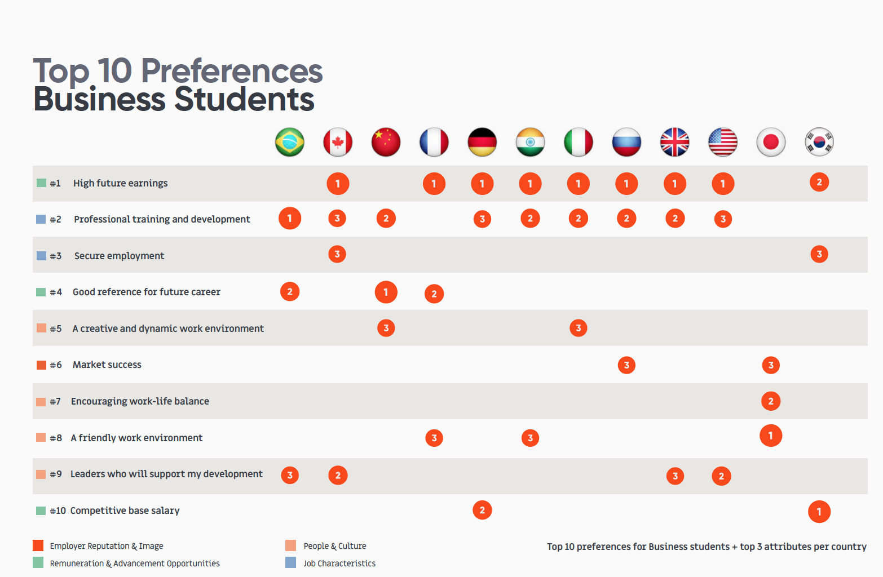
(Röjdmark, 2019)

Appendix 4. Top 10 Communication Channels
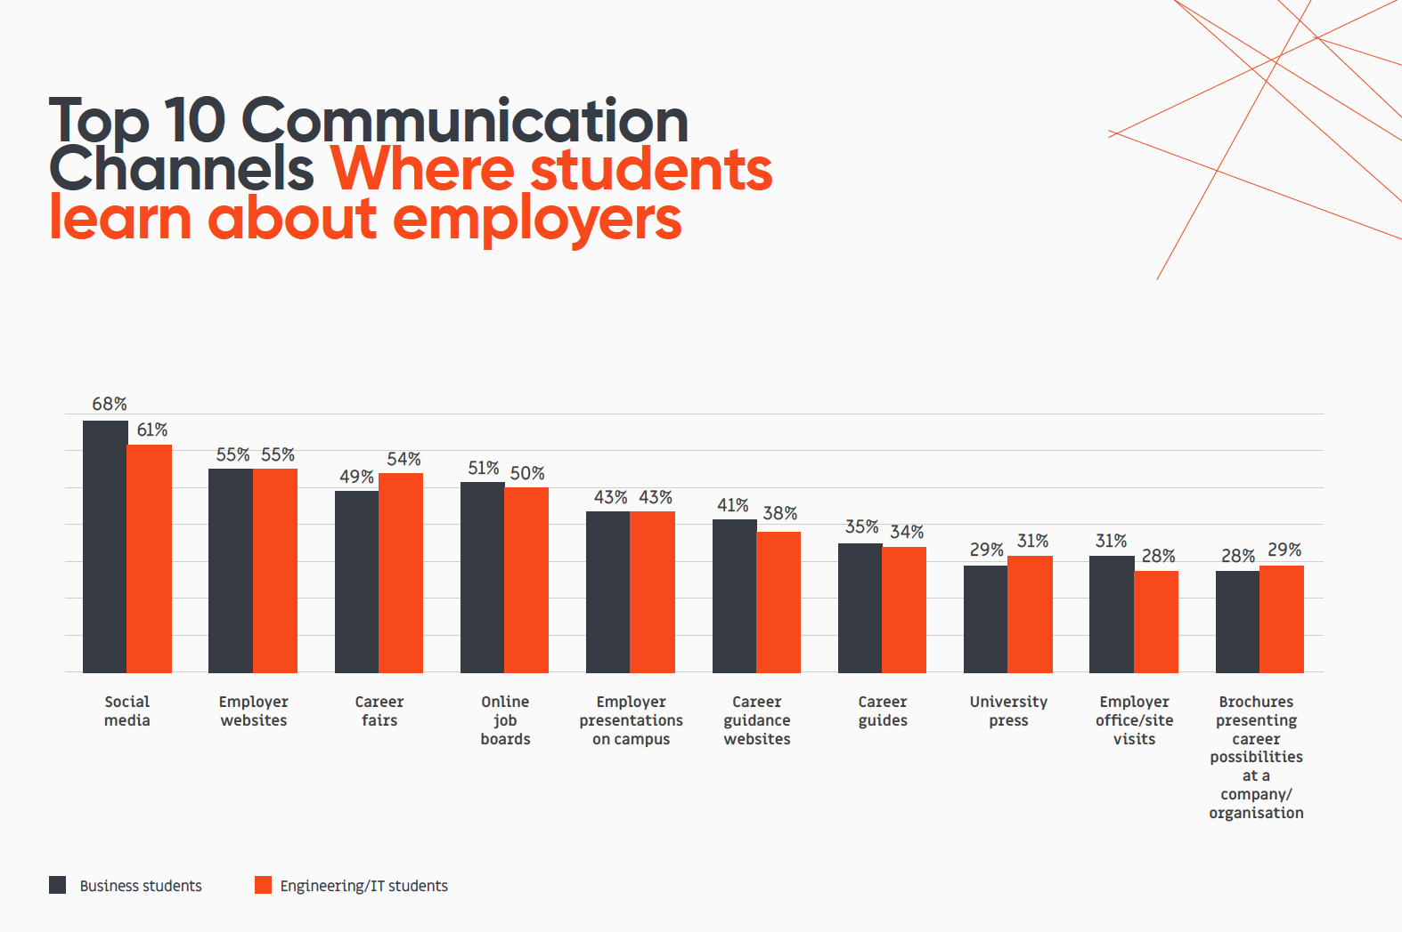
(Röjdmark, 2019).

Appendix 5. Beyond the rankings
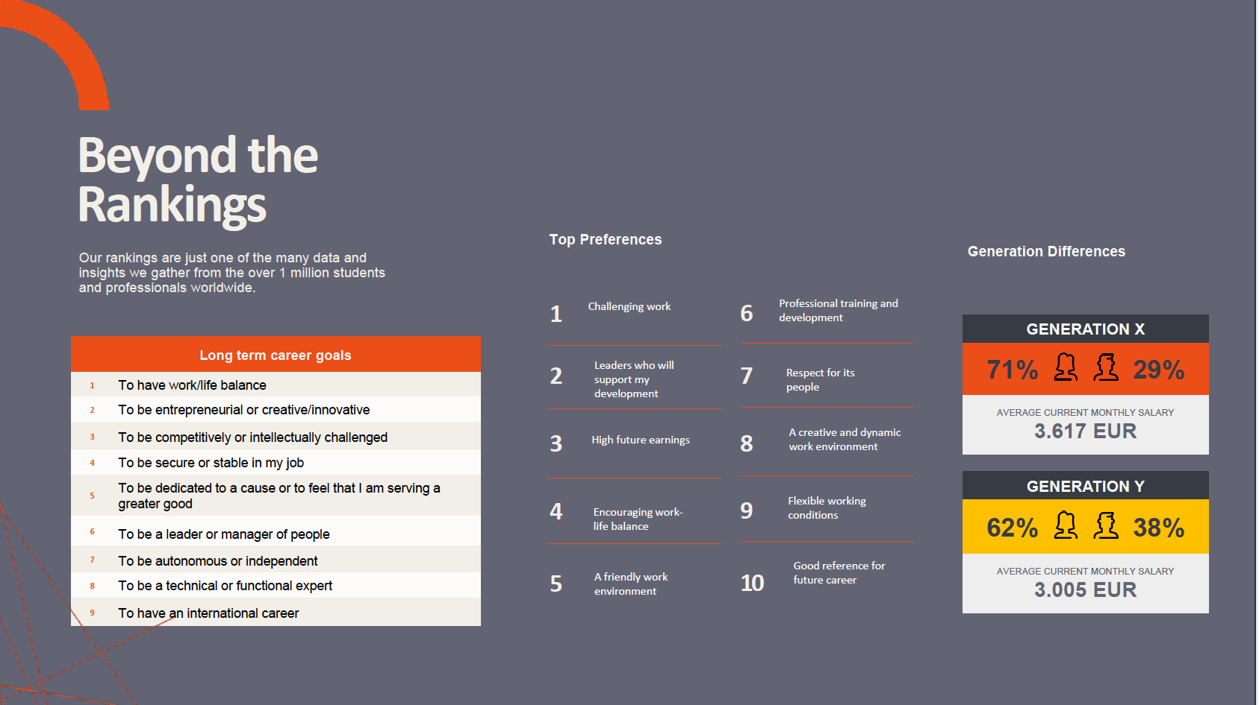
(Universum, 2019).
Appendix 6. World’s most attractive employers
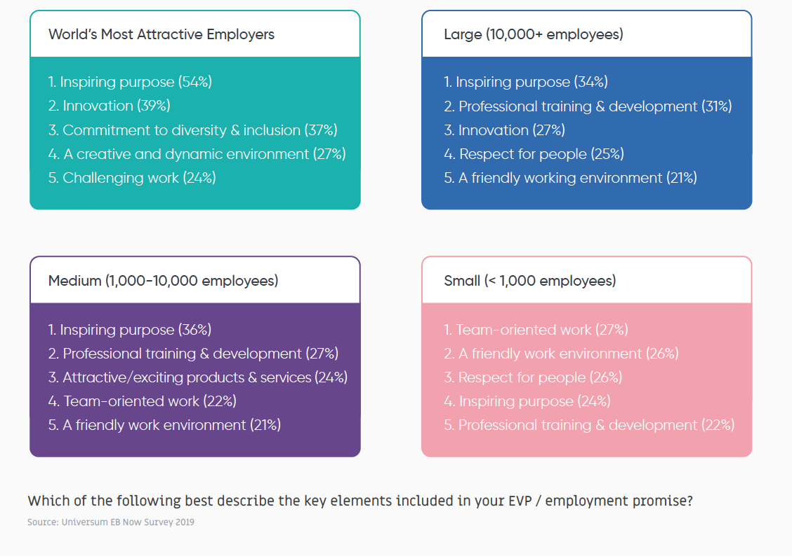
(Universum, 2019).

Appendix 7. EVP / employment promise
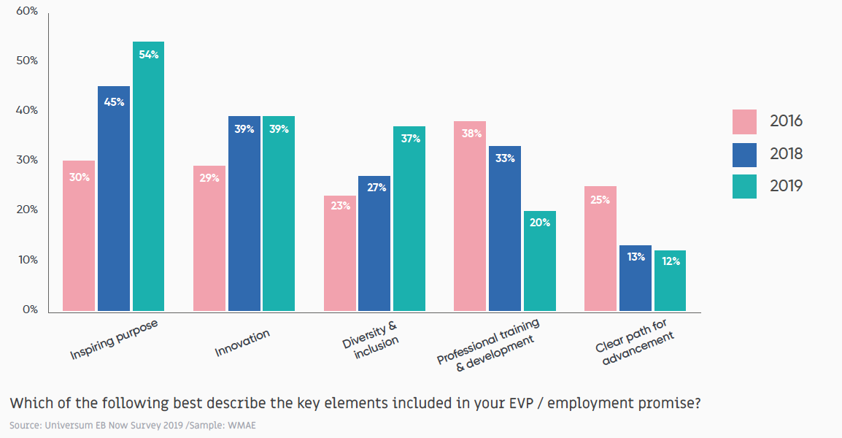
(Universum, 2019).

Appendix 8. World’s Most Attractive Employers Ranking
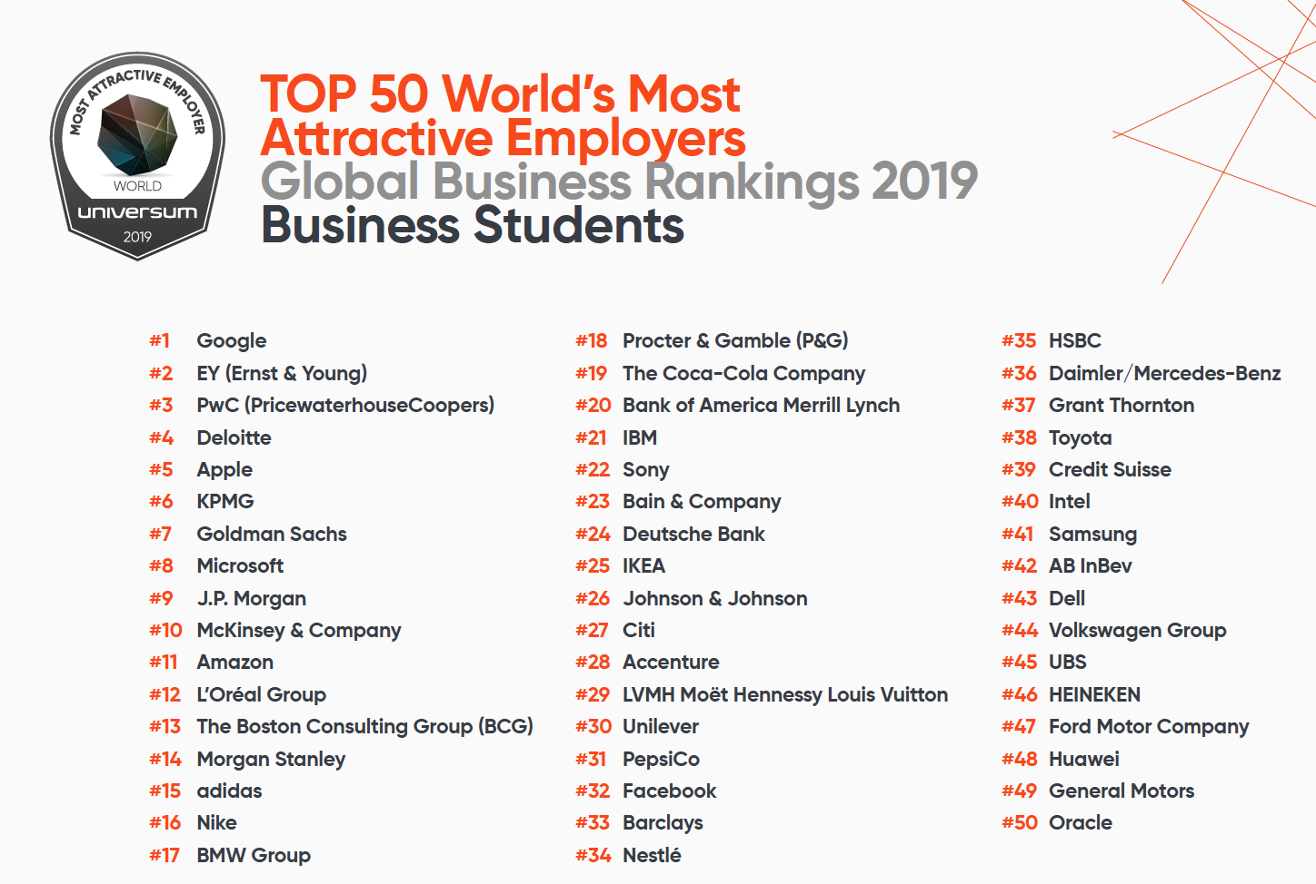
(Röjdmark, 2019).

Appendix 9. Best rated Dutch employers for business-related positions
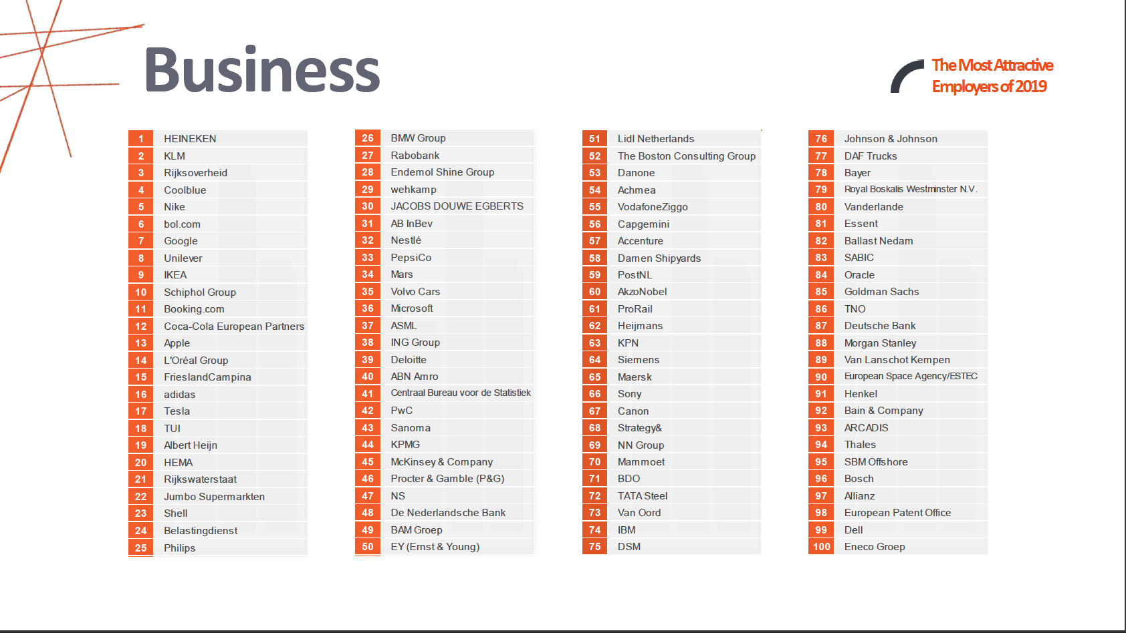
(Universum, 2019).

Appendix 10. Interview questions
Thank you for opening this interview and congrats, your employer is in the top 50 of best employers in the Netherlands!
My research focusses on students and graduates with a study or degree in a business-related study. The aim is to find out how private companies can adjust their employer branding to have a stronger position in the labour market and finding the right employers. To provide a sufficient advice report for private companies, I need you! With this interview, I hope to find out what the companies that are in the ‘top 50 best employers in the Netherlands’ offer to their employees.
Employer Branding is defined by their creators as: the package of functional, economic and psychological benefits provided by employment and identified with the employing company’
Name:
Age:
Gender:
Nationality:
Education:

- Where do you work and for how long have you been working there?
- Which requirements did you seek for in an employer?
- How does your current employer fulfil these requirements? If not, why did you still chose to work there?
- To what extend does the purpose of the company play a role when choosing for an employer?
- What kind of compensation and benefits does your employer offer that are outstanding in your experience and do you think these are important?
- What kind of career opportunities does your employer offer that are outstanding in your experience and do you think these are important?
- What were your opinions about the employer before applying and working at the company?
- Did this change while working at the company and explain how?
- How could the company that you work at improve its employer branding?

Appendix 11. Interview Rijksoverheid
Name: Anonymous
Age: 24
Gender: Female
Nationality: Dutch
Education: Business University

- Where do you work and for how long have you been working there?
Since three months, I work at the Dutch Ministry of Justice and Security. Currently, I am employed at the Immigration- Naturalisation Service.
- Which requirements did you seek for in an employer?
My desired requirements for an employer include the following:
- Great location.
- Reimbursement of travel expenses for home-work route and business trips.
- At least an average amount of holiday days.
- Flexibility in the planning of working hours (so possibility of 4x9 hours etc.).
- Possibility to work at home.
- How does your current employer fulfil these requirements? If not, why did you still chose to work there?
My employer offers all these requirements. As an employee, I have the freedom to plan my working days in the way it suits for me. Hereby, I keep in mind the wishes of the employer regarding which days are the best for working at home. Furthermore, I have the possibility to work more hours than I am contracted for. In that way, I collect additional hours of holiday.
- To what extend does the purpose of the company play a role when choosing for an employer?
This aspect plays a huge role for me. My purpose is to do socially relevant work, as does the Rijksoverheid. My choice for the Rijksoverheid was based on the fact that we work for citizens in and outside the Netherlands. Maybe it is somewhat idealistic, but the political and social aspect attracts me. The profit motive of a company or my salary/bonus is not something that drives me the most, it is the results we create for citizens and the country.
- What kind of compensation and benefits does your employer offer that are outstanding in your experience and do you think these are important?
In my opinion my employer offers a fair amount of holiday days. As an employee you have the opportunity to take vacation more frequently and reload for the upcoming work. Besides that, my employer offers free travel between home and work, even if you live far away. Also, cycling is encouraged by offering a cycling compensation. Maybe the compensation and benefits are not outstanding, but they are pleasant and add to the satisfaction of employees. Also, ‘vakantiegeld’ and a ‘13e maand’ are included.
- What kind of career opportunities does your employer offer that are outstanding in your experience and do you think these are important?
Within the Rijksoverheid there are endless opportunities to work on different topics in different environments. Switching jobs within the Rijksoverheid is encouraged. During my traineeship, I get the opportunity to work at four different places within the Ministry of Justice and Security and other ministries and local governments.
There are plenty of educational courses you can follow as an employee. However, you have to take the chances yourself and be active in searching for other vacancies. Building a network is very important.
- What were your opinions about the employer before applying and working at the company?
That Rijksoverheid offers many career possibilities. Further, my opinion was that there was enough space to work and plan meetings in the government buildings.
- Did this change while working at the company and explain how?
My opinion partly changed. Unfortunately, there are more employees that working places, so finding a table with pc to work can be hard in these so called ‘kantoortuinen’. Also, concentration/focus can be hard with a lot of people in relatively small areas.
I was pleasantly surprised in the way they are flexible with the division of your working hours and working days. Of course, this will differ among the departments because some topics have more political sensitivity that others and bring more workload – and stress.
- How could the company that you work at improve its employer branding?
Perhaps it could promote the opportunities to grow within the company and the diverse jobs that are offered. On the other hand, I think the Rijksoverheid already has a good connection with the labour market. For example, the Ministry of Defence has appealing marketing ads. However, I think that the Rijksoverheid could work on attracting new IT talent, this is scarce.

Appendix 12. Interview Bol.com
Name: Anonymous
Age: 27
Gender: Female
Nationality: Dutch
Education: Master in marketing
- Where do you work and for how long have you been working there?
I work at bol.com as a customer journey specialist since 1,5 years.
- Which requirements did you seek for in an employer?
I preferred a big commercial retail player, since I was working in this industry before bol.com as well. I also searched for a company with a straight forward Dutch working culture since I do not like, for example, a big American organisation where the employee is just a number.
- How does your current employer fulfil these requirements? If not, why did you still chose to work there?
My current employer does fulfil these requirements. Every employee is seen as an entrepreneur in the company. Therefore, it is possible to ‘own’ your own shop where I can test, make mistakes that cost money, and can learn from those tests and mistakes. Furthermore, it is an open organisation where everyone, even the interns, may see the turnover and the strategic decisions.
- To what extend does the purpose of the company play a role when choosing for an employer?
I did play a role for me. The aim of bol.com is to improve the life of the customer through making it easier. This is aim is central in all plans and ideas. As an employee you may think of and suggest everting that could strengthen this aim.
- What kind of compensation and benefits does your employer offer that are outstanding in your experience and do you think these are important?
Bol.com offers the following compensation and benefits: salary, more than the average holiday days, a bonus at the end of the year and after reaching goals, flexible working hours, possibility to work at home, a gym, a minimum of three company parties including an artist, after work drinks on Fridays, taxi from Utrecht station to the office, healthy lunches, events, possibilities to go to personal appointments during working hours (hairdresser), interesting speakers, and games. Bol.com does a lot to attract young people.

- What kind of career opportunities does your employer offer that are outstanding in your experience and do you think these are important?
I think that the amount of trainings that an employee can follow that helps professional and personal growth is outstanding. There is always a possibility to meet with the HR-department to see where there could be new challenge for you. Furthermore, the managers
of bol.com are also eager to discuss your future steps within bol.com and guide you throughout this process.
- What were your opinions about the employer before applying and working at the company?
My opinion beforehand was that bol.com is a straight forward, open, transparent, and a fun group where everything is possible.
- Did this change while working at the company and explain how?
My opinion did not change.
- How could the company that you work at improve its employer branding?
Bol.com could improve their employer branding through providing a better mix between starters and professionals, so they can learn from each other. Nowadays, bol.com is such a big company and not all departments work align. Therefore, it often happens that ‘new’ inventions are invented twice, since it was not communicated well between the departments.

Appendix 13. Interview ING
Name: Anonymous
Age: 24
Gender: Male
Nationality: Dutch
Education: Business administration
Where do you work and for how long have you been working there?
I work at ING since 2 years as a mortgage advisor.
2. Which requirements did you seek for in an employer?
I wanted an employer that offers possibilities for growth and personal development.
3. How does your current employer fulfil these requirements? If not, why did you still chose to work there?
At this moment, the growth possibilities at my department are disappointing and therefore I plan to leave.
4. To what extend does the purpose of the company play a role when choosing for an employer?
It is important for me what kind of purpose the company has. I do not want to work for a company with a bad reputation.
5. What kind of compensation and benefits does your employer offer that are outstanding in your experience and do you think these are important?
ING offer free fruit and snacks and also cares about the employee their vitality.
6. What kind of career opportunities does your employer offer that are outstanding in your experience and do you think these are important?
ING offers growth possibilities at different levels of positions based on work experience and expertise. I think it is important to focus on the difference between junior and senior positions. ING tries to think where growth is possible within the department through training and coaching.
7. What were your opinions about the employer before applying and working at the company?
I thought that ING is an organisation with a huge importance in the society and personally affects people.
8. Did this change while working at the company and explain how?
No, it did not.
9. How could the company that you work at improve its employer branding?
In my opinion, ING could try to be more sustainable regarding society and the business market.

Appendix 14. Interview ABN AMRO
Name: Anonymous
Age: 25
Gender: Male
Nationality: Dutch
Education: Business administration and management
- Where do you work and for how long have you been working there?
I work at ABN AMRO as a Know Your Client Analyst since six months.
- Which requirements did you seek for in an employer?
I wanted flexibility in work and private life. Further, I wanted flexible working hours, for instance, no set working hours. I preferred a big company with many growth possibilities and that can guarantee diversity in work/positions.
- How does your current employer fulfil these requirements? If not, why did you still chose to work there?
Yes, they do fulfil these requirements. ABN AMRO is an organisation that focusses on making it an ‘great place to work’. This through activities like workshops, events, and offering an open culture. Most employees work independently and are responsible for their work. Therefore, the working hours are flexible. ABN AMRO even has an employer branding department that puts extra focus on the well-being of the employees.
- To what extend does the purpose of the company play a role when choosing for an employer?
For me, the purpose of the company is important but not as much as the working conditions. For example, I prefer flexible working hours, growth possibilities, and working independently over the purpose of the company.
- What kind of compensation and benefits does your employer offer that are outstanding in your experience and do you think these are important?
ABN AMRO has a foundation that employees may do volunteer work during their ‘normal’ working hours. The company also offers a budget for improving the employee his/her vitality. For example, bikes with a huge discount, fitness subscriptions, and fitness wearables.
- What kind of career opportunities does your employer offer that are outstanding in your experience and do you think these are important?
ABN AMRO is a financial enterprise and offers many different job positions. For me, this is highly important, so I can try different fields that interest me. There are possibilities to have a trial at another department, to see if you enjoy the work. That these possibilities are available, is also written in the CEO.
- What were your opinions about the employer before applying and working at the company?
I found ABN AMRO an important organisation since banks are big players on the economic market. Therefore, it influences the life of many and it is important to do your job well when working at a bank.
- Did this change while working at the company and explain how?
No, it did not.
- How could the company that you work at improve its employer branding?
I think that ABN AMRO could offer more possibilities regarding vitality, instead just offering an open budget. The bank could influence and stimulate the employees to be healthier. I would definitely use the facilities then.

Appendix 15. Questionnaire
https://www.survio.com/survey/d/P5D1O5N9A6R9B7I1S
Questionnaire for students and graduates with a business-related study/degree
Thank you for opening this survey! My name is Ellen Terpstra and I am writing my thesis about Employer Branding.
Employer Branding is defined by their creators as: the package of functional, economic and psychological benefits provided by employment and identified with the employing company’
My research focuses on students and graduates with a study or degree in a business-related study. The aim is to find out how private companies can adjust their employer branding to have a stronger position in the labour market and finding the right employers. To provide a sufficient advice report for private companies, I need you! With this survey, I hope to find out what the needs and wants are, when seeking for employment after graduating, of business students and graduates.
The estimated time is around 10 minutes. Have fun filling out the survey!
Question 1:
If applicable, what gender do you identify as?
- Male
- Female
- Other
Question 2:
How old are you?
- 15 and younger
- 16-18
- 19-21
- 22-24
- 25-27
- 28-30
- 31-33
- 34 and older
Question 3:
Where are you from?
When more relevant: In which country did you spend most of your life? Please, write down one country.
Question 4:
Are you a student or a graduate?
- Student
- Graduate

Question 5:
What are you studying or from what kind of study do you have a degree?
- Study
- Degree

Question 6:
Would you consider a job in the Netherlands (after graduating)?
- Yes
- No
Question 7:
Please select N.A. and continue to the next question if you answered ‘no’ to the previous question.
If you do consider a job in the Netherlands, please select the options that relate to you.
Multiple answers are possible.
- I am Dutch
- The wages are higher in the Netherlands compared to the country that I am from.
- The work conditions are better in the Netherlands compared to the country that I am from.
- There are more opportunities in the Netherlands compared to the country that I am from.
- I feel at home in the Netherlands and I do not want to leave.
- I can stay working at my internship.
- I prefer the working culture in the Netherlands.
- Other reason:
- N.A.
Question 8:
Please select N.A. and continue to the next question if you answered the previous question. If you don’t consider a job in the Netherlands, please select the options that relate to you.
Multiple answers are possible.
- I only went to the Netherlands to study.
- The wages are higher in my home country compared to the Netherlands.
- The work conditions are better in my home country compared to the Netherlands.
- There are more opportunities in my home country compared to the Netherlands.
- I want to do another study/course abroad.
- I have a better job offer abroad.
- I already got a job offer in another country.
- I do not like the Dutch culture.
- I miss my own country, friends, and family.
- I cannot get a work permit in the Netherlands.
- I want to start my own business.
- Other reason:
- N.A.
Question 9:
Through what kind of channels would you like to receive information about jobs?
You may select multiple options.
- Social media posts of current employers.
- Presentations at your university.
- Through the employer its website.
- Career fairs.
- General online job websites.
- Career websites that provide guidance.
- Brochures.
- Videos where current employers speak about their working experience at the company.
- A separate website with articles about the company, what it has been up to and work experiences of current employers.
- LinkedIn
- Other…
Question 10:
Please select the kind of company you seek to work at:
- Company with around 10 employees
- Company with around 50 employees
- Company with around 250 employees
- Company with around 1000 employees
- Company with around 10.000 employees
- Company with around 50.000 or more employees
Question 11:
What do you seek in an employer?
From number 1 which you prefer the most to number 6 which you prefer the least.
My employer must offer compensation besides my salary in form of …
- an extra high wage.
- a bonus system.
- a lease car.
- card for free public transport.
- extra paid days off (above required vacation days).
- education.
- Retirement.
- Insurance.
Question 12:
What do you prefer in an employer?
From number 1 which you prefer the most to number 6 which you prefer the least.
I want to …
- get a promotion.
- have leaders who support personal development.
- have an international career.
- have a good reference for my future career.
- achieve personal achievements.
- be dedicated to a cause or to feel that I am serving a greater good.
Question 13:
What do you demand of an employer?
From number 1 which you prefer the most to number 5 which you prefer the least.
My employer must …
- secure my employment through providing a permanent contract.
- provide me with possibilities for a good work-life balance.
- provide a friendly work environment.
- provide flexible working hours.
- provide compensation through a high wage.
Question 14:
What must an employer offer?
From number 1 which you prefer the most to number 6 which you prefer the least.
My employer must provide possibilities for employees to be …
- entrepreneurial.
- Innovative.
- a leader or a manager of people.
- competitive or intellectually challenged.
- working in their interest field.
- creative.
Question 15:
What do you prefer in an employer?
From number 1 which you prefer the most to number 2 which you prefer the least.
As an employee, I want to …
- work in a team.
- work independently.
Question 16:
What do you prefer in an employer?
From number 1 which you prefer the most to number ... which you prefer the least.
My employer must …
- be active on local level (charities, volunteer, or sponsor).
- be active on international level (charities, volunteer, or sponsor).
- have a pool of culturally diverse employees.
- have an inspiring purpose.
- sell attractive products or services.
- have a good reputation and image.
- think of PPP: people -> planet-> profit.

Questions based on theories of Geert Hofstede:
Please note that the concepts of Hofstede written in cursive are not added to the official questionnaire.
Hofstede’s Organisation Culture:
Question 17:
Please select the situation you prefer:
1. Means-orientated: I prefer a working day where every day is mostly alike, not much risk is taken and not a high effort is needed.
2. Goal-orientated: I prefer a working day where you get to achieve internal goals and results even if it contains a lot of risks and effort.

Question 18:
Please select the situation you prefer:
1. Internally driven: I agree that business ethics and honesty matters most. What the company does must be for what is the best for the customer and the world.
2. Externally driven: I agree that what the customer wants is what must be prioritized. You prioritize positive results for the company over an ethical attitude.
Question 19:
Please select the situation you prefer:
1. Easy going work discipline: I prefer an easy going work culture with not much predictability, control, and discipline. In this situation improvisation and surprises are a daily thing.
2. Strict work discipline: I prefer a disciplined working method where people are punctual, serious, and cost-conscious.
Question 20:
Please select the situation you prefer:
1. Local culture: I prefer to identify myself with your manager and other co-workers.
2. professional Culture: I prefer to identify myself with your profession or content of the job.
Question 21:
Please select the situation you prefer:
1. Open system: I prefer to work at a company where everyone can work and no special qualities are needed.
2. Closed system: I prefer to work at a company where I have to try really hard to fit in but when you do, you are part of a close group.
Question 22:
Please select the situation you prefer:
1. Employee-oriented: I prefer a workplace where personal problems are taken seriously and where the employer finds your personal welfare more important than the results you deliver.
2. Work-oriented: I prefer to work at a company where the results of the organisation are more important than the employee’s welfare.
Hofstede’s national culture:
Question 23:
Please select the situation you prefer:
1. Low degree of power distance: I prefer a company where there is no hierarchy. For instance, the boss works in the same office as all the other employees and everyone is equal.
2. High degree of power distance: I prefer a company where there is a strict hierarchical order. For instance, you speak to the boss through contacting his/her assistant.

Question 24:
Please select the situation you prefer:
1. Individualism: I prefer a workplace where everyone takes care for only themselves and prefer the ‘I’ over ‘we’.
2. Collectivism: I prefer a workplace where you feel responsible for your colleagues and prefer the ‘we’ over ‘I’.
Question 25:
Please select the situation you prefer:
1. Masculinity: I prefer a company where there is a lot of competition among colleagues and material rewards are normal when being successful.
2. Femininity: I prefer a company where cooperation, caring for each other, having a quality personal life, and being modest is most important.
Question 26:
Please select the situation you prefer:
1. Strong uncertainty avoidance index: I prefer a company with a clear view of what they want to achieve in the future.
2. Weak uncertainty avoidance index: I prefer a company with a relax and flexible view of what they want to achieve in the future.
Question 27:
Please select the situation you prefer:
1. Long-term orientation: I prefer a company that stays true to old traditions. For instance, having separate offices with doors that can close and separate rooms for meetings.
2. Short-Term Normative Orientation: I prefer a company that keeps up with modern innovative happenings and have the eye on the future. For instance, having offices that include game tables, flexible workplaces, places in a living room style for meetings, etc.
Question 28:
Please select the situation you prefer:
1. Indulgence: I prefer a company that requires responsible employees that are allowed to enjoy work and have fun.
2. Restraint: I prefer a company that regulates what the employees do and desire the employees to be serious.

Appendix 16. Abbreviations list
Abbreviations | Meaning
EU-28 | All the 28 European Member states
UWV | the Dutch Employee Insurance Agency
PDI | Power Distance Index
IDV | Individualism vs. Collectivism
MAS | Masculinity vs. Femininity
UAI | Uncertainty Avoidance Index
LTO | Long Term Orientation vs. Short Term Normative
IVR | Indulgence vs. Restraint
WMAE | World’s Most Attractive
EY | Ernst and Young
PwC | PriceWaterhouseCoopers
PPP | People Planet Profit

Appendix 17. Student Ethics Form
European Studies Student Ethics Form
Your name: Ellen Terpstra
Supervisor: Ms Ariens
Instructions/checklist
Before completing this form you should read the APA Ethics Code (http://www.apa.org/ethics/code/index.aspx). If you are planning research with human subjects, you should also look at the sample consent form available in the Final Project and Dissertation Guide.
a. [X] Read section 2 that your Supervisor will have to sign. Make sure that you cover all these issues in section 1.
b. [X] Complete sections 1 and, if you are using human subjects, section 2, of this form, and sign it.
c. [X] Ask your project Supervisor to read these sections (and the draft consent form if you have one) and sign the form.
d. [ ] Always append this signed form as an appendix to your dissertation. This is a knock-out criterion; if not included the Final Project/Dissertation is awarded an NVD.
Section 1. Project Outline (to be completed by student)
(i) Title of Project: Employer Branding for Businesses
(ii) Aims of project: To gather an advisory report for companies in the private sector in The Netherlands on how they can address international business students and graduates to retain in the Netherlands.
(iii) Will you involve other people in your project – e.g. via formal or informal interviews, group discussions, questionnaires, internet surveys etc. (Note: if you are using data that has already been collected by another researcher – e.g. recordings or transcripts of conversations given to you by your Supervisor, you should answer ‘NO’ to this question.)
YES

Section 2 Complete this section only if you answered YES to question (iii) above.

(i) What will the participants have to do? (v. brief outline of procedure):
A. The participants must fill out the multiple choice questionnaire.
B. The four interviewees must fill out all open questions.
(ii) What sort of people will the participants be and how will they be recruited?
A. The participants are mostly international graduates and students that might stay in the Netherlands after their study to work. Some Dutch people responded. They are addressed through me personally, through their friends, or through a Facebook or Instagram post.
B. these four interviewees are contacted, since I know them and know where they work.
(iii) What sort stimuli or materials will your participants be exposed to, tick the appropriate boxes and then state what they are in the space below?
Questionnaires [ X]; Pictures []; Sounds []; Words [X]; Other [ ].
Through a multiple choice questionnaire and through nine open interview questions.
(iv) Consent: Informed consent must be obtained for all participants before they take part in your project. By means of an informed consent form you should state what participants will be doing, drawing attention to anything they could conceivably object to subsequently. You should also state how they can withdraw from the study at any time and the measures you are taking to ensure the confidentiality of data. A standard informed consent form is available in the Dissertation Manual.
(vi) What procedures will you follow in order to guarantee the confidentiality of participants' data?
The questionnaire does not require a name and the interviewees remain anonymous and are not named in the research.
Student’s signature: date: 02-12-2019

Appendix 18. Informed Consent Form
Can be found on Blackboard
Informed Consent Form
- Project Title
- Project Description (1 paragraph)
If you agree to take part in this study, please read the following statement and sign this form.
I am 16 years of age or older.
I can confirm that I have read and understood the description and aims of this research. The researcher has answered all the questions that I had to my satisfaction.
I agree to the audio recording of my interview with the researcher.
I understand that the researcher offers me the following guarantees:
All information will be treated in the strictest confidence. My name will not be used in the study unless I give permission for it.
Recordings will be accessible only by the researcher and relevant university assessors. Unless otherwise agreed, anonymity will be ensured at all times. Pseudonyms will be used in the transcriptions.
I can ask for the recording to be stopped at any time and anything to be deleted from it.
I consent to take part in the research on the basis of the guarantees outlined above.
Interviewee 1. Signed: Date: 02-12-2019

Interviewee 2. Signed: Date: 02-12-2019

Interviewee 3. Signed: Date: 02-12-2019

Interviewee 4. Signed: Date: 02-12-2019

