|  |  |  |
| --- | --- | --- |
| |  | | --- | |  | |  | |
| **Can the export of high quality sport bred KWPN horses be raised to a new level through the application of a modern international trade model?** Marcella van Rooijen |
| 10058931 // ES4N  Mr. van Leeuwen  30 September 2014 |

# 

# Executive Summary

## 

The Netherlands breeds higher segment, potential Olympics horses with unbelievably high price ranges. These horses are already being exported internationally. However, the export approach might lack efficiency. The following research question is brought forward to research whether this sector has potential to accelerate: “Can the export of high quality sport bred KWPN horses be raised to a new level through the application of a modern international trade model?”

This report is focussed on the organization of the Royal Dutch Warmblood Horse (KWPN). The KWPN acts as a representative, researcher and spokesman for the interests of its members and will therefore serve as an example throughout this report. The methodology of this report started with desk research. China and Brazil needed to be evaluated and summarized in chronologic chapters. The basic steps of a modern international trade model are used to compose these chapters (3, page 19 and 4, page 25). Additionally, three interviews have been conducted with respectively Irene Wolfs, Marketing Manager of the Sales Aid department at the KWPN studbook, Robert Smit and Simone Kromkamp, breeders, sellers and trainers of high quality KWPN horses and Marcel van Rooijen, account manager South America at Verdi Import. Combining the allocated primary and secondary data will allow for a conclusion and export advice to be formed.

The analysis of the KWPN showed positive outcomes of an organization that is organized, eager to export, well positioned and able to meet demands. The organization’s drawbacks are mainly focussed on their product: the vulnerability factor and rapid changing demands. The Sales Aid department is established to monitor those drawbacks closely and offer support in further development. China is currently monitored closely by the KWPN who labelled the country as a *core country*. China is considered a country eager to import KWPN horses, although their Equine industry is under developed. Through broad-based service packages (information, education and guidance), the KWPN hopes to overcome the lack of knowledge. The second evaluated country (Brazil) is rather unknown to the KWPN. Their Equine industry is reasonably developed and in theory, their economy is exceedingly strong. On the contrary, Mr. van Rooijen’ opinion varies with the theoretical facts and the decision to export to Brazil might prove to be risky.

Secondary research on the Dutch Equine industry is supported by the interview with Robert Smit and Simone Kromkamp. These business partners explain the process of exporting and selling horses, with an emphasis on the importance of close and personal business relationships with their network. Additionally, a crucial point is the solid trust between supplier and client, which is build throughout the years. This can be achieved by supplying good quality horses, remaining honest and act sincere.

After completion of the conducted desk and field research, a positive conclusion and export advice is formed. The modern international trade model used in this report alters from the traditional one, because of the many differences in high quality sport bred KWPN horses (age, exterior, height). The KWPN starts by conducting research en gathering all necessary information on the chosen country. Simultaneously, promotion is made within the KWPN network and beyond (mainly suppliers/breeders) to arouse interest. The KWPN can establish partnerships with commission agents who have existing networks in a particular country. In return, the commission agent can use the foundation and support of the KWPN. Commission agents will then have the opportunity to expand their network and elaborate on the promotion of the KWPN horse. If international clients are in search of a Dutch sport horse, he or she can also contact the KWPN via an online platform. The KWPN collects incoming requests, demands, clients and information through this online platform, after which they can forward those clients to a suitable commission agent. After analysing and processing the information gathered from the platform, it might prove useful for future endeavours. Considering the current status of the entire project, it would mean a long-term (5-10 years) beneficial partnership for all parties involved: the suppliers, commission agents and the KWPN studbook.

With the commission agents as international representatives and contact points beyond borders as well as the online platform for incoming individual requests, the Plan of Action will cover all channels available for export. Therefore, it is considered a plan worth executing.

**Table of Contents**

Executive Summary 2

Introduction 5

The Dutch Equine Industry 6

1.1 Equestrian sports 7

1.2 Breeding 8

1.3 KWPN 10

1.4 KWPN Sales Aid 2

The export model 4

2.1 History, Mission and Values 4

2.2 Product Description 4

2.3 Market Description 5

2.4 Abell 7

2.5 Internal Analysis 8

2.6 External Analysis 8

2.7 Customer Analysis 9

2.8 Branch/Industry Analysis 10

2.9 Competitor Analysis 13

2.10 Distribution Analysis 14

2.11 Opportunities and Threats of the KWPN 15

2.12 Export Advice 17

China 19

3.1 DESTEP - Demographic Analysis China 21

3.2 DESTEP - Economic Analysis China 21

3.3 DESTEP – Social and Cultural Analysis China 22

3.4 DESTEP – Technological Analysis China 22

3.5 DESTEP – Environmental Analysis China 22

3.6 DESTEP – Political Analysis China 23

3.7 Import/Export duties 23

3.8 Conclusion China 24

Brazil 25

4.1 DESTEP - Demographic Analysis Brazil 26

4.2 DESTEP - Economic Analysis Brazil 26

4.3 DESTEP – Social and Cultural Analysis Brazil 27

4.4 DESTEP – Technological Analysis Brazil 27

4.5 DESTEP – Environmental Analysis Brazil 28

4.6 DESTEP – Political Analysis Brazil 28

4.7 Import/Export duties 29

4.7 Conclusion 29

Conclusion 30

Appendix 32

Bibliography 38

# Introduction

## 

When it comes to horses, the Netherlands is known worldwide for its expertise, high standards, quality animals and excellent position in the market. It makes perfect sense to strive for better outcomes, higher sales and a perfect reputation. The Dutch have been a forerunner in export and the Equine industry is no exception.

The Royal Dutch Warmblood horse (KPWN) possesses strong spokes (wo)men, a structured organization, plenty of supply, the capability to meet demands and the motivation to excel. The organization stands in the centre of the Dutch Equine Industry, has many connections and gathers indispensible information. It has an overview of what the Netherlands has to offer and analyses the demand from abroad. The demand can be divided into two groups: amateur horses and high quality potential Olympics horses. Whereas the amateur horses are mostly sold via Internet and individuals, the actual niche in the market is the high quality, Olympics horse. These horses are sold for high prices and are wanted. A recent example is the purchase of the KWPN stallion Totilas by German entrepreneur Paul Schockemohle in 2010. A business transaction that became known worldwide because the amount Totilas was sold for was an estimated 10 to 16 million euro. Dutch horses are wanted and the prices for the spectacular, unique ones have only increased over the last years. The Netherlands has the ability to breed, train, perform at international events and win prizes. Now the time has come to broaden the perspective of the KWPN and improve their export numbers.

This report shows an analysis of the current Dutch market and two foreign, upcoming markets. In addition, two interviews (with the KWPN Sales Aid department and a seller/breeder of high quality KWPN sport bred horses) are conducted. These two factors lead to a conclusion and advice on how to approach and develop the best possible export model.

# The Dutch Equine Industry

## 

KWPN Select Sales

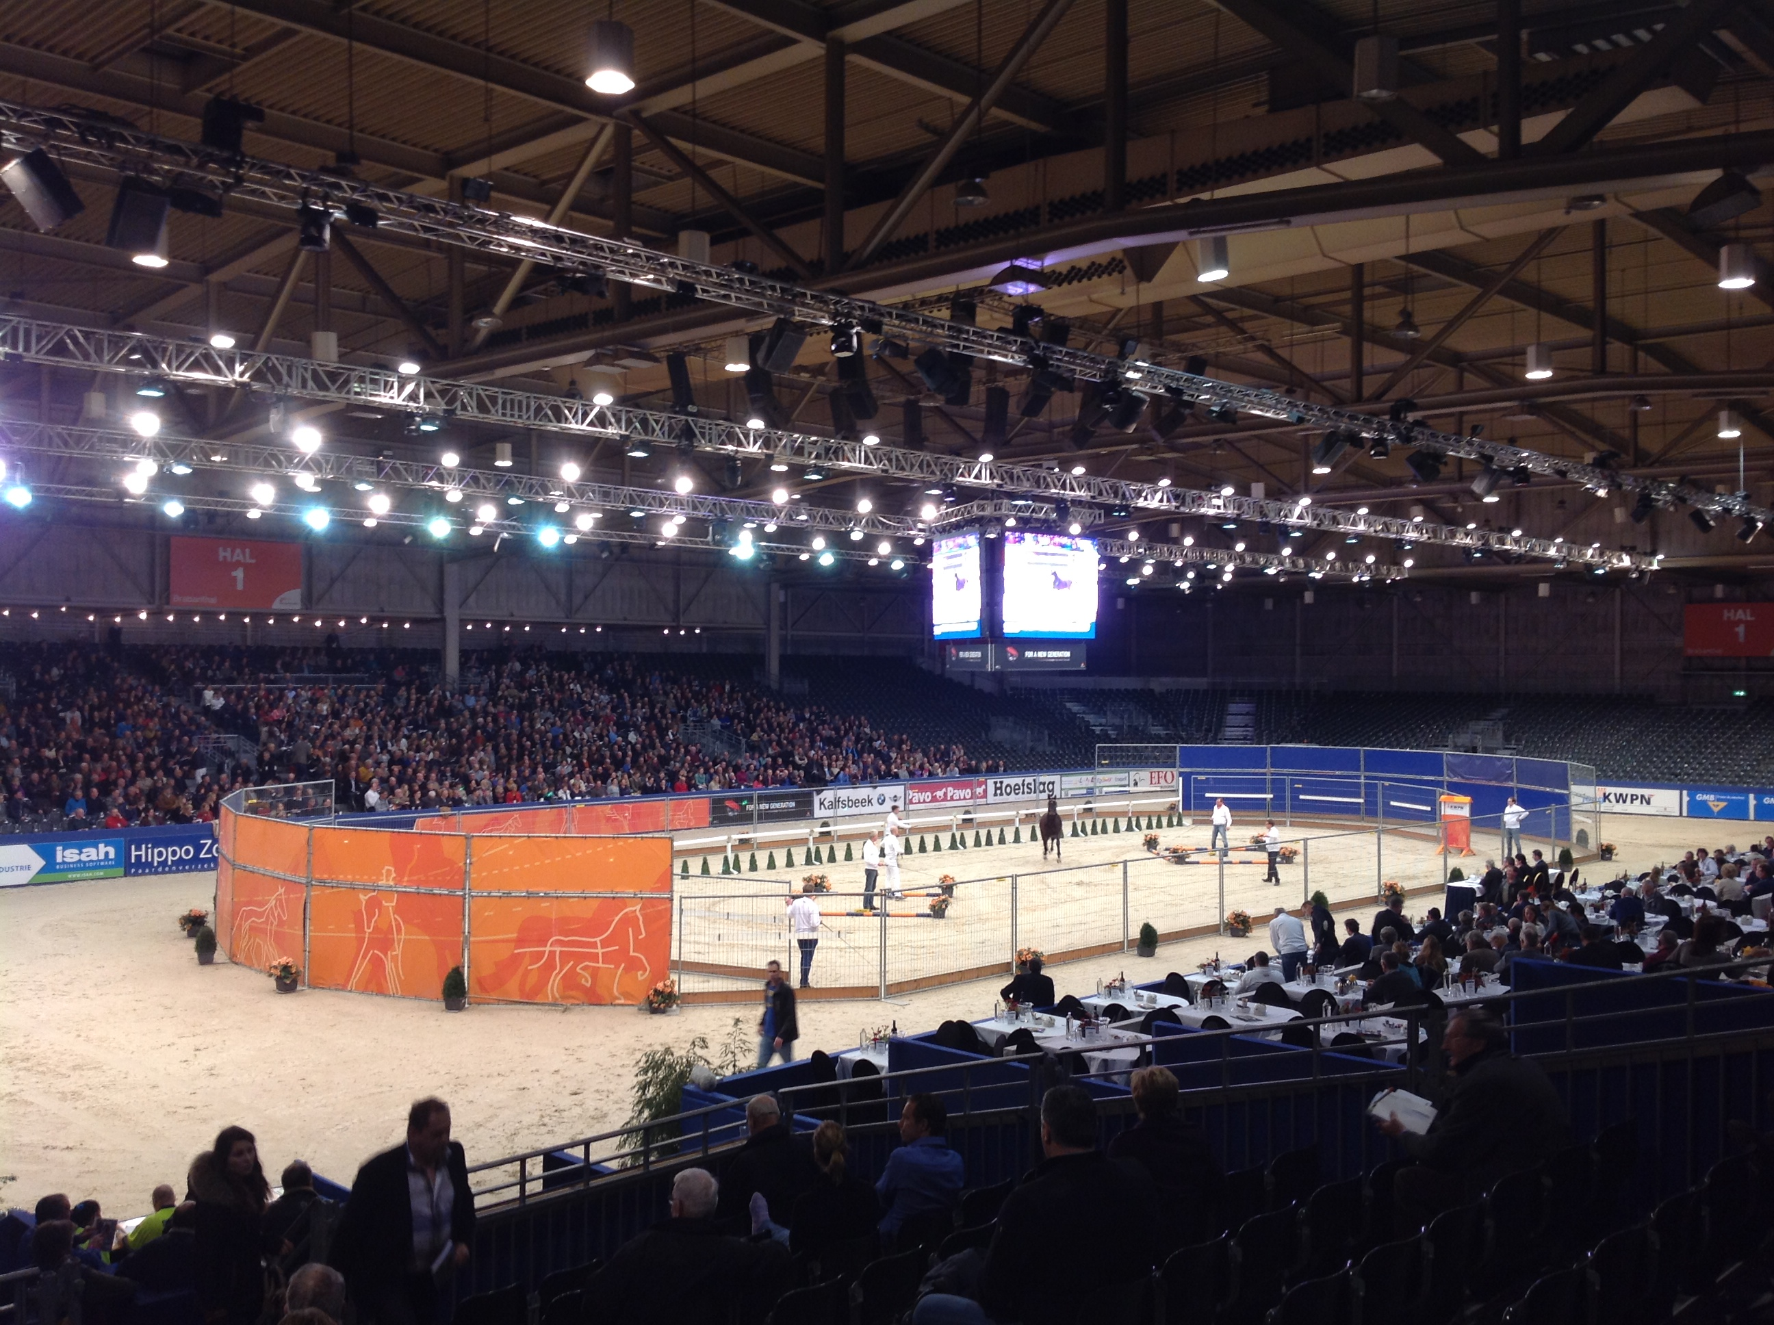The Dutch horse industry is thriving. The number of horses in the Netherlands continues to grow (CBS 1, 2014) and the standard profitability rate per horse per year increased with 6,6% due to higher productivity levels. On an average level, stables and stud farms provide more work employment and there are still many of them across the country. As the Netherlands main pride, the Royal Dutch Warmblood horse (KWPN) will stand as a fine representation of a Dutch top export product.

## 1.1 Equestrian sports

The equine sports industry is extremely active in the Netherlands. Since Dutch bred horses and their (Dutch) riders are performing well on international levels, the dressage and jumping sport became immensely popular. Amongst others, the World Equestrian Games and Jumping Amsterdam contributed to that enthusiasm for Equine sport. These events are internationally oriented and draw attention from countries all over the world. Imagine, that in 2011 in the Netherlands alone, there were 466.000 riders active in competitive riding. (ZKA Consultants & Planners, 2011) It is clear that this sector or branch is immensely big and spreads widely over the entire world.

The Dutch sports industry counts a number of organizations that organise and monitor competitions and welfare of horses. KNHS, Royal Dutch Equine Sports federation, is by far the biggest organisation when it comes to dressage and jumping competitions. The KNHS has assembled all types of equestrian sports activities. Besides dressage and Jumping, being the well known ones, it has added eventing, driving, vaulting, reining and endurance to its portfolio. Furthermore, KNHS divided the Netherlands into 11 regions (11 because at that time, Flevoland was not yet established as a province). In doing so, a new level could be added to the competition part of equestrian games. National competitions and selections were established and put into action. The diversity and overall knowledge and monitoring function of the KNHS make it a suitable organisation for (almost) every rider, be it recreationally or competition focussed. (KNHS 1, 2014)

*Anky van* Grunsven is the Netherlands most famous rider. Van Grunsven put the Netherlands on the map as top deliverer for international titles, Olympic medals and gained respect through her knowledge and skills in the Equine sports industry. Her fame as a professional is established worldwide. She became responsible for several successful KWPN’ers that gained extreme popularity beyond borders. Currently, she’s focussing on other branches of equine sports and educating and teaching students. (Anky, 2014)

Besides van Grunsven, there are others who have contributed to the Dutch reputation when it comes to equestrian sports. The most famous names in dressage are –amongst others– Edward Gal, Hans Peter Minderhout and Adelinde Cornelissen. Lately, Adelinde Cornelissen and Edward Gal have been most successful for the Dutch team. They hold the 3th and 4th place on the FEI (Fédération Equestre Internationale) World Individual Dressage Ranking list. (FEI, 2014) The World Equestrian Games of 2014 are planned in August 2014, where Cornelissen and Gal can upgrade their position. Dutch jumping riders Jeroen Dubbeldam, Maikel van der Vleuten, Gerco Schröder, Albert Voorn and Marc Houtzager are also well known and highly respected on an international level.

During the last Olympic games in London 2012, it became overwhelmingly clear that not only the Dutch riders are highly esteemed by internationals. Dutch bred sport horses, Royal Dutch Warmblood horses (KWPN’ers), were greatly represented. The Dutch horses and their riders won the most medals by far: 11 medals of which five were gold. Earlier on, during the 2009 Olympics in Hong Kong, China, the Dutch bred jumping horses and their riders filled the entire honorary stage. London however, was the year of the dressage horses. Valegro, presented by the British Charlotte Dujardin, was the biggest sensation in the arena. Her trainer and colleague, Carl Hester, brought his KWPN horse Uthopia. The Dutch team brought their own winners; Jerich Parzival, Glock’s Undercover, Salinero, Verdi, Big Star and others. In total, an estimated **30%** of the horses participating in the Olympics were KWPN bred and 30 Dutch horses appeared with riders from over 22 countries. Never before has this number been this high.

The Dutch team of riders performed outstanding during the Olympics and also the KWPN horses that participated won generously, see figure 1 for an overview (KWPN 1, 2012).

Figure 1

## 1.2 Breeding

Within the Netherlands, there is a large community of breeders. It is possible to use stallions from all over the world. Depending on the type of horse a breeder wants to have, they will individually choose a stud for their mares. When it comes to dressage horses, breeders will mainly use KPWN or German studs. The link with the sports sector is important. In order to breed the ‘perfect’ horse, breeders look at studs that have a high classification in dressage/jumping/eventing or other sport. When a stallion has the qualities to become a stud and performs (reasonably) well in competitions, he is worth a lot of money. For a stallion to get approved, it needs to go through training early in life. A stallion is brought ‘home’ from its herd at the age of two. They have to get used to daily activities, be groomed and trained on their gaits (walk/trot/canter). When they are around 2,5 years old, the first selection starts. Keeping in mind that there have been large investments in this stallion since it was a foal, the pressure of ‘hoping’ this one will be an approved stud later, is tremendous. This indirectly means that there is a great amount of money at stake for this particular part of the equine industry, together with the equestrian sports sector.

Either way, the investment part, both financially and physically (training hours etcetera), starts early. If the breeders’ stallion went through the first and second selection successfully, it will have to be broken in and trained under the saddle. In the meantime, big audiences have seen those stallions and many opportunities have occurred where potential buyers could place their bid on a horse. Eventually, when the stallion has been approved, it will start breeding and the breeder can start selling the studs’ semen. By this time, the stud is around 3/3,5 years old. It will start competing in big tournaments and it will get the chance to build a reputation. By now, the breeder has had, if he is fortunate enough, the chance to sell his stud for a good price.

Later on, these stallions are evaluated during events like the Olympics, Jumping Amsterdam, Indoor Brabant and the World Cup Verden. Mares and geldings also participate in those events, though the main focus is laid on studs/stallions because of their increased value. As a Dutch breeder, one can present his/her stud at multiple national and international studbooks. Offering a stud through a German studbook means that a particular company can request the studs’ semen, which is frozen earlier on and send through via a package service worldwide. Also, a stud can be approved at more than one studbook. A horse can be KWPN approved and, for example, Hannover approved. This could be of great help when a breeder wants to promote his/her stud as an export product.

Mares follow different processes and obtain different predicates. Nevertheless, they do follow similar steps. Mares are brought ‘home’ at the age of 2,5/3 years old and made familiar with grooming, training and daily activities. When they show enough talent, they will be prepared for a special mare selection process by which they will eventually receive a permit to be registered in the studbook. With their scores, they can obtain the following predicates: Ster, Keur, PROK, IBOP, EPTM, Elite, Sport, Preferent and Prestatie. These predicates concern the quality of the mare and are important for a breeder. Foals can rise in value due to their dams’ predicates. Usually, mares are offered for studbook inspections and will either be sold or used as a broodmare.

## 1.3 KWPN

In 1887, breeders started registering their foals. Every foal since then is briefly described in a register. This meant the birth of a very successful studbook, which is highly esteemed for its bloodlines, studs and events. Their main goal is breeding. Their breeding goals have altered during the last couple of decades due to the change in demand. The purpose of a horse faces continuous change whereby a horse alters in exterior depending on the current demands. The basic KWPN horse is originally bred from thoroughbreds, German and French stallions. This combination is the base for the contemporary modern sport horse. Nowadays, the stallions are selected on exterior, gaits and movements, health, character and talent. Within the KWPN studbook, there has been made a division in types of horses:

* Dressage horses
* Showjump horses
* Harness horses
* ‘Gelders paard’

(KWPN 3, 2014)

In addition to the breeding part of the KWPN, they also organize and promote big equestrian sports events and are active beyond borders. North America and the UK have shown interest in the KWPN studbook. For instance, breeders in the UK have become members of the KWPN and in return, the KWPN organizes activities like inspections, competitions and information courses. This shows the popularity of this studbook and its studs (KWPN 2, 2014).

## 1.4 KWPN Sales Aid

With the studbooks’ content expanding and their activities growing broader, the KWPN thought it wise to search for new opportunities beyond borders. The KWPN horse has always been exported to the USA, however since the crisis also struck that market, looking for other opportunities is recommendable. Globally analysing the markets, it becomes clear that the Asian market is emerging and rebuilding rapidly. The department of Sales Aid is established to guide and support the export of horses to new markets. Their main activities exist of promoting the company, researching opportunities, considering whether actions are profitable or not, removing trade barriers and building a country coordinated Plan of Action.

To provide an example, the KWPN currently operates with China and Russia. China is, according to Irene Wolfs, Head Marketing and Communication at the Sales Aid department of the KWPN (Wolfs, 2014), an open market where opportunities are widely present. However, though the Chinese are able and willing to purchase a horse, they lack knowledge in maintenance and feeding (see chapter 2; China, page 27). The Sales Aid department researches the need present in a market and establishes a country fitted plan to offer broad-based service.

Marketing and promoting the KWPN horse is part of their export plan. Assigning Trade missions, developing a network through embassies and spreading the word through journalists are main activities of the Sales Aid department. So far, the department has received subsidies to establish these basic pillars and is now ready to build further without subsidized help. The past years, the government and embassies have drafted a successful programme; CPA’s – collective promotion activities, which helps businesses, organizations and companies such as the KWPN to get a foothold in new markets abroad. The CPA’s are based on a proper Plan of Action, written by the company or organization, completed with financial data and prognoses. If the plan is approved, the company or organization receives a fixed amount of money to spend on marketing and PR. Thus, the Sales Aid department is largely built on marketing/PR and trade missions, a first step into trade agreements and profitable export.

Furthermore, a select group of parties involved in the Dutch Equine industry established the HNHF foundation, the Holland National Horse Foundation. The before mentioned broad-based service is the idea behind this foundation, where experts in Nutrition, Transportation, Veterinarian care, Horse Insurance and others are integrated. Their marketing strategy is based on the broad-based service thought: *“you don’t just buy a horse in the Netherlands, you buy the complete package”.* Acting internationally as a representative for the KWPN horse (amongst others), this marketing tool is effectively participating in establishing and promoting the Dutch reputation.

To conclude with, it must be made clear that the KWPN Sales Aid department is not trading horses neither is the department a commission agent. It solemnly acts as a representative, researcher and a spokesman for the interests of its members (Wolfs, 2014).

# The export model

## 

Transportation by KLM Cargo

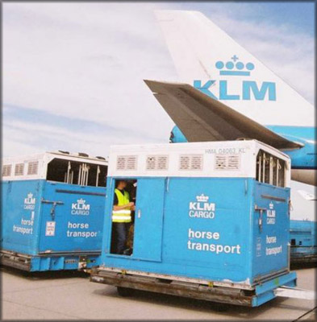In order to fully understand this export product, it is necessary to research and write an export plan. Since the export product is somewhat extraordinary, the export policy plan can deviate from the regular, standard export policy plan. The *marketing mix*, for instance, is left out. The product alters in numerous ways (height, colour, conformation) and it would be impossible to draft a fitting marketing mix for all. Nonetheless, in this chapter, the Royal Dutch Warmblood studbook will be extensively investigated for its export capacities and an advice will be drawn in the conclusion.

## 2.1 History, Mission and Values

In order to avoid unnecessary information, the “company” or studbook will be described and evaluated in a standard export policy plan. The history, mission and values of these studbooks are described in chapter 1.3 and will therefore be excluded from this chapter.

## 2.2 Product Description

The KWPN studbook is registered as an open studbook, meaning that there are no specific characteristics, character and exterior for the KWPN horse. They are bred for their potential to perform in equine sports, such as dressage and jumping. If required, the KWPN horse can be described as followed: height between 1.48-1.90, though very variable, all colours are approved, depending on the type of KPWN (see chapter 1.3). Their exterior can be described as light footed, proud, expressive, medium temperament, healthy, strong and fierce. Markings are approved on the entire body. However, as mentioned before, this can vary extremely per horse. They can be used for multiple sports, though they can also be bred for a specific discipline and consequently, their exterior may be more dressage or jumping directed. The Holland National Horse Fund (see chapter 1.4) uses the below text as a Unique Selling point for the KWPN horse:

*“The KWPN Horse is a Dutch-bred sport horse with international appeal. It is willing, fearless, physically and mentally strong, and bred to perform at the highest level. It is also reliable, easy to handle, and pleasing to the eye.”*(Holland National Horse Fund)

## 2.3 Market Description

Within the Equine industry there is not a distinct market description available. The Equine market has been active in the Netherlands for a long time. Trade has always flourished in the Netherlands and horses have always been a good product to trade. To be active in international trade in the Netherlands, it is not obliged to be a registered cooperation. Every individual person is in the position to sell or buy a horse, on national and international level. Though numbers showed that the total amount of horses in the Netherlands 2013 has decreased somewhat (CBS 2, 2014), the official statistics are just: the Netherlands contains a significant number of horses.

Looking at the Equine industry, statistics show that most enterprises are considered medium to small (MKB). It is important to recognize that the Equine sector is not dominated by large enterprises that aim for monopolies. There are some stud farms that enjoy more familiarity of name, for instance those of familiar trainers, riders and owners (VDL, de Wiemselbach, van Baalen). These stud farms are more likely to receive international clients and requests for high quality sport horses, due to their familiarity of name and -subsequently- earned trust through past performances. Often, although these stud farms are bigger the international sales go through one person, who has earned the trust and holds the connections necessary for international trade. Throughout this paper the focus will be on these companies/individuals. It is difficult to deliver a concise description of these individuals, because, like many factors in the Equine industry, the differences between companies/individuals, horses and clients are extensive. Usually the aimed companies are active in multiple sectors of the Equine industry, they perform in sports, breeding and trading. Familiarity of the companies name is most easily obtained through outstanding performances in sport, in such cases it is mostly the horse that gains international prestige. Therefore the importance of actively participating in sports and education of horses is high and involves high investments. Actually, these three factors -breeding, sports and trade- are intertwined considerably and are the recipe for a successful transaction. A horse is a fragile product and there are many moments that can decrease their value. Those that are offered in this segment and price range fitted for an Olympic horse belong to a small group. The demand for Olympics horses exists both nationally as well as internationally. Currently, the Netherlands has sold so many Olympics horses that the sector thought it necessary to establish the NOP – Netherlands Olympic Horse. The NOP is an initiative of the KWPN, NOC*NSF and Rabobank and aims to hold on to Olympic horses by offering financial support to owners and riders. The organization secures top quality horses for a certain amount of time to allow them to compete for Dutch teams during big competitions (KNHS 2, 2013).

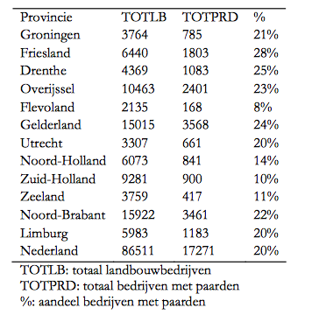**Positioning.** The Netherlands has a strong, steady position in the Equine industry when compared to other countries. One out of three horses during the Olympic games in London were from the KWPN studbook. These horses gave some of the best performances. KWPN stallions are amongst the most used sire’s worldwide and their popularity continues to grow. The Dutch expertise in breeding and training is worldwide acknowledged, appreciated and highly demanded. International riders and breeders have taken the opportunity to learn from the Dutch expertise. This does not only concern riding/training skills, but also maintenance, feeding, shelter, medical care and so on. It covers all facets of the horse.

Figure 2 shows the number of Equine enterprises in the twelve provinces of the Netherlands; this amounts up to a total number of 17.271 companies in 2005, a rough 20% of all agricultural companies. The TOTLB shows the number of agricultural companies in a certain province, whereas TOTPRD shows the number of Equine companies. A number that is most likely to grow.

Figure 2  
(Windt, Loohuis, & Agricola, 2007)

## 2.4 Abell

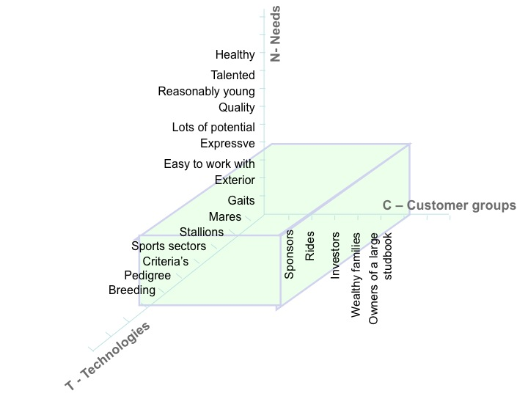**Customers.** The aimed customer is mostly the owner of a large stud farm, sponsor of a talented rider, rider him/herself, investment partner or wealthy family (royalty). The owner of a large stud-farm looks for the most appropriate stallion or mare available, the horse has to fit his current collection, his rider and their ambitions. The rider and/or his/her sponsor main focus are on the quality of the horse and its potential within the desired sport sector. The investment partner is mostly a silent partner and will allow others to search and buy horses for him/her. Wealthy families are mostly on the look for young, talented horses that they can educate further their selves. Within these customer analyses, there is no division in gender, age, status and background.

**Needs**. As described above, the customer’s main need is a healthy, reasonably young horse that has enough qualities and potential to perform on a high level, is expressive and easy to work with. For the KWPN horse, the needs are more sport related and will primarily be about the qualities of the horse and less about appearance/character.

Figure 3

**Technologies.** To create that ‘perfect’ horse, the KWPN started experimenting through breeding in the early 1990’s. Throughout the years the criteria for exterior are recorded and the KWPN works towards those tangible ‘goals’. For every sports sector, different stallions and mare are selected, which laid the foundation for the types described in chapter 1.3.

## 2.5 Internal Analysis

**Strengths and Weaknesses of both studbooks**

The KWPN is worldwide known by name and has gained the trust and respect from its customers by supplying high quality sport bred horses. They are involved with many events and festivities as a sponsor or facilitator and have thereby established a strong marketing/communication foundation. In addition, their ‘product range’ is broad and active in multiple sectors of the Equine sport in order to reach more clients. The KWPN has the possibility to keep their product line broad due to the size of their organisation. They have the knowledge and ability to perform on a professional level in all sectors.

*Strengths* ***KWPN***- High familiarity of name  
- Strong PR/communication  
- Quality horses  
- Orientated on multiple sectors of sport  
- Big organisation

A horse being a fragile product is the KWPN’s first weakness. In many occasions, injuries can mean the end of a sport career and that has financial consequences. The KWPN is also dependent on the unpredictable wish of their customers. Those wishes may vary greatly and in order to reach all customers, they are obliged to keep their ‘product range’ broad. The danger and opportunity at the same time lies in specialization. In conclusion, horse riding is still seen as an elite sport. When actively participating in competitions, one needs their own horse. It takes lots of deliberation and calculation to buy a horse of high quality, which may not happen as often as wished for due to financial or economic reasons.

*Weaknesses* ***KWPN***- Fragile product  
- Dependent on the current need and personal preference  
- Elite product

## 2.6 External Analysis

Within the external analysis, the chosen countries are extensively researched. These analyses will be handled in chapter 3 and 4 of this report, since there are multiple countries that demand evaluation. Also, in chapter 3 and 4 the filtering process as well as the DESTEP analysis will be handled. To give a small indication, the following countries will be evaluated:

* China
* Brazil

China and Brazil are considered BRICS-countries, emerging economies with strong interest to expand or establish their Equine industry. China is commended highly for their fast rebuild economy, but when it comes to horses they are just starting. They have stated their interest and are open to all knowledge and learning processes available. Also, China is a market where capital is available. These two factors, their willingness to learn and possession of capital, make it an interesting market to research and develop. Brazil on the other hand has an established Equine Industry. They players in the Equine world for quite some time and have already gathered a reasonable amount of knowledge. Although they established their own studbook and aim to create that ultimate sport horse, it is interesting for the KWPN to investigate due to country agreements and solid partnership possibilities. To involve the KWPN in that market means a supply of customers, connections and capital. Further elaboration on these countries can be found in chapter 3 and 4 of this report, where the above stated information can also be found with the necessary sources.

## 2.7 Customer Analysis

**Geographic segmentation** – There exists a broad spectrum of interest for Dutch (sport) horses, which is related to the level a country is involved in Olympics/International games and competitions. To present examples, Germany, the UK, Brazil, the US and China are recognized as wholesale customers. These countries are active during important international competitions, such as the World Equestrian Games (ANP, 2013). All these countries have potential to grow and become bigger purchasers of Dutch horses. This paper will focus on two markets: an eager, thriving market – *China* (Vermeer, 2011) and an upcoming, highly potential lucrative market – *Brazil* (Trading Economics, 2013). The decision to explore these markets is based on the fact that both China and Brazil are highly interested in KWPN horses, have strong, growing economies and are thus more reliable on the long run. (Infoteur, 2009)

**Demographic segmentation** – The target group within this export plan is broad. As mentioned before, the aimed customer is mostly the owner of a large stud farm, the sponsor of a talented rider, the rider him/herself, a mere investment partner or wealthy families (royalty included).

**Socio-economic segmentation** – These target groups, except perhaps the rider him/herself, have in common that their lifestyle and income are above average. They are accustomed to investing large amounts of money and taking financial risks. Although these investors handle mostly in groups, there are those who decide to act solitarily.

**Psychographic segmentation** – The target groups psychographic segmentation vary greatly due to country differences. China for instance, has strict rules with regard to doing business. Norms and values have high standards and respect is the key word. Brazil on the other hand manages looser regulations. Nevertheless, Brazilians prefers business oriented meetings and preferably speak their own language (Portuguese). Their focus is mainly on individuals instead of companies, which reflects in their attitude (UKTI, 2014).

**Behavioural segmentation** – China is known for their preference in establishing long-term (business) relationships, whereas Brazilians (Latin Americans) are familiar for the personal touch in business. For them, it is important to personally know their business partner to entitle them with their trust. They do, similar to the Chinese, aim for long-term relationships that are founded on mutual trust and respect. Both Chinese and Brazilians are open to European products and services, but cherish and maintain own values and norms (Rooijen, 2014) (ABN Amro, 2012).

## 2.8 Branch/Industry Analysis

*Five forces of Porter*

**The power of the Suppliers –** Breeders and stud-owners are spread out throughout the Netherlands and are marked as individuals, stud farms and investors. Yearly, a variable number of foals are born with the intention to attract foreign buyers, depending on the quality of the horse. Evidently, suppliers are not hard to find. The last few years did show a decline in breedings, which reduces the number of extraordinary/high quality sport horses. This phenomenon builds a fast competitive atmosphere in the national market (Kromkamp & Smit, 2014).

**The power of the Buyers –** Given the fact that there is plenty of supply, buyers are in a privileged position. Foreign investors and buyers are warmly welcomed because these customers are looking for the higher segment horse and are willing to pay for them. Buyers do need the privilege of knowing the right person in the business. He/she will lead them to the right horse and will not overcharge them (Kromkamp & Smit, 2014).

**The threat of substitutes –** Clearly there are other studbooks the KWPN has to compete against. In the Netherlands they hold a strong market position and it can be said that the KWPN holds a monopoly on sport horses. The threat of substitutes lies beyond borders: Germany and England for example. According to Irene Wolfs, the department of Sales Aid recognized the German presence when researching new markets. German and English studbooks were already known. Lately there Wolfs noticed a shift; the Germans will sooner notice the presence of the KWPN horse in existing and new markets (Wolfs, 2014). A positive message for the Marketing/PR department of the KWPN Studbook.

**The threat of new companies in the markets –** There is no threat of a new Dutch studbook, since there are no new Dutch breeds developing. Currently, the main focus lies on improving the existing KWPN horse. The KWPN studbook can be seen as an overseeing organization that acts on behalf of its members and thrives to push export to a higher level. Thus, most agreements are made with companies or organizations within the Equine industry.

**The threat of potential entrants –** It is but a mere possibility of other studbooks entering the market. Most studbooks are country or region bound and will only consider a partnership under specific agreements. These agreements amongst studbooks of different countries are focussed on the exchange of information, available studs and cooperation understandings. Studbooks compete to offer the best possible horse while maintaining their studbook characteristics. The need for the KWPN to develop and alter their product is derived from this competitive part, which has a positive effect on breeding techniques and brings along a healthy motivation for innovation.

**SUPPLIERS**

A large number of suppliers are available, who strive for the same purpose, to breed that high quality elite horse.

**NEW ENTRANTS**

Not existing – the KWPN is an overseeing member oriented organisation, who advocates for their network.

**RIVALRY**

**SUBSTITUTES**

Exists in form of concurrence – other studbooks. A matter of time and strength of goodwill.

**BUYERS**

Buyers are privileged due to the number of suppliers and the supply itself. However, there are also plenty of buyers available.

Figure 4

The KWPN assembles its suppliers from the Netherlands where all owners/suppliers have to register at the studbook and are then allowed to entitle their stud/stallion/mare/gelding as a KWPN horse. Horses for sale are offered either through organized events by the KWPN studbook or individually – via the Internet. The bigger stud farms have shaped their network of foreign clients and trade is mainly facilitated from those networks, which are established throughout the years (Kromkamp & Smit, 2014).

Buyers are, as mentioned before, mainly owners of large stud farms, sponsors of a talented rider, the rider him/herself, a mere investment partner or wealthy families (royalty). It is not necessary that the studbook is the first point of contact for these customers. Connections can be made on events or through a commission agent, a freelance person that has inside connections with the larger stud farms and can organize visits to view several horses.

**Conclusion –** The KWPN studbook has a strong position, bordering in monopoly in the Netherlands. Their main threat comes from other countries and their studbooks, although they are also partners and established mutual Memorandums of Understandings. Their main aim is to keep on gaining goodwill abroad and thus, stay ahead of competition.

## 2.9 Competitor Analysis

Competition in the horse industry is everywhere. Not only does the KWPN have to compete with German and English studbooks, Brazil also established their own studbook. It is of value for the export model to examine the most important competitors present.

*Competition from China*: China is not known for a particular studbook or breed. From a research report recently conducted by the KWPN department Sales Aid, facts have shown that China considers importing high quality horses more important than creating a national Chinese studbook that can compete with –for instance– the KWPN. China recently invested roughly 40 million euros on importing sport horses, namely Belgium, German and Mongol breeds. The KWPN horse is already introduced in China and their popularity is growing rapidly. Within this market the German and Belgium studbooks are considered active competition. German studbooks (Westphalian, Hannoveraner and Oldenburger) differ in organization with the KWPN studbook. German studbooks lack uniformity, which makes their horses vary strongly from each other. Chinese customers are looking for a steady horse with good qualities. Mostly, German bred horses are also big and heavy build, making them less compatible with the Chinese rider than the light footed, slim KWPN horse. (Janet Doorduin, 2012) The Belgium studbook, BWP – Belgium Warmblood horse, is primarily known for its jumping horses. Since their strength is focussed on the jumping stallions, they lack the ability to be diverse. (BWP, 2014)

*Competition from Brazil*: the Cavalo Brasileiro de Hipismo (abbreviation: BH or BéHáKá) studbook. The Dutch prince João Mauricio de Nassau, ruler of a non-Portuguese colony, originally initiates equine sports. A race was announced between two teams: the Dutch, French, German and English against the Portuguese and Brazilians to compare strengths. Eventually, the Portuguese and Brazilians won the match and Equine sports gradually became popular. Evaluating this history, a conclusion can be drawn that horse racing has since then been the most important equine sport in Brazil. (Historico, 2010) Now-a-days Brazil also competes in dressage, jumping and eventing. To establish an improved type of horse that would be usable in multiple sports, the BéHáKá introduced a combination of English, German and French breeds. The first Equestrian team participated in the World Equestrian Games in 2010 in Kentucky. With three Lipizzaner’s (Portuguese bred –classic– dressage horses), the three riders achieved a fourteenth place in dressage ranking. During the Olympics 1996/2000 three bronze medals have been won and since then, the BéHáKá has mastered to introduce its studbook in 95% of the sport-bred horses in Brazil (Brasileiro de Hipismo, 2014). If viewed as a competitor, the BéHáKá studbook is still young and has not established as much familiarity of name and goodwill as the KWPN studbook. The KWPN studbook must view this as a positive aspect. An agreement with the BéHáKá studbook might serve as an entrance to the Brazilian markets. It would mean development possibilities and support for the BéHáKá studbook and opportunities and connections in a new market for the KWPN studbook.

## 2.10 Distribution Analysis

There are two options to distribute or transport horses internationally: via aviation or by road. Within European countries it is more common to transport horses by road with specially adjusted lorries. There are strict rules concerning the transport of livestock, starting with regulations that have to abide with before transporting livestock. Country bounded rules can be found in respectively chapter 3 and 4 (China and Brazil). Transportation from the Netherlands starts here:

**Transport of livestock by aviation –** Transportation by air is mainly arranged by KLM who controls inbound and outbound flights. KLM designed specially adjusted horse stables in which the horses are kept before the flight. This horse stable is stripped from sharp edges and contains a non-skid floor. The entire stable will be loaded onto the airplane, which gives the horses a steady and calm surrounding. On every fight a specially educated flight attendant will be present to ensure surveillance, besides the owner/veterinarian/rider (KLM, 2013).

**Transport of livestock by road –** An example of a company that internationally transports horses by road is BSS Horse Transport. This company obtains several certificates that prove the company is qualified to transport horses. A company as BSS is also capable of organizing the paperwork and combined transportation modes if necessary (BSS Horse Transport, 2014).

## 2.11 Opportunities and Threats of the KWPN

*Opportunities and Threats*

The KWPN studbook has a defined potential for export: their products enjoy international representation by highly esteemed spokes(wo)man (riders). The fast spread of goodwill gives plenty of opportunities. Through connections made throughout the Equine market, customers who create business transactions are drawn to the Netherlands. The threat concerning this segment is the organization. Although the KWPN studbook is overall decently organized, most business done in the horse market is not structured.

The KWPN studbook has the ability to adapt to the wishes and preferences of its clientele. As long as this is being monitored, breeders will be informed upfront and can start adapting their breeding criteria’s. The worldwide demand is already visible and only growing, meaning that there are enough possibilities when it comes to exporting their ‘product’. If they act to that demand, there would be no reason not to export. Their export possibilities are not restricted to a fixed country or number of countries, which makes their market opportunities worldwide.

*Opportunities* ***KWPN***- Adaptability  
- Demand  
- Export possibilities

Whereas many markets broke down due to the financial crisis, the horse industry is still standing. This is an outstanding performance since horses are luxury products. However, the number of investors and buyers did shrink and requirements are higher. Finding the right customers becomes more difficult. In addition to that, a horse is a fragile ‘product’ to breed, invest in and export. In any time during their life an injury can come up and the horse will be worthless. A good horse is worth millions, a cripple horse is worth nothing. Other studbooks are also aiming towards being a top supplier of high quality horses, which means an ongoing battle in being –and staying– unique.

*Threats* ***KWPN***- Financial crisis  
- Concurrence   
- Remaining unique

|  |  |  |  |  |  |  |  |  |
| --- | --- | --- | --- | --- | --- | --- | --- | --- |
| ***Confrontation matrix KWPN*** | | | ***Extern*** | | | | | |
| ***Opportunities*** | | | ***Threats*** | | |
| Adaptability | Big organization | Export possibilities | Financial crisis | Fragile ‘product’ | Remaining unique |
| ***Intern*** | ***Strengths*** | Familiarity of name | - | ++ | + | + | - - | - |
| Strong PR | - | ++ | ++ | + | - | + |
| Quality horses | ++ | - | ++ | - | - | + |
| Broadly oriented | - | ++ | ++ | + | - - | - |
| ***Weaknesses*** | Concurrence | ++ | + | - | - - | - | + |
| Dependent on need/preference | + | ++ | - | + | 0 | 0 |
| Luxury | + | + | ++ | - | - | ++ |

Figure 5

++ Very positive + Positive  
 - Negative -- Very negative  
0 Inapplicable

*Conclusion confrontation matrix* – the KWPN has numerous chances that have positive influences on possible growth of the organization and export. Their main plus points are the establishment of a big organization, with an excellent PR department and a broad orientation that can adapt to altering demands and wishes of buyers. Drawback is mainly the fragility of the product, which brings risks and uncertainty for possible clients. Furthermore, the financial crisis in combination with a luxury product is equally a negative/positive point. It can degrade the number of buyers, which the studbook can compensate by looking for new customers beyond borders.

## 2.12 Export Advice

As shown in the confrontation matrix the KWPN has numerous advantages and opportunities within reach. Their current situation allows them to grasp these opportunities and turn them into business transactions. An extremely strong point that has served as an directory throughout this report is the level of knowledge by the Dutch Equine industry and the quality of horses bred in the Netherlands. To be able to use these major beneficial points to strengthen the Dutch position on the Equine market seems to be a matter of time. The ability to offer more than just a horse can attract new, wealthy clients. It compensates for the high price of the horse. In return the client receives broad-based service and a complete package. Clients are willing to invest in high quality horses and are able to pay the requested amount. When it comes to the KWPN, the organization is ready to cross borders. It has all the right ingredients: knowledge, motivation, manpower, quality and position.

The first steps of a Plan of Action are already implemented. Via the Sales Aid department, international clients have had the opportunity to get acquainted with the Dutch Equine industry. Furthermore, goodwill and interest have been established through participating in major events. The Olympics and World Equestrian Games placed the KWPN horse on the map. For countries less developed in Equine knowledge a proposal has been drafted that offers additional information besides the purchase of the horse itself. Step 1 and preparatory work for step 2 has been completed. In order to implement and make use of the preparatory work done, it is vital to determine and implement the next logical steps; build on to existing partnerships (and partnerships in making) through establishing commission agents who already have connections in a particular market or country and enter new markets or countries where Dutch individuals have build a network and earned trust. Steady relationships with foreign clients will be established by partnering up with commission agents. Acting as one collective organisation will enlarge the KWPN’s familiarity of name and will be rewarded with recognition. The individuals can profit from the knowledge and strong foundation the KWPN has to offer. Subsequently, the next step could be to gather existing foreign commission agents and bring them together in a *network platform*, preferably online. The KWPN can use this platform to monitor demand and guide possible clients to the right commission agent in the Netherlands.

From this particular approach, the KWPN can establish a highly organised trade foundation, using all ‘tools’ and existing knowledge the Netherlands has to offer by partnering up with commission agents; a business relationship that will benefit both parties. The KWPN can quickly expand their market via the commission agents’ international network. While in return the commission agent is allowed use the research conducted by the KWPN. Although this is a long-term strategy, between 5 – 10 years, it benefits all and is therefore a win-win situation.

# China

## 

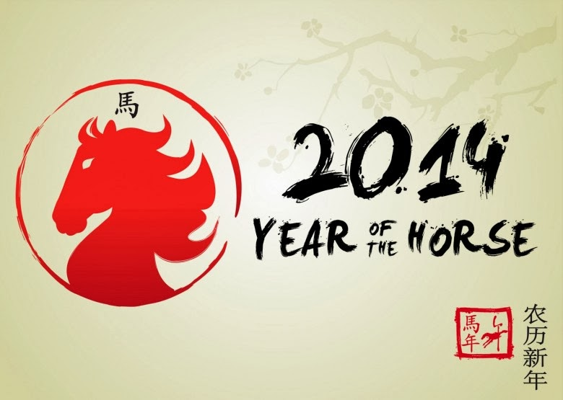In the near future China will likely become the number one economy worldwide, overtaking the USA from their top position. China has a strong economy with ongoing growth and wealth. Nevertheless, the average life standard per inhabitant is emphatically lower than in the USA, making China a difficult economy to see through (NOS, 2014).

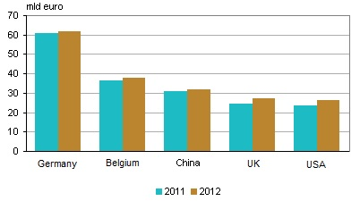China is not known for its strong studbook or history in the Equine industry. On the contrary, their knowledge of horses, breeding, competitions, maintenance and training skills are still in the developing stage. China is starting to gather knowledge abroad, to assist with struggles as –for instance– national transport and veterinary aid. In relation to the Netherlands, China is considered a steady partner in trade. Numbers, collected by the Central Bureau for Statistics (CBS), have shown a growth rate of 14 percent (%) for the fourteenth’ year in a row. This adds China to the list of top 10 countries with the highest acquisition of goods and services from the Netherlands. Although most of the exported goods to China are machinery, the horse export market is certainly increasing (Statline, 2014). Figure 6 shows the top 5 countries concerning export numbers, listing China on third place.

Figure 6

*China through the filtering process*. The Transparency International global coalition against corruption launched a Corruption Perceptions Index 2013, listing 175 countries and their corresponding corruption level. Public corruption in a country or territory can have high impacts on international trade. Governance is highly intertwined with both public and private sectors and suspicious factors can frighten away investors. China is ranked number 80 on the list of total 175 countries and regions, with an average 40 points out of 100 maximum on the corruption level. Given the fact that the higher the number – 100 being the highest – the cleaner the country, China does not score very positively. This might be a point of consideration before drafting a Plan of Action on exporting to China. As mentioned before, China will soon become the number one economy in the world: their figures in relation to 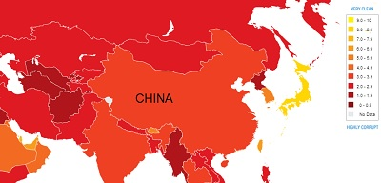trade with the Netherlands have been stable and show solid growth. Looking at their financial and economical foundation, there is no reason to doubt their abilities to do business. Nonetheless, it is important to research the habits and morals that control the manner of doing business in China. By doing so, honest and long term business relationship are established, creating a win-win situation for both countries (Transperancy international, 2013).

Figure 7

The Equestrian industry/market in China is currently growing and wins popularity and ground. Fortunately both private and public investors finance the Equestrian industry. Owning top quality horses is not only positive for the national market and development of –for example– a department of leisure, it also contributes on the international business level. Competing with other countries on events as the Olympics or the World Equestrian Games creates a significant raise in prestige and respectability. A case study drafted by the KWPN Sales Aid department describes China as a core country. When analysing the markets and levels of wealth, it appoints that a broader financial middle-class population is developing, for who sports and leisure becomes more and more important. Thus, the KWPN studbook wishes to make Equine sports available in core countries (amongst others Brazil and China). Another result from the previous case study is the manner of offering products to China. Since knowledge on maintenance and training is not yet present or available for the Chinese people, offering a horse including understandable, detailed information helps to convince potential buyers. A customized package that contains information about the wellbeing and maintenance of a horse and a stud farm is the KWPN’s unique selling point (USP) when it comes to countries like China (Janet Doorduin, 2012).

## 3.1 DESTEP - Demographic Analysis China

China is a diverse country, containing many different religions, ethnicities and a collection of languages. English is mostly spoken only by a younger generation in bigger cities, therefore intercultural communication may experience difficulties when operating in rural areas. Advisable is to hire an interpreter to attend all business meetings. 46 % of the population is between the age of 25 to 54, representing the KWPN’s target group of middle-class inhabitants that wish to get acquainted with the Equine industry and around 50% of the population resides in urban surroundings (CIA World Factbook 1, 2013).

## 3.2 DESTEP - Economic Analysis China

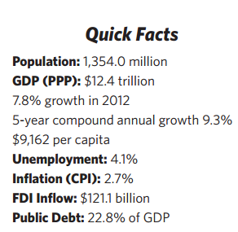Looking at China’s history, the country’s economy is currently facing a difficult period with small cycles of growth and declines. However, China is still the 18th fastest growing economy in the world and is gradually transitioning from a developing country to a developed country.

China has proven to be a country of great contradictions. Equally in demographic terms (language, ethnicity) as in economic terms: poverty is still actively present even though 600 million citizens have been lifted from that line thanks to the booming economy. For the past 36 years, China has reduced the number of State-owned Enterprises to a current 46% of total enterprises. Also, China wishes to reduce the reliance on export and put the focus more on internal consumption.

(Wall Street Journal, 2013)  
Figure 8

China’s most dominant economy sector remains its manufacturing and industries. The industries account for 45,3% of China’s GDP in 2012 – fixing China’s position as the world leader in gross value of industrial output. The major industries include mining and ore processing; iron and other metals; coal; machine building; armaments; textiles and apparel; petroleum; cement; chemicals; fertilizers; consumer products; toys and electronics; food processing; transportation equipment; telecommunications equipment, commercial space launch vehicles and satellites (EW World Economy Team, 2013).

## 3.3 DESTEP – Social and Cultural Analysis China

The Chinese have altered their view on livestock and animals dramatically in the last 20 years. In 2006 a law concerning maintenance and transportation has been implemented, a necessity for a successful export partner. The population shows an increasing curiosity towards equestrian sports, for amateur or professional purposes. As a report on the Equine industry in China says: “Horse riding has become a fashion of modern life”. Horses are not longer only wanted on a farm or helpful during a war, they have become a sector of leisure and sport. Nonetheless, horse riding is still seen as an elite sport and the Chinese aim to keep it that way (Moorsel, 2010).

## 3.4 DESTEP – Technological Analysis China

China is named to be a trendsetter and market leader with regards to technological products. Companies like Huawei are quickly overtaking western competition, personal computer maker Lenovo Group ltd. takes over markets and also the internet has kicked off through Chinese multinational Tensent Holdings ltd. Technology in China is based on innovation and quick change, which the Chinese believe is the only way to achieve sustainable growth (MOZUR, 2014).

## 3.5 DESTEP – Environmental Analysis China

As a consequence of the accelerated industrial growth, a research report drafted by NL Agency – Dutch Ministry of Foreign Affairs concluded that pollution started to rise and natural resources have degraded. Multiple environmental issues developed throughout the years and the Chinese government struggles with soil erosion and desertification. These factors have negative influence on the sustainable development plans of the country. Furthermore, demographic statistics in chapter 3.1 shows that over 50% of total population resides in big cities, which creates overcrowded populated areas and lower quality of living circumstances. Given the fact that the world’s shortage of raw materials and China being one of the head suppliers of neodymium (Meijer, 2013), the Chinese government is forced to switch to renewable and sustainable energy sources (Dutch Consulate-General in Shanghai, 2011).

## 3.6 DESTEP – Political Analysis China

The political system of China is considerably stable and has low risk points. For over 60 years there has been a one party-system that allows stability in the government level of China, but offers a low transparency level. The CCP – Chinese Communist Party, owns political power in the People’s Republic of China since 1949 and established the communist state of today. China’s legal system is based on civil law influenced by Soviet and continental European civil law systems. It is said that if an entrepreneur agrees with the government and does not stir up or create rebellious actions, he has nothing to fear from the Chinese government. This reflects the transparency rate the government preserves nationally and which companies should take into account (Martin, 2013).

## 3.7 Import/Export duties

China joined the WTO –World Trade Organization– in 2001 and has since simplified their trade policies. Import taxes have lowered and entrepreneurs have a better competitive position in the market. Bigger cities have emerged and are rising in level towards Hong Kong standards and other parts of the country have developed as well. In addition, the trade relation with the Netherlands is old and established, with already existing trade agreements and ongoing negotiations. Still, the Chinese market is considered difficult by Dutch traders, mainly because of the demand and lack of knowledge of the Chinese. To provide an example, a Chinese client will probably demand at least 25-30 horses (to avoid high shipping costs, it is more beneficial to purchase a large ‘bulk’ in one shipping), with the sole demand of the horses being either black or white. Also, experience learned that once a horse is shipped to China, there is a no-return policy. This might be a risk when the client is not satisfied with its purchase. (ABN Amro, 2012)

As for practical rules: 30 days before transportation, the horse has to be isolated under care of the NVWA, Netherlands Food and Consumer Product Safety Authority. Prior to the transport to China, the horse has to have resided in the Netherlands for at least six months. The horse has to be vaccinated, in possession of its passport, possible diseases have to be declared in writing and it has to carry all necessary certificates (NVWA, 2014).

## 3.8 Conclusion China

If a conclusion must be drawn from this report, it is that China might not be the safest choice. However, in return there are major trade opportunities present (as shown in recent case studies, executed by the KWPN (Karlas, 2011) and the Chinese NL Embassy (Moorsel, 2010)) and loads of potential in establishing close business relationships. The demand in China already exists, inland development has started and the message towards international studbooks is clear. In theory, China is ready to commit and import. Their economy is thriving and becoming stronger, with major technological industries. To actually become a top importer of KWPN horses, the main focus should lie on building solid relationships. The KWPN has its strong approach of a broad based service and the Chinese have their eagerness to develop. The next logical step is to get involved and prepare Equine and sports facilities, extending knowledge on maintenance and training and gathering a group of buyers who are interested and willing to purchase these high quality, elite horses. Finally, the closing step would be to match Dutch suppliers with interested parties, to allow them to create their own business relationships and let trade flow from there. This means long-term investment, with high potential for profitable business relationships between the Chinese and the Dutch.

# Brazil

## 

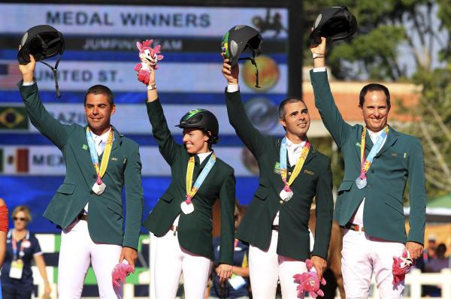Brazil possesses the largest piece of land in South America and is working on its rank amongst the biggest economies of the world. For the last decade, Brazil is busy improving their macroeconomic stability, reducing their foreign debt and outbalancing trade ratios. Brazil rose from the economic crisis as one of the first emerging markets showing signs of recovery. The crisis led up to an exceptional high GDP rate of 7,5%, the lowest unemployment rates in history and an amazingly equal national income rate (CIA.GOV, 2014).

Brazil’s domestic market remains stable, shows economic growth, gives relatively low inflation rates and offers improvements in social wellbeing. Thus, Brazilians benefit on a large scale from this strong brick that holds the Brazilian economy going. Additionally, the banking system in Brazil has persevered and lived through the crisis safe and sound. This offers the financial sector somewhat relieve and gave the chance to recuperate. Furthermore, the World Bank case study states that Brazil’s overall economic framework is “solid and sustainable in the medium term”. (World Bank Group, 2014)

The Brazil Equine Industry is developing. Together with Russia, China, India and South Africa, Brazil is known as a BRICS-country: five (5) countries that are currently at the same stage of economic development. As described before in China’s case, the niche in the market is where the capital lies and development in middle-class income population with a higher regard for leisure sports, thus horse riding. In these markets, the emphasis and marketing/PR should be on equine sports. To promote, develop en broaden this branch of ultimate leisure.

*Brazil through the filtering process.* The transparency level in Brazil is measured and analysed by the Transparency International organization. Brazil ranks 72 out of 175 on the Corruption Index of 2013 and obtains a medium risk level with 42 points (see figure 10). These results show that Brazil and China are categorized in the same corruption level. The 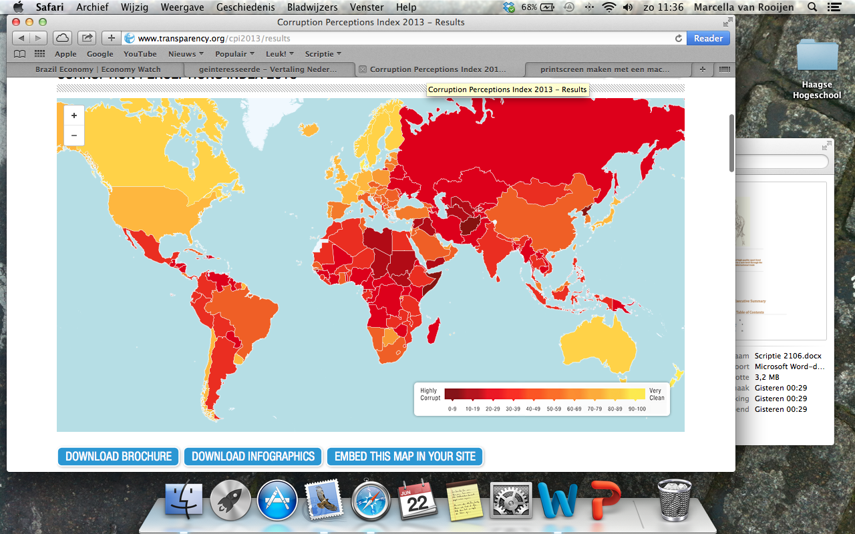public sector controls a fast deal of import/export regulations. However, Brazil already has an existing Equine Industry, with knowledge and capital increasing profitably, which probably makes the government and, in consequence, the rules in favour of importing quality horses (Transperancy international, 2013).

Figure 10

## 4.1 DESTEP - Demographic Analysis Brazil

Brazil is the largest country in Latin America, with a strong domestic market and. The greater part of the population is between 25-54 years old and partly embodies the KWPN target group. For the past few years, Brazil has faced contradictions in national development sectors; they eliminated poverty amongst the elderly, but also cut costs on education investments – one of the few means to escape poverty. In consequence, inequality remains a hot topic in Brazil. Ethnic groups within the country have been assembled for years and are needed to fill the workload. Currently, the main immigrants are unskilled illegals, whereas the emigrants are well educated, middle-class inhabitants (CIA World Factbook 2, 2013).

## 4.2 DESTEP - Economic Analysis Brazil

Brazil currently has the seventh largest Economy in the world, with an average of 56.9 overall score on the 2014 Index of Economic Freedom (The Heritage Foundation, 2014) and is considered the main economy of South America.

For some time now, Brazil has aimed to improve its macroeconomic stability, built foreign reserves, reduce debt, keep inflation rates under control and commit to fiscal responsibilities. Due to the financial crisis the national currency and stock market fluctuated immensely, foreign investments shrivelled, demand for commodity exports faded away and external credit increased. Nevertheless, the Brazilian economy was one of the first to reconstruct. In the year of 2014, Brazil is still recovering and works hard to remain stable. Nowadays, major sectors are service, industry, agriculture and. Additionally, Brazil owns massive reserves in minerals, iron, phosphates, manganese, uranium, copper, coal platinum and gold (EconomyWatch Content, 2010).

## 4.3 DESTEP – Social and Cultural Analysis Brazil

Cultural aspects are widely spread over Brazil’s ground territory and every region has its own variations in content. This is mainly due to diverse ethnic groups living in Brazil: Africans, Europeans and Native Americans. The GDP per capita is divided less equal over society in Brazil, thus the differences between rich and poor differ per region. The first to enter Brazilian land were the Portuguese, hence the official language spoken widely. Second were African slaves, imported by the Portuguese colonists during the colonial period. Later joined the Germans, Japanese and Middle Eastern Immigrants, creating the interracial mix that currently dominates Brazil (Brazil Culture, 2011).

## 4.4 DESTEP – Technological Analysis Brazil

The World Economic Forum published an online Global Information Technology Report 2010-2011 stating that “Brazil is up five places to 56th among 138 economies in the Networked Readiness Index” (see page 28). Especially the Brazilian ICT sector has peaked. The business sector is leading the country when it comes to ICT and innovation, next to the government. It is namely the operation and transactions department that increases in efficiency and capacity. Drawbacks on this subject are the low educational standards in science and math, in combination with high and fixed tariffs for telephone and mobile use. These drawbacks prevent growth and increased usage numbers (Dutta & Mia, 2011).

Figure 11   
Networked Readiness Index (Dutta & Mia, 2011)

## 4.5 DESTEP – Environmental Analysis Brazil

Brazil has some major environmental worries, while on the opposite side Brazil has access to large surfaces of fertile grounds, 5 different eco systems and plenty of natural. Deforestation of the Amazon rainforest is publicly known and condemned. Most of the forest is being cut down to gather timber or make room for development and agriculture. Not only pieces of natural habitat and a great variety of flora and fauna is destroyed, the earth also reaches an unbalanced state with shortages in oxygen and additions in carbon dioxide (CO2) that resolves into greenhouse gasses, indirectly contributing to global warming. As population density rises, cities expand and take little notice for environmental responsibility. Also, urbanization leads to clutter of solid waste, creating a vicious circle of waste problems. Brazilian municipalities use landfills to dispose waste. However, as landfills become larger, natural areas diminish and the soil in and around the landfills becomes toxic and unable to sustain life. (Brazil Geography, 2011).

## 4.6 DESTEP – Political Analysis Brazil

As a democracy, voting is compulsory for all Brazilian residents that are literate and between the age of 18 and 69. The Brazilian government is subdivided in 3 branches: the executive, legislative and judicial branch. Additionally, there are 27 states and over 5500 municipalities. The president holds the main executive power for 1 term – 4 years, unless he or she is elected for a second term. The National Congress, consisting of the Federal Senate and the Chamber of Deputies, holds all legislative power. Each individual state in Brazil has its own governor and elected legislature. The Supreme Federal Tribunal controls the judicial branch and consists of a series of hand picked judges. The judicial system has an enormous amount of power within the legal system of Brazil. Overall, the Brazilian system is acknowledged for its freedom, adaptability and constitution (Brazil Politics, 2011).

## 4.7 Import/Export duties

Brazil implemented three basic import taxes: Import Duty (II), the Industrialized Product taxes (IPI) and the Merchandise and Service Circulation tax (ICMS), other smaller taxes and import fees apply in subdivisions. As for import duties, the Brazilian market holds on to a 10-35% import duty rate, depending on the group or category of the product. From a 2012 report of the World Bank U.S.A, acknowledged possible barriers are: ‘high tariffs, an uncertain customs system, high and unpredictable tax burdens, and an overburdened legal system.’ However, since Brazil implemented the ‘Greater Brazil’ plan (Brasil Maior), exporting to Brazil is simplified and made more attractive. This makes Brazil an interesting partner with high potential for export (Export.gov, 2013).

## 4.7 Conclusion

The KWPN has not yet recorded their familiarity of name or the size of demand in Brazil yet. This market still has to gain shape and structure before it might be a stable and reliable export partner. This means that there is need for a structured analysis of the market in Brazil. Also, the economy has been struck down intensely due to the financial crisis and has consequently been set back a few steps in its development. In theory its resilience is surprising and shows great potential to compete amongst established world economies. Environmental issues are to be taken into consideration, since the Equine industry will have an effect that sector. The overall calmness of the country greatly contributes to the export opportunities and will be a benefit for befriended countries.

In reality, the experiences are divided. Marcel van Rooijen, account manager at Verdi Import/Export with over 20 years of experience with South America and in special Brazil, confirmed that the Brazilian economy finds itself in a bubble, with danger of collapsing. This will be a tangible test for the strength of the Brazilian economy and its resilience. As a conclusion, it can be said that exporting to Brazil is not without risks (Rooijen, 2014). However, thorough evaluation Brazil does place in a positive perspective with a developed Equine industry, in possession of capital and a willingness to import high quality sport bred horses.

## Conclusion

The results of the evaluation of Brazil and China combined with the interview with Irene Wolfs indicate that these new markets have potential to become trade partners. From the KWPN’s point of view, the foundation is to prepare a country for the Equine industry. Thus supply knowledge, information and building the sector, either from zero or from the level the country already possesses. This takes time and is financially a long-term process. The KWPN is currently focussing on promoting their brand, gain goodwill and build a reputation. This part of the report is very trivial since there is a clear plan on how to construct the foundation. In reality however, it shows that the work the KWPN has prepared is solemnly the start of a project that takes time. The interview with Simone Kromkamp and Robert Smit, who train and trade in high quality horses, shows that *building a network of close, personal relationship with clients* is the most important part of the plan. In retrospect, information from the KWPN and the interview with Ms Kromkamp and Mr Smit has a direct link. To combine their knowledge into a Plan of Action would be an ideal situation: preparatory work, research and the goodwill of the KWPN with the knowledge, network and sales skills of commission agents. This report proves that the Netherlands is ready to export. High quality sport horses are available and international clients are willing and eager to pay the suitable price. A recommendation would be to view this market from another perspective, but hold on to the current processes. Promoting the studbook throughout the Equine industry is necessary. If clients do not know the brand, they are not likely to buy the products. Here, it revolves around trust and reputation, which is created by both the seller/commission agent and the KWPN. Looking at the research done, the export process can be structured in two steps. Step one is preparatory work (done by the studbook) that aims for familiarity of name, simplifying/overcoming trade barriers by extensive research and making the market accessible. The second part is the responsibility of the seller or commission agent, be it individually or in name of a stud farm. He or she will be responsible for building his/her reputation (by selling high quality horses), establishing a network of loyal clients and creating a market for him/herself. This aspect makes the difference in selling average horses and high quality, potential Olympics horses. The latter sector cannot be submitted to a standard export model, because the potential Olympics horse is not a standard export product. Perhaps a comparison can be made with export models of equal elite, unique products, which would be an additional research report apart. Although the export process is currently working properly, combining these parts and fine-tuning them into one would be an ideal proposition. This requires a selection of stakeholders, traders and commission agents with already existing networks and high reputations and a dedication of the KWPN studbook to synchronize needs, demands and necessary actions. Above all, it requires financial input to build up markets abroad, spread knowledge, spread familiarity of name, break through country habits and implement the correct wisdom. If done thoroughly this might just be a break in the market, though not in a conventional manner. Also, it has to be kept in mind that this is a long-term project, which can only succeed with ultimate cooperation between the right persons. Taking everything into consideration, this Plan of Action is most likely to be realized within 5 – 10 years. Can the export of high quality sport bred KWPN horses be raised to a new level through the application of a modern international trade model? Yes, though with some minor adjustments in the model to make it fitting for this particular sector. The desired outcome would look as followed: the KWPN initiates the project by making it known amongst their network and start a cooperation with embassies and other linked organisations in the chosen country. Their office and the embassies start researching the current status of the country (Equine facilities, the level of knowledge) and conclude their evaluation with an export plan. Subsequently, commission agents who already have existing connections in the chosen country are selected and start their cooperation with the KWPN. The commission agent and the KWPN can support each other in this process, while the former expands its network and builds a solid foundation for the KWPN horse. Eventually, individual demand coming in from beyond borders, for instance via the online network platform, is evaluated by the KWPN and linked to a suitable commission agent. This is decided on account of the request – branch of sport, kind of horse, pedigree, and price range. Overall, it means a win-win situation for both KWPN and the commission agents and an innovative way to generate new income for all.

# Appendix

## 

**Interview with KWPN department ‘Sales Aid’**. This department is member oriented and operates nationally and internationally by promoting the KWPN horse. ‘Sales Aid’ aims to collect the supply and demand for members as a sort of matchmaking, lobbies against export obstacles and organizes activities to introduce foreign customers to the Dutch market. Main spokeswomen for this department is Irene Wolfs, her official function is Head Marketing and Communication of the KWPN (KWPN, 2014).

Ms Wolfs agreed this interview is recorded on tape, if the results are only used for this dissertation and serve no other purpose. Copying the interview and using its results for own research is therefore not allowed.

Questions:

1. When was the department Sales Aid established?
2. Was the department established on the demand of national suppliers or foreign demand?
3. Are active from you own network or with new customers?
4. Is there research done to new markets?
5. How is that procedure organized?
6. Which markets are currently active?
7. Is there a particular type of customer that looks for horses in the Netherlands?
8. What type of horse are customers searching for?
9. Is there a division in dressage/jumping/eventing horses, if so, what division?
10. What is the role of the KWPN, is it purely matchmaking or are there more activities?
11. Markets in China and Brazil, how are they categorized?
12. Is there an export plan when markets are perceived interesting?
13. What/how is the competition with other (local) studbooks?
14. How is the cooperation with suppliers/big stud farms?
15. Are there improvement points for the Dutch export of horses?
16. What is crucial to become bigger/more important with regard to exporting horses internationally?

**Summary of the interview:**

“You can say we apply a standard export model, yes. It is directed towards shaping markets, marketing and PR, trade promotion activities etcetera. The Dutch have been export long before the KWPN started interfering and was always the business of individuals, because traders and breeders act on their own. We started participating with trade mission, initiated by the Dutch government and involved embassies, where the KWPN is being matched to their network, which opens a lot of doors. What we also did was connect our self to the Holland Branding. Through the Holland Branding organization, we detect Chinese who are searches for a horse in Europe en we want to guide them to the Netherlands, so we started promoting the Netherlands as a horse country. Also with the idea that that market has to be broadened; you are not just selling the horse, you’re selling the complete package, otherwise the attempt is never successful. The KWPN has used several subsidised opportunities that have been completely consumed. The government had CPA programmes, Collective Promotion Activities, where you were supposed to write a plan yourself with substantiation why – market numbers, indications etc. If the plan is approved, you will receive an amount of money with which you can organize big events in cooperation with the embassies. The KWPN is actually not a seller or a commission agent, we match small to medium entrepreneurs in a new markets and once they’ve been there, they will find their own way. If foreign investors want to come to Holland, the government collects their group of interested parties (chosen through a particular consumer profile) and some stakeholders/PR. That group will follow a pre-drafted programme in the Netherlands including matchmaking and attending big events. This is how we introduce them to what the Netherlands has to offer. For those interested parties, the KWPN has introduced a foundation: the HNHF, Holland National Horse Foundation. Often, foreign investors have little knowledge on horses, maintenance etc. and the HNHF offers all there is around horses. We can easily see what parts of the Equine industry in the Netherlands is successful with that group. We started the HNHF and the department of Sales Aid because we noticed that the German studbooks had excellent marketing machines. Everybody knew the Hannover horse, not the KWPN, so you miss out on a great part of the market. We thought it would be in best interest of the breeders to establish the Sales Aid department. As long as there are people buying, people will continue breeding. Currently, we have our own network and we’re intensively building on our own database. All our connections receive our newsletter with the latest new. This is how we maintain contact with our network. After China en Russia, we’re looking at the Turkish and Mexican markets. We have an intern at the Dutch embassy in Turkey who researches the possibilities and analyses the market. We also organized a trade mission to India, to research the market. As for Brazil, we have been working on that market and have eventually decided not to go through with it. There are markets closer up and Brazil means a lot of traveling, which is expensive. Plus, there are high import duties. We as the KWPN Sales Aid department can be seen as an intermediary, we organize events and (online) auctions, we are situated in between. As for suppliers, we advocate for them en they are our clients, so we have frequent contact with them. To boost export, it is important that the Netherlands collects all involved parties and speaks to The Hague (politics) as one. The KWPN has tried to canalize the comments that were said, but this failed unfortunately. If you want to change things, you need all of the parties together and speak loud. The motivation was there, but we did not receive any funding. People saw the advantages but were not ready to take action. We are working on a solution. We believe that export the complete package is the most important, exporting knowledge. After sales is starting to become more important as well, definitely in new markets.”

**Interview with Simone Kromkamp/Robert Smit,** acknowledged breeders, trainers and exporters/sellers of the KWPN horse (dressage and jumping).

Ms Kromkamp and Mr Smit agreed this interview is recorded on tape, if the results are only used for this dissertation and serve no other purpose. Copying the interview and using its results for own research is therefore not allowed.

Questions:

1. Do you work from your own network or are you using other promotion material to draw customers?
2. Are your customers mainly Dutch or also international?
3. Do you sell within the European Union or also beyond?
4. To what kind of horses are your international clients searching?
5. Do you receive help from organizations as the KWPN?
6. Are you familiar with the Sales Aid department of the KWPN?
7. Are there restrictions when it comes to exporting a horse?
8. Which aspects have to improve to export horses?
9. Is there competition with other/bigger stables?
10. Have you noticed a decline in sales during the financial crisis?
11. What are your professional opinions regarding upcoming markets in –for example- China and Brazil?

Summary of the interview:

“Regular horses are easily sold through the Internet, Marktplaats or Sporthorses. The more elite horses are sold through Robert’s network, which he has been building the last 18 years. These are his regular customers. Through the Internet are primarily Dutch or Belgium customers, almost always individuals. If you have an elite horse present at an event, the sale always goes via-via. Someone who knows Robert approaches him directly about the horse and he/she brings along his clients. You build everything on connections and quality horses. Strangers will not approach you for horses in that price segment. It is also partly thanks to your own reputation, Robert is acknowledged for the horses he sales, and his name is already established. We mainly export to Spain, Argentina and Chile, because is it within Roberts’ network. The type of client has to do with the price, the riders, the ambitions and the clients themselves. Foreign buyers sometimes have little knowledge of horses, they priority is the exterior of the horse, it has to be appealing and the gaits. Here, they trust Robert to sell them a quality horse. If he stated that the horse is worth it, they believe him. Through the KWPN we mainly receive individual buyers, not as many foreign clients. Like we stated, in wholesale and for capital, a good name and good connections are important. As for export, the Netherlands has simplified their rules. They have things taken care of very good. Spain is a little more difficult, but not as hard as the USA and China. If you export a horse to China, it may not leave the country anymore after that. So it’s easy to lose customers if something goes wrong. With regard to restrictions, this is mainly due to the country itself, if it doesn’t cooperate. Long quarantine procedures etcetera. Trade agreements are necessary, they are already busy with those. Like in China, but this goes slowly because China is not a traditional horse country. In the Netherlands everybody tries to tie connections, the Equine industry works on a good reputation. Building that reputation takes around 15-20 years. If you’ve established that, you can sell horses through a single phone call. Customers don’t even have to come visit the horse, they maybe want to see it on a picture of film, and those people buy on trust. You sell them the horse, you transport it and it’s finished. With the financial crisis, it’s mainly the regular horse trade that stagnates. If you have a real good horse, it is sold for the highest price possible. Actually, the price for a quality horse has only raised the last couple of years. They are sold within no time. Due to the crisis, there is less breeding, which means that elite horses have become somewhat scarce. This lifts the exclusivity of those horses, you only have to sell one a year, thanks to the augmented price. Discovering other markets goes slow, Robert now has connections in Mexico, China and Colombia. It depends where your connections are, this is not a prepared plan. It depends on the horses you sell, your connections and the quality you offer. China is difficult, they only want to have appealing, nice horses. So if it’s not a KWPN’er, it might just as well be an Andalusians. They select a horse on colour, the rest is not important. So their knowledge is lacking, working with countries that have no knowledge in horses is difficult. Brazil has been active in horses for years, definitely jumping horses. They have knowledge. About the import tax, it is something definitely worth overlooking. The most important thing is to maintain contact with your network, through the telephone, inviting them over. Its not simple, it takes a lot of work. You have to have a good horse and good connection, that’s it.”

**Interview Marcel van Rooijen**, account manager at Verdi Import/Export, specialist in South America with over 20 years of experience in Brazil, Argentina and Chile.

Questions:

1. Brazil is seen as an upcoming, emerging market with capital, ready to invest in foreign products and services. Is this true in reality?
2. Are the Brazilians open to European products and services?
3. Brazil has been working on simplifying its import/export policies. Does your company notices that?
4. The Brazilian government, does it cooperate or counteract?
5. A business relationship with Brazilians, how would you describe that?
6. Are there issues the Brazilian business (wo)man would not allow?
7. Is Brazil a profitable market for Verdi?

Summary of the interview:

“Brazil as an emerging market with capital and ‘open borders’, this picture is partly true. New discovered oil preserves give the economy a boost, but the current circumstances where an estimated 70% of the habitants are financially supported creates a bubble that is likely to explode. Export stagnates and import is rising, creating an imbalance on the export/import balance. Nevertheless, the Brazilians are very open to foreign products and services, because the national supply is qualitatively low. But because the export stagnates, rules and regulations are growing tighter. A big problem is the Brazilian government, there is a lot of corruption and self-enrichment. This makes developments slow and incoherent. With the Brazilians it is necessary to first build a personal relationship, from there you can establish a business relationship. This takes time. If the trust you have build is blemished, it means business suicide. Always honour your agreements and keep contact. Brazil is mainly an uncertain market, depending on the supply and demand.”

# Bibliography

## 

ABN Amro. (2012, 04). *Doing Business with Honk Kong and China.* From ABN Amro: https://www.abnamro.nl/nl/zakelijk/internationaal-zakendoen/index.html?ext=google-paid_s%7Csea_aab%20internationaal%20zakendoen%7Clanden%20china%7Cchina%20-%20exporteren%7Cexporteren%20naar%20china-e&gclid=CjgKEAjwt4-dBRCDnaTUn-mC_0oSJAC4Q6kGBj13aQNvl9bhpaDtKWn0a0s6tGG8wqZW-yLObekav_D_BwE

Anky. (2014). *Biography*. Retrieved 02 23, 2014 from Anky: http://www.anky.nl/home?m=30

ANP. (2013, 06 11). *New milestone export Dutch horses.* Retrieved 2014 from AD: http://www.ad.nl/ad/nl/5597/Economie/article/detail/3456931/2013/06/11/Nieuwe-mijlpaal-export-Nederlandse-paarden.dhtml

*Brasileiro de Hipismo*. (2014, 04 01). Retrieved 05 2014 from KWPN: http://www.bokt.nl/wiki/Brasileiro_de_Hipismo

Brazil Culture. (2011). *Culture*. Retrieved 06 2014 from Brazil.org.za: http://www.brazil.org.za/brazil-culture.html#.U6ieExbY9TB

Brazil Economy. (2011). *Brazil Economy*. Retrieved 06 2014 from Brazil.org.za: http://www.brazil.org.za/economy.html#.U5mRSvl_sto

Brazil Geography. (2011). *Geography - environmental issues*. Retrieved 06 2014 from Brazil.org.za: http://www.brazil.org.za/environmental-issues.html#.U5mGLfl_sto

Brazil Politics. (2011). *Politics intro*. Retrieved 06 2014 from Brazil.org.za: http://www.brazil.org.za/politics-intro.html#.U5mUWPl_sto

BSS Horse Transport. (2014). *Information*. Retrieved 06 20, 2014 from BSS Horse Transport: http://www.paardentransporten.nl/info-bss/

Business Monitor International. (2014, 06 01). Brazil Business Forecast. From file:///C:/Users/sanec6/Downloads/executiveSummary-Brazil-Business-Forecast-Report-252634%20(1).pdf

Butler, R. A. (2012, 04 05). *Brazil can eliminate deforestation by 2020*. Retrieved 06 2014 from Mongabay: http://news.mongabay.com/2012/0405-swf_jatene_interview.html

BWP. (2014). *Stallions*. Retrieved 6 2014 from BWP: http://www.bwp.be/_html/main.php?stb=1&page=hengsten

CBS 1. (2014, 01 30). *Horses/Ponies*. Retrieved 02 24, 2014 from CBS 1: http://www.cbs.nl/nl-NL/menu/themas/landbouw/publicaties/landbouw-vogelvlucht/sectoren-landbouw/2012-paarden-ponys-livv-2011.htm

CBS 2. (2014, 02 19). *Landbouw; gewassen, dieren, grondgebruik en arbeid op nationaal niveau*. Retrieved 04 17, 2014 from CBS 2: http://statline.cbs.nl/StatWeb/publication/?DM=SLNL&PA=81302ned&D1=421-427,463-469&D2=0,5,10,12-13&VW=T

CIA World Factbook 1. (2013, 02 21). *China-Demographics*. Retrieved 06 2014 from Index Mundi: http://www.indexmundi.com/china/demographics_profile.html

CIA World Factbook 2. (2013, 02 31). *Demographics Brazil*. Retrieved 06 2014 from Index Mundi: http://www.indexmundi.com/brazil/demographics_profile.html

CIA.GOV. (2014, 04 29). *Brazil*. Retrieved 06 2014 from CIA: https://www.cia.gov/library/publications/the-world-factbook/geos/br.html

Dutch Consulate-General in Shanghai. (2011, 11 08). *China - Sustainable Building.* Retrieved 06 2014 from NL Agency: http://china.nlambassade.org/binaries/content/assets/postenweb/c/china/zaken-doen-in-china/sectoren/sustainable-building/china---sustainable-building---2011-11-08.pdf

Dutta, S., & Mia, I. (2011). *The Global Information Techonology report 2010-2011.* Geneva: SRO-Kundig.

EconomyWatch Content. (2010, 03 15). *Brazil*. Retrieved 06 2014 from Economy Watch: http://www.economywatch.com/world_economy/brazil/

EW World Economy Team. (2013, 06 04). *China*. Retrieved 06 2014 from Economywatch: http://www.economywatch.com/world_economy/china

Export.gov. (2013, 11 07). *Trade Regulations Brazil*. Retrieved 06 22, 2014 from Export.gov: http://export.gov/brazil/static/CC_BR_DoingBusiness_CCG_PDF_Chap5_TradeRegulations_Latest_eg_br_034997.pdf

FEI. (2014, 01 31). *World Individual Dressage Ranking*. Retrieved 02 23, 2014 from Fédération Equestre Internationale: https://data.fei.org/Ranking/Search.aspx?rankingCode=D_WR

*Historico*. (2010, 01 7). Retrieved 05 2014 from CBH: http://www.cbh.org.br/cbh/historico.html

Holland National Horse Fund. (n.d.). *KWPN*. Retrieved 26 05, 2014 from Holland National Horse Fund: http://www.hnhf.org/index.php?comp=1

Infoteur. (2009, 12 11). *BRIC countries have the Economical Future.* Retrieved 2014 from Mens en Samenleving: http://mens-en-samenleving.infonu.nl/internationaal/47726-bric-landen-hebben-de-economische-toekomst.html

Janet Doorduin. (2012, 11 30). *China: preference for Dutch horses*. Retrieved 05 2014 from KWPN: http://3xl57912lrz22xfysm4fg78whew.wpengine.netdna-cdn.com/wp-content/uploads/2013/09/2012-24_China__voorkeur_voor_Nederlandse_paarden.pdf

Karlas, K. (2011, 12 22). *Brand familiarity of KWPN grows.* Retrieved 05 2014 from KWPN: http://3xl57912lrz22xfysm4fg78whew.wpengine.netdna-cdn.com/wp-content/uploads/2013/09/2011-25-Bekendheid-KWPN-als-merk-in-nieuwe-markt-groeit.pdf

KLM. (2013, 06 14). *Animal Transport*. Retrieved 06 20, 2014 from KLM: http://www.klm.com/corporate/nl/about-klm/information-school-talks/animal-transport.html

KNHS 1. (2014). *The story of KNHS*. Retrieved 02 23, 2014 from KNHS: https://www.knhs.nl/kenniscentrum/over-knhs/wie-zijn-wij/het-verhaal-van-de-knhs/

KNHS 2. (2013, 06 21). *NOP wants to secure top horses for the Netherlands*. Retrieved 06 20, 2014 from KNHS 2: https://www.knhs.nl/actueel/nieuws/knhs/“stichting-nop-wil-toppaarden-behouden-voor-nederland”/

Kromkamp, S., & Smit, R. (2014, 06 19). High class markets. (M. v. Rooijen, Interviewer)

KWPN 1. (2012, 08 09). *OS London Dutch horses obtain gold and silver.* Retrieved 02 23, 2014 from KWPN: http://www.kwpn.nl/2012/08/os-londen-nederlandse-paarden-pakken-goud-en-zilver/

KWPN 2. (2014). *The UK*. Retrieved 02 24, 2014 from KWPN 2: http://www.kwpn.nl/over-kwpn/kwpn-in-het-buitenland/verenigd-koninkrijk/

KWPN 3. (2014). *History*. Retrieved 05 05, 2014 from KWPN 3: http://www.kwpn.nl/over-kwpn/historie/

KWPN. (2014). *Sales Aid*. Retrieved 05 2014 from KWPN: http://www.kwpn.nl/marktplaats/afzetbevordering/

Martin, S. V. (2013). *Understanding China’s Political System.* CRS Report for Congress.

Meijer, R. (2013, 11 11). *Global shortage of materials an increasingly pressing issue*. Retrieved 06 2014 from TU Delft: http://www.tudelft.nl/en/current/latest-news/article/detail/wereldwijde-schaarste-aan-materialen-steeds-nijpender-kwestie/

Moorsel, L. J. (2010, 01). *An overview of Chinas Equestrian Industry.* Retrieved 08 2014 from China NL Embassy: http://china.nlambassade.org/binaries/content/assets/postenweb/c/china/zaken-doen-in-china/import/kansen_en_sectoren/agrofood/rapporten_over_agro_food/an-overview-of-chinas-equestrian-industry.pdf

MOZUR, J. O. (2014, 01 16). The Rise of China's Innovation Machine. *Wall Street Journal* .

NOS. (2014, 5 2). *China doesn't wants to be the biggest*. Retrieved 6 2014 from NOS: http://nos.nl/artikel/642956-china-wil-niet-de-grootste-zijn.html

NVWA. (2014, 02 11). *China, horses*. Retrieved 06 21, 2014 from VWO: http://www3.vwa.nl/werkwijzer/Levend/PRDUV-10%20China%20b.pdf

Rooijen, M. v. (2014, 06 18). Doing Business with Brazil. (M. v. Rooijen, Interviewer)

Statline. (2014, 02 04). *China: again rise in export*. Retrieved 06 2014 from CBS: http://www.cbs.nl/nl-NL/menu/themas/internationale-handel/publicaties/belangrijkste-handelspartners-nederland/archief/2013/2014-china-2012-ih-art.htm

The Heritage Foundation. (2014). *Brazil*. Retrieved 06 2014 from Heritage: http://www.heritage.org/index/country/brazil

Trading Economics. (2013). *Brazil GDP Growth Rate.* Retrieved 2014 from Trading Economics: http://www.tradingeconomics.com/brazil/gdp-growth

Transperancy international. (2013). *CORRUPTION PERCEPTIONS INDEX 2013*. Retrieved 05 2014 from Transparency International: http://www.transparency.org/cpi2013/results

TravelChinaGuide. (n.d.). *Cuisine.* Retrieved 06 2014 from TravelChinaGuide: http://www.travelchinaguide.com/intro/cuisine_drink/cuisine/

TravelChinaGuide2. (n.d.). *Public Holiday.* Retrieved 06 2014 from TravelChinaGuide2: http://www.travelchinaguide.com/essential/public-holiday.htm

UKTI. (2014). *Doing Business In Brazil.* Retrieved 2014 from Doing Business Guide - Business Etiquette: http://www.brazil.doingbusinessguide.co.uk/the-guide/business-etiquette.aspx

Vermeer, E. B. (2011, 03). *The phenomenal Economic Growth of China.* Retrieved 2014 from Internationale Spectator: http://www.internationalespectator.nl/system/files/20080300_is_art_vermeer.pdf

Wall Street Journal. (2013, 11). *China.* Retrieved 06 2014 from Heritage: http://www.heritage.org/index/pdf/2014/countries/china.pdf

Windt, N. v., Loohuis, R. O., & Agricola, H. (2007). *The Equine Industry under a microscope.* Retrieved 09 2014 from Alterra: http://www2.alterra.wur.nl/Webdocs/PDFFiles/Alterrarapporten/AlterraRapport1444.pdf

Wolfs, I. (2014, 06 16). KWPN department Sales Aid. (M. v. Rooijen, Interviewer)

World Bank Group. (2014). *Brazil Overview*. Retrieved 06 2014 from World Bank: http://www.worldbank.org/en/country/brazil/overview

ZKA Consultants & Planners. (2011). *Facts and numbers*. Retrieved 02 23, 2014 from KNHS: https://www.knhs.nl/kenniscentrum/over-knhs/wie-zijn-wij/feiten-en-cijfers/