Jiayi Wang, 11072954, ES-4E-h
Supervisor: Mr. J. Schroder

Assignment provider: Mr. W. Lin
Assignment provide company: Huawei Technology
Faculty of Management & Organization-European Studies
The Hague University of Applied Sciences
Date of completion: 25 May 2016
Develop Virtual Reality Business to the Netherlands

Acknowledgement
Firstly, it is a genuine pleasure to express my immeasurable appreciation and deepest gratitude for the help and support provided by my supervisor, mentor and guider Mr. Jos Schroder. I would not be able to work on this project with passion without his guidance, valuable comments, encouragements and suggestions.
Secondly, I would like to thank my family. My parents continue to give me encouragements and comforts even though I am not always by their side.
Lastly, I would like to take this opportunity to express my gratitude to all the teachers in European Studies program. You are the ones who urged me to do better and pursue more in my future, thanks!

Preface
This dissertation is original, unpublished, independent work by the student, Jiayi Wang. It is submitted as a completion of the four-year bachelor study program in European Studies at The Hague University of Applied Sciences.
Jiayi Wang
25 May 2016

Executive Summary
Traditional toy industries have been influenced by the emergence of tech gadgets such as iPad and Virtual Reality Glasses. Based on a report on The Telegraph (2010), tech gadgets have replaced traditional dolls and cars as children’s favorite presents. Huawei, one of the China’s leading toy companies, is investigating the opportunity to fight downturn in traditional toys by selling Mobile VR to Europe. This research paper aims at producing an advice for Huawei regarding the entry strategy. Therefore, the central question of this study is formulated as “What is the best internationalization strategy for Huawei Technology Group to develop its Virtual Reality Headset business from China to the Netherlands?”
The research has been based on the framework of strategy designing process model by de Wit and Mayer (2014). The literature review and related chapters concerns about the background information of virtual reality, information technology and traditional toy industry, as well as success stories from other businesses in form of case studies. These forms the basis for understanding the product and the market trend. Additionally, information for this study is mainly collected via desk research, questionnaires and interviews.
The results have demonstrated that there is an unprecedented market potential of Mobile VR glasses with educational and entertainment functions in the Netherlands among teenagers from 10 to 20 and their parents. Using trading companies to enter the Dutch market at the early stage and changing to strategic alliance or foreign direct investment at the later stage for the company can be convenient. Besides, for market penetration, retail price of VR glasses in Dutch market can be set around 35 to 45 euros. Retailers such as Media Market, Inter Toys, Cool Blue can be liaised for cooperation. In promotion strategies, digital marketing and physical catalogue can be used as the main media of promotion for business and individual buyers respectively.
The first recommendation for Huawei is to conduct deeper research on Helmet-mounted Display VR as it can provide better user experiences and adopt better technology than Mobile VR. Secondly, Huawei should invest in VR glasses companies in Europe to obtain better margin. The study is limited by the lack of opinions from teenagers, thus further research on their opinions is needed.

Table of Contents
Acknowledgement II
Preface III
Executive Summary IV
Chapter 1: Introduction 8
1.1 Research background 8
1.1.1 Virtualization of toys 8
1.1.2 A reality apart from reality 8
1.2 Project provided and objective 9
1.2.1 Company background 9
1.2.2 Goal of this research 9
1.3 Research questions and theoretical framework 9
1.4 Research model and structure 11
1.5 Research scope 11
Chapter 2: Literature Review 13
2.1 Virtual Reality 13
2.1.1 Definition of virtual reality 13
2.1.2 History of virtual reality 14
2.1.3 Re-rise of virtual reality headset 16
2.1.4 Classification of virtual reality headset 17
2.1.5 VR’s potential with kids and teenagers 19
2.1.6 Manufacturing / research power of virtual reality headset in China 20
2.1.7 Challenges of virtual reality headset 20
2.2 Traditional Toy Industry 22
2.2.1 Definition of traditional toy industry 22
2.3 Information technology 23
Chapter 3: Methodology 24
3.1 Research designing and scope 24
3.2 Research structure 25
3.3 Research methodology 25
3.4 Data sources 26
3.5 Limitation of this research 27
Chapter 4: The Progress of Toy Industry Revolution 29
4.1 Overall picture 29
4.2 Mattel Inc. and LEGO group’s transformation 30
4.3 Insights to Huawei 32
Chapter 5: Internal analysis of the company 33
5.1 Description of the company 33
5.2 Current business scope and Finance 35
5.3 Value chain analysis 36
5.4 Strengths and weaknesses 40
Chapter 6: External analysis 42
6.1 PESTEL analysis 42
6.1.1 Political 42
6.1.2 Economic 43
6.1.3 Social-cultural 43
6.1.4 Technology 44
6.1.5 Legal 44
6.1.6 Environmental 44
6.2 Questionnaire results and analysis 45
6.2.1 Design of the questionnaire 45
6.2.2 Findings of the questionnaire 46
6.2 Porter’s Five Forces 54
6.3 Threats and Opportunities 58
Chapter 7: Confrontation Matrix and Strategy Designing 59
Chapter 8: Market entry strategies 62
Chapter 9: Implementation of the best entry strategy 68
9.1 Product support 68
9.2 People 69
9.3 Place 69
9.4 Price 69
9.5 Promotion/Presentation 70
Chapter 10: Conclusion & Recommendation 72
References 75
Appendices 80
Questionnaire in English 80
Questionnaire in Dutch 84
Interview with Virtual Reality expert at Alibaba 90
Interview with R&D manager at Huawei 95
Brief Interview with Human Resource Manger at Huawei 100
Brief interview with CEO at Huawei 101

Chapter 1: Introduction

1.1 Research background

1.1.1 Virtualization of toys
Information technology is revolutionizing products; this has significant effects on some industries and forces them to face new competitive opportunities and threats (Porter & Heppelman, 2015). Hasbro and Mattel are two main players for toys in European market (Competitiveness and Sustainable Industrial Policy Consortium, 2013). However, Hasbro’s net income declined 11% in the first quarter of 2013 and Mattel’s net income fell 24% (Schumpeter, 2013). The number of children preferring tech gadgets instead of a traditional toy such as a car or a doll is increasing nowadays (The Telegraph, 2010). Traditional toy industries have been impacted by the emergence of the latest tech gadgets such as iPad and Virtual Reality glasses (“VR glasses”, “VR Headset”). Under the current circumstances, toymakers should be aware of the tendency that children nowadays prefer experiencing a character in a digital form to a physical form when they are looking for growth by developing this emerging market (Schumpeter, 2013). Toy companies are seen making strategy adjustments to catch up with the technological advancement, including LEGO Group and Hasbro. LEGO Group produced complex entertainment products such as “logo-lized” superhero movies and games under cooperation with DC Comics and Marvel Studio, and Hasbro signed an agreement with 3D system to allow some of its products being 3D printed (Bejerano, 2014).

1.1.2 A reality apart from reality
Meanwhile, VR is bringing fresh perspective on many industries. Many business analysts believed it has the potential to transform how we interact with almost every industry today (Bellini, 2016). According to Hu & Jiang (2016), “Virtual Reality is a computer-simulated environment. Sensory experiences, such as virtual sight, sound, smell taste and touch can be recreated by virtual reality. Users move from one place to another and computers have a complicated computing at the same time, then a virtual world similar to the real is created” (p.49). Nowadays, VR has evolved from the small circle of technological enthusiasts to pervasive attention on mainstream media; reputable giants such as Google and Sony catalyzed the rapid growth of general public’s interests. Although VR hardware is still the battlefield between mobile manufacturers and software developers, such as HTC, Samsung and Valve (Ciappetta, 2016), as technology enabled the mass production of lower-cost headsets to storm the market, further competition from other industries will soon join the bottle on this new technology as well (Bejerano, 2014). In conclusion, these smart, connected products such like VR Headset is offering new expanding opportunities for traditional industries while forcing them to rethink their positions (Porter & Heppelmann, 2014).

1.2 Project provided and objective

1.2.1 Company background
Huawei Technology, a leading toy company in China founded in 1997 with total capital of 455,364,000 euros, is rethinking their business and considering to take a fresh step to expand their business scope. Huawei Technology has turned to VR and interested in this new business opportunity.
As a strategic move to become an all-rounded entertainment company, Huawei has already entered electronic game software industry and acquired several film production studios. Further to its current acquisition, it wants to completely transform itself from a traditional toy manufacturer to a high-tech company by selling high-tech gadgets to Europe. The International Trade Department in Huawei identified that VR headset is a prevalent electronic gadget among the younger generation aboard and estimated that the investment into VR headset can yield promising return for the company.

1.2.2 Goal of this research
Based on previous research done by the company, Huawei has been aware of this forthcoming trend and recognized VR as a game changer. The goal of this research includes firstly examining if Dutch market has enough customer potentials for VR headset. Secondly investigating the best marketing entry and implementation strategy to develop Huawei’s VR business in the Netherlands.

1.3 Research questions and theoretical framework
In order to help Huawei Technology to develop VR headset business to the Netherlands, the central question is formulated as follow:
What is the best internationalization strategy for Huawei Technology Group to develop its Virtual Reality Headset business from China to the Netherlands?
In order to answer the central question, 4 sub-questions are also listed:
1). How do other traditional toy companies reacted towards VR Headset and how do they transform their business strategies under the impact of information technology?
2). Can Huawei’s existing business resources be utilized to sell VR headset? To what extend are those resources can be helpful?
3). What are the current Dutch market environment for VR headset?
4). What is the best market entry strategy for Huawei?
Additionally, for better understanding the central and sub-questions, theoretical framework has been built on key definitions and discussions on the topic. Discussions are divided into three components: virtual reality, traditional toy industry and information technology. This will be further discussed in the literature review chapter.
Topic | Related research in Literature Review
Virtual Reality | Definition of virtual reality  History of virtual reality  Definition of VR Headset  Classification of VR Headset  Applications of VR Headset  Potential of VR Headset among teenagers  Manufacturing/research power of virtual reality headset in China  Challenges of VR Headset
Traditional toy industry | Definition of Traditional Toy Industry
Information technology | Definition of Information Technology
Table 1 Focus of Literature Review

1.4 Research model and structure
The topic of this project is narrowed to a business strategic unit, and the question that Huawei Technology raised is a strategic problem. To solve strategic problems, the strategic reasoning process (“SRP”) must be gone through (de Wit & Mayer, 2014). Therefore, the author structured the whole research based on SRP theory (de Wit & Mayer, 2014). Incorporating the SRP theory, this project of research is structured as figure 1:
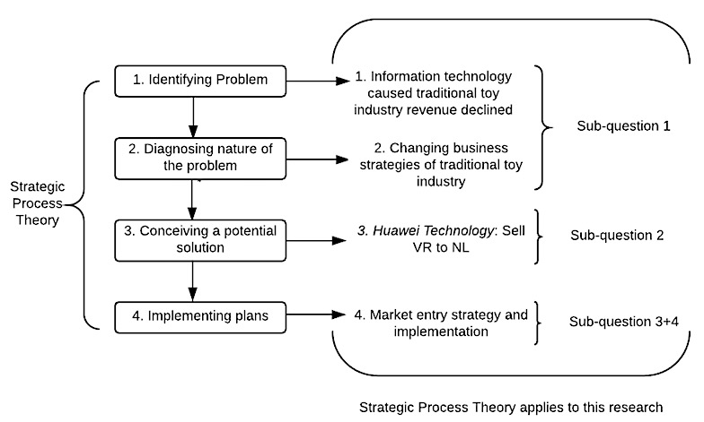
Figure 1 Strategic Reasoning Process theory apply to this research (de Wit & Mayer, 2014)

1.5 Research scope
The aim of this project is only to help Huawei Technology’s International Department to develop its VR headset to the Netherlands. Investigating other traditional toy companies’ business strategies considering of the impact on information technology is only for providing some insights to Huawei Technology. This might be beneficial for their business planning. Furthermore, because VR headsets contain various product forms which require different technology development level, in this paper, the “VR Headset” will mainly focus on Mobile VR with education and entertainment function. Finally, project will mainly focus on the market entry and implementation strategies of the VR headset to the Netherlands.
Sub-topics | Keywords
Research background | - Information technology  - Toy companies’ net income declined  - Tech gadgets  - VR Headset
Project provided | - Huawei has turned to VR, thus they provided this project to the author
Central research question | - What is the best internationalization strategy for Huawei Technology Group to develop its Virtual Reality Headset business from China to the Netherlands?
Research model | - Follow the Strategic Reasoning Process
Research scope | - Only to help Huawei to develop its VR headset to the Netherlands.  - Mainly focus on Mobile VR.
Table 2 Summary chart to Chapter 1

Chapter 2: Literature Review
The purpose of this chapter is to outline the theoretical findings contributing to the understanding of the whole project in a critical way. In this chapter, key variables and related research will be interpreted and explained. Based on the central question, the theoretical framework can be built as follows: Section 2.1 will mainly introduce Virtual Reality, the first key terminology, which includes its history, development, applications, and impacts. Section 2.2 will give a definition on “traditional toy industry” as a support to Chapter 5. Finally, information technology and its impacts on traditional toy industry will be briefly discussed in section 2.3.

2.1 Virtual Reality
Rapid growth on coverage on media both online and offline creates an extensive trend for Virtual Reality. Although Virtual Reality has been around for many years, it is still new to most of us, therefore, understanding this new product is of significant importance to Research and Development department for Huawei. In this section, an explanation and related information of virtual reality will be presented.

2.1.1 Definition of virtual reality
The very first idea of Virtual Reality was presented in 1965 by Ivan Sutherland, a famous internet pioneer and the “father of computer graphics”. Sutherland described his idea of Virtual Reality: “that (virtual) world should in the window, it looks real, sounds real, feels real, and responds realistically to the viewers’ actions” (Mazuryk & Gervautz, 1996). Similarly, Wiley (2006) stated that VR world is a simulation in which computer graphics is used to create a realistic-looking world and this synthetic world is not static. This world has to respond to user’s input (gesture, verbal command and so on). The definition of Virtual Reality hasn’t changed too much since then. In the same vein, researchers Hu and Jiang (2016) from the University of Alabama stated: “Virtual Reality is a computer-simulated environment. Sensory experiences, such as virtual sight, sound, smell taste and touch can be recreated by virtual reality. Users move from one place to another and computers have a complicated computing at the same time, then a virtual world similar to the real is created”.
Overall, the definitions of VR from 1965 to 2016 have barely changed. Together, these research in different decades highlight several common key words on Virtual Reality: (1) computer graphics, (2) computer simulation, (3) sensory experiences and (4) interactivity.

2.1.2 History of virtual reality
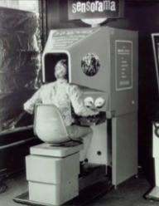
Virtual Reality has been a research interest to scientists for a very long time. One of the earliest realization is Morton Heilig’s Sensorama (as shown in figure 2), it is recognized as one of the first examples of virtual reality. This model was designed in 1962 with the use of 3D visual, audio, haptic, olfactory stimuli and so on. It can be used to play movies, indulging the users into the movie. However, comparing with the definition discussed above in section 2.1.1, the only thing Sensorama missed is the interaction between user and the movie (Gonçalves, 2014).
Figure 2: The Sensorama (Gonçalves, 2014)
After the raise of Virtual Reality concept by the internet pioneer Sutherland in 1965, scientists started the prolonged research to achieve this “Promised Land”. However, constrained by the technical condition of that time, they found it difficult to achieve such a futuristic world. First of all, the high-resolution and high-quality images are hard to render and remain consistent in VR system. Secondly, the computerized environment itself should be interactive, but a desktop at that time is very bulky to achieve so. At the end, scientists decide to compromise and classify the VR system into three level of immersion (Mazuryk & Gervautz, 1996). Mazuryk and Gervautz (1996) defined the desktop VR into the simplest type of virtual reality application as there is only a monitor to display the image but no sensory output can be achieved. Also, the Helmet-mounted Display (HMD) that created in 1961 (helmet-mounted display) was defined as the ultimate version of VR system, because only the helmet can ensure the users’ total immersion to the computer generated world as the HMD itself can sense the movement of the heads. Until today, HMD is still considered the most immersive system for VR experience.
One of the most famous HMDs was invented in 1968, named BOOM (Binocular Omni Orientation Monitor), by Ivan Sutherlands. It had to hang onto the celling and this HMD is too bulky to wear as depicted in Figure 3 and 4.
Figure 4: Ivan and his BOOM (Gonçalves, 2014)
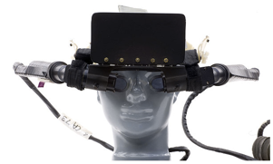
Figure 3: The BOOM(Gonçalves, 2014)

However, just like what Sutherlands defined VR, BOOM was capable to track the position of users. Furthermore, it can also “update the image according to user’s position” (Gonçalves, 2014).
In 1993, Japanese company Sega announced that they were going to introduce an attractive product Sega VR headset, as shown in Figure 5. Sega planned to release it later, nevertheless, the company never actually materialized the real product despite they reported that they have four games developed specifically for it. According to Sega, the virtual reality helmet used integrated LCD displays and sensory units to measure head movement (Sexton, 2016).
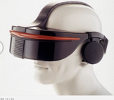
Figure 5: Sega VR (Sexton, 2016)

During 1990s, 3D graphics were popular and VR headset had its glory days, extensive media covered this “new technology”. During that time period, market analysts predicted that there will be a boost increase on VR Headset sales. Nevertheless, just like the failure of Sega VR Headset, VR Headset in the 90s failed partly due to lack of software support. Zelenko and Robertson (2016) believed that virtual reality was not ready for gaming. Furthermore, due to the lack of computation power of hardware at that time, people always felt dizzied when they used VR Headsets to play simple games in the 1990s.
To sum up, Sensorama was the first virtual reality model that created by “the father of VR”, Heilig. However, Heilig failed to let the VR system become interactive with it’s users, the system was only for watching movies. After that, Sutherland developed the functional system with all the defined features but it was too bulky to carry. In 1993, the famous game company Sega announced that they will release the Sega VR Headset and related games, but it failed and no longer had any information on it. During the 1990s, VR had its glory days but it was not popularized.
Together, the above studies indicate that the hardware of virtual reality headset had not been advanced enough to produce comfortable wearing experience, while the lack of software reduced the application for VR and therefore it had vanished in the 90s. This provides important insights for Huawei Technology’s Research and Development Department.

2.1.3 Re-rise of virtual reality headset
Although virtual reality failed in the 1990s, it resurges to the center of focus recently. In fact, virtual reality started to flourish again when Facebook bought virtual reality company Oculus in 2014 (Bellini, 2016). After that, virtual reality has drawn much attention from various media. Google Trends (Figure 6) shows that there has been a steady number of searching people before October, 2015. And from October of 2015, more and more attention has been focused in VR headsets, therefore, more people are likely to search this term on Google. This phenomenon partly due to the fact that Google, Apple were trying to materialize VR headsets and produce VR applications. Thus, on Google Trends, “VR” becomes more and more popular.
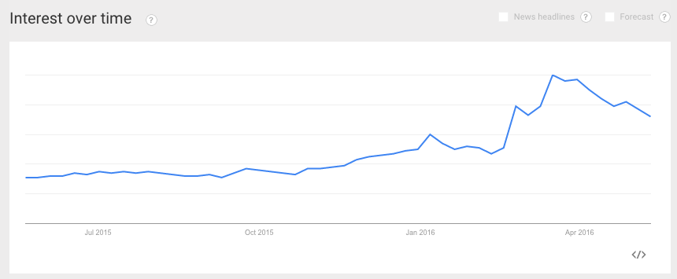
Figure 6: Google trends on term “VR” (Google trend, 2016)

Business analyst Bellini (2016) from the Goldman Sachs described, “Virtual Reality has the potential to transform how we interact with almost every industry today.” Likewise, Matt (2016) holds the view that new virtual reality technology has opened a new door for video games and development of virtual reality platforms are also very promising: 16% of those surveyed software engineers of Game Developers Conference in Los Angeles in 2015 said they are working on a game for VR platforms, 75% believe virtual and augmented reality are “a long-term sustainable business.” Additionally, reputational companies such as Google and Sony catalyzed this interest to grow rapidly.
According to Chiappetta (2016), although VR Headset is still the battlefield for mobile and software companies such as HTC, Samsung and Valve, as more low-cost headsets hit the market and many experts believed that other industries will embrace this new technology as well (Bejerano, 2014).

2.1.4 Classification of virtual reality headset
In today’s market, there are various kind of VR headsets or equipment. Here, VR headsets will mainly be classified into two types (Lo, 2016).
1. Helmet-mounted Display (HMD). This kind of VR headset needs the users to wear the helmet and related equipment, also the users need to make sure the HMD is connected to their personal computers. Oculus Rift (seen in Figure 7) is an example of HMD. Besides, HMDs from other companies such as Morpheus from Sony, Vive from HTC are also going to be released soon. HMDs have very good immersive experiences but it is very expensive at the same time. These products haven’t entered into the customer market and most of them are currently being used in B-to-B field. Companies use HMDs to present their products and allow their customers to experience their products with HMDs (Lo, 2016).
2. Mobile VR. Although this type of product is not as immersive as HMD, mobile VR is more popular as it has relatively low prices. Additionally, they are easier to wear and more portable. Software developers are also familiar with the development environment on Mobile VR. An example of Mobile VR is Gear VR from Samsung.
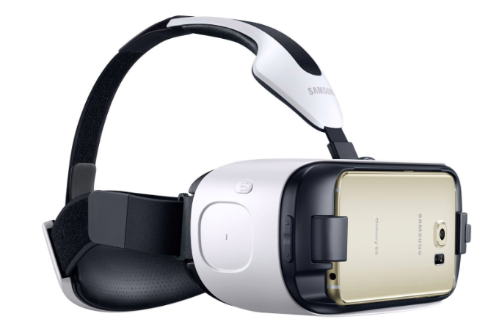
Figure 7: The Oculus Rift
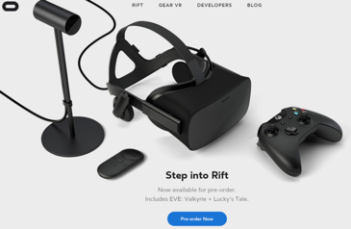
Figure 8: The Gear VR
With better popularity and lower costs, Mobile VR is more convenient for Huawei Technology to develop as a toy for kids.
2.1.5 Application of virtual reality headset
A great deal of previous research has been conducted on applications of virtual reality. The wide range of applications on VR Headset is one of the reasons why it’s so popular and brought so much attention in both past and present. Basically, virtual reality can be applied to any area where computers are involved (Gonçalves, 2013). This section, simply presents some areas where VR can be applied on, then it will focus on the video-gaming industry and toys industry.
- Medical treatment.
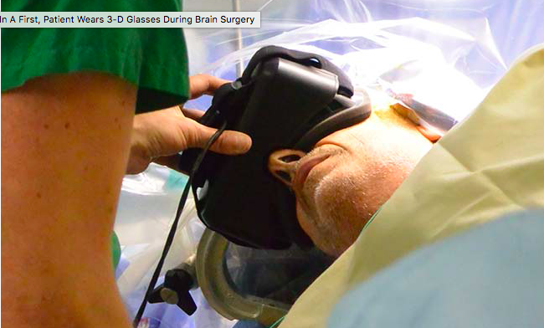
Mazuryk and Gervautz (1996) pointed out that VR Headset can be utilized in tele-operating, meaning that VR Headset can be a technology that allows people to operate in remote environments (p.11). In 2016, this hypothesis has been brought into reality already. Tango (2016) from Discovery News undergoing a brain surgery while wearing a VR headset, in the meantime, a doctor is tele-operating through VR to remove a tumor for him ( shown in Figure 10).
Figure 9: A patient wearing VR while a
doctor is operating remotely (Tango, 2016)

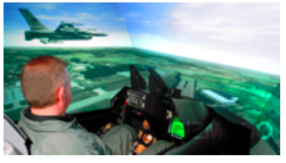
- Education and training.
VR Headset can be used in various training program, as it can simulate the real environments for the trainees. Such as flight simulators (shown in Figure 11) for a pilots and surgeries for doctors (Gonçalves, 2013).
Figure 10: A pilot in a military flight simulator (Gonçalves, 2013).

- Video-gaming and toys
Previous research mentioned that the virtual reality headsets can be a new way of presentation for digital games because digital game and VR share many similar characteristics, for example, both of them focus on achievement (Bouvier, 2008). In fact, it is the virtual reality game and hardware developer Oculus’s Oculus Rift that brought VR back to attention. Originally presented on Kickstarter as a gaming device, it is clear that the main market targeted is the gamers. Previously mentioned in Section 2.1.2, virtual reality has a long history in application for entertainment industries. Overall, the evidence presented in this section reveals that VR Headset has a prominent impact on video-gaming industry.

2.1.5 VR’s potential with kids and teenagers
An online survey has been conducted by a research agency called Touch Stone Research (2016) that located in the US. All the 500 participants who include in this research age from 10 to 17. Designers designed this research to test teenagers’ reactions toward Virtual Reality Technology. Respondents in this survey were enquired their opinions about virtual reality technology and immersive technologies. The results of this research is very promising: 79% of respondents said that they have heard of virtual reality, 68% of them revealed an understanding of this technology, 46% probed know “some/a lot” about VR. Furthermore, 37% of teenagers showed that they know about Samsung Gear VR, whereas 27% of them knew about Mattel’s View Master. After video exposure to the current state of virtual reality, 88% of kids and teens said “it was very cool/ off the charts cool”, 80% of respondents are “very/really, really excited” about the things they might be able to do. Furthermore, top picks for things this age group want to do with VR headset:
- Visit another country virtually (64%)
- Explore a place they could not go to in reality (64%)
- Go on an adventure (62%)
- Going to a virtual amusement park (62%)
- Visit a fantasy-world (61%)
- Traveling back in time virtually (58%)
Huawei has been acting as a toy company that target to kids and teenagers for more than 15 years. Although turning to VR headset is a good business opportunity for them, due to their existing statue of toy exporter, it might be good to keep their existing target group: kids and teens.

2.1.6 Manufacturing / research power of virtual reality headset in China
There are already dozens of Chinese companies working on VR hardware, 360degree content/games, and mobile VR. Leading companies in China in this field are: DeePoon, 3 Glasses, AntVR and Baofeng. Those companies are providing a range of products and platforms with prices starting under 200RMB (around 30 euros). Although their selling price is not high, their online applications still have very limited choices, only few games and travelling experience are available.
This has very important insights to Huawei: as long as there are companies are selling this product, there are manufacturers are making them. If the costs of research& development of the product and software too high, it is also fine to turn to existing manufacturers.

2.1.7 Challenges of virtual reality headset
The first challenge of VR is its side effects. Research into the side effects of VR Headset is complex and difficult. According to Costello (1997), although academic research show some symptoms occurred while using VR tools, those symptoms can only be tracked in a very short term (p.19) .
Kenney et al (1993) classified the symptoms more specifically: general discomfort, fatigue, headache, eyestrain, difficulty focusing, sweating, dizzy (eyes open), dizzy (eyes closed), stomach awareness and so on. The symptoms mentioned by Kenney can be seen as several general sicknesses that will occur during users using VR Headset. They are generalized into dizziness (eye closed) and sickness by Nichols (1999). Previous published studies are limited to the short term symptoms of VR. Whether or not there is a long term effect is very difficult to determine, partly due to the fact that VR Headsets are still constantly evolving and it has not been popularized in the market yet.
Lack of VR contents can also be another challenge of Virtual Reality industry. Although many business analysts predicted that VR will be a mainstream in near future, content creation can still be the main problem. The first reason is because of technology. Making a film or a game on VR glasses requires high-tech team and high capital investment. Furthermore, content creation requires developers to combine different knowledge and extend existing VR fields to attract more customer. The more content that’s out there, the more people will experience VR, and the more people will then purchase it (Content, 2016).
Table 3 below demonstrates the main information of VR headsets in this section.
Related topic | Keywords
Definition | - Computer graphics  - Computer simulation  - Sensory experiences  - Interactivity
History | - 1962: Sensorama  - 1965: Modern definition of VR given  - 1968: BOOM  - 1993: Sega headset
Re-rise of VR Headset | - Gaming industry
Classification of VR Headset | - HMDs (Oculus Rift)  - Mobile VR (The Gear VR)
Application of VR Headset | - Medical treatment  - Education and training  - Gaming and toy
VR’s potential with kids and teens | - Kids and teens are very likely to try it in general
Manufacturer of VR headset in China | - Existing manufacturers are making this product  - Cost price probably not high
Challenges of VR | - Physical Sickness  - Lack of content

Table 3 Summary chart to Chapter 2.1

2.2 Traditional Toy Industry
In this section, definition of traditional toy industry will firstly be addressed. Defining this term will give the researchers a clear scope and therefore beneficial for later research. Then, this section will discuss the relationship between traditional toy industry and information technology.

2.2.1 Definition of traditional toy industry
“Traditional toy industry comprises establishments primarily engaged in manufacturing complete dolls, doll parts, and doll clothes, action figures, and stuffed toys”(Ferman, 2013). However, the term can be defined in a more detailer manner: traditional toy industry should include eight product categories: infant toys, games/puzzles, activity toys, dolls, action toys, vehicles, plush toys, and ride-on, but it does not include game consoles and video games (Weber, 2005). Taken together, traditional toy industry is an industry that comprises all kinds of physical toys, but it does not include game consoles and video games.
Table 4 demonstrates the main information of traditional toy industry.
Related research | Keywords
Definition | - Infant toys  - Games/puzzles  - Activity toys  - Dolls  All kinds of physical toys but not comprise videos games and game consoles

Table 4 Summary chart to Chapter 2.2

2.3 Information technology
In order to discuss the impacts and changes of traditional toys industry and its transformation in recent years, it is important to understand the term information technology. In fact, the emergence of new technology changed many traditional industries.
Information technology can be defined as computer technology for processing and storing information, as well as communication technology (voice and data networks) for transforming information (Carol, Daniel, & Jeffrey, 2011) . Generally speaking, the term IT is very broad, it contains several layers of physical equipment (hardware) and applications (software) and so on (Carol et al., 2011). It is estimated that the VR Headset is also a product of information technology. For this project, understanding information technology is important for acquiring more insights on VR Headset and the transformation of traditional toy industry in the later chapter.
Related research | Keywords
Definition | Computer technology  Communicating technology  Several layers of physical equipment  Application  Hardware  Software  VR is a product of information technology

Table 5: Summary chart to Chapter 2.3

Chapter 3: Methodology
This chapter discusses how this research has been carried out, including how the research is designed, which methodologies are used and the rationales for choosing these methodologies.

3.1 Research designing and scope
Prior to commencing a research, a clear research structure should be established. This research was defined as a strategy designing research, therefore, strategic reasoning process (de Wit & Mayer, 2014) was chosen as the basis of the research structure as shown in figure 11. Furthermore, the strategy designed for this research focused on business and corporate level. Generally speaking, the topic of this research has a stronger inclination to the business level due to the fact that Huawei Technology is trying to extent it’s product profile and to develop new market. The research topic also belongs to the corporate level strategy because Huawei Technology has different Strategic Business Units, this research also needs to coordinate these unit, with a corporate level strategic consideration. After defining research scope, the sub-questions could be elaborated.
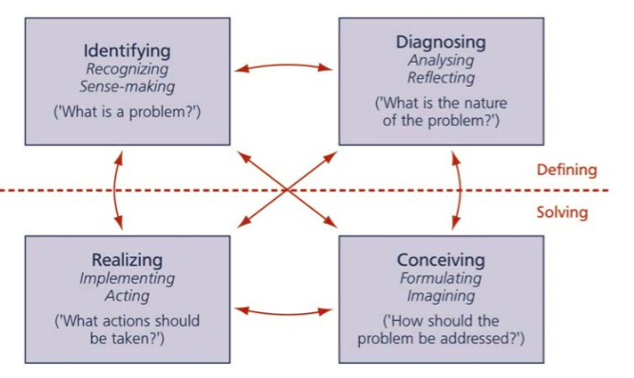
Figure 11 Strategic Reasoning Process (de Wit & Mayer, 2014)

3.2 Research structure
The research structure is developed to illustrate the relationship between the elements discussed in the literature review and the whole research. For the problem statement “What is the best internationalization strategy for Huawei Technology Group to develop its Virtual Reality Headset business from China to the Netherlands?” the research structure can be design as follows.
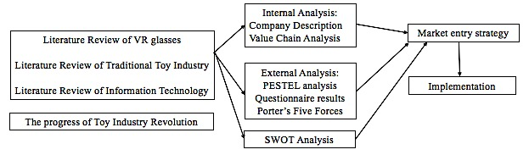
Figure 12 Research structure by the author

3.3 Research methodology
The first step of the strategic reasoning process is to understand the problem, so the methodologies to collect data for sub-questions were designed as follows.
-How other traditional toy companies reacted toward VR headset and how do they transfer their business strategies considering the impact of information technology?
Desk researches and case studies were mainly used to consult how other traditional toy companies (LEGO and Mattel) reacted when facing changes in information technology. For example, business reports from Harvard Business Review and Forbes were adopted and studied. Here, the term VR headset and related terminologies were also collected from journals and other academic sources. A case-study approach is considered as an appropriate research strategy for this sub-question to investigate some famous traditional toy companies, thus the annual reports of big toy companies were also used. Analyzing their transformation allows a deeper insight for Huawei Technology.

-Can Huawei’s existing business recourses be utilized to sell VR headset? To what extents are those recourses can be helpful?
In order to gain a detailed understanding of Huawei’s internal situation, this research conducted interviews. Firstly, several interviewees from Research& Development department and Human Resource Department were liaised to obtain further in-depth information. Afterwards, Huawei’s business scope and company situation were also analyzed via multiple information sources such as annual report.
-What are the current Dutch industry situation for VR Headset?
Questionnaires were designed to estimate the size of Dutch VR headset’s potential market. Criteria for selecting the subjects were as follows: 1) Teenagers that age from 10 to 20; 2) Parents who have kids aging from 10 to 20. The reason for narrowing the target customers to the above two groups is because the Mobile VR glasses that designed by Huawei will have educational and entertainment functions. The product will mainly be used by teenagers.
-What is the best market entry strategy for Huawei?
To establish the best market entry strategy for Huawei, different entry strategies were discussed based on previous research, interviews and questionnaire results.

3.4 Data sources
- Literature Review: The relevant academic literature on virtual reality were studied in this research.
- Printed sources: This study mainly employed theories from various academic sources to guide the research. For example, to review books for theory frameworks including “market entry strategy”, “Porter’s Five Forces”, “SWOT analysis” and “Confrontation Matrix”.
- Online resources: Reputable business magazines such as Harvard Business Review & Forbes were chosen to obtain the latest news on VR headset and to capture the latest trends of VR industry.
- Questionnaires: As it has been mentioned above, only two group of subjects were included in this survey. The questionnaires were designed on Qualtrics Website with filter questions to filter out all the irrelevant respondents. Then the responses are forwarded to Amazon’s Mechanical Turk Website to gather questionnaire results, with a location restriction set on the Netherlands. Each respondent will receive 10 cents when they finish the questionnaire.
- Interviews: Four interviewees were interviewed in this research including one VR expert and three interviewees from Huawei. The VR expert mainly provide generic opinion about the industry and evaluate the difficulties for Huawei to sell VR glasses. Three interviewees from Huawei mainly provide the information to conduct the internal analysis and the value chain analysis.

3.5 Limitation of this research
- Literatures Review
The fast changing nature of VR industry created a difficulty while doing the literature review. During the composition of this paper, there has already been a lot of changes on the technology development. Even though the previous researchers concluded that the use of VR equipment might elicit, some of the researches were conducted in the 1990s. There is not adequate research done to investigate VR based on today’s technology.
- Questionnaire results
In order to reach a big enough sample size efficiently, questionnaires were posted online and the responses are analyzed with online tools. However, this method created an unbalance demographic of respondents. A total of 223 valid results were received but there were only 27 teenagers, 133 fathers and 63 mothers. The mix of respondents does not represent the actual mix of the target groups. As a paid survey, inaccuracy may arise because the paid respondents may not produce authentic answers. Although the casual relationship between payment and the authenticity is not established, it remains as a limitation to the reliability of this research.
- Interviews
There are two limitations presented in the interviews. The first one is subjectivity. As the VR glasses proposed by Huawei is not yet realized, the interview materials are based on assumptions and estimations. These assumptions may be subjective and/or overly-optimistic or pessimistic. The second one is authenticity. Chinese tend to view the capability of their organization as a confidential information, the answers regarding the capability of their company is generally vague.
Related topic | Key information
Research designing | Follow the Strategic Reasoning Process.
Research structure | Systematically clarify the research and organize the relationships between chapter.
Research scope | Huawei’s business and corporate level strategy designing
Main methodologies | Desk researches/Case studies/ Interviews/ Questionnaires
Limitations | - VR is a rapidly changing technology  - The backgrounds of questionnaire respondents are unbalanced.  - Interviews might not objective enough.
Table 6 Summary chart to Methodology and Conceptual Model

Chapter 4: The Progress of Toy Industry Revolution
This chapter begins with the overall picture of how traditional toy industry is being revolted by electronic gadgets, then it continues to discuss the corporate transformation of Mattel and LEGO Group. It would also describe View-Master that developed by Mattel to enrich the discussion. Finally, this chapter ends with the insights that can above information provide to Huawei.

4.1 Overall picture
Many researchers agreed on the fact that those “small, connected products” such as iPad and VR headset are offering an expanding business opportunity to many traditional industries (Porter & Heppelman, 2015).
In toys and video-gaming industry, this tendency even more apparent. People believed that the digital world is replacing the physical, “real” world, especially when researcher had revealed that kids now prefer digital to physical play experiences as early as the age of six (Samuel, 2016). This phenomenon on one hand causes several traditional toy companies’ net sales to decline, while on the other hand, forces toy companies to accelerate their adoptions to the latest technologies (Samuel, 2016).
Despite losses in several traditional companies at the end of 2015, the turnover of the whole toy industry is still very optimistic. 2015 is the strongest year in at least a decade in U.S. for the industry (Benitez-Eves, 2016) . The president of Toy Industry Association said:
“We are seeing a burst of creativity and innovation among toymakers, it is inspiring to see so many companies finding inventive ways to be relevant to toy’s digital natives while also providing kids with classic play experiences that nurture imaginations, encourage experimentation and promote physical activity”(Benitez-Eves, 2016).
Therefore, it is reasonable to believe that the innovation of traditional toy industry is undergoing and is dramatically changing the industry.
Regarding to the innovation of the toy industry, business analysts had already been discussing that the combination of the traditional toys and the virtual reality world would be a very good opportunity for traditional toy industry back in few years ago (Gottlieb, 2008). Gottlieb (2008) proposed a fresh business model by that time: traditional toy companies to sell the physical toy at cost or at a very low margin and to make their profit in the aftermarket with subscriptions in the virtual worlds. Similar strategy has been adopted by one of the video-gaming giant Sony, to sell their signature PlayStation at cost, or even at a loss, in hope of populating the console and profiting from the sales of games afterwards. He also predicted that the traditional toy industry might not only move into that gap between traditional and virtual entertainment, but also have possibility to finally take over the virtual entertainment industry. In fact, the business model Gottlieb mentioned in 2008 is what Mattel is currently doing with their VR headset. He also predicted that the traditional toy industry might not only bridge the gap between traditional and virtual entertainment, but also be able to take over the virtual entertainment industry. In fact, this business model, mentioned by Gottlieb in 2008, is what Mattel using to sell with their VR headset now.

4.2 Mattel Inc. and LEGO group’s transformation
In the year of 2014, Mattel’s net sales declined approximately 7% according to it’s annual report (Sinclair, 2014), and its earning per share declined from $2.57 in 2013 to $1.45 in 2014, a 43.5% decrease. In its annual report, the chairman and CEO Sinclair indicated that this situation is partly due to the lack of consistent innovation across their product portfolio. The doll category, which accounted for about 40% of Mattel’s total business, did not have any growth in 2014. The success of Disney’s Frozen franchise gained a massive part of the market share and became a huge competitor to Mattel’s Barbie. Mattel has reacted swiftly to combat with the situation, as being highlighted in Mattel’s 2015 annual report beginning with the sentence “2015 was a year of transformation of Mattel” (Sinclair, 2015). In 2014, Mattel has been aware of their lack of innovation, and it has corrected it by “resetting” their relationship with Disney by awarding license renewals of several films. What is interesting to mention is that Mattel’s 2015 annual report also described that it had decided to team up with Google and launch a new toy “VR headset”, called the “View-Master”.
Unlike Mattel, LEGO group still maintained a rate of double sales growth, even in 2014 the traditional toy market in most countries grew by very low rates (LEGO, 2014). LEGO Group said that their sales growth in 2014 was largely attributable to their innovation. For example, the significant contribution from THE LEGO MOVIE product line.
As mentioned in section 4.2, in order to be more innovative and to earn market share, Mattel teams up with Google to produce “View-Master” toy (in figure 13) for kids and teens. This can be seen as a tech gadget that is designed for “tech-savvy” parents and is suitable for kids aged 7 or above. This product should be included into the Mobile VR category; the things peculiar with “View-Master” is that this product is designed for kids to explore different landscapes rather than pure playing. This tech gadget, is available in Amazon, Toy “R” Us and Walmart store for US$30 and has received acclaim on sales figures (Weber, 2016). This is not an Oculus Rift, but only a toy.
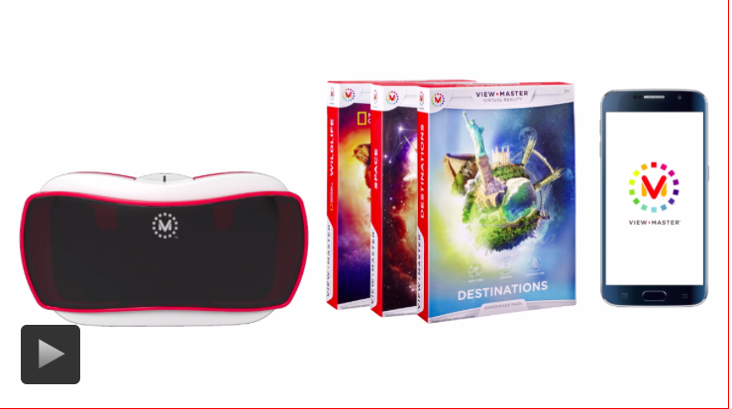
Figure 13: View-Master by Mattel (Weber, 2016)
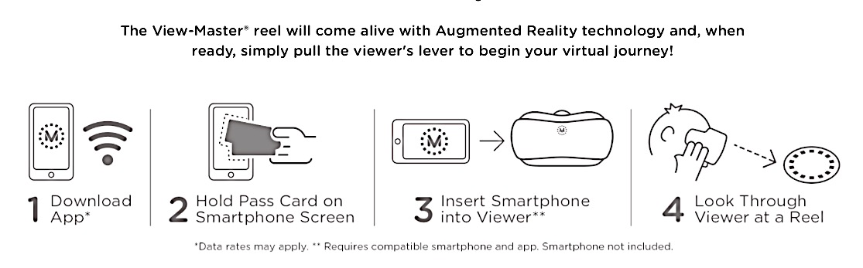
Figure 14: View-Master set up procedure by Mattel (Mattel, 2016)
However, as shown in figure 14, it seems a bit difficult for users to set up. The first step is to download Apps from the App store, then the users need to hold pass cards (included in the package of View-Master) on Smartphone Screen to scan it. After scanning, users need to insert their smartphones into the Viewer. Lastly, the kids can look through viewer at a Reel.
This set-up process is long and complex, as the kids need Pass Card, Reels, and a specialized App to play. It it important to notice that the original toy only comes with 1 “destination” (the Reel), while they can buy extra Reels from Mattel to explore more “destinations”. As mentioned in 4.1, this business model is exactly the same with what analyst Gottlieb described in 2008: traditional toy companies to sell the physical toy at cost and to make their profit in the aftermarket with subscriptions in the virtual worlds.

4.3 Insights to Huawei
View-Master’s business model is vital for Huawei: If Huawei can sell Mobile VR glasses as a toy to the Netherlands at cost, then earn profits in the aftermarket by developing related apps and software support, the operation can be both profitable and competitive. It is noticeable that as an alternative for Huawei, they can cooperate with other existing VR glasses companies mentioned in Literature Review to reduce the long set-up process (in contrast with Mittle’s View-Master) and improve the user experience.

Chapter 5: Internal analysis of the company
In this part, the internal analysis of the company will be presented based on the interviews and desk research results (mainly annual report of Huawei). In order to conduct this internal analysis, four interviewees were chosen. 1). The CEO of Huawei Technology had a brief and short conversation with the author, this brief conversation mainly focused on the transformation of toy industry and strategic adjustment of Huawei in recent years. 2). One VR expert had a detailed and long interview with the author. This interview mainly provided technical guidance about producing and researching VR glasses’ hardware and software. For example, is a digital game company able to produce VR software and what will be their obstacles and so on. 3). The author also interviewed Research and Development vice manager Mr. Ma in Huawei, who owns several patents on toys and has been working for the company for more than 15 years. Mr. Ma mainly gave information on technology development for the company in overall and predict how much will it cost to research and develop VR glasses and so on. 4). Human resource manager in Shenzhen office, Ms. Xu was interviewed to give her opinions on human resource management and current hiring situation and obstacles.

5.1 Description of the company
Huawei Technology, founded in 1997 with total capital of 455,364,000 euros, has been honored with multiple awards by the Chinese government, including “Well-known trademarks in China”, “Famous brand in China” and “Exemption from inspection of export”. Huawei’s factory has more than 3000 employees and more than 35 operating production lines operating. Based on the “Factsheet on well-known trademarks in China” that published by the Foreign & Commonwealth Office of the UK government (2013), well-known trademarks in China can enjoy multi-class protection in the Chinese trade mark system as well as protection for the company in the global marketplace. “Well-known trademark” is a legal concept worldwide and companies normally have to go through detailer scrutiny to gain such title. MBA Lib (2016) also shows that both the honors of “Well-known trademarks”, “Famous brand in China” and “exemption from inspection of export” represent a very high distinction and such brands are well recognized by the public.
Figure 15 Huawei Technology’s Industrial park (Huawei, 2015)
Huawei started as a toy manufacturer in 1997, named Huawei Toys, its main business was to produce toys and export them to the United States, Europe, Middle-East and some other regions. From the 1980s, China’s emergence as a manufacturing powerhouse has been very astonishing to the rest of the world (Eloot, Huang, & Lehnich, 2013). During that period of time, many manufacturers were built in Shenzhen because of excellent government policies. Utilizing the favorable business environment and rigorous societal transformation, these companies achieved skyrocketing turnover and astonishing high volume of revenue. Huawei is one of them. Now, Huawei’s factory is located in Shenzhen. Shenzhen is a city where has hundreds and thousands electronic companies. Based on the information that has been given by one interviewee, the company works well with other electronic companies.
On November 14th of 2010, the company stock has been successfully listed on the Shenzhen Stock Exchange. It is traded under the abbreviation Huawei Culture, and the security code is 002502.
Figure 16 Huawei’s key business transformation by the author
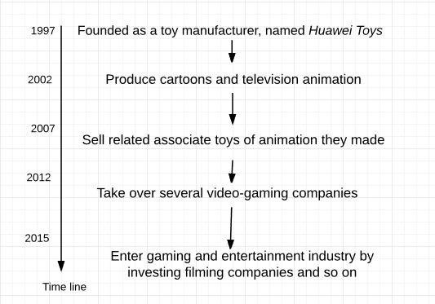
Figure 16 showed several key business transformation of Huawei. Starting as a toy-maker in Shenzhen, like most of its peers during that period, they mainly focus on B-to-B This enabled Huawei to establish strong and stable distributional channels overseas. During 2002 to 2007, the company was renamed to Huawei Technology. After that, CEO Jacky Guo has been award of the emergence of new animating technology, thus he attempted to make cartoons and sell associated toy products. Currently, Huawei has five main toy series, including smart toys, plastic toys, model toys, cartoon toys and other toys. Besides, Huawei also acquired several video-gaming companies and invested into film companies as the company has aimed to develop cultural industry business.
Figure 17: How turnover divided (Huawei, 2015)
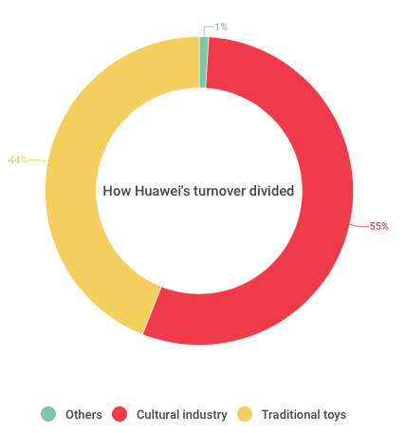

5.2 Current business scope and Finance
Figure 18: Huawei’s current business scope (Huawei, 2015)
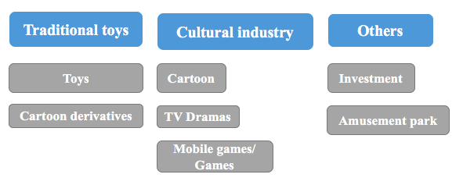

Huawei’s current business scope can mainly be divided into three parts: (1) traditional toys, (2) cultural industry production and (3) venture investment. (1) Traditional toys component includes its conventional business activities: producing, selling toys and cartoon derivatives in both China and overseas. The second part (2) cultural industry production includes the new business mediums such as Mobile games, video games, TV Drama productions and online marketing. The third part venture investment owns several companies, and try to solicit and acquire new businesses to create synergy to other parts of the company.
Traditional toy selling: |  | 35,325,115 euros
Cultural industry that consists of gaming, cartons and TV drams: |  | 43,868,092 euros
Others that consists investment and amusement park: |  | 433, 348 euros
According on Huawei’s annual report (2015), Huawei’s turnover in 2015 is divided in several segments. There segments refer to the different catalogues that they operate in. As shown in the figure 7 below, Huawei’s three main businesses components generate different turnovers. Traditional toy business is still their biggest business. Besides, through many years, cultural industry’s turn over is growing. Investment venturing only contributes 1% of turnover.
Table 7 Turnover of Huawei

5.3 Value chain analysis
A value chain is a set of activities that a firm operating in a specific industry in order to deliver a product or service for the market. Value chain consists of primary activities and support activities. Primary activities refer to inbound logistics, operations, outbound logistics, marketing and sales and service. Secondary activities consist procurement, human resources management, technological development and firm infrastructure (Veldman, 2014). Value chain analysis (VCA) is a strategic tool used to analyze value chain activities of a company. This section will analyze and evaluate the value creation activities of VR headset for Huawei with the use of of VCA and benchmarking. The use of this tool will help to measure the quality of diverse value creation activities, which is of significant importance to decide the market entry strategy. Figure below show the evaluation ranking system:
- Green stands for strong, meaning Huawei has a very strong capability on this value creation activity.
- Yellow stands for middle, meaning that this capability is average.
- Red stands for weak. Besides, between strong and middle will be shown in green and yellow, between middle and weak will be shown in yellow and red.
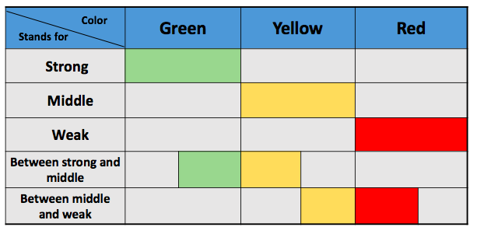

Figure 19: Evaluation ranking system by the author
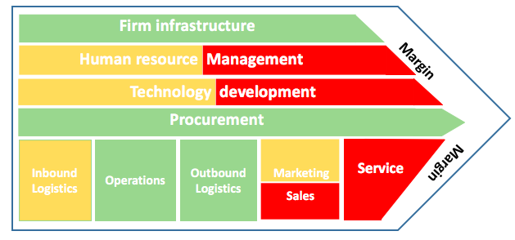

Figure 20: Value Chain analysis results by the author

- Firm Infrastructure
Based on Veldman (2014), firm infrastructure of a company is of significant importance since it supports entire value chain of a company (p.75). The infrastructure consists of a number of activities such as general management, planning, financial control, accountancy, governmental issues, legislation and quality management. Since Huawei a relatively long history and the company stock has been listed in stock market for 6 years, it can be seen as a mature listed company with a stable financial outlook and an organized firm infrastructure. This favorable factor might enable Huawei to support the new product development. Thus, as a part of the support activities, firm infrastructure can be ranked as “good” in the value chain.
- Human resource management
Huawei has several subsidiaries all over China, including Beijing, Shanghai, Hong Kong and Shenzhen. Among these regions, Huawei located its factory and technology center in Shenzhen due to the favorable policies and business environment there (Guo, 2016). For a prolonged period of time, the factory itself works as the sales office, the export office and manufacturing plant. Offices in Hong Kong, Beijing and Shanghai work together to achieve different business objectives such as technology development, distribution, investment and other ad hoc business activities. Different components can generally coordinate smoothly, and the personnel among different subsidies can always be coordinated. Overall, these symbolize that the company has an organized human resource management system. Based on the interview with HR manager Xu, who works in the company for 5 years, the company has a very organized and coherent system for recruiting high-caliber employees and training them. However, Xu’s personal opinion is that although a coherent and smooth system for human resources exists, the company is not attractive enough to highly skilled talents in the field of VR at current stage. She said that the company wanted to build a game developing team to develop games in the year of 2014, when the human resource department had enough financial supports to pay the game developers enough salaries. The company hired several game developers but eventually failed to build a complete team because many game developers thought they would not have a good career path in Huawei because the company is not specialized in games. Therefore, the company decided to take over several video-game companies and this action created much better margins. Secondly, Xu indicated that human resources department has very limited influence in the culture of Chinese companies, so her opinions might be not very valued when it comes to the strategic level.
To conclude, Huawei has an organized human resource system overall. Although it might be difficult for them to recruit related R&D personnel particularly for the VR headsets at this stage, their existing business functions can still formulate regular production, selling and distribution activities. Under such circumstance, Huawei’s human resource management can be seen as between “middle” to “bad” to support the development of VR headset.
- Technology development
China has transformed itself by producing and selling them to overseas buyers, this “Factory of Asia” now manufactures almost half of the world’s goods. Hundreds of thousands of companies earned substantial profit as a manufacturer (Derek, 2015). However, the latest report that published by Inman (2016 ) on the newspaper Guardian indicated that China’s factories have faced a broad decline in manufacturing as demand across Europe and the US remained minimal. However, Guo, CEO of Huawei Technology, said that he has foreseen this tendency years ago. He led the company into cultural industry, video gaming, investing as well as several new technologies to retaliate the shrinking demand. Nowadays, Huawei has also invested in robots and drones as toys. they have around 80 employees working there. With Huawei’s previous research and development history, which have earned them several awards by the local government, and ownerships many patents on toy making field, it is fair to say that the company is transforming rapidly and being ready for new technologies from the strategic level. However, it is noticeable that the company is relatively new to advanced technology and the lack of high-skilled talents might become obstacles to their technology development. Thus, this component is ranked between middle to weak.
- Procurement
Procurement refers to the division of the inputs across primary and secondary activities. Purchased inputs include raw materials, stock, and the company’s assets, such as machinery and buildings. As Huawei Technology is a manufacturer and have been producing all kinds of toys for years and being in the “factory of the world” China, it has all kinds of resources available for producing and manufacturing. The raw material for making VR headset hardware will not be hard to source if the R&D research is ready. Thus, this component ranked as “good”.
- Inbound logistics
Inbound logistics refers to all the activities that linked to receiving, storing and distributing inputs for the product (Veldman, 2014). In terms of VR headsets productions, this includes processing materials of VR, storage of the raw material, storage control, arranging logistics and returning unaccepted goods to suppliers. The inbound logistics includes both hardware and software of the VR headsets. On one hand, Huawei has the experience and the network of sourcing high-tech hardware, therefore inbound logistics of hardware is familiar to the company. On the other hand, software of VR headset can be an obstacle for Huawei. Based on the interview with computer science specialist of the company, Liu (2016), normal game production houses have skills of producing VR games. However, the cost and time needed to make VR games will be multiplied comparing with producing normal video games. Huawei has taken over several video-game production houses to enhance its software R&D capabilities, but it takes time and effort to synchronize multiple houses to deliver expected performance. Thus, this component is ranked as “middle”.
- Operations
Operations refer to the activities turning raw materials into finished products, including processing, assembling, packaging, maintaining machines and other business operations. As discussed in the procurement section, the years of experience as a manufacturer gave Huawei the capability and the know how of operating smoothly. Thus, this component is ranked as “good”.
- Marketing and sales
Huawei’s biggest customer in Europe is Giochi Preziosi in Italy, who have been collaborating with the company for 27 years (Lin, 2016). The business between them are mainly toys’ Original Equipment Manufacturing (OEM). In the meantime, Huawei acts as an agent for Giochi Preziosi when they are buying other factories’ products from China and overseas. Besides, Huawei also has several small trading partners in Europe other than Giochi Preziosi, but they do not have any trading partners in the Netherlands yet. Conducting B-to-B business and maintaining good business relationship with their buyers are some of the strengths of Huawei. However, VR headsets, being a very new product, Huawei’s traditional business partners may have hesitation while purchasing, which makes the selling difficult. Therefore, the Marketing and sales component is ranked from “middle” to “bad”.
- Service
After-sales service will be very difficult for Huawei to perform since the company is located in China, being remote from Europe. The service of after-sell can only be provided by collaborating with their distributors in Europe. However, Huawei has only worked with toy companies in Europe before, and they might not have adequate knowledge on electronic products such as VR glasses. Thus, the choice of the business partner must be careful to make sure they have sufficient technical knowledge on VR headsets. Therefore, this part is the hardest component in Huawei’s whole value creation, ranking as “weak”.

5.4 Strengths and weaknesses
Strengths:
- Huawei has relatively stable firm infrastructure, internal operation system and financial background to support new product development.
- Huawei has sufficient experiences to support selling to overseas. As an experienced manufacturer, it has good experiences on exporting and selling to foreign destinations.
- Maintaining good business relationship with its business partner. Huawei has its biggest distributor in Italy, but it has no distributor in the Netherlands, this can to a certain extent support Huawei to sell VR glasses as toys in Dutch market and the whole Europe.
- Huawei has digital game companies, based on the VR expert, it is easier for a digital game company to produce VR software.
- Huawei has experiences to make educational toys and games. It has more experiences and advantages on knowing and observing kids and teens’ preferences and market than electronic companies.
- Due to its location and better connection to other digital companies in Shenzhen, the costs of outsourcing can be lower.
Weaknesses:
- Weak technology development. It is still difficult for Huawei to research and develop VR glasses hardware in a short time period.
- The lack of abilities to attract high-tech personnel to support the research and development process on VR glasses in a short time period.
- Lack of experiences on producing intelligent products can be a very critical weakness of Huawei. Furthermore, they do not have enough information and knowledge for providing after-sale services on intelligent hardware products.

Chapter 6: External analysis
This chapter outlines the external factors of developing VR business to the Netherlands. This chapter consists of three parts: (6.1) PESTEL analysis, (6.2) Porter’s five forces and (6.3) analysis of potential Dutch market.

6.1 PESTEL analysis
PESTEL analysis is a fundamental tool to analyze an organization’s external macro environment, the six letters stand for Political, Economic, Socio-cultural, Technology, Legal and Environmental (Veldman, 2014). As Huawei is going to market their VR headset to the Netherlands, the macro PESTEL environment should be the related business environment of the Netherlands.

6.1.1 Political
Overall picture for international trade and exporting
The Dutch government is always encouraging international business. The Netherlands have entered the European Union, the World Trade Organization and other international trade bodies. Based on the Ministry of Foreign affairs (2013), an increasing number of countries are linking to the global supply chain and gaining easier access to the latest knowledge and technology. The Dutch government has strengthened the policy and budgetary coherence of foreign trade and development cooperation as well. Furthermore, in history, the Netherlands has always been a trade union and conduct all kinds of international trades. Therefore, the whole societal atmosphere and policy has encouraged exporting and international business. The fact stated above has good insights to Huawei: The Netherlands is an open-minded, business-driven nation, it encourages international trade and welcomes different trade partners all over the world. This will help the international trade activities become easier.
Policy related to import electronic products/ toys to NL
Importing to the Netherlands from other countries have different VAT rate if it is non-EU countries (Belastingdienst, 2016). The VAT rate for toys (including electronic and non-electronic) is 4.7% and the tariff code is 9530. The VAT rate for related electronic product is 5.0% and the tariff code is 8529 90 92 (Belastingdienst, 2016).

6.1.2 Economic
The main goal of analyzing economic situation of the Netherlands is to understand their overall economic situation and consumer’s buying power. This will help to get more insights of the potential market as a whole. The Netherlands is the 16th largest economy in the world and the sixth largest in the European Union (GOV.UK, 2015). The Dutch economy expected to grow by 2.4% in 2016 as the fact that both real disposable income with household consumption, demand for Dutch exports and public spending increase in 2016. Furthermore, unemployment peaked in 2014 at 7.4% whereas it is forecast to decease to 6.7% in 2016. More importantly, CBS (2016) indicated that the consumer confidence ratio has risen by 5 points by April 2016. It is important to know this because the consumer confidence ratio is related to consumer willingness to purchase. Therefore, during 2016, consumer willingness to buy also increases. For Huawei, it is important to know that their export destination has good economy and it is recovering from the previous European unemployment crisis, this fact will highly influence target group’s buying power.

6.1.3 Social-cultural
Demographic
The Netherlands has a total population of 17,000,000 by March 21, 2016 (CBS, 2016). People aged from 10 to 19 occupy 11.87% of the total population, meaning that the Netherlands has approximately 2,017,900 teenagers ages from 10 to 19 (CIA, 2015). The 2 million teenagers and their parents can be estimated as the potential target group of Huawei’s VR glasses.
An active market encourages high-tech products
Amsterdam is considered to have one of the most prominent markets in Europe. The startups in Amsterdam, bring all kinds of high-tech products to the country. In the meanwhile, foreign firms have seen interests in the Dutch market and there are 15 locally venture capital firms active in the market (Egusa & Cohen, 2015). Delft brings all kinds of high-tech innovations to the country. The Netherlands has strong traditional of entrepreneurship and nowadays are taking one step forward: encouraging to build more and more start-ups (Egusa & Cohen, 2015). From this situation, it can be observed that Dutch is a nation that embraces new business model and changes, this is an active market that encourages new things.
Cross-cultural communication
For international business, it is important to reduce communication mistakes and this will help the long-term business running between two nations. Based on the report that published on Europa (2012), 67% of European respondents think that English is the most useful language in Europe. In the meanwhile, 90% to 93% of Dutch claimed that they can use and speak English (Egusa & Cohen, 2015). Dutch people’s strong language ability can help Huawei to reduce communication costs in the future.

6.1.4 Technology
As it has been mentioned above, the Netherlands is a nation that encourages innovations and new technologies. Bert-Jan Woertman, the director at High Tech Campus Eindhoven, speaks for the country: “We continue to grow, we continue to attract talent from all over the world, and with our focus in high-tech, I think we are very well-poised for the future.” (Egusa & Cohen, 2015).

6.1.5 Legal
The Dutch government supports companies that develop innovative products through tax benefits, innovation credits and grants. Furthermore, the government wants to strengthen nine sectors’ international technical positions, one of them is high-tech products (GOV.NL, 2016). However, the government itself does not have any special tax reducing legislation toward VR glasses at current stage.

6.1.6 Environmental
There is no information found related to the topic discussed.
Topic | Keywords
Political | - Encouragements of International Business  - VAT rate for electronic products: 5%  - VAT rate for toys: 4.7%
Economic | - Economic recovering  - Consumer confidence ratio has risen by 5 points
Social-cultural | - 2 million teenagers are estimated as potential markets  - Active market that encourages high-tech
Technology | - Focus on high-tech products
Legal | - Tax benefits on innovative products.
Table 8 Summary chart to PESTEL analysis

6.2 Questionnaire results and analysis

6.2.1 Design of the questionnaire
Basic information of the questionnaire design
Main Purposes of questionnaires | - Measuring the potential market in the Netherlands.  - Compare different buying behaviors among teens and parents  - Deciding VR headset’s feature, price, promotion slogan and so on.
Target group | - Teens age from 10 to 20  - Parents who have kids age from 10 to 20
How many valid | - 223 valid outcomes
Questionnaires, in both English and Dutch, were designed and distributed to Dutch customers. The questionnaires aimed to measure the potential market size in the Netherlands and provide insight on the VR headset’s features, price, promotion slogan and so on. The product, Mobile VR, is intended to be sold to teens aging from 10-20 and their parents. In order to do so, three filer questions about ages and whether they have kids aged from 10-20 were set up at the beginning of questionnaire to make sure the adopted results are coming from respondents belonging into the two targeted groups. As a result, 223 valid responses are received amongst 652 online questionnaires distributed. This section will report key findings based on the questionnaire results. This will help further discussion on the market potential, buying power, market entry strategies and market implementations.
Table 9 Summary chart to Questionnaire designing

6.2.2 Findings of the questionnaire
Who are the respondents?
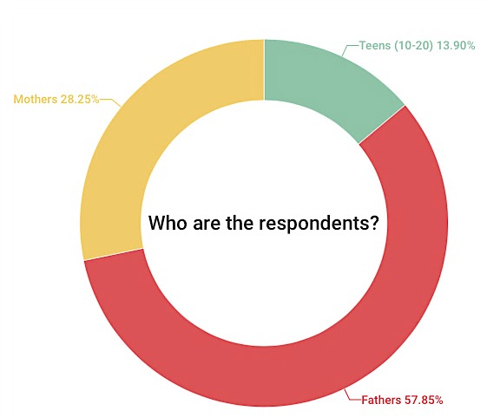
By the end of the survey period, data had been collected from 223 individuals, 27 (13.9%) of whom were teens (10-20) and 196 people were parents. Among those parents, 129 (57.9%) of them were fathers and only 63 (28.3%) of them were mothers.
Figure 21: Who are the respondents?
How often do you or your parents purchase toys?
In response to this question, 13 out of 27 (70%) teenagers and 92 out of 196 (46%) parents indicated that they purchase toys once a month. To sum up, the majority of those (both teens and parents) who responded to this question indicated that they buy toys once a month.
How much do you or your parents spend on toys per month?
When the parents and teens were asked how much they spent on toys per month on average, the results were slightly different between those two groups.
Figure 22: How much do you or your parents spend on toys per month?
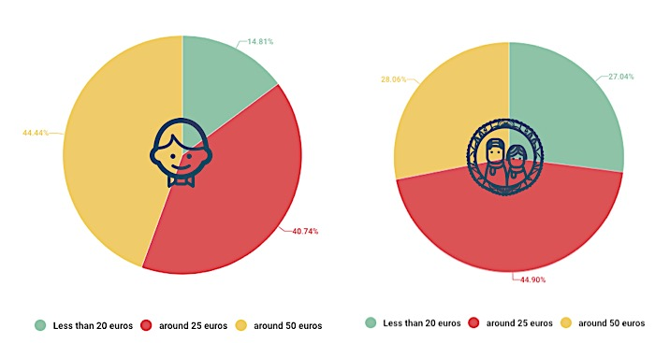

The buying behavior between parents and teens is one of the most insightful information. As it has been showed in above pie charts, 44% of teens (12 out of 27) spent on toys around 50 euros per month. However, 88 out of 196 (44%) parents said that they spent around 25 euros per month.
What are your considerations when you are buying tech gadgets?
Respondents were asked to indicate the factors they consider when they are buying a tech gadget. As it can be shown in blow pie chart, out of the 27 teenagers who responded to this question, 64% (18) teenagers ranked entertainment functions as their first consideration. Nevertheless, 40% of parents ranked education functions as their priority when they buy tech a gadget. Besides, the other factors ranked as the most important in Dutch market when buying tech gadgets are as follows (in descending order of popularity): entertainment functions (63 people ranked it as first), good for eyes (45 people ranked it as first). The findings based on questionnaires revealed the underlying consumer desire on education functions when it comes to purchasing a tech gadget among parents. Among teenagers, entertainment function is still the most important one.
Figure 23 What are your considerations when you are buying tech gadgets?

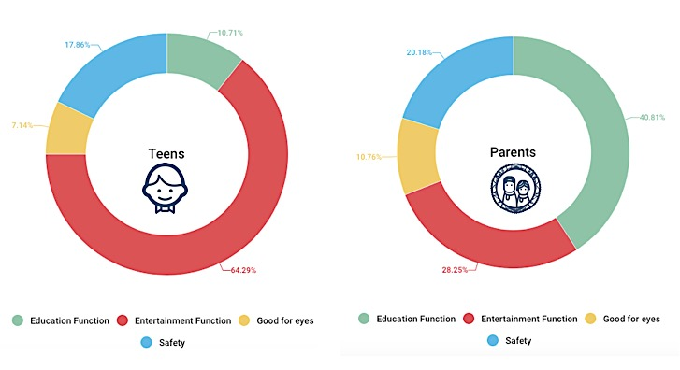
How many customers ranked this function as number 1?

What do you think about tech gadgets?
In this question, respondents were asked to give their opinions on tech gadgets. In response to “to what extent do you agree on below statements?”, most of those surveyed indicated on the imaginations”. On the contrary, only 17 out of 223 agreed on the statement “Tech gadgets can be very harmful for people’s health”. However, it is found that there are 13 out of 17 respondents answered that they have never brought any tech gadgets before, therefore it is unlikely necessary to analyze their buying behaviors further. Moreover, only a small number of respondents illustrated that they have not brought any tech gadgets before. Above results showed a clear distinguish between those two groups as it can be seen in Figure Y. Overall, this outcome illustrated that Dutch people’s advanced mentality on tech gadgets. In fact, this finding echoes with the conclusions drawn in PESTEL section: The Netherlands is a country that is willing to embrace new business model and changes. Dutch market is an active market that welcomes new and innovative products.
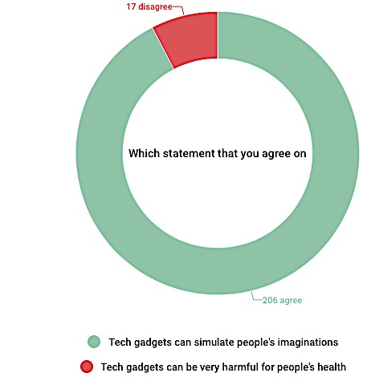
Figure 24 Which statement that you agree on?

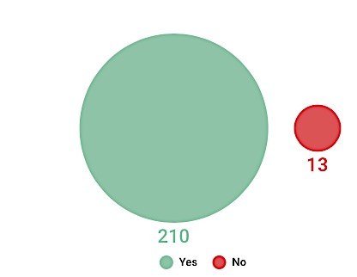
Figure 25 Have you brought tech gadgets before?
Would you be interested in VR glasses with educational functions?
This section of the questionnaire required respondents to give their opinions on VR glasses, thus the product description was being given at the beginning:
Imagine that there is a VR headset designed for people aged from 10 to 20. You can put your mobile into the device and download various applications on mobile that specially made for people aged from 10 to 20. However, when you buy the VR glasses, you will only get three free applications on it, including one game, one space exploration journey and one educational tutorial on the language course.
For extra applications, you need to pay for them. Some apps can be used for exploring the stars, landscape all over the world, some apps can be used to play more complicated educational games such as counting, learning different languages and so on.
This product can encourage kids and teens to gain interests of learning diverse knowledge files (i.e. Geography).
The first was designed after the description of the VR glasses: Would you be interested in such a VR headset? In response to this question, data showed that Dutch people have strong interests on VR headset: nearly 92% of respondents agreed that they are “interested in VR glasses with educational and entertainment functions, and want to try it”. The overall response to the interests on VR glasses and tech gadgets were very positive.
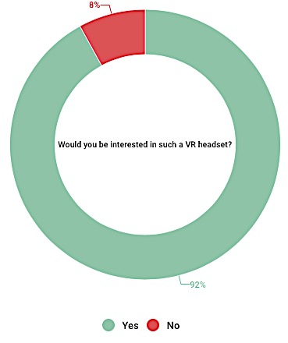

In recent years, people’s consumption habit has undergone enormous changes with the advancement of technology. Generally speaking, the questionnaire results indicated a big proportion of respondents in the Netherlands have strong interests on VR glasses.
Figure 26: Would you be interested in such a VR headset?

Would you like to buy extra applications on your mobile for the VR glasses?
When asked whether they are willing to purchase extra applications for VR glasses on mobile, 84% of the respondents reported “yes”.
What you would like to do with the VR glasses?
In response to the question “please evaluate things below that you think would be interesting to do with the VR glasses”, a range of responses was elicited. As it can be showed in figure 27, the things that Dutch people are strongly like to do with VR glasses are as follows (in descending order): travelling back in time virtually (175 out of 223 people indicated “strongly interested”), visit another country virtually with tour guide (171 respondents are strongly interested), visit museum (165) visit a fantasy world (164), playing video game/online game and watch 3D movies and TV shows. Besides, in question “please evaluate video games below that you would be interesting play with the VR glasses”, respondents are mainly interested in Action games, Virtual Worlds games and Online role-playing games.
Figure 27: Which applications that you are strongly interested in?
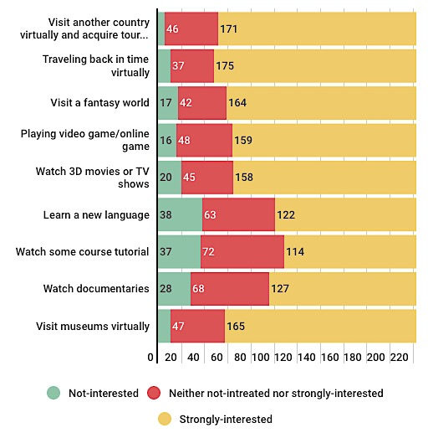
Among above data, kids and parents’ favorite applications are totally different. In order to get a closer look at those differences. Parents and kids’ favorite applications are demonstrated as below figures 28. Below Figures showed that the majority of teenagers (28) ranked paly video games as their favorite thing like to do with the VR glass, visit another country as the second thing they like to do. However, 152 parents ranked travelling back in time virtually as their priority, 146 parents think visit another country with guide and visit museums are the second things would like to do.
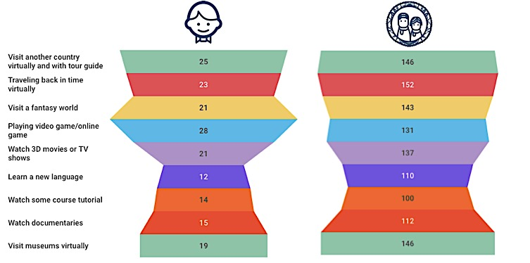
Figure 28: which application are teens and parents interested in?

How much would the respondents willing to pay for the VR glasses?
In overall, the group that willing to pay 50-60 and 41-50 are significantly more than the other groups. However, the respondents that are willing to pay 41-50 euros and 51-60 euros are roughly the same, 31% and 32% respectively.
Figure 29 below illustrates the prices that teenagers and parents are willing to pay. The pies reals that there has been a slight difference between parents and teenagers to pay 41-50 euros for the VR glasses, 30% and 37% respectively.
Figure 29: How much would the respondents willing to pay for the VR glasses?
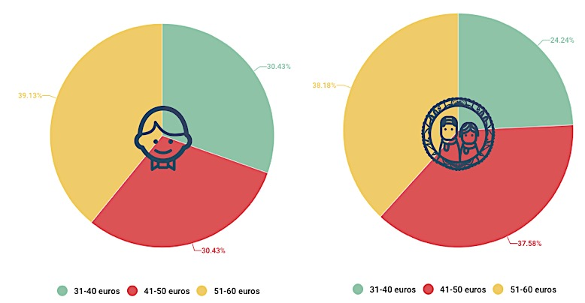

How much you would like to pay for extra applications?
The single most striking observation to emerge from the data comparison is the buying behavior between parents and teens. Parents are willing to spend more on extra applications than teens. 30% of parents are willing to spend 1.99 euros for per extra application, however, more kids (32%) reported that they are willing to pay 0.99 euros for per application.
What is the market potential in the Netherland?
Based on PESTEL analysis, the Netherlands is a wealthy but relatively small market with only 17 million people in total. There are 2 million teens in this country. However, although it is a relatively small market, as it has been mentioned above, the market potential of VR glasses within Dutch market can be very positive because the majority family spend 25-50 euros for their kids’ toys per month and 92% of participants showed their interests on VR glasses.
What is your favorite slogan?
In the question: “in your opinion, which advertisement slogan is the most attractive one?”, of the 223 participants who responded to this question, 44 of them indicated that the best advertisement is “Open your eyes- for the virtual reality education and entertainment” as shown in Figure 30. Only a small number of respondents (15%) think “Change the traditional education way-VR glasses” is a good advertisement. This question was designed to provide insight in building
Figure 30: What is your favorite slogan?
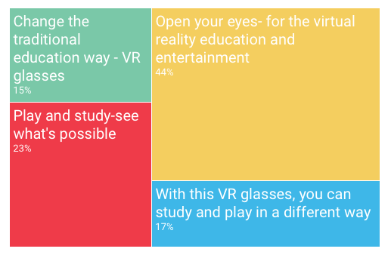
better promotion slogan in marketing campaigns and packages.
How does educational level influences customers’ choices on VR glasses?
A correlation was found between the favorite applications and the parents’ education degrees. What is interesting in this survey is that parents who hold bachelor or master degrees like the application “Travelling back in time virtually” and “Visit museums virtually” the most. Parents who does not hold bachelor degrees or above like the applications “Visit another country virtually with tour guide” the most.
What is the relationship with parents’ income and prices they are willing to pay for toys, VR glasses and extra applications?
The results of the correlational analysis between parents’ income and the prices they are willing to pay is showed in this section.
In this research, 51% of those surveyed have income around 1200 to 2000 euros per month. These group of respondents’ most favorable price for the VR glasses is 51-60 euros (40 out of 114) and most of them buy toys once a month for their kids. Besides, people willing to pay 1.99 and 2.99 euros for extra applications are 26% and 32% respectively.
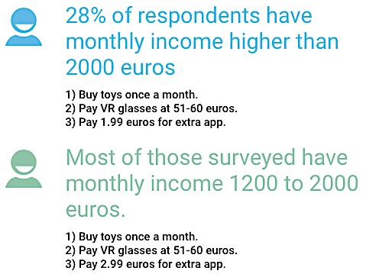
Additionally, there are 64 respondents have monthly income higher than 2000 euros, the majority of them are more likely to pay 51- 60 euros for VR glasses and purchase toys once a month for their kids. However, 21 out of them are willing to pay 1.99 euros for extra apps.
Figure 31: Relationship between income and prices willing to pay

6.2 Porter’s Five Forces
Porter’s Five Forces analysis is a useful model to identify the attractiveness of an industry or sector in terms of competitive forces (Veldman, 2014). The purpose of using this tool here is to analyze the nature of competition within the VR Headset industry in the Netherland.
The VR Headset industry hasn’t reached the booming stage of market growth yet and the existing VR products are rare in Dutch market. So, in general, rivalry among the existing competitors is relatively low. The table below represents the summarization of Porter’s five forces in analyzing VR industry in the Netherlands.
- Threat of new entrants
In order to measure entry barriers, the VR headset sector’s technology level, legislation or government action, differentiation of product are considered to be important factors. Firstly, VR headset sector requires relatively higher standards on technology level comparing with normal customer units such as physical toys. Although the government and the whole society atmosphere encourages advanced technology and new inventions, the Dutch government has no special legislation on taxation regarding VR glasses yet. Lastly, the differentiation of the products is higher than normal toys because there are not many similar VR glasses with educational functions in the Dutch market yet. On the other side, the market potential of VR glasses is booming at current stage in the Netherlands, more competitors have the possibility to come to the market. In conclusion, the entry barriers are medium, but the strong market potential encourages newcomers. Thus, “the threats of new entrant” is ranked as high.
Entry barriers: Relatively high
Technology level | Medium
Legislation or government support  Differentiation of product | Low  High

VS.
Market potential in NL High

Table 10 Summary chart: Entry barriers VS. Market potential

- Threat of substitutes
VR glasses in this paper, is discussed as a tech gadget with both educational and entertainment functions. This unique positioning of the VR headset will significantly reduce the threat of substitute. What Huawei tries to develop is a product that has educational function just like View-Master, thus the treat of substitutes will be relatively low. In fact, except iPad, there are none in sight such a tech gadget that have both education and entertainment functions in the Dutch market yet. In general, it can be ranked as “low”.
- Bargaining power of buyers
There are 2 channels of buyers with distinct characteristics, namely direct retail (B2C field) and wholesale retailer (B2B field). Resellers (B2B) such as supermarkets and online shops have strong bargaining power because this is a new product, and the uncertainty is more. Huawei has to compete with other VR glasses producers in order to get a shelf position from the purchasing department of the retailers. However, as the market potential of VR glasses is substantial and the product is differentiated, the VR Headset produced will be attractive enough for the retails to channel the product because the presence of a distinct product can benefit them with a competitive edge against other retailers in the market. Therefore, the power of buyers is ranked as “low”.
- Bargaining power of suppliers
To discuss bargaining power of suppliers, it is important to identify identify the percentage of purchased components against the percentage of self-producing components. Based on interview with Human Resource Manger from Huawei, it is difficult for them to find the proper personnel to research and develop the VR glasses hardware and to acquire the core technology by itself but it has capability to produce related software by itself. Thus it is suggested that Huawei should negotiate hardware manufacturer of VR glasses’ designing and produce it there. Although the initial costs might be higher at the beginning, when they start to conduct business with each other and sell more items, the bargaining power of hardware suppliers will reduce. Overall, the power of supplier ranked as “medium”.
- Intensity of rivalry
In today’s VR market, there are different kinds of VR headsets or equipment. There are 2 types of VR headsets: Helmet-mounted Display (HMD) and Mobile VR. HMDs require users to wear the helmet and related equipment, and a more sophisticated software. This paper was mainly narrowed to Mobile VR subject because it takes less development effort and the prices are lower.
In the current Dutch market, the rivalry between companies on VR products are not very intense. Electronic company Trust made a similar product and is currently selling it in Media Market with a price of 49.99 euros. Besides, Company Homido also sells VR headsets at a price of 59 euros. Meanwhile, other VR glasses such as one called “VR Boxes” are being sold on Cool Blue, Bol.com and several other websites at around 39 euros. Users can insert their mobile phones into “VR Boxes” and watch movies or play games on it. In general, the level of rivalry is not very intense. In conclusion, the intensity of rivalry can be ranked as middle, and there are not any dominant company in the market yet. In order to remain a good strategic position, the information about competitors’ prices and functionalities are very important for Huawei.
To sum up, there are not any dominant companies in the market yet. Although some electronic companies produced VR glasses, as VR glasses do not differ much in terms of functionality, Huawei’s product can be more competitive advantages on kids and teens’ market. Thus, the intensity of rivalry can be ranked as middle.

 |  | Main competitors ’prices of Mobile VR headset in Dutch market
Retailer shop | Brand |  | Price and picture | Main functionality | Smartphone compatibility | Install procedure
Media Market | Trust |  | 49.99 euros  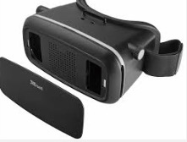 | Watch videos and play games.  Users can watch videos are posted on YouTube; users can watch them directly from their mobile.  Games need to be downloaded from App stores on the mobile.  Many kinds of Apps are available on App store.  No educational apps provided at all. | All smartphones. | 1. Install & start the YouTube app or Apps on your phone. If you want to watch movies, search for ‘3D SBS’ and choose any movie.  2. Open the front cover and insert your phone.  3. Start the movie and enjoy!  Important note: different companies’ Mobile VR glasses are actually have the same procedures.
Media Market | Homido |  | 59 euros  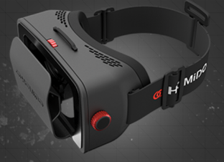 |  | Apple iPhone 6 / 6+  iPhone 5/ 5S /5C  iPhone < 5 limited  Samsung Galaxy S4/Note 3/Note 4  Nexus 4/5  Sony Xperia Z2  LG G3
Cool Blue | VR Box |  | 39 euros  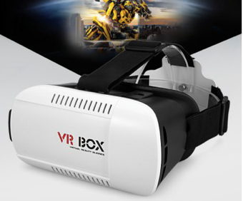 |  | 4.7 - 6 inch screen mobile phone.
Bol.com | Ritech |  | 23.71 euros  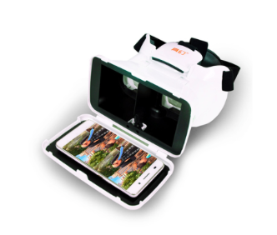 |  | Apple, Samsung, Acer, Huawei, LG, HTC, Nokia, Microsoft, Wiko, Kazam, Alcatel.
Bol.com | Muvit |  | - Euros  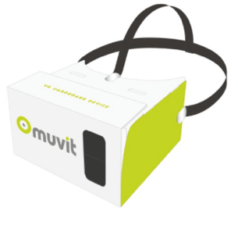
Table 11 Main competitors’ prices and functionalities

6.3 Threats and Opportunities
- Physical sickness. As the technology is not completely mature, VR glasses might induce physical sicknesses such as general discomfort, fatigue, headache, eyestrain, difficult focusing, sweating, dizziness, nausea and so on.
- Lack of software. Although VR is very promising, the current lack of software application can be an obstacle for its future development. If the hardware development outpaced software development, demand will drop because the attractiveness of VR, as an electronic gadget, is severely limited by the use of the VR Headset. It is very hard to convince customers want to buy a VR Headset just for only one or several applications.
- Fiercely intensifying rivalry. The speed of development on VR Headsets are dramatically high, thus intensifying the rivalry at the same high rate. If Huawei waits too long to announce their product, newer technologies by competitors will make Huawei’s headset obsolete in a short period of time.
Opportunities:
- Strong market potential. Survey results indicated a high percentage of people are interested in it. In the meantime, the market of VR headset is starting to grow fast and the media is focusing on it. This will help to accelerate the development and create more demands for VR glasses.
- The economy of the Netherlands is growing and consumer confidence ratio is increasing.
- The Netherlands has a good social atmosphere for high-tech products, customers are open minded to try new products.
- There are no VR glasses with educational and entertainment functions currently at Dutch market

Chapter 7: Confrontation Matrix and Strategy Designing
A confrontation matrix is a tool that to gather and further analyze the results from SWOT analysis outcome. By assigning weightings to the qualitative SWOT, it can produce relatively objectively insights. Starting with a summarization of SWOT analysis, this confrontation matrix is generated based on the most important three SWOT analysis in each component. Lastly, strategies will be designed based on SWOT analysis and the confrontation matrix.
 |  |  | Opportunities |  |  | Threats
 |  |  | O1 | O2 | O3 | T1 | T2 | T3
 |  | Figure 32: Confrontation Matrix by the author | Strong Market potential . | No VR Glasses with educational functions. | Economy and consumer confidence increase. | Physical sickness. | Lack of software. | More competitors coming.
 | S1 | Better Knows kids and teens’ preferences than digital companies. | 5 | 2
 | S2 | Lower outsourcing costs. |  |  | 1 |  |  | 5
Strengths | S3 | Better support VR software by its own digital game companies | 3 | 2 |  | 1 | 3
 | W1 | Weak technology development on VR hardware. |  | 3 |  | 5
 | W2 | Lack of ability to attract high-tech personnel. |  |  |  |  | 3
Weakness | W3 | Lack of experiences on producing intelligent products. | 5 |  | 1 |  |  | 3

Out come quadrants
Growth (S - O) |  | 13
Defend (S - T) |  | 9
Adjust(W - O) |  | 9
Retreat (W- T) |  | 11

Table 12: Outcome quadrants
 | Opportunities | Threats
Strengths | S1+O1+O2=Create a unique VR glasses with educational functions, it should target on kids and teens’ market. This product and segmentation can be differentiated from other products.  S2+O3= Increasing economy and consumer confidence ration can simulate buying, the the product is not very expensive (due to lower costs), customers might be more interested in it.  S3+O1+O2= Huawei’s own digital game companies can produce related software and applications on VR glasses to support the selling process. | S3+T1= Physical sickness is relatively hard to reduce. But if the digital companies of Huawei try to research and develop related software, they might have a solution.  S2+T3= Lower outsourcing costs can help to compete in the market, S2 can help to overcome T3.  S3+T2= Huawei’s own digital game companies can help to produce related VR games. S3 can also overcome T2.
Weaknesses | W3+Q2+Q1= Lack of experiences on producing intelligent hardware, this weakness can not be solved in a short time. Thus it is suggested Huawei outsource the hardware from other Chinese manufacturers that make VR glasses at the early stage to occupy certain market share in the Netherlands. | W1+T2= It is very difficult for Huawei to overcome this technical problem at current stage. This problem exists in the whole VR industry. Huawei needs to find a reliable factory produce their VR glasses.  W3+T3= Lack of experiences on producing intelligent hardware does not influence Huawei’s capability on producing software.
Table 13: Analysis on Confrontation Matrix

Based on the three most important strengths, weakness, opportunities and treats, above confrontation matrix were established. Growth (14) and Retreat (11) have the highest scores. This means that even though there are sizable threats and weaknesses, Huawei still has a positive edge to develop the VR glasses.
Huawei knows kids and teens’ preferences better than other digital companies, as one of their strength over other digital companies in Dutch market. Additionally, the acquired digital game companies have the capability to produce related software and applications for the VR glasses. Meanwhile, the market demands for VR glasses with entertainment and educational functions are high. By creating a niche product that takes full advantages from the toy and tech gadget industry, Huawei can enjoy a unique and profitable market positioning.
Shortfall in technology development cannot be rectified instantaneously. Thus, it is suggested that Huawei should outsource the hardware production from other Chinese manufacturers for making the hardware of VR glasses at the early stage.
It is very difficult for Huawei to overcome “Physical sickness of VR glasses” currently as this is an industry-wide issue. VR technology is under development and not yet mature enough to solve this issue. Meanwhile, resourceful toy and educational companies may have better R&D done to compete on the field of VR glasses.
Huawei can buy VR glasses’ hardware and software from other manufacturers in China at the early phrases and (1) re-package the product, (2) develop corresponding educational applications from proprietary digital game companies to enrich the product.
Huawei can also specify the applications and games developed for the VR glasses be based on the preferences of Dutch market, to have an easier marketing in the after-sales markets. This is essential if Huawei adopts View-Master’s strategy.
Changes in hardware design can render Huawei’s VR software obsolete. However, this is not a very probable risk as the real platform between the application and the user is the mobile phones. Based on Literature Review and interview with VR experts, as long as the software and applications that Huawei developed are compatible with the mobile phone, it is unlikely the hardware manufacturer would be producing incompatible VR glasses.

Chapter 8: Market entry strategies
Based on researches and analyses from previous chapters, the determinants of the entry strategy will firstly be briefly discussed. After that, various entry strategies of Huawei will be compared and discussed to identify the optimal market entry strategy.
Entry strategy describes how a company enters a new market. Which strategy fits best depend on many factors including the company’s size, business nature, international experiences and so on. Based on Veldman (2014), success in a foreign market is strongly dependent on the choice of a type of entry strategy (p.179). Pivot factors that influence the choice of entry strategies can be divided into internal and external factors as shown in figure 33 below.
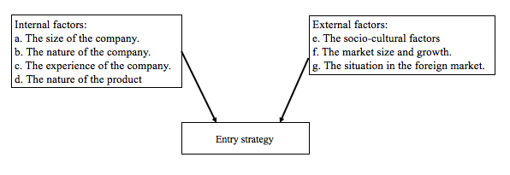
Figure 33: Factors that influence the choice of market entry strategy (Veldman, 2014)
In this section, factors from the framework above that are impacting on the entry strategy will be briefly summarized based on previous researches, interviews, questionnaire results and analyses. After that, the discussion on different entry strategies’ advantages and disadvantages with the consideration of above factors will be continued; then the market entry strategies will be ranked with the use of benchmarking.
- The size of the company: It has 3000 employees and 79,655,565 euros in turnover in the year of 2015. The company has three main business scope: Traditional toys, cultural industry and venture investments.
- The nature of the company: Huawei is a traditional Chinese manufacturer currently transforming the technological aspect to match up with the trend of VR. Huawei is at the early stage of R&D and it might take longer time and more investments. Amongst Huawei’s subsidiaries, video-gaming production houses have the ability to produce software for the VR glasses.
- The experience of the company: Huawei is experienced in selling toys overseas, but it lacks experience in producing intelligent hardware.
- The nature of the product: VR headset is a promising high-tech product. However, it also has a huge room for development.
- The socio-cultural factor: Dutch market has always encouraged new technology, therefore, people will be more likely to accept VR glasses with educational and entertainment functions with support from questionnaire results.
- The market size and growth: Dutch market is not very scaled, but people embrace new technology.
- The situation of the market: Based on the survey results and desk researches, VR glasses with educational and entertainment functions have a strong market potential. Target groups such as teenagers and their parents are very likely to be interested in this product.
The paths of success in entering a foreign market are diverse, but variety of strategies are available. After the brief summary of impacting factors that will influence the entry strategy, some possible entry strategies that relevant to this topic are discussed and evaluated below.
- Agency
Most SMEs (Small and Medium-size) companies produce export products with agents as distributors, the agents themselves do not take the ownership of goods, they only represent the suppliers in a foreign market. The revenue model for the agents is through commissions on the sales volume generated. Agents have smaller product ranges and they normally are sole proprietors or in a small scaled company (Salzano, 2014). However, the exporter needs to set up the selling price for the agent. Finding agencies might be an option for Huawei Technology. A good agent must be familiar with the sector and have sales experience with similar product so they can provide a good service. Huawei has its distributor Giochi Preziosi in Italy, one of the biggest toy trading companies in the country. Huawei might be able to enter Dutch market through its existing distributor. However, being a very new product, Giochi Preziosi might find difficulties when selling VR glasses. Moreover, finding a proper agent who has expertise on this field can be also difficult. Therefore, this option has been ranked as “middle”.
- Trading company/middleman
Trading company and middleman are the most direct and traditional ways to sell products from its home country (Veldman, 2014). This entry strategy is less risky and gives the home-based company more opportunities and time to “learn” the new market. For Huawei, exporting and finding trading companies to re-design and market the products is the most achievable way of entering the Dutch market at an early stage. The reasons for choosing trading company are stated as follow. First of all, local trading companies have more knowledge on government policies and tax regulations. The local trading companies are more likely to choose suitable retailers for Huawei. More importantly, the local market sense possessed by these local companies are more likely to brand the product successfully, based on the Dutch’s preference on VR glasses. Although Huawei has not worked with any trading partners in Dutch market yet, they had contacted several retailers in Dutch market. Figure X depicts the flow of export Huawei:
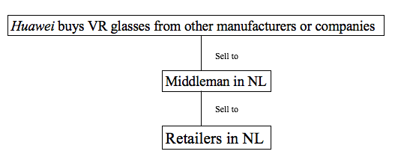
Figure 34: Flow of export by the author

In above export flow, Huawei will firstly purchase VR glasses’ hardware component from other Chinese manufacturers. After that, it can negotiate and find proper middleman companies in the Netherlands, then cooperate with them about the product design and packaging. After the cooperation and coordination, Huawei needs to produce the product as negotiated with its Dutch partner, then sell the products to the middleman. The middleman will then find proper retail channels and decide the proper marketing strategy. However, the drawback is that the trading house or middleman have many other products in its inventory; this means that Huawei can not expect extra attention for their products (Veldman, 2014). The Netherlands are new to Huawei, therefore in the early stage, cooperating with trading companies can be a good entry strategy. Thus this alternative is ranked as “good”.
- Strategic alliances
Strategic alliance means that Huawei corporates with another company in the Netherlands to sell VR glasses in the Dutch market. Strategic alliances enable firms to compete in the global market by building new competitive advantages. It helps companies in gaining access to a desired strategic capability by linking a partner with complementary resources, or by pooling its internal resources with a partner processing similar capabilities (Barua, 2014). The party Huawei works with in the Netherlands can help to develop an efficient brand and conduct marketing activities for them. Strategic alliance requires companies to corporate closely to achieve their common strategic goals by reaching certain agreements in either long-term or short-term. At this earlier stage of entering the Netherlands, it might be hard for Huawei to find a reliable partner because they do not have a network of reliable contacts in the Netherlands yet. Nevertheless, in a later stage, Huawei may utilize this strategy. The choice of business partner in the Netherlands is also limited because the partner would expect value addition for them from Huawei. Therefore, considering what Huawei can offer to its business partners in the Netherlands is significantly important. Firstly, Huawei is located in Shenzhen and has a long history, it also has strong relationships with other electronics factories. As it has been discussed in the internal analysis, China lies the world’s most scaled electronic market and factories in Shenzhen. Cooperating with Huawei allows the partner from the Netherlands to become closer to Chinese manufacturers. This can further help them to reach a better cost position on other electronic products. Secondly, VR glasses being a promising product, Huawei can continue its production of educational software to support the sales in the Netherlands. Business partners in the Netherlands only need to promote and design the package because they are more familiar with the customers than Huawei.
Strategic alliance requires a closer collaboration with other companies, which takes a deeper commitment. However, strategic alliance can maximize both parties’ profits and ensure the after-sales service is adequate. Thus, this method is rank as “good”.
- Foreign direct investment
Foreign direct investment is another alternative under consideration. However, there is a few elements that the company needs to determine. Although consultancies in the Netherlands can provide proper advices on the operation of companies, Huawei may find difficulties in the unfamiliar business environment. It is also important to evaluate the return on investment as the involvement is deeper. For example, if Huawei is to acquire a foreign company, can it uses its existing customer base to sell more VR glasses produced by Huawei? Also, should the company serve the Dutch market only or can it serve other markets in Europe? The geographical scope of the foreign company is vital because even though the Netherlands has a big market potential on VR glasses, as the foreign company may create more cost-efficiency by entering Europe as a whole. Thus this method ranks as “middle”.
In conclusion, at the early stages, using middleman and trading companies will be a preferred choice of Huawei to enter Dutch market. Such method allows Huawei to gain market insights including how other retailers respond to VR glasses. At the later stages, entry strategy has to change from middleman distributors to strategic alliance or direct foreign investment. The change ensures the product selling in the Netherlands has been generating the most mutual benefits. Although trading companies can save costs for Huawei, the inbound limitation that they have a big inventory might create a conflict of interest and affect the efficiency of sales. Figure 25 summarizes the key information discussed in this chapter.
Figure 35: Evaluation of different entry strategies
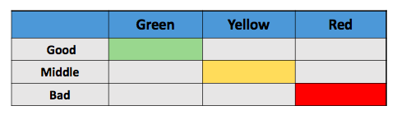
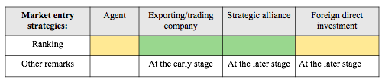

Chapter 9: Implementation of the best entry strategy
Trading companies and strategic alliances were chosen as entry strategies in the previous chapter for Huawei. In this chapter, the marketing mix including product, price, place, people, presentation and promotion will be discussed and analyzed based on the recommended entry strategies and questionnaire results.

9.1 Product support
Souring
As it has been discussed in the Entry Strategy chapter, Huawei can firstly buy VR glasses’ hardware and software from other manufacturers in China then re-sell them through trading houses and middleman companies in the Netherlands. During the transition, Huawei can develop the software and post-sales games needed for the VR glasses they are selling by the digital game companies acquired before. Afterwards, when Huawei is able to produce VR glasses hardware themselves, they can stop purchasing from other manufacturers in China and procure both hardware and software internally.
Product
Based on the questionnaires done previously, the overall response to the interests on VR glasses were very positive. The findings based on questionnaires reveal underlying consumer desire when it comes to purchasing the VR Headset.
Based on the questionnaire results, teens’ favorite applications are video games and parents’ favorite application is travelling back in time virtually. Thus, these two applications can be advertised on the package. Besides, existing competitors such as Trust or Homido’s packages on VR glasses are very formal. It is suggested that Huawei’s product can be more colorful, so it can attract teenagers’ attention on the shelf.

9.2 People
Data from Ecommerce-Europe (2016), a reliable research agency that corporates with Post.NL and GFK, co-published a report that shows 93% of Dutch people shop online and the contribution to Dutch GDP increased 2.37% since 2015. The e-commerce gross merchandise volume (GMV) in the Netherlands increased remarkably by 16.1% in 2015, compared with less than 10% in the preceding years, as online retailer profiles were expanded. People age from 15 years old to 35 years old mainly make up the main Internet user group in the Netherlands. From the figure 36 “Top 10 online retailers”, it is can be noted that Cool Blue is one of most popular online retailers (Ecommerce-Europe,2016).
Figure 36: Top 10 online retailers in NL
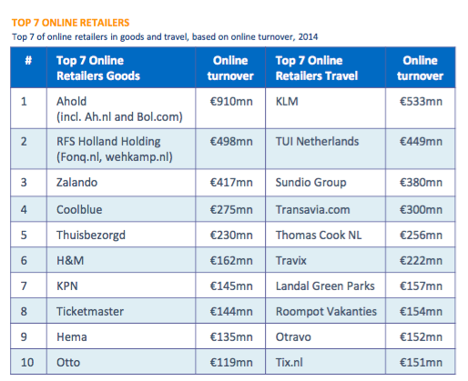

9.3 Place
Results in section 9.2 indicate that when Huawei or its partner is choosing a distribution channel, online-shops are very important. The results from questionnaire corresponds as 70% of respondents in the survey indicated that they want to buy a VR glasses on online-stores such as Cool Blue, Bol.com and Markplaats. Additionally, online-shops create a sense of higher technology and a positive image with VR glasses’ high-tech features. Besides online shops, Media Market, InterToys and other electronic retailers should also be taken into consideration because some it is essential to have a showroom and allow customer to have a trial on the real product.

9.4 Price
In general, the Netherlands’ economy is recovering from the previous unemployment crisis. The Dutch economy is expected to grow by 2.4% in 2016 as real disposable income, household consumption, demand for Dutch exports and public spending are increasing in 2016.
Survey results showed that 47% of Dutch family spend around 25 euros on toys per month. Furthermore, respondents were asked to indicate how often they bought toys in their household, nearly half (48%) of the respondents reported that they buy toys once a month. Of all the respondents who have interests on VR glasses, willingness to spend 41-50 euros and 51-60 euros on the product are roughly the same, 30% and 30% respectively.
Using a market-pricing approach, suggested retail price of 35 to 45 euros can be a very competitive price range for Huawei and the 10-euro difference can create differential pricings on different channel. For example, selling on Cool blue and Bol.com should have a lower price compared with store price on Media market. The table 14 below shows a summary of current competitors’ prices.
Main competitors ’prices of Mobile VR headset in Dutch market
Retailer shop | VR Brand | Price
Media Market | Trust | 49.99 euros
Media Market | Homido | 59 euros
Cool Blue | VR Box | 39 euros
Bol.com | Ritech | 23.71 euros
Bol.com | 3-D Viewer | 18.99 euros
Bol.com | Muvit | - euros
Table 14: Main competitors’ price list

9.5 Promotion/Presentation
The key steps on promotion (marketing) of Huawei’s VR glasses are the following: (1) Find and convince proper retailers to purchase from Huawei, (2) Provide possible marketing plans to assist the retailers to sell VR glasses to their customers.

Digital Marketing (Mainly LinkedIn, Facebook and YouTube): B-to-B
The first initiative of Huawei is to find proper buyers in the Dutch market. Comparing with traditional B-to-B solicitation, (assigning sales personnel to visit the retailers and persuading retailers to purchase the products), the use of social media would be more effective for Huawei to bring the product message to their target group. For example, merchandisers of Cool Blue have registered and shown their contact information on LinkedIn. By creating targeted advertisement, as shown in Figure 37, the purchasers can be effectively reached via Facebook or LinkedIn. Interested parties can contact Huawei’s business partner in the Netherlands.
Figure 37: An example advertisement on Facebook
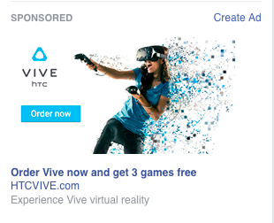
Booklet: B-to-C
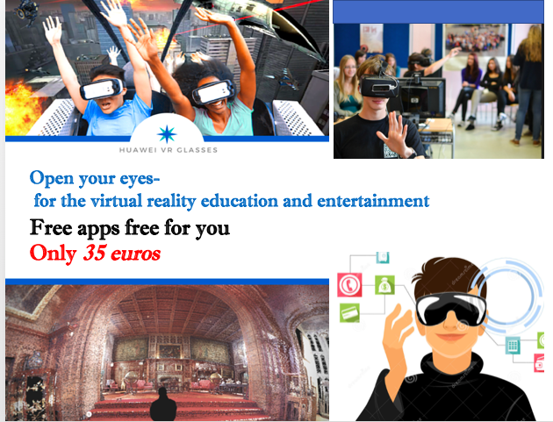
If Huawei wants to sell in retailers like Cool Blue and Bol.com, it is important to be present in their promotion booklets. In the early stage, promoting through booklet on essential as in the Netherlands, they are a common channel to reach customers. The advertisements can encourage B-to-C costumers to purchase the product. Based on questionnaire results, the most attractive slogan is: open your eyes-for the virtual reality education and entertainment.
Figure 38: Booklet ad page created by the author
Besides, coordinating with retailers to create online campaigns can also encourage teenagers to share their experiences of using VR glasses. The advertisement page should contain the popular elements based on questionnaire results and various online marketing tools such as A-B testing and search engine optimization.

Chapter 10: Conclusion & Recommendation
Conclusion
This assignment was target to provide insights for Huawei Technology’s International Department. Faced with the decline of traditional toys’ turnover, the company investigated new products and decided to develop VR glasses to enter the European market. Thus this project designed an internationalization strategy for the company, and investigated the potential market of VR glasses with educational and entertainment functions.
The central question is: “What is the best internationalization strategy Huawei to develop its VR glasses to the Netherlands?” In order to solve this question, the development and potential of VR glasses is important to understand. The Literature Review includes the history and usage of VR glasses. After the introduction of related terminologies and product development, the sub-questions were answered based on the internal and external analyses, questionnaire results and interview results.
1). How do other traditional toy companies reacted towards VR Headset and how do they transform their business strategies under the impact of information technology?
Both LEGO and Mattel have been aware of the new technology and taken swift response to it, as indicated in their annual report. Furthermore, Mattel’s business strategy toward its “View-Master” can be learned by Huawei: to sell the physical hardware at lower price to penetrate the market, then to make more profit in the aftermarket with subscriptions in virtual worlds and software. Questionnaire results also showed that most of the customer are willing to pay for extra applications. These insights provide a direction for Huawei to design their final product.
2). Can Huawei’s existing business resources be utilized to sell VR headset? To what extend are those resources can be helpful?
From Huawei’s internal analysis, they do not have any distributors in the Dutch market yet. However, Giochi Preziosi, as their biggest partner in Europe, may be able to offer help to the selling process of VR glasses in the Netherlands as a trading company. Giochi Preziosi might have clients in the Netherlands that are interested in Huawei’s product. Besides, the company’s long experiences of conducting international business can be beneficial for the selling process to some extent.
3). What are the current Dutch market environment for VR headset?
Based on the questionnaire results, 92% said that they are interested in this product. Among them, 84% of respondents said that they would like to purchase extra applications with the VR headset. Additionally, PESTEL analysis results shows that the Netherlands is a wealthy but relatively small market, and Dutch have interest on high-tech products. While analyses with Porter’s Five Forces indicated that the threat of new entrants is high because the accelerating market might attract more educational companies to compete in the market. Although there are no VR glasses that target to teenagers in the market yet, several competing VR glasses that made by electronic companies still exist. In conclusion, the research and analysis demonstrated that VR glasses has positive market potential and a relatively middle-ranked competitive environment in the Netherlands.
4). What is the best market entry strategy for Huawei?
In the earlier stage, finding middleman or trading companies would be a good start for Huawei to develop its VR glasses business. At the later stage, when Huawei has enough knowledge about the market, they can look for strategic alliances to corporate. Also, after learning the market insights, they can produce related software with extended functions with their acquired video gaming company.
Recommendation
VR glasses is a ground-breaking product at current stage. Although the Dutch customers showed positive attitudes on purchasing it, the size of market and return on investment can still not very attractive to Huawei. Therefore, the first suggestion is that the company should use the Netherlands as a test market at the first place then try to sell the product to other European countries.
Secondly, although this paper mainly focuses on Mobile VR because it is cheaper and seems to more customer-friendly, it is sill suggested that Huawei should conduct more research on Helmet-mounted Display (HMD) VR because HMD VR can provide better user experiences. Huawei can attempt to invest in high-tech companies that produce software on HMD VR in Europe, this strategic move can be beneficial and create better margin in future.
Thirdly, more research is needed to analyze teenagers’ buying behaviors because the questionnaire results of this research gathered more responses from parents. Dutch teenagers might have different buying behaviors than their parents as they have different disposable income and value position.

References

Barua, D. (2014). Market Entry Mode Straregies- A study of Bangladesh Mobile Telecommunication Market for Foreign Companies. Unpublished Master Thesis, Linnaeus University.

Bejerano, G. P. (2014, June 13). Lego's digital toys are transformed into games for smartphones. Retrieved Feruary, 6, 2016, from Bigthink Web site:
http://blogthinkbig.com/legos-digital-toys-are-transformed-into-games-for- smartphones/

Belastingdienst. (2016). VAT relating to purchase and sale of goods. Retrieved 28 April, 2016, from Belastingdienst Web site: http://www.belastingdienst.nl

Bellini, H. (2016, January). The read deal with virtual and augmented reality. Retrieved 8 February 2016 from the Goldman Sachs Web site:
http://www.goldmansachs.com/our-thinking/pages/virtual-and-augmented-reality.html

Benitez-Eves, T. (2015). The year in toys: A look ahead to 2016. playthings, 228.

Bouvier, P. (2008). Cross benefits between virtual reality and games.

Burch, A. (2016, 8 July). Infographic-the new reality of virtual reality and the potential with youth. Retrieved 30 April, 2015, from Touch Stone Research Web site:
https://virtualrealityreporter.com/potential-of-virtual-reality-youth-research-infographic-by-touch-stone-research/

Carol, B., Daniel, D., & Jeffrey, S. (2011). Managing Information Technology. Edingurgh: Peason.

CBS. (2016). Population and population dynamics: Month, quarter and year. Retrieved 20 April, 2016, from CBS Web site:
http://statline.cbs.nl/Statweb/publication/?DM=SLEN&PA=37943eng&D1=0-%209&D2=273-274,290-291,307-308,324-325,341-343,358-360&LA=EN&VW=T

Chiappetta, M. (2016, January 31). What's Hot And What's Not In Virtual Reality? Retrieved 9 February, 2016, from The Forbes Web site:
http://www.forbes.com/sites/marcochiappetta/2016/01/31/whats-hot-and-whats-not-in-virtual-reality/-f07f4f651ad7

CIA. (2015). Population Pyramid of the Netherlands. Retrieved 25 April, 2016, from the CIA Factbook Web site: http://www.indexmundi.com/netherlands/age_structure.html

Competitiveness and Sustainable Industrial Policy Consortium (2013). Study on the competitiveness of the toy industry.: The European Commission.

Content. (2016, 7 April). VR's Next Generation Problem: Lack of Content. Retrieved May 10, 2016, from VR Life Web site:http://www.vrlife.news/vrs-next-generation-problem-lack-content/

Costello, P. (1997). Health and Safety Issues associated with Virtual Reality - A Review of Current Literature. Loughborough: Advanced VR Research Centre.

de Wit, B., & Mayer, R. (2014). Strategy Syhthesis: South-Western.

Derek, B. (2015). Made in China? . The Economist.

Ecommerce-Europe. (2016). The Netherlands B2C E-commerce Report 2016.

Egusa, C., & Cohen, S. (2015). The Netherlands: A Look At The World’s High-Tech Startup Capital. Retrieved 28 April, 2016, from Techcrunch Web site:
http://techcrunch.com/2015/07/05/the-netherlands-a-look-at-the-worlds-high-tech-startup-capital/

Eloot, K., Huang, A., & Lehnich, M. (2013, June 2016). A new era for manufacturing in China. Retrieved 12 April, 2016, from McKinsey & Company Web site:
http://www.mckinsey.com/business-functions/operations/our-insights/a-new-era-for-manufacturing-in-china-0

Europa. (2012). European and thier languages.

Ferman, J. (2013 June). U.S. Department of Commerce Industry Report: Dolls, Toys, Games, and Children’s Vehicles NAICS Code 33993. Retrieved March 1, 2016, from International Trade Commission Web site: http://ita.doc.gov/td/ocg/2012 toy report.pdf

Forgien Common wealth Office. (2013). Factsheet on well-known trademarks in China. Retrieved from https://www.gov.uk/government/publications/factsheet-on-well-known-trademarks-in-china/factsheet-on-well-known-trademarks-in-china.

Gonçalves, Y. (2013). Overview of Virtural Reality Technologies University of Southampton.

Gottlieb, R. (2008). Virtual worlds can help mend the industry's ills. Worlds Colliding, 8.

GOV.NL. (2016). Encouraging innovation. Retrieved 25 April, 2016, from The Dutch government Web site: https://www.government.nl/topics/enterprise-and innovation/contents/encouraging-innovation

GOV.UK. (2015). Doing business in the Netherlands: Netherlands trade and export guide. Retrieved 29 April, 2016, from Web site: https://www.gov.uk/government/ publications/exporting-to-netherlands/exporting-to-the-netherlands

Hu, F., & Jiang, L. (2016). Virtual Reality Enhanced Robotic System for Disability Rehabilitation. the United Sated of America: Medical Information Science Reference.

HuaweiTechnology. (2015). Annual Report. Shenzhen.

Inman, P. (2016, 1 March). Chinese manufacturing fall adds to evidence of sharp global downturn. Retrieved 30 April, 2016, from the Guardian Web site:
http://www.theguardian.com/business/2016/mar/01/chinese-manufacturing-decline-sharp-global-downturn-factory-output-china-uk

Kennedy, R. S., Lane, N. E., Berbaum, K. S., & Lilienthal, M. G. (1993). Simulator sickness questionnaire: An enhanced method for quantifying simulator sickness. International Journal of Aviation Psychology, 3(3), 203-220.

LEGO. (2014). Annual report: LEGO Group.

Lo, K. (2015). The Classification of VR glass. Retrieved 20 March, 2016, from Unity Taiwan Web site: http://unitytaiwan.blogspot.nl/2015/09/unityvr.html

Mazuryk, T., & Gervautz, M. (1996). Virtual Reality: History, Applications, Technology and Future. Vienna: Vienna University of Techonology.

MBALib. (2016). Well-known Trademarks. from MBA Library Web site:
http://wiki.mbalib.com/wiki/Well-known_Trademarks.

Nichols, S. (1999). Virtual reality induced symptoms and effects: Theoretical and methodological issues. University of Nottingham.

Peckham, M. (2016, January 10). Video Game Designers Say Virtual Reality Is Here to Stay. Retrieved 10 February 2016, from Time Magazine Web site: http://time.com/4186688/virtual-reality-games/

Porter, M. E., & Heppelman, J. E. (2015). How smart, connected products are transforming companies. Harvard Business Review, 96-112.

Salzano, L. (2014, 14 April). 4 key differences between trade agents and distributors. Retrieved 5 May, 2016, from International Trade Web site:
http://therightsocialmedia.novertur.com/international-trade-2/4-key-differences-trade-agents-and-distributors/

Samuel, A. (2016). What Technology Companies Can Learn from Toy Makers. Harvard Business Review.

Schumpeter, J. (2013, May 13). Child's play. Rereived Feruary, 9, from Economist Web site:
http://www.economist.com/blogs/schumpeter/2013/09/toy-industry

Sexton, M. (2016). THe History of Virtual Reality. Retrieved 29 March, 2016, from Web site: http://www.tomshardware.co.uk/picturestory/136-12-history-of-virtual-reality.html

Sinclair, C. (2014). Annual report: Mattel Inc.

Sinclair, C. (2015). Annual Report: Mattel Inc.

Tango, R. (2016, Febraury 17). Patient Wears VR duting Brain Surgery. Retrieved 29 March, 2016, from Discovery News Web site: http://www.ndtv.com/health/in-a-first-patient-in-france-wears-3-d-glasses-during-brain-surgery-1278260

Telegraph. (2010, June 13). Chirdren want gadgets not toys for Christmas. Retrieved Feruary, 6, 2016, from The Telegraph Web site:
http://www.telegraph.co.uk/news/8084305/Children-want-gadgets-not-toys-for-Christmas.html

Veldman, H. (2014). Export Management: A European Perspective (1 ed.). Groningen: Noordhoff Uitgevers.

Weber, H. (2015, 4 October). Mattel and Google teamed up to make VR kid friendly, and they got pretty darn close. Retrieved 10 March, 2016, from Web site:
http://venturebeat.com/2015/10/04/mattel-and-google-teamed-up-to-make-vr-kid-friendly-they-got-pretty-darn-close/

Weber, J. (2005). Opportunities within the traditional toy sector of the UK Toys and Games Industry - A German Perspective. Grin.

Wiley, J. (2006). Virtual Reality. Canada: John Wiley & Sons, Inc.

Zelenko, M., & Robertson, A. (2016). Voices from a virtual past. Retrieved 10 March, 2016, from the Verge Web site: http://www.theverge.com/a/virtual-reality/oral_history

Appendices

Questionnaire in English
Questionnaire: Mobile VR glasses’ potential market research (In English)
Filter questions:
1). What is your age?
- Below 10
- From 10 to 20
- Above 20
2). Do you have one or more children who are above 10-year-old?
- Yes
- No
Dear respondent,
Thank you for taking the time to fill out this survey.
The questions asked are related to your preferences of your buying behavior of Mobile VR glasses as a tech gadget with educational and entertainment functions. Therefore, I need your opinions on kids’ traditional toys and tech gadgets.
This survey will take around 5 minutes of your time and the answers given will be confidential and anonymously used. If you have any questions, or would like to read about my results, feel free to contact me by sending an e‐mail to yolandaeei@gmail.com.
Please keep in mind:
- “Toys” in the questionnaire refer to all kinds of toys that include tech gadgets and traditional toys, “tech gadgets” in the questionnaire only refer to electronic products that are designed for the kids (i.e. iPad, 3D printing pen, smart watch or VR glasses), “traditional toys” in the questionnaire refer to physical toys (i.e. dolls, games, puzzles, activity games without any electricity and screen).
Thank you in advance for your participation.
Kind regards,
Yolanda
The following part is about your buying behavior while purchasing *toys.
*Toys=traditional toys+ tech gadgets designed for kids
Q3. How many kids are there in your family?
- 1.
- 2.
- 3.
- 4.
Q4 How often do you or your parents purchase toys?
- Once a month
- Every two months
- Once a quarter
- Once a year
Q5 How much does your family spend on toys per month for all the kids?
- Less than 20 euros per month
- Around 25 euros per month
- Around 50 euros per month
- Around 100 euros per month
The second part is about your buying behavior while purchasing *tech gadget as a toy.
*tech gadget = electronic products i.e.: iPad, 3D printing pen, smart watch or VR glasses and so on.
Q6 Have you ever purchased any tech gadgets before?
- Yes
- No
Q7 Rank below factors that will affect your buying decision for a tech gadget.
- Education functions
- Good for eyes
- Entertainment functions
- Safety
Q8 to what extent do you agree on below statements?
- Agree
- Neither Agree nor Disagree
- Disagree
Tech gadgets can simulate people’s imaginations
Tech gadgets can be very harmful for people’s health
Imagine that there is a VR headset designed for people aged from 10 to 20. You can put your mobile into the device and download various applications on mobile that specially made for people aged from 10 to 20. However, when you buy the VR glasses, you will only get three free applications on it, including one game, one space exploration journey and one educational tutorial on the language course.
For extra applications, you need to pay for them. Some apps can be used for exploring the stars, landscape all over the world, some apps can be used to play more complicated educational games such as counting, learning different languages and so on.
This product can encourage kids and teens to gain interests of learning diverse knowledge files (i.e. Geography).
Q9 Would you be interested in such a VR headset?
- It is a cool product, very interesting, I want to try it.
- I am not interested.

Q10 Please evaluate things below that you think would be interesting to do with the VR glasses
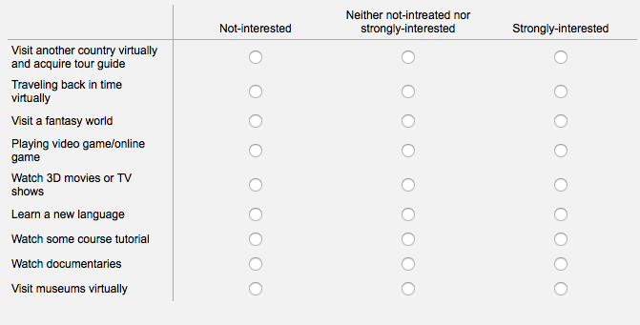
Q11 Please evaluate the types of games below that you think would be interesting to do with the VR glasses.
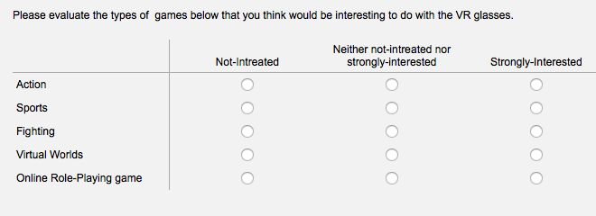
Q12 How much would you like to pay for *above product?
*Above product refers to the VR glasses designed for 10 to 17-year-old kids, it has three free applications.
- 31-40 euros
- 41-50 euros
- 50-60 euros
- None at all
Q13 Would you like to buy extra applications if you bought the VR glasses?
- Yes
- No
Q 14 How much would you pay for extra applications in App Store for the VR headset?
- 0.99 euros per application
- 1.99 euros per application
- 2.99 euros per application
- Above 5 euros
Q 15 If you are interested in such a VR glasses, where would you go when you want to purchase it?
- Offline-store. i.e.: Media Market and inter-toys
- Online-store. i.e.: Cool Blue, Bol.com, Markeplaats.
Q16 in your opinion, which advertisement slogan is the most attractive one?
- With this VR glasses, you can study and play in a different way
- Change the traditional education way - VR glasses
- Play and study-see what's possible
- Open your eyes- for the virtual reality education and entertainment
Q17 Are you interested at VR technology and tell your friends about this new technology?
- Yes
- Maybe
- No
Lastly, please tell a bit about your demographics.
Q18 What is your gender?
- Male
- Female
Q19 What is your highest education level?
- High school
- Bachelor degree
- Master degree
Q20 What is your income per month (After tax)?
- Below than 1200 euros
- Around 1200-2000 euros
- Higher than 2000 euros

Questionnaire in Dutch
Vragenlijst: Potentiële marktonderzoek Mobile VR bril
Vraag 1. Hoe oud bent u?
- Onder 10 jaar oud
- 10 – 20 jaar oud
- Ouder dan 20 jaar

Vraag 2. Heeft u meer dan een kind die boven de 10 jaar zijn?
- Ja
- Nee

Geachte Heer/Mevrouw,
Hartelijk dank voor uw tijd om deze vragenlijst in te vullen.
Wij willen graag onderzoeken over uw voorkeuren voor de Mobile VR bril, een technologische apparaat met educatieve en amusement functies. Daarom hebben wij de mening nodig over traditionele speelgoed en tech gadgets van uw kind.
Deze enquête duurt ongeveer 5 min en uw antwoorden zullen vertrouwelijk en anoniem blijven. Als u nog vragen heeft, of als u de uitslag van deze enquête wilt ontvangen, kunt u een mail sturen naar yolandaeei@gmail.com.
Hou rekening met de onderstaande punten:
- “Speelgoed” in deze enquête verwijst naar alle soorten speelgoed die technologische apparaten en traditioneel speelgoed bevatten.
- "Tech gadgets" in de vragenlijst hebben alleen betrekking op elektronische producten die zijn ontworpen voor de kinderen (bijvoorbeeld iPad, 3D print pen, smart horloge of VR-bril), "traditioneel speelgoed" in de vragenlijst verwijst naar naar fysieke speelgoed (bvb. poppen, spelletjes, puzzels zonder elektriciteit en/of schermen).
Bij voorbaat dank voor uw deelname.
Met vriendelijk groet,
Yolanda
Het eerste deel gaat over uw koopgedrag voor speelgoed.
*Speelgoed= traditionele speelgoed + tech gadgets speciaal gemaakt voor kinderen
Vraag 3. Hoeveel kinderen zijn er in uw familie?
- 1
- 2
- 3
- 4

Vraag 4. Hoe vaak koopt u of uw ouders speelgoed?
- 1 keer per maand
- 1 keer per twee maanden
- 1 keer per kwart jaar
- 1 keer per jaar

Vraag 5. Hoe veel geeft uw familie uit op speelgoed per maand voor alle kinderen?
- Minder dan 20 euro per maand
- Rond de 25 euro per maand
- Rond de 50 euro per maand
- Rond de 100 euro per maand

Het tweede deel gaat over uw koopgedrag voor tech gadgets als speelgoedproducten. *Tech gadget = elektronische producten, bvb. iPad, 3D print pen, smart horloge, VR bril enz.
Vraag 6. Heeft u ooit wel eens tech gadgets gekocht?
- Ja
- Nee

Vraag 7. Rang de onderstaande factoren die uw aankoop beslissing voor een tech gadget zal beïnvloeden.
- Leerzaam
- Goede invloed op de ogen
- Amusement
- Veiligheid

Vraag 8. In hoeverre bent u het eens op onderstaande uitspraken?
Tech gadgets kunnen de verbeelding van mensen simuleren
Tech gadgets kunnen slechte invloed hebben op de gezondheid van mensen.
- Mee eens
- Niet mee eens of oneens
- Oneens

Stel je voor dat er een VR-koptelefoon is ontworpen voor jongeren tussen 10 - 20 jaar. U kunt uw mobiele telefoon met het toestel linken en verschillende apps op de mobiel die speciaal gemaakt voor mensen van 10 tot 20 jaar erop zetten. Wanneer u de VR-bril koopt, krijgt u drie gratis apps op het toestel: een spel, een tutorial om het toestel te verkennen en een educatieve tutorial over een taalcursus.
Voor extra apps zal u ervoor moeten betalen. Sommige apps kunnen worden gebruikt voor het verkennen van de sterren en landschappen. Terwijl andere apps kunnen worden gebruikt voor educatieve spelletjes, zoals tellen of een nieuwe taal leren.
Dit product moedig kinderen en tieners aan om meer algemene kennis te leren, zoals aardrijkskunde.

Vraag 9. Zou u geïnteresseerd zijn in deze VR koptelefoon?
- Het lijkt een leuk product, ik zou het willen uitproberen
- Ik ben niet geïnteresseerd in dit product.

Vraag 10. Kunt u de onderstaande aspecten evalueren dat de VR bril interessanter zou maken.
Aspecten/uw mening | Niet geïnteresseerd | Niet geïnteresseerd of geïnteresseerd | Erg geïnteresseerd
Het bezoeken van een ander land met reisleider
Terug in de tijd reizen
Een fantasiewereld bezoeken
Een video game or online game spelen
3D films of TV shows bekijken
Een nieuwe taal leren
Online tutorials bekijken
Documentaires bekijken
Musea virtueel bezoeken

Vraag 11. Evalueer de onderstaande soorten spelletjes dat u interessant vind voor VR-bril.
Soorten games/uw mening | Niet geïnteresseerd | Niet geïnteresseerd of geïnteresseerd | Erg geïnteresseerd
Actie
Sport
Vecht
Virtuele werelden
Online rollenspelletjes

Vraag 12. Hoe veel zou u willen betalen voor het bovenstaande product*?
*Met het bovenstaande product bedoelen wij de VR bril gemaakt voor tieners tussen de leeftijd 10 – 17 jaar oud. Het bevat 3 gratis apps.
- 31 – 40 euro
- 41 – 50 euro
- 50 – 60 euro
- Ik zou dit product niet willen kopen.
Vraag 13. Zou u extra apps kopen na het aanschaffen van de VR bril?
- Ja
- Nee

Vraag 14. Hoe veel zou u voor de extra apps willen betalen in de App Store voor de VR koptelefoon?
- 0,99 euro per maand
- 1,99 euro per maand
- 2,99 euro per maand
- Boven de 5 euro per maand

Vraag 15. Als u geïnteresseerd bent in de VR bril, waar zou u hem willen kopen?
- Fysieke winkel, zoals Media Markt, Intertoys
- Online winkel, zoals Coolblue, Bol.com, Marktplaats

Vraag 16. In uw mening, welke reclame slogan spreekt u het meest aan?
- Met deze VR bril kun je leren en spelen op een nieuwe manier!
- Verander de oude traditionele manier van leren: VR Bril
- Speel en leer: bekijk de mogelijkheden
- Open je ogen: voor de virtuele realiteit educatie en amusement

Vraag 17. Bent u geïnteresseerd in VR technologie en zou u het aanbevelen aan familie en/of vrienden?
- Ja
- Misschien
- Nee

Tenslotte, graag uw persoonlijke informatie invullen.

Vraag 18. Wat is uw geslacht?
- Man
- Vrouw

Vraag 19. Wat is uw hoogste afgeronde onderwijs/opleiding?
- Middelbare school
- Bachelor
- Master

Vraag 20. Wat is uw maandelijkse inkomen (inclusief belastingkosten)?
- Minder dan 1,200 euro
- Rond de 12,00 – 2,000 euro
- Meer dan 2,000 euro

Interview with Virtual Reality expert at Alibaba
Interviewee name: Yao Liu
Job description: Graduated from Computer Sciences at Imperial College in London, had his final project on VR glasses. Liu had strong interests on VR glasses since few years ago. He is currently working at Alibaba’ s VR Group.
Age: 25

Introduction to this topic / 对此项目的介绍：
本访问的目的是调研专业人员对虚拟现实眼镜的看法、前景、以协助笔者判断工作的公司“骅威科技”是否具备科研实力研发此项产品 。This interview was designed to require related expertise about VR headset. The experts will firstly be consult the VR glass’s prospects and potential business opportunities. After that, they will also be required to assist the author to decide if Huawei has the capability to produce VR glasses based on Huawei’s own situation.

问题（Interview questions）:
问题1: 90年代时，VR眼镜曾如今天一样大热，它快速占据了各大媒体头条，无数商业专家预测其会来不可想象的商业价值。但很快，因为其软件硬件设施都没有发展完善，VR眼镜作为一项失败的科技产品，消失在了众人视线。如今，带着更加完善的设备和应用，在各大科技公司的加持下，VR眼镜重新回归并再次刮起了一阵科技的旋风。您认为VR眼镜此次回归，将会有怎样的发展？会像90年代一样遭遇滑铁卢，亦或从此改变若干传统行业和普通人的生活？
Question 1: In the 1990s, VR headset was very popular. Extensive media covered this “new technology” and various market analysts predicted that there will be a boost increase on VR headset sales. Nevertheless, the hardware of VR glasses had not been advanced enough to produce comfortable wearing experience, while the lack of software reduced the application for VR and therefore it had vanished in the 90s. Nowadays, with improved software and hardware, VR headset is re-rising and coming back to our attention again. In your opinion, what is VR headset’s future? Will it fail again or change traditional industries and people’s life?

回答1：2015年中国VR市场规模达到15.4亿元，到2020年这一数字将达到550亿元。总体上看，中国虚拟现实市场在5年里增长了36倍，年复合增长率为104.91%，也就是说每年都在翻番。VR的初步定位是消费电子，在智能手机取得巨大成功的鼓舞下，国内众多厂商磨拳擦手，跃跃欲动。2015年底，各家互联网厂商纷纷发布自主产品。所以从长远来看，目前的VR市场基础条件已经具备，未来会有更好的而发展。
Answer 1: VR market reached 1.54 billion Yuan in China in 2015, by 2020 the number will reach 55 billion Yuan. Overall, China's virtual reality market increased by 36 times in five years with compound annual growth rate of 104.91%. In another word, the market doubles every year. The preliminary positioning of VR is consumer electronics. Inspired by the success of smartphone, the domestic manufacturers are bending over backwards to seize the emerging opportunity. By the end of 2015, many Internet companies had released their branded VR products. Thus, considering the basic market condition VR market has been established, VR will have a better development in the future.

问题2：在VR 眼镜大热的今天， 中国的若干企业都想研发不同应用，分一杯羹。您认为Mobile VR眼镜会为传统的出口型玩具公司带来怎样的契机？
Question 2: It seems that VR headset is bringing fresh perspective on various industries. Many business analysts believed it has potential to transform how we interact with almost every industry today. In China, many companies are trying to research or invest on VR glasses as well. In your opinion, VR glasses used in different industries will have a positive effect? What kinds of business opportunities will VR glasses provide to traditional toy manufacturers? Do you think that VR glasses will bring a positive effect?
回答2：现实+虚拟能带来更多新奇的交互形式和玩法，也能创造出极具想象力的玩具产品。其他一些行业都开始尝试将 AR 和 VR 商业化，预计这些技术也会运用在儿童玩具产品中。因此基于技术的积累，Mobile VR 眼镜可以为传统的出口型玩具公司带来更多的VR视频、VR游戏产品。
Answer 2: Virtual reality can bring new forms of interaction and ways of entertainment, and it can create very imaginative toys products. Many industries are beginning to try commercializing AR and VR; it can also be foreseen that these technologies will be used in children's toys products. So with the accumulation of technology, mobile VR glasses can bring traditional export-oriented toy company more VR video, VR games products.

问题3： Mobile VR, 由于其造价较低，为许多行业都打开了一扇窗。您认为Mobile VR作玩具用途，会否有足够的商业前景？
Question 3: Mobile VR provides new business opportunities to many industry, it has lower production costs and relatively lower technological component. In your opinion, if we develop Mobile VR as a toy, will it has enough business potentials?
回答3：答案是肯定的。VR可能是始于为个人电脑提供图形用户界面的计算机平台的下一站，就在最近，全球的智能手机都有了多点触控界面。这是Palm及Resolution为Gear VR创造游戏从而进军虚拟现实领域的原因之一。其他原因还包括高盛投资公司和技术顾问Digi-Capital预测虚拟和增强现实（结合真实和数字图像的相关技术）的业务将在未来几年内增长到大约1100亿美元到1200亿美元。智能手机对于大多数地方和人来说已经无处不在。他们是多用途的设备,各种各样的消费者的私人生活和工作都与之密不可分。人们更倾向于在智能手机上添加虚拟现实和增强现实，而不是试图让另一个专门的硬件融入到他们的生活中去。
Answer 3: The answer is yes. VR is probably the next-stop graphical computer interface which replace personal computer. Recently, the global smartphone has a multi-touch interface. This is one of the reasons why Palm and Resolution create games for Gear VR. Another reason is that Goldman Sachs, an investment company, and technical consultant of digi-capital predict virtual and augmented reality (a combination of reality and the relevant technology of the digital image) business growth in the next few years to about $110 billion to $120 billion. Smart phones have been used by most of the people everywhere. They are multifunctional equipment and closely connected with various parts of consumer's personal life and work. Thus people tend to be add virtual reality and augmented reality on their smart phone, rather than trying to get another dedicated hardware into their lives.

问题4：您认为Mobile VR可以通过传统玩具的销售渠道（主要针对欧洲市场）销售出去吗？
Question 4: Do you believe that VR glasses can be sold via traditional toy distribution channels in European market?
问题4：可以的，大部分的销售渠道还是传统的电商平台以及线下的实体店体验商店。让顾客能够身临其境去感受下VR的虚拟+现实。不同的VR对于客户的体验不一样，因此线下实体店的销售渠道可能会比线上的销量更多。
Answer 4: I think so, most of the sales channel are still traditional electric business platform and offline store experience store, as they allow consumers to experience VR before purchasing. Different VR experience is different, so the offline store sales channels may be more effective than the online channels.
问题5：如果一间公司想要研发VR Mobile，其R&D部门需要满足什么样的条件？
Question 4: What kinds of conditions that the R&D department in a company will have to meet if they want to research and develop VR glasses?
回答5：对软件开发工程师、软件测试工程师以及美术方面职位。对Web 前端工程师和Windows 客户端开发工程师的职位附加条件是参与过APP商店平台项目。对于软件方面的要求，由于VR在游戏领域具有巨大潜力，因此研发部门也需要游戏的设计师。
Answer 5: It requires strong capability of software development, software test engineering, and fine arts. Moreover, it requires Web front-end engineers and Windows client development engineers who have experience with APP store projects. In terms of software, as VR has great potential in the field of the game, R&D department also needs game designer.
问题6：研发和制作Mobile VR，最大的技术难点在软件还是硬件？
Question 6: If a company wants to develop and produce a VR headset, what is their biggest technical problem, would it be in software or hardware?
回答 6：硬件技术。现在还是技术不成熟，这也是为什么Oculus迟迟未出消费版，就是因为有体验者会眩晕，你像一款游戏玩个十分钟不到就头晕，那肯定不行，强调沉浸感的游戏至少要能玩2个小时。毕竟防晕这块主要就是要硬件设备好。现在很多硬件都不是特别成熟，配合开发的时候，眩晕感控制是软件现在比较微妙的一个点，硬件端现在才刚刚找到一些解决方案，看到一个利好的方向。
Answer 6: Hardware technology is the bottleneck. The technology is not mature; it is why the Oculus has not been released in the consumer market. It gets people dizzy quickly. A game cannot be a success if it gets people dizzy in less than 10 minutes. An immersive game should be played at least 2 hours. After all, hardware is the key to the dizziness problem. Now a lot of hardware is not very mature, cooperate with development, vertigo control software is a more subtle solution, There is a positive direction for hardware development.

问题7：生产一款Mobile VR的硬件，研发部门大概需要投入多少资金？
Question 7: If a company wants to produce the hardware of a mobile VR headset, how much capital will they need to provide?
回答：开发一款原生态的VR游戏，一个30人团队需要花费6个月时间，所需资金大约100万，而同样开发一款手游所需的时间和资金大约只需一半。“如果拿原有的3D游戏来转制VR游戏的话，里面的交互系统甚至是游戏的玩法、角色的视角转换等都要做很大改变，而且要从最底层去改，成本会很高。”一游戏开发者说道。VR的硬件研发成本没有直接的数字，但是从VR的公司接收到的投资额度，我们大概可以看到关于硬件的研发成本并不低。
Answer 7: Developing an original VR games requires six-month time of a team of 30 people. It costs about 1 million. However, Developing a mobile game costs only about half the time and money. "If you convert the original 3D games to VR games, the conversion of the interactive system and even the way of gaming, the angle of role transformation need to have very big change, consequently, the cost will be very high." A game developer said. There is not direct number on VR hardware development costs. But according to the investment amount VR company receives, we can probably predict that hardware research and development costs are quite significant. According to this link below, you can find the recent financing situation of VR company.

Interview with R&D manager at Huawei
Interviewee name: Zhenbiao Ma
Job description: Vice Manager of the whole Research & Development department.
Background introduction: Ma has been working for Huawei since 1997. He is an expert on toy model making and very good at managing factories. Ma and his team in Huawei owns more than 300 patens on toys.
Age: 48

Introduction to this topic/对此项目的介绍：
VR 虚拟现实眼镜作为骅威科技有可能发展的一款新产品（做玩具用途），笔者对此进行了一些调研。本采访主要目的是调研骅威科技的研发部门是否具备制作VR眼镜硬件的能力，以及作为一款智能出口产品，投入资金研发此款新产品是否具有足够的商业价值和投资回报率 。
This interview was designed to research if Huawei has the capability to make VR headset and does this development has enough business value and ROI for the company.

Interview questions:
采访问题：
行业角度 (Angle from the toy industry):
- 传统玩具行业的锐意转型，在世界范围内都有目共睹。从乐高到美泰，再到孩之宝， 整合资源并从不同角度、在不同行业里追求创新，是全世界传统玩具行业共同的需求。以您的观点，中国传统玩具行业，面对新科技l例如VR眼镜的来袭，做出了什么样的战略调整？
The transformation of traditional toy industry is very obvious to observe. Lego, Mattel, Hasbro are clear examples for that. In your opinion, how other traditional toy companies reacted toward VR Glasses and how do they transfer their business strategy considering the impact of information technology?

骅威科技一向坚持以创新为导向 。2003年-2008年之间，骅威公司模具部的改造和技术革新，从设备、设计软件和技术人员的改造培训升级，将传统的模具制造工艺提升为现代化的模具制造技术。2003年开始组建骅威公司研发部，带领整个部门从当初的传统玩具的研发，逐步从技术上不断创新，现在已经拥有300多项专利的多领域研发的部门，技术领域更加全面和广泛，产品从常规转变为高技术含量的科技产品，如消费级无人机和机器人等等。
Hua technology always adhere to innovation as the guide. Between 2003-2008, Hua company mold department of transformation and technological innovation, from the device, the design of software and technical personnel training upgrades, to upgrade the traditional die manufacturing technology for modern mold manufacturing technology. Started in 2003 to form a Hua company research and development department, to lead the whole department from at the beginning of the development of the traditional toys gradually from the technical innovation, now has more than 300 patents in the field of research and development department, technology is more comprehensive and extensive, products from conventional to high technology content of science and technology products, such as consumer unmanned aerial vehicles and robots, and so on.
公司角度 (Angle from the company):
- 在目前的玩具市场里，骅威科技最大的竞争对手是？
In current physical (traditional) toy market, who is the biggest competitor of Huawei?
奥飞动漫为目前骅威科技在深圳地区的最大竞争对手。
The flying animation is our biggest competitor in Shenzhen.
- 这些竞争对手，在新科技的风潮下，做出了什么样的战略调整？
What kinds of strategic adjustments do above competitors make?
奥飞动漫像文化、影视方面转型。他们用自己拥有的动漫IP拍摄动画片，取得了较大成功。其旗下也拥有多家投资公司，而2015年年底和今年年初，奥飞动漫也投资了多家国内的VR公司。
The flying animation are cultural transition, film and television. They use their own IP anime cartoons, has been a big success. Its also has many investment companies, and at the end of 2015 and early this year, the flying animation also invested in VR company at home.
- 据您的观察，骅威科技目前的企业文化、内部企业氛围是否支持创新？
Does Huawei Technology’s current corporate culture have innovative atmosphere and do the board of directors always supports innovative ideas? What is your personal feeling and idea about it?
虽然骅威科技是一家传统的玩具企业，以制造销售玩具起家。但在年轻的CEO郭先生的带领下，一直如意创新。这点我毋庸置疑。Although Huawei technology is a traditional toys enterprise, to manufacturing sales started with toys. But under the guidance of the young CEO Mr. Guo, has been the best innovation. I never doubt about this.
产品角度 (Angle from the new product):
- 如果将虚拟现实眼镜作为玩具销售，可否借助骅威已存在的在欧洲的分销途径？ 您认为此新产品在国际市场（欧洲地区）的前景如何？
If we sell VR glasses as a toy to the European market using the existing distributional channel, in your opinion, whether this new product will have good prospect or not?
我认为这是一个非常具有前景的产品。借助我司在意大利的分销途径，会取得成功。I think this is a very promising product. With the aid of the distribution way to our company in Italy, will succeed.
- 如果将虚拟现实眼镜作为玩具，由骅威旗下的科技公司制作相关软件，您认为应该面向多大的儿童以及青少年？If we sell VR headset as a toy to the European market with the support of Huawei’s related video-gaming companies (they can make software), in your opinion, what kinds of age group should we target (what is the age range of our target group)?
15-20岁。15-20 years old.
- 骅威科技目前是否具备研发实力来制作VR 眼镜的硬件？包括组建相关团队、在相对快速地时间段里招到相关技术人才、支持设备研发、售后等。Does Huawei Technology’s R&D department have capability to make hardware of VR glasses? The “capability” includes building team within a certain time period, hiring related talents, supporting the production of the device (hardware), after-sale service and so on.
虽然在短期内确实有一定难度，但只要公司提供帮助，我认为是可以办到的。
I think it is not so possible to produce it in a short time, but as long as the company is willing to support, we can make the product and also support after-sale service.
- 您预计公司需要投入多少资本来研发一款新的硬件产品？If Huawei Technology has above technical capability, how much investments should the company provide to research and develop the VR headset?
500-1000万人民币。5-10 million RMB. (500,000-1,000,000 euros)
- 从商业模式分析，您认为公司自主研发VR眼镜再销往到欧洲市场，可以在产生长期稳定的投资回收吗？From business perspective, if the company produces then sells VR glasses to overseas, can this strategic movement create long-term and stable turn over?
我认为这很难判断。
I think it is difficult to judge.
- 美泰和Google 制作的玩具VR 眼镜（如图）售价20欧元（140人民币），此款产品让小朋友看到不同的地貌并通过眼镜上的按钮与之简单互动。此款产品可以通过购买卡片（卡片可以使使用者看到不同的世界,7.99 欧一个）来实现利润的增长。目前在亚马逊官网“地球科学“玩具类别排名第一。您认为如果骅威科技如果出口销售类似产品是否可行？Mattel and Google teamed up to make VR headset (showed in picture), Mattel sells it at the price of 20 euros. This product enables kids to explore different landscapes and allows kids simply interact with them by clicking the button on the glasses. Besides, customers need to buy experience pack (7.99 euros each) to see more landscape. This product ranks number 1 in Geology& Earth Science Toys now. How do you think of this product?
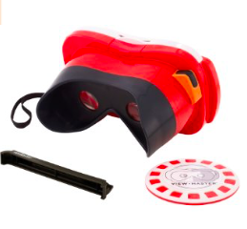
我认为可行。
Yes.

Brief Interview with Human Resource Manger at Huawei
This interview was mainly conducted to help the author to formulate internal analysis, thus it is very short and straightforward.
Interviewee name: Xu
Job description: Vice Manager of Human Resource Department
Background introduction: Ma has been working for Huawei for 5 years.
Age: 30
This part was asked and answered in English, it was conducted through a conversation then summarized by the author.
- How many employees in Huawei in total? And there are how many employees in R&D department?
In total, we have 3000 employees. In R&D Department, we have 80 people.
- How many subsidiaries does Huawei have in China?
Huawei has several subsidiaries all over China, including Beijing, Shanghai, Hong Kong and Shenzhen.
- Do you think the company has an organized system for recruiting high-caliber employees and training them? Do you think it is able to attract VR glasses related highly skilled personnel at current stage?
Yes. My personal opinion is that although a coherent and smooth system for human resources exists, the company is not attractive enough to highly skilled talents in the field of VR at current stage. In fact, the company wanted to build a game developing team to develop games in the year of 2014, when our department had enough financial supports to pay the game developers enough salaries. The company hired several game developers but eventually failed to build a complete team because many game developers thought they would not have a good career path in Huawei because the company is not specialized in games but toys. Therefore, the company finally decided to take over several video-game companies and this action created much better margins than hiring and building our own game developer team. But I also think my opinion might not very valuable from the strategic level. In Chinese culture, the HR department really do not have so much power to decide. I think if the company really wants to do it, they can eventually find a way to do it. My opinions are only based on my own position, it has quite a lot limitation.

Brief interview with CEO at Huawei
This interview was mainly conducted to ask Guo’s opinions on toy industry transformation and what he wants to achieve in the future.
Interviewee name: Guo
Job description: CEO of Huawei Technology
Background introduction: Guo had built this company with the help of his father. During so many years, he is in charging of the strategic planning.
Age: 48
- The transformation of traditional toy industry is very obvious to observe. Lego, Mattel, Hasbro are clear examples for that. In your opinion, how other traditional toy companies reacted toward high technology?
Toy industry definitely needs to find their way out. Few years ago, I started to make arrangements on changing and reducing the producing of toys. In my personal opinion, many kids will no longer need toys anymore because everybody can see how amazing the video games are. My own kid, she barely plays any physical games at home because she thinks it is very boring. My main target is to produce cartoons and also get involved into movie-making, just like what LEGO is doing. Today’s Chinese movies are developing very fast. People used to be too poor to have entertainment. But not anymore. So I want to invest in movies and also high-tech companies.
- If Huawei changes to make intelligent hardware such as VR glasses, like what we discussed in this study, what kind of advantages you think it will have?
I like VR glasses and this concept. I think one of the competitive advantage of my company is that we are located in Shenzhen and has very good relationship with other digital manufacturers. But as a business man, I mainly want to have good ROIs in any project we invest. Does is worth it or not? I think the Netherlands is a very small market, if we invest in, it can be a small test market. Due to the location and good business environment, many later on we can try to sell to other countries.

