Increasing enrollment in the ES program: Preferred communication channels and message content among international students
Dissertation

Elisabeth Samarin
15038319
ES3-3.A

Bart Kuijpers

The Hague University of Applied Sciences
Faculty of Management & Organisation
European Studies three-year program

09.01.2018

Executive summary
The purpose of the dissertation was to research how to increase the European Studies program international students’ enrollment by recommending through which information channels and what message content to promote. Four topics were researched to give recommendations:
- International students’ study abroad motivations;
- Factors affecting international students’ choice of study abroad destination;
- International students’ preferred information channels;
- The image of the European Studies according to the international students.
To research the topics, three methods were used: the desk research, quantitative and qualitative research. The desk research was based on the previous academic literature about the four addressed topics. The quantitative research was conducted by surveying 155 high school students from five Estonian high schools. Qualitative research was conducted with semi-structured interviews with five European Studies’ international students and with an interview conducted with the European Studies program coordinator.
It was concluded that I. international students’ study abroad motivations are mainly personal and career-related. The primary personal motivations are the possibility to travel while studying abroad, meeting new people and creating new social connections, being surrounded by multicultural environment, gaining independence and possible future migration to the country of the study destination. Career-related motivations are improved employment opportunities after the graduation and developing the practical skills needed on the job market. II. The most influential factors affecting the study abroad choice among international students are employment opportunities after the graduation, practical study methods, reasonable study fee, accessibility of information about the host country and the study opportunities and easy application process to the country and to the University. III. International students’ preferred information channels are the word-of-mouth referral and media. The outcomes of the quantitative research demonstrate that IV. the international students believe the ES program to contain public sector and culture-related course content, while the private sector courses are not related with the program. Furthermore, the study concluded that majority of the international students do not know what are the employment opportunities after graduating the European Studies program.
The recommendations for increasing the international students’ enrollment were divided into two categories: preferred information channels and message content suggestions. The suggestions for information channels are: including ES program under various study categories in the Bachelor’s Degree Databases, direct promotion in foreign high schools, referral program made by ES graduates or currently enrolled students (promotion in home country high schools and sharing the ES related content on their social media page), having social media advertisements on the websites that are visited frequently by generation Z, optimizing the Google search engine and enhancing the content on the ES program web page.
The suggestions for message content improvement are: communicating the relevant study abroad motivations to the international students, demonstrating the value of the program, emphasizing the visual aspect of THUAS, emphasizing the employment possibilities after graduating the ES program and explaining the importance of the interdisciplinary curriculum.

Table of Contents

CHAPTER ONE. INTRODUCTION 1
1.1 The purpose of the dissertation and the problem statement 1
1.2 Definitions 2
1.3 Assumptions and limitations ………………………………………………………………………………………………….4

CHAPTER TWO. THEORY AND RATIONALE 5
2.1 The necessity of attracting international students 5
2.2 International students’ study abroad motivations 8
2.3 Factors affecting the international students’ study abroad destination choice 9
2.4 International students’ choice of information channel 13

CHAPTER 3. METHODOLOGY 15
3.1 Desk research 15
3.2 Quantitative research method: survey 15
3.3 Qualitative research method: semi-structured interviews 18

CHAPTER 4. RESULTS 21
4.1 The results from the Estonian high school surveys 21
4.1.1 What are the motivating factors of international students to study abroad? 21
4.1.2 What factors affect international students’ study abroad destination choice? 23
4.1.3 Through which information channels do the international students search for a study abroad program?................................................................................................................................................25
4.1.4 What associations do the international students have with the European Studies program? 25
4.2 The results from the European Studies students’ interviews 28
4.3 The results from the European Studies program coordinator 35
4.3.1 What are the motivating factors of international students to study abroad? 35
4.3.2 What factors affect international students’ study abroad destination choice? 36
4.3.3 Through which information channels do the international students search for a study abroad program?................................................................................................................................................37

CHAPTER 5. ANALYSIS 38
5.1 The first sub-question: What are the motivating factors of international students to study abroad? 38
5.2 Through which information channels do the international students search for a study abroad……………… program? 39
5.3 What associations do the international students have with the European Studies program? 40
5.4 What factors affect international students’ study abroad destination choice? 40

CONCLUSION 42

RECOMMENDATIONS 44
Recommendations for the information channels 44
Recommendations for the content and message 46

REFERENCES 49

APPENDICES 53
Appendix 1. The survey distributed in the Estonian high schools 53
Appendix 2. Results from the survey distributed in Estonian high schools 57
Appendix 3. Interview questions and answers from the European Studies students 65
Appendix 4. The interview questions asked from the European Studies coordinator and his answers 85

CHAPTER ONE. INTRODUCTION
1.1 The purpose of the dissertation and the problem statement
The purpose of the dissertation is to research how could the enrollment of international students in the European Studies (hereafter ES) program be increased. The recommendations chapter shall offer suggestions to the ES communication and promotion department, based on the outcomes of the results and analysis chapters. The recommendations shall be based on four research sources: the desk research, on a survey distributed in Estonian high schools (since the author of the dissertation is Estonian, they focus on the Estonian high schools because of the access to respondents group), the interviews with the ES students and with the ES program coordinator. This issue needs to be addressed since the enrollment of international students in the ES program has declined. According to the ES program coordinator, the enrollment in the ES is down, particularly in the three-year study program, but also in the four-year study program (van Ginhoven, D., 18. December 2017, personal interview, appendix 4, question 1, par. 1). The coordinator further explains that despite the decline of enrollment, the percentage of the international students has not changed significantly. The ratio in the ES4 program remains to be 80% Dutch nationals and 20% international students, while in the ES3 program the percentage is reversed (ibid.). However, ten years ago, the ES program had five three-year classes. In the academic year of 2017/2018, only two ES3 classes follow the program (ibid.). The increased international student enrollment would be positive for three benefiting parties: for The Hague University of Applied Sciences (hereafter THUAS), the international students and for the mobility and integration of the European Union (hereafter EU). Further explanation of international students’ impact on the three parties can be read in chapter 2.1 ‘The necessity of attracting international students’.
Since the objective of the thesis is to increase the enrollment of international students in the ES program, the title of the paper is following: Increasing enrollment in the ES program: Preferred information channels and message content among international students. To solve the central issue, four sub-questions need to be addressed:
- What are the motivating factors of international students to study abroad?
- What factors affect international students’ study abroad destination choice?
- Through which information channels do the international students search for a study abroad program?
- Lastly, what associations do the international students have with the ES program?

1.2 Definitions
International Student- This dissertation defines an international student according to UNESCO’s definition: “International students are defined as students who have crossed a national border and moved to another country with the objective of studying.” (UNESCO, 2014, Box 5: Definition of international students, p. 33).
European Studies - European Studies is an integrated Bachelor’s degree program with an interdisciplinary international curriculum. The studies emphasize four main aspects:
- To offer the variety of the courses proceeding the European job market demands, since young people must be adaptable and knowledgeable in various fields;
- To recognize the functioning and purpose of the EU;
- To develop students’ professional skills, which prepare them for current volatile job market;
- To enable the participation in language courses, which form a significant part of the ES program.
The first aspect
The example courses from the first-year curriculum include Introduction to Business, Essentials of Marketing, Oral Presentations, Introduction to Research Skills, foreign language courses and others. The first year’s curriculum is varied and covers subjects from different employment sectors. The purpose of the variety is to help the student to identify the field or subjects that are of further interest. Knowing that, the student chooses a suitable specialization in the second year of the studies. The choice is made between the public sector (focus on politics and international relations) or the private sector (focus on marketing and export).
The second aspect
European Studies program teaches about the EU. Throughout the three/four years of the study, the EU is discovered from different perspectives: the history and the purpose of the Union, the role of the EU institutions and the process of creation and application of the EU treaties and legislation. The EU-related courses are a crucial part of the curriculum, since the Union’s legislation and economic activity is influencing the member states and the Union-wide integration is increasing. The functioning of the Union is not limited only to economic activity: the movement of four fundamental freedoms- capital, goods, services and people. The attempt to integrate the Union is reflected also in other areas such as educational, environmental and social policies. Since the ES program aims to equip the students with the skills and knowledge that are needed on the international job market, the information about the functioning of the EU is one of the assets that can be used as a tool in the professional life.
The third aspect
Students improve their professional skills while on the study exchange semester and when doing a work placement. The study exchange is assumed to enhance the international communication skills, since the student is immersed in a different cultural environment for a semester. A change of culture teaches how to interact and understand people who think and behave different from home country culture. An addition to the study exchange is the work placement. It is supposed to prepare students for entering professional life. During the last year of the studies, a five-month work experience helps the students understand what it means to be part of a company, to solve practical problems and what do the employers expect from graduates.
The fourth aspect
Languages form a significant part of the ES program. Since the aim of the program is to equip the students with expertise necessary for today’s globalizing job market, THUAS offers foreign language courses to increase the students’ international employment opportunities. The curriculum is composed of two mandatory foreign languages courses. One is English and another language is chosen by the student. The choice is made between five European languages: French, Spanish, German, Italian and Russian. Should the student wish to learn more than the compulsory languages, they can follow one or two extra language courses. The courses are offered on the levels ranging from zero to two. Thus, the students are grouped based on their proficiency level.
To achieve the four aspects, the ES program has diverse teaching methods. These include both practical and academic methods: group work, individual assignments, self-study, lectures, practical application and desk research. Moreover, throughout the studies, students are surrounded by multicultural environment. Firstly, their peers come from different cultural backgrounds and countries. Secondly, as described in the previous paragraph, the program allows following two foreign language courses. Lastly, living in a multicultural country such as the Netherlands is likely to make the student appreciate the importance of adaptability and good communication skills, as interaction with each person in a new situation requires an independent approach. This is where the intercultural expertise acquired in the ES program can be applied. Ultimately, the aim of the ES program is to transform the students into global citizens, with a raised awareness of intercultural communication, able to interact with people from different cultural backgrounds. After graduating the ES program, the students should be fit for contemporary job market, where one has to show the ability to think both analytically, critically, be adaptable, and act independently.
1.3 Assumptions and limitations
The dissertation assumes that the researched people provide their opinions truthfully. The first assumption stems from the quantitative and qualitative data collected through a survey. The survey was distributed amongst 155 high school students within five Estonian high schools. The outcomes of the examination help to support and explain the desk research, answer the sub-questions and contribute to the suggestions in the recommendations chapter. Furthermore, five semi-structured interviews are conducted with the ES students and an interview is conducted with the ES program communication and promotion coordinator to answer the sub-questions and create promotion recommendations.
Additionally, the thesis assumes that the ES program communication and promotion aimed at the international students might be improved based on the recommendations of the research. Once the motivators of international students to study abroad are established and factors of influence in choosing the study abroad destination are confirmed, THUAS could accommodate those suggestions, as the objective of the study is to elevate the number of international students.
The study has three limitations. Firstly, the dissertation aims to research the international students. Due to the limitations of time and financial resources, the author has narrowed the target group to Estonian high school students. Secondly, the survey conducted with the Estonian high school pupils is made in the capital of Estonia, Tallinn. High schools in the other cities of Estonia are not involved. The reason for opting for these specific high schools located in the capital of Estonia lies behind their well-established structure, long history and their internationally recognized reputations. These schools are also well-exposed to the study of foreign languages and cultures. Furthermore, the number of students who fill in the survey is 155. To have a more generalized and solid outcome, a number of additional confirmatory studies in other contexts would be needed.

CHAPTER TWO. THEORY AND RATIONALE
2.1 The necessity of attracting international students
The relevance of attracting international students to ES program benefits three parties. The need concerns THUAS, the international students and the integration-oriented European Union. First, the need for THUAS to attract the international students will be explained. According to Dave van Ginhoven, the communication and promotion coordinator of ES program, the need for international students is, first and foremost, related to the employment opportunities after graduating the program. He mentions the following:
“ES tries to prepare the students for an international career. Their job market is, by definition, international, which brings certain complications, both benefits and complexities. Our goal is to prepare the students for such environment, and the only way to do that, is to have such environment. If you do not have international students here, then you cannot effectively prepare people for an international career.” (van Ginhoven, D., 18. December 2017, personal interview, appendix 4, question 2, par. 1).
An indication of THUAS’ attempt to internationalize the studies is further supported with an accreditation given by European Consortium for Accreditation. The ES program has been awarded with the certificate of ‘Quality in Internationalization’ (thehagueuniversity.com, n.d.).
There are various reasons why the international students are valued in the Universities. To begin with, it makes the University reputable on the international stage, as the modern Universities compete at who attracts more foreign students. Ivy’s study about the image of higher education institution (as cited by Cubillo, Sanchez and Cervino, 2006) claims that global trends within the field of higher education have brought new competitors, involved in an increasing and intense struggle to attract new students. In this context, educational institutions must maintain their competitive advantage by developing a distinctive image and positioning (p. 101, par. 3). This argument is supported by Maringe’s study of the meaning of globalization and internationalization in Higher Education, (as cited by Hemsley-Brown and Oplatka, 2015) which explains that higher education institutions are facing increasingly complex challenges, such as rapidly growing global competition, which demands a greater understanding of the reasons for the choices prospective students make when applying to a University (p. 254, par. 1). For THUAS, the increased enrollment is beneficial in competition with other higher education institutions located in The Hague, such as Leiden University, The Hague Royal Conservatory, Hotelschool The Hague and several others.
Furthermore, the need to communicate the ES program to the international students is, according to Petruzzellis, Romanazzi, (2010), related to students’ raised awareness about the programs and services offered by different Universities. Students have a wide choice of study programs. Thus, they do an in-depth research about the benefits that the Universities offer in order to make the best choice (p. 139, par. 1). Here, a parallel can be drawn between consumers’ and students’ purchasing behavior. Modern consumers have become more aware of different products and the value offered. Therefore, they demand more information and transparency regarding the content of the products and services. In the higher education market, the students are the customers and the Universities are the companies offering a service, which would be the ES program.
Petruzzellis, Romanazzi, (2010) also suggest that the students expect Universities to advertise and create an awareness of their offerings with various marketing techniques. One of the possible marketing techniques is the word-of-mouth advertisement. Increasing the international student enrollment is beneficial because it creates a grapevine effect that, in turn, serves as a potent marketing and advertising tool. Consequently, international students might inadvertently promote the University to their peers and acquaintances creating a platform for new enrollments (p. 139, par. 1-2).
International students have always been a source of revenue for the Universities. However, rather than increasing the income of the institution, the international students have obtained further significance. Altbach and Knight’s study about the motivations and realities of the internationalization of higher education (as cited by Alfattal, 2016) claims that the significance of international students extends beyond the amounts of money these students bring, they also make useful political, cultural, social, and educational contributions (p. 921, par. 2). The author further adds that countries attracting and retaining talented international students build their human capital, knowledge economy, and develop strategic alliances with other nations (ibid.). This statement is confirmed by the ES program coordinator:
“The Netherlands is trying to shape itself as a knowledge economy. It is a small country which has been at its best when looking outward- doing business with foreign people and participating ‘in a larger world’. They cannot afford to turn inwards and say: ‘The 17 million of us are going to figure out everything by ourselves’. You have got to be able to bring people in, and to do so, you need new ideas, new people. That means, if you have more international students, also more international teachers, the better you will be equipped for the knowledge economy.” (van Ginhoven, D., 18. December 2017, personal interview, appendix 4, question 2, par. 2).
Secondly, the reasons why international students should apply to THUAS will be explained. Study abroad experience in THUAS allows them to take practical courses that teach the skills which are appreciated on the job market. As stated by Cant’s study of internationalizing the business curriculum: developing intercultural competence (cited by Cubillo, et al., 2006) in order to be successful in the present global environment, students must develop some key global cultural skills (p. 101, par. 1). Furthermore, study abroad experience offers other value besides the academic knowledge. As stated by the study of Salyers, Carston, Dean and London (2015), University students who participate in study abroad programs may develop improved cultural sensitivity, language proficiency, personal growth, openness to diversity, and enhanced civic responsibility as the result of these experiences (p.371, par. 2). The students are likely to develop skills such as adjustment to another learning style, gaining independence and improving the problem-solving skills. In general, studying abroad will result in personal development. Lastly, study abroad enhances the students’ CV content and is likely to increase their international job opportunities.
The third benefiting party is the European Union. The students’ study abroad mobility contributes to further integration of the EU. The Union’s attempt to integrate the member states is not only reflected in the four freedoms of the Single Market, which generate economic cooperation. According to Altbach and Knight (2007) the integration process is also reflected in the educational policies, such as the Erasmus+ program, that provides EU University students with academic experiences outside their home country (p.293, par. 4). As mentioned by Bologna Secretariat (cited by Ahmad et al., 2016), it is important to note that the increase of student mobility in Europe is driven by the Bologna developments (p.1088, par. 2). Altbach’s and Knight’s study further explains that the Bologna process harmonizes entire academic systems to ensure compatible degree structures, transferable credits, and equal academic qualifications throughout the EU (p.293, par. 4). Since the beginning of the Erasmus+ program in 1987, about 2.5 million students have participated in the program (Erasmus, Facts and Figures, 2014). In 2016, which marked the 30th anniversary of the program, 725.000 people went abroad to study, train, teach, work or volunteer with the support of funding granted through the Erasmus+ (European Commission, 2017, par. 1). Ahmad et al. (2016) emphasize that the new European mobility strategy set the target of 20% of graduates in Europe to have studied or been trained abroad by 2020 (p.1088, par. 2).
2.2 International students’ study abroad motivations
According to Salyers et al., (2015), among the many expectations students have about global learning environment, foreign language acquisition, exposure and immersion to other cultures, application of classroom concepts, and enhanced employment opportunities are mentioned frequently (p.371, par. 3). The authors further describe that students reported practical motivations for participating in global learning environment. Their responses acknowledged opportunities for ‘hands on’ career development, language, and cultural knowledge acquisition (p. 375, par. 2).
A study by Mazzarol and Soutar (2002) emphasizes that the students’ motivations to study abroad are that overseas education is often of better quality than local, it is difficult to gain entry at home country institutions, the course is not available at home institution, to gain better understanding of other cultures and the intention to migrate to the host country (Table I: Factors influencing student decision to study overseas, p. 85).
A paper by Maringe and Carter (2007) describes that international students’ study abroad motivations in United Kingdom include international recognition of qualiﬁcations, international quality of British higher education and safe learning environment (Table II: Key pull factors drawing African students to UK HE, p. 466).
Nyaupane’s, Paris’ and Teye’s (2011) study analyzes 23 motivational factors among 136 international students. The 23 factors are divided into four categories: international, escape, academic and social factors and ranked on the loading scale of zero (0) to one (1). Items with a factor 0.5 or above include in the category international factors: socially/culturally learn more about the host country, interacting with people in host country, experiencing culture of host country, meeting people from different countries, learning about host country, getting broader understanding of the world, and traveling. In the escape factor: getting away from stressful situation, escaping social boundaries, traveling independently without family, escaping day-to-day and escaping legal boundaries. In academic factor: earning academic credits, earning academic credits while traveling and exploring career opportunities. Lastly, in the social factors: showing friends/family that they have been to host country and traveling with friends and buying goods and gifts from host country (Table II: Exploratory factor analysis of study abroad students’ motivations, p.212).
A research conducted in United Arab Emirates, written by Wilkins, Balakrishnan and Huisman (2012) distributes a questionnaire consisting of 40 study abroad motivations, ranked on a scale from zero (0) to one (1). The items scoring higher than 0.5 include: host country is safer than home country, host country is pleasant to live/study in, I can maintain close contact with friends and family, I am familiar/comfortable with culture/lifestyle, there is interaction with students from diverse cultures, chances to find a job in host country are higher after I graduate (Table III: Rotated Component Matrix: Student Motivations for Studying at an International Branch Campus in the United Arab Emirates, p. 420).
A study made by Oliveira and Soares (2012) found that students’ motivations for studying abroad include scholarships provided by governments at their home countries, competition and lack of opportunities at local universities, access restrictions and censorship on scientiﬁc information, the will to return to home country while holding a degree from a reputable international institution, lack of educational oﬀers or research opportunities in the student’s ﬁeld of interest and lack of pedagogical and laboratory conditions (p. 132, par. 1-2). The respondents mentioned also that the outcome of the international experience and learning a period abroad encourage them to leave their country: individual development, strengthening the respect for other ways of thinking, knowing other cultures, learning and/or practicing foreign languages were mentioned as motivational factors (p. 132, par. 3). Lastly, the students conﬁrmed that former international experiences of family members and friends are highly motivational, which supports the idea that social references and personal recommendations are relevant study abroad motivations (p. 133, par. 5).
According to the survey of StudentPulse (cited by Nilsson and Ripmeester, 2016), the top mentioned motivations to study abroad include quality of education in the foreign institution, improvement of career-prospects, broadening the experience, improvement of language skills and that the course is not being offered in home country. Less mentioned motivations are lower education costs abroad, family/friends wanting the student to study in another country, inability to obtain a place in the home country institution and the pressure to leave the home country (Figure II: Important factors for prospective students in their decision-making process before studying abroad, p. 623).
2.3 Factors affecting the international students’ study abroad destination choice
It is important to note that there are many factors affecting the international students’ study abroad destination choice. As explained by Cubillo, et al., 2006, when the student chooses where to study abroad, they are not only buying the education service, but also acquiring an important pack of international services jointly provided with the core service. Thus, the decision to study abroad increases the complexity of the selection process (p.102, par. 6). Several academic papers were chosen to research what factors affect international students’ study abroad destination. Each of them propose a model to explain or categorize the factors affecting their decision.
A study conducted by Petruzzellis and Romanazzi (2010) categorizes the attributes affecting students’ University choice to three groups. These include firstly, the physical facilities such as University accommodation, library, course materials, lecture halls, catering and recreational areas. Secondly, the staff teaching ability and study methods. Thirdly, the psychological or implicit services, which consist of factors such as willingness to help and give individualized attention to every student, alumni associations, placement chances after graduation, the expertise acquired during the course, University reputation, the cost of study and social activities organized for the students (p.141, par. 5-7).
The study made by Hemsley-Brown and Oplatka (2015) categorizes the factors affecting international students’ study abroad destination choice into eight categories: demographic factors (family income, parental education, racial group, gender and socio-economic status), academic factors (qualifications and performance at the high school), the outcomes and benefits of the study (career prospects, experiential benefits, lifestyle benefits, overall expected experience, social benefits and post-degree employability), characteristics of the institution (psychological climate, research success, the visual appearance and safety of the campus, quality of staff, types of Universities, administrative efficiency, entrance standards, quick response to the application, facilities, course content, course program), quality of the study (teaching quality, reputation), geographic factors (possibility to live with parents, proximity to home, travel to institution), information channels (direct sources, media sources, friends, parents and social channels) and the price sensitivity (study fee, financial aid, affordability, fear of debt and cost of living) (Table II: Choice factors shown by categories which emerged from the analysis, p. 258-260).
Ahmad et al. (2016) suggest categorizing the factors that affect study abroad choice into four groups: country attractions, institutional attractions, seeing and learning experiences and recommendations. Each category consists of factors which are ranked from one (1) to five (5). Firstly, the country attractions scoring the highest are safety, prospects of better employment and higher salary, exciting place to live and strategical study location. Secondly, the key factors determining choice of institution include the University’s reputation for quality of the education/program, recognition of international qualifications and attending a prestigious institution. Thirdly, from the seeing and learning experience the highest scores are experiencing new culture and seeing attractions. Lastly, the factors which score the highest in recommendations were recommendations from family and friends (Table II: Rating of factors that attract and influence the decision making of international students in HTP studying in UAE, p.1096).
A hypothetical model developed by Cubillo et al. (2006) claims that students’ choice of University depends on four factors: personal reasons, the effect of country image, institution image and the evaluation of the program of study. Each of the factors are composed of sub-factors. The first one, personal reasons, is composed of future job prospects, future earnings prospect and living in a different culture. The second one, effect of country image is composed of opportunity to make international contacts, improving the language skills, recommendations from family/friend/acquaintances, cultural proximity to home country, development level, cost of living, immigration procedures and opportunity of working during the course. The third one, institution image is composed of institution’s prestige, ranking position, expertise of teaching staff, sport facilities, campus social life, safety and security and library facilities. The fourth one, program evaluation is composed of program suitability, cost and finance and recognition by future employers (Table II: Main factors and variables identified in the choice process, p.107).
Alfattal’s (2016) study collects from 12 undergraduate and graduate international students through semi-structured interviews their opinion on what matters for their choice of University. The students’ answers include physical services such as libraries, housing and dining area. Furthermore, they aspire to distinguish themselves by having international education experiences that would elevate them socially, and qualify them for improved employment prospective (p.925, par. 1). Some students mention that the program abroad has better quality and more concentration than the programs and home country (Ibid.). Moreover, international students appreciate the engagement opportunities provided by activities organized by student unions, student clubs, and their campus recreational center (p.926, par. 6). Lastly, the students place importance on the safety, tolerance and peace in the country of the study destination (p.927, par. 1).
The study made by Salyers et al. (2015) determine that the study abroad motivations can be categorized into four groups. These are firstly, social motivations: encouragement from faculty, peers and family, challenge self, explore values. Secondly, professional motivations: resume and career development. Thirdly, educational motivations: course credits and hands-on experience. Lastly, cultural motivations: language acquisition, seeing different cultures and perspectives (Table I: Student themes from Phase 1, p.378).
A study made by Daily, Farewell and Kumar (2010) had students rate the attributes influencing the study abroad choice from one (1) to six (6). Attributes that score more than 3.5 include opportunities of post-graduation employment, financial aid, reputation of the institution, accessibility of information on the institution, accreditation, tuition, cost of living in the area and public safety in the area (Table III: Mean responses by factor, p. 9-10).
A study made by Li and Bray (2007) asks the mainland Chinese students to rate 14 factors which affect the study abroad decision. The rating is made on scale from one (1) to seven (7). The factors scoring more than 4.5 include host University’s facilities and resources for research, country’s economic and comprehensive power, quality and level of education, level of science and technology, international exchange, international impact and chances for scholarships (Table VI: Reasons for mainland Chinese students’ choice of location, p. 810-811).
A research conducted by Oliveira and Soares (2016) suggests that geographical location of the country, specifically the short distance to the home country is an important factor. It allows the students to be closer to their families or even ﬁnd similar cultural habits (p. 133, par. 3). Also, the cost of living was mentioned as an affecting factor (p. 133, par. 7). Furthermore, regarding the academic reputation and quality, ﬁndings show that students refer not only to the overall reputation of the institution but also to the reputation of a particular scientiﬁc area or researcher (p. 135, par. 1). Moreover, concerning the available information on the destination institution, respondents referred mainly to how easily they could contact the University’s services and how fast they would get a reply, which positively inﬂuenced their decision and motivated them to select the destination institution (p. 135, par. 6).
A survey distributed among students, in the study of Simões and Soares (2010) found that geographical proximity, University’s academic reputation and the influence from University’s current students and family are the factors influencing the choice of higher education institution (Table V: Higher education institution choice factor, p. 383).
International Student Barometer of 2014 (as cited by Nilsson and Ripmeester, 2016) shows that the highest ranked factors (ranked higher than 70% of 164.863 students worldwide) affecting the study abroad choice are: teachers’ reputation, opportunities to study further after the graduation, work opportunities, University scholarship, earning potential, research quality, cost of living, location, personal safety, cost of study, institution’s reputation, specific course title and social life (Table III: Important factors for studying abroad. A comparison between students from continental European with the rest of the world, p. 624).
2.4 International students’ choice of the information channel
An information channel is a medium through which a message is transmitted to its targeted audience (Businessdictionary, 2017). Researching international students’ choice of information channel is necessary to understand through which mediums should THUAS promote the ES program. The correct choice of the information channel may ensure the increase of international students’ enrollment.
Bonnema and van der Weldt’s study about information and channels’ preferences of a student market in higher education, (as cited by Hemsley-Brown, 2015) claims that channels of information used to make the University choices include direct channels (from the University), social channels (word-of-mouth referral) and media channels (p. 266, par. 1).
A study made by Mazzarol and Soutar (2002) on the topic ‘Push-pull’ factors influencing international student destination choice, mentions that the word-of-mouth referral is one of the most powerful forms of promotion international education institutions can use (p. 85, par. 1). The authors further add that friends, parents and relatives who have graduated, worked or traveled to the respective destination and enjoyed the experience are likely to recommend it to their family or friends (Ibid.).
The research made by Cubillo et al., (2006) confirms the importance of word-of-mouth referral. The studies describe that recommendations from family, friends, or acquaintances who have already selected the educational services are one of the most important factors included in the choice of the institution (p. 107, par. 2). Furthermore, the authors refer to a study made by Binsardi and Ekwulugo on the topic of “International marketing of British education: research on the students’ perception and the UK market penetration” which claims that 52% of the sampled students think that the best promotion strategies are those based on students’ networks. This indicates that the advice among students is a good channel of communication.
A research conducted by Oliveira and Soares (2016) divides the information channels to three categories: external, internal and interpersonal information sources. Internal sources refer to information provided by the University, such as University’s institution website, leaﬂets, educational program guides or other oﬃcial documentation (p. 129, par. 4). Interpersonal sources of information are the student’s reference group: family, friends, professors and former students (p. 129, par. 6). External sources are considered as third-party information and are not controlled by the institution. The examples include assessment reports or World University Rankings (p. 130, par. 2). Out of the three types of channels, the interpersonal sources were found to be the most influential. According to the study, consumers rely more on personal sources when buying services. Thus, the word-of-mouth is referred to as the most relevant source of information when it comes to buying risk reduction (p. 129, par. 6). Thus, the study concludes that word-of-mouth is the best form of promotion of a higher education institution internationally.
A study conducted by Simões and Soares (2010) questioned 1641 respondents about their choice of information channel. The channels were divided into four categories: marketer controlled (information provided by the University), third-party independent (media), interpersonal (word-of-mouth) and direct inspection of the service (campus visits). It was found that the most used information channels are the University website (marketer controlled source) and references from teachers or former/current University students (interpersonal source). Thus, the media and the word-of-mouth referral are the most influential information sources (Table I: Most used information sources, p. 379).

CHAPTER THREE. METHODOLOGY
To answer the central question, the essential components of the dissertation are desk research, qualitative and quantitative research methods. This chapter explains why the two methods, used in this research, are the most appropriate for obtaining relevant results.
3.1 The desk research and literature review
For the first research method, the dissertation uses the desk research. In the Theory and Rationale chapter, several previously conducted studies were reviewed to research what knowledge and content is available about the four topics of the thesis. The outcomes of the previously made researches contribute to answering the central question of the dissertation. The previously conducted researches are also used to retrieve statistical data and information to support the creation of the survey for the Estonian high schools students. The researches are retrieved from various sources. These include online journals’ databases (such as Emerald Insight), University dissertations’ database (California State University San Bernardino thesis database), online education resources databases (such as ERIC), the European Commission homepage, United Nations Terminology Database, the UNESCO Institute for Statistics and THUAS website.
3.2 Quantitative research method: survey
The second research method is a survey. According to the terminology of the statistical metadata defined by The United Nations: „A survey is an investigation about the characteristics of a given population by means of collecting data from a sample of that population and estimating their characteristics through the systematic use of statistical methodology.” (United Nations, p. 42, par. 4). Since this study does not conduct a population-wide research, the term ‘population’ is replaced by the term ‘target group’. The target group of the survey are 155 high school pupils from five Estonian high schools.
The students are asked six (6) questions which help to answer the central research question. The survey can be found in appendix one, on the page 59. The necessity of the first question: „Have you ever considered studying abroad?“ is because the paper aims to understand how many people have weighed the possibility of applying to a University abroad. The applicants who answer positive proceed to the second question. The applicants who answer negative proceed to the fourth question. The second question: „Why do you consider studying abroad?“ aims to discover the motivations of international students’ wish to study abroad. The outcomes of the second question will help to answer the first sub-question of the research.
The third question: „Which information channels do you use when searching for a study abroad University?“ targets to discover what sources are used to collect information about the Universities and study programs abroad. It is necessary to research this to know through which channels should THUAS present itself. The outcomes of the third question will help to answer the third sub-question of the research.
The fourth question is aimed at both, the students who answer the first question negative but also at those who answer positive. The question: „Why do you not consider studying abroad?“ should give insight to what are the obstacles for not being able or not wanting to study abroad. It is necessary to ask this question since some of the weaknesses of the study abroad experience could be turned into an opportunity.
The fifth question: „There is a Bachelor’s degree called ’European Studies’. What courses could be in this program? What are the employment opportunities in this program?“ is asked in order to understand what is the image of the ES program. Since the survey is distributed among people who, most likely, have never heard about the program, it is possible to scrutinize what associations and assumptions do the students have about it. This question helps to explain the first impression of the program when students browse through study information channels. The assumptions are of great importance, since customers (students) decide whether to consider purchasing the service (ES program) or choose another program. The outcomes of the fifth question will answer the second sub-question.
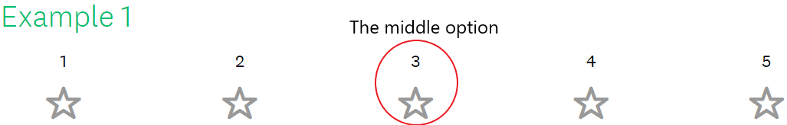
The last question: „When you choose a University, how important are the following?“ asks to grade 20 study abroad factors on a scale from one (1) to six (6). The reason why the ranking scale is from one (1) to six (6) is because it leaves no middle option for the respondents. The suitability of the chosen ranking system is explained with the examples below:

In case the first example is chosen, it becomes impossible to determine whether the factor is of more importance or of less importance to the student. Since the student might choose to rate the factor with number three, which is the middle of the scale, it is not clear if the factor is of more importance to them or of less importance. Thus, the first example is not used in the questionnaire design.
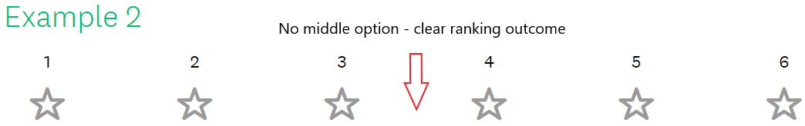
The second example is the most fitting for ranking and is used in the questionnaire design. The reason for its suitability is because of the lack of the middle option. If the student does not have a middle ranking option, then it becomes clear if the factor is on the important or non-important side of the scale. When describing the results, it is easier to categorize which factors affecting the study abroad University choice are considered more important and which are considered less important.
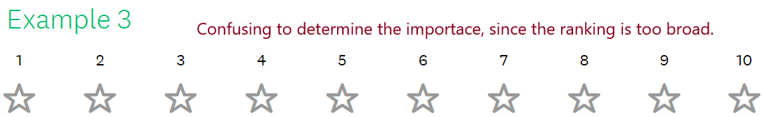

A third example, with the ranking system from one (1) to ten (10) was also considered for the questionnaire design. The reason for its inappropriateness is because it is hard to prioritize the importance of factors. Although this scale also has no middle option, such as the second example, it was still considered inferior to the second example. A scale with too many values to choose from becomes broad and confusing for the respondents. In consequence, the respondents are more likely to give false or unreasoned answers.
The factors that are included in the survey are based on the theory part the research „What are the factors affecting international students’ University choice?” In order to categorize the factors affecting the University choice, Kotler’s and Fox’s (1995) 7P Marketing Mix Model (from now on abbreviated as MMM) has been used. Since the international students can be compared to customers and THUAS can be compared to a company offering a service (the ES program), the MMM is appropriate for categorizing students’ study abroad destination choice factors. An additional 8P has been added to the model, named as ‘Profit’. Since the students choose the University education, assuming that there is certain value to it, it was necessary to create a category which consists of the benefits that the study abroad experience provides. The 20 factors that were selected from the desk research are illustrated in the diagram one below:
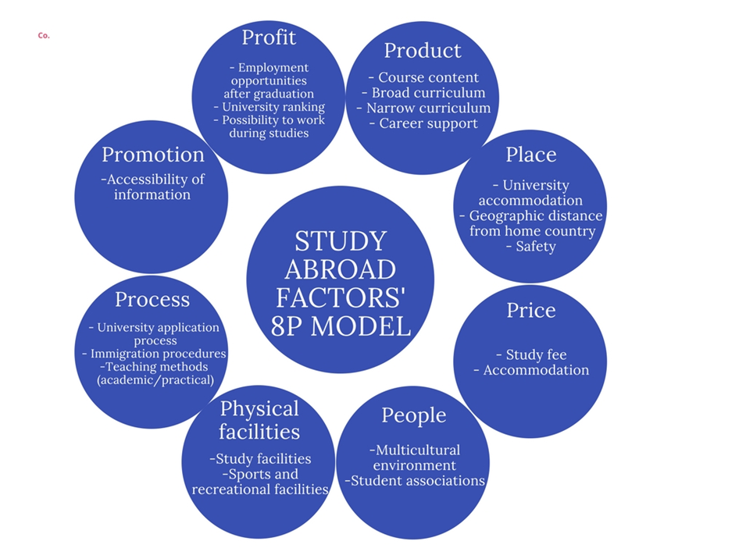
Diagram 1: The 8P model of the 20 factors affecting International students’ University choice
The survey is distributed among Estonian students because the examined participants are international students. Since the dissertation aims to research how to elevate international students’ enrollment, the Estonian high school students are an appropriate target group. Also, the students are in a proper age group, ranging from 17 to 19 years. Thus, they are currently on their last year of the high school and are in the process of searching for a suitable higher education institution program. Since they are thinking about the questions asked in the survey, their answers are relevant and contribute to answering the central question of the study. Lastly, the Estonian high schoolers have most likely never heard about the ES program. Thus, their answers to the fifth question are truthful and give insight about the image of the ES program from an outsider’s perspective.
3.3 Qualitative research method: semi-structured interview
The third research method is a semi-structured interview. A semi-structured interview is, as defined by the The United Nations Terminology Database (UNTERM): „An informal or less formal interview conducted with a fairly open framework which allow for focused, conversational, two-way communication and can be used both to give and receive information.” (cms.unov.org, n.d.). This study conducts two semi-structured interviews.
The interviews with European Studies final year students
The interviews with European Studies final year studies are scheduled after the results from the high school survey have been processed. The chosen interviewees have different nationalities: an Australian, an Indonesian, a Hungarian, a Slovakian and an Italian-French person from Luxembourg. Choosing students from different nationalities contributes to the variety of the answers. People from different cultural backgrounds are likely to provide distinct opinions, since their understanding of study abroad priorities and opinion about the ES program vary.
The students are asked nine (9) questions. The aim of the first question: „Name five keywords that you associate with the ES program” is to have a comparison between associations given by the Estonian high school pupils and the students who are following the program and know it thoroughly. The first question helps to answer the third sub-question. The second question’s answer: “What do you think are the strengths of the ES program?” will contribute to the recommendations chapter. Since the objective of the thesis is to suggest how to increase the international student enrollment, it is necessary to know what do the current ES students consider to be the strengths of the study program. The strengths of the ES should be included in the promotion of the study for the international students. The answers of the third question: “What do you think are the weaknesses of the program?” are asked in order for THUAS to know, what do the students think can be improved to provide improved study experience. Moreover, if the weaknesses of the program are improved, then the current ES students are more likely to recommend the study program to their acquaintances and give a more positive feedback about the course. The fourth and fifth questions: “What do you think makes the program stand out from other studies?” and “What skills have you developed during the ES program?” have similar purpose as question two. The value and skills that the program offers could be used to promote the studies to international students. The answers to the sixth question: “How did you find out about the program?” will help to understand through which information channels should the study program be communicated to international students. The outcomes of the sixth question provide answers to the third sub-question. The seventh question: “Now that you are on the final year of the studies, what do you consider to be suitable employment opportunities for you?” is asked to compare the image of the ES of the Estonian high schoolers and the current students. Questions eight and nine require interviewees’ reaction about the results of the high school pupils’ answers. The ES students have no prior information about the data shown to them. Question eight asks interviewees whether they agree with the high school students’ ranking of the factors affecting the study abroad choice and whether their priorities were the same when they were searching for a fitting program. The eighth question further asks to comment and identify the problems on the two pie charts of the Estonian high school survey. The ninth question will only be asked if the interviewee has identified any issue(s) with the two pie charts. The question is: “Do you have any recommendations how to solve the problem(s) in the two pie charts?”.
An interview with European Studies program coordinator
After the perspectives of the Estonian high schoolers and the ES students have been collected, the study conducts a second semi-structured interview with the ES program communication and promotion coordinator. The interview consists of six (6) questions.
The first question “What is the current enrollment situation in the ES three- and four-year programs?” aims to understand the present international students’ enrollment trends. The second question: “Why do you believe, and do you believe, that it is important to have international students in the ES program?” scrutinizes the motivating factors of the ES program to attract the international students. The answers to the latter will help to compare the research in the desk research part 2.1 ‘The necessity of attracting international students’. The third question: “What do you think motivates a student to do a Bachelor’s degree abroad?” is asked to have a comparison between the desk research, Estonian high schoolers’, ES students’ and the coordinator’s understanding of international students’ motivations. If the four parties’ answers align, the promotion of the ES program intended for the international students should be emphasizing the relevant value. Should the answers not align, this indicates that the ES program’s promotion might be information, which does not engage international applicants’ interest. The fourth question: “Through which information channels is the ES program promoted/communicated abroad?” is asked to compare, if the ES program’s information channels align with the findings in the desk research, those of the Estonian high school pupils’ and the ES students’. Should the answers of ES program coordinator and the other sources differ, it might indicate that the ES program is promoted through incorrect channels. The fifth question: What are some challenges or difficulties with the promotion of the ES program to the international students?” is asked to understand which problems is THUAS confronting with attracting the international students. The last question asks the coordinator whether the there are any further plans or goals regarding the ES program.

CHAPTER FOUR. THE RESULTS
4.1 The results from the Estonian high school surveys
4.1.1 The first sub-question: What are the international students’ study abroad motivations?
Estonian high school students’ interest of studying abroad is high. The first question: “Have you ever considered studying abroad?” gives an overview of how many respondents have expressed interest in studying abroad. Out of 155 people, 132 have considered studying abroad. As shown on the chart one, this is 85.2% of respondents. The 14.8% of respondents have never considered studying abroad. The reasons for not wanting to study abroad will be shown in question four.
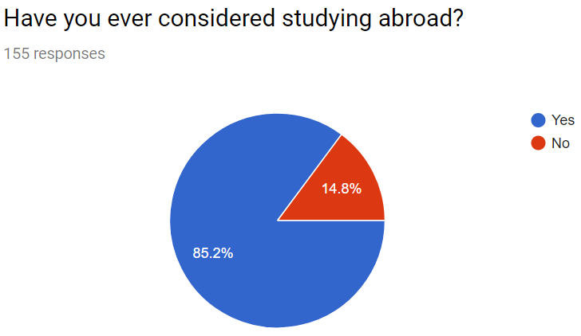

Chart 1. The percentage of respondents who have considered studying abroad

To answer the first sub-question, the second survey question: “Why do you consider studying abroad?” explains what are the respondents’ motivations to study abroad. The second question was applicable only to respondents who answered ‘Yes’ to the first question. Thus, the number of responses is 132. Since it is a multiple answer question, the percentage does not equal to 100% when partitioned between the answer options. As seen on graph one, the top three reasons for studying abroad are “I want to meet new people and create new social connections”, chosen by almost 80% of the students. The second and third most popular reasons, chosen by three fourths of respondents, are “I want to travel” and “I want to improve my language skills”. The fourth most popular reason, selected by 82 respondents was “I want to increase my international job opportunities”. Responses chosen by 50% to 60% of people are: “I want to be surrounded by multicultural environment”, “I want to gain independence” and “I want to live in a country other than Estonia”. Less popular answers included “The program I want to study is not available in Estonia”; “My parents encourage studying abroad” and “Studying abroad is a trend I want to follow”.

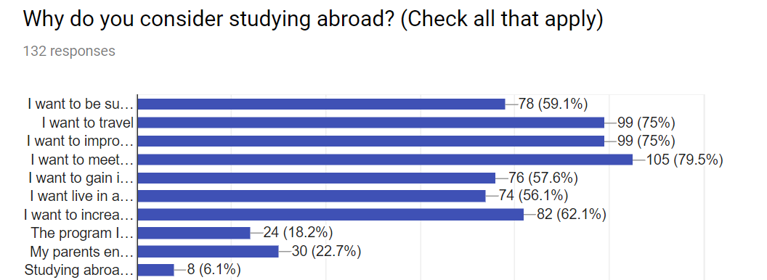
The second question also had an option ‘Other’, chosen by 12 respondents. Five of the respondents expressed their interest to study abroad since foreign Universities offer better quality of education. Other seven answers included “For sports”; “I want to study in English”; “It is cheaper than in Estonia”; “Seems like quite an adventure”; “I already have many friends that live all over Europe/world, I would like to be closer to them”; “I want to experience living in a culture different than Estonia” and “I want to experience something different by stepping out of my comfort zone”.
Graph 1. International students’ study abroad motivations
The fourth question: “Why do you not consider studying abroad?” explains why the international students do not want to go abroad and what the potential obstacles are. The question is mandatory for those who answered ‘No’ in the first question (“Have you ever considered studying abroad?”) and voluntary for those who answered ‘Yes’. Since it is a multiple answer question, the percentage does not equal to 100% when partitioned between the options for an answer.
The top three reasons why the students do not want to or cannot go abroad can be seen in the graph 2. Half of the students answered, “The program I want to study is available in my home country.” This answer was followed closely by two other reasons: “I will miss my friends and family”, chosen by 46.2% of people and “I cannot afford it”, chosen by 43% of people. Almost a third of students think that they are not confident in their language skills. Less than a fifth answered that they dislike change and uncertainty and that it is more beneficial to make connections in the home country. Lastly, less than a tenth of students believe that going abroad is not safe.
Eight participants chose the option ‘Other’. Their answers included “Hard entry requirements”; “I will miss my boyfriend”; “I am not confident in my social skills”; “It is easier to study in Estonian”; “I am lazy”; “My family can afford study abroad, but I do not want to be a financial burden”; “Bachelor degree is useless anyway, so it does not matter where I do it. I would rather do a Master’s degree abroad” and “I am afraid that I can’t survive living in a new environment and it’s too hard for me to understand the subject I want to study. I fear that I cannot handle the stress.”
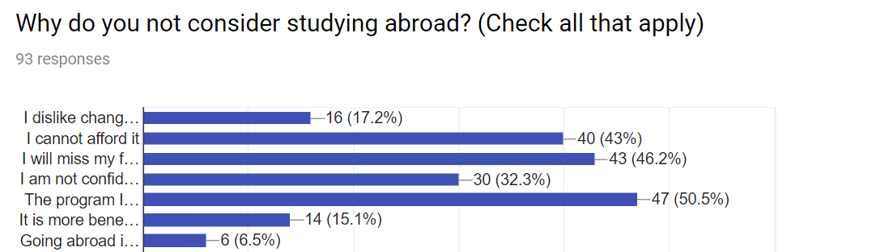
Graph 2. The reasons of not wanting to study abroad and the obstacles

4.1.2 The second sub-question: what factors affect international students’ study abroad choice?
The sixth question „When you choose a University, how important are the following?“ consisted of 20 factors. The students were asked to rank the factors on the scale from one (1) to six (6). The 20 factors were selected from the theory and rationale chapter, since these motivations were mentioned the most, when considering to study abroad. The outcome of the ranking answers the first sub-question: “What factors affect international students’ choice of University?” The factors were categorized in the 8P table, on the page 18. The outcome of the ranking results can be seen in the graph 3:
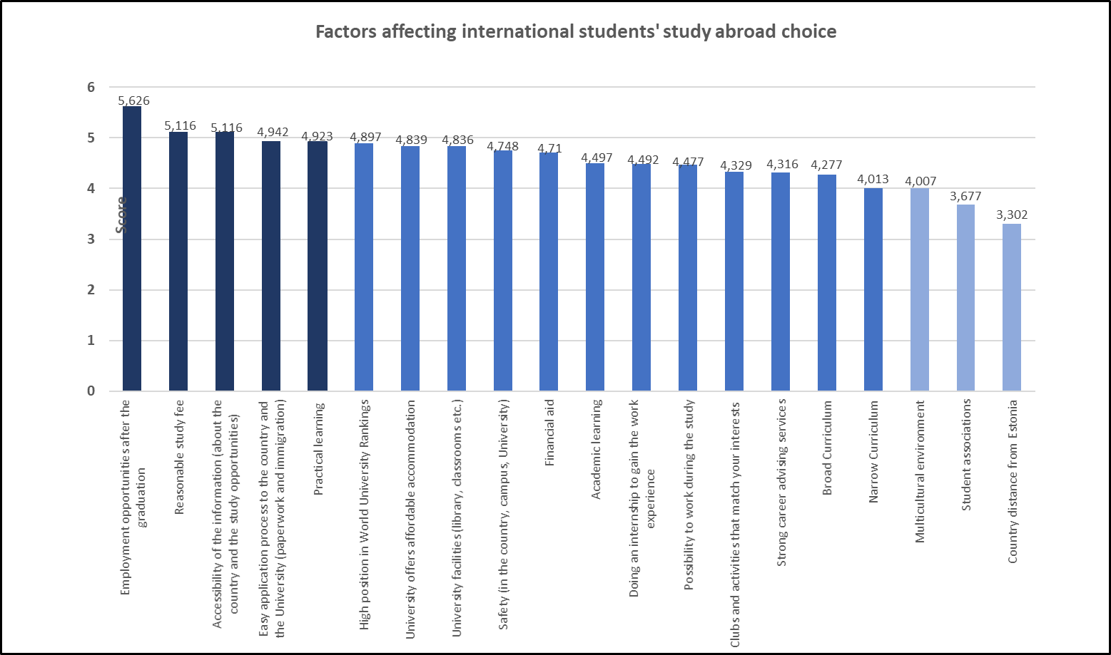
Graph 3: Ranking of the 20 factors affecting the study abroad choice
4.1.3 The third sub-question: Through which information channels do the international students search for a study program?
The third question “Which information channels do you use when searching for a University?” researches which information channels are used the most by international students. The question was only applicable to respondents who answered ‘Yes’ to the first question. Thus, the number of responses is 132. Since it is a multiple answer question, the percentage does not equal to 100% when partitioned between the options for an answer.
The most used information channel is the Google search engine, chosen by 87.1% of participants. The second most used information channels are the University websites, that more than three fourth of the participants visit. Channels chosen by less than half of people were: education fairs (42.4%), relying on word-of-mouth referral (39.4%) and social media (32.6%). The least popular information search channels were Bachelor degree databases (24.2%) and attending the University’s ‘Open Day’ (20.5%). The third question also had an option ‘Other’, which was chosen by six respondents. Three of the respondents answered that they search for a University by ‘World University Rankings’ and three students mentioned ‘Dream Foundation group’, which is an Estonian private company providing high schoolers with study abroad services. They help to choose the most suitable University course, based on the person’s interests and assist with the study abroad application process.
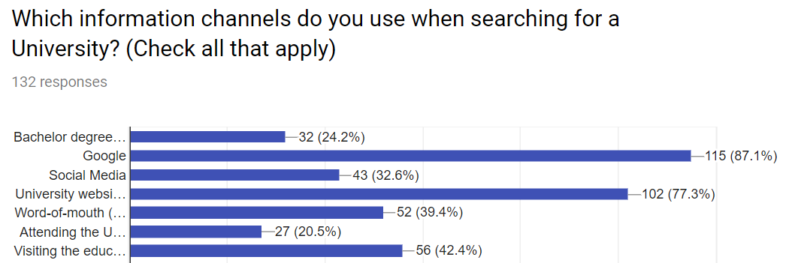
Graph 4. International students’ choice of the information channel

4.1.4 The fourth sub-question: What associations do the international students have with the European Studies program?
The fifth question was „There is a Bachelor’s degree called ’European Studies’. What courses could be in this program? What are the employment opportunities in this program?“ This question was an open question and was asked in order to understand what do the young people, who have never heard about the ES program, think of it. The objective was to understand what is the image of the ES program and what kind of associations does the program’s name create in peoples’ mind. The fifth question answers the third sub-question. The answers for this question are divided into two parts. The first pie chart shows the answers of the first question „What courses could be in this program?“ and the second chart demonstrates the answers for the second question „What could be the employment opportunities in this program?“.
Since the fifth question was mandatory to answer, all 155 respondents gave their opinion. If the respondent wrote that (s)he does not know the answer to either of the questions or the question box was left blank, then the answer is labeled as ’No answer’. Since it is an open answer question, the percentage does not equal to 100% because one student might have given several answers.
Furthermore, since the fifth question was an open answer question, students’ answers have been compressed into appropriate shortened terms where necessary. For example, in the question „What courses could be in this program?“, a respondent replied following: „I think European Studies is something where you learn about the interaction and relations about the different countries of Europe.“ In this example, the answer has been shortened to the course name ’International Relations’. A second example from the second question „What are the employment opportunities in this program?“ a student answered: „Seems like a degree with what you can work at the companies that are related to the European Union.“ In this example, the answer has been shortened to ’EU Institutions’.
In the second chart, Estonian high school pupils predict what courses and subjects might the European Studies program contain. As seen from the second chart, 45 people, which is a third of respondents, do not associate the ES program with anything. Further development on this outcome can be read in the analysis chapter. The five most popular answers were Politics 24% , History 20.7%, Culture 18%, Languages 17.4% and International Relations 14.8%. These five courses were followed by less popular options, which can be seen in the pie chart two. The respondents who wrote other than the answers shown by the pie chart, were included in chart ’OTHER’. They believed the ES program has courses such as Sports, Cultural integration, Analytics, Religion, Maths, Statistics, Social skills, Geography, Demographics, Literature, Gender Studies and Marketing.
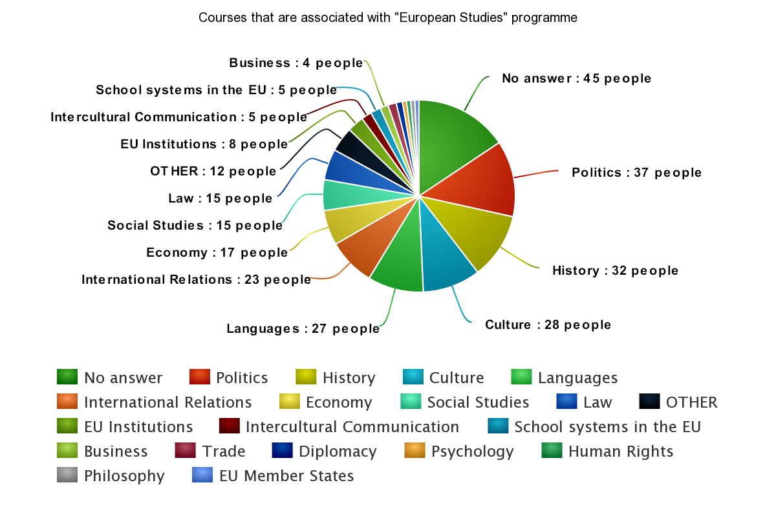
Chart 2: The courses that international students associate with the European Studies program

In the third chart, the respondents give their opinion about what could be the employment opportunities after graduating the ES program. As seen from the third chart, 68.4% gave no answer. Further development on this outcome can be read in the analysis chapter. Besides the option ’OTHER’, the three most popular answers were Politician 7.7% , European Parliament 6.5% and EU Institutions 6.5%. Under the option ‘OTHER’, the high schoolers thought that after graduation, one could work as a scientist, social activist or journalist. Other guesses include working at Human Rights Organizations, communication-related jobs, at the UN, in the foreign ministries, in NATO, at UNICEF, at the public relations, in media or doing international work.
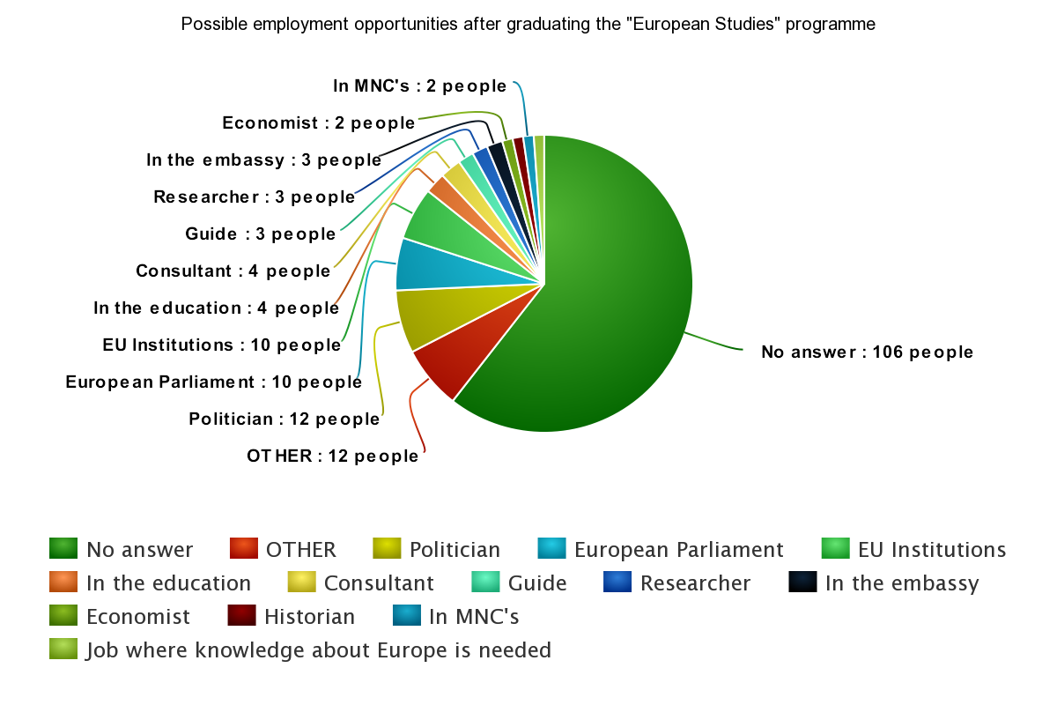
Chart 3: International students’ associations with employment opportunities after the graduation from the European Studies program.

4.2 The results from the European Studies students’ interviews
Five ES final year students were asked nine (9) questions. Their answers are displayed and described below. Students’ full-length answers are included in the appendix number three, on the page 67. As seen from the fourth chart, the keywords that the students associate with the ES program are interdisciplinary, international, practical, which were mentioned by four students out of five. Less mentioned keywords were teamwork and disorganized. Under the option ‘OTHER’, keywords such as variety, current, social, small groups, direct, languages, politics and unique were mentioned.

Question 1: Name five keywords that you associate with the European Studies program
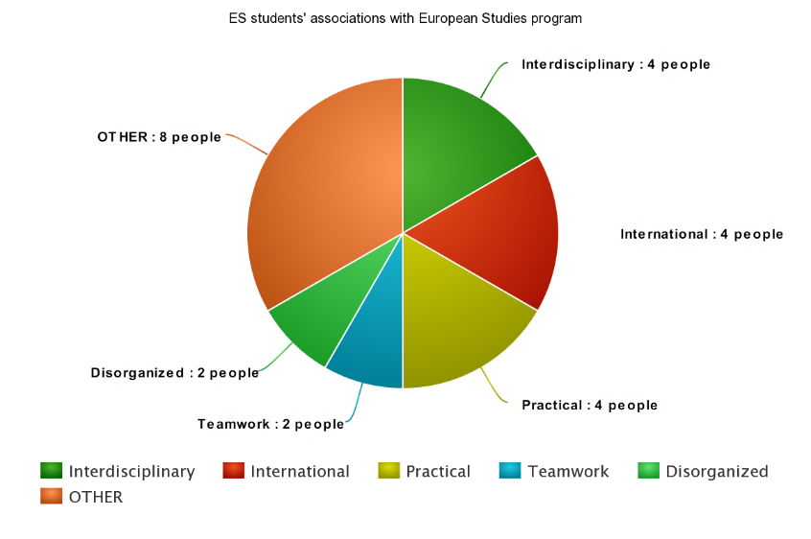

Chart 4: ES students’ associations with the European Studies program
The fifth chart displays what the students think the strengths of the program are. All five students emphasized that the strength of the program is practicality. Moreover, factors such as multicultural, interdisciplinary and language study are seen as a strength. Under the option ‘OTHER’ students mentioned the helpful and knowledgeable teachers, students developing the research skills, University being accommodating and the University looking pretty.

Question 2: What do you think are the strengths of the European Studies program?
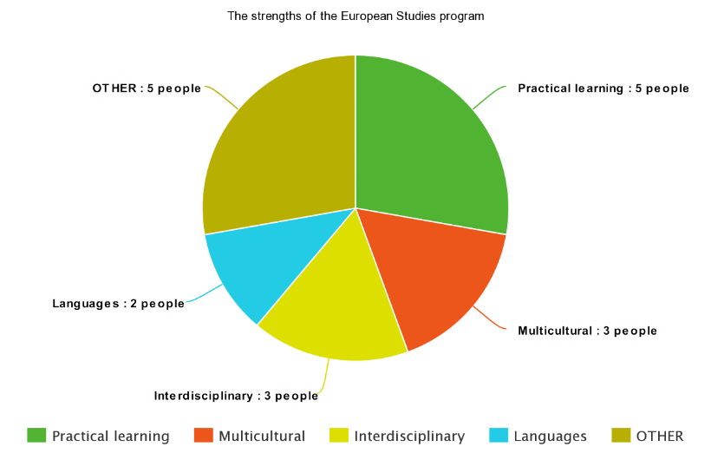

Chart 5: The strengths of the European Studies program
In contrast, as seen on the chart six, all the interviewees mentioned that the ES program is poorly organized, and the teachers can be unreachable or unhelpful. Under the option ‘OTHER’, the weaknesses included lack of the excellence program, the broadness of the program and the strict-guidance/spoon-feeding. Students’ explanation of the weaknesses can be read in appendix four.

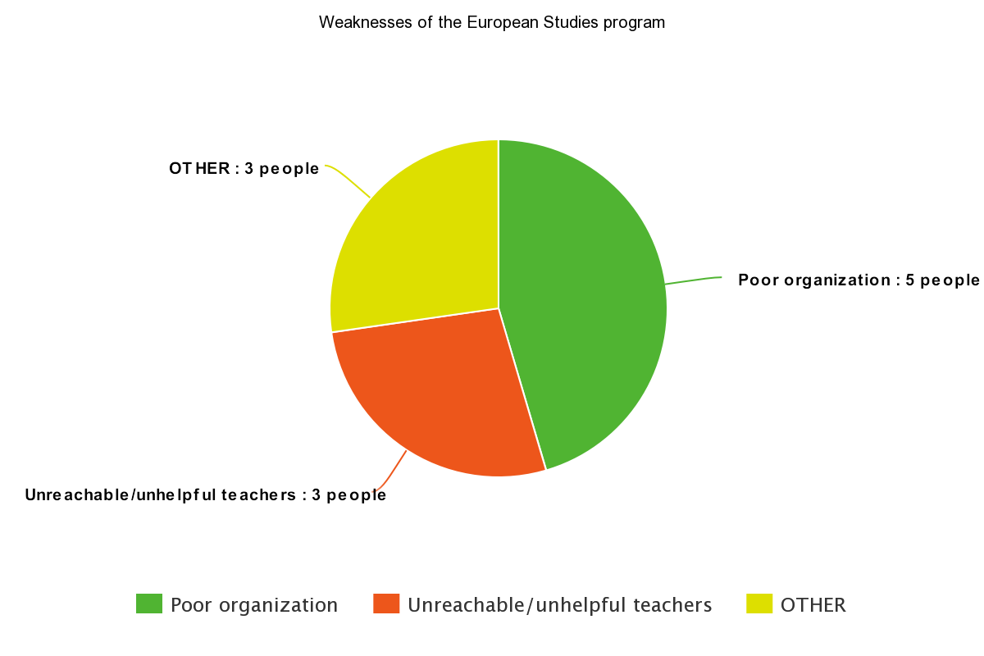
Question 3: What do you think are the weaknesses of the program?

Chart 6: The weaknesses of the European Studies program

Following, the students were asked if the program has a certain value or bonus that other studies do not. As seen from the chart seven, students appreciate the multicultural environment, the interdisciplinary curriculum, possibility to learn languages and the practical study. In the option ‘OTHER’, teamwork, applied sciences education and possibility to specialize were mentioned.

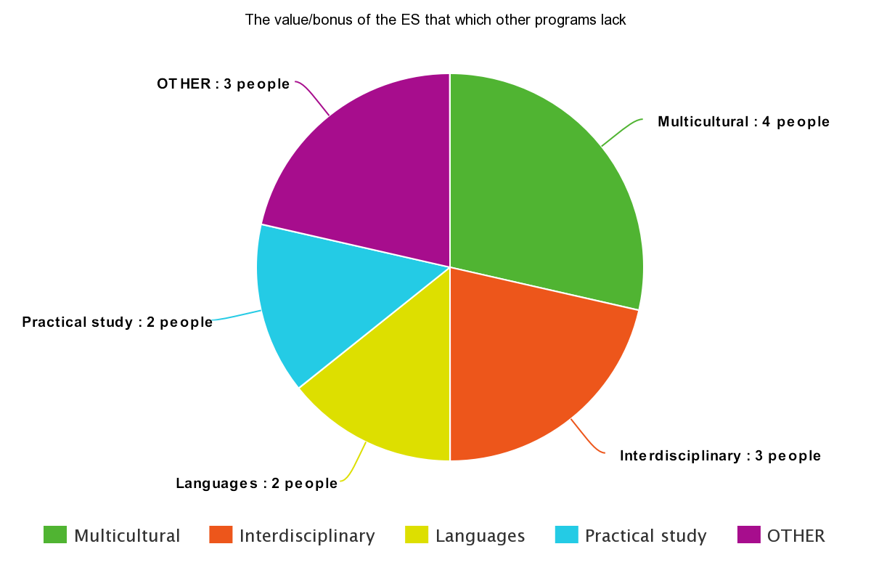
Question 4- What do you think makes the program stand out from other studies? A certain value or bonus that other Bachelor degrees are missing?
Chart 7: The value/bonus of the European Studies program which other programs lack
The next question aimed to discover what skills have the students developed during the studies. The eighth chart shows that students have been taught public speaking, research, intercultural communication and English skills. Other expertise that were mentioned are structured writing, teamwork, ability to critique information and open-mindedness.
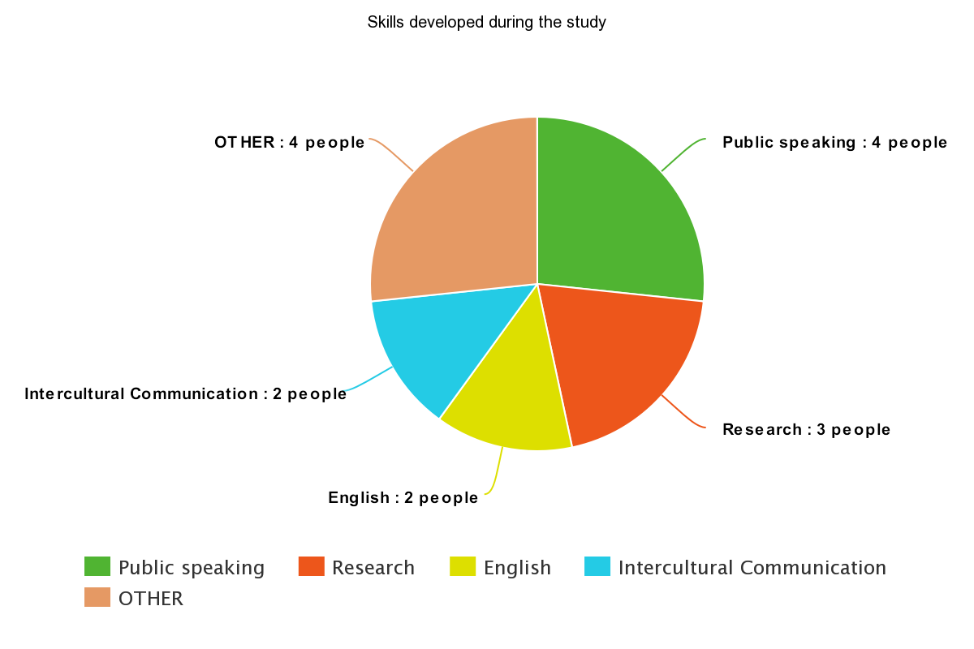
Question 5- What skills have you developed during the ES program? List either practical, academic or social skills.

Chart 8: Skills developed during the study

The sixth question asked how and through which information channel did the students discover the ES program. The answers differed for each student. The six mentioned channels are: promotion from my high school, the University website, an organization providing study abroad services, word-of-mouth referral, Bachelor’s degree database and the Google search engine.

The seventh question asked which employment field do the students consider after graduating the ES program. The first interviewee considers following a Master’s degree to further specialize. The second interviewee also wishes to continue the education with a Master’s degree in a business-related field. The third interviewee considers management roles in the public sector or research-related position as suitable employment considerations. The fourth interviewee wishes to work for a while before continuing with studies for a Master’s degree. The considered fields include crisis communication, public relations, digital media and social marketing. The last interviewee is considering a public-sector position in a private company. Her examples included law-, public relations- or media-related jobs.
Questions eight and nine asked the ES students to reflect on the outcomes of the Estonian high school pupils. In the eighth question, the ES students opinioned on the ranking of the 20 factors that affect the study abroad choice. The interviewees’ opinions of the highest ranked factors were mostly in accordance with their own priorities. The reasonable study fee and practical learning were also considered important by the ES students. However, the students mentioned that the highest ranked factor ‘Employment opportunities after graduation’ was important, but not a priority when they searched for a program. Regarding the lowest ranked factors, the students agreed that the home country distance from the country of study destination is not of major importance. The ES students also agreed that student associations are not a priority when searching for a study abroad program. However, most of the interviewees disagreed with the low importance of the multicultural environment, which they would rank higher. Other differing opinions were about the ranking of the possibility of doing an internship, which is why many ES students chose the program.
The interviewees were also requested to comment on the two pie charts. The first chart demonstrated what the Estonian students think about the content of the ES program. The interviewees mentioned that the courses are accurate, considering that the answers were given by people who have never heard about the ES program. The ES students identified a problem on the first chart. According to them, the high schoolers only thought about the public-sector and culture-related courses, such as politics, languages, international relations and history. However, not many participants associated the ES degree with private-sector courses. Yet, the students who choose the private specialization are following the private sector courses. Should the student choose a public specialization, the curriculum is composed in such manner that they will continue following a few private-sector courses.
On the second pie chart the ES students identified two issues. The first issue is that majority of the high schoolers do not know the employment opportunities after the graduation. The second issue being that the high schoolers imagine the ES graduates working only in the politics field or in the EU-related organizations. ES students suggested that the program does not only enable a graduate to work for EU institutions and public-sector but also for the private-sector, non-governmental organizations (from now on abbreviated as NGO’s), in a start-up or as an entrepreneur.
The ninth question requested the ES students to propose solutions to the problems identified on the two pie charts. For the problem identified in the first pie chart, that students imagine the ES to only have public-sector and culture-related courses, two solutions were proposed. For potential applicants to understand that the ES program is focused on both public- and private-sector courses, one interviewee suggested including the ES program in multiple categories in the Bachelor’s degree databases:
“People browsing the Bachelor degree databases usually have a keyword or a category they look into. If the ES was included under many categories, it would keep popping up every time. That might make the student think: ’What is this study? It keeps popping up every time. Why is that so? Maybe I should check it, there has to be a reason for that.’ That could potentially spark interest in more people. Rather than just putting it under one section, it should be included in more categories. After all, ES in not about one thing, it falls under many categories.“(Interviewee number five, 8. December 2017, personal interview, appendix 3, question 9, solution five, p. 88).
Another interviewee proposes a solution regarding the content of the ES website:
“The fact that the people do not know what the program is and what it contains, could be solved, for example, if the program was more specified. If, in addition to the name ‘European Studies’, there would be written a few disciplines such as X, Y, Z, the content of the study would become clearer.”(Interviewee number one, 8. December 2017, personal interview, appendix 3, question 9, solution one, p. 87).

On the second pie chart, two problems were identified. Firstly, that people do not know the employment opportunities after graduating the ES program. Secondly, that people imagine the graduates working in politics or in the public-sector. The students proposed several solutions, while most of them emphasize on the importance of word-of-mouth referral. Majority of the interviewees advise to promote the studies in foreign high schools. A graph with all the suggestions can be seen below:
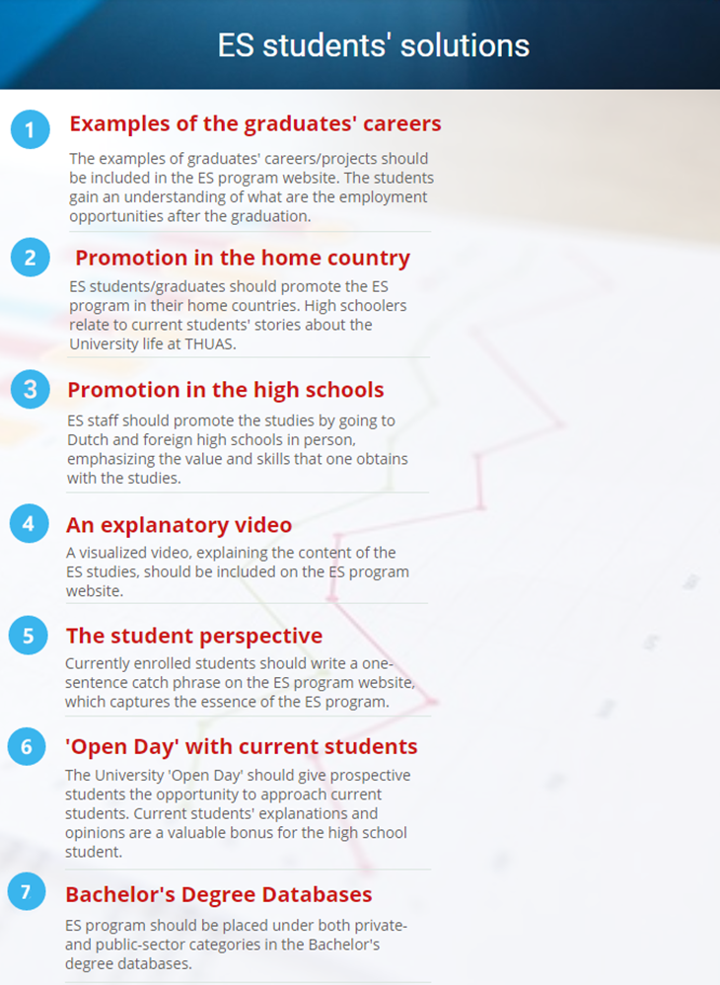
Graph 5: The solutions ES students propose to promote and clarify the content of the European Studies program

4.3 The results from the European Studies program promotion and communication coordinator Dave van Ginhoven
The interview with Mr. van Ginhoven answers the questions from THUAS’s perspective. The answers for this dissertation’s sub-questions are given exclusively about the ES program. Therefore, chapter 4.3 answers what are ES program international students’ study abroad motivations, through which channel they find the program and what affects their choice to study at THUAS.
4.3.1 What are the international students’ study abroad motivations?
Mr. Van Ginhoven’s research has shown that there are three main motivations for international students to study abroad: career options, tuition and the study environment. The coordinator has said the following about the three aspects:
„One of the most important things, for any students, are their career aspirations. When I talk to young people about our program, does not matter where they are from, they want to know: ‘What kind of a job am I going to get?’ Young peoples’ moms and dads, they want to know: ‘Is my son/daughter going to get a job in four years? And if they will, what kind of job is it?’” (van Ginhoven, D., 18. December 2017, personal interview, appendix 4, question 3, par. 1).
“In some cases, it has got to do with the tuition - we have some of the cheapest tuition in Europe. If you are a European and looking for an international career, then chances are, you want to be educated in an international, English environment. So, if you want to do an English language international study, and you do not want to pay £9000 a year, the Netherlands is the place you go.” (van Ginhoven, D., 18. December 2017, personal interview, appendix 4, question 3, par. 2).
“The motivations have also got to do with the reputation of the Netherlands. It is known as a fun place for young people, there are certain things you can do here, which you cannot do in another countries, at least not officially).” (van Ginhoven, D., 18. December 2017, personal interview, appendix 4, question 3, par. 3).

4.3.2 What factors affect international students’ study abroad choice?
According to the ES coordinator, the enrollment of the international students in ES is declining. The ratio of Dutch and international enrollments has not changed: 80% of home students and 20% of international students. However, the overall enrollment is declining, both in the four-year and three-year program. The reasons for enrollment are associated from both micro and macro environment factors.
From the micro environment factors, the coordinator mentioned the competition, the customers (the students), the general public and technology. Firstly, THUAS competes with other higher education institutions in The Hague: Leiden University, Hotelschool The Hague, Royal Academy of Art, Royal Conservatory in The Hague, International Institute of Social Studies and several more. Also, there is direct competition with Leiden University’s Bachelor’s programs such as International Studies and International Law. Also, customers’ (students’) reasons for buying the product (ES program) were mentioned. The declining numbers can be associated with the problem of perception of the Applied Sciences study. The students’ and general public’s tendency to consider a research University superior to Applied Sciences University has caused a decline in enrollment (van Ginhoven, D., 18. December 2017, personal interview, appendix 4, question 5, par. 2). Lastly, the coordinator mentioned a technological factor, which is the enrollment process:
“The enrollment procedure is complex and takes time, since The Netherlands is a bureaucratic country. For a student, it takes quite a long time to hear whether their application is accepted. Efforts are under way to speed things up: people making the improvements work hard. Also, you’ve got to evaluate peoples’ diplomas from all over the world. Imagine someone comes from Tajikistan: we have to find an expert who can tell, which level it equals- HAVO, VWO or VAVO, and it takes time.” (van Ginhoven, D., 18. December 2017, personal interview, appendix 4, question 5, par. 3).
From the macro environment factors, Mr. van Ginhoven mentioned the political, economic and socio-cultural factors. Firstly, as a political factor, there was a change made in Dutch education system law, which roughened the requirements for following a VWO education in the high school. Since the ES three-year program is targeted towards Dutch people with VWO education, the enrollment numbers among Dutch declined (van Ginhoven, D., 18. December 2017, personal interview, appendix 4, question 1, par. 1). Consequently, the ES fast-track program has become more international. Secondly, the economic factor includes the tuition fee. THUAS has a fierce competition with other EU countries’ tuition, despite having one of the most affordable study fees for the EU citizens (van Ginhoven, D., 18. December 2017, personal interview, appendix 4, question 3, par. 2). Moreover, the internationalization of the EU Universities was mentioned. More Universities attempt to attract international students by offering English taught programs (van Ginhoven, D., 18. December 2017, personal interview, appendix 4, question 5, par. 1). Since there is more competition, THUAS’s attempt to attract international students requires further efficient promotion efforts.

4.3.3 Through which information channels do the international students search for a study program?
The coordinator mentioned that the program is promoted by both the University and the ES students. The Univesity uses various information channels: education fairs, educational agencies, promotional organizations, the University website, Bachelor degree databases, fliers and leaflets sent to the high schools, visits to the high schools, social media (Instagram, Facebook, YouTube) and individual approach (personalized postcards) (van Ginhoven, D., 18. December 2017, personal interview, appendix 4, question 4, par. 1-6). Promotion by students includes the word-of-mouth referral and creation of the social media content. However, the ES enrollment statistics show that majority of international students have discovered ES program through two main channels: the University website and word-of-mouth referral (van Ginhoven, D., 18. December 2017, personal interview, appendix 4, question 4, par. 3).

CHAPTER FIVE. ANALYSIS
5.1 The first sub-question: What are the international students’ study abroad motivations?
Based on the desk research, students are motivated to go abroad for multiple reasons. Since 85.2% have considered studying abroad, the reasons vary. The motivations can be divided into three main groups: educational, career-related and personal reasons. Some of the motivations may be categorized under multiple groups. The educational reasons include gaining study credits and combining the study abroad experience, obtaining better education, the course not being available at home country Universities. The career-related reasons include hands-on career development, enhanced employment opportunities and possibility to improve foreign language skills. Personal reasons include the intention to migrate to study abroad destination, discover other cultures besides own culture, possibility to travel and meeting people from various cultures and gaining new experiences.
The survey distributed in Estonian high schools supports the desk research. However, majority of the participants mentioned the personal motivations. The participants’ top three motivations for studying abroad, selected by more than three fourths of participants were the wish to meet new people and create new social connections, to travel and to improve language skills. More than half of participants said their motivations were increasing their international job opportunities, wanting to be surrounded by multicultural environment, becoming more independent and they want to live in a country other than Estonia. It can be concluded that Estonian high schoolers’ study abroad motivations align with the motivations described in the desk research, with majority of them emphasizing the personal motivations.
The desk research is further supported by the ES students’ answers. However, contrary to Estonian high schoolers, the ES students chose the ES program more for career-related reasons. The first participant chose the study program to learn languages, to go do an internship and to have a study exchange experience. The second participant chose the ES because of her aim to become a diplomat, since ES has courses and teaches skills that are needed in her field of work. The third participant’s reason for choosing ES program was personal- the interviewee wished to know more about Europe from political, legal, geographic and historical perspective. The fourth and fifth participants chose the program for both career-related and personal reasons. The fourth participant first did an academic program but decided to enroll in an Applied Sciences University. She believes that the Applied Sciences education has more value on the job market. Also, she chose the program to become more open-minded, since the studies are multicultural and international. The fifth participant chose the program because of the curriculum, since it aligns with her wish of the future employment field and because of the international environment.
The desk research, survey and interview with ES students are further supported by the ES program coordinator’s research. According to him, the three top motivations to study abroad are employment opportunities after graduation, tuition fees and the study environment in the country of study destination and the University (van Ginhoven, D., 18. December 2017, personal interview, appendix 4, question 3).
5.2 Through which information channels do the international students search for a study program?
Based on the desk research, the information channels international students use the most to search for a study program abroad can be divided into three categories. Firstly, the direct channel- getting information directly from the University. An example of the direct information retrieving would be attending the University’s ‘Open Day’. Secondly, the social channel, which is the word-of-mouth referral. The examples of social channels are friends, family, acquaintances, student groups or associations and organizations providing educational services. The last category is composed of media channels. As suggested by the desk research, when searching for a study abroad destination, the media channels students use are mostly internet based sources. These include search engines, websites, blogs, social media platforms and e-mails.
Majority of the desk research emphasizes that social channels (word-of-mouth referral) are the main determinant of international students’ study abroad choice. It is likely that relatives or friends who graduate, work or travel in the country of study destination, and enjoy the experience, will recommend it to their family and friends. Another influencing attribute are the student networks. It is suggested that students’ associations, groups and clubs are effective to communicate the study abroad destinations.
However, the surveys distributed in Estonian high schools and the interviews conducted with the ES students determined that the most preferred information channel is media. Based on the outcome of the survey, 87.1% of participants use Google search engine and 77.3% use the University websites as their primary channel of information. The importance of social channels is also significant, since 42,2% of the students visit education fairs and 39.4% rely on word-of-mouth referral. The least used information channel is the direct source. Only 20.5% of students have attended the University’s ‘Open Day’. Similarly to the Estonian survey outcomes, the ES students’ information channels were either social (promotion from the high school, an organization providing study abroad education services and word-of-mouth information) or media channels (Bachelor degrees database, Google search engine and the University website). Furthermore, the ES program coordinator confirms that most of the students reach the program through University website (media channel) and secondly, through acquaintances (word-of-mouth referral).

5.3 What associations do the international students have with the European Studies program?
To understand what assumptions do the international students have with the ES program, two methods were used. First, the survey distributed in the Estonian high schools asked two questions about the ES program. Secondly, five international students in the ES program were asked what keywords do they associate with the program.
Two pie charts were included in the results chapter which demonstrated what do the Estonian high schoolers think about the program. The first one showed which courses do the high schoolers associate with the ES program. The second chart demonstrated what employment opportunities would a student have after graduating the ES program. Based on the results, the courses associated with the ES program were accurate. However, two issues were identified with the students’ answers. Firstly, a third of students gave no answer, which indicates that they do not know what the program contains. Secondly, most of the answers were either public-sector or culture-related courses. However, the ES program focuses also on the private-sector courses. It seems that people, who have no prior knowledge about the program, do not associate the ES curriculum with private-sector courses.
The second pie chart demonstrates similar issues. Firstly, 68.4% of students do not know what are the employment opportunities after graduating from ES program. Secondly, the assumed employment opportunities only included positions in the public sector. Almost no participants mentioned employment in the private sector, NGO’s, start-ups or entrepreneurship.
To solve the two issues, the ES students were asked to comment and advise on the results of the pie charts. The potential solutions for the two identified issues were demonstrated in graph 5, on the page 35.
5.4 What factors affect international students’ study abroad choice?
The academic papers used for the desk research each proposed a model or a categorization for the factors that affect international students’ study abroad choice. This study selected 20 factors that were ranked the highest and mentioned the most.
These were categorized into Kotler’s 7P Marketing Mix table. An additional, 8P was created and labeled as ‘profit’ and added to the diagram one, on the page 18. These 20 factors were then used to survey the Estonian high school students, to understand which are the most important factors. The survey outcomes indicate that the top five most influential study abroad factors and the three least important study abroad factors are, as shown in the second and third diagrams below:
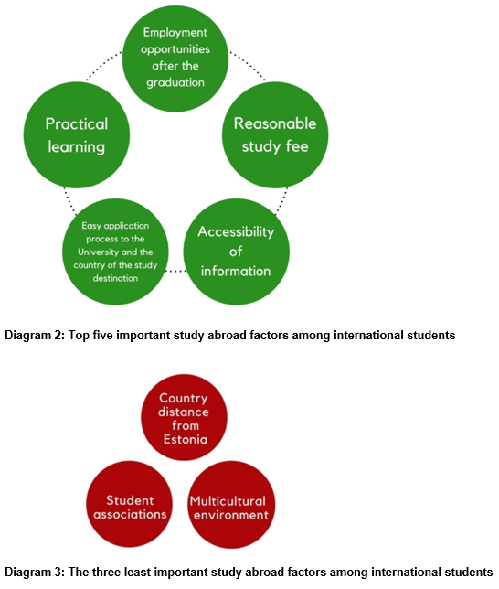

However, there are a few differences in the ranking of the study abroad factors between the Estonian high school and the ES students. The factor that the ES students consider the most important, or would have ranked higher, is the multicultural environment, which was mentioned by all five interviewees. The ES students also mentioned that their reason for choosing the study program were the opportunity to complete an internship and to participate on the study exchange. The two factors which both ES and Estonian high school students considered important were reasonable study fee and employment opportunities after the graduation.

CONCLUSION
The research shows that international students’ study abroad motivations can be divided into three main categories: career-related, academic and personal motivations. The main career-related motivations include improved employment opportunities after the graduation and developing the practical skills needed on the job market. The main academic motivations are the improvement of the foreign language skills and foreign Universities offering higher quality of education than home country Universities. Personal motivations include the possibility to travel, meeting new people and creating new social connections, being surrounded by multicultural environment, gaining independence and possible future migration to the country of the study destination. It can be concluded that the prevailing study abroad motivations are career-related and personal since these were mentioned the most by Estonian high schoolers, ES students and the ES program coordinator and were further supported by the desk research.
The main factors affecting international students’ study abroad choice are linked to the study abroad motivations, since the most influential factors are employment opportunities after the graduation and practical study approach; these two factors were mentioned by both Estonian high school and the ES students. For Estonian high school pupils, further important factors are reasonable study fee, accessibility of information about the host country and the study opportunities and easy application process to the country and to the University (migration and enrollment process). For the ES students, further important factors are multicultural environment and the possibility of doing an internship and study exchange.
The desk research suggests that the most prominent information channel for the international students is the word-of-mouth referral. Thus, the positive feedback and suggestions about the country of study destination or the study program from relatives, friends, acquaintances, professors, high school, education fairs and student associations is considered to be the most influential for international students’ study abroad choice. In contrast, the survey and the interview with the ES program coordinator both confirm that the most used information channel is the media. The results demonstrate that Google search engine and University website produce the most enrollment to the ES program. Therefore, the two information channels, word-of-mouth referral and media, are the most influential study abroad information channels.
The associations of the ES program differ among the students who have no prior knowledge about the program and the currently enrolled students. The high schoolers believe the program to have public sector and culture-related courses, while the ES students mention private- and public- sector, language and cultural courses. The high school students do not know what are the employment opportunities after graduating the ES program; few of them mention employment in politics or EU institutions. The ES students suggest that the ES program allows to be employed in public or private sector, NGO’s and start-ups.

RECOMMENDATIONS

The recommendations chapter includes ES students’ and author’s suggestions, based on the analytical work conducted with the current dissertation. The promotion strategies mentioned by the ES students, but which are already being implemented by the University, are excluded. Since the central question concentrates on information channel(s) and message content, the recommendations are presented in two categories: information channel and the content and message.
Recommendations for the information channels
- Bachelor Degree Database classification
As suggested by an ES students, since the ES program’s curriculum has both public- and private-sector and culture-related courses, it should be included under many categories or keywords in Bachelor Degree’s databases. Currently, the studies can be found only under the politics and international relations category. Including the program name under multiple categories might attract more people to view the content of the program. In consequence, more people might initially find and finally choose the program.
- Direct promotion
In the interviews with the ES students, three students suggested that the ES staff should promote the study program in foreign high schools. Thus, ES students believe that promoting the service to potential customers directly is likely to increase the enrollment to the study program. Considering the international nature of the ES program, it is advisable to target high schools with an IB program, the schools that are foreign language oriented and the Eastern European market, since the example of Estonian high school students showed that 85.2% of students have considered studying abroad.
- Referral program
The research emphasizes that the word-of-mouth referral is one of the most influential information channels for study abroad choice. Therefore, promotion efforts should be made also by the ES graduates or currently enrolled students. They should visit high schools in their home country and inform the students about the content of the ES program and studying in THUAS.

- Social Media

- Since social media was one of the intermediaries through which the high schoolers search information about the study abroad opportunities, the ES graduates and currently enrolled students should share ES studies related content on their social media. For example, if the University organizes an ’Open Day’, the students could share the event on their social media wall.

- According to the ES program coordinator, the program is not yet promoted through internet advertisements which would appear in targeted people´s feed. Thus, it is suggested to use the ES program advertisements on the websites which are visited the most by the generation Z:
- Social media such as Facebook, Instagram, Snapchat and YouTube (Nanji, graph 1)
- Entertainment websites such as Netflix, Twitch or Spotify (Alexa n.d.).
- Utility websites such as eBay or Amazon (ibid).
- On the website of the brands, that the generation Z young adults like.

- Search engine optimization
The ES program attracts majority of the students through Google search engine, which leads the students to the University website. Also, Estonian high school students’ survey results show that the most used media channel to search for study abroad opportunities is the Google search engine. Thus, it is advisable to enhance the visibility of the ES studies by optimizing the search engine results. Consequently, the targeted audience would see the ES program website among first search results whenever a certain keyword is typed.
- ES program website
As mentioned in the previous paragraph, a significant number of ES students retrieve information about the program through the University website. Although ES program website already contains relevant and visually appealing content, it was further suggested by an ES student to add an explanatory video of the ES content. The student further suggested uploading the video in that part of the website, where it is visible and easily navigated. A video is likely to enhance the potential students’ interest in the study program.

Recommendations for the content and message
- Relevant study abroad motivations
Based on the results from the Estonian high school pupils’ survey and the interviews with the ES students, certain study abroad motivations are more important than others. The motivations which need to be emphasized when promoting the studies are personal and career-related motivations. Since these two categories were mentioned the most, they are likely to attract the high schoolers’ interest to choose the ES program.
The personal motivations that need to be mentioned are:
- The possibility to travel: The Netherlands is situated geographically close to many other European countries, many of which are cultural heritage, entertainment, shopping and sightseeing spots.
- Meeting people and creating new social connections: Estonian high school survey results show that 80% of students’ motivations for studying abroad was meeting people and creating new social connections.
- Being surrounded by multicultural environment: As mentioned by the European Studies students, one of the reasons for choosing the ES program was the possibility to study together with colleagues from different nationalities and backgrounds.
- The study exchange semester: The ES students also emphasized the opportunity to go on an exchange semester to another country during the second/third year of the program.

The career-related reasons need to be emphasized by mentioning the skills that a student obtains from the ES program. The skills that students obtain from the program were mentioned by the ES students in appendix 3, on the page 74-77.
- Public speaking and presenting skills: speech, pitch, presentations
- Research skills: the ability to critique and analyze different types of media and other written content.
- Writing skills: press release, speech, dissertation, marketing plan, export plan, public policy plan.
- Intercultural communication
- Academic English
- Teamwork

- Demonstrating the value of the program
When the ES students were asked what they consider as the value of the program, their answers included colleagues and lecturers from different nationalities and backgrounds, practical study methods, assignments in teams and a lot of teamwork, the interdisciplinary program, possibility to follow foreign language courses and that the students specialize on the second year of the studies. These strengths need to be communicated to international students in order to show how the ES program differentiates itself from other study programs and what value is offered to potential students.
- Emphasizing the visual aspect of THUAS
The University visuals need to be included while promoting the studies to international students. As mentioned by an ES student, when she was browsing for study programs, one reason for choosing THUAS was because she found the University architecture pretty. Since visuals create the first impression, the presentation of the University in foreign high schools needs to demonstrate the University’s modern facilities, catering, unique architectural solution and its proximity to the city center.
- Emphasizing the employment possibilities after graduating the ES program
Estonian high school students, ES students and the ES program coordinator attest that employment opportunities after the graduating are an important factor when choosing a study abroad program. Thus, it is necessary to explain what employment does the European Studies give to the graduates. A list of possible job positions has been already included on the ES website. In addition, as suggested by an ES student, when the ES staff visits the high schools, it is often not the job title that the high schoolers wish to hear, but rather the job description. The student further explains that the nature of the job that ES graduates have should be put into question form: „Do you want to work in an international organization?“, „Do you want to work in a major company doing social research?“, „Do you want to have a job involving people?“, „Do you want to cross borders with your job?“, „Do you want to be in a job where you talk to people“ or „Do you want to have a personal budget that you can use to achieve the right results?“ This way, the students can identify if such employment characteristics appeal to them or not.

- Explaining the importance of the interdisciplinary curriculum, both form the University’s and the students’ perspective
As mentioned by the ES program coordinator, the ES is an interdisciplinary program, since the aim is to cultivate students who are knowledgeable in various fields. The mixture of both private- and public-sector courses, languages, practical skills and intercultural communication skills form the core of the interdisciplinary program, which prepares the graduates for positions in private- and public-sector companies, NGO’s and start-ups. That would be the University perspective. Alternatively, the ES staff could present the interdisciplinary curriculum with a different message: The ES program is suitable for the people who have not yet figured out what are they best at. Since the program introduces various subjects, (business, politics, marketing, EU institutions and legislation etc.) it will help the student understand, what are they interested in the most. Later, during the second year of the studies, the student will already know their preference based on the first-year curriculum and has the opportunity to specialize either in private- or public-sector direction.

REFERENCES
Ahmad, S. Z., Buchanan, F. R., Ahmad, N. (2016). Examination of students’ selection criteria for international education. International Journal of Educational Management, volume 30, issue 6, p .1088-1103. Retrieved from the website of Emerald Insight:
http://www.emeraldinsight.com/doi/abs/10.1108/IJEM-11-2014-0145
Alexa (n.d.). The top 500 websites on the web. Retrieved from the commercial web traffic data and analytics website of Alexa Internet Inc.:
https://www.alexa.com/topsites
Alfattal, E. (2017). Globalization, internationalization, marketing, and college choice: key factors affecting international students’ mobility. Retrieved from the California State University San Bernardino (CSUSB) electronic theses, projects and dissertations database:
http://scholarworks.lib.csusb.edu/etd/494/
Alfattal, E. (2017). International students’ college choice is different!. International Journal of Educational Management, volume 31, issue 7, p. 930-943. Retrieved from the website of Emerald Insight:
http://www.emeraldinsight.com.portaal.nlib.ee:2048/doi/pdfplus/10.1108/IJEM-05-2016-0095
Altbach,P. G. & Knight, J. (2007). The Internationalization of Higher Education: Motivations and Realities. Journal of Studies in International Education, volume 11, issue 3/4, p. 290-305. Retrieved from the website of Sagepub:
http://journals.sagepub.com.portaal.nlib.ee:2048/doi/pdf/10.1177/1028315307303542
Daily, M. C., Farewell, S., & Kumar, G. (2010). Factors influencing the university selection of students. Academy of Educational Leadership Journal, volume 14, issue 3, p. 59-75. Retrieved form the website of EBSCO Information Services:
http://web.a.ebscohost.com.portaal.nlib.ee:2048/ehost/pdfviewer/pdfviewer?vid=4&sid=eb6a4dcc-d736-48c8-b326-a86d39fc7a18%40sessionmgr4006
European Commission. (30 November, 2017). 725,000 Europeans went abroad with Erasmus+ in 2016. Retrieved from the website of European Commission:
http://ec.europa.eu/programmes/erasmus-plus/news/725000-europeans-went-abroad-erasmus-2016_en
European Commission. (2014). Erasmus, facts and figures. The European Union support for student and staff exchange and university cooperation in 2012-2013. Luxembourg. Publication Office of the European Union. Retrieved from the website of European Commission:
http://ec.europa.eu/dgs/education_culture/repository/education/library/statistics/erasmus-plus-facts-figures_en.pdf
Information channel (n.d.). In the online dictionary of Business Dictionary. Retrieved from the website of Businessdictionary:
http://www.businessdictionary.com/definition/information-channel.html
Jane Hemsley-Brown, Izhar Oplatka, (2015). University choice: what do we know, what don’t we know and what do we still need to find out?. International Journal of Educational Management, volume 29, issue 3, p. 254-274. Retrieved from the website of Emerald Insight:
https://doi.org/10.1108/IJEM-10-2013-0150
Cubillo, J. M., Sánchez J., Cerviño, J. (2006). International students' decision‐making process. International Journal of Educational Management, volume 20, issue 2, p .101-115. Retrieved from the online digital library Education Resources Information Center (ERIC):
https://eric.ed.gov/?id=EJ801560
Li, M. & Bray, M. (2007). Cross-border ﬂows of students for higher education: Push–pull factors and indentmotivations of mainland Chinese students in Hong Kong and Macau. Higher Education, volume 6, issue 53, p. 791–818. Retrieved from the website of EBSCO Information Services:
http://web.b.ebscohost.com.portaal.nlib.ee:2048/ehost/pdfviewer/pdfviewer?vid=3&sid=3512c439-a710-4b4e-b806-06eba5392f22%40sessionmgr102
Maringe,F.,& Carter, S.(2007). International students' motivations for studying in UK HE: Insights into the choice and decision making of African students. International Journal of Educational Management, volume 21, issue 6, p. 459-475. Retrieved from the website of Emerald Insight:
http://www.emeraldinsight.com.portaal.nlib.ee:2048/doi/pdfplus/10.1108/09513540710780000
Mazzarol, T., & Soutar, N. G. (2002). “Push-pull” factors influencing international student destination choice, International Journal of Educational Management, volume 16, issue 2, p. 82-90. Retrieved from the website of Emerald Insight:
http://www.emeraldinsight.com/doi/abs/10.1108/09513540210418403
Nanji, A. (23 March, 2017). The Most Popular Social Networks With Millennials, Gen X, and Baby Boomers. Retrieved from the website of Marketingprofs:
https://www.marketingprofs.com/charts/2017/31792/the-most-popular-social-networks-with-millennials-gen-x-and-baby-boomers
Nilsson, P. A., Ripmeester, N. (2016). International Student Expectations: Career Opportunities and Employability. Journal of International Students, volume 6, issue 2, p. 614-631. Retrieved from the online digital library Education Resources Information Center (ERIC):
https://eric.ed.gov/?q=international+students+study+choice&ft=on&id=EJ1094882
Nyaupane, G.P., Paris, C.M., Teye, V. (2011). Study Abroad Motivations, Destination Selection and Pre-Trip Attitude Formation, International Journal of Tourism, volume 13, issue 3, p. 205–217. Retrieved from the website of EBSCO Information Services:
http://web.a.ebscohost.com.portaal.nlib.ee:2048/ehost/pdfviewer/pdfviewer?vid=3&sid=a3c7b9c6-2c85-4d35-a54a-a167a33b1e87%40sessionmgr4007
Oliveira, D. B., Soares, A. M. (2016). Studying abroad: developing a model for the decision process of international students. Journal of higher education policy and management, volume 38, number 2, p. 126-139. Retrieved from the website of Taylor & Francis Online:
http://www.tandfonline.com/doi/full/10.1080/1360080X.2016.1150234
Salyers, V., Carston S., Dean, Y., London, C. (2015). Exploring the Motivations, Expectations, and Experiences of Students Who Study in Global Settings. Journal of International Students, volume 5, issue 4, p.368-382. Retrieved from the website of Emerald Insight:
https://jistudents.files.wordpress.com/2015/05/2015-vol-5-issue-4-final-book.pdf
Semi-structured interview, United Nations Terminology Database. Retrieved from the website of cms.unov.org:
https://cms.unov.org/UNTERM/Display/Record/UNHQ/NA/b6ab198b-5f04-46d1-885c-b1d59c9bbc1b
Simões, C., Soares, A. M. (2010). Applying to higher education: information sources and choice factors. Studies in Higher Education, volume 35, number 4, p. 371–389. Retrieved from the website of ProQuest:
https://search-proquest-com.portaal.nlib.ee:2443/docview/521184752?accountid=10768
Survey, Terminology of the statistical metadata, United Nations, Geneva 2000. Retrieved from the website of ec.europa.eu:
http://ec.europa.eu/eurostat/ramon/coded_files/UNECE_TERMINOLOGY_STAT_METADATA_2000_EN.pdf
The Hague University of Applied Sciences. Introduction to the European Studies program. Retrieved from the website of thehagueuniversity:
https://www.thehagueuniversity.com/programmes/bachelors/european-studies-3
United Nations Educational, Scientific and Cultural Organization (UNESCO) (2014). Higher education in Asia: expanding out, expanding up. Retrieved from the UNESCO Institute for Statistics:
http://unesdoc.unesco.org/images/0022/002275/227516e.pdf
Wilkins, S., Balakrishnan, M. S., Huisman, J. (2012). Student Choice in Higher Education: Motivations for Choosing to Study at an International Branch Campus, Journal of Studies in International Education, volume 16, issue 5, p. 413 –433. Retrieved from the website of Sagepub:
http://journals.sagepub.com.portaal.nlib.ee:2048/doi/pdf/10.1177/1028315311429002

APPENDICES

Appendix 1. The survey distributed in the Estonian high schools

This survey was created to research what are the high schoolers’ motivations and obstacles when considering studying abroad and what is their image of “European Studies”. It consists of six questions and will take 10 minutes to complete. The collected data will be used only for this research and you will remain anonymous.
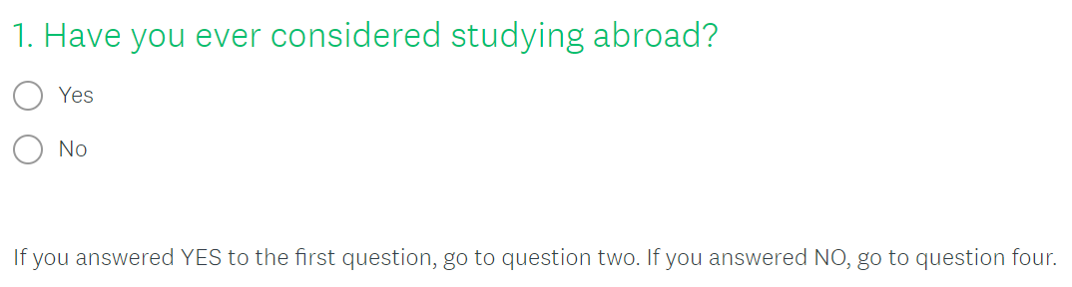

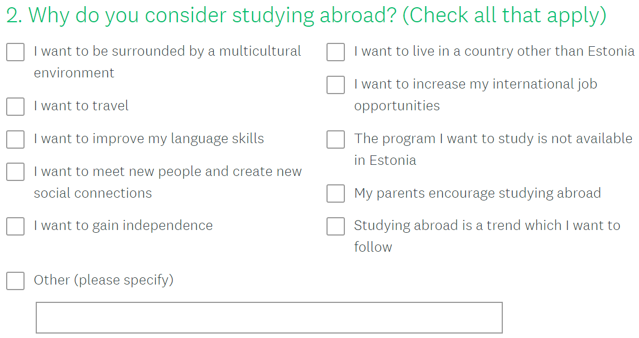

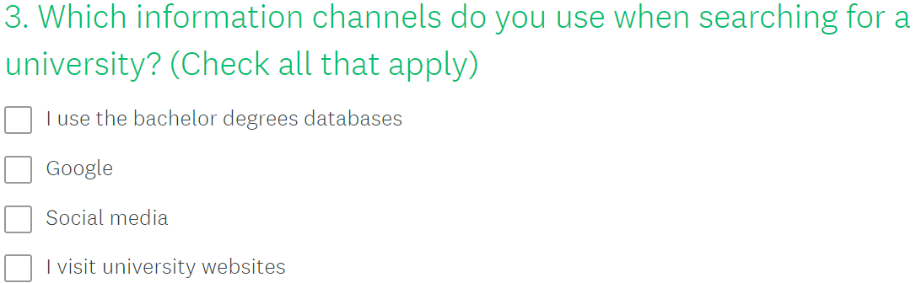

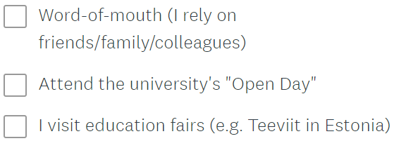

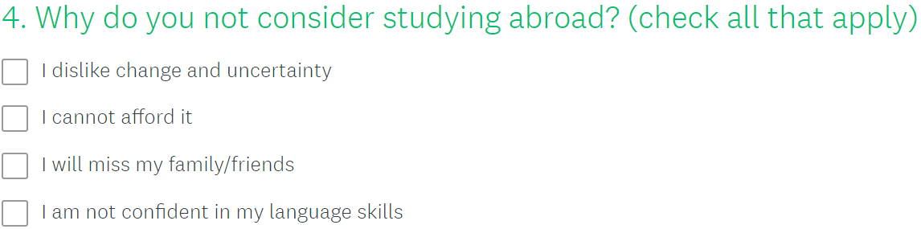
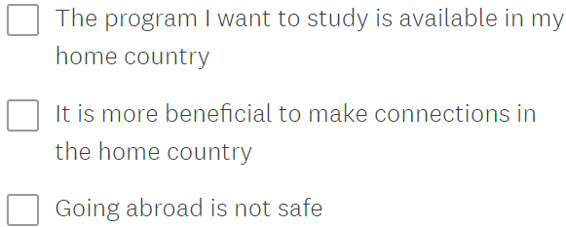

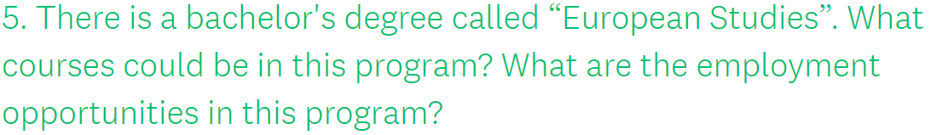
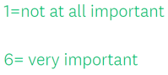
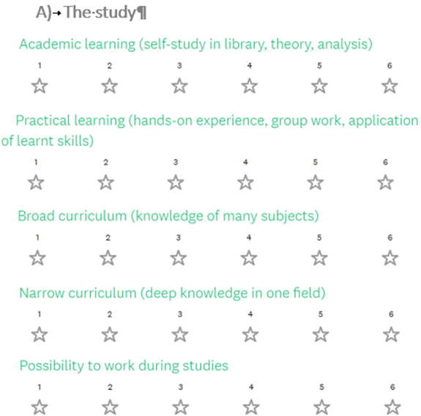

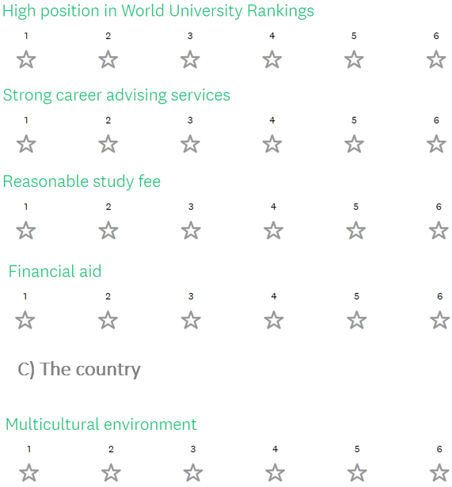
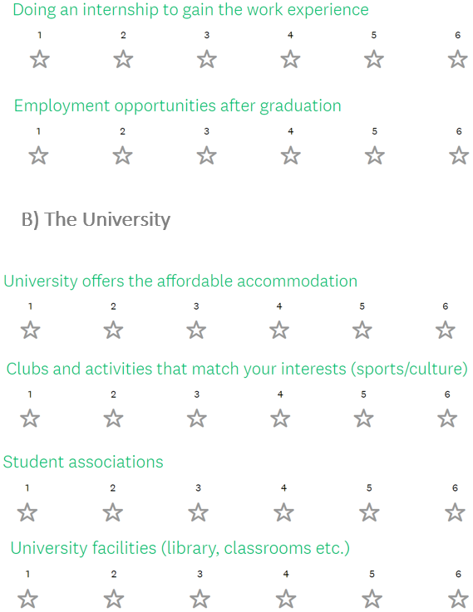
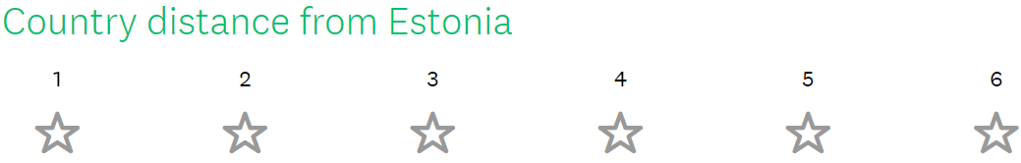

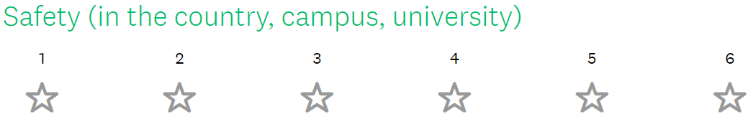
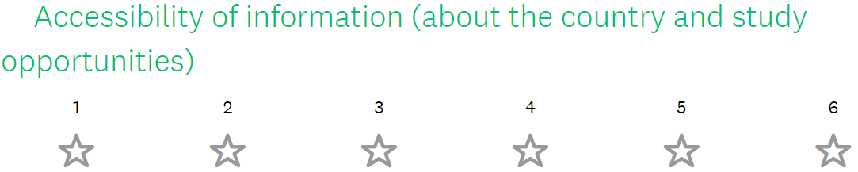

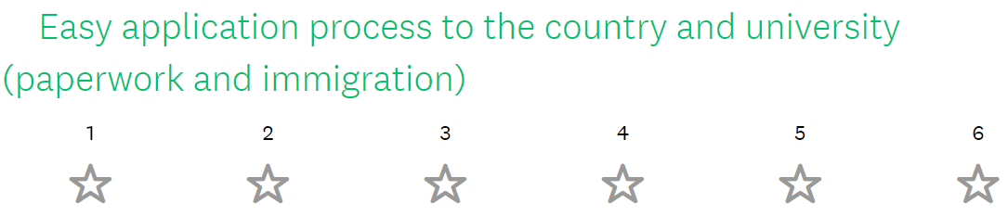

Thank you for participating in the survey. Your feedback is much appreciated!

Appendix 2. Results from the survey distributed in five Estonian high schools. Details of the 20 factors that were ranked from one (1) to six (6)

The first factor of the section A ’The study’ is the ’Academic learning’. It explains how important is the academic learning style (as opposed to the practical learning style) considered, when applying abroad. As seen from the fifth graph academic learning is considered important, with the medium being 4.497/6.
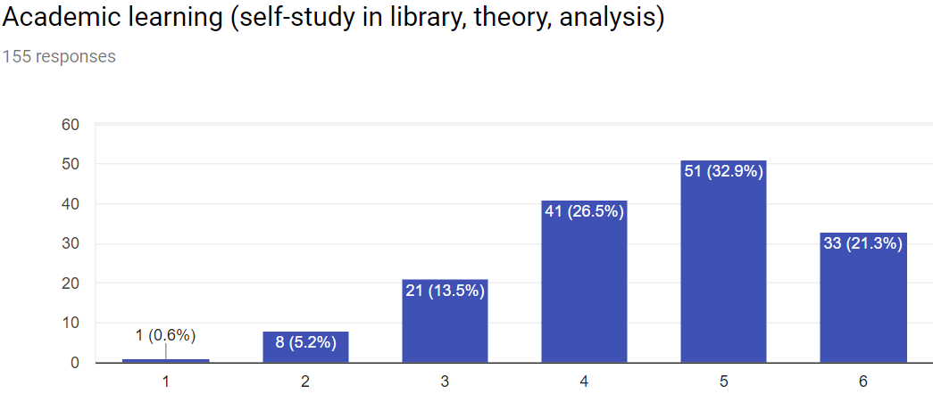

Graph 5: The importance of the academic learning style.
The second factor which is the ’Practical learning’ shows how important is the practical learning style. As seen from the sixth graph, the practical learning style is considered more important than the academic learning style, with the medium being 4.923/6. It is necessary to mention that the practical learning ranking has very few answers which are given less than a score of five, meaning that most of the respondents ranked it as five or six. This means that the preference for practical learning is considered very important by most of the respondents.
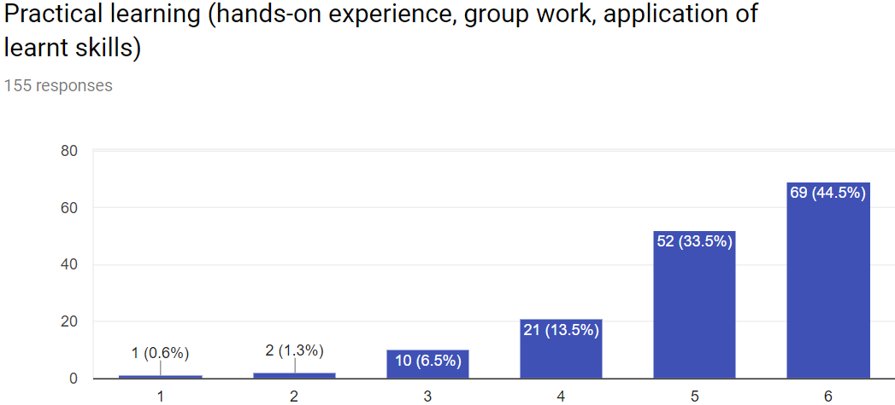
Graph 6: The importance of the practical learning style
The third ranking factor is the Broad curriculum (as opposed to the narrow curriculum). The students were asked to rate how important is it to have a knowledge of many subjects. As seen from the graph number seven, the importance of the broad curriculum is quite significant with the medium being 4.277/6.
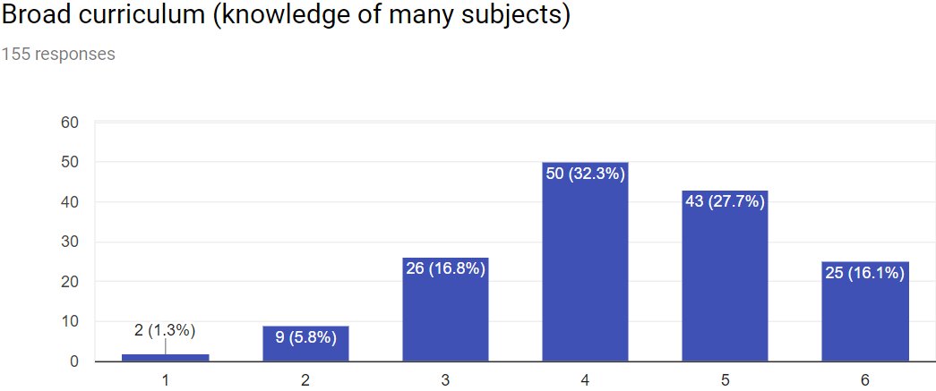
Graph 7: The importance of the Broad curriculum.
The fourth ranking factor is the Narrow curriculum – having deep knowledge in one field. Compared to the ranking of the Broad curriculum, the Narrow curriculum is considered slightly less important, with the medium of 4.013/6.

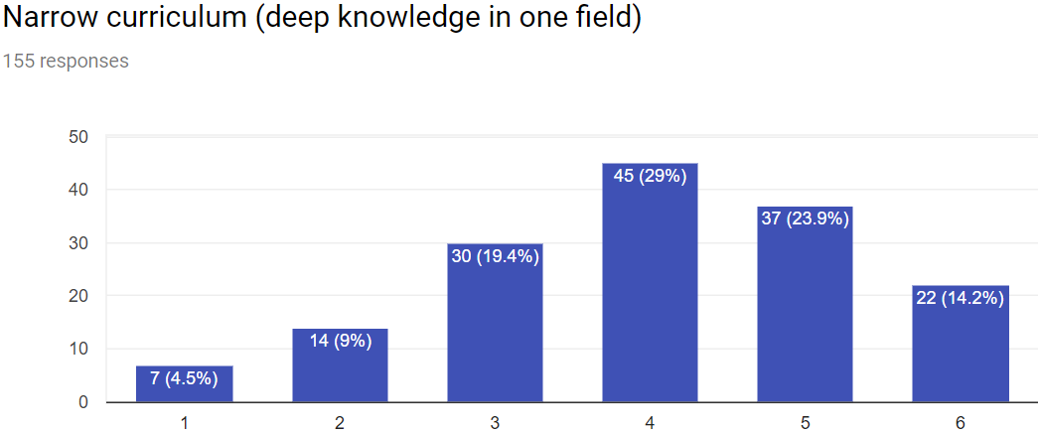
Graph 8: The importance of the Narrow curriculum.

Next, the respondents were asked to rank the possibility to work during the studies. As seen from the graph number 9 it was given a medium score of 4.477/6.
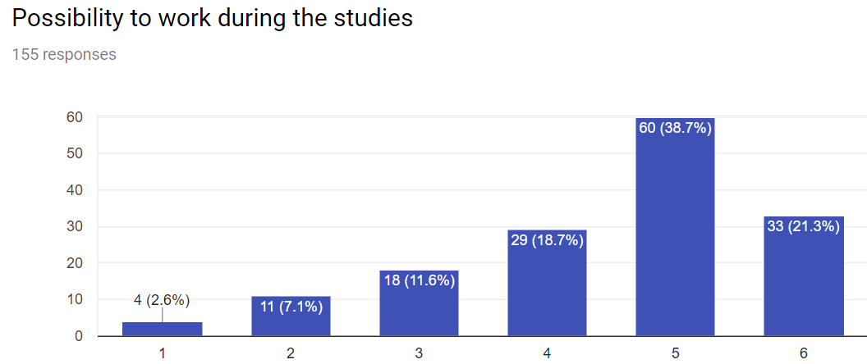
Graph 9: The importance of the possibility to work during the studies.
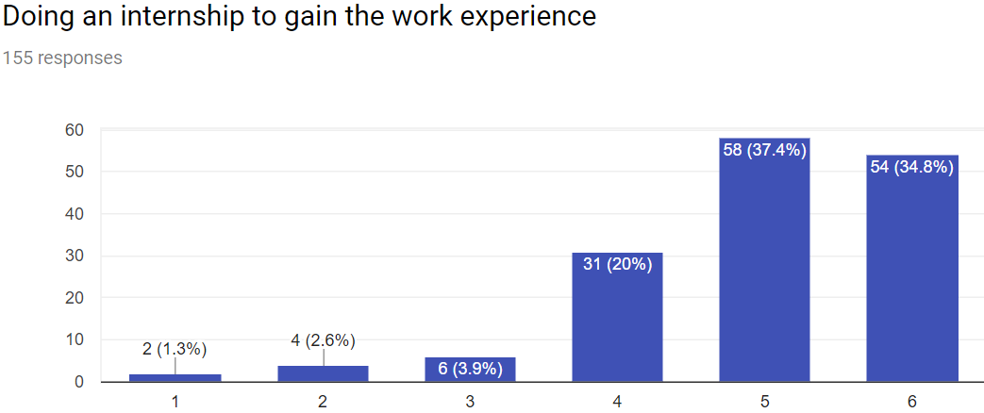
Following, the students were asked how important is it for them to do an internship to gain the work experience. As seen from the tenth graph, doing an internship was scored 4.492/6. Similarly to the graph number six ‘Practical learning’, the respondents have mostly chosen the score five and six, which indicates the importance of the internship.
Graph 10: The importance of doing an internship to gain the work experience
The last factor of the section A, ‘Employment opportunities after the graduation’ has the highest score out of all the 20 factors which were ranked in this questionnaire. The medium score for this is 5.626/6.
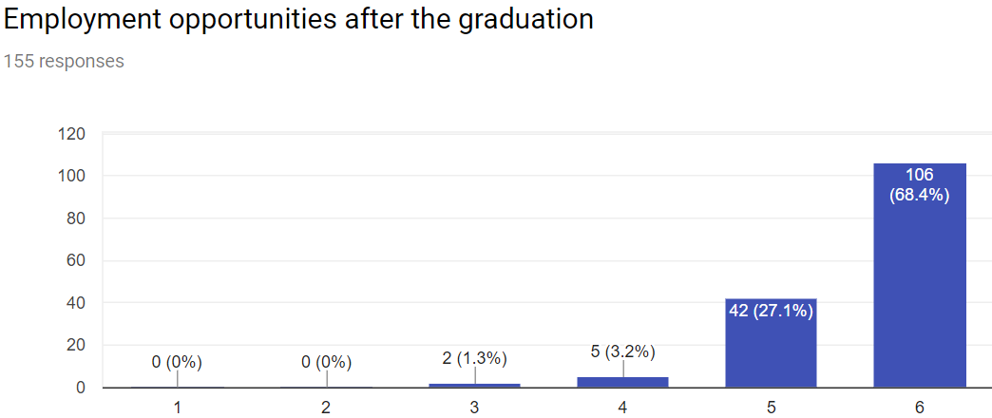
Graph 11: The importance of emplyment opportunities after the graduation
the section B ‘The University’, respondents were asked to rank the factors that the Universities offer. The first factor was the University offering an affordable accommodation. As seen from the graph 12, the students’ score is 4.839/6.

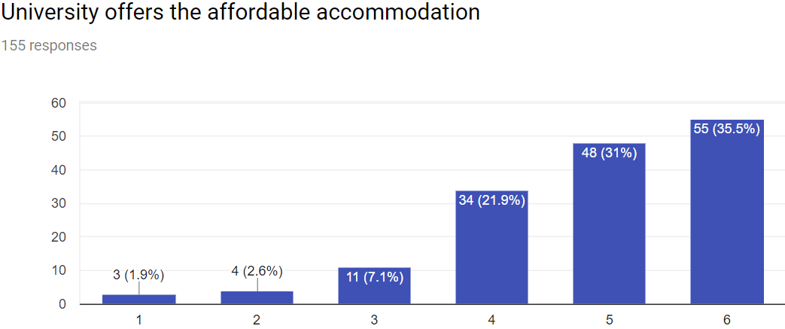
Graph 12: The importance of the University offering an affordable accommodation
Students were asked to rate how important is it for them that there are clubs and activities that match their interests available in the University. The graph below shows that the score for this is 4.329/6.
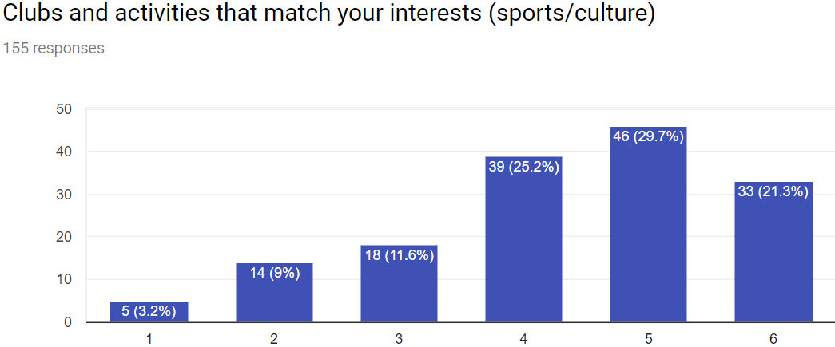
Graph 13: The importance of the University having clubs and activities that match the students’ interests
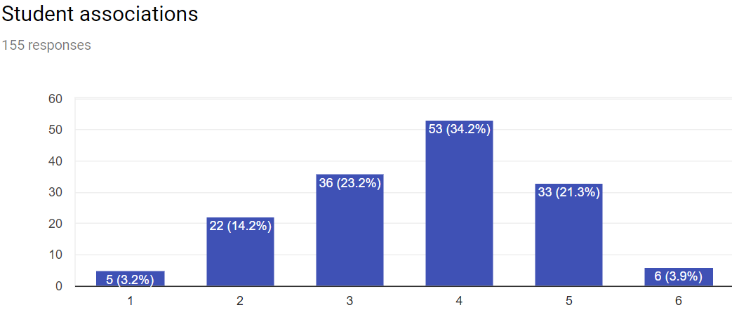
Furthermore, the students ranked how important do they consider the student associations. The outcome was that out of the maximum score of six, the student associations got a 3.677/6.
Graph 14: The importance of the University having student associations
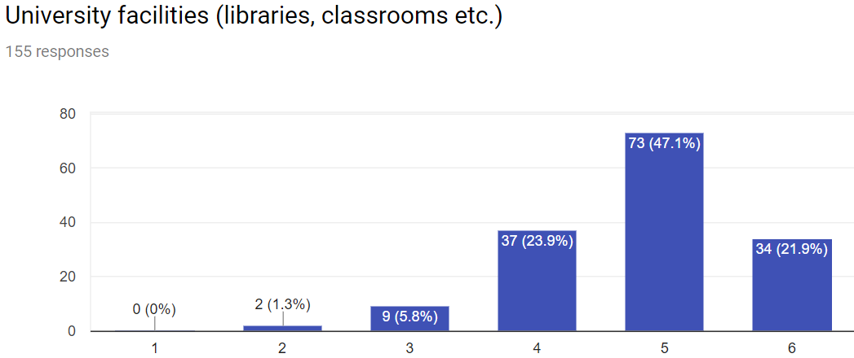
Another factor of the University were the facilities (library, classrooms etc.). As seen on the graph 15, the students ranked the facilities’ importance 4.836/6.
Graph 15: The importance of the University facilities

Moreover, the respondents were asked how important is it for them that the University they choose ranks high in The World University Rankings. The graph 16 shows that the University ranking scores 4.897/6
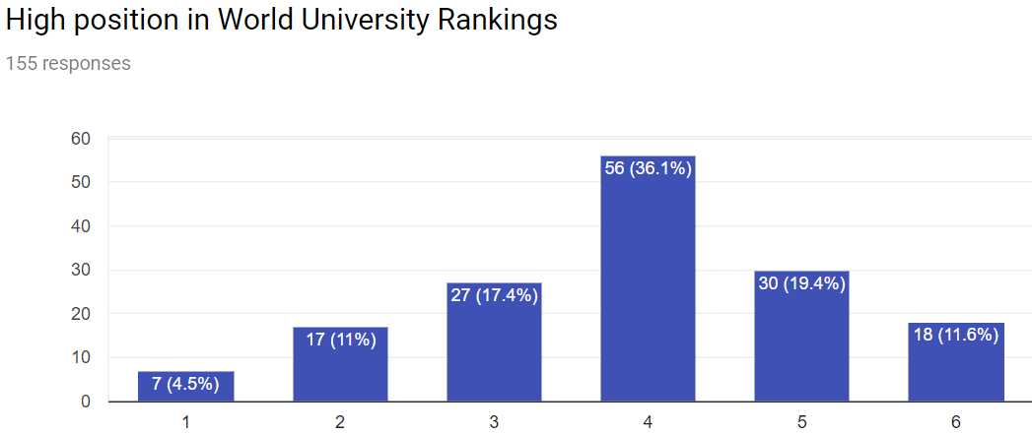
Graph 16: The importance of high rank in The World University Ranking
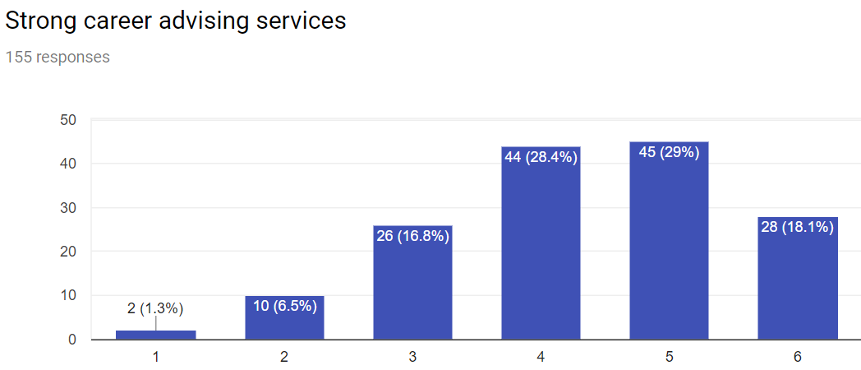
Another factor, which is showed in the graph 17, are the strong career advising services. The students found that the importance of the University offering career advice is 4.316/6.
Graph 17: The importance of strong career advising services
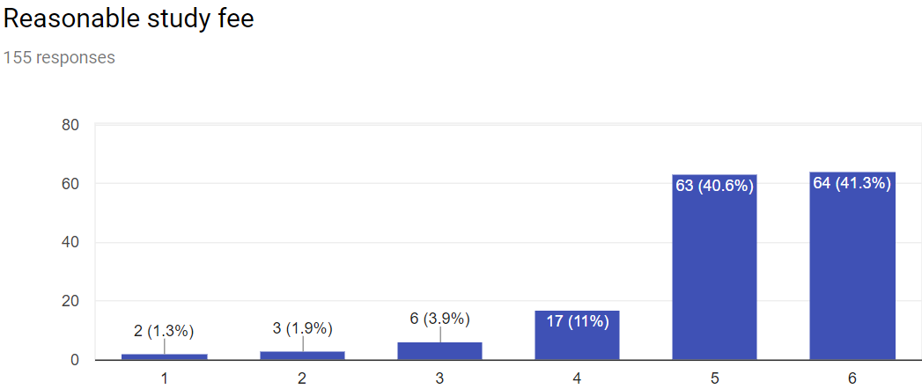
The second most high ranking factor that affects the study abroad decision is the reasonable study fee. As seen from the graph 18, the students scored the study fee 5.116/6

Graph 18: The importance of a reasonable study fee
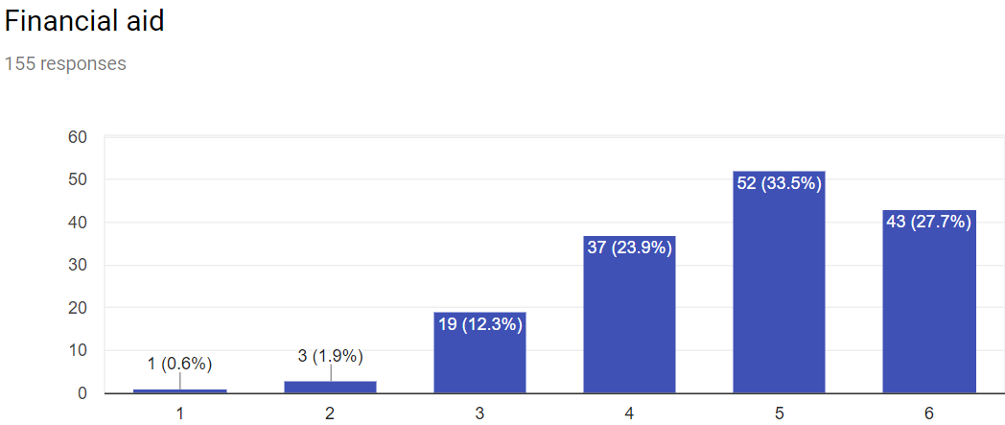
Moreover, the people were asked if it is important that the Univesity provides financial aid. As seen on the graph 19, Estonian high schoolers score the financial aid 4.710/6
Graph 19: The importance of the University offering financial aid

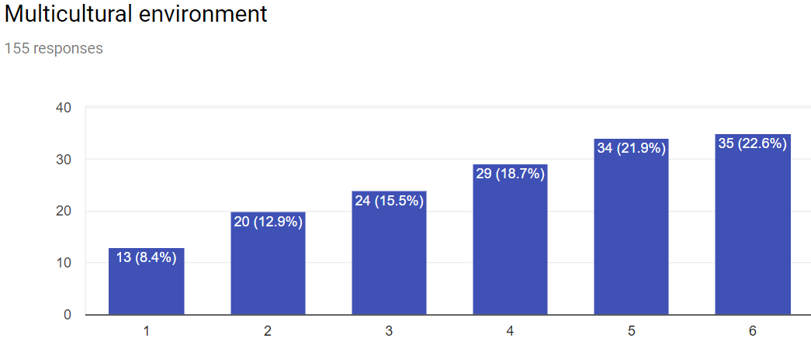
Following, the students anwered their preferences in the last section, C ’The country’. The first factor which was asked to rank was the ’Multicultural environment’. As seen on the graph below, it scores 4.007/6.
Graph 20: The importance of country’s multicultural environment
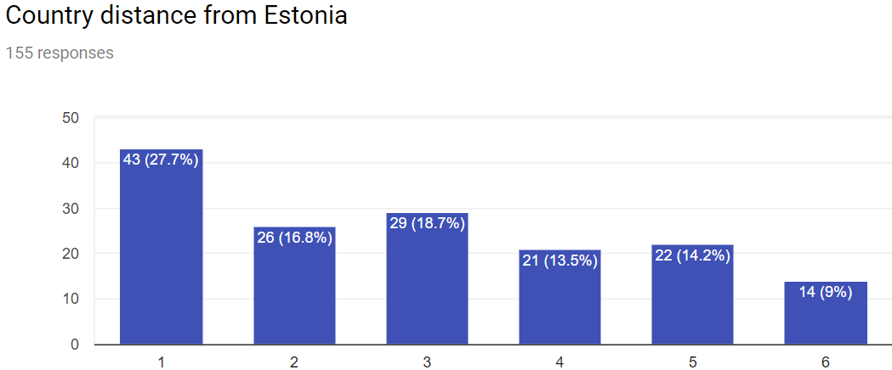
The second factor in the section C is the country distance from Estonia. This factor scored the lowest out of the 20. The respondents believe that University country distance from the home country ranks 3.302/6.
Graph 21: The importance of country distance form Estonia
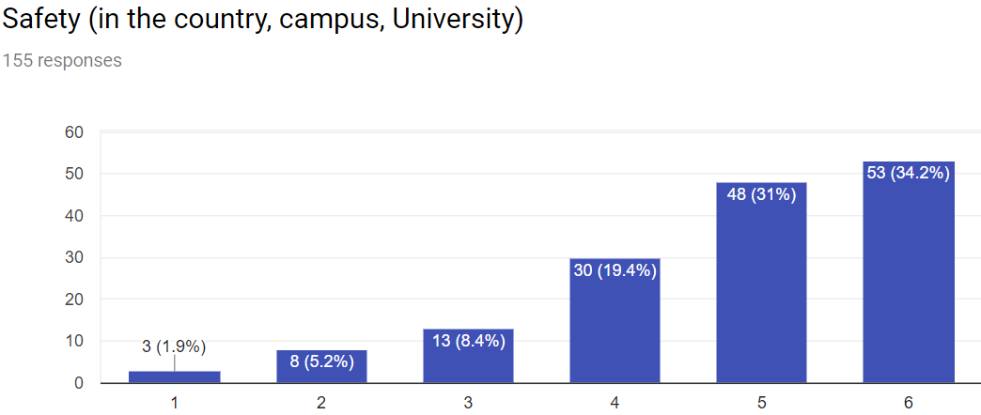
The next factor for ranking was the safety. The respondents were asked to rate how important is the safety for them in the country, on the campus and in the University. As seen on the twenty-second graph safety scores 4.748/6
Graph 22: The importance of safety (on the campus, in the University and in the country

The factor which scored relatively high among the repondents was the accessibility of information. The students were asked to rank how important is it to easily reach the information about the country and the study opportunities in this country. As seen on the next page, the accessibility of the information scores 5.116/6.
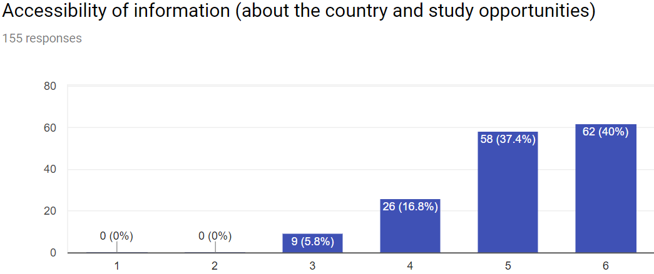
Graph 23: The importance of accessibility of the information (about the country and the study opportunities in this country)

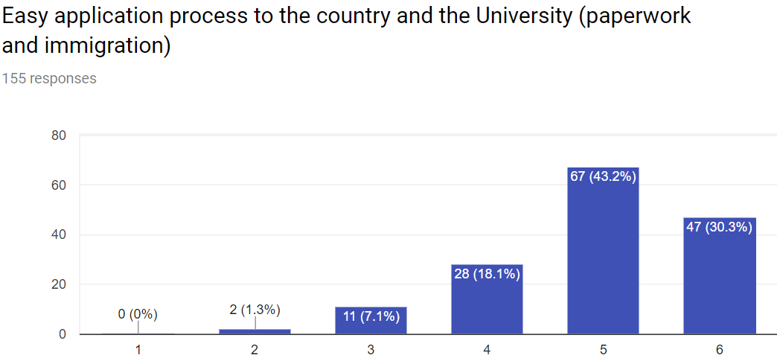
The last factor of the section C, and of the whole questionnaire was the ease of application. The respondents rated how important they believe are the easy application process to the University and the country of the study destination. By ease of application process it is meant that the paperwork and the immigration should be a process that is coherent and not time consuming. As seen on the graph 24, the respondents scored it 4.942/6.

Graph 24: The importance of easy application process to the University and the country of study destination

Appendix 3. Interview questions and answers from the European Studies students
Question 1- Name five keywords that you associate with European Studies program
Interviewee 1
- Interdisciplinary
- International- „We focus on languages, which is a skill that we can apply in an international job context.“
- Practical
- Small division of groups- „There’s more interaction with the teacher and we can communicate with each other during the lectures.“
Interviewee 2
- Interdisciplinary- „ES is a various study with many subjects where we choose either private or public specialization.“
- Practical (applied sciences University, hands-on assignments)
- Teamwork (working in groups, how to work together with people from different nationalities.)
- Disorganized (More details given in the issues section)
- International (different nationalities participating in the program)
Interviewee 3
- Practical- „It’s definitely a practical program, you actually do stuff.“
- Variety- „The courses are varied, as well as the people we work with, by nationality I mean.“
- Current- „It’s focused on today. It will give you the skills that you need now. I don’t think I have learned something overly irrelevant in this course.“
- Direct- „The contact you have with the person teaching you is high. For example, in my exchange University, the lecturers didn’t even mark your papers. You wouldn’t be able to talk to your teacher- he’ll be busy during the office hours. Overall, the lecturer had very little contact with you. Actually... none. In THUAS, on the other hand, the lecturers are the most accessible resource you have. I can literally go to someone’s office and knock on the door, and they’ll help me out.“
- Social- „It’s a very social program. Again, comparing to my exchange University: there you wouldn’t talk to your fellow students. Here, you know your colleagues personally, you’ve made friends and developed a network. It’s not always like that. In most Universities, it’s very work focused and the only people you know are the small group in your house or accommodation. It has also got to do with the small size of the ES groups, which makes it easier to form closer relationships.“
Interviewee 4
- Interdisciplinary
- Languages
- International
- Politics
- Unique
Interviewee 5
- Interdisciplinary
- International
- Practical
- Disorganized
- Teamwork

Question 2- What do you think are the strengths of the European Studies program?
Interviewee 1
Advantage 1: Multicultural classes
Advantage 2: Practical learning (makes us more prepared for the job market after the graduation)
Interviewee 2
Advantage 1: Interdisciplinary (different courses, exchange experience)
Advantage 2: Practical courses „Practical courses make me learn more: instead of just memorizing the information but not using it after the exam is over.“
Interviewee 3
Advantage 1: Research skills- „By research, I don’t mean that you spend a lot of time researching theoretical concepts, that would not be a strength. You do a lot of varied research: reports, papers, plans, surveys. When you’re going to have an employer, he will, for example, ask you to investigate something. For example, to find out what would the restaurants like to serve, in terms of pasta brands. As an ES student, you know immediately how to do it. You know what the report is going to look like. A student from another study might spend hours to first find out how to do it. So, the research is an absolute strength in this program.“
Advantage 2: Languages- „Languages are definitely a strength. Other courses don’t have them, maybe only as a minor. The way the language component has been structured in our program, shows that they’re very important.”
Advantage 3: Multicultural- „You know, if I want to speak to someone from, let’s say Turkmenistan, then the support group that we have on Facebook will connect me with that person in one click. The diversity is enormous and that’s a huge strength.“
Interviewee 4
Advantage 1: Languages- „I appreciate the possibility to study languages. You have the compulsory first language, but you can also choose a second and even a third language. There is quite a variety in the selection of the languages; the main European languages are all represented. And you can choose between different levels too. Also, the language classes are in small groups which is positive. In a small class, you improve your oral skills quicker. During the practicals, the teacher has enough time to give individual feedback and during the lessons you speak with your colleagues.“
Advantage 2: Practical approach- „Before the ES studies, I attended a research University, which did not suit me. After that, I had a choice between International Studies in Leiden University and European Studies in THUAS. Of course, since I preferred HBO education, I picked THUAS. Hands-on experience and the amount of academic research we do in THUAS is well-balanced.”
Advantage 3: Interdisciplinary- „Because the program is interdisciplinary, we have an insight into different work fields. Now, that I have had a few interviews for the internship, I see how to use this to my advantage. When I applied for organizations I could elaborate on both: skills related to public and private field. We’ve done so many types of research papers- marketing plan, research paper, public policy plan- and that’s what impresses the employers.“
Advantage 4: The University and the staff are accommodating- „When it comes to providing to the people with either health issues, disability or physical handicap, the building takes into consideration their needs: the elevators, toilets etc.- everything is there. Also, the teachers, they are understanding: you don’t have to explain yourself in detail; they realize that everyone is human, everyone can have good days and bad days as well. It’s not like that everywhere. The country where I come from is different. But here, the people who want to study, are intelligent and have the capabilities but lack in health, they are given an opportunity to do so.
Advantage 5: Knowledgeable and helpful lecturers- „Our teachers are knowledgeable and helpful- quite some of them are teaching and doing research for other institutions or for their doctorate degree, which is really nice. They have a great knowledge of the industry. It is rare that you can approach someone who gives you advice or insight about the work field you want to be in. Usually, you’d have to know someone in your private life to get that information. Also, I have never come across a teacher who is not helpful.“
Interviewee 5
Advantage 1: Practical- “In the 1st year we organized a project, which is something different- not just sitting in a room and listening to a teacher. It was a good bonding experience and fun.
Advantage 2: Multicultural- “The studies are international, so you get to work with people from different cultures. It boosts the whole experience, since we study about different cultures and intercultural communication. It would not make sense if the ES course would only have Dutch people in it. Not only students but also the teachers have different national backgrounds which gives you a broader perspective of the world.”
Advantage 3: The University is pretty
Advantage 4: Interdisciplinary- “The fact that the program is broad can be seen both as a weakness and a strength. The strength is that you get to study many areas and it gives you insight into different industries. Some of them which you might like, some dislike- it’s not that you’re forced to study something specific. But at the same time, you wonder “What exactly am I studying?”
Advantage 5: Practical study- “I like that ES is a very hands-on program. As I mentioned before, you don’t just listen to the teacher in the classroom; that does not give you anything. We’ve done a lot of research and written different types of papers and reports. We’ve learned how to present and deal with other people. These are the skills that matter. We’ll need them later in professional life. That’s what life’s about, life is not exams.”
Question 3- What do you think are the weaknesses of the program?
Interviewee 1
Issue 1: Poor organization
Example 1: The courses and assessment are not made in our favor.
Example 2: The division of the credits is unequal in different terms.
Explanation: „In the final year, managing the dissertation, attending courses and extra minors and searching for the internship at the same time is very tough.“
Issue 2: Unreachable lecturers- „I cannot reach the teacher not by e-mail nor in person. Often, first I go to one person and I am led to the next one and next one, until the correct person is reached, which takes time.“
Interviewee 2
Issue 1: Disorganized-
Example 1: “On the 2nd year of the studies, the second semester had many credits and we had many papers to write (research paper, marketing paper and Fish case paper), while the third semester had almost no study load.)”
Example 2: „In the final year, there is a clash between the January exam week and the internship starting date. It is not professional to apologize to the company who has hired you for the intern, saying that ‘Oh, I am sorry, I need to start later because I have an exam in the University.’ It makes a bad image for both the University and the student.“
Example 3: „Another problem would be that if a student fails the January exam/ or is doing an internship during the exam week, they can only resit it in August, which means the graduation date is delayed only because the exam which they took in January was failed. The resit could be, for example in June, then the student can still graduate in July.“
Issue 2: Teachers- „Some teachers are not of help when the student tries to reach them. For example, I sent an e-mail and receive no reply. When I go to meet the teacher in person, his/her reply is ‘Yes, I saw your e-mail’. It makes me wonder, why does the teacher not reply, if he/she saw the e-mail.“
„Another example would be the flexibility of the deadlines and taking into consideration the student’s problems. Sometimes, the teachers should understand that the student has things going on in personal life and they cannot submit the assignment on time. This situation could be solved if the two talk and agree to extend the deadline. To do so, there has to be a mutual understanding. The teachers and the students should both make an effort to understand, what the other is experiencing. The teacher should understand that their subject is not the only course students have and the students should also understand that the teachers have their lives too.“

Interviewee 3
Issue 1: The strict guidance/spoon-feeding- „What we have in the program, is all very very good, but there’s one major flaw. That is: you get too much help. On one hand, it’s good that lecturers are always available and accessible, but you need to know how to use this advantage. What we’ve seen, particularly in this course, and in our grade, is that people don’t know how to take responsibility. From the day they entered the program, they take it for granted that they’ll have a Bachelor’s degree in a few years. It is just unthinkable that a deadline might be pushed. This is a major problem- the fact that there’s so much leniency amongst us students. It’s making us spoiled little brats. What I noticed in my exchange University, is that if there is a deadline, everyone would respect it. And the people who did not submit on time, would know it was their own fault. While in our class, people are quick to blame something else. However, this situation is created by the University. I would suggest some serious strictness- you get it done or you wait for the resit.
Issue 2: Disorganized- „In the second and third year of the program, some courses need to be switched. It is in the Dutch law, that one ECTS equals to 25-30 hours (might vary based on the University), and that should be equal to every student. However, the way that the course is organized, is that, if you go on an exchange, you follow four or more courses, which give you 15 credits and you’d also do the i-Start, which is another 15 credits. However, if you stay at the home institution, you follow two minors, which give you 15 credits each. That is a massive disadvantage for those who go on the exchange. The hours you put in are many many more, a triple weight I’d say. It is an injustice that needs to change.”
Interviewee 4
Issue 1: Lack of an excellence program- „Some other HBO level programs offer an excellence program, which I believe, many students would appreciate. Also, other Universities team up with each other to offer a pre-Master’s course during the Bachelor’s studies. That’s something I miss here in THUAS.“
Issue 2: The poor organization-
„Sometimes it can be chaotic. Let me give some examples:
- I would prefer if the Legal Dimension of the EU course was in the end of the 1st year or in the beginning of the 2nd year. Legal Dimension of the EU, such as the other 1st year courses, is a ‘dimension’ course. Since we write the dissertation during the last year, it would be nice, if we’d have the knowledge about EU laws beforehand. I’m sure it would help with the dissertation writing.
- The workload is distributed unevenly. The amount of responsibilities in the last year is huge: courses, minors, search for the internship and writing a dissertation. That’s a workload a human cannot manage.

- The deadlines clash. For example, we were supposed to have a feedback session and an exam during the time we’ll be already on the internship. You wouldn’t want to not be on the internship because of such two things.”
Interviewee 5
Issue 1: Broad nature of the program- “Since the program is interdisciplinary, when Il finish the studies in January and go on an internship, I don’t know what to look for. And I don’t think the University helps much with that. They expect me to know what European Studies is, and tell me: ‘Yeah, so for six months you’re going to do an internship.’ While I am thinking: ‘What? I don’t know what to do or where to apply’. Their answer is pretty much: ‘Just go!’. In short, I am feeling lost and don’t know what type of internship to look for.”
Issue 2: Disorganized
Example 1: Poorly regulated workload- “It is very frustrating that the Uni asks us to start looking for an internship just 1-2 months before the deadline. I suggest they would mention it to us before the start of the final year, so we can already search for something in summer. It is not just the final year that is disorganized. We have had during the previous study years some situations where one semester, the study load is super high and then the next semester just a few assignments and almost no exams. For example, those who go on an exchange and those who stay and take minors- the amount of work they do differs a lot. Shortly, its either too much pressure or no pressure at all.”
Issue 3: Teachers- “That’s not a major issue, but some teachers are not really there for students. They say they are, but they are not. But that’s just a few who ruin the whole picture. Sometimes, I have a feeling that students are a joke for the teachers or we’re treated as kids. For example, if I ask a question and the teachers replies: ‘You should know, that. It’s in the module book.’ I understand, that the answer might be partially in the module book, but sometimes, it needs further explanation. There is a reason why I ask a question, it’s not just like that. Please be helpful.”

Question 4- What do you think makes the program stand out from other studies? A certain value or bonus that other Bachelor degrees are missing?
Interviewee 1
Value 1: Interdisciplinary- “It is an interdisciplinary program. We can study many different aspects: communication, marketing, international relations.”
Value 2: Specializing- “We can choose the specialization. I like that, although we specialize, we continue studying subjects from both private and public courses.”
Value 3: People- “Those who choose the program are not necessarily Dutch, they come from international backgrounds. And not only form the EU countries but worldwide.”
Value 4: Language study
Interviewee 2
Value 1: Languages- „You can study a language from level zero to three. ICM and IBMS students do not have this option. It’s a bonus, since multilingual people are valued in the job market. For instance, if you have two CVs, then the person who has an extra language has an advantage.“
Value 2: The people- „THUAS has students and teachers from different backgrounds; the Europeans coming from different countries. You see how they work, how they are. It’s a whole experience in itself- being in the University and seeing students and teachers in their everyday life. It’s like a lesson. I sometimes understand that I have to fit myself to the other person. I need to change how I act and what I say according to a particular teacher or student.“
Interviewee 3
Value 1: Professional education: knowledge + skills combined- „Professional education, to me, means knowledge combined with the skills. Because the technical studies will give you a lot of ability and academic Universities give a lot of knowledge, but applied sciences University gives you both. These two, skills and knowledge, are the two most important pillars of the professional life.“
Value 2: Teamwork- „You work a lot in small groups, which is important. When you’re an entry level job applicant, most of your tasks will be done in teams or in small groups. You will not be given responsibility or trusted to do something on your own. Not before you’ve been in the company for a few years and have built relationship with your superiors. The program is focused on teamwork and that is essentially what we need to enter the professional world.“
Value 3: Multicultural
Interviewee 4
Value 1: Practical- „The education system in Netherlands is different than back home. Here, you choose between three types of higher education. In my country, the choice is either technical institution or University (WO). As mentioned before, the combined education (HBO) is very appealing to the employers.“
Value 2: Interdisciplinary „I understand why people tend to complain that the program is ‘broad’, but ‘Interdisciplinary’ is indeed a better term for it- since all the things we learn tie up together. Bachelor’s programs are usually not about specializing in something, you have Master’s degree for that. With the ES program you get a good idea of what each field looks like, you do an internship and then decide which industry you want to specialize.“
Interviewee 5
Value 1: Interdisciplinary- “Again, interdisciplinary program is both a strength and a weakness. Let’s say, you do an architecture degree. If you complete it, but you don’t like it, then you’re stuck with it. While with the ES, you try one thing and if you don’t like it, you change to another. It gives you a variety of choices.”
Value 2: The hands-on approach- “It’s really something special. Back in my country, among my friends, there is barely anyone who does a practical study. They all follow a very academic degree, where you study study and study.”
Value 3: International- “The international environment suits the ES program. It’s European Studies, so expect people from all over Europe to be gathered here. I would not like if I followed the ES program with only Dutch people in it.”
Question 5- What skills have you developed during the ES program? List either practical, academic or social skills.
Interviewee 1
Skill 1: Practical application- “Thanks to the practical nature of the program, we have developed our social skills. For example, the public speaking and presenting skills are something we can use to convince people and do lobbying. Thanks to some courses, we can do a confident and structured delivery.”
Skill 2: Writing skills- “We’ve written different types of papers such as press release, marketing plan, research paper.”
Skill 3: English skills- “I have developed both oral and written English skills. I believe it’s an advantage for the future employment.”
Skill 4: Intercultural communication skills- “We know that cultural differences can cause misunderstandings in the international professional environment, because we followed the intercultural communication course and interacted with fellow students who have different national backgrounds.”
Interviewee 2
Skill 1: English- „My English has improved. Especially the written academic English and grammar. That is thanks to the writing courses we had.“
Skill 2: Social skills- „I used to be less confident in my social skills. But, for example, the Oral Presentations course encouraged me to face my audience. I needed to make sure that I use the right words, so that the message gets through, and I don’t make a fool out of myself.“
Skill 3: Teamwork- „We have many team assignments. This teaches me how to work together with people from different nationalities, who might have different working styles. It motivates me to work hard, because we have to make sure that we work as a team. Not just one person who does everything. After all, you don’t want to let anyone down, so we need to work all together to get a good grade. No free riders allowed.“
Interviewee 3
Skill 1: Research- “We do varied types of research: qualitative, quantitative, problem-oriented research. THUAS does not only teach how to conduct different types of research but also how to turn those results into a report. The only part we were not taught during the research courses, was how to structure and build up the billing and budget plan.”
Skill 2: Ability to critique the information- „We know how to be careful and what information sources to look for. We’ve been taught how to break the flow of information down to categories. We can distinguish what is news, what is fabricated, what is real, what is academia, what is a clickbait, what is attention seeking, what is drama, what is rubbish. We can separate what is news media, social media or academic reports. In short, the ability to critique the massive amount of daily information.“

Interviewee 4
Skill 1: Research- „I would say writing and research skills, because for example, where I come from, there is no proper referencing culture. In general, we did not write much papers, we had more written and oral exams. Back home, referencing meant copy paste’ing the website link where you retrieved the information from, and maybe adding a paragraph or a page number. Here, the referencing follows the APA style which is a whole new level.“
Skill 2: Public speaking- „We give a lot of presentations: Oral Presentations and the argumentative speech building course with Mr. Ginhoven, but also other courses, which use presenting as one of the assessment forms- they have all improved the public speaking skills.”
Skill 3: Open mindedness- „Since The Hague is a multicultural city, where you find people with different backgrounds, religions and ideologies, it has made me more open minded. Surprisingly, when I go back home, I miss this diversity. I look around and it is weird because I don’t see the diversity that exist here- it has become my norm now.“
Interviewee 5
Skill 1: Public speaking- “The classes we had such as Oral Presentations, Professional Argumentation and few others where we’ve presented- they helped me to develop public speaking skills. The speaking skills have gotten better also with languages I learn: English and Spanish. My English vocabulary has become ‘fancier’ and I can speak some Spanish now.”
Skill 2: Referencing and research- “There are two things I am grateful for. Firstly, my APA skills have improved. Secondly, the papers I write have more structure now.”
Skill 3: Intercultural Communication- “We’re learning how to deal with people who come from different parts of the world. Of course, you might know in theory what the behavioral differences are, but in practice it is different. When you’re actually here, you realize, how hard it is to communicate with people from other cultures. The difference lies usually in the little things. All of a sudden, I find myself wondering: ‘Why is this person doing it differently than I do?’. And indeed, the University prepares you for that: ‘Look, there are other realities besides yours, deal with that.’ – is what I have learned here.”

Question 6- How did you find out about the program? (Through which information channel)
Interviewee 1
Information channel- University webpage and advertisement from the high school. „I first browsed different studies through internet. Initially, I was aware only of the Leiden University, through high school advertisement. When I came to visit The Hague, I discovered The Hague University and end up enrolling here.“
Interviewee 2
Information channel- Organization providing educational services. „There was an Indonesian education organization that helps Indonesian students who want to study in the Netherlands. I had two options if I wanted to study in the Hague: THUAS and Leiden University. But for some reason, THUAS caught my eye. I guess I wanted something to do with diplomacy and politics, since my ambition was to become a diplomat. I had a choice between ES and ICM, but ICM was more about communication and I thought that ES aligns more with my interests. However, when I started the program, I understood that my strength lies in the private specialization. I feel like I am thankful and grateful that I chose ES because I figured out that I am better at the business sector.“
Interviewee 3
Information channel- Word-of-mouth information. „I found out about the ES degree through a friend. I was interested about the program because of where I lived at that time- Brussels. I am from another continent and I was fascinated with Europe. However, being in Brussels, I realized that I didn’t know anything about Europe. Living here, but not understanding it... I didn’t know the language, the institutions, I didn’t even know under which law system I am living. The thought of living my life in the darkness- that’s how I felt like- was not acceptable. I did not know what any of the state powers are, how they acted. What my role was, what my rights were. All those things dragged me towards European Studies. In short, I chose the degree because I wanted to know about Europe. However, I thought that the content would be about culture, geography and history. Turns out it was much more than that, and indeed, everyone who is here has different reasons why they are here.“
Interviewee 4
Information channel- Online bachelor degree’s portal.

Interviewee 5
Information channel- Word-of-mouth information and Google search engine. “I remember looking for courses that had no math and more politics and international relations. Then, ES came up and I thought it sounded cool. The reason why I chose the Netherlands is because some of my friends back home suggested it. They said: ’Try the Netherlands, all the Dutch speak English.’ So, I went online and googled ‘Dutch Universities’. I saw which Universities had the ES program and, in the end, came here because it was the best city, had the best curriculum and seemed to be a nice University. ES was not something that I planned, I bumped into it accidentally.”
Question 7- Now, that you are on the final year of the studies, what do you consider to be suitable employment opportunities for you?
Interviewee 1
Employment considerations- „Nothing specific, since the program is interdisciplinary and does not give a concrete job specialization. It might become clearer if the student continues with a Master’s degree and specializes, to become an expert. Furthermore, if the student wants an employment in the Netherlands, it is wise to get a Master’s degree from a WO University, not HBO University, since it is considered inferior in comparison with WO’s academic knowledge and capacities.“
Interviewee 2
Employment considerations- Business related- „Not quite sure yet what is good for me. I still want to grow my knowledge in the business field. ES is a bit broad compared to other studies, where people have a more concrete specialization. I might do a business-related Master’s degree and afterwards I’ll go to a company or an organization.“
Interviewee 3
Employment considerations- Management roles in the public sector or research: „I think there are two main fields that are appropriate, obviously there are many other fields that you can get into, but I think this course prepares you for two main fields. These are research and academia. The example work places of research would be at the Universities or at the institutions, doing the policy research. Then, by management roles in the public sector I mean for example: press management, diplomacy, policy, human resources- anything that is linking people and is slightly abstract. After all, this course does not prepare us for specified functions such as accounting. This course is all about being social, dynamic, adaptable and knowing how to communicate interculturally. We’re very prepared to involve ourselves and deal with people, after this course.“
Interviewee 4
Employment considerations- „At first I want to work a little bit, before deciding which Master’s program to do. I don’t have an exact idea yet, but I did a minor in crisis and risk management, which I liked. So maybe I would like to try myself out there. Crisis communication, working for a PR agency, digital media and social marketing – these interest me. Whether it’s a private company or an NGO- does not really matter, I just want to enjoy what I do, where I contribute or work for a greater good.“
Interviewee 5
Employment considerations- Public sector position in a private company. “I guess, the public-sector job in a private company would be the best. For instance, something to do with legal or PR side. You know, it depends in which country I end up working. Here, in the Netherlands, the public sector is well-organized. If I went back home, I would have to participate in the state competition for the government jobs, I would have to have personal connections and the whole bureaucracy of it… But yes, right now either PR or something where I can combine travel and marketing. I suppose, I’ll end up in a private company. That’s, more or less, in which direction this University is pushing us to. There’s a higher chance getting employed if I apply to private companies.”
Question 8- Comments on the outcomes of the Estonian high schoolers’ ranking of factors and on the pie charts demonstrating the assumptions about the content of the ES and potential employment opportunities after the graduation.
Interviewee 1
Ranking of the 20 study factors:
- „ I see that the employment opportunities after the graduation is ranked the first, but for me it was not the most important. For me, it was more important to have interdisciplinary program, to know better for my Master’s choice. I do agree, that reasonable study fee is ranked the second.“
- „One of the factors, that they ranked in the middle, is the internship opportunity. For me, the internship and the exchange were definitely priorities, these are what I value about this program.“

- „About the lowest ranked factors: The country distance from my own country was important to me and indeed, the multicultural environment was also one of the reasons why I chose THUAS and The Hague. I do agree though, that the student associations are not that important.“
The comments on the two pie charts:
- „The courses associated with the ES are quite accurate. Although, according to the specialization, there might be more emphasis on the business courses.
- Regarding the employment opportunities, well, the people who gave no answer are as lost as we are. The thing is, with ES program, there is no concrete path that everyone takes. But as a person who has never heard of it before, I would also assume that you will work in EU Institutions.“
Interviewee 2
Ranking of the 20 study factors:
- „I understand why they ranked employment opportunities the highest. The society nowadays seems to have set the ‘right path’ that students needs to follow. The society really pushes you: first you graduate high school, you go to University and get the diploma to have a good and stable employment. It’s logic, since going to University is nowadays crucial, without a diploma you are not taken seriously. Not going to a University is not even a choice. There is nothing you can do without a diploma. Sure, you might say that some things can be learned online or by yourself, but the paper as evidence counts. Parents too, they expect you to succeed and make a living for yourself, for which a degree is needed. About the lowest scored factors, I understand why the country distance has a low score. Nowadays, the further you study, the more admiration it receives. People will say ‘Wow, you studied there?’. Studying abroad is seen as an advantage and elevates your social position. The factor I would place differently is the multicultural environment. I am a curious person, I want to experience something different. I would not want to stick only with Indonesians. I get to be a different self when I speak English or Indonesian. When I speak in English I am a different person: more extroverted and I speak more. When I am back to Indonesian, I am just like... okay. It’s different.“

The comments on the two pie charts:
- „It makes sense why people don’t have an answer. It is confusing ‘European Studies, what is it?’. Even I thought, when I chose the program, that I’ll learn about European history or I might do politics courses. I had no expectations.“
- „The possible employment... It’s sad. A big majority does not answer. But again, most of us also don’t know what job we’ll end up with. It is an interdisciplinary study, and it can be anything. We don’t focus on anything specific, you’re free to scatter around and discover your career options.
Interviewee 3
Ranking of the 20 study factors:
„For me, the top factors were the multicultural environment, reasonable study fee and the third place is shared between the possibility to go on an exchange and do an internship. Of course, employment opportunities after the graduation were also important but not on the first place, as in this ranking.“
The comments on the two pie charts:
- „The courses that they associated with the program are remarkably accurate. However, the intercultural communication, EU Institutions and the business part are more important than they think. Well, politics and history go hand in hand, as well as culture and languages.“
- „If you ignore the fact that most of them answered nothing, it is accurate. However, the MNC’s should be way up there, that’s where many people end up working.
Interviewee 4
Ranking of the 20 study factors:
„The clubs and activities had a higher priority for me. I do not socialize easily, so having activities that tie me together with people and help make social connections would help a lot. THUAS does not have them a lot. But everything that’s ranked the highest is more or less same for me. Maybe the easy application process can be lower, as long as it’s not too complicated. However, I’d rank doing an internship, career advising and multicultural environment higher.“
The comments on the two pie charts:
„It’s pretty accurate, I don’t have a lot to add about it. If you don’t know anything about ES, then I guess it’s as accurate as it can get.“
„The employment opportunities are partially true for the public specialization. However, a lot of people will do an internship and work in private companies, even with public specialization, simply because it’s difficult to make your way in the public institutions. What’s missing are the start-up’s, MNC and private institutions“.
Interviewee 5
Ranking of the 20 study factors:
“I like that most of them are open minded, because they don’t consider country distance form Estonia to be that important. At the same time, I see that they’re very future-oriented, since employment opportunities after graduation is ranked the highest. I was not thinking of that when I chose the study. Then, safety…, I would place it even higher. If I was a female high school student, soon to live alone in a country I’ve never been before, it would be very important to consider such things. What else… I was not thinking much about hobbies, clubs and student associations. However, I see, that the multicultural environment is ranked low. I would put that higher; I’ve always been an international person- lived abroad and surrounded by people from different cultures. Why would you study abroad if you’re surrounded by people from your country? The whole point of a study abroad experience would be lost. Also, I would’ve been nice if the University offered better accommodation opportunities. I understand that the Netherlands is not the U.S., where the campus system is well-developed. However, I think THUAS has quite a significant number of international students, so they should prioritize the housing options. Ah, I see that Estonian students look at the ranking of the University. I don’t really judge the Uni based on the rankings. Not to be mean, but THUAS is not a highly ranked University but it’s still a very good University. I don’t think that outside the Netherlands people consider it as a ‘University’.”
The comments on the two pie charts:
“Well, the first pie chart is accurate. It is pretty much what we study; it’s hard to know what we do here in the ES unless you’re part of it.”
“I can identify myself with the people who answered that they don’t know what the employment opportunities are, we’re on the same page. Well, besides those who said they don’t know, the other answers are something I would have said too, three years ago. To be honest, becoming a politician, working in an embassy or in the EU institutions and Parliament are something that I imagined myself as, when I started the ES program. Now I think differently of course. Well, I don’t think any of us will end up as a politician. We do study politics, but the course discovers political science and the theories, rather than actual politics. It is interesting that very few of them mention positions in the private specialization. They mention them briefly in the course contents (business, economy, trade), but they don’t seem to consider these fields for the employment. Yet, the private sector is where this University is pushing us. Europe is not all about politics, it’s even more about business and trade. It’s interesting that these kids did not think about it. But then again, the study name ‘European Studies’, does indeed suggest something else. It suggests that you study history, politics and about European Union and consequently, end up working for the Union.”
Question 9- Do you have any recommendations how to solve the problems identified in the two pie charts?
Interviewee 1
- Making the program more concentrated on the University website.
- Including the examples from the graduates on the University website.
„The fact that the people do not know what the program is could be solved for example, if the program is more specified. So, if additionally to the name ‘European Studies’, there is written focus on disciplines such as X, Y, Z. Another thing that may help, is if on the University website, the European Studies course has a section with the examples of the graduates. It would show that after graduating, X went to this industry, or Y has this job and Z followed this Master’s program. It would be important to emphasize where the graduates applied and in which countries do they work now. “
Interviewee 2
- Word-of-mouth advertisement from ES graduates and advertisement from the local schools.
„I guess the students who have graduated, when they return to their country, they could inform other people about it. The more people do it, the more popular the ES will get. Then the ES program might, one day, match up to other studies and have a better quality. For the people searching for a program in the high schools, I think they should be informed by the schools. For instance, schools could inform that this kind of program exists.“
Interviewee 3: Word-of-mouth advertisement- high schools. „I believe that it is necessary for the University to take action. The way to clarify, what the studies is and to attract more people to the program, is the responsibility of the University. If I was a high school student, ‘European Studies’ would mean absolutely nothing to me. The solution- either post fliers or posters in the high schools. It’s up to this University to send people to the high schools worldwide and explain the course: what it is about, what is the content and what can you become after the graduation. The person explaining the program could ask leading question such as: „Do you want to be a researcher?“, „Do you want to work in an international organization?“, „Do you want to work in a major company doing social research?“, „Do you want to have a job involving people?“, „Do you want to cross borders with your job?“, „Do you want to be in a job where you talk to people“ or „Do you want to have a personal budget that you can use to achieve the right results?“. „Then, I think, you should do European Studies.“ That’s what I’d need to hear if I was a high school student and didn’t know what the European Studies is. I need people to tell me: „Do you want to do this?“ And if I say yes, they tell me: „You can do it with European Studies“ I ask: „Really, how?“ and they would explain me: „Because we offer this, this and this.“ All that needs to happen, is to hear from someone, what the study program is and what can I achieve with this study program.“
Interviewee 4
- Going to the high schools to explain and promote the European Studies
„To change something, you have to educate people. If you want to change how they think about it, then you have to tell them how it is.“
- Posting an explanatory video on the ES program website
„When promoting the study online, then the video would explain what the study is, why is it the way it is and what can you do with it. Also, it would be nice to include some statistics that shows if the graduates ended up in public or private sector. “
Interviewee 5
- Promoting the ES in the high schools
„Honestly, if it was possible, I would change the name of the program. But you can’t really do that... and what would you even change it to? No other name would make sense of what we do here. So, it’s not about the impression of the studies but about promoting the studies for what it is. The problem is- as much as this Uni tries to promote ir, they just make it harder to understand. I don’t know, it’s the kind of study, where you just have to go for it.“
- Students writing about their opinion/experience in the ES on the University website.
- Students’ point of view/understanding about the content of the study
„The only way to get people to understand what the program is about, is when their peers explain it to them, not the teachers. Teachers and students have a different point of view. The teacher will make it seem like the best Uni, best study, the most interdisciplinary program in the world. But what the high schooler wants is the opinion of the person studying it; with all the goods and bads that come with it.“
- During the ’Open day’, it would be better if it’s the current student who the applicant can approach, not the teachers.
- When the European Studies appears in the bachelors databases, it should be placed under different categories. Not only ’politics’ or ’international relations’, also ’business’, ’management’ and other sections.
„When people browse the Bachelor degree databases, they usually have a keyword or a category they look into. If the ES is included under many categories, it will keep popping up each time. That might make the student think: ’What is this study? It keeps popping up every time. Why is that so? Maybe I should check it, there has to be a reason for that.’ That could potentially spark interest in more people. Rather than just putting it under one section, it should be included in more areas. After all, ES in not about one thing- it falls under many categories. ’You want to study languages?- come here!’; ’You want to study IR?- come here!’; ’ You want to study politics/business/marketing...?- you come here!’. The Uni has to make the study accessible. It makes sense that people come here, expecting the study to have only public courses, since in the search engines the study is categorized as a public sector program. That’s why we have so little private sector students.“

Appendix 4. The interview questions asked from the European Studies program communication and promotion coordinator Dave van Ginhoven and his answers
- What is the current enrollment situation in the ES program? Is it steady or declining, ES3/ES4?
“Enrollment in general is down. I do not know the exact numbers for international students, but the enrollment is down across the board. Particularly in the three-year program, but also in the four-year program. I think that the overall percentage of the international students has not changed that much. It’s still about 80% Dutch and 20% internationals. There are more international students in the four-year program, but more of the three-year program is international. That’s because the three-year program has a target group of Dutch students with a VWO diploma (students are eligible for all educational levels: MBO, HBO, WO) or international students with an equivalent diploma. The problem is, the last years there are fewer Dutch students with a VWO diploma, since the entrance requirement for that level of high school were tightened up. There are already few VWO students, and right now, there is not much interest for the VWO’s to go to an Applied Sciences University. Ten years ago, when I started working here, there were five ES3 classes. Currently, there are only two. Back then, there were more VWO’s who were willing to try the HBO education. I am not exactly sure what happened with the requirement, but the number of VWO’s coming to us has declined. So, more of ES3 is international, as a result.”
- Why do you believe, and do you believe, that it is important to have international students in the ES program?
“Well, I cannot speak, or maybe I could speak for the whole University, but let’s talk about the ES program. The value of international students, first and foremost, is that ES is a program that tries to prepare the students for an international career. Where they can go and do all kinds of things all over the world: they are not prepared for one specific job, but rather, preparing to adapt to the changing needs of the labor market. That market is, by definition, international. And international market brings certain complications, well, benefits and complications. Our goal is to prepare the students for the environment like that, and the only way to do that, is to have such environment. If you don’t have international students here, then you cannot effectively prepare people for an international career. Yes, theoretically, you can say: “When you get out there and meet people from other countries…”. It’s way more fun to be here, now, in that environment.
I know that sometimes people, especially if I read Dutch newspapers, jump to the conclusion that it’s about money. It might be to some extent, but not as much as you’d think. For example, EU nationals pay the same tuition as Dutch. It’s not bringing in that much. Students outside of the EU pay more, but we don’t necessarily get more money out of that either. They pay more because their tuition is not being subsidized by taxes. So they don’t bring in money directly as such. They do bring money to local economy: renting rooms, buying stuff, going out. Which is good for everybody but it’s not really so much about the money. The Netherlands, as a whole, is trying to shape itself as a knowledge economy. It is a small country and it’s always been at its best, when its looking outward- to do business with other people and to participate ‘in a larger world’. You cannot afford to turn inwards and say: “Okay, the 17 million of us are going to figure out everything together.” You’ve got to be able to bring people in, to do this- you need new ideas, new people. And that means, if you have more international students, also more international teachers, the better you’ll be equipped for that kind of a knowledge economy.”
- What do you think motivates a student to do a Bachelor’s degree abroad?
“That’s a good question. The research that I’ve done and the experience that I have with promotion the program seems to show that, one of the most important things, for any student, are their career aspirations (1). When I talk to young people about our program, doesn’t matter where they’re from, they want to know: “What kind of a job am I going to get?”. That’s the main thing for them. It’d always a little bit tricky with ES, it does not come with a specific job title attached. But, I think it’s the best thing about us- now is a terrible time to be too specific about your career goals, because there aren’t very many specific jobs out there. Also, the way the labor market is changing, the way it is going to continue to change for next 15 years, it’s not a good time to know how to do only one thing. It’s good to be able to do a lot of different things and have these adaptation skills I was speaking about earlier. To be able to adapt to new environments, to do new things, to continue to grow. So, I actually do think, (not trying to sell this program or something), we are a great program for anybody who is looking to start their career now. As a result, it’s a little bit harder to explain. Young people and their moms and dads, they want to know: “Is my son/daughter going to get a job in four years? And if they will, what kind of job is it?”.
So, that is important motivator. After that comes, in what kind of environment do I want do it (Bachelor’s degree). Maybe I should do some research on what makes people choose the Netherlands or what makes people do it abroad. In some cases, it has got to do with the tuition (2)- we have some of the cheapest tuition in Europe. There are some countries that have free education, but they tend to have much smaller population. We have a very competitive tuition rate- even if you have to pay non-EU tuition. It is still cheaper then, let’s say, the UK. So, if you’re an European and looking for an international career, then chances are you want to be educated in an international, English environment study. Not every country has many English language studies as we do. It is developing in lots of countries, certainly. But in Germany, for example, there are pretty limited options in English. It’s increasing, more and more Germans speak English. But 20 years ago, no one spoke English. Now, major German cities do speak English and are more interested in that. So, if you want to do an English language international study, and you don’t want to pay £9000 a year, this is the place you go.
Of course, the motivations have also got to do with the certain reputation of the Netherlands. It’s known as a fun place to be for young people, there are certain things you can do here, which you cannot do in another countries (at least not officially)(3).”
- Through which information channels is the ES program promoted/communicated?
“Lots, ES does a lot of different things. There’s the stuff that I do, and the stuff that the University does centrally. If we’re focusing on the international recruitment: the central marketing people, who sit in another building across there, they travel. They go to international education fairs (1), mostly throughout Europe, those fairs don’t actually produce a lot of students. They represent the whole University, with all 11 international programs, including us.
They also work with businesses, such as education agencies and promotional organizations (2), in certain countries. For example, there’s this German website I’m in contact with right now, because their information of the studies is outdated, so I’m writing a new text for them. I might also give some money, so they put some of my videos on their website.
The center also maintains the University’s website (3). I write all the texts for the website and try to provide pictures and other content, such as students’ profiles. The website is the number one recruitment tool, the most important thing we’ve got. The vast majority of students we get, come to us through the website. That’s how they first hear about us. So, either they’re Google’ing, looking for the programs, and land on the website.
The word-of-mouth is also hugely important, according to my research (4). Like I said, the international stuff is mostly done by the marketing people but I have also made some efforts. Last year, I got the access to a database showing all the international schools in Europe. And I sent them the brochures about the University as a whole, but also about the European Studies. As a result, I got invited to couple of events. I was in Brussels last year. I, and some people on my team, go, whenever possible, to international schools. In The Hague, Amsterdam, Utrecht, IB schools. By word-of-mouth, I think there’s more that the students here hear it either from someone who does the program, or a teacher told them, or cousin does it… that kind of thing.
We do a lot of stuff on social media too (5). We have an Instagram, Facebook and also a YouTube channel. We put all kinds of content there, to promote the program. I ask the students to make videos; make a video that captures the study experience. I’ll post anything that the students send me. If anything even remotely interesting happens, I’ll put it on Instagram and hope that someone likes it. However, my research shows that, that’s not where people find us. When I first started doing it a couple of years ago, I thought: “Now people are on Facebook and will discover us.” But that’s not really true. Maybe the ads, that show up in targeted peoples’ feed, might have potential, but I have not dealt with that much. The social media is not useful to get people to hear about us. It’s not useful for initial interest. What happens is that people go to the website, and after they’ve read about us on the website, they check out the social media channels. So, I don’t use social media channels to promote the channel to those, who have not heard of it. It’s more like, I try to fill the channels with as much content as possible, so that the people, who are already interested, can see what it’s like. That’s what those channels are for.“
There’s also the individual approach method (6). When the application for the program starts, every two weeks I get the latest information about the registration. I write the applicants e-mails and say something like: “Hi dear X. Thank you so much for signing up for the ES.” Now, we also have personalized postcards. So, we try to keep them warm, if you will. Not just the postcards, also the Facebook group and Instagram. Also, there’s a project I have, ‘Shadow student’. The student can come and attend some lectures, to see what it looks like, studying here.
- What are some challenges or difficulties with the promotion of the ES to the international students? Enrollment process in general?
“There are lot of challenges. Lots and lots. Both with attracting and with the enrollment process. When it comes to attracting the students: ten years ago, when I started here, we had five or six ES3 classes. Ten years ago, we were one of the only English language programs in this University, one of the very few in The Netherlands and one of the few programs offering the three-year fast-track. Now, every other school is trying to catch up to us, in terms of internalization. European Studies was sort of a leader for internationalization, within this institution, but also nationwide. Not only did the rest if this University internationalize, but the country. It seems like every school in The Netherlands want to offer stuff in English, now. We’re drowning in three-year programs- so many three—year programs, so many English language programs out there. So much more competition. Basically, we are fishing in a shrinking pond, and there are more people fishing in that pond. Right now, we have a campus of University of Leiden in The Hague, and they several programs that compete directly with ours. Not just the ES, but also International Law or International Public Management programs. That certainly cuts in into international recruitment, into VWO recruitment and also, people who do their first year at THUAS might decide to transfer Leiden after they have completed first-year studies.
A separate, but linked issue, is that when we compete with other Universities, we have to constantly combat with the perception issue: there is a perception, that one type of University is better than the other. One of them is the ‘real University’ and other one is the Applied Sciences University. This is certainly an issue because Research Universities, who also have a much bigger budget than us, profit from this perception. It is not in their interest to try to correct it, it’s in ours. Because of competition being what it is, people think that a Research University is necessarily better than the Applied Sciences University. I don’t think that’s true. What’s true today is that one University is better for you or for Bobby or for Jim, for Fatima or Jan. It really depends on what type of student you are, what type of program you should be in. If you just want to go to big lectures and listen to interesting stories, there’s nothing wrong with going to the Research University, but then you have to be able to learn things on your own. Because many Research University graduates know a lot about the subject but they don’t actually know how to do much. For example, they know a lot about business but don’t know how to write a marketing plan. We sometimes hear from our work placement providers that they’d rather have our students than the Research University students, because here students learn how to do stuff, and we’re very proud of that. Still, that makes it even more frustrating to hear people assuming that one type of University is better than the other one.
Also, the enrollment procedures are complex and take time. The Netherlands is a bureaucratic country. We love paperwork in this country. For a student, it takes quite a long time to hear, whether or not their application is accepted. Efforts are under way to speed that up, they’re working very hard on that right now. People who carry out these procedures are very good people and work hard, but it’s complicated. You’ve got to evaluate people’s diplomas from all over the world. Imagine someone comes from Tajikistan: we have to find an expert who can tell to which level it equals- HAVO, VWO or VAVO, and it takes time.
One of the most irritating thing about enrollment is that Dutch law allows for internationals to apply for four different programs. And that’s a part of problem: we don’t have a problem with the number of applications, the problem is the number of people who actually become students. We call that conversion. So there’s this four-level gap between application and registration: 0- you have applied, 2- applied and done this and that, 4- applied, uploaded diploma, paid tuition, ready to start the program. In many years, we’ve lost about half during that process, only half have actually paid and showed up. We managed to keep up the conversion rate this year. We had less applications (~640), but out of all the applications, more people started the program. We had 380 in the four-year program and 25 in the three-year program. That made me happy, since a year before we went from 1000 applications to 380. And a lot of that has got to do that people are applying for multiple things and decide later. Either they notify us late or don’t tell us at all. Eventually, they disappear from or list but that happens only in October, when the first exam session is over.”
- Are there any future plans or goals with the program?
We’ve got lots of plans. We’re working on a major review of the program, the plan is to completely reinvent the curriculum. It’s a fun project- we’re not doing it to solve a problem, for once. We had an accreditation is 2016. We run a good program, good quality program. But we don’t want to wait until it starts to suck, so we make changes. There are lots of opportunities to improve, modernize, get on the cutting edge. So far, we’ve made changes to solve problems: such as the Dutch law which required the three-year programs to have as much credits per year as the four-year ones. But what you want to do once in a while is to stop and make sure everything in the program is coherent, has a common vision and that the link is there. That’s why the big curriculum reinvention is going on.
In terms of the promotion, until recently, the promotion was mostly me and the PR team (me and Ms Szabo). We’ve expanded the team; more teachers are involved. We’re trying to professionalize the social media part- get more content, more videos. These are the ways to reach and help internationals. We do have ‘Open days’ and ‘Trial days’, but if you live in country X, chances are you will not visit these events. We want to be able to offer something meaningful for them as well.

