The Triangular Commercial Relations
Büsra Durmuskaya
ES4 09023550
Academy of European Studies & Communication Management
The Hague University of Applied Sciences
Supervisor: L.G.M. Tunderman
Date of completion: 12th December 2013

The consequences of the increasing German-Polish commercial relations for the intensive German-Dutch commercial relations.

Executive Summary

This report provides information about the commercial relations between three important European states: The Netherlands, Germany and Poland. The triangular relations of these states is researched with the next question in mind: What are the consequences of increasing German-Polish commercial relations, for German-Dutch commercial relations?

Germany and the Netherlands have a history of commercial relations. The importance of this bilateral commercial relation can be seen in the trade balance between the Netherlands and Germany, which is only exceeded by relations between the United States and Canada.

Germany is the most important trading partner for the Netherlands with regard to import and export. Most of Germany’s exports go to the Netherlands. An important factor is the Rotterdam Port. The Rotterdam Port is considered to be a German port because of its importance to Germany and the German state (Bundesland) North Rhine - Westphalia, where many of the exported goods are produced. North Rhine - Westphalia also has the highest amount of trade with regards to the Netherlands. The German-Dutch trade consists mainly of chemical products and machinery.

While the German-Dutch relation has increased, other players have now also reached the playground of the European market. One of these growing economies which offer opportunities for other European states is Poland, with favorable advantages for strong economies such as Germany. Poland is unique due to its changing commercial character. Poland has been a communist state with a social economy mainly characterized by agriculture. After the fall of communism Poland went through a period of economic change, converting its economic system to a free market. Principally after its accession to the European Union in 2004, Poland has begun developing its own economy and is on its way to becoming an industrial state with great opportunities for trade and investments. It’s strong neighbor Germany, is already a main trader and investor in Poland and has contributed a great deal in the development of Poland and its Gross National Product.

As mentioned before, this report aims to research the possible competition between Poland and the Netherlands in the “German trade field”. It was therefore important to outline the situation between Poland and the Netherlands too but to what extent is there a competition?

The Polish-Dutch commercial relation seems to have become stronger too over the last few years and the Netherlands has been investing vastly in Poland. The trade between these two countries has also increased, although the trade relations is not as strong as the German-Dutch or German-Polish commercial relations. It could be pointed out that in the near future, instead of competition, a growing relation is developing between the Netherlands and Poland.

On the other hand, the increase of the German-Polish trade is inevitable. However, although the German-Polish trade increased dynamically until 2011, it experienced a decrease after 2011. The German-Dutch commercial relations, on the other hand, has been increasing steadily.

When the most important products within the trade traffic of the German-Dutch and German-Polish trade are compared, it seems that the same types of products are traded. In both relations there are products which have increased and this shows that the increase of one is not at the expense of the other. These products which have increased in the German-Dutch relations but not in the German-Polish relations are controversial. Although it cannot be determined with certainty, it could indicate that, for example, the Netherlands is taking the lead in trading with specific products with Germany, without affecting the relations between Poland and Germany. However, the German-Dutch trade traffic has been increasing, while the German-Polish trade traffic has been decreasing since 2011. German-Polish commercial relations focus more on German investments in Poland rather than the trade traffic. Although a broader research is necessary to give a definite answer, at the end of this research the results should indicate that German-Polish commercial relations has not increased at the expense of German-Dutch commercial relations.

Tabel of Contents
Executive Summary 1
Introduction 4
Chapter 1 6
The German-Dutch Commercial Relation 6
Chapter 2 15
The German-Polish Commercial Relation 15
Chapter 3 25
The Polish-Dutch Commercial Relation 25
Conclusion 34
List of References 39
Appendices 43

Introduction

Germany and the Netherlands are two neighboring European states with a long history and have one of the strongest bilateral relations in the world. This could never have been imagined for about 70 years ago during the Second World War. With the European cooperation, which has developed to the European Union as it is known now, the Netherlands and Germany have developed a relationship which seems to be so intense that it could not be affected by other states. The continuously increasing trade relations, the positive political relations, the traffic of tourism, cooperation on border regions (Euregio) and even further relations, make Germany and the Netherlands almost perfect neighbors. This report is not about German-Dutch relations in general, but is limited to an initial exploration of a possible scenario; the triangular relations of three European states: Germany, the Netherlands and Poland.

The Netherlands and Germany have such intensive commercial relations, with such a great history, that one would think this could not be affected easily, “perfect neighbors”, as mentioned before. However, after the European enlargement rounds in 2004 and 2007, new Member States started to develop their economies and Europe had more trade markets, under which falls Poland, one of Germany’s biggest neighbors. Poland is a country where highly trained and educated laborers demand low labor costs. Poland is developing, which makes it a state of opportunities.

Germany is one of many European markets that benefit from emerging markets, namely its eastern neighbor Poland. The trade relations between Germany and Poland has been increasing mainly since Poland’s accession to the European Union. Could this trade relation be increasing at the expense of German-Dutch commercial relations? Presuming the scenario of increasing Polish-Dutch commercial relations, which could grow at the expense of German-Dutch relations, this report is named “The Triangular Commercial Relations”. The triangular relations of these states is researched in the context of the central question: What are the consequences of the increasing German-Polish commercial relations for German-Dutch commercial relations?

To answer the central question three chapters are provided about the commercial relations between the three states and in conclusion, an analysis is made with the results. It is important to answer the central question above by having an overview of where the commercial trading ties of Germany and the Netherlands stand and if this relation is as strong as it seems or if it can be affected by emerging economies with new or more opportunities.

In order to study the three relations as described above, a comparison is made between the German-Dutch, German-Polish and Polish-Dutch commercial relations by studying the development of the trade relation, the figures of trade, and the important branches and sectors in the trade traffic. The research is based on desk-research, mainly online literature provided by organizations and secondary analysis of previously published reports relevant to this subject. These findings/reports are used to study facts and figures, and eventually to analyze the literature for a conclusion based on facts. The desk-research has been the biggest source of information in this report. In scope of this research, the second method was qualitative research in which experts are approached for information (open questions) by an interview conducted by telephone, in order to gain information based on the subject of this report or to verify the gained information of the desk-research with expert opinion. Names of people and organizations are provided in the references. The answers to the questions provided by the experts are all processed in this report in the relevant chapters.

Chapter 1

The German-Dutch Commercial Relation

  - §1.1 The Development of the German-Dutch Commercial Relations

This chapter will describe the development and recent commercial relations of Germany and the Netherlands. A short introduction about Germany and its economic profile will be given.

Germany is located in the center of Europe and borders 9 countries, including the Netherlands. Due to its favored location, Germany can reach markets throughout Europe. The German market has an advantage due to its rich infrastructure. The infrastructural facilities in Germany are airports in Frankfurt am Main, Düsseldorf and Munich; the seaports Bremen and Hamburg, which are the biggest ports of Europe, and Duisburg Port, which is the largest European inland port (German-Dutch Chamber of Commerce, 2012). The metropolitan regions of Germany act as an engine for social, economic and cultural developments. They also uphold the presentation capability and competitiveness of Germany in place. The main metropolitan regions are the areas Rhine-Ruhr, Frankfurt / Rhine -Main , Hamburg , Munich, Berlin - Brandenburg , Stuttgart and Rhine – Neckar (German-Dutch Chamber of Commerce, 2012). Germany’s economy is the fourth strongest of the world and the third exporter after China and the United States. Germany encourages innovation business-wise as well as competitive, international enterprises with qualified and motivated laborers. It has an internationally recognized education system, an excellently developed infrastructure and peak performances in the fields of research and development. The German economy is a social market economy characterized by: “welfare for all” (German-Dutch Chamber of Commerce, 2012). The same thing can be said for the Netherlands. The Netherlands and Germany have followed the same economic development during the last sixty years. After the Second World War until the 1970s, both states experienced a period of economic growth, where West-Germany took the lead due to its economic power. After 1990, Germany’s growth was affected by reunification, the integration of West- and East-Germany was more radical than expected and slowed down economic growth, whereas in the same period the Netherlands managed to strengthen its economy. For the first time the Dutch economy was growing more rapidly than that of Germany. Only after 2010 did Germany catch up and become a fast growing economy again (CBS, 2010).

The fact that the two states maintained a comparable economic system may be a reason for the strong relations they developed. In 2012, the German-Dutch trade volume was one of the largest trade volumes in the world. Only the economic interdependence between the United States and Canada is stronger than that of German-Dutch, which means the bilateral relations of Germany and the Netherlands is very intensive (German-Dutch Chamber of Commerce, 2012). In fact, the success of commercial relations between both states is again proven because for Germany the Netherlands is the most important importer of German products, and the fourth trading partner for exports in 2012. For the Netherlands, Germany is the most important trading partner for both imports and exports (Holland Pioneers in International Business, 2012). The value of goods exported from Germany to the Netherlands in 2012 reached approximately seventy billion euros. On the other hand the exported goods from the Netherlands to Germany amounted to more than eighty billion euros. This again shows the strong economic relations of these neighboring countries (German-Dutch Chamber of Commerce, 2012).

With regards to the importance of the Netherlands for Germany, Rotterdam PFrort plays a vital role as a transit port for German goods. Germany is an important transit state for the Netherlands due to the access to other European states (German-Dutch Chamber of Commerce, 2012). In the Rotterdam Port, there are more German goods stocked than in any other German port, which shows again the economic interdependence. The Netherlands is the ‘bridge’ for Germany’s trade with Asia (Auswärtiges Amt, 2013). It could be said that Rotterdam Port is actually a German port. Germany and the Netherlands are interdependent and have common benefits which make trading ties so important.

Germany has sixteen states of which North Rhine-Westphalia is the most important, regarding economics. Because North Rhine-Westphalia is a direct neighbor to the Netherlands, there is mutual economic relations between this state and the Netherlands, especially due to the comparable area and population. The trade between the NRW and the Netherlands is significantly larger than the trade between NRW and other German states (Universität Münster, 2009). NRW is not only the most important German state for the Netherlands, it is also the most important state for Germany. This state forms a great percentage of the German Gross National Product, moreover the NRW has the greatest population of all German states.

The most important sectors in this state are technology and service. 39 of the 100 most important German companies are established in NRW. Examples of these important companies are: E.ON, Deutsche Telekom, RWE, Bayer, ThyssenKrupp, Ford, Deutsche Post World Net, Bertelsmann and Henkel. According to research by the German- Dutch Chamber of Commerce, there are around 750 Dutch subsidiary companies established in this state, with more than 80 in Dusseldorf and almost 50 in Cologne (German-Dutch Chamber of Commerce, 2012).

  - §1.2 Figures of German-Dutch trade: Imports and Exports

Dutch trade with NRW is of vital importance to both Germany and the Netherlands. NRW is the German state with the strongest imports with an import volume of over two hundred billion euros. Quite a good share of the total German imports is delivered to North Rhine-Westphalia. Last year, in 2012, North Rhine - Westphalia traded nearly four hundred billion euros in total and over a half of this amount came from the Netherlands (NRW Invest Germany, 2013). The importance of the trade between the Netherlands and NRW is proven by the great share of the Dutch market, and therefore the Netherlands is also the main trading partner of NRW (NRW Invest Germany, 2013). It has been mentioned before that Germany imports high amounts (table 1) from the Netherlands, therefore it is important to highlight the fact that over forty percent of these imports is destined for North Rhine – Westphalia. Trade between NRW and the Netherlands is a result of a continuous development, and it has doubled its amount in euros (NRW Invest Germany, 2013). NRW is not only important for imports, but for exports because the production of export products in Germany mainly takes place in NRW. Besides, the export volume between the Netherlands and North Rhine – Westphalia has nearly doubled in the period between 2001 and 2012 (NRW Invest Germany, 2013) .

To understand the trade volume between Germany and the Netherlands it is important to highlight the figures, shown in the tables below. Table 1a shows the development of German-Dutch trade between 2010 and 2012. The overall imports of Germany have increased during these 3 years and the share of Dutch
imports have obviously increased as well. The share of exports to the Netherlands from Germany has also increased in the aforementioned period as seen below in Table 1b.

1. Development German-Dutch trade 2010-2012 *(translations in appendix 1).
a. Imports from Germany to the Netherlands in million euros of the first quarter of each stated year.
Source: Holland Pioneers in International Business, 2012.
b. Exports from Germany to the Netherlands in billion euros of the first quarter of each stated year.
Source: Holland Pioneers in International Business, 2012.

The import of German goods to the Netherlands is of vital importance to both states. The Netherlands also has a huge share in export. In table 1 it can be seen that the German-Dutch trading ties have increased over the last few years and in Table 2 it can be noted that the Netherlands is the most important import partner for Germany, with the highest amount in billion euros.

2. The ten main importers of Germany, in billion euros, 2012.
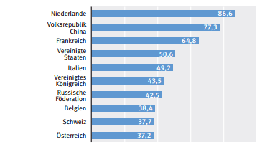

Source: Statistisches Bundesamt Der deutsche Außenhandel im Jahr 2012, 2013

  - §1.3 Branches in the German-Dutch trade

This paragraph provides information about the most important products and sectors in German-Dutch commercial relations between 2010 to 2012, giving a more detailed overview of the trade balance. German enterprises with a leading role in international trade are enterprises with chemical products and investing goods such as cars and machines. Important sectors in the economy are the automobile industry, machinery, and the chemical industry. These sectors form the greatest share of the German export. Furthermore biotechnology, the service sector (financial services, management- and marketing consultants, telecommunication services and ICT-advice), energy, airlines and astronautics, are important pillars of the German economy (German-Dutch Chamber of Commerce, 2013).

According to the Dutch embassy in Berlin, trade traffic between Germany and the Netherlands were as can be seen in the next tables. Tables 3a and 3b give an overview of the traded products in 2010 and 2011, with the most imported or exported products at the top of the list. The most exported products from Germany to the Netherlands were chemical products (mainly synthetic materials, plastic and rubber), pharmaceutical products and machinery.

3. Import and export traffic between Germany and the Netherlands. Value of goods in billion euro*.

3a. Exports from Germany to the Netherlands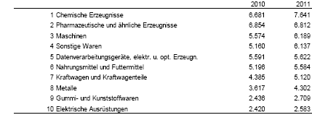

Coke fuel and mineral oil products, chemical products and nutriments are the mainly imported products from the Netherlands to Germany in last few years.
3b. Imports to Germany from the Netherlands
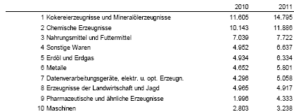 Source: Holland Pioneers in International Business, 2012

In 2011, mainly cars and transport equipment, machinery, chemical products, semi-finished metal products, electronics and nutriment were exported from Germany to the Netherlands. The export from the Netherlands to Germany in the same year contained machinery, transport equipment, fossil fuels and lubricants, chemicals and nutriment (Hermsen, S. 2013). In 2012, products remain more or less the same, there are few differences in the types of products being traded. From Germany, mainly chemical and pharmaceutical products, machinery and nutriment were exported to the Netherlands (German-Dutch Chamber of Commerce, 2013). Mainly earth oil products, earth oil and gas, chemical products and nutriment are exported from the Netherlands to Germany in the same year, as to be seen in tables 4.a and 4.b (German-Dutch Chamber of Commerce, 2013). However, when compared to 2011, the trade of most products increased. Mainly chemicals and nutriment from Germany to the Netherlands have increased, pharmaceutical products and machines have slightly increased too. These products are there main German products which are exported to the Netherlands. With regards to Dutch goods imported by Germany, there is a slight increase in coke fuels and mineral oil products from 2011 to 2012. The greatest increase is to be found in earth oil and earth gas, with an increase of 5, 4 million euros. Furthermore, there is an increase in chemical products and a slight decrease in nutriment goods.

4a. Export to the Netherlands in million euros and percentages (share of total German export to the Netherlands)*
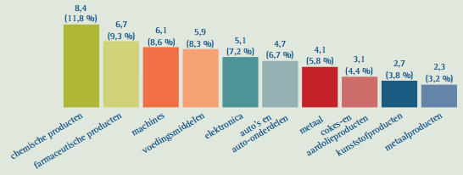
4b. Import from the Netherlands in million euros and percentages (share of total Dutch import by Germany)*
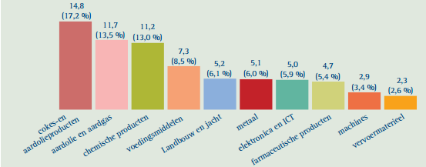
Source: German-Dutch Chamber of Commerce, 2013.

After highlighting the overall trade traffic, it is also important to study what the trade traffic of the Netherlands with North Rhine Westphalia consists of, as North Rhine – Westphalia is the most important German state for the Netherlands. The trade between NRW and the Netherlands does not differ much from that of Germany overall. The main exported goods from the Netherlands to NRW are earth oil and gas, earth oil products, chemical products, nutriment, agricultural and hunting products and metals. The main exported goods from the Netherlands to NRW are chemical products, nutriment, metals, earth oil products as well as machinery (NRW Invest Germany, 2013).

Chapter 2

The German-Polish Commercial Relation

  - §2.1 The development of the German-Polish commercial relations

After the reunification of Germany and the reconstruction of Poland after the collapse of communism in 1990, these were two very different neighboring states. Poland and Germany represented very different economies, with great differences in the Gross National Income, capital, qualified labor and labor productivity. Compared in percentages, Germany was far ahead with its national economy. During the 1990s, Poland had gone through a political as well as financial transformation, which has turned into an integration of Poland with Germany, which was economically, a much stronger state. Due to Germany’s strength and Poland’s struggle to catch up, Poland was experiencing an integration shock. Poland had to follow Germany’s economy to catch up and to increase bilateral trade.

This Polish transformation made it possible to form a narrow relationship with Germany, the first trading partner for Poland (Wolf, N. 2007). The narrow relation between Poland and Germany is mainly formed by an economic cooperation. Poland has an advantage with being the largest market among the new European Union Member States and is the second largest German neighbor after France. After Poland’s accession to the European Union in 2004, the commercial relations with Germany have developed to an even more dynamic level. Germany has been the most important trading partner for Poland. Poland has developed its trading ties with Germany and achieved a more important role in German trade. In 2010 Poland had reached tenth place in the trading list of German trade and had become the most important trading partner of Eastern and Central Europe. The bilateral trading ties also kept growing in the years after 2010 (Deutsches Generalkonsulat Breslau, 2011). Poland has also been able to prevent economic collapse during the global financial crisis, and has even increased its financial situation with a growing percentage of its Gross Domestic Product (Auswärtiges Amt, 2013). Poland has developed its national economy rapidly. This development turned into increased trade with Germany. Statistics from the German-Polish Chamber of Commerce determine that the trade between both states have increased since Poland’s accession to the EU (German-Polish Chamber of Commerce, 2012). Both imports as well as exports between Germany and Poland have increased in the years after Poland’s accession to the European Union. Most noticeable is the development of a negative trading balance to a positive trading balance after 2009 in the table below.

5. Development of Polish trade with Germany. 2005-2011.In billion euros. Output (Ausfuhr) & Input (Einfuhr).

Source: German-Polish Chamber of Commerce 2013.
Notwithstanding the growing international competition with emerging economic world powers, Poland is the most attractive location in Eastern and Central Europe for German companies due to Poland’s access to high subsidies, its high and dynamic Gross National Product with approximately 38 million inhabitants, the availability of well-trained graduates and qualified professionals (Deutsches Generalkonsulat Breslau, 2011).

The importance of Poland to Germany can be recognized in the German support to Poland. Germany has supported Poland by the economic catching-up process after its accession to the European Union and is the largest net contributor to the development of the Polish economy. Germany has also supported Poland with several programs of The World Bank and the European Bank for Polish reconstruction and development. Moreover, Poland has accessed the Schengen-Agreement in which the rules of guards on the borders have been abolished, and this caused even more cross-border cooperation between Germany and Poland (Deutsches Generalkonsulat Breslau, 2011).

Germany has remained the most important trading partner for Poland in 2012 , as seen in the table below. Poland remains in the top list of German trade, in tenth place (Statistisches Bundesamt, Außenhandel 2013). Below is Table 6 which illustrates imports and exports of Poland in billion euros in 2012. It can be seen that Germany remains the most important importer and exporter to Poland and a great difference in figures can be seen in comparison with other countries.

6. Import to Poland and export from Poland, 2012, in billion euros*.
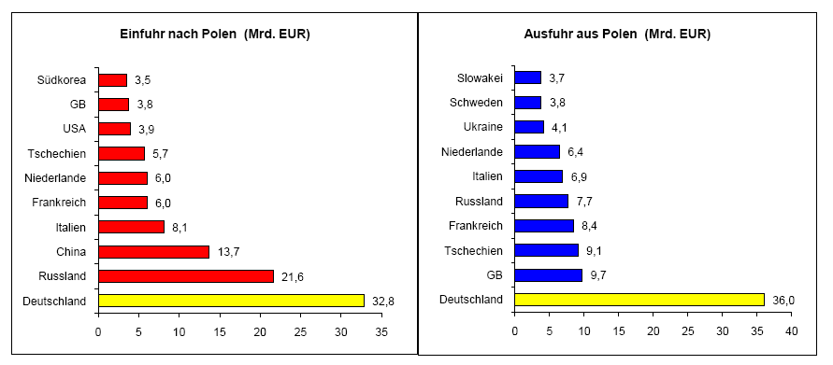Source: Botschaft der Bundesrepublik Deutschland – Warschau, 2013

Germany is not the only most important partner in trading products for Poland, but also a very important investor. With regards to direct foreign investments in Poland, Germany again plays a leading role, both with respect to the quantity of German companies as well as the sum of investments (Auswärtiges Amt, 2013), there are approximately 6000 German companies active in Poland (Willerhausen, F., 2012). Since the system change in ’89-90 Germany has invested over twenty billion euros in Poland. In addition to this sum, there are the investments in SMEs which have not been recorded statistically, with a sum of one billion euros. Most of these investments in SMEs are found in the border regions. Moreover, most of the German investments are start-up investments, only a small part of investments concern acquisition. Germany is increasingly investing in technologically advanced production, and is trying to sharpen its research and development activities in Poland (Auswärtiges Amt, 2013). Paragraph 2.3 will explain more about the chances and opportunities German companies have in Poland.

  - §2.2 Figures of German- Polish trade: Imports and Exports

Below are two tables (table 7) which show the overall balances of Germany and Poland and two tables with figures of the German-Polish trade. The first table contains percentages of Polish trade with Germany; the second table contains figures of German trade with Poland. In general, the Polish balance has increased between 2008-2013. An outstanding fact in the first table, is the development of a negative balance in 2008 to a positive balance in 2013. There is a slight decrease from 2012 to 2013 which could be explained by the fact that these figures show only the first months of 2013. Moreover, there is a slight decrease in the overall German export in 2012. In fact, the export to European Union Member states has decreased by 0, 3 % last year (Statistisches Bundesamt, Außenhandel, 2013). The second table shows that between 2008 and 2013, surprisingly in the period of the financial crisis, there has been more exported to Germany than imported into Germany.

7. .Polish trade with Germany 2008- partly 2013. In billion euros. (Contains the imports, exports, turnover and trading balance) (Graph contains Balance=Blue, Output=Yellow, Input=Red).
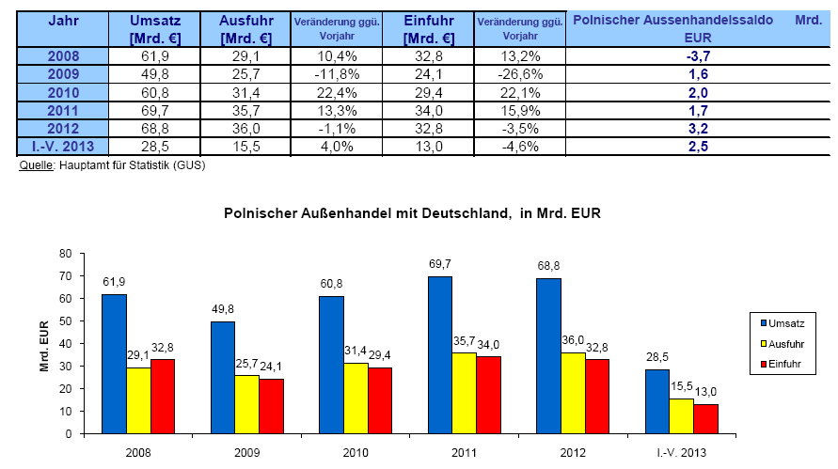
Source: Botschaft der Bundesrepublik Deutschland – Warschau, 2013.

The German trade balance has decreased in the asserted period of 2008-2013. A decreasing balance means that the state has imported more than it has exported. This is also proven by the figures of exports (Ausfuhr) and imports (Einfuhr) in the table below. This table shows figures of the German-Polish trade from 2008 until 2013. An interesting fact in the second graph (graph 8) is that the balance of German trade with Poland has increased in the period of 2008- 2013. There is more exported to Poland than imported into Poland. However the overall German export experienced a slight decrease in 2012.

8. German trade with Poland 2008- partly 2013. In billion euros. (Contains the imports, exports, turnover and trading balance) (Graph contains Balance=Blue, Output=Yellow, Input=Red).
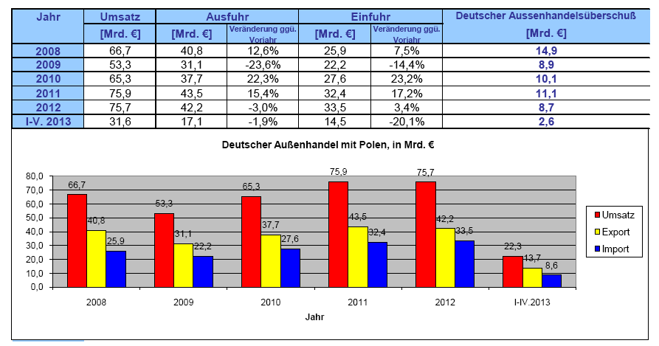
Source: Botschaft der Bundesrepublik Deutschland – Warschau, 2013.
In Table 6 “Import to Poland and Export from Poland”, the most important trading partners of Poland and the figures of import and export with these states are shown. As mentioned before, there is an obvious difference between the figures of trade with Germany and the rest of the states. It is again proven that Polish trade with Germany is of vital importance. The import to and export from Germany is by far the highest income of the top trading partners. Previous figures are evidence that Germany is essential to the Polish national economy and the bilateral trade.

  - §2.3 Branches in the German-Polish trade

The lure of Poland as a trading partner for Germany can be explained by the great demand and interest for German products, which are favored by the Polish population, because they are known for their high quality.

Many German SMEs are active in Poland and successfully sell their products in the Polish market. German SMEs have the best chances in the technical field. Products such as machinery, electronics, automation techniques and medical techniques. Germany remains the main supplier of machinery (Standort Mittel- und Osteuropa, 2012). Examples of German companies active in these branches in Poland are Bühler, Heidelberg, Kaufmann, Benning Power Electronics, and Dräger Safety (German-Polish Chamber of Commerce). Poland is renewing its infrastructure and is starting to give more priority to its renewable energies and environment. This offers great prospects to German companies, as they can offer their expertise in these sectors. Other interesting sectors are the food industry, in particular the organic foods, and engineering services (Standort Mittel- und Osteuropa, 2012). The German-Polish trade exists mostly out the industry, infrastructure, nutriment and construction sector.

To study the import and export traffic between Germany and Poland and to make the overview clearer, the information can be found in the table below. The table shows the percentages of the total of Polish export to Germany and German import from Poland, per branch. The Polish export to Germany in 2011 consists of chemical products, machinery, vehicles and parts nutriments, electronics, electro technology and textiles and metals. Exact percentages are seen in the table below. The German import from Poland in 2011 consists of vehicles and parts, machinery, nutriments, electro technology, chemical products, non-ferrous metals, raw materials, electronics, iron and steel, textiles and paper and cardboards (German-Polish Chamber of Commerce, 2013).

9. German-Polish traffic of import and export, 2011. Polish export to Germany & German import from Poland. Percentages of the total trade*.

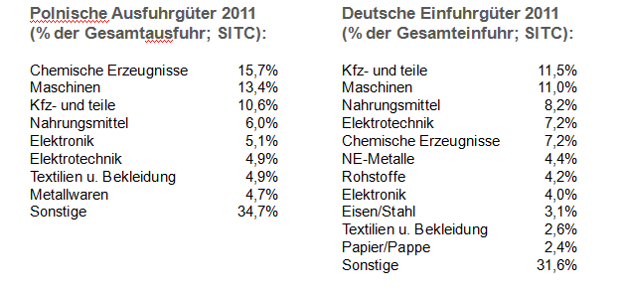
Source: German-Polish Chamber of commerce, 2013.

The most commonly traded products generally remain the same in 2012. Poland has mostly imported mostly chemical products, earth oil, machinery, electronics, vehicles and parts , nutriments, electro technology, and iron and steel products in 2012. The export in the same year contains vehicles and parts, nutriments, machinery, chemical products, electronics and electro technology according to Germany Trade and Invest (GTAI, 2013). Below are two tables published by the Polish Embassy in Berlin, concerning goods in the German-Polish trade traffic from 2009 till 2012, which makes it possible the compare the increases from 2011 (Table 9) to 2012 (Tables 10a and 10b) with two different sources. The German-Polish trade traffic has decreased from 2011 to 2012 and this has affected the main traded products of 2011 too; chemical products, machinery, vehicles & parts and nutriments experienced a slight decrease in 2012. It is also noticeable in Tables 10a and 10b that the overall German-Polish trade traffic experiences a slight decrease in the period of 2009 and 2012, mainly the Polish export goods to Germany have decreased. This is also determined by the Polish Embassy in Berlin which published a report about German-Polish trade relation. The report shows that Poland was ranked as tenth place as importer and exporter for Germany until 2011. In 2012 Poland sank to eleventh place. This report also shows that export from Poland to Germany has decreased since 2011 (Polish Embassy Berlin, 2013).

10a. Polish export goods to Germany in percentages of total exports to Germany, 2009-2012*.
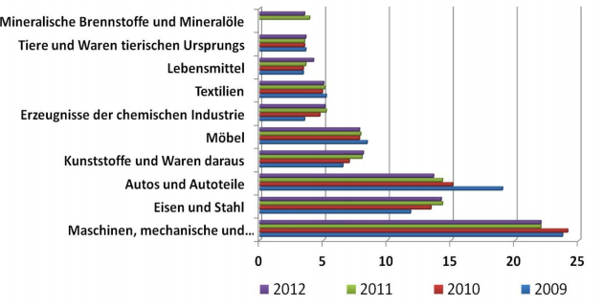
10b. Polish import goods from Germany in percentages of total imports from Germany, 2009-2012*.
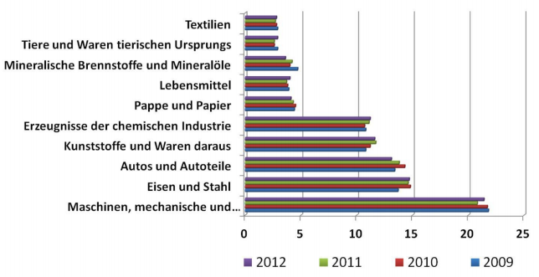

Source :Polish Embassy Berlin, section trade and invest, 2013.

Chapter 3

The Polish-Dutch Commercial Relation

§3.1 The development of the Polish-Dutch commercial relations

Paragraph 2.1 has already described the development of the Polish economy after communism. In addition to that information, this chapter will briefly describe the period after communism and will look deeper into Polish-Dutch relations.

During communism, Poland changed from an agrarian to an industrialized country. In particular the heavy industry was highly represented and as a the result, the service sector was vastly underdeveloped after the fall of communism. Innovation was absent and modern technology was lacking. Waste was very high and in turn resulted in environmental pollution. Poland had to improve in many fields, in particular economy. However, the conversion to a free market economy from a social economy had not been easy. It has been thanks to the enterprising spirit of the Polish population that businesses and companies rose and became interesting for other states, under which the Netherlands. Dutch multinationals such as ING, Rabobank, Unilever, Philips and Heineken placed themselves in Poland after the fall of communism. In the first 10 to 15 years there was a wave of takeovers because many companies were in search of new markets and it was mainly companies which took over government enterprises (Meenink, L., 2013). Poland and the Netherlands have and maintain close relations (since the 15th century). In Gdansk there are still Dutch gables of old warehouses, which witnessed the close trading ties. The Netherlands provided a lot of assistance to Poland during its accession to the European Union by maintaining close contacts concerning the procedure of Poland´s accession. After the accession the contacts between Poland and the Netherlands increased even further. There is an annual conference in Utrecht on behalf of important European Union issues, for instance economy and energy (Rijksoverheid, 2013).

Poland has a growing economy and is expected to develop further in the near future. In the period of 2013 until 2016, an average growth of 3,4 percent is expected. Due to a market with 38 million inhabitants with a growing purchasing power and well educated and hard working population, Poland is an interesting player on the international market. Especially the demand of water, energy and agriculture (in paragraph 3.3 a more detailed description of these important sectors will be given) is interesting for other states regarding investments. (Meenink, L., 2013). The Netherlands is one of the major foreign investors in Poland. Many Dutch entrepreneurs have invested in Poland since the 1990s as mentioned in the second section of this paragraph. Many Dutch multinationals are operating in Poland in the electronics sector and many SMEs are operating in the field of agriculture (Rijksoverheid, 2013). There are approximately 1400 Dutch companies in Poland with one or more establishments. The main reasons for Dutch companies to operate in Poland are the growing economy, low labor costs, high productivity as well as highly educated laborers (Meenink, L., 2013). Examples of some of these ca. 1400 Dutch companies are Imtech, Bredenoord, Hendrik Gras, Grontmij, ESA Security, Philips, Kersten Europe, and TLS- Boca Systems (NPCH, 2012).

The Netherlands Council for Trade Promotion has done a survey on Dutch companies. These companies are active in Poland detailing their experiences and also providing information about companies per branch. The survey was taken over 49 companies. According to the NCH (Netherlands Council for Trade Promotion) there are precisely 1393 Dutch companies operating in Poland with one or more Polish entities. The graph below shows in which branches the Dutch companies are operating in Poland (NCH, 2012).

11. Survey Dutch Companies in Poland: How many Dutch companies are active in Poland? & Positive future Polish entities in the next two years?
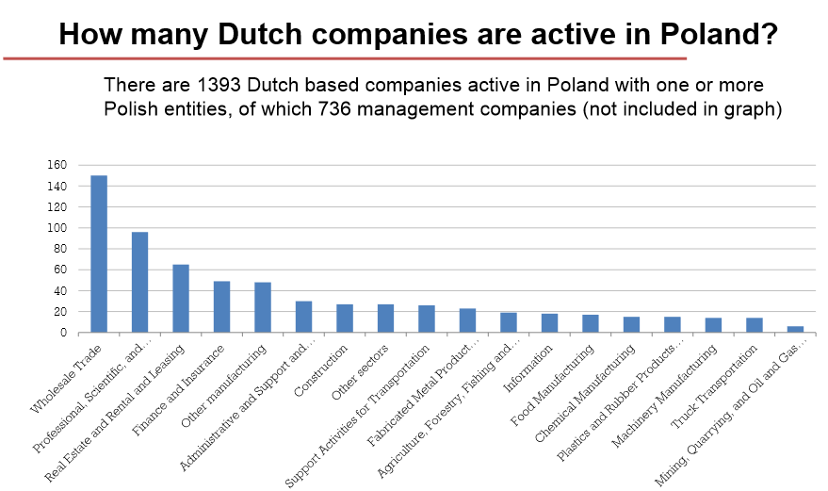
_{Source: NPCH,2012..}
In the same survey Dutch companies were asked about their expectations of their Polish entities in the coming 2 years. 80 percent of the companies had a positive view of their entities in Poland. Further answers can be seen in the graph below.
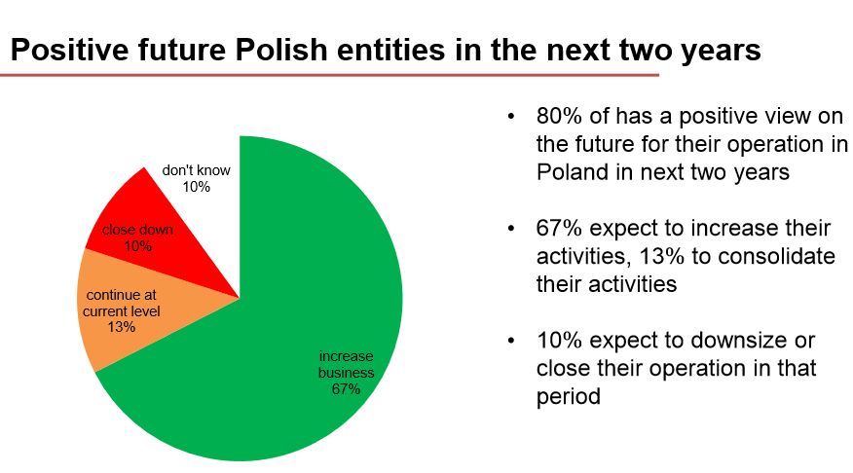
_{Source: NPCH,2012..}

  - §3.2 Figures of Polish-Dutch trade: Imports and Exports

Poland’s balance of trade reached its highest amount in April. Since the beginning of this decade, the turnover of Poland’s trade has developed thus far that the amount is ten-fold. The European Union Member States are by far the largest trading area of Poland, nearly eighty percent of exports and over sixty percent of imports are from the European Union (Trading Economics, 2013). Poland is ranked as the eighth most important trading partner for the Netherlands and the value of imports and exports keeps increasing annually. In the period of 2006 until 2011 the value of imports from Poland to the Netherlands has increased by thirty percent and the imports increased by over fifteen percent. In the years after this period, trade has increased even further and a growth of approximately 3,4 percent per year is expected until 2015 or even 2016. The processing industry, which has doubled, is the main force behind the economic growth in Poland. In addition, there is an increasing domestic demand in Poland (NCH,2012). In Poland a survey about the image of the Dutch was taken this year (by the Dutch Embassy in Warsaw) and results showed that many Poles are not yet familiar with Dutch companies and products, which means the Netherlands has a growing chance in the Polish market (Meenink, L., 2013).

The value of trade to and from Poland is even more important to the Netherlands than that of Brazil, which is one of the emerging economies in the world market. The Netherlands is ranked as sixth for import from and seventh for export to Poland (Meenink, L., 2013). In Table 12 (appendix 2) the import and export traffic between Poland and the Netherlands is shown between 2010 and part of 2013. The table contains imports from Poland to the Netherlands and export from the Netherlands to Poland. Furthermore the figures of the balance of trade between both states is given. What stands out immediately is the trade of nutriments and animals, chemical products and machinery & transport materials. These products are the most traded products between the Netherlands and Poland. From 2010 to 2011 an increase in the total balance can be seen, however from 2011 to 2012 show a slight decrease. This year could result in an increase due to the recent figures of the period January-July 2013, the figures in this period are almost 2 billion, which means that there is a possibility that it could double by the end of the year. However, some sources expect a slight decrease in 2013, although it is also expected that the balance will increase after 2013 (Agentschap NL, 2013). The expected growth of the Polish economy of 3.4 percent could make Poland more and more attractive as a trading partner. As mentioned before, it is the conclusion of a survey already carried out, that Poland is not yet familiar with many Dutch products and companies, which means that these products and companies are still yet to be discovered in Poland, which could lead to an increase in the trade between the Netherlands and Poland.

  - §3.3 Branches in the Polish-Dutch trade

In this paragraph the information about the most important branches, sectors and products in Polish-Dutch commercial relations will be provided. The products in Polish sectors which offer the best challenges for Dutch companies will be discussed, as well as the sectors and products which are most commonly traded between both states.

The prospects for Dutch companies are great in the Polish water sector due to the Dutch expertise and experience in comparison with Poland. Besides, there is a great demand and interest for the water sector by the Polish too, as mentioned before. The most important challenges in the water sector are the water supply and the treatment of waste water, since most EU and Polish funds are spent on these subsectors (Agentschap NL, 2013). Furthermore, Poland has a priority in enlarging energy efficiency, assurance of energy supply, introduction of kern energy, stimulation of renewable energy and reduction of negative environmental influences. There is a great demand for energy and the necessity of reducing CO²-expulsion and, on behalf of the European Union directives, there is a demand for restricting Russian oil and gas. Poland still has to improve its energy sector which results into chances for foreign investments Agentschap NL, 2013). Another sector, namely the agriculture sector in Poland, is important because the Netherlands is one of the only states that has a positive trade balance with Poland in the agrarian field. The Polish consumer, however, prefers locally produced products, which turns export of agricultural products into opportunities in exporting agriculture technology. Especially in the field of mechanization of agriculture, are there opportunities for investment in robotics and precision agriculture. With regards to irrigation and water management which mainly involves the construction and renovation of drainage and irrigation works associated equipment. The subsectors with the greatest prospects for Dutch companies are horticultural sector, dairy sector and the food (nutriments) industry (Agentschap NL, 2013).

The service sector is the largest sector in Poland, which makes a great share of the Polish Gross National Product. There are many logistic services in Poland, such as transport companies, and due to its strategic location in central Europe is considered as a bridge between Eastern and Western Europe. The infrastructure in Poland has improved and in this way, it is easier for trading partners to approach other growing regions in Eastern Europe. The UEFA European Championship 2012 has played a key role in the improvement of the Polish infrastructure and due to an improved infrastructure, the economy keeps growing (Meenink, L. 2013). After the service sector, the largest sector is determined as the industry sector. The nutriment industry, automotive and metals are the most important ones in the industry sector of Poland. After the industry sector, the agriculture and fisheries are the biggest contributors to the Gross National Product (Meenink, L. 2013).

The traffic of traded products from the Netherlands include mainly machinery, chemicals, manufactured goods and agricultural products which are exported to Poland. Many products are used as intermediate products and are exported to Poland to be finished. After the finishing process, the products are imported back to the Netherlands (NC, 2012). Other export products to Poland contain mainly machinery (telecom equipment and agricultural machines), transport appliances and chemical products (such as medicines, plastics and perfumed oils). Imports from Poland to the Netherlands consist of agricultural products, machinery (such as office machines and telecom equipment), clothing textiles and chemical products (plastics) (Rijksoverheid, 2013). Graph 12 below shows the export products from Poland to the Netherlands. The main exported products are machines.

12.: Exports to Poland from the Netherlands, 2011. ( Machines: Yellow/Chemicals: Blue/ Nutriments: Brown /Others: Red)

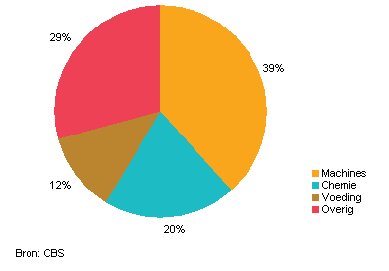
_{Source: CBS, 2012.}
Exports from the Netherlands to Poland has increased by one billion euros in 2011. A great share of this increase belongs to the machinery and chemicals sector (CBS, 2012). A big part of exports to Poland refer to machinery and transport equipment and chemicals, which is determined in the last paragraph. A further popular export product is computer parts, which makes up nearly a quarter of the total Dutch export to Poland. The export of computers alone however has decreased (CBS, 2012). Other important export products are vehicles (table 13), such as conventional and hybrid cars (CBS, 2012).

13: Exports of vehicles from the Netherlands to Poland, 2011. 1. Vehicles, total. 2. Trucks. 3. Others. (Total: Yellow /New: Blue /Used: Brown)
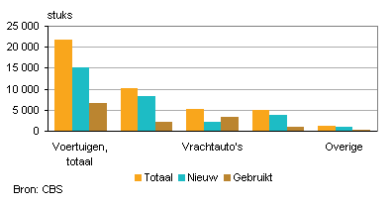
_{Source: CBS, 2012.}

Conclusion

Within the context of this research, the mutual commercial relations of three countries are studied with the aim of answering the next question: What are the consequences of the increasing German-Polish commercial relations for German-Dutch commercial relations? In order to answer this question, relations between the three states were studied, first of all German-Dutch commercial relations were studied, which resulted in a continuous increase in trade. The mutual German-Dutch trade relation is based on strong interdependencies of the Rotterdam Port for Germany and the German state North Rhine - Westphalia for the Netherlands. The bilateral trade between the neighboring states has a long history and has become closer through the years. There is a mutual need of trading in import and export, in particular for the Netherlands. Germany is the top partner of import and export for the Netherlands, and the Netherlands is the number one partner of imports but the fourth partner for exports. The most commonly exported product categories from Germany to the Netherlands are: chemical products, pharmaceutical products, nutriments and machinery. The imports from Germany to the Netherlands are mainly coke fuel and mineral oil products, chemical products and nutriments.

In the last few years, an increase in German-Dutch trade volume can be seen, as well as an increase of most traded products. In trade traffic, an increase is noticeable in the most commonly traded products; chemical products, nutriments, pharmaceutical products, coke fuels and mineral oil products and machinery have increased. The trade of earth oil and earth gas experienced the highest increase. In the most commonly traded products, the only decrease is seen in nutriments. Is the Netherlands in “danger” of a favorable competitor in trade in the “German trade field”? Germany, Poland and the Netherlands are three important European states in terms of trade and investments, each with a unique character. Germany is recognized by its industrial character, the Netherlands has been known as a trading state ever since the “Golden Age”, Poland was characterized by its agricultural character but has started to develop its economy, principally since the fall of communism. There are great chances for trade and investments in Poland and Germany is benefiting from this.

There is an economically interdependent relationship between the Netherlands and Germany, with the second largest trade volume in the world, but the German-Polish trade is experiencing prosperity, mainly since Poland’s accession to the European Union. Poland made it to the top ten of German trading partners although Germany is more important to Poland as the first trading partner, an increase in the German-Polish trade volume is noticeable. The accession to the European Union has made Poland a more easily reachable market. Due to Poland’s need for development and expertise as well as the demand for quality, there is a national demand and interest for German products. The trade traffic between Germany and Poland exists mostly from the sectors of industry, infrastructure, nutriments and construction.

The German-Polish trade traffic contains mainly chemical products, machinery, nutriments, iron & steel and vehicles & parts. Although trade has been increasing since Poland’s accession to the European Union, the German-Polish trade has experienced a decrease since 2011, which mainly affected trading of machinery, iron & steel and chemical products. However the German investments in Poland keep increasing. At the same time, German-Dutch trade continues to increase.

To measure if the amount of increase between Germany and Poland affects German-Dutch trade, relations between the Netherlands and Poland has been studied too. This study has shown that the Netherlands is developing a more and more intensive trade and invested relations with Poland. There are already almost 4000 Dutch companies active in Poland and most of these companies want to maintain or even improve their businesses in Poland because of their positive views of the future. In fact, the Netherlands is one of the main investors in Poland. Besides, there are great opportunities for Dutch companies due to emerging sectors in Poland. There is a need for expertise in the Polish water sector and in enlarging energy efficiency and stimulation of renewable energy. Another advantage for the Netherlands is the fact that it is one of the only states that has a positive trade balance in the agrarian field, although the Polish consumer prefers locally produced products, it turns into opportunities for exporting agricultural technology. Concerning the trade of goods between the Netherlands and Poland , the products consist mainly of nutriments & (living) animals, chemical products and machinery & transport materials. The trade balance between these two states show an overall increase in the period of 2010 and part of 2013.

When the trade traffic of these three states are studied as a whole, it can be determined that without a doubt that Poland is the most favored state of the three to invest in, due to emerging sectors which offer good prospects for Dutch and German companies to benefit from. This shows that in this area, there could be competition between Germany and the Netherlands rather than between the Netherlands and Poland. Most importantly, when the trade traffic competition is studied carefully, it is still not certain if German-Polish trade affects the German-Dutch trade. However, with the information in the three chapters of this research, an increase in the German-Dutch trade balance can be seen in the period of 2010 until 2012. German-Polish trade balance does not encounter an increase in the same period, instead it shows a slight decrease after 2011. However this is not per se evidence that German-Polish commercial relations do not affect German-Dutch commercial relations. It was therefore necessary to study the increases of trade products and the important sectors of the trade. Most noticeably, it can be said that the overall picture of the product categories in the trade of all three states are quite similar. The trade of chemical products and machinery for instance, which have increased in German-Dutch trade but decreased in German-Polish trade over the last few years. Although this is again not direct evident, it shows that German trade with Poland is not at the expense of German-Dutch trade relations. However, this could only mean that the Netherlands takes the lead in these product categories and does not automatically lead to the answer of the central question, because Poland could be taking the lead in other product categories, such as trading in vehicles & parts. Poland and the Netherlands are both benefiting from German trade, and vice versa.

To specifically study if one relation could increase at the expanse of the other needs more expertise and more detailed research. A professional of EUNITE (Consult office of investing in Poland) was consulted for this research and confirmed that several states could benefit from a market at the same time and that this does not definitely mean that it would be at the expense of other states. Germany is, in this case, a fruit garden of which one or more other states could benefit from.

The result of this research is remarkable with regard to what was expected in the first place: Poland as an emerging and developing economy where a strong neighbor as Germany could benefit considerably from. It seems that the increase of German-Polish trade is more aligned with investments in Poland rather than trading in goods, so as the trade traffic decreased, the German investments in Poland increased. On the other hand, German-Dutch trade relations remain profitable and has kept increasing over the years. In conclusion, the overall picture is that there are no real or direct consequences of German-Polish commercial relations for German-Dutch commercial relations which can be determined in the scope of this research.

List of References

Agentschap NL. (2013). Kansen voor het Nederlandse bedrijfsleven in Polen. Kansendossier Polen. Retrieved from Marieke van der Wilk-Areamanager NCH by e-mail: MvanderWilk@nchnl.nl.

Agentschap NL. (2012). Nederlands bedrijfsleven actief op Euro 2012. Retrieved from: Marieke van der Wilk-Areamanager NCH by e-mail: MvanderWilk@nchnl.nl. .

Auswärtiges Amt. (2013). Beziehung zu Deutschland. Retrieved from the German Federal Foreign Website: http://www.auswaertiges amt.de/DE/Aussenpolitik/Laender/Laenderinfos/Niederlande/Bilateral_node.html

Botschaft der Bundesrepublik Deutschland Warschau. (2013). Daten zur Polnischer Wirtschaft. Retrieved from German Embassy Website: http://www.warschau.diplo.de/contentblob/3421896/Daten/3387449/Statistik.pdf

Botschaft der Repubik Polen in Berlin. (2013). Stand der polnisch-deutschen Wirtschaftsbeziehungen: Jahrergebnisse 2012 und Jahresentwicklungsprognose 2013. Retrieved from Polish Embassy Website: http://www.msz.gov.pl/resource/6c79fc3c-a972-4839-8eb2- e2e08df444dd:JCR

Centraal Bureau voor Statistiek. (2010). De naoorlogse economische ontwikkeling van Nederland en Duitsland. Retrieved from Federal Bureau of Statistics Website: http://www.cbs.nl/NR/rdonlyres/50D75D40-C00F-40D4-B209- 286F876937D1/0/2010p215p19art.pdf

Centraal Bureau voor Statistiek. (2012). Polen: Uitvoer stijgt harder dan invoer. Retrieved from Federal Bureau of Statistics Website :http://www.cbs.nl/nl- NL/menu/themas/internationale- handel/publicaties/belangrijkste- handelspartners-nederland/archief/2012/2012- polen-2011-art.htm

German-Dutch Chamber of Commerce. (2012). Economische Vestigingsplaats. Retrieved from DNHK Website: http://www.dnhk.org/nl/niederlande/fakten/economische- vestigingsplaats/

German-Dutch Chamber of Commerce. (2013). Economisch Profiel Duitsland. Retrieved from DNHK Website: http://www.dnhk.org/fileadmin/ahk_niederlande/Bilder/Publicaties/2013_Economis ch_Profiel_Duitsland.pdf

German-Dutch Chamber of Commerce. (2012).Handel met Nederland. Retrieved from DNHK Website: http://www.dnhk.org/nl/niederlande/fakten/handel-met- nederland/#c115572

Deutsches Generalkonsulat Breslau. (2011). Deutsch-Polnische Wirtschaftsbeziehung. Retrieved from German Consulate Website: http://www.breslau.diplo.de/Vertretung/breslau/de/05/11__Deutsch__polnische__ Wirtschaftsbeziehungen/Deutsch__polnische__Wirtschaftsbeziehungen___C3_9C bersicht seite.htmlhttp://www.breslau.diplo.de/Vertretung/breslau/de/05/11__Deutsch__pol nische_Wirtschaftsbeziehungen/Deutsch__polnische__Wirtschaftsbeziehungen__ C3_9Cbersichtseite.html

Deutsch-Polnische Industrie- und Handelskammer. (2012). Handel zwischen Polen und Deutschland [Powerpoint]. Retrieved from: Mr. P Kwiatkowski by e-mail: pkwiatkowski@ahk.pl

Deutsch-Polnische Industrie- und Handelskammer. (2013). Mitgliederliste. Retrieved from AHK Poland Website: http://ahk.pl/mitgliedschaft/mitgliederliste/?no_cache=1

Germany Trade & Invest. (2013). Deutsch-polnischer Handel auf hohem Niveau stabil. Retrieved from Germany Trade and Invest Website: http://www.gtai.de/GTAI/Navigation/DE/Trade/maerkte,did=798040.html

Hermsen, S. (2013). Handel met Duitsland – Feiten en Cijfers. Retrieved from Dirk Zwager Ondernemingsrecht Website: http://dirkzwagerondernemingsrecht.nl/2013/03/18/handel-met-duitsland-feiten-en- cijfers/

Holland Pioneers in International Business. (2012).Analyse van de economische betrekkingen tussen Nederland en Duitsland. Retrieved from Dutch Embassy Website: http://duitsland.nlambassade.org/bijlagen/duitsland-in-cijfers---analyse- economische-betrekkingen-nederland/duitsland-in-cijfers---analyse-economische- betrekkingen-nederland---baden-wurttemberg.html

Meenink, L. (2013). Business Guide Polen. Retrieved from Dutch Embassy Website: http://polen.nlambassade.org/you-and-country/zakendoen-in-polen

Nederlands Centrum voor Handelsbevordering. (2013). Retrieved from NCH Website: http://www.handelsbevordering.nl/regios/4/4/99

Nederlands-Pools Centrum voor Handelsbevordering. (2012). Dutch business experiences in Poland. Results based on a survey among Dutch companies operating in Poland. Retrieved from Marieke van der Wilk-Areamanager NCH by e-mail: MvanderWilk@nchnl.nl.
.

NRW Invest Germany. (2013). Buitenlandse Handel van Noordrijn Westfalen met Nederland.Retrieved from NRW Invest Website: http://www.nrwinvest.com/nrwinvest_dutch/Overzicht_van_Noordrijn- Westfalen/Daten___Fakten/index.php

Rijksoverheid. (2013). Betrekkingen Nederland – Polen. Retrieved from Rijksoverheid Website: http://www.rijksoverheid.nl/onderwerpen/betrekkingen-met- nederland/polen

Standort Mittel- und Osteuropa. (2012). Deutsch-polnischer Handel mit hoher Dynamik. Retrieved from Standort Website: http://www.estandort.com/deutsch-polnischer-handel-mit-hoher- dynamik/

Statistisches Bundesamt. (2013). Außenhandel. Rangfolge der Handelspartner im Außenhandel der Bundesrepublik Deutschland (mit Umsatz und Saldo). Retrieved from Federal Statistical Office Website https://www.destatis.de/DE/ZahlenFakten/GesamtwirtschaftUmwelt/Aussenhandel/ Handelspartner/Tabellen/RangfolgeHandelspartner.pdf?__blob=publicationFile

Statistisches Bundesamt. (2013). Der deutsche Außenhandel im Jahr 2012. Retrieved from Federal Statistical Office Website: https://www.destatis.de/DE/Publikationen/WirtschaftStatistik/Aussenhandel/Ausse nhandel2012_52013.pdf?__blob=publicationFile

Statline Centraal Bureau voor Statistiek. (2013). Internationale handel; in-en uitvoer volgens SITC- indeling. Retrieved from Federal Bureau of Statistics Website: http://statline.cbs.nl/StatWeb/publication/?DM=SLNL&PA=7137SHIH&D1=0- 2&D2=0- 1,48,55,101,117,125,169,231,291,331&D3=49&D4=194,207,220,l&HDR=T,G2&S TB=G3,G1&VW=T

Trading Economics. (2013). Poland Balance of Trade. Retrieved from Trading Economics Website:http://www.tradingeconomics.com/poland/balance-of-trade

Universität Münster. (2009). Niederlande-wissen – Handel, Transport und Infrastruktur. Retrieved from University of Munster Website: http://www.uni-muenster.de/NiederlandeNet/nl- wissen/wirtschaft/vertiefung/handel/

Willerhausen, F (2012). Der unterschätzte Nachbar: In Polen gibt’s noch was zu holen. Retrieved from Wirtschafts Woche Website: http://www.wiwo.de/politik/europa/der-unterschaetzte-nachbar-in- polen-gibts-noch-was-zu-holen/7334732.html

Wolf, N. (2007). Ökonomische Zugänge zur Geschichte der deutsch-polnischen Beziehungen. Retrieved from University of Warwick Website: http://www2.warwick.ac.uk/fac/soc/economics/staff/academic/wolf/wolf.pdf

Appendices
Appendix I
Translation of tables:
Table 1: Development German-Dutch trade 2010-2012.
Table 1a:
- Imports in Germany
- Imports in Germany from the Netherlands
Table 1b:
- Export from Germany
- Export from Germany to the Netherlands
Table 2: The ten main importers of Germany, in billion euros, 2012.
- The Netherlands
- Republic of China
- France
- United States
- Italy
- United Kingdom
- Russian Federation
- Belgium
- Switzerland
- Austria
Table 3. Import and export traffic between Germany and the Netherlands. Value of goods in billion euros.
Table 3a:
- Chemical products
- Pharmaceutical and comparable products
- Machinery
- Others
- Data-processing appliances and electronics
- Nutriments and feeding
- Vehicles and parts
- Metals
- Rubber and synthetic materials
- Electric appliances
Table 3b:
- Coke fuel and mineral oil products
- Chemical products
- Nutriments and feeding
- Others
- Earth oil and gas
- Metals
- Data-processing appliances and electronics
- Appliances for agriculture and hunting
- Pharmaceutical and comparable products
- Machinery
4a. Export to the Netherlands in million euros and percentages (share of total German export to the Netherlands
- Chemical products
- Pharmaceutical products
- Machinery
- Nutriments
- Electronics
- Cars and parts
- Metal
- Coke fuel and mineral oil products
- Synthetic materials
- Metal products
4b. Import from the Netherlands in million euros and percentages (share of total Dutch import by Germany)
- Coke fuel and mineral oil products
- Earth oil and gas
- Chemical products
- Nutriments
- Agriculture and hunting
- Electronics and ICT
- Pharmaceutical products
- Machinery
- Transport materials
Table 6. Import to Poland and export from Poland, 2012, in billion euros.
Input Poland:
- South-Korea
- Great-Britain
- United States
- Czech Republic
- The Netherlands
- France
- Italy
- Russia
- Germany
Out from Poland:
- Slovakia
- Sweden
- Ukraine
- The Netherlands
- Italy
- Russia
- France
- Czech Republic
- Great-Britain
- Germany
9. German-Polish traffic of import and export, 2011. Polish export to Germany & German import from Poland. Percentages of the total trade
Polish Export goods 2011 (% of total, SITC):
- Chemical products
- Machinery
- Vehicles and parts
- Nutriments
- Electronics
- Electro techniques
- Textiles and clothing
- Metals
- Others
German Import goods 2011 (% of total, SITC)
- Vehicles and parts
- Machinery
- Nutriments
- Electro techniques
- Chemical products
- Non-Ferrous metals
- Raw materials
- Electronics
- Iron and steel
- Textiles and clothing
- Paper and cardboard
- Others

10a. Polish export goods to Germany in percentages of total exports to Germany, 2009-2012.
- Mineral fuels and oils
- Animals and goods of animal origin
- Nutriments
- Textiles
- Products for chemical industry
- Furniture
- Synthetic materials
- Cars and parts
- Iron and steel
- Machinery
10b. Polish import goods from Germany in percentages of total imports from Germany, 2009-2012.
- Textiles
- Animals and goods of animal origin
- Mineral fuels and oils
- Nutriments
- Paper and cardboard
- Products for chemical industry
- Synthetic materials
- Cars and parts
- Iron and steel
- Machinery

Appendix II
12. Polish-Dutch trade: imports and exports of goods, 2010-2013 (January-July).
Perioden | SITC | Invoer Uitvoer Handelsbalans
2010 | Totaal goederen | 4 624 217 | 7 377 787 | 2 753 570
 | 0 Voeding en levende dieren | 702 215 | 1 013 546 | 311 331
 | 1 Dranken en tabak | 119 676 | 18 646 | -101 030
 | 2 Grondstoffen, niet eetbaar | 77 060 | 362 708 | 285 647
 | 3 Minerale brandstoffen, smeermiddelen | 381 106 | 88 596 | -292 510
 | 4 Dierlijke en plantaardige oliën | 6 548 | 56 622 | 50 074
 | 5 Chemische producten | 190 572 | 1 413 961 | 1 223 388
 | 6 Fabrikaten | 596 914 | 774 422 | 177 508
 | 7 Machines en vervoermaterieel | 1 822 429 | 2 886 653 | 1 064 224
 | 8 Diverse gefabriceerde goederen | 720 615 | 757 604 | 36 989
 | 9 Niet afzonderlijk genoemde goederen | 7 082 | 5 030 | -2 052
2011 | Totaal goederen | 5 094 156 | 8 410 835 | 3 316 679
 | 0 Voeding en levende dieren | 767 052 | 1 092 817 | 325 766
 | 1 Dranken en tabak | 151 781 | 47 075 | -104 706
 | 2 Grondstoffen, niet eetbaar | 79 649 | 454 472 | 374 823
 | 3 Minerale brandstoffen, smeermiddelen | 500 870 | 160 763 | -340 107
 | 4 Dierlijke en plantaardige oliën | 5 456 | 73 110 | 67 654
 | 5 Chemische producten | 383 550 | 1 717 193 | 1 333 644
 | 6 Fabrikaten | 659 750 | 874 324 | 214 575
 | 7 Machines en vervoermaterieel | 1 810 430 | 3 212 127 | 1 401 697
 | 8 Diverse gefabriceerde goederen | 734 582 | 773 951 | 39 369
 | 9 Niet afzonderlijk genoemde goederen | 1 036 | 5 001 | 3 965
2012 | Totaal goederen | 5 452 921 | 8 537 932 | 3 085 011y
 | 0 Voeding en levende dieren | 894 845 | 1 022 039 | 127 194
 | 1 Dranken en tabak | 138 681 | 42 435 | -96 247
 | 2 Grondstoffen | 69 159 | 556 475 | 487 316
 | 3 Minerale brandstoffen, smeermiddelen | 627 359 | 99 351 | -528 008
 | 4 Dierlijke en plantaardige oliën | 12 177 | 84 690 | 72 513
 | 5 Chemische producten | 294 673 | 1 722 272 | 1 427 599
 | 6 Fabrikaten | 692 698 | 844 315 | 151 617
 | 7 Machines en vervoermaterieel | 1 968 669 | 3 363 096 | 1 394 427
 | 8 Diverse gefabriceerde goederen | 753 313 | 751 334 | -1 979
 | 9 Niet afzonderlijk genoemde goederen | 1 347 | 51 925 | 50 578
2013 januari - juli* | Totaal goederen | 3 239 911 | 5 229 827 | 1 989 917
 | 0 Voeding en levende dieren | 563 533 | 682 543 | 119 010
 | 1 Dranken en tabak | 90 846 | 22 772 | -68 074
 | 2 Grondstoffen, niet eetbaar | 59 589 | 320 528 | 260 939
 | 3 Minerale brandstoffen, smeermiddelen | 396 400 | 63 544 | -332 855
 | 4 Dierlijke en plantaardige oliën | 14 114 | 63 910 | 49 796
 | 5 Chemische producten | 198 636 | 988 077 | 789 441
 | 6 Fabrikaten | 391 168 | 489 828 | 98 660
 | 7 Machines en vervoermaterieel | 1 060 376 | 2 128 007 | 1 067 631
 | 8 Diverse gefabriceerde goederen | 464 326 | 453 456 | -10 870
 | 9 Niet afzonderlijk genoemde goederen | 923 | 17 162 | 16 239
Source: Centraal Bureau voor de Statistiek, Den Haag/Heerl,2013
Translation of goods in table above:

Total goods
- Nutriments and living animals
- Drinks and tobacco
- Raw materials, not eatable
- Mineral fuels, lubricants
- Animal and vegetable oils
- Chemical products
- Fabricates
- Machines and transport materials
- Various fabricated goods
- Not separately mentioned goods.

The amount of trade in 2012 between the Netherlands and Germany contained 157, 6 billion euros.
Hereafter known as “NRW”.
A share of 22, 3 percent of the total German import belongs to NRW.
43,4 percent of imports from the Netherlands are destined to NRW.
The trade has developed from 18,1 billion euros to 37,6 billion euros.
Table 1 shows only the first quarter of each year, which is the reason for the relatively low import and export figures. The calculation is: 21,558 billion euros x4= 86,232 billion euros (import), and 18,530x4= 74,120 billion euros (export). 86,232 billion euros + 74,120 billion euros= 160, 352 billion euros. This amount is very close to the amount of the 157,6 billion euros trade volume given by the German-Dutch Chamber of Commerce.
Small and Medium Enterprises, abbreviated as SME.
There is a difference to be seen in the figures of table 7 year 2013: In the table 2013 is shown from the months January until May. The graphic underneath this table shows 2013 over the months January until April.
An amount of 581 billion euros
63 percent of the Polish Gross National Product
The industry sector makes up 19,3 percent of the Gross National Product
The year 2011 is an indication of the overall trade relation due to lack of information over more recent years.
Nearly 40 percent
EUNITE consults and assists Western organizations in Central and Eastern Europe. Mr. De Bruin gave advise mainly about Poland and its relations.

