Reduction of cyanobacterial problems with Moringa oleifera
An exploratory research on the flocculation performance of the natural flocculant Moringa oleifera seeds to diminish cyanobacterial problems

Nieke Hoenjet

Bachelor thesis Aquatic Ecotechnology

Date 05-06-2017
Reduction of cyanobacterial problems with Moringa oleifera

An exploratory research on the flocculation performance of the natural flocculant Moringa oleifera seeds to diminish cyanobacterial problems

Name: | Nieke Hoenjet
Student number: | 64894
Part of education project: | Bachelor thesis
Study year: | 2016-2017
Study: | Aquatic Ecotechnology
Supervisor HZ University of Applied Sciences: | Jouke Heringa
Supervisors Wageningen University: | Miquel Lürling and Maíra Mucci
Report type: | Research report
Version: | Final version
Date: | 05-06-2017
Sources pictures front page: | 1: EnviroScience, 2017  2: A Healthy Leaf, 2016  3: RFE B.V., n.d.  4: Libelle TV, 2017
Summary
Nutrient enrichment, scientifically known as eutrophication, is a worldwide problem. Eutrophication is one of the main drivers for cyanobacteria blooms. Cyanobacteria blooms can have a negative effect on ecology, economy and human health, as a result of to the ability of some species to release toxins. Due to the absence of water treatment plants in developing countries, cyanobacteria blooms causes increasing problems as the surface water is often the only source for drinking water. Lacking financial resources keeps this situation critical, which is why an instant cheap and effective solution is needed.
Geo-engineering is the manipulation of biogeochemical processes (mainly targeting phosphorus) using different materials such as metals or clay. A flocculant is combined with a ballast product to sink the flocks. Ballast products can be P-sorbents or natural materials such as soil or clay. Flocculants can be e.g. polyaluminiumchloride or natural materials, such as chitosan and recently Moringa oleifera has been used. In this study the flocculation performance of the natural flocculant Moringa oleifera seeds was investigated.
In the general experiment design crushed Moringa seeds extracted with different solvents were added to cyanobacteria cultures in different concentrations and after 1 hour chlorophyll-a, PSII and pH were measured.
During a series of experiments the effects were studied of different Moringa extraction methods, initial chlorophyll-a concentrations, inorganic turbidity, pH, addition of ballast, seed variability and different cyanobacteria species on the flocculation performance of Moringa oleifera seeds. Furthermore, it was explored how Moringa oleifera seeds influence the pH of the water and the nutrient release by Moringa. Additionally, the flocculation time of Moringa oleifera extract was measured and the optimum Moringa seed concentration was found for a cyanobacteria solution with an initial chlorophyll-a concentration of 200µg/L.
Filtered Moringa extract showed a better flocculation performance than unfiltered MO extract. Furthermore, the reliability of 1M NaCl MO extract was higher than that of MO water extract. The pH affect the flock size, but had no effect on the removal efficiency. The optimum MO concentration depended on the initial chl-a concentration, but for removing 200µg/L cyanobacteria the optimum concentration was 80mg/L. Moringa did not influence the pH. Moringa seemed to be unable to flock inorganic turbidity. A high removal efficiency does not automatically mean that Moringa is a good flocculant, because at some species Moringa influences the PSII and toxins can be released. In that case, it is recommended not to use Moringa. The flocculation performance and removal efficiency can be influenced by both the flocculant and the ballast. Moringa releases nutrients to the water and might contribute even more to eutrophication if added in the system. Seed variability might cause variation in flocculation performance, since it was observed that in repeated experiment with similar treatments sometimes flocculation occurred and sometimes not.
It can be concluded that at this point Moringa seeds are not yet a reliable flocculant, but there is potency in this natural flocculant. Undoubtedly, more research is needed to better understand the flocculation process of Moringa oleifera seeds.

Table of Contents
1. Introduction 1
1.1 Cyanobacteria blooms 1
1.2 Hysteresis 1
1.3 Eutrophication management 2
1.4 Geo-engineering 2
1.5 Moringa oleifera 4
1.6 Flocculation mechanisms 6
2. Objectives and research questions 7
2.1 Objective 7
2.2 Research questions 7
2.3 Hypothesis 8
3. Materials and Methods 11
3.1 Materials 11
3.2 Methods 13
3.3 Experiments 14
3.4 Data analysis 18
4. Results 19
4.1 Results pre-experiments with green algae 19
4.2 Results experiments with cyanobacteria 22
5. Discussion 34
5.1 Discussion pre-experiments 34
5.2 Discussion experiments 36
5.3: General discussion 40
6. Conclusion 41
7. Recommendations 42
References 43
Appendices 49
Appendix 1: Overview research questions + pertinent experiments 49
Appendix 2: Overview variables algae experiments 50
Appendix 3: Extensive results pre-experiments green algae 52
Appendix 4: Extensive results experiments cyanobacteria 58

1. Introduction

1.1 Cyanobacteria blooms
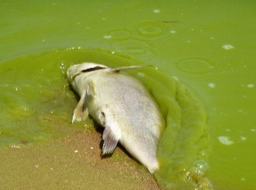
Cyanobacteria blooms are a growing problem in the world (O’Neil et al., 2012) which can cause serious ecological, economical and human health problems, due to the toxins released by some cyanobacteria species (Figure 1: Ecological impact of toxic cyanobacteria blooms (Lake Erie, USA) (Archer, 2011) (Lürling & Spears, 2016; Paerl & Huisman, 2008; Waajen et al., 2016).
Figure 1: Ecological impact of toxic cyanobacteria blooms (Lake Erie, USA) (Archer, 2011)
Nutrients are often drivers for cyanobacteria blooms and can come from different sources: 1) external loading, 2) external and internal loading, and 3) internal loading. Another driver for cyanobacteria bloom - which is not driven by nutrients - is accumulation. The first three key drivers are related to eutrophication; which means nutrient enrichment mainly by nitrogen and phosphorus. External loading that causes eutrophication is often due to demographic changes, such as population growth (sewage input) and economical changes, such as agriculture (intensive use of fertilizers) or industry (sewage input). Internal processes, such as nitrogen fixation, denitrification and phosphorus release from the sediment affect the nutrient pool as well (Hoenjet, 2016b). The fourth driver is not per definition related to eutrophication as accumulation regularly occurs in oligotrophic lakes, such as North-Patagonian lakes (Nimptsch et al., 2016), oligo-mesotrophic lake Stechlin (Üveges et al., 2012), and oligo-mesotrophic lakes in North-America (Carey et al., 2012). The water quality problems caused by toxic cyanobacteria is not so much their presence as such, but their presence in high densities and the ability of several of the most notorious cyanobacteria to control their buoyancy.

1.2 Hysteresis
Eutrophication, has resulted in widespread degradation of the ecology and functioning of fresh water lakes at global scale (Smith, 2003; Spears et al., 2016). Phosphate takes an important role in eutrophication and the state of the water. Shallow lakes can often be in two stable states: 1) a low nutrient, clear, plant-dominated state or 2) a high nutrient, turbid, algae-dominated state (Figure 2: Pictural view of the hysteresis phenomenon. Picture A is 'turbidification' and picture B is 'clarification' (restoration). Adapted from Janse (2005).Figure 2). Ecosystems may transition from one to the other stable state, known as a state shift, when disrupted. Eutrophication is a possible disruption that could set in motion the change from a clear to a turbid state of the water. This happens when the phosphorus load exceeds the critical P-load (Pcrit₁)(Figure 2A). To recover a water body from a turbid to a clear state is often difficult. The critical phosphorus load (Pcrit₂) is much lower than the shift the other way around (Figure 2B). This process is called hysteresis. When the P loading increases, the macrophytes increase first (Planbureau voor de Leefomgeving, n.d.). In addition, the biomass of small water animals and benthivorous fish increase. The burrowing fish in the sediment, and the increase of algae (chlorophyll-a), cause the water to become turbid. As the transparency decreases, the macrophytes die from inadequate light. At this point the critical phosphorus loading (Pcrit1) is reached and the algae start dominating the system. To go back to the clear state, the P-loading has to be decreased. But, even if the P loading gets below Pcrit 1, the water stays turbid due to the burrowing of organic sediment by the fish. Only if the P loading comes below Pcrit 2 - the second shifting point - the algae growth decreases enough and macrophytes can start growing again (Janse, 2005; Planbureau voor de Leefomgeving, n.d.)
A
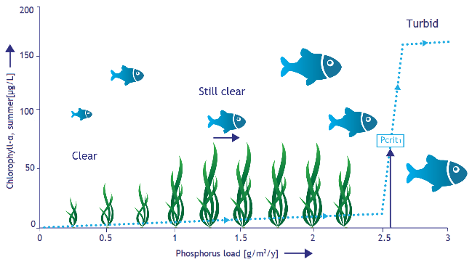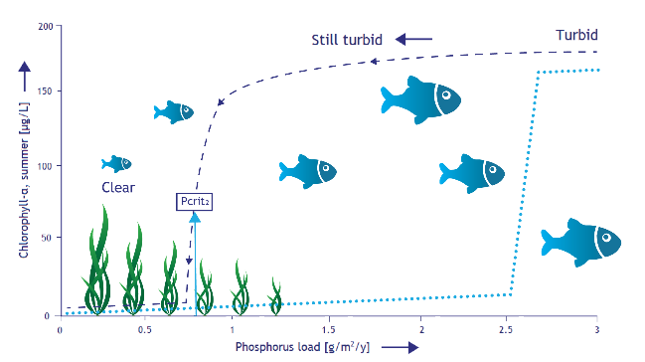
B
Figure 2: Pictural view of the hysteresis phenomenon. Picture A is 'turbidification' and picture B is 'clarification' (restoration). Adapted from Janse (2005).

1.3 Eutrophication management
Much effort have been done to improve the ecological state of lakes in the last decades (Jeppesen et al., 2005). Environmental policies, such as the European Water Framework Directive (EWFD) which was adopted in 2000 (“Introduction to the new EWFD,” 2016), have been implemented to reduce nutrient loads to lakes. In many catchment areas large-scale reductions in phosphorus (P) loading to fresh waters have been achieved. However, after the reduction of external P loading, lake recovery takes decades (Jeppesen et al., 2005). This is because P, accumulated in the lake bed sediment when catchment inputs were high, known as internal loading, continues to be released during the recovery period, especially due to the presence of burrowing fish. This process maintains poor water quality conditions (Jeppesen et al., 2005; Spears & May, 2014). Internal restoration measures that have been applied to reduce eutrophication in Denmark and The Netherlands are: biomanipulation, hypolimnetic oxygenation, alum treatment, and sediment dredging (Søndergaard et al., 2007). Furthermore, several chemical, (Burson et al., 2014) mechanical (Li et al., 2014) and biological techniques have been developed to reduce the impacts of harmful algae blooms (HAB’s). Geo-engineering techniques are becoming a commonly considered eutrophication management tool in solving both eutrophication and HAB problems (Spears et al., 2014; Waajen et al., 2016b).

1.4 Geo-engineering
The term “geo-engineering” means to achieve a desired chemical or ecological response by manipulating biogeochemical cycles, mainly targeting P, by adding materials such as modified clay or metal compounds to a lake (Spears et al., 2014). This method can be used to speed-up the restoration of the water quality (Spears et al., 2014). In-lake phosphorus control requires both water column dephosphatisation, as well as blocking phosphorus release from the sediment (Spears et al., 2013). Traditionally, aluminium-, calcium- and iron salts have been applied for in-lake restoration, e.g. Cooke et al. (1993). More recently Flock and Lock treatment has gained interest (Lürling et al., 2016; Lurling & Oosterhout, 2013) in which a low-dose flocculant combined with a solid-phase P sorbent is able to not only strip both dissolved phosphate and particulate-P (inside cyanobacteria) from the water column, but also block phosphate release from the sediment.
New interest has come into the use of a natural flocculant, derived from Moringa oleifera seeds, in cyanobacteria removal. Part of this research is to evaluate the use of this natural flocculant for a Flock and Sink treatment over the more traditional flocculants, such as metal based salts (e.g. (van Oosterhout & Lürling, 2013; Waajen et al., 2016b). There are different kinds of ballast products that can be added which make the flocks heavy so they sink; those are a natural soil or clay (Flock & Sink)(e.g. Noyma et al., 2016) or a P-sorbent ballast, which does not only solve the cyanobacteria problem, but also tackles eutrophication (Flock & Lock).
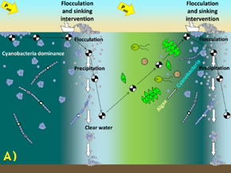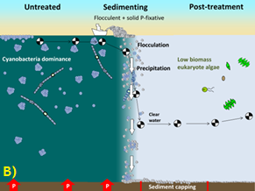
Figure 3: Visualisation of the short and long term effects and the difference between A) Flock & Sink and B) Flock & Lock treatment on cyanobacteria and nutrient loading. Pictures are from the AEW research group of Wageningen University.
Figure 3 illustrates the difference in working between A) Flock & Sink treatment of with cyanobacteria infested water with ongoing external load, and B) Flock & Lock treatment of with cyanobacteria infested water with controlled or diffuse external loading. The decision of which treatment would suit best depends on the system analysis. This analysis gives insight in the water flow, source of nutrients and the ecosystem and is essential in a successful eutrophication and cyanobacteria management. In the Flock & Sink method the water will temporarily be cleared from cyanobacteria, because of the phosphorus still entering the system. The cyanobacteria need time to regrow to nuisance concentrations, after which the treatment needs to be repeated. If the external P loading is also reduced, the Flock & Sink treatment will work for a longer time. For the Flock & Lock method the internal loading is the main driver of the nuisance. Stripping the water column clear of cyanobacteria and P and hampering P efflux from the sediment will lead to prolonged mitigation of cyanobacteria nuisance. In water bodies where accumulation is the main drive for the cyanobacteria problems, the Flock & Sink treatment can cause a quick improvement of the water quality.
Different from green algae, cyanobacteria not automatically sink after flocculation, because certain nuisance cyanobacterial species possess gas vesicles that allow buoyancy control. A ballast product is then needed to make the flocks heavier so that they will sink. The “Flock and Sink” method with a natural clay is used in some of the experiments in this research, because natural ballast products such as soil and clay are available everywhere. Easy access to Moringa in third world countries may facilitate its use as a flocculant above fabricated materials, such as polyaluminiumchloride (PAC) that need transport and personal protection of those that will apply it. The use of a local soil is preferred as it is cheap and no transport is needed, but if phosphorus needs to be adsorbed from the water column or blocked from the sediment, then a P-sorbent ballast product is recommended. Furthermore, the external loading is still very high in developing countries, and there is no time to wait till some day in the future water treatments plants are build. A quick solution needs to be found which provide clean and safe drinking water. Moringa oleifera seeds seem to be promising in achieving clean water in combination with a local soil.

1.5 Moringa oleifera
Moringa seeds come from the fast growing tree Moringa oleifera, which grows mainly in tropical and subtropical climates (Figure 4). The tree grows best on dry sandy soil and is resistant to drought (De Persgroep Digital, 2012). Traditionally, Moringa seed powder is used in rural areas of Sudan and Malawi for clarification of their drinking water (Muyibi & Evison, 1995), and research performed by Ndabigengesere & Subba Narasiah (1998), supported the effectiveness of Moringa oleifera seeds in reducing inorganic turbidity.
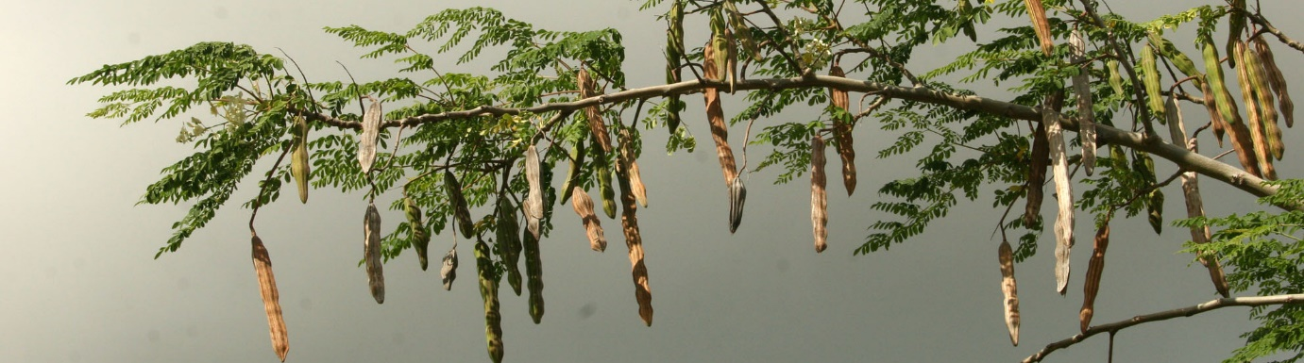
Figure 4: Moringa oleifera tree (Frans & Karin, 2013)
The high inorganic turbidity removal performance of Moringa oleifera seeds was of special interest, because colleague students were in Vietnam to investigate a way to reduce the turbidity in the ponds of a snakehead farm. Currently, PAC is used to remove the inorganic turbidity, but the disadvantage of this metal based treatment is that the pH can drops rapidly depending on the dose (de Magalhães et al., 2016), which potentially can causing stress and damage to the fish. The ponds already have a low pH due to the peat layer underneath the clay at the bottom of the ponds. Snakeheads grow better and have a higher tolerance to ammonia at a higher pH (Qin et al., 1997). At the fish farm in Vietnam lime is added to the ponds to increase the pH again after PAC treatment. Moringa oleifera can also remove turbidity and does not affect the pH of the water (Ndabigengesere & Subba Narasiah, 1998). The use of Moringa is less harmful to the fish compared to PAC, and could therefore be an improvement for the fish farm. Furthermore, Moringa oleifera trees grow naturally in Vietnam and would be a cheap, safe and effective way for solving the turbidity problem at the fish farm. It would be a great opportunity if this laboratory research on the flocculation performance of Moringa could be applied immediately in the field in a developing country.

Also for removing cyanobacteria Moringa oleifera is highly efficient. Moringa can achieve a removal efficiency up to 78-97% already at a low dose of 1-100 mg/L Moringa oleifera seed extract (e.g. Abdul Hamid et al., 2016; Carvalho et al., 2016; Moreti et al., 2016), especially in combination with local soil (Oladoja & Pan, 2015). The sunken cyanobacteria flocks will be degraded by the wealthy bacterial flora commonly present in the sediments of eutrophic lakes and reservoirs, which additionally will degrade liberated toxins and thus no cyanotoxins will be released to the water column (Li & Pan, 2015). Moringa seeds are not toxic to human and environment (Abdul Hamid et al., 2016; Nishi et al., 2011; Shehata et al., 2002) and are a sustainable (Abdul Hamid et al., 2016; Camacho et al., 2017; Oladoja & Pan, 2015) alternative for metal based flocculants. Additionally, the end product by the coagulation of Moringa with cyanobacteria sludge is not only biodegradable but also in smaller volume than sludge produced with chemical alum coagulation (Camacho et al., 2017; Ndabigengesere et al., 1995). Lürling and Beekman’s study in 2010 showed that Moringa seed extract has potential for an effect-oriented measure in lessening cyanobacteria nuisance due to its anti-cyanobacterial activity. It is of special interest in less developed countries for its effective use in combination with the low costs (Abdul Hamid et al., 2016; Oladoja & Pan, 2015). Water and wastewater treatments plants are lacking in developing countries due to the necessary high costs. In this context, water clarification and disinfection with a natural product, such as the seeds from the Moringa oleifera tree is desirable (Lürling & Beekman, 2010).
The characteristics from Moringa oleifera mentioned above are not the only reason why Moringa is a tree of interest for developing countries. Moringa has extraordinary high nutritional values. Almost all parts of the tree are edible; it has healing properties or can be used for other purposes, such as in cosmetics (Scott & Van den Berg, n.d.). The leaves contain a high dose of vitamins, minerals, beta-carotene, proteins, antioxidants and essential amino acids. The results from The Hunger Project Nederland (2015) show that the birthweight of babies from women who eat Moringa during their pregnancy increased and also that the quality of mother milk improved. The high nutrition values of the roots and leaves can help prevent hunger and malnutrition (Scott & Van den Berg, n.d.; The Hunger Project Nederland, 2015). Additionally, the leaves and seeds from Moringa oleifera possess antimicrobial activity (Dahot, 1998) against microorganisms and decreases the amount of bacteria (Omodamiro et al., 2014).

1.6 Flocculation mechanisms
There are several flocculation interaction types that depend on different mechanisms and kinetic processes. In Table 1: Flocculation mechanisms adapted from Yang et al. (2016) four different mechanisms are explained more in detail, based on Yang et al. (2016). In general it can be said that as a consequence of adding a suitable concentration of flocculant to waste water, the macromolecular flocculant gets in contact with the suspended colloids (in this case cyanobacteria) by adsorption, though electrostatic interactions, hydrogen bonding, Van der Waals forces etc.. As a result, the conformation of the absorbed polymer is rearranged in such way that large flocks are formed. (Yang et al., 2016)
Mechanism | Description | Illustration
Simple charge neutralization | Efficient reduction of the thickness of the electric double layer and full charge neutralization. | e.g. 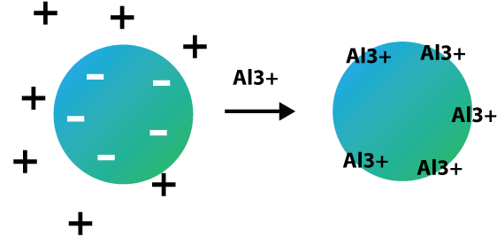
Charge patching | Uneven distributed surface charges are incompletely neutralized.
Bridging | Adsorption and connection of the primary flocs on soluble linear large-molecular weight flocculants. | 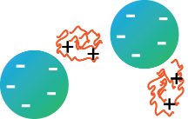
Sweeping | Enmeshing and entrapping of small colloidal pollutants by large flocs or polymeric precipitates. | 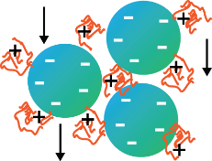
Table 1: Flocculation mechanisms adapted from Yang et al. (2016)
Most of the processes during flocculation take place by two or more flocculation mechanisms. The dominant mechanism depends on several conditions:
- The characteristics of the colloidal distribution and dissolved particles (in this case cyanobacteria), for example hydrophobic, hydrophilic, surface charge density and functional groups,
- The properties of the flocculant used (e.g. Moringa oleifera seeds), such as, molecular weight, charge characteristics, adsorption capacity and functional groups, and
- The features of the (waste) water, like pH, salinity, temperature, dissolved organic carbon (DOC) (Yang et al., 2016).
Which main mechanisms cause the flocculation ability of Moringa is not yet well known.

2. Objectives and research questions

2.1 Objective
The focus in this study is on the flocculation performance of Moringa oleifera seed extract as a relatively cheap, easy applicable and efficient effect-oriented geo-engineering method for controlling cyanobacteria problems, especially for developing countries. The idea is that Moringa oleifera ‘glues’ the cyanobacteria together in flocks and to let them sink by an added ballast product. Flock and Sink is a promising method – depending on the system - to (temporary) solve a cyanobacteria problem. The reason why this is of special interest for developing countries is because of laggard building of waste water treatment plants at fast urbanization. Consequently, much surface water suffers from extensive nutrient pollution with frequently heavy cyanobacteria blooms. In case this surface water is the only source for drinking water, an urgent problem arises. People are used to boil water to clean it, but in fact this kills the cyanobacteria and the toxins are released. Such a problem needs an instant problem solving approach, because the users cannot wait till some day in the future water treatments plants are built to provision clean and safe drinking water.

2.2 Research questions
The main research question in this study is “To what extend are Moringa oleifera seeds a reliable flocculant in removing cyanobacteria?” The following aspects are addressed:
- What is the effect of different ways of Moringa extraction on the flocculation performance?
- To what extend do the different chlorophyll-a concentrations affect the flocculation performance of Moringa seeds?
- How does pH influence the flocculation performance of Moringa seeds?

- What is the flocculation performance of Moringa seeds on removing inorganic turbidity?
- To what extend is Moringa able to flock and sink cyanobacteria with a ballast?

- How does seed variability influence the flocculation performance of Moringa seeds?

- What is the flocculation performance of Moringa seeds in brackish water?

- How do Moringa seeds influence the nutrient concentration?

- What is the optimum Moringa seed extract concentration for algae flocculation at an initial chlorophyll-a concentration of around 200 µg/L?
- What is the flocculation time of Moringa oleifera seeds?

- To what extend does Moringa seed extract influences the pH?

- To what extend does Moringa influence the Photosystem II efficiency of green algae and cyanobacteria?
An overview that shows which experiments were done to answer the subsidiary questions can be found in Appendix 1: Overview research questions + pertinent experiments.

2.3 Hypothesis
- What is the effect of different ways of Moringa extraction on the flocculation performance?
First, it will be investigated if the Moringa water extract performs better as a flocculant when it is filtered or unfiltered. Both filtered and unfiltered Moringa water extracts have been investigated in a study of Ndabigengesere et al. (1995) finding a removal efficiency of 80-90%, but no further explanation was given on the difference between those two methods. Filtered Moringa (destilled) water extract had been used as a flocculant in removing Microcystis (Nishi, Salcedo Vieira, et al., 2012) and inorganic turbidity (Nishi et al., 2012; Okuda et al., 1999). Also, when using other extract solvents and methods the Moringa seed extract was always filtered (e.g. Barrado-Moreno et al., 2016; Ghebremichael et al., 2005; Lea, 2014; Oladoja & Pan, 2015). Therefore it is expected that the filtered Moringa water extract causes better flocculation and a higher removal efficiency. This question will be analysed in pre-experiment 1.

Secondly, two different solvents will be investigated to find out which solvent would be better to extract the active flocculation ingredient from Moringa. The solvents water and 1M NaCl solution will be analysed in experiment 1 and 2. NaCl (1M) had been found to be a better solvent for preparing Moringa extract in removing inorganic turbidity (Okuda et al., 1999) and Microcystis (Oladoja & Pan, 2015). NaCl was found to be the best salt solutions compared to other salts (Prasad, 2009). It is expected that Moringa in combination with the solvent 1M NaCl extract results in better flocculation than water. This question will be answered in experiment 1.

- To what extend do the different chlorophyll-a concentrations affect the flocculation performance of Moringa seeds?
In the study of Barrado-Moreno et al. (2016) the removal efficiency showed a little increase as the initial chl-a concentration increased at a fixed dose of Moringa extract. Thus, it is expected that the flocculation will be slightly better at a higher initial chl-a concentration.

- How does pH influence the flocculation performance of Moringa seeds?
It is expected that pH will not affect the flocculation performance of Moringa, as this was found by Barrado-Moreno et al. (2016).

- What is the flocculation performance of Moringa seeds on removing inorganic turbidity?
Several studies have investigated the removal efficiency of Moringa on a range of inorganic turbid solutions (e.g. Ghebremichael et al., 2005; Liew et al., 2006; Nishi, Vieira, et al., 2012). It was found that Moringa achieves a higher removal efficiency at a high initial turbidity, and performs worse at a lower initial turbidity (Ghebremichael et al., 2005; Nishi et al., 2012). The high organic load in the Moringa seeds probably causes the turbidity to increase or stay the same at a low initial turbidity (Ndabigengesere & Subba Narasiah, 1998; Nishi, Vieira, et al., 2012). So, it is expected that Moringa is able to remove inorganic turbidity, especially at a high initial turbidity.
- To what extend is Moringa able to flock and sink cyanobacteria with a ballast?
In the study of Oladoja & Pan (2015) Moringa was used to modify a soil to flock and sink cyanobacteria, achieving a removal efficiency of > 90% (Oladoja & Pan, 2015). Thus, it is expected that Moringa is well able to flock and sink cyanobacteria with a ballast.
- How does seed variability influence the flocculation performance of Moringa seeds?
Moringa seeds are natural products and the composition of each seed (e.g. protein types, protein content, oil content) are different for each seed. The study of Ghebremichael et al. (2005) found that Moringa consists of a mixture of proteins showing the same characteristics instead of a single homogeneous protein and thus it is expects that this might influence the flocculation performance.

- What is the flocculation performance of Moringa seeds in brackish water?
The studies of Okuda et al. (1999) and Oladoja & Pan (2015) found already that 1M NaCl was a better solvent than water, because of the higher ionic strength. Taking this in mind, it is expected that the flocculation performance of Moringa seed extract would be better in brackish water than in fresh water.

- How do Moringa seeds influence the nutrient concentration?
Moringa oleifera seeds are oil rich and have a high organic load (Camacho et al., 2017; Okuda et al., 2001). It is expected that organic matter can be released into the water during the Flock & Sink treatment and so increase the nutrient concentration.

- What is the optimum Moringa seed extract concentration for algae flocculation at an initial chlorophyll-a concentration of around 200 µg/L?
It is expected that the optimum concentration depends on the initial chlorophyll-a concentration or inorganic turbidity. A guess is made that the optimum MO dose lies between a minimum of 14.6 mg/L (Oladoja & Pan, 2015) for cyanobacteria removal and 5 mg/L (Ndabigengesere et al., 1995) for inorganic turbidity removal and a maximum of 200 mg/L (Lea, 2014).

- What is the flocculation time of Moringa oleifera seeds?
Barrado-Moreno et al. (2016) investigated the flocculation time of Moringa at two concentrations flocculant on a range between 10 and 60 minutes. It was found that after 30 minutes the algae removal equilibrium was reached. This is different from the studies of Oladoja & Pan (2015) and Pan et al., (2006) in which the equilibrium was found after 120 and 480 minutes respectively. It is expected that the flocculation time of Moringa will be at least 30 minutes. In the study of Noyma et al. (2016) samples were taken after 1 hour, similar to most experiments in this study.

- To what extend does Moringa seed extract influences the pH?
It is expected that Moringa will not significantly affect the pH as found by Ndabigengesere et al., 1995; Ndabigengesere & Subba Narasiah, 1998; Nishi, Salcedo Vieira, et al., 2012 and Oladoja & Pan, 2015.

- To what extend does Moringa influence the Photosystem II efficiency of green algae and cyanobacteria?
At the study of Lürling & Beekman (2010) the PSII value dropped rapidly at Moringa concentrations from 20 to 160 mg/L at day 2 of the experiment. Because here the experiment time is only 1 hour the effect might be less. So, despite the results of the study of Lürling & Beekman (2010) it is expected that the PSII value will not be affected.

3. Materials and Methods

3.1 Materials

3.1.1 Cyanobacterial cultures
The cyanobacteria used in this research first had to be cultivated to have a sufficient volume for executing experiments. Meanwhile, green algae were used to do already some tests with Moringa oleifera. Two green algae species, S. obliquus and Chlorella vulgaris were available. The species used for an experiment was based on the available volume. It was assumed that there would be no difference between the two green algae species’ reaction on the flocculation with Moringa oleifera.
The green algae strain of Scenedesmus obliquus (Turpin) Kützing was obtained from the culture collection at the Max Planck Institute for Limnology (Plön, Germany). The green algae strain Chlorella vulgaris (NIVA-CHL 19) (Spydeberg, Østfold, Norway) was obtained from the Culture Collection of Algae of the Norwegian Institute for Water Research (NIVA) (Oslo, Norway). The algae were grown in a 1 Liter chemostat in continuous light of ~36.5 µmol/m²/s) on a Chu#10 and Wright’s (1964) Medium without vitamins added (Lurling & Beekman, 2006) at a temperature of 25 °C (±1°C) and at a dilution rate of ~1 day. Compressed air was added from the bottom into the chemostat which causes continuous mixing.
Beside the two green algae, three cyanobacterial strains were used in the experiments (two strains of Microcystis aeruginosa and one Anabaenopsis sp. strain). The freshwater cyanobacterial strain M. aeruginosa (MIRF-01, Brazil) was grown in the laboratory in 100 mL Erlenmeyer flasks containing 50 mL of Chu#10 and Wright’s (1964) Medium with vitamins added (biotin at 52 ng L⁻¹ and B₁₂ at 56 ng L⁻¹ and Thiamine HCL at 100 ng L⁻¹)(Lürling & Beekman, 2006). The brackish water cyanobacteria strains Microcystis aeruginosa (BC: Bình Chánh District, Ho Chi Minh City, Vietnam) and Anabaenopsis sp. (BC) were grown in 100 mL Erlenmeyer flasks containing 50 mL of the growth medium at 5 ‰ salinity using sea salt (Lurling & Beekman, 2006). The flasks were placed in an open cabinet with a 14:10-h light/dark cycle and a daily average light intensity of ~2.1 µmol quanta m²/s (measured with the LI-250A light meter) at a temperature between 21.3°C and 25.0°C. Both M. aeruginosa strains were swirled three times per week and the Anabaenopsis sp. was swirled twice a day (only weekdays). All three cyanobacteria strains were transferred to bigger flasks or refreshed with new medium every two weeks, to ensure enough volume and good conditions of the algae for the experiments. The transferring and refreshing was done under controlled and sterile circumstances in a Laminar Air Flow POLARIS cabinet (Telstar) next to a blue flame to prevent contamination.

3.1.2 Moringa seeds
Seeds of Moringa oleifera were obtained from Vreeken’s Zaden (Dordrecht, The Netherlands). The seeds were stored in a closed plastic bag and stored at room temperature 21°C (±1°C).

3.1.3 Soils
Natural red soil from Brazil was used in the experiments as a ballast. The red soil was collected from the banks of the Funil Reservoir (22°30’S,44°45’W, Rio de Janeiro, Brasil).
Two other soils were included to create inorganic turbidity in the water. The two soils were kaolinite (white soil) and bauxite (red soil). Kaolinite (C-3090) was obtained from Ve-Ka IKG B.V. (Dreumel, The Netherlands). Bauxite (BAU 1 Gr) was obtained from European Bauxites S.A. (Amfissa, Greece). Prior to use, both red soil and bauxite were dried, grinded using a mortar and sieved over 0.5 mm. The soils were stored in a closed plastic pot at room temperature 21°C (±1°C).

3.2 Methods
An overview of the input-, experiment- and output variables can be found in Appendix 2: Overview variables algae experiments Table 1 and Table 2.

3.2.1 Moringa seed extract
One of the objectectives of this research was to find an easy applicable method for treating cyanobacterial blooms in developing countries. Thus, it was chosed to use water and NaCl salt solution as solvents for the extraction, which can be prepared in primitive households.
The seed coat of 10 seeds were removed and the seed kernels of good quality seeds were crushed in a mortar. The solvent (water or NaCl solution) was added to the Moringa seed paste to get a stock solution with a concentration of 10 g of seeds/L (Ndabigengesere & Subba Narasiah, 1998). The mixture was stirred with a magnetic stirrer for 30 minutes at room temperature (20±1°C). The suspension was filtered through a coffee filter (coffee filters original Melitta, Germany) or left unfiltered. The resultant filtrate or unfiltered solution was used as a flocculant. The stock solution was prepared fresh for use, since deterioration sets in if stored for more than two days at room temperature (Muyibi & Evison, 1995).
If a different method was used for preparing Moringa extract for an experiment (e.g. more/less seeds, different solvent, other mixing method, longer mixing time), this is mentioned at the detailed experiment description in paragraph 3.3 Experiments.

3.2.2 General experimental design
The cyanobacteria suspension with the specific initial chlorophyll a concentration was prepared by diluting the high density culture with ultrapure water, also called MilliQ, as referred to in the rest of this report. An aliquot of 100 mL of the cyanobacteria suspension (initial chlorophyll-α of around 200 µg/L (±25 µg/L)) was transferred to 125 mL glass tubes. This chlorophyll a concentration can be found in a heavy bloom (see Figure 2). The initial chlorophyll-α (µg/L) as well as the Photosystem II (PSII) efficiency were determined using a PHYTO-PAM phytoplankton analyser (HeinzWalz GmbH, Effeltrich, Germany). The cyanobacteria suspensions were treated with different materials (treatments) or left untreated (controls). Immediately after adding the materials, the contents in each test tube was mixed for 10 seconds using a metal rod. After 1 hour, 10 mL samples were taken from both the top and the bottom of the tubes in which the chlorophyll-α concentrations and PS-II efficiencies was measured. The pH was measured in the tubes after sampling.
Meaning of photosystem II (PSII) and the reason for measuring it: Photosystem II is the first protein complex in the light-dependent reactions of oxygenic photosynthesis. The PSII value given by the PHYTOPAM (see above) lies between 0 and 1. The higher the PSII value the better the photosynthetic performance of the algae. Microcystis aeruginosa is a toxin producing cyanobacteria. These toxin are released when the cyanobacteria dies or the cell wall breaks (extracellular toxins)(United States Environmental Protection Agency, 2014). If the PSII value in the treated tube gets much lower than the control, there is a bigger chance of toxin release. Thus, it is important to not damage or kill the cyanobacteria in the surface layer of the water while flocking and sinking.

3.3 Experiments

3.3.1 Pre-experiments
During the pre-experiments (experiments done with green algae) the Moringa extract was prepared with 2 seeds. The amount of Moringa extract needed for the experiments is very small, nevertheless, it is difficult to work with such a small volume as gained from one seed. That is why it was decided to use two seeds to produce the extract. Furthermore, the mixing time of the extract was 3-4 minutes using a metal rod.

3.3.1.1 Pre-experiment 1: Filtered or unfiltered Moringa water extract
The goal of this experiment was to find out which extraction method of Moringa seeds works best as a flocculant, unfiltered Moringa water extract or filtered Moringa water extract.
Green algae Scenedesmus obliquus were used in this experiment. The initial chlorophyll concentration of the algae suspension was 290 µg/L.The algae suspension was made using tapwater instead of milliQ water. The Moringa extract was prepared using MilliQ water. The following amounts of M.oleifera extract were added: 0, 50, 100, 200, 400, 800, 1600, 3200 µL, which corresponds to 0, 5, 10, 20, 40, 80, 160 and 320 mg crushed Moringa per liter.

3.3.1.2 Pre-experiment 2: Different chlorophyll concentrations on flocculation ability Moringa
The main goal of this experiment was to find out to what extend do the different chlorophyll-a concentrations affect the flocculation performance of Moringa seeds. Two different initial chlorophyll concentrations were used (1930 µg/L and 480 µg/L). The highest concentration seems unreal for natural water systems, but if a bloom is blown to one side of a lake by wind some scums might occur in such high concentrations. In addition, flocculation would be very well visible. A concentration range for the Moringa was used to try to find a more precise optimum concentration.
Green algae Chlorella vulgaris were used. In the first series, the tubes had an initial chlorophyll a concentration of 1930 µg/L and the second series had an initial chlorophyll a concentration of 480 µg/L. Filtered Moringa tap water extract was added to the tubes of the first series in the conc. 0, 0.1, 0.33, 1, 3.33, 10, 33 and 100 mg/L and the second series in the same concentration range as in pre-experiment 1, from 0-320 mg/L.

3.3.1.3 Pre-experiment 3: Repetition of the filtered Moringa water extract treatment to investigate the reliability of this extraction method using PAC as a positive control
The main goal of experiment 3 was to see if by applying seemingly the same method the result between PAC and MO would be similar. The flocculant AquaPAC39 (polyaluminium-chloride, Al_{n}(OH)_{m}Cl_{3n-m}, ρ=1.37 kg L/L, 8.9% Al, 21.0% Cl; PAC), obtained from Kemira was used as a positive control, since this is a widely used reliable metal based flocculant.
Green algae Chlorella vulgaris where used with an initial chlorophyll concentration of 295 µg/L. Filtered Moringa water extract was added in the concentrations 0, 10, 20 ,40 ,80 ,160 and 320 mg/L. PAC was added in the concentration 0, 1, 2, 4 and 8 mgAl/L. This range was used, since PAC is effective to flocculate cyanobacteria at low doses as 2 mgAl/L (de Magalhães et al., 2016; Noyma et al., 2015; Waajen et al., 2016a).

3.3.1.4 Pre-experiment 4: The effect of pH on the flocculation performance of Moringa seeds
The methods applied in pre-experiment 1 and 3 were seemingly the same, but the result was the opposite. The only difference that was found was the pH. That is why in this experiment the effect of pH on flocculation performance of Moringa was investigated.
The green algae species Scerendesmus obliquus was used with an initial chlorophyll concentration of 193 µg/L. 20 µL of 1 M NaOH was added to get an initial pH of 9 and 20 µL of 1 M HCl was added to achieve an initial pH of 6. The suspensions were mixed until a stable pH was achieved. Afterwards, filtered Moringa MilliQ water extract was added in the concentration range 0, 40, 80, 160 and 320 mg/L and tubes with 8 mgAl/L PAC were included as a positive control.

3.3.1.5 Pre-experiment 5: Moringa as a flocculant in removing inorganic turbidity
Several studies have shown that Moringa oleifera (MO) can also be applied in removing inorganic turbidity from water (Ghebremichael et al., 2005; Liew et al., 2006; Ndabigengesere & Subba Narasiah, 1998; Okuda et al., 1999). To find out what the flocculation efficiency of MO in inorganic turbid water, this experiment was executed.
Kaolinite turbid water was prepared in three turbidity categories based on Lea (2014) and Liew et al.(2006), namely: low (14.5 and 18.7 NTU), middle (64.3 NTU) and high (164 NTU), by adding different amounts of bauxite to MilliQ water. The turbidity was measured with the Hach 2100P turbidity meter (Hach, Loveland, Colo. USA). One bauxite solution was prepared with an initial turbidity of 131 NTU. Filtered Moringa tap water extract was added in the following concentration range: 0, 0.1, 0.33, 1, 3.33, 10, 33 and 100 mg/L. The experiment time was 75 minutes. At the end of the experiment the turbidity was measured.

3.3.2 Experiments
The experiments were executed with cyanobacteria.

3.3.2.1 Experiment 1: Flocculation cyanobacteria, NaCl or water Moringa extract
The main goals of experiment 1 was to find out which solvent (water or NaCl) would cause best flocculation performance of Moringa oleifera.
In all pre-experiments two Moringa seeds where used to prepare the flocculation extract. From this experiment on 10 seeds were used per extract to decrease the fault by seed variability. 10 seeds (8 light seeds, 2 little darker seeds) were used to prepare the Moringa water extract and 10 seeds (4 light, 4 dark, 1 medium colored and 1 shriveled) where used to prepare the Moringa 1 M NaCl extract. The 1 M NaCl solution was prepared with MilliQ water. Both extracts where mixed for 30 minutes, using a magnetic stirrer, before filtering.
The cyanobacteria species used was Microcystis aeruginosa with an initial chlorophyll content of 220 µg/L. The concentration range of tubes treated with Moringa was 80, 160 and 320 mg/L. Untreated tubes (controls) and tubes treated with 8mgAl/L (positive controls) were included as well. The experiment duration was 1.5 hour.

3.3.2.2 Experiment 2: Flocculation cyanobacteria with NaCl Moringa extract
The main goal of this experiment was to do a control experiment with 1M NaCl Moringa extract to be sure that indeed the extract solvent caused flocculation and not the use of a different set of seeds, as was done in the previous experiment. There different seeds were used to prepare water extract and the 1M NaCl extract.
Microcystis aeruginosa with an initial chlorophyll conc. of 190 µg/L was used. The tubes were treated with 0, 40, 80, 160 or 320 mg/L 1M NaCl Moringa extract or 8 mgAl/L PAC.

3.3.2.3 Experiment 3: Flock and sink cyanobacteria with Moringa and ballast
The Microcystis aeruginosa strain used in this research had a positive buoyancy, thus to be able to remove it from the water column ballast was added in a set of experiments. In addition, it was evaluated if the flocculation performance of Moringa was influenced by the ballast. This experiment is split into two parts. In the first part the ballast was added before the flocculant, so that the soil particles could be captured in the flocks formed by Moringa making the flock heavy and sinking (Noyma et al., 2015). In the second part the ballast was added after flocculation happened.
In both parts the initial chlorophyll concentration of Microcystis aeruginosa was 175 µg/L. The fixed dose red soil added to the tubes was 300 mg/L and was based on a study of (Noyma et al., 2015) in which 320 mg/L of red soil was sufficient in sinking Microcystis aeruginosa from the water column.
In the first part the tubes were treated with 80, 160 and 320 mg/L 1M NaCl Moringa extract + red soil, 8 mgAl/L PAC+ red soil or only red soil. The solutions were mixed shortly and left for 60 min.
In the second part the following treatments were included: 1) control, 2) only red soil, 3) 8mgAl/L PAC + red soil, 4) 80, 160 and 320 mg/L 1M NaCl Moringa extract + red soil and 5) 320 mg/L 1M NaCl Moringa extract. The red soil was added to the tubes after flocculation happened, which was after 105 minutes. All tubes were mixed and left untouched for 60 minutes. Additionally, one treatment was added in which first the red soil was added followed by 320 mg/L 1M NaCl Moringa extract, similar to the first part of this experiment. This tube was also left untouched for 60 minutes after short mixing.

3.3.2.4 Experiment 4: Individual Moringa seeds
Moringa oleifera is a natural product and seed variability might cause variability in flocculation performance. The goal of this experiment was to find out if there is indeed seed variability.
10 seeds were used in this experiment. All seeds were weighted and the characteristics (color, shape, shriveled or not) were written down. In a pre-test the seeds were tested on their water absorption ability. In nature often good quality seeds have a good water absorption property. Due to this they become heavy and when putting them in a glass with water they sink, and bad quality seeds stay afloat (Gonzalez, 2015; Woodie, 2013). Ten 125 mL tubes were filled with 100 mL tap water. The individual seeds were added to the tubes and after 40 min. the seeds were observed at their float/sink ability. 5 seeds floated and 5 seeds sank to the bottom of the tube. The seeds were pat dried before the start of the real individual seed experiment.
So, the variables that were analyzed in this experiment to find out if seed variability influences the flocculation performance of Moringa were 1) floating or sinking seeds, 2) seed size and 3) dark or light colored seeds.
The initial chlorophyll content of Microcystis aeruginosa was 170 µg/L. 1M NaCl Moringa extract was prepared for each individual seeds and mixed for 40 minutes on a shaker table. The filtered Moringa 1M NaCl extract was added in a concentration of 320 mg/L to the tubes.

3.3.2.5 Experiment 5: Effect of brackish water cyanobacteria on flocculation by Moringa
The goal of this experiment was to find out if Moringa oleifera is also a good flocculant for brackish water cyanobacteria.
The species that were used in this experiment were fresh water Microcystis aeruginosa (MIRF-01, Brazil), brackish water Microcystis aeruginosa (BC: Bình Chánh District, Ho Chi Minh City, Vietnam) and brackish water Anabaenopsis sp. (BC). M. aeruginosa (BC) was chosen because it is the same species as the fresh water variant. A disadvantage, which was observed, is that M. aeruginosa (BC) grows in colonies (balls) that have a tendency to sink due to their weight. To have another comparison between fresh and brackish water species, Anabaenopsis sp. (BC) was chosen. This species lives individually and is spread homogeneous in the water. The initial chlorophyll content of M. aeruginosa (MIRF-01, Brazil) was 188 µg/L, of M. aeruginosa (BC) was 193 µg/L and of Anabaenopsis sp. (BC) was 201 µg/L. The filtered 1M NaCl Moringa extract was mixed for 40 minutes with a magnetic stirrer. Treatments included were: (1) control, (2) only 300mg/L red soil, (3) PAC (4 mgAl/L) + 300mg/L red soil, (4) 80 mg/L Moringa oleifera, and (5) 80 mg/L Moringa oleifera + 300mg/L red soil.
The execution of the treatment went as follows: all treatment products (flocculant and ballast) were added at the same time. The tubes were covered with parafilm and mixed upside down 10 times to ensure homogenous mixing. The experiment duration was 210 minutes. After 60, 120, 180 and 210 minutes pictures were made to get a visualization and indication of the flocculation time.

3.3.2.6 Experiment 6: Effect Moringa on nutrient concentration
In order to test if Moringa seeds will release nutrients in the water a batch experiment was conducted. 205 mg Moringa seeds powder was added to 100 ml of mili-water in a 400ml glass bottle. The experiment was conducted in triplicate. The suspensions was continuously mixed on a shaker for 24 hours at 22°C, where after samples were taken and centrifuged for 10 minutes at 3000 rpm. The supernatant was filtered through unit filters (Aqua 30/0.45CA, Whatman, Germany). Filtrates were analysed for their SRP concentration using a Skalar SAN+ segmented flow analyser following the Dutch standard NEN-EN-ISO 15681-2:2005. This part of ISO 15681 specifies determination of orthophosphate by continuous flow analysis (CFA) (NNI, 2005).

3.4 Data analysis
The flocculation effciciency was determined by visual observation. The removal efficiency was only calculated in case flocculation occurred in the pre-experiments or at experiments with cyanobacteria + ballast. This was done by using the following equation for the top samples:
%Removal efficiency (RE)= $\left(\frac{(Ci-Cf)}{Ci}\right)∙100$ in which Ci and Cf are the initial and final chlorophyll α concentration (µg/L), respectively.
Graphs, tables and calculation were made in MOS Excel or SigmaPlot 12.5, Systat Soft- ware Inc. In this explorative study no duplicates were used, so no statistical analysis could be applied on the obtained data.

4. Results

4.1 Results pre-experiments with green algae

4.1.1 Pre-experiment 1: Filtered or unfiltered Moringa water extract
Observations: The experiment showed very clearly that the flocculation performance of the filtered Moringa water extract was better than for the unfiltered Moringa water extract. The flock size increased at the increasing filtered MO concentrations and the bigger the flocks, the more flocks sank to the bottom. (Figure 1 in Appendix 3.1 Pre-experiment 1: Filtered or unfiltered Moringa water extract). The tubes treated with unfiltered MO water extract showed small flocks at all treatments, only at the highest concentrations MO (160 and 320 mg/L) the flocks were big and sank to the bottom.
PSII and pH: No effect on PSII was observed in any concentrations of unfiltered or filtered extract (Fig 2, Appendix 3.1). The pH values of the treated tubes (both filtered and unfiltered MO) where a little higher than the control. The pH of the control tube was 7.11 and average pH of all treated tubes was 7.68 with a standard deviation of 0.223.
Chlorophyll-a concentration: The unfiltered treatments showed no difference compared to the control until the 80 mg/L MO for both the top and the bottom samples. However, when the flock size increased at the concentrations 160 and 320 mg/L MO, it was found around 9 times more chl-a in the bottom compared to the control (Fig 2 left, Appendix 3.1). The filtered samples showed a chl-a content in the bottom of 3.4 times higher than in the control already at the lowest concentration (10mg MO/L). And around 5.3 times more chl-a in the bottom samples in the MO conc. from 20 mg/L onwards compared to the control (Fig 2 right, Appendix 3.1). The difference in chl-a conc. between the unfiltered and filtered MO water extract and the between top and bottom samples was clearly visible in the samples taken (Fig 3a-d, Appendix 3.1 Pre-experiment 1: Filtered or unfiltered Moringa water extract.
Removal efficiency: The removal efficiency (RE) gives the clearest view of the difference in MO performance between the unfiltered and filtered Moringa water extract. The max. RE for the unfiltered MO water extract was ~89% and was found only at the MO concentrations of 160 and 320 mg/L. Whereas for the filtered MO water extract the max. RE was 95% and was found from the concentrations 20 mg/L onwards. For the tube treated with 10 mg/L filtered MO water extract the RE was already 80%, compared to 40% in the unfiltered samples. (Figure 4a and 4b in Appendix 3.1 Pre-experiment 1: Filtered or unfiltered Moringa water extract).
Thus, the filtered Moringa water extract formed bigger flocks and the removal efficiency was higher compared to the unfiltered Moringa water extract.

4.1.2 Pre-experiment 2: Different chlorophyll concentrations on flocculation ability Moringa
Observations: In both series of the experiment (initial chl-a 480 µg/L and 1930µg/L) no flocculation was visible. No samples were taken from the series with the initial chl. a conc. of 1930 µg/L for several reasons; no flocculation was visible, this chl-a conc. does not (rarely) occur in nature, and it would take extra time to analyze them and not add something to this research.
PSII and pH: The PSII value in the treated tubes did not differ from control tube (Fig 1, Appendix 3.2 Pre-experiment 2: Different chlorophyll concentrations on flocculation ability). The average pH in the treated tubes was a little lower than the pH in the control tube, 8.36 and 8.43 respectively.
Chlorophyll-a concentration: The chlorophyll-a concentration in the series with the initial chl-a conc. of 480µg/L, did not show a relationship with the Moringa concentration (Fig 1, Appendix 3.2 Pre-experiment 2: Different chlorophyll concentrations on flocculation ability).

4.1.3 Pre-experiment 3: Repetition of the filtered Moringa water extract treatment to investigate the reliability of this extraction method using PAC as a positive control
Observations: No flocculation was visible in the tubes treated with filtered Moringa water extract (Fig 1a, Appendix 3.3 Pre-experiment 3: Compare flocculation between PAC and Moringa). Small flocks were visible at the tube treated with 4mgAl/L PAC and big flocks that sank to the bottom at 8mgAL/L PAC (Figure 1b, Appendix 3.3 Pre-experiment 3: Compare flocculation between PAC and Moringa).
PSII and pH: The PSII value was not influenced by either Moringa of PAC treatments (Fig 2, Appendix 3.3 Pre-experiment 3: Compare flocculation between PAC and Moringa. A clear difference in pH effect of both flocculants was found. Whereas Moringa did not influence the pH, the increasing PAC concentrations show a linear decrease in pH from 8.6 in the control tube to 7.0 at the tube treated with 8mgAl/L PAC (Fig 3, Appendix 3.3 Pre-experiment 3: Compare flocculation between PAC and Moringa).
Chlorophyll-a concentration: The results of the chlorophyll measurements prove the observed results. No big difference in chl-a conc. was found between the Moringa treatments, the chl-a conc. in the top was on average 42 µg/L lower than the control and 49 µg/L higher in the bottom than the control. The chl-a conc. at the top of the tubes treated with PAC decreased from 287 µg/L in the control to 101µg/L in the tube treated with 8 mgAl/L PAC. The highest chl-a conc. was measured at the bottom of the 8mgAL/L PAC treatment, which was 1772 µg/L (Fig 2, Appendix 3.3 Pre-experiment 3: Compare flocculation between PAC and Moringa).

Removal efficiency: The removal efficiency of PAC increased with concentration. The lowest efficiency, 22% was found at 1 mgAL/L and the highest RE was 66% at the PAC concentration 8 mgAl/L (Fig 4, Appendix 3.3 Pre-experiment 3: Compare flocculation between PAC and Moringa).
No flocculation happened at the tubes treated with Moringa. Big flocks were found at the 8mgAl/L PAC treatment. Despite of the pH drop at the PAC treatments, the PSII value was not influenced.

4.1.4 Pre-experiment 4: Effect pH on flocculation Moringa
Observations: Flocculation happened at all treatments at both pH 6 and 9. It was observed that the flocks at the concentration 40mg/L MO were smaller compared to 80,160 and 320 mg/L MO and 8mgAl/L PAC (Fig 1, Appendix 3.4 Pre-experiment 4: Effect pH on flocculation Moringa.
PSII and pH: The PSII value was not influenced by 8mgAl/L PAC and all Moringa concentrations. The average PSII value was 0.63 with a standard deviation of 0.02 for the treated tubes. The pH was a little lower at the tubes treated with MO compared to the control and much lower at the 8mgAl/L PAC treatment (Table 2: Effect treatments on pH. Table 2).
Table 2: Effect treatments on pH.
 | Initial pH | Final pH control | Average final  pH all MO treatments | St.dev final  pH all MO treatments | Final pH 8 mgAl/L PAC treatment
pH 6 | 6.22 | 6,53 | 6,41 | 0,03 | 4,87
pH 9 | 9.66 | 9,64 | 9,55 | 0,04 | 5,94

Chlorophyll-a concentration: The chlorophyll-a concentrations in the top of all the tubes treated with Moringa were on average 5-7 times lower than in the bottom, indicating that flocculation indeed took place (Fig 2, Appendix 3.4 Pre-experiment 4: Effect pH on flocculation Moringa.
Removal efficiency: The maximum removal efficiency (RE) at pH 6 was found to be 53.3% at a MO conc. of 320 mg/L. At pH 9 the max. RE was 67.5% at 160 mg/L MO. At both pH 6 and pH 9 the removal efficiency of Moringa was higher than the RE of 8mgAl/L PAC. At pH 6 the RE MO was 1.3% higher than 8mgAl/L PAC at a conc. of 160mg/L MO and 7.6% higher at a conc. of 320 mg/L MO. At pH 9 the RE was 2-13% higher than PAC from 40mg/L MO onwards. The RE of the control was high, namely 34% and 48% for pH 6 and pH 9 respectively. (Fig. 3, Appendix 3.4 Pre-experiment 4: Effect pH on flocculation Moringa.
So, small flocks were formed at all concentrations at both series with the initial pH of 6 and pH 9. Both PSII and pH were not influenced by Moringa treatment. The higher chlorophyll-a concentration in the bottom than in the top of the tubes proved the visible flocculation. Furthermore, the removal efficiency of Moringa was higher than that of PAC.

4.1.5 Pre-experiment 5: Moringa as a flocculant in removing inorganic turbidity
Observations: No flocculation was visible during the experiment with two different clays used to create an inorganic turbid solution. It was observed that at the start of the experiment already a part of the clays sank to the bottom due to gravity. This explains the lower final turbidity compared to the initial in all concentration of MO added, including the control (Table 1, Appendix 3.5 Pre-experiment 5: Moringa as a flocculant in removing inorganic turbidity).
Turbidity: The Moringa concentration did not play any role on turbidity There is no big difference found in turbidity between the treated and untreated tubes (Table 1, Appendix 3.5 Pre-experiment 5: Moringa as a flocculant in removing inorganic turbidity).
Thus, no flocculation occurred. Part of the clays sank immediately to the bottom at the start of the experiment, which explains the lower final turbidity in the tubes.

4.2 Results experiments with cyanobacteria

4.2.1 Experiment 1: Flocculation cyanobacteria, NaCl or water Moringa extract
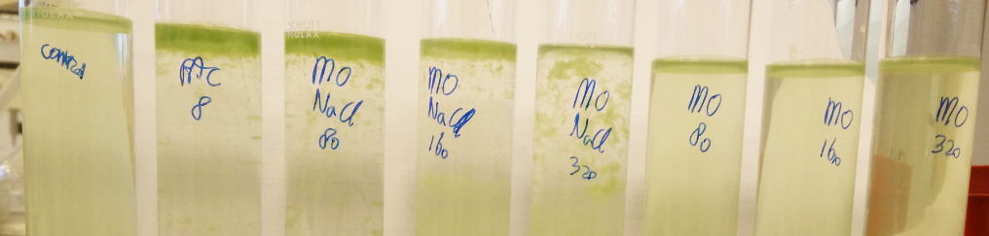
Observations: Right at the start of the experiment little flocculation was visible at the tube treated with PAC and medium sized flocks were visible after 30 minutes. Small flocks where then visible whole water collum of the tube treated with MO NaCl 80 mg/L and only in the upper three cm of the tubes treated with 160 and 320mg/L MO NaCl extract. After 60 min. – the end of the experiment – a thick layer of floating flocks were observed at the tubes treated with PAC and 80 mg/L MO NaCl extract. The flock layer was a little less thick at the tube treated with 160 mg/L MO NaCl extract. In the tube treated with 320 mg/L MO NaCl extract, most of the flock were still in the water column (Figure 5). The tubes treated with Moringa NaCl 160 and 320 mg/L showed a decreased in flock size from the top to the bottom of the tube.

Figure 5: Visible flocculation performance at 1M NaCl Moringa extract and the absence of flocculation at Moringa water extract at different concentrations and the buoyancy of cyanobacteria after 60 min. One tube was left untreated (control) and 8mgAl/L PAC was added as a postive control.
PSII and pH: The PSII value in the tubes treated with Moringa (both extracts, bottom and top) show an average of 0.39 with a standard deviation of 0.022, compared to the control, which had a PSII value of 0.57. PAC clearly influenced the photosystem II of the cyanobacteria, because at the bottom of the tube the PSII value was 0 (Figure 6).
The pH of the control tube was 8.63. The pH in tubes treated with MO did not differ from the control tube, with an average of 8.83 and a standard deviation of 0.097. This is in great contrast with the pH in the tube treated with PAC, which dropped to 4.8.
Chlorophyll-a concentration: The chlorophyll-a measured show the same results as the visual observations. A significant difference between the top and bottom concentrations was found in the tubes where flocculation happened (Figure 6). The chlorophyll a concentration of the tubes treated with 80 and 160 mg/L MO NaCl extract is 12 and 2 times higher in the top than in the bottom. The flocculation in the tube treated with 320 mg/L MO NaCl extract is not visible in the chlorophyll a concentration, because the flocks stayed through the whole water column. The chlorophyll a concentration in the tubes treated with Moringa water extract stayed similar to the control tube.
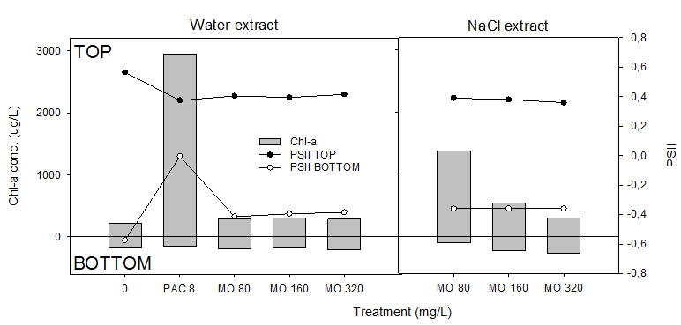
Figure 6: Chl a conc. and PSII value at the top and bottom of the tubes for the MO water extract and MO NaCl extract
Thus, the Moringa 1M NaCl extract has a better flocculation performance on M. aeruginosa than the Moringa water extract.

4.2.2 Experiment 2: Flocculation cyanobacteria with NaCl Moringa extract
Observations: Flocculation happened at all concentrations Moringa 1 M NaCl extract. The flocks observed at a concentration of 40 mg/L MO NaCl extract were small, compared to medium sized flocks in the tubes treated with 80, 160 and 320 mg/L MO NaCl extract. The flock size was similar for 80, 160 and 320 mg/L Moringa. Big flocks where immediately formed at the start of the experiment in the tube treated with 8 mgAl/L PAC. The flocks in the tubes treated with PAC and 80 mg/L MO NaCl extract were clearly going up to the surface. In the tube treated with 160 mg/L MO the flocks concentrated in the upper half of the tube, whereas in the tube treated with 320 mg/L MO the bigger flocks concentrated in the midle and lower half of the tube (Figure 7).
Figure 7: Visual flocculation in all tubes treated with Moringa NaCl extract and PAC
PSII and pH: The PSII value of the control tube was 0.56 and did not differ from the tubes treated with 1M NaCl Moringa extract (st.dev. 0.006)(Fig 1, Appendix 4.1 Experiment 2: Flocculation cyanobacteria with NaCl Moringa extract). The average pH in the tubes treated with Moringa was a little lower than the control tubes, 8.81 and 8.98 respectively and had a standard deviation of 0.095.
Chlorophyll-a concentration: Compared to the visual observation, the measured chlorophyll a concentration did not show a clear result. This is because there was no clear flock and float outcome, the flocks stayed in the water column. For all (un)treated tubes the chlorophyll a concentration in the bottom was approximately 200 µg/L (±27), except from the tube treated with 320 mg/L MO, in which it was 578 µg/L. In the top samples the chl a concentrations were more divers. Like visible in Figure 7, the chlorophyll a concentration was the highest in the tubes treated with 8mgAl/L PAC and 80 mg/L Moringa, 490 µg/L and 464 µg/L respectively. The lowest chl-a conc. was found in the tube treated with 320 mg/L Moringa, namely 90 µg/L (Fig 1, Appendix 4.1 Experiment 2: Flocculation cyanobacteria with NaCl Moringa extract).
The most important outcome of this experiment was that the flock size of the tube treated with 40 mg/L 1M NaCl Moringa extract was clearly smaller than the tubes treated with higher concentrations Moringa seed extract.

4.2.3 Experiment 3: Flock and sink cyanobacteria with Moringa and ballast
First all results of part one of this experiment are explained in which the ballast was added right before the flocculant, followed by the results of the second part of the experiment in which the ballast was added after flocculation happened.
Observations: Immediately during the mixing PAC created big flocks that sank to the bottom of the tube. No flocculation was visible in the tubes treated with filtered 1M NaCl Moringa seed extract (Figure 8: No flocculation visible in tubes treated with filtered 1M NaCl Moringa extract. Only the Flock and Sink performance of 8 mgAl/L PAC is clearly visible.).
PSII and pH: No PSII effect was observed in any concentration 1M NaCl MO extract. The tube treated with 8 mgAL/L PAC clearly influenced the PSII value, which dropped till 0.15 in the top and 0.43 in the bottom of the tube, compared to 0.65 in the control tube. The average pH of the tubes treated with Moringa was a little lower than in the control tube, 8.11 and 8.47 respectively, with a standard deviation of 0.176. The pH in the tube treated with 8 mgAl/L PAC was much lower than the control, namely 5.06.
Figure 8: No flocculation visible in tubes treated with filtered 1M NaCl Moringa extract. Only the Flock and Sink performance of 8 mgAl/L PAC is clearly visible.

Chlorophyll-a concentrations: The (un)treated tubes showed a chlorophyll a conc. in the top of 142 µg/L (±16µg/L) and 172 µg/L (±14 µg/L) in the bottom, except from the tube treated with PAC, in which the chl-a conc. in the top was 11 times lower than in the bottom, 56 µg/L and 611µg/L respectively (Figure 9).
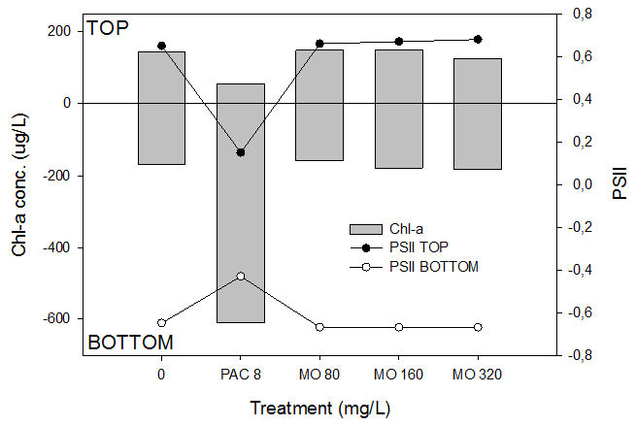
Figure 9: Chl-a conc. and PSII value of the top and bottom samples of tubes treated with a flocculant (PAC or Moringa) and 300 mg/L red soil.
Experiment 3 part 2
Observations: First, all tubes were treated only with a flocculant. After 1 hour and 45 min. flocks were visible in all treated tubes. The flocks in the tubes treated with PAC, 80 mg/L MO and 160 mg/L MO where floating. In the tube treated with 320 mg/L MO the flocks where throughout the whole column, of which the biggest flocks were visible in the upper half of the tube (Figure 10: Flocculation visible in all treated tubes before a fixed amount of 300mg/L red soil was added). Immediately after adding the ballast the flocks that where formed by PAC sank to the bottom. Small flocks at the treatment with 320 mg/L MO also sank to the bottom. One tube that was included, was treated as in the first part, in which the ballast was added right before 320mg/L Moringa extract. After 1 hour small flocks sank in the tubes treated with red soil followed immediately by 320mg/L MO, as well as in the tubes treated with 8 mgAl/L PAC + red soil, 80mg/L MO + red soil, 160 mg/L MO + red soil and 320 mg/L MO+ red soil. The water column was clear and the flock were on the bottom of the tube. The tube treated with only 320mg/L Moringa showed big flocks thoughout the whole water column.
PSII and pH: The PSII value was the same for the untreated and the with Moringa treated tubes, namely on average 0.61 with a standard deviation 0.005. The PSII of 8mgAl/L on the other hand dropped till 0.05. The pH was measured 48 hours after the experiment. It was found that the pH of the tubes treated with 320 mg/L Moringa (3 tubes; with red soil (before and after MO) and without red soil), had a lower pH than the tubes treated with 80mg/L and 160 mg/L MO, on average 7.7 and 8.2 respectively (standard deviation of 0.117 and 0.184). The average pH of the control tubes was 8.7 with a standard deviation of 0.177.
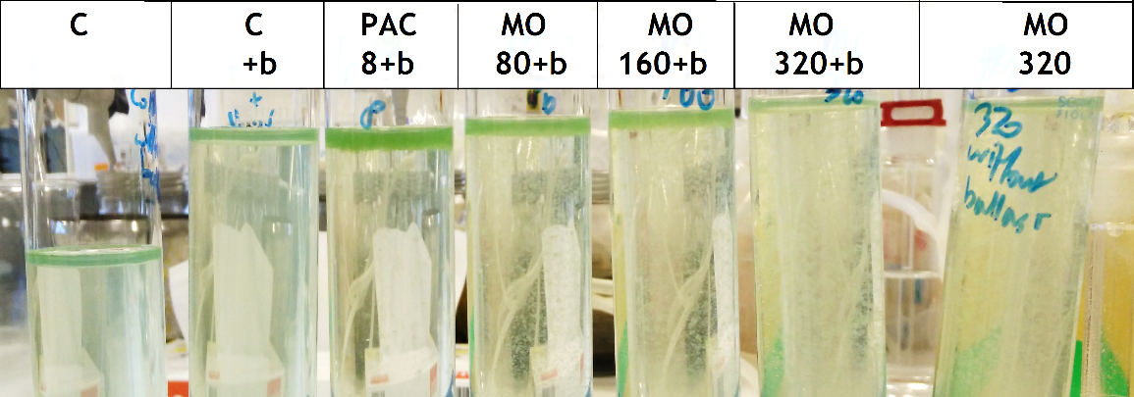
Figure 10: Flocculation visible in all treated tubes before a fixed amount of 300mg/L red soil was added. C= control, C+b= only red soil, PAC 8+b= 8mgAl/L PAC + red soil, MO 80+b, 160+b and 320+b= 80, 160 and 320 mg/L filtered 1M NaCl Moringa extract + red soil and MO 320= only 320mg/L MO.
Chlorophyll-a concentration: There was little difference between the different concentrations of Moringa in both the top and the bottom of the tubes. The chl-a concentrations in the bottom of the tubes treated with 80, 160 and 320mg/L filtered 1M NaCl Moringa extract were similar between them and were on average 14 times higher than in the top. In the tube where the ballast was added immediately with the 320 mg/L Moringa the bottom chl-a conc. was ~9 times higher than in the top. The tube treated with only 320 mg/L MO showed a similar chl-a concentration as the control tubes, as the flocks stayed through the whole water column. In the tube treated with PAC the bottom chl-a conc. was ~7 times higher in the bottom than in the top of the tube (Figure 11: Chlorophyll-a conc. and PSII value of control tubes with and without ballast, tubes treated with Moringa (MO conc.), Moringa + ballast after flocculation (MO conc. + B) or ballast and Moringa at the same time (B + MO conc.).).
Removal efficiency: The removal efficiency (RE) had been calculated for the tubes treated with Moringa and ballast (immediately and after flocculation). It was found that the tubes treated with different concentrations Moringa and ballast added after flocculation had a removal efficiency between 56% and 60%. In the tube where the ballast was added together with 320 mg/L Moringa the RE was a little lower, namely 51%.
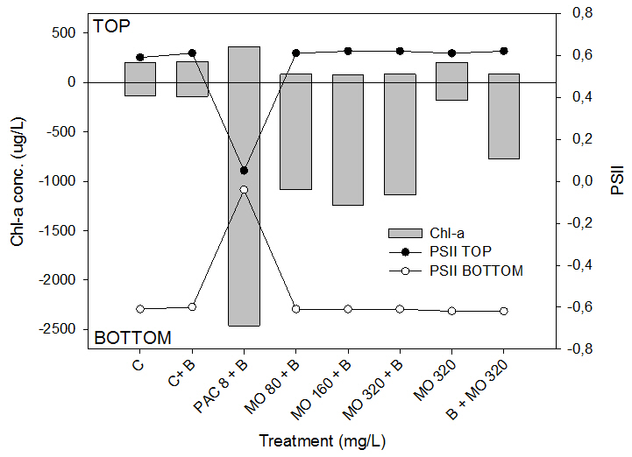
Figure 11: Chlorophyll-a conc. and PSII value of control tubes with and without ballast, tubes treated with Moringa (MO conc.), Moringa + ballast after flocculation (MO conc. + B) or ballast and Moringa at the same time (B + MO conc.).
Thus, there was no differency found in the flock size and removal efficiency between 80 and 320 mg/L filtered 1M NaCl Moringa extract. Furthermore, there is only little difference in removal efficiency between adding ballast together with the flocculant or after flocculation.

4.2.4 Experiment 4: Individual Moringa seeds
Observations: The outcome of the float and sink test of the individual Moringa seeds was that the seeds 1 to 4 and 6 sank, and seed 5 and 7 to 10 were afloat (Fig 1, Appendix 4.3). Big flocks were clearly visible in all tubes, except from the tube with seed number 8 where no flocculation happened. Seed 8 had a triangular shape, was quite dark, and shriveled on three sides. Those characteristics were close to similar to seed 7. The flocks stayed throughout the whole water column. The experiment was executed in two phases. In the first phase the 1M NaCl Moringa extract of seeds 1-5 were added to the tubes, and 1.5 hours later seeds 6 to 10. The next day, 17 hours after the experiment, the visual flocculation performance was even clearer (Figure 12).
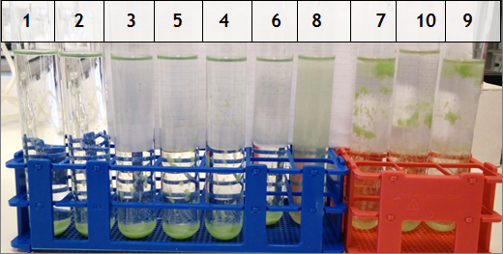
Figure 12: Visual flocculation performance of 10 individual seeds ~16 hours after the experiment, be aware, the seed numbers are not in a logical order, as the tubes are in line of the visual seed size, instead of the seed size by weight.
PSII and pH: The average PSII value was 0.39 with a standard deviation of 0.020. The average pH of the tubes treated with seeds 1 to 7 was 8.2 with a standard deviation of 0.046 compared to the higher pH found in the tubes treated with seeds 8 to 10, namely 8.4 with a standard deviation of 0.04.
Chlorophyll-a concentration: The chlorophyll-a results do not show a clear result, because the flocks were spread throughout the whole water column when taking the samples at the end of the experiment. The biggest difference in chl-a conc. between top and bottom was found with the smallest seeds 1 and 3 in which the bottom chl-a conc. was almost double from the top (Figure 13). Furthermore, it was analyzed if the color of the seed and their float/sink ability influenced the flocculation, measured with the chl-a concentration. It was found that mainly the small seeds are light seeds and the sinking seeds, whereas mainly the big seeds are dark and floating. The chl-a concentration for the top samples was lower for the light colored and sinking seeds have a lower chl-a concentration than the dark colored and floating seeds, 184 µg/L compared to 228 µg/L. In the bottom the differences in chl-a conc. were smaller; the light colored and sinking seeds had a chl-a conc. of 230 µg/L compared to the lower chl-a conc. in the floating and dark seeds, namely 225 µg/L. It was visible that at both the light and dark seeds, the chl-a conc. increases in the top by the increasing seed size (Fig 2 and 3 in Appendix 4.3).
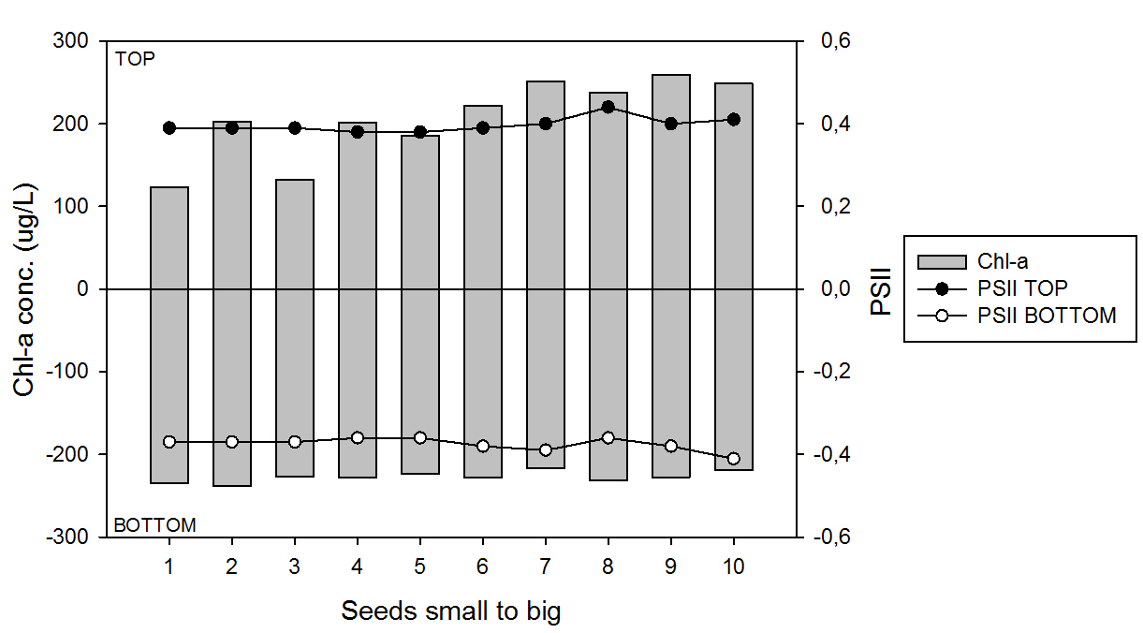
Figure 13: Chl-a conc. and PSII value of the top and bottom samples of 10 individual seeds. The seeds are in order of size by weight.
To summarize, it was found that there is little seed variation. Moringa extract of 9 out of 10 seeds caused flocculation. Differences in chl-a conc. between sinking and floating seeds and between light and dark seeds were similar.

4.2.5 Experiment 5: Flocculation effect Moringa on brackish cyanobacteria
Observations: It was visible that in all species tested in the 4mgAl/L PAC treatment flocculation and sinking of the flocks happened immediately after mixing. The brackish water cyanobacteria species M. aeruginosa (BC) was in colonies and the colonies sank immediately at all tubes, both treated and untreated (yellow circle, Figure 14: M. aeruginosa (BC) is labeled with MBC and M. aeruginosa (MIRF) is labeled with MIRF. C=control, b=ballast. Visible sinking colonies at all tubes with the species M. aeruginosa (BC), which are marked with the yellow circle. Big flock sank at M. aeruginosa (MIRF) treated with 4mgAl/L. No flocculation happened in the tubes treated with Moringa (with and without ballast) at the fresh water cyanobacteria M. aeruginosa (MIRF) (green square, Figure 15). On the other hand, clear flocculation was visible in the treatment with 80 mg/L filtered 1M NaCl Moringa extract in the brackish water cyanobacteria Anabaenopsis sp. (BC) (red circle, Figure 15). In the tube with both Moringa and red soil, the Anabaenopsis sp. flocks sank (blue circle, Figure 15). Pictures taken 60, 120, 180 and 210 minutes after the start of the experiment did not show any difference, indicating that the flocculation equilibrium was reached after 60 minutes.
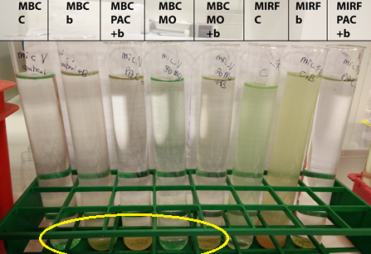
Figure 14: M. aeruginosa (BC) is labeled with MBC and M. aeruginosa (MIRF) is labeled with MIRF. C=control, b=ballast. Visible sinking colonies at all tubes with the species M. aeruginosa (BC), which are marked with the yellow circle. Big flock sank at M. aeruginosa (MIRF) treated with 4mgAl/L PAC. In the untreated tubes (MIRF C and MIRF b) with M. aeruginosa (MIRF) the algae stay in the water column and only the ballast sank. This picture was made 60 min after the start of the experiment.

Figure 15: No flocculation happened with fresh water M. aeruginosa (MIRF) treated with 80mg/L Moringa with and without ballast, which is marked in the green square. Flocks are well visible at the brackish water Anabaenopsis sp. (BC) (labeled as ABC), treated with 80mg/L MO (red circle). The flocks formed by Moringa sank when ballast was added (blue circle). This picture was made 60 min after the start of the experiment.

PSII and pH: The average PSII value of the brackish water M. aeruginosa (BC) dropped from the 0.53 (standard deviation of 0.008) in the control to 0.42 in the bottom of tube and 0.26 in the top of the tubes treated with 80 mg/L MO. The average PSII of the top and bottom samples at M. aeruginosa (BC) treated with 4mgAl/l PAC was 0.51, with a standard deviation of 0.035.
The PSII value from the freshwater M. aeruginosa (MIRF) was less influenced by Moringa. The PSII value was 0.61 in the control tube and the average PSII of the top and bottom samples of the tubes treated with 80 mg/L Moringa (with and without red soil) was 0.48 with a standard deviation of 0.049. The PSII of the top and bottom samples in the tube treated with 4mgAl/l PAC was 0.43.
The brackish water cyanobacteria Anabaenopsis sp. (BC) was mostly influenced by the Moringa seed extract. Here the PSII value dropped from 0.50 in the control to 0.14 in the top samples and 0.23 in the bottom samples of the tubes treated with Moringa. The average PSII value for the tube treated with 4mgAl/L PAC was 0.44 with a standard deviation of 0.035 (Figure 17).
The average pH of M. aeruginosa (BC) and Anabaenopsis sp (BC) treated with 80 mg/L Moringa (with and without ballast) were 7.9 with a standard deviation of 0.226 and 7.5 with a standard deviation of 0.092 which was lower than the average pH in the controls which were 8.3 (standard deviation 0.346) and 7.8 (standard deviation 0.078) respectively. This is different from M. aeruginosa (MIRF) in which the pH of both the treated and untreated tubes was around pH 9 with a standard deviation of 0.151. The salinity increased with 0.25 to 0.5 mg/L in the tubes treated with 80 mg/L filtered 1M NaCl Moringa extract compared to the control.

Figure 16: Difference in pH between M. aeruginosa (BC and MIRF) and Anabaenopsis sp. at different treatments.

Chlorophyll-a concentration: The chl-a conc. of M. aeruginosa (BC) showed that the top chl-a conc. of the control tube and the tube treated with 80 mg/L MO were close to each other, 172 and 159 respectively. Furthermore, it can be seen that only the addition of a ballast without MO removed almost all the chlorophyll in the top of the tube, similar to the result of the tube treated with 80mg/L MO + ballast. The chl-a conc. in the top and bottom of the 80 mg/L MO+ ballast treatment was close to that of 4mgAl/L PAC at M. aeruginosa (BC), 2 µg/L and 16 µg/L for the top and 2597µg/L and 2374 µg/L for the bottom respectively (Figure 17A). The average chl-a conc. in the top samples of the untreated and with Moringa treated fresh water M. aeruginosa (MIRF) was 296 µg/L ±50 µg/L. Only at 4mgAl/L PAC the chl-a in the top was much lower, namely 30µg/L. In the bottom the highest chl-a conc. was found at 4mgAl/L PAC, namely 1162 µg/L followed by the 80mg/L MO treatment in which the chl-a conc. was 736 µg/L (Figure 17B). The tubes with Anabaenopsis sp. (BC) showed the biggest difference in chl-a conc. between top and bottom for the different treatments. Solo addition of ballast without MO was more effective in removing the cyanobacteria than 4mgAl/L PAC + ballast. The tube treated with only MO had a chl-a conc. of 23 µg/L in the top and 3647 µg/L in the bottom. The difference was even bigger in the tube treated with 80 mg/L MO + ballast in which the top chl-a conc. was 2.1 µg/L and the bottom chl-a conc. 4876 µg/L (Figure 17C).
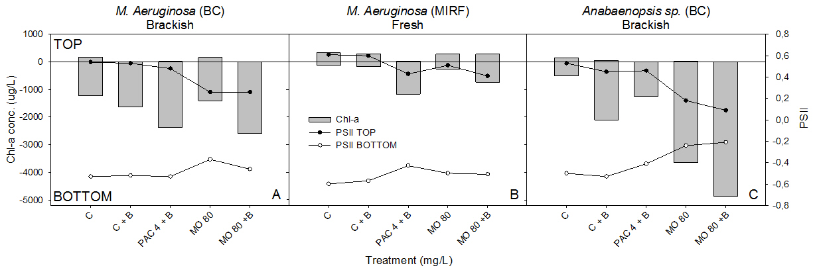
Figure 17: Chl-a conc. and PSII value for the top and bottom samples of A) brackish water M. aeruginosa (BC), B) freshwater M. aeruginosa (MIRF) and C) brackish water Anabaenopsis sp. (BC)
Removal efficiency: The removal efficiency (RE) has been calculated for only Anabaenopsis sp. (BC), as flocculation happened at this species. It can be seen that the RE was already 88.6% at the tube treated with only 80 mg/L MO, and that the RE increased to 98.9% when ballast was added to this treatment (Figure 18). The RE of 80 mg/L MO + ballast was only 3% higher than the RE at the 4mgAl/L PAC +ballast treatment.
Figure 18: Removal efficiency brackish water cyanobacteria M. Anabaenopsis sp. (BC) at different treatments.
Thus, the species that was most influenced by Moringa was Anabaenopsis sp. (BC), because the PSII value dropped dramatically. No flocculation occurred at the fresh water M. aeruginosa (MIRF). The highest removal efficiency of Moringa was found at the 80mg/L MO + ballast treatment and was similar to the 4mgAl/L PAC treatment.

4.2.6 Experiment 6: Effect Moringa on nutrient concentration
In this experiment the nutrient release of Moringa oleifera seeds was measured. Moringa seeds released nutrients, mainly phosphate (Table 3).
Table 3: Nutrient release Moringa oleifera seeds
 | NO3+NO2 µg N/l | PO4 µg P/l | NH3 µg N/l
Bottle 1 | 14,26 | 756,71 | 377,51
Bottle 2 | 35,53 | 628,54 | 367,04
Bottle 3 | 7,64 | 683,13 | 380,38
Average | 19,15 | 689,46 | 374,98
Sample standard deviation | 14,57 | 64,32 | 7,02
Nutrient release per mg Moringa | 0,009 | 0,336 | 0,183

5. Discussion

5.1 Discussion pre-experiments

5.1.1 Pre-experiment 1: Filtered or unfiltered Moringa water extract
A coffee filter (coffee filters original Melitta, Germany) was used to filter the Moringa suspension, which is a cheap, easy and available alternative for professional filters. It was found that the flocculation performance of filtered Moringa water extract was better already at a lower concentration Moringa than the unfiltered Moringa water extract, as big flocks were visible that sank to the bottom. A study of Ndabigengesere et al. (1995) found that coagulation was present in both filtered and unfiltered dried and shelled Moringa seeds. In most studies filtered Moringa extract was used, which is probably because this works better than the unfiltered extract (e.g. Barrado-Moreno et al., 2016; Ghebremichael et al., 2005; Lea, 2014; Oladoja & Pan, 2015)

5.1.2 Pre-experiment 2: Different chlorophyll concentrations on flocculation ability Moringa
Different from the results of this study, in which no flocculation happened at an initial algae concentration of 480 and 1930 µg/L chl-a, Oladoja & Pan (2015)found that the removal efficiency of Moringa increased with an increasing initial algae concentration. In that study this is explained by the increased inter-particle bridging and flock formation at a higher initial concentration. In the study of Barrado-Moreno et al. (2016) a chl-a range from 0-80 µg/L was used finding the same result as Oladoja & Pan (2015). But both studies cannot be compared completely with this experiment, because the Moringa extract method and initial cl-a concentrations were different. The chlorophyll-a concentration in the series with the initial chl-a conc. of 480µg/L, did not show a relationship with the Moringa concentration. This can be explained by the flocculation that did not occur.

5.1.3 Pre-experiment 3: Repetition of the filtered Moringa water extract treatment to investigate the reliability of this extraction method using PAC as a positive control
No flocculation was found in the tubes treated with filtered Moringa water extract, compared to big flocculation in pre-experiment 1, which means that this flocculant or the extraction method is not very reliable. The results of the treatments with different concentrations PAC were a little different from the results found in a similar experiment done by de Magalhães et al. (2016), where small flocks were formed at the concentrations 1 and 2 mgAl/L and big sinking flocks at the concentrations 4 and 8mgAl/L, compared to no flocculation in 1 and 2 mgAl/L, small flocks at 4 mgAl/L and big sinking flocks at 8mgAl/L in this experiment. This resulted in a chlorophyll a concentration on the bottom 17 times higher than in in the top at the 8mgAl/L treatment, compared to 11 times in the study of de Magalhães et al.

5.1.4 Pre-experiment 4: Effect pH on flocculation Moringa
Two series of experiments were done, one series with a low pH of 6 and one series with a high pH of 9. In both cases small flocks were formed, resulting in a maximum removal efficiency of 67.5%. The study of Barrado-Moreno et al., (2016) also did research about the role of different pH values (pH 5 to 9) on flocculation performance of Moringa, but there was no influence found of pH on the removal efficiency of Moringa oleifera seeds. Though, it was observed that the flocks were much smaller than the flocks visible in the tubes treated with the filtered Moringa water extract in pre-experiment 1 and 3, in which the average pH was 7.7 with a standard deviation of 0.191 and 8.6 with a standard deviation of 0.015.

5.1.5 Pre-experiment 5: Moringa as a flocculant in removing inorganic turbidity
The method used for this experiment is the first point of discussion. The inorganic turbid solution with bauxite was prepared right before the start of the experiment. The kaolinite suspension was prepared 24 hours before the start of the experiment, but was completely mixed before pouring it to the test tubes. In the tubes it was visible that part of the clay immediately sank to the bottom. This influenced the results. In previous studies, the turbid solution was mixed for 30 minutes after which it was left for 24 hours, so that the particles could be fully hydrated and settled. The supernatant was then - if necessary diluted to achieve the desired turbidity - used for the experiment, giving a more correct result than the result of the experiment in the current study (Ghebremichael et al., 2005; Ndabigengesere & Subba Narasiah, 1998; Okuda et al., 1999).
A second point of discussion is that in this study no flocculation took place at the various levels of turbidity. The study of Ghebremichael et al. (2005) found that at a high initial turbidity the removal efficiency of Moringa was similar to a metal based flocculant. On the other hand, at a low initial turbidity, the metal based flocculant performed better than Moringa. Liew et al. (2006) also found that the removal efficiency of Moringa was higher at a higher initial turbidity. In the research of Dorea (2006)(as quoted in Lea (2014)) it was discovered that removal of turbidity with Moringa does not work at a turbidity lower than 50 NTU. In both studies – Liew et al. (2006) and Dorea (2006) - it is discussed that the relationship between initial turbidity and removal efficiency of Moringa might depend on the flocculation mechanism. It can also be because of the high organic load of Moringa seeds that is released in the water increasing or leaving the turbidity the same, at a low initial turbidity, whereas at a high initial turbidity the small volume of flocculant has naught effect (Camacho et al., 2017; Okuda et al., 2001). At the tubes with initial turbidity 18.7, 64.4 and 164 of kaolinite clay the final turbidity was the highest at the highest concentration of Moringa. This might indicate that organic matter of Moringa seeds is released into the water. Though, the difference was very small and there was no linear relationship found.
The Moringa seed extract was prepared 1 day before the turbidity experiment with kaolinite clay. Decay of the Moringa seeds might have started already and so causing the Moringa seeds to lose their flocculation ability. But at the experiment with bauxite, the Moringa seed extract was prepared fresh, and also there no flocculation happened.

5.2 Discussion experiments

5.2.1 Experiment 1: Flocculation cyanobacteria, NaCl or water Moringa extract
In the tubes treated with 160 and 320 mg/L 1M NaCl Moringa extract it was visible that the flocculation mostly took place in the upper part of the tube. This can be explained by not well mixing causing the flocculant to stay mostly in the top of the tube. In the study of Okuda et al. (1999) the extraction method of Moringa oleifera seeds was also investigated. In that study a similar result about flocculation performance of Moringa water extract and Moringa 1M NaCl extract was found. The Moringa seed extract prepared with 1M NaCl solution showed better flocculation and a higher removal efficiency than the Moringa seed extract prepared with water. According to Okuda et al. (1999) this might happen due an increased ionic strength and solubility of proteins (Okuda et al., 1999). Four different salt extract solvents were investigated (NaCl, KCl, NaNO3 and KNO3) by them and no difference in flocculation efficiency was found between the salts. The studies cannot be compared totally, as in the study of Okuda et al. (1999), the flocculation performance was tested with kaolinite inorganic turbidity instead of Microcystis. An investigation about the colour removal efficiency of different salt solvents (NaCl, KCl, NH₄Cl, NaNO₃ and KNO₃) and Moringa showed that the best decolourization was achieved with a 0.25 and 1M NaCl and KCl Moringa extract (Prasad, 2009).

5.2.2 Experiment 2: Flocculation cyanobacteria with NaCl Moringa extract
Experiment 1 was repeated in this experiment to find out if the same experiment repeated gives the same result. This was done, because from the experience with filtered Moringa water extract in pre-experiment 1 and 3, where the same treatments did not show the same result when repeated. This time, when repeating the same experiment with filtered 1M NaCl extract the same result was found, indicating that this extraction method and solvent is more reliable than water.

5.2.3 Experiment 3: Flock and sink cyanobacteria with Moringa and ballast
Green algae Scenendesmus obliquus can exist as unicells, but they are also frequently found in colonies. The large mass of large colonies promotes sinking (Lürling, 1999). When the flocculant Moringa oleifera is added, flocks are formed. Those flocks have a large mass weight and the flocks will automatically sink. It was assumed that this is the same for the green algae Chlorella vulgaris. The cyanobacteria Microcystis aeruginosa on the other hand has different characteristics. The cells have a gas vesicle, and as the cells are usually organized into colonies they have the ability to regulate their buoyancy (“Microcystis,” 2016). Because of their tendency to float, and by doing so positioning themselves in the photic zone, ballast is needed to let the flocks - formed with Moringa oleifera seed extract - sink (Figure 19).
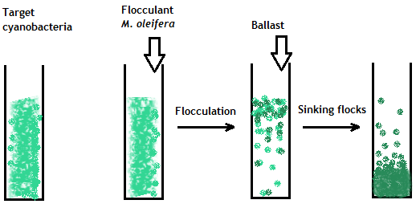
Figure 19: Flock and sink process with Moringa seed extract and cyanobacteria, showing the buoyancy ability of the cyanobacteria and the need of adding a ballast to let the flocks sink (Hoenjet, 2017).
The fixed dose ballast added was 300 mg/L. This concentration was based on a study of Noyma et al. (2016) in which 320 mg/L of red soil was sufficient in sinking Microcystis aeruginosa from the water column. However, the high dose red soil increased the amount of negatively charged particle in the solution, and could have caused the flocculant MO to interact with to the soil particles instead of the cyanobacteria (Oladoja & Pan, 2015). This possibly led to the sinking of the red soil particles (Fig 1a and 1b, Appendix 4.2 Experiment 3: Flock and sink cyanobacteria with Moringa and ballast). On the other hand, the red soil also sank in the control tube, indicating that the soil sank due to gravity. In the study of Oladoja & Pan (2015) the flock and sink experiment was run successfully with a high removal efficiency. One remark that has to be made is that in the study of Oladoja & Pan (2015) different concentrations Moringa and red soil were used.
Because of the failed flocculation at this experiment a second test was run in which the red soil was added after flocculation had happened. Flocculation happened and a removal efficiency of 56 to 60% was achieved after the addition of ballast. However, at the control tube in which the ballast was added before the flocculant, like in part 1, the removal efficiency was similar to the treatments in which the ballast was added after flocculation. So, the repeated treatment gave an opposite result from the first time, which means that Moringa is not very reliable for Flock & Sink treatment. Furthermore, on a small scale in the laboratory the addition of ballast 1 hour after the Moringa is not a problem, but at real application in a lake, a boat needs to go on the lake twice, once for adding the flocculant and later for spreading out the ballast. This is inefficient, expensive and time consuming. Noyma et al. (2016a) found in an experiment with another natural flocculant (chitosan), that the flock and sink experiment was less effective with chitosan + red soil than PAC + red soil, as a higher chl-a conc. remained in the top of the tube treated with chitosan, which shows that both the flocculant and ballast type influences the removal efficiency.

5.2.4 Experiment 4: Individual Moringa seeds
Investigated was if seed variability in Moringa seeds, giving a variation of results in flocculation performances. Of the 10 seeds that were investigated, 9 seeds let flocculation happen. No duplicates were used, so no hard conclusions can be made. The tube treated with seed 8 did not show any flocculation. Surprisingly, two other seeds (7 and 9) with the same characteristics as seed 8 - big sized, dark and floating seeds - did show flocculation. More research should be done on seed variability, because sometimes the same method for an experiment or treatment was applied a second time but with different seeds and the result was opposite from the first time. This happened with pre-experiment 1 and 3. In pre-experiment 1 flocculation happened and in pre-experiment 3 with the same methods did not. In the first test of experiment 3 ballast was added to the tubes together with the Moringa and no flocculation happened. In the second test of experiment 3, one tube was treated the same as in the first part, but then flocculation did happen, contrary to the first test, although the method and conditions were similar. Moringa seeds consist for 35 to 40 % of oil by weight (Leone et al., 2016). The oil is an important ingredient when it comes to the flocculation performance. Moringa seed powder achieves a higher removal efficiency of green algae Chlorella sp. than Moringa protein powder of de-oiled Moringa seeds, 97% and 78% respectively (Abdul Hamid et al., 2016). So a variation in oil-content might lead to a better or worse flocculation performance. Also, the different types of proteins give Moringa the flocculating property. The concentrations and presence of the various proteins might be different per seed (Gassenschmidt et al., 1995; Ghebremichael et al., 2005). Also the period of harvesting - during the wet or the dry season - might have an influence on the flocculation performance: “It had been experienced that the “level of polyelectrolytes present in the kernels is substantially less during the wet season”; and therefore, it is recommended to use seeds that are “harvested during the dry season only””(Fuglie, 2000 as quoted in Lea, 2014)). All these intrinsic characteristics might increase the variability of Moringa seeds.

5.2.5 Experiment 5: Flocculation effect Moringa on brackish cyanobacteria
It was observed already at experiment 1 that the flocculation performance of Moringa is better when the extract is prepared in a NaCl solution than water, because of the stronger ionic strength and solubility of proteins (Okuda et al., 1999). In brackish water the ionic strength is even higher, which might explain why in this experiment the removal efficiency in the tubes with the brackish water cyanobacteria was so high. The flock and sink assay for the brackish water M. aeruginosa (BC) was a bit more difficult. This species was present in colonies and because of their weight, the colonies sank to the bottom in both treated and untreated tubes. In all experiments executed with the freshwater M. aeruginosa (MIRF) the PSII value was not or barely influenced by the Moringa oleifera. This was different from the brackish water M. aeruginosa (BC) and Anabaenopsis sp. (BC). The PSII efficiency in the top samples dropped till below 0.3 for M. aeruginosa (BC) and Anabaenopsis sp. (BC), which means that the cells were clearly damaged and Anabaenopsis sp. (BC) was almost completely killed as the PSII values were 0.18 and 0.09. In the bottom samples M. aeruginosa (BC) was less damaged, the average PSII was 0.42 for the tubes treated with Moringa. The PSII value for Anabaenopsis sp. (BC) dropped till an average of 0.23 in the bottom samples treated with Moringa. So, even though the removal efficiency of Anabaenopsis sp. (BC) was above 90%, the cyanobacteria were damaged or killed, so that toxins could have been released. Therefore it is recommended to not use Moringa in Flock and Sink treatment for Anabaenopsis sp. (BC). The concentration of PAC had been lowered to 4mgAl/L, as the previous concentration 8mgAl/L caused a tremendous pH drop which killed the cyanobacteria. By doing so, the pH drop will be reduced and damage or death of cyanobacteria is lessened. The PSII for M aeruginosa (BC) and Anabaenopsis sp (BC) was lower at the MO treatments than PAC treatments.
It was remarkable that the results of the fresh water cyanobacteria M. aeruginosa (MIRF). In experiment 3 and 5 seemingly the same treatments had been executed using the same methods, but the outcomes were different. In the second part of experiment 3 flocculation happened in the tubes treated with 80mg/L or higher concentrations of filtered 1M NaCl MO extract, whereas no flocculation happened in the first test of experiment 3 and experiment 5. Another difference that was found, was that at experiment 3 the final PSII value of the M. aeruginosa treated with Moringa was 0.64, similar to the control, and in experiment 5 this was dropped to 0.48 compared to 0.6 in the control. This indicates that flocculation is not related to the PSII. Also the pH does not give an explanation why flocculation happened in the same treated tube in the second test of experiment 3 and not in the first test of experiment 3 and experiment 5. The pH in both parts of experiment 3 was around 8.3 for both MO treatments and untreated tubes, whereas the pH in experiment 5 was 9.1.

5.2.6 Experiment 6: Effect Moringa on nutrient concentration
Moringa highly increases the nutrient concentration of the water. This result was already found in the study of Ndabigengesere & Subba Narasiah (1998). It is important when applying Moringa, to investigate if Moringa does not increase the nutrient concentration too much. If that is the case, the eutrophication problem will be retained and the cyanobacteria problem will come back. A good option to prevent this from happening is to use a P-sorbent product as a ballast, instead of a local soil. Though, Noyma et al. (2016) found that local red soil from Brazil has a phosphate adsorption capacity, this was 4-12 times lower than the P adsorption of lanthanum modified bentonite. A P-sorbent only binds dissolved phosphate and in combination with a flocculant it can also capture the phosphate inside cyanobacteria and prevent the phosphate to release again from the sediment (Lürling et al., 2014). In this way the eutrophication and cyanobacteria problems are solved in one time. There are different types of P-sorbents, those can be; (1) natural minerals or soil, (2) natural or synthetically produced materials, (3) modified clays or soil, and (4) mining, mineral processing and industrial by-products (Douglas et al., 2016; Spears et al., 2013). An examples of a P-sorbents that has been used in combination with a flocculant to solve both eutrophication and cyanobacteria nuisance is lanthanum modified bentonite (Phoslock®)(van Oosterhout & Lürling, 2013; Waajen et al., 2016a, 2016b). It has to be taken into account that the use of a P-sorbent instead of a local soil does make the treatment more expensive. It is important to analyse the amount of nutrients released by Moringa compared to the internal and external leading in the water system. Only after a good system analysis a decision should be made before the application of a certain Flock & Sink or Flock & Lock treatment. Additionally, the available financial resources should be taken into account in the decision.

5.3: General discussion

5.3.1 Experiment duration
The experiment duration in most of the algae flocculation experiments was 60 minutes. In the study of Barrado-Moreno et al. (2016) experiments were executed duration times varying from 10 to 60 minutes with an initial algae conc. of 50µg/L and 10 mg/L of Moringa. It was found that from 30 minutes the chlorophyll-a reduction does not significantly change anymore. However, the equilibrium removal efficiency in the study of Oladoja & Pan (2015) was reached at 120 minutes. At experiment 5 the flocculation time was investigated finding a flocculation equilibrium after 1 hour, which is in between above mentioned studies.

5.3.2 Dose Moringa
In the study of Barrado-Moreno et al. (2016) the removal efficiency increased as the dose increased from 4.5 mg/L to 45mg/L. The optimal dose at which a RE was achieved of about 80% for Microcystis was from 25mg/L filtered 1M NaCl Moringa extract. The initial chl-a conc. of Microcystis in the present study was on average 190µg/L, which is 3.8 times higher than the initial chl-a. used in the study of Barrado-Moreno et al. (2016). When converting the Moringa dose from Barrado-Moreno et al. (2016) to the initial chl-a conc. used the present study, this would be 95mg/L MO which is close to the used dose of 80 mg/L 1M NaCl Moringa extract. It is difficult to compare the results with other studies, because of e.g. different methods or units; (1) a different MO extract method (Oladoja & Pan, 2015), (2) the initial Microcystis conc. was different (Barrado-Moreno et al., 2016), (3) the initial Microcystis conc. was not given (Abdul Hamid et al., 2016), (4) the Microcystis conc. was measured as turbidity (Nishi, Salcedo Vieira, et al., 2012), or (5) the Moringa treatment was done in combination with another treatment (Nishi, Salcedo Vieira, et al., 2012)). In all cases the optimum Moringa concentrations were different, and not comparable, as other methods or units were used or additional factors might influenced the flocculation performance.

5.3.2 Effect Moringa on pH and PSII
It was expected that Moringa would not affect pH, as this result was found in the studies of Ndabigengesere et al. (1995), Ndabigengesere & Subba Narasiah (1998), Nishi, Salcedo Vieira, et al. (2012) and Oladoja & Pan (2015), and this expectation was right. This is an advantage above the use of PAC, which can – depending on the dose - highly decreases the pH (de Magalhães et al., 2016; Ndabigengesere et al., 1995; Ndabigengesere & Subba Narasiah, 1998; Noyma et al., 2015).
Moringa did not affect the PSII efficiency of green algae. Depending on the species, Moringa can affect the PSII efficiency and thereby damaging the cells which can release toxins. Additionally, the effect on the PSII efficiency can depend on the concentration and type flocculant, as was found in the studies of de Magalhães et al. (2016) and Noyma et al. (2015) in which no PSII effect was found of the natural flocculant chitosan and PAC up to a concentrations of 2 mgAl/L. The zeta-potential can also be used to measure damage to cells. Zeta-potentials means the electrokinetic potential in the spreading of particles. If this value changes, it means the cells are broken. Additionally, the zeta-potential can help to find the mechanism(s) and kinetic processes that cause flocculation of Moringa. Several studies have measured the zeta-potential of Moringa oleifera seeds as a flocculant, but the conclusions were often different (e.g. Liew et al., 2006; Okuda et al., 2001).

6. Conclusion
To find an answer to the main question: To what extend are Moringa oleifera seeds a reliable flocculant in removing cyanobacteria, many experiments have been executed. Different variable were investigate that might influence the flocculation performance of Moringa oleifera seeds and sometimes experiments or treatments in order to measure the reliability of Moringa oleifera (MO) seeds as a flocculant.
- It was found that filtered MO water extract gives a better flocculation performance than unfiltered MO water extract.
- 1M NaCl Moringa extract was found to be more reliable than Moringa water extract.
- Different initial chlorophyll-a concentrations with a fixed dose Moringa seed extract resulted in different flocculation performances or the absence of flocculation.
- It was found that pH had a little effect on the flocculation performance of Moringa
- Moringa seemed not able to flocculate inorganic turbidity at a range of dissolved particles using two different clays; kaolinite and bauxite.
- Moringa oleifera in combination with red soil as a natural ballast is able to flock and sink cyanobacteria, but this is not very reliable. When adding Moringa together with the ballast, no flocculation occurred. In the next experiment were ballast was added after flocculation occurred but one tube was included in which the red soil was added together with ballast, flocculation occurred.
- Seed variability might be the cause of the variation in flocculation performance, which reduces the reliability of using Moringa oleifera seeds as a flocculant.
- Flocculation happened both at freshwater and brackish water cyanobacteria.
- Moringa oleifera seeds releases nutrients in the water.
- The optimum Moringa concentration was found to be 80 mg/L for an initial chlorophyll-a concentration of ~200µg/L.
- The flocculation equilibrium of Moringa seed extract is around 1 hour.
- Moringa does not affect the pH.
- Moringa does not influence the photosystem II efficiency at the green algae species Scenendesmus obliquus and Chlorella Vulgaris and the fresh water cyanobacteria Microcystis aeruginosa. However, the brackish water species M. aeruginosa and Anabaenopsis sp. showed a decrease in PSII efficiency after the Moringa treatment.
At this point Moringa oleifera seeds are not yet a reliable flocculant, as repeated experiments or treatments do not always give the same results. Though, Moringa oleifera has the potency to be a good flocculant for removing cyanobacteria, as a natural, cheap and safe flocculant mainly for developing countries.

7. Recommendations
In this study many variables have been investigated that might be of influence on the flocculation performance of Moringa oleifera seeds. It was found that Moringa oleifera has some advantages above metal based flocculants, such as no gloves are needed to be worn at application, it is biodegradable and it does not affect pH. But a big disadvantage is that the flocculant is not reliable and the release of nutrients. More research is necessary to develop Moringa oleifera seeds to a reliable flocculant.
Only a few chlorophyll-a concentrations have been used in analysing the flocculation performance of Moringa. Thus, it is recommended that a range of initial chlorophyll-a concentrations is analysed to get more insight in the working and reliability at different circumstances of Moringa oleifera seed extract in flocking cyanobacteria.
It was found that different cyanobacteria species were affected in different ways by the addition of Moringa oleifera. Recommended is to do more research about the effect of Moringa oleifera seed extract on the PSII efficiency of different species, including fresh, brackish and marine species.
The seed variability might be due to different proteins and different compositions of proteins in the Moringa seeds as well as the oil content. Thus, it is important to investigate more about the variability of the seeds and to find the compound responsible for the flocculation to get more insight in the working of this natural flocculant. The recognition helps to find the optimum way to use Moringa (with or without oil, only the oil, a certain part (protein) of the Moringa seed etc.) and can reduce the seed variation and improve the development of a highly efficient and reliability natural flocculant.
In this study repetition of experiments was done several times to measure the reliability of Moringa oleifera seed extract. Repetition with a different set of seeds is a method, but also the inclusion of duplicates would be recommended in future studies to further investigate the reliability.
No clear conclusion could be made about the Flock and Sink experiments with Moringa and ballast (red soil) and the best moment of adding this – before the flocculant, so that the particles are capture in the flocks or after flocculation happened -. More research about the Flock and Sink treatment will lead to a better application method for diminishing cyanobacteria nuisance.
Flocculation did not happen at the experiments with inorganic turbidity. As discussed, the method applied might have been a part of the failure of the flocculation. In other studies a high removal efficiency was found with Moringa at removing inorganic turbidity. More research about inorganic turbidity removal at a wide range and with different clays will give better insight in the flocculation performance and reliability of Moringa oleifera. The information gathered with investigation will help the application of Moringa in for example fish farms, such as the one mentioned in the introduction in Vietnam.
No research was found on the effects of Moringa on other organisms than algae. Even though Moringa oleifera seeds are natural, it is good to investigate the effects on different water animal species, such as fish, before applying it in, for example a fish farm.

References
A Healthy Leaf. (2016). Moringa Seeds. Retrieved May 26, 2017, from https://www.ahealthyleaf.com/product/moringa-seeds-pkm1/
Abdul Hamid, S. H., Lananan, F., Khatoon, H., Jusoh, A., & Endut, A. (2016). A study of coagulating protein of Moringa oleifera in microalgae bio-flocculation. International Biodeterioration and Biodegradation, 113, 310–317. doi:10.1016/j.ibiod.2016.03.027
Archer, T. (2011). Lake Erie algae bloom. Retrieved May 12, 2017, from http://www.huffingtonpost.com/2014/08/04/lake-erie-algae-bloom-2014-_n_5647824.html
Barrado-Moreno, M. M., Beltran-Heredia, J., & Martín-Gallardo, J. (2016). Microalgae removal with Moringa oleifera. Toxicon, 110, 68–73. doi:10.1016/j.toxicon.2015.12.001
Burson, A., Matthijs, H. C. P., de Bruijne, W., Talens, R., Hoogenboom, R., Gerssen, A., … Huisman, J. (2014). Termination of a toxic Alexandrium bloom with hydrogen peroxide. Harmful Algae, 31, 125–135. doi:10.1016/j.hal.2013.10.017
Camacho, F. P., Sousa, V. S., Bergamasco, R., & Teixeira, M. R. (2017). The use of Moringa oleifera as a natural coagulant in surface water treatment. Chemical Engineering Journal, 313, 226–237. doi:10.1016/j.cej.2016.12.031
Carey, C. C., Ewing, H. A., Cottingham, K. L., Weathers, K. C., Thomas, R. Q., & Haney, J. F. (2012). Occurrence and toxicity of the cyanobacterium Gloeotrichia echinulata in low-nutrient lakes in the northeastern United States. Aquatic Ecology, 46(4), 395–409. doi:10.1007/s10452-012-9409-9
Carvalho, M. S., Alves, B. R. R., Silva, M. F., Bergamasco, R., Coral, L. A., & Bassetti, F. J. (2016). CaCl2 applied to the extraction of Moringa oleifera seeds and the use for Microcystis aeruginosa removal. Chemical Engineering Journal, 304, 469–475. doi:10.1016/j.cej.2016.06.101
Cooke, G. D., Welch, E. B., Martin, A. B., Fulmer, D. G., Hyde, J. B., & Schrieve, G. D. (1993). Effectiveness of Al, Ca, and Fe salts for control of internal phosphorus loading in shallow and deep lakes. Hydrobiologia, 253(1-3), 323–335. doi:10.1007/BF00050758
Dahot, M. U. (1998). Antimicrobial activity of small protein of Moringa oleifera leaves. Journal of Islamic Academy of Sciences, 11(1), 27–32.
de Magalhães, L., Noyma, N. P., Furtado, L. L., Mucci, M., van Oosterhout, F., Huszar, V. L. M., … Lürling, M. (2016). Efficacy of Coagulants and Ballast Compounds in Removal of Cyanobacteria (Microcystis) from Water of the Tropical Lagoon Jacarepaguá (Rio de Janeiro, Brazil). Estuaries and Coasts, (September), 1–13. doi:10.1007/s12237-016-0125-x
De Persgroep Digital. (2012, January 26). ’Wonderboom helpt tegen ondervoeding in Zuid-Afrika. De Morgen. Retrieved from http://www.demorgen.be/buitenland/-wonderboom-helpt-tegen-ondervoeding-in-zuid-afrika-ba08ab18/
Douglas, G. B., Hamilton, D. P., Robb, M. S., Pan, G., Spears, B. M., & Lurling, M. (2016). Guiding principles for the development and application of solid-phase phosphorus adsorbents for freshwater ecosystems. Aquatic Ecology, 1–21. doi:10.1007/s10452-016-9575-2
EnviroScience. (2017). Harmful Algae Bloom Surface Sample. Retrieved May 26, 2017, from http://enviroscienceinc.com/services/laboratory-analysis/harmful-algal-blooms/
Frans, & Karin. (2013). Mousse di tonno nel limone – met tonijnmousse gevulde citroen. Retrieved May 12, 2017, from http://fratello-sorella.nl/mousse-di-tonno-nel-limone-met-tonijnmousse-gevulde-citroen/
Gassenschmidt, U., Jany, K. D., Bernhard, T., & Niebergall, H. (1995). Isolation and characterization of a flocculating protein from Moringa oleifera Lam. BBA - General Subjects, 1243(3), 477–481. doi:10.1016/0304-4165(94)00176-X
Ghebremichael, K. A., Gunaratna, K. R., Henriksson, H., Brumer, H., & Dalhammar, G. (2005). A simple purification and activity assay of the coagulant protein from Moringa oleifera seed. Water Research, 39(11), 2338–2344. doi:10.1016/j.watres.2005.04.012
Gonzalez, R. (2015). Quick Guide: How To Do A Seed Viability Test. Retrieved June 3, 2017, from https://www.craftsy.com/blog/2015/03/seed-viability-test/
Hoenjet, N. (2016a). FLocculation filtered MO water extract. HZ University of Applied Sciences.
Hoenjet, N. (2016b). Vision and strategies environment Baltic Sea. Vlissingen.
Hoenjet, N. (2017). Experiment design.
Introduction to the new EU Water Framework Directive. (2016). Retrieved April 27, 2016, from http://ec.europa.eu/environment/water/water-framework/info/intro_en.htm
Janse, J. H. (2005). Model studies on the eutrophication of shallow lakes and ditches.
Jeppesen, E., Søndergaard, M., Jensen, J. P., Havens, K. E., Anneville, O., Carvalho, L., … Winder, M. (2005). Lake responses to reduced nutrient loading - An analysis of contemporary long-term data from 35 case studies. Freshwater Biology, 50(10), 1747–1771. doi:10.1111/j.1365-2427.2005.01415.x
Lea, M. (2014). Bioremediation of turbid surfacewater using seed extract from the Moringa oleifera Lam. (Drumstick) tree. Current Protocols in Microbiology, (SUPPL.33), 1–14. doi:10.1002/9780471729259.mc01g02s33
Leone, A., Spada, A., Battezzati, A., Schiraldi, A., Aristil, J., & Bertoli, S. (2016). Moringa oleifera Seeds and Oil : Characteristics and Uses for Human Health. International Journal of Molecular Sciences, 17(2141), 1–14. doi:10.3390/ijms17122141
Li, H., & Pan, G. (2015). Simultaneous removal of harmful algal blooms and microcystins using microorganism- and chitosan-modified local soil. Environmental Science and Technology, 49(10), 6249–6256. doi:10.1021/acs.est.5b00840
Li, P., Song, Y., & Yu, S. (2014). Removal of Microcystis aeruginosa using hydrodynamic cavitation: Performance and mechanisms. Water Research, 62, 241–248. doi:10.1016/j.watres.2014.05.052
Libelle TV. (2017). 8 glazen water per dag is gezond: waar of niet waar? Retrieved May 26, 2017, from http://www.libelletv.nl/serie/wat-is-gezond/kokosolie/
Liew, A. G., Noor, M. J. M. M., Muyibi, S. A., Fugara, A. M. S., Muhammed, T. A., & Iyuke, S. E. (2006). Surface water clarification using M. oleifera seeds. International Journal of Environmental Studies, 63(2), 211–219. doi:10.1080/00207230500117670
Lürling, M. (1999). The smell of water: Grazer-induced colony formation in Scenedesmus. Retrieved from http://edepot.wur.nl/197509
Lurling, M., & Beekman, W. (2006). Palmelloids formation in Chlamydomonas reinhardtii : defence against rotifer predators? Annales de Limnologie - International Journal of Limnology, 42(2), 65–72. doi:10.1051/limn/2006010
Lürling, M., & Beekman, W. (2010). Anti-cyanobacterial activity of Moringa oleifera seeds. Journal of Applied Phycology, 22(4), 503–510. doi:10.1007/s10811-009-9485-y
Lürling, M., Mackay, E., Reitzel, K., & Spears, B. M. (2016). Editorial – a critical perspective on geo-engineering for eutrophication management in lakes. Water Research. doi:10.1016/j.watres.2016.03.035
Lurling, M., & Oosterhout, F. Van. (2013). Controlling eutrophication by combined bloom precipitation and sediment phosphorus inactivation. Water Research, 47(17), 6527–6537. doi:10.1016/j.watres.2013.08.019
Lürling, M., & Spears, B. M. (2016). Geo-engineering to clean up decades of phosphorus pollution in lakes. Elsevier. Retrieved from https://www.elsevier.com/about/press-releases/research-and-journals/cleaning-up-decades-of-phosphorus-pollution-in-lakes
Lürling, M., Waajen, G., & Van Oosterhout, F. (2014). Humic substances interfere with phosphate removal by lanthanum modified clay in controlling eutrophication. Water Research, 54, 78–88. doi:10.1016/j.watres.2014.01.059
Microcystis. (2016). In Wikipedia. Retrieved from https://en.wikipedia.org/wiki/Microcystis
Moreti, L. O. R., Coldebella, P. F., Camacho, F. P., Bongiovani, M. C., Pereira de Souza, A. H., Gohara, A. K., … Bergamasco, R. (2016). Removal of Anabaena flos-aquae in water treatment process using Moringa oleifera and assessment of fatty acid profile of generated sludge. Environmental Technology, 37(11), 1408–1417. doi:http://dx.doi.org/10.1080/09593330.2015.1117144
Muyibi, S. A., & Evison, L. M. (1995). Moringa oleifera seeds for softening hardwater. Water Research, 29(4), 1099–1104. doi:10.1016/0043-1354(94)00250-B
Ndabigengesere, A., & Subba Narasiah, K. (1998). Quality of water treated by coagulation using Moringa oleifera seeds. Water Research, 32(3), 781–791. doi:10.1016/S0043-1354(97)00295-9
Ndabigengesere, A., Subba Narasiah, K., & Talbot, G. B. (1995). Active agents and mechanism of coagluation of turbid waters using Moringa oleifera. Water Research, 29(2), 703–710. doi:10.1016/0043-1354(94)00161-Y
Nimptsch, J., Woelfl, S., Osorio, S., Valenzuela, J., Moreira, C., Ramos, V., … Vasconcelos, V. (2016). First record of toxins associated with cyanobacterial blooms in oligotrophic North Patagonian lakes of Chile—a genomic approach. Hydrobiology, 101(1-2), 57–68. doi:10.1002/iroh.201401780
Nishi, L., Guilherme, A. L. F., Vieira, A., Araujo, A. A., & Bergamasco, R. (2011). Cyanobacteria removal by coagulation/flocculation with seeds of the natural coagulant Moringa oleifera Lam. International Conference on Chemical and Process Engineering, 24. doi:DOI: 10.3303/CET1124189
Nishi, L., Salcedo Vieira, A. M., Fernandes Vieira, M., Bongiovani, M., Pereira Camacho, F., & Bergamasco, R. (2012). Hybrid process of coagulation/flocculation with Moringa oleifera followed by ultrafiltration to remove Microcystis sp. cells from water supply. Procedia Engineering, 42(August), 865–872. doi:10.1016/j.proeng.2012.07.479
Nishi, L., Vieira, A. M. S., Vieira, M. F., Silva, G. F., & Bergamasco, R. (2012). Application of hybrid process of coagulation/flocculation and membrane filtration for the removal of protozoan parasites from water. Procedia Engineering, 42(August), 148–160. doi:10.1016/j.proeng.2012.07.405
Noyma, N. P., de Magalhães, L., Furtado, L. L., Mucci, M., van Oosterhout, F., Huszar, V. L. M., … Lürling, M. (2015). Controlling cyanobacterial blooms through effective flocculation and sedimentation with combined use of flocculants and phosphorus adsorbing natural soil and modified clay. Water Research, (January), 1–13. doi:10.1016/j.watres.2015.11.057
Noyma, N. P., de Magalhães, L., Furtado, L. L., Mucci, M., van Oosterhout, F., Huszar, V. L. M., … Lürling, M. (2016). Controlling cyanobacterial blooms through effective flocculation and sedimentation with combined use of flocculants and phosphorus adsorbing natural soil and modified clay. Water Research, 97(January), 1–13. doi:10.1016/j.watres.2015.11.057
O’Neil, J. M., Davis, T. W., Burford, M. A., & Gobler, C. J. (2012). The rise of harmful cyanobacteria blooms: The potential roles of eutrophication and climate change. Harmful Algae, 14, 313–334. doi:10.1016/j.hal.2011.10.027
Okuda, T., Baes, A. U., Nishijima, W., & Okada, M. (1999). Improvement of Extraction Method of Coagulation Active Components From Moringa Oleifera Seed. Water Research, 33(15), 3373–3378.
Okuda, T., Baes, A. U., Nishijima, W., & Okada, M. (2001). COAGULATION MECHANISM OF SALT SOLUTION- EXTRACTED ACTIVE COMPONENT IN MORINGA OLEIFERA SEEDS. Water Research, 35(3), 830–834.
Oladoja, N. A., & Pan, G. (2015). Modification of local soil/sand with Moringa oleifera extracts for effective removal of cyanobacterial blooms. Sustainable Chemistry and Pharmacy, 2, 37–43. doi:10.1016/j.scp.2015.08.003
Omodamiro, O. D., Nwankwo, C. I., & Ejiofor, E. U. (2014). Antimicrobial and Coagulant Property of Moringa Oleifera Seed in Water Purification, 1, 279–287.
Paerl, H. W., & Huisman, J. (2008). CLIMATE: Blooms Like It Hot. Science, 320(5872), 57–58. doi:10.1126/science.1155398
Pan, G., Zhang, M. M., Chen, H., Zou, H., & Yan, H. (2006). Removal of cyanobacterial blooms in Taihu Lake using local soils. I. Equilibrium and kinetic screening on the flocculation of Microcystis aeruginosa using commercially available clays and minerals. Environmental Pollution, 141(2), 195–200. doi:10.1016/j.envpol.2005.08.041
Planbureau voor de Leefomgeving. (n.d.). De kritische fosfaatbelasting van meren: een inleiding. Retrieved June 2, 2017, from http://www.pbl.nl/dossiers/water/modellen/InleidingKritischeFosfaatbelastingOndiepeMeren
Prasad, R. K. (2009). Color removal from distillery spent wash through coagulation using Moringa oleifera seeds: Use of optimum response surface methodology. Journal of Hazardous Materials, 165(1-3), 804–811. doi:10.1016/j.jhazmat.2008.10.068
Qin, J., Fast, A. W., & Kai, A. T. (1997). Tolerance of Snakehead Channa striatus to Ammonio at Different pH. Journal of the World Aquaculture Society, 28(1), 87–90. Retrieved from http://www.academia.edu/18299821/Tolerance_of_Snakehead_Channa_striatus_to_Ammonia_at_Different_pH
RFE B.V. (n.d.). flocculation photo. Retrieved May 26, 2017, from http://rfeholland.com/nl/
Scott, J., & Van den Berg, J. (n.d.). Alles over Moringa. Retrieved September 9, 2016, from http://www.moringasfinest.nl/moringa-oleifera.html
Shehata, S. A., Badr, S. A., & Wahba, S. Z. (2002). Drinking water treatment options for eliminating freshwater algae. International Journal of Environmental Studies, 59(6), 679–688. doi:10.1080/00207230214397
Smith, V. H. (2003). Eutrophication of freshwater and coastal marine ecosystems a global problem. Environmental Science and Pollution Research, 10(2), 126–139. doi:10.1065/espr2002.12.142
Søndergaard, M., Jeppesen, E., Lauridsen, T. L., Skov, C., Van Nes, E. H., Roijackers, R., … Portielje, R. (2007). Lake restoration: Successes, failures and long-term effects. Journal of Applied Ecology, 44(6), 1095–1105. doi:10.1111/j.1365-2664.2007.01363.x
Spears, B. M., Maberly, S. C., Pan, G., Mackay, E., Bruere, A., Corker, N., … Reitzel, K. (2014). Geo-engineering in lakes: A crisis of confidence? Environmental Science and Technology, 48(17), 9977–9979. doi:10.1021/es5036267
Spears, B. M., Mackay, E. B., Yasseri, S., Gunn, I. D. M., Waters, K. E., Andrews, C., … L??rling, M. (2016). A meta-analysis of water quality and aquatic macrophyte responses in 18 lakes treated with lanthanum modified bentonite (Phoslock??). Water Research, 97, 111–121. doi:10.1016/j.watres.2015.08.020
Spears, B. M., & May, L. (2014). Long-term homeostasis of filterable un-reactive phosphorus in a shallow eutrophic lake following a significant reduction in catchment load. Geoderma, 257-258, 78–85. doi:10.1016/j.geoderma.2015.01.005
Spears, B. M., Meis, S., Anderson, A., & Kellou, M. (2013). Comparison of phosphorus (P) removal properties of materials proposed for the control of sediment p release in UK lakes. Science of the Total Environment, 442, 103–110. doi:10.1016/j.scitotenv.2012.09.066
The Hunger Project Nederland. (2015). Moringa - wonderboom. Retrieved September 9, 2016, from http://thehungerproject.nl/wat-we-doen/themas/moringa/moringa-achtergrond/
United States Environmental Protection Agency. (2014). 2014a Cyanobacteria and Cyanotoxins: Information for Drinking Water Systems. Fact Sheet., 11. Retrieved from https://www.epa.gov/sites/production/files/2014-08/documents/cyanobacteria_factsheet.pdf
Üveges, V., Tapolczai, K., Krienitz, L., & Padisák, J. (2012). Photosynthetic characteristics and physiological plasticity of an Aphanizomenon flos-aquae (Cyanobacteria, Nostocaceae) winter bloom in a deep oligo-mesotrophic lake (Lake Stechlin, Germany). Hydrobiologia, 698(1), 263–272. doi:10.1007/s10750-012-1103-3
van Oosterhout, F., & Lürling, M. (2013). The effect of phosphorus binding clay (Phoslock®) in mitigating cyanobacterial nuisance: A laboratory study on the effects on water quality variables and plankton. Hydrobiologia, 710(1), 265–277. doi:10.1007/s10750-012-1206-x
Waajen, G., van Oosterhout, F., Douglas, G., & Lürling, M. (2016a). Geo-engineering experiments in two urban ponds to control eutrophication. Water Research, 97, 69–82. doi:10.1016/j.watres.2015.11.070
Waajen, G., van Oosterhout, F., Douglas, G., & Lürling, M. (2016b). Management of eutrophication in Lake De Kuil (The Netherlands) using combined flocculant - Lanthanum modified bentonite treatment. Water Research, 97, 83–95. doi:10.1016/j.watres.2015.11.034
Woodie, M. (2013). How to Know If Garden Seed Is Viable. Retrieved June 3, 2017, from http://www.hortmag.com/weekly-tips/propagation/how-to-know-if-garden-seed-is-viable
Yang, R., Li, H., Huang, M., Yang, H., & Li, A. (2016). A review on chitosan-based fl occulants and their applications in water treatment. Water Research, 95(2015), 59–89. doi:10.1016/j.watres.2016.02.068

Appendices

Appendix 1: Overview research questions + pertinent experiments
Table 1: Overview research questions plus their pertinent experiments
 | Research questions + pertinent experiments
1 | What is the effect of different ways of Moringa extraction on the flocculation performance?
Pre-experiment 1: Filtered or unfiltered Moringa water extract
Experiment 1: Flocculation cyanobacteria, NaCl or water Moringa extract
Experiment 2: Flocculation cyanobacteria with NaCl Moringa extract

2 | To what extend do different chlorophyll-a conc. affect the flocculation performance of Moringa seeds?
 | Pre-experiment 2: Different chlorophyll conc. on flocculation ability Moringa
3 | How does pH influence the flocculation performance of Moringa seeds?
Pre-experiment 1: Filtered or unfiltered Moringa water extract
Pre-experiment 3: Compare flocculation between PAC and Moringa
Pre-experiment 4: Effect pH on flocculation Moringa

4 | What is the flocculation performance of Moringa seeds on removing inorganic turbidity?
 | Pre-experiment 5: Moringa as a flocculant in removing inorganic turbidity
5 | To what extend does a ballast influence the flocculation performance of Moringa?
 | Experiment 3: Flock and sink cyanobacteria with Moringa and ballast
6 | How does seed variability influence the reliability of Moringa seeds as a flocculant?
 | Experiment 4: Individual Moringa seeds
7 | What is the flocculation performance of Moringa seeds in brackish water
 | Experiment 5: Flocculation effect Moringa on brackish cyanobacteria
8 | How do Moringa seeds influence the nutrient concentration?
 | Experiment 6: Effect Moringa on nutrient concentration
9 | What is the optimum Moringa seed extract concentration for algae flocculation at an initial chlorophyll-a concentration of around 200 µg/L?
10 | What is the flocculation time of Moringa oleifera seeds?
11 | To what extend does Moringa seed extract influences the pH?
12 | To what extend does Moringa influence the Photosystem II efficiency of green algae and cyanobacteria?

Appendix 2: Overview variables algae experiments
Table 1: Overview input variables
Exp. | Algae type | Algae species /  clay type | Fresh or brackish species | Initial chl a conc. (µg/L) | Seeds used | Extract solvent  MO | Extract method  MO | Research question per experiment
Pre 1 | Green | S. obliquus | Fresh | 290 | 2 | Water | F&UF | Which extract method is better, filtered or unfiltered MO water extract?
Pre 2 | Green | Chlorella vulgaris | Fresh | 480 | 2 | Water | F | Do different initial chl-a conc. influence the flocculation performance of MO?
Pre 3 | Green | Chlorella vulgaris | Fresh | 290 | 2 | Water | F | Will this seemingly the same experiment as pre-exp. 1 give the same result? Reliability test.
Pre 4 | Green | S. obliquus | Fresh | 190 | 2 | Water | F | How does pH influence the flocculation performance of MO?
Pre 5 | Inorganic turbidity | - Kaolinite  - Bauxite | Fresh water suspension | 14.5 – 164 NTU | 2 | Water | F | What is the flocculation performance of Moringa on removing inorganic turbidity?
1 | Cyano | M. aeruginosa | Fresh | 220 | 10 | Water & NaCl | F | Which extract solvent is better, water of 1 M NaCl for preparing filtered MO extract?
2 | Cyano | M. aeruginosa | Fresh | 190 | 10 | NaCl | F | Will this seemingly the same experiment as exp. 1 give the same result? Reliability test.
3.1 | Cyano | M. aeruginosa | Fresh | 175 | 10 | NaCl | F | To what extend is Moringa able to flock and sink cyanobacteria with a natural ballast added before the flocculant?
3.2 | Cyano | M. aeruginosa | Fresh | 175 | 10 | NaCl | F | To what extend is Moringa able to flock and sink cyanobacteria with a natural ballast added after flocculation has happened? Is this result different from adding the ballast before the flocculant?
4 | Cyano | M. aeruginosa | Fresh | 170 | 1 | NaCl | F | Do various individual seeds result in difference in flocculation performance of Moringa?
5 | Cyano | 3 species | 1 Fresh &  2 Brackish | ~194 | 10 | NaCl | F | Is Moringa able to flock and sink brackish water cyanobacteria in a brackish water solution?
Table 2: Overview experiment and output variables. (n.d. means no data)
Exp. | Conc. MO mg/L | Extract mixing time (min) | Exp. Time  In min. | Average final pH and standard deviation | Ballast | Salinity | Flocculation  yes or no | Flocculation green algae/ cyano+ballast yes? THEN highest removal efficiency
Pre 1 | 0, 5 - 320 | 3 | 60 | 7.7 (0.223) | No | 0 | Yes, at all conc. for both filtered and unfiltered MO extract | 95%
Pre 2 | 0, 0.1-100 | 3 | 60 | 8.4 (0.070) | No | 0 | No | -
Pre 3 | 0, 10-320 | 3 | 60 | 8.6 (0,15) | No | 0 | No | -
Pre 4 | 0, 40-320 | 3 | 60 | 6.4 (0.030) and 9.6 (0.040) | No | 0 | Yes, for both pH | 67.5%
Pre 5 | 0, 0.1-100 | 3 | 60 | n.d. | No | 0 | No | -
1 | 0, 80-320 | 30 | 60 | 8.8 (0.097) | No | 0 | Yes, only with NaCl extract | -
2 | 0, 40-320 | 30 | 60 | 8.8 (0.095) | No | 0 | Yes | -
3.1 | 0, 80-320 | 30 | 60 | 8.1 (0.175) | Yes | 0 | No | -
3.2 | 0, 80-320 | 30 | 60 (after ballast was added) | 7.9 (0.304) | Yes | 0 | Yes | 60%
4 | 320 | 40 | 75 | 8.3 (0.111) | No | 0 | Yes, at 9 out of 10 tubes | -
5 | 0, 80 | 40 | 210 | 8.1 (0.713) | Yes | 0 for fresh species and 5‰ for brackish species | Yes, only in brackish tubes | 98.9%

Appendix 3: Extensive results pre-experiments green algae

3.1 Pre-experiment 1: Filtered or unfiltered Moringa water extract
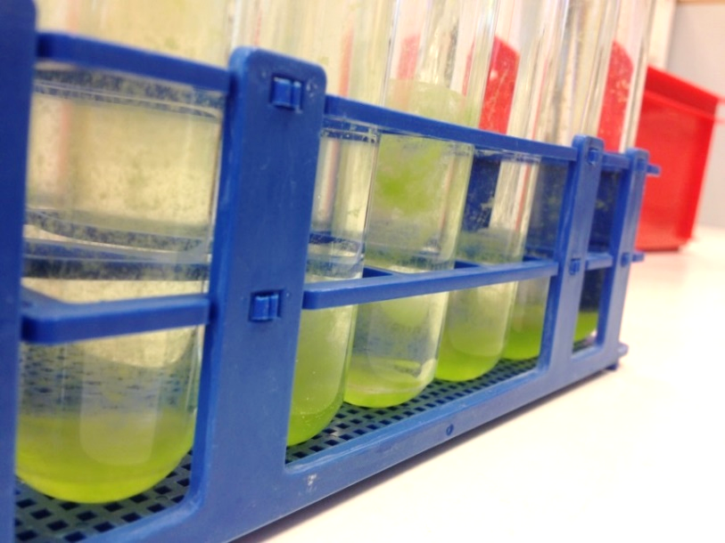
Figure 1: Picture flocculation and flock size of tubes treated with and increasing concentration from front to back of filtered Moringa water extract (Hoenjet, 2016a)
Figure 2 below, show the chlorophyll α concentration and the PSII of the samples taken at the end of the experiment from the top and the bottom of the tubes. The tubes were treated with filtered or unfiltered (UF) Moringa (MO) water extract.

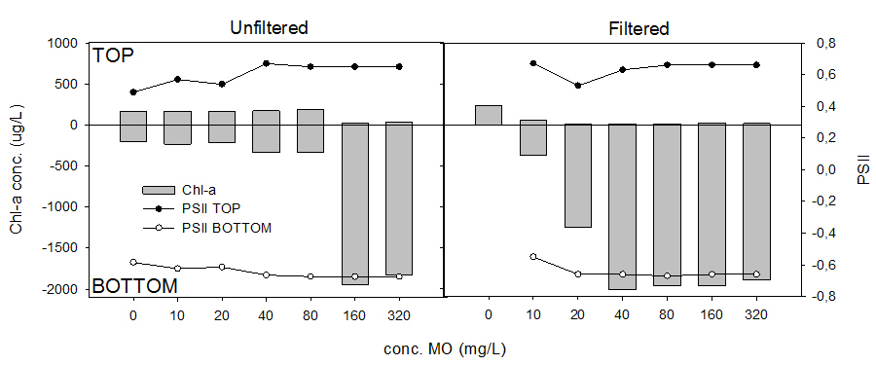
Figure 2: Chl-a concentration and PSII top and bottom for the unfiltered and filtered Moringa water extract

Figure 3a: Top samples unfiltered Moringa Figure 3b: Top samples filtered Moringa
Figure 3c: Bottom samples unfiltered Moringa Figure 3d: Bottom samples filtered Moringa

Figure 4a: Removal efficiency unfiltered MO Figure 4b: Removal efficiency filtered Moringa

3.2 Pre-experiment 2: Different chlorophyll concentrations on flocculation ability
Figure 1 show the final chlorophyll concentration and PSII value of the series with an initial chlorophyll conc. of 480 µg/L. No flocculation happened in this series and the series with an initial chl. a conc. of 1930 µg/L.
Figure 1: Chl. a conc. and PSII value of top and bottom samples taken from the series of tubes with the initial chl-a conc. of 480 µg/L.

3.3 Pre-experiment 3: Compare flocculation between PAC and Moringa
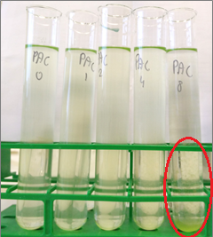 Figure 1a: No flocculation visible with MO treatment Figure 1b: Flocculation visible with PAC
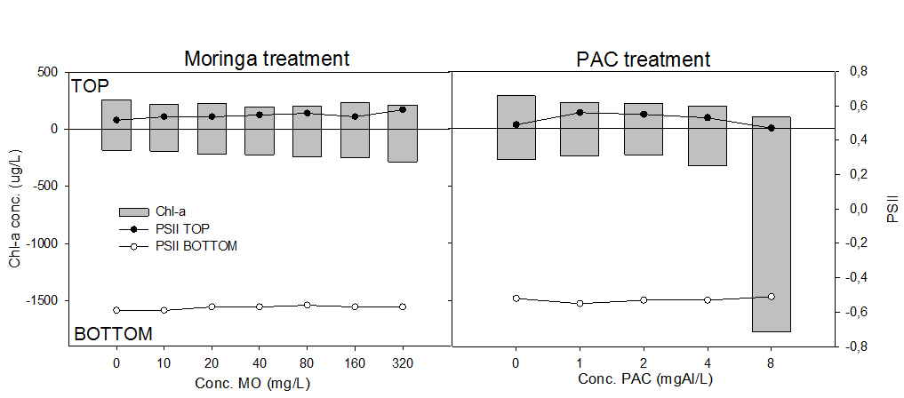
Figure 2: Difference in chl-a conc. and PSII in the top and bottom samples of the treatments with Moringa and PAC

Figure 3: Relation pH and type + conc. flocculant Figure 4: RE Chlorella vulgaris with PAC

3.4 Pre-experiment 4: Effect pH on flocculation Moringa
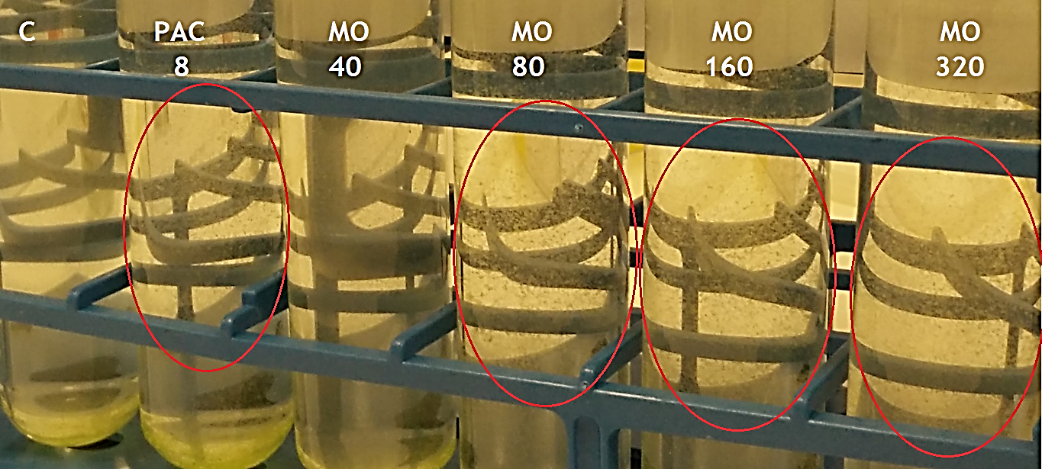
Figure 1: Exp. pH 6: Small flocks were visible in tubes treated with PAC and 80, 160 and 320 mg/L Moringa
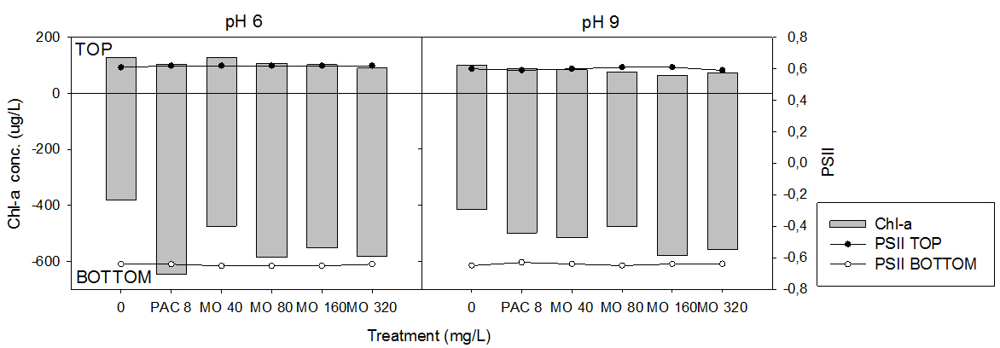
Figure 2: Difference in chl-a conc. and PSII in the top and bottom samples of the treatments with Moringa at the initial pH of 6 and pH 9.

Figure 3: Removal efficiency of Moringa at pH 6 and pH 9

3.5 Pre-experiment 5: Moringa as a flocculant in removing inorganic turbidity

Table 4: The final turbidity for (1) bauxite and (2) kaolinite – labeled with the different initial turbidities – treated with a range of Moringa concentrations measured at the top of the tubes. The yellow color marks the minimum final turbidity of that column and the blue the maximum final turbidity of that column.
Clay type | Kaolinite | Kaolinite | Kaolinite | Bauxite | Kaolinite
Initial turbidity | 14.5 NTU | 18.7 NTU | 64.3 NTU | 131 NTU | 164 NTU
Conc. MO (mg/L)
0 | 7,4 | 13,3 | 28,5 | 72,2 | 42,3
0,1 | 6,55 | 8,23 | 27,6 | 88,3 | 51,6
0,33 | 7,23 | 9,43 | 20,2 | 83,4 | 65,8
1 | 6 | 10,9 | 23,1 | 84,2 | 61,9
3,33 | 5,82 | 10,7 | 28,8 | 80,8 | 54,2
10 | 3,86 | 11 | 17,7 | 77,1 | 47,7
33 | 2,4 | 11,4 | 30,3 | 72,4 | 64,5
100 | 3,15 | 13,4 | 30,8 | 75,9 | 76,6

Appendix 4: Extensive results experiments cyanobacteria

4.1 Experiment 2: Flocculation cyanobacteria with NaCl Moringa extract
Figure 1: Chl. a conc. and PSII top and bottom samples of tubes treated with different concentrations filtered 1M NaCl Moringa extract

4.2 Experiment 3: Flock and sink cyanobacteria with Moringa and ballast
Those are the results of part 1, in which the red soil was added right before the flocculant.
Figure 1a: Low conc. ballast visible in the top samples
Figure 1b: Higher conc. ballast visible in all bottom samples

4.3 Experiment 4: Individual Moringa seeds
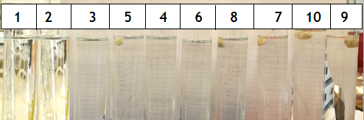
Figure 1: Float or sink test Moringa seeds, be aware, the seed numbers are not in logical order, as the visual seed size was used in the experiment, instead of the size by weight.
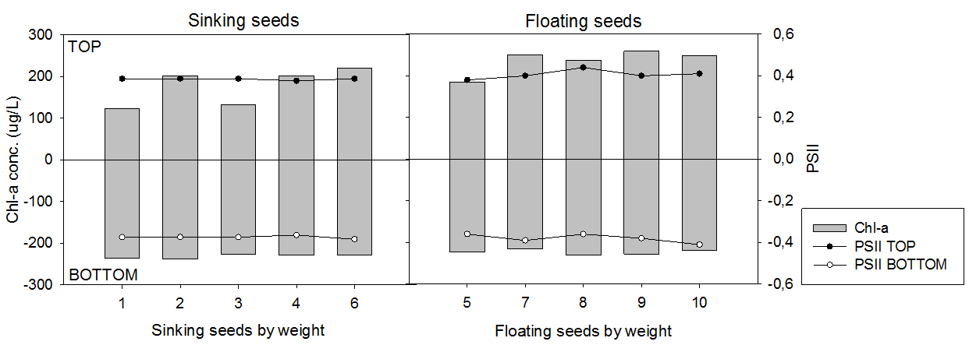
Figure 2: Difference in chl-a conc. and PSII in the top and bottom between sinking and floating Moringa seeds.
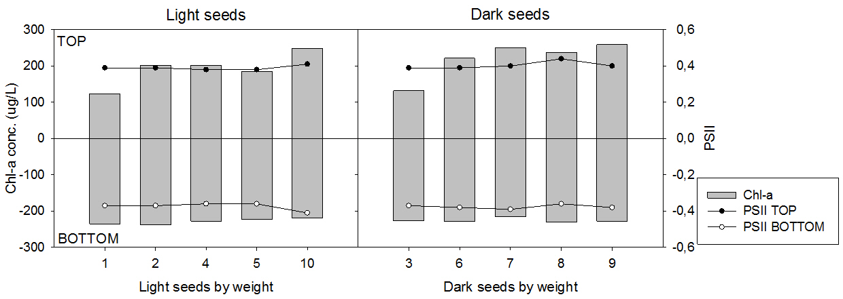
Figure 3: Difference in chl-a conc. and PSII in the top and bottom between light and dark colored seeds

