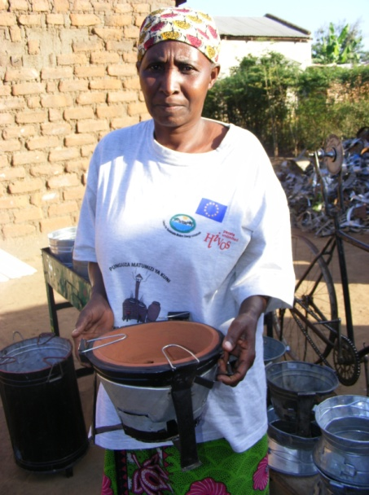
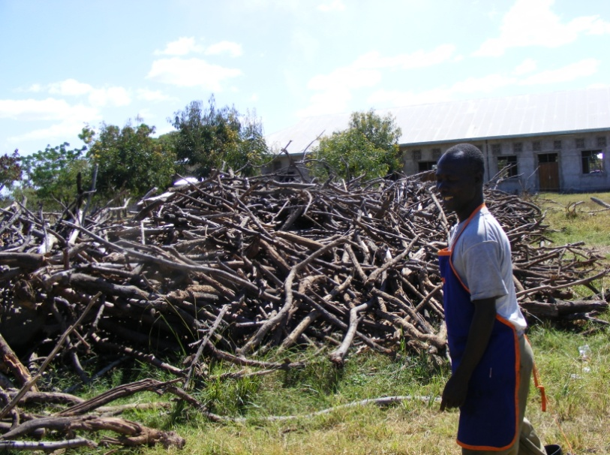

Internship Graduation Project Report
(July 2011)
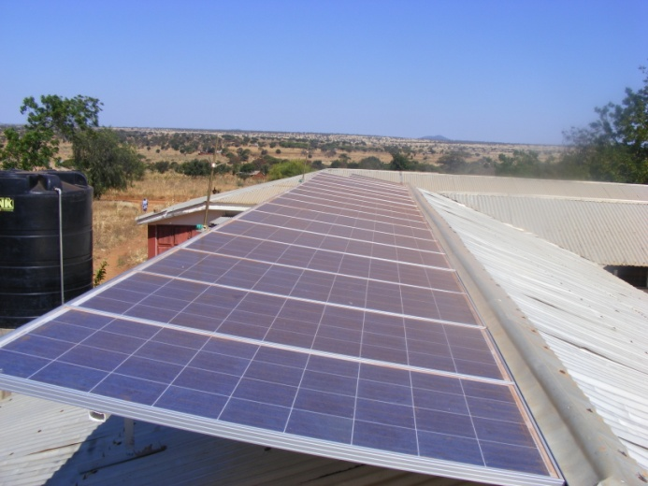
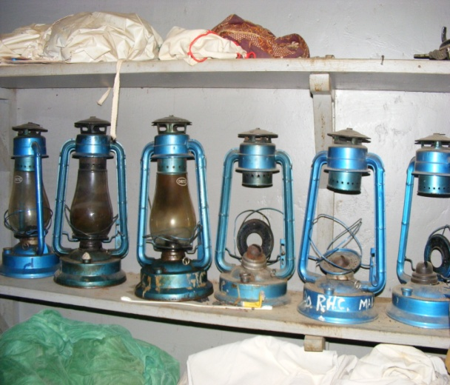
Kofi Annan Business School
Ikupa Hakimu Mwandima: ID (1533942)
Supervised by: Leehe Skuler
First Examiner: Menno de Lind van Wijngaarden
Second Examiner: Karel van Hoestenberghe

Table of Contents
Introduction 3
Internship 4
Internship Company - E+Co 5
Project and/or activities performed 7
Internship evaluation 9
Experiences during internship period 9
Objectives and achievements 11
Link between theory and practice 13
Usefulness of the internship 15
Final assessment and advice 16

Introduction

This report is intended to describe my experiences of working as an intern at E+Co, an organisation investing in renewable energy and energy efficient technologies in developing countries of Africa, Asia and Latin America. This was my last internship for my bachelor degree; therefore I was obliged to come up with a research question about a company, of which I was going to work on for the time that I had to be at the organisation. In total, I spent five months at E+Co, four months at E+Co Europe in the Netherlands and a month at E+Co Tanzania, conducting interviews with clients of enterprises financed by E+Co. The aim of this research was to find out the social impacts of E+Co investment activities in the rural areas of Tanzania and its relation to poverty reduction.
Among things that will be discussed in this report include, internship preparation, activities and assignment that were assigned to me during my internship period, learning goals and whether they were achieved. Furthermore, the usefulness of this internship to me and E+Co is described, and finally the report finishes with recommendations to E+Co, HU and future interns.

Internship

I carried out my internship at E+Co, a non profit investment organisation which finances renewable energy and energy efficient projects in developing countries.

Internship Preparation
Just as hard as it was with my first internship, it took me nearly 4 months to find an internship organisation. It was not easy to find a suitable organisation, because I was specifically interested to work for a company/organisation/NGO which was active in developing countries. This made the choice very limited. After a number of applications (nearly 10), I finally got connected to E+Co which offered me a position. It was very clear after my intake interview that I would have liked to work for the organisation. I liked the relaxing atmosphere and the energy of the people who seemed to have a lot of experience on what they were doing.

Duration of the internship
The internship took five months from 1st February until June 24th 2011. From February until the 3rd June I worked in the Amsterdam office, and from 5th June until 24 June, I spent in carrying out interviews with clients of the enterprises of which E+Co is financing.

Supervision
From school, I was supervised by Mr. Menno de Lind and on daily basis I was supervised by Leehe Skuler, my company supervisor. Mr Lind supervised me throughout my internship period, and we mostly communicated through emails and few visits. Mr Lind visited me once at E+Co, and I went to his office three times. After Mr. Lind’s first visit to E+Co, he had a clear overview of the activities of the company and what I planned to do on my graduation research thesis. Through this, he advised me to change my research question, which I honestly say was very helpful in overseeing my research work.
At the end of my internship period, Mr Lind communicated Ms. Skuler via the telephone to evaluate my entire internship period at E+Co. Mr Lind was unable to visit the company for the second time because Ms. Skuler was on holiday.

Internship Company - E+Co

E+Co is a non-profit investment firm that finances clean energy enterprises in developing countries, empowering them to serve local communities with reliable and affordable access to energy. Founded in 1994, E+Co was one of the first organizations to develop financing and advisory services for clean energy enterprises in developing countries. E+Co’s business model tackles the problem of energy poverty and the significant social and environmental damage it causes through investing in local clean energy and energy efficient business. Many of E+Co’s portfolio enterprises have become local business champions that are charting a new, cleaner, more inclusive development path for their countries. The improved access to modern energy provided by these enterprises offers opportunities for education, employment, better health and improved livelihoods to their end-users - thereby breaking the cycle of poverty that is holding back so many communities around the world.

The company identifies, advises and invests in small and medium enterprises working in solar, hydro, biomass, biogas and fuel-efficient cook stoves in Africa, Asia and Latin America. E+Co’s business model is based on the combination of investment capital with business development services allowing the company to make start-up and growth investments that other investors do not have the capacity or specific funding for.

In addition to stable financial returns, these investments yield significant developmental and sustainability benefits such as: the creation of new enterprises, employment, economic opportunity, improved health and quality of life, reduction of greenhouse gas emissions, and protection of natural resources. E+Co has more than 45 employees in eight offices, headquartered in Bloomfield in the USA. All these offices together serve 21 developing countries throughout Africa, Asia and Latin America.
I was working at E+Co Europe which is specialized in securing funds and donations from different type of investors and donors. Together with my company supervisor, we grant proposals to different donor institutions. I was also involved in market research activities on finding other possible investors who could be willing to invest in E+Co.

Visiting address
E+Co Europe
Corvershof, Nieuwe Herengracht 18
1018 DP Amsterdam, the Netherlands
Website: www.eandco.net

Customers and trade volume
E+Co’s clients include small scale and medium sized enterprises involved in renewable energy (solar, hydro, biomass, biogas) and fuel efficient cook stoves (charcoal, firewood, briquettes, Liquefied petroleum gas stoves) businesses in the developing areas of Africa, Latin America and Asia. E+Co’s total revenue for the year ended December 2010 was 7.5 million dollars (includes donor supports and other receivables, (E+Co Annual report, 2010))

Competition
The immediate competitors of E+Co include banks (local and international banks), microfinance institutions, consultancy companies, NGOs and companies which also operate in renewable energy and energy efficient field of business. Though these are competitors, E+Co prefers to see them as business partners in reducing poverty. In some countries E+Co find possibilities to work in collaboration with microfinance institutions which could provide financing to enterprise’s customers, who are mostly low income earners. Currently, local banks are not a serious threat to E+Co because the technologies that E+Co is investing in (such as solar power, wind power, biomass, energy efficient technologies etc), are not widely known in those markets of developing countries. Local banks fear to offer loans to entrepreneurs in those sectors because they cannot calculate the risks involved.
However, these technologies such as solar power are gaining popularity, therefore it might not take very long before local banks become also a threat to E+Co.

Project and/or activities performed

My day to day activities at E+Co were highly diversified. Mostly, my day started with reading emails. Here is a summary of all the activities I carried out during the entire period of my internship.

Phase 1: From February until 3rd June,
- The first three weeks I read a number of E+Co reports, and online websites to get familiar with the company and the sector
- E+Co’s research
- Writing grant proposals to different donors
- Formulating and structuring documents

And with regard to the graduation assignment
  - Formulated the research question
  - Read the literature review
  - Started working on the literature review and collecting information and sources that were useful for my assignment.
  - Reviewed a number of E+Co’s case studies in its database to get an idea of which clean energy technologies I should focus on.
  - Started contacting E+Co Tanzanian office to arrange with enterprises so that I can visit their clients.
  - Prepared for the interviews (arranged camera, flight ticket, hotels and renting a car)

Phase 2- June 5th –June 24th
- Visited E+Co Tanzanian office, to get all the instructions about the visits.
- Visited and interviewed clients of 4 enterprises in 4 rural areas of Tanzania.
- Recorded all the data obtained in the field work.

Phase 3- June – July
- Finish writing the Graduation assignment report
- Defence presentation

I was also involved in other day to day activities of the company, joining in conference calls, meetings and answering phone calls. I also helped writing minutes of these meetings/ phone conversations.

Internship evaluation

Experiences during internship period

The nature, diversity, volume and level of assignment(s) and other activities
The E+Co Europe office is mainly involved in obtaining new funds from different investors and donors, and other interested parties. As can be seen from the above section, my assignments were highly diversified from writing grant proposals to doing research. This diversity made the whole experience very interesting since every time there was something new to be learnt. I had to position and approach each donor/investor differently depending on the “language that they speak” as my supervisor will put it.
The volume of the work was bearable; I worked two to two and half days for E+Co, and one and half to two days on my thesis. However, during busy days, such as when there was a deadline for submitting proposals, then I spent more time working for the organisation.
All activities and assignments I was involved in comprise daily activities of the organisation. I totally felt that the level of these activities was challenging enough, especially in the beginning of my internship. The activities were definitely not easy but also not too difficult to perform with the assistance I got from my company supervisor and the E+Co Europe Director.

Work methodology
Every time we had a new assignment, I got instructions from either my supervisor or the E+Co Europe director on how to do it. The work was then sent back and forth depending on the feedback I got and how to further proceed.

Understanding of the various aspects of professional work
The diversity of my work activities gave me a greater understanding of different aspects of professional work. In the beginning, I took more time to understand and do the assignments because I was not familiar with the jargon and whole energy sector in general. Slowly I gained pace in my activities and in the end my supervisor commented that it went very well. Through these activities, I improved my communication skills, presentation skills, and writing skills as well. My confidence highly improved, if I compare myself to my first internship in the second year. I was free to give my thoughts and make suggestions based on our work, I could write in my own words, take phone calls and participate in the organisation’s meetings.

Personal preferences and functioning, social and communication skills
There was no activity that I can say I preferred to do more than others. What I liked the most was that as time passed by, my confidence and ease of doing various activities improved. This was because I became more familiar with the organisation’s activities and what was expected from me. I felt more comfortable when the whole assignment was clear to me in advance.
Based on the feedback I got from my company supervisor, my performance was excellent, especially during the last period of my internship. There was a great understanding between me and all the colleagues both, in the Netherlands and Tanzania as well. I still felt that I needed to improve my communication skills, on getting right to the point in my first sentences. This is because of cultural difference, while communication in the Netherlands is straight and to the point, in Tanzania, where I come from, communication goes in circles, as it is a high context culture. However, I have seen a great progress if I compare myself to two years ago when I did my first internship, also in the Netherlands.

Objectives and achievements

To determine what I have achieved from this internship, there are number of objectives that can be graded from 1 to 5, 1 receiving low score while 5 has a higher score. These objectives are;
Objectives | Explanation
Objective 1: | Extension of your practical skills/strengths and weaknesses.  Grade - 3  Explanation: This internship gave me the opportunity to see, hear and experience the working life in a medium sized organisation. It is an addition to the experience that I acquired through my first internship which was a small organisation. I also extended my knowledge on how theories exactly work in practice, through participating in doing research for example. I also learned to understand my strength (high learning ability, can easily cope with different cultures etc) and weaknesses (I get nervous and uncomfortable in unfamiliar situations) in various aspects of working life in general.
Objective 2: | Familiarisation with company culture, the needs and problems of trade and industry.  Grade- 4  Explanation: Right from the beginning of my internship, my first task was to understand E+Co, the businesses involved, and how it is done, and how different E+Co is compared to other financial institutions. This gave me a greater understanding of E+Co and its activities in developing countries. My visit to Tanzania to meet the clients of the enterprises financed by E+Co gave me another look at E+Co. E+Co is involving itself in activities which many other organisations like local banks may call it risky and not profitable, the activities which results in economic and social benefits. I also gained a clear understanding of the challenges that renewable energy and energy efficient technology businesses are still facing. General acceptability, the high costs (solar power), and market challenges (markets distorted by cheap and fake Chinese products) are just few of them.
Objective 3 | Recognition of your position and future career. Did you acquire an understanding of your own career prospects?  Grade- 3  Explanation: Visiting the clients of enterprises financed by E+Co, made me see and feel how it is to be poor. I would like to continue to work in this field, possibly helping people to climb up in the poverty radar and live decent lives. I therefore decided to take follow development studies in order to acquire more knowledge on how I could help those people. I found out that I enjoyed more to hear different stories form people on how their lives have changed after they started using either solar power or efficient cook stoves. I will prefer to do more activities of this kind.
Objective 4 | Further personal development, adaptability, social and communication skills  Grade – 4  Explanation: Based on the last evaluation with my company supervisor, I showed great advancement on the activities that I was assigned to at the organisation. I adapted well to the companies’ culture and I could learn things very fast. Socially, I performed excellent as I coped well with people within and outside the organisation. According to my company supervisor, I still need to improve my communication skills, more to the point.

Link between theory and practice

Some of the courses I studied at Kofi Annan Business School include,
(These subjects are graded according to the following ;)
1 = subjects which have no link to practice
2 = subjects which are partly linked to practice
3 = subjects which are clearly linked to practice

Grades per course
Courses | Grade | Explanation
Cultural differences, and Intercultural management | 3 | These courses were very useful when it came to communication in this multicultural organisation.
Marketing and sales in Emerging markets, | 1 | The course was too general, and was not specifically tailored for emerging market as it is named.
Corporate social Development | 3 | My graduation assignment was to see how clean energy can help to improve lives of poor people in rural areas of developing countries. This subject which dealt with the socio-economic impacts of business enterprises in developing  countries were very useful.
Business ethics and social venturing | 3 | The course was very helpful in understanding E+Co’s social and at the same time business relation model with its entrepreneurs. Eradicating poverty through business relationship.
Microcredit | 2 | E+Co small loans to small and medium enterprises could be compared to micro financing, though still different.
Copywriting | 3 | This course was helpful in writing reports
Business Skills- Research  method | 3 | This course thought me the basic skills on how to do a research. It was very useful throughout my internship period, doing company’s internal assignments and field interviews.
Sustainable management | 3 | This subject dealt with how economic, social, and environmental objectives should be integrated to improve the social well-being of people and ecosystems. The course made it easier for me to understand E+Co business model which was falling into this category. The subject was also very useful in formulating arguments for my graduation assignment.

All courses, in one way or other help students to gain a basic knowledge on carrying out various job activities. Somehow every subject has a link to the practice depending on the work one will be doing, because what might seem irrelevant in one job function might be relevant for the other. The subjects that I indicated to have a clear link to practice (also scored high) are therefore only relevant when linked to this internship.
Advice- KABS
I advise the Kofi Annan Business School (KABS) to include the course “Graduation Project Research Skills” (offered in IBMS) in its program so as students can improve their research skills, specifically for the graduation assignment. The lack of knowledge on how to do this assignment makes the assignment unreasonably difficult which results into wastage of time through sending the work back and forth to the school supervisors. It is not a problem to students only but also to teachers who instead of supervising, start teaching students on how to properly write those graduation reports. The inclusion of this course in KABS program, will not only make the students enjoy the experience of doing the assignment, but will also improve the quality of the reports produced to a sufficient academic level.
Overall it was a great pleasure to study this course (KABS), it made me feel at home by studying courses which provided knowledge about situations which I was very familiar with such as ‘poverty, Microfinance, Exporting from Emerging Markets, Business Ethics and social Venturing and Sustainable management’ and of which I am still interested to build a career with.

Usefulness of the internship

To E+Co,
It is my expectation that E+Co benefited by having me at its Amsterdam office through the work that I produced. Moreover I believe E+Co is going to benefit from the researches I did as part of my graduation assignment. According to my company supervisor, E+Co has been having difficulties in explaining to third parties about E+Co is and what the organisation does. I hope with the stories from the users of solar power and energy efficient cook stoves will help E+Co to clearly explain about whom they are and what they do in developing countries. Furthermore, with the stories from the users, E+Co can provide evidence that its investment activities play a role in improving poor people’s day to day lives in rural areas of developing countries.

To myself
This internship has given me the opportunity to better understand myself and the interests I have regarding pursuing my future career. Before I started my internship at E+Co, I did not know whether I should continue with further studies or look for a job after finishing my bachelor studies. I was hesitating to take either decision because I did not know what kind of a job I will want, what further studies I should take. Being at E+Co made me realise that I have a strong interest in developing countries and I would like to take part in their struggles towards their development. Visiting the clients of enterprises financed by E+Co, and seeing how E+Co has been able to impact their lives, made me feel like “I want to do more of this work”. I therefore made a decision to apply for a further study in “International Development studies” to gain more theoretical knowledge on development issues. Through this study, I hope that later in the future I will be able to work in development organisations such as in NGO’s, private organisations, government, or establish my own business in a developing country.

Final assessment and advice

I would like to thank E+Co for giving me this great opportunity to learn about their investment activities, and allowing me to go see for myself, the impact of those activities into poor people’s daily lives. In addition to the advice I gave to E+Co in my thesis report, I would like to encourage E+Co to continue with the work that you are doing in developing countries. Entrepreneurs do appreciate your input, and they openly admit that without E+Co they could not envision on where their businesses would have been, because they could not obtain loans through local banks. I hope through E+Co, many other organisations will take that as an example on how to create ethical business relationships with developing countries.
I will definitely recommend E+Co to other students who also are interested to work in/with developing countries. E+Co will be a great place to learn and experience how poverty reduction can be done through ethical business relations. I will advise future interns to go out there and visit some of E+Co projects like how I did it, to have an impression, see hear and feel how that is done. Though it consumes a lot of energy and time, it worth doing it, it was a great experience for me.

