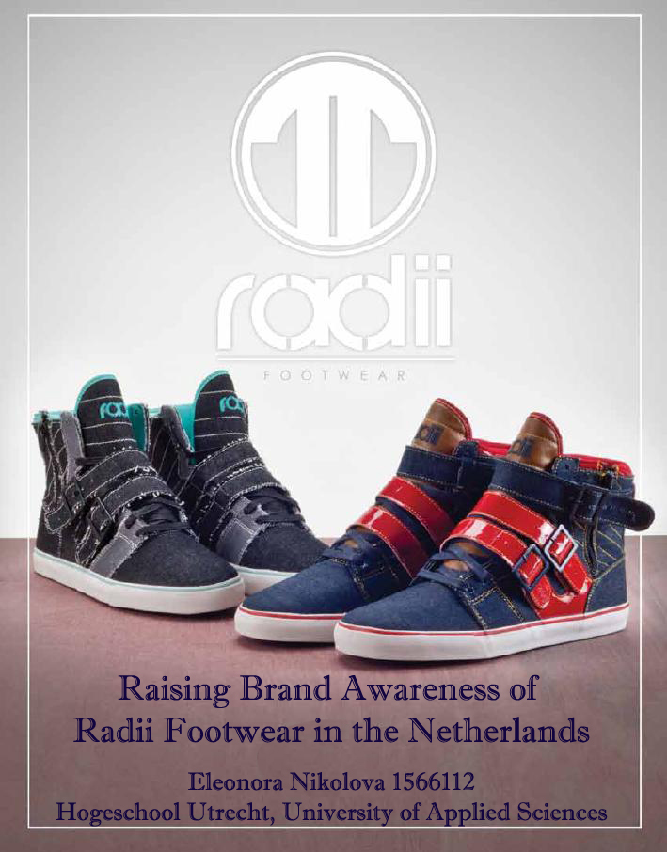

Raising brand awareness of Radii Footwear in order to increase customer responsiveness in the Netherlands

Eleonora Nikolova 1566112
Year 4 IBMS
Hogeschool Utrecht: University of Applied Sciences
June 2013

Foreword
First of all, I would like to thank Gerard van de Beek for giving me the priceless opportunity to do an internship at his company, Str8 Casuals, and get introduced into the exciting, fast moving and ever changing sports fashion business. By being a helpful, interactive and open supervisor he has provided a challenging working atmosphere among collaborative professionals that made my experience valuable and enjoyable.
Secondly, I owe my gratitude to my school supervisor and first reader, Ute Massholder, who has shown me not only her experienced and skilled professionalism but also her admirable personality, making her a mentor any student would wish for. She has been attentive, understanding, always available and helpful throughout my internship and made the whole process smooth and cooperative.

Executive Summary
Str8 Casuals is a Dutch company that distributes and sells the American sports fashion brand Radii Footwear in the Netherlands. The products are targeted at young people around the ages of 14 to 28. Considering that the shoes are not well known on the Dutch market, the aim of the project is to find out how Str8 Casuals should raise brand awareness of Radii Footwear in order to increase customer responsiveness in the Netherlands by spring 2014. Because of the time frame of the project, it is not possible to measure the change in sales as a result of the proposed strategy. Therefore, customer responsiveness is the measurable variable, which represents buyers’ investment in the brand and provides long-term benefits for the company.
In the process of collecting data, triangulation of methods is used, combining desk research, interviews and questionnaires. Both qualitative and quantitative data are acquired to cover the constructs in the research question. Interviews were conducted in person with all employees of Str8 Casuals and written interviews were sent by e-mail to four sales agents working with the company. Moreover, questionnaires were distributed to end customers with the help of social media and in person, and 102 responses were collected. The gathered results were compared, correlated and discussed using analytical tools and marketing models.
According to desk research, brand awareness greatly influences customers’ attitudes and decision-making, consequently impacting sales, market share and prices. However, the effects should not be measured in immediate sales but in customer responsiveness, which produces long-term benefits to the brand. Furthermore, social media is perceived as one of the most effective marketing channels that influences customers, enhances communication and builds lasting relationships. According to the findings, it helps raising brand awareness of Radii and aids word-of-mouth, thus diminishing the weakness of being new and unknown on the market. This view is also supported by the results from the interviews and opinions of customers in the questionnaires, as well as by the preliminary results of measuring customer responsiveness. Field research proves that marketing is essential for the success of Radii Footwear and more attention should be paid to it. In addition, the creativity behind the brand is highly appreciated and is a strength to be transferred to their promotional efforts. Thinking outside of the box, including complementary gifts and offering discounts are valued by customers and influence their decision-making.
Finally, it is recommended that Str8 Casuals substantially develop their marketing efforts by investing both time and capital. They should focus on using social media effectively to raise brand awareness of Radii Footwear and commit to building relationships with customers. In addition, giving away promotional Radii USBs with the shoes and using creative in-store graffiti advertising are advisable as they enhance the exposure of the brand, attract the attention to Radii and influence customers’ buying behavior. These marketing tools are recommended to be used in the autumn campaign of the brand. They allow costs to be kept within the marketing budget of Str8 Casuals and are expected to positively affect both financial and non-financial results in spring 2014 in the Netherlands.

Contents
Foreword 2
Executive Summary 3
1. Introduction 7
1.1 General introduction 7
1.2 Introduction into the topic 7
1.3 Problem definition 8
1.4 Structure of the report 8
1.5 Purpose and rationale 9
2. Literature Review 10
3. Methodology 14
3.1 Introduction 14
3.2 Data collection 14
3.3 Data analysis 15
3.4 Population and sampling 16
3.5 Ethics 16
4. Findings 17
4.1 Desk research 17
4.1.1 Media usage 17
4.1.2 Creative and effective approaches to marketing 18
4.2 Field research 19
4.2.1 Company interviews 19
4.2.2 Interviews with sales agents 20
4.2.3 Questionnaires 21
5. Discussions and Conclusion 25
5.1 Company and market analysis 25
5.1.1 SWOT analysis 25
5.1.2 Five forces of Porter 26
5.2 Target market 26
5.3 Segmentation 27
5.3.1 Geographic and demographic 27
5.3.2 Psychographic and behavioral 27
5.4 Targeting 27
5.5 Marketing mix 28
5.5.1 Product 28
5.5.2 Place 28
5.5.3 Price 29
5.5.4 Promotion 29
5.5.4.1 Promotional channels 29
5.5.4.2 Promotional ideas 30
5.6 Marketing budget and time 31
5.7 Preliminary results of measuring customer responsiveness 32
6. Recommendations 33
6.1 Use social media effectively 33
6.2 Include promotional materials in the shoe boxes 33
6.3 Attract attention with in-store advertising 34
Bibliography 35
Appendix 1: Questions for company interviews 39
Appendix 2: Questions for interviews with sales agents 40
Appendix 3: Questionnaire 41
Appendix 4: Graphs with results from questionnaires 43
Appendix 5: Marketing ideas and overview of prices 45

Introduction

General introduction
The footwear market consists of the revenues generated through the sale of all types of men's, women's and children's shoes. The four product groups within that market are: casual, sports, formal and evening footwear. The Dutch footwear market has experienced a slight growth over the last couple of years since its moderate decline in 2010. The market is predicted to experience marginal growth over the following years up to 2016. The performance of the players in the industry is expected to improve, therefore reaching a value of about €2,114.88 by the end of 2016 (MarketiLine, 2012). By value, the Netherlands accounts for around 4.5% of all footwear sales in the EU (3.2% by volume), being the sixth largest EU market for footwear. Considering the consumers, the Dutch are susceptible to fashion trends but nowadays they expect even more added value for their money in terms of design, durability and comfort (CBI, 2010).

Introduction into the topic
Str8 Casuals is a Dutch company that is the distributer and seller of four American sports fashion brands to retailers all over Europe. Radii Footwear is one of the brands the company is working with in the Netherlands and is the chosen one for the research. Considering that the shoes are not well known on the Dutch market, the aim of the project is to find out how Str8 Casuals can improve their marketing efforts in order to effectively introduce the products to the customers and increase purchases in the Netherlands.
Taking into account that the company is working in the dynamic sports fashion industry the sales period takes place around half a year in advance before the orders are delivered. Therefore, in order for the research project to influence the spring fashion season in 2014, results should be achieved in the autumn of the previous year. The time frame of the project is not synchronized with the sales periods in the fashion industry, therefore it would not be possible to measure the increase in the number of orders by the end of the project. However, several researchers (Hoffman & Fodor, 2010; Kaplan & Haenlein, 2010) agree that the outcome of a marketing strategy needs to be measured not in immediate sales but in customer responsiveness, which represents buyers’ investment in the brand and provides long-term benefits for the company.
According to the studies of Homburg, Klarmann, and Schmitt (2010) and Huang and Sarigöllü (2012), building and maintaining high brand awareness is strongly connected to the subsequent performance of a company. This view is also supported by Verbeeten and Vijn (2010) who argue that brand awareness affects the financial position of firms in the consumer goods industry in the Netherlands.

Problem definition
The problem statement is: Radii Footwear is an American brand that is new and not popular enough in the Netherlands, therefore Str8 Casuals need to raise brand awareness in order to increase customer responsiveness
The proposed research question is: How should Str8 Casuals raise brand awareness of Radii Footwear in the Netherlands in order to increase customer responsiveness by spring 2014? In order to acquire an in-depth answer to the research question it can be divided into several related parts. Possible sub-questions can be the following:
- What does brand awareness imply?
- Which are the most effective strategies for raising brand awareness?
- What does an effective marketing strategy mean?
- Which strategies fit Str8 Casuals and their marketing budget?
- What is customer responsiveness?
- How is boosting brand awareness related to customer responsiveness?
- How can customer responsiveness be measured?

Structure of the report
Firstly, an extensive literature review is included, covering the studies of a number of researchers investigating topics that are of concern to the report. Secondly, the various methods of acquiring and handling results through desk and field research are explained. Then, all findings from secondary sources, interviews and questionnaires are presented and clarified. The gathered data is compared, correlated and discussed using analytical tools and marketing models. Moreover, preliminary results from measuring customer responsiveness are included. Finally, conclusions are drawn and several options are recommended to Str8 Casuals to use in their marketing efforts for raising brand awareness of Radii Footwear in the Netherlands.

Purpose and rationale
The proposed research can be considered of a significant importance as it is aimed at investigating various approaches to raising brand awareness and selecting the most effective ones for Radii Footwear in the Netherlands. Consequently making the products known to the targeted audience is expected to lead to greater customer responsiveness and an increase in sales. Interviews within the company and with the agents provide valuable information about the situation on the market. In addition, the questionnaires distributed to the end customers provide data about their perception and attitudes as buyers. Their contribution is valuable as their opinions help shaping the proposed marketing strategy that targets them. The chosen approach is designed to achieve as many positive results as possible while keeping the marketing efforts within the budget of the company. Moreover, as the products are stylish and fashionable shoes that are targeted to the young population of the Netherlands, an important goal for the project is to be creative and generate new and fresh ideas that stand out and differentiate Radii from other brands.

Literature Review
Brand awareness can be described as the ability to recognize or remember a brand and the building and retaining of this aspect of marketing is a key element to success (Homburg et al., 2010). Advertising as a method of boosting brand awareness is considered to alter quality perceptions and to have a significant effect on subsequent sales (Clark, Doraszelski, & Draganska, 2009). Moreover, it is argued that social media is the leading marketing communication channel that aids traditional tools into influencing customer decision-making (Mangold & Faulds, 2009). Taking into account the way business is done in the fast paced fashion industry, forming strong customer relationships is of utmost importance and it is to a great extent aided by the maintaining of high brand awareness through various marketing techniques (Donnell, Hutchinson, & Reid, 2012).
Several researchers (Buil, Chernatony, & Martínez, 2013; Huang & Sarigöllü, 2012) agree that retaining high brand awareness is strongly connected to the following performance of a company. Using different marketing strategies in order to develop higher brand awareness leads to a positive perception of the brand and affects the number of products sold by the company. In addition, establishing brand awareness among potential customers affects positively value judgments, increases purchase intention and decreases search behavior (Oh, 2000). Hoyer and Brown (1990) agree that brand awareness has a significant influence on consumer choice. Being aware of a brand can make customers sample fewer other ones and choose the particular brand without paying much attention to its quality.
Moreover, according to Homburg et al. (2010), establishing high brand awareness helps companies differentiate their products and gain an advantage over competitors. In both B2B and B2C sectors branding increases performance and results in a positive economic outcome. Other researchers (Huang & Sarigöllü, 2012; Kim, Kim, & An, 2003) agree stating that there is a strong positive connection between brand awareness and several market outcome measures, such as sales revenues, share premium and price premium. This view is also supported by Verbeeten and Vijn (2010) who focus on the Netherlands in particular and argue that brand awareness affects the financial position of firms in the consumer goods industry in the country.
In addition, building brand awareness develops the qualitative aspects of marketing programs resulting in the creation of brand loyalty and positive purchase decision-making (Buil et al., 2013; Lee, Chen, Huang, & Hsu, 2010). Donnell et al. (2012) confirm that building strong relationships with customers has a large impact on the successful performance of companies. They argue that those factors are related to brand awareness and repetitive purchases. Moreover, this is of highest importance for businesses in the fashion industry. Firms operating in the dynamic retail sector need to maintain an effective customer relationship management (CRM) and it can be aided by a successful brand awareness program. As brand awareness has a positive impact on perceived quality and brand associations, it can also influence beneficially brand loyalty (Buil et al., 2013). In turn, brand loyalty makes customers more inclined to recognize the value of the brand and purchase more products offered by the company (Lee et al., 2010).
A number of researchers (Clark et al., 2009; Homburg et al., 2010; Wang, Zhang, & Ouyang, 2009) agree that advertising significantly contributes to improving brand recognition. Not only that advertising is used to provide information to customers about the products and services offered by the company but more importantly it can be used to alter quality perceptions. Homburg et al. (2010) also state that advertising can be accompanied by sponsoring, brand alliances and public relations as effective means of raising brand awareness. Moreover, according to Huang and Sarigöllü (2012), there is a positive connection between the marketing mix elements and brand awareness. They argue that price promotions can effectively increase awareness by building brand exposure and presenting customers with the opportunity to use and experience the products. Furthermore, distribution intensity in the marketing efforts has proven to have the greatest impact on brand awareness.
On the other hand, a number of researchers (Kaplan & Haenlein, 2010; Mangold & Faulds, 2009) argue that advertising and other traditional integrated marketing communication (IMC) tools are becoming less useful for increasing brand awareness. Instead social media is the preferred source of information and purchasing decisions. Furthermore, according to Michaelidou, Siamagka and Christodoulides (2011) consumers believe that companies need to have social media presence and in this way adopt a more customer-centered approach. Therefore, the effectiveness of social media for raising brand awareness should be measured not in immediate revenue but in customer engagement with the brand.
Hoffman and Fodor (2010) agree that it is recommendable to marketers to revise their way of interpreting corporate objectives when estimating social media return on investment. Instead of emphasizing their own marketing costs and calculating the return in terms of sales, management needs to consider the motivation for customers to engage in the social media efforts of the brand and customers’ own investment on that venue. Measuring performance in such a way is perceived to be much more logical. It takes into account not only short-term goals, such as the increase in sales one month after a marketing campaign on social media or reducing costs with the help of online support forums, but also the long-term benefits of a strong social media presence. Using social media in marketing is supposed to be about participation, communication and cooperation instead of plain advertising and selling (Kaplan & Haenlein, 2010).
Furthermore, customer responsiveness as a behavior that contributes to the monetary objectives of the company can be generated through social media. The term encompasses the time spent with applications such as Facebook and Twitter as well as the more active reaction of leaving comments, ‘liking’ or ‘following’ the brand. These customer investments can be used to gauge the change in brand awareness or word-of-mouth increase over time. Moreover, social media can be used to develop and nurture long-term relationships with customers that have a very interactive nature and require continuous commitment and constant availability. In addition, a marketer has the opportunity to provide a venue where customers do not only communicate with brand representatives but even more, they connect with other customers and create and consume online content that is mostly user-generated rather than marketer-generated. This is part of the four key motivations (4c’s): connection, creation, consumption and control, which stimulate customers to use social media (Hoffman & Fodor, 2010).
The idea about the benefits from creating a relationship with the consumers and shifting from corporate to customer-oriented perspective is also supported by Marzo-Navarro, Pedraja-Iglesias and Rivera-Torres in their study from 2004. They argue that building customer loyalty has recently become one of the highly used and successful business strategies creating a competitive advantage. It helps creating a connection between the consumers and the brand that is strengthened by an interactive and personalized contact. The benefits obtained by the customers through such a relation are expected to result in a respective behavior that benefits the organization. For instance, having loyal customers decreases marketing costs, provides a communication channel that improves company image, makes it difficult for competitors to reach them and allows more freedom in pricing. In addition, researchers distinguish between cognitive and behavioral loyalty. The former motivates a positive attitude toward the brand, while the latter affects the number of purchases. Moreover, such product involvement generates feelings of interest and enthusiasm about the brand, makes them attach more importance to the products and knowledge about them. Therefore, involvement of consumers has become a significant factor in promotional strategies (Kim, 2005). According to Park, Kim and Forney (2006), this is especially true in the fashion industry. It is assumed that fashion involvement, positive emotion and consumption based on pleasure are related to fashion-oriented buying behavior. Thus, market share and sales can be increased not only by simple advertising but mainly by creating an entertaining experience with the brand. In addition, marketing strategies that focus on the image and the atmosphere around the brand lead to improved company performance in the fashion industry. Customer service and collaboration in the footwear sector, in particular, are important requirements in order to meet the expectations of the audience (Moore & Fairhurst, 2003).
Furthermore, Beaudoin, Lachance and Robitaille (2003) state that adolescents, out of all age groups, are most significantly influenced by fashion and beauty. They comprise the majority of fashion innovators, are brand sensitive and highly affected by peers. In addition, the so called “Generation Y” motivates their purchases with brands that stand for a certain lifestyle they aspire to and match their personal fashion style (Dias, 2003). According to Coley and Burgess (2003), advertising that can effectively reach such customers needs to inspire positive buying emotion, functionality and social rationales. However, as the fashion buying cycle requires long-term forecasts and orders are placed by retailers half a year before the launch of the season, changes occur in this fast-paced market so predictions are difficult to be made (Bruce & Daly, 2006).
To sum up the literature, brand awareness is part of the qualitative aspect of marketing and is perceived to greatly influence customers’ attitudes and decision-making, which consequently leads to an impact on sales, market share and prices. There are several possible techniques for raising brand awareness and social media is selected as one of the most effective methods to influence customers, while it can still be accompanied by traditional marketing tools. The outcome should not be measured in immediate sales but in customer responsiveness, which produces long-term benefits to the brand. Moreover, this is applicable in the fashion industry in the Netherlands, in particular, and increasing brand awareness together with brand loyalty can ensure the positive outcome for a company on that market. The results from the literature review are further investigated in the discussions and conclusions section, where they are compared and correlated to the data generated by the field research.

Methodology

Introduction
In the process of doing research for the company triangulation was the preferred approach in order to increase the validity and reliability of the obtained results (Verhoeven, 2007). Therefore, a combination of several research techniques was used, including desk research, interviews and questionnaires. Both qualitative and quantitative data were acquired to cover the constructs in the research question. Considering the intent of the main question and the sub-questions, most of the information required has come from literature and other secondary sources. However, some of the issues needed further investigation through field research where employees within Str8 Casuals and the final customers were concerned. The answers obtained through desk research were compared and correlated to the findings from the interviews and questionnaires. In addition, certain trends and implications from the literature were used as a basis for the design of the questions.

Data collection
Firstly, desk research was a primary source of data as issues, such as brand awareness, possible strategies for its increasing and the most effective ways of approaching customers on the sports fashion market needed to be investigated. Considering the literature, according to Homburg et al. (2010), building brand awareness is a key element in marketing, which represents the ability to recognize and remember a brand. In order to make the research question measurable operationalization was used (Verhoeven, 2007). The construct “brand awareness” and “customer responsiveness” needed to be quantified, therefore results obtained from desk and company research were used to answer how awareness leads to a certain reaction from the audience. Moreover, a great deal of the research was focused on online marketing channels, social media in particular, in order to find the most effective way of using it to the advantage of the marketer and to create an overview of the possible outcomes. Several weeks were attributed to acquiring all the necessary information.
Secondly, interviews were conducted within Str8 Casuals consisting of informal, semi-structured, open and closed questions, with respect to the informal corporate culture of the company (King & Horrocks, 2010). This approach made it possible to use an outline prepared in advance for better organization but it also left room for adjustments on the spot to further clarify the topic, as additional questions were asked inspired by the answers of the interviewees and the direction of the conversation. Interviews were done in person with the director and other managers (Please see interview questions in Appendix 1). In addition, written formal interviews of around one page and a half were provided to four sales agents that are working with Str8 Casuals. The interview questions were sent by e-mail to the ones operating in Western Europe so more concrete information can be received from the market itself (Please see interview questions in Appendix 2). The company has only one sales agent in the Netherlands, therefore, in order to get more information and estimations about the situation of Radii, three more interviews were done with agents working for the company in Germany, the UK and France. Interviews were held within the time frame of three weeks. The questions were intended to gather qualitative information about the current position of Radii on the market as well as the future goals of the company. Moreover, closed questions of quantitative nature were included concerning various marketing channels and the potential of the brand on the market.
Finally, a questionnaire was designed on an online survey tool called “Survey Monkey” which offers the possibility to devise the questions and the respective answers, creates a customized link that can be sent to participants and collects, stores and evaluates the responses. The survey was aimed at young people around the ages of 14 to 28 who live in the Netherlands. The questionnaires were distributed to end customers with the help of social media. People who were approached to take part in the survey were also asked to share it with their friends, thus creating a larger pool of responses through a snowball effect. Acquaintances were asked to take part in the research and the survey was also posted on the Facebook and Twitter pages of Radii Footwear Europe to be available for fans and followers. In addition, a number of questionnaires were handed out in person and the responses were added to the ones acquired and stored online. The survey lasted for about eight weeks. Data concerning the attitudes of the targeted audience towards sports fashion brands, and Radii in particular, was collected. Furthermore, the questionnaire helped assessing which channels of marketing communication are the preferred sources of information and which strategies can be most influential on consumers’ decision-making process (Please see questionnaire in Appendix 3).

Data analysis
The interviews within Str8 Casuals were done in person and consisted of mainly qualitative questions, therefore, the answers were collected, summarized and analyzed in a written form on Word. The responses were compared and correlated among the employees at Str8 Casuals and the sales agents. Considering that an online survey tool was used for the questionnaires, the program itself provided an analysis and generated graphs. However, as several responses were collected in person, it was impossible to add them to the online database. Therefore, all information was transferred to Excel and was personally grouped, analyzed and visualized there.

Population and sampling
In order to get more information from the managers at Str8 Casuals an in-company research was applied. The company is really small and only eight employees are working there, including two interns. One of the employees is on a maternity leave so there are five full-time employees at the office. Therefore, it was possible to choose a census as a type of sampling where 100% of the population is taken. The ability to approach every manager with the certainty that a response will be received minimized the percentage of error to zero and increased reliability (Nowack, 1990).
Moreover, as Str8 Casuals works closely with several sales agents all over Europe they were researched as well. Considering that the company cooperates with those agents to sell different products, such as clothes, shoes and accessories, a purposive sample was taken where only the sales agents for Radii were chosen who operate in the Netherlands, Germany, France and the United Kingdom, which created a clearer picture of the peculiarities of the Western fashion market (Verhoeven, 2007).
Finally, research on the end customers was carried out. A snowball sample was drawn from users of social media who were asked to fill in the survey and then share it within their own network. In addition, questionnaires were given out in person, therefore, a convenience sample from the population of customers was taken where every person willing to participate was able to do so. 102 responses were collected from people living in various regions in the Netherlands. Statistical errors occurred very rarely and only in the online responses, which consisted of people skipping questions and comprised only 0.47% of all answers.

Ethics
The participants in the research were treated with respect and their contribution was greatly appreciated. They were able to participate on a voluntarily basis, their responses were kept anonymous and confidential, and they were analyzed in a fair and impartial way. It was offered to the respondents to receive the results of the research if they are interested.

Findings

Desk research

Media usage
PR Newswire’s study (2006) argues that consumers continue using heavily TV, newspapers and magazines in their decision making process concerning buying behavior. More than half of the young people between 18 and 24 read newspapers and they are considered to express the most variety in media usage, combining diverse types of new and traditional media. Dutch citizens are still print media-reading people, using a number of newspapers and more than 9,000 magazines distributed throughout the country, although circulation and readership are decreasing (Bakker & Vasterman, 2010). However, according to CBS statistics from 2009 in the Netherlands, their reliance on information from online media sources has increased significantly over the recent years, which has negatively influenced traditional physical media. For instance, the total circulation of daily newspapers in the Netherlands has decreased by around 16% between 2002 and 2008.
Furthermore, listening to the radio in the Netherlands has remained stable since 2000 with an average of about three hours per day. Watching television has a little higher rate and is a very used media channel in the country. However, there is a difference in tendencies among age groups and younger people, who belong to the target group of Radii, are reported to watch less than the older generations (Bakker & Vasterman, 2010).
In the study for CBS, Hoksbergen (2009) states that the number of people in the Netherlands who are using the advantages provided by online media is continuously increasing. In 2012 more than twelve million people were part of the internet user community in the Netherlands, which comprises 96% of all Dutch citizens between the ages of 12 and 75 (European Travel Commission, 2013). The country occupied the second position of internet engagement in 2011 with about 32.8 hours per month. The Netherlands also has the highest frequency of visits on the internet in 2010. What is more, Dutch users spend more time on social networks than on any other kind of online activity.
According to the European Travel Commission (2013), even though the internet market in the Netherlands is in its maturity, the social media category continues with its strong growth with eleven and a half million Dutch visitors in 2011. There were 6,556,000 people in the Netherlands with profiles on Facebook and 3,207,000 with accounts on Twitter in 2011. Moreover, the country has the highest internet penetration worldwide for two of the key global social networking sites - Twitter and Linkedin. It can be considered that Dutch people are leaders in global social networking behavior (Azvedo, 2011).
Furthermore, word-of-mouth can significantly influence a communications campaign. Advice from family and friends is used by most consumers when making purchase decisions and a significant percentage turns to coworkers for opinions. It is difficult to control word-of-mouth but it is possible to be influenced through communication channels providing information and displaying creativity (PR Newswire, 2006).

Creative and effective approaches to marketing
Jeffrey (2010) argues that a marketing campaign can be considered effective when it increases both sales and profits and the best way to do that is to be creative and find tools that can attract the attention of the target audience. A few ingenious strategies are: Facebook advertising campaigns connected to search engine optimization (SEO) and 3d street art for promotional purposes. In addition, those techniques are suitable for small business as they are efficient and cost effective and have proven to have beneficial results.
Firstly, SEO creates online contents in a way that makes the website and social media pages easily found by customers who are looking for them. The more reachable the information is, the lower the costs are to attract people to it. Moreover, including Facebook campaigns in the marketing efforts can be advantageous for the organizational performance. Using social media presents a number of ways to be creative and reach the audience (Jeffrey, 2010). For instance, it allows including photo and video content, which gets 60% more likes and comments than contents without. Having an account on Facebook is valuable for businesses, not only to use it for low-cost advertising but also to create a venue to engage and interact with customers. It is a way to inspire word-of-mouth, which is assumed to help acquiring new customers of higher lifetime value. In addition, it is highly effective, affordable and measurable. The economic value of social media includes the micro conversions of likes and comments into macro conversions leading to sales in the long run (Lecinski, 2012). Furthermore, using 3d street painting as advertising is a highly successful way to catch the eye of the customers in an artistic and inventive way. It is perceived to increase brand awareness, number of online fans, stories about the event in the media and sales. It can also be conveniently aligned with social media strategies, taking into account number of likes, shared pictures and mentions of the brand in the network (Jeffrey, 2011).

Field research

Company interviews
Considering the current position of Radii in the Netherlands, all interviewed employees within Str8 Casuals agree that the brand does not have a strong position on the Dutch market. Is fresh and new but unknown to the customers, therefore quire small among strong competitors. It can be perceived that Radii is still in its introduction stage, it has a small number of selling points and only a few customers in the B2B sector. The brand is sold at nine retailers, the biggest of which is Go-Britain, so it is not often seen and easily reachable by the audience.
According to the management, although all efforts depend on the economic situation, the brand has a lot of potential to grow within the next five years. It offers a great variety of footwear models, from urban sneaker fashion to elegant boots, the designs and the image are advantageous and positively received by the current customers. Radii shoes are “American”, fashionable, fresh, cool and represent a certain lifestyle. Although the brand can improve its position considerably on the Dutch market, the opportunity to continue its expand internationally is also attractive, especially in Germany and the UK. An important goal for Radii is to work with more retailers so it gains a better exposure on the market.
Even though the Dutch market is dominated by large and strong footwear brands, 100% of the interviewees agree that Radii has the potential to successfully compete with them. It can be easily differentiated through the designs that make the brand special, the cool packaging and the creativity in the product and its presentation. Moreover, the excellent service that Str8 Casuals provides for the customers in the Netherlands separates Radii from the competition.
In addition, the employees were asked to measure the importance of various channels for information concerning buying behavior. Search engines on the internet were chosen as the most used medium, followed by social media and the retailers. TV was voted as the least used source, while magazines and the company website were perceived as not very important.
 | 1 (least used) | 2 | 3 | 4 | 5(most used)
Search engines on the Internet |  |  | 1 | 1 | 3
Social Media |  |  | 1 | 4
The website of the company | 1 | 1 | 2 | 1
TV | 1 | 3 |  | 1
Magazines | 1 | 1 | 2 | 1
The stores that sell the shoes |  |  | 2 | 3
Table 1: Most used sources of information about footwear brands

Interviews with sales agents
According to the responses of the sales agents, the most important characteristics that affect the position of Radii on the market are the brand’s uniqueness, the quality of the shoes, the online presence, especially in social media, and celebrities that are seen wearing the shoes or promote and like the brand. Moreover, all interviewees agree that the marketing efforts of the company need to be improved significantly in order for Radii to be successful on the Dutch market. The footwear can satisfy a number of the customers’ wants and needs with its stylish and fashionable designs, attractive image and suitability for young people’s tastes. However, the pricing of the brand can be a negative influence as the shoes are perceived as too expensive by the consumers.
Moreover, the market is dominated by a lot of strong brands, with the tendency of one brand excelling at a time. In the sneaker sector, low designs are preferred, which is in sync with the latest collections that Radii has brought to the Netherlands. Nevertheless, the performance of the brand is heavily influenced by the economic situation, which is disadvantageous for both retailers and end consumers and presents a challenge for Radii’s further efforts. What is more, buyers’ expectations have changes, as there is an increasing importance on prices compared to materials and finish of the shoes, as well as on quality.
In the quantitative part of the interviews, the sales agents were asked to score a number of marketing communication channels based on their importance in the footwear industry. As it can be seen on the figure below, 100% of the responses indicated that social media is the most essential channel in marketing, followed by e-marketing and celebrity endorsement. On the other hand, advertising on the radio was considered the least useful medium, and TV and magazines were not among the favorite options.
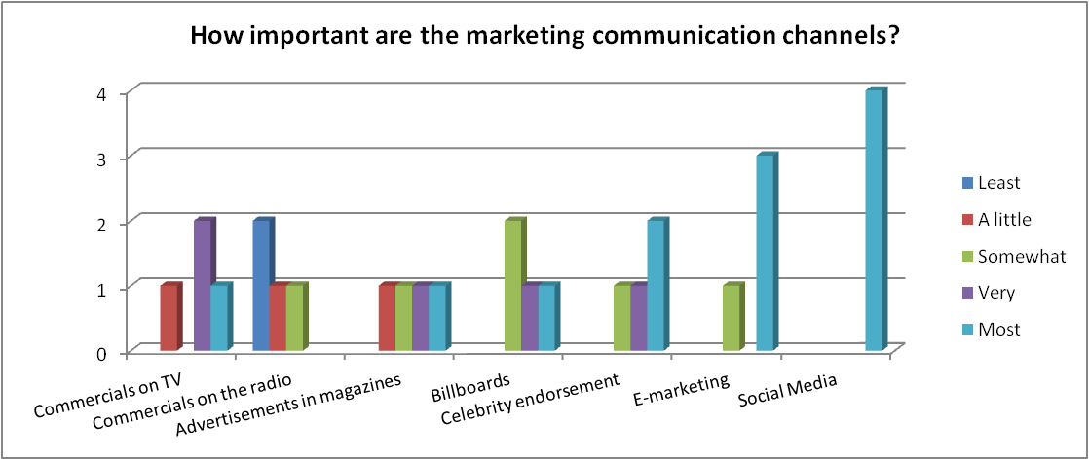
Figure 1: Importance of marketing communication channels
In addition, the sales agents graded several media channels based on their perception of how much they think customers use them. Table 2 displays that social media and search engines on the internet are considered to be the most used ones and the retailers are scored second. TV commercials were voted as the least effective channels for information.
 | 1 (least used) | 2 | 3 | 4 | 5(most used)
Search engines on the Internet |  |  |  | 1 | 3
Social Media |  |  |  | 1 | 3
The website of the company |  | 1 | 1 | 1 | 1
TV |  | 2 |  | 1 | 1
Magazines |  | 1 | 1 | 1 | 1
The stores that sell the shoes |  |  | 1 | 2 | 1
Table 2: Most used sources of information about footwear brands
Furthermore, the interviewees were presented with two Likert scale questions. The first one measured their views on whether there is room for new brands on the footwear market in the Netherlands and the majority of them agreed (50%), while 25% disagreed. The second question was concerned with whether customers are not very loyal to certain brands and can easily switch to a new one. The responses were equally divided as 50% of the sales agents agreed and 50% disagreed.

Questionnaires
Graphs with all results from the questionnaire distributed to the end customers in the Netherlands, which are not shown in this section can be found in Appendix 4. With the first two questions in the survey, the demographic characteristics of the sample were established. The figure below represents gender and age distribution among the respondents. Around 88% of the participants are within the age group targeted by Radii (14-28) and 12 people are younger or older. In addition, there are more female than male respondents.
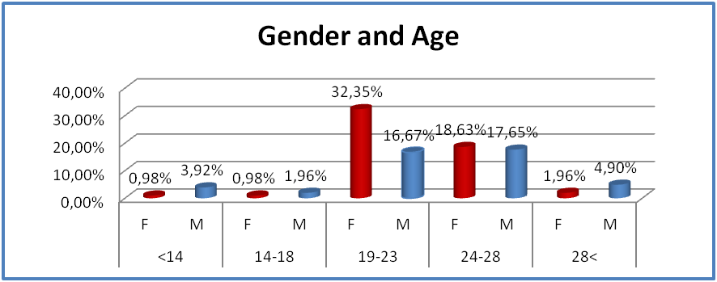
Figure 2: Demographic characteristics of participants in the questionnaire
Moreover, the current level of awareness among the surveyed audience was measured. Only 30% of them have heard of Radii Footwear and their answers about the ways they have found out about the brand gave an insight into which communication channels have been useful so far on the market. The four channels that scored the most can be seen in Table 3. Word-of-mouth proved to have created the highest awareness, followed by social media and personal experiences of seeing the shoes at the retailers or being worn by celebrities.

How did you find out about the brand?
- Heard about the shoes from a friend |  | 60%
- Came across the brand on social media |  | 36%
- Saw the shoes at a store |  | 16%
- Saw a celebrity wearing the shoes |  | 16%
Table 3: Channels that made participants aware of Radii Footwear

The respondents were also asked to choose from several of Radii’s competitors as their preferred brand on the market. Therefore, 58.8% picked Nike, 46.1% preferred Adidas, 25.5% - Converse and 15.7% - Vans. However, Radii was also popular, considering that out of all the people who were aware of the brand about 36% chose Radii as their favorite. The three most popular brands are considered indirect competitors as they are huge brands offering a wide variety of footwear. However, Vans that is ranked number four is specializing exactly in the segment that is targeted by Radii Footwear.
Furthermore, two Likert scale questions concerning customer loyalty were asked to the audience. The first one was aimed to assess the situation on the footwear market in the Netherlands and its attractiveness and possibilities according to attitudes of consumers. As it can be seen on Figure 3, overall most participants disagree to be very loyal to their favorite brand and not interested in a new one – 48% disagree and 22.6% strongly disagree. Only 27.5% support the statement, which can be considered a positive trend on the market as people are open to new products and ideas. The ones who agree show another tendency that can also be used to the benefit of Radii, taking into account that customers that become loyal to Radii will not be interested in new entrants on the market, thus creating a competitive advantage for the brand.
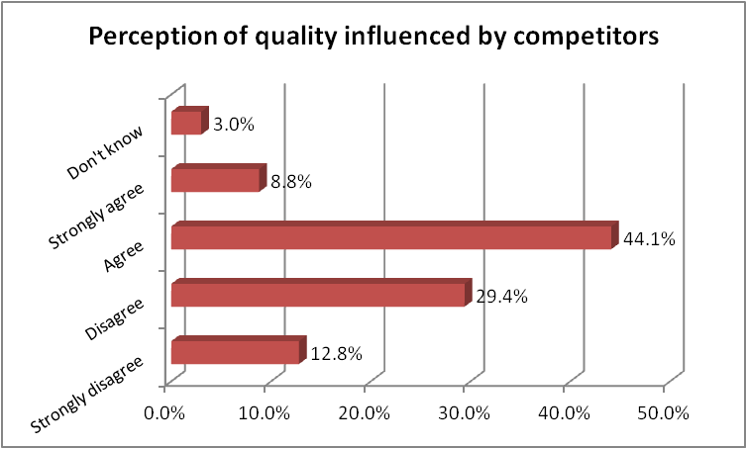
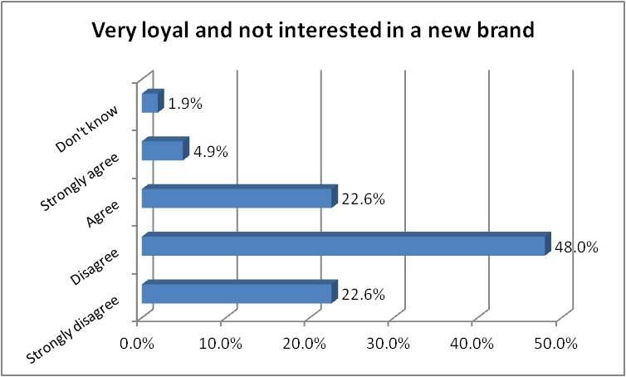
Concerning the second question on Figure 4, the percentage of people who overall agree (52.9%) that quality perception is affected by brand loyalty is higher than the ones who disagree (42.2%). Therefore, it can negatively impact Radii’s performance as a new player in the Netherlands.
The goal of the last three questions in the survey was to investigate customers’ points of view on three variables closely connected to devising a marketing strategy and their opinion on the ability to successfully reach the audience. The three measured variables are media channel usage, influences on buying decisions and promotion attractiveness. In Table 4 the four highest scores of all three variables are displayed.
Figure 4: Perception of footwear quality
Figure 3: Brand loyalty and interest in new brands
Media Channel Usage | Buying Decision Influences | Promotion Attractiveness
Stores 53.9% | Word-of-mouth 56.9% | Price discounts 63.7%
The internet 51.0% | *Other 30.4% | Out of the box marketing 39.2%
Company website 44.1% | Social media 27.5% | Complementary gifts 28.4%
Social media 29.4% | Print advertisements 25.5% | Social media 21.6%
Table 4: Participants' input on media channel usage, buying decision influences and promotion attractiveness
First of all, several media channels were scored by the participants according to their level of usage. The retailers that sell the shoes got the highest score of 53.9%, followed closely by the internet with 51% as a source of information. The website of the company and social media are also heavily used venues for inquiries about footwear brands.
Secondly, it was assessed how customers can be reached most effectively and which channels are most influencing on their buying behavior. Word-of-mouth got almost 57% of the votes and scored first, considering that opinions of friends and family are assumed to have the most effect on purchasing decisions. Third and fourth places for influencing capabilities were occupied by social media (27.5%) and advertising campaigns in magazines and on billboards (25.5%). Furthermore, for the first time throughout the questionnaire, the open answer ‘other’ was widely used taking the second place with 30.4%. Taking into account every person’s individual response in the ‘other’ category, three characteristics that can be seen on Figure 5 were proposed by a number of participants and repeatedly written in the open box. The price of the shoes was considered to most significantly influence buying behavior chosen by 35.5% of all who answered ‘other’. In addition, looks and design (29%) as well as quality and comfort (25.8%) were pointed out as successfully swaying customers’ purchasing decisions.
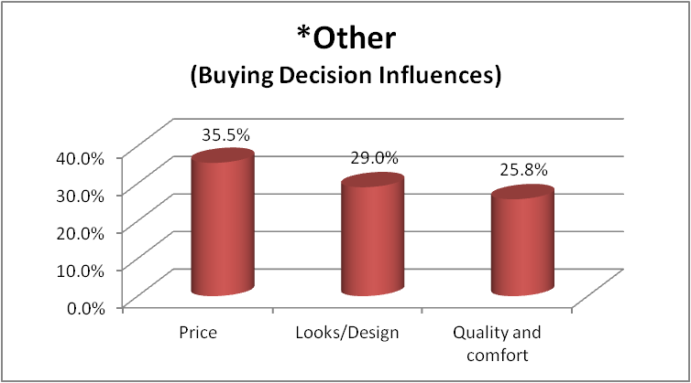
Figure 5: Buying decision influences proposed by participants
The final variable in Table 4 was focused on various promotional ideas and made it possible to measure customers’ perceptions of their attractiveness. Similarly to the previous questions, most of the responses (63.7%) chose price discounts to be highly successful in motivating people to take an interest in the brand and generate orders. The second most popular answer with 39.2% supported the importance of creativity and thinking outside of the box in marketing. Furthermore, 28.4% of the responses indicated complementary gifts given out with the products are attractive to buyers and 21.6% agreed that social media is a valuable part of marketing strategies that can successfully promote footwear brands.

Discussions and Conclusion

Company and market analysis

SWOT analysis
SWOT
 | Favorable | Unfavorable
Internal | Strengths  - The brand, the designs, the creativity  - Being trendy and on top of the sneaker fashion  - Providing excellent service to clients  - Handling complaints efficiently  - The company behind Radii in the Netherlands – Str8 Casuals - a well known name and a long time in the business  - Connecting Radii to the other strong brands Str8 Casuals work with and are better established on the Dutch market | Weaknesses  - The brand is unknown on the market and not much information is available about it  - Few selling points  - Lack of marketing  - Inconsistency that is in the culture of the headquarters in the US – stop offering a model that has been selling very well  - Str8 Casuals is not involved enough in the developing process for the collections in Europe  - The quality of the shoes, even though it is already much better than previous seasons
External | Opportunities  - A lot of potential in the designs for the collections next year  - Celebrities like Jay-Z and Justin Bieber that wear the shoes influencing customers worldwide  - The sneaker market is still growing  - Room for growth in the Netherlands  - Expanding throughout Europe – Germany, France, the UK  - Investing in marketing to attract the stores to increase sales and get new stores and new customers | Threats  - Less power over retailers as they become bigger and stronger, wanting bigger discounts and better payment terms  - The economic situation, especially for the Netherlands, stores are not doing well at the moment and t are afraid to try new things  - Competitors, such as Vans and Converse getting stronger  - The fact that marketing is needed but the company might not have a budget that is big enough
Table 5: SWOT based on information from interviews within Str8 Casuals
The above SWOT analysis, which combines results of the field research about Radii in the Netherlands, clearly shows that the product itself, the designs and the ingenuity are the biggest strengths of the brand. They need to be in the basis of the company’s efforts to diminish the weakness of being new and unknown on the market. Using the opportunity to grow further in the Netherlands and start working with more retailers, it is of utmost importance to focus on successfully implementing marketing strategies. Even though Str8 Casuals have a limited marketing budget, the creativity around Radii can be used to increase brand awareness, create a competitive advantage and gain power over retailers while keeping costs low even in the current state of the economy.

Five forces of Porter
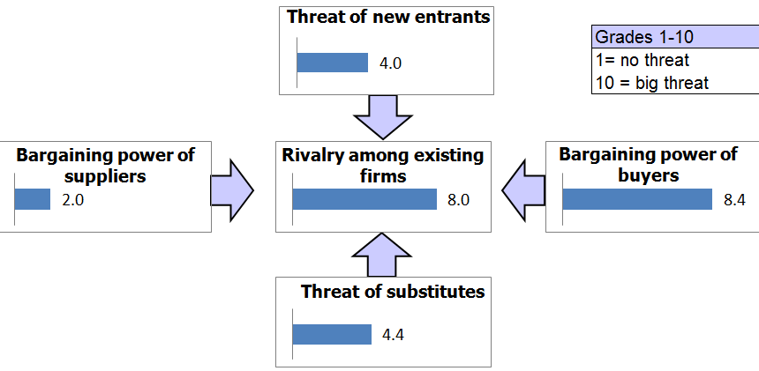
Figure 6: Five forces of Porter for Radii in the Netherlands
Suppliers in the case of Radii are footwear manufacturers located in low-cost China. The high number of providers and their undifferentiated offerings make switching easy, which means that supplier power is weakened. Furthermore, the buyers with respect to Radii are the retailers who sell the shoes in the Netherlands. During the interviews, the power of buyers as their number decreases and they get bigger is one of the more important threats for the company. In addition, the interviewed sales agents pointed out that the market is dominated by large brands and the rivalry between them is significant, so marketing efforts are highly used for differentiation. Moreover, as footwear is a basic necessity it cannot be easily substituted. Nevertheless, there is a high level of substitution between segments of the market, as sportswear is often replaced by other footwear types. Considering Radii is still in its introduction stage, the force of new entrants is of interest. Fixed costs are relatively low and the required supply chain can be easily established, therefore new providers can enter the market. However, the established large players rely on significant economies of scale and brand recognition. In sports fashion brand awareness and marketing efforts are crucial, which is a hindrance to new entrants (MarketiLine, 2012).

Target market
Taking into account all traits of the target group and the age structure of the Netherlands, it can be concluded that more than four million young people can be perceived as prospective customers. Around 26% of the population is within the age group that is significant for Radii and considering the household income and consumption, most Dutch citizens are in the high segment (Central Intelligence Agency, 2013). As the buyers are dispersed throughout the entire country, they are reached through the various retailers Str8 Casuals works with and with the help of their newly established European website and their active presence on social media.

Segmentation

Geographic and demographic
From a geographic point of view, the company is targeting the entire territory of the Netherlands. However, the promotional activities for Radii are concentrated in and around the stores that are clients of Str8 Casuals and sell the shoes, therefore, marketing campaigns will be organized in some of the bigger cities in the country. The demographic characteristics of Radii’s target market include a large age group (14-28), depending on the image and the style of the shoes. There is no gender preference as the shoes are intended for both males and females. In addition, when income is concerned, buyers with income around the average and above are included in the target group with respect to the premium prices of Radii. However, the company has cheaper models and certain discounts in order to meet the needs of a wider audience of prospective customers.

Psychographic and behavioral
The benefits that the targeted customers are expected to seek are, above all, the creativity and passion behind Radii Footwear and the excellent service Str8 Casuals provides for the brand users in the Netherlands. The company targets first-time users and potential users who are supposed to be in the awareness readiness stage as Radii can be considered a new brand on the market and only essential awareness of its existence has been created so far. The company should focus its efforts on attracting and retaining strongly loyal clients to establish long-term relationships with the current customers but also to attract new ones with the help of positive responses and reviews through word-of-mouth. In addition, the preferred group consists of enthusiastic and positive people who can easily acknowledge an innovative brand that adds flavor to their lifestyle. As the formula goes, effectiveness is directly dependent on the multiplication between quality and acceptance (Kotler, Armstrong, Wong, & Saunders, 2008).

Targeting
Undifferentiated targeting strategy is going to be used to approach potential customers as it is an appropriate choice for a starting brand like Radii Footwear. First of all, such a targeting is affordable, it keeps low costs and can be realized in an effective and efficient way. Str8 Casuals can communicate the benefits of its brand by sending the same promotional message to everyone. An advantage that makes such a promotion easier is that the product is readily available and affordable and generates a similar feel for the consumers in the target market.

Marketing mix

Product
During the interviews it was found out that the products of Radii are considered to be the brand’s biggest strength. The fresh and fashionable designs, the creativity and the image behind them are appealing to the targeted audience and differentiate them from the competition. Participants in the survey carried out in the Netherlands also agree that looks and designs are among the most influential characteristics for footwear. In addition, researchers who have done studies on the topic confirm that young people are highly influenced by products that carry a certain lifestyle that matches their personal fashion senses.
However, the decision-making process about which models are to be sold on the Dutch market needs to be improved as the management of Str8 Casuals should have more say about the offered models based on the trends they get from the market. Another drawback can be the occasional issues with the quality of the shoes. According to the data collected through the survey, quality and comfort can significantly influence buying behavior. Respondents also agree that loyalty to competing brands can affect their perception of the quality of Radii. This view is supported by researchers who state that especially in the fashion industry, brand loyalty influences quality assessment. However, if Radii successfully builds positive relationships with its customers certain incidents with respect to quality can be more easily overlooked.
In addition to the Radii product itself, the services provided by Str8 Casuals in the Netherlands are making the brand stronger. They are of utmost importance as researchers argue that customer service and the whole experience around the brand is essential in the footwear industry.

Place
The interviewed employees at Str8 Casuals state that a weakness of Radii’s performance in the Netherlands is the low exposure the brand has on the market. It is still in its introduction stage and is not known to the audience. Considering the company’s customers in the B2B sector, there is an insufficient number of selling points as the company is working with only nine retailers. Moreover, out of all 102 participants in the survey, merely four answered to have seen the shoes at store locations. According to them, stores are a preferred channel for information so they need to be actively included in the marketing strategy of Radii.
According to scientific studies it has been proven that brand awareness is affected by the distribution intensity of the brand. Therefore, the number of selling points for Radii in the Netherlands is crucial for the improvement of the responsiveness of customers.
What is more, with the help of Radii’s pages in social media networks, it has been determined through interaction with customers that people who are interested in the brand have little or no information about brick and mortar locations where they can buy the shoes in the Netherlands. However, the newly established European website of Radii not only provides the opportunity to shop online but also lists all physical stores that sell the shoes. In addition, social media proves to be a favorable venue to handle such uncertainties and raise awareness about the brand, its locations and offerings.

Price
During the interviews within Str8 Casuals, the employees agreed that the disadvantageous economic situation in the Netherlands is negatively affecting the performance of many footwear brands on the market as customers are more careful with spending their money. In addition, several sales agents pointed out that pricing is important and some buyers perceive Radii shoes to be too expensive.
Considering the trends from the responses to the questionnaires, even though it was not among the listed answers, price was added by participants and chosen as one of the most important variables that can sway customers’ purchasing decisions. What is more, price discounts scored highest as a marketing strategy that can attract the attention of the consumers. This view is also supported by researchers who argue that price promotions are effective ways to raise brand awareness. Moreover, according to the literature one of the positive outcomes from raising brand awareness is the possibility for companies that are widely recognized to have a bigger freedom in pricing. Researchers agree that by creating and maintaining relationships with customers, brand loyalty is aided, which leads to an emotional connection with the brand making pricing less relevant to purchasing decisions.

Promotion

Promotional channels
Considering the most useful marketing communication channels according to the desk research, studies of several researchers argue that young people are most significantly influenced by opinions of their peers, therefore word-of-mouth should play a central role in the marketing efforts of footwear brands, such as Radii. In addition, the usefulness of traditional media to effectively reach buyers and raise brand awareness has significantly decreased over the past few years to the advantage of online media and social networks in particular. According to statistics in the Netherlands, young people still consider traditional media, such as TV, radio, newspapers and magazines when they making decisions about purchasing footwear. Even though they use a combination of various channels, the popularity of online media has been increasing considerably. The Dutch are heavy internet users and their presence on social media has experienced a strong growth with almost seven million accounts on Facebook. Moreover, using such an online promotion helps establishing a customer-oriented approach that produces beneficial results over a longer period of time. It is also recommended to measure the return on investment not in immediate sales but in customer responsiveness on social media and other venues provided by the company. Building brand loyalty affects the financial performance as well, by decreasing the costs connected to promoting the products and improving brand image through word-of-mouth among satisfied customers.
These findings are supported by the field research carried out in the Netherlands. Both employees at Str8 Casuals and sales agents agree that the importance of social media in the promotional efforts of Radii is increasing considerably. Furthermore, according to participants in the survey, word-of-mouth and social media have been the two channels that were most successful in creating brand awareness until now and they are considered to be most influential on buying decisions. Online media and social networks, in particular, are also the preferred channels for information about footwear brands.

Promotional ideas
Taking into account that prospective customers on the Dutch market took part in the survey, the thoughts and opinions of the actual target audience can be included in the analysis. Even though price discounts were voted as the most attractive promotional strategy, it was already established through research that pricing decisions depend on the level of brand awareness and customer loyalty. Therefore, the focus should be on raising brand awareness with the help of creative marketing ideas, promotional gifts accompanying the shoes and availability on social media. Several companies were contacted about implementation and prices for several promotional ideas. An overview of all ideas, providers and respective costs can be found in Appendix 5.
First of all, considering that literature as well as responses from all interviews and questionnaires confirm that social media plays a crucial role in marketing nowadays, Str8 Casuals need to become more invested in this communication channel. In order to successfully use social networks to the advantage of the marketing efforts of a brand, interaction, availability and commitment are essential. It is not enough to only create a page for the brand but content needs to be updated regularly and there should be responses to questions, complaints and compliments. Human interaction with a representative of the brand is required. Social media presence can help building customer loyalty and not only raise brand awareness but considerably improve the position of the brand on the Dutch market (Zarrella & Zarrella, 2011). Furthermore, Facebook, as an example, can be used to design advertisements or promote posts about the brand.
Secondly, thinking outside of the box, two contemporary marketing campaigns can be of use: 3d street art and sand printing graffiti. Desk research supports the idea of 3d street painting to be an ingenious and effective way to raise brand awareness. It creates exposure and can be easily connected and combined with social media efforts. In addition, using graffiti is another way of creatively attracting the attention to Radii. The provider is also very environmentally conscious and ensures the “green” nature of all materials involved in the process. As customers are becoming more environmentally concerned, it is recommendable for the company to share its own interest on the topic and display it through sustainable and effective advertising campaigns.
Finally, as small gifts with every sold pair of shoes are highly appreciated by customers, a couple of promotional materials can be given out with every pair of shoes: stickers and personalized USB sticks. Stickers can be used further for raising brand awareness as they can be stuck on a number of objects allowing the brand name to be seen by a larger audience. In addition, personalized USBs can display the product and the logo as well as be an original and functional possession.

Marketing budget and time
Taking into account that Str8 Casuals has a limited budget for its marketing activities, the available funds for the project are up to €10,000. Therefore, not all promotional ideas can be included and only some are selected to be used this year. The remaining ones can be incorporated at a later stage of the marketing process. The proposed marketing campaign is to be organized in August and September 2013, which is the order period for the retailers in the fashion industry in the Netherlands. Being organized in advance, enough time is provided for the campaign to influence customer responsiveness, which respectively can affect sales in Spring 2014.

Preliminary results of measuring customer responsiveness
Considering the social media presence of Radii Footwear, the brand currently has a page on Facebook and a profile on Twitter, which are the two most used and popular networks for young people worldwide. In the beginning of the internship, Radii already had a Facebook account with around 500 ‘likes’, however, a completely new Twitter profile was created in February. Just for a short period of time Radii has gained 73 followers on Twitter. In addition, a significant increase has been achieved on Facebook with a growth of 34% in the number of fans there. This is more than one third of all followers the brand was able to attract over the course of more than two years and was reached for only a couple of months of active usage. What is more, due to consistent promotional work on the site, further increase in customer responsiveness was observed. The results were measured once in the middle of the project, in April, and again close to its end. After the first assessment there was an increase of 400% in the total reach of customers on Facebook and a growth of 380% in people talking about the brand. The same variables were measured again in June and the results can be seen on the figure below. Those values fluctuate organically but are dependent on Facebook commitment.
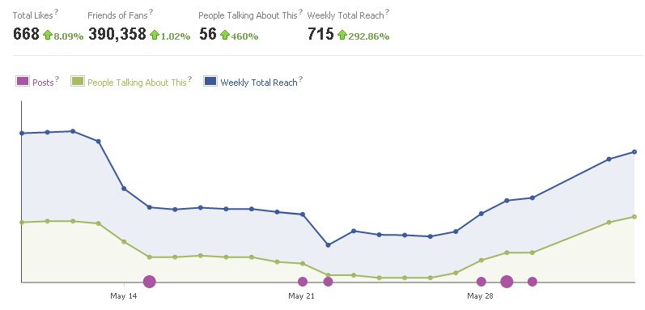
Moreover, customer responsiveness was also accounted to lead to actual sales. Taking into account that Str8 Casuals recently launched the European website for Radii Footwear, due to heavy promotion on Facebook, only a day after the announcement several orders were generated on the website. Overall, the company has sold twelve pairs since the launch adding up to almost € 2,000.

Recommendations

Use social media effectively
Considering that all results from both desk and field research confirm that social media is vital for marketing, it is recommended that a part-time worker is hired to devotedly maintain Radii’s presence in social networks. As social media requires significant time investment, it is advisable that the marketer is busy with updating content and responding to demands and comments of fans for an average time per week equal to two full working days. Such activities positively affect customer responsiveness and brand loyalty, and not only raise brand awareness but lead to beneficial financial results as well. Such a strategy allows a customer-oriented approach and considering the buyers’ concern for pricing, social media can be used to address that issue. For instance, keeping to the interactive and motivating nature of social networks, certain brand-related activities and contests can be organized where the winners receive price discounts or coupons. That can not only shift the focus away from the price but can also contribute to the feeling of exclusivity that fans enjoy.
In addition, social media presents an advantageous venue to spread word-of-mouth, which has proven to be the most effective way of reaching the target audience so far. Furthermore, in order to increase exposure, posts on the Facebook page of the brand can be promoted with the paid service “boost post” reaching from 1,300 to 2,400 users at a time for € 4.00 per post. On the whole, it is of utmost importance for the company not to overlook the amount of time and attention that must be invested in social media in order to produce the desired results.

Include promotional materials in the shoe boxes
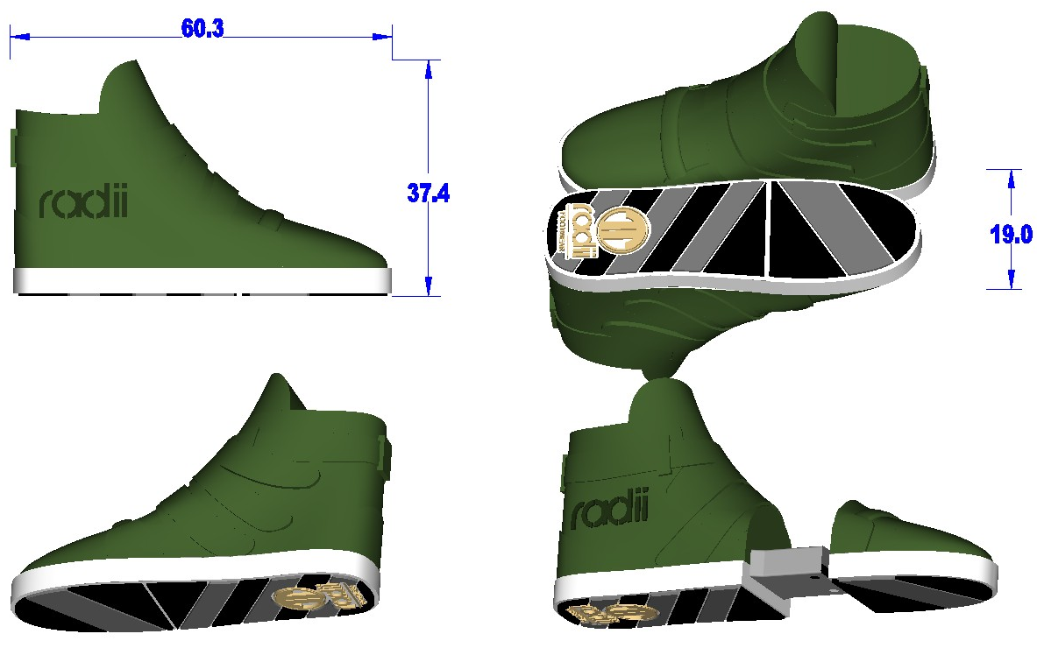
USBs in the shape of the most popular model of Radii – Straight Jacket VLC, are recommended to be given away with every sold pair of shoes. They are not only promotional materials that expose the product and the logo but are also ingeniously looking and can be put to use by customers. In addition, as the USBs are given to the stores to distribute to end buyers, retailers can get more involved with Radii, which is helpful to consumers as they often prefer acquiring information about footwear brands at store locations. Art work especially designed for Radii by the favored manufacturer, Shenzhen Wealths in China, is displayed on Figure 7.
Figure 7: Art work for personalized Radii USBs

Attract attention with in-store advertising
Using sand printing graffiti inside the various retailers that work with Str8 Casuals is recommended. The company that offers such types of advertising supplies a ‘do-it-yourself-kit’ (DIY) that can be used by an employee at Str8 Casuals. It does not require training or any special considerations and produces up to 50 prints. The design, the colors and the message can support the creativity of the strategy. Overall, social media will be used to raise brand awareness and attract customers to the retailers and then the graffiti, placed inside the stores, will draw the attention to the Radii shoes and differentiate them from competing brands at the point of sale.
In the table below a cost overview of the chosen combination of tools can be seen. As prices of USB sticks were given by the manufacturer in US dollars, in the table the prices are converted to euro with the exchange rate of 6 June 2013, therefore, it needs to be adjusted for the actual rate on the day when the order is placed. The total cost of the proposed marketing strategy is € 8,587.00, which is within the allowed budget of Str8 Casuals.
Cost Overview
Marketing tools | Price per item/day | Quantity | Other | Total
Social media marketer | € 125.00 | 16 |  | € 2,000.00
Promoting Facebook posts | € 4.00 | 8 |  | € 32.00
Radii USB sticks | € 2.84 | 2,000 |  | € 5,680.00
Sand printing graffiti |  |  | € 875 | € 875.00
 |  |  |  | € 8,587.00
Table 6: Cost overview for the proposed marketing campaign in August-September 2013
Taking into consideration all aspects of Radii Footwear’s position on the Dutch market, it can be concluded that the brand has the potential to develop its business and achieve a considerable improvement. By focusing on its marketing efforts and investing in the promotion of the shoes, Str8 Casuals can effectively raise brand awareness influencing positively both financial and non-financial results. Committing to social media, inspiring brand loyalty, intensively exposing the brand name, logo and designs for the audience to see, and relying on creativity throughout the process, are what Radii Footwear needs in order to increase customer responsiveness by Spring 2014.

Bibliography
Azvedo, H. (2011). The Netherlands ranks #1 worldwide in penetration for Twitter and Linkedin. Retrieved from http://www.comscore.com/Insights/Press_Releases/2011/4/The_Netherlands_Ranks_number_one_Worldwide_in_Penetration_for_Twitter_and_LinkedIn
Bakker, P., & Vasterman, P. (2010). Media landscapes: The Netherlands. European Journalism Centre. Retrieved from http://ejc.net/media_landscapes/the-netherlands
Beaudoin, P., Lachance, M. J., & Robitaille, J. (2003). Fashion innovativeness, fashion diffusion and brand sensitivity among adolescents. Journal of Fashion Marketing and Management, 7, 23-30.
Bruce, M., & Daly, L. (2006). Buyer behavior for fast fashion. Journal of Fashion Marketing and Management, 10, 329-344.
Buil, I., Chernatony, L., & Martínez, E. (2013). Examining the role of advertising and sales promotions in brand equity creation. Journal of Business Research, 66, 115–122.
CBI. (2010, May). The Footwear Market in the Netherlands. Retrieved from http://www.cbi.eu/marketintel/The-footwear-market-in-The-Netherlands/162608
Central Intelligence Agency. (2013, May 7). The world factbook: The Netherlands. Retrieved from https://www.cia.gov/library/publications/the-world-factbook/geos/nl.html
Clark, C., Doraszelski, U., & Draganska, M. (2009). The effect of advertising on brand awareness and perceived quality: An empirical investigation using panel data. Quantitative Marketing and Economics, 7, 207–236.
Coley, A., & Burgess, B. (2003). Gender differences in cognitive and affective impulse buying. Journal of Fashion Marketing and Management, 7, 282-295.
Dias, L. P. (2003). Generational buying motivations for fashion. Journal of Fashion Marketing and Management, 7, 78-86.
Donnell, L., Hutchinson, K., & Reid, A. (2012). Fashion retailing in the new economy: The case of SMEs. International Journal of Retail and Distribution Management, 40, 906 - 919.
European Travel Commission. (2013, May). New Media Trend Watch: The Netherlands. Retrieved from http://www.newmediatrendwatch.com/markets-by-country/10-europe/76-netherlands
Hoffman, D., & Fodor, M. (2010). Can you measure the ROI of your social media marketing?. MIT Sloan Management Review, 52, 40-49.
Hoksbergen, M. (2009, May 19). Internet supplanting traditional media products. CBS Statistics Netherlands. Retrieved from http://www.cbs.nl/en-GB/menu/themas/vrije-tijd-cultuur/publicaties/artikelen/archief/2009/2009-2789-wm.htm
Homburg, C., Klarmann, M., & Schmitt, J. (2010). Brand awareness in business markets: When is it related to firm performance?. International Journal of Research in Marketing, 27, 201–212.
Hoyer, W. D., & Brown, S. P. (1990). Effects of brand awareness on choice for a common, repeat-purchase product. Journal of Consumer Research, 17, 141-148.
Huang, R., & Sarigöllü, E. (2012). How brand awareness relates to market outcome, brand equity, and the marketing mix. Journal of Business Research, 65, 92–99.
Jeffrey, K. (2010). 5 highly effective advertising ideas for small businesses. Articlesbase. Retrieved from http://www.articlesbase.com/advertising-articles/5-highly-effective-advertising-ideas-for-small-businesses-1749302.html
Jeffrey, K. (2011). How to use 3d street art advertising to create massive publicity and sales. Articlesbase. Retrieved from http://www.articlesbase.com/branding-articles/how-to-use-3d-street-art-advertising-to-create-massive-publicity-and-sales-4252661.html
Kaplan, A. M., & Haenlein, M. (2010). Users of the world, unite! The challenges and
opportunities of social media. Business Horizons, 53, 59-68.
Kim, H. B., Kim, W. G., & An, J. A. (2003). The effect of consumer-based brand equity on firms' financial performance. Journal of Consumer Marketing, 20, 335-351.
Kim, H. S. (2005). Consumer profiles of apparel product involvement and values. Journal of Fashion Marketing and Management, 9, 207-220.
King, N., & Horrocks, C. (2010). Interviews in qualitative research. London: SAGE Publications.
Kotler, P., Armstrong, G., Wong, V., & Saunders, J. (2008). Principles of marketing (5th ed.). Essex: Pearson Education Limited.
Lecinski, J. (2012). The ZMOT handbook: Ways to win shoppers at the zero moment of truth. Mountain View, CA: Google Inc.
Lee, Y., Chen, S., Huang, C., & Hsu, C. (2010). The moderating effect of brand loyalty on the relationship between promotion activities and consumers’ purchase decision-making. International Journal of Management, 4, 93-106.
Mangold, W., & Faulds, D. (2009). Social media: The new hybrid element of the promotion mix. Buziness Horizons, 52, 357-365.
MarketLine. (2012, February). Footwear in the Netherlands. Retrieved from MarketLine Advantage database.
Marzo-Navarro, M., Pedraja-Iglesias, M., & Rivera-Torres, M. P. (2004). The benefits of relationship marketing for the consumer and for the fashion retailers. Journal of Fashion Marketing and Management, 8, 425-436.
Michaelidou, N., Siamagka, N., & Christodoulides, G. (2011). Usage, barriers and measurement of social media marketing: An exploratory investigation of small and medium B2B brands. Industrial Marketing Management, 40, 1153-1159.
Moore, M., & Fairhurst, A. (2003). Marketing capabilities and firm performance in fashion retailing. Journal of Fashion Marketing and Management, 7, 386-397.
Nowack, K. (1990). Getting them out and getting them back. Training and Development Journal, 44, 82-85.
Oh, H. (2000). The effect of brand class, brand awareness, and price on customer value and behavioral intentions. Journal of Hospitality & Tourism Research, 24, 136-162.
Park, E. J., Kim, E. Y., & Forney, J. C. (2006). A structural model of fashion-oriented impulse buying behavior. Journal of Fashion Marketing and Management, 10, 433-466.
PR Newswire. (2006, December 12). Traditional Media Far from Dead. Retrieved from http://www.prnewswire.com/news-releases/traditional-media-far-from-dead-reveals-ketchumusc-media-usage-survey-findings-also-refute-common-communications-myths-identify-new-realities-56168957.html
Verbeeten, F., & Vijn, P. (2010). Are brand-equity measures associated with business-unit financial performance? Empirical evidence from the Netherlands. Journal of Accounting, Auditing & Finance, 25, 645-671.
Verhoeven, N. (2007). Doing research: The hows and whys of applied research. 2nd rev. ed. Amsterdam: Boom Academic.
Wang, F., Zhang, X., & Ouyang, M. (2009). Does advertising create sustained firm value? The capitalization of brand intangibles. Journal of the Academy of Marketing Science, 37, 130-143.
Zarrella, D., & Zarrella A. (2011). The Facebook marketing book. Sebastopol, CA: O’Reilly.

Appendix 1: Questions for company interviews
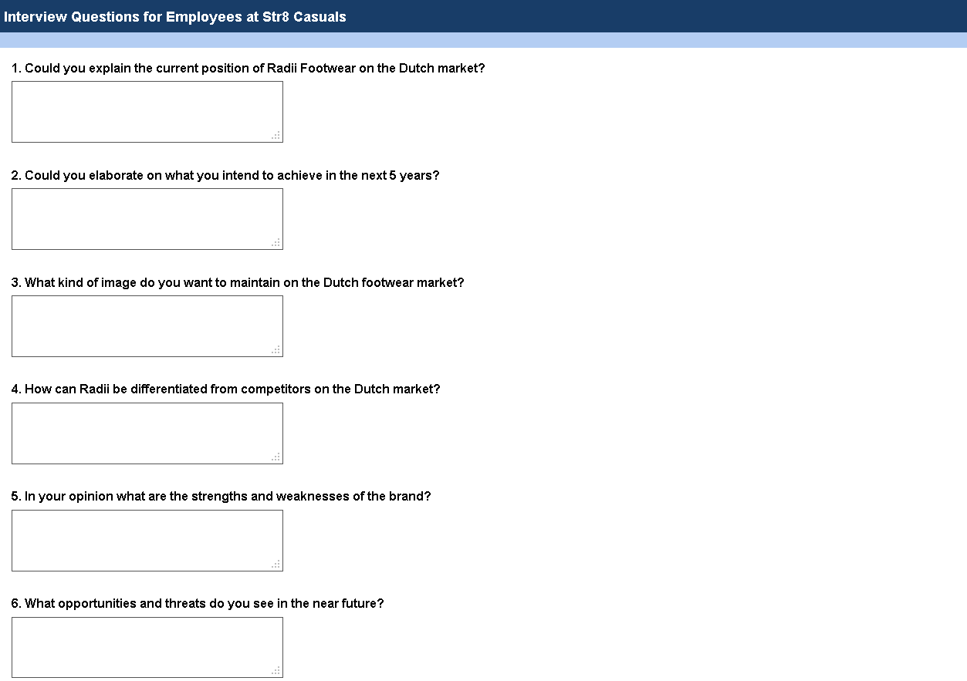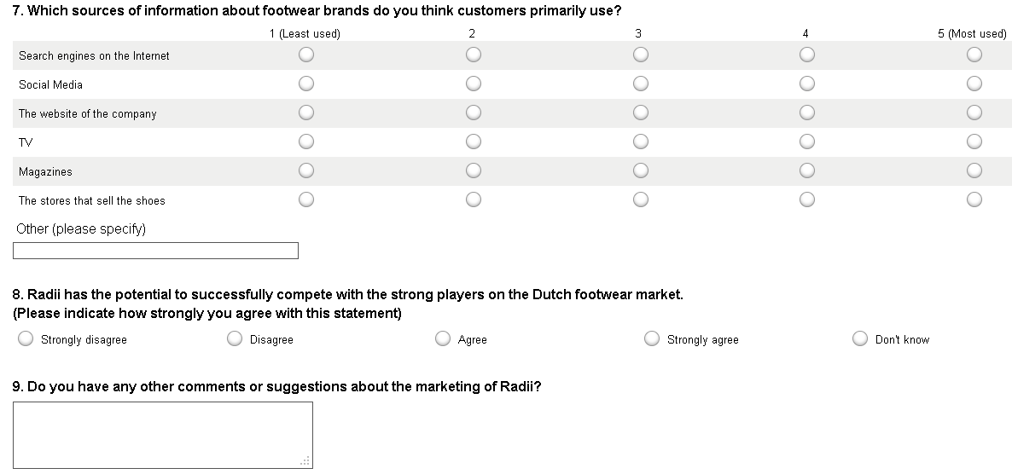

Appendix 2: Questions for interviews with sales agents
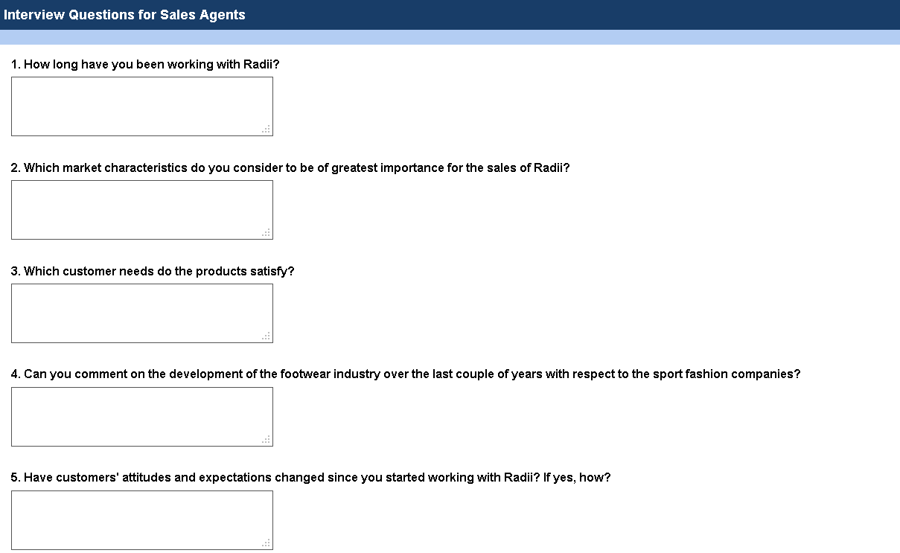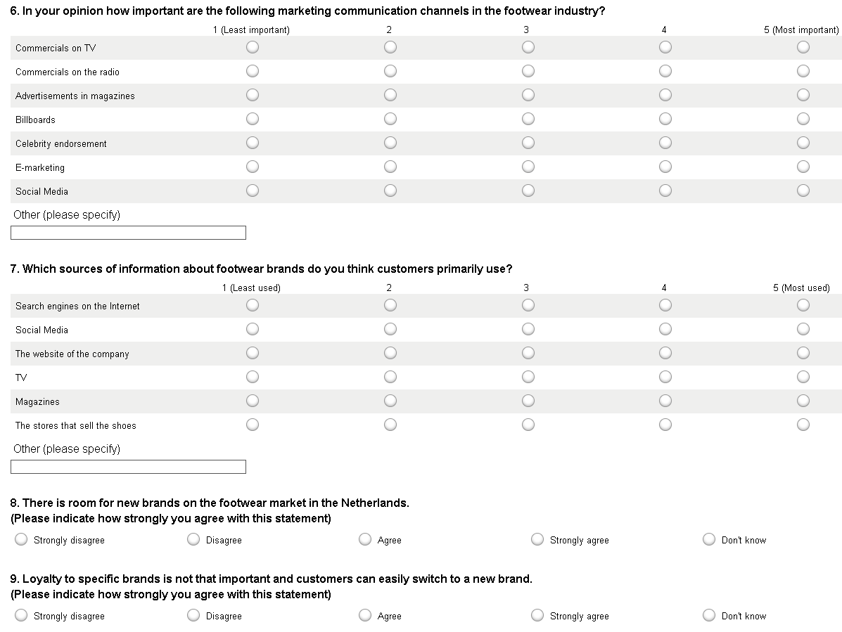

Appendix 3: Questionnaire
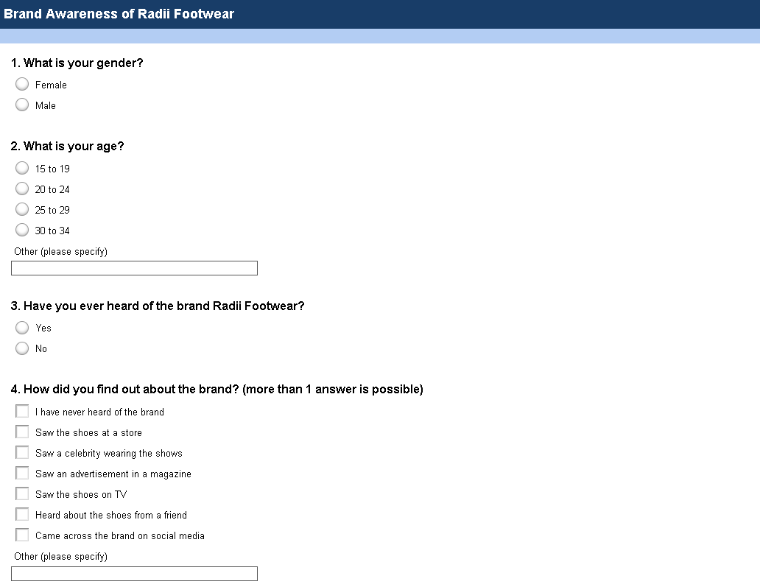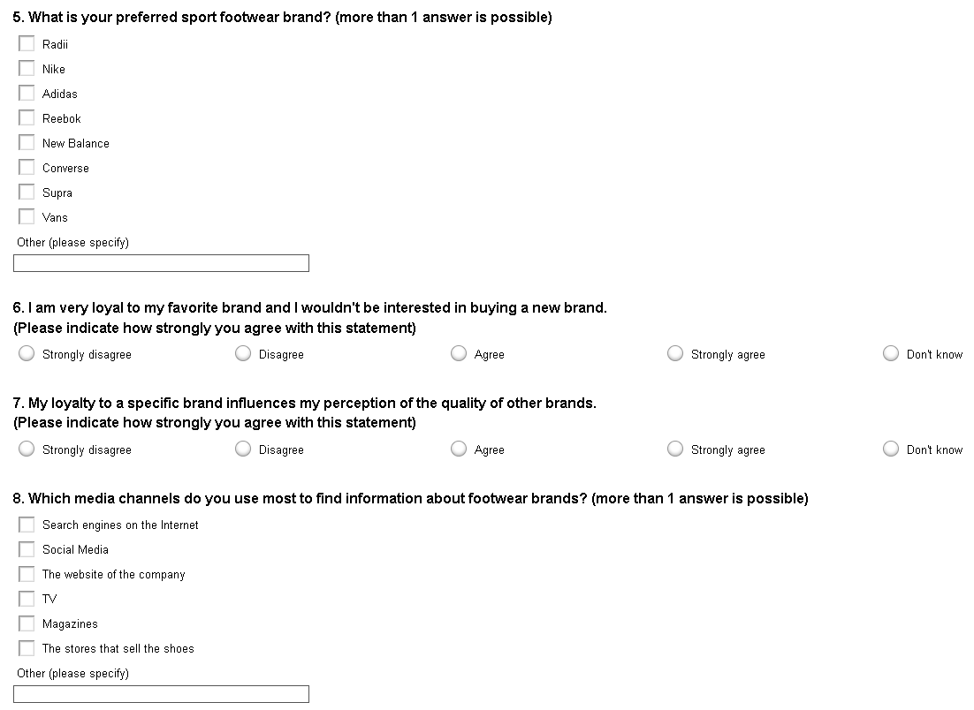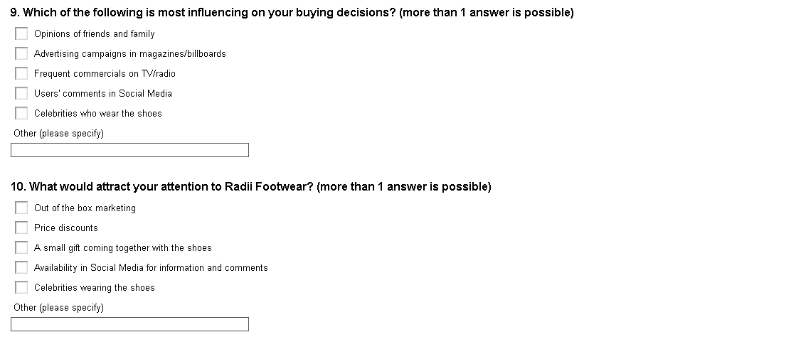

Appendix 4: Graphs with results from questionnaires

Appendix 5: Marketing ideas and overview of prices
USB | Price 1000 | Price 2000 | Additional
- Apexto Technology | $4.43 | $4.23 | Mould fee: $125 (get it back if 2000 or more pieces are ordered)
- VTD Promotions | $4.27 | $4.24 | Freight: $180/$230
- Tomaxtech | $3.7 | $3.6 | Mould fee: $70 (get it back when ordered)  Shipping: $150/$250
- Shenzhen Wealths | $3.85 | $3.74 | Mould fee: $66 (only for 1000 pieces)
- S. L Design Manufacture | $4.05 | $4.05 | Mould fee: $80
Stickers | Price 10,000 | Price 20,000 | Additional
- Virtual Printer | €1,020  + €340 (shape)  = €1,360 | €1,190  + €495 (shape)  = €1,685 | 100x100 mm  ex. btw
Outdoor Advertising | Price |  | Additional
- GreenGraffiti Sandtastique® 'do-it-yourself-kit' (DIY) | €875 |  | ex. 21% btw and transport costs
3D Street Painting | Price |  |  | Additional
- Streetpainting 3D (Leon Keer) | €3,750 – painting  €400 – design  €90 – 3 days of work |  |  | ex. transport costs
Social Media | Price |  | Additional
- Part-time worker | €1000/month |  | 2 days a week
- Boosting posts | €16/month |  | €4/post, 1 post a week

