**Competitive Analysis for International Bureau of Fiscal Documentation (IBFD)**



Kingsley Ivan Evans (1501836)

Friday, the 24 July, 2009

Graduation Assignment

By

Kingsley Ivan Evans

A thesis submitted in partial fulfillment of the requirements for the degree of

Bachelor of Business Administration



2008/2009 Academic Year

Approved by Mr. Harrie van Kerkvoort



School Supervisor 1

Mrs. Raya Nunez



School Supervisor 2

Mrs. Sorrel Hidding



Company Supervisor

### Abstract

In today's world of fierce competition, publishers and information providers of cross-border tax are well aware of the pace and nature of changes in their business. While compelling content remains the driving force. The revolution in technology is opening up new ways to gather, package and present information products to customers. Increasingly, the customers of this information have changed and they expect both depth and breadth contents, these customers are in the driver's seat as more options emerge, they are increasingly willing to turn to new content sources and formats, from blogs to mash-ups to eBooks. The challenge that established publishers and information providers of cross-border tax are faced with, is to create competitive advantages against new entrants and direct competitors under the circumstances of environmental changes. In addition, the described problem model was developed in order to picture the situation. This paper aims to provide an answer to the specific question *“What strategy should IBFD employ in order to create and maintain sustainable competitive advantage?”*

Both qualitative and quantitative research methods were used for the research. The research nonetheless is exploratory and secondary methods presented under the framework of a case studies technique. Appropriate strategy concepts were reviewed first in order to present a comprehensive understanding of the topics covered. A case study followed in which a successful implemented model was analysed. Comprehensive analyses were also carried out about the competitors in the LTR industry to have a clear idea of their business activities and to be aware of what their future plans are.

Different generic strategies were also described in the research for achieving sustainable competitive advantage in the IBFD: cost leadership, differentation and focus. Competitive advantave is about how a company actually puts the generic strategies into practice and how the IBFD can differentiate itself from its competitors in the LTR industry. Obviously, the formulation of sustainable competitive strategy has become crucial theme for forward looking companies. Primary, for a business to have a competitive advantage within its industry it means that firm must have a better product or service which creates better value than others in the industry. The concept further assumes that in order for a company to achieve sustainable competitive advantage for a longer period of time such company is required to constantly re-invent its strategies and communicate to the customers[1]. Communication is essential in any relationship, building and managing relationships with customers has a direct bearing on marketing communications. Marketing communications helps define a company’s relationships with customers not only by the kind messages exchanged but also by the occasion to suit their customer’s preferences. Schultz and Kitchen, (2000) suggest that a further way of improving marketing communications strategy is to think through the timing and context of messages from the point of view of the customers. This concept presented a view that customer preferences make communications more effective and more economical. Failure to follow customer’s changing preferences can be expensive for a company. The report also stress the strategic importance of marketing communications in a company, rather than seeing it as merely a tactical process of promoting the other elements of the marketing mix. Brands exist in the minds of customers not only through their experience of a product or service, but also because of the long-term effects of communication.

Finally, there were some limitations in carrying out this research, the limitations was that information were difficult to find, the reason is that companies operating in the LTR industry focus on 3 main areas (Tax, Accounting and Legal), while IBFD main operations are tax & accounting. There were also difficulties in finding the most recent annual report of the IBFD competitors. However, the report was based on Tax, accounting and legal.

**Keyword:** *Sustainable Competitive Advantage*

### Glossary of terms

CFOs: Chief Financial Officers

CPE: Continuing Professional Education

IBFD: International Bureau of Fiscal Documentation

IT: Information Technology

ITA: International Tax Academy

LTR: Legal, Tax and Regulatory

PDA: Personal Digital Assistant

SCA: Sustainable Competitive Advantage

SWOT: Strength, Weaknesses, Opportunities and Threats

TAA: Tax and Accounting

TNS: Tax News Service

### Table of contents

Acknowledgement……………………………………………………………………..…….iii

Abstract…………………………………………………………………………..………...iv-v

Abbrevations…..…………………………………………………………………..…………vi

Table of contents…………………………………………………………………………….vii

Table of figures…………………………………………………………………….................ix

1. Introduction…………………………………………………………………..…………1-3
   1. Problem formulation and purpose…………………………………………..………....3
   2. Research objective…………………………………………………………….……....4

1.2.1Company background………………………………………………………….….4-5

* 1. Literature review………………………………………………………………….…..6

1.3.1 Significance of the research…………………………………………………….......6

* 1. Concepts definition………………………………………………………………..7-10
  2. Situational Analysis………………………………………………………………….10
     1. Industry Analysis…………………………………………………………10-11

1. Methodology……………………………………………………………………………..12
   1. Exploratory…………………………………………………………………………...12
   2. Primary Research……………………………………………………………………..12
   3. Secondary Research…………………………………………………………………..12
   4. Data Collection…………………………………………………………………….....13
   5. Constraints……………………………………………………………………………13
   6. Credibility………………………………………………………………………….....13
2. Market Analysis…………………………………………………………………………..14
   1. Market Overview………………………………………………………………….14-15
   2. Global Market Share and size……………………………………………………..15-16
   3. Factors Impacting Market Share…………………………………………………..16-17
   4. Internal and External analysis(SWOT)……………………………………………17-19
3. Competitors Analysis………………………………………………………………….20-24
4. Customer Analysis…………………………………………………………………….25-26
5. Marketing Communications………………………………………………………………27

6.1 The role of Marketing Communications…………………………………………..27-28

6.1 The Marketing Communications mix……………………………………………..28-29

6.3 IBFD competitors marketing communications…………………………………....29-31

7. Empirical Findings…………………………………………………………………….32-37

8. Analyzing the empirical findings……………………………………………………...38-39

9. Recommendations and Conclusion……………………………………………………40-42

References…………………………………………………………………………………43-44

Appendix………………………………………………………………………………….45-48

### Table of figures

Figure 1: The Components of Competitive Analysis by Porter…………………………………..8

Figure 2: The LTR Global Market Size and Growth, 2007-2008 by Outsell Inc……………….16

Figure 3: The top 3 competitors, growth and market share, 2008 by Outsell Inc……………….16

Figure 4: The five elements of Marketing Communications mix by Fill………………………..28

Table 1: SWOT Analysis……………………………………………………………………...…18

Table 2: The activities of main companies in the LTR industry…………………………….......24

### Introduction

In most industries central characteristics of competition is that companies are mutually dependent: companies feel the effects of each others’ moves and are prone to react to them. The outcome of a competitive move by one company depends at least to some extent on the reactions of its rivals.[2]

Competitive moves are also a game of finesse. Some companies seem to view competitive moves as entirly a game of brute force: sheer resources are massed to attack a rival. A company’s strengths and weaknesses certainly help define the opportunities and threats it faces. However, even sheer resources are often not enough to insure the right outcome if competitors will be tough in their responses or if competitors are pursuing greatly different objectives. Moreover, possession of clear strengths is not always realistically available to every company seeking to improve its strategic position.

For the purpose of achieving SCA, the use of strategies to create greater values to customers than the competitors offer has become the method companies are using to stay competitive. Today, companies are not only re-inventing strategies that address their immediate threats but also the one that attend to their future needs. Obviously, the formulation of sustainable competitive advantage has become crucial theme for forward looking companies. Most importantly, the concept addresses the idea that for a business to have a competitive advantage within its industry that it must have a better product or service which creates better value than what competitors can offer. The concept further assumes that in order for a company to achieve sustainable competitive advantage for a longer period of time that such company is required to constantly re-inventing its strategies[3].

Generally, effective business strategies create value and offer a business competitive advantage in market competitions. But nonetheless, even perfect strategies do not have barriers to imitations when it remains static and fails to address the immediate and future anticipated dynamics. Just as a successful strategy can be copied by competitors, competitive advantage unfortunately does also erode as time changes. So having a successful strategy is one thing but making sure it is sustained for a long period of time defines a sustainable competitive advantage.

A competitive advantage is a position that a company occupies against its competitors Porter, (1980). The three generic strategy methods for creating a sustainable competitive advantage are through:

1. Cost leadership: cost advantage occurs when a firm delivers the same services as its competitors but at a lower cost.

2. Differentiation: differentiation advantage occurs when a firm delivers greater products and/or services for the same price of its competitors. They are collectively known as positional advantages because they denote the company's position in its industry as a leader in either superior products and services or cost.

3. Focus (economics): A focused approach requires the firm to concentrate on a narrow, exclusive competitive segment (market niche), hoping to achieve a local rather than industry wide competitive advantage. There are cost focus seekers, who aim to obtain a local cost advantage over competition and differentiation focuser, who are looking for a local difference.

The primary factors of sustainable competitive advantage are innovation, reputation and relationships Peteraf, (1993). Porter’s approaches of competitive advantage and sustainable competitive advantage build the base of the model by explaining how sustainable competitive advantage can be achieved through a generic strategy. According to Porter (1980), a generic strategy is a strategy followed by a company that give a choice between cost leadership, differentiation and focus as explained above. All those choices could give a leadership depending on objectives of every company. A perfect generic strategy method could generate a competitive advantage and by this gives sustainability to a company.

The purpose of this method is to better understand and identify the needs of these customers in order to offer their best products and services in return (Liou, 2009). In order to make this model more dynamic, factors such as environmental changes or competitors that have an effect on the implementation of a strategy are included. Different factors will influence the company’s generic strategy and more specifically industry competitors. Significant changes on the global as well on domestic markets drive managers to react. Through the development of skills, attitudes and knowledge managers of companies and organizations try to compete on the high competitive markets. The more competitive global competition is the more choices of products and services are provided for the customers (Gursoy and Swanger, 2007). These choices are affected by the prices, product range and customer service provided by the competing companies (Internet reference: “*Business studies: a competitive mark”*).

It is also really interesting the fact that customers have a relation with LTR industry. Those customers are controlled by the company thanks to tools of relationship marketing. There is a relation between customers and companies that could influence generic strategies and all the superior part of the model (Liou, 2009).

As a result of increasing cost marketing communication need to be taken into account. Additionally, companies are more aware of the costs that arise by acquiring new customers but they do not consider that retaining customers might be relatively less costly for the companies (Doole and Lowe, 2008). Marketing communications is a tool that could affect the generic strategy. It enables companies to communicate in a more effective and efficient way by using more qualitative messages to reach existing and potential customers and to get a better understanding what they might expect from the company (Doole and Lowe, 2008).

1.1 Problem formulation and purpose

In the mist of the modern market competitions, publishers and information providers are trying to keep and maintain their customers with loyalty factors. This study will focus on how the IBFD will enhance and maintain its competitiveness in the LTR industry. The reality of the modern market order is that competitions can come to a company’s vicinity at any given time when such market is interesting, such situation mostly occuried when a company is unprepared to face stiff competition and outside market entrance. Following such predicament the IBFD formulated the following research question: ***“What strategy should IBFD employ in order to create and maintain sustainable competitive advantage?”***The term sustainable competitive advantage is defined as “when a company implements a value creating strategy not simultaneously being implemented by any current or potential competitors in the industry (Barney, 1991). Sustainable competitive advantage allows for the maintenance and improvement of company’s competitive position in the market.

For the IBFD to successfully uphold a sustainable competitive advantage in LTR industry, it must perform its value activities in a way difficult to replicate or imitate by its competitors. This is an advantage that will enable IBFD to survive against its competition over a long period of time.

1.2 Research objectives

The objective of the research is for the IBFD to understand what the competitors are doing, what they (competitors) are offering to the customers and how IBFD should gain or maintain a sustainable competitive advantage in the LTR industry both domestically and internationally. It will also help the IBFD to expand dialogue within the development team and with other business units in the IBFD. Such dialogue can open up new options that would not otherwise have been considered.

1.2.1 The IBFD Background

The IBFD is an independent non-profit organization based in Amsterdam, the Netherlands and has presence in Virginia (USA) and Kuala Lumpur (Malaysia). It was founded in 1938; tax practitioners from all over the world rely on the IBFD for authoritative expertise on cross-border taxation. The IBFD is the portal to high quality independent tax research, international tax information and education with the aim to enable customers to do their work more quickly and efficiently.

The IBFD is a successful independent non-profit organization and its management has high ambitions for growths and expansions. Currently they are initiating moves to open an office in China and some major countries in Africa.[4]

Its objectives can be summarized in the following mission statement: “To research, develop, process and disseminate information and insight in the field of international and comparative taxation and foreign investment legislation.” The IBFD focuses on research, education and publications in the area of international tax law; it gathers information about tax systems worldwide and serves as an information resource for tax lawyers and advisors around the world.

In addition to publishing information about and providing comment on international tax law, the IBFD also concentrates on the development of software solutions.[5]

There are about 50 research specialists and teacher’s staff from around 25 different countries that are ready to make sure that IBFD customers achieve their aims.

*International focus*

The IBFD caters for both the private and the public sector. Over the years, the IBFD has grown from a tax documentation centre into contemporary online research institute. It fulfills the information needs of tax advisory firms, multinational enterprises, international organizations, ministries of finance, tax administrations, universities and other tax practitioners in over 150 countries.

*Independent*

IBFD operates on a not-for-profit basis and is completely independent. The organization is divided into IBFD’s Products and Services, which covers all publishing, educational, research and consultancy activities. IBFD Foundation executes several Academic Activities.

*IBFD’s activities[6]*

* There are over 40 online products on (inter)national tax law and cross-border investments covering every country in the world.
* Various journals and books on general and specialized tax issues.
* Simple software solutions to complex cross-border taxation issues.
* There is also a training centre that offers a wide range of open and in-house courses on international tax law and specialized topics
* Tailored client research and comparative research on (inter)national tax matters
* The Government Consultancy Department provides consultancy for ministries of finance and tax administrations regarding tax policy, tax legislation and organisation of tax administrations.

*Academic Activities*

The tax academic is the platform for academic discussions on international tax law. It encourages scholarly debate on international tax law topics through the following activities:

* *Visiting Research School program:* Academics are given the opportunity to undertake substantial research at IBFD’s premises and contribute to and stimulate academic discussions within IBFD.
* *Research Student Meeting:* In Research Student Meeting students discuss their research with colleagues and experts in their own field. The IBFD Doctoral Series those dissertations that make a substantial contribution to the international academic debate.

## 1.3 Literature review

The study of competitor profiling provides a comprehensive picture of the strengths and weaknesses of current and potential rivals. Competitive analysis provides both offensive and defensive strategic context through which to identify opportunities and threats in the LTR industry.

The objective of a competitor analysis is to develop a profile of the nature and success of the likely strategy changes each competitor might make. Competitor profiling actually combine all of the relevant sources of competitor analysis into one framework in the support of efficient and effective strategy.[7] A competitive analysis is a critical part of a company marketing plan. With this evaluation IBFD will be able to establish what makes its product or service unique, and also it will enable IBFD to place its competitors in a strategic group according to how directly the compete in the LTR industry.[8]

There are four main components to a competitor analysis: Future goals, current strategy, assumptions and capabilities. Understanding these four components is essential because it will allow and informed prediction of the competitor’s response profile. This response profile includes both potential offensive and defensive moves. The specific moves and their expected strength can be estimated using information gleaned from the analysis.[9]

1.3.1 Significance of this research

The importance of this research is that it will help the IBFD in its strategic planning, for example;

* It will help the IBFD management to understand their competitive advantages/disadvantages relative to competitors.
* To generate understanding of competitors’ past, present (and most importantly) future strategies.
* It will provide an informed basis for IBFD to develop strategies to achieve competitive advantage in the future.[10]

1.4 Concepts definition

Competitive Analysis

In today's market, companies want to know what their competitors are doing and what to do to stay ahead of the competition. Many businesses believe they are providing a good product or service to their customers, but do not have reliable information showing how customers perceive their product or how it compares to the competition.

In formulating business strategy, managers must consider the strategies of the competitors.[11]

Competitor analysis has two primary activities, which are; obtaining information about the main competitors and also using that information to predict competitor’s behaviour. The main goal of a competitor analysis is to develop a greater understanding of what competitors have in place in terms of resources and capabilities, what they plan to do in their businesses, how the competitors may react to various situations in reaction to what the company does and also how to influence competitor behaviour to the company's own advantage.

Competitive Analysis Framework

Competitive strategy involves positioning a business to maximize the value of the capabilities that distinguish it from its competitors. It follows that a central aspect of strategy formulation is perceptive competitor analysis. The objective of a competitor analysis is to develp a profile of the nature and success of the likely strategy changes each competitor might make, each competitor’s likely response to the range of feasible strategic moves other companies could initiate, and each competitor’s likely reaction to array of industry changes and broader environmental shifts that might occurs.[12] There are four diagnostic components to a competitor analysis: future goals, current strategy, assumptions and capabilities. Understanding these four components shown in figure 1 will allow an informed prediction of the competitor’s response profile.

Fig. 1 the components Competitor Analysis

|  |  |  |
| --- | --- | --- |
| *What drives the competitor* |  | *What the competitor is doing or is capable of doing* |
| Future Goals |  | Current Strategy |
| |  | | --- | | Competitor’s Response Profile | | | |
| Assumptions |  | Capabilities |

Source: Diagram adapted from Michael E. Porter*, Competitive Strategy*, pg. 49

The components and questions presented in the competitor’s response profile are stated in terms of competitors, the same ideas can also be turned around to provide a framework for self-analysis. The same concepts can provide a company with a framework for probing its own position in its environment. Clearly, it is important to analyze all existing competitors and also the potential competitors that may come on the scene. Another potentially valuable exercise is to attempt to predict possible mergers or acquisitions that might occur, either among established competitors or involving outside the industry. A merger can instantly boost a weak competitor into prominence, or strengthen an already formidable one.

Future Goals

A knowledge of competitor’s goals will allow predictions about whether or not each competitor is satisfied with its present position and financial results, and thereby, how likely that competitor is to change strategy and the strength with which it will react to outside events or to move by other companies. For example, a company placing a high value on stable sales growth may react very differently to a business downturn or a market share increase by another company than a company most interested in maintaining its rate of return on investment.

Knowing a competitor’s goals will also aid in predicting its reactions to strategic changes. Some strategic changes will threaten a competitor more than others, knowing its goals and any pressures it may face from a corporate parent. This degree of threat will affect the probalility of retaliation. Finally, an analysis of a competitor’s goals helps interpret the seriousness of initiatives the competitor takes. Similarly, an analysis of its goals will help determine whether a corporate parent will seriously support an initiative taken by one of its business units.

Assumptions

The second crucial component in competitor analysis is identifying each competitor’s assumptions. These assumptions fall into two main categories: the competitor’s assumptions about *itself,* and the competitor’s assumptions about *the industry and the other companies in the industry*

A competitor’s assumptions about its own situation may or may not be accurate. Just as each competitor holds assumptions about itself, every company also operates on assumptions about the industry and competitors. These also may or may not be correct. If a competitor believes it has the greatest customer loyalty in the market and it does not, for example, a provocative price cut may be a good way to gain position. The competitor might well refuse to match the price cut believing that it will have little impact on its share, only to find that it loses significant market position before it recognizes the error in its assumption.

Examining assumptions of all types can identify biases or blind spots that may creep into the way managers perceive their environment. The blind spots are areas where a competitor will either not see the significance of events (such as a strategic move). Rooting out thses spots will help the company identify its moves.

Current Strategy

This component is developing statements of current strategy of each competitor. A competitor’s strategy is most usefully thought of as its key operating policies in each functional area of business and how it seeks to inter-relate the functions. This strategy maybe either explicit or implicit – one always exists in one form or the other.

Capabilities

A realistic assessment of each competitor’s capabilities is the final analytic step in competitor analysis. Its goals, assumptions, and current strategy will influence the likelihood, timing, nature and intensity of a competitor’s reactions. Its strengths and weaknesses will determine its ability to initiate or react to strategic moves and to deal with environmental or industry events that occur.

Competitor Response Profile

Knowing the competitor’s future goals, assumptions, current strategies and capabilities then the company can begin to ask some critical questions such as *(Is the competitor satisfied with its current position? Where is the competitor vulnerable? What moves or strategy shifts will the competior make? What will provoke the greatest and most effective retaliation by the competitor?)* Thatwill lead to a profile of how a competitor is likely to respond and can also define its thoughts on what actions competitors may purse depending on the understanding of the information gathered from the analysis. The result of the competitor analysis should be an improved ability to predict the competitor's behavior and even to influence that behavior to the company's advantage. This profile can be both *offensive and defensive moves.*

1.5 Situational Analysis

To fully understand how IBFD will gain a sustainable competitive advantage over its competitors, the situation must be looked at from several different points. These include industry, customer, competitor analyses and marketing analysis, as well as a look at the different marketing strategies and changing marketing trends.

1.5.1 Industry Analysis

Every business operates within the larger classification of an industry. This includes companies selling similar products and services, as well as complementary or supplementary products or services.

This report will be focusing on the Legal, Tax & Regulatory (LTR) segment in the publishing and information industry. This will include detailed analysis of the top companies in the LTR segment. It will also examine key trends and drivers in the LTR market, and the impact of new technologies.

The outlook of LTR industry is positive. The improved customer spending in the LTR industry has supported impressive growth of top LTR companies like RIA Thomson, Lexis Nexis, CCH and IBFD.

The publishing and information industry revenue in 2008 was $14.8 million. Growth in the sector, traditionally one of the more stable information industry segments with 6% - 8% growth annually, was 6.5%, down from 10.1% the previous year. The performance reflects the overall economic slowdown throughout 2008 and its effect on the LTR segment.[13]

There are three major competitors in the LTR segment that collectively account for over 70% of Legal, Tax and Regulatory market share in 2008; these include Thomson Reuters, LexisNexis and Wolters Kluwer despite the economic slowdown.

Increasingly, companies in this segment (particularly the larger ones) have added software and service offerings that have moved them beyond traditional publishing models and into their customers’ workflows and processes in more direct ways.

The key drivers in this entire segment include global expansion and the globalization of the practice of tax and law. Workflow integration for tax and legal professionals is another key driver for the big players in this industry, as they fill out their core content portfolios with applications that assist in the business practices, including marketing and client acquisitio.

### Methodology

This chapter will employ both quantitative and qualitative research methods. Qualitative method will be used as a tool to understand what are known in the field of business strategies. Quantitative method will be used to quantify the frequency and percentage of IBFD products used by customers over its competitors.

2.1 Exploratory

Exploratory research was conducted, because the problem was not yet clearly defined. This was also done to be more familiar with IBFD and the problem to be study. The research was done by looking at the IBFD and the competitor’s internet sites, annual report and other documents. The research was of great use and gave more confidence to set up the hypothesis. It also helps to determine the best research design, data collection method and selection of subjects. It provided significant insight into the current situation and why it is important to conduct a competitive analysis for IBFD.

2.2 Primary Research

In the primary research phase of this report, information was gathered in order to find a way to answer the research question. Instead of using written sources, data was collected by using content analysis of the competitors and that of IBFD, also a formal observation and questionnaire was sent out to IBFD’s customers.

2.3 Secondary Research

Existing marketing data had to be collected in order to discover how the IBFD is positioned in the LTR industry. In the beginning of the project the internet was consulted to gather the required data needed for this report. However, not much information about LTR was available on the internet. After calling a couple of research companies, which were found on several internet site and also companies that IBFD is a member (subscriber), an analysis of the LTR industry was acquired. It contained crucial and important information about the market, from which on further research has been done. The internet was further used to gather information.

2.4 Data Collection

Finally, data collection is not a methodological process per se. However, this aspect is to point out the importance of the previous steps while collecting the data. Therefore, as a researcher, it is significant that the method chosen is well structured and appropriately followed, to make sure that the data collection process is as accurate and faithful to the chosen procedures as possible.

2.5 Constraints

The paper finding is limited to extensive quantitative data. Parts of the reasons are time constraint, non access to some classified pieces of information.

Arguably, no research undertaking goes without limitations, and the same holds for research. The single most important obstacle I was faced with was the time factor. Sometimes I had to wait for at least two days before I got responses to my emails, making telephone calls to research companies for information about publishing industry.

Notwithstanding the aforementioned hurdles, I was still able to obtain a great deal of information for the preparation of this report.

2.6 Credibility

The report research gathering will be done by me and administered by IBFD marketing department and my institution supervisor. As a business student, part of my study curriculum includes academicals training on effective business research conducting. As an intern of IBFD Company for 20 weeks, I am guaranteed to access the necessary information needed to complete this report.

### Market Analysis

The goal of this market analysis is to determine the attractiveness of the LTR market and to understand its evolving opportunities and threats as they relate to the stragths and weaknesses of the industry. This analysis will provide essential data and an in-depth view into the LTR segment. This includes analysis of the top competitors in the LTR, market overview, global market size and growth, factors impacting market share and market shares of the publishers and information providers in the industry. The information provided will help IBFD to predict the future of the LTR market.

3.1 Market Overview

In recent years the revenue in the LTR segment has become more complex because of major swing in exchange rates, particularly the fall of the US dollar. Companies that report results in Euros or British pounds or that have significant revenues in those currencies, show inflated growth rates when revenues are converted into US dollars at current rates.

The LTR segment is dominated by three publicly traded companies, with over 70% of segment revenues among them. Companies in the LTR segment primarily provide information such as administrative decisions, case law, law review articles, policies, public records, regulations, risk management, statutes, tax information and tax compliance, and trademark registration.

The LTR units of Thomson Reuters, Wolters Kluwer and Reed Elsevier’s LexisNexis unit collectively known as “the Big Three”continue to dominate the industry with their combined market share of over 75%. These big three combined growth rate of 7.4% exceeded the total LTR growth rate of 6.5% in 2008. The upward trend of this segment reflects both the general health of the LTR industry and a high level of innovation and adoption on technology.

A market research company (Outsell inc.), forecast that the segment will grow by about 6.4% in 2010 to $16.4 billion, largely on the continued health of professional services markets worldwide, global expansion and an increased emphasis on practice related technologies.

All companies capitalized on the integration of digital content and productivity tools within common interfaces. LexisNexis’s Total Solutions strategy and Thomson’s focus on the Business of Law/Practice of Law dynamics both looked to litigation tools, while Wolters Kluwer’s Law & Business online libraries continued to show profitable organic growth. Similarly, Thomson and Wolters Kluwer used comparable strategies to drive growth in tax and accounting markets.

New sales of online services drove moderate single-digit growth (6% - 7%) in the US markets, as LTR practitioners in law companies, government, and corporations continued to migrate to electronic products and solutions, offsetting declines in print/CD usage. The industry generally derives more of its revenue from electronic products and less from print products. Among the larger players, Thomson stands out with 78% of revenues from electronic products.

Subscription revenues dominate LTR, at 76% while transactional sales stand at 20%. There is very little advertising revenue in the LTR segment. Subscription revenues tend to be more stable and predictable over time, and many sources in the segment are considered must have, so providers can count on steady, if not spectacular, revenue growth from year to year.

3.2 Global Market size and growth

The LTR segment growth rate fell to 6.5% in 2008 as compared to the growth rate 10.1 in 2007, as indicated in figure 2. There was an increase in the global revenue of the publishers, in 2008 the revenue increased to $14.8 million as compared to 2007 ($13.9 million). The increase was that publishers and information provider in the industry strengthened their positions in international markets largely due to the growing awareness of and demand for online services. Growth was strongest in Europe, where Thomson and LexisNexis saw results from global platform initiatives, and where Wolters Kluwer combined a strong market presence with selective acquisitions. Acquisitions remained a key driver of overall growth and revenue, with a strong focus on technology and workflow based software applications. The top three IBFD competitors (Thomson Reuters, Wolters Kluwer, and LexisNexis) all serve very broad markets with a wide range of content types and solutions; there are significant differences in the mix of revenues. Thomson Reuters and LexisNexis serve, to a larger extent, the core tax information market, while Wolters Kluwer provides relatively more legal and regulatory content.

Figure 2, the LTR Global Market Size and Growth, 2004-2008

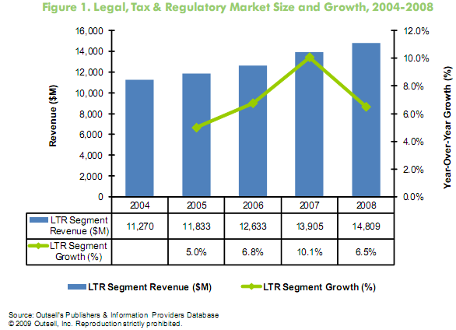

Source: *Outsell’s publishers & information providers database*

3.3 Factors Impacting Market Share and growth

The research of market shares and growth rate of the competitors provide essiential actions for IBFD in order to create revenue opportunities, attract new buyers and achieve competitive advantages over its competitors. It will also help in greater understanding of the LTR segment.

Figure 3; illustrate the shares and growth rate of the three big competitors in the industry. the fig 3 shows that Thomson Reuters leads the top tier with 9.2% growth and a market share of 29.7%, and was closly followed by Wolters Kluwer with a growth rate of 8.8% and market share of 26.7%, while LexisNexis a divison of Elsevier growth rate stands at 2.8% and market share at 18.7%.

Figure 3. The top 3 competitors, growth and market share, 2008

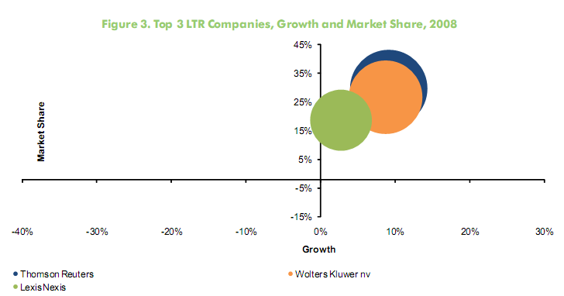

Source: *Outsell’s publishers & information providers database*

The major factor that impacts the growth and market shares of these three competitors was acquisitions, for example, Most of the acquisition-related growth for Thomson Reuters came through its Tax & Accounting unit’s the acquisitions of Property Tax Services and TaxStream. Paisley, a governance and compliance software and services business was acquired in late 2008 and Thomson Reuters expect the acquisition of Paisley to contribute in the revenues of 2009.

Also, The Tax, Accounting & Legal unit of Wolters Kluwer acquired Ci3 Consultancy to enhance the CCH TeamMate offering, and its Small Firm Services unit was expanded with the acquisition of IntelliTax. The Law & Business unit acquired MYOB Limited’s offerings for the accounting market in the UK and Ireland, and acquired Thomson’s GEE unit in the UK compliance space. Together those three acquisitions accounted for 5% growth in Tax, Accounting & Legal of Wolters Kluwer.

Despite the acquisitions made by these competitors, these leading publishers still shared common ideas:

*Digital products led the way.* All three competitors capitalized on the integration of digital content and productivity tools within common interfaces. LexisNexis, Thomson and Wolters Kluwer used similar strategies to drive growth in tax and accounting markets.

*Global perspective widened.* Online business is the primary driver of growth in new geographic markets. Growth was strongest in Europe, where Thomson and LexisNexis saw results from global platform initiatives, and where Wolters Kluwer combined a strong market presence with selective acquisitions.

3.4 Internal and External analysis

This SWOT analysis will summarize the strengths, weaknesses, opportunities and Threats of the IBFD both internal and external. The Strengths and Opportunities are the positive aspects of the analysis, while the Weaknesses and Threats are the negative. The idea of this analysis is to make future possibilities clear and to set goals for the future. The strengths and weaknesses are all about the IBFD in relation to its competitors, this relates to the internal environment. While the opportunities and the threats is about the developments, events and influences that relates to the external environments of IBFD.

Table 1 below shows the internal and external analysis (SWOT) of the IBFD.

Table 1, SWOT analysis

Strengths and Weaknesses

|  |  |
| --- | --- |
| **Strengths** | **Weaknesses** |
| * The average number of subscribers is favorable * The IBFD small customers and identified prospects offer opportunities to be escalated in the customer pyramid * Strong European basis, about 70% of the revenue comes from the European customers * There are research staff who are ready to answer customer queries and use its extensive international network * Customer service of handling of orders and complaints is quick | * IBFD number of (new) book titles is low compared to its competitors * The RIA Thomson agreement limits the IBFD expansion with electronic publications in the US and Canada * Half of IBFD publications income growth comes from price increase * The IBFD has a low presence in the US and Canada |

Opportunities and Threats

|  |  |
| --- | --- |
| **Opportunities** | **Threats** |
| * The major growth in the market can be realized through the acquisition of titles, publishers and/partnership * The US, Asian-Pacific and the African-Middle East market offers opportunities for growth, investments and development * The continuous increase of information is driving the emergence of new publication formats * The contribution to income from electronic formats will rapidly increase in the future. And the contribution to income from electronic formats will also continue increase | * Capable of providing high intellectual content * Have made substantial investment into e-Business * Huge acquisition; the competitors has the power to buy smaller publishing companies because they are profit oriented * Have diversified businesses, and also from traditional business publishing to events into tax publications * Competitors are dynamic and market driven, and they also maintain tight financial control * Competitors has combination of tax and legal businesses * The major competition comes from the large international publishers who have made huge investments in e-business and have eroded the small company target markets * Free information |

The SWOT analysis below shows that the IBFD have a great opportunity to expand in the LTR industry;

Strengths and Opportunities

Table 1 above shows that the IBFD revenues came from the European customers this indicates that its products are well known within the European customers. The IBFD research staff is capable of handling the customer’s querries with its international network. The table also shows that there are opportunities for the IBFD to expand or increase its growth rate in the US, Asian-Pacific and the Africa-Middle East market. Acquisition of titles, publications and/partnership will help the IBFD to increase growth and also expand in the market where there are little or no existence.

Weaknesses and Threats

As shown in table 1, the number of IBFD new books title is low if compared to the competitors in the industry. The presence of the RIA Thomson electronic publications in the US and Canada has a huge impact in the expansion of IBFD in the US and Canada. Competitors in the LTR industry are capable of providing high intellectual content that is because the competitors are profit oriented companies unlike the IBFD which non-profit oriented. The competitors have huge financial control that is the reason they are able to aquire the smaller publishing companies in the industry. These competitors have combination of tax and legal businesses, and also the huge investment in e-business has also helped the major competitors in the LTR industry to eliminate the smaller companies target markets.

### Competitors Analysis

The aim of the competitor’s analysis is to identify the performance and the competitor’s products in the marketplace. This will help to plan an effective marketing strategy that will enable the IBFD gain/maintain a sustainable competitive adavantage in the LTR industry.

In the LTR industry, large international publishers form the major competition for the IBFD; Reed Elsevier, Thomson, Wolters Kluwer, BNA and Euromoney. Other competitors include the big five advisory firms which publish a large number of publications on tax matters.

The major publishers manage to justify their premium pricing, combining national with an international focus, these competitors have made substantial investments in e-publishing and e-business, and they have huge acquisition, market driven forces and maintain tight budgetary control. The introduction of the internet, intranet and extranet in the market place has lead to the formation of large global communities for which new pricing models must be developed. Because the customer becomes the owner of the information in the print format and they only receive a license to use the information in electronic format for a limited period of time, infinite may become an issue in the LTR industry.

The performances, products and services of the main competitors of the IBFD in the LTR indusrty are dicussed below;

CCH, a Wolters Kluwer business

CCH, a Wolters Kluwer business is a leading provider of tax and business law information and software, it also provide print and electronic products to business professionals. CCH and its subsidiaries explain, track, report and analyze tax and related law for accounting and legal. It has served tax, accounting and business professionals since 1913.[14]

CCH markets approximately 700 products for the U.S. market and many of its publications are subscriptions and they are updated daily, monthly or annually.

Information is usually provided via various media in order to meet the needs of a diverse customer base, includes;

* Internet and Online database services
* Loose-leaf publications
* CD-ROM
* Soft and hard cover books and booklets
* Newsletters

Many of its publications are provided through subscription services, with focus on ensuring accurate and timely solutions delivered in virtually all media types.

*CCH Tax and Accounting (TAA) marketing products includes;*

* CCH Tax Research Network is an integrated online research platform
* ProSystem *fx suite of software products;* this includes modules for tax compliance, tax planning, trial balance, fixed assets, practice management, paperless tax and audit engagements and web site development.
* *CorpSystem;* this brand form an integrated end-to-end solution for enterprises faced with sales and use tax issues in billing or purchasing as well as any corporation faced with tight deadlines with monthly sales and use tax compliance and filling.
* *CCH IntelliConnect;* this system help streamlines workflow, and it also enhances accuracy and increases team’s productivity.
* The US Master Tax Guide plus; this product provide customers with the quickest, most convenient and accurate source of federal tax documents.

LexisNexis (Reed Elsevier)

LexisNexis (a member of Reed Elsevier Group plc) is a leading provider of legal, tax, regulatory, risk information and analytics, and business information solutions to professional, corporate and government customers worldwide.

LexisNexis provides authoritative content through trusted market leading brands which enabled by technology, offers online information solutions increasingly integrated within the customer workflow. In risk information and analytics, it also helps customers in managing risk through identity verification in more than 100 countries and they dedicated to putting the customer first.[15]

*Tax and Accounting*

LexisNexis tax and accounting products are analytical and current awareness information that is presented on a single platform for streamlined access and ultimate efficiency. The solutions are designed to help customers face complex regulations and frequently changing guidelines with complete confidence.

*LexisNexis Tax product lines include;*

* LexisNexis® Tax Center: Tax Center combines cases, codes, regulations, tax analysis, and also includes exclusive expert analysis and practical insights from leading practitioners.
* Shepards® for Tax Professional Flyer: It assists customers in determining whether a case, agency decision or ruling, statute or regulation is “good law.” It is also an exceptional tool for finding additional cases, articles and rulings that deal with the same or similar legal issue as the item Shepardized™.
* Practice Insights on Tax Center Flyer: LexisNexis Practice Insights provide timely analysis, an experienced perspective, and useful practice tips that will be helpful to even the seasoned tax professional.
* LexisNexis® Tax Advisor: its Tax Advisor is an easy-to-use online system designed to make topical tax research more efficient and reliable. With Tax Advisor Federal Topical and Tax Advisor Code, it is possible to consult the collective wisdom and experience of more than 140 leading tax practitioners and professors; it is easy to validate any tax case with thousands of their helpful explanations, practice tips, examples and checklists.
* Article on LexisNexis® Tax Center

RIA Thomson *(a division of Thomson Reuters)*

The RIA Thomson, Tax & Accounting (Professional division) is a segment in Thomson Reuters that offers technology and information solutions as well as integrated tax compliance software and services to accounting, tax and corporate finance professionals in accounting firms, law firms, corporations and government agencies.[16]

RIA Thomson develop industry leading software, services and informational tools that enable its customers to take full advantage of advanced technology and streamline their workflow processes. Its mission is to improve the productivity and profitability of accounting, tax and corporate finance professionals by rethinking traditional processes, leveraging cutting-edge technology and providing the most accurate and insightful research available. Thomson Reuters’s have 3 products brands in the Tax & Accounting segment, these products ranges from (Research & Guidance, Professional Software & Services and Corporate software & Services).

*Research & Guidance*; this aspect of the Professional Division includes RIA, PPC, checkpoint, Adultwatch, quickfinder and Warren Gorham & Lamont Palsley (WG&L), which delivers intergraded information-based solutions, expert guidance, workflow tools and continuing professional education (CPE) to tax and accounting professionals in the professional, corporate, government and academic markets.

*Professional Software & Services*; this section of Professional Division provides business automation solutions for accounting firms in areas of tax compliance, firm management and client services. There are 3 main brands in Professional Software & Services these includes CS Professional Suite, Enterprise Suite and mypay Solutions. These brands deliver software and online products and services to professional accounting firms.

*Corporate Software &Services;* is an integrated online software, it helps to manage services that automate taxation and corporate compliance. The main brand in Corporate Software & Services is the ONESOURCE. This is an online portal that enables corporate tax departments to access tools, this product also manage their workflow and keep track of vital information.

The activities of main companies in the LTR industry

Tble 2 shown below is the main companies in the LTR industry different activities, regions where they are operating, turnovers and also the companies they belong. Some companies in the indusrty report revenues in different currencies: dollars, pounds and euro. This makes comparing growth rates in a single currency a bit challenging. The table expresses revenues in Euro after conversion based on the exchange rate[17] (July 26, 2009).

Table 2, The activities of main companies in the LTR industry

|  |  |  |  |  |  |
| --- | --- | --- | --- | --- | --- |
| **Company** | **Region** | **Turnover (m) /Market share** | **Online Publisher** | **Trial Access** | **Division** |
| LexisNexis | The UK and The Netherlands | €1,947  18.7% | Yes  (too much to list) | No.  Pay per view model forbids real trials. | Reed Elsevier |
| RIA Thomson | USA | €3,091  29.7% | Yes  *RIA/Thomson material  * Public Domain material  * 3rd party content | Yes  Via email | division of Thomson Reuters |
| CCH | The Netherlands | €2,782  26.7% |  | No. | Wolters Kluwer business |
| IBFD | The Netherlands | €21.52  0.2% | Yes  * IBFD material  * Public Domain (Treaties, Cases, Directives)  * Other (EVD,IFA) | Yes.  Via email | None |
| BNA | USA | €224  0.8% | Yes  * BNA material  * Public domain (Treaties, complete US materials) | Yes  Via telephone with sales rep. | None |
| Tax Analysts | USA | €16.1  0.2% | Yes  * Tax Analysts material  * Public Domain (Treaties, complete US materials) | Yes.  Via email | None |

In this table some companies have market shares of less than 10% that is because these companies only provide information on taxes and they have no partnership with other companies while those companies with 18% and above have partnership and they provide information on both legal, taxes and regulatory.

### Customer Analysis

In order for the IBFD to gain or maintain sustainable competitive advantage in the LTR industry, a customer analysis is needed to explore all the possible avenues for growth, otherwise, they will be blosing business to the competitors in the industry. This analysis will also help to identify new opportunities to increase business in the IBFD. Growing sales is a never-ending challenge. Often, some managers believe that they’ve had the same customers for 30 years or more and these customers been loyal to us. That’s all we need to know, or they think, ‘They keep buying from us, so we must be doing something right.’ Others have a really good customer that provides over 50% of the business and they think that’s a good thing. They don’t see that depending on one customer is risky.” Misperceptions can rob companies of valuable information that can help better meet customer needs.

Publishers in the LTR segment, provide information to the same target audience. For example, the IBFD, RIA Thomson, CCH, LexisNexis and other smaller competitors in the industry have professional accounting firms, large corporation, small busineses, banks, trust markets, corporate tax departments, finance and accounting departments, law firms, internal auditing departments and governments as their target audiences (customers), that is why it is difficult for companies in the publishing industry to hold on to a particular customer, and if a company in the industry fails to satisfy its customers in the market, they will risk losing that customer to the competitor that offers a better product or service.

IBFD’s competitors normally use one avenue to increase sales which is Customer Focus; they take an in-depth look at customers, with the goal of finding opportunities to increase business with those customers or companies with similar profiles. In the industry customer focus means having a passion for understanding and exceeding customer’s expectations. These companies strive to be the customers indispensable partners. Having a good understanding of our customers, there is always more to learn about them. For example, LexisNexis helps customers in over 100 countries make confident business decisions. Across the globe, its customers have access to five billion searchable documents from more than 40,000 legal, news and business sources.[18] LexisNexis also has a close relationship with its customers and this contact help in planning their product development strategy.[19]

The IBFD should emulate its competitors by having a close contact with its customers in order to increase growth or maintain a sustainable competitive advantage, having close contact foster better understanding of customers. If they don’t, they cannot use their competencies to solve customer’s problems, and they’ll miss lots of opportunities to grow. Also, if a company does not have a close relationship with their customers they will not know whether their customers are satisfied with the product they (customers) bought from the company, and if they are not satisfied the company might miss a great opportunity to use customer feedback to improve the business. IBFD’s customers should perceive them as an essential part of their success. This will promote long term relationship with customers. The IBFD should classify its customers, classification of current customers is very important to identify the primary value of good and challenging customers. Customers should position into three categories: A, B or C. An A customer should be the one that contributes the highest sales and profits or customers that offer the most growth opportunity for profit and sales. B customers should be the modest or stable growth potential and match your strategic objectives. C customers these should be customers that show no growth potential or are shrinking and do not match any strategic objectives. When these customers are categorized IBFD will then focus its resources on A and B customers. Sometimes companies do spend a great deal of their resources on C customers when they should be concentrating on A and B customers.

### Marketing Communication

Marketing communication provide the means by which IBFD can enters into a dialogue with its various audiences with the goal of stimulating a dialogue that will lead to a succession of purchases. This interaction represents an exchange between IBFD and each customer, according to the quality and satisfaction of the exchange process. The skill and judgment of management determines in most cases, success or failure. To accomplish this process, the IBFD needs to develop, present and evaluate a series of messages, in order to (re)position the IBFD and/or its products in the mind of each member of the target audience, which will encourage the buyers to perceive and experience the IBFD and its products as solutions to some of their current and future dilemmas.[20]

Although, the IBFD have been using various tools to communicate with its audiences, these audiences not only consist of individuals who uses their products or services, but also of individuals and companies who might be able to influence the IBFD, and also support and help them by providing, for example, financial, distribution and legal advice. The IBFD is aware that effective communication is the key to success in the LTR industry, that is why they have been using variety of promotional tools such as; advertising, sales promotion, public relations, direct marketing, personal selling and added-value (workshops, siminars and summer courses) to communicate to its customers, potential customers, suppliers, distributors and employees.

6.1 The role of Marketing Communication

Marketing Communication facilitates in the demand of a product or service in the marketplace and is instrumental in influencing the consumer’s purchase decision. Bowersox and Morash (1989) demonstrated how it can flow as a network which has its sole purpose the satisfaction of a customer needs and wants. The marketing communication was represented as a DRIP: ***D****ifferentiate* products and services, ***R****emind* and reassure customers and potential customers, ***I****nform* and ***P****ersuade* targets to think or act in a particular way. Communication plays a vital role in an organization and it can inform and make potential customers be aware of a product. It can act as *differentiator* especially in the market where there is little to separate competing products or services. In a case like this it is the communication surrounding that will disassoicate one product from its competitors and it will also create various product images enabling customers to make purchasing decisions. It can help to *remind* people of a need they might have or remind them of the benefits of past transactions also convincing them that they should enter into a similar exchange. This *reassurance* or comfort element of marketing communication is of vital importance to a company. Communication can also *inform* current customers as well as potential customers aware of a company’s products or services they offer. It may attempt to *persuade* current and potential customers of the desirability of entering into an exchange relationship. Marketing communication process does not only support the transaction by either differentiating, reminding, informing or persuading but it also offers a means of exchange itself.

6.2 The Marketing Communications mix

The tools of marketing communications are regarded as advertising, sales promotion, public relations, direct marketing and personal selling. Basically the five elements of the mix are blended in different quantities in a marketing campaign. Collectively they are referred to as the promotional mix. Figure 4 below shows the five elements of marketing communications mix.

*Fig. 4*

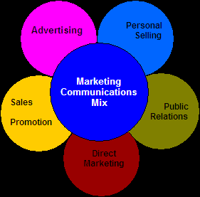

*The five elements of marketing communications mix[21]*

When a company is deciding how to properly utilize the marketing communications mix to meet its marketing objectives, it is important to consider the relative strengths and weaknesses of each elements of the mix. The company will have to balance the various parts of the mix not only to create an integrated approach to its marketing communications but it must also devote enough resources for each elements to be successful. The five elements mix can be explain below;

*Advertising* is any paid form of non-personal presentation and promotion of ideas, goods, or services by an identified sponsor.

*Personal selling* is traditionally perceived as an interpersonal communication tool which involves face-to-face activities undertaken by individuals, often representing a company, in order to inform, persuade or remind an individual or group to take action.

*Sales promotion* is a short-term incentive to encourage the purchase or sale of a product or service. It has a greater capability to be targeted at smaller audiences, and it is controllable.

*Public relations* is building a good relationship with the company’s various publics by obtaining favorable publicity, also building up a good "corporate image", and handling or heading off unfavorable rumors, stories, and events.

*Direct marketing* is a direct communications with carefully targeted individual consumers to obtain an immediate response and cultivate lasting customer relationships.

6.3 IBFD competitors marketing communications

The big players in the LTR industry use various marketing communications mix to reach their target audience. The IBFD and its competitors use almost similar strategies to communicate to their target audiences. Although, some competitors have more features in their mix. Below are different ways IBFD competitors carry out their communications.

LexisNexis, for example, does its marketing communications through newsletters (via email), e-voicing, video and web tutorials, social network online communities[22] where people connect with the professionals (attorneys, corporate executives, regulators, government officials and academicians), LexisNexis also use download centre to communicate to its audience, in this centre there are links to obtain software, product tutorials, documents, podcasts, news feeds and components (such as iGoogle gadgets and Yahoo! Widgets).[23] Current and potential customers can get these contents for FREE with no strings attached. LexisNexis have a link to Facebook social network, (see appendix 1).

CCH on the other hand reaches its current customers and potential customers through different means, which include;

*Live Interactive Audio Seminars*; it’s a two-hour audio seminar that requires a telephone connection. For one low fee per site, you can have an unlimited number of listeners at your site participate.[24]

***CCH® Journals and Newsletters alerts;* this email alerts notify its audience when the current issue is available online and also provide summary of contents.**[25]

***Tax News Headlines;* is a daily tax and accounting news headlines, which is available online or required signup**[26] **for delivery to customers email inbox or PDA.**

***Focus on Tax Newsletter;* it is a monthly newsletter that features analysis of current issues for tax accounting and legal professionals.**

***Product Demos;* CCH also offer a product demos that has links to *Live Web Demos, Flash Overviews and Trial Software* (see appendix 3).**

***CCH Training &Consulting Solutions;* is site provided by CCH where clients learn more view e-Brochure (firms) e-Brochure (Corporations). There are other ways of marketing communications used by CCH, such as;** promotions, direct mail and advertising.

RIA Thomson; a major player in the industry also communicate to its audience in a similar way like every other company in the publishing industry, they use learning center[27] (such as; Live Virtual, Live Regional, On-Demand).

*Live Virtual;* training includes classroom training with instructor led web-based training. When you click on the Live Virtual links it will lead the customer to RIA Thomson’s various Virtual classrooms (Webinar).

*Live Regional*; this includes a traditional hands-on classroom setting with a presenter. Live Regional is offered across the country, and for a select group of courses.

*On-Demand;* this is accessed by anyone in the client company, at anytime and from anywhere an Internet connection is available. They also offer trials and demos access to the following products; *Financial Reporting & Management on Checkpoint*[***®***](http://ria.thomsonreuters.com/integratedsolutions)*, Checkpoint*[***®***](http://ria.thomsonreuters.com/integratedsolutions) and *E-Form RS[28]* to facilitate clients purchase decision. The trial is free for 30 days and if a customer is interested in a particular product and there is no trial available the client has to contact RIA Thomson’s customer service representative for assistance

|  |  |  |
| --- | --- | --- |
| Financial Reporting & Management on Checkpoint[**®**](http://ria.thomsonreuters.com/integratedsolutions) | Checkpoint[**®**](http://ria.thomsonreuters.com/integratedsolutions) | E-Form *RS* |
| The Financial Reporting & Management on Checkpoint gives CFOs, controllers, and financial managers the guidance to make critical decisions and manage their company’s profitability and success. | Checkpoint is an easily-searchable online system, which assist clients to get straight to their answer. With Checkpoint there is no wading through endless entries of unrelated information just the important results you need to know. | e-Form *RS* is a Web-based product that allows clients to use the Internet to access current forms immediately without waiting for CD-ROM updates. |

*Product brochures*; is where all the products are listed and there is link to view the products.[29]

*Support by product*; assist customers in whatever information they want to know about a particular product before making purchase decision.[30]

### Empirical findings

The results of the findings carried out revealed the evaluations of various products of both the IBFD and its competitors, there were no significant differences compared to the previous surveys.

The sample’s influence on the evaluation’s results is fairly limited. Thus, the given evaluations provide an accurate indication of how the IBFD products are judged, and that therefore a direct comparison with the competitors’ offerings is valid.

The result also compared those customers who rely solely on IBFD for their tax information with those customers that use the IBFD tax products as well as other competitor’s products for their tax information needs. The issues that emerged from the questionnaire are listed below:

Awareness of different products by publishers

*List all publishers you know who offer information on international taxation via books, online publications, journals and software applications*

*Chart 1*



Source: chart adapted from Millward Brown survey

From chart 1 above, shows that the IBFD is still the recognized publisher for international taxation in the industry, since the last benchmark survey carried out by Millward Brown. The awareness of other competitor’s in the publishing industry is low, if you compared it with the amount professionals using publishers for international tax information.

Use of publishers

*Which publishers do you rely on for cross-border tax information?*

*Chart 2*



Source: chart adapted from Millward Brown survey

*Does one rely only on the IBFD for cross-border tax information?* *(This is based on regions)*

*Chart 3*



Source: chart adapted from Millward Brown survey

From charts 2 & 3 above, indicate that about 85% of respondents rely on IBFD for cross-border tax information. The respondents also rely on the competitors for tax information which also show that IBFD competitors are well known publishers in the industry. About one in ten newsletter subscribers does not rely on the IBFD only but also its competitors.

Chart 3; show that about one in four tax professionals rely solely on IBFD, while three out of the four tax professionals rely on the main competitor’s for international tax information.

Frequency of use

*Which of the following IBFD products do you use?*

*Chart 4*%



Source: chart adapted from Millward Brown survey

*How frequently do you use the following IBFD products?*

*Chart 5*



Source: chart adapted from Millward Brown survey

Chart 4 & 5, shows the percentage of frequent use of the IBFD products. 43 % of tax professionals use Tax News Service and 30 % Tax Treaties Database; it shows that these are the most popular titles. One in ten of IBFD customers cannot identify the title(s) they use from the list presented.

Most IBFD products are used at least once a month by the majority of their users, with the Tax News Service.

Publisher evaluations per region

*Could you rate the publisher’s products? (% excellent and good)*

*Chart 6*



Source: chart adapted from Millward Brown survey

Chart 6 publisher evaluations by regions. Chart 6 shows that the IBFD is viewed more positively by its US users by 87% than those users in Scandinavia 75% and the rest of the world at 77%. LexisNexis users in Europe are not as positive as their counterparts in the rest of the world. BNA International is rated lower by the users in Europe than those in the US.

Solves issues in daily tax practice

*Could you indicate to what degree you feel the following statements apply to the product…?*

*Chart 7*



Source: chart adapted from Millward Brown survey

From chart 7 above, the respondents show that IBFD and its competitors are seen as solving issues in daily tax practice. This means that there is no difference between IBFD and its competitors in the publishing industry.

Is up-to-date

*Could you indicate to what degree you feel the following statements apply to the product…?*

*Chart 8*



Source: chart adapted from Millward Brown survey

Chart 8 indicate the degree of having up-to-date information is extremely essential to the customers, and although the IBFD is rated quite highly when compared to some competitors, customers feel that there is still room for improvement.

Offers good value for money

*Could you indicate to what degree you feel the following statements apply to the product…?*

*Chart 9*



Source: chart adapted from Millward Brown survey

The chart above shows how customers view the value of the products for money from the publishers. It remains difficult for most tax professionals to judge whether a publisher offers value for money.

Is easy to access

*Could you indicate to what degree you feel the following statements apply to the product…?*

*Chart 10*



Source: chart adapted from Millward Brown survey

From the chart above, 40% of respondents totally agreed that IBFD and Tax Analysts products are easy to access, and they were both highly rated.

### Analyzing the empirical findings

The findings clearly showed that respondents are aware of the publisher’s products. The IBFD is still the publisher that offers information on international taxation via books, online publications, journals and software application in the publishing industry as indicated in chart 1 with 32% of the respondents. There were no significant changes in the awareness of the various publishers’ products since last survey done by Millward Brown (*one of the world leading research companies*).

The awareness and use of other competitor’s products is low compared with the amount of customers using the publisher’s products for international tax information. Chart 1 also shows that 16% of the respondents are not aware neither uses the publisher’s products for information on international taxation.

About 85% of the respondents actually acknowledge that they rely on IBFD products for cross-border tax information. Chart 2 also shows that some of the publishers (such as; LexisNexis, CCH and Tax Analysts) products are popular and the respondents also rely on them for international tax information. There are about 5% of the respondents that does not rely on international tax information from none of these publishers. Chart 3 shows the use of the publisher’s products based on regions. The chart indicates that 83% of the UK respondents and 70% of the US respondents uses IBFD products and other products. The IBFD’s products are well represented in the Scandinavia with 35% respondents compared to the rest of Europe which has 25% of respondents.

The chart also reveals that 30%, 26% and 23% of the respondents in the UK, US and the rest of the world do not rely on IBFD for cross-border tax information.

Publisher evaluations on chart 6 indicate that the IBFD’s products are rated more positively by its US respondents than the Scandinavia and the rest of the world respondents. Chart 4 and 5 illustrate the frequency of use of the IBFD products. The TNS (online, E-mail and Newsletter) is the most frequent product used by the respondents as shown in chart 4. 36% of the tax professionals who took part in the survey use the TNS daily and some of them weekly. Other products (such as the Tax Treaties Data (online) and the Value Added Taxation in Europe (online) also demonstrated a huge interest of by respondents with 30% and 14% respectively.

The majority of the products are used frequently by tax professionals, at least once a week or once a month as indicated in chart 5, apart from the Europe-Individual Taxation (Online) which stands at 42% and is not often used by the respondents. Both chart 4 and 5 also point out that most respondents do not know which title(s) they actually used or maybe not aware of the products from the list of products presented. For example, 11% of the respondents don’t know as shown in chart 4.

The respondents who participated in the survey sees all the publishers as solving issues in daily tax practice as you can see in chart 7. The IBFD does not distinguish itself from this area of solving issues from its competitors. Although, some of the publishers especially CCH 14% and BNA International 34% are seen by the respondents as publishers not solving issues in the daily tax practice as denoted in chart 7. The tax professionals totally agreed that the IBFD offers products value for money, in other words they are satisfied with purchase from the IBFD.

Up-to-date information is an essential part of the publishing industry. Chart 8 denotes the percentage of respondents that sees IBFD cross-border information as up-to-date information; although 5% of the tax professionals believe that there is still opportunity for improvement. Tax Analysts was rated high 48% tax professionals feel Tax Analysts furnish them with up-to-date information. Customers totally agreed with the IBFD and Tax Analysts on accessibility; both publishers scored 40% on chart 10, while 12% of the respondents neither agree nor disagree with IBFD accessibility.

### Recommendations and Conclusion

Referring to the problem formulation (see pg 3) the purpose of this study is what strategy should the IBFD employ in order to create and maintain sustainable competitive advantage. In order for the IBFD to achieve a sustainable competitive advantage over its competitors in the LTR changing industry structure and competitive situation, the IBFD clearly require a viable competitive strategy. It has to make adequate adaptations to these dynamic changes and respond quickly to create or sustain its competitive advantage (Picard, 2003). By so doing, the IBFD have to put its forces active in the market into perspective and by narrowing the problem down to such an extent that the current and future changes in the industry can be linked to possible strategic opportunities.

Considering the three generic strategic methods outlined by Porter on how to achieve sustainable competitive advantage on pg 2, it is not advisable for the IBFD to employ cost leadership strategy because it is a non-profit organization. The best strategy to achieve a sustainable competitive advantage in the LTR industry is through *differentiation.* Differentiation is based upon company’s specific skills and it creates a durable asset that is difficult for competitors to imitate. It can also create commitment for the customers. Therefore, differentiating IBFD products can create a sustainable competitive advantage. The impact that differentiation has on demand depends on the competitive nature of the publishing product market environment. The IBFD may seek one or maybe a few attributes that a large amount of customers find important and should capitalized on it and position its strategy uniquely to meet those needs. In other words, the differential strategy must add value in terms of greater customer’s satisfaction and unique features. When IBFD offer a product and/or service perceived by the customers as unique, they will be rewarded by a price premium. Of course, achieving superior performance IBFD must ensure that the price premium earned exceeds the extra costs incurred for being unique.

Another method of achieving a sustainable competitive advantage is *information technology* (IT); IT is a general term that helps to produce, communicate and/or disseminate information and store information, associated with the use of computers and information. This source has a great potential for achieving sustainable competitive advantage and the awareness of the IBFD products. The improvement of the IBFD information technology developments will facilitate and increase its efficient and effective utilization of information over ranges of products and services to their current and potential customers. The improvement of information technology will also help facilitate differentiation of products and services (Chyi and Sylvie, 1998). The internet and online subscription has been a great instrument for the IBFD marketing strategy. The IBFD should also offer services such as; interactive forum (an active learning techniques whereby current and potential customers can ask questions and get immediate responses from tax professionals), searchable news archives, up-to-the minute information and audio/video presentations. The integration of more activities will allow a greater personalization of relationships and interactivity between customers and the IBFD and this will also set the potential competitive advantage of the IBFD. However to use these technologies in a competitive way, substantial investments in capital and expertise is required.

The introduction of social network (such as facebook, blogs, forum, mash-ups and eBooks) by some of the competitors created a competitive advantage for those companies that introduced these technologies.

Furthermore, the IBFD can also gain or maintain a sustainable competitive advantage through *innovation*; Innovation is an essential business strategy to add value, and the only way to meet and stay ahead of the competition and it is a positive way of changing or making products better in a company and industry as a whole. Creating unique ideas is the fundamental source of increasing customer’s loyalty and revenues in a company. Innovations will give the IBFD competitive edge in the LTR industry because no competitors in the industry will be able to duplicate or imitaiate betters the innovations or the products. Innovations are essential for the IBFD because it would help them to protect or increase the market share, or even better generate funds to strength IBFD competitive position.

Finally, in the LTR industry *marketing and reputation* play an important role in gaining and maintaining sustainable competitive advantage, the purpose of marketing is to create a brand image and loyalty of current and potential customers while, Image and loyalty are related to the notion of ‘reputation’. A company can build up a reputation with a consistent policy, marketing and reputation highly qualified products and services. The IBFD is a reputable player in the publishing industry with a brand image and customer’s loyalty. In order to maintain this reputation in the LTR industry, the IBFD should continue to offer products that significantly depend on their reputation and reliability to its customers, because customers relate closely to the reputation and reliability of a company to the quality of its products and services. The IBFD can also use their reputation to diversify into number of unrelated and related businesses that are centered around their core business.

To conclude this resaerch the IBFD should be aware that the publishers and information providers of cross-border tax operate in more or less similar circumstances and under similar conditions. This operation of these companies has lead to declining profits because of increased competition, and lack of proper marketing communications in the LTR industry which also contributed to declining profits. Other publishers and information providers in the LTR industry are also well aware of the pace and nature of changes in the indusrty, the revolution in IT is opening up new ways to gather, package and present information about products to customers. The customers themselves have changed as more options are emerging; these customers are increasingly willing to switch on to new content sources and formats, from blogs, to social networks to mash-ups to eBooks. The rapid pace of changes in the LTR industry and the structure of the industry may be very different from the past. These changes are forcing publishers and information providers in the LTR industry to discover their competitive advantages. The ability for a publisher to change its organizational structure and existing activities and businesses along evolution of IT in the industry can be seen as a major source of success, if the right strategies are implemented or failure if they fail to implement the right strategies.

For the IBFD to achieve/maintain a sustainable competitive advantage in the LTR industry, it should implement the various strategies discussed in this report in order to create/add value to its products or services and also to improve satisfaction to the customers. The IBFD should also embark on major advertising campaigns for the coming years for the awareness of its products.

### References

Literature

**Barney, J. (1991)**, *"Firm Resources and Sustained Competitive Advantage",* Journal of Management, Vol. 17 No.1, pp. 99-120.

**Blythe, J. (2000),** *Marketing Communications*, Edinburgh, Pearson Education

**Doole, I. , Lowe, R. (2008),** *“ Internat ional marketi ng str ategy“* , Fifth edition, Seng Lee Press, London.

**Duncan, T. (2002)**, *IMC: Using Advertising and Promotion to Build Brands*, McGraw-Hill, New York, NY, International edition,

**Fill, C. (2002)**, *Marketing Communications, Contexts, Strategies and Applications*, Europe, Prentice Hall

**Fleisher, C.S. & Bensoussan, B.E. (2003),** Strategic and Competitive Analysis, New Jersey: Pearson Education

**Gordon, I. (1998)**, *“Relationship Marketing: New Strategies, Techniques and Technologies to Win the Customer You Want and Keep them forever”*, John Wiley and Sons Publisher, 1998.

**Gursoy, D., Swanger, N., (2007),** *“Performance-enhancing internal strategic factors: impacts on financial success”. International Journal of Hospitality Management”,* Vol. 26, No. 1, pp. 213-227.

**Hamel, G. and Heene, A. (eds)** *Competence-Based Competition*. Chichester: John Wiley & Sons Ltd.

**Hofer, C. W. and Schendel, D. (1978)***, Strategy Formulation: Analytic Concepts*. West, St Paul.

**Holm, O. (2004),** *Victims of power and tradition in a market economy*, Business Strategy Review, Spring edition

**Johnson, G., Scholes, K. (2002),** *Exploring Corporate Strategy*, Edinburgh, Prentice-Hall

**Kluyver, C. & Pearce II, J. (2006)***, Strategy A view from the top*, New Jersey; Prentice Hall

**Kotler, P. (2003),** *Marketing Management*, New Jersey, Prentice-Hall/Pearson Education

**Liou, J.J.H. (2009)**, *“A novel decisi on rules approach for customer relationship management of the airl ine market”,* Expert Systems with Applications, Vol. 36 (2009), 4374-4381.

**Peteraf, M. (1993),** *“The Cornerstones of Competitive Advantage: A Resource-Based View”,* Strategic Management Journal, Vol.14, No.3, March 1993, pp. 179-191.

**Pickton, D., Broderick, A. (2001),** *Integrated Marketing Communications*, Harlow, Pearson Education Limited

**Popa I. (2004),** *Management strategic*, Bucuresti, Editura Economica

**Porter, M.E. (2001**), "Strategy and the internet", *Harvard Business Review*, March

**Porter, M. (1980)***, Competitive Strategy: Techniques for Analyzing Industries and Competitors*, New York: The Free Press.

**Porter, M. (1985),** *Competitive Advantage: Creating and Sustaining Superior Performance*, New York, The Free Press.

**Porter M. (1985),** *Competitive Advantage*, New York, The Free Press

**Porter, M.(Nov – Dec 1996),** *"What is strategy?"* Harvard Business Review v74, n6

**Schultz, D. and Kitchen, P. (2000),** *Communicating Globally: An Integrated Marketing Approach* London, Macmillan Business.

**Smith, P.R., Berry, C., Pulford, A. (1999),** *Strategic Marketing Communications*, London, Kogan Page

Web pages

*“Business studies: a competitive market”:*

(http://www.bbc.co.uk/schools/gcsebitesize/business/environment/acompetitivemarketrev1.shtml) viewed 2009-08-10.

<https://clients.outsellinc.com/revenue/detail.php?i=15>

<http://www.cch.com/About/>

<http://tax.cchgroup.com/email/default.htm>

<http://www.lexisnexis.com/about-us/>

<http://ria.thomsonreuters.com/>

<http://ria.thomsonreuters.com/brochures/>

<http://support.rg.thomsonreuters.com/>

<http://www.ibfd.org/portal/AboutIbfd.html>

<http://www.ibfd.org/portal/IBFDPublicationsBV2.htm>l

### Appendix

Appendix 1

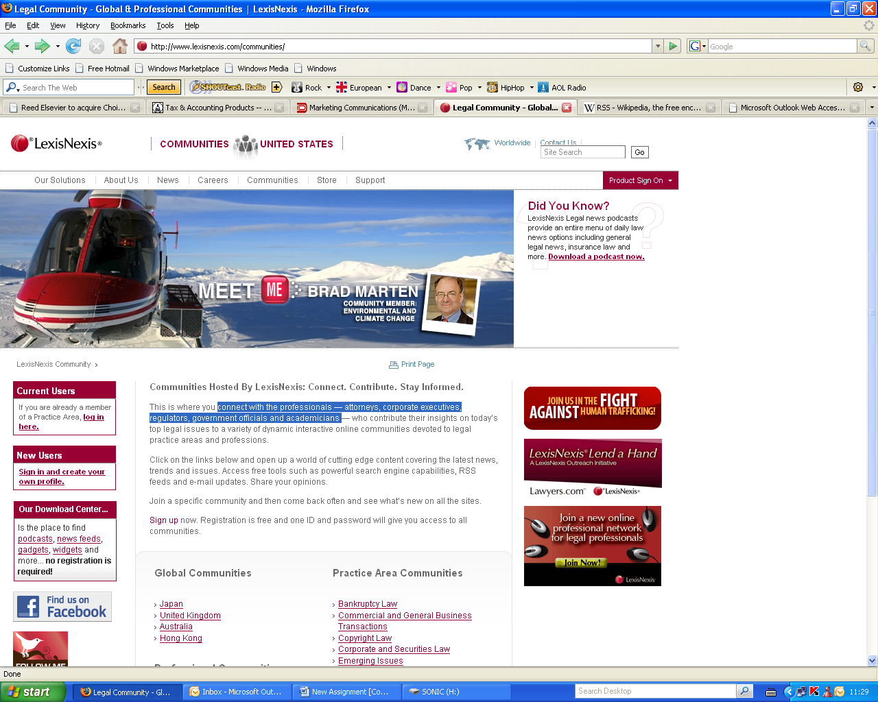

Online communities

**Source:** [*http://www.lexisnexis.com/communities/*](http://www.lexisnexis.com/communities/)



E-voicing

**Source:** *http://www.lexisnexis.com/Community/DownloadandSupportcenter/media/p/4248.aspx*

Appendix 2

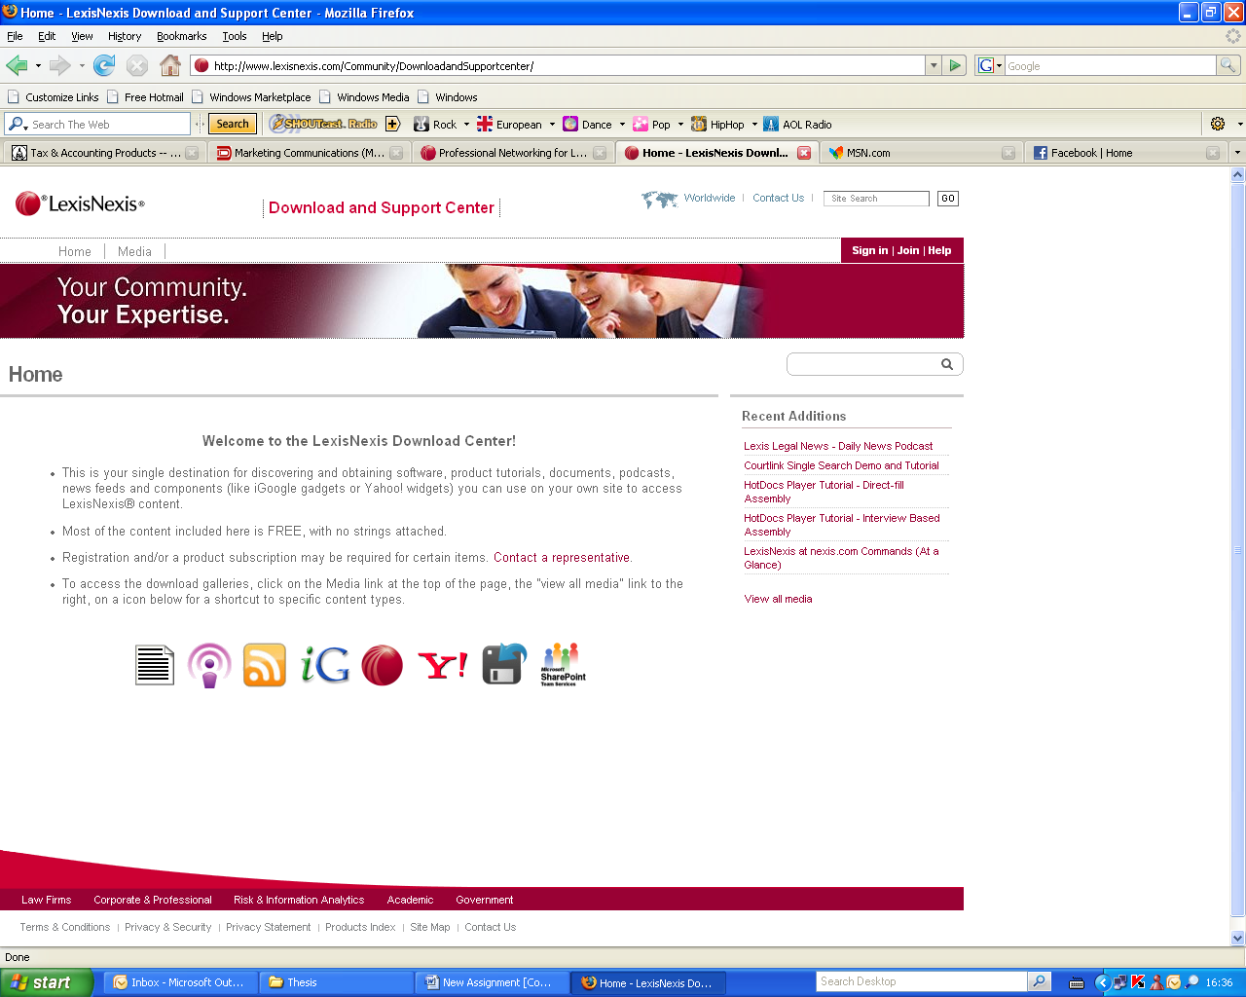

**Source:** *http://www.lexisnexis.com/Community/DownloadandSupportcenter/*

Appendix 3

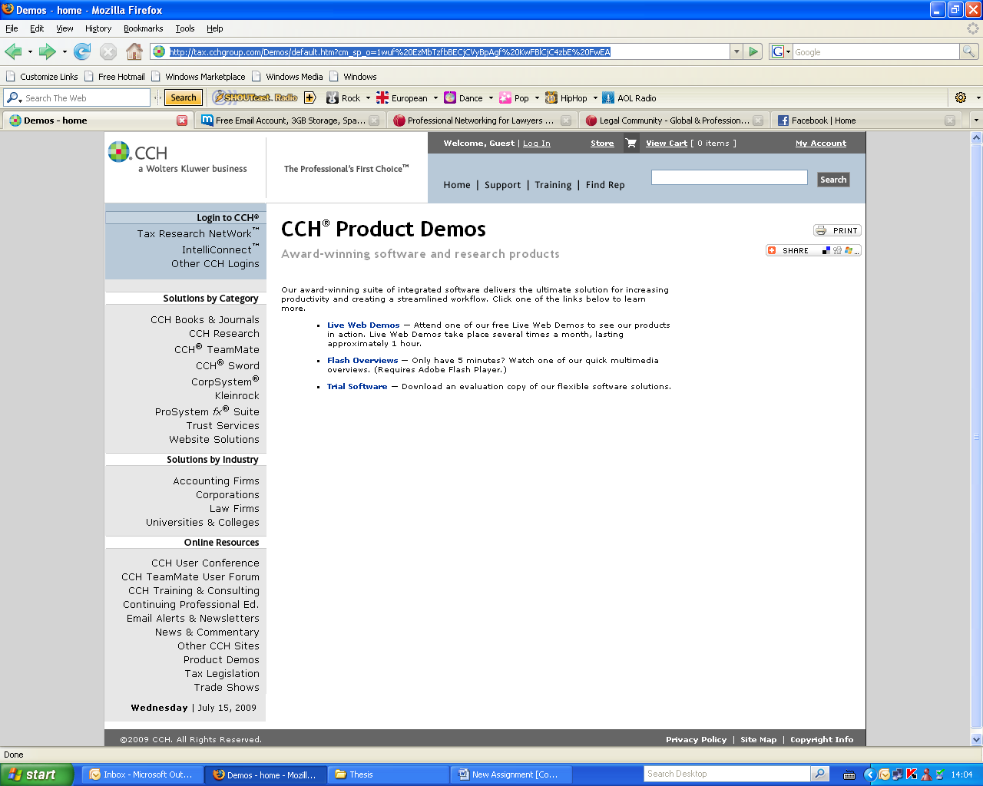

**Source:** *http://tax.cchgroup.com/Demos/default.htm*

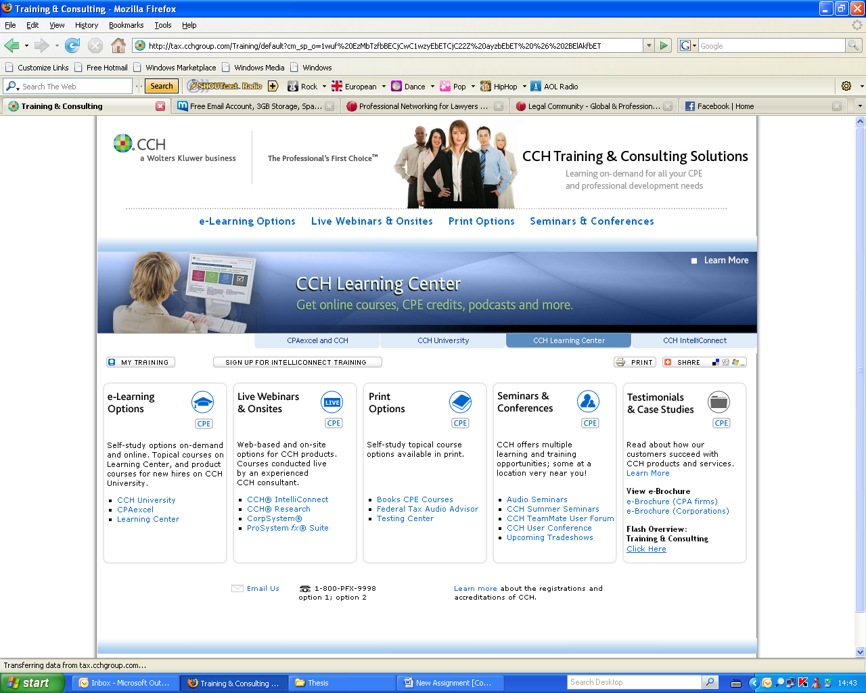

**Source:** [*http://tax.cchgroup.com/Training/default*](http://tax.cchgroup.com/Training/default)

Appendix 4

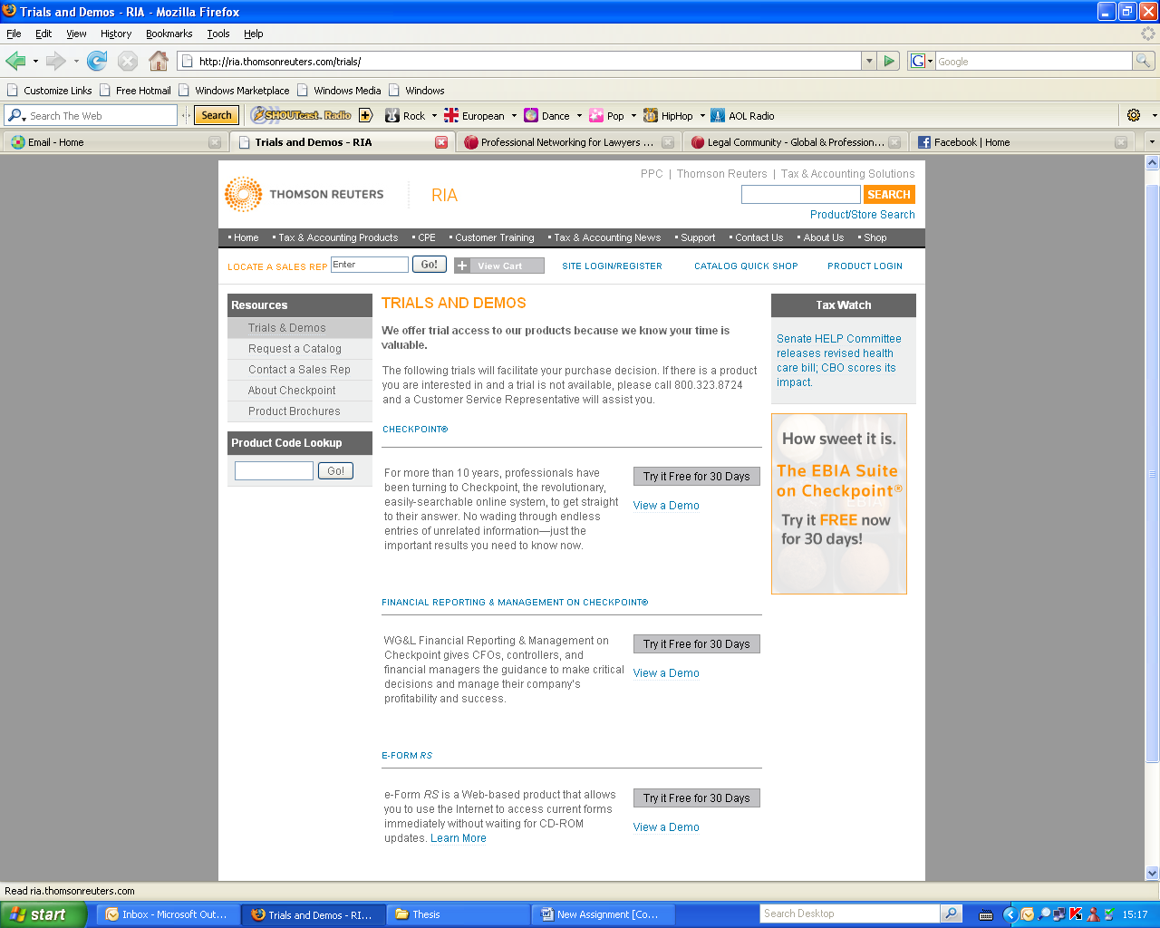

**Source:**<http://ria.thomsonreuters.com/trials/>

Appendix 4.1



**Source:** [*http://support.rg.thomsonreuters.com/Training/default.asp*](http://support.rg.thomsonreuters.com/Training/default.asp)*?*

Appendix 4.2

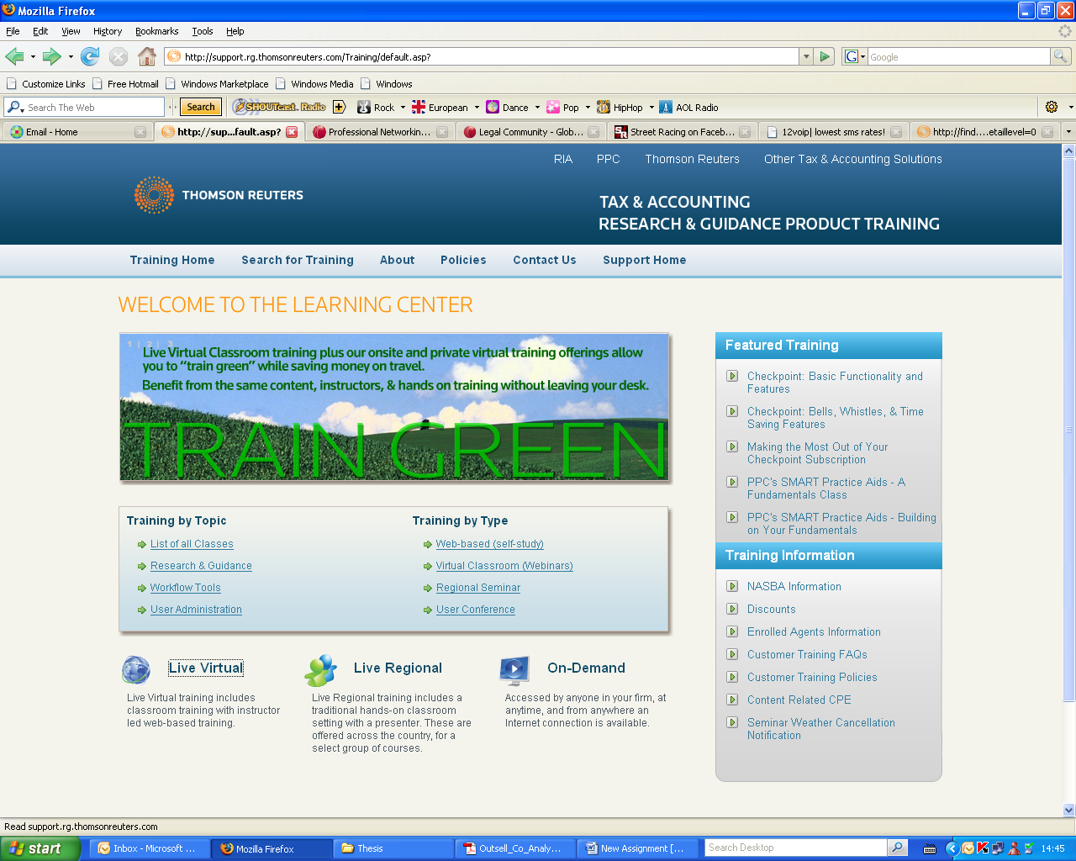

**Source:** [*http://support.rg.thomsonreuters.com/Training/default.asp*](http://support.rg.thomsonreuters.com/Training/default.asp)*?*

1. Kluyver, C. & Pearce II, J. (2006) *Strategy A view from the top*, New Jersey; Prentice Hall
2. Porter, M. (1980) *Competitive Strategy: Techniques for Analyzing Industries and Competitors*, New York: The Free Press.
3. Cornelis A.de Kluyver, John A. Pearce II ,2006
4. *http://www.ibfd.org/portal/AboutIbfd.html*
5. *http://www.ibfd.org/portal/AboutIbfd.html*
6. *http://www.ibfd.org/portal/IBFDPublicationsBV2.htm*
7. Porter, M.E. (1998) *Competitive Strategy,* New York: The Free Press
8. Fleisher, C.S. & Bensoussan, B.E. (2003) *Strategic and Competitive Analysis,* New Jersey: Pearson Education
9. Porter, M. (1980) *Competitive Strategy: Techniques for Analyzing Industries and Competitors*. New York: The Free Press
10. Oster, S.M. (1999) *Modern Competitive Analysis,* New York: Oxford University Press
11. Porter, M. (1980) *Competitive Strategy: Techniques for Analyzing Industries and Competitors*. New York: The Free Press.
12. Porter M. (1985) *Competitive Advantage*, New York; The Free Press
13. http://www.outsellinc.com/legal_tax_regulatory/products/855
14. *http://www.cch.com/About/*
15. *http://www.lexisnexis.com/about-us/*
16. *http://ria.thomsonreuters.com/*
17. http://www.oanda.com/currency/converter/
18. http://www.lexisnexis.com/privacy/for-customers/
19. *Mr. Viljoen T. Director, Business Development & Africa, LexisNexis*
20. *Fill, C. (1999) Marketing Communications, Contexts, contents and strategies, Harlow, Pearson Education Limited*
21. Fill, C. (2002), *Marketing Communications, Contexts, Strategies and Applications*
22. *Appendix 1*
23. *Appendix 2*
24. *http://tax.cchgroup.com/AudioSeminars/Default.htm*
25. *http://tax.cchgroup.com/email/default.htm*
26. *http://tax.cchgroup.com/NewsHeadlines/default.htm*
27. *Appendix 4.2*
28. *http://ria.thomsonreuters.com/trials/*
29. *http://ria.thomsonreuters.com/brochures/*
30. *http://support.rg.thomsonreuters.com/*