HAn university of Applied sciences
HAN hogeschool van Toegepaste Biowetenschappen en Chemie
Treatment of the gastrointestinal microbiome to decrease ASD symptoms
INSIGHTS FROM MOUSE MODELS
Marloes Pots LS-2W
2024

Abstract
Autism Spectrum Disorder (ASD) is a neurobiological condition affecting about 1% of the population, characterized by repetitive behaviors, restricted interests, and communication deficiencies. While ASD has both genetic and environmental influences, the role heritable yet non genetic gastrointestinal microbiome is of great importance to this review. Research indicates differences in the gut microbiome of individuals with ASD, with increased Pseudomonadota and Firmicutes and decreased Bacteroidetes. ASD patients often experience gastrointestinal (GI) issues, but these are frequently overlooked. With the gut-brain axis being wide accepted in the scientific field it is of great importance to look more into the effect of the gut microbiome on ASD symptoms. Two treatment method are review, first supplementing 5-aminovaleric acid (5AV) and taurine and second supplementing L. reuteri. Both methodsresult in an increase in the social behaviors and thus hold great promise.

Keywords: autism spectrum disorder (ASD), gastrointestinal microbiome, gut microbiome, gut-brain axis, mouse model, 5AV, taurine, L. reuteri

Introduction
Autism spectrum disorder (ASD) is a neurobiological disorder affecting about 1% of the population. The disorder is characterised by repetitive and restrictive behavioural patterns, activities, and interests as well as a deficiency in communication affecting the social interactions (Kang et al., 2017).

Neuroimaging has been used to gain more insight into the underlying neurobiological mechanisms of ASD. These images show that during brain development structural and functional abnormalities arise in patients with ASD. These abnormalities have an effect on the microstructural cortical folding, this then affects the functioning of brain regions and local neuronal circuits likely causing the atypical behaviours (Ha et al., 2015). Even though ASD is present and affects the lives of a large number of people the understanding of the causation of these abnormalities in brain structure remains below par.

ASD is influenced by both genetic and environmental factors however, how much these environmental factors play a role remains relatively unknown. One non genetic yet heritable factor that could play a cause in the atypical behaviours is the gastrointestinal microbiome (Sharon et al., 2019). This is a complex population of microorganisms colonising the gastrointestinal tract of humans. These microorganisms consist of bacteria, archaea, and eukarya together they are called the gut microbiome (Thursby & Juge, 2017). Research into the gut microbiome of ASD patients show that there is a difference between the microorganisms populating the gut of people with and without ASD. People with ASD show an increase in Pseudomonadota and Firmicutes and have a decrease of Bacteroidetes (Lewandowska et al., 2023).

Studies have shown that the gut microbiome influences the interactions between the central and enteric nervous system and the peripheral intestinal functions (Carabotti, 2015). Patients with ASD often suffer from gastrointestinal (GI) disorders. Children with ASD are 3.5 times more likely to have GI issues compared to children with a typical development. However, these issues are mostly overlooked and left untreated (Madra et al., 2021).

With GI disorders being linked to changes in the gut microbiome of patients with ASD; the gut microbiomes influence on the interaction between the central nervous system and the enteric nervous system. It could offer a way of treating the behavioural patterns of patients with ASD by applying changes to the gut microbiome. This review will therefore dive into different treatment methods of the gut microbiome and their influences on ASD symptoms. A summary of multiple murine models will be used to answer the question, is targeting the gastrointestinal microbiome an effective way of treating ASD symptoms?

Treating the excitability – inhibition imbalance
Germ-free wild type mice colonized with the faecal microbiota of people with ASD are able to produce offspring that exhibit the behavioural symptoms of ASD patients when compared to the offspring of mice colonised with the faecal microbiota of people with typical development (TD). They were less socially adapt and showed more repetitive behaviour. These “humanized” ASD mice also showed an altered gene expression in their brain along with a significant decrease in the metabolites 5-aminovaleric acid (5AV) and taurine compared to the “humanized” TD mice (Sharon et al., 2019).
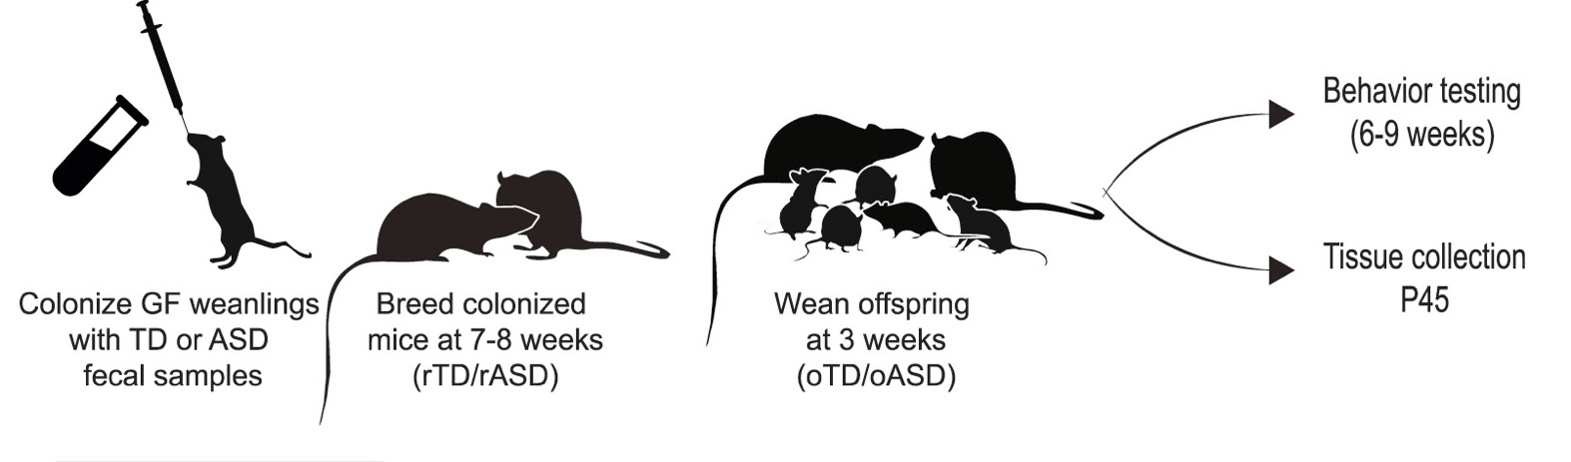
Figure 1. The creation of “humanized” ASD mice. Experimental set up showcasing how “humanized” ASD mice are created as the offspring from germ-free mice colonized with faecal samples (Sharon et al., 2019).

5AV and taurine are metabolites of gut bacteria that are linked to the inhibitory neural receptors known as GABA receptors (Bacteria and Their Bearing on Bowels and Brain, n.d.). With some forms of ASD likely having an imbalance between excitability and inhibition as it’s causation. The lack of the metabolites compared to the typical developed mice can offer an explanation.

Treating the ASD mice with 5AV to make up for the lack of production, showed that the pyramidal neurons in layer five of the medial prefrontal cortex had decrease in the excitability. This decrease has a positive effect on the behaviours of ASD mice by increasing their social behaviour and reducing their repetitive behaviour (Sharon et al., 2019). Furthermore, treatment of the ASD mice with taurine also saw a decrease in excitability resulting in an increase in the social behaviours and a decrease of repetitive behaviour. On top of this the ASD mice displayed a major reduction in their anxiety levels (Sharon et al., 2019).

However, treatment with both 5AV and taurine only has these desired effect when done during the prenatal and weaning periods (up to 3/4 weeks after birth). Treating juvenile and adult mice did not result in any alterations to the atypical behaviours (Sharon et al., 2019). This would mean that treating humans with ASD using this method will be considerably harder as autism is diagnosed between the ages of 38 to 120 months (Van ‘T Hof et al., 2020). With the weaning period of humans being between 24 to 48 months (“Weaning From the Breast,” 2004), this would mean that the 5AV and taurine treatment would start too late for most ASD cases.

Treating the oxytocin – dopamine reward system
The shank3 mouse model was used to test the treatment method using L. reuteri. Shank3 serves as a synaptic scaffolding protein found abundantly in the postsynaptic density of excitatory synapses. The protein is crucial for the establishment, development, and upkeep of synapses (Peça et al., 2011). At the genetic level the disturbance of shank3 could be linked to development of 22q13 deletion syndrome better known as Phelan-McDermid Syndrome and a plethora of other non-syndromic ASDs (Peça et al., 2011).
The shank3 mice all show similar ASD behavioural symptoms, there is a great social deficit along with repetitive and restrictive behaviour. Most notably of which is the repetitive self-injurious grooming of the mice (Peça et al., 2011). When comparing the gut microbiome of the shank3 mice with the wild type mice there appears to a notable difference. The shank3 mice have a significantly lower level of L. reuteri compared to the WT (Sgritta et al., 2019).

Making up for this lack of L. reuteri present in the gut microbiome of shank3 mice by adding the bacteria to the water supply reverses the social deficit displayed by the mice before treatment. Previous research has shown that the activation of vagus nerve is done as a response to specific bacteria. The Lactobacillus species L. rhamnosus is known to depend on stimulating the vagus nerve to reduces anxiety related behaviour (Sgritta et al., 2019). With L. reuteri coming from the same species it could explain why it depends on stimulating the vagus nerve to reverse the social deficit.

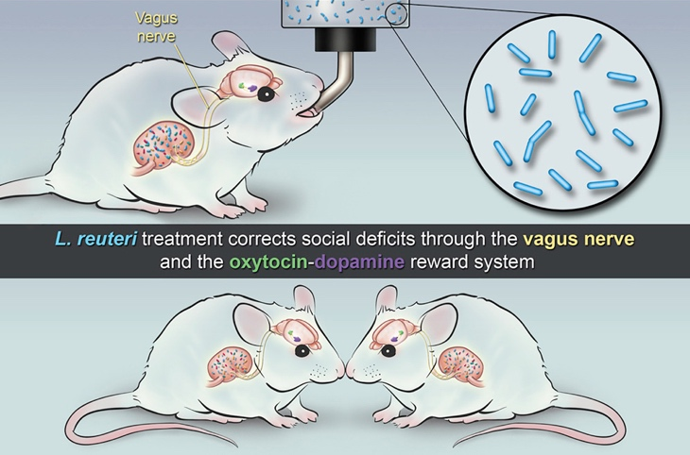
Figure 2. Treatment of mice with L. reuteri. The vagus nerve and the oxytocin – dopamine reward system are targeted using L. reuteri to correct the social deficits based on differences in gut microbiome compared to WT mice (Sgritta et al., 2019).

Shank3 mice show a reduction in the number of oxytocin positive neurons in the paraventricular nucleus of the hypothalamus (PNV) when compared to WT mice. The treatment with L. reuteri increases the number of oxytocin positive neurons in the PNV. This increase is due to the promotion of oxytocin that is released, this release is done by stimulating the vagus nerve which as state before L. reuteri is capable of (Sgritta et al., 2019).

However, with oxytocin playing a role in this system it leaves the question whether simply administering oxytocin instead of L. reuteri yields the same results, an increase in the social behaviours of shank3 mice.

Conclusion
Both treatment methods hold promise for treating the ASD symptoms found in mice however, they have yet to be tested on humans.

For the mice supplementing 5AV and taurine show a significant decrease in social defects and repetitive behaviours. However, these supplements only show this result when started during the prenatal and weaning periods (Sharon et al., 2019). This would make this treatment method considerably harder to use for humans as autism is generally diagnosed between 38 and 120 months (Van ‘T Hof et al., 2020) and the weaning period of humans usually ends around 48 months (“Weaning From the Breast,” 2004). Thus, in order to use this specific method, the diagnosis of autism should be preferably during the prenatal stages. This would mean that more research needs to be done in the development of the human brain with autism or any genetic deficits resulting in autism in order to diagnose it earlier.

The L. reuteri treatment is able to decrease the social defects by stimulating the vagus nerve and thus increasing the production of oxytocin. However, this opens the debate on whether simply supplementing the ASD patient with oxytocin would give the same positive effect as supplementing with L. reuteri does (Sgritta et al., 2019). More research needs to be done before an answer. Although this treatment method could likely be started at a later age due to its reliance on the vagus nerve being stimulated, treating social behaviours at a young age is still preferable.

Furthermore, neither of the treatment methods specifically change the gut microbiome of the ASD mice. They keep the gut microbiome and get the metabolites that are not produced by the microorganisms that they lack; or as in the case for L. reuteri they get bacteria that stimulates the vagus nerve however does not settle in the gut to become part of the microbiome. In conclusion the gut microbiome is not specifically targeted to treat ASD symptoms as much as it is used to determine where there is a lack of metabolites or stimulus.

References
Bacteria and their Bearing on Bowels and Brain. (n.d.). Feature | PNNL. https://www.pnnl.gov/news-media/bacteria-and-their-bearing-bowels-and-brain
Carabotti, M. (2015, June 1). The gut-brain axis: interactions between enteric microbiota, central and enteric nervous systems. PubMed Central (PMC). https://www.ncbi.nlm.nih.gov/pmc/articles/PMC4367209
Ha, S., Sohn, I. J., Kim, N. W., Sim, H. J., & Cheon, K. (2015). Characteristics of Brains in Autism Spectrum Disorder: Structure, Function and Connectivity across the Lifespan. Experimental Neurobiology, 24(4), 273–284. https://doi.org/10.5607/en.2015.24.4.273
Kang, D. W., Adams, J. B., Gregory, A. C., Borody, T. J., Chittick, L., Fasano, A., Khoruts, A., Geis, E., Maldonado, J., McDonough-Means, S., Pollard, E. L., Roux, S., Sadowsky, M. J., Lipson, K. S., Sullivan, M. B., Caporaso, J. G., & Krajmalnik‐Brown, R. (2017). Microbiota Transfer Therapy alters gut ecosystem and improves gastrointestinal and autism symptoms: an open-label study. Microbiome, 5(1). https://doi.org/10.1186/s40168-016-0225-7
Lewandowska, Z., Figlerowicz, M., & Mazur‐Melewska, K. (2023). Microbiota in Autism Spectrum Disorder: A Systematic review. International Journal of Molecular Sciences, 24(23), 16660. https://doi.org/10.3390/ijms242316660
Madra, M., Ringel, R., & Margolis, K. G. (2021). Gastrointestinal issues and autism spectrum disorder. Psychiatric Clinics of North America, 44(1), 69–81. https://doi.org/10.1016/j.psc.2020.11.006
Peça, J., Feliciano, C., Ting, J. T., Wang, W., Wells, M. F., Venkatraman, T. N., Lascola, C. D., Fu, Z., & Feng, G. (2011). Shank3 mutant mice display autistic-like behaviours and striatal dysfunction. Nature, 472(7344), 437–442. https://doi.org/10.1038/nature09965
Sgritta, M., Dooling, S. W., Buffington, S. A., Momin, E., Francis, M., Britton, R. A., & Costa-Mattioli, M. (2019). Mechanisms underlying Microbial-Mediated changes in social behavior in mouse models of autism spectrum Disorder. Neuron, 101(2), 246-259.e6. https://doi.org/10.1016/j.neuron.2018.11.018
Sharon, G., Cruz, N. J., Kang, D. W., Gandal, M. J., Wang, B., Kim, Y. M., Zink, E., Casey, C., Taylor, B. C., Lane, C. J., Bramer, L., Isern, N. G., Hoyt, D., Noecker, C., Sweredoski, M. J., Moradian, A., Borenstein, E., Jansson, J. K., Knight, R., . . . Mazmanian, S. K. (2019). Human Gut Microbiota from Autism Spectrum Disorder Promote Behavioral Symptoms in Mice. Cell, 177(6), 1600-1618.e17. https://doi.org/10.1016/j.cell.2019.05.004
Thursby, E., & Juge, N. (2017). Introduction to the human gut microbiota. Biochemical Journal, 474(11), 1823–1836. https://doi.org/10.1042/bcj20160510
Van ‘T Hof, M., Tisseur, C., Van Berckelear-Onnes, I., Van Nieuwenhuyzen, A., Daniels, A., Deen, M., Hoek, H. W., & Ester, W. A. (2020). Age at autism spectrum disorder diagnosis: A systematic review and meta-analysis from 2012 to 2019. Autism, 25(4), 862–873. https://doi.org/10.1177/1362361320971107
Weaning from the breast. (2004). Paediatrics and Child Health, 9(4), 249-253. https://doi.org/10.1093/pch/9.4.249

