Branding the Vanderlande Intranet

Veghel, January 2010

Michael Verheijden
Information and Communications Technology Media Design
Fontys University of Applied Sciences
m.verheijden@student.fontys.nl
Student number: 2066427

Vanderlande Industries
Vanderlandelaan 2, Veghel
Workflow Information Systems
Michael.Verheijden@Vanderlande.com

First tutor: Slaats, E.H.M.A.
Second tutor: Gaffert, J.J.
External expert: van Hout, B.
Preface
This report is written to clarify and inform about the actions taken to complete the assignment 'Branding the Vanderlande Intranet'. I've had the privilege of working at an the inspiring company Vanderlande Industries. Thanks to their excellent care and facilities I have had an inspiring and enriching 100 days. I have learned a lot here and I would hereby thank the company Vanderlande Industries for making this possible.
Special thanks go out to:
Dirk-Jan Verheijden, Ria Huls and Manon Verheijden for providing me with help and support whenever needed in the busy times of the internship.
Marc Schaaks, my supervisor from Vanderlande Industries for supporting me, providing me with help / advice whenever needed. And for inviting me to the two exclusive company visits made during my internship. I found these visits to be very educational and well organized.
Eric Slaats for his continuous support, guidance and advice throughout the internship.
My close colleagues at the Workflow Information Systems department for helping me out in times of need and for providing a fun and educational environment for me to work in.
The people of the Vanderlande Academy for helping me with conducting usability tests and helping me obtain information / photo material whenever needed.

Michael Verheijden
January 2010

Index Page

Chapter 1 Introduction 8
Chapter 2 Research 14
Chapter 3 Techniques 28
Chapter 4 Actions taken and preliminary recommendations 36
Chapter 5 Usability 44
Chapter 6 The new design 52
Chapter 7 The new navigation menu 64
Chapter 8 Silverlight 70
Chapter 9 Quality control 74
Chapter 10 Conclusion and final recommendations 78
Chapter 11 Evaluation and source list 80
Summary
This report describes how the different phases of the 'Branding the Intranet’ project have been taken. These phases are:
- Research on the wishes, needs and demands of Vanderlande Industries employees
- Research on the technology needed to achieve the fore mentioned goals
- Realization of prototype and design of the Vanderlande Intranet. This prototype combines the findings of conducted research on the needs and whishes of people with the technology found capable of fulfilling the wishes of said users into a usable design.
Research
Research has shown that the employees of Vanderlande Industries are unhappy about the current Intranet, it does not fit their needs and whishes. These whishes include an improved design that is more modern and up to date than the current design of the intranet. Also Interactivity in the form of forums and blogging are in high demand.
Design
The Vanderlande Employees have the need for an Intranet that is web 2.0. Research on web 2.0 technologies has been conducted to define what web 2.0 is and how the web 2.0 functions can be applied to the Intranet. The final design has been made to include the demands of the employees and to provide a web 2.0 environment where the Vanderlande employees have access to the demanded features.
Implementation
The design has been implemented on a pilot website. This pilot website was hosted on the SharePoint 2010 platform. This has been done to research the possibilities of this platform and to gain insights in the question whether SharePoint 2010 is an improvement over SharePoint 2007 and if Vanderlande should migrate to this new environment.
During user testing and developing, SharePoint proved to be such a viable platform that it is recommended for Vanderlande Industries to migrate to the SharePoint 2010 platform. The platform is currently still in beta and will be released in the second quarter of the year 2010.
The design has been tested and evaluated thoroughly during its development and also after implementation. Therefore it is safe to say that the new design is accepted by a large number of key users of the Vanderlande Intranet. No further problems are foreseen with the implementation of the design corporate wide.
The new Intranet will be more usable and accessible for its users. The functions allow for a much higher degree of collaboration and can increase the degree of productivity of all Vanderlande employees significantly compared to the old platform, saving money and time.
List of Figures Page:
Figure 1: Order intake financial years 2004-2009 of VI business areas 10
Figure 2: The WIS organ gram 10
Figure 3: Defining representivity:http://www.allesovermarktonderzoek.nl/Extra/Steekproef.aspx 15
Figure 4: Giving the perfect example of the new Web 2.0 look 21
Figure 5: Example of the search bar on www.tweakers.net 23
Figure 6: Related internet links on the BBC news website 23
Figure 7: Web 2.0 Tag cloud 24
Figure 8:
Creation of a text document using office 2010 web applications via the internet 24
Figure 9: EyeOS run via the internet 25
Figure 10: RSS newsfeed on a mobile phone 25
Figure 11: RSS Logo 26
Figure 12: Silverlight logo 29
Figure 13:
Example of Microsoft Expression Blend, from the Microsoft Expression suite. 30
Figure 14: Deep Zoom composer logo 31
Figure 15: Microsoft SharePoint feature Wheel 32
Figure 16: FAST Search results example 41
Figure 17: Example of the opening page of Vanderlande’s current intranet 45
Figure 18: Example of documentation on the Vanderlande intranet 46
Figure 19: Points of improvement on the current Vanderlande intranet 47
Figure 20: The interface of the public library 49
Figure 21: From http://www.useit.com/alertbox/reading_pattern.html 51
Figure 22: The new design on the Pilot environment 56
Figure 23: Impressions of the new design 57
Figure 24: Impressions of the new design 57
Figure 25: Impressions of the new design 57
Figure 26: The search bar 58
Figure 27: People matches 59
Figure 28: Discussion boards 59
Figure 29: Blogging 60
Figure 30: Profile tags 60
Figure 31: Streaming video 61
Figure 32: Notification icons 61
Figure 33: Overall website view 62
Figure 34: Website top image 62
Figure 35: F-Figure incorporated in the intranet design 63
Figure 36: Vanderlande’s current navigation menu 65
Figure 37: Vanderlande’s new navigation menu 65
Figure 38: Vanderlande’s new navigation menu 66
Figure 39: Vanderlande’s new navigation menu 66
Figure 40: Public navigation tree 68
Figure 41: Silverlight picture viewer 71
Figure 42: Deep Zoom tag browser 72
Figure 43: Silverlight Smooth Stream 73

List of definitions
Intranet
Internal company network used to disclose information. This network is only accessible to employees. An Intranet should not be confused with the Internet. The internet is visible to everybody
VIPP
Vanderlande Intranet Portal Project, the project the author has been working on for the past 100 days.

Expression Web
Tool from Microsoft to develop web pages with techniques like .ASP, CSS and HTML.
Expression Blend
Microsoft tool to develop Silverlight Applications.
Deep Zoom
Silverlight application that allows you to zoom very deep into collections of images.
VI
Vanderlande Industries, the company where this internship has been completed.
Public library ( IT-511 )
The old Vanderlande Intranet. This Intranet was used before SharePoint 2007 was deployed. Since the Who = Who does not work well on the SharePoint platform, this library is currently still used sometimes.
SmarTeam
Data storage and version management system that Vanderlande uses for their documents.
Chapter 1
Introduction
The first chapter of this report, the introduction. Vanderlande as a company is described as is the business unit the author has worked in the past 100 days. In addition the motivations for the assignment will be explained
Introduction
Company profile
Vanderlande Industries B.V. (abbreviated VI) is a supplier of material handling products and solutions in baggage handling, express parcel and distribution markets. It was founded in 1949 and currently employs around 2000 people worldwide and customer centers in the Netherlands, Belgium, Germany, France, Great Britain, Spain, Canada, PR China, South Africa and the USA with the headquarter located in Veghel, The Netherlands.
Markets and products
Material handling can include the following processes: transporting objects to the appropriate workstation, sorting objects to match the sequence the customer requires, order picking and item storage. VI offers various products and solutions in baggage handling, express parcel and distribution markets, including integration of robotics, concept design and analysis and long-term services (operations and maintenance).
Baggage handling
VI offers all possibilities of technology for baggage handling at airports, from security screening, check-in, storage, sorting to arrival claims. It also offers the operational management of baggage handling systems in airports (IT-solutions). Around 46 airports, from regional, medium, large, to major hub airports are using the services offered by VI. Some major hub airports include Amsterdam Airport Schiphol, London Heathrow, Houston International Airport, Hong Kong International Airport, etc. Other airports include Barcelona, Sydney, Boston, Düsseldorf, Vancouver, Rio de Janeiro, Eindhoven, etc.
Express parcel
VI offers IT-solutions and automated sorting systems for parcel handling and documents with customers ranging from S to XXL – Systems, e.g. DHL, UPS, FedEx, TNT Express Worldwide, etc.
Distribution
In distribution market, VI offers products and solutions in consolidation, sorting, order picking, automated storage, and warehouse management at different stages of the supply chain. The customers range in various sectors, from care, fashion, food, automotive, parts and components, retails, etc (e.g. Amazon, Daimler, Nike, Wurth, etc) with more than a thousand distribution centers having been automated.
Services
VI also offers services in training and management, including maintenance management, service process management, service project management, and validation management.
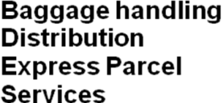
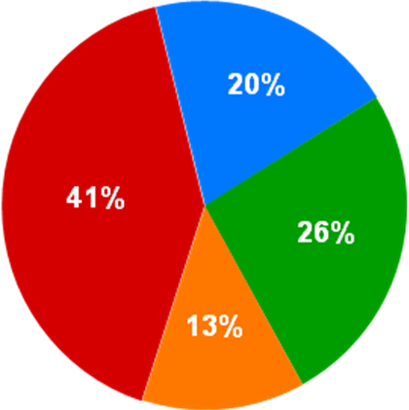
Figure 1: order intake financial years 2004-2009 of VI business areas
VI is ranked among the top 5 worldwide in its fields, especially in baggage handling solutions Vanderlande is currently one of the leading suppliers in the field.
Workflow Information Systems background
The past 100 days I have worked within the Workflow Information Systems group. The team Workflow & Information Systems (7 FTE) is responsible for the development and maintenance of software that serves the purpose of supporting the business processes within Vanderlande. Examples of this include Product Lifecycle Management, applications supporting Change & Configuration management and disclosure of information for internal as well as external customers by the use of portal applications via the internet as well as the Vanderlande Intranet.
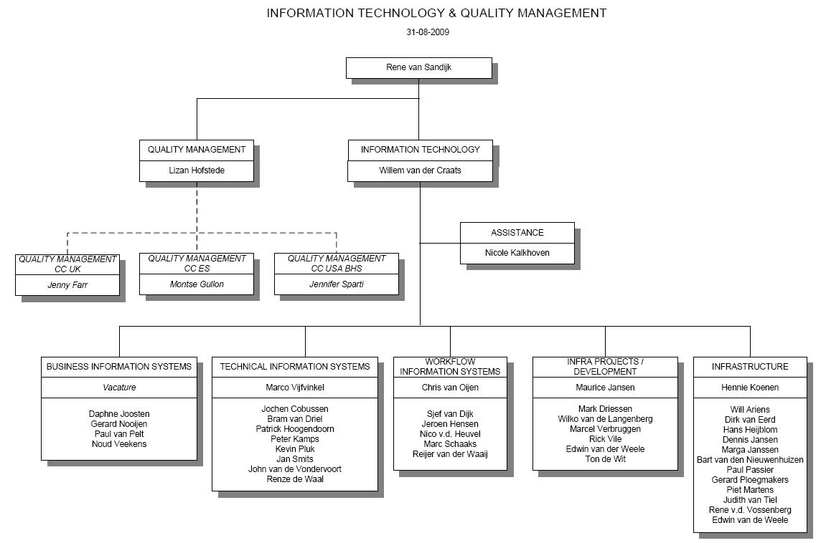
Figure 2: The WIS organigram
Assignment
Within the WIS group I have conducted research on the current Vanderlande Intranet. Also I have conducted research on the possible applications of web 2.0 technologies that can be used on the future Vanderlande intranet. These technologies include the use of Silverlight, forums, blogging and the use of meta-tagging within the Vanderlande intranet environment.
The conclusions and results of this research have been reached by the use of different research methods. This includes:
- Surveys
- Meetings, brainstorm sessions and discussions with Vanderlande Employees
- Studying multiple books based on website usability and usability testing listed in the chapter 'sources'
- Desk research, gathering information from the Internet.
Goals
To design a fitting graphic design on behalf of the future portal environment within the intranet, and to conduct research on application possibilities of web 2.0 technologies within the collaboration platform Sharepoint 2007.
Why this project
The Vanderlande Intranet Portal is developed on the Microsoft Sharepoint platform. Within the WIS group a solution architect is appointed to, in form of a project, redesign the Intranet Portal. This redesign is required to improve the use of the intranet. Currently the Vanderlande intranet has been developed on the Microsoft Sharepoint 2007 platform. WIS has concluded that the current intranet is not being used to its full potential. Modern intranets offer people easy access to personal information or forms, give them the ability to collaborate with colleagues and since SharePoint is able to connect to different document management systems this allows people to access information that is spread across different information systems via one information portal. Meaning that all documents can be accessed via one uniform platform. Currently not all of these points are true for the Vanderlande Intranet
Biggest concern of the WIS group is the difficulty of finding information in the current Intranet. The search function is not working properly and is returning very poor results at the moment. Making it impossible for users to find information they need by using the search function on the Intranet. In addition the navigational structure of the Intranet is not optimal. All the buttons and links are there and the amount and quality of the information on the Intranet is also very high, sadly there is no good way to navigate to that information. In other words, the usability of the website is low and the WIS group wants to have this improved.
In addition the WIS group currently feels the Intranet is not used enough. The website is static and does not look appealing. Redesigning the website can make the website look more appealing to its users encouraging them to dive further into the information stored on the Intranet. A lack of functions has also been concluded by the WIS group. For example the current Who = Who is not only out of date, it should have more functions added to it. Examples are a Who = where or a Who-knows-what. These functions make looking for people's names or pictures possible and in addition users are able to look where their colleagues are, whether or not they are available at the moment and what knowledge / skills they have.
In this report the different phases of the Vanderlande Intranet Portal Project (VIPP) will be described. These phases are:
- Research on the wishes, needs and demands of Vanderlande Industries employees
- Research on the technology needed to achieve the fore mentioned goals
- Realization of prototype of the Vanderlande Intranet. This prototype combines the findings of conducted research on the needs and whishes of people with the technology found capable of fulfilling the wishes of said users into a usable design.
Scope
Focus is on the research of a fitting graphic design that improves usability and on making a workable prototype of the new design available for evaluation, testing and tweaking. The three main research questions that will be answered are:
- What do the users think of the current intranet and what are the (missing) features Vanderlande employees want to see implemented on the intranet?
- How can the user's needs be addressed by the new design of the Vanderlande Industries Intranet?
- What techniques will be used to achieve these needs?
The objective of this report is to illustrate what the new design will look like, what features the new intranet will have how these features fit the needs of the Vanderlande Employees and what techniques are used to achieve these goals.

Chapter 2
Research
The chapter research elaborates on the research conducted during the internship. The Vanderlande Intranet Portal Project Survey will be explained. The Survey was used to gather information about the users of the Vanderlande Intranet. In addition the term usability will be clarified, as will the term web 2.0

The Vanderlande Intranet Portal Project Survey
The new intranet portal should give its users a better user experience. Before starting with the creation of a new design one should know what the current intranet users need, demand and wish for. Since it was not exactly known what these needs, whishes and demands were a survey was conducted to find this out.
The survey was conducted via the internet. By choosing this method the survey is able to reach all of the Vanderlande employees who are spread all over the world and gives all employees a fair chance to react, nobody is not heard as could be the case with interviews. The survey has been emailed to around 2200 people, and led to about 260 replies. This is enough to give an impression of what it is that the users of the Vanderlande Intranet wish for. With the information gathered from the survey the current shortcomings of the Intranet can also be determined. The survey also gives Vanderlande employees a chance to express their feelings, wishes and demands regarding the Vanderlande Intranet.
Representivity

The VIPP Survey was conducted from 06-10-2009 to 16-10-2009. The survey was emailed to all Vanderlande employees, of which there are about 2200. Of these 2200 employees there were 260 responses. This means 12% of the target group. To warrant the representivity of a survey, a test sample of 242 people is needed at a reliability level of 90%. Since 260 people have responded, the survey is therefore representative of VI Intranet users and their respective opinions.

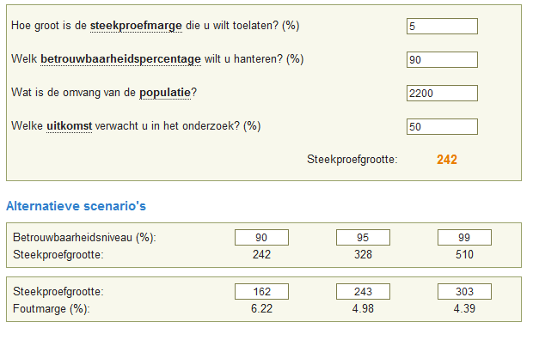Figure 3: defining representivity:http://www.allesovermarktonderzoek.nl/Extra/Steekproef.aspx

What were the open questions?

Question:
1 In your opinion, is there anything you miss on the current VI Intranet?
2 What do you think is a particular strong point of the current Intranet?
3 What do you think is a particular weak point of the current Intranet?
4 Name (up to) 3 Websites you particularly like, and explain (in one sentence) why.
5 Name (up to) 3 Websites you particularly dislike, and explain (in one sentence) why.
6 Further suggestions and/or comments:
7 What is your name? (Leave this field empty if you want to remain anonymous)
Composing of the questions has been done in close cooperation with the rest of the WIS team. As a result this set of questions will provide a lot of useful information about our target group (Vanderlande Employees) Both the open questions as the multiple choice questions have been carefully selected to give us the best possible insights of the user experience the target group has with the current Intranet.
The WIS group is aware the current Intranet has some shortcomings. This has been concluded from receiving calls of Vanderlande employees asking questions about missing functionality, not working features like the search function , having meetings and of course by talking to colleagues. To test the feeling that a lot of users are dissatisfied with the current intranet the survey questions are geared to the most heard complaints. Furthermore the questions have been geared to probe the attitude Vanderlande Employees have in regard to new internet technologies. Examples of new internet technologies are forums, blog spots, communities and the ability to create custom user profiles on the Intranet containing user generated content. This is important, as results may show a very negative attitude to new web 2.0 technologies like forums which would mean implementing forums in the new design is not fulfilling the wishes of users.
Results and conclusion
Multiple choice questions
The results of the multiple choice questions are shown in appendix B They contain the individual questions and their corresponding answers, including percentages.

The Vanderlande employees who took the survey have made a lot of comments and suggestions. The most mentioned remarks and points of improvement from the open questions have been collected in the following list categorized by subject.

Organization of information on the intranet
There needs to be a clearly defined way to add information on the Intranet. This way information is all formatted and added in the same way across the entire platform. A lot of information is still on the ‘old’ public library. The public library is the previous version of the Vanderlande Intranet, before SharePoint 2007 was introduced. The public library is aged and does not have a high degree of accessibility. In addition it is also not very user-friendly / attractive. Information stored on the public library is not placed on the Intranet, sustaining the need for two different platforms.
Sharing information and news between Veghel and Customer Centers
Different Customer Centers worldwide feel the need to have a separate Intranet page that reflects the activities and ‘personality’ of that specific Customer Centre. At the moment some Customer Centers feel they have a lot of differences with ‘VI Veghel’ and therefore do not feel the VI Intranet fits their Customer Center.
Markup of the Intranet
When using the current Intranet the design is not consistent. The designs of the two portals (public library and SharePoint 2007) are very different, switching between the Sharepoint and public library environment is considered confusing
A lot of reactions have also been made about the picture viewer. As stated above the current picture viewer is hard to navigate, and it is also hard to download a certain selection of pictures. Downloading the pictures one by one does not pose any problems, but the photo viewer could use some more advanced options.
The Vanderlande news
The news that is being published on the Intranet is regarded as of high quality. But in addition to the already available news, people would like a little less ‘feel good’ news. At the moment users have the idea that only the positive news is being pushed out. It might be an idea to publish a bit more realistic news in the future, as everybody knows it can’t all be positive news. Also, there have been a number of complaints about the quality of the news items regarding English grammar. The level of English used on the Intranet should be improved. There are a number of people who want to proof-read the news items before they are published on the Intranet. Last point is the localization of news items for Customer Centers. It would be appreciated to have a few localized news items about what is happening around them, this makes reading the news more interesting for people in distant Customer Centers.
SharePoint is not being used to its full potential
The full potential of SharePoint is not being used by Vanderlande. The possibilities of sharing documents and making custom websites for a specific department are not being used a lot, or people are being limited by a lack of knowledge or profile space. In SharePoint 2010 a lot of these features should become a lot more accessible. Also people should be better informed about the possibilities of SharePoint as a platform.
Keeping information up to date
The information posted on the Intranet should be kept up to date. People who post information on the Intranet should also bear some kind of responsibility for keeping it up to date. This would prevent people from posting information that is up to date today, and is then forgotten. Finding out of date documents on the Intranet is frustrating and will decrease the likeliness of people looking for information on the Intranet a second time, making it a less useful tool for the organization.
A knowledge sharing website, or any website for that matter, is useless when its content is out of date and when its content is not what people are looking for.
Organization of menus
The navigation of the Intranet is not optimal. The menu’s that are in use are not very user friendly as they are not intuitive and have some markup problems. For instance if you have more tabs than can fit on your screen, the website will display a horizontal scrollbar. This is not very user-friendly; the menus should be divided into multiple levels instead of spreading horizontally endlessly. Also the classification of items on the menu bars should be rethought to make it more intuitive and faster to navigate to certain information.
The speed at which information can be found should be kept in mind while rearranging the menu classifications.
The search engine
There are a lot of complaints about the search engine. Searching for the most obvious keywords simply does not return the wished for results.
There is also a big demand for user generated content. People would like to contribute to the Intranet on for instance a wiki, something that is now completely impossible. Also, there is a large demand for ways to communicate with each other / different departments via (for instance) a forum. Make the places where information can be found more centralized, instead of spread over multiple platforms (Public Library) to speed up the time to find desired information.
Who = Who What Where
There is a big demand for a better Who = Who. The current version is simply insufficient. Employees think finding out of date information very annoying. At the moment an employee can be in the Who = Who with a telephone number that is over a year old. Photos should be done more professionally, there are profiles that do not have a picture at all and there are a lot of complaints about people thinking their photo is too impersonal and business like. Some of the photos were taken unexpected and people want to be able to have their photo retaken, or have the ability to send in their own pictures.

Another feature people would like to have added to the Who = Who is the Who = Where function. It saves the company valuable time when an employee is able to check on the intranet where a certain colleague is. This reduces the time it takes to find a colleague, and it also reduces the chance of walking to somebody’s desk, only to find that the person is in a meeting or has (recently) moved desks within the company.
The third function high in demand is the Who knows What function. This would allow users to search for knowledge within Vanderlande Industries. As of now, there might be certain knowledge within Vanderlande Industries but nobody knows who has this specific knowledge. If employees would have a personal profile, they can enter what knowledge they have, and what their areas of experience are. This would allow employees to type in a certain keyword in the search engine, and colleagues who have knowledge of the specific subject will be listed in the search results.
Design (Web 2.0 look)
Vanderlande employees think the Intranet could use an overall update regarding design and markup. The current design is very static and unpleasing to the eye. Employees think that making the Intranet more attractive will provide a better user experience. Vanderlande employees are strongly against most of the current ' flashy’ web designs with flashing banners and crowded ad filled web pages. It can be done as long as it is done with care.
Employees think a better classification of items and more intuitive information structure would make the Intranet a more useful tool for Vanderlande Industries.
Interactivity
There is a need for interactivity. This can be implemented in multiple forms. One would be the most basic, giving users the ability to respond to news articles. This gives people the ability to vent their opinions, this could spark discussions regarding a specific news item.
The use of a forum also gives employees the ability to discuss certain matters online. Now communication is mainly done in person, via E-mail of via telephone. These forms of communication are mostly peer to peer, and meetings are mostly done with people of the same group or department. A forum will never replace these ways of communication, but it does allow a lot more people to join the discussion. For instance there might be people with experience or knowledge about a certain subject that nobody knew they had (also see Who knows what) Making discussions and problem solving more company spread.
Contributing should be made a lot easier a lot easier. Currently the intranet is used as a portal to display all sorts of information and news. Users hardly have any influence or say in what gets posted on the Intranet.

What is usability?
‘Usability’ is an umbrella term that encompasses two related concepts:
Usability is an attribute of the quality of a system:
“We need to create a usable intranet”
Usability is a process or set of techniques used during a design and development project:
“We need to include usability activities in this project”
This second aspect is sometimes described as usability engineering, and is more accurately described as user-centered design.
‘Usability’ refers to the quality of a system and the process of designing a usable system
"source: http://www.steptwo.com.au/papers/kmc_whatisusability/index.html"
The old Vanderlande Intranet
To improve the usability of the current Intranet and to see where the room for improvement is, the design of the current Intranet will have to be examined.
The current Vanderlande intranet is based on the Microsoft Office SharePoint Server 2007 Collaboration platform. Implementation and design has been done by an external company. It is currently fairly basic in its design. Since there are no usability or design- guidelines there are great differences between sites. The content of the Intranet is provided by appointed people from the different divisions within the company. This means that Baggage Handling, Parcel & Postal, Distribution and Services all manage their own site-content. Due to the lack of guidelines the different sites vary from each other in terms of markup, arrangement of information and actuality of information. Guidelines and/or templates can prevent this from happening. If there are certain guidelines to follow whilst making a page, the intranet would be more uniform and easier to navigate as the different pages are more recognizable.

What is web 2.0?
Information Technology is an area that is always rapidly changing. New techniques are coming available at a high rate. The question that remains is: How can we actually achieve a high grade of usability using the newest web technology? Let’s have a look at some of the different techniques and how these can be implemented in the Vanderlande intranet.
Having identified some points of improvement when looking at the old Vanderlande intranet and now that we know what it is the users of the intranet want. We can have a look at how exactly we can improve the current website, how these improvements can be achieved and also what techniques should be used to achieve these improvements.
Vanderlande wants to have a more usable, modern Intranet. This can be achieved by the use of various web 2.0 techniques. To start, we have to define what web 2.0 is exactly and how different modern techniques can be used to achieve the highest grade of usability.
The use of Microsoft SharePoint is a given, this means the chosen techniques should be implementable on this platform.
Web 2.0 design
The technical aspects of the World Wide Web have improved over time. The design of web pages has also changed dramatically. Today most internet users have access to broadband internet connections. As a result, web sites have also become more attractive. The extra bandwidth allows heavily animated websites to load fast and gives users the opportunity to view more diverse content then in the early days of the internet.
Web 2.0 websites can be roughly defined by some typical design elements:
- Gradients
- Rounded corners
- Backgrounds with diagonal shading
- A ‘wet-floor’ effect
- Big fonts
- ‘Supermarket sticker’ saying ‘ beta’ or ‘ new’
All of these elements are captured in figure 4:
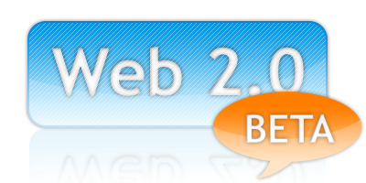

Figure 4: giving the perfect example of the new Web 2.0 look

This is what most web pages look like at the moment. When a web site is Web 2.0 you will always find at least one of the elements in its design. Operating systems, Mobile phones and software like Microsoft’s Office have also started to adopt this way of design.
Web 2.0 technical improvements
As well as an improved visual style, Web 2.0 also features technical improvements, new features and properties made possible by the advance in technology. Users have more bandwidth available giving users possibilities that were unthinkable during the days of dial-up internet. With the increase of bandwidth also came new possibilities to advertise on the internet. Higher bandwidth allowed animated banners and also banners with streaming video and audio to be shown. For example It is now possible to show a movie trailer in the form and dimensions of a banner.
Today the internet has billions of web pages with a lot of different content and subjects. Now that content is also supplied by users themselves, the internet has become a unique medium. Its content is based on collaboration. A lot of people have MySpace or LinkedIn accounts. These websites allow you to create an online profile, which has led to the development and evolution of online communities. YouTube is also a great example of a website thriving on user generated content, YouTube allows you to upload your home made videos and show them to the entire world.
It is also possible to run entire programs within a browser by the use of Java (web programming language) Flash (program that enables you to make animations, but also simple online applications) or AJAX (web programming language). Also the higher bandwidth allows users to download movies, audio, games and watch streaming High-Definition video. The internet has become a medium that can deliver a wide range of high quality media directly into your home.
This is the new internet, where content is less and less generated by a single webmaster or institute and more and more by users themselves. Making the internet a perfect medium to express yourself and enables you to discuss and collaborate with millions of different people around the world.
Web 2.0 websites usually consist out of certain new features which can typically be defined by the SLATES model, SLATES means:
- Search
- Links
- Authoring
- Tags
- Extensions
- Signals
What are the typical uses and properties of each of these features exactly?
The first feature ‘Search’ means it should be easy to find the information you want within a website by using simple keywords, almost all modern websites therefore have a search function implemented. In the case of the Vanderlande Intranet, search is a very important feature.

Figure 5: Example of the search bar on www.tweakers.net
The second feature is ‘Links’ websites often provide links to information that is directly relevant to the information you are reading at that moment. News website use this often, for instance to link to other news items about the same subject. Or external websites related to the topic of the news item.
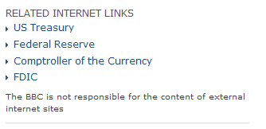

Figure 6: Related internet links on the BBC news website

The third feature is called ‘Authoring’. This means it gives the users of a website the ability to add their own content. In the early days of the internet, content was delivered by a single webmaster. Now owners of a website can actually have a constantly updating website that does not require them to add content themselves. Wikipedia is also a good example of this, people can add articles of their own regarding a certain subject. When other people disagree, or find better pieces of information they can edit the page and add the information they had in mind. Because Wikipedia has millions of users constantly checking each other’s work, the information on the website has a very high quality. The quality is much better than it would have been when done by a single editor, and of course also articles are added much faster.
The fourth feature is called ‘Tags’. Tag clouds are a good example of using search words to navigate through a webpage. It shows different clickable words other users used to search the website. The more users have used a certain search word, the bigger it shows up. This means that in a tag cloud the most popular search terms are also the most obvious ones and usually the words that are of the most interest to you.
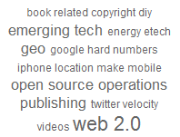

Figure 7: Web 2.0 Tag cloud

The use of tags provides simple one-word descriptions of categories. This is less limited as premade categories as there will always be certain subjects that do not fit under an inflexible set of predefined categories.
The fifth feature is called ‘Extensions’, there is a wide variety of extensions available on the web. This means the World Wide Web is not only able to provide you with information, but you can also make use of applications that operate via your web browser. The World Wide Web can be seen as a platform on which different applications operate, much as Microsoft’s Windows 7 is a platform that programs can operate on.
Ajax is an example of a programming language that allows you to write applications that are web based. A good example of using the Web as a platform for applications is Office web apps. Office web apps allow you to make text documents, spreadsheets and presentations via the internet. Office web apps is a part of the new office version from Microsoft called office 2010.
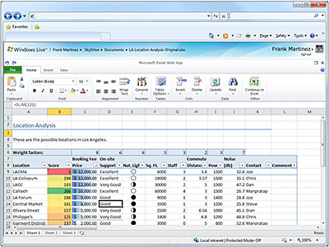

Figure 8: Creation of a text document using office 2010 web applications via the internet

Even entire operating systems can be run via the internet as shown in the picture below:
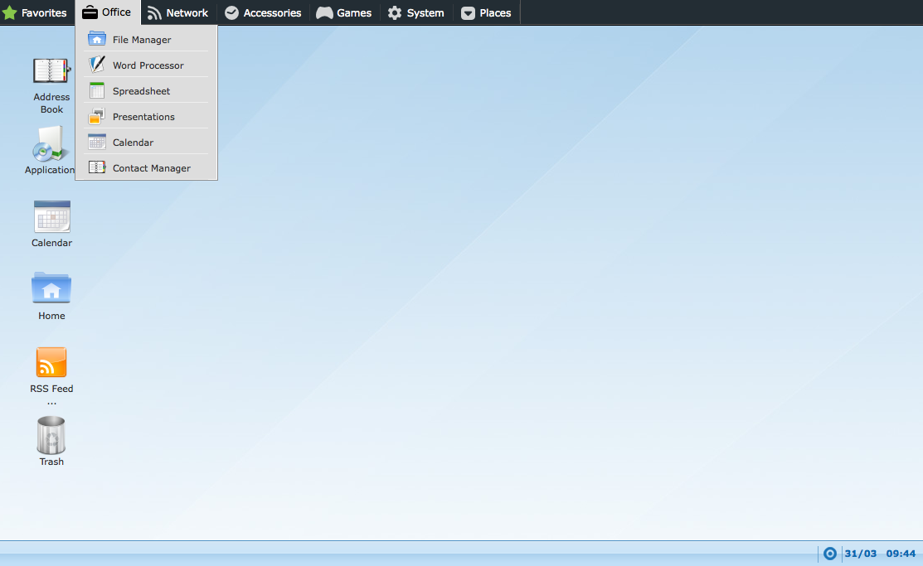

Figure 9: EyeOS run via the internet
The sixth and last feature is called ‘Signals’. Web 2.0 websites define themselves by using different ways to alert its visitors or members of changes. This can be either via E-mail or via RSS feeds to any device that supports the reading of RSS feeds. This can be a computer as well as a mobile phone. In other words, a Web 2.0 web page keeps its users up to date wherever they go.
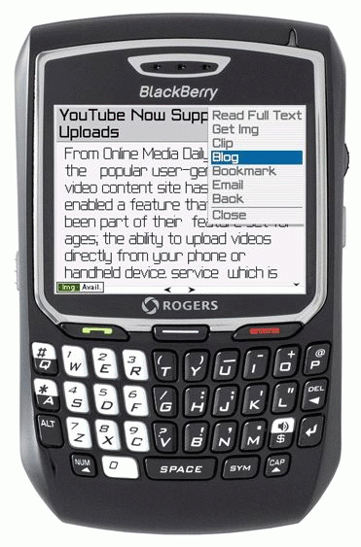

Figure 10: Rss newsfeed on a mobile phone

RSS is one of the most significant advances in the architecture of the Web. As it allows you to subscribe to a webpage and have a web page ‘pushed’ to you as soon as it updates, instead of having to actively visit the site by yourself. As of today RSS is not only used to push notifications of new news items, but it can also be used to push certain data to its subscribers. This can be weather data, product sales or specials, calendars, stock quotes and much more. RSS has made the internet come to you instead of it always being the other way around.

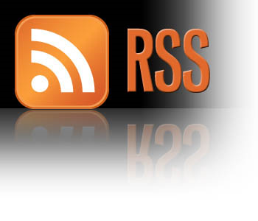

Figure 11: RSS Logo

Chapter 3
Techniques
The chapter techniques elaborates on some of the techniques used to achieve the end result are explained. These techniques include Microsoft Silverlight, Deep Zoom Composer and Microsoft SharePoint. In addition, the two company visits made during the internship are elaborated.

Silverlight
Vanderlande is interested in knowing if Silverlight can be an added value to their Intranet. To answer this question research has been conducted to find answers to this question. Now what is Silverlight exactly?
Figure 12: Silverlight logo
Microsoft Silverlight is a relatively new product from Microsoft, it was introduced in April 2007. Currently version 3.0 is available. Silverlight is a web application framework designed to provide similar functions Adobe Flash provides. This includes animations, multimedia and interactivity.
What can Silverlight do for the Vanderlande Intranet?
Silverlight has been researched in various ways. Examples of the possibilities have been examined through the internet. This includes the Microsoft Silverlight website: http://silverlight.net/ and also multiple Silverlight repositories including:
http://www.shinedraw.com/
http://silverlike.net/
http://www.componentart.com/products/silverlight/
These websites have enough examples to see the Microsoft Silverlight features.
While researching, a number of test animations were made with use of Microsoft Expression Blend and Deep Zoom composer. Both programs are from the Microsoft Expression suite and can be used to develop Silverlight applications.
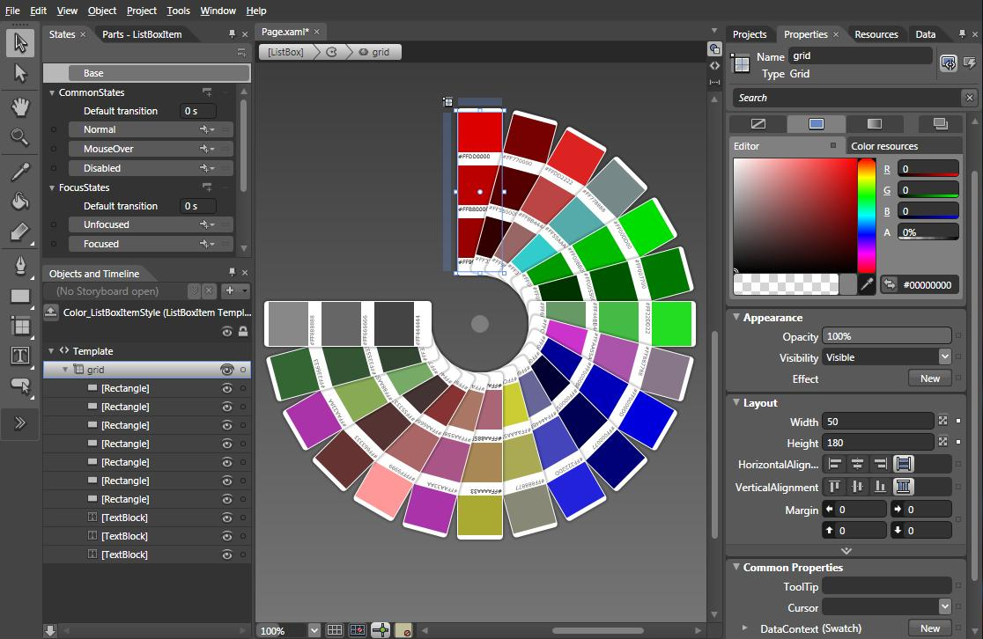Figure 13: Example of Microsoft Expression Blend, from the Microsoft Expression suite.
The Expression suite from Microsoft is comparable to the Adobe Creative Suite. It features roughly the same types of programs the Adobe has.

What's Included:
- Expression Blend™ 3 + SketchFlow (Create Silverlight applications )
- Expression Web 3 ( Create web pages, supports .ASPX pages )
- Expression Design 3 ( Create images and edit photos )
- Expression Encoder 3 + IIS Smooth Streaming ( Encode video files to other formats or to a smooth streaming format to enable the video to stream over the web much like a YouTube video )

A lot of research has been conducted on the use of the suite. There is no experience within the company with this suite and it is now installed for the first time within the company. The good thing about this suite is that is integrates seamlessly with other Microsoft products. Since Vanderlande is using a Microsoft Intranet environment this suite is well fitted to develop applications within the organization.
The suite drew immediate attention due to the ease of creating simple animations. There are a lot of out of the box components that can be dropped on the canvas and used.
After testing the software and making the first few animations, the fact is established that Silverlight is as powerful a platform as Flash. It is stronger on some points then Flash, weaker on other. Overall the differences are really small deciding whether to use Silverlight or Flash depends on the use and deployment environment. Since it is very easy to integrate Silverlight within a SharePoint environment and the .ASPX Silverlight controls are easy to integrate with SharePoint, using Silverlight would pose no problems.
Deep Zoom Composer
Deep Zoom Composer allows you to import your own images, arrange and position them, and export the final output as either a Deep Zoom Image or Collection that can be fed into Silverlight's MutliScale Image control. This means that you too can use your own images and display them using our Deep Zoom technology.
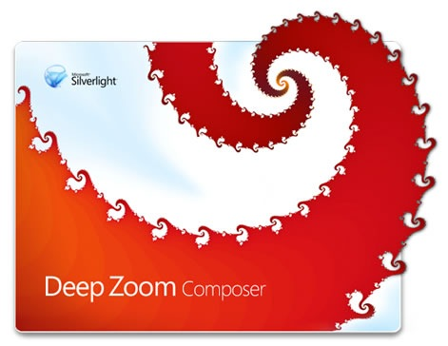
Figure 14: Deep Zoom composer logo
Deep zoom composer is not part of the Expression Studio but is a free download. A powerful free tool to create a Silverlight image viewer. The Deep Zoom application is easily deployed into SharePoint, this offers a wide ranges of possibilities as seen in chapter 'Design'.
What is SharePoint 2007 and 2010?
The Vanderlande Intranet runs on the Microsoft Office SharePoint Server platform. To make any kind of recommendations or adjustments the first thing that has to be established what SharePoint 2007 is exactly.
SharePoint 2007 is a web based collaboration platform. It provides the skeleton for an Intranet on which employees can store data, find and use data and collaborate with their colleagues. Since Vanderlande uses SmarTeam to manage their documents, this is not done with SharePoint although it has the possibility to do so. The main reason to use SharePoint is that once set up it is easy for people to add information and to create websites within the portal environment. This allows even inexperienced web users to add and edit information stored on the internet.
Vanderlande does not store product document files within SharePoint, but you can still use Sharepoint to show data. In the case of Vanderlande this is done with queries to other systems, another advantage of SharePoint. SharePoint provides users of the Intranet with a single portal environment. Users do not have to switch systems or applications to view information that is stored over a wide variety of systems.
The Intranet is now mainly used for posting daily news, looking for people and looking up product data. The Intranet is not used interactive, content is provided by certain people who have the administrative rights and the same content is the viewed by people just like in the early days of the internet.
SharePoint 2010
When research was being conducted on SharePoint 2007, it was announced that the public beta version of SharePoint 2010 would be available soon. The question arose, Is SharePoint 2010 worth the time, effort and money to upgrade. That is why the new features of SharePoint 2010 have been studied as well.
The new version of Microsoft 2010 will sport a new ' feature wheel’ as seen in Figure 15
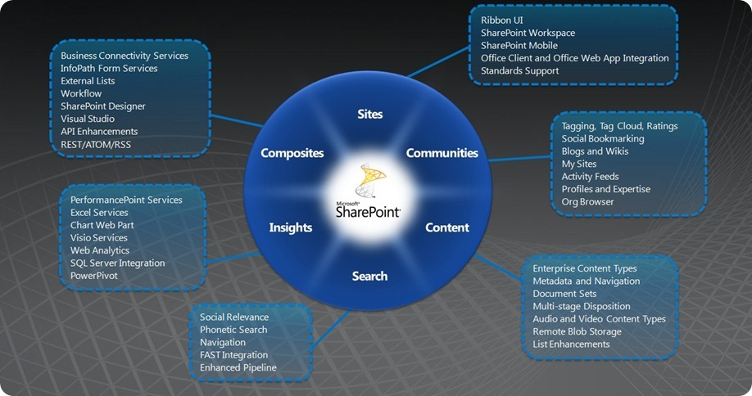
Figure 15: Microsoft SharePoint feature Wheel
SharePoint 2010 comes out of the box with a big set of new features. The new version of SharePoint is geared more towards collaboration. The search function has been improved an enriched with new features like checking availability, searching for tags within user profiles and previewing thumbnails of documents and PowerPoint presentations without even opening them. This should all improve the ease of finding information and sharing it with colleagues.
The tagging functionality is particularly interesting. This feature allows people to tag content, tag their own profiles and browse through information by using tag clouds.
Company visits regarding SharePoint 2010
Exclusive presentation Sharepoint 2010 Wortell
The first company visit took place on Tuesday 29 September 2009 In Amsterdam
Wortell is a Microsoft gold certified partner of Microsoft that specializes in Sharepoint 2010. Being gold certified means they have access to software like SharePoint 2010 before it comes publically available. This allows them to test the product and gain experience with it. They used this meeting to inform their (possible) customers about the advantages of SharePoint 2010 over SharePoint 2007. The SharePoint wheel in figure 15
Avanade Collaboration event
The second business meeting took place on Wednesday 2 December 2009, 13:00 – 17:00
Amsterdam. The collaboration event had a goal of learning from other companies. How do they collaborate, and how important collaboration is.
There were several speakers at the event:
Jules Hoppenbrouwers – Technical Solution Professional – Microsoft Nederland B.V.

Charlotte Pedersen – Senior Manager -Accenture

Mark Jonker – Senior Manager - Accenture

Adrian Turtschi – Director Software Development - Avanade Germany

Thomas Hoglund Senior Executive Accenture

To sum up the most important insights gained at the events:
Sneak peak of SharePoint and its functions before actual release!
SharePoint 2010 - Offers a more flexible UI making editing and adding pages much easier. SharePoint 2010 has improved integration with Microsoft Office, documents can be edited while on the road, and office even has online editing tools called Office 2010 web applications. This allows employees who are on the road without having office installed to edit and save documents to SharePoint 2010. Working on a document with more than one person at a time is also a possibility; this improves the degree of collaboration possible on the Intranet. Implementation of new search technology called FAST, allows availability information on people search, searching through profile tags and phonetic search. Silverlight is a vital part of SharePoint 2010. A lot of components of SharePoint are rendered in Silverlight. Adding Silverlight as web parts to a page is as simple as clicking the web part and pointing it to the Silverlight file.
Collaboration - has never been easier. The new UI and web 2.0 technologies allow you to create, interact and find all the information you need. Social bookmarking, similar to adding friends on Face book. This allows you to create a chain of colleagues that you can easily access and collaborate with via the Intranet.

Chapter 4
Actions taken and preliminary recommendations
The chapter actions taken and preliminary recommendations describes the actions taken in response to the survey results found in the chapter ‘Research ‘accompanied by a recommendation on how to resolve the issue. Each heading describes how the respective issue should be resolved.

This chapter should be considered as a complete overview of actions taken in response to the survey. Some have been explained in this report, others have not.

Organization of information on the intranet
There needs to be a clearly defined way to add information on the Intranet and the use of the 'old' public library should be phased out. The public library is the first version of the Vanderlande intranet, which was replaced by SharePoint 2007.
Templates have been made to keep information uniformly structured so that baggage handling, distribution, Parcel & Postal and Services have a uniform markup. Information on the sites of these different areas can be found under an identical menu structure.
The templates will aid people to structure information in a unified manner, all business areas have now been appointed a manager of the business area websites. The manager will be responsible and also the contact person for that particular site. Since there is an appointed person responsible for the content, it is much easier to keep a unified structure within those websites. Minor or Major changes on the website will only have to be discussed with the appointed people and not with the entire organization.
Sharing information and news between Veghel and Customer Centers
Customer centers around the world need a place on the Intranet, currently they do not feel very connected to the Intranet as there are many differences between the customer centers and VI Veghel and there is no place to find customer center specific information.
The new design will accommodate these features. There is room for a specific picture to give the customer center's website a characteristic look. Also in the new news center there is room for customer center specific news that employees can sign up to via RSS feed enabling them to follow customer center specific news live.
With the implementation of forums there can be a separate forum for each customer center where topics can be discussed. Blogs of colleagues from the same customer center can be read.
Markup and consistency of the Intranet
Data should be kept up to date, and well structured. This has been done by institution data governance discussed under the heading ' organization of information on the intranet' and 'Keeping information up to date'.
The SharePoint 2007 picture viewer is found inadequate and hard to navigate. Silverlight is used on the new intranet for picture viewing and also for displaying other media like movies. Silverlight can be used to stream media in HD quality and offers the ability to automatically downscale the quality to match your available bandwidth to make watching movies on the intranet possible when employees are on a location without broadband internet access.
When using the current Intranet the design is not consistent. The designs of the two portals (public library and SharePoint 2007) are very different, switching between the Sharepoint and public library environment should therefore be avoided as it decreases usability.
With the help of a more accessible Intranet Vanderlande employees can be more efficient are not as efficient as they could be. A lot of time is lost looking for certain information or people. A lot of the data is spread over different platforms. Examples are the Public library (IT-511) for the Who is Who, documents and forms. SmarTeam (Product data management tool used by Vanderlande to manage all products within the organization, including their documentation) for documents. And straitweb to look for documents within SmarTeam on a web client. Because there are a lot of different interfaces and programs used to access data, there are a lot of different interfaces employees have to work with. SharePoint can link all these different systems to provide a single web portal to all information. This way, users can stay within the user interface of SharePoint. This makes looking for information more user friendly, consistent and efficient.
The Vanderlande news
The news that is published on the VI Intranet should sometimes be less ' feel good'. A lot of employees have the opinion that the news is only positive. Reading news items about projects that for example did not make a deadline can be a good thing, as it is more realistic. Not all projects always go perfect, adding a degree of reality is something the employees appreciate but it should not be overdone.
The communications department who are in charge of the news items have also read the conclusions of the survey and are now aware of the need for more realistic news coverage. More diverse news items will be published in the future.
SharePoint is not being used to its full potential
Employees feel that SharePoint is not being used to its full potential. Users should be informed about the new possibilities the intranet will bring. Also users should be encouraged to use the collaboration features of the SharePoint platform.
People per business area which are Parcel & Postal, Distribution, Baggage Handling and Services have been appointed to be in charge of the information that is published on the intranet. They are key figures from the different business areas that have a high interest in the intranet, so called product 'champions'. These champions will be leading in the developments that occur within the Vanderlande Intranet. Since they are employees within the different business areas they will have to convince their colleagues within respective business areas to make use of the new features that are available on the new intranet. They will be a big part of motivating employees to use functions on the Intranet they did not use before thereby increasing the usage of the Intranet as a collaboration platform.
To explain the new features of the intranet to its users and to bring new features under the attention of users a launch site has been implemented. This site will contain information about the new features that can be used on the new intranet. Examples of this include video tutorials and written articles on how certain features work and how they can improve productivity. The launch site’s main goals are to answer any questions employees have about the intranet to decrease calls made to the helpdesk. But also to introduce the users to features the intranet has that they are unaware of. If you implement a new intranet without explaining what the added features are, or how they work. It is not very likely VI Employees will start using those functions.
Next to the launch site the product champions should motivate their people to start using certain functions. If employees are anxious or uninterested in features of the new intranet, they might be directed towards the launch site by the product champions to find out what is to gain.
Keeping information up to date
Data governance should be instituted. Data governance ensures that important data assets are formally managed throughout the company. It is about putting people in charge of data so that they can be held responsible for information that is out of date or of low quality. Also people should be put in charge of fixing and preventing issues with the data that is on the Intranet so that the company can be more efficient.
The communications department is in charge of updating the news. The Communications department will also monitor the websites that are being created (with as much freedom as possible) on the intranet for the different business areas to keep the sub sites in check with the company style guides. Communications will not tell the product champions how to make the websites, but they will be able to give advice and tips to keep the websites as usable and as well arranged as possible.
The goals is to have the adding of information done by people of the respective business areas. So a manger from the business area baggage handling will add information on the baggage handling site. This way the information on the specific business areas is always of good quality. It is near impossible for people outside of a business area to add content on the intranet since the websites are so specific and in depth, people from other business areas simply do not have the knowledge to add content on those sites. So the most important thing is to teach and guide the people adding the content through the aforementioned launch site and information templates.
Organization of menus
The navigation of the current Intranet is not optimal and not user friendly. Therefore the navigation menu has been rethought it should allow for easier access to data and also allows for access to the new features that will be implemented on the Intranet.
Search
As the survey has shown, a good search function is in high demand. The search will be used to find documents that are on the intranet. But SharePoint 2010 allows for much more. Compared to the SharePoint 2007 platform its search function has been greatly improved and refined. For instance search results will be ranked on the click-through behavior of similar search queries by colleagues, search results will contain thumbnails and previews of PowerPoint presentations for example. Meta-data can be automatically extracted from documents and much more. Also tagging should be applied to sites and items on the website to make the website much more searchable and data easier to find.
With the new search function you will not only be able to find information, but also people and their expertises. The Who = Who is currently one of the biggest points on the VI Intranet to be improved. Therefore the new VI Intranet will feature an advanced people search which can be accessed via the main navigation bar under the 'people' tab.
With the new search engine you will be able to search phonetically for people, since it is common that you do not know the exact spelling of a colleague’s name.
At the moment Vanderlande employees are not as efficient as they could be. A lot of time is lost looking for certain information or people. The SharePoint 2010 search function will make looking for documents easier and faster. A good search function is important for a number of reasons:
When people are looking for certain information within the intranet, it should be easy. If it is too hard to find what employees are looking for they will abandon the search function and maybe the intranet all together. Of course this is not the desired behavior. The results of a search should be accurate, easy to navigate and fast. Since the Vanderlande Intranet is so immense a good search function is critical to its survival. The current implementation of the SharePoint 2007 platform suffers from this flaw, the search function does not work as wished and therefore the search function is rarely used. Since the menu structure of the current intranet is not very user friendly people are frustrated with the intranet while some stopped using it altogether.
A search function should be faster at delivering results than doing so manually (with help of colleagues or other information sources). A good search function will always manage to do so, therefore saving a lot of valuable time. Since Vanderlande Industries is such a large company only a small amount of time saved per employee comes down to a huge save in money. for example if every employee saves 5 minutes per week looking for other people or data, knowing that there are 2200 employees, this would save 11000 minutes every week, or 733.2 hour ( 18.3 FTE ) on a monthly basis.
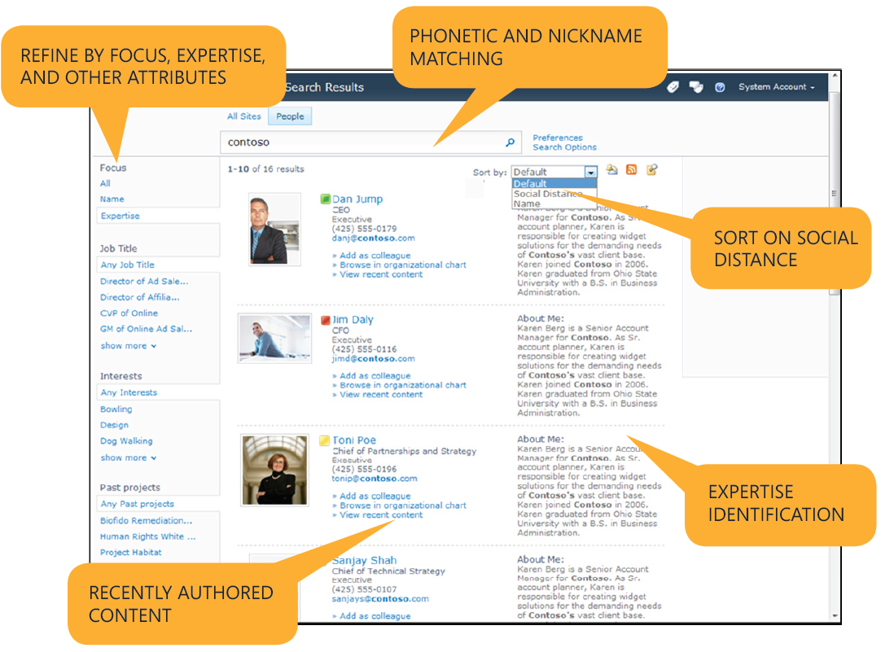
Figure 16: FAST Search results example

Who = Who, Knows what and Where
The Who = Who functionality is one of the most used and wanted functions on the Intranet. At the moment the Who = Who function is still provided by the IT-511 (public library) environment, an environment that should be phased out.
The new VI Intranet will feature an advanced people search which can be accessed via the main search bar at the top right of the screen. Since SharePoint 2010 allows for the creation of user profiles employees can fill their profiles with information about themselves. This includes skills. This means that you can use the search function to look for people who have certain knowledge about a certain topic. Usually employees of Vanderlande have a number of close colleagues of who they know what skills they have. If one of their close colleagues is out of office or not present at the time of a question employees get into trouble. They will have to look for another person to help them with their question. This will usually be done by calling, or asking other colleagues if they know somebody that can help them. This is a very inefficient and time consuming process. Allowing employees to look for this information through the intranet saves a lot of valuable time. As shown in the earlier example up to 18.3 FTE on a monthly basis.
With building maps placed on the profiles of the employees, you will be able to see where colleagues are in the different Vanderlande buildings. A marker on the map indicates the employee’s workplace. This feature allows you to find your colleagues faster when you do not know their exact workplace especially useful for new employees of Vanderlande Industries.
The Who = Who should be decentralized to a profile for every employee that they can fill in themselves, as well as an admin. Then there are 2 people per employee profile keeping track of changes, making it more up to date. When employees have their own profile they can fill in and edit all the information they want. This is positive since the more information you have on your profile, the easier you will be found by the search engine. Employees who are annoyed with their current photo on the Who = Who can easily change their photo to their favorite one.
Design (Web 2.0 look)
The design of the Intranet is the base of the Intranet. It is the first thing users will notice when they start using the Intranet. It is important to have a website that is designed with users in mind. The design is what binds the different techniques used on the Intranet together. A search engine might return the exact results the user is looking for, but if it is not easy to navigate those results the search engine will not be regarded as good or user friendly.
Therefore, extensive research and thought have been put in the new design to give the Intranet’s users the best user experience possible and to make the design fit to the demands and needs of Vanderlande Employees. The definition of 'Web 2.0' design is described in chapter 3 'Techniques' whereas the final design is described in chapter 6 ' Design' .
Interactivity
Forums are one of the oldest forms of communication on the internet. Bulletin Board Systems (BBS) were one of the first applications available to customers when the internet was rolled out to home users around the year 1980. This means forums, of all the new techniques used on the internet to communicate are the most likely to be known (how to use) by Vanderlande Employees. Since forums are not real-time they are the perfect tool for use in an office environment. There are time differences between the different Customer Centers like Veghel and USA. Forums allow people to post a message which can be read multiple hours later when the employee on the other side of the world that posted the message is off duty. This allows for companywide discussions on the message boards that are currently impossible.
Even though forums will not be able to replace actual meetings they do serve as a great place to discuss different topics. Employees can brainstorm, find out what colleagues think of a certain idea for example.
Topics that are not related to work can also be discussed. 'meaningless' discussions may sometimes spark ideas for actual products or problems. And it is a good way to get to know colleagues that you otherwise might never have met. Some initiatives within Vanderlande (think employee events, good causes etc) are now being published via Email. Since it is not allowed to reply to all on emails that are sent to all VI employees there is no chance of discussion about these kinds of great activities / initiatives. Making a forum post and alerting employees with an email would be a great example to make use of a forum. People can discuss the initiative and get to know colleagues who support the same initiatives as themselves creating a tighter bond between Vanderlande employees
A Wiki can also be an important tool in knowledge sharing. People are free to contribute to certain articles, giving a lot of different insights. More than you would be able to achieve with regular meetings and Email/phone communications.
Blogging is also one of the possibilities, being able to share your thoughts with your colleagues is important and can spark interesting discussions. Blogging follows the same dynamics as forums with the fundamental difference that a forum is more of a discussion place with multiple people at the same time, and blogging is more of a place to share thoughts, ideas and your views on certain subjects with others who in their turn are free to agree, disagree or discuss with you.

Chapter 5
Usability
The chapter usability focuses on the usability aspect of the website. A number of pages of the current Vanderlande Intranet are analyzed. And in addition there is general usability information kept in mind during the design of the new website.

Usability Analysis
Having established what usability actually is in chapter 2, namely an attribute of the quality of a system and a set of techniques used during a design and development project. The set of techniques to ensure this quality must first be defined. To find out what elements should be improved and which elements are already of good quality, the results of the survey were consulted. Also several meetings with people from the ICT Department provided insights into what known problem areas are.
The analysis has been done on the starting page of the Intranet, which can be seen in picture x.
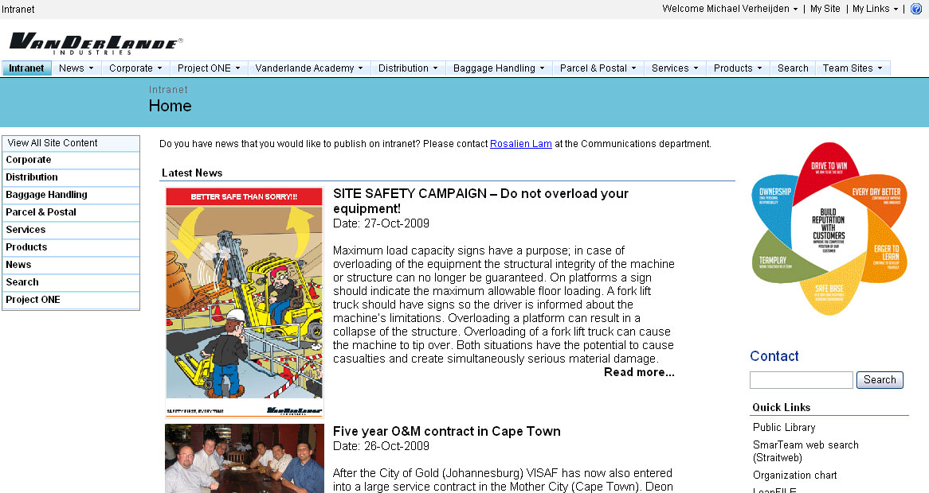
Figure 17: Example of the opening page of Vanderlande’s current intranet

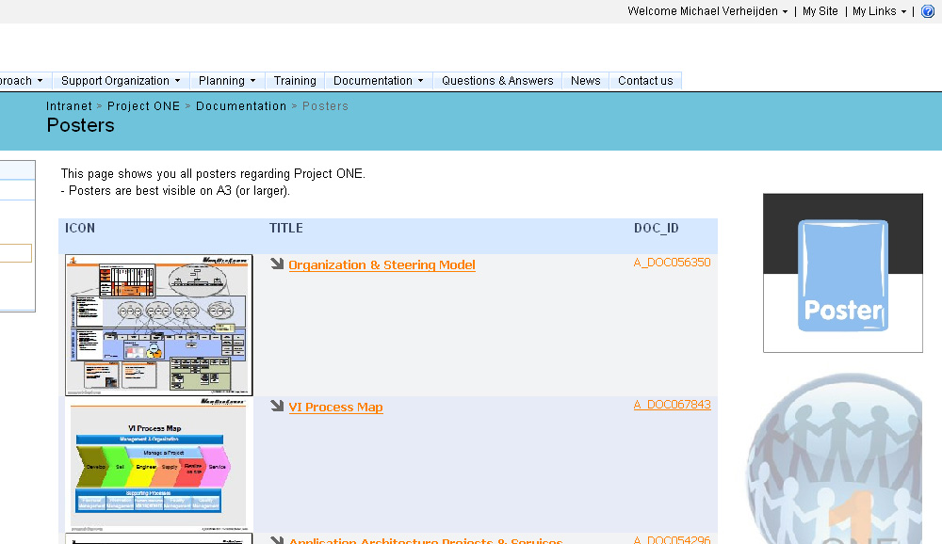
Figure 18: Example of documentation on the Vanderlande intranet
Points of improvement on the current Vanderlande intranet:
Figure 19: Points of improvement on the current Vanderlande intranet

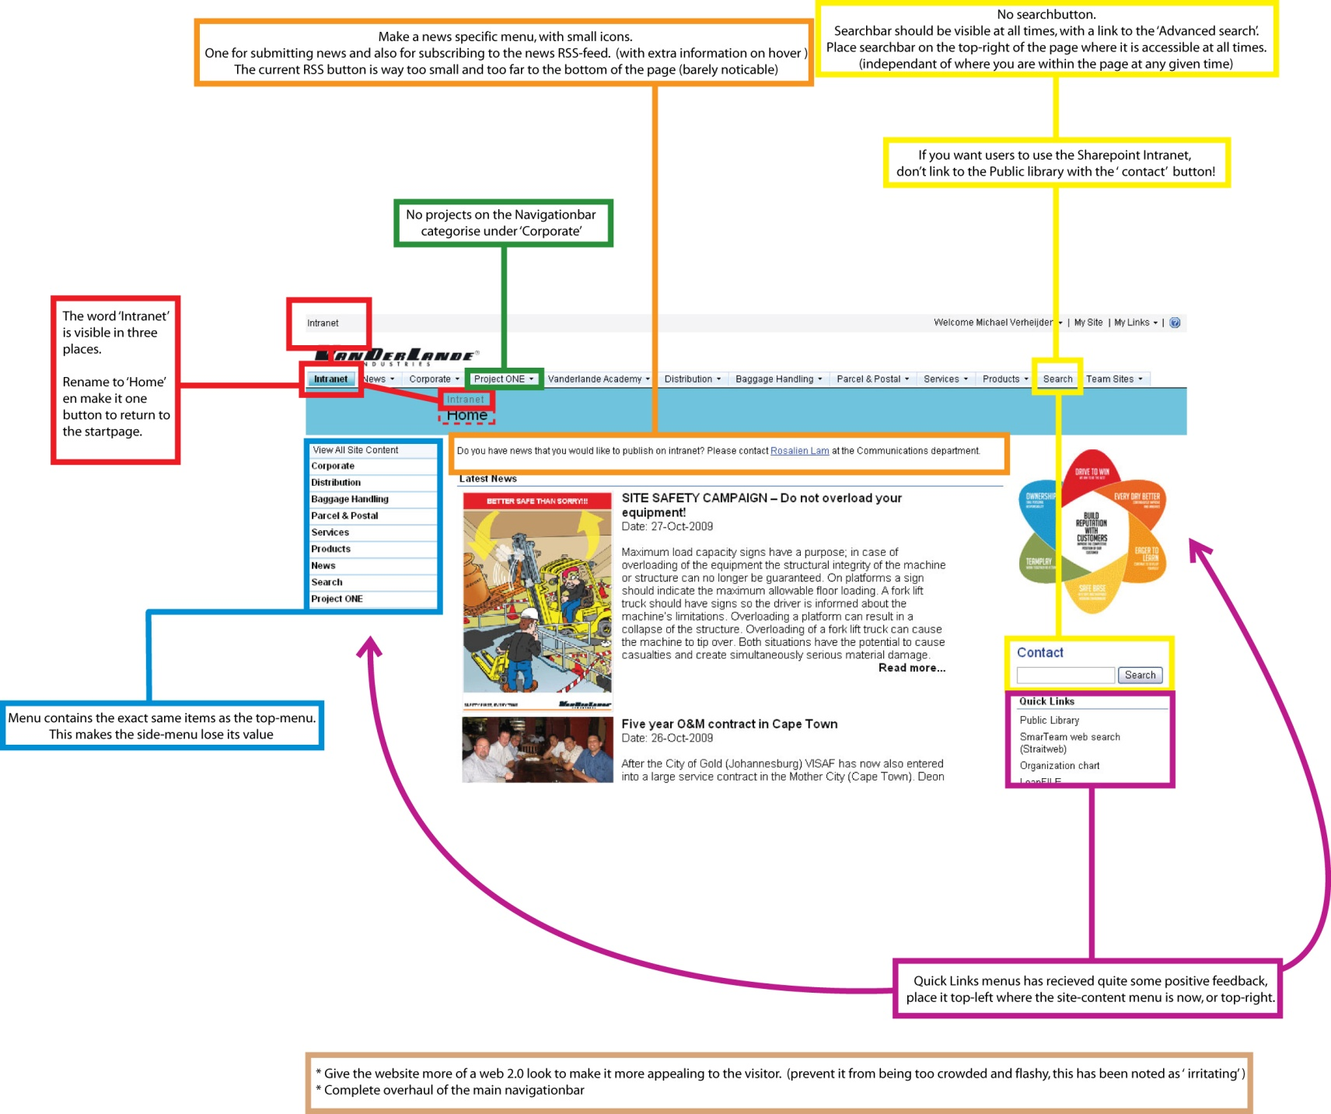
RED
Currently the word 'intranet' is visible at three places on the starting page. A button saying ' intranet' is not intuitive, having a button that says 'Home' is more clear and it is generally accepted that a 'Home' button will take you to the starting page of a website. Also people might think the button 'intranet' will take them to the intranet, and that they are currently not looking at the intranet when browsing another tab on the top navigation menu.
The word ‘intranet’ in the top left corner is unnecessary, the address in the web browser will also show 'http://intranet' making it clear to users that they are currently on the Vanderlande intranet. This is also visible in the top of the browser window. Also, the distinct look of the Intranet should make it clear to users that they are actually looking at the intranet this should not have to be mentioned.
GREEN
Project ONE is listed on the main navigation bar. Even though it is an important project, this should not be placed on the main navigation menu. There are multiple projects going on within Vanderlande continuously, placing a single project on the navigation bar is confusing and makes it look more important than other projects. Also, when the project is finished the button will have to be removed and when another important project is started up, this project will have to be placed on the navigation bar as well. These changes reduce familiarity. The main navigation bar should not be used to place ever changing information. The goal of a navigation bar is to allow the user to navigate to information they are looking for. The navigation bar should be recognizable and should not change much over time. Therefore the items on the main navigation bar should be flexible and descriptive enough to allow them to guide users to information they are looking for, even when the information the navigation bar leads to changes a lot.
YELLOW
Searching is an important part of the Vanderlande intranet. The intranet is most used for finding information, a search function is the best tool to find information when you are not entirely sure where to find this information within the intranet. The search box should be visible at all times for instance in the top right corner. This means that people can instantly use the search function wherever they are within the website at that moment.
At the moment when the 'contact' search box is used to look for people in the Who = Who, it links to the ' Public library'. The public library is the first version of the Vanderlande intranet, which was replaced by SharePoint 2007. Even though the public library is replaced, people still use it and it is still updated with project information and contact information of employees. This is a highly inefficient way to work, when an employee is in need of certain information it is hard to tell whether to find this information on the SharePoint intranet or on the public library. This is not only confusing but also inefficient since there are 2 systems that have to be kept under maintenance, not to mention the fact that the public library is technically outdated. The information found on the public library is not as well managed as on the SharePoint platform. A lot of the information is outdated and there is no way to tell if the version of a certain document on the public library is the latest available version of that specific document. Vanderlande uses SmarTeam as a document management system which always contains the latest versions of documents. There is no link between the SmarTeam system and the public library meaning that SmarTeam might contain more up to date documents then can be found on the public library. SharePoint can be linked to SmarTeam so that it always contains the latest documents.
The interface of the public library is also very different to that of SharePoint 2007 as seen in the image below, this degrades the usability of the intranet.
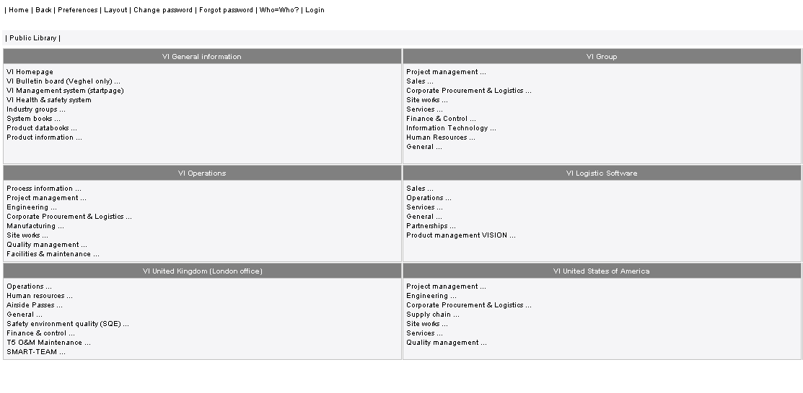Figure 20: The interface of the public library
SharePoint has the technical capability to contain all the information that is currently in the public library and can link to documents contained in the SmarTeam system. Since the public library does not have any advantages or capabilities that SharePoint 2007 does not have, the public library should be phased out to increase usability of the intranet as a whole. Content-wise the information on the intranet should only be allowed on it when there is at least one person responsible for this information. This is what we call governance. When people are allowed to put information on the intranet without having responsibility for it, information will become outdated as people who placed information on the intranet forget about it, leave Vanderlande, or think somebody else will take care of it. This is what happened on the public library and should not happen on the new Intranet. Intrinsic responsibility for information on an intranet is rare, administrators / site owners should be appointed.
ORANGE
Some pages have specific possibilities, like RSS feeds or contact persons. Currently the buttons to access these functions are placed all over the page. The RSS button is on the bottom of the page and the contact link is on the top of the page with no further visual indicator. To increase the usability, these functions should be placed in a specified area, which is the same on all the intranet pages. To improve the clarity and functions of these links they should be accompanied by icons to give users a visual representation of what the button does. For example a little envelope is often considered a button to contact or e-mail a certain person.
BLUE
The left navigation menu contains the exact same links to items as are available on the main navigation bar. This makes the menu lose its value, it is more intuitive to have the left navigation menu contain links to items that are within the area (chosen from the main navigation bar) that the user is currently browsing.
PURPLE
Quick Links are links to pages that are visited most frequently. Therefore this menu should be place more in sight. Since the quick link is visible on every page, it decreases the area where actual information can be displayed. Only the middle part of the page can now be used to show information. This can cause problems, especially on smaller screens with low resolutions the actual area to show information becomes so small, users have to scroll down a lot which reduces usability. Also when all navigation menus are on one side of the screen it becomes easier to scan all the links for the information or links that you are looking for.
General usability
The use of words like 'read more’ or ' click here’ to link to items should be avoided. This degrades the scanability of the website. When people are scanning for the information they need (which may be behind a certain hyperlink) the text 'read more' does not describe what the link leads to. Using multiple links with the same name that lead to different articles degrades usability.
Navigation in four questions.
When considering navigation from the perspective of user there are four questions users will consciously or unconsciously ask themselves:
Where am I?
Where can I go?
Where have I been?
How do I get there?
A good design will always be able to answer these questions at any given time. The newly implemented design discussed later can answer these four questions at any given time.
F-Shaped pattern for reading web content
When users visit a website the content is usually scanned in an F pattern. The user’s eyes first make a horizontal movement, across the top content. Next the content a bit lower is scanned horizontally and finally the left content is scanned up and down making the letter F as visible in the left of figure 21.
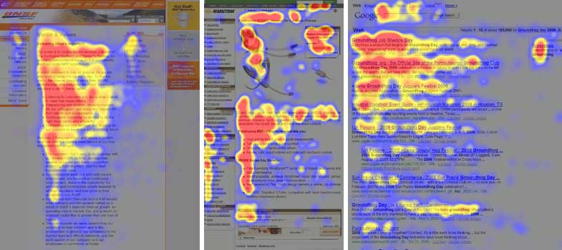
Figure 21: from http://www.useit.com/alertbox/reading_pattern.html
The scans of content are not always exactly three parts, sometimes an inverted L can be seen and sometimes there is a clear E pattern. Despite the small differences the eye movement of a person can be roughly defined as being an F pattern. The design of the new Vanderlande Intranet was created with this in mind.

Chapter 6
The new design
Chapter the new design describes what elements can be found in the new design. The new style guides and the iconset made to keep the design of the Intranet uniform are described. The choices made while designing the document are also explained. Lastly it is described how the gathered information in the chapter ‘Research’ is incorporated into the new design.

Styleguides
To keep the Intranet uniform in terms of design, there are some rules and elements pages on the Vanderlande Intranet must consist of. To begin a color scheme has been created.
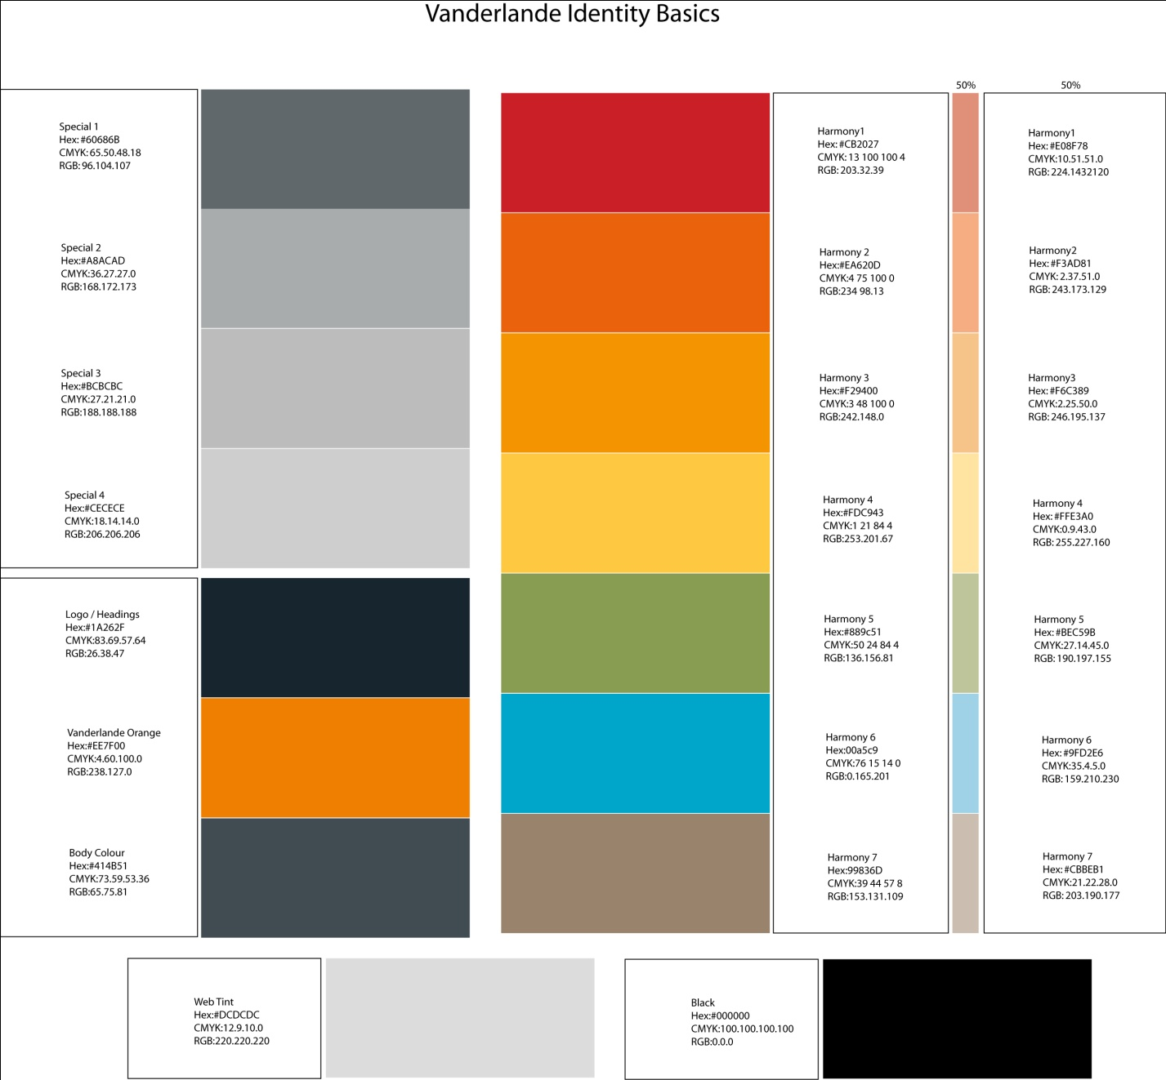
This color chart is also available on the Digital appendix. The Vanderlande colors are defined, as are default colors for the website. Special colors can be used when the default body color is too dark. The Harmony colors can be used to make a page more colorful, the Special colors in the left column can be combined with one harmony color chosen from the right column. Also the 50% RGB values are provided to simulate the Harmony color at a 50% color intensity.
50% Harmony colors may be combined as seen fit with a chosen 100% Harmony color of the same number. There is no limit on using Special colors on a page, they can be combined to make gradients from one special color to another.
The color chart ' Identity Basics’ has been created in close cooperation with the communications department and the final version has been approved. The colors used in the final design are all taken from this chart.
Iconset
Having defined the colors, there is another element that can warrant consistency on the Internet. Icons, when using the same icons on the Intranet for certain items users will slowly start to recognize the icons. This enables users to quickly establish where they are currently browsing within the intranet. Using these icons on the navigation bar enables users to identify what the button does without having to read the caption on the button. This improves scan ability of the website and improves the speed of browsing through the menus.
The iconset should incorporate the web 2.0 definitions found earlier in this report. The iconset has been created in close cooperation with the communication department. During the design process the findings of the web 2.0 research were kept closely in mind. The result of this design process can be seen on the following page. The icons have been used on the Pilot environment.

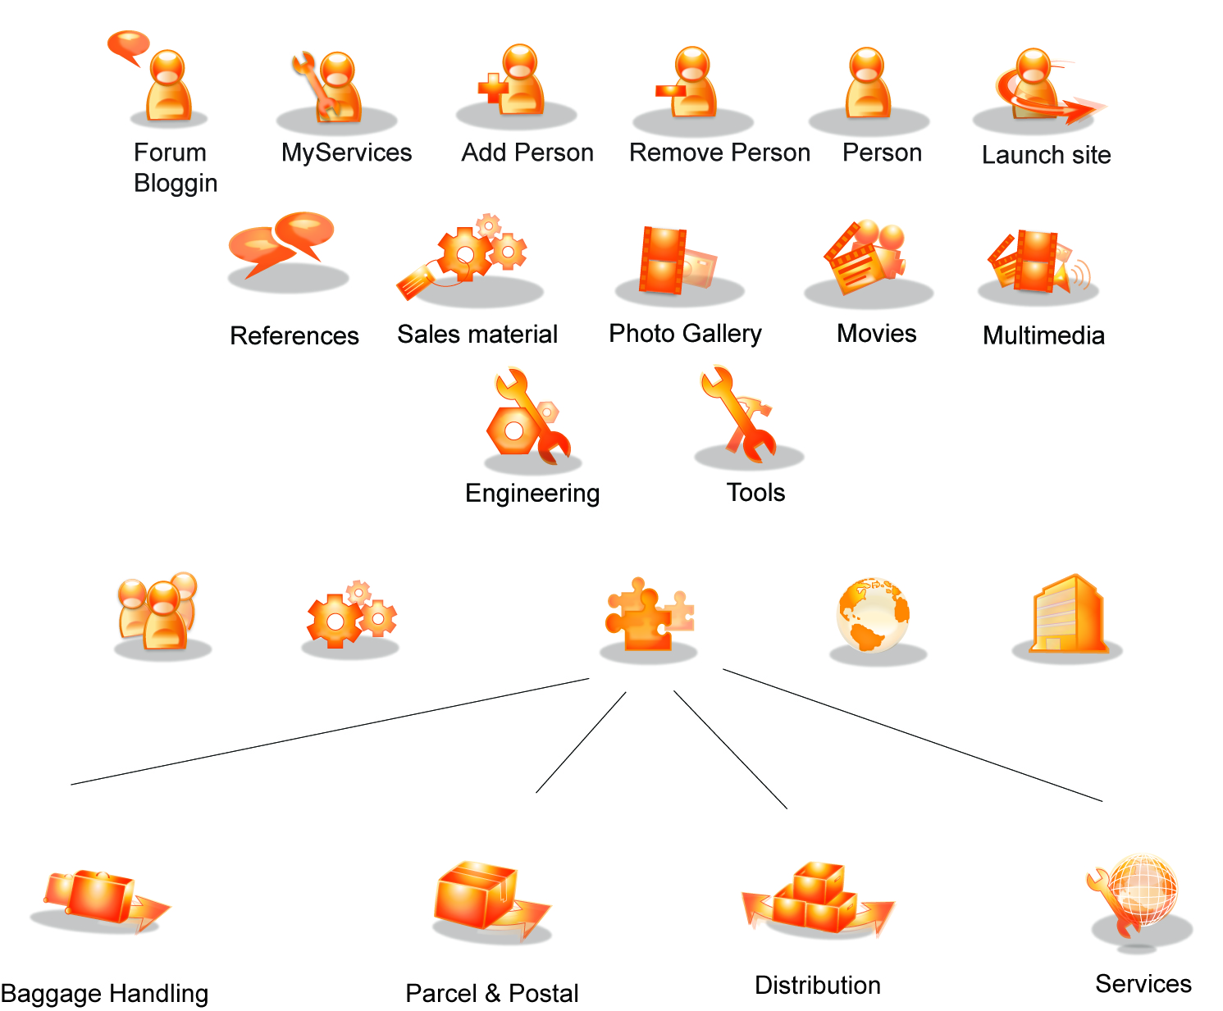
Design
During research on the Microsoft SharePoint 2007 and 2010 products soon became clear that SharePoint 2010 had such great advantages in terms of features and ease of use that Vanderlande has decided to start a pilot on the SharePoint 2010 environment. Therefore the realization of the design has been done on the SharePoint 2010 platform. The screenshots shown are from are taken from a working SharePoint 2010 pilot environment. More on this in the chapter 'recommendations'.
To start off, different screenshots taken from the Pilot environment with the newly created design applied.
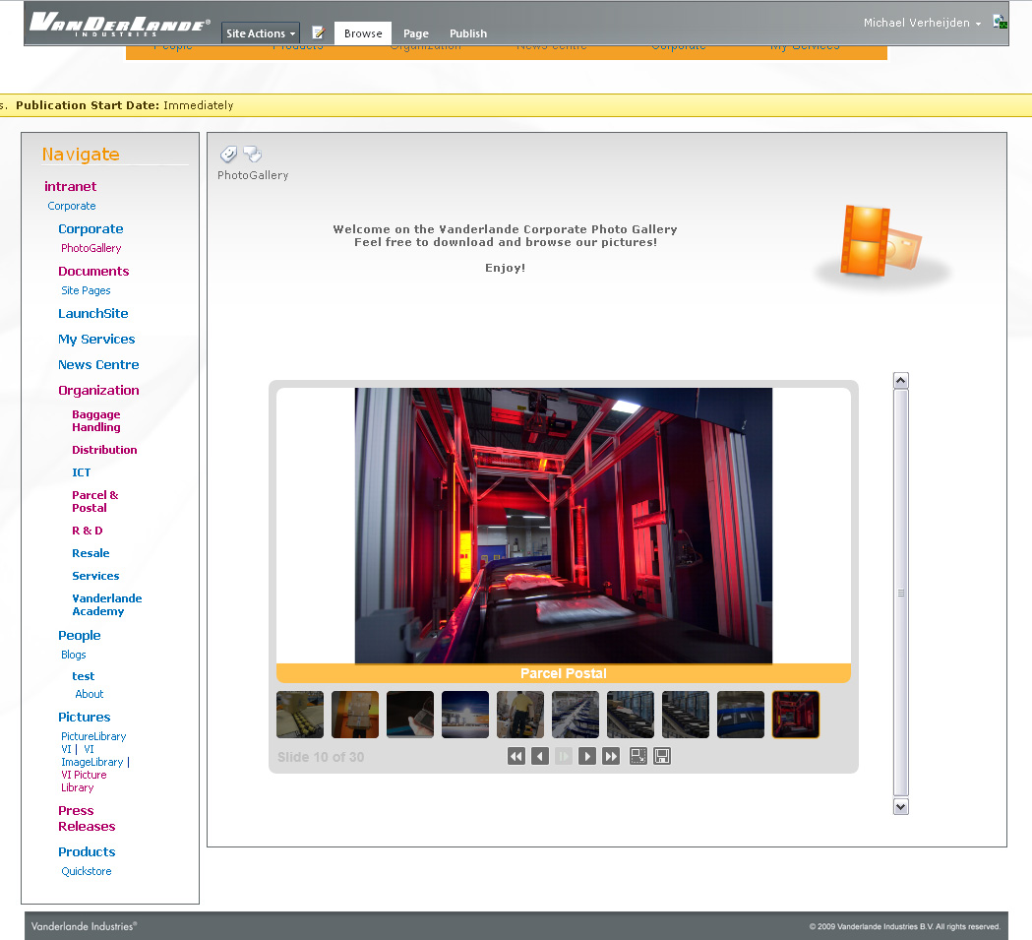
Figure 22: The new design on the Pilot environment
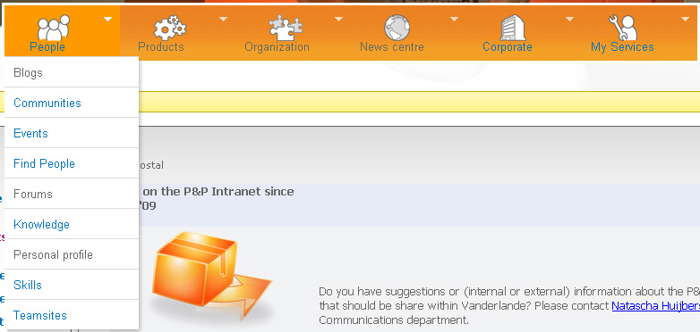
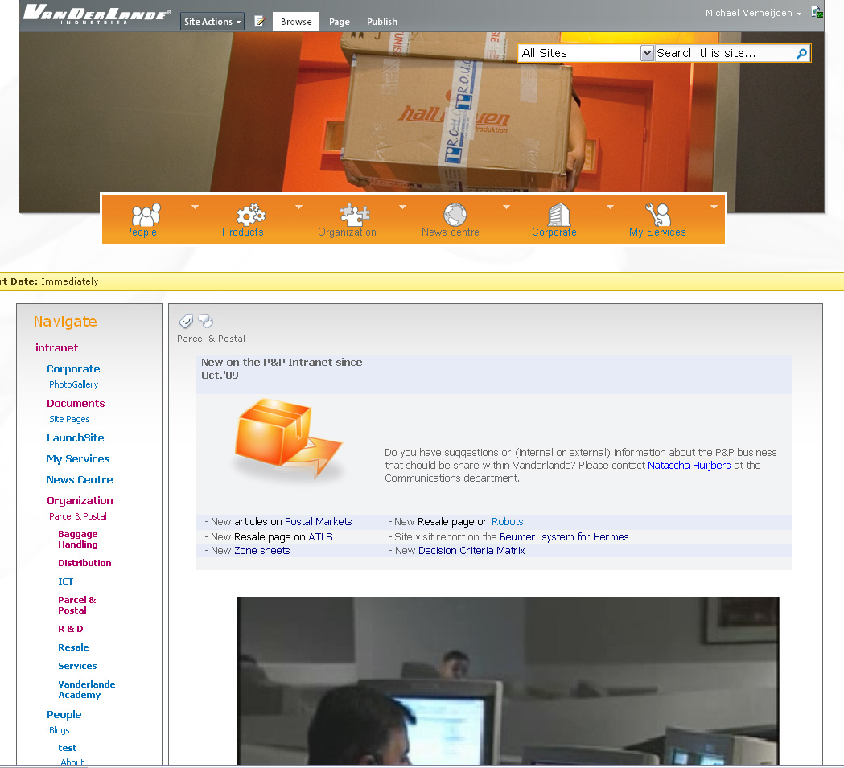
Figure 23, 24 & 25: Impressions of the new design
Combining the gathered information and knowledge into the new Vanderlande Intranet design
After defining a set of usability rules, defining the techniques that make up a web 2.0 webpage and gathering information of the user’s whishes the creation of the new design for the Intranet portal can begin.
Where can the components of the SLATES model described in chapter X be found?
Search
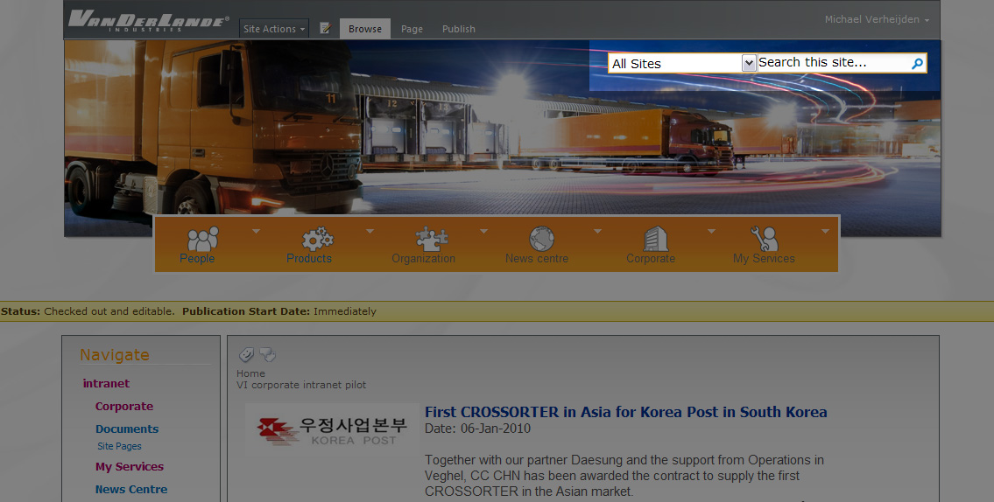
Figure 26: The searchbar
As mentioned, the search function is one of the most important features on the Intranet. Not only to find information but also to look for people in the Who = Who database. A search function increases the findability of information and is an essential part of a modern web 2.0 website. A search function is used on the Vanderlande Intranet and placed on a prominent place on the website

Links
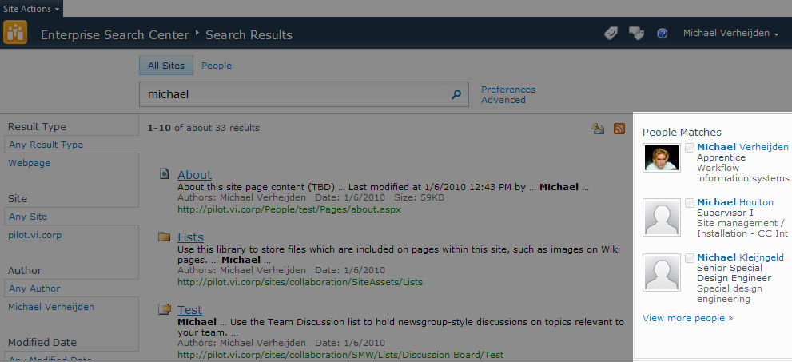
Figure 27: People matches
Searching with the search engine provides the user with links to other valuable content, in this case the user is being linked to three user profiles that contain content similar to the search term.
Authoring
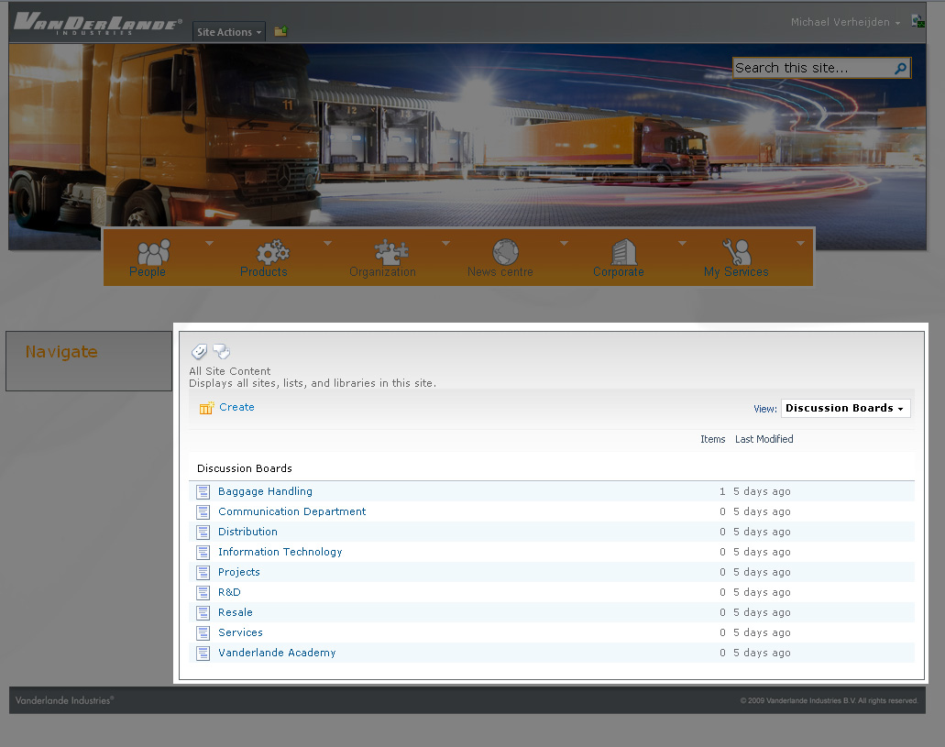
Figure 28: Discussion boards
Forums, found under the 'people' tab found on the main navigation menu. A forum is available for each business unit. Users are also free to create any new topic they desire.
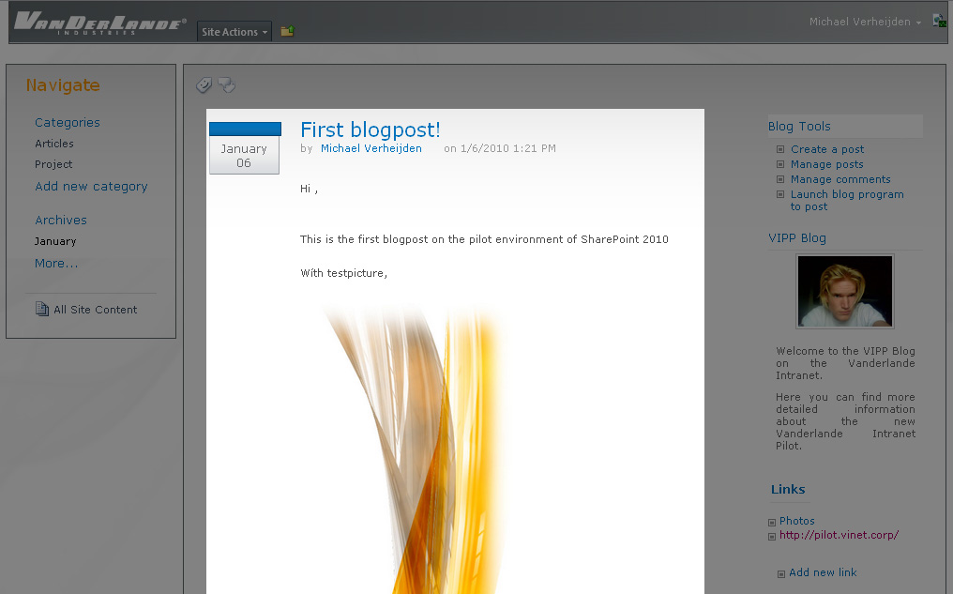
Figure 29: Blogging
Blogging, users are able to create a blog item on the Intranet. Also found under the button 'people' on the main navigation bar. Both the forum and blog tool allow uploading of video and pictures.
Tags
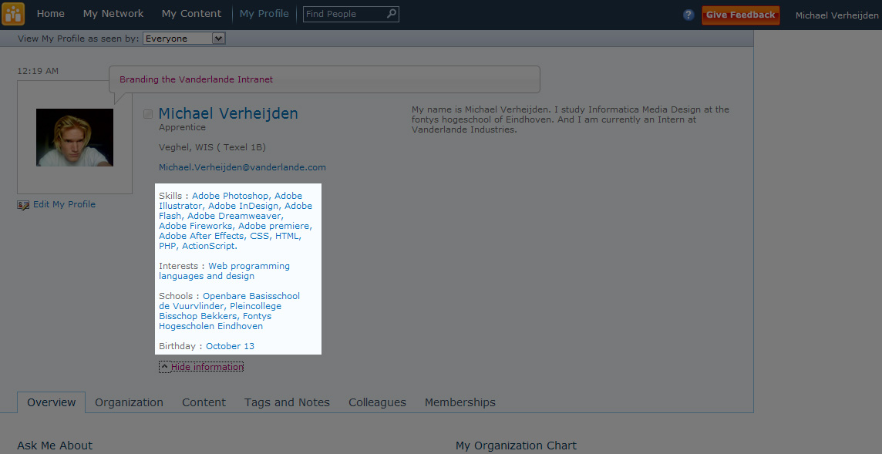
Figure 30: Profile Tags

Users are able to add tags to content or even to their profile. Tagging yourself with skills you have means your skills can be found by the searchengine. A Who knows What function, now you are able to use the Intranet searchengine to find colleagues that have certain skills. Maybe colleagues the users did not even know. Location and availability information is also available, after finding a colleague you are immediately able to tell if he or she is available, and if so where.
Extensions
Out of the box support for Silverlight applications allows you to run any Silverlight driven application there is. Making the portal not only an information source, but a true software platform much like Microsoft Windows is for other applications.
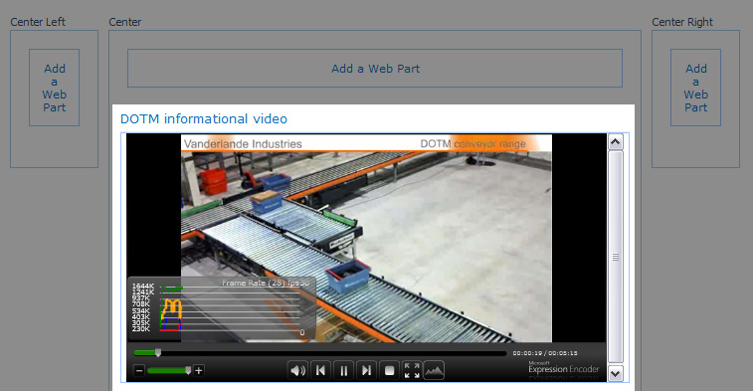
Figure 31: Streaming video
Signals
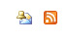
Figure 32: Notification icons
RSS feeds and alert me buttons are available on dynamic content, such as forums, blogs, news items and profiles. Meaning the Intranet keeps you informed about changes and news. This should also help to increase the usage of the Intranet, users are pulled back to the content by the website’s signals.

Results of the usability research have also been incorporated in the new design. Major points are described below:
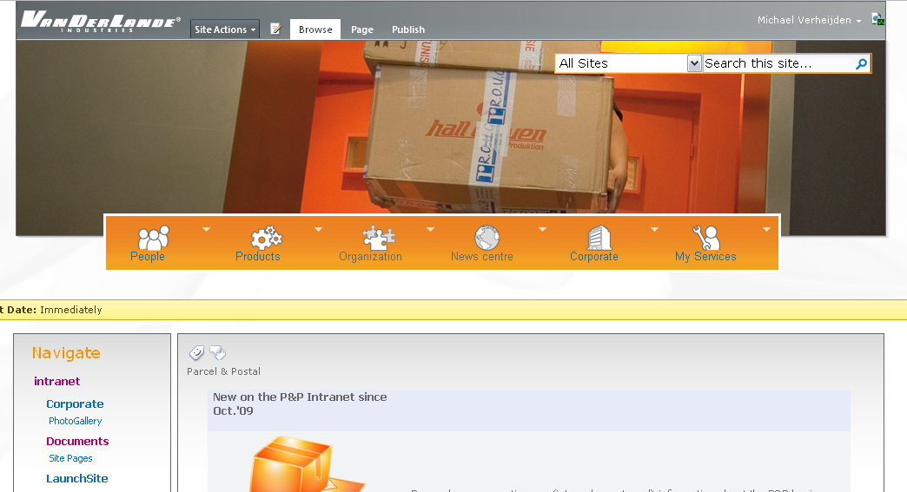
Figure 33: Overall website view
The searchbox is visible at all times in the tor right corner, providing direct access to search and the Who = Who. The logo in the top left corner allows you to navigate to the starting page by clicking it.
The big picture on the top of the page is dynamic and will change according to where the users are located at that time. A distribution picture will be displayed when the user is browsing the website of the business unit Distribution. This helps users to answer one of the four navigational questions which are: Where am I, Where can I go, Where have I been and how do I get there.
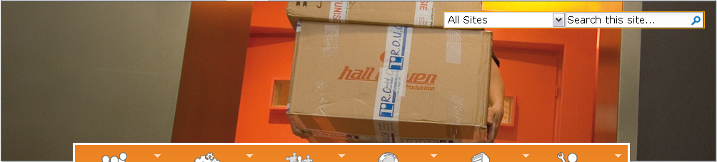
Figure 34: Website top image
The question where have I been will be answered by visited links turning a darker color. How do I get there and where can I go are answered by the left and main navigationmenu.

Research has shown most users scan websites following an 'F' pattern, when designing the website this has also been kept in mind as can be seen in figure 34
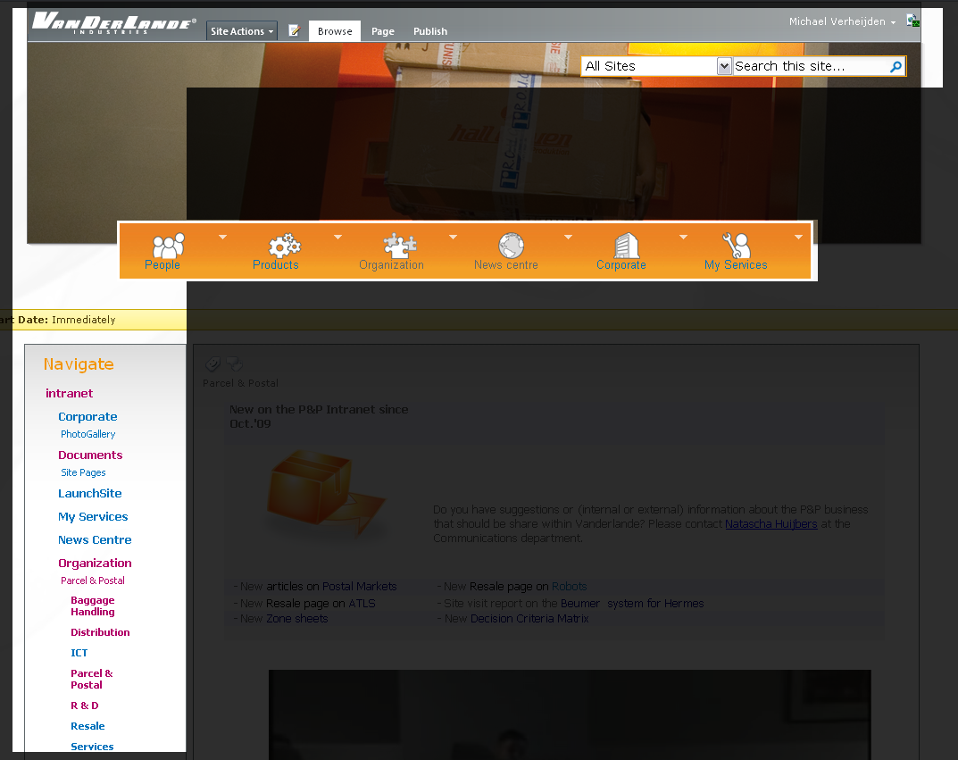
Figure 35: F-Figure incorporated in the intranet design
All of the website’s main navigational features and the search function are shown in the ' F' figure and will therefore be the first items to be noticed by the users increasing usability.

Chapter 7
The new navigation menu
The following chapter describes how the new navigation menu was designed and how the new functions of the new Vanderlande Intranet are incorporated into the navigation menu. In addition a description is provided on how the old Vanderlande navigation menu was analyzed.

Below you can see the old navigation menu of the Vanderlande Intranet. The old navigation bar has been completely redone for a number of reasons.
Figure 36: Vanderlande’s current navigation menu
As the picture clearly shows, the navigational bar is very wide. This can cause problems on screens with a lower resolution. A big part of the navigation menu might extend outside the users screen forcing the user to scroll sideways. Sideways scrolling is always undesired behavior as it decreases usability immensely. When users are forced to scroll vertically this means they will be able to scroll to information in four directions, namely up, down and left and right confusing users.
Therefore the new menu has a fixed width of 800 pixels. This means it can be seen without horizontal scrolling even when viewed on a 800*600 screen resolution.
Also having departments as main navigation is not preferred. There are too many making the menu cluttered and hard to scan. Besides having departments on the main navigation bar there are also major projects listed on the main navigational menu. Even though some projects are very important for Vanderlande, impermanent buttons should not be used on the main navigation bar. This decreases familiarity with the menu, as buttons are constantly changing according to which projects are carried out at that moment.
Keeping this in mind the following icons have been created to be used on the main navigational bar. These buttons have been created with the added functionality of SharePoint 2010 in mind.
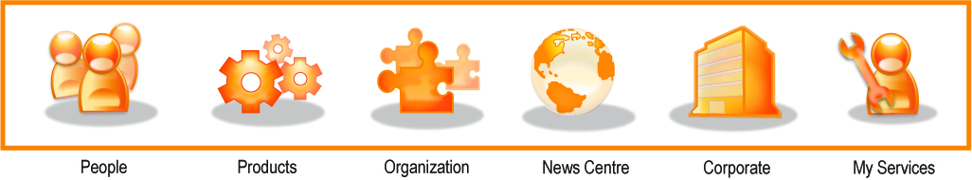
Figure 37:Vanderlande’s new navigation menu
These buttons cover all of the new functions named in this rapport. It has a fixed width and is not susceptible to change when projects are started or shut down or when departments are added, closed or renamed.
The choice was made to make as few buttons as possible on the menu to keep the menubar as clear as possible, making it easier for people browsing for information to see the button they need in a single glance.
When evaluating the design (with the communications department), the big icons proved to be unclear when used on a small menu bar. Therefore simplified versions of the big icons have been used on the final version of the menu bar. These buttons are clear even at smaller sizes and are still recognizable at these small sizes.
Figure 38:Vanderlande’s new navigation menu
The menu bar has been made in close cooperation with the communications department and the managers of the different business areas. This was done in the form of meetings where the designs were evaluated and adjusted until a universally accepted and highly usable categorization of menu items was reached.
The new navigation menu and the new features being implemented in the new Vanderlande
Figure 39: Vanderlande’s new navigation menu
Intranet also called for a new navigation structure. A rough division of items was made in the beginning of the design phase. In close cooperation with the communications department and key users of the Vanderlande Intranet the navigation menu has been incrementally improved and reviewed to reach its final form.
Figure 39 shows the division of information within the main navigation menu.
The 'Standard menu' visualized in grey are the menu items that are shown when a users hovers above the chosen icon.
The ' Personal menu' visualized in orange is a recommendation for user specific content. This content is shown when you click an icon that is on the main navigation menu (the actual icon itself, not the submenus shown when hovering over the icon). The content is loaded in the main body of the website. This information is specific to the user browsing. An example of this could be a user from a Customer Center that is in Spain. When clicking the News Centre icon the user will be able to browse news about the Spanish customer centre. Sadly this has not been applied to the pilot environment as the techniques and programming used to achieve these features on the SharePoint 2010 platform have to be studied further.

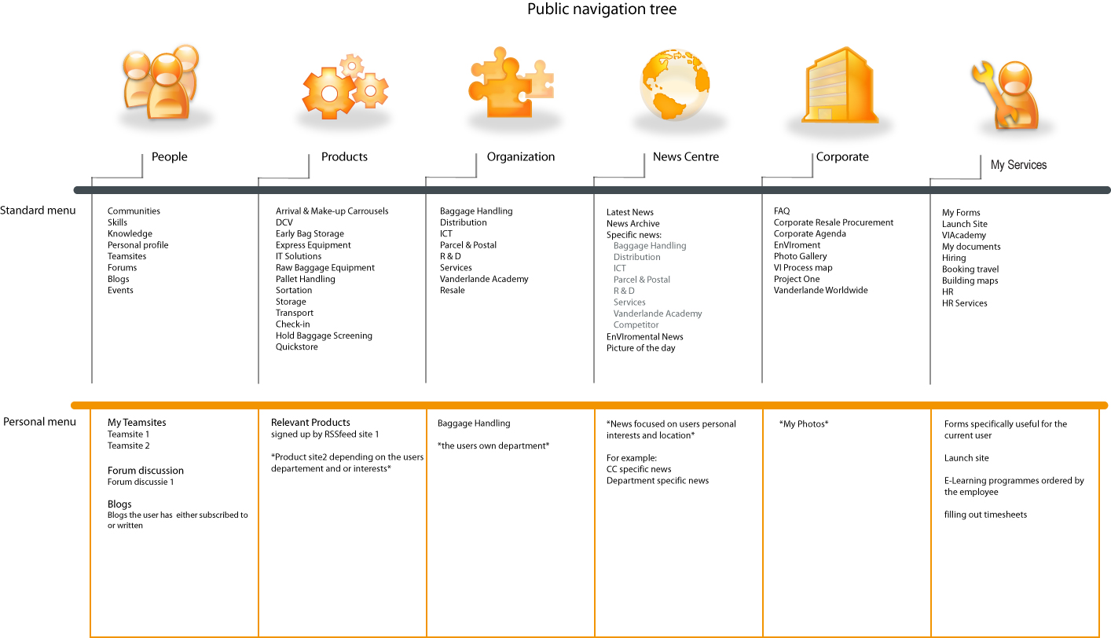
Figure 40

Chapter 8
Silverlight
The Silverlight chapter describes which Silverlight applications have been created during the duration of the project. In addition it is also described how these applications should be used within the Vanderlande Intranet and for what functions.

Where and how Silverlight can Silverlight be used within the new Vanderlande Intranet
As know Silverlight is very easy to implement on the SharePoint 2010 platform. Silverlight can be used as a tool to make websites livelier and deliver content wrapped in an animated environment. This tool provides the perfect tool to spice up the looks of the Vanderlande Intranet and to make its content livelier.
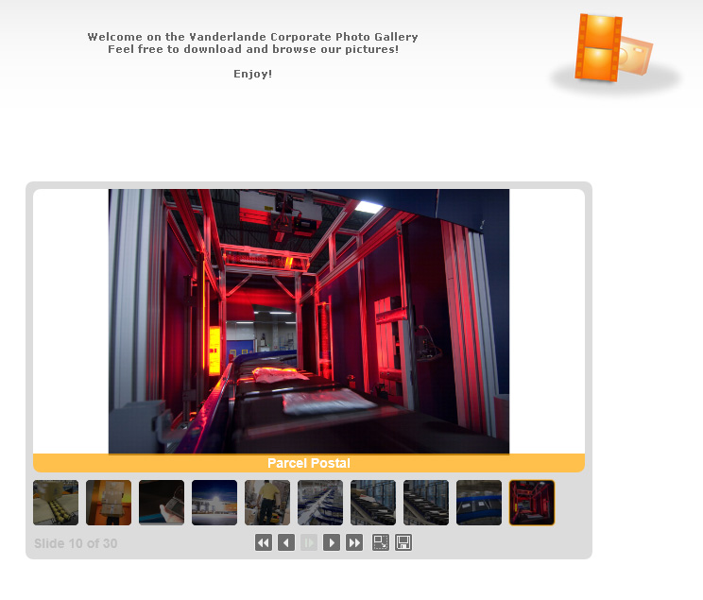
Three applications have been developed using respectively Expression Blend, Deep Zoom and Encoder.

Figure 41: Silverlight picture viewer
Slide Show
This Silverlight application is a picture viewer developed specifically for the Vanderlande Internet. (A working example can be found on the digital appendix) The picture viewer can be seen embedded on the pilot environment in figure 40. The picture viewer allows the user to browse a collection of images. Thumbnails are shown at the bottom and are clickable to select an image. The images can be tagged with captions that are shown in the orange bar. The picture can be saved to the hard drive by pressing the save button. And the pictures can also be viewed full screen when pressing the full screen button. This picture viewer is geared towards presenting big collections of pictures and offering them for download. The design is minimalistic yet stylish, so it can be included on sites of the Intranet without being disruptive to the user.
Deep Zoom
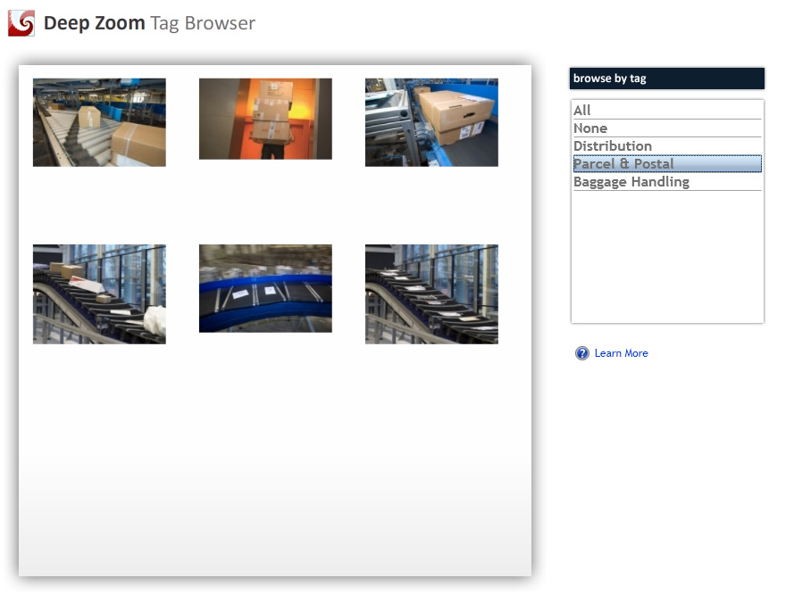
Figure 42: Deep Zoom tag browser
The Deep Zoom tag browser application is also a picture viewer, but features different functionality. As the name implies the viewer allows for very deep zooming ( an example can be found on the digital appendix ) When inserting high resolution photos in a Deep Zoom application the user can zoom in and out and pan around the collection of images. In addition the gallery can display its full contents, or a tag can be selected to show only the images that belong to a certain category. This picture viewer is geared towards showcasing a set of pictures in a high-tech fashion.

Smooth Streaming
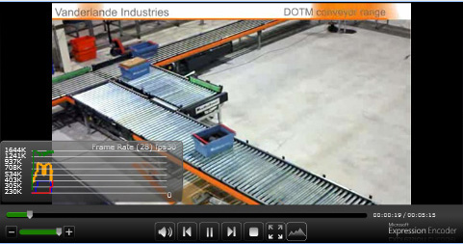
Figure 43: Silverlight Smooth Stream
Smooth streaming is a Silverlight application featured on the Intranet pilot, and is also included on the Digital appendix. The application enables the streaming of videos on the Intranet. Specific and great feature of this YouTube-like streaming application is that the quality of the video is dynamically altered to match the available bandwidth. When a Vanderlande employee is out of office and does not have access to a broadband internet connection videos can still be streamed and viewed without stuttering. Also when a streaming server is under heavy load due to a high amount of users viewing a movie simultaneously, the quality is automatically lowered on all clients to ensure smooth streaming.
Videos have to be encoded to smooth streaming format before they can be streamed. Microsoft Expression Encoder (video encoder in the Expression Web Suite) is the program to do this. Added bonus is that the program is able to upload videos to a streaming server directly after encoding. This means users are able to change videos being displayed by the application (on the Intranet) without having to edit any HTML, ASP or CSS code.
Chapter 9
Quality control
The Silverlight chapter describes which Silverlight applications have been created during the duration of the project. In addition it is also described how these applications should be used within the Vanderlande Intranet and for what functions.

To warrant a high level of quality of the research, and design work the process as a whole had been subjected to continuous testing and adjusting.
The testing consists out of meetings and usability testing. Meetings were planned regularly with the communication department. They have kept a close eye on the whole process of the design. The colors used on the Intranet were chosen in cooperation with communications over multiple meetings and email conversations. The first few designs that were presented to the communications department were evaluated and the best of these designs was chosen as a base for the rest of the design process. When designing the icon set their opinions about the icons were heard and the design was adjusted accordingly. When the design reached a certain level of maturity and was presentable enough a meeting with the key internet users was planned. The key users are the managers of the different product departments who also add most content on the intranet and manage their respective business unit websites on the Intranet. In this meeting the design was presented and questions and comments were heard. The design was generally accepted with some minor remarks that have been taken into consideration.
Marc Schaaks who guided me during the entire internship has been in close contact with me the entire duration of the 100 day internship, and was of great help in defining and solving problems that arose, and helped me deploy the design on the pilot environment providing tips and a helping hand whenever needed.
To sum up the design has been approved by the communications department, the intranet’s key users (managers of business units) and the ICT department that I was in close contact with as well.
Usability test
To see what 'average' users think of the usability of the new Intranet design a usability test was conducted. This was done during the last stages of the implementation and design to provide a testing environment that was as close to completion and full functionality as possible.
The test has been conducted with 5 users. 5 is a good number as more people do not necessarily provide more usability information. Once you have established a certain function is flawed or unclear, it does not help your research to see the same error pointed out a multitude of times. Less than test subject does however mean that your test audience is not diverse enough.
To test the usability of the design the users were posed with 5 questions, these questions were the following:
- Find out who in the organization has the skill ' Photoshop'
- Locate Michael Verheijden' s work desk within the company
- Post a Baggage Handling related question in the appropriate forum
- Download a general ( corporate ) picture from the Vanderlande Intranet
- Locate the blogging feature and post a comment to an existing blog item
The questions were aimed at the new features incorporated in the new Intranet design. The tests were conducted with the use of a computer that had access to the Pilot site on the intranet. When the users were performing the tasks they were monitored while doing so. This allows you to see how people interact with the design. When people have to think for a long time, or when they are unsure where an item is located you can see the steps they take to find the wanted information. When you detect that users always choose the same button to access functionality that is actually not located behind that button, you may have to rethink the design as there might be a better more logical way to place the link.

As a conclusion of the usability test some minor adjustments were made to the layout of the navigation bar. For example, when people are looking for the Baggage Handling forum they always chose to look under the button ' Organization' and then clicking ' Baggage Handling' expecting to find the forum on the departments site. In reality the button ' Forums' was placed under the ' People’ button. This button has been kept there as it will still be used when people want to access general forums. But a link to the forums of all business areas has been placed on the business area sites.

Chapter 10
Conclusion and final recommendations
The conclusion and final recommendation chapter contains the conclusion and the final recommendations made to Vanderlande Industries regarding the Vanderlande Intranet Portal Project. These recommendations should be kept in mind when continuing the development of the SharePoint 2010 platform.

The research and testing conducted during the internship has provided Vanderlande with a lot of useful information about the whishes and demands of the Vanderlande Intranet users. This information is very useful when trying to design an Intranet that its users experience as easy to use and of good quality. When implementing the new Intranet these whishes and demands should be kept in mind at all stages of the deployment.
The pilot environment should be used for further usability testing to increase the usability even further. More content should be added to make the testing as realistic as possible. Use a selected group of up to 5 people to ensure a high quality of usability testing.
Use programs like Deep Zoom and Expression Encoder to make it easy for non programmers to deploy Silverlight applications to the Intranet. These tools allow users to present information in a visually attractive fashion, and are easy to use.
Implement SharePoint 2010. The platform has proven to be of high quality and comes with a lot of out of the box features SharePoint 2007 currently does not have. This saves costs as no further development of webparts has to be done. Also the new searchengine featured by SharePoint 2010 allows Vanderlande to replace the aging Public Library which is still being used for the Who = Who today.
Phase out the old Public Library as it is old and outdated. Information stored on the Public Library is often outdated and the markup (visually) is appalling.
Develop an Intranet Launch Page. This page should help users getting to know the new portal environment. Items featured on this site should be informational videos about new functions on the intranet and how to use them. This should offload questions from the IT Helpdesk and provides users a better user experience. It is better to have the website provide you with the answers, this way if an employee forgets a previously asked question the employee can look up the answer by him/herself.
Make sure the key users of the Intranet (business area managers) define templates for data structuring. The templates should be made by people that have in depth understanding of the content and actually know what content the visitors of their websites look for.
Make the company news on the frontpage more realistic, users sometimes experience the news as too 'feel good'.
By concluding this report Vanderlande should have enough information about the flaws of the current Intranet and the possibilities created by new techniques like Silverlight and Sharepoint 2010 to counter these flaws. The information can be used to create an Intranet that is great on look and feel, functionality and an Intranet that is able to make use of the latest web technologies to give Vanderlande employees the multifunctional Intranet platform they deserve.
Chapter 11
Evaluation and source list
This chapter contains an evaluation of the entire project and a list of sources used during the entire project from planning to implementation.

Evaluation
The 100 days I spent at Vanderlande Industries went by before I knew it. And to see what I have achieved in this short period of time is more then I had expected. The things that went wrong were mostly minor things. Like books being ordered arriving too late, code not working and being unable to find the solution. Luckily these issues were easy to resolve. While waiting for the books I did additional desk research and when I could not get code to work there was always a workaround available with other code. One of the benefits of programming software is that there are multiple ways that lead to Rome.
Second minor downside is the fact that Vanderlande Industries is a very technical company. Most employees are technicians. Technicians as the word implies care a lot for technique and for the business area they work for. Sadly they do not care much for modern web 2.0 designs. An often heard sentence ‘As long as it works’ is one that a designer does not like to hear. Not all things are ‘OK’ as long as they ‘work’. The term work here relates to the technical aspect of a system like the Intranet. Yes the current Intranet works technically speaking, this does not mean that the system as a whole ‘works’ for its users. Adding a good design making a system easier to use and therefore more efficient is just as important as designing and implementing the system itself. Sometimes it seems some Vanderlande employees forget this fact. Vanderlande should try to invest more time in the design of their products. But I must say that a lot of initiatives have been started up and they are defiantly going down a good path.
Before starting the internship I had no experience with Silverlight, .ASP, SharePoint and the Microsoft Expression suite. Still I have managed to create a working pilot environment using these programs as tools. Logically this has been a huge learning experience for me.
Another big learning experience has been working in a company as big as Vanderlande. This organization has a lot of facilities and motivated personnel. Within Vanderlande nothing is impossible to achieve. Only some things have to be fought for more than others. The idea that you can achieve anything if you want it bad enough is very motivating. I have talked and worked with a lot of people I did not know before. I have experienced all cooperation as smooth and pleasant. Even though I sometimes get a bit nervous when facing new people, I did not encounter a lot of problems during this internship. Without going to meetings the project would have been impossible to complete, being ‘forced’ to go into these meetings I mostly though I’d just as well make the best out of it, which worked in my advantage. Near the end I totally lost this feeling which is a great step for me.
The presentation I gave in front of all the Business Area managers was also a great experience. It felt good to present my work in front of these people and hearing the good news they like it. The presentation went very well and I am very happy about that.
On the whole I think I fit into the organization and I think my presence has been experienced as pleasant. No negativity at all, just pleasant people all with a great will to help you out with any problems you have. I think it is great I had the opportunity to do an internship at such a great company as Vanderlande Industries.
Source list
Books:
Rubin, Jeffrey: Usability Testing
Kassenaar, Peter: Website usability
Van der Put, Ward: Website usability
Websites:
http://www.silverlightbuzz.com/
Blog with info and tutorials on Silverlight
http://www.maxdesign.com.au/presentation/center/
Page about CSS and the centering of items with CSS
http://hyper-metrix.com/#Burst
JQuery website, providing a lot of code and example to use with JQuery
http://www.webtoolkit.info/css-drop-shadow.html
CSS tutorials
http://silverlike.net/#/home
Silverlight repository
http://videos.visitmix.com/MIX09/
Microsoft MIX videos about Branding in SharePoint 2010
http://www.useit.com/alertbox/20020512.html
Usability guidelines
http://www.augenblix.com/
A special Silverlight Picture viewer
http://www.microsoft.com/silverlight/resources/resource-kit.aspx
Resource center of Microsoft containing documentation on a wide variety of software.
http://www.shinedraw.com/flash-vs-silverlight-gallery/
Large Flash vs. Silverlight repository
APPENDIX A
Project planning
This is a short version of the planning covering the most important parts. The full planning can be found on the Digital Appendix.

Results and goals
Within the duration of my Internship (from 01-09-’09 untill 29-01-’10) The realization of a concept: A graphically improved Intranet, that fits within Vanderlande' s corporate style and is equipped with a navigation that functions according to described and researched usability and style-guidelines. The website should:
- Fit the wishes and demands of its users
- Pull visitors into the website. The searching and finding of information should be made as easy and efficient as possible. In other words a high grade of usability should be achieved.
- Fit the current Vanderlande branding style. The new website should be designed according to newly created styleguides and usabilityguides to make accessing information as efficient as possible.
- The design should be future proof
Personal development
I hope to gain knowledge within these specific fields of expertise.
- SharePoint 2007 and 2010
- Programming on the .NET platform
- Design using Adobe Illustrator and Adobe Photoshop
- Design using the Microsoft Expression suite, This includes Expression Blend and Expression Web
- Project planning and execution
- Communicating organization wide
- Work projectbased within a corporation
I hope to develop my skill in programming on the .NET framework from Microsoft. Also I hope to develop my skills and knowledge of Silverlight. I hope to gain a lot of experience within the company Vanderlande. With about 2200 employees Vanderlande is a big corporation. Communication within the corporation will be done mainly via email or meetings. This means there is a more formal way of communication than there would be in a smaller company. Within the company Vanderlande Industries my task is to complete the project ' Branding the Vanderlande Intranet'. This is the first time i will lead a project within an organization and will have to work according to Vanderlande' s project approach. This will be an interesting experience and I hope this will be a very educational challenge.
Furthermore i will have to arrange numerous meetings with people from the communications department and collect information about the whishes and demands of the employees using the Intranet. This is also a big challenge for me since I have never done this before within a big corporation.

Quality
Naturally the website should meet certain quality requirements. This includes the usability of the website. And how well the website fits with Vanderlande's current corporate identity. Also the arrangement of information and departments should be done according to a certain structure. The quality of the website will be determined for a large part by its design, research shows that quality is dependent on:
1. Clear navigation and ease of use (40%)
2. Speed (21%)
3. Value of content (19%(
4. Esthetically appealing and lay out (13%)
*source: http://web.xmedia.nl/2005/04/25/kwaliteiteisen-webdesign/
How will the quality be measured?:
The quality can be tested by conducting a survey. The survey will be aimed at users of the Vanderlande Intranet. If users are satisfied ,the design and usability requirements have been met. Also the design of the website will be checked regularly by the communications department and Marc Schaaks.

Risks
Naturally there are some risks that might endanger completion, progress or implementation of the end product. These have been described with probability and solution in the following table:

Risk | Chance | Effect | Risk level (C*E) | Oplossing
Product does not meet the requirements of Vanderlande Industries | 3 | 1 | 3 | Ensure quality control after every important milestone
Product does not meet requirements of the end users | 1 | 3 | 3 | Aquire a clear picture of what the endusers want and need
SharePoint 2010 does not offer the expected or wished for ' out of the box' features | 1 | 3 | 3 | Develop own software solutions within the SharePoint 2010 environment.
Silverlight does not offer the expected funtionality | 2 | 1 | 2 | Use Flash instead of Silverlight or use Silverlight in a limited amount
Too little internal knowledge to implement Silverlight. | 2 | 3 | 6 | Hire external knowledge or expertise

Deliverables
- 'Gespreksformulier'

- Project Planning

- Graduation report

- Research whishes and demands of Intranet users within the organization

- Research on how to implement Silverlight on the Intranet, which techniques should be used for this and what these techniques can and cannot do.

- Research the current styling of the Intranet

- Research current usability guidelines

- Usability guidelines

- Redesign of the Intranet in prototype form ( by using Illustrator, Photoshop and Sketchflow ) The protoype should be deployed in a SharePoint testing environment

- Usability testing of users

Scope
Finished products thus include a number of things. Namely usability guidelines, style guidelines, results in report form of the various investigations described, a prototype of the graphic design made according to the developed style and usability guidelines. A study of satisfaction with the prototype on the test server of Vanderlande this is done via meetings, and usability testing. Of course everything is documented in the thesis which includes the progress described.
Aim of the task is to initiate the redesign of the intranet. This includes said products. These products do not actually have to be implemented on the live environment. Functionality may be added by Vanderlande to a certain Silverlight application. The Style and usability guidelines are a concept for the final style and usability guidelines used by Vanderlande. It should not be expected that the final products delivered at the end of the internship are corporate widely deployed.

Planning
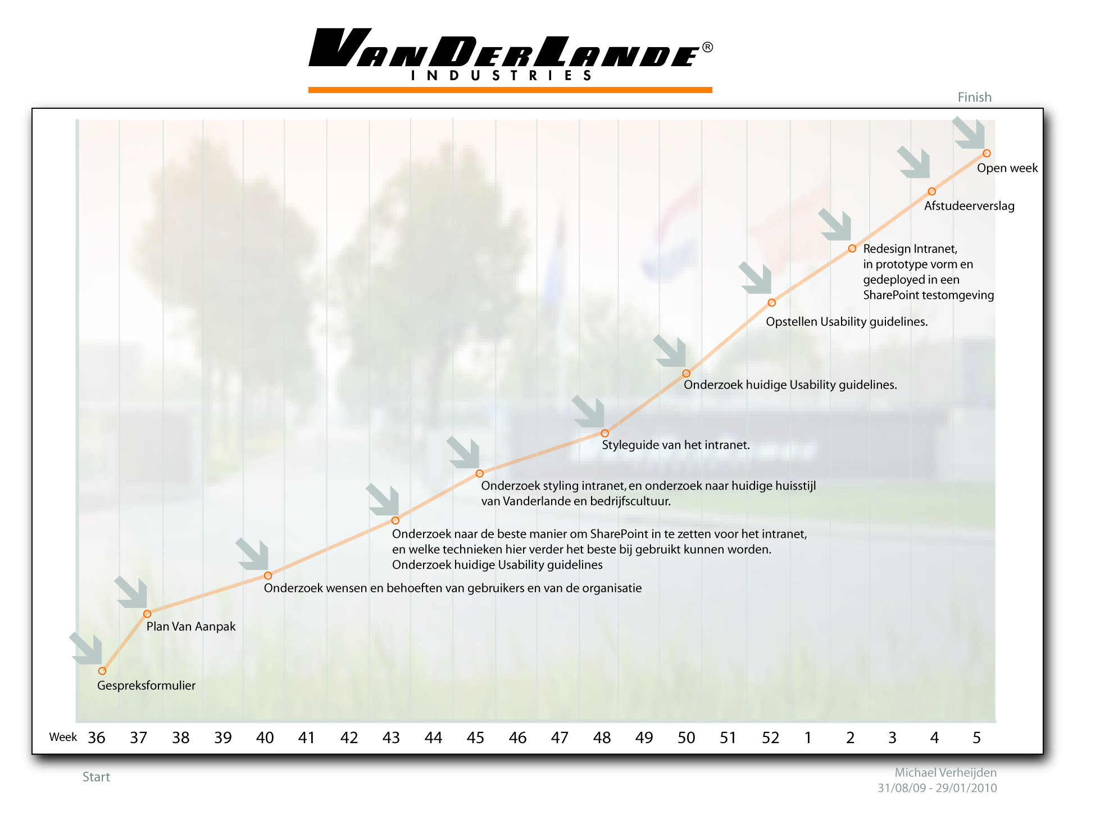
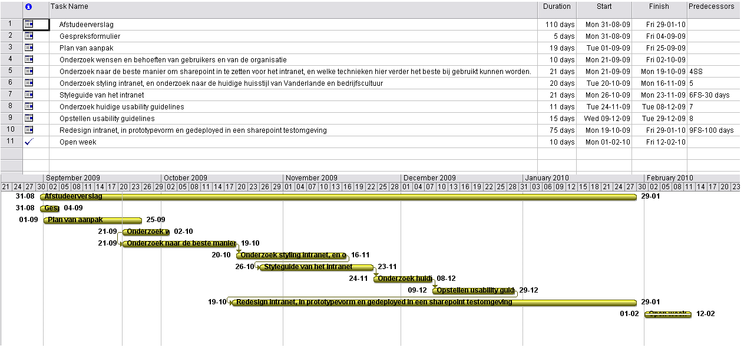
APPENDIX B
The results of the multiple choice questions asked in the Vanderlande Intranet Portal Project Survey.

